Request for Proposals

RFP #C043776

Converged Eligibility and Enrollment (E&E) System and Appeals Management System (AMS)

Exhibit G.02
NYSOH System Design Document

New York State
Department of Health

New York State of Health (NYSOH) Project
NYSOH System Design Document
Version Number: 32.0
Contract Number: C027853
Date Submitted: July 15, 2024
Effective Date: May 3, 2024
Record and Approval of Changes
Version | Author | Date | Approver | Approval Date | Description iof Changes
28.0 | P. Brown | 8/5/2022 | E. Kopicky | 8/5/2022 | Incorporate NYSOH releases through 37.1 with additional content generated under CR1716, SDD Content Enhancement
29.0 | S. Wang | 1/13/2023 | S. Bhat | 1/13/2023 | Incorporated NYSOH releases through 40.2 with additional contents generated under CR1716, SDD Content Enhancement
30.0 | S. Wang | 5/10/2023 | S. Bhat | 7/14/2023 | Incorporated NYSOH releases through 42.3 with additional contents generated under CR1716, SDD Content Enhancement
31.0 | M. Ravilla | 11/29/2023 | S. Bhat | 1/12/2024 | Incorporated NYSOH releases through 45.1 with additional contents generated under CR1716, SDD Content Enhancement
32.0 | S. Wang  M. Ravilla | 5/10/2024 | S. Bhat | 7/9/2024 | Incorporated NYSOH releases through 47.2

Note: Only the five most recent revisions to this document are listed above. For the revision record of earlier versions, please refer to the change history in prior versions.

Table of Contents
1. Introduction 1
1.1 Purpose of the SDD 2
2. General Overview and Design Guidelines/Approach 3
2.1 General Overview 3
2.2 Assumptions/Constraints/Risks 7
2.2.1 Assumptions 8
2.2.2 Constraints 9
2.2.3 Architectural Strategies 11
2.2.4 Risks 12
2.3 Alignment with Federal Enterprise Architecture 12
3. Design Considerations 13
3.1 Goals and Guidelines 13
3.2 Development Methods and Contingencies 13
3.3 Architectural Strategies 13
3.3.1 Spring MVC Framework 13
3.3.2 Single Page Application (SPA) Architecture with Angular 15
3.3.3 Spring WS Framework 15
3.3.4 Database Access 15
3.3.5 Message-Oriented Middleware (MOM) Pattern 17
3.3.6 JAX Web Services Pattern 17
3.3.7 XStream 18
3.3.8 Activiti Pattern 18
3.3.9 Alfresco Process Services (BPM) Pattern 18
3.3.10 IBM DataStage ETL Pattern 18
3.3.11 Logging and Exception Handling 19
3.3.12 SPRING Validation Framework 22
3.4 Performance Engineering 23
4. System Architecture and Architecture Design 25
4.1 Logical View 26
4.2 Hardware Architecture 28
4.2.1 NYSOH Environments 28
4.2.2 Security Hardware Architecture 31
4.2.3 Performance Hardware Architecture 31
4.3 Software Architecture 33
4.3.1 Security Software Architecture 35
4.3.2 Performance Software Architecture 36
4.4 Information Architecture 37
4.4.1 Conceptual Data Model 38
4.4.2 Logical Data Model 39
4.4.3 Physical Data Model 39
4.4.4 Records Management 40
4.5 Internal Communications Architecture 40
4.6 Security Architecture 42
4.6.1 Security Architecture 42
4.7 Performance 43
4.8 Service Architecture 45
4.8.1 Rest Services 45
4.8.2 SOAP Services 54
4.8.3 Java Interfaces 54
4.9 Deployable Components 54
4.10 System Architecture Diagram 66
5. System Design 70
5.1 Business Requirements 70
5.2 Database Design 70
5.2.1 Data Objects and Resultant Data Structures 71
5.2.2 File and Database Structures 71
5.3 Data Conversion 86
5.4 User Machine-Readable Interface 86
5.5 User Interface (UI) and User Experience (UX) Design 86
5.5.1 Overview 86
5.5.2 Section 508 Compliance 86
5.5.3 NYSOH Verified and Tested Web Browsers 87
5.6 System Monitoring 87
5.7 Document Management 89
5.8 Client Communication 90
6. Operational Scenarios 91
6.1 Anonymous Plan Search 93
6.2 Manage Individual Plan Membership 95
6.2.1 Apply For Health Insurance 95
6.2.2 Verification 96
6.2.3 Eligibility 97
6.2.4 Enrollment 98
6.2.5 Manage Appeals 105
6.2.6 Manage Events Impacting Membership/Eligibility 105
6.2.7 Manage Member Account 106
6.2.8 Manage NYSOH Back Office Activities 107
6.3 Manage Provider Encounters 107
6.4 Manage Plan Information 108
6.4.1 Manage PM Account 109
6.5 Manage Reporting 109
6.6 Manage Notices 114
6.7 Manage Small Business Marketplace 115
6.7.1 Manage SB Accounts 116
6.8 Manage CSR Accounts 116
6.9 Manage Brokers/Assistors 117
6.10 Manage NYS and NYSOH System Access 117
6.11 Common Support Services 118
6.12 System Management Activities 118
6.12.1 Notices 119
6.13 Operational Design Patterns 120
6.13.1 System Clock Pattern 120
6.13.2 External Interface Operational Scenario Design Patterns 121
7. Detailed Design 129
7.1 Hardware Detailed Design 129
7.2 Software Detailed Design 129
7.3 Security Detailed Design 129
7.3.1 Front End Users using NY.Gov ID 130
7.3.2 Back Office Users 133
7.4 Performance Detailed Design 136
7.5 Internal Communications Detailed Design 136
8. System Integrity Controls 137
9. External Interfaces 138
9.1 Interface Architecture 138
9.2 Interconnection Security/Data Use Agreements 150
9.3 Interface Detailed Design 150
9.3.1 Batch File Processing 150
9.3.2 Business Services Outsourcing Center (BSOC) Interactions 152
9.3.3 Department of Corrections and Community Supervision (DOCCS) Interactions 152
9.3.4 Department of Financial Services (DFS) Interactions 152
9.3.5 Department of Health (DOH) Interactions 153
9.3.6 Department of Labor (DOL) Interactions 153
9.3.7 Department of Motor Vehicles (DMV) Interactions 153
9.3.8 Department of Tax and Finance (DTF) Interactions 153
9.3.9 Division of Eligibility and Marketplace Integration Interactions 153
9.3.10 eMedNY Interactions 154
9.3.11 Federal Data Services Hub Interactions 154
9.3.12 IPRO Interactions 154
9.3.13 Issuer Interactions 154
9.3.14 Knowledge, Information and Data System (KIDS) Interactions 154
9.3.15 Maximus Interactions 155
9.3.16 National Association of Insurance Commissioners (NAIC) Interactions 155
9.3.17 Office of Information Technology Services (ITS) Interactions 155
9.3.18 OTDA and HRA Interactions 156
9.3.19 NY State Health Insurance Assistance Program (NYSHIP) Interactions 156
9.3.20 Twilio SMS Messaging Interactions 156
9.3.21 Twilio SendGrid Email Service Interactions 157
9.3.22 Contentstack System Architecture 158
10. Attachments 159
11. Glossary & Acronyms 160
Appendix A Referenced Documents and Supporting Tools 161

Table of Figures
Figure 1. Health Insurance Plans 3
Figure 2. NYSOH System Business Context 4
Figure 3. Business Areas 5
Figure 4. Technical Areas 7
Figure 5. Spring MVC Framework 14
Figure 6. HTTP Request Handling - Normal Scenario 14
Figure 7. High level interactions between SPA and backend REST services 15
Figure 8. Spring Mybatis 16
Figure 9. Annotations in Java Source 17
Figure 10. Spring Validation Framework 23
Figure 11. NYSOH System Functional Capabilities 27
Figure 12. NYSOH Communications Architecture Overview 28
Figure 13. NYSOH Environments 28
Figure 14. AppProd Environments 29
Figure 15. AppPreProd Environments 29
Figure 16. AppNonProd Environments 30
Figure 17. SupportProd Environments 30
Figure 18. SupportNonProd Environments 31
Figure 19. Software Categories 34
Figure 20. NYSOH FTI Data Flow 35
Figure 21. High Availability and Scaling 36
Figure 22. Database Architecture Overview 38
Figure 23. Plans 39
Figure 24. Internal Communications 40
Figure 25. System Architecture 41
Figure 26. Load Balancing 42
Figure 27. Enrollment Volume Specifications 44
Figure 28. Peak Page views 45
Figure 29. REST Service Modules Client Enumeration 46
Figure 30. WSRRUtil 46
Figure 31. ApplicationAggregatorRESTWS 47
Figure 32. AutoApplicationRESTWS 48
Figure 33. BoRESTWS 49
Figure 34. NYHXBusinessProcessRESTWS 50
Figure 35. CommonServicesRESTWS 51
Figure 36. DocumentRESTWS 52
Figure 37. UserMgmntRESTWS 53
Figure 38. Rules Engine 54
Figure 39. Portals 55
Figure 40. External SOAP Services 55
Figure 41. Batch Jobs 56
Figure 42. Activity Initiator Support 57
Figure 43. Internal Java Services 58
Figure 44. Internal REST Services 59
Figure 45. Internal SOAP Service 59
Figure 46. Data Transfer Objects 60
Figure 47. Interface Invocation Java Client 61
Figure 48. Outbound Messaging 62
Figure 49. Queues 62
Figure 50. Java Business Domain 63
Figure 51. Data Domain 64
Figure 52. Utilities 65
Figure 53. Testing Support 65
Figure 54. Deployment Support 66
Figure 55. Logical Application Architecture 67
Figure 56. NYSOH Encounter Solution Architecture 68
Figure 57. NYSOH Component Deployment View 69
Figure 58. Address Database Details 72
Figure 59. Broker Database Details 73
Figure 60. Appeals Scope 74
Figure 61. Application Scope 75
Figure 62. Application Details 76
Figure 63. Application Member Scope 77
Figure 64. Application Plan Scope 78
Figure 65. Application Transaction Scope 78
Figure 66. Eligibility Scope 79
Figure 67. NYS Government Accounts 80
Figure 68. Issuer Scope 80
Figure 69. Member Scope A 81
Figure 70. Member Scope B 82
Figure 71. Organization Database Details 83
Figure 72. Phone Number Details 83
Figure 73. Plan Details Scope 84
Figure 74. User Profile Scope 85
Figure 75. CMIS Meta Model 90
Figure 76. High Level NYSOH Individual Operational Flow 91
Figure 77. High Level Individual End-to-End Operational Flow (Subsidized EE) 92
Figure 78. High Level Small Business End-to-End Operations Flow 92
Figure 79. Anonymous Plan Search 93
Figure 80. Anonymous Plan Search - Business View 93
Figure 81. Anonymous Plan Search - Technical View 94
Figure 82. Manage Individual Plan Membership 95
Figure 83. Apply for Health Insurance 95
Figure 84. Verification Activities 96
Figure 85. Determine Eligibility 97
Figure 86. Manage Enrollment 98
Figure 87. Select Plan 98
Figure 88. Enrollment 99
Figure 89. Disenroll 100
Figure 90. CHP Member Level Non-Payment Overview 101
Figure 91. CHP Member Level Non-Payment Functional Flow Sequence Diagram 102
Figure 92. CHP Member Level Non-Payment Technical Overview 103
Figure 93. Get Issuer Terminate Member Coverage Request 103
Figure 94. Renew 104
Figure 95. Manage Appeals 105
Figure 96. Manage Events Impacting Membership_Eligibility 105
Figure 97. Manage Member Account 106
Figure 98. Manage CIN Activities 106
Figure 99. Manage NYSOH Back Office Activities 107
Figure 100. Manage Provider Encounters 107
Figure 101. Plan Management Activities 108
Figure 102. Manage PM Account Activities 109
Figure 103. Reporting Activities 110
Figure 104. NYSOH Reporting Operational View 111
Figure 105. DataStage - Load Process 112
Figure 106. Sample QARR Data Stage Job Sequence 113
Figure 107. Manage Notices 114
Figure 108. Small Business Marketplace Activities 115
Figure 109. Manage SMB Marketplace Account Activities 116
Figure 110. Manage CSR Accounts 116
Figure 111. Manage Brokers_Assistors 117
Figure 112. Manage NYgovID Activities 117
Figure 113. Common Support Services (Customer Service, Back Office, Individual) 118
Figure 114. System Management Activities 118
Figure 115. Notices Process 120
Figure 116. System Clocks 121
Figure 117. High Level Business Process for Plan Management, FM, and Small Business and Individual Marketplaces 122
Figure 118. X12 EDI Outbound Processing 123
Figure 119. X12 EDI Incoming Processing 124
Figure 120. Internal Services Implementation Pattern 125
Figure 121. External Outbound Services (real-time and file transfer) 126
Figure 122. NYS Department of Corrections and Community Supervision (DOCCS) Interface 127
Figure 123. MEC Web Services Hosted by eMedNY 128
Figure 124. Validation Process for Front End Users via NY.Gov ID 131
Figure 125. ID Proofing Process 132
Figure 126. CSR Credential Creation Process 134
Figure 127. MAXIMUS Back Office User Credential Creation Process 135
Figure 128. NYS Agency User Credential Creation (back-end) 136
Figure 129. NYSOH System External Interfaces 138
Figure 130. Business Services Outsourcing Center (BSOC) Interactions 152
Figure 131. DOH Interactions 153
Figure 132. DTF Interactions 153
Figure 133. Division of Eligibility and Marketplace Integration Interactions 153
Figure 134. eMedNY Interactions 154
Figure 135. Maximus Interactions 155
Figure 136. ITS Interactions 155
Figure 137. OTDA and HRA Interactions 156
Figure 138. Inbound calls from Twilio to NYSoH 157
Figure 139. Outbound calls from NYSoH 157
Figure 140. Email System Architecture 158
Figure 141. Contentstack System Architecture 158

Table of Tables
Table 1. Release Summary Schedule 1
Table 2. System Design Assumptions and Impacts 8
Table 3. System Design Constraints and Implications 9
Table 4. NYSOH System Performance Specifications 23
Table 5. Architectural Views 25
Table 6. Hardware Description 32
Table 7. NYSOH Verified and Tested Web Browsers 87
Table 8. System Monitoring 88
Table 9. Cross Track Capability Functional Design Documentation 88
Table 10. External Interfaces 140
Table 11. Attachments 159
Table 12. Referenced Documents 161

Introduction
This System Design Document (SDD) provides an overview of the system architecture, the technical, application, and database designs, the user interface and business processes implemented in the New York State of Health (NYSOH) Health Exchange system.

The SDD is created in accordance with the guidance provided by Centers for Medicare and Medicaid Services (CMS) in published templates (Table 12). Additional references are included to further detail where the system design is decomposed into lower-level detailed design specifications.

Engineering and development work products are managed in System Development Life Cycle (SDLC) tools and published or referenced in the SDD, as appropriate for the level of detail.

The SDD is a living document. It will be updated twice a year to include each of the NYSOH releases. The covered releases in this version of the SDD are listed in Table 1 below.

This document is considered “Confidential” and is only authorized for release for official NYSOH Program business needs and with guidance as to proper handling for such purposes.

Table 1 outlines the NYSOH Release Summary Schedule for major releases spanning from Release 32.1.3 through the most recent release covered by this SDD.
Table 1. Release Summary Schedule
Release | Build | Production Deployment Date
32 | 1.3 | 06/05/2021
32 | 1.5 | 06/24/2021
33 | 1 | 07/18/2021
34 | 1 | 08/15/2021
34 | 1.1 | 09/11/2021
35 | 1 | 09/23/2021
35 | 1.5 | 10/16/2021
36 | 1 | 10/21/2021
36 | 1.2 | 11/15/2021
36 | 1.5 | 11/16/2021
36 | 2 | 11/18/2021
36 | 3 | 12/09/2021
36 | 3.1 | 12/30/2021
36 | 3.2 | 01/06/2022
36 | 4 | 01/20/2022
36 | 4.1 | 01/29/2022
36 | 5 | 02/27/2022
36 | 5.5 | 03/05/2022
37 | 1 | 03/31/2022
38 | 1 | 06/26/2022
38 | 2 | 07/28/2022
38 | 3 | 08/18/2022
39 | 1 | 09/25/2022
40 | 1 | 10/06/2022
40 | 2 | 11/10/2022
40 | 3 | 12/20/2023
41 | 1 | 01/05/2023
41 | 1.1 | 01/19/2023
41 | 2 | 02/16/2023
42 | 1 | 03/16/2023
42 | 2 | 04/13/2023
42 | 2.5 | 05/01/2023
42 | 3 | 05/18/2023
43 | 1 | 6/22/2023
43 | 1.5 | 7/1/2023
43 | 2 | 7/20/2023
43 | 3 | 8/17/2023
43 | 3.1 | 8/31/2023
43 | 3.2 | 8/31/2023
44 | 1 | 9/14/2023
44 | 1.1 | 10/1/2023
45 | 1 | 10/15/2023
45 | 1.1 | 10/17/2023
45 | 1.2 | 10/31/2023
45 | 2 | 11/12/2023
45 | 2.1 | 11/16/2023
45 | 3 | 12/14/2023
45 | 3.0.1 | 1/1/2024
45 | 4 | 1/25/2024
46 | 1 | 2/8/2024
46 | 1.1 | 2/18/2024
46 | 2 | 3/5/2024
47 | 1 | 4/4/2024
47 | 1.1 | 4/17/2024
47 | 2 | 5/2/2024

Purpose of the SDD
The SDD tracks the necessary information required to provide guidance on the architecture of the NYSOH Health Exchange system in every release. It is incrementally and iteratively produced during the system development life cycle.

The SDD is intended to provide system architectural and design information to the NYSOH Department of Health (DOH) Business, Policy, Systems Engineering, and Acquisition organizations as well as to the CSRA State and Local Solutions LLC, a General Dynamics Information Technology Company (GDIT), NYSOH Program staff who maintain and enhance the NYSOH Health Exchange system.

The SDD describes how the system architecture and design satisfy the functional and nonfunctional requirements of the NYSOH Health Exchange marketplace system.

General Overview and Design Guidelines/Approach

General Overview
The U.S. Department of Health and Human Services (HHS) required each state to either have a Health Benefits Exchange (HBE) in place by 2014 or utilize the Federal Exchange. The goal is to cover uninsured consumers. This helps create a healthier community and reduce overall healthcare costs. Each exchange must:
- Determine eligibility for subsidies and programs
- Educate consumers on programs and eligibility
- Provide an online storefront for consumers to evaluate, compare, and select health coverage
- Facilitate the enrollment process
- Provide assistance for consumers to use in evaluating options and choosing coverage

States must ensure they are able to attract the participation of health plans to be competitive with the commercial market.

The NYSOH Health Exchange system was developed and implemented with GDIT as the contractor to design, build, test, deploy, and operationally support the NYSOH Health Marketplace.

New York State provides additional health care plans beyond those mandated by HHS. Figure 1 shows the types of health insurance plans presently being managed by NYSOH System. Each of these plan categories carries with it its own set of rules regarding eligibility, enrollment, and administration. This variability between plan types is a significant contributor to the complexity of the NYSOH System design. Some of the plans have two associated acronyms. In these cases, both acronyms can be found within the system and both are included here for completeness.

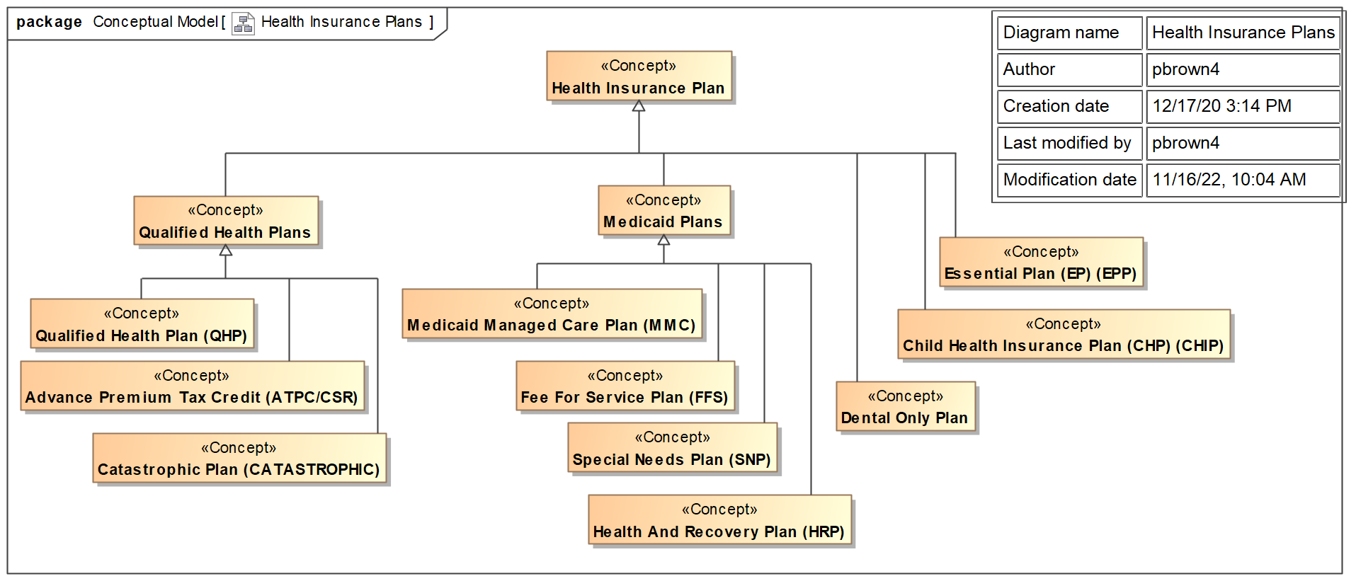
Figure 1. Health Insurance Plans

The NYSOH System and Software architectures are introduced and discussed in subsequent sections of this document.

This SDD is updated bi-annually. As noted in other sections of this document, the system detailed functional and technical design is documented by a set of Change Request (CR)-specific Requirements Specification Documents (RSDs), Requirements Specification Technical Documents (RSDTech),Technical Specification Documents (TSDs), Software Design Specifications (SDSs), and Technical Design Documents (TDDs).

Information regarding the system is provided by the various technical and functional diagrams and narrative shown in this document in accordance with CMS guidance as to the level of specificity. The information presented in this document reflects the release capabilities “as built.”

Figure 2 shows the business context of the NYSOH system, identifying the business entities with which it interacts. This view indicates the full scope of the environment in which the NYSOH system lives.

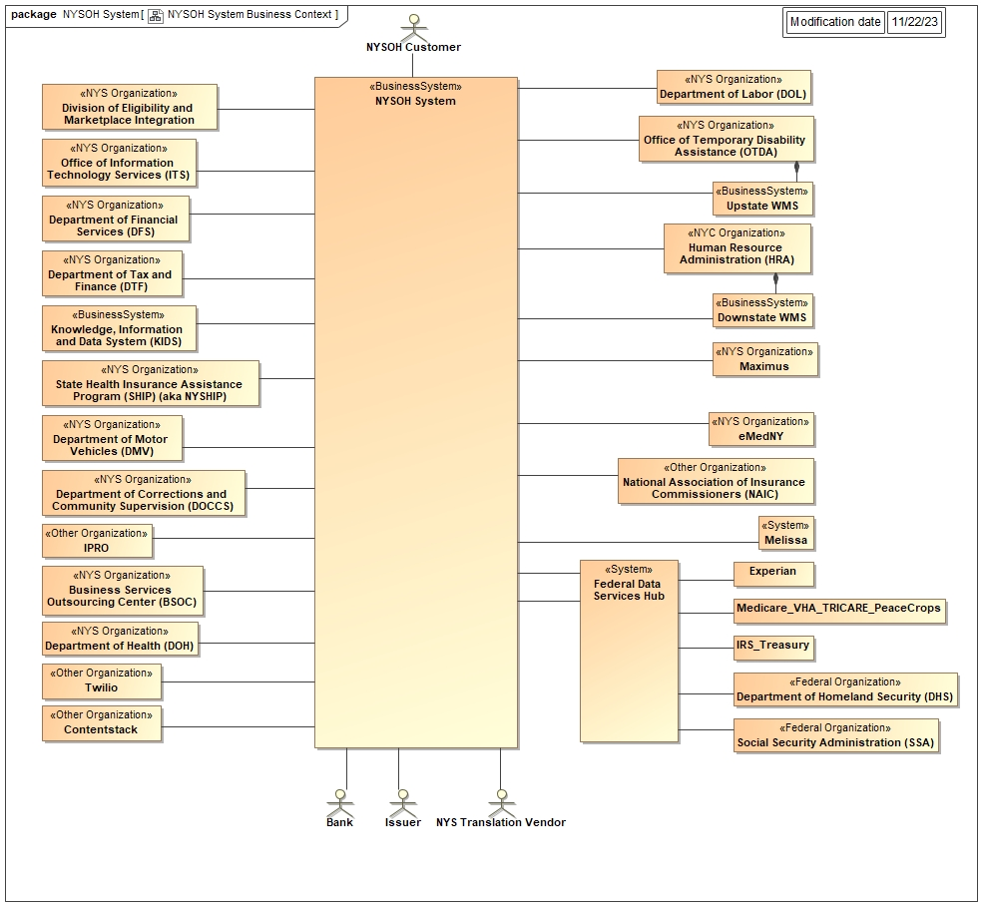

+
Figure 2. NYSOH System Business Context

From a business perspective, the system supports the functional areas shown in Figure 3. The details of the activities in each functional area are provided in Section 6 Operational Scenarios.

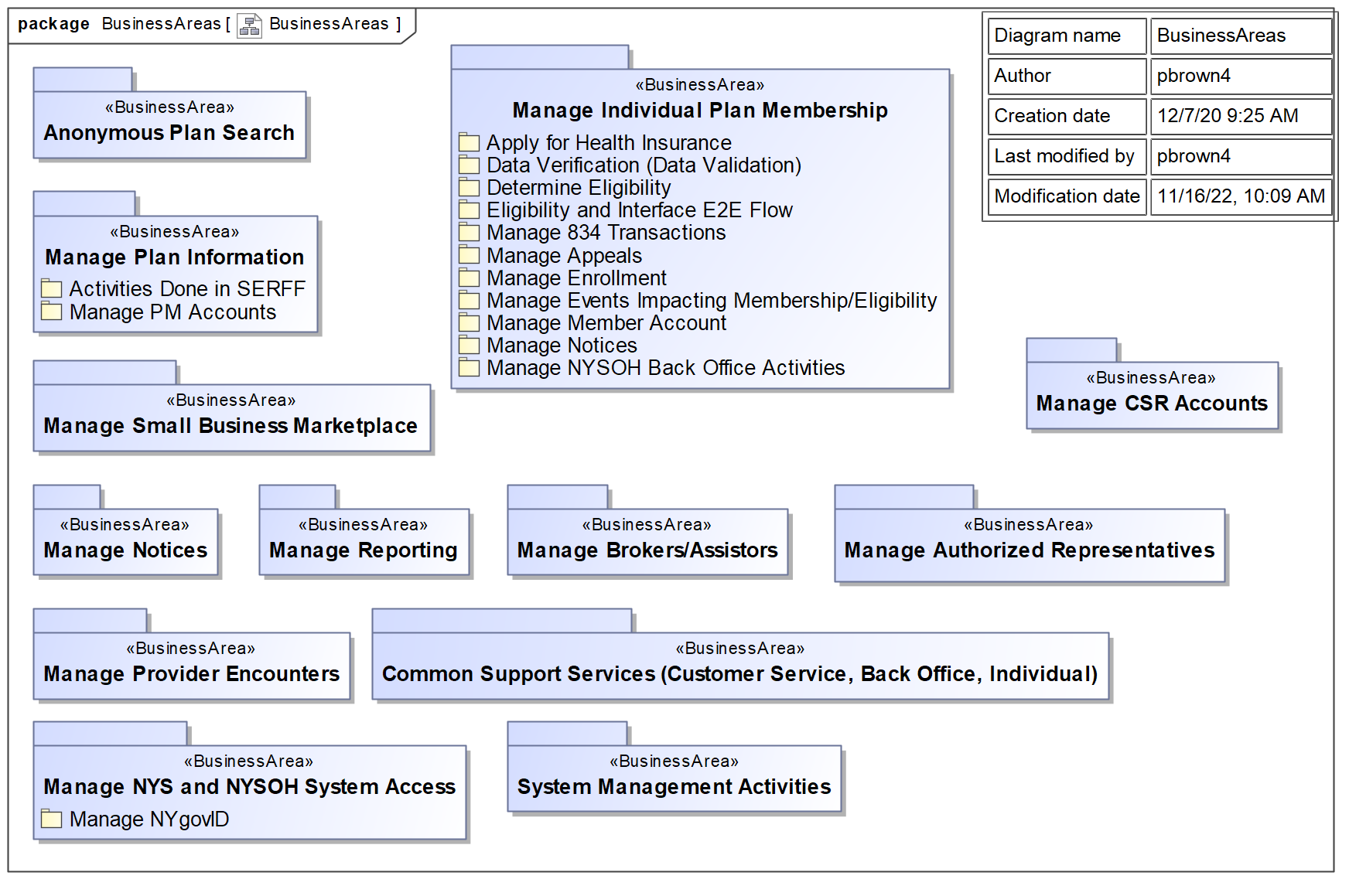
Figure 3. Business Areas

The NYSOH System Technical Areas are shown in Figure 4.

The NYSOH System is driven by different kinds of events: users interacting at portals; batch jobs being run; and external systems invoking Simple Object Access Protocol (SOAP) services. These are collectively categorized as Activity Initiators.

The Activity Initiator Support components provide logic for dedicated use by the Activity Initiators.

Internal Services organizes the system capabilities. Data Transfer Objects define the internal data representations used by the Java code. Interface Invocation Clients facilitate the use of external interfaces. Internal Java Services provide capabilities for internal use in the form of Java objects, while Internal REST Services provide internal use capabilities with RESTful interfaces. Outbound Messaging provides mechanisms for initiating outbound messaging.

The Queues category provides a single work queue for probabilistic search match.
Business Domains encapsulate business logic, either provided directly by Java objects or accessible via RESTful interfaces.

The Data category includes the Data Domain, which provides data access objects (DAOs) that provide access to database tables. The Databases, as the name implies, are the actual databases used by the system.

The Utilities category includes specialized functionality related to the use of specific technologies.

Testing support provides stubs required to test portions of the system.

The Deployment Support category provides functionality that is used in the deployment and operation of the NYSOH system itself.

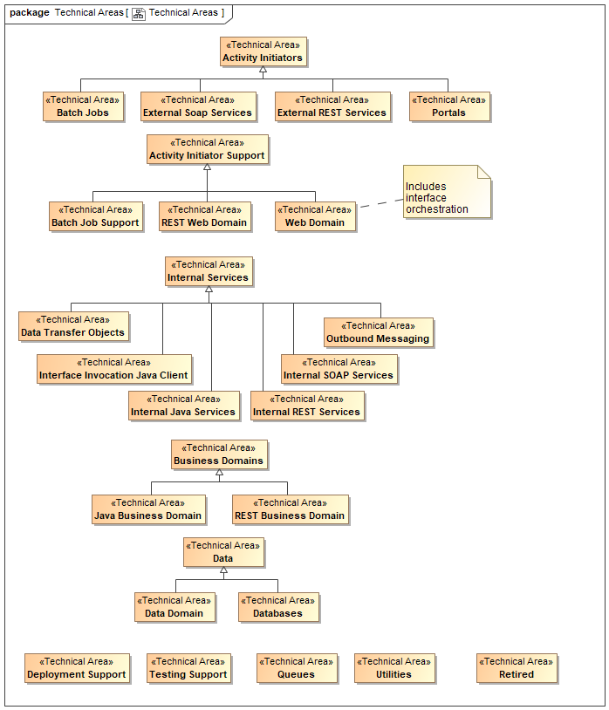
Figure 4. Technical Areas

Assumptions/Constraints/Risks
This section introduces design assumptions, design constraints, and technical risks regarding the NYSOH system and the developed or Commercial Off-The-Shelf (COTS)/Non-Developmental Item (NDI) software and its use.

Assumptions
Table 2 lists the System Design Assumptions and Impacts and retains assumptions from prior SDD versions in order to maintain the record of items that may have influenced system design decisions at some point in time but via program risk mitigation and/or monitoring, issue resolution, or due to external events are no longer relevant. These assumptions are shown in italics in the table, with the items that follow ones that are current influences upon system design activities and implementation.
Table 2. System Design Assumptions and Impacts
Assumption | Implication of making this assumption | Potential Impact if this assumption does not hold true
NYSOH functionality leverages the NY Medicaid Management Information System (MMIS) infrastructure | - State benefits from increased Medicaid Information Technology Architecture (MITA) integration  - Operational efficiency gains from re-use of existing assets | - Increased costs for labor and equipment  - Less MITA integration possible
For Security purposes, New York State Department of Health (NYSDOH) is classified as a Non-Federal Covered Entity, and GDIT as a Non-Federal, Non-Covered Entity Business Associate, although both entities are subject to the same rules | - National Institute of Standards and Technology (NIST) Standards as apply to Health Insurance Portability and Accountability Act of 1996 (HIPAA), Health Information Technology for Economic and Clinical Health Act of 2009 (HITECH) and Internal Revenue Service (United States) (IRS) Pub 1075 are applicable security controls  - NIST standards that apply only to Federal Covered Entities are not required  - NIST Moderate controls specifically indicated in IRS Pub 1075 Section 4 are required | - Increased costs for labor and equipment  - Increased security controls impacting the pace of work building and operating the NYSOH solution  - Decreased leverage of NY MMIS, a prominent feature and basis for the Grant funding behind the project
Federal Data Services Hub will be available when needed | - Simplifies Federal interfaces to a single connect point | - Alternate solution for Federal data sources required
State data source interfaces will be available as needed | - The NYSOH solution will leverage recognized master data files from State source systems | - Alternate solution for State data sources required
Trading partner information will be available as needed | - Details regarding interfaces will be available in support of design and development schedules to provide automated data exchange | - Alternate solution for trading partner data source required
The system will adhere to the seven standards and conditions for Medicaid technology and the CMS guidance for exchange and Medicaid information technology (IT) systems | - Adherence to the standards and conditions improves interoperability, flexibility, reusability and service to business needs | - Inflexible system, incapable of responding to business needs, and loss of enhanced funding opportunities from CMS
The CMS Interface Control Document (ICD) for Group Enrollment will be available as needed | - The Health Plan Marketplace, Small Business Marketplace Group Enrollment will leverage the CMS ICD | - Alternate solution for CMS ICD data required
Eligible NYS businesses have been verified through the Marketplace and Department of Tax and Finance (New York) (DTF) | - The NYSOH solution will leverage DTF data from State source systems | - Alternate solution for eligibility verification of NYS businesses required
The Encounter Intake System will accept all valid Product/Service code sets on PACDR submissions, according to the Implementation Guide rules. | - Future analysis will be performed to determine if validation is needed for code sets such as Advanced Billing Concepts (ABC) Codes. However, not all accepted code sets will be used for validation. For Procedure Codes, only Healthcare Common Procedure Coding System (HCPCS) (including Current Procedural Terminology (CPT)), American Dental Association (ADA) Current Dental Terminology (CDT), and International Classification of Diseases - Procedure Coding System (ICD-PCS) will be used for validation. For pharmaceuticals, only First DataBank and Medi-Span code sets will be used for validation. | - Product/Service transaction data will not be validated correctly.
International Classification of Diseases 10th Revision - Clinical Modification (ICD-10-CM) Diagnosis Code and Procedure Coding System (ICD-10-PCS) will not be loaded into the Oracle database until the federal implementation date is finalized. | - Once the implementation date is determined, a change will be requested to load the ICD-10 code sets and implement any additional business logic. | - The Encounters functionality will not be compatible with the mandated standard interchange format.

Constraints
Table 3 lists the system design constraints and implications. It retains constraints from prior SDD versions in order to maintain the record of items that may have influenced system design decisions at some point in time but because of changes in policy, in system requirements, or due to external events, are no longer relevant.
Table 3. System Design Constraints and Implications
Constraint | Implication
NIST Standards identify Federal Tax Information (FTI) as Moderate Impact | - Limits options for security controls, in some cases, are more stringent than HIPAA
- National Information Exchange Model (NIEM) interactions are expected for NYSOH to Federal/State agency interfaces  - HIPAA interactions are expected for NYSOH to Health Plans for enrollment and invoicing  - System for Electronic Rate and Form Filing (SERFF) APIs are expected for NYSOH plan data submissions | - Limits options for interface creation  - Limits Standards selections
NYSOH is required to leverage the hCentive product | - Requires architectural use of the Spring Hibernate Framework
Processing of both inbound and outbound files for the EIS will be subject to availability within the processing schedule of NYSOH. | - Encounter processing will take place off hours using the idle work cycles of the existing equipment.

The NYSOH solution ensures compliance with the appropriate regulatory standards and requirements for information security, privacy and compliance, including:
- HIPAA
- Applicable NIST Publications
- HITECH of 2009
- Patient Protection and Affordable Care Act (ACA) of 2010, Section 1561 Recommendations
- Safeguards for Protecting Federal Tax Information PUB 1075 (26 U.S.C. §6103 and related provisions)
- Compliance with the Harmonized Security and Privacy Framework — Exchange TRA Supplement
- Compliance with MARS-E v2.0

The laws and associated regulations above define specific protection, reporting, and notification requirements related to safeguarding sensitive information defined as Personally Identifiable Information (PII), Protected Health Information (PHI), and FTI. In conjunction with the above regulatory controls and guidance, the NYSOH has an approved System Security Plan (SSP) and a Safeguard Security Report (SSR) from the IRS (with the exception of the Appeals Process as this official process has not been approved and distributed by the IRS) document.

The NYSOH System complies with MITA Guidance. The system and software engineering decisions that have been made are summarized below and provide a record of the ongoing evaluation of project adherence to Seven Standards.
- Modularity Standard - use of a modular, flexible approach to systems development
- Spring Model–View–Controller (MVC) pattern for web application development.
- Adherence to the Department of (United States) HHS Information Technology (IT) recommendation to separate business rule content from the application is being implemented.
- Business rules are coded using an open source Business Rules Engine tool (Drools).
- Service-Oriented Architecture (SOA) wherever applicable.
- Spring Hibernate for data access and Spring application framework for building the application.
- Leveraging commercial software products such as Drools for business rules, ContentStack (cloud-based headless content management system) for web content management, Apache Chemistry OpenCMIS for document management, and Twilio for communications.
- Business Process Execution Language (BPEL) for orchestration and workflows.
- MITA Condition - requires states to align to and advance to increasing levels in MITA maturity for business, architecture, and data.
- Industry Standards Condition - ensures States alignment with, and incorporation of, industry standards
- SOAP over Java Message Service (JMS) and SOAP over Hypertext Transfer Protocol (HTTP) for web service communication.
- Secure File Transfer Protocol (SFTP) for transferring batch files.
- Hypertext Transfer Protocol Secure (HTTPS) for communication between browser and the web application.
- HTTP-based REST APIs for web service communication, lightweight, resource-oriented interactions and supporting asynchronous communication.
- Leverage Condition - promotes solution sharing, leverage, and reuse of Medicaid technologies and systems within and among states.
- The hCentive product code is leveraged for all possible system functionality and for integrating UX 2014 features.
- COTS products used in the Marketplace infrastructure are typically configured but not customized. There are several exceptions to this in the NYSOH use of the PeopleSoft COTS product and the details of the COTS customization are indicated in the appropriate technical section of this document. Vendor documentation is used for understanding the product functionality. NYSOH-specific configurations are documented alongside the use of the product.
- Leverages existing code, data, and solution sources including utilization of the Federal Data Services Hub and existing state data sources, hCentive code base, other relevant state artifacts/processes/code, programming enhancements created for other state exchanges, and Electronic Medicaid System New York (eMedNY) infrastructure, where appropriate.
- Sharing of design documents and development artifacts using IBM RTC, such as:
- SDD
- Requirements Specification Documents (RSDs)
- Requirements Specification Technical Documents (RSDTech)
- Solution Documents (High-Level Design Documents (HLDD), SDS, ICD)
- Business Results Condition - Supports accurate and timely processing of claims (including claims of eligibility), adjudications, and effective communications with providers, beneficiaries, and the public.
- Eligibility engine built around a consumer-facing portal. Data sources and automated processes are used wherever possible to minimize manual interventions.
- Reporting Condition - requires states to produce transaction data, reports, and performance information
- Auditing Capabilities - full transaction and data auditing is intrinsic to system architecture, existing reporting mechanisms (such as MMIS) are leveraged wherever possible, overall focus is on items such as data and process transparency.
- Reporting and business analytics capabilities designed, built, and delivered with the NYSOH system.
- Interoperability Condition - ensures seamless coordination and integration with NYSOH (whether run by the state or federal government), and allows interoperability.
- Eligibility system designed as a business service within the overall portfolio of NYSOH processes. MMIS data and processes provide interoperability with existing public program systems and business processes, such as Medicaid, Children's Health Insurance Program (CHIP), third-party management, and FDH.
- Utilization of Mulesoft Anypoint Platform as the integration platform to provide service APIs to enable system integrations between application modules and with external agencies, partners and third-party vendors.
- Use of IBM DataStage for Extract, Transform, and Load (ETL).
- Use of Electronic Data Interchange (EDI) X12 to communicate with partners (issuers and eMedNY).
- Utilization of the open source Spring Batch framework to develop and implement batch processes within the NYSOH application, such as Notice Creation.

Architectural Strategies
The NYSOH solution has been architected to be compliant with the core CMS Enterprise Architecture principles, as described in Section 2.2.2. It is constructed as a Service-Based Architecture, utilizing the Spring Hibernate framework, the core platform on which hCentive is built. Extensive use is also made of the Spring Batch framework.

Risks
The NYSOH Risk and Issue Management Plan describes a process to address all types of risks identified during project activities including those associated with system design tasks. The NYSOH Risk Register provides the current inventory, the status of analysis, and mitigation activities in progress for program risks.

Project Risks and Issues are maintained, reported, and managed in accordance with the Risk and Issue Management Plan, within the Process Asset Library (PAL) which is available from the NYSOH Home page of the NYSOH SharePoint portal.

Alignment with Federal Enterprise Architecture
The purpose of the Federal Enterprise Architecture Framework (FEAF) is to facilitate shared development of common processes and information among Federal Agencies and other government agencies.

Based on the FEAF, a given architecture can be partitioned into business, data, applications, and technology architectures:
- Business architecture: What is done, by whom, how, when and why?
- Data architecture: Information used by the Agency to do business.
- Application architecture: Computer applications/software that process the data according to defined business rules.
- Technology Architecture: Computer/communications technology / hardware that supports above three layers.

This document describes the NYSOH architecture from these perspectives.

Design Considerations

Goals and Guidelines
Development work on the NYSOH Health Exchange System was started on June 4, 2012 and initial production deployment occurred on October 1, 2013. The system has been maintained and enhanced since that time as reflected in prior versions of the SDD. The applicable content that would normally be discussed for a new system is not relevant at this point in the system timeline.

Development Methods and Contingencies
The NYSOH project methodology is an iterative build-based SDLC approach which allows identified requirements to be designed and developed in phases, referred to as “builds,” within releases. A high-level description of the methodology is provided in the NYSOH Project Management Plan. Also, project plans, processes, procedures, and work instructions that govern the activities of the NYSOH Program SDLC are published on the NYSOH PAL hosted on the NYSOH SharePoint Portal.

Architectural Strategies
The following paragraphs describe COTS products and basic software design patterns used by the NYSOH Application.

Spring MVC Framework
The web portals provided by the NYSOH System are built upon the Spring MVC Framework (Figure 5). In this framework, the user's browser interacts with a Spring MVC Dispatcher Servlet. This servlet manages the handling of HTTP requests from the browser. It uses the Filter Chain to invoke a series of Spring Filters that evaluate the request from a security and access control perspective.

Requests that successfully pass through the filters are then passed to the Interceptor Chain and the preHandle() operations are invoked on each interceptor. If all return true, then the request is passed on to the appropriate MVC Controller. After the controller has performed its function and before the view is called, the postHandle() method is called. This method is often used for things like logging and progress bar updates. Finally, after the view is called, the afterCompletion() operation is called.

In the NYSOH System design, the association of request names (the end of the request Uniform Resource Locator (URL) with MVC controller operations is defined by a @RequestMapping annotation in the Java file preceding the operation that actually handles requests. At load time, the DispatcherServlet builds a map of requests to operations. After the interceptor preHandle() operations have been called, if all return true then the appropriate MVC Controller operation is invoked. This operation invokes the system component operations that perform the business functions and returns an MVC model containing the data to be returned and the name of a View for its visualization.

Another web architecture introduced in 2017 is Angular, which is not MVC. This is a Single-Page Application (SPA) architecture described in the next section.

The Dispatcher Servlet then uses the Spring MVC View Controller to map the name of the view into the specific Java Server Page (JSP) that will provide the HTTP rendering of the data. It then invokes the View (JSP) to provide the rendering and returns the response to the Browser.

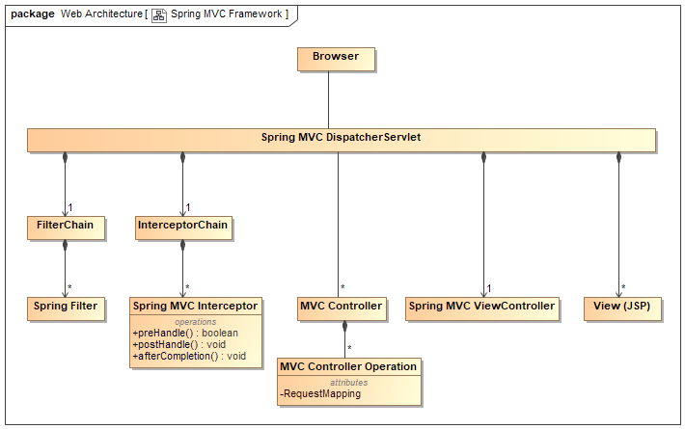
Figure 5. Spring MVC Framework

An example execution scenario and additional details of the artifacts being passed between the components are shown in Figure 6.

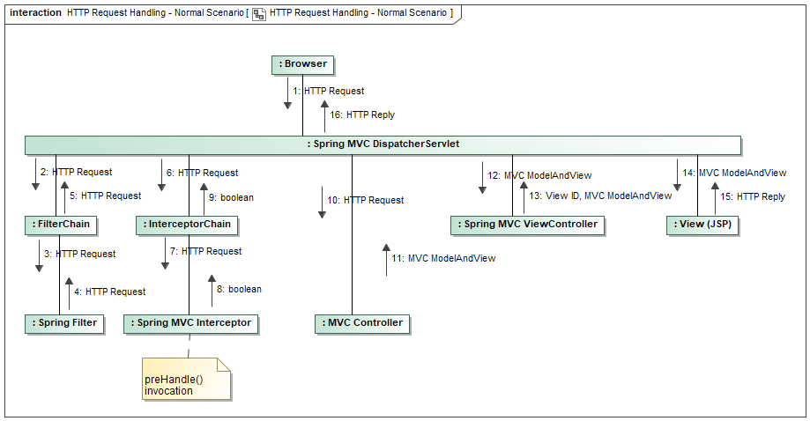
Figure 6. HTTP Request Handling - Normal Scenario

Single Page Application (SPA) Architecture with Angular
NYSOH CSR phone application is developed based on the SPA architecture using Angular which is an application development framework and platform for SPA applications. Angular provides easy tools and framework that allow applications developers to create application view templates, functional components and services to help implement business logic. If the SPA applications need to retrieve data from backend databases, other applications or external data sources, they will send requests directly from user’s browser to the backend REST services to obtain the needed data. Figure 7 below shows the high level interactions between the SPA applications and the backend REST services in NYSOH.

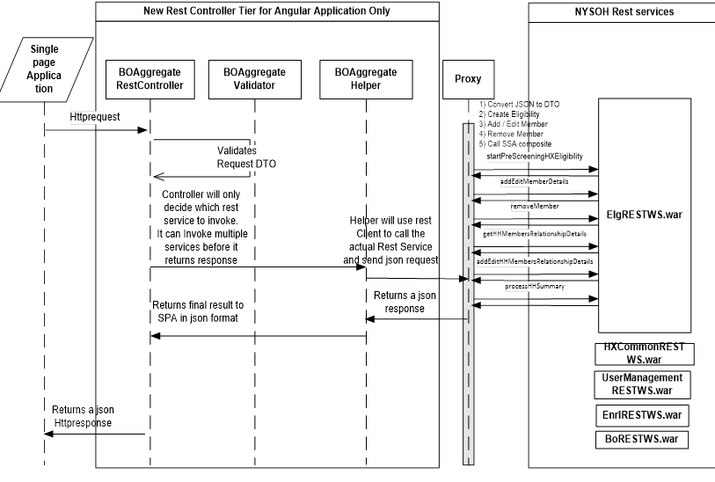
Figure 7. High level interactions between SPA and backend REST services

Spring WS Framework
[Content will be added in a subsequent release]

Database Access
The NYSOH System employs two different design patterns for database access: Spring Mybatis and Spring Hibernate.

Spring Mybatis Database Access
The Spring Mybatis framework (https://mybatis.org/mybatis-3) is the framework used by the Hibernate application upon which the NYSOH System was built. It specifies the relationships between Java classes used as data structures and the tables in the database along with the queries that can be executed against the database. Figure 8 shows the components of this framework. The mapper defines the relationship between the data structures and the database tables and columns along with the actual SQL select statements that are being used. The configuration, defined in an eXtensible Markup Language (XML) file, identifies the mappers to be used.
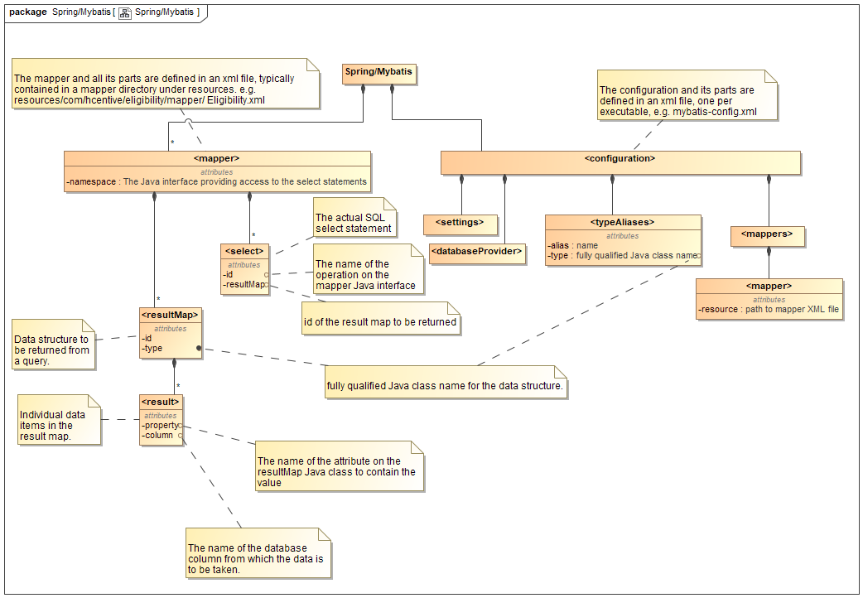
Figure 8. Spring Mybatis

Spring ORM (Hibernate) Database Access
More recent NYSOH System additions to database access have been implemented using the Spring ORM framework (Figure 9).

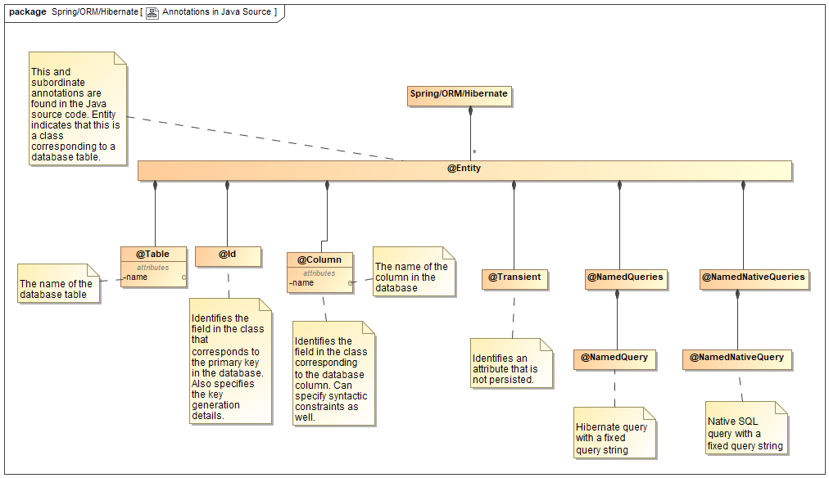
Figure 9. Annotations in Java Source

Message-Oriented Middleware (MOM) Pattern
IBM WebSphere MQ – WebSphere Messaging Queue (MQ) implements Message Oriented Middleware (MOM). This allows applications running on different platforms to pass messages without concern for the network, platform, or language differences between where the two applications are hosted.

Some of the NYSOH interfaces use an asynchronous method of passing data. This method decouples the two systems and allows the data to be sent with assured delivery. When using File Transfer Protocol (FTP) to deliver data, any number of factors can prevent the data from arriving at the destination. With FTP, it is possible for the sending application to be informed of a successful transfer even if the data are not delivered. MOM technologies break the synchronous link between two systems. Once the data are passed to the MOM applications, it is assured to arrive at the destination. If the destination system is not accepting data, the sending system can still send the data; and when the destination is available to accept the information, the data are transmitted.

JAX Web Services Pattern
JAX-WS Web-Services: These are standalone web services used internally. They use industry standards Java Application Programming Interface (API) for XML Web Services (JAX-WS). These web services are used for abstraction between components within the NYSOH application.

XStream
XStream (https://x-stream.github.io/) is a library for converting Java classes to/from XML structures. Mapping between the Java class attributes and the XML names is specified by the @XStreanAlias annotations in the Java source file. This notation may be used both at the class level and the individual attribute level.

Activiti Pattern
Activiti: Activiti is an open-source workflow engine written in Java that can execute business processes described in BPMN 2.0. Activiti is the foundation for Alfresco Process Services (APS). The product is a suite of applications that work together:
- Modeler, a web-based graphical workflow authoring interface
- Designer, an Eclipse plug-in for developing workflows
- Engine, the core workflow processor
- Explorer, a web tool to deploy process definitions, start new process instances and carry-out work on workflows
- Cycle, a web app for collaboration between business users and software engineers

Alfresco Process Services (BPM) Pattern
Alfresco Process Services (BPM) - Activiti
Alfresco Process Services (powered by Activiti) is an enterprise Business Process Management (BPM) and is used to write business process to achieve express LSC process for CSR.

IBM DataStage ETL Pattern
IBM DataStage: The NYSOH solution receives data from multiple sources, processes, and delivers it to multiple consumption end-points. The process, commonly known as ETL, ensures accurate transformation and loading of the data received so that it is available in a timely manner.

ETL is performed using IBM DataStage/QualityStage. Individual jobs are created and executed in a predefined order based on the load using a master sequencer job.

The requirements relating to the NYSOH ETL are derived from the context of exchanging data among the various interfacing systems. These systems exchange bi-directional data for specific purposes. Also, from a DataStage/ETL perspective, there are both inbound and outbound flows.

Inbound flow validates the files received from outside NYSOH, transforms, and loads it in the NYSOH database. Outbound flow extracts data from NYSOH database and sends it in predefined formats to external agencies. The ETL solution maps the source data to targets so the data is readily available for consumption.

The inbound data processing flow is as follows:
- NYSOH receives files from various sources.
- Input files formats include; comma separated value (csv), fixed field length text (txt) or XML. DataStage support additional file types, but these are the types currently implemented.
- Data is pushed to a specific file system.
- DataStage reads the file from this location.
- Upon reading the file, DataStage performs necessary validation using IBM Information Analyzer, in accordance with FDD/Unit Design Documents (UDD) specifications.
- Valid data records are sent to the appropriate target database and loaded.
- Email notification regarding successful processing is sent to identified recipients.
- Errors from the loading step are collated into an error log file.
- A failure email is sent to identified recipients with the error log attachment.
- The processed file is moved into the archive folder to pave the way for the next file.

The outbound data processing flow is as follows:
- DataStage jobs extract data from NYSOH database.
- The data is prepared in specific formats according to specification.
- These data files are sent out to the appropriate agency or partner using an SFTP server.

Logging and Exception Handling

Application Exception Handling
The application implementation patterns which support the NYSOH application are web application transactions, external interface transactions and processes, and internal batch processes (i.e., Notices). All of these patterns are designed to identify and handle various types of exceptions. When application or system exceptions occur, the NYSOH must respond appropriately to the users, partners, and agencies to make them aware that an issue exists and to advise them who to contact or what action needs to be taken. The delivered messages will vary based on the exception and user.

All of these patterns are designed to identify and log various types of exceptions. These exception logs are available and leveraged by technical staff to assist in problem resolution when application or system problems are identified.

Below is a list of Exception Handling Guidelines which are being followed:
- System exceptions should be handled as unchecked exceptions as summarized below:
  - It is the application’s responsibility to ensure that these unchecked system exceptions get logged before they are thrown.
  - The exception should be thrown as an unchecked exception.
  - For customer-facing web transactions, the exception should result in the user receiving the default message.
  - These exceptions must be caught and handed over to the Java Runtime Environment (JRE) so the transaction will terminate abnormally and rollback.
- Throw an unrecoverable business exception immediately. If the application encounters an unexpected business condition and nothing can be done to handle it, an unchecked exception should be thrown immediately. For example, if an SQL Select statement returns “Not Found” and the application expects the row to exist (data integrity violation) then the application should:
  - Log the exception details at the original point of failure. This will assist in the problem resolution process.
  - Throw the exception as an unchecked exception so a default message is delivered to the user.
- Avoid catching exceptions that cannot be handled. Developers should not attempt to catch system exceptions, such as java.lang.Exception or java.lang.Throwable. These should have been logged when the exception occurred and should be caught at the top of method call stack.
- Recoverable Business Exceptions usually fall into one of two conditions:
  - First, the caller of a method fails to satisfy the requirements of the API or business rule violations occur, e.g., null data is supplied in a required interface field or supplied key data is not found on the database. In this instance, the application must return a descriptive error response message to the caller. The caller will then decide whether they wish to log the information and throw a checked exception or return the error response to the user so corrective action can be taken.
  - Second, the application may be able to take action to attempt to resolve the exception. For example, a method may call a web service and receive a connection or timeout exception. The method can identify these types of exceptions and attempt to retry the call. If the retry fails, the method will throw an unchecked exception.
- Standardized exception handler(s) should be leveraged so exception information is maintained in a consistent manner. This will be described later in this document.
- Detailed exception information will be logged. The exception information logged will identify the type of exception, the Java component which failed, and the time of failure.

Communication Processes for Exceptions
Understanding how to correctly handle and log exceptions is vital. However, ensuring the system and application issues are communicated to the right people is equally important. Channels and associated processes to insure these issues are managed and communicated to appropriate group or individuals are listed below:
- Production issues are reported to, triaged by, and communicated to the appropriate group or individuals by GDIT staff who are assigned to the Operations Center (Ops Center). For additional details on the communication processes associated with Production issues see the NYSOH Operations and Maintenance Manual. A link to this document is included in Table 12 of Appendix A. Production issues are reported to the Ops Center from NYSOH Customer Service, Department of Health (DOH) NYSOH staff, GDIT NYSOH and Rensselaer Data Center (RDC) staff and any of the various federal, state or private partners involved with the NYSOH System.
- Formal testing of NYSOH application occurs in multiple environments; System Integration Testing (SIT), Developer Integration Testing (DIT) and User Acceptance Testing/User Release Testing (URT). All testing processes utilize the defect tracking system Engineering Workflow Management (EWM) to manage the communication of exceptions to the appropriate group or individuals. For additional details on the communication processes, see the Master Test Plan. A link to this document is included in Table 12 of Appendix A. Environment outages or severe system issues are communicated directly to the Technical Architecture group who are available to respond.
- Initially, batch processes are manually monitored by GDIT technical owners. The process of automating the execution and monitoring of these NYSOH batch processes in order to identify exception/issues is being managed and documented in the O&M Manual by the GDIT Production Operation team, in conjunction with the GDIT Development and Architecture teams and external partners.

Exception Logs Samples
The Application and Database Log files and sample log entries are included for reference below.

Web Service Calls (MuleSoft Exception logs)
Web services that communicate with external data sources are implemented as Mule services and APIs. They are deployed on on-prem Mule runtimes and managed through Mulesoft Anypoint cloudhub.

An unhandled service exception from mule service log is shown below:
Message : DOCS WSRR End point not found for : SBIT1
Element : DOCCS_Sub_Flow/processors/4/route/0/processors/3/route/2/processors/1 @ NYHXSSAComposite:SSAComposite.xml:224 (Raise WSRR EPNF)
Element XML : <raise-error doc:name="Raise WSRR EPNF" doc:id="ca3e1473-66e0-4acf-b132-a0b56ca37df9" type="WSRR:ENDPOINT_NOT_FOUND" description="#["DOCS WSRR End point not found for : " ++ (vars.env default "no environment received" as String)]"></raise-error>
Error type : WSRR:ENDPOINT_NOT_FOUND
Payload Type : org.mule.runtime.core.internal.streaming.bytes.ManagedCursorStreamProvider

These service calls can also result in HTTP connection failures, a sample log for this is shown below:
Message : HTTP POST on resource 'https://impl.hub.cms.gov/Imp1/VerifySSACompositeService' failed: PKIX path building failed: sun.security.provider.certpath.SunCertPathBuilderException: unable to find valid certification path to requested target.
Element : SSA_Service_Sub_Flow/processors/4/route/0/processors/4/route/0/processors/0 @ NYHXSSAComposite:SSAComposite.xml:156 (FedSSAConsumeHttps)
Element XML : <wsc:consume doc:name="FedSSAConsumeHttps" doc:id="063aee59-45dd-4fac-a55e-e919989f8aff" config-ref="ConsumerFed_SSA_Https" target="fedSSAServiceConsumer" operation="VerifySSA"></wsc:consume>
Error type : HTTP:CONNECTIVITY
Payload Type : org.mule.runtime.core.internal.streaming.bytes.ManagedCursorStreamProvider

The log message indicates that the connection “SSA” service failed to connect to the server due to certificate error.

MuleSoft error log can be found using analytics and custom logging tool.

Redhat JBOSS Enterprise Application Server Logs
When Web Application Exceptions occur in Production, log entries are captured by various components of Web Application running on Redhat’s JBOSS Enterprise Application Server (JBOSS EAP). The information below was extracted from JBOSS EAP. This information describes the information captured in these logs. GDIT has JBOSS EAP administrators supporting all environments, based on application availability.

Actual JBOSS EAP logs snippets are shown here:
Log Entry Example 1:
This is a Handled Application Exception, generated by Application code, based on an unexpected situation.
2023-10-28 18:53:01,523 ERROR
[WebContainer : 12] c.h.u.e.DefaultExceptionLoggingHandler [DefaultExceptionLoggingHandler.java:64] Some unknown error has happened, please try again later.{Actual Message- Multiple records found in query result where single record is expected}
org.springframework.dao.InvalidDataAccessApiUsageException: Multiple records found in query result where single record is expected
at com.hcentive.utils.orm.dao.GenericDAOImpl.findObjectByNamedQuery(GenericDAOImpl.java:103) ~[utils-core-4.0.0.jar:na]
at com.hcentive.user.BaseUserManagerService.getUserProfileId(BaseUserManagerService.java:913) ~[user-management-core-4.0.0.jar:na]

The information in italics provides the Service Component which failed and a description of the error.
Log Entry Example 2:
This is an Unhandled Application Exception, thrown by JBOSS EAP at the time of the application failure.
2023-10-28 18:51:37,823 ERROR
[WebContainer : 0] c.h.u.e.DefaultExceptionLoggingHandler [DefaultExceptionLoggingHandler.java:64] Some unknown error has happened, please try again later.{Actual Message- null} java.lang.NullPointerException: null
at com.hcentive.individual.hix.prescreening.util.ext.HXIncomeBeanEntityMapper.populateTotalIncomeSummaryFromEntityToBean (HXIncomeBeanEntityMapper.java:1267) ~[individual-hix-core-4.0.0.jar:na]
at com.hcentive.individual.hix.prescreening.util.ext.EligibilityWebUtilsExt.populateIncomeFromEntitytoBean (EligibilityWebUtilsExt.java:327) ~[individual-hix-core-4.0.0.jar:na]
at com.hcentive.individual.web.eligibility.ext.EligibilityControllerExt.renderEligibilityIncomePage
(EligibilityControllerExt.java:977) ~[individual-web-core-4.0.0.jar:na]
at com.hcentive.individual.web.eligibility.ext.EligibilityControllerExt$$FastClassByCGLIB$$287c9a9c.invoke(<generated>) ~[cglib-2.2.jar:na]

The information in italics provides the Service Component which failed and the reason for the failure.

SPRING Validation Framework
The NYSOH System uses the SPRING Validation Framework for syntactic validation of user inputs. As shown in Figure 10, the framework uses a DataBinder class to configure a specific validation. The target class is the class whose data values are being validated. One or more Validator classes perform the actual validation. Validation is performed when the MVC controller invokes the DataBinder.validate() method.

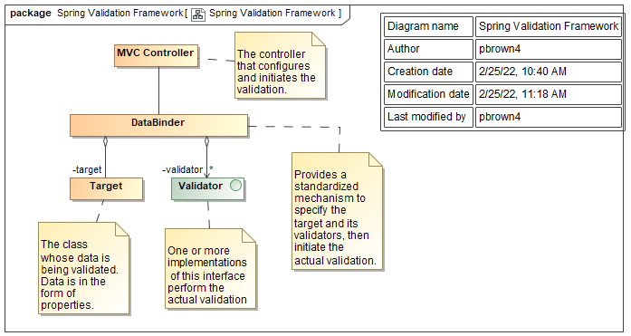
Figure 10. Spring Validation Framework

Performance Engineering
The NYSOH architecture is designed and sized to satisfy the overall performance requirements stated in Table 4. This exhibit also indicates the architectural layers that have contributions to meeting these specifications and thus have constraints upon their design. More detailed performance requirements at the on-line transaction and user response level are provided in Section 4.7.

In accordance with the CMS SDD template, additional information regarding system performance appears in Section 4.2.3, Section 4.3.2 and Section 4.7.

The NYSOH architecture is designed to be scalable to meet changes in anticipated system load requirements that occur during periods such as Annual Renewal/Open Enrollment activities.
Anticipated system loads and handling their impact upon associated transaction rates for various system services is performed by engineering analysis and performance testing of every NYSOH Release to identify any needs for application performance changes or system hardware scalability actions.
Table 4. NYSOH System Performance Specifications
Service Level | Requirement | Application | Data | Network | Business Continuity
Production Hours of System Availability | Mon – Friday: 08:00AM to 01:00AM (following day)  Sat – Sun: 08:00AM to 11:00PM | ✓ | ✓ | ✓ | ✓
CIN Clearance Service | 24 x7 |  | ✓ | ✓ | ✓
Inbound / Outbound File and SFTP Service | 24x7 |  | ✓ | ✓ | ✓
Batch Jobs and Output | 24x7 |  | ✓ | ✓ | ✓
Availability | 99.9% | ✓ | ✓ | ✓ | ✓
Inbound Files | 12 hours of receipt | ✓ | ✓ | ✓
Outbound Files | Every hour | ✓ | ✓ | ✓
Document Image Retrieval | 90% w/in 5 secs  10 % w/in 20 secs | ✓ | ✓ | ✓
Real time Transactions | 98.25% w/in 5 secs  99.25 % w/in 10 secs | ✓ | ✓ | ✓
Backup and Recovery | Start w/in 1 hour |  |  |  | ✓
Failover | 5 mins | ✓ | ✓ | ✓ | ✓
Disaster Recovery | 2 days | ✓ | ✓ | ✓ | ✓

The requirements documented in this table do not contradict any Service Level Agreements (SLA) currently in place. Some requirements noted here may be more rigorous than an SLA requirement. Any reference to an SLA is provided for information only. Please refer to the Operations and Maintenance (O&M) Manual documents listed in Table 12 of Appendix A for specific SLA information.

System Architecture and Architecture Design
The architectural views used in this document are derived from the Department of Defense Architecture Framework (DODAF) standard. Since DODAF does not specify views for the logical and physical organization of the system components (e.g., deployment), the DODAF views have been augmented with additional views that depict the logical and physical organization of the system. (Note that these views are called models in DODAF terminology. To avoid confusion, this document uses the term model to refer to the single underlying Universal Modeling Language (UML) model and each of the diagrams represents a view into that model). Table 5 identifies the types of views used in this document and, where applicable, indicates the corresponding DODAF view in parentheses.
Table 5. Architectural Views
Viewpoint | View | View Description | Notation
Business Perspective | Capabilities Taxonomy (CV-2) | Identifies and organizes the business capabilities supported by the system. | UML Use Case Diagram
Business Perspective | Capability Dependencies (CV-4) | Identifies the business activities required to implement each business capability | UML Use Case Diagram
Operational Perspective | Business Process Workflows (OV-5b) | Shows the activities of the business process and their relationships, inputs, and outputs. May also show the required activity performers as swim lanes. | UML Activity Diagram
Operational Perspective | Operational Flows (OV-2) | Shows the flow of information and other artifacts between the participants in the business process. | UML Class Diagram with Flows
Operational Perspective | Business Rules (OV-6a) | Defines the business rules that constrain operations | Table
Operational Perspective | Business Process State Diagram (OV-6b) | For business processes with persistent state, identifies the states and the transitions between them. | UML State Diagram
Operational Perspective | Business Process Sequence Diagram (OV-6c) | Shows the sequence of interactions between the participants required to execute the scenario. | UML Sequence Diagram
Solution Perspective | Systems Interface Description (SV-1) | Identifies systems, system elements, and their interconnections | UML Class Diagrams showing system elements and communications channels
Solution Perspective | Detailed Interface Description (SV-2) | Identifies the structure of system elements, the interconnections between them, and the communications artifacts exchanged | UML Class Diagrams showing system elements, element structure, communications channels, and flows representing communications artifacts
Solution Perspective | System Functional Description (SV-4) | Identifies the activities being performed by system elements and the artifacts exchanged between activities | UML Activity Diagram with swim lanes representing system elements
Service Perspective | Services Context Description (SvcV-1) | Identifies the services, their organizational structure, and the interconnections | UML Class Diagram with classes representing services showing generalization and aggregation structure, communications channels, and artifact flows
Service Perspective | Services Functional Description (SvcV-4) | Identifies the activities being performed by the service and the artifacts being exchanged between the activities | UML Activity Diagram with swim lanes representing the services
Service Perspective | Service Rule Description (SvcV-10a) | Identifies the constraints imposed on the functionality of the service due to some aspect of the system design or implementation | Table
Service Perspective | Services State Transition Description (Svc-10b) | Identifies the service’s response to events | UML State Diagram
Service Perspective | Services Event-Trace Description (Svc-10c) | Identifies service-specific refinements of critical sequences described in the Operational Perspective | UML Sequence Diagram
Physical Deployment Perspective | Network Description | Identifies the network topology and all devices connected to each network segment | Standard to be determined
Physical Deployment Perspective | Machine Logical Description | Describes the logical configuration of a machine, identifying all deployable elements residing on the machine | UML Composite Structure Diagram or Table
Physical Deployment Perspective | Machine Logical to Physical Mapping | For each machine on the network diagram, identifies the logical description of the machine | Table

Logical View
The NYSOH System covers a number of functional business areas as was shown in Figure 3. Figure 11 shows the functional capabilities and technical subsystems. An enumeration of the activities related to each functional area is provided in Section 6 along with the details of how these activities are executed by the NYSOH system.

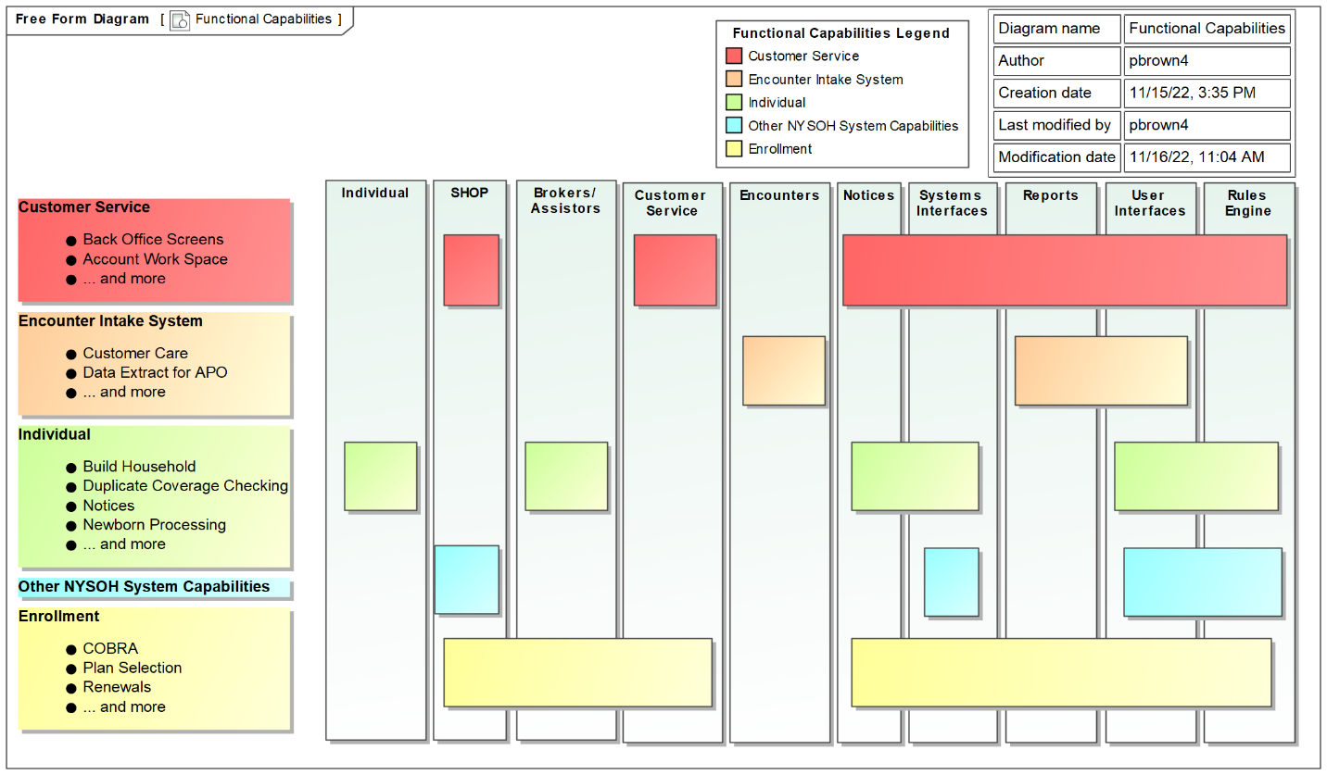
Figure 11. NYSOH System Functional Capabilities

Hardware Architecture
This section describes the physical organization of the NYSOH system. Figure 12 shows the network-level organization.

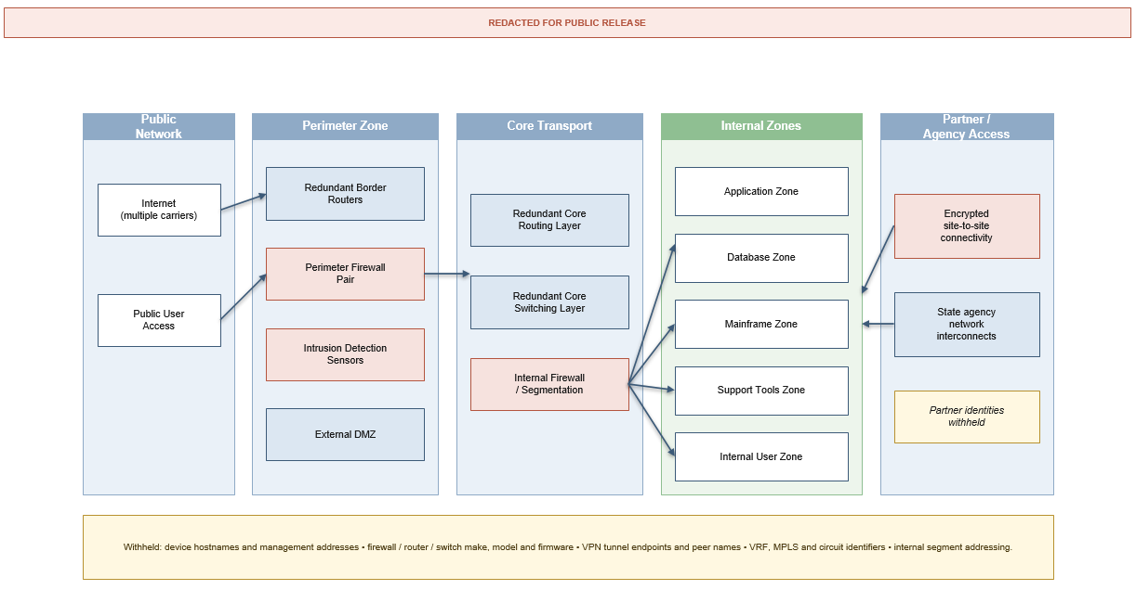
Figure 12. NYSOH Communications Architecture Overview

NYSOH Environments
The virtual machines are organized into a number of environments, and the environments themselves fall into categories. Figure 13 below shows the environment categories.

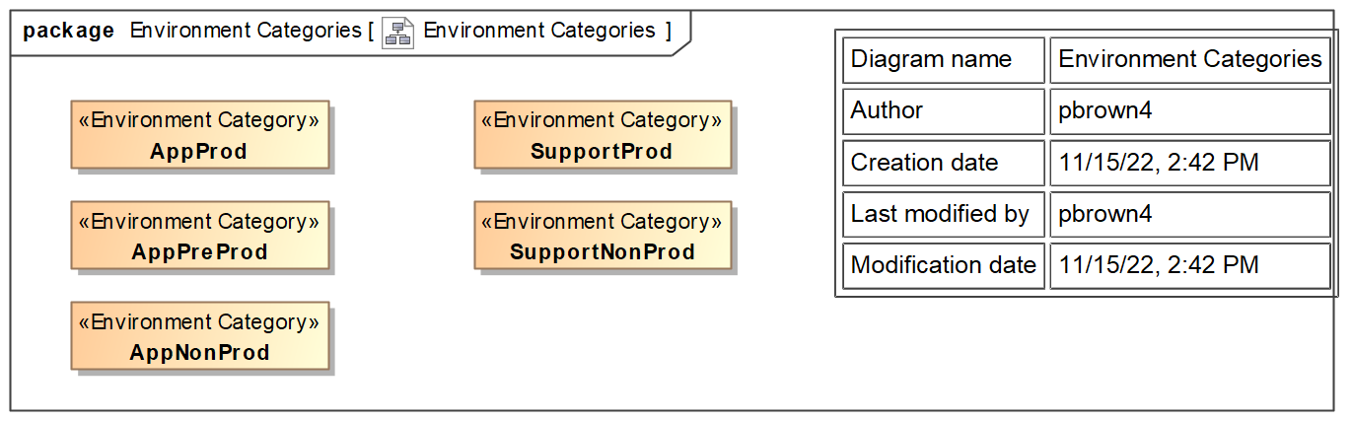
Figure 13. NYSOH Environments

Application Production Environment
The Application Production Environments (AppProd) host all the virtual machines used for production operation of the NYSOH Application. Figure 14 below shows the AppProd environments.

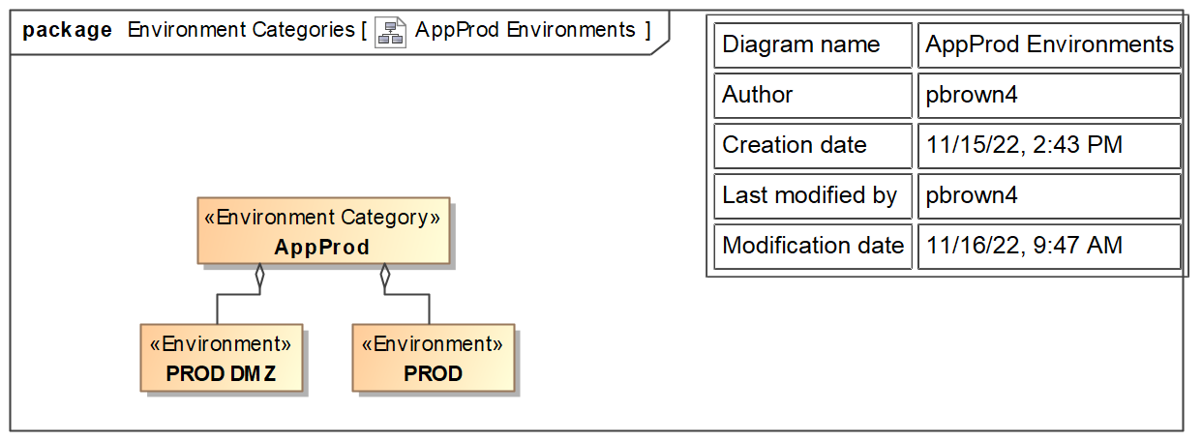
Figure 14. AppProd Environments

Application Pre-Production Environments
There are two Application Pre-Production (AppPreProd) environments, as shown in Figure 15 below.

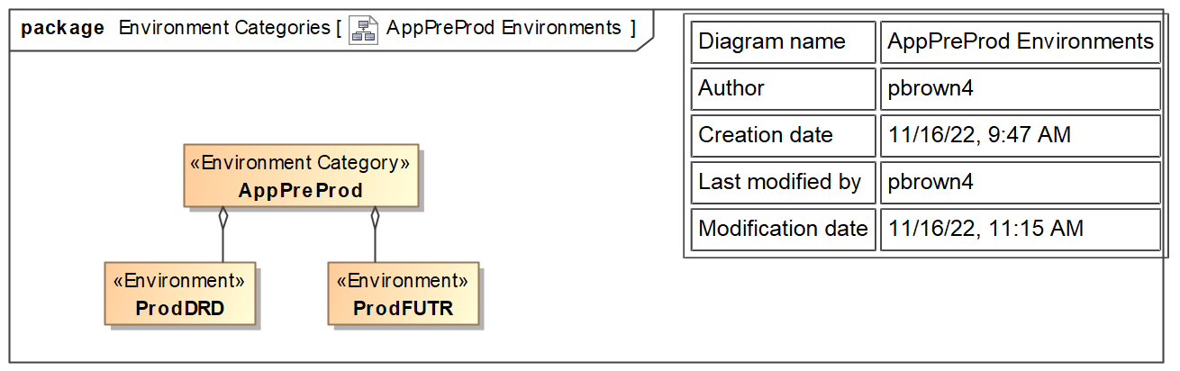
Figure 15. AppPreProd Environments

Application Non-Production Environments
There are a number of Application Non-Production (AppNonProd) environments used for the development and testing of the NYSOH Application. These are shown in Figure 16 below.

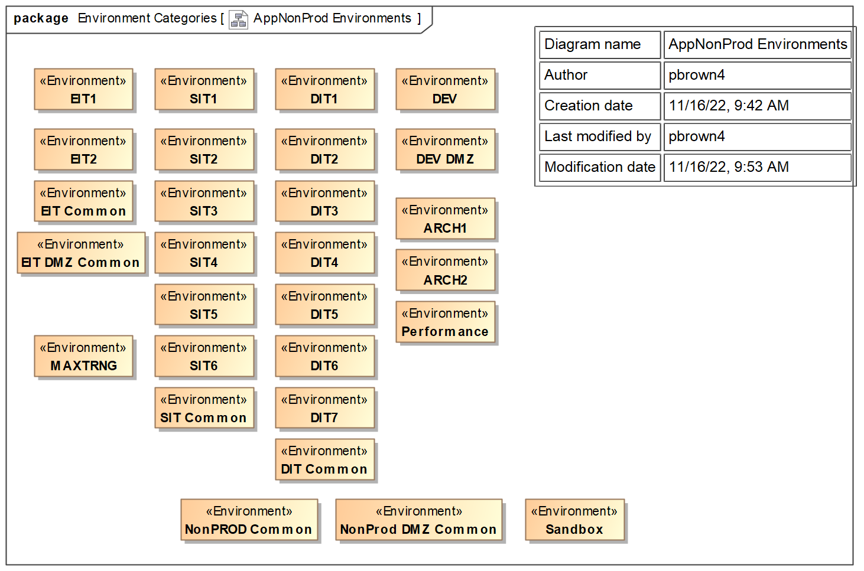
Figure 16. AppNonProd Environments

Support Tool Production Environments
There are a number of Support Tool Production (SupportProd) environments used to host the various tools used to support the development of the NYSOH Application. These environments are shown in Figure 17 below.

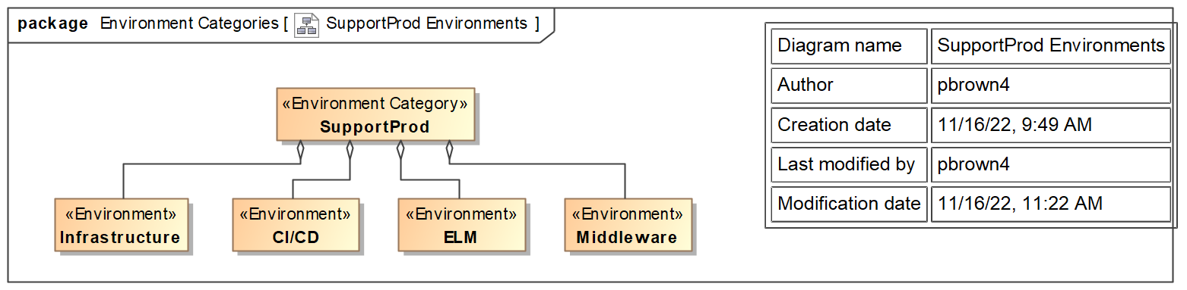
Figure 17. SupportProd Environments

Support Non-Production Environments
There are a number of Support Non-Production (SupportNonProd) environments that are used for the maintenance of the support tools. These environments are shown in Figure 18 below.

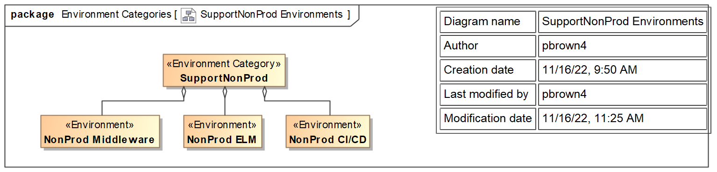
Figure 18. SupportNonProd Environments

Security Hardware Architecture
NYSOH uses the following hardware based security controls to further protect the NYSOH system and data.
- Application Layer Firewall and XML gateway
  - Parse, validate, transform, and route XML messages via XPath and XSLT.
  - Control access to applications that expose data and functionality through XML APIs
  - Control SLAs for how XML-based services are shared with other applications
  - Track the XML traffic and usage of specific application services which are exposed through XML interfaces
- Managed Vulnerability Scanning
  - A monthly scanning to detect system vulnerabilities
- Managed Endpoint Protection
  - Antivirus and Host Intrusion Prevention Software
- Audit Logging and Monitoring (MST)
  - 24/7 security event monitoring and alerting
- Network Intrusion Detection Service
  - Detects and prevents network based attacks
- Web App Scanning
  - Proactively discover web-based vulnerabilities such as Cross Site Scripting and SQL Injection
- Tiered Architecture
  - Logically separates main functions of web service applications into three components - Presentation, Business Logic, and Data tiers
- Compliance Scanning
  - IRS SCSEMs of all assets in the FTI flow process
- HashiCorp Vault
  - Protect all system credentials/secrets for NYSOH applications and systems on HashiCorp Vault.

Performance Hardware Architecture
The NYSOH hardware design:
- Provides a solution hosted on the system integrator’s RDC that meets Uptime Institute Tier III Data Center Infrastructure standards.
- Provides high-speed, high-capacity solution which consists of IBM equipment connected to the production servers over a dedicated 10GB/1GB speed network.
- Uses a fault-tolerant / redundant hardware using clustered IBM X5 servers.
- Supports provided high-availability clusters by using VMware ESX vSphere, vCenter, and vSphere vMotion.
- Enables the production failover environment by using redundant components in active-passive or active-active configurations.
- Ensures a timely recovery of the total hardware configuration by backing up the operating system files and critical data files to the Storage Area Network (SAN), located at 11:11 Systems Disaster Recovery (DR) facility.
- Provides an automatic backup solution through Symantec NetBackup. NetBackup can reliably execute and manage both scheduled and on-demand backups and automatically tag the backup data with handling, retention, and expiration attributes.
- Uses redundant Cisco 6509s, with all devices in the core of network and hosting infrastructure designed to N+1 standards to ensure reliability and availability.
- Uses Cisco firewalls designed and built into the distribution layer chassis.
- Uses multiple carrier connections to the Internet.

Table 6 identifies the major hardware that comprises the NYSOH infrastructure environment. The exhibit indicates whether hardware resides in the alternate data center to deliver business continuity and DR.
Table 6. Hardware Description
Hardware Description | Failover Technology | Duplicate DR Environment
Intel SOA Expressway ESB: Used for data and schema validation, XML acceleration, systems and application messaging, Web services, encryption/decryption, mapping, x509 certificate usage  The Intel ESB also appears as software. The FIPS-140 version is an appliance. | Active – active | Virtualized at the DR location
IBM X5 server platform: Provides the host foundation hardware to support the virtualized guest servers which enables the Platform as a Service (PaaS) component of the NYSOH private cloud | All hosts active. Services and guest running on the hosts are automatically moved to other hosts as needed in the case of a host or guest failure | Duplicated at the DR location to support the development and production (ORR sized). Guest and data images are replicated between the primary and DR locations based on specific backup schedules. Duplicate tape backups are created for local and offsite storage
Hitachi Virtual Storage Platform (VSP): Supplies the high performance, high availability storage platform. Storage is dynamically added or subtracted as needed. This SAN is presented to each platform as physically attached storage, yet the storage is virtualized to support transparent and uninterrupted service and maintenance windows and events. This VSP also is configured to provide Network Attached Storage (NAS) for folder and content storage. Network File System (NFS) version 4 will be used within the NYSOH solution | Multiple active-active disk controllers and cache engines. Supports multiple and simultaneous Redundant Array of Independent Disks (RAID) levels. The GDIT NYSOH design is configured for RAID 6 (dual disk fault tolerance) for all NYSOH SAN and NAS storage | Duplicated at the DR location. The VSP software replicates data to the DR location directly between VSP storage systems
Cisco Network Firewalls: Provide both data – circuit termination points and the firewall perimeter defense to the NYSOH system | Active-active | Part of the DR solution
Tape Backup System - Supports local backup, archive, and restoration with encryption. Blank medium is included to support tape backup life cycle. Tape backups are created and maintained offsite to support DR requirements as described in the Business Continuity and DR Draft Plan. | N/A | Part of the DR solution
Cisco 2951 Network and Host Intrusion Detection System: Provides a high-availability configuration | Active-passive | Part of the DR solution

Software Architecture
As the NYSOH application leverages the COTS product hCentive, the basic NYSOH software architecture is built upon the hCentive software structure, but has been modified and extended to meet NYSOH requirements. Like the hCentive software, the NYSOH software is organized into subsystems that address functional areas such as enrollment, eligibility and plan selection and more. This hCentive foundation was modified, extended, and supplemented with components to implement plan management, external system interfaces, cross-track capabilities such as system notices and access management, data analysis and report generation. The detailed design in these areas is recorded in referenced FDDs (this was true for some types of detailed design information until the introduction of the TSD document), TSDs, SDSs (TDDs on older CRs), UDDs, and ICDs.

Figure 19 shows the current NYSOH Software Categories of NYSOH Architecture. This diagram shows the as-built NYSOH software system in terms of the types of software being used. These include presentation services, application services, business domain services, integration services, common services, infrastructure services, web services, and technical services. Further details later in the document show their relationships to one another.

The NYSOH software architecture is based on componentization and object-oriented paradigms. These paradigms build on the Java Enterprise Edition (Java EE) platform. Componentization is the process of application decomposition into discrete components with well-defined component interfaces. Business application componentization is facilitated by object oriented design and construction methodologies. Business application components are the building blocks used to structure and construct the business application. What follows is the high level technical design providing a view of the as built solution that satisfies functional and non-functional requirements.

NYSOH application components are supported by COTS products that provide application services to facilitate the separation of service delivery, business logic, data access/services integration, and enterprise resource tiers. The separation of user presentation, business logic, data access/services and enterprise layers provides a flexible and scalable architecture.

NYSOH utilizes the Redhat JBOSS enterprise application server as the J2EE application server, the DB2 database as the internal data source, and the MuleSoft Anypoint product to support the data exchange and transformation between the NYSOH and external trading partners.

The application architecture facilitates the integration of the NYSOH components to enable:
- Seamless business processes while adhering to product and industry standards for maintainability.
- Effective allocation of NYSOH business functions across applications.
- The use of COTS/NDI functionality insuring interoperability with developed components.

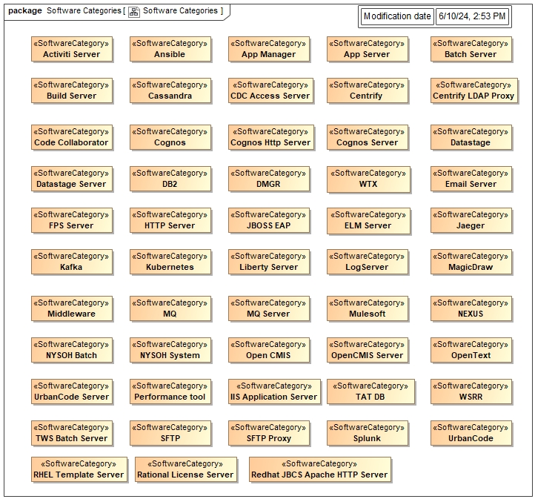
Figure 19. Software Categories

Security Software Architecture
The flow of data in the NYSOH system is shown at the system component level in Figure 76, Figure 77, and Figure 78. Figure 20 is a view focused upon FTI data. FTI is defined as any return or return information received from the IRS or secondary source, such as SSA. All FTI data persisted to the NYSOH database are contained in the following tables: FTI_RESPONSE_DATA, FTI_RESPONSE_DATA_REASON, RRV_IRS_RESPONSE, and FTI_MULE_AUDIT_LOG.

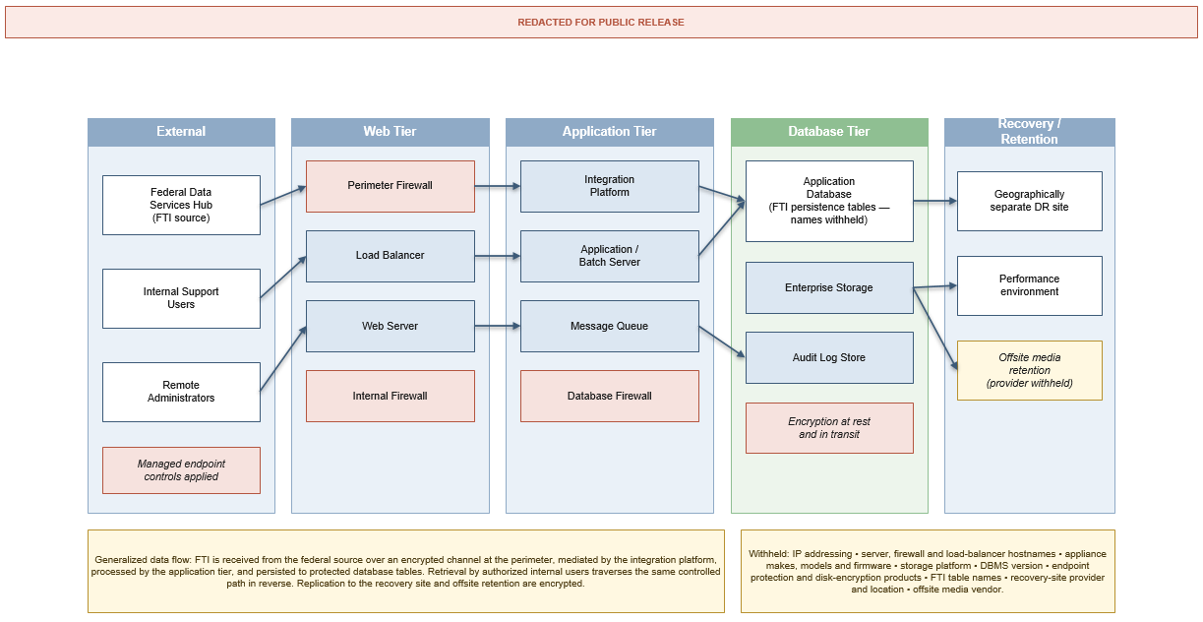
Figure 20. NYSOH FTI Data Flow

Performance Software Architecture
The NYSOH system has been architected in a manner in which loosely coupled application components are allocated across multi-tier, distributed hardware components. This facilitates increased performance via the addition of hardware at the appropriate tier, in order to support an increased demand upon the application software or COTS. Figure 21 illustrates this approach.
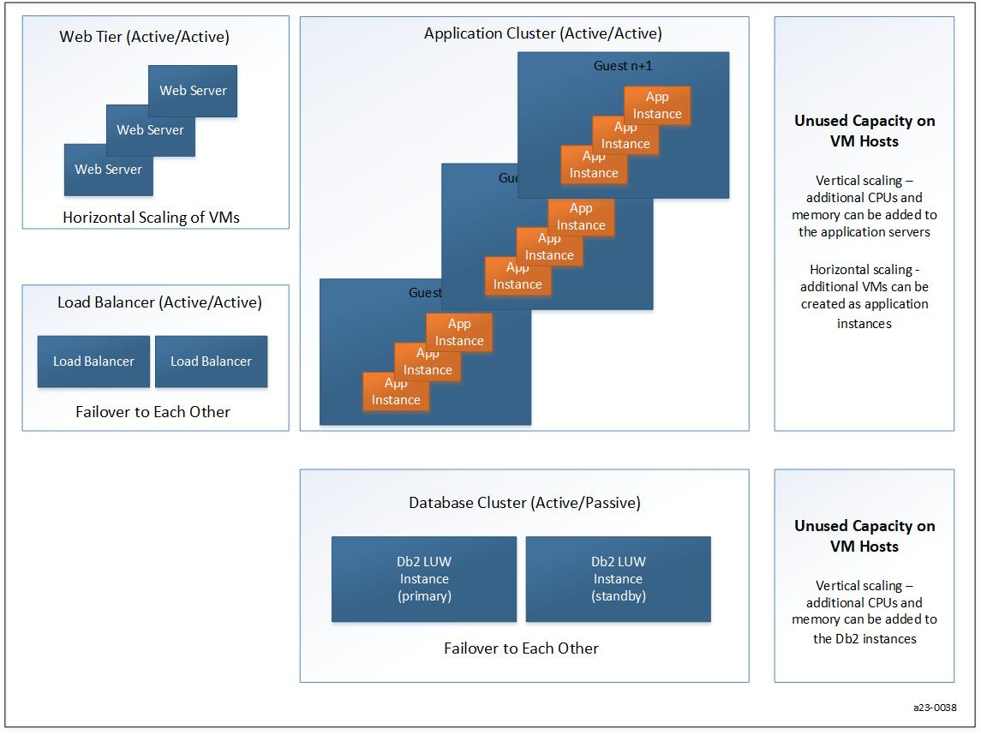
Figure 21. High Availability and Scaling

The business continuity, backup, failover and DR features of the NYSOH leverage the eMedNY platform, guest images and data replication environment already in place between the RDC and the 11:11 Systems DR facility in Carlstadt, NJ.

This configuration benefits business continuity with minimal downtime due to hardware failure. When hardware problems are detected on an individual component, the failover components are in place to assume the system’s workload.

Primary data storage is provided by Hitachi VSP storage systems, with redundant power.

Akamai - Content Edge Caching Network) provides for NYSOH application content caching and an external "As a Service" capability. This allows the infrastructure platform to offload static content serving demand from core web/application servers-to-servers closer to the end users; thereby, dramatically improving system performance for static or non-changed content.

The Akamai Dynamic Site Accelerator service is a Content Delivery Network (CDN) service that augments the NYSOH infrastructure web and application serving capacity. Akamai operates a network of web and application servers around the world and leases space on these servers. Having the web serving for the front end of the application distributed across the Akamai network allows the NYSOH website to perform some serving functions faster by distributing the application's static content from GDIT's data center servers to web servers located closer to the user.

When a user navigates to the NYSOH website, their browser is redirected to one of Akamai’s copies of this website, transparent to the user. Akamai's content network stores the "heavy" static content of the application web pages on these distributed servers. The benefit to users is that they receive content from whichever Akamai server is closest to them or has a good connection, leading to faster download times and less vulnerability to network congestion or outages while using the NYSOH application.

Akamai’s CDN provides the following application performance benefits:
- Offloads the web/application serving burden for static content to Akamai's delivery network.
- Speeds up end user application home page load.
- Speeds up end user access to and browsing of non-transactional application elements/pages.
- Provides the following local copies of web pages for browsing static content.
- Help Pages.
- Reference documents.
- Improves internet user access to the NYSOH application due to multiple access points on the Akamai network and dedicated network fast paths between Akamai and the GDIT data center.

Information Architecture
The NYSOH Data Architecture includes four descriptive reference resources to specify the architecture, design, and implementation:
- Conceptual Data Model, which is a representation of the major business concepts and relationships relevant to the NYSOH system. Its intent is to provide an understanding of the terminology used in requirements documents and business process design documents.
- Data Dictionary, which is a centralized repository of information about metadata such as meaning, relationships to other data, usage, format, PHI/PII designation, and codes/values.
- PDM, which is a physical data model that represents the implemented physical database structures and objects used by the application.
- LDM, which is a logical data model that represents the data used in the enterprise.

The combination of four elements provides the framework to build three views of the data:
- The conceptual view provides a high-level visual perspective of each subject area of the NYSOH solution. It contains the most basic and critical business entities within each subject area and function and relationships between entities. This data model takes into account information on business entities contained in the CMS Exchange Blueprints updated with NYS-specific information.
- The physical view of the data, which is used by the application, is optimized for specific access patterns and takes into account constraints of the Database Management System (DBMS) platform and performance requirements.
- The logical view currently shows the relationships between the entities and the beginning stages of normalization and the separation of data into key based structures.

The high-level NYSOH data architecture is shown in Figure 22.

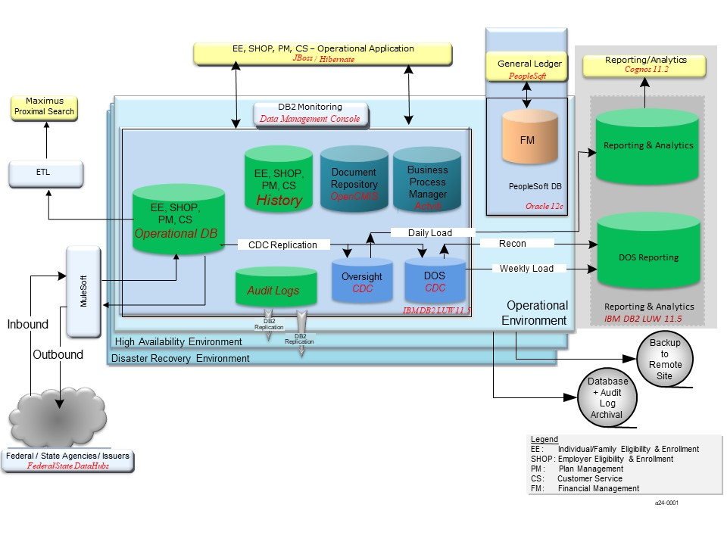

Figure 22. Database Architecture Overview

Conceptual Data Model
Figure 23 shows the health insurance plans covered in the NYSOH System.

Figure 23. Plans

Logical Data Model
ER Studio Data Architect is the data modeling tool used to maintain the current Logical Data Model (LDM). The LDM primarily served as a normalized "future state" logical reference model for the NYSOH system, and was used to guide the database design. The data dictionary lists data elements and their definitions. To enhance the value of the data dictionary GDIT has provided codes and values contained in the reference tables.

The LDM depicts the NYSOH view or business view of those entities and attributes which are required for the NYSOH to be able to provide health insurance. These entities and attributes may include the following to support the vision of what the LDM contains:
- Health Plan contains the data associated with the health plans offered by the NYSOH
- Benefit Plan contains the data associated with the benefits that a particular health plan offers
- Issuer contains the data associated with the insurance company that is issuing or offering the Health Plan and Benefit Plan
- Provider contains the data associated with the doctors or providers, who are authorized by the issuer to provide the services
- Organization contains the data associated with the organization
- Networks contain the data associated with the health care management for the clients
- Brokers contain the data associated with those who are working with the NYSOH to obtain clients, sort of like the salesman for the health care management
- The column names are the business names for the data
- There may be other enterprise entities that the NYSOH may wish to include

Physical Data Model
ER Studio Data Architect is the data modeling tool used to maintain the current Physical Data Model (PDM). The PDM is the physical implementation of the tables and columns used to store the data in a relational DBMS. The relational DBMS software is IBM Database 2 (DB2) Version 11 Linux, Unix, Windows (LUW). The database is able to handle data in XML, geospatial, and other formats. The system leverages virtualized platforms to maximize performance and high availability.

The LDM entities are expanded to form the PDM that represents the physical representation of the data model containing table and column names, column data types, and data characteristics. LDM attribute names are the business names which are converted to physical column name formats. Therefore, while expanding the LDM to create the PDM, many columns are created from a single LDM column.

Records Management

Data
[Content will be added in a future release]

Manual/Electronic Inputs
[Content will be added in a future release]

Master Files
[Content will be added in a future release]

Internal Communications Architecture
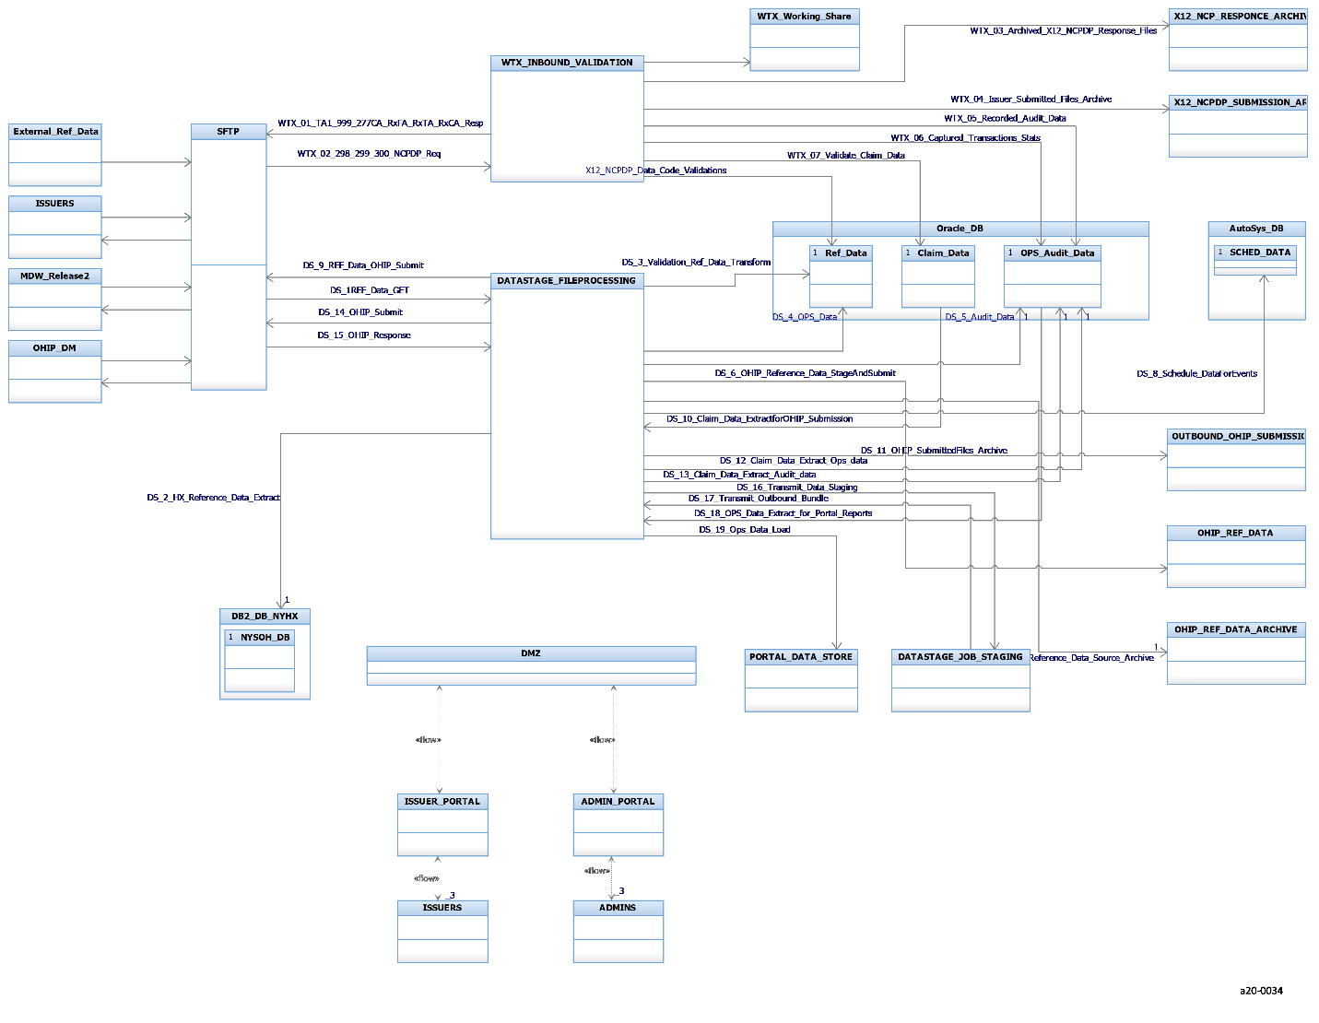
Figure 24. Internal Communications
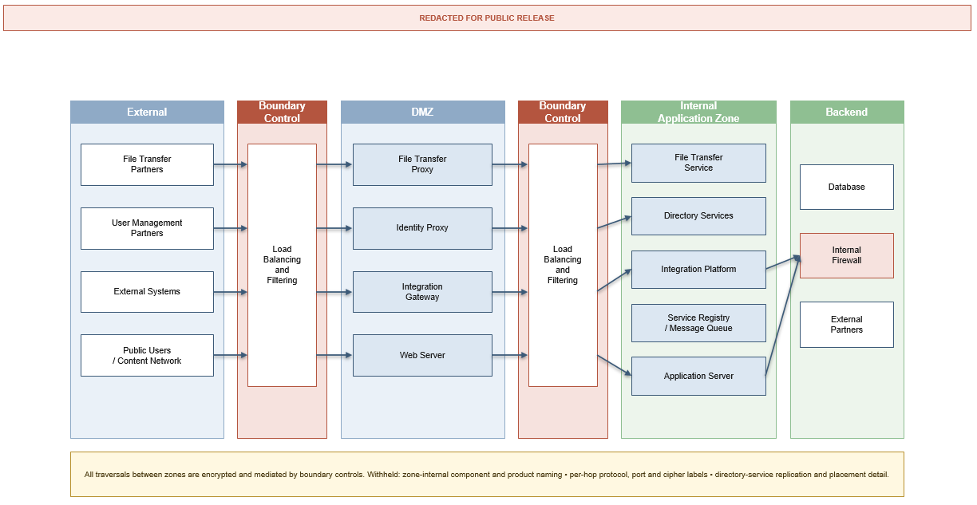
Figure 25. System Architecture

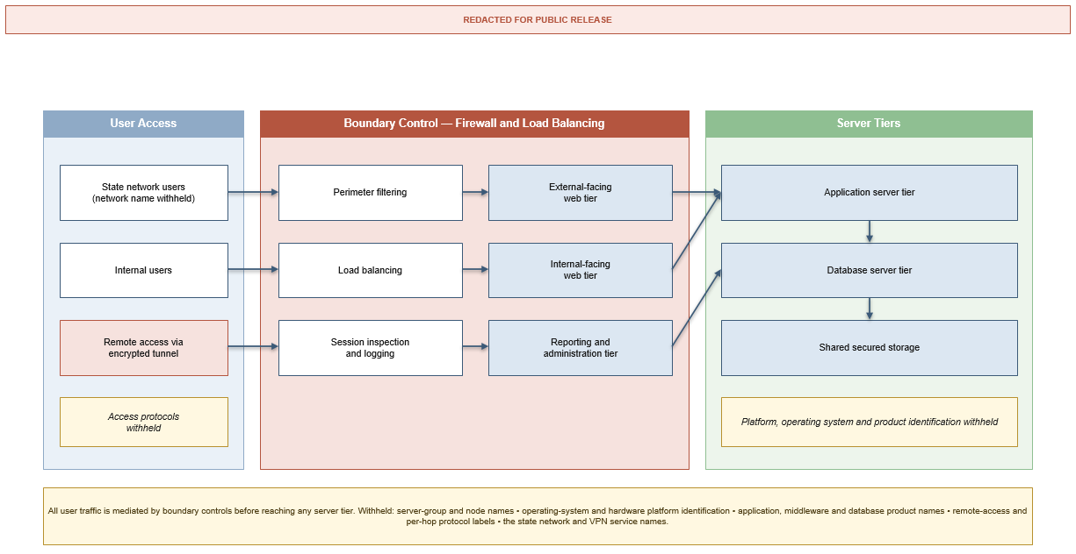
Figure 26. Load Balancing

Security Architecture

Security Architecture
The NYSOH security architecture ensures that the NYSOH business capabilities are protected and operate in accordance with security and vulnerability best practices and NYSOH Information Assurance (IA) requirements. Access enforcement is designed in accordance with Electronic Authentication Assurance Level Guidelines for ACA Administering Entity Systems and the following assumptions:
- All access control documents are maintained and updated annually as per our approved SSP.
- User credentials are stored in Lightweight Directory Access Protocol (LDAP)/Active Directory (AD) which is key to the underlying systems so access is appropriately provisioned for the users.
- NYSOH uses the NYGov ID as an access management and ID proofing component of public-facing application security.
- During emergencies or other serious events, GDIT Cyber Security Group (CSG) security staff can authorize override as required.
- NYSOH implements Access Management Controls to map role based (Role-Based Access Control (RBAC)) security groups based on least privilege and separation of duties.
- NYSOH will implement identity proofing tools to map technical and administrative controls, including third party authenticators/credentialing authorities.
- NYSOH will use industry standard encryption for website/portal access (e.g., Transport Layer Security (TLS)).
- NYSOH will use standard encryption for data in-motion consistent with Federal Information Processing Standard (FIPS) 140-2–approved cryptographic modules.
- NYSOH will implement Public Key Infrastructure (PKI) models and interoperability requirements.
- GDIT-RDC complies with established computing control standards including IRS and CMS MARS-E standards.
- All support staff sign a "Rules of Behavior" agreement that will govern usage, access, and regulatory standards.
- GDIT adheres to the Information Technology Infrastructure Library (ITIL) v3 framework, which uses the change management process to implement any new procedures or changes in existing policy.

Additionally, the NYSOH system will:
- Adhere to the National Information Exchange Model (NIEM) and Nationwide Health Information Network (NHIN) standards, when applicable, to support information exchange among various systems containing pertinent information to support NYSOH services.
- Implement the use of hard tokens, as defined by e-Authentication-Guidelines-for-ACA-AEs for Identification Assurance Levels (IAL) 1-3, TLS, and encryption to support remote access to the system.
- Be maintained in a secure data center where guards are on duty 24 hours per day, 7 days per week.
- Be hosted in a controlled area where access to the data center is restricted to designated Operations staff for routine data center maintenance in support of the NYSOH program and infrastructure.
- Follow the final HIPAA Security rule, which specifically addresses the handling of electronic Protected Health Information (ePHI), to guide our platform for the protection, storage and handling of sensitive information contained within the NYSOH program.
- Be implemented so that all development and handling of sensitive information within the Marketplace references meet the Minimum Acceptable Risk Standards (MARS-E) and HIPAA privacy standards as defined in the approved SSP.
- Implement the following applicable HIPAA Final Security Rule Safeguards as defined in 45CFR Part 160 and Part 164, Subparts A and C:
- Managerial Controls,
- Operational Controls, and
- Technical Controls.
- Meet all appropriate IRS Pub 1075 standards and Internal Revenue Code (IRC) 6103 standards.

Performance
Figure 27 shows NYSOH historical enrollment data. For the purposes of this planning, “Enrollments” are defined as the number of HX_CONFIRMATION pages rendered after completion of the processes for an end user, agent or customer service representative. During Open Enrollment, approximately 30% of pageviews are generated by Customer Service Representatives. Based on previous patterns, it is expected that peak usage will occur at the early stages of open enrollment and near the deadline for completion.

Time-based volume estimates for enrollments and the resulting user web transactions, as well as projections for inbound messages and outbound web service calls necessary to process each enrollment are documented. In the case where there existed an initial set of performance requirements upon which the original design was based, that set of requirements is so indicated and remains. The current corresponding requirements projection for the near future is then indicated.

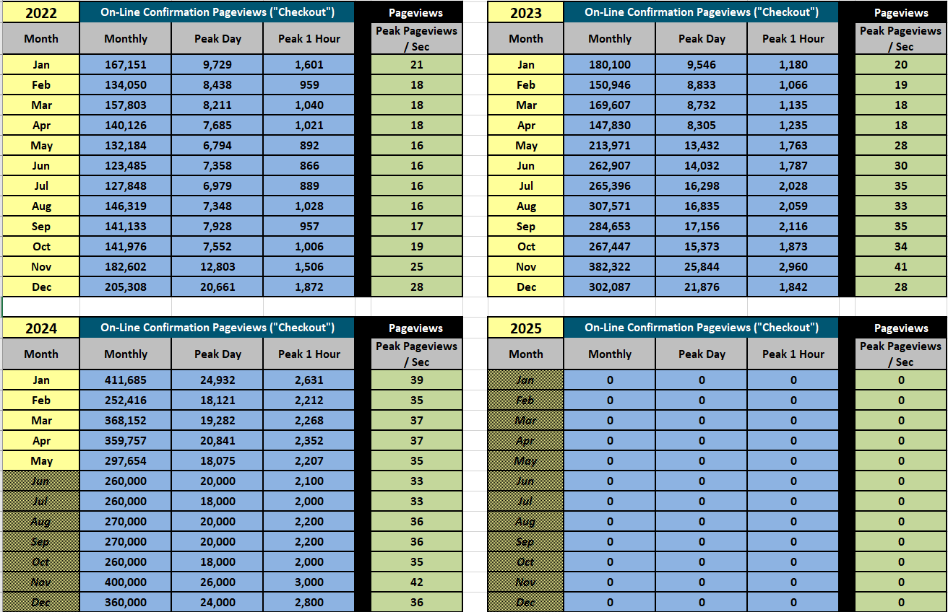
Figure 27. Enrollment Volume Specifications

Figure 28 details the historical and forecast through the year 2024 for NYSOH end-user transactions. These transactions consist of the Hyper Text Markup Language (HTML) and dynamic content returned to the browser for a rendered page, based on the number of pages for each enrollment channel. The number of transactions can potentially stay flat year over year based on the historical and projected numbers.

Sizing of the architecture is based on actual average network bandwidth, I/O and Central Processing Unit (CPU) milliseconds consumed per page view on the application and database tier. Components are sized to support this expected volume.

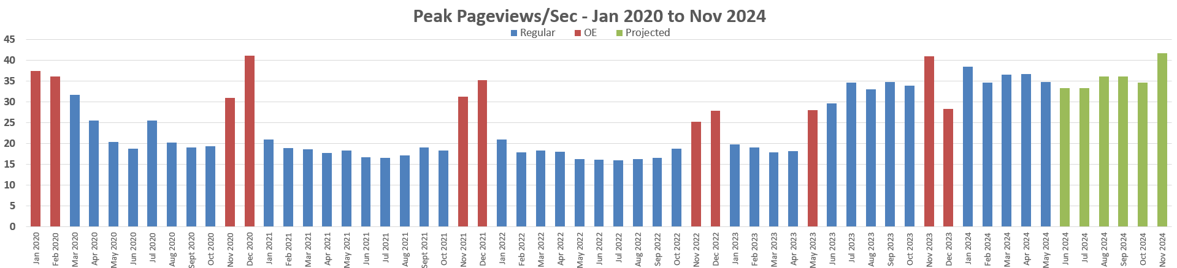
Figure 28. Peak Page views

Web Services: Each enrollment is expected to initiate five outbound web service calls per enrollment. Figure 28 shows a peak enrollment per second rate of 42 for individuals and for Customer Service. Therefore, approximately 180 outbound web service calls per second are expected. Services and proxies have been designed to support this volume. This summarizes the assumptions relative to the performance of the system at the volumes anticipated as the CR 134 requirement. For future open enrollment periods, a similar level of outbound web services calls is expected.

Service Architecture
Some functionality in the NYSOH System is deployed in the form of services. This section provides an overview of the available services. Two different technologies are used for services: SOAP and REST.

Rest Services
The Restful services are organized into a number of modules. Figure 29 shows the modules available to the NYSOH System clients in the present design.

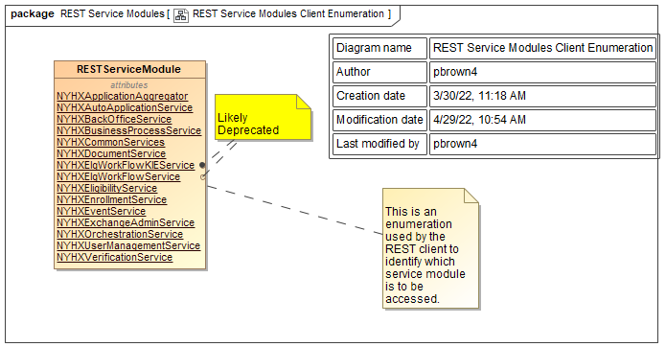
Figure 29. REST Service Modules Client Enumeration

The WSRRUtil class (Figure 30) plays a key role in translating this enumeration into URLs that can actually be invoked.

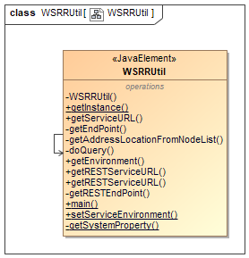
Figure 30. WSRRUtil

The actual URLs and their mapping are stored external to the system. The static getInstance() method, which is used to obtain an instance of this class, determines the source of this information. If the environment is WebSphere, it gets the WSRR_URL from "ref/HxProperties".

If the environment is not WebSphere it is assumed that it is a batch environment. The method it checks to see if there is an "hxenvironment" property. If there is, it retrieves the "HxWSRRURL" property value. Otherwise it looks for an "hxWSRRURL" environment variable.
Finally, if it is a batch environment, a batch suffix of "-BAT" is added.

Application Aggregator REST Services
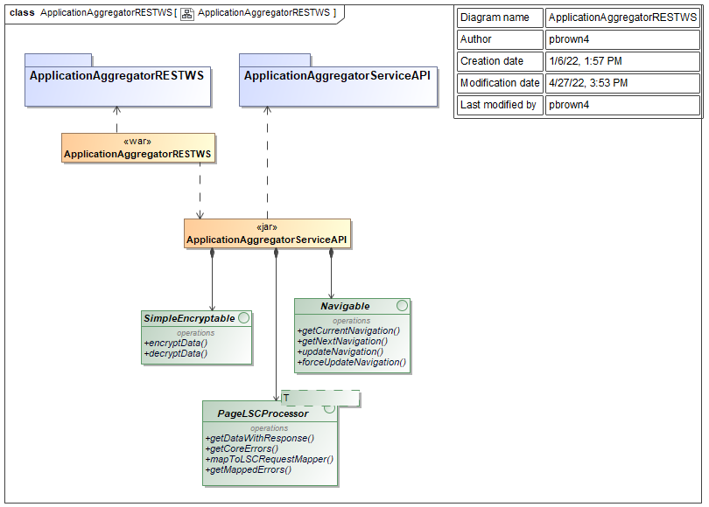
Figure 31. ApplicationAggregatorRESTWS

Auto Application REST Services
The auto application REST services are shown in Figure 32.

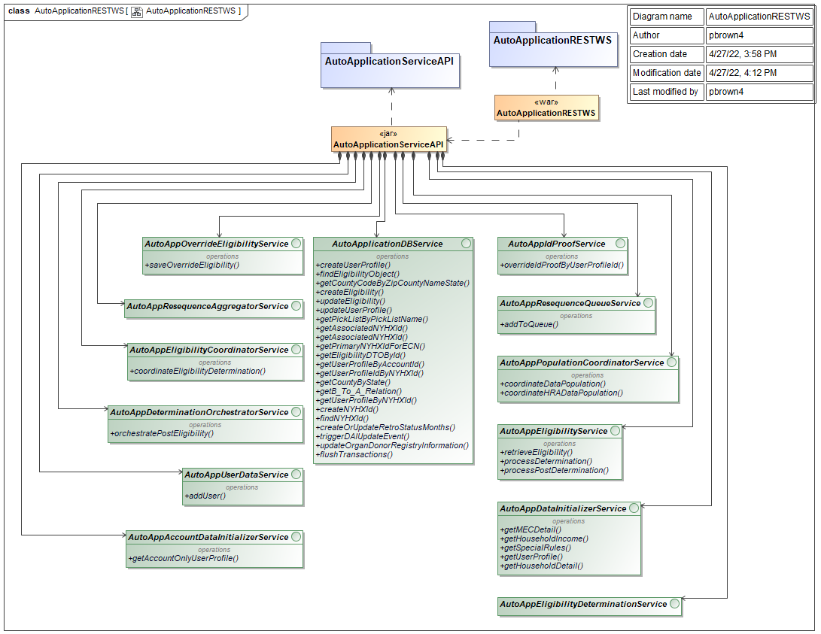
Figure 32. AutoApplicationRESTWS

Back Office REST Services
The Back Office REST services are shown in Figure 33.

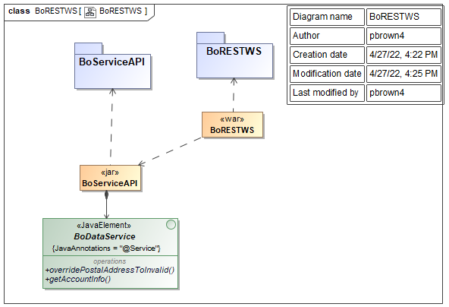
Figure 33. BoRESTWS

Business Process REST Services
The business process REST services are shown in Figure 34.

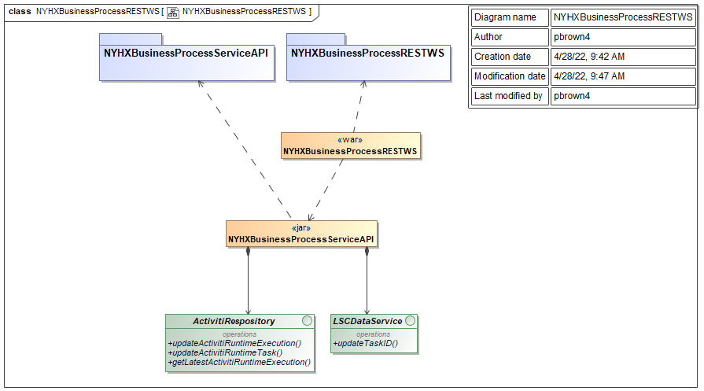
Figure 34. NYHXBusinessProcessRESTWS

Common REST Services
The Common REST Services are shown in Figure 35. This deployable war file contains the common rest services.

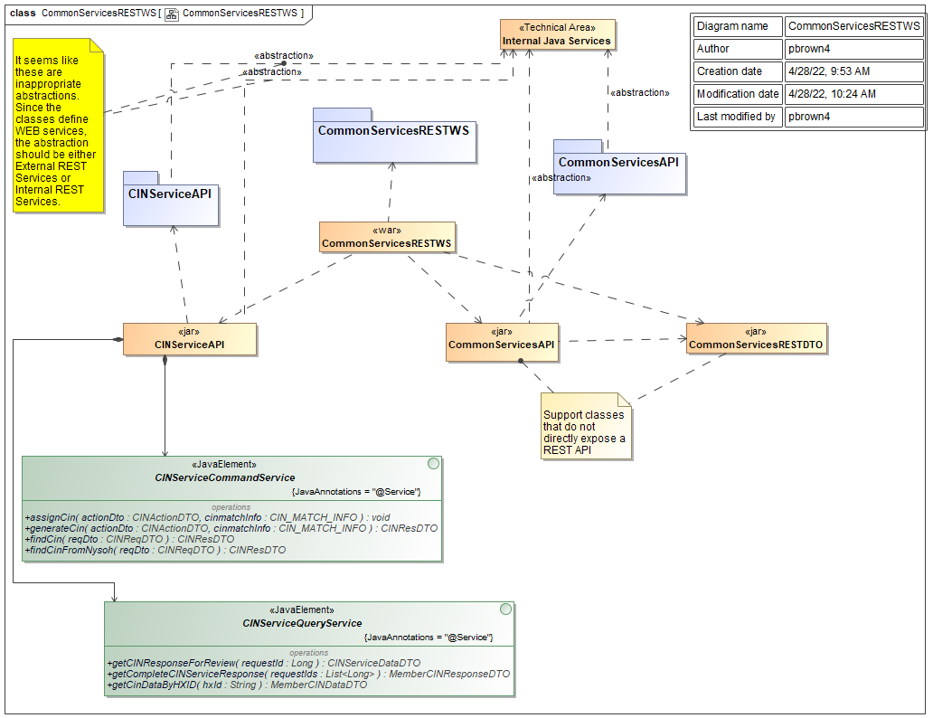
Figure 35. CommonServicesRESTWS

Document REST Services
The document REST services are shown in Figure 36.

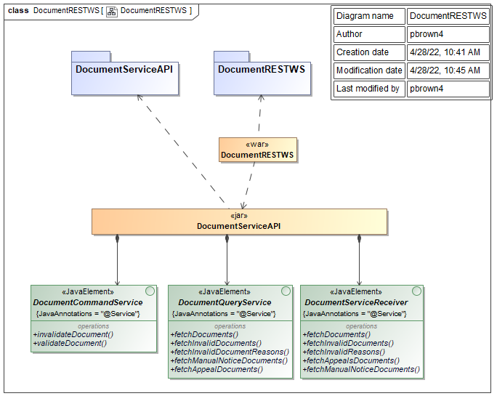
Figure 36. DocumentRESTWS

Eligibility REST Services
NYSOH uses a set of internal REST services to support the determination of customers’ eligibility for the insurance programs provided in NYOSH. These REST services are listed below. They help de-couple the Eligibility module from other modules such as Enrollment module, thus improve the reusability and maintainability of the NYSOH subsystems.

- /eligibility/getChpLockPeriodPremium
- /eligibility/getAddressDtlsForAEQByElgIdMemId
- /eligibility/elgDetails
- /eligibility/eligibilityResults

User Management REST Services
The user management REST services are shown in Figure 37.

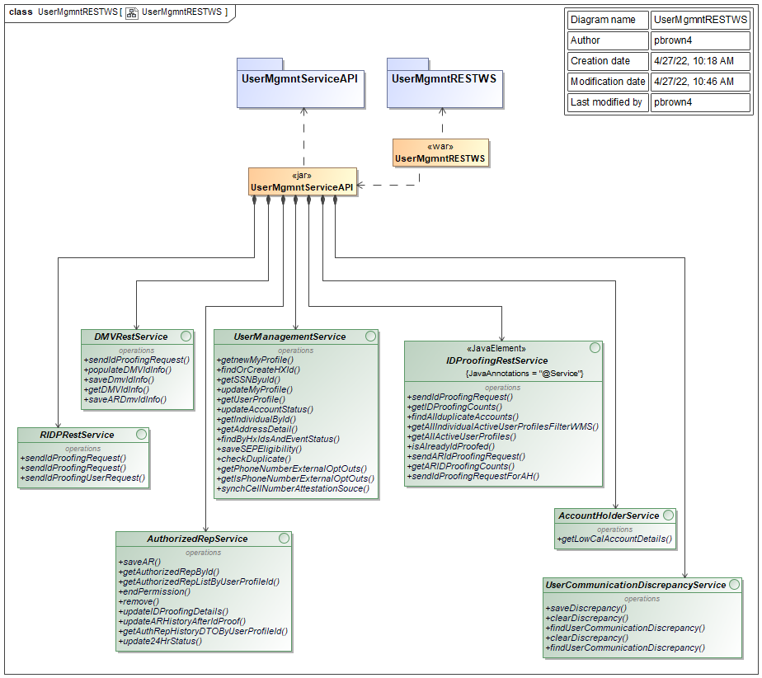
Figure 37. UserMgmntRESTWS

SOAP Services

Java Interfaces

Java Rules Interfaces
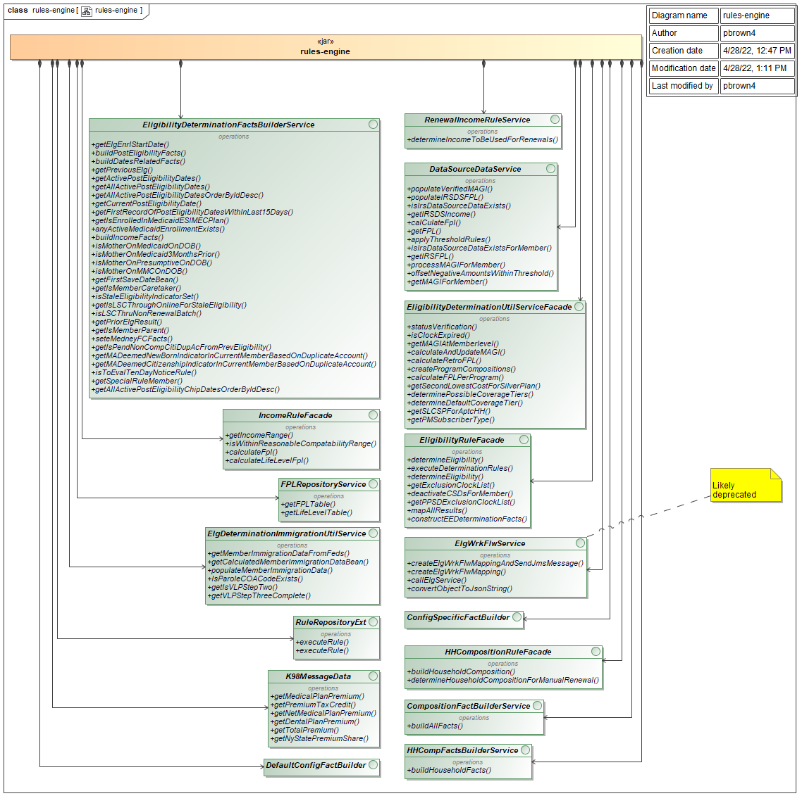
Figure 38. Rules Engine

Deployable Components
This section outlines the NYSOH system, providing a general understanding of how the system is organized into its components. As was outlined in Figure 4 and accompanying discussion, the system is organized into a number of technical areas.

The most prominent components are the Activity Initiators. These are the components whose behavior triggers activity within the NYSOH system. There are four types of activity initiators: Portals (user interfaces), SOAP Services that can be invoked by external systems, REST Services that can be invoked by external systems, and Jobs (batch processes that are run either on a schedule or on-demand).

Figure 39 shows the deployable artifacts comprising the portals used in the NYSOH System. The static-hix-bundle contains the static web pages for the www.newyorkstateofhealth.com. This is the initial access point for all user interactions. The other <<war>> artifacts serve to modularize the user interface functionality. The web-template-public provides supporting elements that are shared across all portal components. The remaining <<war>> artifacts provide dynamic functionality built using the Spring MVC framework. The operation of this framework is described in Section 3.3.1.

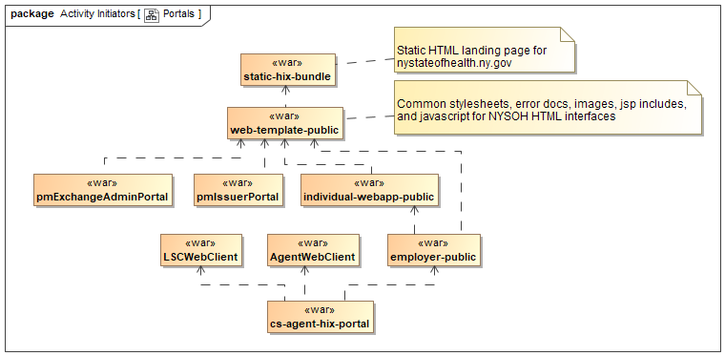
Figure 39. Portals

The deployable artifacts defining the Front-End SOAP Services are shown in Figure 40. These services are constructed using the Spring WS framework. The operation of this framework is described in Section 3.3.3.

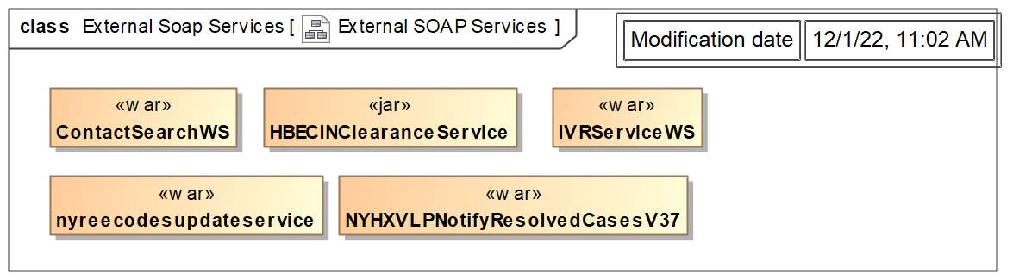
Figure 40. External SOAP Services

The artifacts comprising the Batch Jobs are shown in Figure 41. Each of these JARs contains one or more Java classes with a main() function that can be executed as a stand-alone process.

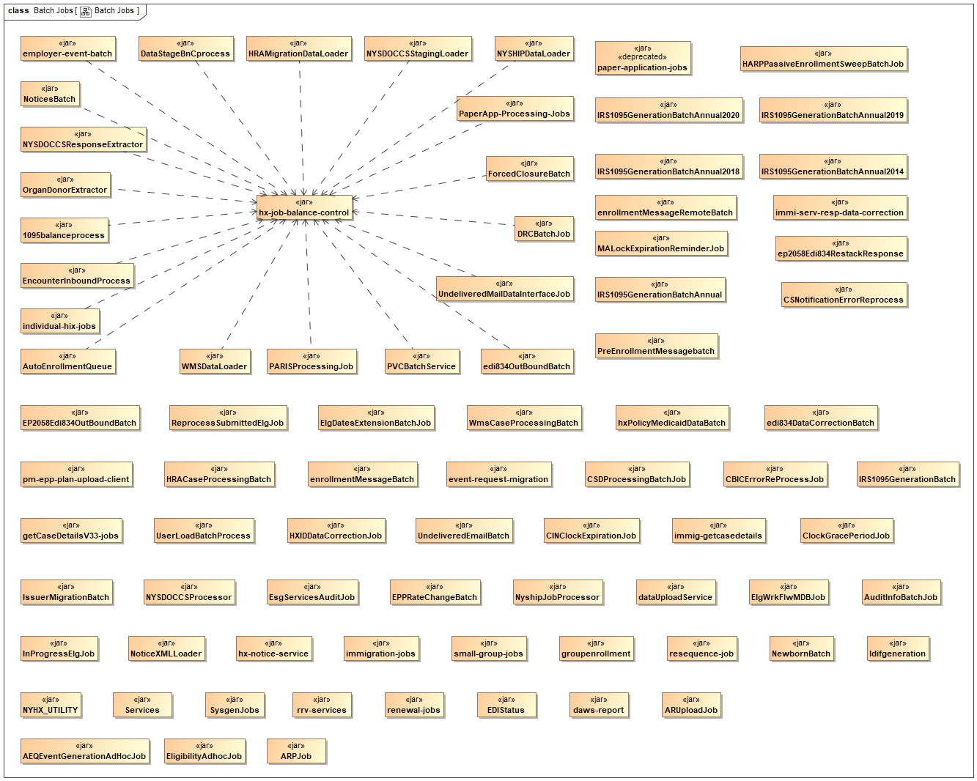
Figure 41. Batch Jobs

Figure 42 shows the artifacts that provide direct support for the activity initiators. Web Domain and Batch Job support are provided as Java classes that can be directly invoked by their respective activity initiators. Web Domain REST Support provides support for portals in the form of REST services that can be invoked by the portals.

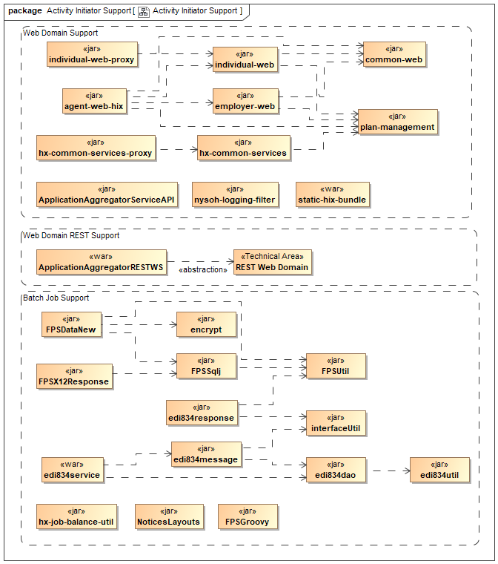
Figure 42. Activity Initiator Support

The following figures show the artifacts containing internal services within the NYSOH system.

Figure 43 shows the artifacts comprising the Internal Java Services. These are services provided as java objects whose API is directly invoked by Activity Initiators and their support components.

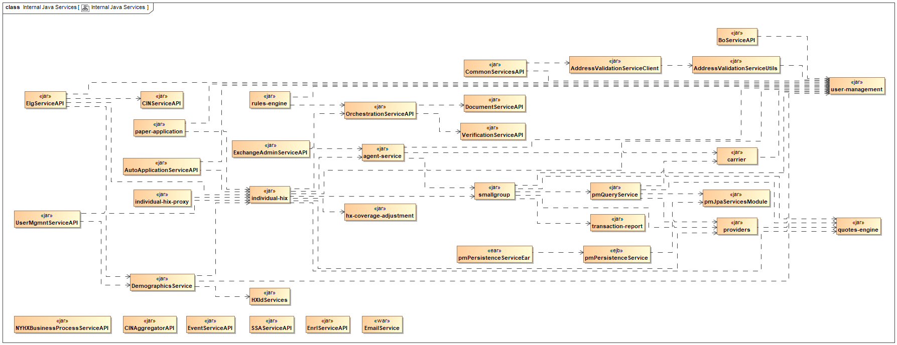
Figure 43. Internal Java Services

Figure 44 shows the artifacts comprising the Internal REST Services. These services provide RESTful access to internal services.

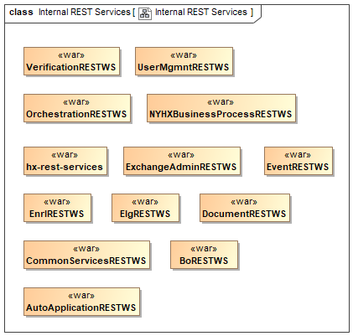
Figure 44. Internal REST Services

Figure 45 shows the artifacts comprising the Internal SOAP Services. These services are provided with SOAP web services interfaces.

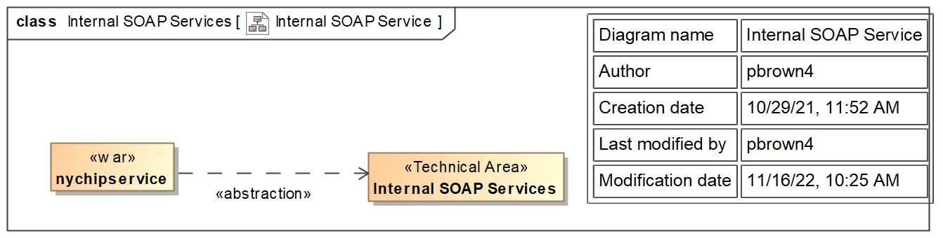
Figure 45. Internal SOAP Service

Figure 46 shows the artifacts comprising the Data Transfer Objects. These objects provide standardized Java representations of information that can be moved between software components.

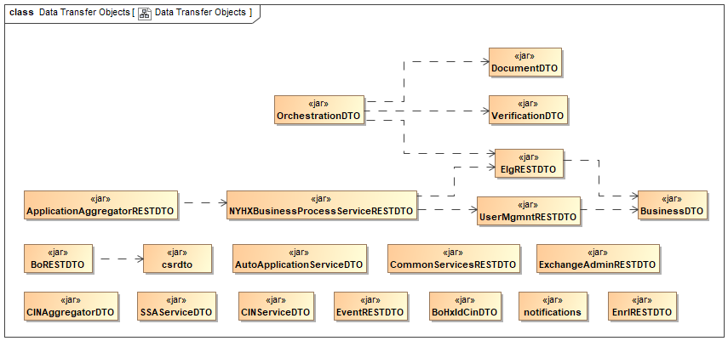
Figure 46. Data Transfer Objects

Figure 47 shows the artifacts comprising the Interface Invocation Clients. These clients are Java classes that provide convenient mechanisms for invoking external services.

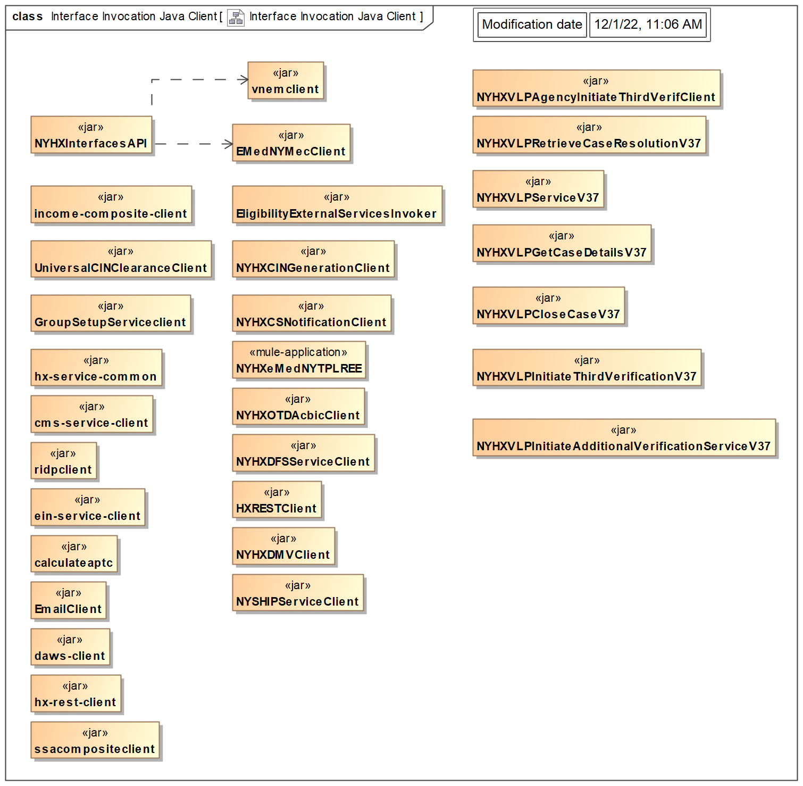
Figure 47. Interface Invocation Java Client

Figure 48 shows the artifacts comprising the Outbound Messaging services. These services provide outbound messaging capabilities to the NYSOH System.

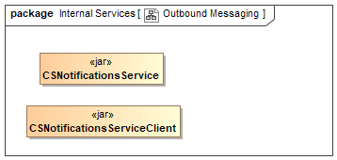
Figure 48. Outbound Messaging

Figure 49 shows the artifacts comprising the pending work queues within the system.

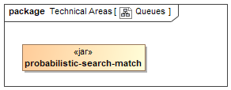
Figure 49. Queues

Figure 50 shows the artifacts comprising the Java Business Domains for the NYSOH system. These components encapsulate business logic for use within the application in the form of Java classes.

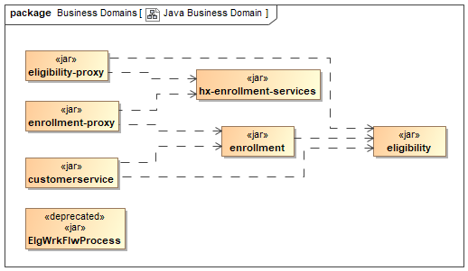
Figure 50. Java Business Domain

Figure 51 shows the components comprising the Data Domain. This comprises Java components that access database tables.

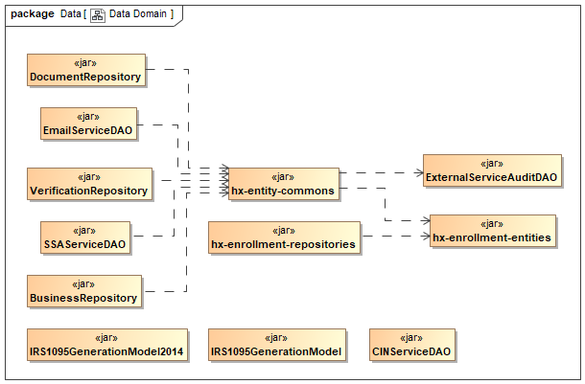
Figure 51. Data Domain

Figure 52 shows the artifacts comprising the utilities within the NYSOH system. For the most part, the utilities provide convenience operations for using various technologies.

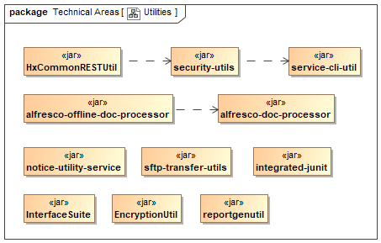
Figure 52. Utilities

Figure 53 shows the artifacts comprising the testing support for the NYSOH System.

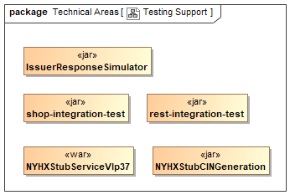
Figure 53. Testing Support

Figure 54 shows the artifacts containing the components that support the deployment and operation of the NYSOH System.

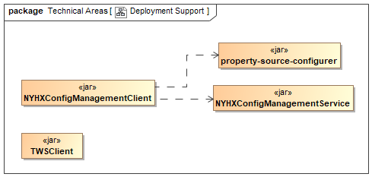
Figure 54. Deployment Support

System Architecture Diagram
The purpose of the NYSOH System is to provide for an integrated health exchange solution that is reliable, maintainable, scalable, and extendable to future enhancements.

In this document, the NYSOH architecture is described from multiple perspectives: the business architecture (i.e., operational or functional), the application architecture (logical structure and organization of the system components), physical architecture (the physical structure and organization of the system components) and the data architecture (structure and organization of the system data). Collectively, these architectures provides the foundation for the design and implementation of the application services and the business functionality they provide.
Note that because the NYSOH System was based upon an existing design that did not follow the OSGI architecture model, the NYSOH System architecture is not consistent with the OSI model.

The application architecture establishes a framework for the integration of solution capabilities, whether these capabilities are custom built or externally provided. Industry-standard design patterns and supporting libraries are employed in assembling this framework. These design patterns are described in Section 2.2.3.

The application is implemented on a physical infrastructure that satisfies NYSOH business process, technical, security, and performance requirements. Figure 25 shows the basic physical organization of the NYSOH system. Figure 55 is the logical application architecture.

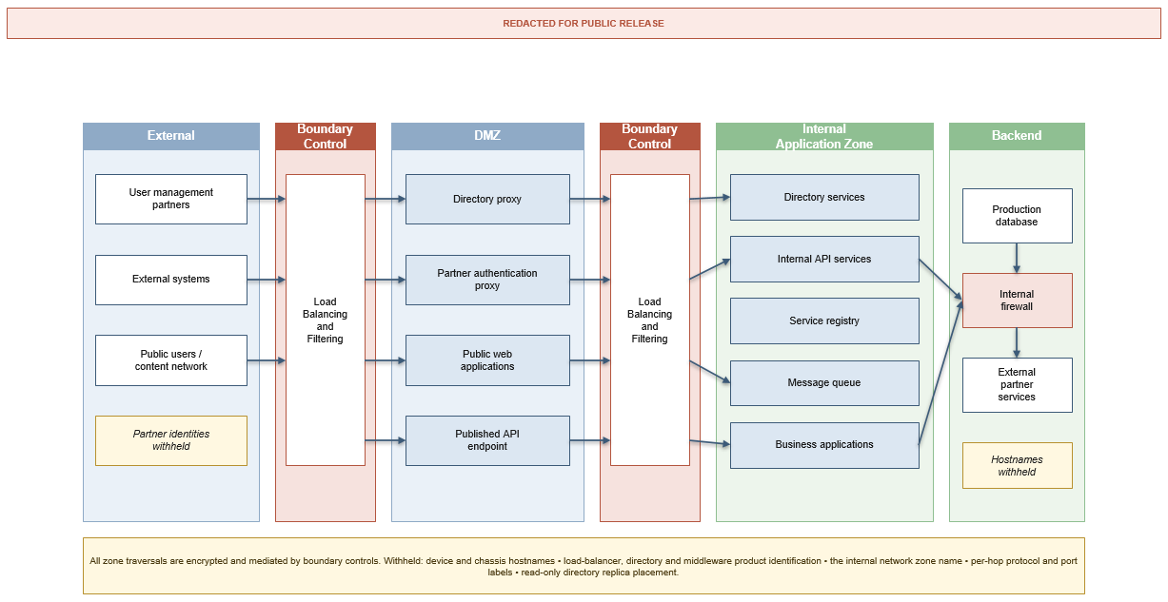
Figure 55. Logical Application Architecture

A major NYSOH capability enhancement was made to Encounter for Release 1 on 5 January 2015 and for Release 2 on 15 September 2015 that collects data required to monitor various aspects of the NYSOH performance. The Encounter processing system collects Encounter data from NYSOH Qualified Health Plans (QHPs) and provides information about the individual, their diagnoses, the services received, and the cost of those services to fulfill a variety of reporting and analytical requirements. Figure 56 shows the Encounters Solution Architecture.

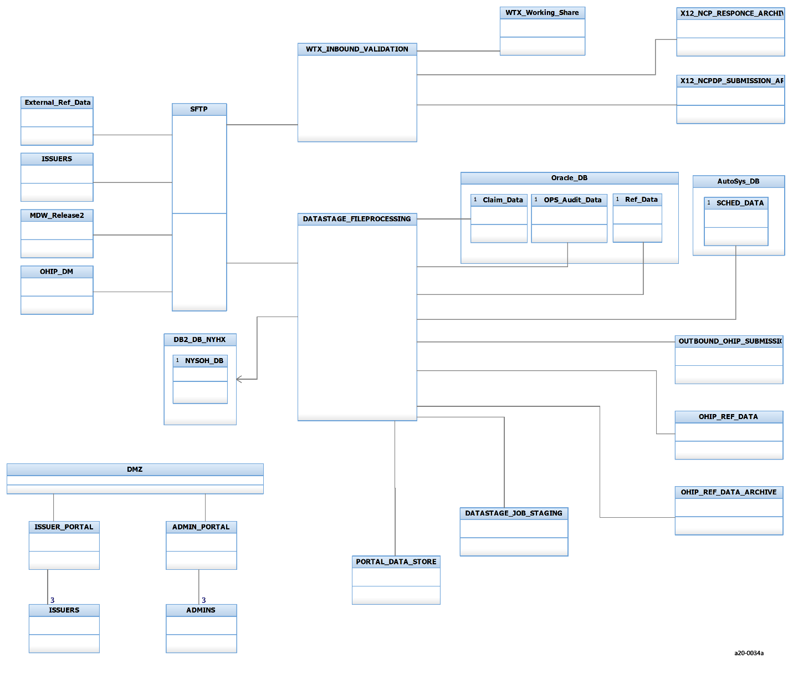
Figure 56. NYSOH Encounter Solution Architecture

Figure 57 shows the application components configured for the NYSOH project and the servers to which they are deployed within the NYSOH system.

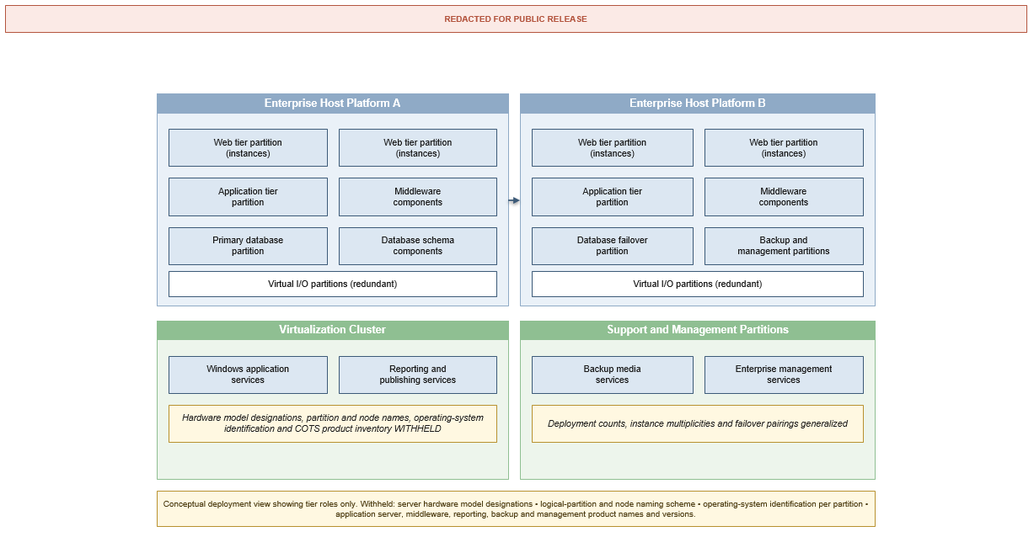
Figure 57. NYSOH Component Deployment View

System Design

Business Requirements
NYSOH system business requirements are documented as User Stories/Shall Statements in the NYSOH Engineering Toolset. These requirements are documented discretely as IBM Rational EWM Work Items and categorized by various metadata for ease of identification.

Groupings of requirements are integrated in requirements documents for DOH review and approval on a NYSOH Change Request (CR) basis.

These requirements are accessible in both fashions by access to the NYSOH Engineering Toolset.

Database Design
Details regarding the NYSOH Database Design are provided in the NYSOH LDM and PDM. Both of these are provided as attachments to the SDD along with a Data Dictionary providing data element attribute information. These attachments reflect the NYSOH production database as of NYSOH Release 47 Build 2.

Within the PDM, there are four types of tables: master data tables, static data tables, config data tables, and transactional tables identified in the Database Data Dictionary, which is also an attachment to this document. The definitions of those types of tables are below.
- Master (Reference) data tables contain information that is considered to play a key role in the core operation of a business. Master reference data may include standard information such as ZIP_CODES, USER_PROFILE_TYPE_MASTER, and STATE so all values are consistent across the NYSOH system. Transaction data such as an individual account, address, or members of a household may contain references to master reference data. Master Reference data rarely changes and is usually updated on a periodic basis.
- Configuration (config) data tables contain data that control the application flow and are usually limited to specific functionality. The configuration data is used to tailor the application for specific scenarios or conditions without having to modify the software. As an example, the ENROLLMENT_PERIOD_CONFIG table contains the dates for Open Enrollment that control/configure the enrollment period dates. Entries in this table change the application behavior before and after the dates contained in the configuration table. As a simple example, if an individual is enrolling during the effective period, the system will allow them to select any plan whereas, if the individual is attempting to select a plan outside of the effective dates, they must provide a justifiable reason before the system will allow a plan to be selected.
- Static data tables contain data that control the behavior of the application. Static data values rarely change; however, it is common to add to these values as the system matures and features/functions are added. The primary characteristic is that static tables are usually limited to a specific function/page. As a general description, a page is required to display drop down or check box values. The Static data tables are used to populate the drop down values on front end selections such as PICKLIST or SECURITY_QUESTIONS.

The NYSOH Data Dictionary includes data element name, type, partial validation rules and description as well as information regarding PII/PHI indication, foreign keys, null values, and primary keys.

Data Objects and Resultant Data Structures
The NYSOH PDM provides details of the NYSOH database, including identification of data tables and columns used to store and process the data. The NYSOH LDM provides details of functional data objects. Business rules for utilizing the data are in the RSDs, TSDs, and ICDs that define how the NYSOH Application uses and updates this data.

Functional data objects that implement data passed between software components are described in the SDSs (TDDs on older CRs). Where appropriate, SDSs (TDDs) are created for each NYSOH CR.

File and Database Structures
Data that is received from/passed to external interfaces and sourced from/stored in the NYSOH Database is described in the SDSs (TDDs on older CRs) created for each NYSOH CR.

As part of the active, the Logical Data Modeling CR, the NYSOH Database is being modeled using ER/Studio. When available, this database model will be used to auto-generate the DDL and will include storage groups, tablespaces, SOR, etc., details.

The following diagrams show the Java classes that provide database access for selected database tables. For simple concepts (e.g., address, phone) the full mapping is shown in the diagram. For more complex concepts (e.g., Application) the diagram shows the scope of classes associated with the concept. Many of the diagrams indicate other diagrams providing information about other concepts. In the MagicDraw model, these are live links to those diagrams.

In these diagrams, if an association is marked with <<Eager Load>>, then whenever the association owner is loaded, the referenced class is also loaded. This will automatically retrieve the table associated with that class. For associations marked with <<Lazy Load>>, the class and database table are not loaded until an attempt is made to use the association in the code. Also indicated in the diagram are the names of the NYSOH Model UML diagrams that show the details of the individual database tables and their mappings to the Java classes.

Figure 58 shows the details of mapping address-related Java classes to their corresponding database tables.

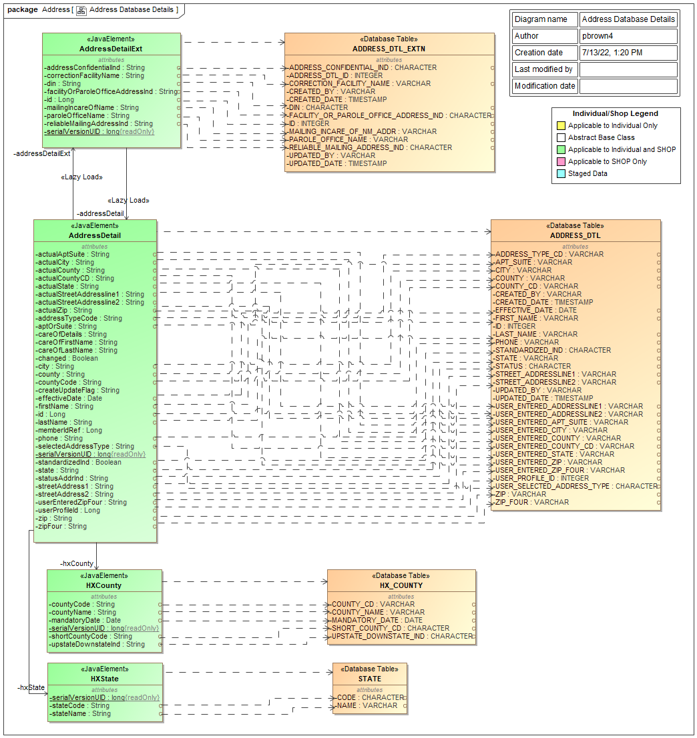
Figure 58. Address Database Details

Figure 59 shows the Agent and Broker Java classes and their mapping to the Broker database table.

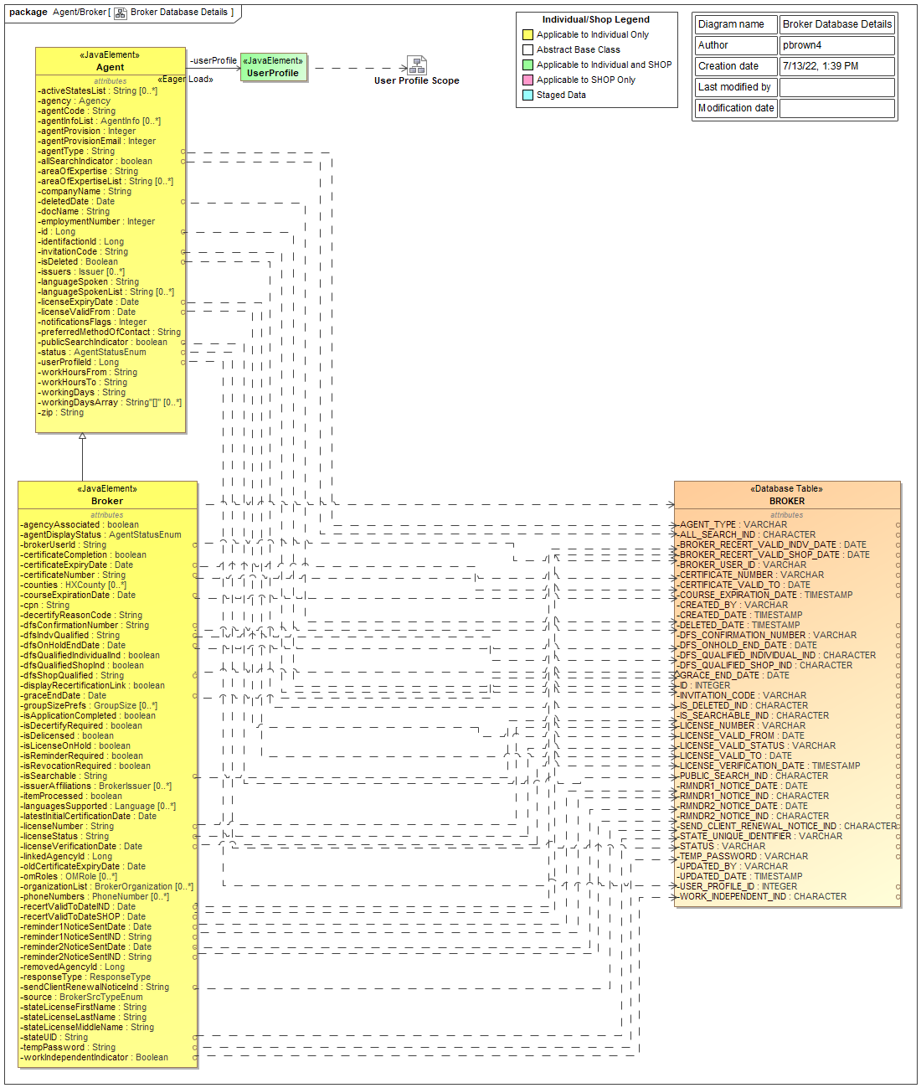
Figure 59. Broker Database Details

Figure 60 shows the Java classes related to appeals. Information about the corresponding database tables and column mappings can be found in the Appeals Database Details.

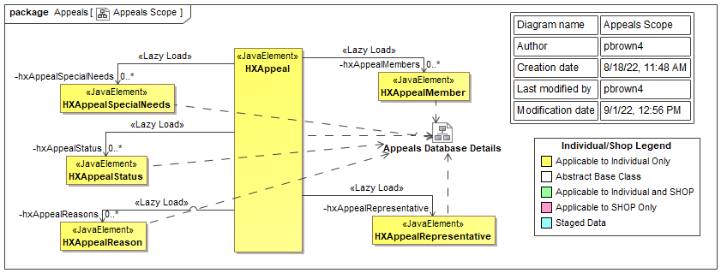
Figure 60. Appeals Scope

Figure 61 shows the scope of classes related to an application. The details of mapping these classes to individual database tables are shown in the indicated diagrams which can be accessed in the MagicDraw model.

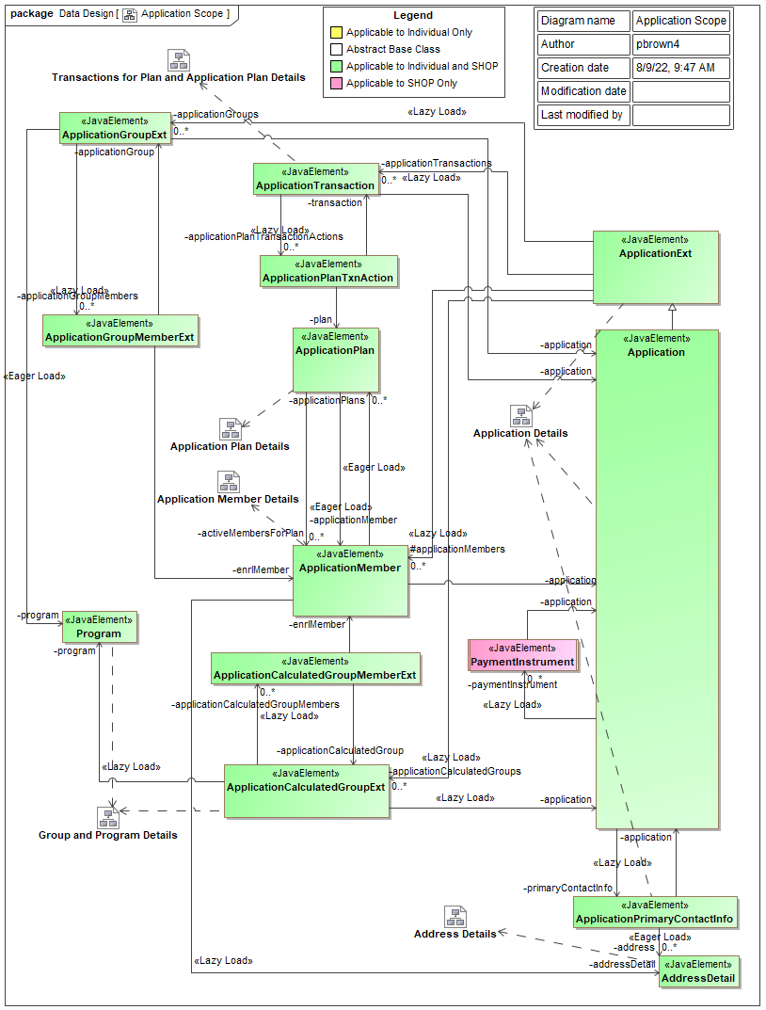
Figure 61. Application Scope

Figure 62 shows the Application class, its parent, and related ApplicationPrimaryContactInfo classes along with their relationship to the Enrollment database table. Individual attributes are mapped to their corresponding database columns with dependencies.

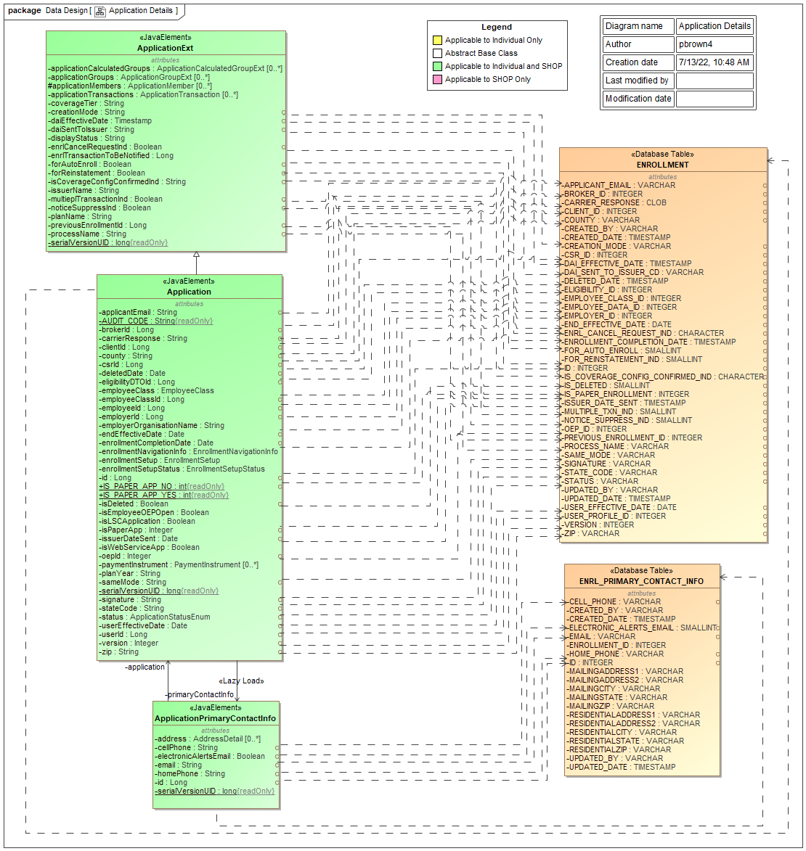
Figure 62. Application Details

Figure 63 shows the Java classes related to Application Member. Database table and column information can be found in the indicated diagrams in MagicDraw.

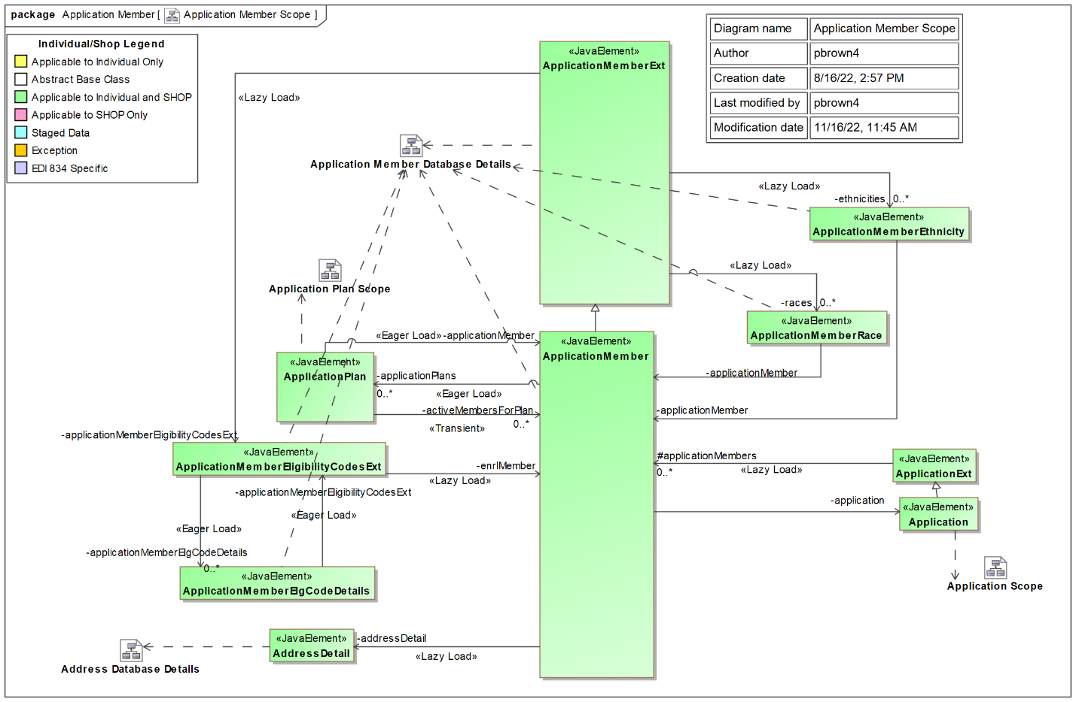
Figure 63. Application Member Scope

Figure 64 shows the Java classes associated with Application Plan. Related database table and column information can be found in the indicated diagrams in the NYSOH model in MagicDraw.

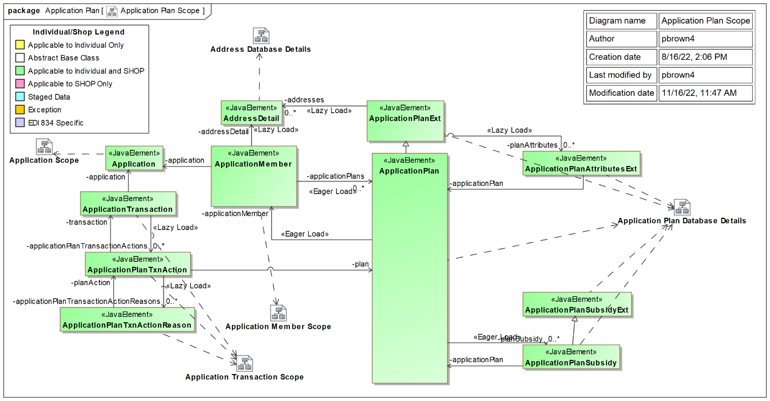
Figure 64. Application Plan Scope

Figure 65 shows the Java classes related to Application Transactions. Database table and column information can be found in the indicated NYSOH Model diagrams in MagicDraw.

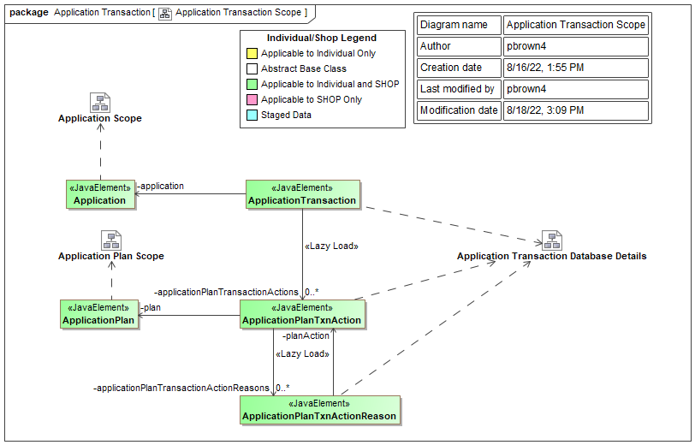
Figure 65. Application Transaction Scope

Figure 66 shows the Java classes related to Eligibility. Database table and column information can be found in the indicated NYSOH Model diagrams in MagicDraw.

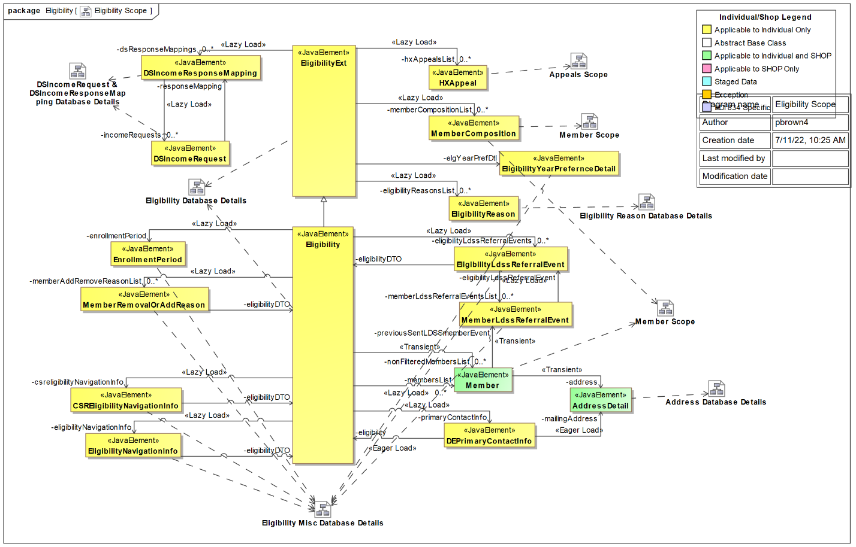
Figure 66. Eligibility Scope

Figure 67 shows the Java classes and related database tables and columns for New York State (NYS) Government Accounts.

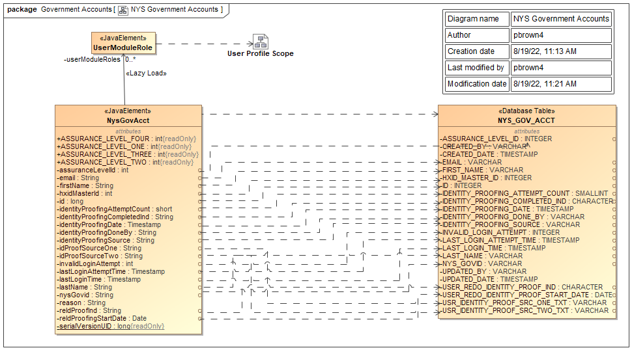
Figure 67. NYS Government Accounts

Figure 68 shows the Java classes related to Issuer. Corresponding database tables and columns can be found in the indicated NYSOH Model diagrams in MagicDraw.

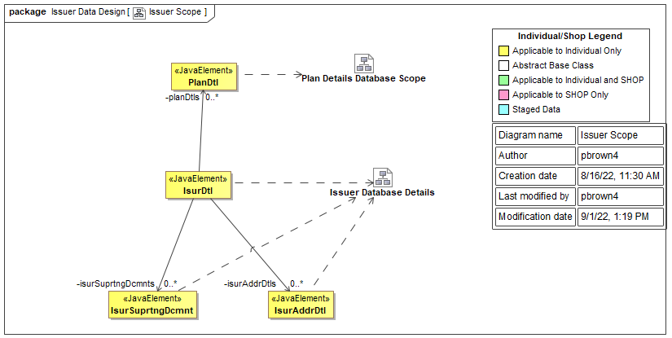
Figure 68. Issuer Scope

Figure 69 and Figure 70 together show the Java classes related to Member. The details of related database tables and columns can be found in the indicated NYSOH Model diagrams in MagicDraw.

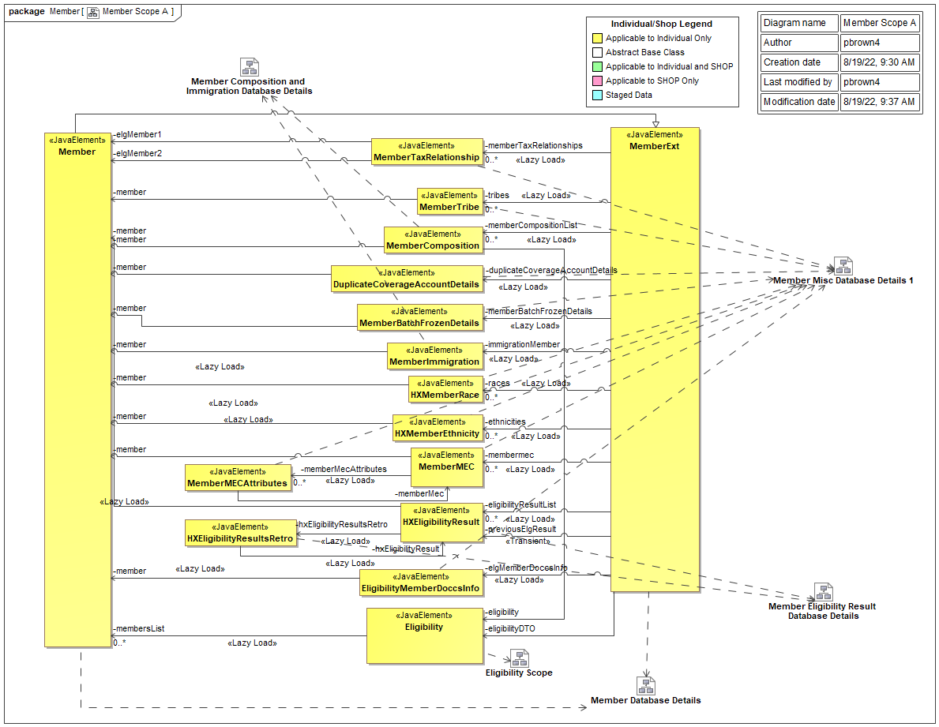
Figure 69. Member Scope A

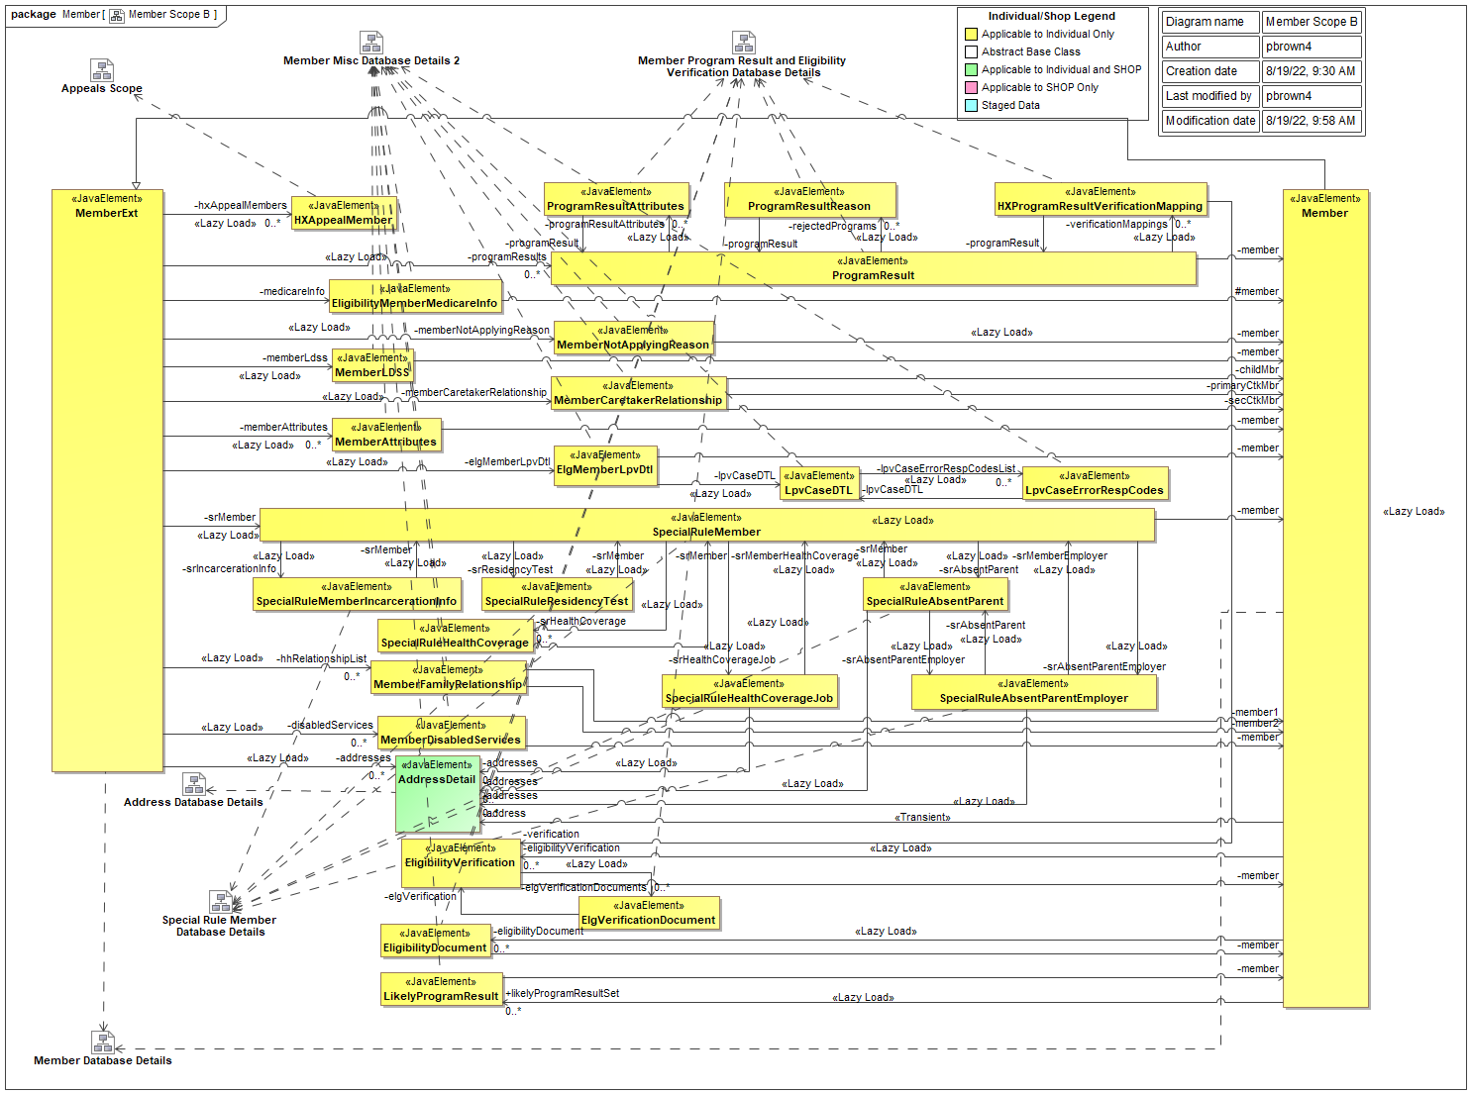
Figure 70. Member Scope B

Figure 71 shows the Java classes related to Organization and their corresponding database tables and columns.

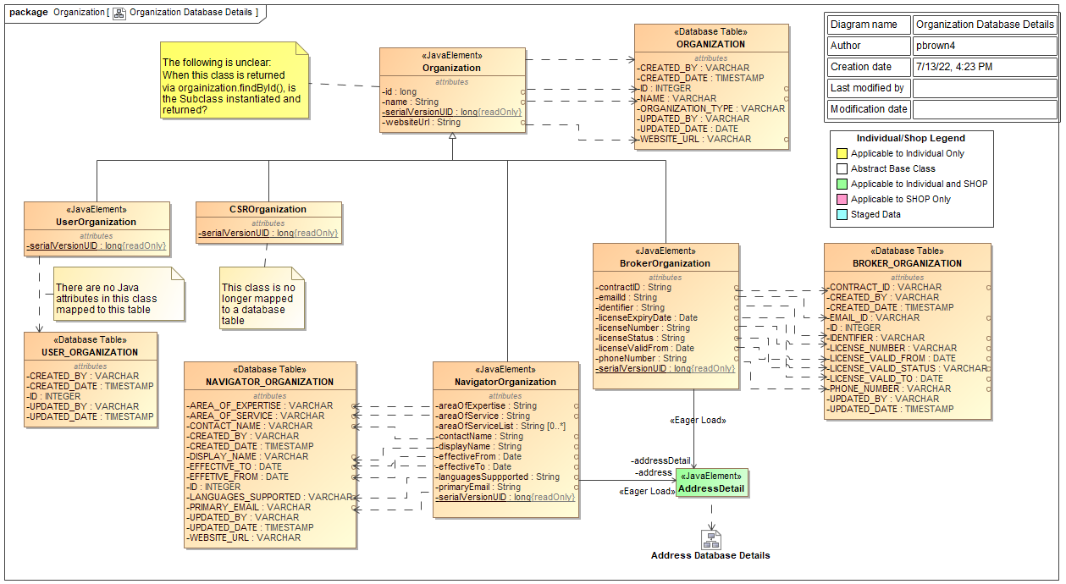
Figure 71. Organization Database Details

Figure 72 shows the Java classes related to Phone Numbers and their related database tables and columns.

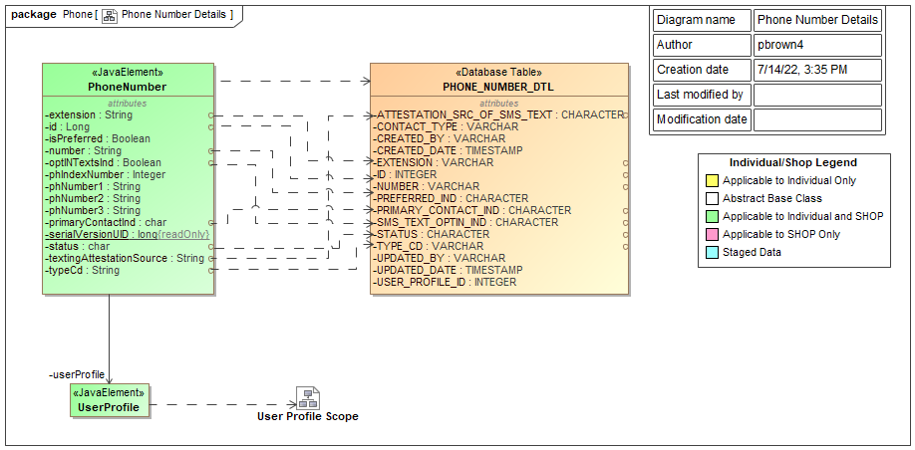
Figure 72. Phone Number Details

Figure 73 shows the Java classes related to Plan Details. Further details regarding these classes and their related database tables and columns can be found in the indicated NYSOH Model drawings in MagicDraw.

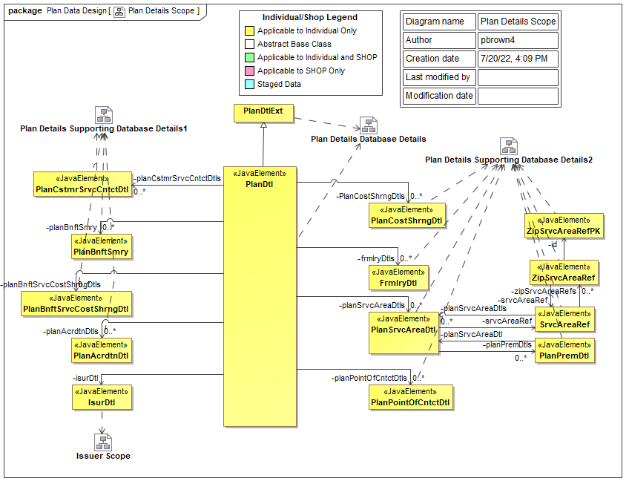
Figure 73. Plan Details Scope

Figure 74 shows the Java classes related to User Profile. Also indicated are the NYSOH Model diagrams that detail the class attributes and related database tables and columns.

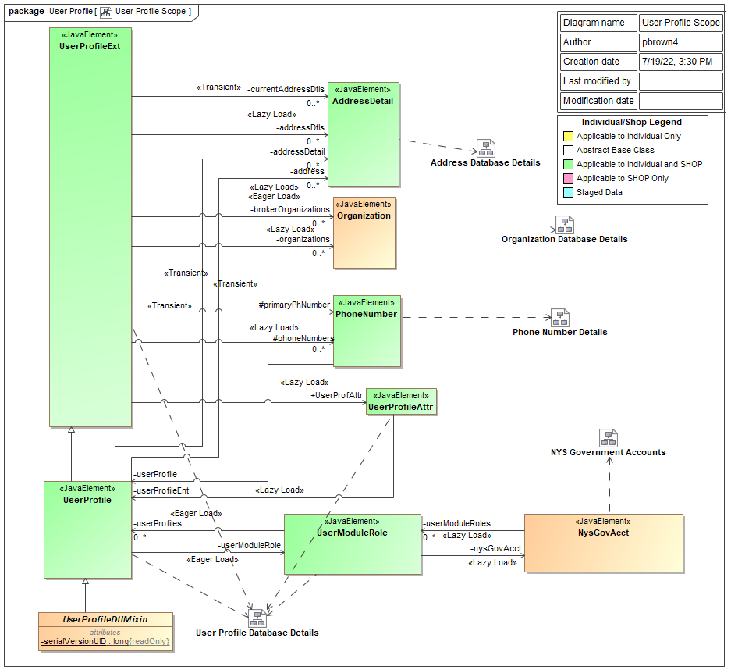
Figure 74. User Profile Scope

Database Management System Files
The NYSOH database is managed with an IBM DB2 Version 11 for LUW database management system. DB2 LUW is a COTS product with extensive documentation describing its file and directory storage structure. Refer to product documentation for details of its storage model and file architecture. As noted above, the NYSOH PDM describes the application-specific database objects.

Non-Database Management System Files
Data exchanged from the NYSOH Health Exchange System and external entities are described in ICDs, BSDs as to the format and data exchange protocol. CR-specific SDSs (TDDs on older CRs) described how the NYSOH Application populates messages or data files for the data exchange.

Data Conversion
Transformation of input data files are handled as System Interfaces or as part of TWS batch job documentation.

User Machine-Readable Interface
[Content will be added in a future release]

User Interface (UI) and User Experience (UX) Design

Overview
State marketplace best practices and design principles were established under the UX 2014 project in June 2012. A joint policy decision was made to incorporate minimal UX 2014 look and feel for the 1 October 2013 go-live. The UX 2014 project is since no longer supported, and GDIT has established a UI/UX team to guide the evolution of the NYSOH system user interface and user experience.

The majority of NYSOH UI/UX leverages the capabilities of the base hCentive product – a mix of JSP, JavaScript, JQuery, CSS, Bootstrap and some custom UI elements. With the adoption of Angular as a core technology in 2016/2017 GDIT intends to leverage the Angular framework (TypeScript) and a component-based front-end methodology to maximize code reusability and better enforce consistent design standards.

All UI changes to the NYSOH interface are tested for compatibility with multiple browsers. NYSOH minimum browser standards are stored and maintained on the SharePoint PAL.

Initially, as a part of the design and development of each release, RSD/TSD documentation contained the screen design. Prior to SDD v13.0, the SDD included attachments that contained the UI screen designs. Starting with Release 25 UI/UX design has been included as part of the RSD documentation in its own section.

Section 508 Compliance
The NYSOH system has been developed and validated to be substantially compliant with Section 508 requirements per the standards defined below.

NYSOH was developed to adhere to the following subparts of the Federal Section 508 Compliance Standards, as published in the Federal Register on December 21, 2000:
- Subpart B-Technical Standards
- 1194.21 - Software Applications and Operating Systems
- 1194.22 - Web Based Intranet and Internet information and applications
- Subpart C-Functional Performance Criteria
- 1194.31 – Functional Recommended Evaluation Criteria
- Subpart D-Information, Documentation and Support
- 1194.41 - Information Documentation and Support

All new development which occurs on or after January 18, 2018 adheres to the following appendices to Part 1194 of the Section 508 Compliance standards (the “ICT Refresh”), as published in the Federal Register on January 18, 2017:
- Appendix A
- Chapter 1- Application and Administration
- Chapter 2 - Scoping Requirements
- Appendix C
- Chapter 3 - Functional Performance Criteria
- Chapter 5 - Software
- Chapter 6 - Support Documentation and Services.

Section 508 Compliance Testing tests the accessibility and usability of the system in accordance with the current Section 508 standards for the accessibility of technology systems by users with physical and/or cognitive disabilities. The NYSOH application has been tested by examining all user interfaces for the display of the applications content; and for interaction with, and control of, the application.

Section 508 Compliance Testing has been performed using the following tools:
- Job Access With Speech (JAWS)
- ARC Toolkit

NYSOH Verified and Tested Web Browsers
NYSOH has established the verified and tested web browsers based on the following considerations:
- The vast majority of users visiting NYSOH web portals can access and use the system without issue.
- The verified and tested web browsers are easily available for customers and for development and testing of the system as well.
- The verified and tested web browsers support the Transport Layer Security (TLS) 1.2 security protocol.
- Updates for the verified and tested browsers are expected to typically occur in the background and on a frequent basis, so that users are kept on the latest version.

As of the writing of this version of the SDD, the NYSOH verified and tested web browsers are listed below. All web browsers are verified and tested in the form of their latest major/stable release. For the detailed information, please refer to the document “Supported Browsers for NYSOH Web Applications” in Table 12 of Appendix A.
Table 7. NYSOH Verified and Tested Web Browsers
Supported Web Browser | Version | Coverage based on  Jan2023-Oct 2023 Data
Safari | Latest major version | 46.02%
Google Chrome | Latest major version | 39.50%
Microsoft Edge | Latest major version | 6.20%
Firefox | Latest major version | 2.19%
 |  | Total coverage: 93.91%

Note that unless a browser is blocked due to security requirements, other web browsers that are not listed above will still function correctly for NYSOH web applications.

System Monitoring
Table 8 describes the capabilities related to monitoring system usage, performance and system issues encountered during the operation of the NYSOH application. For additional details on the monitoring procedures refer to the Operations and Maintenance Manual (O&M Manual).
Table 8. System Monitoring
Category | Value
Scope of automated system monitoring | Server monitoring occurs as described below:  - Non-zLinux servers will be monitored for up/down.  Application/database monitoring. Applications and databases will be monitored for:  - CPU, memory, and hard disk utilization  - Response time  - Deep diagnostic metrics  Application/database monitoring tool (ATLAS/EM7 from ScienceLogic Inc.) is capable of sending automated alerts:  - Backup monitoring  - Onsite tape library monitoring  - Virtual Storage Platform (VSP) Storage Area Network (SAN) monitoring  - VLP 37 services (which are migrated to MuleSoft) are being continuously monitored by Operations team for availability and thruput.
Scope of manual system monitoring | GDIT RDC Operations team makes scheduled walk-throughs of the data center to check hardware indicator lights.
Supporting software tools | - Microsoft System Center Operations Manager (SCOM) for monitoring non-zLinux servers.  - IBM Application Manager.  - Hitachi Command Suite for enterprise level Virtual Storage Platform (VSP) Storage Area Network (SAN) monitoring/management.  - Hitachi Storage Navigator for single VSP SAN monitoring/management.  - Netbackup.  - IBM TS3500 web interface for tape library monitoring/management.  - ManageEngine Applications Manager from Zoho Corp for application and database performance monitoring.
Responsible teams | - GDIT RDC Competency teams will perform server monitoring e.g., GDIT RDC Wintel team will monitor VMWare virtual servers.  - NYSOH GDIT System Architecture team will perform application and database monitoring.  - GDIT RDC Competency teams and GDIT Finance and Procurement team will monitor license compliance.
Table 9. Cross Track Capability Functional Design Documentation
Service Provided | Service Summary | FDD
Unified Access Management | Describes the process for all users creating account credentials on NY.Gov ID and Identity Proofing on the NYSOH system. This includes Credentials Creation/Authentication, Credentials Maintenance and User Name/Password, User Account Profile and Security (Identity Proofing, Multi Factor Authentication (MFA)), and Role-Based Access. | CT01 FDD_Unified Access Management
Notices Management | Describes how notices are created, managed, and sent by the NYSOH system to applicants, employers and all third party assistors, navigators and brokers.  Triggering events and/or notice junctures are identified throughout the Enrollment and Eligibility process for consumers that access NYSOH and submit information to receive an eligibility determination. Additional notice junctures are identified as the user selects a plan, enrolls in a plan, and makes changes and/or notifies NYSOH of life events throughout the year. | CT02_Notices Management
Document Management | Describes the capabilities provided by the NYSOH Document Management System (DMS) for the capture and storage of uploaded NYSOH documents. This includes uploading documents to facilitate enrollment, eligibility, or verification of individuals or entities. | CT03 FDD_Document Management
Client Communications | Describes capabilities for the Client Communication (secure Inbox) to view outgoing communication enabling the user to view messages and to save the documents associated with the messages and notifications in their inbox. | CT06 FDD_Client Communication
Static Content | Describes capabilities for the creation and access of static, web-based content. This includes public and private content. Public content is available to anyone who comes to the site such as an anonymous shopper. Private content is available to consumers who are logged into the NYSOH system. | CT07_Static Content

Document Management
The NYSOH document management system utilizes the Apache Chemistry OpenCMIS system to store and retrieve all documents created by the system or sent by external partners such as MAXIMUS and the Business Services Outsourcing Center (BSOC). It also stores user-uploaded documents. Users have the capability to view documents from the web application.

Apache Chemistry OpenCMIS is used to store or retrieve documents. Documents are stored in Portable Document Format (PDF) or MS Word format. All user-uploaded documents are subject to a virus scan before being loaded into NAS/Database using Apache Chemistry OpenCMIS. There is a size limit of four megabytes (MB) per file for user-uploaded documents. All documents are assigned a unique Document Control Number (DCN) which is used to store and retrieve documents from Apache Chemistry OpenCMIS. There is no size limit on internally generated documents or scanned copies received from MAXIMUS or BSOC.

Apache Chemistry OpenCMIS also stores scanned copies of documents received from MAXIMUS or BSOC. Documents are first scanned, quality checked and assigned to a user account by MAXIMUS and/or BSOC before sending to NYSOH to be uploaded to NAS/Database using Apache Chemistry OpenCMIS libraries and custom code. NAS is used to store the file and database is used to store the metadata related to the document.

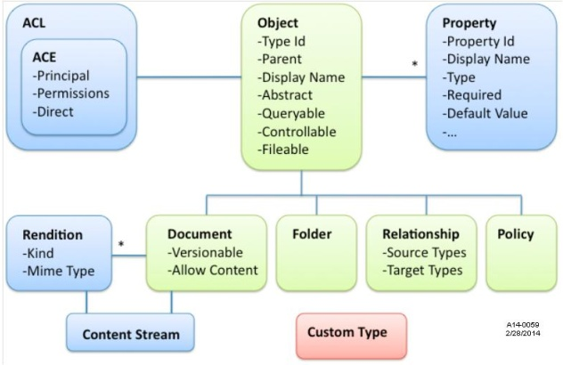
Figure 75. CMIS Meta Model

Client Communication
Client Communication (Secure Inbox) is a cross track capability built to view outgoing communications (notices) from NYSOH.

Secure Inbox allows users to view notices in the Message section of the application. Notices are stored in PDF format in Apache Chemistry OpenCMIS. A hyperlink is created for each document using the DCN, which once clicked, retrieves the document from Apache Chemistry OpenCMIS and displays to the user as a PDF.

The message text will be bold if unread. Once the user clicks the message, it is marked as read and displayed as normal text.

An email is then sent to users notifying them of all new notices so they can check the message using the web application.

Operational Scenarios
Business process models are a graphical representation of a business process and are created by business users to represent the sequence of tasks performed from initiation to completion for a given process.

Detailed representations of models are provided within the RSD documents and updated as applicable for the business functionality contained in a given release.

The NYSOH SDD includes the Business Process Management (BPM) models developed for each release referenced as an SDD attachment. The BPM flows are those developed and provided to the State as part of the FDD/RSD concurrence process and modified for any changes made during development.

An overview of the business processes and functions provided by the NYSOH system is introduced by Figure 76, Figure 77, and Figure 78.

The BPM models developed and included/referenced in the release-specific sections of the SDD further detail the operational details and time sequencing of process steps. Customer Service leverages the Individual EE and SHOP flows shown.

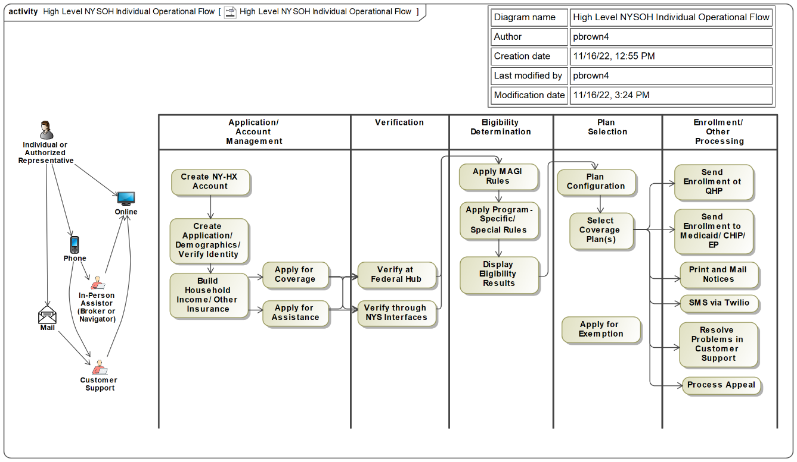
Figure 76. High Level NYSOH Individual Operational Flow

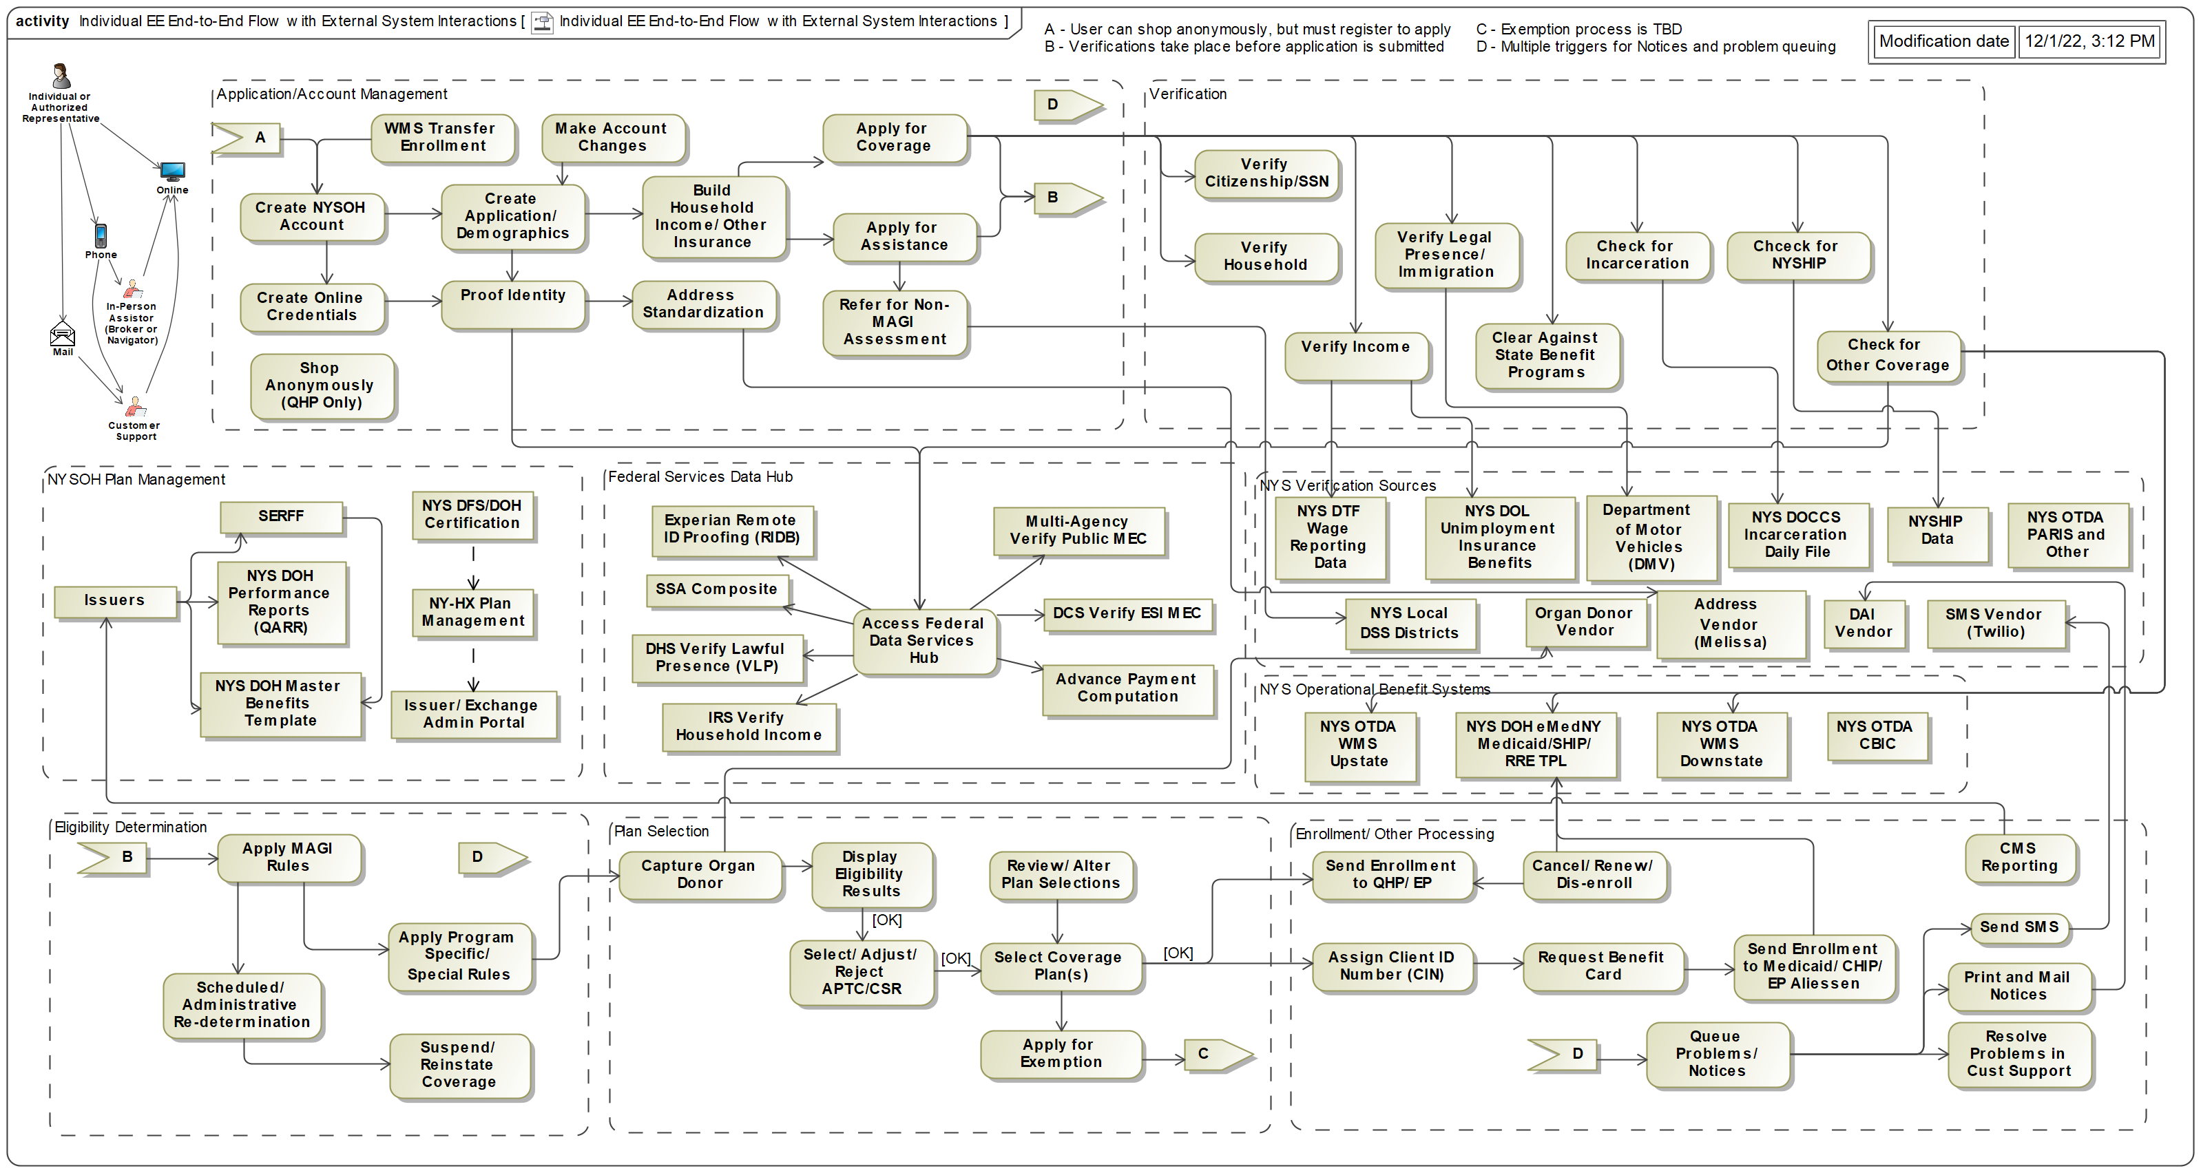
Figure 77. High Level Individual End-to-End Operational Flow (Subsidized EE)

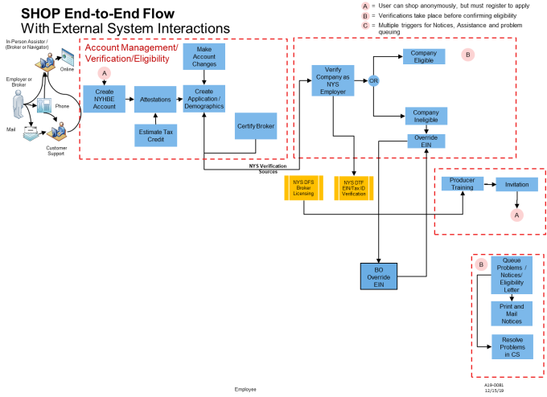
Figure 78. High Level Small Business End-to-End Operations Flow

An outline of the business areas covered by the NYSOH system is shown in Figure 3. The following sections provide details of these business areas.

Anonymous Plan Search
The NYSOH System allows someone to come in and anonymously determine the plans for which they might be eligible (Figure 79).

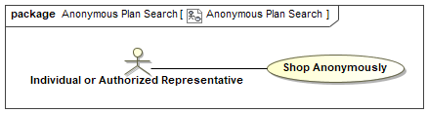
Figure 79. Anonymous Plan Search

The search scenario is shown in Figure 80; the user, interacting with the Individual Portal, enters the search parameters and initiates the search. The portal identifies the plans meeting the search criteria and returns information about the identified plans. The browser then displays the information to the user, who may choose to change the search parameters and search again.

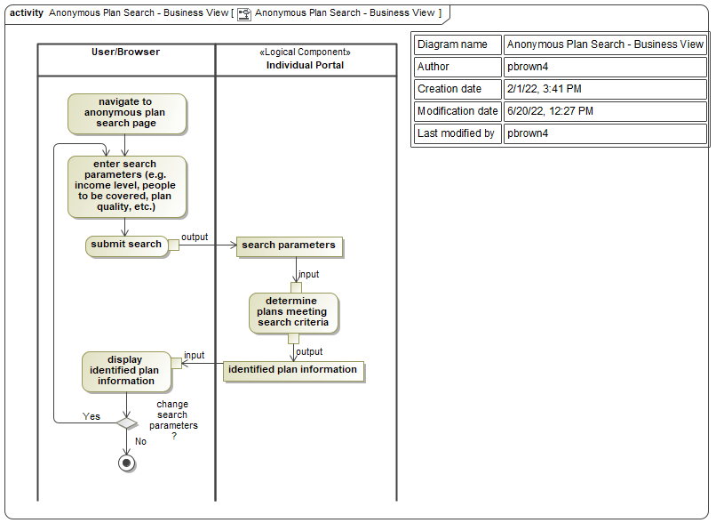
Figure 80. Anonymous Plan Search - Business View

The technical details of this interaction are shown in Figure 81. The user interacts with the browser, enters the parameters to be used in the search (e.g., income level, people to be covered, plan quality, etc.) and initiates the search. The browser posts to /searchAnonymousPlan/search and the Spring MVC Dispatcher invokes SearchAnonymousPlanController.searchAnonymousQuotes(). The figure shows the subsequent execution. The referenced diagrams (getSearchMetaInfo and searchPlans) can both be found in the NYSOH System MagicDraw Model. Both are children of the PMPlanServiceImpl class in the model.

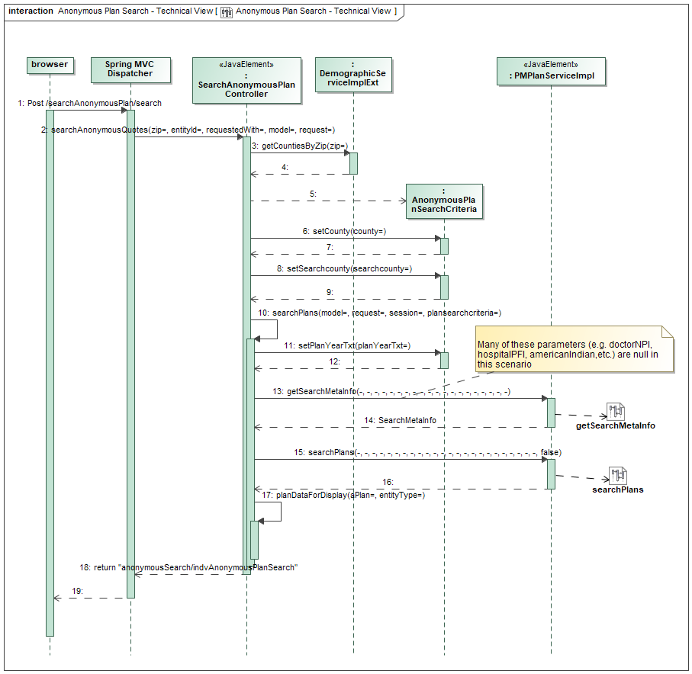
Figure 81. Anonymous Plan Search - Technical View

Manage Individual Plan Membership
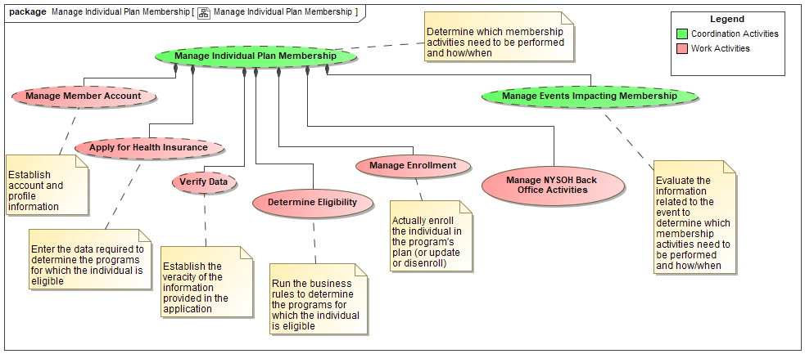
Figure 82. Manage Individual Plan Membership

Apply For Health Insurance
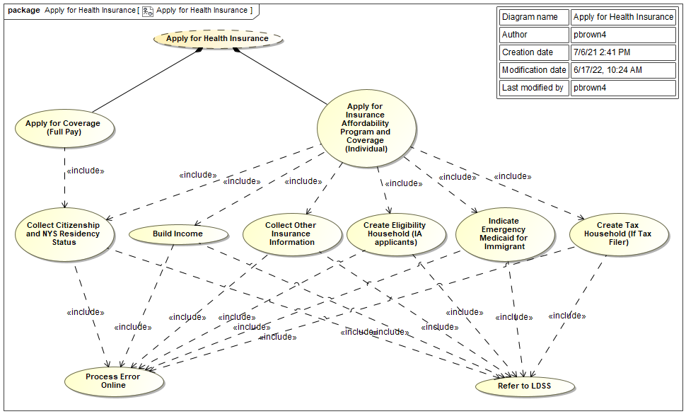
Figure 83. Apply for Health Insurance

Verification
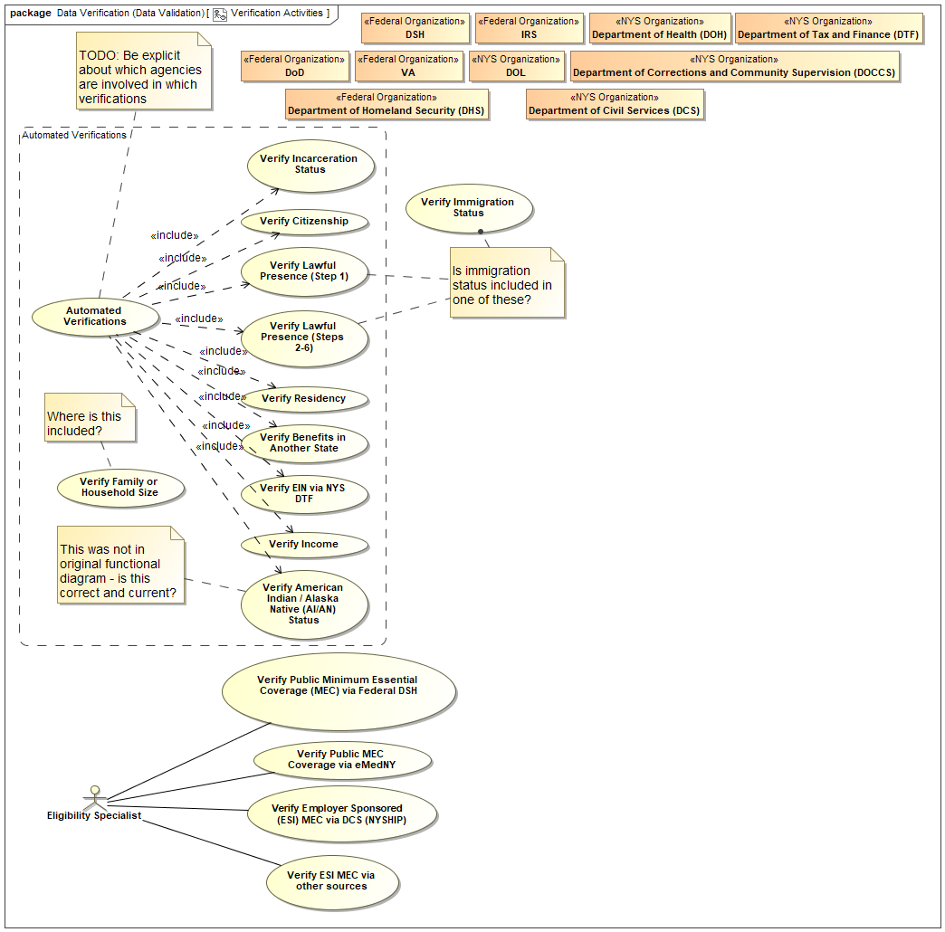
Figure 84. Verification Activities

Eligibility
Determining eligibility breaks down into a number of use cases as shown in Figure 85.

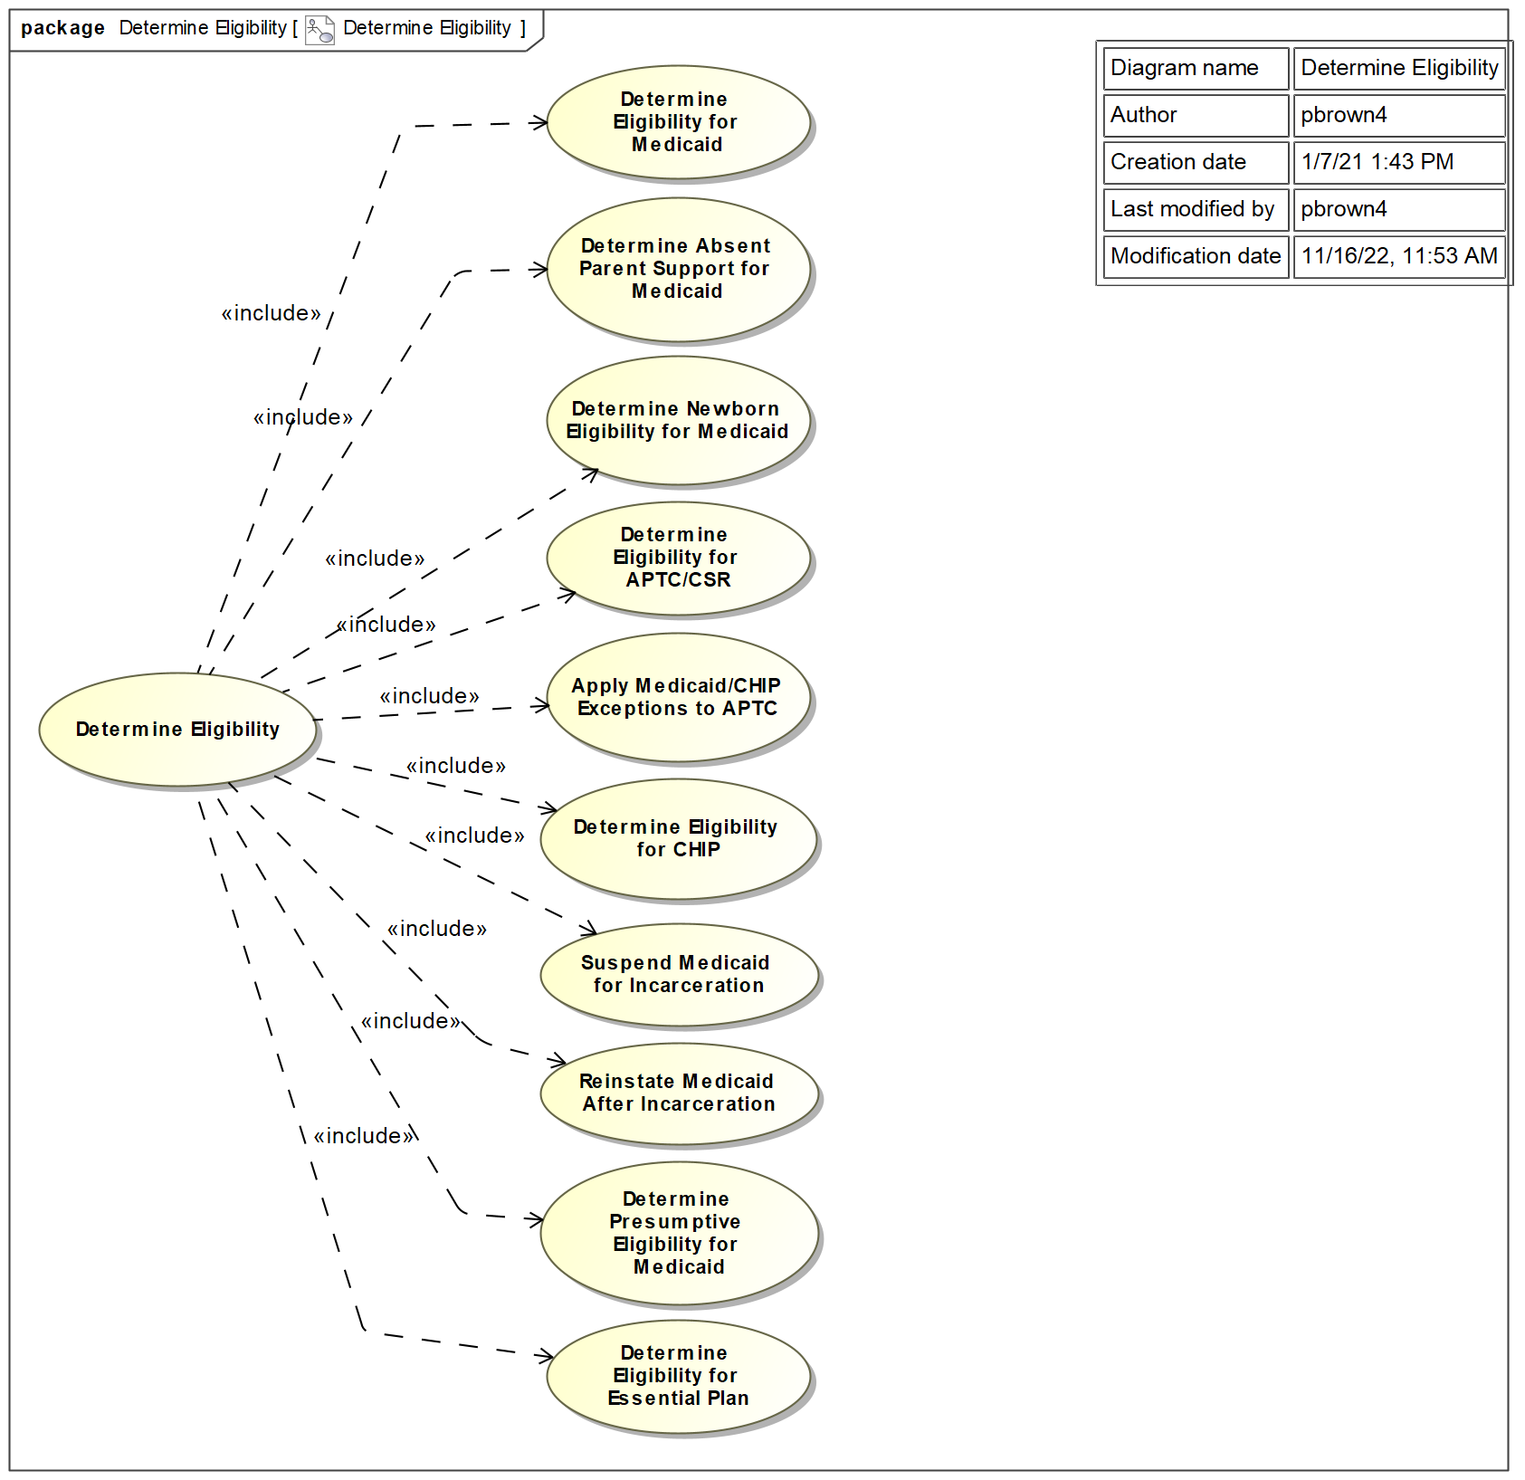
Figure 85. Determine Eligibility

Business rules defined within the NYSOH application are documented within the RSDs/TSDs. The version history and controlled versions maintained in EWM. The following Business Rules documents are updated and re-baselined as required for each NYSOH release:
- NYSOH TSD_Eligibility Determination Date Adjustment Rules_CRXX.docx
- NYSOH TSD_Eligibility Determination Household Comp_CRXX.docx
- NYSOH TSD_Eligibility Determination Income_CRXX.docx
- NYSOH TSD_Eligibility Determination Post Eligibility Rules_CRXX.docx
- NYSOH TSD_Eligibility Determination Public MEC_CRXX.docx
- NYSOH TSD_Eligibility Determination Special Rules_CRXX.docx
- NYSOH TSD_Eligibility Determination Summary_CRXX.docx
- NYSOH TSD_Eligibility Determination Verifications_CRXX.docx
- NYSOH TSD_Enrollment_Disenrollment_Cancellations_Updates_CRXX.docx
- NYSOH TSD_Eligibility Determination Batch Frozen_CRXX.docx
NOTE: File names containing ‘CRXX’ are updated with each release to reflect the appropriate Release ID (i.e., CR16, CR18, CR19)

Enrollment
The Enrollment use cases are shown in Figure 86. This diagram also indicates the notifications that are sent to CMS, DOH, and Issuers as a consequence of enrollment activities.

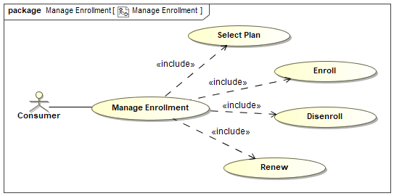
Figure 86. Manage Enrollment

Plan Selection
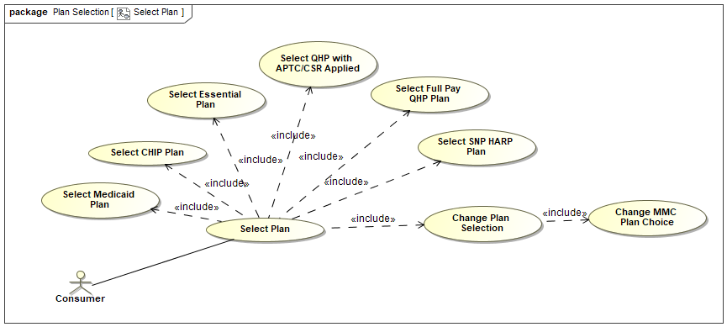
Figure 87. Select Plan

Enrollment
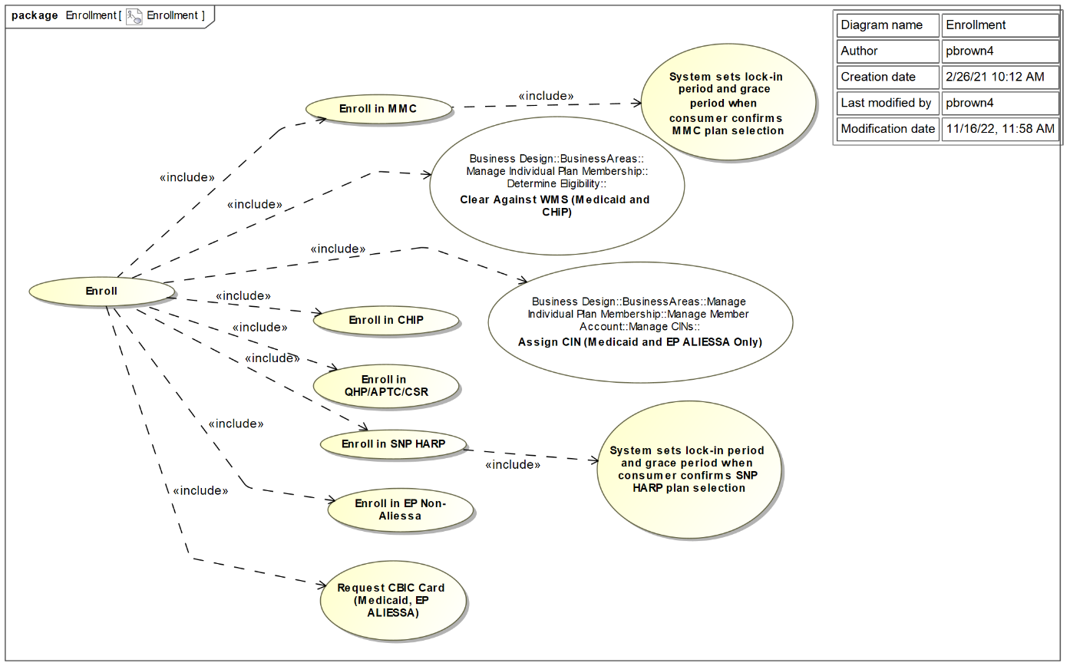
Figure 88. Enrollment

Disenrollment
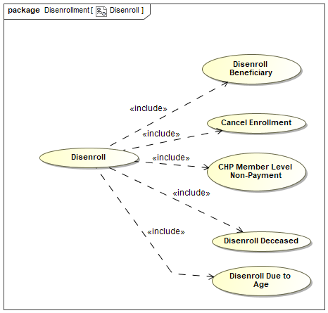
Figure 89. Disenroll

Cancel Enrollment

CHP Member-Level Non Payment
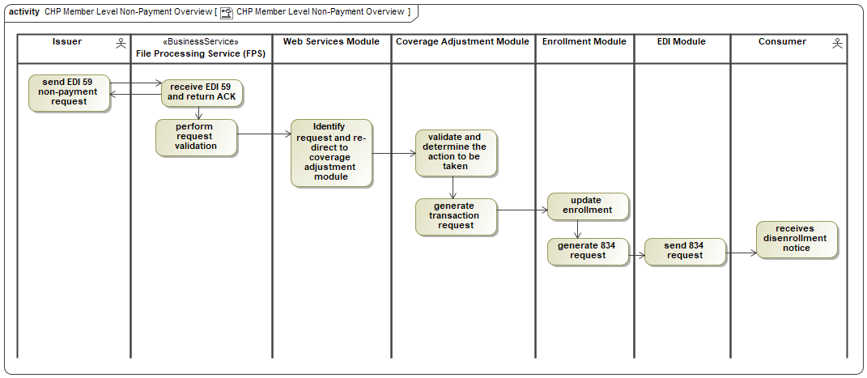
Figure 90. CHP Member Level Non-Payment Overview
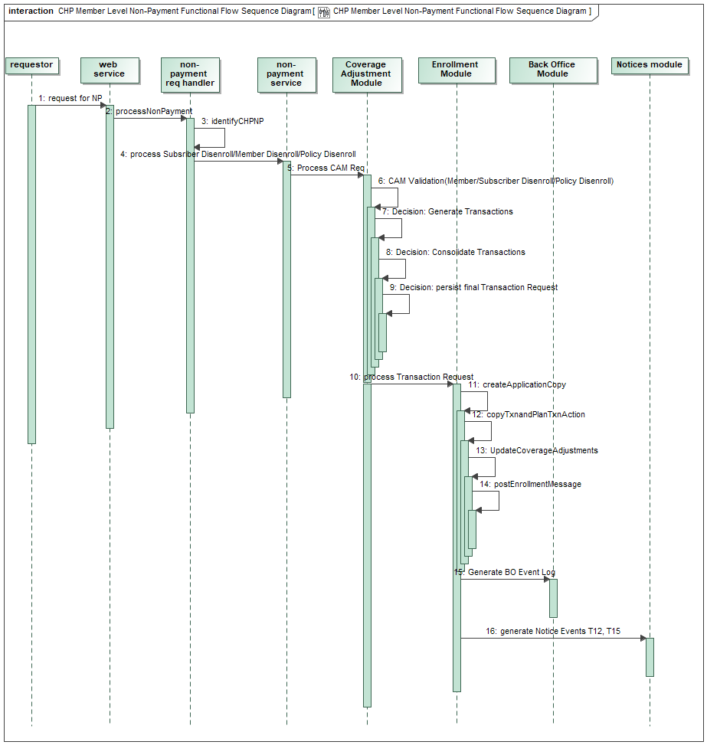
Figure 91. CHP Member Level Non-Payment Functional Flow Sequence Diagram
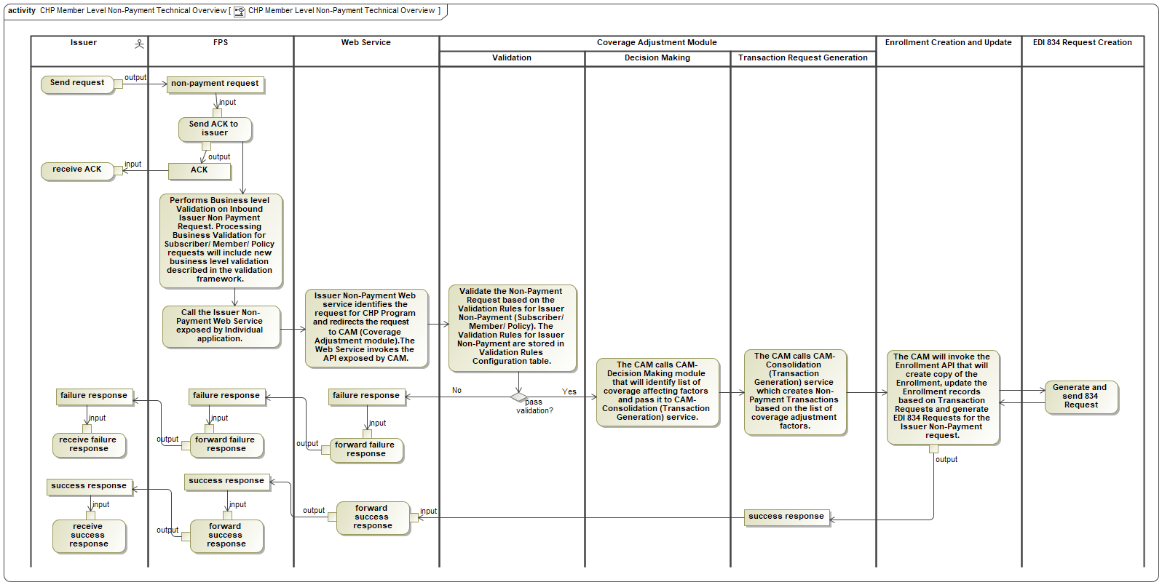
Figure 92. CHP Member Level Non-Payment Technical Overview

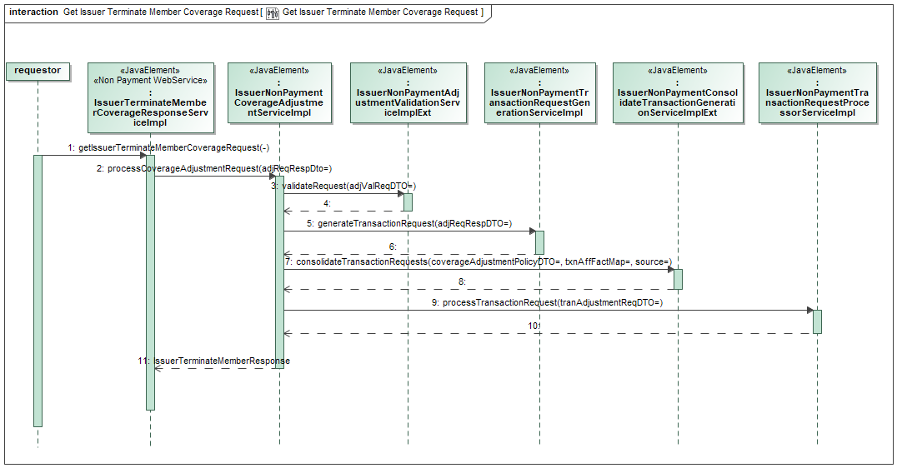
Figure 93. Get Issuer Terminate Member Coverage Request

Disenroll Beneficiary

Disenroll Deceased

Disenroll Due To Age

Renewal and Change
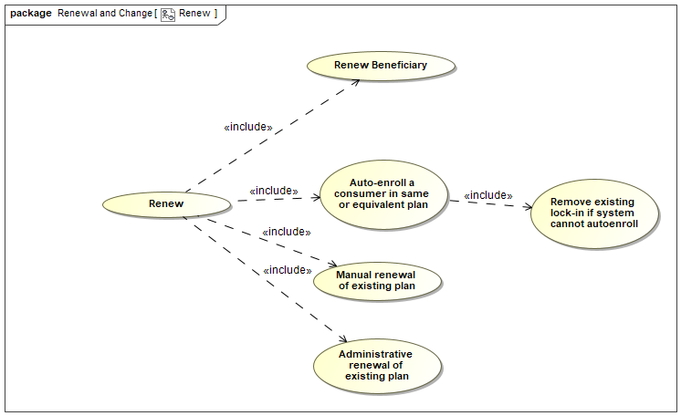
Figure 94. Renew

Manual Renewal of Existing Plan

Administrative Renewal of Existing Plan

Auto-Enroll A Consumer In Same or Equivalent Plan

NYSOH PARIS Quarterly Process

Manage Appeals
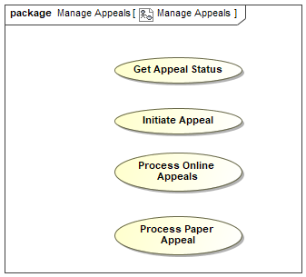
Figure 95. Manage Appeals

Manage Events Impacting Membership/Eligibility
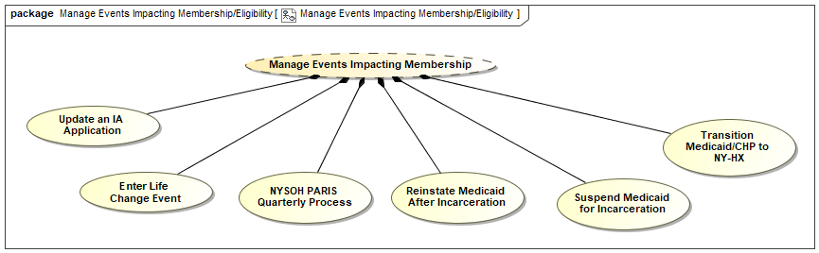
Figure 96. Manage Events Impacting Membership_Eligibility

Manage Member Account
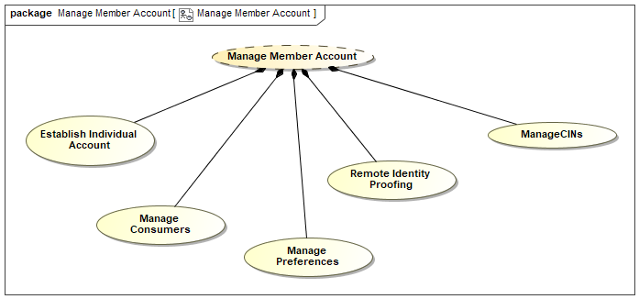
Figure 97. Manage Member Account

Manage CIN Activities
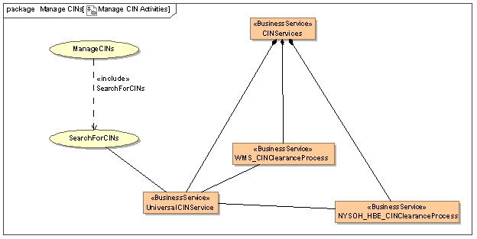
Figure 98. Manage CIN Activities

Manage NYSOH Back Office Activities
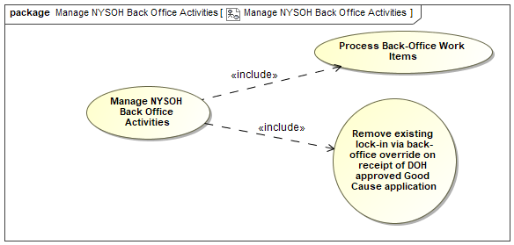
Figure 99. Manage NYSOH Back Office Activities

Manage Provider Encounters
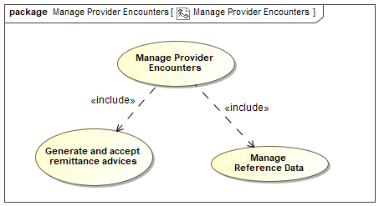
Figure 100. Manage Provider Encounters

Manage Plan Information
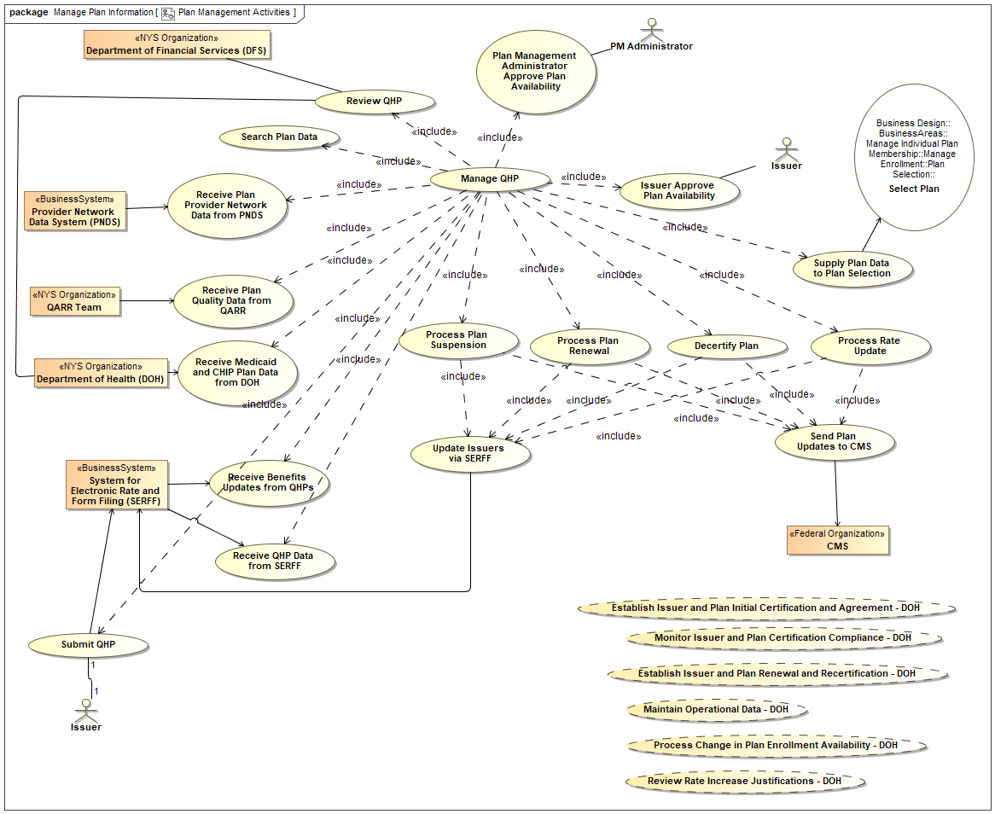
Figure 101. Plan Management Activities

Manage PM Account
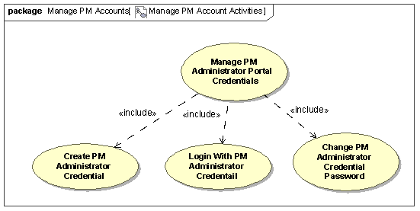
Figure 102. Manage PM Account Activities

Manage Reporting
The system level goals of the NYSOH Reporting Capabilities are to:
- Analyze process and outcomes for eligibility determination, enrollment, and plan selection
- Enable operational assessment
- Conduct long-term evaluation of the Marketplace
These capabilities enable data collection and reporting tools to facilitate implementation of:
- Oversight and Monitoring Policies and Procedures and Financial Integrity Provisions
- Reporting Required Outcome Metrics to Center for Consumer Information and Insurance Oversight (CCIIO)
- Supplemental State Based Marketplace (SBM) Data Collection
- Outcome Metrics and/or Supplemental Data Collection

Provision of this cross-track capability is necessary to:
- Maintain Internal Policies and Procedures for the Operational Business Units
- Ensure Adherence to Established Federal ACA Regulatory Guidelines
- Conduct Internal Operational Audits; Verify Business Unit Adherence to Established Policy and Procedures; Focus on Internal Controls:
- Plan Management - Provider Network Adequacy, Rate Setting
- Individual Marketplace - Federal Poverty Level (FPL), Advanced Premium Tax Credit (APTC), CSR
- Small Business Marketplace - Eligibility, 834
- Operations:
- Financial Management (FM): Accounts Receivable (A/R), Accounts Payable (AP), Dunning, General Ledger, Financial Statements, 820
- Contracting: Navigator agreements
- Oversight and Reporting - Reporting Metrics, Form 1095, COGNOS Data Integrity
- Appeals - Correspondence Turnaround Time

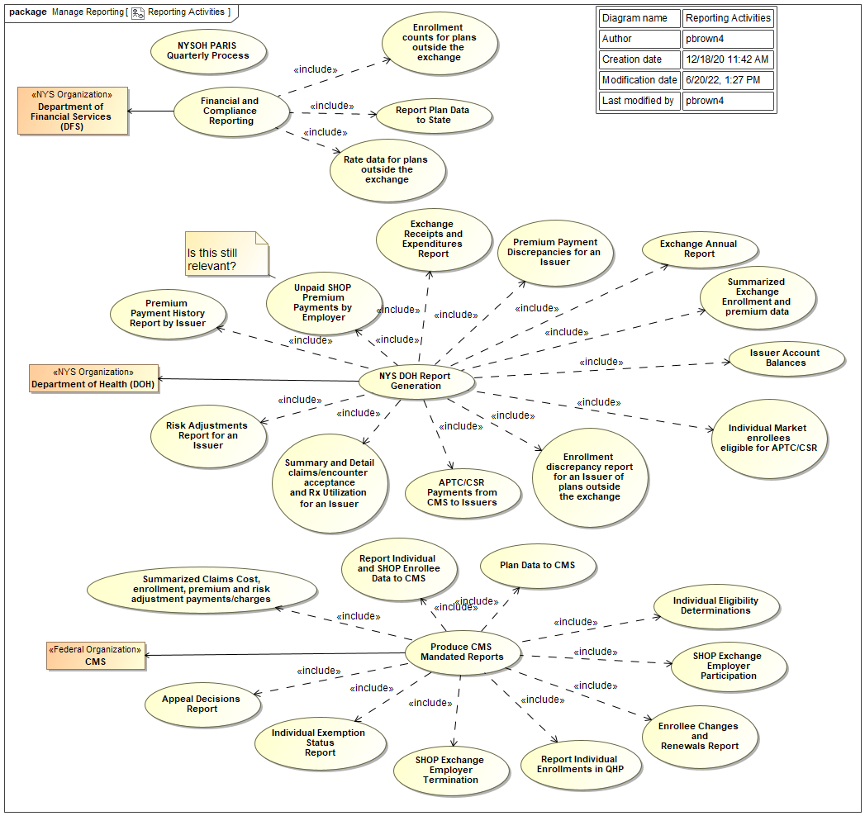
Figure 103. Reporting Activities

Figure 104 is the reporting infrastructure that allows the Oversight & Reporting Releases to satisfy their allocated requirements. Details regarding specific reports designed and developed, access to these reports, scheduled execution or upon demand, and retention are included in release-specific sections of this SDD. The Reporting Database in Figure 104 is referred to as “RPT” in subsequent sections and the Snapshot Process is the mechanism by which the Reporting Database is updated nightly from the operational NYSOH Database.

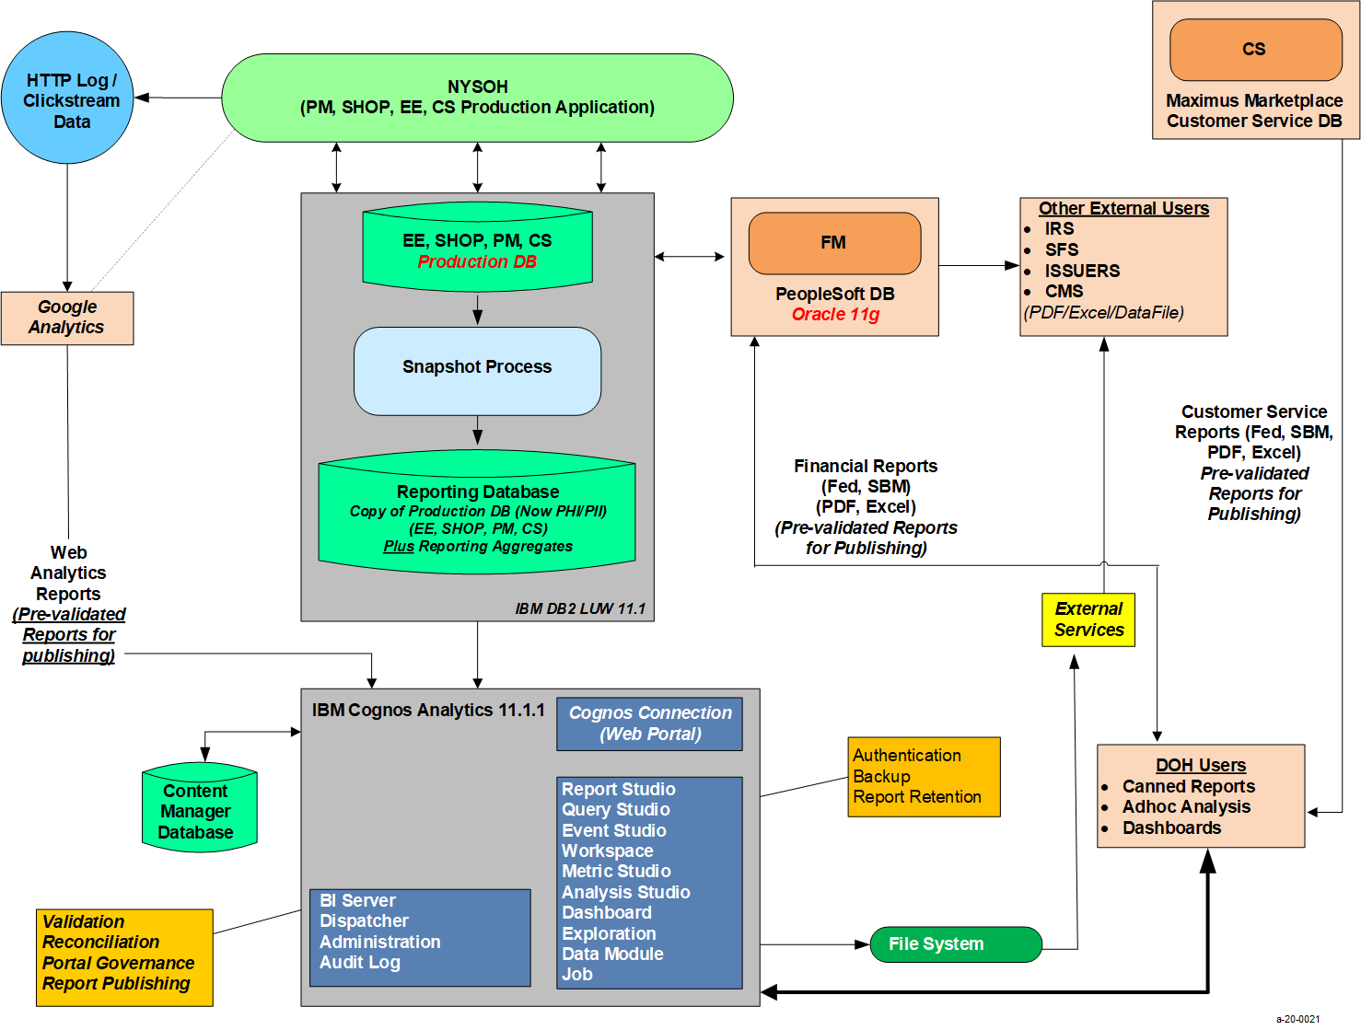
Figure 104. NYSOH Reporting Operational View

Both the inbound and outbound data processing flows are depicted in Figure 105.

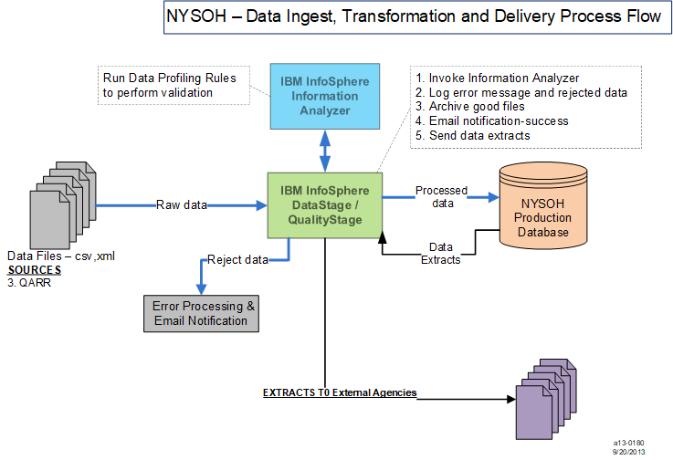
Figure 105. DataStage - Load Process

Master Sequence Jobs are “wrapper” jobs that invoke other jobs in a sequence. Since inbound jobs have an event dependency for a file to be available, the first job in the master sequence waits for the file. Once the file becomes available in the specified file system location, the job senses it and starts the next job in the sequence. Figure 106 is an example of a job sequence used in the Quality Assurance Reporting Requirements (QARR) process. The DataStage jobstep labeled Execute_Command_126 is a Unix Command step. This step contains Unix command code to determine if the QARR inbound file process has resulted in an error or was successful. If successful, the inbound file will be moved to an archive folder. If the process results in an error, the file will be moved to an error folder. In both cases, the inbound file name will have the current timestamp appended.

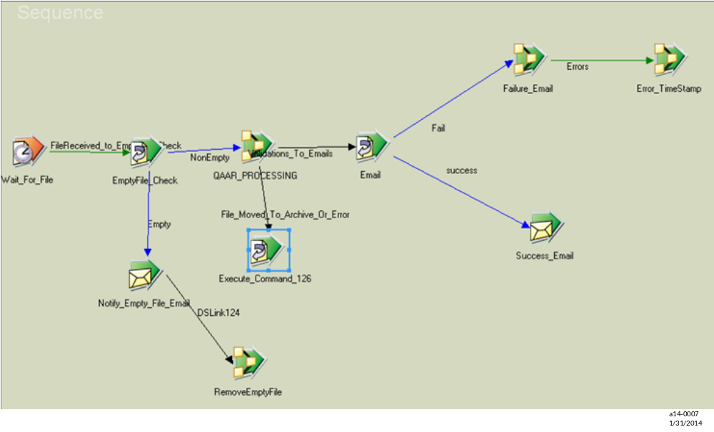
Figure 106. Sample QARR Data Stage Job Sequence

Manage Notices
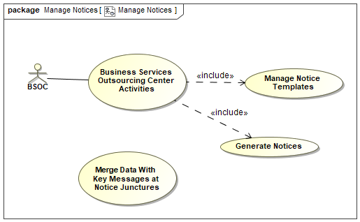
Figure 107. Manage Notices

Manage Small Business Marketplace
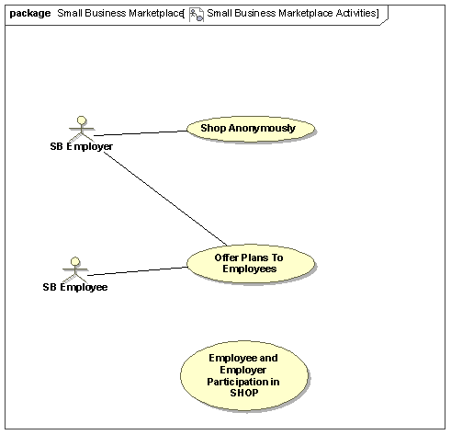
Figure 108. Small Business Marketplace Activities

Manage SB Accounts
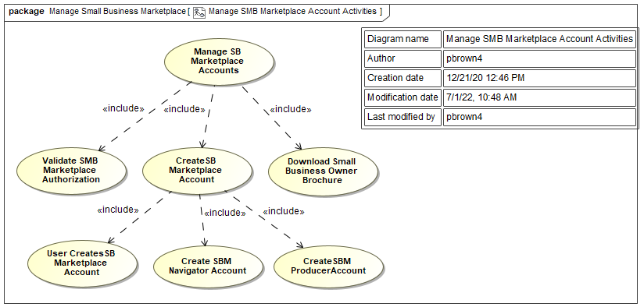
Figure 109. Manage SMB Marketplace Account Activities

Manage CSR Accounts
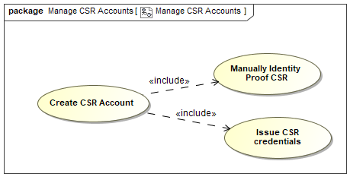
Figure 110. Manage CSR Accounts

Manage Brokers/Assistors
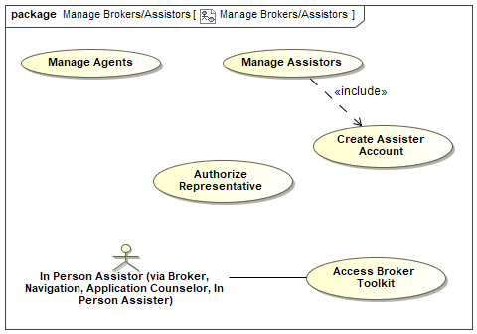
Figure 111. Manage Brokers_Assistors

Manage NYS and NYSOH System Access
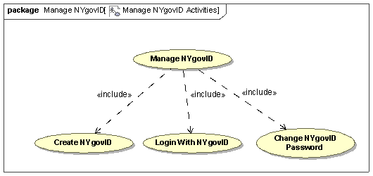
Figure 112. Manage NYgovID Activities

Common Support Services
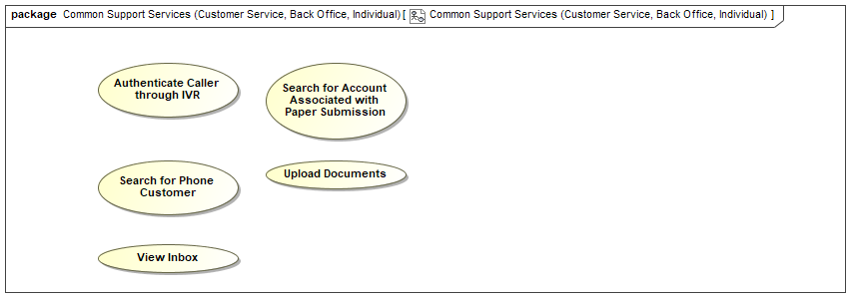
Figure 113. Common Support Services (Customer Service, Back Office, Individual)

System Management Activities
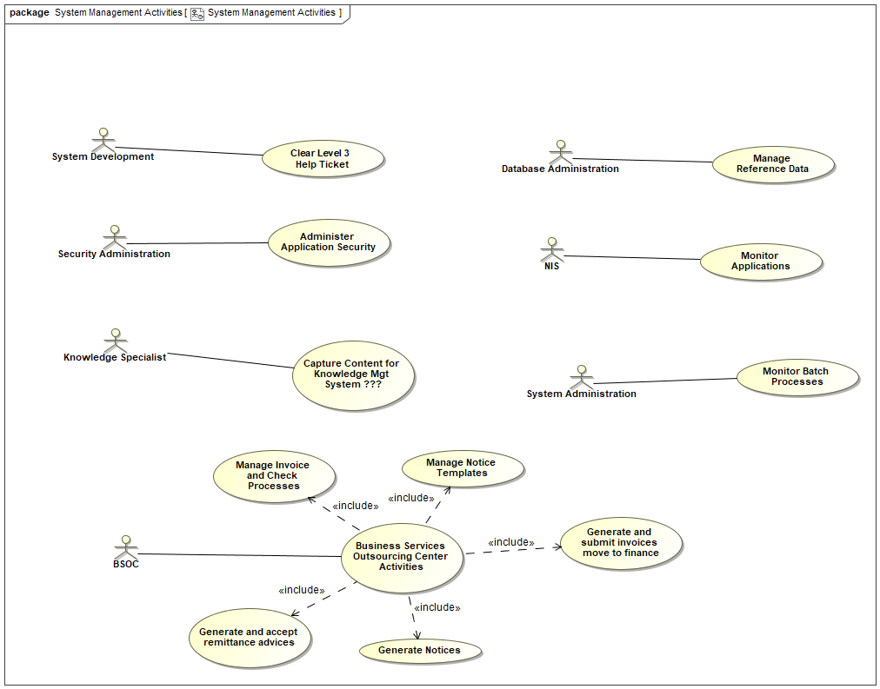
Figure 114. System Management Activities

Notices
Notices are communications from NYSOH providing information to consumers about their eligibility and enrollment for health insurance coverage through NYSOH. Notices are produced daily for the consumer and DOH through a series of batch jobs for activities that occurred on the NYSOH site the previous day. The events created by the prior day’s activities determine which notice template is to be generated. Notices are created in PDF and PostScript, PS, file formats. A PDF is created for all notices in the daily batch and are uploaded to consumer accounts in OpenCMIS, Content Management Interoperability Services, the NYSOH Document Management System, for access by DOH, MAXIMUS, and the consumer. OpenCMIS is an OASIS, Organization for the Advancement of Structured Information Standards, standard enabling information sharing between different content management systems.

Consumers can select their communication preference, either paperless (electronic) or paper, in their account. For consumers that select paperless communications, an email alert is sent informing the consumer that a new notice has been uploaded to their account. For any email returned due to an invalid email address the notice is regenerated in paper format and that consumer will receive notices in paper until their email address has been corrected. The invalid email job is run prior to the start of the notice processing. For consumers that select paper communications, a PostScript version is created in addition to the PDF file. PostScript files are sent to BSOC, Business Services Outsourcing Center operated by GDIT, for printing and mailing.

NYSOH uses the two systems listed below to create the PDF and PostScript files for notices.
- Legacy – a system that was created by NYSOH and has the ability to send notices in English and Spanish only.
- OpenText – a software product that provides the capabilities of creating notices in multiple languages. Currently NYSOH creates notices in the following languages: Arabic, Bengali, Polish, French, Russian, Traditional Chinese, Simplified Chinese, Urdu, Spanish, Korean, Italian, Haitian-Creole and English.

USPS returns mail that is undeliverable. i.e., bad address, customer move, etc. to MAXIMUS. MAXIMUS scans the QR, quick response, code on the notice into a file that is sent to GDIT for processing the next day, i.e., the file created for Monday’s return mail is processed by GDIT on Tuesday. When GDIT processes the undeliverable mail file, tables are updated with an error code per the DOH business rules which determines which notice will be regenerated and resent to the consumer using the address found in Melissa Data. GDIT sends MAXIMUS a response file after processing.

For consumers who selected paperless (electronic) delivery for their notices, NYSOH sends the consumer an email stating a new document is available in their account for viewing. NYSOH receives bounce-back emails for an invalid email address as well as user responses such as “out of office” response, return receipt, etc. For any email returned to NYSOH due to an invalid email address, NYSOH updates that consumer’s communication preference to paper and regenerates the notice with a cover page for delivery in paper. The consumer will continue to receive their notices in paper until they update their email address in their account and change the communication preference back to paperless.

Figure 115 provides a high-level overview of the process for creating notices. Each job that is run is described in subsequent sections.

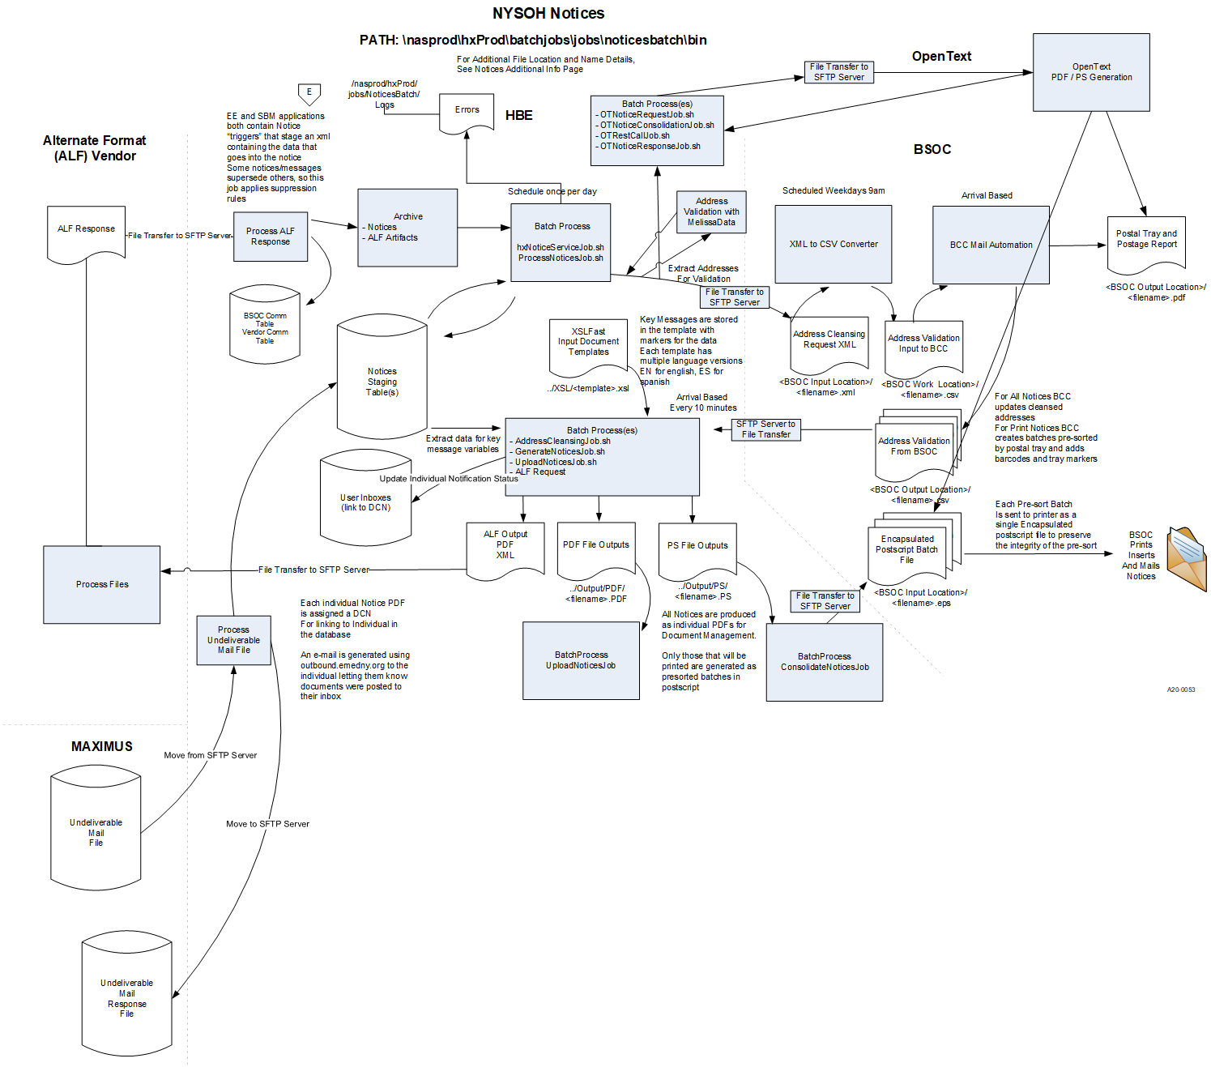
Figure 115. Notices Process

Operational Design Patterns

System Clock Pattern
Much of the NYSOH business activity is centered around periods of time that applicants have to respond to requests. Some terminology has developed to simplify the discussion of business requirements and the corresponding system design. Chief among these terms is the notion of a System Clock.

A System Clock is a day-level timer characterized by three major attributes: the creationDate (the date on which the clock was created, i.e., the start date for the clock); the dueDate (the date on which the requested activity is supposed to be completed); and the scheduledOn date (the date at which the system will actually check to see whether the activity has been completed). The scheduledOn date is the dueDate plus a grace period.

System Clocks come in two flavors: Deterministic Clock (or just Clock) and Non-Deterministic Clock. A Deterministic clock is a clock that was created as a result of some consumer action. A Non-Deterministic Clock is a clock that was created as a result of some system-initiated action such as a regularly scheduled query of some external information such as Social Security Administration records.

Figure 116 shows the assortment of clocks presently in use within the NYSOH system. Most clock names identify the nature of the information related to the clock and the time interval in days between the creationData and the dueDate for the particular clock. Thus the Deterministic Clock named Citizenship_90 is a clock created as a result of the consumer taking some action within the system that requires the consumer to provide proof of citizenship within 90 days.

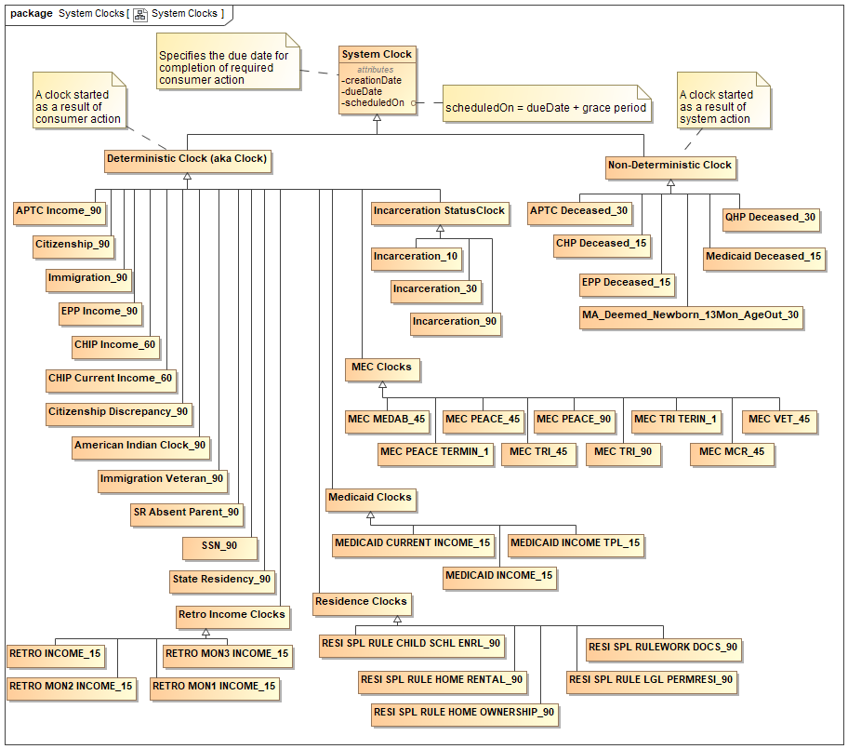
Figure 116. System Clocks

External Interface Operational Scenario Design Patterns
External services provided by NY State Agencies connect to the MuleSoft for HTTPS web services transactions and to IBM MQ FTE for SFTP transactions. Java-based applications are supported by JBOSS EAP and web services are managed by WebSphere Service Registry and Repository (WSRR). NYSOH utilizes IBM DB2 as the relational database.

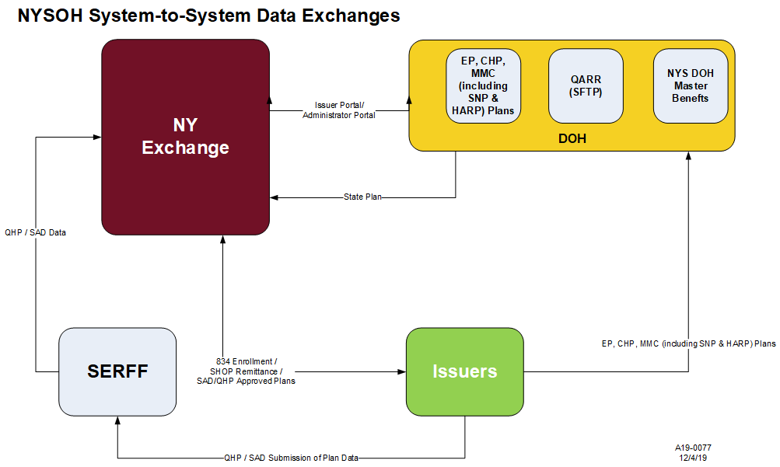
Figure 117. High Level Business Process for Plan Management, FM, and Small Business and Individual Marketplaces

EDI Pattern for 834 Enrollment and Maintenance (EDI example)
The EDI 834 transaction set represents a Benefit Enrollment and Maintenance document. It is used to enroll members into healthcare benefit plans. Transactions leveraged by the NYSOH include:
- New enrollments.
- Changes in a member’s enrollment.
- Reinstatement of a member’s enrollment.
- Disenrollment of members (i.e., termination of plan membership).

Additional design details relating to the use of the 834 transaction listed above can be found in the FDD titled EE68 FDD_Enrollments/Disenrollments/Cancelations/Updates.

The diagrams below provide the technical implementation and transaction flow for 834 Provider transactions. Both outbound and inbound transaction diagrams are shown.

Figure 118 details the X12 EDI Outbound processing.

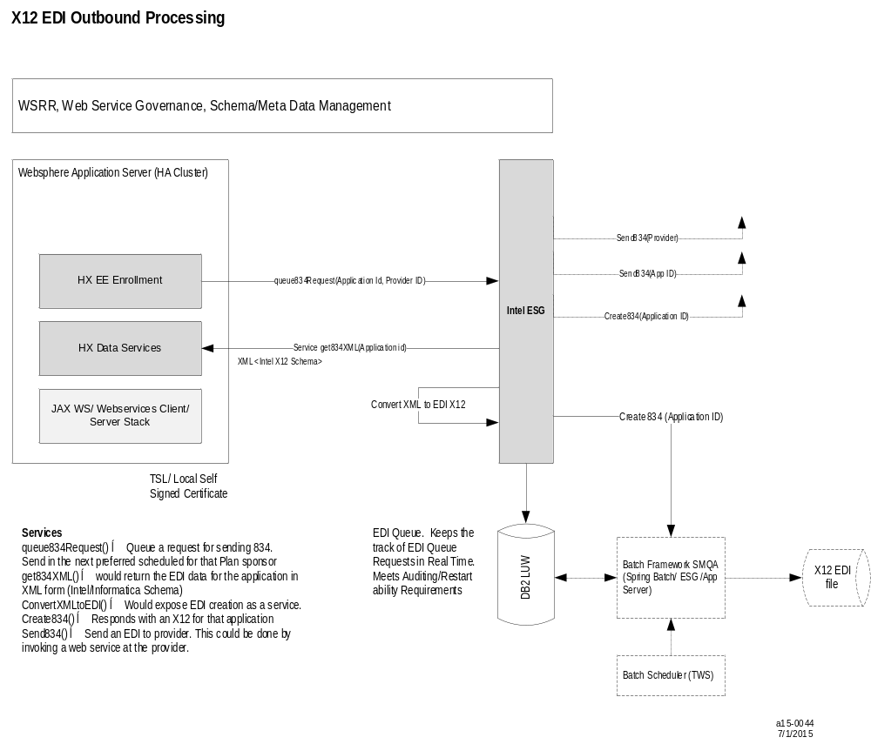
Figure 118. X12 EDI Outbound Processing

Figure 119 details the X12 EDI Incoming Processing.

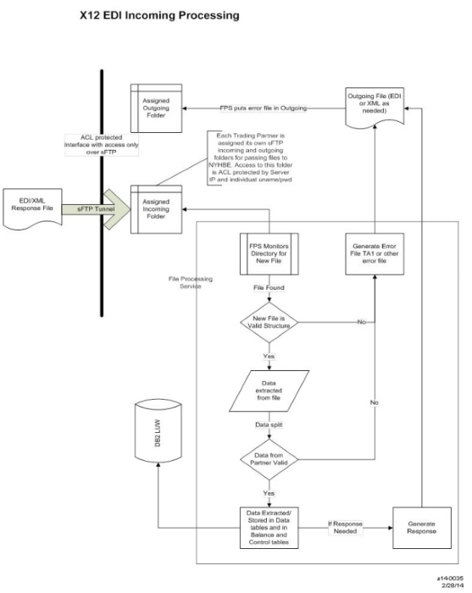
Figure 119. X12 EDI Incoming Processing

Internal Services Implementation Pattern
Figure 120 describes two service contract implementation patterns for exposing internal services.

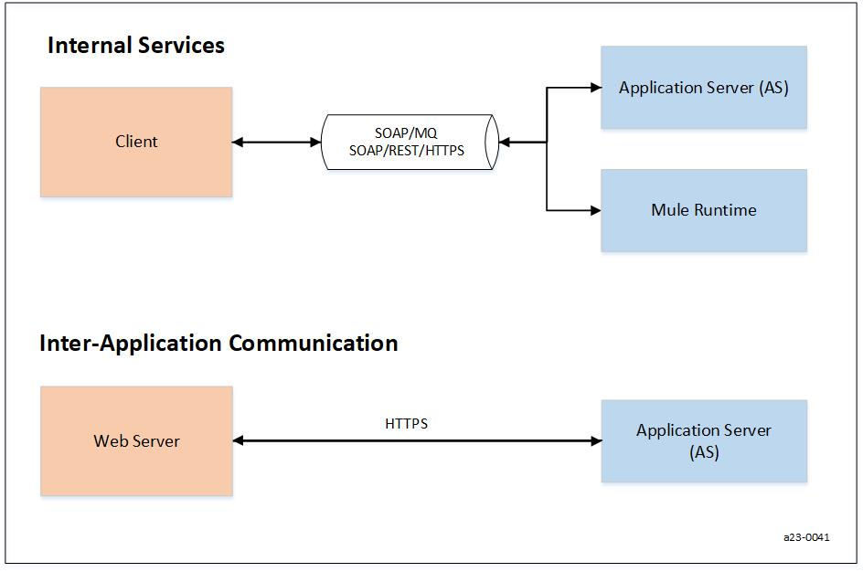
Figure 120. Internal Services Implementation Pattern

External Outbound Services (real-time and file transfer)
Figure 121 describes the inbound and outbound implementation and communication patterns for both real-time transactions and file transfers.

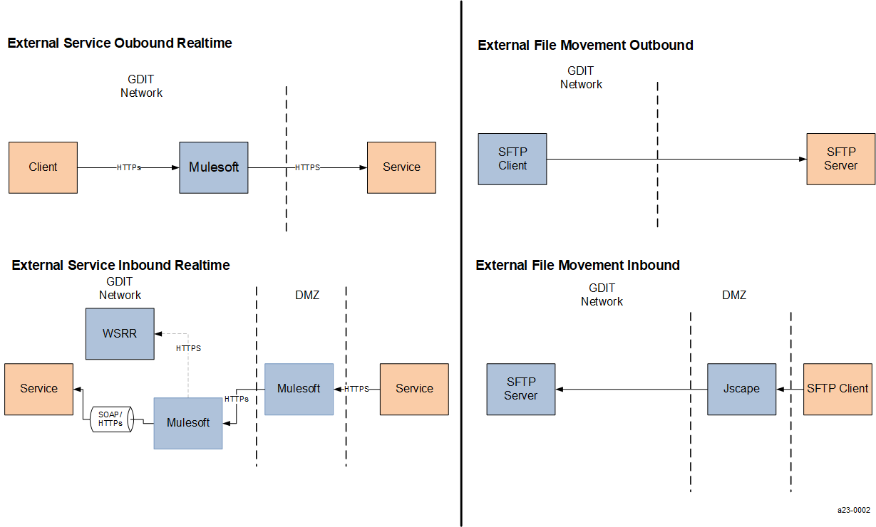
Figure 121. External Outbound Services (real-time and file transfer)

Communication Interface Using Two-Way File Transfers
This section describes an example of files being exchanged between the NYSOH and an External State Agency, specifically, the interface between NYSOH and DOCCS.

DOCCS Interface Requirements
This interface exchanges three files:
- DOCCS to NYSOH – daily Under Custody file containing all inmates.
- DOCCS to NYSOH – daily Released file containing release data for all inmates released on the prior day.
- NYSOH to DOCCS – daily Suspend file containing Medicaid suspension data.

Daily files are sent seven days per week, 365 days per year.

Figure 122 shows the transactions used for this interface. Data files are transferred between NYSOH and DOCCS using SFTP.

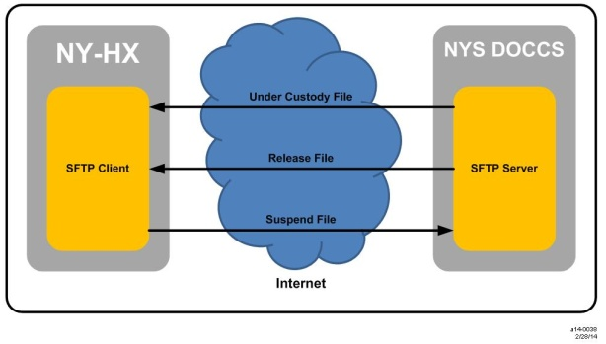
Figure 122. NYS Department of Corrections and Community Supervision (DOCCS) Interface

Example of Web Service Hosted by eMedNY
The NYSOH must determine the Minimum Essential Coverage (MEC) for an applicant to meet the individual responsibility requirement under the ACA. To accomplish this, NYSOH consumes a web service hosted by eMedNY to retrieve data from DOH systems as depicted in Figure 123.

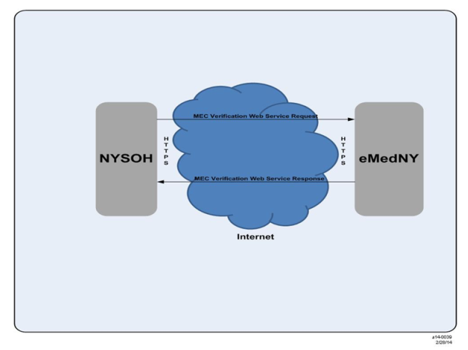
Figure 123. MEC Web Services Hosted by eMedNY

Detailed Design

Hardware Detailed Design
[Content will be added in a future release]

Software Detailed Design
The details of the software design are described in a number of documents: FDDs, RSDs, TSDs, and SDSs. To place the use of FDDs, RSDs, and TSDs in historical context, initially, the NYSOH design methodology was based upon a singular document, the FDD, which contained business requirements (user stories) jointly developed with the NYSOH Product Owners and SMEs. Then, functional design details such as business process flows, UI panel layouts, and business rule definitions were added to the FDD and jointly reviewed and baselined. A UDD which contained the detailed software component specification was then created, as necessary, to document lower level software design details.

Shortly after the October 1, 2013 Health Exchange go-live, a methodology process improvement was implemented whereby an RSD and a TSD pair was defined. The RSD is developed closely with the NYSOH Product Owners and SMEs and baselined with the functional requirements (now described as shall statements instead of user stories) for a piece of work.

The TSD contains the functional design specification details previously resident in the FDD, and includes some of the detailed design details previously in the UDD. The TSD is iteratively developed and finalized during the detailed design, coding, unit testing, and informal integration activities. In certain cases where complexity warrants, a UDD may still be created to capture additional design details.

TSDs are generally named with the specific CR to which they relate included in the document name. In the cases where this is not true, such as NYSOH TSD_Back_Office_Role_Provisioning_R8.xls, NYSOH TSD_Referrals_CR8.docx, and NYSOH TSD_Eligibility Determination Income_CR8.docx, this is because these are "living" TSD documents containing capabilities that are updated as a consequence of other specific CRs. The release for which they have been updated was appended to the TSD name and the document history section inside the TSD describes what changed and for which CR(s). This process is described in "NYSOH Document Naming Convention" which is posted on the NYSOH PAL.

More recently, TSDs were replaced by Technical Design Documents (TDD), which in turn were replaced by Software Design Specifications (SDS).

These documents that provide more detailed design specifications are available in the NYSOH IBM Rational CLM Engineering Toolset document.

Security Detailed Design
The following paragraphs describe how authentication, authorization, logging and auditing functions are handled by the NYSOH system.

Unified Access Management (UAM) functionality includes creating credentials for all users who access NYSOH, including both front end and back end users. It implements the State Enterprise Identity and Access Management (EIAM) solution NY.Gov ID for all front end users using Security Assertion Markup Language (SAML) 2.0 security assertion between NY.Gov ID and NYSOH.

Front End Users using NY.Gov ID
All users who access NYSOH via the internet use NY.Gov ID, including the following:
- AAL1 - Failed Cases
- AAL2 - Individual/Employee
- AAL2 - Producer/Navigator/Employer/Issuer Rep/Broker/CAC (Certified Application Counselors)

Currently, NY.Gov ID is used for user credentials for many NY State agencies such as the DTF, the Department of Labor (DOL), and the Department of Motor Vehicles (DMV). NYSOH uses existing SAML-based browser redirect patterns established by NY.Gov ID for authentication along with hCentive Spring security for authorization.
The following steps take place for authentication:
- User accesses NYSOH and attempts to access a protected resource.
- User is presented with the option to login (if user already has a NY.Gov ID account) or to create a new NY.Gov ID account.
- NYSOH generates a SAML Request with RelayState and the user’s browser is redirected to NY.Gov ID. SAML Request is the authentication request and RelayState is the Uniform Resource Locator (URL) the user accessed.
- If the user does not have a NY.Gov ID account, the user’s browser is redirected to the NY.Gov ID login page. After successful authentication, the user is redirected back to PingFederate (the NY.Gov ID federation server).
- PingFederate validates the user’s SiteMinder session cookie and after successful validation, generates SAML 2.0 Response with the authenticated user’s NY.Gov ID information as attribute name-value pairs.
- PingFederate then posts the SAML 2.0 assertion to NYSOH via browser redirect (HTTPS form POST).
- NYSOH web application or assertion consumer service verifies the signature of SAML 2.0 assertion, gathers the users’ attribute name-value pairs that the application requires and creates a session in the NYSOH security domain.

Figure 124 details the validation process for front end users via NY.Gov ID.

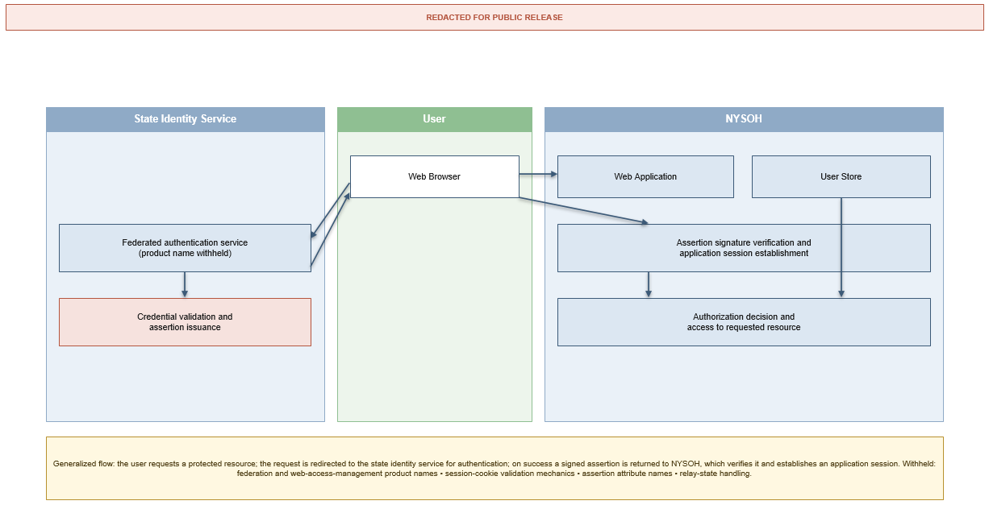
Figure 124. Validation Process for Front End Users via NY.Gov ID

Refer to the UAM Solution Approach (https://clm.emedny.org/ccm/web/projects/NY-HX (CM)#action=com.ibm.team.scm.browseElement&workspaceItemId=_a8A3IbtKEeOxwq1LBo-54Q&componentItemId=_hozogK26EeKX06hQiewzIw&itemType=com.ibm.team.scm.Folder&itemId=_O0KcIOsjEeKY-9bbb1tbyA) for the detailed process flow and user access level.
[Note: If the above link returns an error, try copying and pasting it into your browser address bar and then press the Enter key.]

All users are Identification (ID) proofed for either level IAL2 or IAL3. The Federal Data Services Hub is used to ID proof users in NY.Gov ID. FedHub webservice is used for ID proofing. Refer to the FedHub Business Service Definition (BSD) BSD37IDproofingV5.0June2013.docx. Figure 125 details the ID Proofing process.

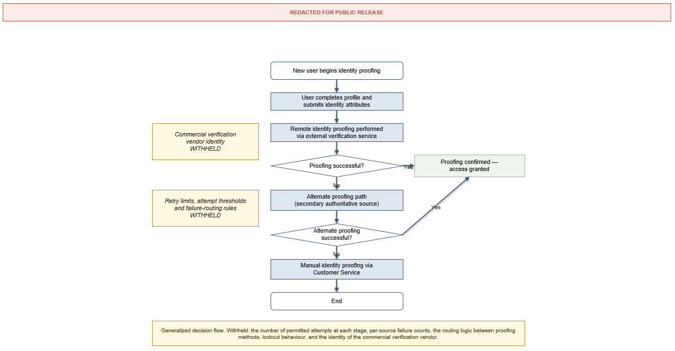
Figure 125. ID Proofing Process

The following is high level summary for ID Proofing:
- User presents to NYSOH and successfully creates profile.
- User is sent to the Federal Data Services Hub where data are input and a search for the customer is performed.
- If the customer is found, customer is required to correctly answer security questions to confirm identity.
- If the customer is not found or not able to ID Proof through Federal Data Services Hub, customer is redirected to NY DMV path for ID Proofing.
- If both ID Proofing fails, customer is directed to submit documents proving identity to Customer Service.

All AAL3 users require second factor authentication. The soft token used with AAL2 users is sent to the email address provided during the profile creation process. The following rules apply to soft token generation:
- Code is a six-digit numeric, randomly-generated number.
- Only one active token per user at a time.
- If the user tries to login again without using unused token, a new token is generated and the previous token terminated.
- Tokens expire after 15 minutes.

User Credential Process for Users created via Paper, Phone, Navigator and Producer
User profiles are created for applications submitted via paper or created by Phone/Navigator/Producer web applications. In these instances, a code is generated and sent to the user via email or US mail. Users are asked to create a NY.Gov ID account as described above and use an invitation code to tie their profile to NY.Gov ID.

The following steps take place for authentication and authorization:
- Automated process creates a user profile in NYSOH and sends an invitation code to the user via email or US mail notice (if user does not have email) for application submitted via Paper or created by Phone, Navigator, Producer.
- Users create a NY.Gov ID account as described above and enter an invitation code to access their existing user profile.
- Existing hCentive broker invitation code generation process is used to generate the invitation code.
- Once the user has validated the user profile information, the ID proofing process is followed as described above.

Navigators/Producers Account Credential
New York State Department of Financial Services (DFS) sends Producer data to NYSOH via a web service and a producer user profile is automatically created. An invitation code is generated and sent to the producer via email. The Producer then follows the process described in Section 7.3.1.

Profiles for Navigators are created by DOH Admin users via an Admin portal. An invitation code is generated and emailed to the Navigator. Navigators then follow the process as defined in Section 7.3.1 to create credentials. Refer to the ICD for DFS interface webservice details.

Back Office Users
The following users are defined as “back office users”:
- MAXIMUS: Consumer Support Specialists (CSSs) and Eligibility Specialists.
- DOH: Plan Administrators and Super Eligibility Specialists.

The "back office" systems are:
- Issuer Portal: Issuer Role (full access).
- Exchange Admin Portal: Plan Admin Role (full access, access handled via SharePoint User ID).
- Back Office: Eligibility Specialist Role (access to all, but functionality specific to SES) and Super Eligibility Specialist Role (full access).

MAXIMUS Users
NYSOH uses a batch file process to create and maintain MAXIMUS users. MAXIMUS sends a list of users who require access to the Customer Service (CS) Portal in .csv format to NYSOH via existing SFTP process. NYSOH batch process creates User ID and password (for non Siebel users, a temporary password is created). Refer to the UAM FDD for the data elements received from MAXIMUS.

CSRs (Siebel Users)
The following authentication steps occur:
- MAXIMUS sends a CSR user list to NYSOH via SFTP.
- NYSOH creates CSR accounts with a unique user ID and password for each CSR using a batch process.
- Existing hCentive user management module is utilized to create and manage MAXIMUS users.
- User ID and password are sent back to MAXIMUS via an SFTP response file.
- MAXIMUS attaches the NYSOH ID and password with the MAXIMUS Siebel user ID.
- When MAXIMUS users log into the Siebel system and attempt to access NYSOH, MAXIMUS Identity Management (IdM) appends the user ID and password in the request header sent to NYSOH.
- NYSOH validates the request and checks for the user in the user store to facilitate automatic access.

Figure 126 details the CSR credential creation process.

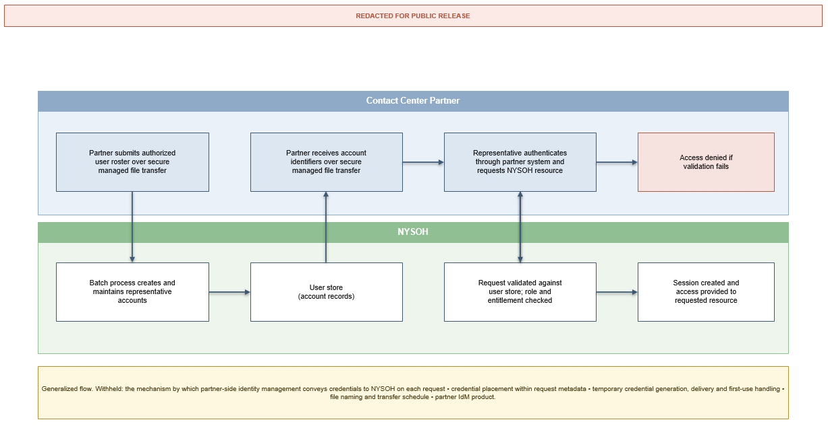
Figure 126. CSR Credential Creation Process

MAXIMUS Back Office Credential Creation (Non Siebel)
The following authentication steps occur:
- MAXIMUS sends a back office user list to NYSOH via SFTP.
- NYSOH automatically creates MAXIMUS back office user accounts using a batch process.
- NYSOH creates users in the User table and emails a temporary password to each back office user.
- NYSOH returns the user ID to MAXIMUS via an SFTP response file.
- The existing hCentive user management module will be utilized to create and manage MAXIMUS users.
- MAXIMUS back office user is required to change their password after the first login.
- hCentive password management system will be used for password changes.
- Passwords will expire and users will be required to change their password every 90 days.

Figure 127 details the back office user credential creation process.

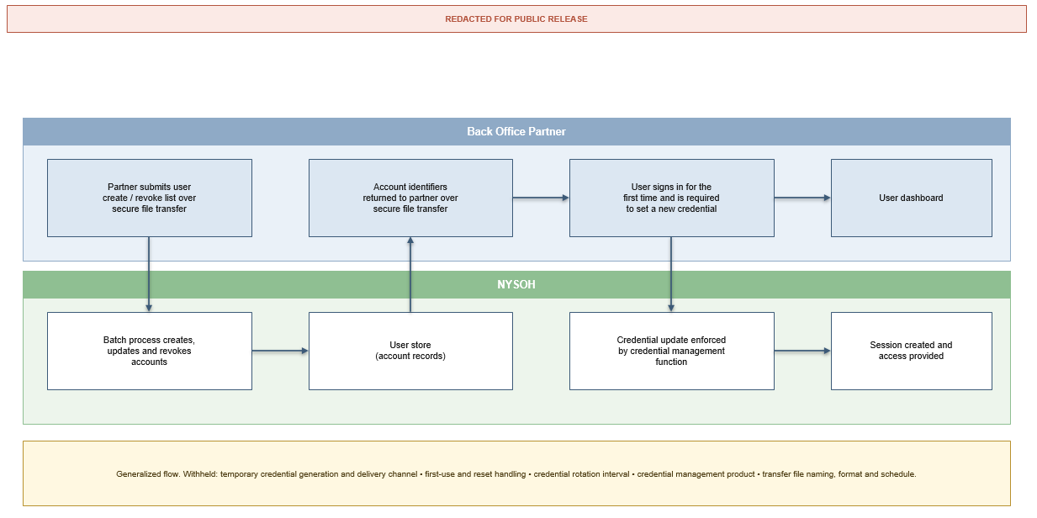
Figure 127. Back Office User Credential Creation Process

NYSOH New York State Agency User Credential Creation
NYSOH utilizes the existing AD as a user store for State Agency users. The existing process between GDIT and the New York State DOH is leveraged to create State Agency users in AD. A new AD group is created and any State Agency user added to this group will have access to NYSOH.

The following authentication steps will occur:
- DOH Point of Contact (POC) requests access to a particular group for a State Agency user from GDIT Global Cyber Security.
- GDIT Global Cyber Security creates a user in AD and assigns them to the requested group.
- When the State Agency user attempts to access NYSOH, NYSOH authenticates their credentials with AD and provides access to their authorized groups.

Figure 128 details the DOH User credential creation process.

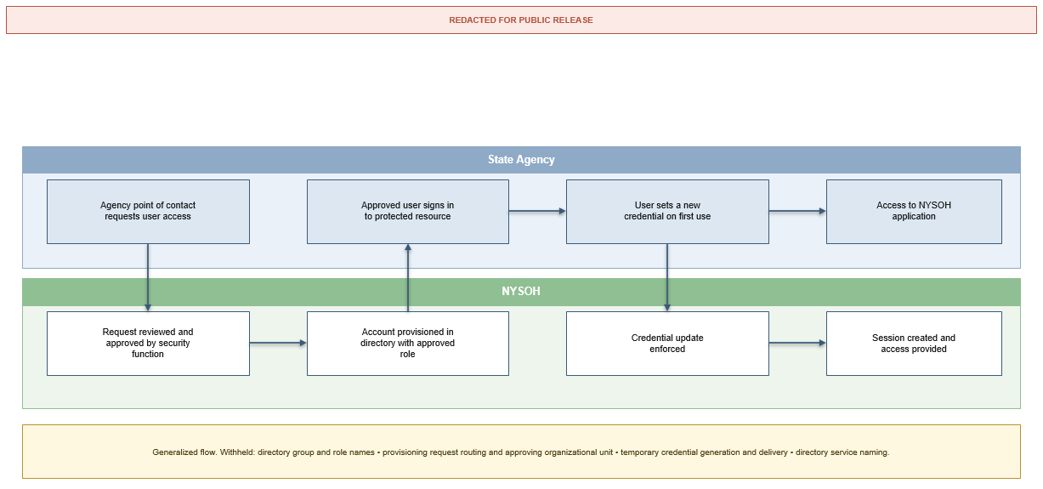
Figure 128. NYS Agency User Credential Creation (back-end)

Performance Detailed Design
[Content will be added in a future release]

Internal Communications Detailed Design
[Content will be added in a future release]

System Integrity Controls
[Content will be added in a future release]

External Interfaces

Interface Architecture
The NYSOH system interfaces with many external entities such as federal and state agencies, business partners, and third-party venders through industry standard internet protocols including SFTP, SOAP/HTTPS, and REST/HTTPS. An overview of the external interfaces and the communication protocols used is shown in Figure 129.

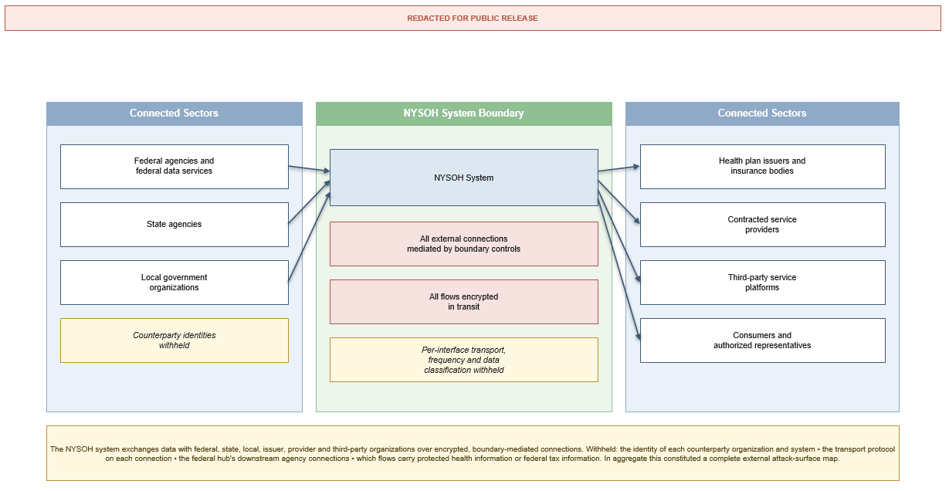
Figure 129. NYSOH System External Interfaces

The NYSOH applications exchange information with Federal agencies, NY State agencies and other partners, which include MAXIMUS, Issuers and the National Association of Insurance Commissioners (NAIC)/SERFF) to satisfy NYSOH business requirements. The data being received from and transmitted to these agencies and partners is documented in various ICDs or BSDs. NYSOH leverages the CMS BSDs which define the interface communication details for the services provided by the Federal Data Services Hub. The NYSOH ICDs and BSDs are available on the NYSOH SharePoint Portal at following locations:

Interface Control Documents (ICDs):

https://clm.emedny.org/ccm/web/projects/NY-HX%20(CM)#action=com.ibm.team.workitem.runSavedQuery&id=_cFFlEKmSEeW-vYeOVy5WHw

Note: specific version of an ICD can be located by clicking on the ICD and then the appropriate Change Set linked to the work item.

Business Service Definitions (BSDs):
https://portal.nystateofhealth.ny.gov/referencedocs/Forms/category.aspx (refer Category-> Business Service Definitions).

These external interfaces vary in terms of their design pattern. These patterns include:
- EDI files, for example, 834 enrollment transactions.
- Custom format file exchanges, for example, NYS Department of Corrections and Community Supervision (DOCCS) daily incarceration data.
- Web service interactions, for example, Income verification using the Federal Data Services Hub.

From an implementation perspective, these interfaces are handled as batch processes or synchronous transactions.

The NYSOH application leverages available data from existing interface agreements if this information can satisfy the NYSOH requirements in terms of data sufficiency and availability. For example, if an interface partner has an existing service that can fulfill specific NYSOH requirement(s), the NYSOH will consider leveraging this service rather than ask the partner to build a new service.

All data are captured by the system as a primary source. No acquisitions of existing data stores or repositories are planned.

The required data transformations which occur during these exchanges/integrations are implemented based on the ICD/BSD definitions and performed at the edge of the NYSOH integration boundaries on a transaction-by-transaction basis.

Table 10 provides additional details on the system interfaces that have been built and deployed to Production.
Table 10. External Interfaces
Interface Entity | Interface Name | NYSOH Sub-system | NYSOH Release | Communication Method | Implementation Frequency | ePHI | ICD/BSD Name
DOH | CHIP and Medicaid | PM | PM R1 | SFTP | On demand | Y | N/A
DOH | Current ICD Version:  https://portal.nystateofhealth.ny.gov/cm/cm_docs/Forms/status.aspx
CMS | Fed SSA Composite(RJ3) | EE | EE R1/R39.1 | REST/HTTPS (MuleSoft Services) | Real-Time  Available on-demand | Y | Social Security Administration (SSA) Composite (BSD)
CMS | Current ICD Version:  https://portal.nystateofhealth.ny.gov/cm/cm_docs/Forms/status.aspx
CMS | Fed Verify Household Income (RJ9) | EE | EE R1/R39.1 | REST/HTTPS  (MuleSoft Services) | Real-Time  Available on-demand | N | Verify Annual Household Income and Family Size (BSD)
CMS | Current ICD Version:  https://portal.nystateofhealth.ny.gov/cm/cm_docs/Forms/status.aspx
CMS | Fed Advance Payment Computation Service(RJ19.2T) | EE | EE R1/R42.1 | REST/HTTPS  (MuleSoft Services) | Real-Time  Available on-demand | N | Advance Payment Computation (BSD)
CMS | Current ICD Version:  NA
DOH | Plan Quality Data - QARR | PM | PMR3 | SFTP | Annually | Y | Template
DOH | Current ICD Version:  NA
DOH | UIClaimHistory Service | EE | EE R1 | SOAP/HTTPS | Real-Time  Available on-demand | Y | ICD NYS Department of Labor_DOL
Current ICD Version:
https://clm.emedny.org/ccm/web/projects/NY-HX%20(CM)#action=com.ibm.team.workitem.viewWorkItem&id=88360
DOH | CHIP & MMS Plans Templates | PM | PMR4 | SFTP | On demand | N | Template
DOH | Current ICD Version:  https://portal.nystateofhealth.ny.gov/cm/cm_docs/Forms/status.aspx
NAIC SERFF | Plan data | PM | PM4 | SOAP/HTTPS (MuleSoft Services) | Real-time  Available  On-demand | N | SERFF Plan Management Web Service Design
NAIC SERFF | Current ICD Version:  https://portal.nystateofhealth.ny.gov/cm/cm_docs/Forms/status.aspx
CMS (Federal Data Services Hub) | (RX142.1) - Verify Lawful Presence  Immigration data | EE | R24.1/R46.1 | Web Service (Mulesoft, Client)  REST/HTTPS | Real-Time  Available On-demand | Y | Verify Lawful Presence (VLP) BSD V37.1
CMS (Federal Data Services Hub) | Current ICD Version:  https://portal.nystateofhealth.ny.gov/cm/cm_docs/Forms/status.aspx
CMS (Federal Hub) | (RJ19.2T) - Advance Payment Computation  Maximum APTC allowed | EE | EER2B3/R42.1 | Web Service (MuleSoft, Client)  REST/HTTPS | Real-Time  Available On-demand | N | Advance Payment Computation (APC) BSD
CMS (Federal Hub) | Current ICD Version:  https://portal.nystateofhealth.ny.gov/cm/cm_docs/Forms/status.aspx
CMS (Federal Data Services Hub) | RX142.4 – VLP Close Case V37.1 | EE | R24.1/R46.1 | Web Service (Mulesoft, Client)  REST/HTTPS | Real-Time  Available on-demand | Y | Verify Lawful Presence (VLP) BSD V37.1
CMS (Federal Data Services Hub) | Current ICD Version:  https://portal.nystateofhealth.ny.gov/cm/cm_docs/Forms/status.aspx
NYS DOH | KIDS - CHP Public MEC | EE | EER2B5 | SFTP - DS | Monthly | Y | ICD NY-HBE DOH KIDS
Current ICD Version:
https://clm.emedny.org/ccm/web/projects/NY-HX%20(CM)#action=com.ibm.team.workitem.viewWorkItem&id=130373
NYS DOH | eMedNY - Public MEC | EE | EER2B4 | Web Service (MuleSoft, Client)  SOAP/HTTPS | Real-Time  Available On-demand | Y | NY-HBE DOH ICD v1.0
NYS DOH | Current ICD Version:  NA
MAXIMUS | Eligibility Referral to LDSS - Upstate MAXIMUS will create and mail a PDF | EE | EER2B5 | SFTP | Daily | Y | NY-HX Maximus ICD-R2V09-20130722
MAXIMUS | Current ICD Version:  NA
NYC HRA | Eligibility Referral to LDSS - Downstate Data to EDITS file | EE | EER2B5 | SFTP | Daily | Y | ICD NYC 07.00 NYC HRA Master
Current ICD Version:
https://clm.emedny.org/ccm/web/projects/NY-HX%20(CM)#action=com.ibm.team.workitem.viewWorkItem&id=33250
Issuer | Effectuation/  Confirmation  EDI 834 from Issuer 1  999 to Issuer 1 | EE | EER2B3 | SFTP | Daily – Multiple Times | N | 834 - Benefit Enrollment and Maintenance Companion Guide
Issuer | Current ICD Version:  https://portal.nystateofhealth.ny.gov/cm/cm_docs/Forms/status.aspx
NYS DOCCS | Incarceration Data | EE | EER2 | SFTP - DS | Daily | N | ICD NYS DOCCS 10.01 Incarceration Data
Current ICD Version:
https://clm.emedny.org/ccm/web/projects/NY-HX%20(CM)#action=com.ibm.team.workitem.viewWorkItem&id=33251
BSOC | Notices - Post Script file | EE | EER2B5 | SFTP | Daily | Y | Template
BSOC | Current ICD Version:  NA
BSOC | Notices - Addr Check & PostNet | EE | EER2B5 | SFTP | Daily | Y | Template
BSOC | Current ICD Version:  NA
NYS Office of Temporary and Disability Assistance (OTDA) | CIN Assignment (Spawn) | EE | EER2B5 | SOAP/HTTPS (MuleSoft Services) | Real-Time  Available On-demand | Y | ICD NYS OTDA 15.01 CIN Assignment (Spawn)
Current ICD Version:
https://clm.emedny.org/ccm/web/projects/NY-HX%20(CM)#action=com.ibm.team.workitem.viewWorkItem&id=33254
NYS OTDA | WMS Dn Clearance | EE | EER2B5 | SOAP/HTTPS (MuleSoft Services) | Real-Time  Available On-demand | Y | Interface Control Document (ICD) for NYS Office of Temporary and Disability Assistance (OTDA)
Current ICD Version:
https://clm.emedny.org/ccm/web/projects/NY-HX%20(CM)#action=com.ibm.team.workitem.viewWorkItem&id=33254
NYS OTDA | WMS Up Clearance | EE | EER2B5 | SOAP/HTTPS (MuleSoft Services) | Real-Time  Available On-demand | Y | Interface Control Document (ICD) for NYS Office of Temporary and Disability Assistance (OTDA)
Current ICD Version:
https://clm.emedny.org/ccm/web/projects/NY-HX%20(CM)#action=com.ibm.team.workitem.viewWorkItem&id=33254
NYS DFS | Receive Broker data | SHOP | SHOPR3B4 | SOAP/HTTPS (MuleSoft Services) | Real –Time | N | NY-HBE NYS DFS ICD
NYS DFS | Current ICD Version:  https://clm.emedny.org/ccm/web/projects/NY-HX%20(CM)#action=com.ibm.team.workitem.viewWorkItem&id=156185
NYS DFS | Send Broker Certification data | SHOP | SHOPR3B4 | SOAP/HTTPS (MuleSoft Services) | Real –Time | N | NY-HBE NYS DFS ICD
NYS DFS | Current ICD Version:  https://clm.emedny.org/ccm/web/projects/NY-HX%20(CM)#action=com.ibm.team.workitem.viewWorkItem&id=156185
Issuer | Employer data - Group Setup File | SHOP | SHOPR3B5 | SFTP-FPS | End of Open Enrollment period | N | NY-HBE Group Setup
Issuer | Current ICD Version:  NA
NYS DTF | EIN Verification; Wage Reporting Service; New Hire Inquiry Service | SHOP | SHOPR3B5 | SOAP/HTTPS (MuleSoft Services) | Real-Time  Available On-demand | N | ICD NYS Department of Taxation and Finance_DTF
Current ICD Version:
https://clm.emedny.org/ccm/web/projects/NY-HX%20(CM)#action=com.ibm.team.workitem.viewWorkItem&id=93194
CMS (Federal Data Services Hub) – VLP CMS hosted | (RX142.6, RX142.7) –Retrieve Case Resolution | EE | R24.1/R46.1 | Web Service (Mulesoft, Client)  REST/HTTPS | Real-Time  Available On-demand | Y | Verify Lawful Presence (VLP) BSD V37.1
CMS (Federal Data Services Hub) – VLP CMS hosted | Current ICD Version:  https://portal.nystateofhealth.ny.gov/cm/cm_docs/Forms/status.aspx
CMS (Federal Data Services Hub) - VLP-CMS hosted | (RX142.5) –Get Case Details | EE | R24.1/R46.1 | Web Service (Mulesoft, Client)  REST/HTTPS | Real-Time  Available On-demand | Y | Verify Lawful Presence (VLP) BSD V37.1
CMS (Federal Data Services Hub) - VLP-CMS hosted | Current ICD Version:  https://portal.nystateofhealth.ny.gov/cm/cm_docs/Forms/status.aspx
CMS (Federal Data Services Hub) - VLP-NYSOH Hosted | VLP Notify Resolved CasesV37 | EE | R24.1 | Web Service (Mulesoft, Client)  SOAP/HTTPS | Real-Time  Available On-demand | Y | Verify Lawful Presence (VLP) BSD V37
CMS (Federal Data Services Hub) - VLP-NYSOH Hosted | Current ICD Version:  https://portal.nystateofhealth.ny.gov/cm/cm_docs/Forms/status.aspx
MAXIMUS | IVR-Current Contact Status | CS | CS2 | SOAP/HTTPS (Mulesoft Services) | Real-Time  Available on-demand | N | ICD Maximus 05.00 Customer Service Master
Current ICD Version:
https://clm.emedny.org/ccm/web/projects/NY-HX%20(CM)#action=com.ibm.team.workitem.viewWorkItem&id=29344
MAXIMUS | Contact Search  Member Identification | CS | CS1 | SOAP/HTTPS (Mulesoft Services) | Real-Time  Available on-demand | N | ICD Maximus 05.00 Customer Service Master
Current ICD Version:
https://clm.emedny.org/ccm/web/projects/NY-HX%20(CM)#action=com.ibm.team.workitem.viewWorkItem&id=29344
MAXIMUS | Proximal Search Document Association | CS | CS1 | SOAP/HTTPS (Mulesoft Services) | SFTP | N | ICD Maximus 05.00 Customer Service Master
Current ICD Version:
https://clm.emedny.org/ccm/web/projects/NY-HX%20(CM)#action=com.ibm.team.workitem.viewWorkItem&id=29344
MAXIMUS | Appeals - Workflow trigger | CS | CS2 | SOAP/HTTPS (Mulesoft Services) | Real-Time  Available on-demand | N | ICD for Maximus
MAXIMUS | Current ICD Version:  NA
MAXIMUS | Notification Service | CS | CS2 | SOAP/HTTPS (Mulesoft Services) | Real-Time  Available on-demand | N | ICD_NYS_OTDA_CINAssignment (Spawn)
Current ICD Version:
https://clm.emedny.org/ccm/web/projects/NY-HX%20(CM)#action=com.ibm.team.workitem.viewWorkItem&id=33254
MAXIMUS | Paper Process File Transfer | CS | CS2 | SOAP/HTTPS (Mulesoft Services) | SFTP | Y | ICD_Paper_App_v_8_05_2013
MAXIMUS | Current ICD Version:  NA
NYS OTDA | WMS Forced Closure | EE | EER3 | SFTP  (Client) | Daily | Y | ICD NYS OTDA 15.10 Transfer Enrollee to from WMS
Current ICD Version:
https://clm.emedny.org/ccm/web/projects/NY-HX%20(CM)#action=com.ibm.team.workitem.viewWorkItem&id=53511
NYS OTDA | New Born Notification | EE | EER3 | SFTP  (Client & Provider) | Daily | Y | ICD NYS OTDA 15.09 Newborn Processing
Current ICD Version:
https://clm.emedny.org/ccm/web/projects/NY-HX%20(CM)#action=com.ibm.team.workitem.viewWorkItem&id=33257
NYS OTDA | Common Benefits Identification Card (CBIC) | EE | EER3 | Web Service (Mulesoft, Client)  SOAP/HTTPS | Real-Time  Available on-demand | Y | ICD NYS OTDA 15.07 WMS CBIC
Current ICD Version:
https://clm.emedny.org/ccm/web/projects/NY-HX%20(CM)#action=com.ibm.team.workitem.viewWorkItem&id=33256
NYS OTDA | CIN Clearance | EE | EER3 | Web Service (Mulesoft, Client) | Real-Time | Y | ICD NYS OTDA 15.01 CIN Assignment (Spawn)
Current ICD Version:
https://clm.emedny.org/ccm/web/projects/NY-HX%20(CM)#action=com.ibm.team.workitem.viewWorkItem&id=33254
NYS OTDA | SNAP | EE | EER43.3 | SFTP  (Client) | Monthly | Y | ICD NYSOH OTDA SNAP Data
Current ICD Version:
https://clm.emedny.org/ccm/web/projects/NY-HX%20(CM)#action=com.ibm.team.workitem.viewWorkItem&id=233705
NYS DOH | eMedNY - TPL / RRE | EE | EER10 | Web Service (Mulesoft, Client)  SOAP/HTTPS | Real-Time  Available on-demand | Y | ICD NYS DOH 11.11 eMedNY - TPL / RRE
Current ICD Version:
https://clm.emedny.org/ccm/web/projects/NY-HX%20(CM)#action=com.ibm.team.workitem.viewWorkItem&id=33252
WMS | WMS Transfer |  | EE r9.2 | SFTP  (Client) | Daily | Y | ICD NYS OTDA 15.10 Transfer of MA and EP Eligible from WMS to NYSoH
Current ICD Version:
https://clm.emedny.org/ccm/web/projects/NY-HX%20(CM)#action=com.ibm.team.workitem.viewWorkItem&id=49943
eMedNY | ForceClosure |  | EE r10 | SFTP  (Client) | Daily | Y | ICD NYS eMedNY Transfer Enrollee to WMS from NYSOH eMedNY Forced Closure
Current ICD Version:
https://clm.emedny.org/ccm/web/projects/NY-HX%20(CM)#action=com.ibm.team.workitem.viewWorkItem&id=53511
eMedNY | REECodeUpdates |  | EE r10 | WebService | online | Y | ICD NYS DOH 11.15 eMedNY - RRE Codes Update
Current ICD Version:
https://clm.emedny.org/ccm/web/projects/NY-HX%20(CM)#action=com.ibm.team.workitem.viewWorkItem&id=33253
eMedNY | 1095B Meta Data Transfer and API |  | EE r45 | SFTP and Web Service  (REST/HTTPS) | Annual/Adhoc and Real-Time | Y | ICD Load IRS Form 1095-B for NYSOH Consumers
Current ICD Version:
https://clm.emedny.org/ccm/web/projects/NY-HX%20(CM)#action=com.ibm.team.workitem.viewWorkItem&id=244398
NYS Translation Vendor | Alternate Format Notices | Notice | R10 | File/ SFTP | Daily | Y | ICD NYS Translation Vendor 16.02 Alternative Format Notices
Current ICD Version:
https://clm.emedny.org/ccm/web/projects/NY-HX%20(CM)#action=com.ibm.team.workitem.viewWorkItem&id=49861
Melissa | Online Address Validation |  | EE R11 | Webservice(HTTPS) | Online | N | Product Specification available on http://www.melissadata.com/  ICD NY-NYSOH Melissa Address Validation
Current ICD Version:
https://clm.emedny.org/ccm/web/projects/NY-HX%20(CM)#action=com.ibm.team.workitem.viewWorkItem&id=175463
Melissa | Batch Address Validation |  | EE R11 | Webservice(HTTPS) | Batch | Y | Product Specification available on http://www.melissadata.com/  ICD NY-NYSOH Melissa Address Validation
Current ICD Version:
https://clm.emedny.org/ccm/web/projects/NY-HX%20(CM)#action=com.ibm.team.workitem.viewWorkItem&id=175463
DOH | NYSHIP |  | EE R13 | SFTP | Batch | Y | ICD DOH 11.16 NYSHIP File Transfer to NYSOH
Current ICD Version:
https://clm.emedny.org/ccm/web/projects/NY-HX%20(CM)#action=com.ibm.team.workitem.viewWorkItem&id=75179
ITS | Organ Donor |  | EE R13 | SFTP | Batch | Y | ICD NYS ITS 17.01 Organ Donor Registration File Transfer to NYS ITS_R13.docx
Current ICD Version:
https://clm.emedny.org/ccm/web/projects/NY-HX%20(CM)#action=com.ibm.team.workitem.viewWorkItem&id=76268
iPRO | PNDS |  | EE R13 | SFTP | Batch | N | ICD Receipt of Provider Network Data from iPro PNDS
Current ICD Version:
https://clm.emedny.org/ccm/web/projects/NY-HX%20(CM)#action=com.ibm.team.workitem.viewWorkItem&id=76052
MAXIMUS | Undelivered Mails Data Transfer Interface | CS | R14.5 | File/SFTP | Batch (Everyday) | N | Maximus ICD
MAXIMUS | Current ICD Version:  NA
Twilio | NYSOH Interface with Twilio SMS | EE | R36 | Saas (Software as a Service) | Batch | N | ICD NYSOH Interface with Twilio
Current ICD Version:
https://clm.emedny.org/ccm/web/projects/NY-HX%20(CM)#action=com.ibm.team.workitem.viewWorkItem&id=203280
Twilio | NYSOH Interface with Twilio SendGrid Email Service | EE | R42 | HTTPS (SaaS) | Online/Batch | N | ICD NYSOH Interface with SendGrid
Current ICD Version:
https://clm.emedny.org/ccm/web/projects/NY-HX%20(CM)#action=com.ibm.team.workitem.viewWorkItem&id=235545
DMV | DMV |  | R17.1 | Webservice(HTTPS) | Online | Y | ICD NYS Department of Motor Vehicles
Current ICD Version:
https://clm.emedny.org/ccm/web/projects/NY-HX%20(CM)#action=com.ibm.team.workitem.viewWorkItem&id=89374
CMS (Federal Data Services Hub) -VLP-CMS hosted | (RX142.3) – VLP Initiate Third VerificationV37.1 | EE | R24.1/R46.1 | Web Service (MuleSoft, Client)  REST/HTTPS | Real-Time  Available On-demand | Y | Verify Lawful Presence (VLP) BSD V37.1
CMS (Federal Data Services Hub) -VLP-CMS hosted | Current ICD Version:  https://workspace.nyhx.emedny.org/referencedocs/Forms/category.aspx
eMedNY | HARP RRD code to eMedNY | EE | R20 | File/SFTP | Batch (Everyday) | Y | ICD NYSOH to eMedNY Transmission File
Current ICD Version:
https://clm.emedny.org/ccm/web/projects/NY-HX%20(CM)#action=com.ibm.team.workitem.viewWorkItem&id=100237
Maximus Choice | Maximus Choice opt-out interface | EE | R20 | File/SFTP | Batch (One time) | Y | ICD Maximus Choice
Current ICD Version:
https://clm.emedny.org/ccm/web/projects/NY-HX%20(CM)#action=com.ibm.team.workitem.viewWorkItem&id=29344
OTDA | PARIS Interface  (Public Assistance Reporting Information System) | CS | R4, R21 | File/SFTP | Batch(Every 3 months) | Y | ICD NYS OTDA 15.04 PARIS Data Extract
Current ICD Version:
https://clm.emedny.org/ccm/web/projects/NY-HX%20(CM)#action=com.ibm.team.workitem.viewWorkItem&id=33255
CMS (Federal Data Services Hub) -VLP-CMS hosted | (RX142.2) VLP InitiateAdditionalVerif v37.1 | EE | R24.1/R46.1 | Web Service (MuleSoft, Client)  REST/HTTPS | Real-Time  Available On-demand | Y | Verify Lawful Presence (VLP) BSD V37.1
CMS (Federal Data Services Hub) -VLP-CMS hosted | Current ICD Version:  https://portal.nystateofhealth.ny.gov/referencedocs/Forms/category.aspx
MAXIMUS | Authorized Representative Response Type | CS | R23.21 | File/SFTP | Batch (Everyday) | N | Maximus ICD
MAXIMUS | Current ICD Version:  NA
CMS (Federal Data Services Hub) -Remote Identity Proofing and Fraud Archive Reporting Service | (RJ139) Remote Identity Proofing and Fraud Archive Reporting Service | EE | EE R1/R46.1 | Web Service (MuleSoft, Client)  REST/HTTPS | Real-Time  Available On-demand | Y | Remote Identity Proofing and Fraud Archive Reporting Service RJ139 file bundle
Current ICD Version:
https://portal.nystateofhealth.ny.gov/referencedocs/Forms/category.aspx

Interconnection Security/Data Use Agreements
In addition to the ISA with the Federal Data Services Hub, NYSOH incorporates Interconnection Security Agreements (ISAs), Memorandums of Understanding (MOUs), and ICDs with business partners, service providers, and some agencies that share data or connect to the NYSOH system.

For each non-DOH State agency, the NYSOH incorporates a Data Use Agreement into a Memorandum of Understanding (MOU). The MOU references the associated agency-specific ICD.

Data Use Agreements for Issuers exist within an MOU and ICD agreement between DOH and these Issuers.

Interface Detailed Design

Batch File Processing

Overview
The Spring Batch framework is used to develop and implement batch processing applications within the NYSOH.

Spring Batch is a widely used framework. It provides reusable functions that are essential in processing large volumes of records, including logging, transaction management, job processing statistics, and job restart and resource management. It can be scaled and configured to handle multiple concurrent complex and high volume batch jobs through optimization and partitioning techniques. The Notice Creation process was built using Spring Batch.

When batch processes are complex, such as Notice Processing and Paper Application Processing, the development team will implement the process within a Java framework and reuse multiple existing services within each transaction. This type of design will be implemented within Spring Batch.

IBM’s DataStage is also used to process incoming files, for example, the QARR process. The management and scheduling of the various inbound and outbound files and batch processes are handled both on a scheduled and manual basis.

DataStage is an ETL tool which is very good at processing files when the business logic within the process is straight forward. DataStage also contains internal parallel processing which provides performance gains.

IBM’s TWS process scheduling software is used to automate and generate emails to process owners.

Batch Process Operational Management
In order to manage and coordinate the various file transfers, batch processes and operational processes (i.e., database backups) which run within the NYSOH Production system GDIT has created a Production Operation Management group. This group is working with GDIT development, architecture and database teams as well as the various external partners to:
- Build and maintain a schedule of batch processes and file exchanges within the NYSOH system.
  - Job names (shell scripts) and process summary descriptions.
  - Location of scripts.
  - Time and frequency by job.
  - SLA requirements.
  - Implementation (e.g., DataStage, SFTP).
  - Input/outputs.
  - Dependencies.
  - Location of error logs.
  - Process owners for notification purposes (email groups or individuals).
- Document system monitoring and maintenance processes.
- Coordinate the effort to automate the execution and communication associated with these processes.

The information described above is documented in the Operations and Maintenance Manual (O&M Manual) for the New York State of Health within the Process Asset Library (PAL) in the NYSOH SharePoint portal.

An example of a batch process which is being managed is the Notice Creation process. This is the NYSOH’s largest batch system, in terms of annual batch transaction volume.

This Notice process is initiated by IBM’s TWS. The process runs daily, but the exact time of this run varies, based on notice volume and other system related variables (i.e., business priorities, in progress issue resolution, potential effect for online users). The development group works with operations to determine the exact run times. Emails are sent to the GDIT technical owner indicating whether the process ran successfully.

For additional information on the Notice Generation process see the UDD named NY_HX_CommonServices_Notices_DetailedDesign_v1.5.

Batch Process Controls and Balance Checking
[Content will be added in a future release]

FPS Usage (834, Group Setup)
The NYSOH leverages an eMedNY application called the File Processing System (FPS) to control, validate, and process outgoing files. Incoming files will be processed through WTX.
The NYSOH interface team modified this software to validate and process incoming 834 transactions and send outbound responses relating to these 834 transactions. The Group Setup process also leverages the FPS application.

This FPS updates control tables defined in the NYSOH database to support the requirements of these processes. The application keeps track of all successful and unsuccessful transactions.

Notice Process Controls
The notice process uses NYSOH database tables to keep track of processed notices. A manual process is in place to ensure the number of hard copy Notices generated, by notice type, is verified against the number of notices printed by the Business Services Outsourcing Center (BSOC). If discrepancies exist between these counts, the individual notice sequence numbers, for the missing notices, are identified and the issue is resolved.

General Control Guidelines for Incoming Files
- Frequency of file arrival time must either be fixed and scheduled or on demand with automated or manual notification/triggers set up to process the file.
- Empty files should be identified by the process.
- Duplicate files (previously processed) must be identified, because if they are processed, they will create system issues.
- Emails should be sent to the owner if the process fails.
- Transactions which result in errors must either be logged or captured in a database.
- If a process warrants additional controls to validate that all sent transactions have been received and processed, the sender should provide the incoming record count and the process should validate against this count.

General Control Guidelines for Outgoing Files
- File creation processes should be scheduled or run on demand with an automated or manual notification/trigger set up to notify the partner that the file is ready for processing.
- Empty files should be identified by the process and not sent.
- Emails should be sent to the owner if the process fails.
- Transactions which result in error must either be logged or captured in a database.
- If a process warrants additional controls to validate that all sent transactions have been received and processed by the partner, the file creation process should identify and include this information with the file.

Business Services Outsourcing Center (BSOC) Interactions
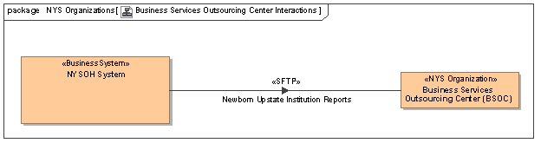
Figure 130. Business Services Outsourcing Center (BSOC) Interactions

Department of Corrections and Community Supervision (DOCCS) Interactions
[Content will be added in a future release]

Department of Financial Services (DFS) Interactions
[Content will be added in a future release]

Department of Health (DOH) Interactions
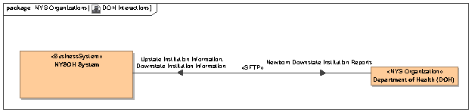
Figure 131. DOH Interactions

Department of Labor (DOL) Interactions
[Content will be added in a future release]

Department of Motor Vehicles (DMV) Interactions
[Content will be added in a future release]

Department of Tax and Finance (DTF) Interactions
Figure 132 shows the interfaces provided by DTF that are used by the NYSOH System. Details of the interfaces can be found in the DTF ICD listed in Table 10.

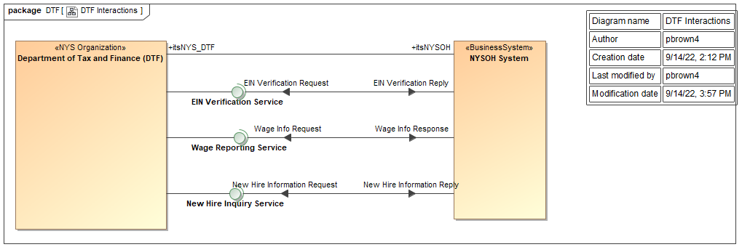
Figure 132. DTF Interactions

Division of Eligibility and Marketplace Integration Interactions
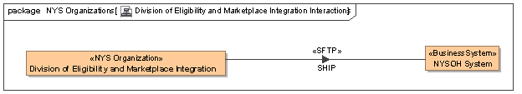
Figure 133. Division of Eligibility and Marketplace Integration Interactions

eMedNY Interactions
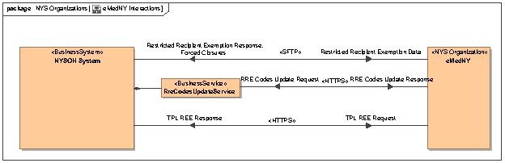
Figure 134. eMedNY Interactions

Federal Data Services Hub Interactions
[Content will be added in a future release]

IPRO Interactions
[Content will be added in a future release]

Issuer Interactions
[Content will be added in a future release]

Knowledge, Information and Data System (KIDS) Interactions
[Content will be added in a future release]

Maximus Interactions
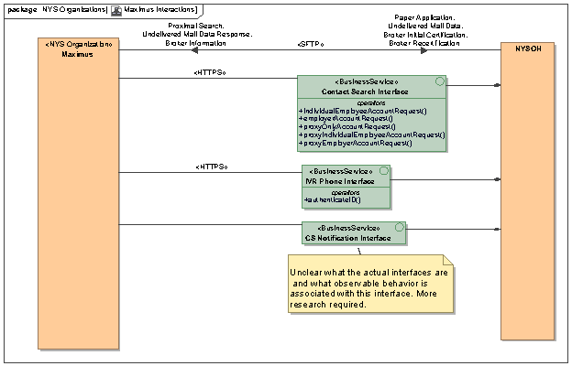
Figure 135. Maximus Interactions

National Association of Insurance Commissioners (NAIC) Interactions
[Content will be added in a future release]

Office of Information Technology Services (ITS) Interactions
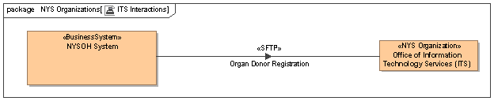
Figure 136. ITS Interactions

OTDA and HRA Interactions
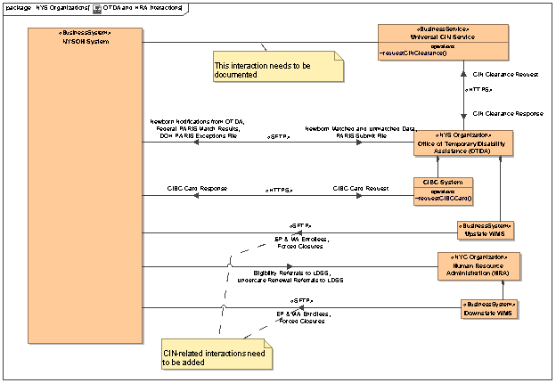
Figure 137. OTDA and HRA Interactions

NY State Health Insurance Assistance Program (NYSHIP) Interactions
[Content will be added in a future release]

Twilio SMS Messaging Interactions
NYSOH integrates with Twilio SMS messaging services through the Mule services deployed on the on-prem Mule runtimes. Two Mule service APIs, “SMSWebhook“ and “SMSCallback”, are created to receive inbound SMS messages from Twilio. The high-level system architecture is shown in Figure 138 below.

Another Mule service API, “SMSOutbound”, is created to send SMS messages to Twilio. This Mule service API internally uses the Anypoint Twilio Connector to integrate with Twilio SMS APIs. The high-level system architecture is shown in Figure 139 below.
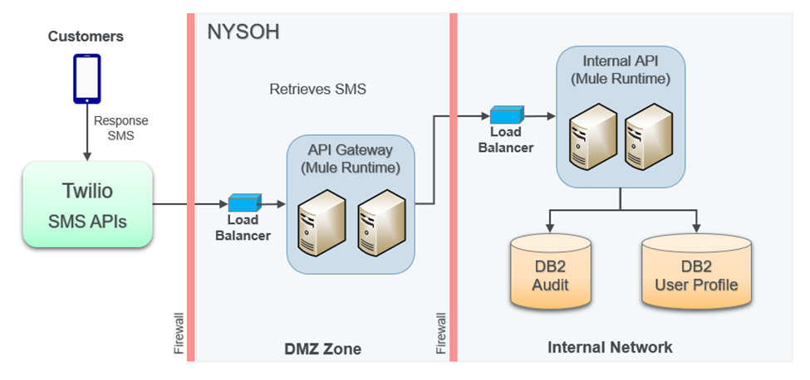
Figure 138. Inbound calls from Twilio to NYSoH

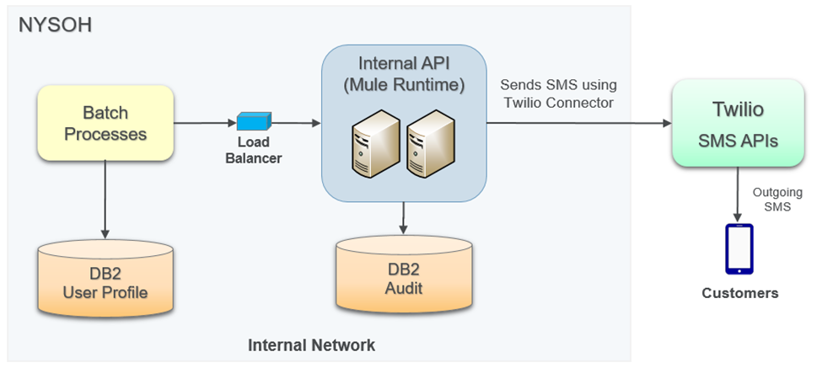
Figure 139. Outbound calls from NYSoH

Twilio SendGrid Email Service Interactions
NYSOH uses Twilio’s cloud-based SendGrid Email Service APIs to send emails to consumers. These emails include transactional emails, notices, and ad-hoc email campaigns. The system integration architecture is shown in Figure 140 below. In this architecture, NYSOH is responsible for preparing the email content and format for all recipients. The email requests are then sent to SendGrid API through the internal EmailService one at a time. SendGrid is responsible to deliver the emails to the recipients via their own mail servers. SendGrid also provides monitoring and audit services that can be reviewed and downloaded from the SendGrid console. SendGrid enables users to unsubscribe from future email campaigns by clicking the unsubscribe link embedded in the body of campaign emails.

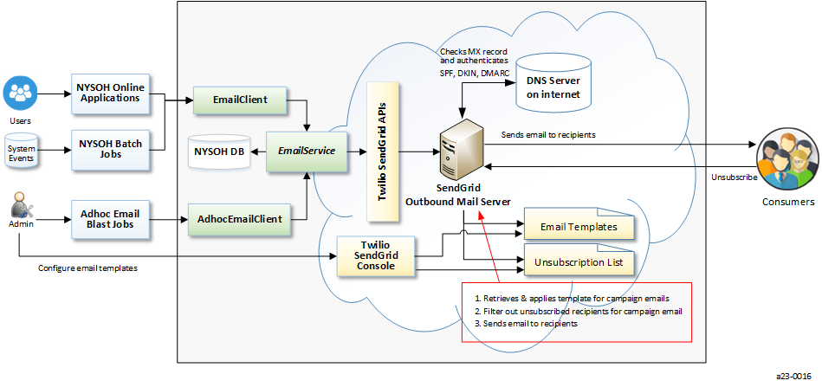
Figure 140. Email System Architecture

Contentstack System Architecture
Contentstack is a cloud-based headless content management system (CMS). With Contentstack, all the CMS components are hosted in cloud, including contents storage, model design, content creation, review and authorization modules. NYSOH applications only need to invoke Contentstack APIs in order to retrieve contents. The high-level system architecture is shown in Figure 141 below.

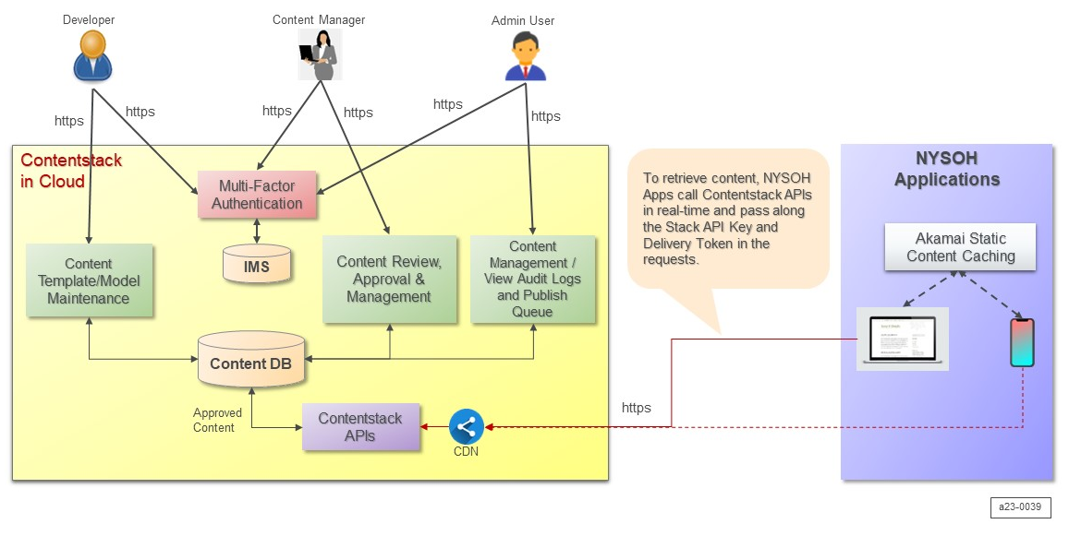
Figure 141. Contentstack System Architecture

Attachments
The documents listed in Table 11. Attachments are attached to improve accessibility to this information.
Table 11. Attachments
No | Attachment | File Name
1 | NYSOH Physical Data Model | NYSOH_PDM_v32.0.pdf
2 | NYSOH Physical Data Model | NYSOH_PDM_v32.0.dm1
3 | NYSOH Logical Data Model | NYSOH_LDM_v32.0.pdf
4 | NYSOH Logical Data Model | NYSOH_LDM_v32.0.dm1
5 | NYSOH Data Dictionary | DataDictionary_v32.0.xlsx
6 | NYSOH Encounters Data Dictionary | NYSOH_Encounters_Data_Dictionary_v4.0.xlsx
7 | NYSOH Encounters Physical Data Model | NYSOH_Encounters_PDM v4.0.pdf
8 | NYSOH Encounters Physical Data Model | NYSOH_Encounters_PDM v4.0.dm1
9 | Notice Volume Estimates | Notice_Volume_Estimates for SDD v32.xlsx
10 | Benefits Template CHIP MMC QHP with Descriptions | Benefits Template CHIP MMC QHP with Descriptions Final 082913.pdf

Glossary & Acronyms
Refer to the Glossary/Acronyms process group within the Process Asset Library (PAL) which is available from the NYSOH Home page of NYSOH SharePoint portal. The link is: https://portal.nystateofhealth.ny.gov/pal/Forms/group.aspx.

Appendix A Referenced Documents and Supporting Tools
Table 12 lists the NYSOH documents and supporting tools that contribute to plans, processes, deliverables, or technical materials used to form this document.
Table 12. Referenced Documents
Date | Reference | Description | Link
12/20/21 | CMS System Design Document Template | This is the CMS template for the System Design Document which is published on CMS website under “Optional Project Management Templates”. | https://www.cms.gov/research-statistics-data-and-systems/cms-information-technology/tlc, select “Optional Project Management Templates (ZIP)”
01/08/24 | Supported Browsers for NYSOH Web Applications | The minimum browser standards for the NYSOH Project. | https://portal.nystateofhealth.ny.gov/pal/Supported%20Browsers%20for%20NYSOH%20Web%20Applications.docx
07/15/24 | NYSOH Glossary | This document provides definitions of commonly used NYSOH terms. | https://portal.nystateofhealth.ny.gov/pal/NYSOH_glossary.pdf
07/15/24 | NYSOH Acronym List | This document provides commonly used NYSOH terms and the associated acronyms. | https://portal.nystateofhealth.ny.gov/pal/NYSOH_acronym_list.pdf
N/A | Risk Register | This report shows the status of risk mitigation and issue resolution actions for the NYSOH project. | https://portal.nystateofhealth.ny.gov/pm/Lists/RiskTracker/Weekly%20Risk%20Register.aspx
N/A | Issue Tracker/Action Items | Issue Tracker - Tracks issues and captures decisions. Action Items - Tracks various types of assigned Action Items (AIs). | https://portal.nystateofhealth.ny.gov/pm/Lists/IssueTracker/Weekly%20Issue%20Register.aspx
07/15/24 | NYSOH Business Continuity and Disaster Recovery Plan | This document represents how the NYSOH team will prepare for the eventuality of a disaster, the procedures to be followed during a disaster, how operations would be restored to the primary facility, and testing procedures. | https://portal.nystateofhealth.ny.gov/pal/Business%20Continuity%20and%20Disaster%20Recovery%20Plan.docx
07/15/24 | Operations and Maintenance Manual (O&M Manual) for the New York State of Health | The O&M Manual (O&M) describes the production operations processes and procedures that keep NYSOH in operation. | https://portal.nystateofhealth.ny.gov/pal/Operations%20and%20Maintenance%20(O%26M)%20Manual.docx  SLA Attachment:  https://portal.nystateofhealth.ny.gov/doc_mgmt/release_deliverables/A-255-04114%20att1%20Operations%20and%20Maintenance%20(O%26M)%20Manual%20SLA%20Attachment_v4.1.docx
08/15/21 | NYSOH Data Management Plan (DMP) | The NYSOH DMP describes GDIT’s approach and tools for activities that continuously enhance and manage the database platforms and operations associated with NYSOH. | https://portal.nystateofhealth.ny.gov/pal/NYSOH%20Data%20Management%20Plan.docx
02/15/24 | NYSOH Risk and Issue Management Plan (RIMP) | This Risk and Issue Management Plan (RMP) defines and guides the risk and issue activities for the New York State of Health (NYSOH) project | https://portal.nystateofhealth.ny.gov/pal/NYSOH%20Risk%20and%20Issue%20Management%20Plan.docx
10/13/22 | NYSOH Master Test Plan | This Master Test Plan is used to describe all facets of the test team role and actions within the Program. | https://portal.nystateofhealth.ny.gov/pal/NYSOH%20Master%20Test%20Plan.docx
NYSOH Release Deliverables
4/15/13 | Section 508 Compliance Test Strategy | This document verifies that the NYSOH meets or exceeds Federal regulations pertaining to accessibility. | https://portal.nystateofhealth.ny.gov/pm/working_docs/508%20Compliance%20Test%20Strategy.docx
4/22/13 | PM R2 ARIS Business Process Models | Business process models for Plan Management, Release 2. | https://portal.nystateofhealth.ny.gov/plan/team_docs/PM%20R2%20Process%20Models.pdf
Standards and Guidelines
N/A | Section 508 Standards Guide | Defines implementation of Section 508 of the Rehabilitation Act of 1973. | https://www.section508.gov
N/A | Model-View-Controller (MVC) | Software Architecture Framework which segregates user interface, business logic, and database layers. | http://en.wikipedia.org/wiki/Model%E2%80%93view%E2%80%93controller
N/A | Hypertext Transfer Protocol/Hypertext Transfer Protocol Secure (HTTP/HTTPS) | Communications protocols for communication over a computer network designed especially for wide deployment on the Internet. | http://www.w3.org/Protocols/
N/A | Simple Object Access Protocol (SOAP) | A protocol specification for exchanging structured information in the implementation of Web Services in computer networks using the eXtensible Mark-up Language (XML) Information Set for its message format. | http://www.w3.org/TR/soap/
5/13/12 | Knowledge Application Programming Interface (API) 5.4.0.Final API | Drools reference providing the details for available packages and classes. | http://docs.jboss.org/drools/release/5.4.0.Final/knowledge-api-javadoc/

