Request for Proposals

RFP #C043776

Converged Eligibility and Enrollment (E&E) System and Appeals Management System (AMS)

Exhibit G.03
NYSOH System Operations and Maintenance Manual

New York State
Department of Health

New York State of Health (NYSOH) Project
Operations and Maintenance (O&M) Manual
Version Number: 31.0
Contract Number: [REDACTED]
Date Submitted: July 15, 2024
Effective Date: May 3, 2024
Revision History
Version | Date | Change Implemented By | Change Approved By | Description of Changes
28.1 | 5/26/2023 | Shahana Dudekula | Vijay Veeraraghavan | Appendix B updated in response to DOH comment.
29.0 | 7/14/2023 | Shahana Dudekula | Vijay Veeraraghavan | Release 40.3 through Release 42.3 details.
29.1 | 10/31/2023 | Shahana Dudekula | Vijay Veeraraghavan | Document updated in response to DOH comments.
30.0 | 1/15/2024 | Shahana Dudekula | Vijay Veeraraghavan | Release 43.1 through Release 45.1 details.
31.0 | 7/15/2024 | Shahana Dudekula | Vijay Veeraraghavan | Release 45.2 through Release 47.2 details.

Note: Only the five most recent revisions to this document are listed above. For the revision record of earlier versions, please refer to the change history in Appendix J of this document.

Table of Contents
1. Introduction 1
2. System Manual Identification 2
3. NYSOH System Overview 3
3.1 NYSOH Core Application System 3
3.2 NYSOH Ancillary Support Services 3
3.3 Hours of Operations 3
3.3.1 NYSOH Hours of Operation 4
4. Releases 5
4.1 Release 9 Build 2 5
4.1 Release 10 Build 1 6
4.2 Release 10 Build 2 6
4.3 Release 10 Build 3 8
4.4 Release 10 Build 4 8
4.5 Release 11 Build 1 9
4.6 Release 11 Build 2 9
4.7 Release 11 Build 3 10
4.8 Release 11.3.2 10
4.9 Release 12.1 10
4.10 Release 12.2 11
4.11 Release 13.1 11
4.12 Release [REDACTED]
4.13 Release 13.3. 11
4.14 Release 14.1 12
4.15 Release 14.2 12
4.16 Release 15.1 12
4.17 Release 15.2 12
4.18 Release 15.3 13
4.19 Release 15.4 13
4.20 Release 16.1 13
4.21 Release 17.1 13
4.22 Release 17.1.1 13
4.23 Release 17.1.2 14
4.24 Release 18.1 14
4.25 Release 19.1 14
4.26 Release 19.1.1 14
4.27 Release 19.1.2 14
4.28 Release 20.1 14
4.29 Release 20.2 15
4.30 Release 21.1 15
4.31 Release 21.1.2 15
4.32 Release 21.2.1 15
4.33 Release 21.3 15
4.34 Release 22.1 16
4.35 Release 23.1 16
4.36 Release 24.1 16
4.37 Release 25.1 16
4.38 Release 26.1 16
4.39 Release 26.2 17
4.40 Release 27.1 17
4.41 Release 27.2.4 17
4.42 Release 27.3.3 17
4.43 Release 27.4 17
4.44 Release 27.5 17
4.45 Release 27.6 18
4.46 Release 28.1 18
4.47 Release 28.3 18
4.48 Release 28.4 18
4.49 Release 29.1 18
4.50 Release 30.1 19
4.51 Release 30.2 19
4.52 Release 30.3.5 19
4.53 Release 30.5 19
4.54 Release 31.1 19
4.55 Release 31.5 19
4.56 Release 32.1 20
4.57 Release 32.1.3 20
4.58 Release 33.1 20
4.59 Release 34.1 20
4.60 Release 35.1 21
4.61 Release 36.1 21
4.62 Release 36.2 21
4.63 Release 36.5 21
4.64 Release 37.1 21
4.65 Release 37.2 21
4.66 Release 37.3 22
4.67 Release 38.1 22
4.68 Release 38.2 22
4.69 Release 38.3 22
4.70 Release 39.1 22
4.71 Release 40.2 22
4.72 Release 40.3 23
4.73 Release 41.1 23
4.74 Release 41.1.1 23
4.75 Release 41.2 23
4.76 Release 42.1 23
4.77 Release 42.2 23
4.78 Release 42.3 24
4.79 Release 43.1 24
4.80 Release 43.1.5 24
4.81 Release 43.2 24
4.82 Release 43.3 24
4.83 Release 44.1 24
4.84 Release 44.1.1 24
4.85 Release 45.1 25
4.86 Release 45.2 25
4.87 Release 45.3 25
4.88 Release 45.4 25
4.89 Release 46.1 25
4.90 Release 46.2 25
4.91 Release 47.1 26
4.92 Release 47.2 26
5. Processing Overview 27
5.1 Physical System Architecture 27
5.1.1 Physical Architecture 27
5.1.2 System Context and Flow Diagram 28
5.1.3 System Architecture 29
5.1.4 Logical Application Architecture 30
5.1.5 Financial Management System 31
5.1.6 Security and Privacy Overview 33
6. NYSOH O&M Responsibilities 34
7. NYSOH High Level Error Handling Overview 35
8. NYSOH High Level Description of the Escalation Process Overview 36
9. NYSOH Operational Internal File Transfer Management and Standards 37
9.1 File Transfer Usage 37
9.1.1 Purging the Directories 39
9.1.2 Access Control 39
10. NYSOH Data and Database Administration 41
10.1 GDIT Incident Management 41
10.2 Database Problem Analysis 42
10.2.1 Identification and Isolation 42
10.2.2 Database Analysis Tools 43
10.3 Database Management Supporting Documentation 44
10.4 Data Architecture of the NYSOH Platform 44
10.4.1 Federal Tax Information (FTI) in the Data Architecture 47
11. NYSOH Configuration Management (CM) 49
12. Disaster Recovery and Business Continuity Operations 50
13. NYSOH Backup Procedures 51
14. NYSOH Security and Vulnerability Monitoring Procedures 52
15. NYSOH Maintenance Procedures 53
16. Core and Ancillary NYSOH Application Operational Processes 55
16.1 Plan Management Operations 55
16.1.1 Annual Plan Management (PM) Data Load Process: 55
16.1.2 Plan Management High Level Work Flow 56
16.1.3 Plan Management Operations Sequence 56
16.1.4 Plan Management Operations Procedures 59
16.1.5 Diagnostic and Problem Handling Procedures 78
16.1.6 Plan Management Restart/Recovery Procedures 78
16.2 Small Business Marketplace Operations 80
16.2.1 Small Business Marketplace High Level Flow 80
16.2.2 Small Business Marketplace Operations Procedures 81
16.2.3 Small Business Marketplace Diagnostic and Problem Handling Procedures 83
16.3 Customer Service Operations 85
16.3.1 CS High Level Flow 85
16.3.2 CS Operations Sequence 85
16.3.3 CS Operations Procedures 87
16.3.4 Diagnostic and Problem Handling Procedures for Customer Service 95
16.3.5 Customer Service Restart/Recovery Procedures 96
16.4 Individual Marketplace Operations 97
16.4.1 Individual Marketplace High Level Flow 97
16.4.2 Individual Marketplace Operations Sequence 98
16.4.3 Individual Marketplace Operations Procedures 101
16.4.4 Individual Marketplace Input/Output Procedures 101
16.4.5 Individual Marketplace Diagnostic and Problem Handling Procedures 194
16.4.6 Individual Marketplace Restart/Recovery Procedures 195
16.5 Financial Management Operations 196
16.5.1 FM Diagnostic and Problem Handling Procedures 196
16.5.2 FM Restart/Recovery Procedures 197
16.6 NYSOH Interfaces 198
16.6.1 NYSOH State Agency Interfaces 199
16.6.2 Federal Interfaces 199
16.6.3 BSOC Interfaces 201
16.6.4 Issuer Interfaces 201
16.6.5 MAXIMUS Interfaces 201
16.6.6 State Agency Interfaces 202
16.6.7 Other Interfaces 206
16.6.8 Encounters Interfaces 206
16.6.9 Alternative Format Notice Interfaces 206
16.6.10 Interface Security 206
16.6.11 Overall Interface data flow 207
16.6.12 Outbound FPS File workflow 208
16.6.13 Inbound FPS File workflow 209
16.7 Special Processes 209
16.7.1 eMedNY 209
16.8 Oversight Reporting Platform 210
16.8.1 Federal Requirements for Reporting to CMS 210
16.8.2 Timeline for SBM Data Submissions 210
16.8.3 Key Interactions Required 211
16.8.4 Oversight Record and Retention Management 211
16.8.5 Oversight Work Context 212
16.8.6 Oversight Workflow 213
16.8.7 End-to-End Oversight Reporting Architecture 214
16.8.8 Key Oversight Processes 214
16.9 IRS 1095A Process 216
16.9.1 Oversight and Reporting for 1095A to IRS/CMS 216
16.9.2 Oversight and Reporting for 1095A to Consumers 217
16.9.3 Oversight and Reporting for SBMI to CMS 222
16.9.4 Oversight Reports 225
16.9.5 SBM Quarterly Reporting Requirements 260
16.10 Encounter Intake System 264
16.10.1 CR 2195: Encounter Intake System (EIS) Archive 264
16.10.2 Data Intake Solution 265
16.10.3 Data Warehousing Solution 265
16.10.4 Analytics Platform Solution 265
16.10.5 EIS Reference Data Flow 267
16.10.6 Encounter File Submission Process 269
16.10.7 Reference Data 271
16.10.8 Encounter Operational Processing 276
16.10.9 X12 Submission / Response / Acknowledgement Process 278
16.10.10 NCPDP Submission / Response / Acknowledgment Process 280
16.10.11 APD Data Delivery 283
16.10.12 MAEE Data Delivery 285
16.10.13 Quarantine Process for Issuer/TPA File Transfer 286
17. NYSOH Operational Security (OPSEC) and Compliance 288
17.1 System and Data Center Security Incident Management 288
17.1.1 Systems Incident Management 288
17.1.2 Steps and Procedures for system and Data Center Security Incident Response 289
17.1.3 Operational Security Incident Management 291
17.1.4 Security and Privacy Incident Reporting 296
17.1.5 Operational Security Incident Processes 296
17.1.6 Security and Privacy (Incident) Management and Monitoring Detailed Process 298
17.2 Back Office and Active Directory User Access and Provisioning for MAXIMUS 299
17.2.1 How to add MAXIMUS Siebel Users for NYSOH 299
17.3 Back Office Support Access and Provisioning for GDIT and DOH 301
17.3.1 Requesting Access to Federal Tax Information (FTI) Database Tables or Application Tab 301
17.4 Context Diagram for Role Assignment and Password Management 302
17.5 Naming conventions for all Back Office Accounts 302
17.6 Password Reset and Expiration Notification Process 303
17.6.1 Notification to the users 303
17.7 Enhanced Fine Grain Permissions 304
17.7.1 Back Office Termination Process 304
17.7.2 Termination Request(s) 305
17.7.3 Expedited Termination Request 305
17.7.4 Summary of Process for Terminating Users or Changing User Account Status 305
17.7.5 Audit and Retention 307
17.8 Inspections and Assessments 307
17.8.1 Security Oversight and Monitoring 307
17.8.2 POA&M 308
17.8.3 Record Retention Schedule for the NYSOH 309
17.8.4 Security and Risk Monitoring 311
Appendix A Disaster Recovery Procedures 312
Appendix B NYSOH Emergency Call List (ECL) 313
Appendix C Primary Operations Contact List 314
Appendix D Special Considerations for Agency Services and Issues 316
Appendix E Center for Medicare and Medicaid System Outage Schedule for 2024 318
Appendix F Acronyms and Glossary 319
Appendix G Referenced Documents 320
Appendix H NYSOH Policies and Procedures Reference 321
Appendix I NYSOH Operational Security Forms 322
Appendix J Version Description History 323

Table of Figures
Figure 1. EWM Path of the Software, Hardware and Supplies Inventory Lists 27
Figure 2. NYSOH System Context and Flow Diagram 28
Figure 3. System Architecture 29
Figure 4. Logical Application Architecture 30
Figure 5. Integration of FMS System Components and Core SBM 31
Figure 6. NYSOH Encounter Intake System End to End 32
Figure 7. NYSOH File Share Directory Structure - Part 1 37
Figure 8. NYSOH File Share Directory Structure - Part II 38
Figure 9. Internal DOH/GDIT (formerly CSC) User Provisioning Folders 39
Figure 10. Data Architecture View 46
Figure 11. Data Model Levels 47
Figure 12. FTI Data Flow 48
Figure 13. Plan Management High Level Workflow 56
Figure 14. Quality Assurance Reporting Requirements (QARR) Data from DOH 60
Figure 15. CHIP Rates from DOH 64
Figure 16. EPP Rates from DOH 66
Figure 17. Master Benefits Data from DOH 69
Figure 18. Small Business Marketplace High Level Flow 80
Figure 19. Small Business Marketplace Employer Event Batch Notices 81
Figure 20. CS High Level Flow 85
Figure 21. Customer Service - Proximal Search to MAXIMUS 88
Figure 22. Customer Service - Paper Application and Documentation Uploads 91
Figure 23. Customer Service User Batch Loads 93
Figure 24. Individual Marketplace High Level Flow 97
Figure 25. EDI 834 Outbound Batch 103
Figure 26. EDI 834 Inbound (FPS) 105
Figure 27. WTX EDI 834 Inbound process 106
Figure 28. Custody and Release Files from NYS DOCCS 108
Figure 29. NYSOH KIDS 111
Figure 30. LDSS Referral 113
Figure 31. PVC Service Process Flow (from PVC Service BSD) 116
Figure 32. NYSHIP Loader and Service Process Flow 118
Figure 33. Organ Donor Extractor Process Flow 120
Figure 34. Notice Processing 122
Figure 35. Complete HRA Case Transfer Process 184
Figure 36. Complete HRA Process Flow 185
Figure 37. PVC Service Process Flow (from PVC Service BSD) 192
Figure 38. PVC High level flow for PVC – Medicare process 193
Figure 39. NYSOH System Business Context 207
Figure 40. Outbound from NYSoH 208
Figure 41. Inbound Interface File Workflow 209
Figure 42. Work Content Diagram 212
Figure 43. Oversight Workflow 213
Figure 44. Oversight Reporting Architecture 214
Figure 45. Process Flow for Marketplace Monthly reporting to IRS 218
Figure 46. NYSOH Annual File to CMS/IRS and Consumer 219
Figure 47. NYSOH Generation of SBMI Feed to CMS 223
Figure 48. Encounter Intake End-to-End Process 265
Figure 49. EIS Data Transfer Patterns 267
Figure 50. EIS Reference Data Flow 268
Figure 51. Transaction Flow for Encounter Intake Release 270
Figure 52. Transaction Flow for Encounter Intake System 272
Figure 53. NYSOH Exchange Reference Data 274
Figure 54. NYSOH EIS Reference Data 275
Figure 55. X12 Submission Process Workflow 279
Figure 56. NCPDP Submission Process Diagram 281
Figure 57. NYSOH Operational and Reporting of an Incident 297
Figure 58. Transmittal Workflow for Security Incident Response 298
Figure 59. MAXIMUS Folder Selection 299
Figure 60. Seibel Profiles Updated File Selection 300
Figure 61. Seibel User ID Spreadsheet Example 300
Figure 62. Active Directory Role Assignment 302
Figure 63. Password Notification Form email 303
Figure 64. Enterprise Web Services Gateway Escalation Procedures 2014 317

Table of Tables
Table 1: System Identification Information 2
Table 2: Hours of Operations Outside of Open Enrollment 4
Table 3: Hours of Operations During Open Enrollment 4
Table 4: Change Requests for Release 9, Build 2 5
Table 5: Enhancements Included in Release 9, Build 2 6
Table 6: Change Requests for Release 10, Build 1 6
Table 7: Enhancements Included in Release 10, Build 1 6
Table 8: Change Requests for Release 10, Build 2 6
Table 9: Enhancements Included in Release 10, Build 2 7
Table 10: Release 10, Build 3 8
Table 11: Enhancements Included in Release 10, Build 3 8
Table 12: Change Requests for Release 10, Build 4 9
Table 13: Enhancements Included in Release 10, Build 4 9
Table 14: Change Requests for Release 11, Build 1 9
Table 15: Enhancements Included in Release 11, Build 1a 9
Table 16: Change Requests for Release 11, Build 2 9
Table 17: Change Requests for Release 11, Build 3 10
Table 18: Change Requests for Release 11.3.2 10
Table 19: Change Requests for Release 12.1 10
Table 20: Change Requests for Release 12.2 11
Table 21: Change Requests for Release 13.1 11
Table 22: Change Request for Release [REDACTED]
Table 23: Change Request for Release 13.3 11
Table 24: Change Requests for Release 14.1 12
Table 25: Change Requests for Release 14.2 12
Table 26: Change Requests for Release 15.1 12
Table 27: Change Requests for Release 15.2 12
Table 28: Change Requests for Release 15.3 13
Table 29: Change Requests for Release 15.4 13
Table 30: Change Requests for Release 16.1 13
Table 31: Change Requests for Release 17.1 13
Table 32: Change Request for Release 17.1.1 13
Table 33: Change Request for Release 17.1.2 14
Table 34: Change Requests for Release 18.1 14
Table 35: Change Requests for Release 19.1 14
Table 36: Change Requests for Release 19.1.1 14
Table 37: Change Requests for Release 19.1.2 14
Table 38: Change Requests for Release 20.1 14
Table 39: Change Requests for Release 20.2 15
Table 40: Change Requests for Release 21.1 15
Table 41: Change Requests for Release 21.1.2 15
Table 42: Change Requests for Release 21.2.1 15
Table 43: Change Requests for Release 21.3 15
Table 44: Change Requests for Release 22.1 16
Table 45: Change Requests for Release 23.1 16
Table 46: Change Requests for Release 24.1 16
Table 47: Change Requests for Release 25.1 16
Table 48: Change Requests for Release 26.1 16
Table 49: Change Requests for Release 26.2 17
Table 50: Change Requests for Release 27.1 17
Table 51: Change Requests for Release 27.2.4 17
Table 52: Change Requests for Release 27.3.3 17
Table 53: Change Requests for Release 27.4 17
Table 54: Change Requests for Release 27.5 17
Table 55: Change Requests for Release 27.6 18
Table 56: Change Requests for Release 28.1 18
Table 57: Change Requests for Release 28.3 18
Table 58: Change Requests for Release 28.4 18
Table 59: Change Requests for Release 29.1 18
Table 60: Change Requests for Release 30.1 19
Table 61: Change Requests for Release 30.2 19
Table 62: Change Requests for Release 30.3.5 19
Table 63: Change Requests for Release 30.5 19
Table 64: Change Requests for Release 31.1 19
Table 65: Change Requests for Release 31.5 19
Table 66: Change Requests for Release 32.1 20
Table 67: Change Requests for Release 32.1.3 20
Table 68: Change Requests for Release 33.1 20
Table 69: Change Requests for Release 34.1 20
Table 70: Change Requests for Release 35.1 21
Table 71: Change Requests for Release 36.1 21
Table 72: Change Requests for Release 36.2 21
Table 73: Change Requests for Release 36.5 21
Table 74: Change Requests for Release 37.1 21
Table 75: Change Requests for Release 38.1 22
Table 76: Change Requests for Release 38.2 22
Table 77: Change Requests for Release 38.3 22
Table 78: Change Requests for Release 39.1 22
Table 79: Change Requests for Release 40.2 22
Table 80: Change Requests for Release 40.3 23
Table 81: Change Requests for Release 41.1.1 23
Table 82: Change Requests for Release 41.2 23
Table 83: Change Requests for Release 42.1 23
Table 84: Change Requests for Release 42.2 23
Table 85: Change Requests for Release 43.1 24
Table 86: Change Requests for Release 43.1.5 24
Table 87: Change Requests for Release 43.2 24
Table 88: Change Requests for Release 43.3 24
Table 89: Change Requests for Release 44.1 24
Table 90: Change Requests for Release 45.1 25
Table 91: Change Requests for Release 45.2 25
Table 92: Change Requests for Release 45.3 25
Table 93: Change Requests for Release 45.4 25
Table 94: Change Requests for Release 46.1 25
Table 95: Change Requests for Release 47.1 26
Table 96: Severity Levels 44
Table 97: NYSOH Database Management Documents 44
Table 98: Database Administration Procedures 46
Table 99: Approved FTI User 47
Table 100: Backup Procedures Category 51
Table 101: NYSOH Monitoring Services Domain 52
Table 102: Maintenance Procedures 53
Table 103: Operations Sequence for Core Processing in Plan Management 59
Table 104: Data Quality Interface 63
Table 105: CHIP Standard Rate Data Interface 66
Table 106: EP Standard Rate Data Interface 68
Table 107: Plan Benefit Data Interface 71
Table 108: Plan Administration Data of CHIP Plans Interface 73
Table 109: Plan Administration Data for Medicaid Managed Care Plans Interface 75
Table 110: Plan Administration Data for Essential Plans Interface 78
Table 111: Diagnostic and Problem Handling Procedures for Plan Management 78
Table 112: Restart/Recovery Procedures for Plan Management 79
Table 113: Small Business Marketplace Employer Notices Event Batch Notices 83
Table 114: Diagnostic and Problem Handling Procedures for Small Business Marketplace 84
Table 115: Restart and Recovery Procedures for Small Business Marketplace 84
Table 116: Operations Sequence for Core Processing in CS 87
Table 117: Proximal Search to MAXIMUS 90
Table 118: Paper Applications and Documentation Uploads 93
Table 119. Customer Service User Batch Loads 94
Table 120: Customer Service Diagnostic and Problem Handling Procedures 96
Table 121: Customer Service Restart/Recovery Procedures 96
Table 122: Operations Sequence for Core Processing for Individual Marketplace 100
Table 123: Enrollment Message Batch Job 103
Table 124: EDI 834 Outbound Batch 105
Table 125: EDI 834 Inbound (FPS) 108
Table 126: Custody and Release Files from NYS DOCCS 110
Table 127: NYSOH KIDS 112
Table 128: LDSS Referral 114
Table 129: Forced Closure 115
Table 130: Death Confirmation 117
Table 131: NYSHIP Data Loader 119
Table 132: NYSHIP Data Processor Job 119
Table 133: Organ Donor Extractor 121
Table 134: List of Notice Batch Jobs 125
Table 135: Alternative Format Response 126
Table 136: Archive Artifacts 126
Table 137: File Archive 127
Table 138: OpenText File Archive 129
Table 139: Pre-HX Notice Service 130
Table 140: HX Notice Service 130
Table 141: Post-HX Notice Service 131
Table 142: Process Notice Min and Max IDs 132
Table 143: Process Notices 132
Table 144: Wait for the Process Notices to Complete 133
Table 145: Address Validation Process 134
Table 146: OpenText Notice Request Job 135
Table 147: OpenText Notice Consolidation Job 135
Table 148: OpenText Consolidation Validation 136
Table 149: OpenText Command Center Check 137
Table 150: OpenText Rest Call Job 138
Table 151: OpenText Wait for Done 138
Table 152: OpenText dB Paper Drive 139
Table 153: Open Text IDX Driver Validation 140
Table 154: OpenText Notice IDX Consolidation 140
Table 155: OpenText IDX File Validation 141
Table 156: BSOC OpenText Request Removal 142
Table 157: OpenText BSOC Outbound Transfer 142
Table 158: OpenText BSOC Request Files 143
Table 159: OpenText Command Center Check 1 144
Table 160: OpenText Notice Paper PDF Generation 144
Table 161: OpenText Wait for BSOC Response Done 145
Table 162: OpenText BSOC Response 146
Table 163: OpenText BSOC Inbound Transfer 147
Table 164: OpenText BSOC Response Archive 147
Table 165: OpenText Command Center Check 2 148
Table 166: OpenText BSOC 149
Table 167: Paper PDF Response Validation 149
Table 168: OpenText PostScript Files Validations 150
Table 169: OpenText PostScript Files to BSOC 151
Table 170: OpenText PostScript Staging to FTP 152
Table 171: OpenText PostScript Archive Done 152
Table 172: OpenText dB Email Driver 153
Table 173: Email PDF Response Validation 154
Table 174: OpenText PostScript Response Files Move 154
Table 175: OpenText Response Job 155
Table 176: BSOC Outbound Cycle Switch 156
Table 177: BSOC Request Job 157
Table 178: BSOC Outbound Address Transfer 157
Table 179: BSOC Inbound Cycle Switch 158
Table 180: Wait for Address Cleansing File 159
Table 181: BSOC Inbound Transfer 159
Table 182: Address Cleansing Job 160
Table 183: BSOC Inbound Cycle Close 161
Table 184: Generate Notices Min Max ID's 162
Table 185: Generate Notices 163
Table 186: Wait Generate Notices to Complete 163
Table 187: Consolidate Notices Get File Identifiers 164
Table 188: Create Consolidated Files 165
Table 189: Consolidate Instances 166
Table 190: Wait for Consolidate Notices to Complete 166
Table 191: Validate Notices Batch 167
Table 192: BSOC Outbound PostScript 168
Table 193: BSOC Outbound Cycle Close 168
Table 194: Notice Reports Generation 170
Table 195: Alternate Format Request Job 171
Table 196: Send Alternate Format Files 172
Table 197: Upload Notices Job 173
Table 198: Newborn Downstate Report 173
Table 199: Move Zip Files to FTP 174
Table 200: Email Sender Job 175
Table 201: XML Multi Instance 176
Table 202: Wait for Notice XML Loader to Complete 176
Table 203: Trigger Email 177
Table 204: OpenText EP Response Archive 178
Table 205: OpenText EPPS Response File 179
Table 206: OpenText Response Job 179
Table 207: Undeliverable Mail File Download 180
Table 208: Undeliverable Mail File Processing 181
Table 209: Undeliverable Mail Response File 181
Table 210: Locations for Notice Files 183
Table 211: Individual Marketplace HRA Migration Loader/HRA Case Processor 187
Table 212: NYSOH SMS Loader Job 188
Table 213: NYSOH SMS Processor Job 189
Table 214: NYSOH SMS Inbound Job 190
Table 215: Deceased Process Job 191
Table 216: PVC Medicare Match 194
Table 217: Individual Marketplace Service Diagnostic and Problem Handling Procedures 195
Table 218: Individual Marketplace Restart/Recovery Procedures 196
Table 219: Diagnostic and Problem Handling Procedures for FMS 197
Table 220: FM Restart and Recovery Procedures 198
Table 221: Table of NYS Agency Interfaces 199
Table 222: Federal Interfaces 200
Table 223: BSOC Interfaces 201
Table 224: Issuer Interfaces 201
Table 225: MAXIMUS Interfaces 202
Table 226: State Agency Interfaces 205
Table 227: Other Interfaces 206
Table 228: Alternative Format Notices Interface 206
Table 229: Special Processes 209
Table 230: Timeline for SBM Data Submissions 210
Table 231: Key Interactions Required 211
Table 232: Oversight Record and Retention Management 212
Table 233: Oversight Key Processes 216
Table 234: IRS Monthly (with CMS) 221
Table 235: IRS EOY report and 1095A to Consumer 222
Table 236: SBMI Monthly (with CMS) 225
Table 237: Oversight Reports 260
Table 238: SBM Quarterly Reporting Requirements 263
Table 239: Encounters Logical Solution Architecture 266
Table 240: EIS Reference Process 269
Table 241: Transaction Flow for Encounter Intake System Process 271
Table 242: External Reference Data 273
Table 243: NYSOH Exchange Reference Data Process 274
Table 244: NYSOH EIS Reference Data 276
Table 245: Encounter Operational Processing 278
Table 246: X12 Submission Process 280
Table 247: NCPDP Submission Process 283
Table 248: APD for EIS process 285
Table 249: DataStage Extract Process 286
Table 250: Incident Risk Levels 289
Table 251: Steps and Procedures for Security Incident Responses 291
Table 252: NYSOH Security and Privacy Team 2024 294
Table 253: Operational Security Incident Category Table 296
Table 254: Applicable NYSOH Policies 296
Table 255: Incident Management and Monitoring 299
Table 256: Back Office Naming Conventions 303
Table 257: Term Notice Supervisors 305
Table 258: User Account Organization or Partner Management 307
Table 259: Security Oversight and Monitoring Requirements 308
Table 260: 2024 POA&M Schedule 309
Table 261: 2024 Regulatory Retention Schedule 311
Table 262: Scanning Schedule 311
Table 263: Help Desk Information 313
Table 264: Referenced Documents 320
Table 265: Example of Account Access Online Queries 322

The data and screen shots contained in this document are for informational and training purposes only. Any data presented in the screen shots is not actual information from the New York State of Health (NYSOH) marketplace system and is not in violation of our privacy practices or Health Insurance Portability and Accountability Act (HIPAA) regulations. All data is test data and has no significant value commercially or individually to the reader.

Introduction
The Operations and Maintenance (O&M) Manual for the New York State of Health (NYSOH) Marketplace describes the support processes of system activities which are integral for maintaining ongoing operations for the NYSOH system. Information supporting operational activities may be derived from any number of sources, each with specific agendas, but consistent in their common support of operational continuity.

This O&M manual is provided based on the recommended Centers for Medicare and Medicaid Services (CMS) template for all State Based Marketplaces. The template upon which this document is based will also be updated on a semi-annual basis throughout the project.

This version of the O&M manual is intended to provide as much operational processes and references as possible in a single document; however, there are many supporting references with additional detail. A list of these resources can be found in Table 264 (Appendix G) of this document.

This document makes every attempt to follow the CMS O&M guidelines (Centers for Medicare & Medicaid Services CMS eXpedited Life Cycle (XLC) – Operations and Maintenance Manual) provided to the New York State Department of Health (NYSDOH).

The O&M Manual is a living document that will be updated periodically as the operational procedures are updated for each NYSOH subsystem and support activity.
- Sections 2-10 of this document provide an overarching view of the solution.
- Sections 11-15 describe configuration management, disaster recovery, business continuity, security and vulnerability, and maintenance operations and procedures.
- Section 16 describes relevant content and processes related to Plan Management (PM), Small Business Marketplace (SBM), Customer Service (CS), Individual Marketplace, Financial Management (FM), NYSOH Interfaces, Oversight and Reporting, and Encounter Intake System.
- Section 17 describes supporting operational processes, including Security Incident Management, Security and Compliance, and Security Risk and Monitoring.

System Manual Identification
NYSOH Marketplace through Release 47.2, NYSOH, O&M Manual version 31.0. See Table 1.

System Location | Response Data
Official System Name: | New York State of Health, The Official Health Plan Marketplace
System Acronym: | NYSOH
Location of System: | 327 Columbia Turnpike, Rensselaer, NY 12144
System Identifier | Response Data
Official System Name: | New York State of Health, The Official Health Plan Marketplace
System Acronym: | NYSOH
System of Records (SOR): | NYSOH; Enterprise System Catalog (ESC) System ID is 2022.
Internal | Response Data
Name of Organization: | NYSDOH Office of Health Insurance Programs (OHIP)
Address: | One Commerce Plaza
City, State, Zip: | Albany, New York 12210
External | Response Data
Name of Organization: | GDIT [CSRA State and Local Solutions LLC, a General Dynamics Information Technology Company (GDIT)]
Address: | 327 Columbia Tpke
City, State, Zip: | Rensselaer, NY 12144
Primary Contact: | Joseph Adams, Interim Account Executive
Contract Number: | [REDACTED]
Contract Name: | New York State Department of Health (NYS DOH) Office of Health Insurance Programs, New York State Health Benefit Exchange
External | Response Data
Name of Organization: | MAXIMUS Health Services
Address: | 22 Corporate Woods Blvd.
City, State, Zip: | Albany, NY 12211
Contract Number, Contractor contact information (if applicable): | [REDACTED] Office: [REDACTED]
Table 1: System Identification Information

NYSOH System Overview
The NYSOH provides eligible New York State (NYS) health insurance consumers (both individuals and small businesses) with "one stop" and "no wrong door" shopping for their health insurance needs. Through streamlined business processes and easy access to relevant health insurance plan information, NYSOH enables health insurance consumers to make informed choices regarding their health insurance coverage options.

The goal of the Marketplace is to ensure we provide an operational-ready exchange that meets the requirements of the Funding Availability Solicitation (FAS) along with the requisite hardware, software, network, and computer facility to run the Exchange.

This document provides all the details of Operating and Maintaining the Marketplace platform.

NYSOH Core Application System
This document contains the O&M procedures and processes for the following subsystems of the NYSOH system:

- Plan Management (PM)
- Small Business Marketplace (SBM)
- Customer Service (CS)
- Oversight
- Individual Marketplace – Eligibility and Enrollment (EE)
- Financial Management (FM) and Oversight
- Encounter Intake System (EIS) (Sub System)
- Information Security

NYSOH Ancillary Support Services
The NYSOH platform has several ancillary services provided in support of the program. The following are outlined in this document:

- NYSOH Operational Internal File Transfer Standards (FTS)
- NYSOH Operational Security (OPSEC) Compliance
- Security and Privacy (Incident) Management and Monitoring Detailed Process NYSOH Interfaces
- User Access and Provisioning
- Encounter Intake System (EIS) (Encounter data provides critical health care information about insured individuals, their diagnoses, services received and the costs of their care)
- Mail-Gard Disaster Recovery Services for Notices and print jobs for Business Services Outsourcing Center (BSOC) services.
- CMS Federal Outage Schedule for 2024
- NYSOH Hours of Operations 2024

Hours of Operations
The NYSOH Marketplace has an agreed-upon set of operating hours open to the consumers as detailed below.

NYSOH Hours of Operation
Note: One Thursday each month, upon the Department having been notified by GDIT at least two weeks in advance, the NYSOH Marketplace may have an extended maintenance window of an additional two hours. On the designated Thursday, the hours of operation shall be 8:00AM ET - 11:00PM ET. The following tables detail the hours:

Hours of Operations Outside of Open Enrollment
 | Civilian | Military |  | Consumer Friendly
Monday | 8am – Midnight | 0800 to 0000 |  | Monday – Friday  8am- 12:55 am  (hours go beyond midnight)  Saturday  8am – 8:55 pm  Sunday  8am – 10:55 pm
Tuesday | Midnight – 12:55am & 8am - Midnight | 0000 to 0055 & 0800 to 0000
Wednesday | Midnight – 12:55am & 8am - Midnight | 0000 to 0055 & 0800 to 0000
Thursday | Midnight – 12:55am & 8am - Midnight | 0000 to 0055 & 0800 to 0000
Friday | Midnight – 12:55am & 8am - Midnight | 0000 to 0055 & 0800 to 0000
Saturday | Midnight – 12:55am & 8am – 8:55pm | 0000 to 0055 & 0800 to 2055
Sunday | 8am – 10:55pm | 0800 to 2255
Table 2: Hours of Operations Outside of Open Enrollment

Hours of Operations During Open Enrollment
 | Civilian | Military |  | Consumer Friendly
Monday | 8am - Midnight | 0800 to 0000 |  | Monday – Friday  8am- 12:55 am  (hours go beyond midnight)  Saturday  8am – 12:00 am  Sunday  8am – 10:55 pm
Tuesday | Midnight – 12:55am & 8am - Midnight | 0000 to 0055 & 0800 to 0000
Wednesday | Midnight – 12:55am & 8am - Midnight | 0000 to 0055 & 0800 to 0000
Thursday | Midnight – 12:55am & 8am - Midnight | 0000 to 0055 & 0800 to 0000
Friday | Midnight – 12:55am & 8am - Midnight | 0000 to 0055 & 0800 to 0000
Saturday | Midnight – 12:55am & 8am - Midnight | 0000 to 0055 & 0800 to 0000
Sunday | 8am – 10:55pm | 0800 to 2255
Table 3: Hours of Operations During Open Enrollment

GDIT will request a Service Level Agreement (SLA) waiver in the event of a planned or unanticipated but necessary event that requires an extended maintenance window outside of the above notification conditions.

Releases
The changes for Release 9 Build 2 through Release 47 Build 2 are represented in this update. All details of these changes can be found in the Release 9 Build 2 through Release 45 Build 1 Requirements Specification Documents (RSDs), RSD Tech Documents, and Technical Description Documents (TDDs)/Software Detailed Specification (SDS) documents. Only releases with Change Request (CR) content are listed.

Rational Team Concert (RTC) has been replaced with Engineering Workflow Management (EWM).

Release 9 Build 2
The basis for this release is contained in the following seven CRs in Table 4.

# | Scope Tracer ID | Track
1 | 1142 | EE
2 | 1161/121 | EE
3 | 1151 | EE
4 | 448 | EE
5 | 517 | SHOP
6 | 1104 | EE
7 | 564 | EE
Table 4: Change Requests for Release 9, Build 2

In addition to the CRs listed in Table 4, there were other functional Enhancements implemented during the period from NYSOH CR Release 9 Build 1 to the date of the Production deployment of Release 9, Build 2. Note that the majority of these were implemented via NYSOH maintenance releases and documented in deployment release documentation, but are being listed here as they are now part of the merged NYSOH Production software baseline and the Release 9, Build 2 functionality listed in Table 5.

# | Scope Tracker ID | Track
1 | 48528 | EE
2 | 48329 | EE
3 | 48292 | EE
4 | 48193 | EE
5 | 48005 | Interface
6 | 47812 | EE
7 | 47732 | Notices
8 | 47541 | FM
9 | 47529 | EE
10 | 47021 | EE
11 | 46878 | Cross Track
12 | 46832 | SHOP
13 | 46828 | EE
14 | 46814 | EE
15 | 46317 | FM
16 | 46289 | EE
17 | 46288 | EE
18 | 46287 | EE
19 | 46249 | Cross Track
20 | 46060 | EE
21 | 45474 | SHOP
22 | 45462 | SHOP
23 | 43270 | FM
24 | 43239 | SHOP
25 | 43072 | Notices
26 | 43003 | SHOP
27 | 42792 | EE
28 | 42583 | PM
29 | 40198 | Interface
30 | 38763 | EE
Table 5: Enhancements Included in Release 9, Build 2

Release 10 Build 1
The basis for this release is contained in the following CR in Table 6.

# | Scope Tracker ID | Track | Comments
1 | 1200 | EE | Part 1 Enrollment
Table 6: Change Requests for Release 10, Build 1

In addition to the CR listed in Table 6, there were other functional Enhancements implemented during the period from NYSOH CR Release 9 Build 2 to the date of the Production deployment of Release 10, Build 1. These Enhancements Included in Release 10, Build 1. Note that the majority of these were implemented via NYSOH maintenance releases and documented in deployment release documentation, but are being listed here as they are now part of the merged NYSOH Production software baseline and the Release 10, Build 1 functionality listed in Table 7.

# | Scope Tracker ID | Track
1 | 50375 | EE
2 | 50178 | EE
3 | 49991 | Notices
4 | 49735 | OVR
5 | 48191 | EE
6 | 47081 | OVR
7 | 46986 | EE
8 | 44851 | FM
9 | 44396 | EE
10 | 43415 | OVR
11 | 42792 | EE
12 | 42583 | PM
13 | 41600 | CS
14 | 41505 | EE
15 | 40810 | EE
Table 7: Enhancements Included in Release 10, Build 1

Release 10 Build 2
The basis for this release is contained in the following CR in Table 8.

# | Scope Tracker ID | Track | Comments
1 | 1200 | EE | Part 2 Issuer Terminations and Back Office
Table 8: Change Requests for Release 10, Build 2

In addition to the CR listed in Table 8, there were other functional Enhancements implemented during the period from NYSOH CR Release 10 Build 1 to the date of the Production deployment of Release 10, Build 2. These Enhancements Included in Release 10, Build 2. Note that the majority of these were implemented via NYSOH maintenance releases and documented in deployment release documentation, but are being listed here as they are now part of the merged NYSOH Production software baseline and the Release 10, Build 2 functionality listed in Table 9.

# | Scope Tracker ID | Track
1 | 52827 | EE
2 | 52752 | FM
3 | 52067 | EE
4 | 52066 | EE
5 | 51971 | Cross Track
6 | 51583 | SHOP
7 | 51579 | SHOP
8 | 51308 | Interface
9 | 50822 | Interface
10 | 50454 | SHOP
11 | 49889 | EE
12 | 49760 | OVR
13 | 49322 | Notices
14 | 48815 | Cross Track
15 | 48456 | EE
16 | 48380 | EE
17 | 47227 | Encounters
18 | 47106 | CS
19 | 46351 | CS
20 | 44823 | SHOP
21 | 44659 | EE
22 | 44177 | CS
23 | 44016 | SHOP
24 | 43765 | SHOP
25 | 41736 | EE
26 | 41052 | SHOP
27 | 38754 | SHOP
28 | 37377 | Interface
29 | 37233 | EE
30 | 36560 | EE
31 | 35899 | CS
32 | 34268 | SHOP
33 | 32139 | SHOP
34 | 30987 | SHOP
35 | 26244 | SHOP
36 | 25456 | SHOP
37 | 22661 | CS
38 | 19963 | SHOP
39 | 18090 | EE
40 | 17098 | SHOP
Table 9: Enhancements Included in Release 10, Build 2

Release 10 Build 3
The basis for this release is contained in the following four CRs in Table 10.

# | Scope Tracker ID | Track
1 | 1186 | EE
2 | 254 | EE
3 | 1112 | EE
4 | 1139 | SHOP
Table 10: Release 10, Build 3

In addition to the CR listed in Table 10, there were other functional Enhancements implemented during the period from NYSOH CR Release 10 Build 3 to the date of the Production deployment of Release 10 Build 4.These Enhancements Included in Release 10, Build 3.Note that the majority of these were implemented via NYSOH maintenance releases and documented in deployment release documentation, but are being listed here as they are now part of the merged NYSOH Production software baseline and the Release 10, Build 3 functionality listed in Table 11.

# | Scope Tracker ID | Track
1 | 58029 | OVR
2 | 56203 | EE
3 | 53379 | SHOP
4 | 53324 | EE
5 | 53119 | EE
6 | 53052 | CS
7 | 53025 | OVR
8 | 52916 | FM
9 | 52674 | SHOP
10 | 52568 | CS
11 | 52343 | EE
12 | 52141 | SHOP
13 | 51615 | EE
14 | 49789 | SHOP
15 | 49598 | OVR
16 | 38765 | SHOP
17 | 38648 | SHOP
18 | 34186 | EE
19 | 32511 | EE
20 | 32421 | EE
21 | 30909 | EE
22 | 16535 | EE
Table 11: Enhancements Included in Release 10, Build 3

Release 10 Build 4
The basis for this release is contained in the following nine CRs in Table 12.

# | Scope Tracker ID | Track
1 | 554 | EE, BO, Notices
2 | 398 | SHOP
3 | 201 | SHOP
4 | 522 | EE, BO, Notices
5 | 1172 | EE, BO, Notices
6 | 577 | EE, BO, Notices, Interface
7 | 1330 | Common Services
8 | 1382 | SHOP
9 | 1429 | EE, BO, Notices
Table 12: Change Requests for Release 10, Build 4

In addition to the CRs listed in Table 12, there were other functional Enhancements implemented during the period from NYSOH CR Release 10 Build 3 to the date of the Production deployment of Release 10 Build 4. Enhancements Included in Release 10, Build 4.Note that the majority of these were implemented via NYSOH maintenance releases and documented in deployment release documentation, but are being listed here as they are now part of the merged NYSOH Production software baseline and the Release 10, Build 4 functionality listed in Table 13.

# | Scope Tracker ID | Track
1 | 32421 | EE
2 | 34186 | EE
3 | 36102 | CS
4 | 50655 | EE
Table 13: Enhancements Included in Release 10, Build 4

Release 11 Build 1
The basis for this release is contained in the following five CRs in Table 14.

# | Scope Tracker ID | Track
1 | 1209 | EE
2 | 1318 | PM
3 | 1425 | EE
4 | 1480 | EE
5 | 1394 | EE
Table 14: Change Requests for Release 11, Build 1

Additional changes were made in Build 1a. The basis for these changes are listed in Table 15.

# | Scope Tracker ID | Track
1 | 51615 | EE
Table 15: Enhancements Included in Release 11, Build 1a

Release 11 Build 2
The basis for this release is contained in the following nine CRs in Table 16.

# | Scope Tracker ID | Track
1 | 1194 | EE, BO, Notices
2 | 46 | EE, Notices
3 | 1132 | EE, BO, Notices
4 | 1150 | Eligibility, BO, Enrollment
5 | 1165 | SHOP
6 | 1193 | EE, BO, Notices, Paper App
7 | 1269 | EE, BO, Notices
8 | 1381 | EE, BO, Notices, Interface
9 | 1329 | EE, BO, PM
Table 16: Change Requests for Release 11, Build 2

Release 11 Build 3
The basis for this release is contained in the following nine CRs in Table 17.

# | Scope Tracker ID | Track
1 | 555 | EE, Interface
2 | 1346 | EE
3 | 46 | EE, Notices
4 | 1329 | EE
5 | 1530 | EE, SHOP
6 | 1310 | SHOP
7 | 1533 | ESG
8 | 1542 | All UI
9 | 1489 | EE
Table 17: Change Requests for Release 11, Build 3

Release 11.3.2
Note the release naming convention has changed to reflect that releases are indicated by the N. format, monthly CRs by the N.N format, maintenance builds by the N.N.N. format and interim builds by the N.N.N.N format.

The basis for this release is contained in the following three CRs in Table 18.

# | CR | Track
1 | 1299 | Interface
2 | 1137 | PM
3 | 1610 | Individual
Table 18: Change Requests for Release 11.3.2

Release 12.1
The basis for this release is contained in the following CRs in Table 19.

# | CR | Track
1 | 1297 | SHOP
2 | 1327.1 | Individual
3 | 1308.1 | Individual
4 | 1227 | Individual
5 | 1415 | Individual
6 | 1479 | Individual
7 | 1508 | Individual
8 | 1513 | Individual
9 | 1521 | Individual
10 | 1527 | Individual
11 | 1540 | Oversight
12 | 1541 | Individual
13 | 1602.1 | Individual
14 | 1669 | Technical
Table 19: Change Requests for Release 12.1

Release 12.2
The basis for this release is contained in the following CRs in Table 20.

# | CR | Track
1 | 1396 | SHOP
2 | 1539 | Individual
3 | 1308.2 | Individual
4 | 1327.2 | Individual
5 | 1596.2 | Individual
6 | 1651 | Individual
7 | 1405 | Individual
8 | 1416 | Individual
9 | 1536 | Individual
10 | 1602.2 | Individual
11 | 1620 | Individual
Table 20: Change Requests for Release 12.2

Note the release naming convention has changed to reflect that releases are indicated by the N. format, monthly CRs by the N.N format, maintenance builds by the N.N.N. format and interim builds by the N.N.N.N format. Neither maintenance releases nor interim builds are presented.

Release 13.1
The basis for this release is contained in the following CRs in Table 21.

# | CR | Track
1 | 1361 | Individual
2 | 1117 | SHOP
3 | 1445 | Individual
4 | 1455 | Individual
5 | 1420 | Individual
Table 21: Change Requests for Release 13.1

Release [REDACTED]
The basis for this release is contained in the following CR in Table 22.

# | EWM ID/CR | Track
1 | 79973/1723 | EE
Table 22: Change Request for Release [REDACTED]

Note the CR number is preceded by Engineering Workflow Management (EWM) ID for the following format:

Release 13.3.
The basis for this release is contained in the following CR in Table 23.

# | EWM ID/CR | Track
1 | 61658/1299 | Interface
Table 23: Change Request for Release 13.3

Release 14.1
The basis for this release is contained in the following CRs in Table 24.

# | EWM ID/CR | Track
1 | 61554/1333 | Individual
2 | 61567/1307 | Individual
3 | 61574/1231 | SHOP
4 | 61576/1228 | Individual
5 | 62937/1413 | Individual
6 | 63644/1398 | Individual
7 | 63667/1454 | Individual
8 | 70397/1589 | CS
9 | 70726/1594 | Individual
10 | 71673/1606 | Individual
11 | 77744/1706 | Individual
12 | 80046/1725 | Individual
13 | 80973/1751 | SHOP
Table 24: Change Requests for Release 14.1

Release 14.2
The basis for this release is contained in the following CRs in Table 25.

# | EWM ID/CR | Track
1 | 63585/1210 | Oversight
2 | 64411/1449 | Individual
3 | 81246/1753 | PM
4 | 81863/1758 | FM
Table 25: Change Requests for Release 14.2

Release 15.1
The basis for this release is contained in the following CRs in Table 26.

# | EWM ID/CR | Track
1 | 63489/506.1 | Individual
2 | 63643/1397 | Individual
3 | 67648/1528 | CS
4 | 74688/1671 | Individual
5 | 76977/1701 | Notices
Table 26: Change Requests for Release 15.1

Release 15.2
The basis for this release is contained in the following CRs in Table 27.

# | EWM ID/CR | Track
1 | 67646/1529 | CS
2 | 68118/1487 | Individual
3 | 71947/1612 | Individual
Table 27: Change Requests for Release 15.2

Release 15.3
The basis for this release is contained in the following CRs in Table 28.

# | EWM ID/CR | Track
1 | 63691/1491 | Individual
2 | 73679/1665 | Individual
3 | 74979/1677 | Individual
Table 28: Change Requests for Release 15.3

Release 15.4
The basis for this release is contained in the following CRs in Table 29.

# | EWM ID/CR | Track
1 | 80736/1740 | Individual
2 | 90173/1810 | Oversight
Table 29: Change Requests for Release 15.4

Release 16.1
The basis for this release is contained in the following CRs in Table 30.

# | EWM ID/CR | Track
1 | 75089/1678 | Individual
2 | 67649/1526 | Individual
3 | 66824/1509 | Individual
4 | 64396/1353 | Individual
5 | 63638/1387 | Individual
6 | 62936/1395 | Individual
Table 30: Change Requests for Release 16.1

Release 17.1
The basis for this release is contained in the following CRs in Table 31.

# | EWM ID/CR | Track
1 | 77457/1703 | Customer Service
2 | 76231/1686 | Technical
3 | 71635/1603 | Technical
4 | 63687/1484 | Individual
5 | 61611/140 | Individual
6 | 61560/1332 | Individual
Table 31: Change Requests for Release 17.1

Release 17.1.1
The basis for this release is contained in the following CR in Table 32.

# | EWM ID/CR | Track
1 | 92151/1820 | SHOP
Table 32: Change Request for Release 17.1.1

Release 17.1.2
The basis for this release is contained in the following CR in Table 33.

# | EWM ID/CR | Track
1 | 97999/1288.1 | Individual
Table 33: Change Request for Release 17.1.2

*Note: The JDK 1.8 upgrade was successfully completed under Release 17.1.2.

Release 18.1
The basis for this release is contained in the following CRs in Table 34.

# | EWM ID/CR | Track
1 | 98000/1288.2 | Individual
2 | 63596/1288 | Individual
Table 34: Change Requests for Release 18.1

Release 19.1
The basis for this release is contained in the following CRs in Table 35.

# | EWM ID/CR | Track
1 | 85141/1782 | Interface
2 | 82441/1763 | Technical
Table 35: Change Requests for Release 19.1

Release 19.1.1
The basis for this release is contained in the following CRs in Table 36.

# | EWM ID/CR | Track
1 | 104313/1860 | Common Services
Table 36: Change Requests for Release 19.1.1

Release 19.1.2
The basis for this release is contained in the following CRs in Table 37.

# | EWM ID/CR | Track
1 | 71640/1605 | Eligibility/Common Services
2 | 64774/1421 | Backoffice/Eligibility
Table 37: Change Requests for Release 19.1.2

Release 20.1
The basis for this release is contained in the following CRs in Table 38.

# | EWM ID/CR | Track
1 | 90543/1814 | Eligibility
2 | 84376/1774 | Eligibility/Backoffice/Common Services
3 | 79773/506.2 | Backoffice/Eligibility/Common Services
4 | 71637/1604 | Backoffice/Eligibility
Table 38: Change Requests for Release 20.1

Release 20.2
The basis for this release is contained in the following CRs in Table 39.

# | EWM ID/CR | Track
1 | 94398/1836 | PM
Table 39: Change Requests for Release 20.2

Release 21.1
The basis for this release is contained in the following CRs in Table 40.

# | EWM ID/CR | Track
1 | 100114/1846 | Backoffice
2 | 94454/1837 | Eligibility/Backoffice/Oversight
3 | 82612/1766 | Eligibility/Backoffice
4 | 82531/1765 | SHOP
5 | 82221/1760 | Common Services
6 | 76562/1694 | Eligibility
7 | 75608/1682 | Common Services/Backoffice/Eligibility
8 | 63604/1316 | Eligibility
Table 40: Change Requests for Release 21.1

Release 21.1.2
The basis for this release is contained in the following CRs in Table 41.

# | EWM ID/CR | Track
1 | 80101/1729 | Enrollment
Table 41: Change Requests for Release 21.1.2

Release 21.2.1
The basis for this release is contained in the following CRs in Table 42.

# | EWM ID/CR | Track
1 | 108638/1863 | PM
Table 42: Change Requests for Release 21.2.1

Release 21.3
The basis for this release is contained in the following CRs in Table 43.

# | EWM ID/CR | Track
1 | 112465/1871 | Enrollment
2 | 116371/1878 | Oversight
3 | 64673/1506 | Eligibility
Table 43: Change Requests for Release 21.3

Release 22.1
The basis for this release is contained in the following CRs in Table 44.

# | EWM ID/CR | Track
1 | 64400/1391 | Eligibility
2 | 69863/1579 | Eligibility
3 | 77939/1707 | Eligibility
4 | 83874/1773 | Eligibility
Table 44: Change Requests for Release 22.1

Release 23.1
The basis for this release is contained in the following CRs in Table 45.

# | EWM ID/CR | Track
1 | 63506/556 | Eligibility
2 | 69053/1550 | SHOP
3 | 78032/1710 | Eligibility
4 | 83153/1770 | SHOP
5 | 92351/1822 | Technical
Table 45: Change Requests for Release 23.1

Release 24.1
The basis for this release is contained in the following CRs in Table 46.

# | EWM ID/CR | Track
1 | 114119/1873 | SHOP
2 | 115491/1875 | SHOP
3 | 63467/359 | Back Office
4 | 92463/1824 | Enrollment
5 | 94807/1838 | Enrollment
Table 46: Change Requests for Release 24.1

Release 25.1
The basis for this release is contained in the following CR in Table 47.

# | EWM ID/CR | Track
1 | 104221/1859 | SHOP
Table 47: Change Requests for Release 25.1

Release 26.1
The basis for this release is contained in the following CR in Table 48.

# | EWM ID/CR | Track
1 | 73527/1657 | Individual
Table 48: Change Requests for Release 26.1

Release 26.2
The basis for this release is contained in the following CR in Table 49.

# | EWM ID/CR | Track
1 | 123277/1899 | PM
2 | 126198/1904 | PM
3 | 63617/1340 | Individual
4 | 69254/1201 | Individual
5 | 77600/1705 | Back Office
Table 49: Change Requests for Release 26.2

Release 27.1
The basis for this release is contained in the following CRs in Table 50.

# | EWM ID/CR | Track
1 | 130851/1916 | Individual
2 | 130852/1917 | Individual
3 | 63538/646 | Individual
4 | 82348/1762 | Individual
Table 50: Change Requests for Release 27.1

Release 27.2.4
The basis for this release is contained in the following CRs in Table 51.

# | EWM ID/CR | Track
1 | 130853/1918 | Oversight and General
Table 51: Change Requests for Release 27.2.4

Release 27.3.3
The basis for this release is contained in the following CRs in Table 52.

# | EWM ID/CR | Track
1 | 141179/1931 | Oversight and General
Table 52: Change Requests for Release 27.3.3

Release 27.4
The basis for this release is contained in the following CRs in Table 53.

# | EWM ID/CR | Track
1 | 141295/1932 | Oversight and General
Table 53: Change Requests for Release 27.4

Release 27.5
The basis for this release is contained in the following CRs in Table 54.

# | EWM ID/CR | Track
1 | 146266/1939 | Technical
2 | 148419/1948 | Technical
3 | 149625/1961 | Individual
Table 54: Change Requests for Release 27.5

Release 27.6
The basis for this release is contained in the following CRs in Table 55.

# | EWM ID/CR | Track
1 | 144895/1936 | Technical
2 | 149060/1953 | Technical
Table 55: Change Requests for Release 27.6

Release 28.1
The basis for this release is contained in the following CRs in Table 56.

# | EWM ID/CR | Track
1 | 117402/1883 | Individual
2 | 127638/1908 | Individual
3 | 127652/1909 | Individual
4 | 61548/1372 | Back Office
5 | 61548/1713 | Back Office
Table 56: Change Requests for Release 28.1

Release 28.3
The basis for this release is contained in the following CRs in Table 57.

# | EWM ID/CR | Track
1 | 145549/1938 | Back Office
2 | 147650/1942 | Individual
3 | 147663/1943 | Individual
4 | 149619/1958 | Technical
5 | 150599/1963 | Individual
6 | 153684/1966 | Technical
7 | 153691/1967 | Individual
8 | 91744/1818 | Technical
Table 57: Change Requests for Release 28.3

Release 28.4
The basis for this release is contained in the following CRs in Table 58.

# | EWM ID/CR | Track
1 | 157605/1976 | PM
Table 58: Change Requests for Release 28.4

Release 29.1
The basis for this release is contained in the following CRs in Table 59.

# | EWM ID/CR | Track
1 | 115575/1876 | Individual
2 | 131537/1920 | SHOP
3 | 63594/1279 | Individual
Table 59: Change Requests for Release 29.1

Release 30.1
The basis for this release is contained in the following CRs in Table 60.

# | EWM ID/CR | Track
1 | 146281/1940 | Technical
2 | 149621/1959 | PM
3 | 149624/1960 | Individual
4 | 63527/626 | Back Office
Table 60: Change Requests for Release 30.1

Release 30.2
The basis for this release is contained in the following CRs in Table 61.

# | EWM ID/CR | Track
1 | 160293/1979 | Technical
Table 61: Change Requests for Release 30.2

Release 30.3.5
The basis for this release is contained in the following CRs in Table 62.

# | EWM ID/CR | Track
1 | 168660/1997 | Oversight and General
2 | 172138/2005 | Oversight and General
Table 62: Change Requests for Release 30.3.5

Release 30.5
The basis for this release is contained in the following CRs in Table 63.

# | EWM ID/CR | Track
1 | 168484/1996 | Individual
2 | 172153/2006 | Oversight and General
Table 63: Change Requests for Release 30.5

Release 31.1
The basis for this release is contained in the following CRs in Table 64.

# | EWM ID/CR | Track
1 | 161869/1982 | Individual
2 | 81891/1759 | Individual
Table 64: Change Requests for Release 31.1

Release 31.5
The basis for this release is contained in the following CRs in Table 65.

# | EWM ID/CR | Track
1 | 174878/2010 | Individual
2 | 180449/2021 | PM
3 | 181829/2030 | PM
Table 65: Change Requests for Release 31.5

Release 32.1
The basis for this release is contained in the following CRs in Table 66.

# | EWM ID/CR | Track
1 | 63556/1133 | Individual
2 | 174761/2009 | Individual
3 | 161871/1984 | Individual
4 | 167223/1994 | Individual
5 | 184727/2040 | Individual
6 | 147982/1945 | Common Services
Table 66: Change Requests for Release 32.1

Release 32.1.3
The basis for this release is contained in the following CRs in Table 67.

# | EWM ID/CR | Track
1 | 184728/2041 | Individual
2 | 186408/2044 | Individual
Table 67: Change Requests for Release 32.1.3

Release 33.1
The basis for this release is contained in the following CRs in Table 68.

# | EWM ID/CR | Track
1 | 63454/283 | Individual
2 | 140200/1929 | Interface
3 | 147989/1946 | Individual
4 | 148333/1947 | Technical
5 | 174971/2012 | Individual
6 | 179889/2019 | Technical
7 | 189735/2051 | Individual
Table 68: Change Requests for Release 33.1

Release 34.1
The basis for this release is contained in the following CRs in Table 69.

# | EWM ID/CR | Track
1 | 166487/1992 | Individual
2 | 166488/1993 | Individual
3 | 174952/2011 | Individual
4 | 170916/1999 | SHOP
Table 69: Change Requests for Release 34.1

Release 35.1
The basis for this release is contained in the following CRs in Table 70.

# | EWM ID/CR | Track
1 | 180333/2020 | Individual
2 | 182190/2032 | Individual
3 | 189498/2046 | PM
4 | 191337/2055 | Technical
4 | 190432/2053 | SHOP
Table 70: Change Requests for Release 35.1

Release 36.1
The basis for this release is contained in the following CRs in Table 71.

# | EWM ID/CR | Track
1 | 166479/1991 | Individual
2 | 73471/1652 | Individual
3 | 80491/1733 | Individual
Table 71: Change Requests for Release 36.1

Release 36.2
The basis for this release is contained in the following CRs in Table 72.

# | EWM ID/CR | Track
1 | 170919/2000 | SHOP
2 | 195494/2063 | Individual
Table 72: Change Requests for Release 36.2

Release 36.5
The basis for this release is contained in the following CRs in Table 73.

# | EWM ID/CR | Track
1 | 161870/1983 | Individual
2 | 199713/2066 | Customer Service
Table 73: Change Requests for Release 36.5

Release 37.1
The basis for this release is contained in the following CRs in Table 74.

# | EWM ID/CR | Track
1 | 150111/1962 | Individual
2 | 171370/2001 | Customer Service
3 | 181901/2031 | Individual
4 | 205913/2084 | Common Services
Table 74: Change Requests for Release 37.1

Release 37.2
This release had no CRs; only Cross Program Improvements (CPIs).

Release 37.3
This release had no CRs; only CPIs.

Release 38.1
The basis for this release is contained in the following CRs in Table 75.

# | EWM ID/CR | Track
1 | 184195/ 2038 | Back Office
2 | 184200/ 2039 | Back Office
3 | 206124/2085 | Individual
4 | 209126/2097 | Individual
Table 75: Change Requests for Release 38.1

Release 38.2
The basis for this release is contained in the following CRs in Table 76.

# | EWM ID/CR | Track
1 | 213999/ 2110 | Individual
Table 76: Change Requests for Release 38.2

Release 38.3
The basis for this release is contained in the following CRs in Table 77.

# | EWM ID/CR | Track
1 | 207555/ 2091 | Individual
3 | 200307/2068 | Individual
Table 77: Change Requests for Release 38.3

Release 39.1
The basis for this release is contained in the following CRs in Table 78.

# | EWM ID/CR | Track
1 | 183304/ 2035 | Individual
3 | 205250/2079 | Individual
5 | 206253/2088 | Individual
7 | 208308/2093 | Individual
9 | 210785/2099 | Technical
11 | 216506/2119 | Shop
Table 78: Change Requests for Release 39.1

Release 40.2
The basis for this release is contained in the following CRs in Table 79.

# | EWM ID/CR | Track
2 | 215188/2115 | Notices
4 | 217904/2123 | Notices
Table 79: Change Requests for Release 40.2

Release 40.3
The basis for this release is contained in the following CRs in Table 80.

# | EWM ID/CR | Track
1 | 217225/ 2121 | Oversight
2 | 219354/2127 | Technical
3 | 219828/2131 | Notices
4 | 220837/2133 | Technical
5 | 223432/2141 | Technical
Table 80: Change Requests for Release 40.3

Release 41.1
This release had no CRs; only an OSR.

Release 41.1.1
The basis for this release is contained in the following CRs in Table 81.

# | EWM ID/CR | Track
1 | 217226/ 2122 | Oversight
Table 81: Change Requests for Release 41.1.1

Release 41.2
The basis for this release is contained in the following CRs in Table 82.

# | EWM ID/CR | Track
1 | 63505/ 552 | Individual
2 | 101738/ 1850 | Customer Service
3 | 191201/ 2054 | PM
4 | 210077/ 2098 | Individual
5 | 213164/ 2107 | Notices
Table 82: Change Requests for Release 41.2

Release 42.1
The basis for this release is contained in the following CRs in Table 83.

# | EWM ID/CR | Track
1 | 183303/ 2034 | Individual
2 | 183308/ 2036 | Individual
3 | 205399/ 2082 | Individual
4 | 210786/ 2100 | Technical
5 | 216526/ 2120 | Individual
6 | 218559/ 2124 | Notices
7 | 219956/ 2132 | Notices
Table 83: Change Requests for Release 42.1

Release 42.2
The basis for this release is contained in the following CRs in Table 84.

# | EWM ID/CR | Track
1 | 224044/ 2143 | Technical
Table 84: Change Requests for Release 42.2

Release 42.3
This release had no CRs; only CPIs.

Release 43.1
The basis for this release is contained in the following CRs in Table 85.

# | EWM ID/CR | Track
1 | 207543/ 2090 | Individual
2 | 212072/ 2106 | Individual
3 | 214660/ 2113 | Individual
4 | 215696/ 2116 | Customer Service
Table 85: Change Requests for Release 43.1

Release 43.1.5
The basis for this release is contained in the following CRs in Table 86.

# | EWM ID/CR | Track
1 | 228953/ 2155 | Individual
Table 86: Change Requests for Release 43.1.5

Release 43.2
The basis for this release is contained in the following CRs in Table 87.

# | EWM ID/CR | Track
1 | PD Phase 1 - 230800/1655 | Content Management
Table 87: Change Requests for Release 43.2

Release 43.3
The basis for this release is contained in the following CRs in Table 88.

# | EWM ID/CR | Track
1 | 205256/ 2081 | Individual
2 | 210789/ 2101 | Technical
3 | 210919/ 2103 | Individual
4 | 221585/ 2136 | Individual
5 | 225456/2146 | Individual
6 | 231306/2160 | Individual
Table 88: Change Requests for Release 43.3

Release 44.1
The basis for this release is contained in the following CRs in Table 89.

# | EWM ID/CR | Track
1 | 205407/ 2083 | Customer Service
2 | 209106/ 2096 | SHOP
3 | PD-234040/ 2118 | Individual
4 | 219570/ 2129 | Individual
Table 89: Change Requests for Release 44.1

Release 44.1.1
This release had no CRs; only CPIs.

Release 45.1
The basis for this release is contained in the following CRs in Table 90.

# | EWM ID/CR | Track
1 | PD Phase 2 - 73520/1655 | Content Management
Table 90: Change Requests for Release 45.1

Release 45.2
The basis for this release is contained in the following CRs in Table 91.

# | EWM ID/CR | Track
1 | 215781/2117 | Customer Service
2 | P2 - 215987/2118 | Individual
3 | 227067/2149 | IE, CS
4 | 229600/2158 | Individual
5 | P1 - 234393/2168 | Individual
Table 91: Change Requests for Release 45.2

Release 45.3
The basis for this release is contained in the following CRs in Table 92.

# | EWM ID/CR | Track
1 | 224006/2142 | Individual
2 | 231560/2161 | Individual
3 | 233223/2166 | Individual
4 | 243568/2192 | Oversight & General
Table 92: Change Requests for Release 45.3

Release 45.4
The basis for this release is contained in the following CRs in Table 93.

# | EWM ID/CR | Track
1 | 221407/2135 | Individual
2 | 243112/2187 | Individual
3 | 243569/2193 | Oversight & General
Table 93: Change Requests for Release 45.4

Release 46.1
The basis for this release is contained in the following CRs in Table 94.

# | EWM ID/CR | Track
1 | 175927/2013 | Individual
2 | 219636/2130 | Technical
3 | 229627/2159 | SHOP
4 | 236350/2174 | Individual
Table 94: Change Requests for Release 46.1

Release 46.2
This release had no CRs; only CPIs.

Release 47.1
The basis for this release is contained in the following CRs in Table 95.

# | EWM ID/CR | Track
1 | 181443/2024 | Customer Service
2 | 232735/2165 | Individual
3 | 235695/2169 | Individual
4 | 238574/2179 | Individual
5 | 63581/1204 | Individual
6 | 149618/1957 | Individual
Table 95: Change Requests for Release 47.1

Release 47.2
This release had no CRs; only CPIs.

Processing Overview

Physical System Architecture

Physical Architecture
The business services and the business architecture are the driving forces for design and implementation decisions. The technical architecture must be aligned to support these business processes and the data requirements. The technical architecture logically connects the business and application domains by providing storage, database, messaging, transformation, reporting, auditing, and other capabilities built upon the technical architecture.

The following diagrams describe the NYSOH system as of the date of this document.

- Figure 1. EWM Path of the Software, Hardware and Supplies Inventory Lists
- Figure 2. NYSOH System Context and Flow Diagram
- Figure 3. System Architecture
- Figure 4. Logical Application Architecture
- Figure 5. Integration of FMS System Components and Core SBM
- Figure 6. NYSOH Encounter Intake System End to End

For details about the enterprise system design, refer to the New York State of Health (NYSOH) Project System Design Document (SDD).

Current Software and Hardware lists are located in EWM at the following location:

NYSOH EWM Hardware, Software, and Supplies Inventory folder. The path to this folder is shown in Figure 1.

Figure 1. EWM Path of the Software, Hardware and Supplies Inventory Lists

System Context and Flow Diagram
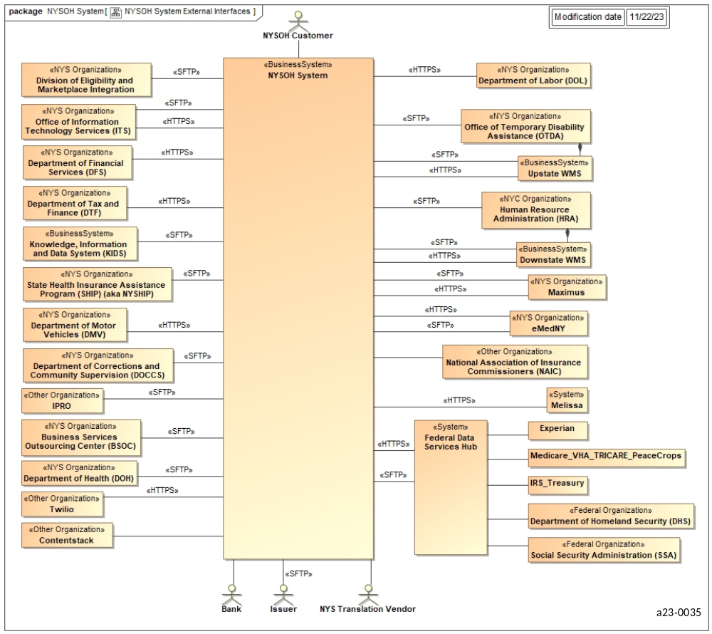
Figure 2. NYSOH System Context and Flow Diagram

System Architecture
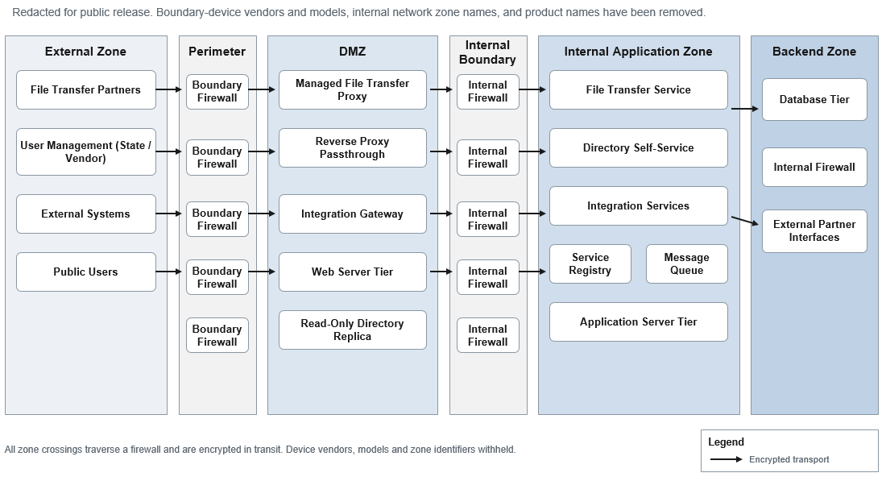
Figure 3. System Architecture

Logical Application Architecture
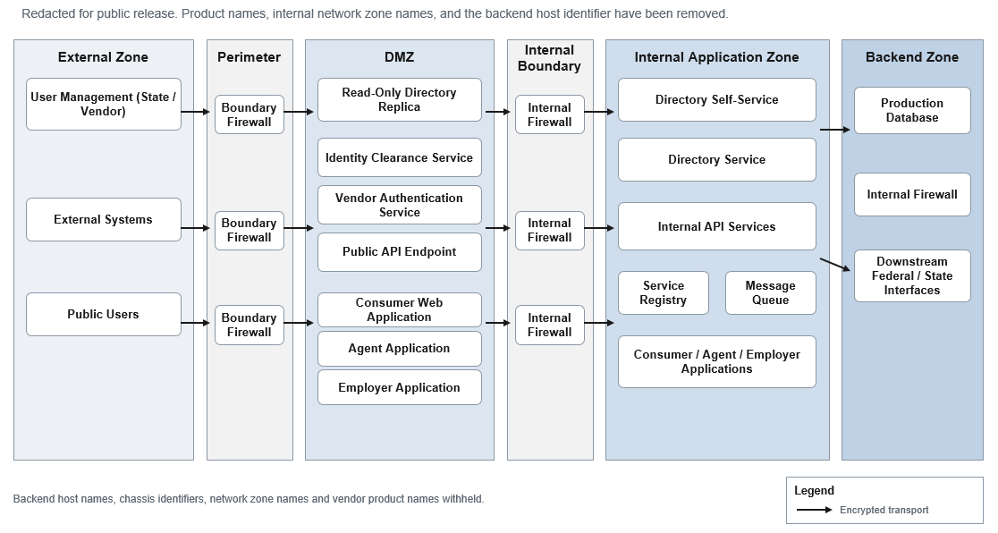
Figure 4. Logical Application Architecture

Financial Management System
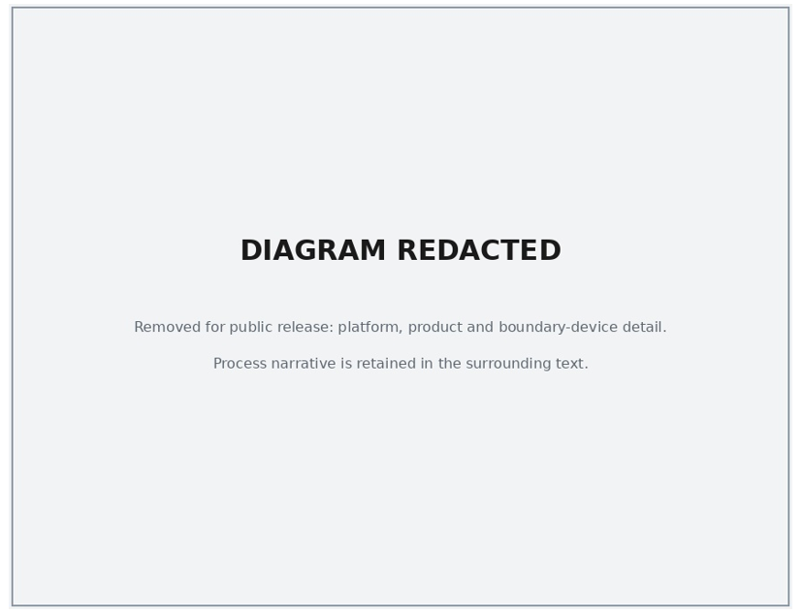
Figure 5. Integration of FMS System Components and Core SBM
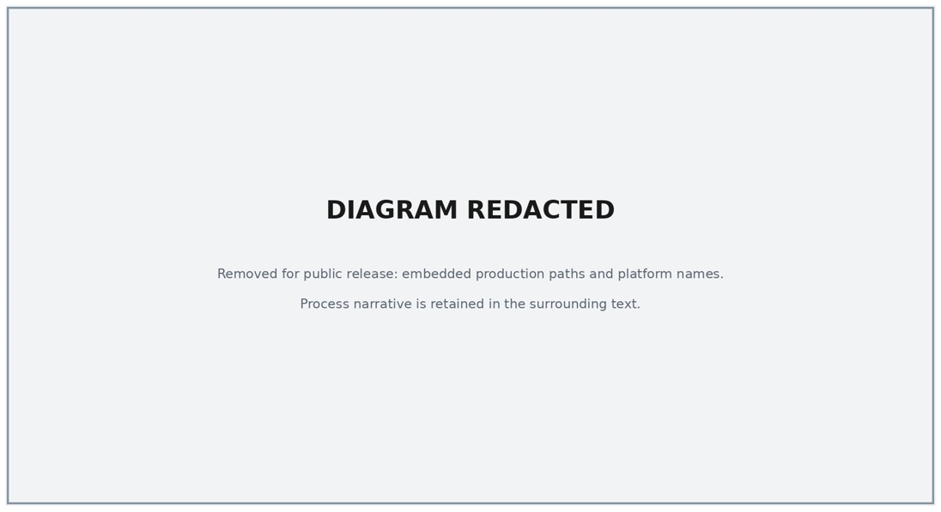
Figure 6. NYSOH Encounter Intake System End to End

Security and Privacy Overview
The NYSOH platform meets Security, Compliance and Privacy requirements as defined and approved by CMS and the Internal Revenue Service (IRS). Compliance is based on controls cited within MARS E Document Suite, Version 2.0, Volume IV: ACA Administering Entity System Security Plan and IRS Pub 1075. For details regarding NYSOH security strategy and standards, refer to the current NYSOH System Security Plan and the Safeguard Security Report.

NYSOH O&M Responsibilities
O&M of the marketplace is outlined in the agreements between GDIT and NYSDOH. Refer to the current contract for details about responsibilities and expectations.

NYSOH High Level Error Handling Overview
Across main applications (NYSOH, FMS, and Encounters) GDIT employs the same high level process to address error handling. On the front end GDIT uses a combination of GDIT monitoring services (i.e., SMART and Managed Security Tools (MST)) and the GDIT Bossier City Command Center to produce and react (e.g., e-mails, text messages, and phone calls) to events, including error messages, alerts, and the like. Whether GDIT encounters an alert before a related error is actually seen or becomes an actual error, GDIT has the needed processes in place to trap those events and trigger the appropriate action. When an event is encountered, GDIT has escalation instructions, vendor support, and service restoration processes in place to work toward resolution. While the GDIT support staff resources and involved vendors may vary between NYSOH, FMS, and Encounters, as well as within the individual solutions of each, the overall process is the same. The GDIT Bossier City Command Center has tools in place to trigger automated e-mails, text messages, and/or phone calls to defined on-call resources. Further, GDIT has monitors in place which allow GDIT to proactively discover possible or active issues and the ability to access the same tools to manually trigger e-mails, text messages, and/or phone calls to defined on-call resources. At times GDIT, reacting to incidents threatening or impacting SLAs, will trigger Collaborative Work Bridges (CWBs) or Service Restoration Teams (SRTs). This will bring all necessary on-call resources into one collective bridge to quickly assess, triage, and resolve incidents. If and when necessary, GDIT has maintenance agreements in place with hardware and software vendors who have products included in the impacted NYSOH, FMS and/or Encounters solutions. While each vendor may have different protocols and support structures, GDIT, generically speaking, will open tickets (various severities based on issue) with involved vendor(s), bringing the vendor support resources and tools (Knowledge Database, Known Error Database, etc.) to bear to assist in resolving incidents and restoring service.

If the interface terminates abnormally because of a system exception (e.g., database is down), then NYSOH GDIT System Architecture team will fix issues related to the system exception and, if applicable, restart the job and notify MAXIMUS Health Services, and NYSDOH representative.

NYSOH High Level Description of the Escalation Process Overview
Across the user interface, application, and database tiers of the NYSOH, FMS, and Encounters applications, GDIT employs a like process for escalation. First, the GDIT Testing, Development, Database, and Middleware SA teams provide daily on shift coverage which covers more than the typical Monday – Friday, 8:00 AM to 5:00 PM work week. While each team has a different model, each team provides on shift coverage additionally covering typical second and/or third shift, as well as weekend hours. In between the on shift coverage, each team provides on call coverage with an assigned primary and secondary resources. Along with the on shift and on call coverage provided, contact for each identified resource is included. This coverage and documentation allows internal GDIT teams, as well as DOH resources, to quickly identify and contact the assigned resource. For DOH, they may contact GDIT team leads to manage and to contact the appropriate on call/on shift resource. Additionally, GDIT has the Bossier City Command Center working 24x7, 365 days a year. The Bossier City Command Center has the shift coverage, contact information, and resources defined to the paging system to allow them to quickly escalate to appropriate resources.

NYSOH Operational Internal File Transfer Management and Standards
NYSDOH and GDIT often need to transfer large or sensitive files between organizations to operate the marketplace. To meet this need, a secure file share location has been established to ensure the secure file transfer of such information via a “post and retrieve method” only. This process reduces the risk of accidental disclosure of confidential information to NYSDOH and GDIT and potentially sensitive personal and health information.

This file share service is not to be used as a place to store files for long periods of time, but rather is only used for specific operational purposes. Further, this file share service is not used for processing Production files.

File Transfer Usage
These are pre-defined folders created under the root NYSOH folder and must be approved by a designated NYSDOH employee. Current file structure listed below Figure 7 and Figure 8:

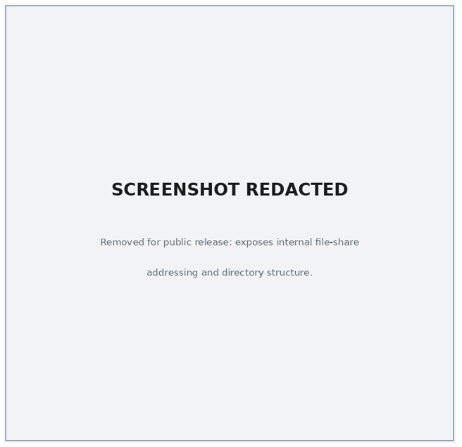
Figure 7. NYSOH File Share Directory Structure - Part 1
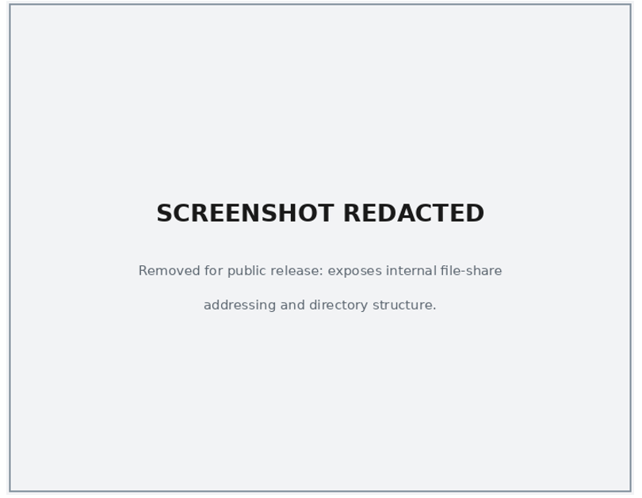
Figure 8. NYSOH File Share Directory Structure - Part II

Ad hoc folders are folders which are accessible to select employees of NYSDOH and GDIT that allow for the transfer of files.

User Provisioning Folders are folders used to send and receive DOH/GDIT User access and Password Reset requests.

Directory Structure for Provisioning NYSDOH and GDIT Accounts for database Access and the Back Office Marketplace application
- A User Access Request (UAR) Form must be submitted in the program's access request portal and approved prior to Directory, Database, Server, and Application access as described in the following sections.

The following people have access to this shared structure:
- NYSOH Ops Leadership
- NYSOH Operations Team
- NYSOH Database Administrator (DBA) Group
- Security and Compliance
- GDIT Operations Manager
- NYSDOH Project Coordinator

For GDIT resources the directory address (shared folder):
\\[REDACTED]\nysoh

For NYSDOH resources the directory address (shared folder):
\\[REDACTED]\nysoh

Under this directory are the following sub-folders as presented in Figure 9.
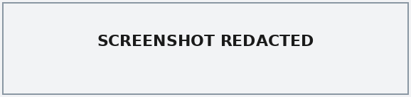
Figure 9. Internal DOH/GDIT (formerly CSC) User Provisioning Folders

Purging the Directories
Each folder has a pre-defined life expectancy of its contents defined as follows:
- Use Case folders – eight days
- Ad hoc folders – three days

A batch process is run to purge all files within each folder based on creation date.

Access Control
This service is intended for a specific usage and provides access for NYSDOH and GDIT staff. Strict controls are placed on each folder, from the root (NYSOH) to all folders under the root. The file share will use “Fine Grain” access controls to manage rights and privileges based on Minimum Use Necessary and Least Privilege rules along with program-level access controls.

User access will be reviewed every 180 days to ensure access is still required.

Provisioning Access
All users granted access to this file share will have Read-Only (RO) access to the NYSOH root directory and will have Read and Write privileges to designated sub-folders.

Provisioning is done through Active Directory (AD).

Only select users defined by NYSDOH and GDIT program management will have full administrative rights with the exception of the Cyber Group that administers and manages the share.

Users will request access to these folders through UAR. Once approved, the request will be sent to the GDIT Cyber group for provisioning.

Once a user is granted their rights, they will use their enterprise directory credentials to access the folders they are authorized to read and/or write.

File Transport Standards
All files stored in this file share shall never contain Production-level data provided by a connecting entity for the purpose of loading data into the NYSOH Production database. All files stored in this file share shall be used for Quality Assurance (QA) purposes only.

Access to this file share service will only be accessible via the NYDOH subNet over the NYeNet and the GDIT internal network using the secure VPN tunnel established between NYSDOH and GDIT.

All files posted to any of the folders in the NYSOH Root Directory must be file level password protected and must meet the established guidelines for password management.

Once a file is posted to the folder, the originator of the file must either contact the intended recipient via a phone call or send the password via email to the recipient.

NYSOH Data and Database Administration
There are a number of ways errors or issues are identified through the following conditions:
- Monitoring Alerts (system and availability notifications)
- Database errors (application and database)
- Application latency (slow response time and timeouts)

Additionally, NYSOH has tools configured to provide notification and alerts based on configurable thresholds:
- Application Manager:
  - Alert on Server availability, File systems thresholds and Central Processing Unit (CPU) utilization
- Data Management Console (DMC):
  - Alert on configured threshold for locking; lock waits, timeouts, escalations, and deadlock, and High Availability Disaster Recovery (HADR) availability
- Automatic Manual Monitoring Scripts:
  - Database availability; organic growth and applications connected, health check and audit policy

GDIT Incident Management
Tech Bridges, Collaborative Work Bridges (CWB), and Service Restoration Team (SRT) are essential components of the GDIT Incident Management Policy. Each has a set workflow, which includes but is not limited to establishing a bridge with the right/required resources and escalation/notification of incidents to all appropriate levels of GDIT management. During SRT/CWB/Bridge Call with Command center, GDIT will update the progress to DOS operations via Text or email.
Tech Bridge - SLAs are not threatened nor impacted. Likely a non-production issue, but could be a low level production issue as well. Bossier City Command Center is called and will trigger the bridge. Paging out the needed resources.
Collaborative Work Bridge (CWB) - SLAs are threatened, SLAs are not yet impacted. Bossier City Command City is contacted and is tasked to trigger the CWB. Automatic paging is set up for CWBs (and SRTs) which the command center will invoke. Resources will gather on the bridge and any resources not needed for the specific problem will be immediately released from the CWB.
Service Restoration Team (SRT) - SLAs are impacted, possibly already violated. Automatic paging is set up for SRTs (and CWBs) which the command center will invoke. Resources will gather on the bridge and any resources not needed for the specific problem will be immediately released from the SRT. An SRT, unlike a CWB, will also trigger a Problem Management ticket and associated Root Cause Analysis (RCA) to be assigned. SRTs will also trigger a Major Incident Report (MIR) which will be updated and sent hourly to GDIT management until service is restored and the SRT is closed with an ALL CLEAR announcement.

Database Problem Analysis

Identification and Isolation
Once a report of poor performance/database issue is received, the following questions to quickly determine the best place to start looking for a potential cause:

When did the problem first occur? Under which conditions does the problem happen?
If the problem has been occurring for some time, and if a database monitor schedule has been implemented, you can use historical data to find differences. This will allow you to focus on changes in system behavior and then focus on why these changes were introduced.

Is the performance issue constant or intermittent?
If the poor performance is continual, check to see if the system has started to handle more load or if a shared database resource has become a bottleneck. Other potential causes of performance degradation include increased user activity, multiple large applications, or removal of hardware devices. If performance is poor only for brief periods begin by looking for common applications or utilities running at these times. If users report that a group of applications are experiencing performance issues, then you can begin your analysis by focusing on these applications.

Does the problem appear to be system-wide or isolated to DB2 and its applications?
System-wide performance problems suggest an issue outside of DB2. It is possible that something at the operating system level/Storage needs to be addressed. If the poor performance is confined to DB2 applications, obviously we will focus on what DB2 is doing.

If isolated to one application, is there a particular query that appears to be problematic?
If one application is problematic, then we can further examine if users are reporting a query or set of queries that are experiencing a slowdown. We might be able to isolate the issue to one application and a potential group of queries.

Is there any commonality to the poor performance or does it appear to be random?
We should determine if any common database tables, table space, indexes, etc. are involved. If so, this suggests that these objects are a point of contention. Other areas to potentially focus on are referential integrity constraints, foreign key cascades, locking issues etc.

Are there any impacts to data replication?
Assess the change-data-capture replication service to determine any performance bottlenecks with data stores, subscription latency/throughput, and resource utilization. To quickly identify a replication issue, review generated alert notifications and collected snapshot metrics, then review the replication management console for events, error conditions, or abnormalities in the history metrics.

The issue is with newly deployed workload/existing workload?
Is the problem reproducible? Are there any stale connections?
Have you applied all known fix packs?
These brief initial questions are invaluable in developing an action plan to help debug a performance problem.

Database Analysis Tools
IBM Data Management Console:
Alerts concerned teams, helps in identifying availability, performance issues. Drill down into a database to quickly identify and analyze database problems; lock waits, timeouts, escalations and deadlocks. Real-time and historical monitoring; configured to collect both real-time and historical metrics for a database.

Database snapshot monitor:
This utility uses the snapshot monitor to provide a single-system view for partitioned and non-partitioned database environments. It helps identify performance problems across the whole database system or in individual partitions. This is an interactive tool.

Database monitoring console utility:
A text-based monitoring utility that provides key performance indicators across the same areas covered by the snapshot monitor plus additional areas relevant to more recent features. It is intended primarily for use on supported Linux and Windows platforms and requires no web server or windowing environment.

Analyzing db2diag log files using db2diag tool:
The primary log file intended for use by database and system administrators is the administration notification log. Diagnostic information about errors is recorded in this text log file. This information is used for problem determination and use for troubleshooting purposes.

Administrative events:
These entries are valuable, since they indicate whether events such as backups runstats, reorg, reclaim high watermark space, partition detach and restores started and finished.

Error information:
This information is only useful if you are trying to diagnose an external symptom, or if you have already determined what the error is and are looking for more information. For example, when an application receives an unexpected SQL code, or when a database crashes, the file can contain error information, including pointers to dump files.

Administration notification log - instance.nfy:
When significant events occur, DB2 writes information to the administration notification log. The information is intended for use by database and system administrators. Many notification messages provide additional information to supplement the SQLCODE that is provided. The type of event and the level of detail of the information gathered are determined by the NOTIFYLEVEL configuration parameter.

Monitoring and troubleshooting using db2pd:
The db2pd command is a stand-alone command that you can use to monitor and troubleshoot a DB2 instance from its database system memory. The db2pd command collects information without using any engine resources or acquiring any latches. Because the db2pd command does not acquire any latches, we can normally retrieve information that is changing while the db2pd command is collecting information. This tool helps monitoring the HADR status.

IBM Change Data Capture (CDC) Management Console:
IBM CDC data replication events, error conditions, and historical metrics can be retrieved for display and problem determination by using the Windows-based CDC Management Console tool. It will also retrieve and display real-time and historical status and performance metrics of replication subscriptions collected by the CDC Access Manager server. The contents of the very detailed native CDC transaction logs can also be retrieved from data source & target servers using the Management Console and displayed in user-friendly graphics and easily understandable text for assisting in troubleshooting.

Open PMR with IBM DB2 Support:
A Problem Management Report (PMR) can be opened with IBM DB2 technical support to investigate problems with DB2 Linux, Unix, Windows (LUW). For further information, refer to the NYSOH Business Continuity and Disaster Recovery Plan. Table 96 lists the available severity levels.

Severity Levels | Business Impact
Severity 1 | Critical Impact/System Down: Business critical software component is inoperable or critical interface has failed. This usually applies to a production environment and indicates you are unable to use the program resulting in a critical impact on operations. This condition requires an immediate solution.
Severity 2 | Significant business impact: A software component is severely restricted in its use or you are in jeopardy of missing business deadlines because of problems with a new application rollout.
Severity 3 | Some business impact; Indicates the program is usable with less significant features (not critical to operations) unavailable.
Severity 4 | Minimal business impact: A non-critical software component is malfunctioning, causing minimal impact, or a non-technical request is made.
Table 96: Severity Levels

Database Management Supporting Documentation
Database Management consists of three parts: the overall plan and maintenance, the security strategy, and the detailed procedures. These documents are living documents and evolve as necessary with periodic updates. Table 97 lists these documents.

Document Name | Description
NYSOH Data Management Plan | Overall description of how the database is managed and maintained.
NYSOH Master Database Security Plan | Outlines the security strategy and controls of the NYSOH database.
NYSOH Database Administration Procedures | Details on how the database is managed, backed up and other operational processes and controls.
Table 97: NYSOH Database Management Documents

Data Architecture of the NYSOH Platform
There are three core elements to the data architecture:
- Logical Data Model (LDM)
- Data Dictionary (DD)
- Physical Data Model (PDM)

The combination of these elements provides the framework to build three views of the data:
- The conceptual view provides a high-level visual perspective of each subject area of the NYSOH solution. It contains the most basic and critical business entities within each subject area and function plus relationships between entities. This data model takes into account information on business entities contained in the CMS Exchange Blueprints updated with NYS-specific information.
- The logical view shows the relationships between the entities, the cardinality (one-to-many, one-to-one), plus the beginning stages of normalization and the separation of data into key based structures.
- The physical view of the data represents how the data is used by the application. This view is optimized for specific access patterns, takes into account constraints of the Database Management System (DBMS) platform and performance requirements.

The data is stored in a vendor-supported enterprise relational DBMS. The database is able to handle data in eXtensible Markup Language (XML), geospatial, and other formats. The system leverages virtualized platforms to maximize performance and high availability.

Table 98 shows the regularly scheduled database administration processes.

Job Name | Script | Freq. | Trigger From | Execute on | Job Dep. | Scheduled Time
Oversight MQT Refresh (the reporting database) | [REDACTED] | Daily | TWS | Database server & 40 | Yes | 12:00 AM
Refresh Plan MQT | [REDACTED] | Daily | TWS | Database server | None | 1:00 AM
Proximal Search | [REDACTED] | Daily | TWS | Database server | None | 2:00 AM
IRS1095_Daily_Load | [REDACTED]IRS1095_Daily_Load.ksh | Daily | TWS | Database server | None | 6:00 AM
Runstats (the production database) | [REDACTED] | Sat | TWS | Database server | None | 6:00 AM
Crontab Backup | [REDACTED] | Daily | TWS | Database server | None | 7:30 AM
DB & DBM CFG Backup | [REDACTED] | Daily | TWS | Database server | None | 7:30 AM
DB Health Check | [REDACTED] | Daily | TWS | Database server | None | 7:45 AM
Backup Prune (the production database) | [REDACTED] | Daily | TWS | Database server | None | 9:00 AM
the reporting database Prod Backup | [REDACTED] | Tue - Sat | TWS | Database server | Yes | 5:00 PM
the reporting database Prune | [REDACTED]RPT_Backup_Prune.sh | Tue - Sat | TWS | Database server | None | 8:00 PM
Truncate_Logs | [REDACTED] | Daily | TWS | Database server | None | 10:59 PM
Prune_backup | [REDACTED]  [REDACTED]  [REDACTED] | Su,Tu,Th | TWS | Database server | None | 5:30 PM
Prod Full Backup Online | [REDACTED] | Su,Tu,Th | TWS | Database server | Yes | 5:30 PM
Table 98: Database Administration Procedures

For the complete active database jobs or any changes in the job dependencies, refer to the “TWS_ReportTemplate” worksheet in the configuration management repository, and then choose a Database track to review the contents or make changes.

The high-level NYSOH data architecture is shown in Figure 10. Figure 11 depicts the relationship between the data models.

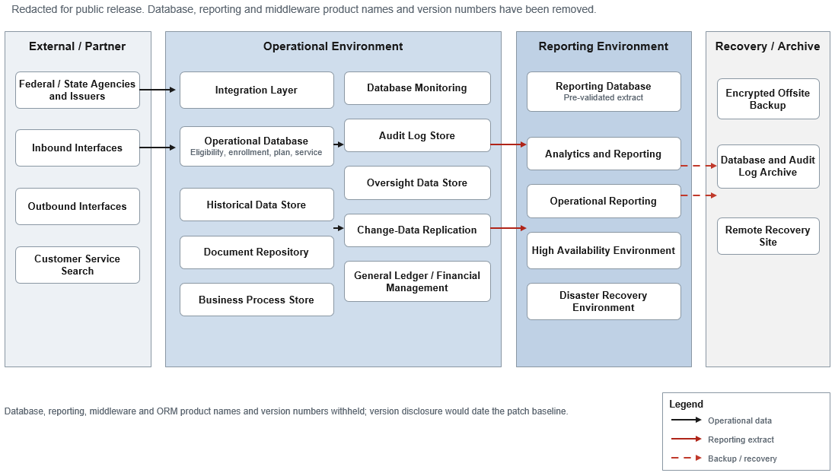
Figure 10. Data Architecture View
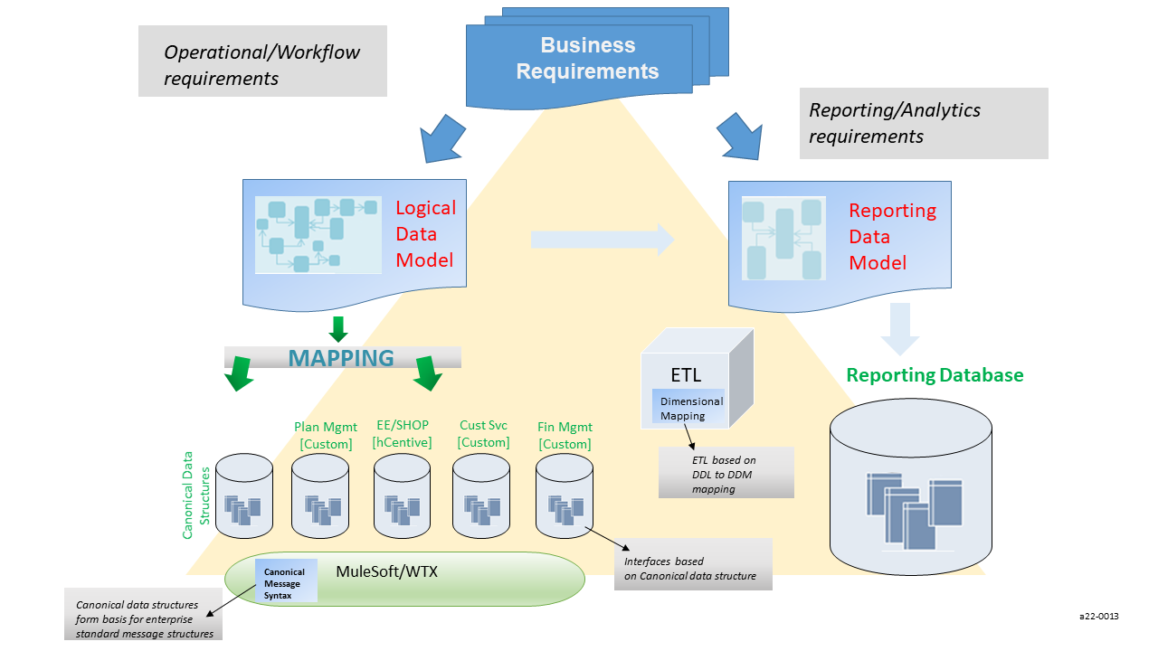
Figure 11. Data Model Levels

Federal Tax Information (FTI) in the Data Architecture
The NYSOH platform manages data derived from the Federal hub, and certain restrictions and compliance requirements that are needed for the protection and use of Federal Tax Information (FTI).

NOTE: FTI cannot be provided or reviewed by any auditing function such as Federal Audits or NYS auditor as defined in Internal Revenue Code (IRC) 6103 and Publication 1075.
FTI is restricted to a limited number of approved users; any additions of users must be approved by the NYDOH Chief Information Security Officer (CISO) and the NYSOH Information System Security Officer (ISSO).

Approved users include those listed in Table 99.

User Type | Description
Database administration role | Elevated privileges to manage database operations.
Application support role | Elevated privileges to support the business owner, exercised only on behalf of the business owner upon written request (for audit purposes).
Appeals support role | Elevated privileges to support appeals hearings and inclusion in the evidence packet for determination of benefits during an appeal.
Table 99: Approved FTI User

Figure 12 presents the FTI Data Flow.
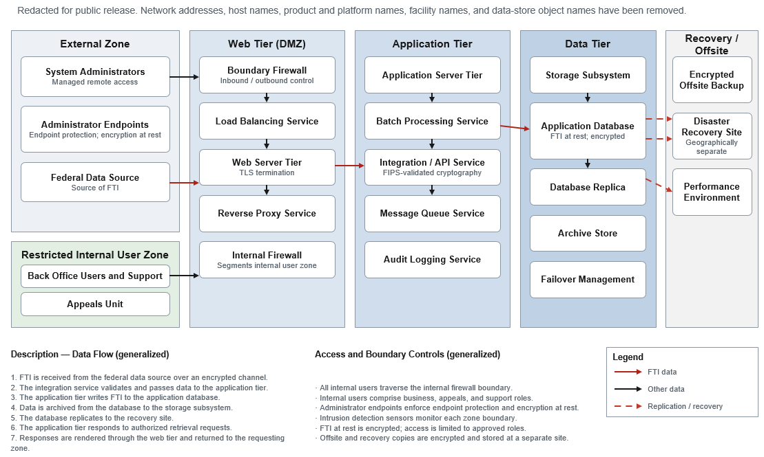
Figure 12. FTI Data Flow

NYSOH Configuration Management (CM)
The NYSOH Configuration Management Plan, maintained in the program's controlled document repository, includes details regarding NYSOH Configuration Management (CM) processes.

Disaster Recovery and Business Continuity Operations
The details of the approved Disaster Recovery Plan (DRP) can be found in the NYSOH Business Continuity and Disaster Recovery Plan document, which will be made available upon request and approval.

NYSOH Backup Procedures
The following section, described in Table 100, documents procedures for regularly scheduled backups of the entire network, including creating, storing, maintaining, and securing backups and associated logs. Details of all procedures can be found in the System Security Plan (SSP) as well as provided upon written request to our Data Center Manager.

Category | Value
Scope | NYSOH environments including Development, Test and Production virtual and physical servers
Backup storage/media and its location | - Tapes. Backup tapes are stored:  - Onsite at the primary data center (RDC); and  - Offsite storage is managed under contract with a commercial records-management provider.  Details of the offsite storage schedule can be found in the SSP, Part B.  - Disk storage at the RDC.  - Disk storage at a Disaster Recovery (DR) facility.
Frequency of backups | Online backups are performed on alternate days of the week. These online backups are stored at a geographically separate offsite location.
Supporting software tools | The following software is used to perform backups:  - Enterprise backup software,  - Virtual-machine backup software,  - Storage-array replication software  Backup monitoring is done by the RDC Command Center on a 24x7 basis.
Back-up and DR vendors | - Commercial records-management provider for offsite media storage.  - Third-party managed disaster recovery service.
Handling backup media | - All backup tapes with NYSOH data are:  - Encrypted in accordance with Federal Information Processing Standard (FIPS) Publication 140-2 using FIPS-validated enterprise key management software;  - Assumed to contain Personally Identifiable Information (PII) and FTI and be labeled as such; and  - Labeled in accordance with program media-marking procedures.  - Offsite archival of backup tapes is achieved through a contract with a commercial records-management provider. All removable media for the NYSOH system is marked in accordance with program media-marking procedures. All shipments are documented at the time of transport. The documentation includes information on the contents of the media, such as the dates of shipping and receiving. Backup tapes are shipped in locked containers.  - Backup tapes with Production data are retained in accordance with the retention period defined in the SSP before reuse.
Responsible Teams | - The contractor database support team is responsible for ensuring that the NYSOH backup strategy is executed as designed.  - The contractor storage support team is responsible for the handling of backup tapes.
Reference Documents | - System Security Plan (SSP)  - Business Continuity and Disaster Recovery Plan
Table 100: Backup Procedures Category

NYSOH Security and Vulnerability Monitoring Procedures
The NYSOH system uses a variety of industry leading monitoring tools for the network and directory domains listed in Table 101.

The details of the monitoring and procedures can be found in the NYSOH SDD, SSP, and DRP.

All monitoring software and services used on the program are active 24x7, 365 days per year.

Monitoring of security incidents is performed on a 24x7 basis. During these hours, the GDIT Technology Shared Services (TSS) MST will analyze events escalated by the correlation engine to confirm and escalate suspicious activity to pre-defined points of contact.

Domain | Software Services | Monitoring Services
Network | - Infrastructure and availability monitoring  - Enterprise storage management console for the SAN)  - Storage array administration tooling for the SAN  - Firewall Log Monitoring  - Network Intrusion Detection Service (NIDS)  - Managed Vulnerability Assessment | - GDIT TSS Managed  - GDIT TSS Managed  - GDIT TSS Managed  - GDIT TSS Managed  - GDIT MST Monitored  - GDIT MST Monitored  - GDIT MST Monitored
Application and Database | - Static application security testing  - Web usage analytics | - GDIT Cyber Group Monitored  - GDIT NYSOH Project monitored
Security Perimeters | - Edge security and content delivery service  - Manages Web application firewall (WAF)  - Origin protection service  - Central Managed Endpoint Protection  - Endpoint detection and anti-malware protection  - Server (GDIT MST)  - Intrusion Detection Services  - MST Monitoring Services  - Monitor the legitimacy of users access to servers and other networked devices  - Retain the integrity of unaltered logs (essential for collection of admissible evidence)  - Establish real-time monitoring and audit trails to address threats  - Correlate logs from multiple endpoints and technologies  - Report of material events to clients | - GDIT NYSOH Project Monitored  - GDIT MST Monitored  - GDIT NYSOH Project Monitored  - GDIT MST Monitored  - GDIT MST Monitored  - GDIT MST Monitored
Table 101: NYSOH Monitoring Services Domain

NYSOH Maintenance Procedures
Table 102 describes procedures for maintaining the file system. This includes procedures for installing and testing system updates and for moving/installing the system updates to the operational environment, and procedures for creating and updating maintenance reports where applicable.

Category | Value
Scope and schedule | Install patches and upgrades to operating system, applications, databases, firewalls, and other system components.  - Patches and minor version upgrades will be reviewed to determine if they need to be deployed to the NYSOH system. If a decision is made to deploy patches and/or minor upgrades, they will be first deployed into test environments to be tested prior to deployment into Production.  - Minor version upgrades and most patches will be deployed to Production within a regular maintenance schedule.  - Patches considered to be "critical” may be deployed to Production outside of the regular maintenance schedule with the goal of zero down time of the NYSOH Production systems.  Install major version upgrades of operating system, applications, databases, firewalls, and other system components.  - Major version upgrades of system components can be caused by:  - Major upgrades of related system components. For example, major upgrade of operating system can be caused by a major upgrade of the database that resides on this operating system.  - Discontinuation of vendor support for current versions of system components.  - On an annual basis, an evaluation will be done to determine whether Operating Systems (OSs) should be migrated to a major new release.  - Major upgrades will be first deployed into test environments to be validated prior to deployment into Production.
Supporting software tools | The technical support team uses an internal, access-restricted IT service management system to coordinate and track the process of testing and deploying patches and all version upgrades.
Responsible Teams | - System administration and routine system maintenance are performed by the contractor's infrastructure and cybersecurity support teams. These users have no application access.  - Deployment of OS and network patches and version upgrades is performed by the contractor's infrastructure support teams.  - Deployment of application/database patches and version upgrades is performed by NYSOH GDIT System Architecture team.  - Testing of patches and version upgrades is performed by NYSOH Testing team.
Reference Documents | - The following documents were either directly referenced for this section of the manual or provide context regarding the contents of this section.  - NYSOH Security Policy Handbook  - NYSOH Security Procedure & Guideline Handbook  - NYSOH Configuration Management Plan  - System Security Plan
Table 102: Maintenance Procedures

The scope of this section currently covers the maintenance and upgrade of the NYSOH solution hosted at the primary data center. This solution is maintained solely by contractor resources. There are services provided by NYS ITS which the NYSOH solution connects to. These services, hosted at a State-operated data center, are maintained by NYS ITS.

Core and Ancillary NYSOH Application Operational Processes
Note: See Section 17.1 for the Security Impact Assessment vulnerability scanning discussion.

Sections 16.1 through 16.10 contain all detailed operational processes for managing the application and data associated to each of the core and ancillary business applications. These are provided for historical purposes and include:
- Plan Management (PM)
- Small Business Marketplace
- Customer Service (CS)
- Individual Marketplace
- Financial Management (FM)
- NYSOH Interfaces
- Special Processes
- Oversight Reporting Platform
- IRS 1095a Process and Forms
- Encounter Intake System (EIS)

Plan Management Operations
This section contains the operations sequence and the operations, diagnostic, problem handling, and restart/recovery procedures for the PM subsystem of the NYSOH system. Figure 13 provides an overview of the workflow.

Annual Plan Management (PM) Data Load Process:
The Annual PM Data Load process starts every year in the last week of August and finishes in the last week of September. As part of the Annual PM Load Process, the following steps are performed.

- GDIT PM Team prepares a list of all the tasks that need to be performed with the tentative dates by which the data needs to be loaded.
- The List is shared with the DOH PM Team and DOH Systems Teams to confirm the schedule.
- Once confirmed, the schedule is added to the Renewal Calendar and the tasks are tracked on a weekly basis with the DOH PM Team and DOH Systems.
- For all the data that is file-based load, the DOH PM Team will send all the files as scheduled to NYSOH Operations team which are then loaded into test environments. If files are successfully loaded, the NYSOH Operations Team sends a request to the Sys-Admin Team for them to be loaded into Production. In case of any errors, they are reported back to the DOH PM Team to rectify.
- For System for Electronic Rate and Form Filing (SERFF) data load, in the event of any failure to load or invalid data loaded, the DOH PM Team will work with the GDIT PM Team to identify and resolve the issues. In some instances, the DOH PM Team will co-ordinate with SERFF or the Issuers to resolve the issues.
- As the plan data is being loaded and plans are available in the Issuer Portal, the DOH PM Team coordinates with Issuers to get the plans reviewed and approved. In case the Issuer finds any issues with the data, the Issuer will report to the DOH PM Team and PEND the plan(s).
- Once the plans are approved in the Issuer Portal, the plans are available for the DOH PM Team to review and approve in the Exchange Admin Portal. In case the DOH PM Team finds an issue with the plan information, the Issuer is notified to correct the information and the plans need to be reloaded.
- In the event of any technical issues or any data display issues, the DOH PM Team coordinates with the GDIT PM Team to analyze and resolve the issues with the DOH Systems and NYSOH Operations Teams apprised along the way.

Plan Management High Level Work Flow
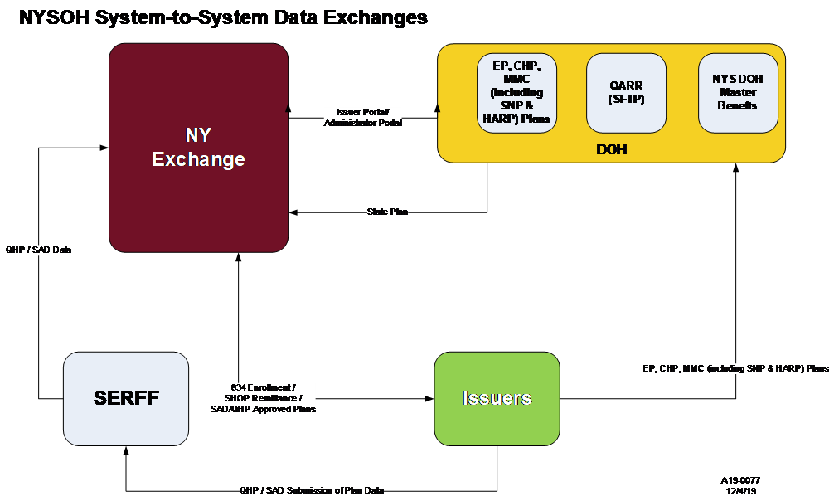
Figure 13. Plan Management High Level Workflow

Plan Management Operations Sequence
Table 103 lists the operations sequence for the PM subsystem. The operations sequences are identified in the table below, delineating the logical breaks between the processing steps for the PM functionality.

Process Name | Step 1  of Processing | Step 2  of Processing | Step 3  of Processing
Load Qualified Health Plan (QHP) links into the NYSOH system | This is pre-request step for QHP plan data loading. Plan links data implemented for Plan Year 2021 and forward:  - NYSOH will receive a CSV file with web links for benefit coverage, formulary, network, brochure and payment data from DOH.  - Batch interface verifies and loads CSV contents into the NYSOH system.  - System looks up links while plan data is being processed and attached to the plan. | NA | NA
Load QHP update data into the NYSOH system | Web service verifies and loads QHP update into the NYSOH system. Certain values (e.g., status) are populated in the system in such a way that QHP update:  - Is made available for review and approval/ pending in the web-based Issuer Portal;  - But, is not made available for consumers to review and select. | Issuer reviews and approves/pends the QHP update in the Issuer Portal. If the QHP update is approved, the status value is updated in such a way that the update:  - Is made available for review and approval/pending in a web-based Exchange Admin Portal;  - But, is not made available for consumers to review and select. | Exchange Administrator reviews and approves/pends the QHP update in the Exchange Admin Portal. If the QHP update is approved, certain values (e.g., status) are updated to make the plan available on Individual or Small Business Marketplace for consumers to review and select.
Load QHP suspension data into the NYSOH system | Web service verifies and loads QHP suspension data into the NYSOH system. Certain values (e.g., status) are populated in the system in such a way that the suspension:  - Is made available for review and approval/pending in the Exchange Admin Portal;  - But, is not reflected for consumers. | Exchange Administrator reviews and approves/pends the QHP suspension in the Exchange Admin Portal. If the suspension is approved, certain values (e.g., status) are updated to reflect this and suspended plans are not available to consumers on Individual or Small Business Marketplace. | N/A
Load QHP data related to lifting a suspension into the NYSOH system | Web service verifies and loads data related to lifting a suspension for QHP plan into the NYSOH system. Certain values (e.g., status) are populated in the system in such a way that the data related to lifting a suspension:  - Is made available for review and approval/pending in the Exchange Admin Portal;  - is not reflected for consumers. | Exchange Administrator reviews and approves/pends the data related to lifting a suspension in the Exchange Admin Portal. If the lifting of a suspension is approved, certain values (e.g., status) are updated to reflect this lifting of a suspension and the plan will be available to consumers on Individual or Small Business Marketplace. | N/A
Load QHP decertification data into the NYSOH system | Web service verifies and loads QHP decertification data into the NYSOH system. Certain values (e.g., status) are populated in the system in such a way that the decertification:  - Is made available for review and approval/pending in the Exchange Admin Portal;  - is not reflected for consumers. | Exchange Administrator reviews and approves/pends the QHP decertification in the Exchange Admin Portal. If the decertification is approved, certain values (e.g., status) are updated to reflect this decertification and decertified plans are not available to consumers on Individual or Small Business Marketplace. | N/A
Load QHP recertification data into the NYSOH system | Web service verifies and loads QHP recertification into the NYSOH system (in the form of a new plan). Certain values (e.g., status) are populated in the system in such a way that the recertification:  - Is made available for review and approval/pending in the Issuer Portal;  - is not reflected for consumers. | Issuer reviews and approves/pends the QHP recertification in the Issuer Portal. If the recertification is approved, the status value is updated in such a way that the recertification:  - Is made available for review and approval/pending in the Exchange; Administrator Portal;  - is not reflected for consumers. | Exchange Administrator reviews and approves/pends the QHP recertification in the Exchange Admin Portal. If the recertification is approved, certain values (e.g., status) are updated to reflect this recertification and the plan will be available to consumers on Individual or Small Business Marketplace.
Load a new Children's Health Insurance Program (CHIP) plan into the NYSOH system | Batch interface verifies and loads CHIP plan data into the NYSOH system. Certain values (e.g., status) are populated in the system in such a way that the CHIP plan:  - Is made available for review and approval/pending in the web-based Issuer Portal;  - is not made available for consumers to review and select. | Issuer reviews and approves/pends the CHIP plan in the Issuer Portal. If the plan is approved, the status value is updated in such a way that the plan:  - Is made available for review and approval/pending in a web-based Exchange Admin Portal;  - is not made available for consumers to review and select. | Exchange Administrator reviews and approves/pends the CHIP plan in the Exchange Admin Portal. If the plan is approved, certain values (e.g., status) are updated to make the plan available on Individual Marketplace for consumers to review and select.
Load a new Medicaid Managed Care (MMC) plan into the NYSOH system – this includes Special Needs Plans and Health and Recovery Plans which are submitted as Medicaid plans with a Plan Type of SNP or HRP. | Batch interface verifies and loads MMC plan data into the NYSOH system. Certain values (e.g., status) are populated in the system in such a way that the MMC plan:  - Is made available for review and approval/pending in the Issuer Portal;  - is not made available for consumers to review and select. | Issuer reviews and approves/pends the MMC plan in the Issuer Portal. If the plan is approved, the status value is updated in such a way that the plan:  - Is made available for review and approval/pending in a web-based Exchange Admin Portal;  - is not made available for consumers to review and select. | Exchange Administrator reviews and approves/pends the MMC plan in the Exchange Admin Portal. If the plan is approved, certain values (e.g., status) are updated to make the MMC plan available on Individual Marketplace for consumers to review and select.
Load a new Essential Plan (EP) into the NYSOH system | Batch interface verifies and loads EP plan data into the NYSOH system. Certain values (e.g., status) are populated in the system in such a way that the EP plan:  - Is made available for review and approval/pending in the web-based Issuer Portal;  - is not made available for consumers to review and select. | Issuer reviews and approves/pends the EP plan in the Issuer Portal. If the plan is approved, the status value is updated in such a way that the plan:  - Is made available for review and approval/pending in a web-based Exchange Admin Portal;  - is not made available for consumers to review and select. | Exchange Administrator reviews and approves/pends the EP plan in the Exchange Admin Portal. If the plan is approved, certain values (e.g., status) are updated to make the plan available on Individual Marketplace for consumers to review and select.
Table 103: Operations Sequence for Core Processing in Plan Management

Plan Management Operations Procedures
The following section includes instructions for each identified state and mode of operation. The following paragraphs describe the operations procedures in terms of inputs, processes, outputs, error locations, and other pertinent information where applicable. The relevant figures for this section are:

- Figure 13. Plan Management High Level
- Figure 14. Quality Assurance Reporting Requirements (QARR) Data from DOH
- Figure 15. CHIP Rates from DOH
- Figure 16. EPP Rates from DOH
- Figure 17. Master Benefits Data from DOH

Input/Output Procedures
The following is a list of input/output jobs in the PM subsystem. These jobs represent inbound batch interfaces into the NYSOH system. Web services are not considered to be input/output jobs and are not included in the list of jobs below. For example, a web service for receiving QHP data from the National Association of Insurance Commissioners (NAIC) SERFF is not listed below; the SDD includes this information:
- Table 104: Data Quality Interface
- Table 105: CHIP Standard Rate Data Interface
- Table 106: EP Standard Rate Data Interface
- Table 107: Plan Benefit Data Interface
- Table 108: Plan Administration Data of CHIP Plans Interface
- Table 109: Plan Administration Data for Medicaid Managed Care Plans Interface
- Table 110: Plan Administration Data for Essential Plans Interface

Quality Assurance Reporting Requirements (QARR) Data from DOH
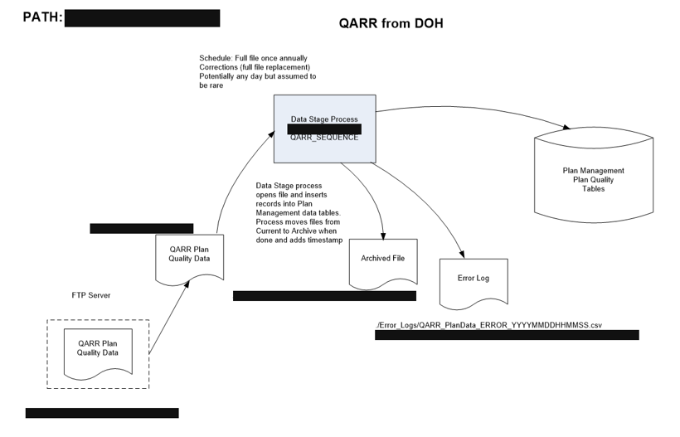
Figure 14. Quality Assurance Reporting Requirements (QARR) Data from DOH

Category | Value
Description | Validate, map, and load quality data into the NYSOH system.
Mode of Operation | This is an automated job that will run on a schedule. The schedule is defined in the NYSOH Production Job Schedule.  The job will check if an applicable input file exists in a specific location on the NYSOH system. If the applicable input file is found, subsequent interface processing will initiate. If no applicable input file is found, the job will terminate.
Job Type | Inbound batch interface. This is a non-Electronic Data Interchange (EDI) interface.
Systems | An Autosys scheduled job performs this function  - DS_QARR_PROD.sh invokes the Data Stage process QARR_SEQUENCE
Inputs | A single input file in a CSV format contains quality data records for QHPs (except for multi-state plans) offered on Individual and/or Small Business Marketplace, EP, CHIP or MMC plans (including Special Needs Plan (SNP) & Health and Recovery Plans (HARP)). Quality data will not be provided for multistate QHPs and stand-alone dental plans. See the row entitled Naming Convention and Location of Input and Output Files section of this table for the locations and names of these files.  DOH will transmit the input file to the NYSOH system.
Outputs | Plan Management Plan Quality tables are updated by this process. The input file is moved to an archive, where a timestamp is appended to the filename. If there are errors, an error log file is written as shown in the Naming Convention and Location of Input and Output Files section of this table.
Business Frequency | Input files received by NYSOH as part of a regular submission cycle are referred to as regular input files. Input files received outside of the regular submission schedule are referred to as correction input files. A correction input file represents full replacement of an associated regular input file. (Both types of files have the same format and are processed in the same way by the interface).  The frequency of receiving regular input files by NYSOH is:  - Approximately one input file per Issuer per year.  Correction input files can be received anytime, but occurrences are expected to be rare. The following is a potential reason for receiving a correction input file:  - Record(s) from a prior regular input file did not pass the interface validation or mapping.
Processing (High-Level) | Select an input file from the location on the NYSOH system.  Determine whether the input file is empty. If it is empty, then:  - Send an email to the NYSOH GDIT System Architecture team indicating that the input file is empty.  - Append the name of the input file with the processing timestamp and move this file to the error folder.  - If the input file is not empty, then perform data validation on the input file.  - Map data records that successfully passed the validation to associated plan records in the NYSOH system.  - Check for duplicates among data records that successfully passed validation and mapping.  If all data records successfully passed validation, mapping, and duplicate check, then:  - Load all data records into NYSOH system.  - Send an email to the NYSOH Plan Management team indicating interface processing completed successfully.  - Append name of input file with processing timestamp and move this file to archive folder.  If one or more data records did not pass validation or mapping, then:  - Load data records that successfully passed validation and mapping into NYSOH system.  - Create error files in error reports folder.  - Send an email to the NYSOH GDIT System Architecture team indicating validation or mapping errors were encountered during interface processing. Error files will be attached with the email.  - Append processing timestamp to name of input file and move this file to error folder.  - Append processing timestamp to names of error files and move these files to error log folder.  If duplicate records are identified among records that successfully passed validation and mapping, then:  - Load data records that successfully passed validation, mapping, and duplicate check into NYSOH system.  - For records that passed validation and mapping but have duplicates, load only one unique record from duplicate set into NYSOH system.  - Create error files in the error reports folder. Error files will include data on duplicate records.  - Send an email to the NYSOH GDIT System Architecture team indicating that duplicate records were found during the interface processing. Error files will be attached with the email.  - Append processing timestamp to name of input file and move this file to the error folder.  - Append processing timestamp to names of error files and move these files to the error log folder.
Distribution of Outputs | Outputs are distributed only as described above.
Naming Convention and Location of Input and Output Files | - Input file  - Location  - [REDACTED]  - Naming convention  - QARR_PlanData.CSV  - Output error files  - Location  - [REDACTED]  - Naming convention  - QARR_PlanData _ERROR_YYYYMMDDHHMMSS.CSV  - QARR_PlanData _ERROR_DETAILS_YYYYMMDDHHMMSS.CSV
Error handling (High-Level) | - If the interface terminates abnormally because of a system exception (e.g., database is down), then:  - NYSOH GDIT System Architecture team will fix issues related to the system exception, and, if applicable, restart the job.  - If the interface terminates normally, but determines that the input file is empty, then:  - The interface will send an email to the NYSOH GDIT System Architecture team indicating that the input file is empty.  - The interface will append the processing timestamp to name of input file and move this file to the error folder.  - DOH will transmit a correction input file to the NYSOH system. Not all system errors are due to faulty input files; a few can be process or system related.  - The interface will process the correction input file in the same way as a regular input file.  - If the interface terminates normally, but encounters validation or mapping errors, then:  - The interface will load data records that successfully passed validation and mapping into the NYSOH system.  - The interface will create error files in the error reports folder.  - The interface will send an email to the NYSOH GDIT System Architecture team indicating that validation and/or mapping errors were encountered during processing. Error files will be attached with the email.  - The interface will append processing timestamp to name of input file and move this file to the error folder.  - The interface will append processing timestamp to names of error files and move these files to the error log folder.  - DOH will transmit a correction input file to the NYSOH system. This file will represent full replacement of the original input file. Not all system errors are due to faulty input files; a few can be process or system related.  - The interface will process the correction input file in the same way as a regular input file. If applicable, the interface will:  - Perform “logical deletes” of data records in the NYSOH system that were created by processing of the original input file; and  - Load matching data records from the correction input file.  - If the interface terminates normally, but identifies duplicate records, then:  - The interface will load data records that successfully passed validation, mapping, and duplicate check into the NYSOH system.  - For records that successfully passed validation and mapping but have duplicates, the interface will load only one unique record from a duplicate set into the NYSOH system.  - The interface will create error files in the error reports folder.  - The interface will send an email to the NYSOH GDIT System Architecture team indicating that validation and/or mapping errors were encountered and/or duplicate records were found. Error files will be attached with the email.  - The interface will append processing timestamp to name of input file and move this file to the error folder.  - The interface will append processing timestamp to names of error files and move these files to the error log folder.  - If validation or mapping errors were encountered, DOH will transmit a correction input file to the NYSOH system. This file will represent full replacement of the original input file. (If no validation or mapping errors were encountered but duplicates were identified, DOH will not send a correction input file).  - If a correction input file is received, the interface will process the correction input file in the same way as a regular input file.
Responsible Teams | - DOH Plan Management team  - NYSOH GDIT System Architecture team  - NYSOH GDIT Application Development team
Table 104: Data Quality Interface

State CHIP Rates from DOH
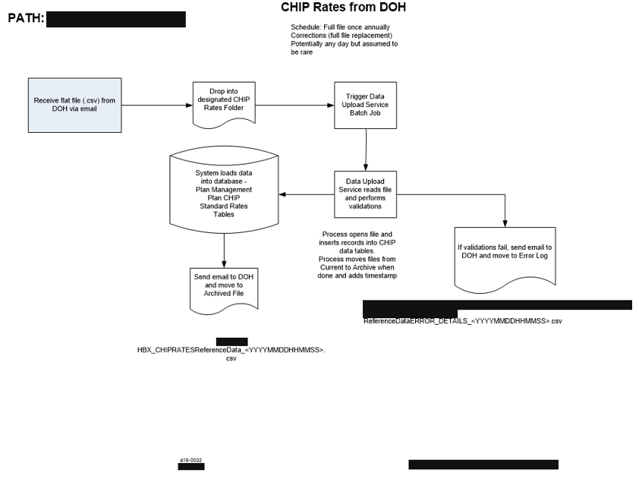
Figure 15. CHIP Rates from DOH

Category | Value
Description | Validate and load data related to CHIP standard rates. These are also known interchangeably within NYSDOH as Child Health Plus (CHP) rates. (Currently, these rates are applicable to members with family incomes of less than or equal to 400% of the Federal Poverty Level (FPL)).
Mode of Operation | This is a job that runs on demand.  The job will determine if an applicable input file exists in a specific location on the NYSOH system. If the applicable input file is found, subsequent interface processing will initiate. If no applicable input file is found, the job will terminate.
Job Type | Inbound batch interface. This is a non-EDI interface.
Systems | This is an on demand job that is run as needed
Inputs | A single input file in a CSV format that contains data on CHIP standard rates. DOH will transmit this file to the NYSOH system. See the Naming Convention and Location of Input and Output Files section in this table for locations and names of these files.
Outputs | Plan Management Standard CHIP Rates tables are updated by this process. The input file is moved to an archive, where a timestamp is appended to the filename. If there are errors, an error log file is written as shown in the Naming Convention and Location of Input and Output Files section in this table below.
Business Frequency | Input files received by NYSOH as part of a regular submission cycle are referred to as regular input files. Input files received outside of the regular submission schedule are referred to as correction input files. A correction input file represents full replacement of an associated regular input file. (Both types of files have the same format and are processed in the same way by the interface).  The frequency of receiving regular input files depends on the frequency of applicable changes to the legislation related to CHIP standard rates. It is expected these changes will be rare.  An input file will not contain Issuer-specific data.  Correction input files can be received anytime but occurrences are expected to be rare. The following is a potential reason for receiving a correction input file:  - Record(s) from a prior regular input file did not pass the interface validation.
Processing (High-Level) | - Receive the input flat file (.CSV) from DOH via email.  - A manual check is done to determine whether the input file is empty. If it is empty, then:  Send an email to the DOH PM Team indicating that the input file is empty.  - If the input file is not empty, then drop the file into the designated folder – folder is configurable based on type of file.  - Trigger Data Upload Service batch job.  - Data Upload Service batch job reads the file and performs validations.  - If all data records successfully passed the validation, then:  - System loads all data records into the NYSOH database.  - Send an email to the NYSOH Plan Management team indicating that the interface processing completed successfully.  - Append processing timestamp to name of input file and move this file to the archive folder.  - If one or more data records did not pass validation, then:  - Send an email to the NYSOH PM team indicating that validation errors were encountered during interface processing. Error files will be attached with the email.  - Append processing timestamp to name of input file and move this file to the error folder.  - Append processing timestamp to names of error files and move these files to the error log folder.
Distribution of Outputs | Outputs are distributed only as described above.
Naming Convention and Location of Input and Output Files | - Input file  - Location  - [REDACTED]RATE/Current  - Naming convention  - CHIPRatesReferenceData.CSV  - Output error files  - Location  - [REDACTED]RATE /Error_Logs  - Naming convention  - CHIPRatesReferenceData_ERROR_YYYYMMDDHHMMSS.CSV  - CHIPRatesReferenceData_ERROR_DETAILS_YYYYMMDDHHMMSS.CSV
Error Handling (High-Level) | - If the interface terminates abnormally because of a system exception (e.g., the database is down), then:  - NYSOH GDIT System Architecture team will fix issues related to the system exception including data and, if applicable, restart the job.  - If the interface terminates normally, but determines that the input file is empty, then:  - The interface will send an email to the NYSOH GDIT Application Development team indicating that the input file is empty.  - The interface will append processing timestamp to name of input file and move this file to the error folder.  - DOH will transmit a correction input file to the NYSOH system. Not all system errors are due to faulty input files; a few can be process or system related.  - The interface will process the correction input file in the same way as a regular input file.  - If the interface terminates normally, but encounters validation or mapping errors, then:  - The interface will create error files in error reports folder.  - The interface will send an email to the NYSOH GDIT Application Development team indicating that validation errors were encountered during processing. Error files will be attached with the email.  - The interface will append processing timestamp to name of input file and move this file to the error folder.  - The interface will append processing timestamp to names of error files and move these files to the error log folder.  - DOH will transmit a correction input file to the NYSOH system. This file will represent full replacement of the original input file. Not all system errors are due to faulty input files, a few can be process or system related.  - The interface will process the correction input file in the same way as a regular input file. If applicable, the interface will:  - Perform “logical deletes” of data records in the NYSOH system that were created by the processing of the original input file; and  - Load matching data records from the correction input file.
Responsible Teams | - DOH Plan Management team  - NYSOH GDIT System Architecture team  - NYSOH GDIT Application Development team
Table 105: CHIP Standard Rate Data Interface

State EPP Rates
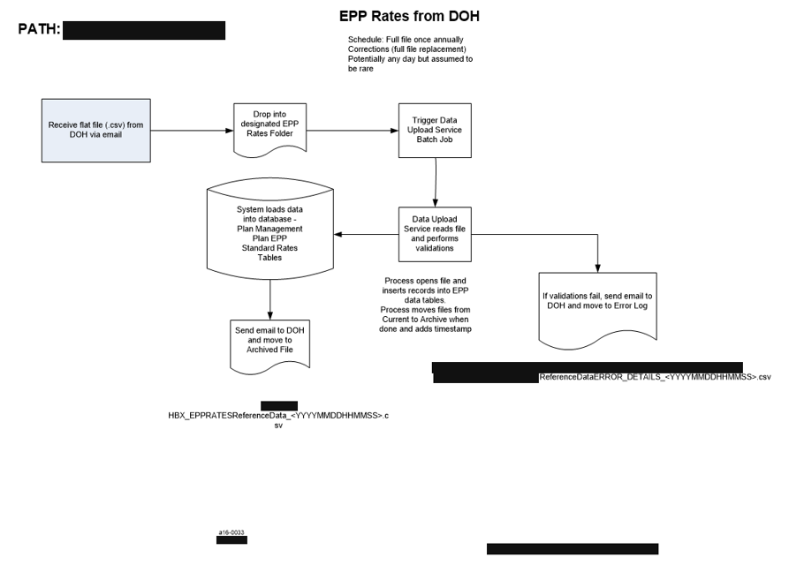
Figure 16. EPP Rates from DOH

Category | Value
Description | Validate and load data related to Essential Plan (EP) standard rates. (Currently, these rates are applicable to members with family incomes between 138% and 200% of FPL and to the Aliessa population with incomes less than or equal to 138% of FPL.)
Mode of Operation | This is a job that runs on demand.  The job will determine if an applicable input file exists in a specific location on the NYSOH system. If the applicable input file is found, subsequent interface processing will initiate. If no applicable input file is found, the job will terminate.
Job Type | Inbound batch interface. This is a non-EDI interface.
Systems | This is an on demand job that is run as needed
Inputs | A single input file in a CSV format that contains data on EP standard rates. DOH will transmit this file to the NYSOH system. See the Naming Convention and Location of Input and Output Files section in this table for locations and names of these files.
Outputs | Plan Management Standard EP Rates tables are updated by this process. The input file is moved to an archive, where a timestamp is appended to the filename. If there are errors, an error log file is written as shown in the Naming Convention and Location of Input and Output Files section in this table below.
Business Frequency | Input files received by NYSOH as part of a regular submission cycle are referred to as regular input files. Input files received outside of the regular submission schedule are referred to as correction input files. A correction input file represents full replacement of an associated regular input file. (Both types of files have the same format and are processed in the same way by the interface.)  The frequency of receiving regular input files depends on the frequency of applicable changes to the legislation related to EP standard rates. It is expected these changes will be rare.  An input file will not contain Issuer-specific data.  Correction input files can be received anytime but occurrences are expected to be rare. The following is a potential reason for receiving a correction input file:  - Record(s) from a prior regular input file did not pass the interface validation.
Processing (High-Level) | - Receive the input flat file (CSV) from DOH via email.  - A manual check is done to determine whether the input file is empty. If it is empty, then:  Send an email to the DOH PM Team indicating that the input file is empty.  - If the input file is not empty, then drop the file into the designated folder – folder is configurable based on type of file.  - Trigger Data Upload Service batch job.  - Data Upload Service batch job reads the file and performs validations.  - If all data records successfully passed the validation, then:  - System loads all data records into the NYSOH database.  - Send an email to the NYSOH Plan Management team indicating that the interface processing completed successfully.  - Append processing timestamp to name of input file and move this file to the archive folder.  - If one or more data records did not pass validation, then:  - Send an email to the NYSOH PM team indicating that validation errors were encountered during interface processing. Error files will be attached with the email.  - Append processing timestamp to name of input file and move this file to the error folder.  - Append processing timestamp to names of error files and move these files to the error log folder.
Distribution of Outputs | Outputs are distributed only as described above.
Naming Convention and Location of Input and Output Files | - Input file  - Location  - [REDACTED]RATE/Current  - Naming convention  - EPPRatesReferenceData.CSV  - Output error files  - Location  - [REDACTED]RATE /Error_Logs  - Naming convention  - EPPRatesReferenceData_ERROR_YYYYMMDDHHMMSS.CSV  - EPPRatesReferenceData_ERROR_DETAILS_YYYYMMDDHHMMSS.CSV
Error Handling  (High-Level) | - If the interface terminates abnormally because of a system exception (e.g., the database is down), then:  - NYSOH GDIT System Architecture team will fix issues related to the system exception and, if applicable, restart the job.  - If the interface terminates normally, but determines that the input file is empty, then:  - The interface will send an email to the NYSOH GDIT Application Development team indicating that the input file is empty.  - The interface will append processing timestamp to name of input file and move this file to the error folder.  - DOH will transmit a correction input file to the NYSOH system. Not all system errors are due to faulty input files; a few can be process or system related.  - The interface will process the correction input file in the same way as a regular input file.  - If the interface terminates normally, but encounters validation or mapping errors, then:  - The interface will create error files in error reports folder.  - The interface will send an email to the NYSOH GDIT Application Development team indicating that validation errors were encountered during processing. Error files will be attached with the email.  - The interface will append processing timestamp to name of input file and move this file to the error folder.  - The interface will append processing timestamp to names of error files and move these files to the error log folder.  - DOH will transmit a correction input file to the NYSOH system. This file will represent full replacement of the original input file. Not all system errors are due to faulty input files; a few can be process or system related.  - The interface will process the correction input file in the same way as a regular input file. If applicable, the interface will:  - Perform “logical deletes” of data records in the NYSOH system that were created by the processing of the original input file; and  - Load matching data records from the correction input file.
Responsible Teams | - DOH Plan Management team  - NYSOH GDIT System Architecture team  - NYSOH GDIT Application Development team
Table 106: EP Standard Rate Data Interface

Master Benefits Data from DOH
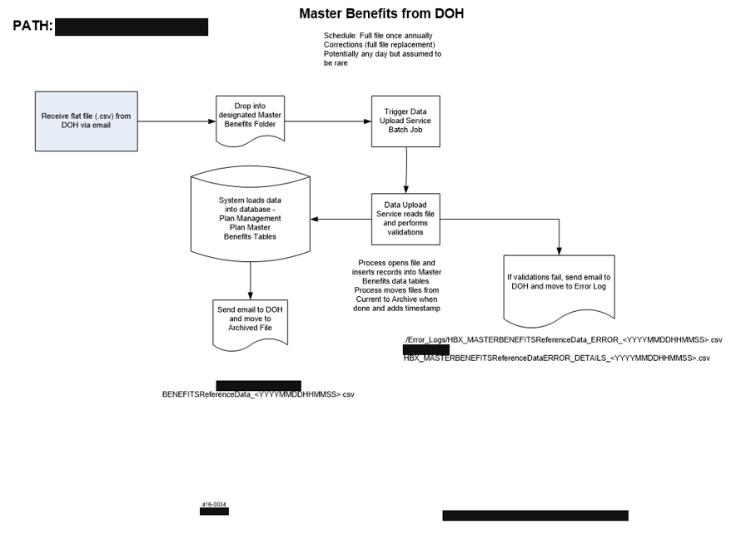
Figure 17. Master Benefits Data from DOH

Category | Value
Description | Load the Master Benefits data related to QHP, Essential Plan, CHIP and Medicaid (including SNP and HARP) benefits into the NYSOH system.
Mode of Operation | This is a job that runs on demand.  The job will determine if an applicable input file exists in a specific location on the NYSOH system. If the applicable input file is found, subsequent interface processing will initiate. If no applicable input file is found, the job will terminate.
Job Type | Inbound batch interface. This is a non-EDI interface.
Systems | This is an on demand job that is run as needed
Inputs | A single input file in a CSV format that contains data on QHP, Essential Plan, CHIP and Medicaid (including SNP and HARP) benefits. See the Naming Convention and Location of Input and Output Files section in this table for locations and names of these files. DOH will transmit this file to the NYSOH system.
Outputs | Plan Management Plan Benefits tables are updated by this process. The Input file is moved to an archive, where a timestamp is appended to the filename. If there are errors, an error log file is written as shown in the Naming Convention and Location of Input and Output Files section in this table.
Business Frequency | Input files received by NYSOH as part of a regular submission cycle are referred to as regular input files. Input files received outside of the regular submission schedule are referred to as correction input files. A correction input file represents full replacement of an associated regular input file. (Both types of files have the same format and are processed in the same way by the interface.)  The frequency of receiving regular input files depends on the frequency of applicable changes related to QHP, EP, CHIP, and MMC (including SNP and HARP) plan benefits. It is expected these changes will be rare.  An input file will not contain any Issuer-specific data.  Correction input files can be received anytime, but occurrences are expected to be rare. The following is a potential reason for receiving a correction input file:  - The previous input file contained incorrect information that needs to be replaced.
Processing (High-Level) | - Receive the input flat file (CSV) from DOH via email.  - A manual check is done to determine whether the input file is empty. If it is empty, then:  Send an email to the DOH PM Team indicating that the input file is empty.  - If the input file is not empty, then drop the file into the designated folder – folder is configurable based on type of file.  - Trigger Data Upload Service batch job.  - Data Upload Service batch job reads the file and performs validations.  - If all data records successfully passed the validation, then:  - System loads all data records into the NYSOH database.  - Send an email to the NYSOH Plan Management team indicating that the interface processing completed successfully.  - Append processing timestamp to name of input file and move this file to the archive folder.  - If one or more data records did not pass validation, then:  - Send an email to the NYSOH PM team indicating that validation errors were encountered during interface processing. Error files will be attached with the email.  - Append processing timestamp to name of input file and move this file to the error folder.  - Append processing timestamp to names of error files and move these files to the error log folder.
Distribution of Outputs | Outputs are not distributed other than as described above.
Naming Convention and Location of Input and Output Files | - Input file  - Location  - [REDACTED]  - Naming convention  - BnftSrvcRef.CSV  - Output error files  - Location  - [REDACTED] /Error_Logs  - Naming convention  - BnftSrvcRef_ERROR_YYYYMMDDHHMMSS.CSV  - BnftSrvcRef_ERROR_DETAILS_YYYYMMDDHHMMSS.CSV
Error Handling (High‑Level) | - If the interface terminates abnormally because of a system exception (e.g., the database is down), then:  - NYSOH GDIT System Architecture team will fix issues related to the system exception and, if applicable, restart the job.  - If the interface terminates normally, but determines that the input file is empty, then:  - The interface will send an email to the NYSOH GDIT Application Development team indicating that the input file is empty.  - The interface will append processing timestamp to name of input file and move this file to the error folder.  - DOH will transmit a correction input file to the NYSOH system. Not all system errors are due to faulty input files; a few can be process or system related.  - The interface will process the correction input file in the same way as a regular input file.  - If the interface terminates normally, but encounters validation or mapping errors, then:  - The interface will create error files in error reports folder.  - The interface will send an email to the NYSOH GDIT Application Development team indicating that validation errors were encountered during processing. Error files will be attached with the email.  - The interface will append processing timestamp to name of input file and move this file to the error folder.  - The interface will append processing timestamp to names of error files and move these files to the error log folder.  - DOH will transmit a correction input file to the NYSOH system. This file will represent full replacement of the original input file. Not all system errors are due to faulty input files, a few can be process or system related.  - The interface will process the correction input file in the same way as a regular input file. If applicable, the interface will:  - Perform “logical deletes” of data records in the NYSOH system that were created by the processing of the original input file; and  - Load matching data records from the correction input file.
Responsible Teams | - DOH Plan Management team  - NYSOH GDIT System Architecture team  - NYSOH GDIT Application Development teams
Table 107: Plan Benefit Data Interface

Plan Administration Data for CHIP Plans Interface
Category | Value
Description | Verify and load plan administration data for CHIP plans into the NYSOH system.
Mode of Operation | This is a job that runs on demand.  The job will determine if an applicable input file exists in a specific location on the NYSOH system. If the applicable input file is found, subsequent interface processing will initiate. If no applicable input file is found, the job will terminate.
Job Type | Inbound batch interface. This is a non-EDI interface.
Systems | This is an on demand job that is run as needed.
Inputs | A single input file in a CSV format that contains plan administration data for CHIP plans. See the Naming Convention and Location of Input and Output Files section in this table for locations and names of these files. DOH will transmit this file to the NYSOH system. Not all system errors are due to faulty input files; a few can be process or system related.
Outputs | Plan Management Plan administration tables are updated by this process. The Input file is moved to an archive, where a timestamp is appended to the filename. If there are errors, an error log file is written as shown in the Naming Convention and Location of Input and Output Files row below.
Business Frequency | Input files received by NYSOH as part of a regular submission cycle are referred to as regular input files. Input files received outside of the regular submission schedule are referred to as correction input files. A correction input file represents full replacement of an associated regular input file. (Both types of files have the same format and are processed in the same way by the interface.)  The frequency of receiving regular input files by NYSOH is:  - As often as one input file per month and at least one input file per year. (An input file will contain plan administration data for CHIP plans for all applicable Issuers.)  Correction input files can be received anytime. The following is a potential reason for receiving a correction input file:  - Records from the previous regular input file did not pass interface validation.
Processing (High-Level) | - Receive the input flat file (CSV) from DOH via email.  - A manual check is done to determine whether the input file is empty. If it is empty, then:  Send an email to the DOH PM Team indicating that the input file is empty.  - If the input file is not empty, then drop the file into the designated folder – folder is configurable based on type of file.  - Trigger Data Upload Service batch job.  - Data Upload Service batch job reads the file and performs validations.  - If all data records successfully passed the validation, then:  - System loads all data records into the NYSOH database.  - Send an email to the NYSOH Plan Management team indicating that the interface processing completed successfully.  - Append processing timestamp to name of input file and move this file to the archive folder.  - If one or more data records did not pass validation, then:  - Send an email to the NYSOH PM team indicating that validation errors were encountered during interface processing. Error files will be attached with the email.  - Append processing timestamp to name of input file and move this file to the error folder.  - Append processing timestamp to names of error files and move these files to the error log folder.
Distribution of Outputs | Outputs are distributed only as described above.
Naming Convention and Location of Input and Output Files | - Input file  - Location  - [REDACTED]  - Naming convention  - CHIP_PlanData.CSV  - Output error file  - Location  - [REDACTED]  - Naming convention  - CHIP_PlanData_YYYYMMDDHHMMSS.CSV
Error Handling (High-Level) | - If the interface terminates abnormally because of a system exception (e.g., the database is down), then:  - NYSOH GDIT System Architecture team will fix issues related to the system exception and, if applicable, restart the job.  - If the interface terminates normally, but determines that the input file is empty, then:  - The interface will send an email to the NYSOH GDIT Application Development team indicating that the input file is empty.  - The interface will append processing timestamp to name of input file and move this file to the error folder.  - DOH will transmit a correction input file to the NYSOH system.  - The interface will process the correction input file in the same way as a regular input file.  - If the interface terminates normally, but encounters validation or mapping errors, then:  - The interface will create error files in error reports folder.  - The interface will send an email to the NYSOH GDIT Application Development team indicating that validation errors were encountered during processing. Error files will be attached with the email.  - The interface will append processing timestamp to name of input file and move this file to the error folder.  - The interface will append processing timestamp to names of error files and move these files to the error log folder.  - DOH will transmit a correction input file to the NYSOH system. This file will represent full replacement of the original input file. Not all system errors are due to faulty input files; a few can be process or system related.  - The interface will process the correction input file in the same way as a regular input file. If applicable, the interface will:  - Perform “logical deletes” of data records in the NYSOH system that were created by the processing of the original input file; and  - Load matching data records from the correction input file.
Responsible Team | - DOH Plan Management team  - NYSOH GDIT System Architecture team  - NYSOH GDIT Application Development team
Table 108: Plan Administration Data of CHIP Plans Interface

Plan Administration Data for Medicaid Managed Care Plans Interface
Category | Value
Description | Verify and load plan administration data for Medicaid Managed Care (MMC) plans into the NYSOH system. Special Needs Plans (SNP) and Health and Recovery Plans (HARP) are submitted as Medicaid plans but have a Plan Type of SNP or HRP.
Mode of Operation | This is a job that runs on demand.  The job will determine if an applicable input file exists in a specific location on the NYSOH system. If the applicable input file is found, subsequent interface processing will initiate. If no applicable input file is found, the job will terminate.
Job Type | Inbound batch interface. This is a non-EDI interface.
Systems | This is an on demand job that is run as needed.
Inputs | A single input file in a CSV format that contains plan administration data for MMC (including SNP and HARP) plans. See the Naming Convention and Location of Input and Output Files section in this table for locations and names of these files. DOH will transmit this file to the NYSOH system.
Outputs | Plan Management Plan Administration tables are updated by this process. The input file is moved to an archive, where a timestamp is appended to the filename. If there are errors, an error log file is written as shown the Naming Convention and Location of Input and Output Files section in this table.
Business Frequency | Input files received by NYSOH as part of a regular submission cycle are referred to as regular input files. Input files received outside of the regular submission schedule are referred to as correction input files. A correction input file represents full replacement of an associated regular input file. (Both types of files have the same format and are processed in the same way by the interface).  The frequency of receiving regular input files by NYSOH is:  - One input file per year. (An input file will contain plan administration data for MMC (including SNP and HARP) plans for all applicable Issuers).  In the future, the frequency of regular input files can be impacted by applicable changes to the legislation related to MMC, SNP, or HARP plans. These changes are likely to be rare.  Correction input files can be received anytime. The following is a potential reason for receiving a correction input file:  - Records from the previous regular input file did not pass interface validation.
Processing (High-Level) | - Receive the input flat file (CSV) from DOH via email.  - A manual check is done to determine whether the input file is empty. If it is empty, then:  Send an email to the DOH PM Team indicating that the input file is empty.  - If the input file is not empty, then drop the file into the designated folder – folder is configurable based on type of file.  - Trigger Data Upload Service batch job.  - Data Upload Service batch job reads the file and performs validations.  - If all data records successfully passed the validation, then:  - System loads all data records into the NYSOH database.  - Send an email to the NYSOH Plan Management team indicating that the interface processing completed successfully.  - Append processing timestamp to name of input file and move this file to the archive folder.  - If one or more data records did not pass validation, then:  - Send an email to the NYSOH PM team indicating that validation errors were encountered during interface processing. Error files will be attached with the email.  - Append processing timestamp to name of input file and move this file to the error folder.  - Append processing timestamp to names of error files and move these files to the error log folder.
Distribution of Outputs | Outputs are distributed only as described above.
Naming Convention and Location of Input and Output Files | - Input file  - Location  - [REDACTED]  - Naming convention  - MMC_PlanData.CSV or SNP_PlanData.CSV or HRP_PlanData.CSV  - Output error file  - Location  - [REDACTED]  - Naming convention  - MMC_PlanData_YYYYMMDDHHMMSS.CSV or SNP_PlanData_YYYYMMDDHHMMSS.CSV or  - HRP_PlanData_YYYYMMDDHHMMSS.CSV
Error handling (High-Level) | - If the interface terminates abnormally because of a system exception (e.g., the database is down), then:  - NYSOH GDIT System Architecture team will fix issues related to the system exception and, if applicable, restart the job.  - If the interface terminates normally, but determines that the input file is empty, then:  - The interface will send an email to the NYSOH GDIT Application Development team indicating that the input file is empty.  - The interface will append processing timestamp to name of input file and move this file to the error folder.  - DOH will transmit a correction input file to the NYSOH system. Not all system errors are due to faulty input files; a few can be process or system related.  - The interface will process the correction input file in the same way as a regular input file.  - If the interface terminates normally, but encounters validation or mapping errors, then:  - The interface will create error files in error reports folder.  - The interface will send an email to the NYSOH GDIT Application Development team indicating that validation errors were encountered during processing. Error files will be attached with the email.  - The interface will append processing timestamp to name of input file and move this file to the error folder.  - The interface will append processing timestamp to names of error files and move these files to the error log folder.  - DOH will transmit a correction input file to the NYSOH system. This file will represent full replacement of the original input file. Not all system errors are due to faulty input files, a few can be process or system related.  - The interface will process the correction input file in the same way as a regular input file. If applicable, the interface will:  - Perform “logical deletes” of data records in the NYSOH system that were created by the processing of the original input file; and  - Load matching data records from the correction input file.
Responsible Teams | - DOH Plan Management team  - NYSOH GDIT System Architecture team  - NYSOH GDIT Application Development team
Table 109: Plan Administration Data for Medicaid Managed Care Plans Interface

Plan Administration Data for Essential Plans Interface
Category | Value
Description | Verify and load plan administration data for EP plans into the NYSOH system.
Mode of Operation | This is a job that runs on demand.  The job will determine if an applicable input file exists in a specific location on the NYSOH system. If the applicable input file is found, subsequent interface processing will initiate. If no applicable input file is found, the job will terminate.
Job Type | Inbound batch interface. This is a non-EDI interface.
Systems | This is an on demand job that is run as needed.
Inputs | An input file containing four templates (Service Area, Rates, Plan and Benefits, Admin Data) in a CSV format that contain plan administration data for EP plans. See the Naming Convention and Location of Input and Output Files section in this table for locations and names of these files. DOH will transmit this file to the NYSOH system.
Outputs | Plan Management Plan administration tables are updated by this process. The Input file is moved to an archive, where a timestamp is appended to the filename. If there are errors, an error log file is written as shown in the Naming Convention and Location of Input and Output Files row below.
Business Frequency | Input files received by NYSOH as part of a regular submission cycle are referred to as regular input files. Input files received outside of the regular submission schedule are referred to as correction input files. A correction input file represents full replacement of an associated regular input file. (Both types of files have the same format and are processed in the same way by the interface).  The frequency of receiving regular input files by NYSOH is:  - As often as one input file per month and at least one input file per year. (An input file will contain plan administration data for EP plans for all applicable Issuers).  Correction input files can be received anytime. The following is a potential reason for receiving a correction input file:  - Records from the previous regular input file did not pass interface validation.
Processing (High-Level) | - Receive the input flat file (CSV) from DOH via email. Contains four templates – Service Area, Rates, plan and Benefits, Admin Data.  - A manual check is done to determine whether the input file is empty. If it is empty, then:  Send an email to the DOH PM Team indicating that the input file is empty.  - If the input file is not empty, then drop the file into the designated folder – folder is configurable based on type of file.  - Kick start the “PM-EPP-Plan-Upload-Client” process.  - System sends request to PM Persistence Service to perform validations.  - If all data records successfully passed the validation, then:  - System loads all data records into the NYSOH database.  - Send an email to the NYSOH Plan Management team indicating that the interface processing completed successfully.  - Append processing timestamp to name of input file and move this file to the archive folder.  - If one or more data records did not pass validation, then:  - Send an email to the NYSOH PM team indicating that validation errors were encountered during interface processing. Error files will be attached with the email.  - Append processing timestamp to name of input file and move this file to the error folder.  - Append processing timestamp to names of error files and move these files to the error log folder.
Distribution of Outputs | Outputs are distributed only as described above.
Naming Convention and Location of Input and Output Files | - Input file  - Location  - [REDACTED]  - Naming convention  - EPP-Admin.CSV  - EPP-Plans.CSV  - EPP-Rates.CSV  - EPP-ServiceArea.xml  - Output error file  - Location  - [REDACTED]  - Naming convention  - EPP-AdminYYYYMMDDHHMMSS.CSV  - EPP-PlansYYYYMMDDHHMMSS.CSV  - EPP-RatesYYYYMMDDHHMMSS.CSV  - EPP-ServiceAreaYYYYMMDDHHMMSS.xml
Error Handling (High-Level) | - If the interface terminates abnormally because of a system exception (e.g., the database is down), then:  - NYSOH GDIT System Architecture team will fix issues related to the system exception and, if applicable, restart the job.  - If the interface terminates normally, but determines that the input file is empty, then:  - The interface will send an email to the NYSOH GDIT Application Development team indicating that the input file is empty.  - The interface will append processing timestamp to name of input file and move this file to the error folder.  - DOH will transmit a correction input file to the NYSOH system.  - The interface will process the correction input file in the same way as a regular input file.  - If the interface terminates normally, but encounters validation or mapping errors, then:  - The interface will create error files in error reports folder.  - The interface will send an email to the NYSOH GDIT Application Development team indicating that validation errors were encountered during processing. Error files will be attached with the email.  - The interface will append processing timestamp to name of input file and move this file to the error folder.  - The interface will append processing timestamp to names of error files and move these files to the error log folder.  - DOH will transmit a correction input file to the NYSOH system. This file will represent full replacement of the original input file. Not all system errors are due to faulty input files; a few can be process or system related.  - The interface will process the correction input file in the same way as a regular input file. If applicable, the interface will:  - Perform “logical deletes” of data records in the NYSOH system that were created by the processing of the original input file; and  - Load matching data records from the correction input file.
Responsible Team | - DOH Plan Management team  - NYSOH GDIT System Architecture team  - NYSOH GDIT Application Development team
Table 110: Plan Administration Data for Essential Plans Interface

Diagnostic and Problem Handling Procedures
Table 111 describes the diagnostic and error handling procedures.

Category | Value
Scope | - Error handling for input/output jobs.  - System performance monitoring.
Supporting Software Tools | - Error handling for input/output jobs.  - System performance monitoring.  - Supporting software tools related to system performance monitoring are included in the list of licensed production software contained in the NYSOH EWM Hardware, Software, and Supplies Inventory folder.  - Security vulnerability monitoring:  - Nessus scanner.  - McAfee NIPS.
Responsible Teams | - Error handling for input/output jobs.  - For teams responsible for error handling of input/output jobs, please refer to the “Responsible Teams”.  - System performance monitoring.  - For teams responsible for system performance monitoring, please refer to “Responsible Teams”.  - Security vulnerability monitoring.  - NYSOH Security, Compliance and Privacy (ISSO)  - contractor cybersecurity.  - GDIT MST.  - contractor infrastructure competency teams.  - NYSOH GDIT Application Development team.  - NYSOH GDIT System Architecture team.
Reference Documents | - Error handling for input/output jobs.  - No reference documents are available.  - System performance monitoring.  - For teams responsible for system performance monitoring, please refer to “Responsible Teams”.  - Security vulnerability monitoring. The following documents were either directly referenced for this section of the manual or provide context regarding the contents of this section:  - NYSOH Security Policy Handbook - Risk Assessment  - NYSOH Security Procedure & Guideline Handbook
Table 111: Diagnostic and Problem Handling Procedures for Plan Management

Plan Management Restart/Recovery Procedures
Table 112 describes procedures for restart/recovery in the event of a system failure, including automated restart and recovery procedures.

Category | Value
Scope of Automated Restart/Recovery | Some system components are implemented using redundant architecture.  - Virtual server redundancy. Some virtual servers have the capability to automatically move across physical devices. As a result, if a physical device used by an applicable virtual server goes down, the virtual server will automatically move to a different physical device.  - Network redundancy. Some applications on Linux, and Advanced Interactive eXecutive (AIX) operating systems have been network load balanced.  - Database redundancy. A DB2 database runs in a multi-node environment. The data is synchronously replicated between two nodes within RDC and asynchronously replicated to the DR environment. If one of the nodes at RDC goes down, the unaffected node at the RDC will automatically take over the database processing initiated after the failure.  - Application redundancy. IBM JBOSS EAP Server and IBM HyperText Transport Protocol (HTTP) Server applications run in multi-node environments. If a node at RDC that supports one of these applications goes down, the unaffected corresponding node at RDC will automatically take over the application processing initiated after the failure.
Scope of Manual Restart/Recovery | Some system components are implemented using a non-redundant architecture. These components will need to be restarted manually.  Examples of such components are:  - DataStage software tool  - Certain virtual servers  GDIT technical support team uses GDIT’s Service Now to coordinate and track manual restart/recovery activities.
Responsible Team | - contractor infrastructure support team  - GDIT RDC Mid-Range team  - contractor network support team  - NYSOH GDIT Application Development team  - NYSOH Program Management team
Reference Documents | Business Continuity and Disaster Recovery Plan
Table 112: Restart/Recovery Procedures for Plan Management

Small Business Marketplace Operations
This section contains the operations sequence, the operations procedures, diagnostic and problem handling procedures, and the restart/recovery procedures for the Small Business Marketplace subsystem of the NYSOH system. Figure 18 shows the end-to-end sequence for SBM.

Small Business Marketplace High Level Flow
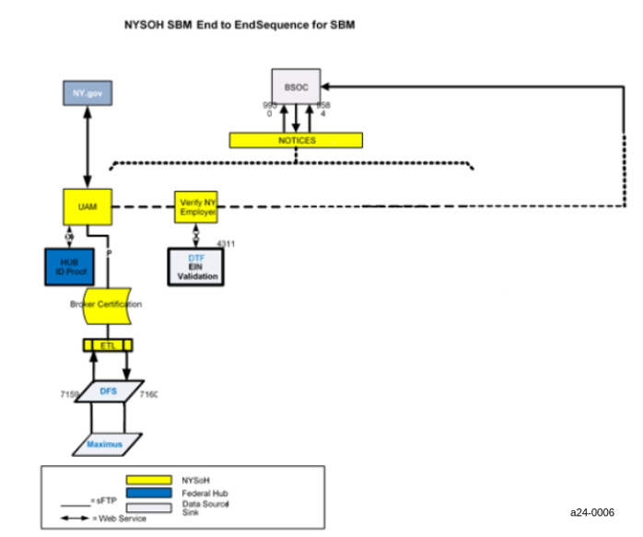
Figure 18. Small Business Marketplace High Level Flow

Small Business Marketplace Operations Procedures
The following section includes instructions for each identified state and mode of operation. The following paragraphs describe the operations procedures in terms of inputs, processes, outputs, error locations, and other pertinent information where applicable. Figure 19 provides an overview.

Small Business Marketplace Input/Output Procedures
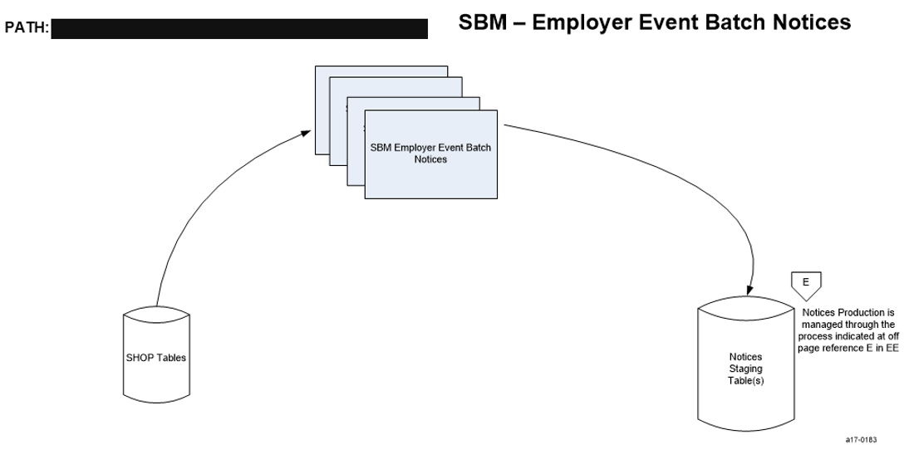
Figure 19. Small Business Marketplace Employer Event Batch Notices

Table 113 contains specific details on the Small Business Marketplace Employer Event Batch Notices process.

Category | Value
Description | Small Business Marketplace Employer Event Batch Notices is a set of batch jobs that trigger scenario-based Notices in Small Business Marketplace.
Mode of Operation | Automated batch jobs that run on a schedule defined in the NYSOH Production Job Schedule.
Job Type | Batch processes.
Systems | - BrokerJob BROKER_DELICENSE_TERM  - BrokerJob BROKER_DFS_LICENSE_VALIDATION  - BrokerJob BROKER_CERTIFICATION_EXPIRATION  - BrokerJob BROKER_CERTIFICATION_OUTBOUND  - BrokerJob BROKER_INITIAL_CERT_INBOUND  - BrokerJob BROKER_RECERT_INBOUND  - BrokerJob BROKER_RECERT_REMINDER_2  - BrokerJob BROKER_RECERT_TERM  - BrokerJob BROKER_RECERT_REMINDER_1  - BrokerJob AGENT_CLIENT_EMPLOYER_RENEWAL_REMINDER_NOTICE  - BrokerJob AGENT_CLIENT_INDIVIDUAL_RENEWAL_REMINDER_NOTICE  - BrokerJob BROKER_REASSIGN_INDIVIDUAL_CLIENT  - EmployerRosterProcessJob.sh  - EmployerRenewalV2.sh  - AdminAssistorClientProcessJob  - TriggerReIdProofingJob  - AgentClientSearchElgEnrlJob  - AgentClientSearchJob
Inputs | Small Business Marketplace tables.
Outputs | Notices Staging tables as shown in the Naming Convention and Location of Input and Output Files section of this table.
Frequency | - Process NoticesJob (Batch Process) runs once per day  - eXtensible Markup Language (XML) to CSV Converter – Runs at 9:00 AM each weekday  - BCC Mail Automation – Arrival Based
Processing (High-Level) | - Shop_Renewal_Reports - This job is to extract the before and after reports for renewal. Reports are placed under [REDACTED] (Extracted an unsupported link: [REDACTED])  - TriggerReIdProofingJob - Trigger re id proof for AL3 users.  - BrokerJob BROKER_CERTIFICATION_OUTBOUND - batch for creating an outbound CSV to MAXIMUS for initial or recertification. Job is scheduled to run daily.  - BrokerJob BROKER_RECERT_INBOUND - Batch for accepting broker recertification results in a CSV from MAXIMUS. Job is scheduled to run daily.  - BrokerJob BROKER_INITIAL_CERT_INBOUND - Batch for accepting broker initial certification results in a CSV from MAXIMUS. Job is scheduled to run daily.  - BrokerJob BROKER_CERTIFICATION_EXPIRATION – Batch for updating the broker status back to pending for initial certification for that certification period is expired. Job is scheduled to run daily.  - BrokerJob BROKER_DFS_LICENSE_VALIDATION – Batch for validating license against the DFS six month before the certification end date for brokers eligible for recertification. Job is scheduled to run daily.  - BrokerJob BROKER_RECERT_REMINDER_1 - Batch for broker recertification reminder - 90 days before cert end date. Job is scheduled to run daily.  - BrokerJob BROKER_RECERT_REMINDER_2 - Batch for broker recertification reminder. Job is scheduled to run daily.  - BrokerJob BROKER_RECERT_TERM - Batch for updating broker details at the end of grace period to complete recertification or termination. Job is scheduled to run daily.  - BrokerJob BROKER_DELICENSE_TERM- Batch for terminating the broker whose license is not verified by the DFS. Job is scheduled to run daily.  - BrokerJob BROKER_REASSIGN_INDIVIDUAL_CLIENT - Batch to update AEQ table in order to send 834 for assigned Individual Client with Broker. Job is scheduled to run daily.  - BrokerJob AGENT_CLIENT_EMPLOYER_RENEWAL_REMINDER_NOTICE - Batch for broker Clients employers’ renewal reminder. Job is scheduled to run 1st of every month.  - BrokerJob AGENT_CLIENT_INDIVIDUAL_RENEWAL_REMINDER_NOTICE - Batch for broker Clients individuals’ renewal reminder. Job is scheduled to run 17th of every month.  - EmployerRosterProcessJob – Batch job to process employer roster and determine their eligibilities, which will generate Notice 1055. Job is schedule to run daily and process if any roster available. Notice 1055 is searchable by back office SHOP SES user through Broker’s Client Notices Tab  - EmployerRenewalV2 – Batch job to process renewal eligible new employers and generate Notice 1059 (Annual Re-Identification to Employer) and Notice 1060 (re-determination / renewal to Broker). Job is schedule to run yearly on 1st of June. Notice 1059 is searchable by back office SHOP SES user through Broker’s Client Notices Tab  - AdminAssistorClientProcessJob - Batch job to handle unassign of assistor clients or reassign of clients between Assistors within the same agency. The unassign/ reassign request will be triggered from PM Admin portal.  - AgentClientSearchElgEnrlJob - Agent Client Search Elg Enrl Crawler job to validate changes to individual tables and sync it to AGENT_CLIENT_ELIGIBILITY_ENROLLMENT_DETAILS table. Job is scheduled to run daily.  - AgentClientSearchJob - Agent Client Search Crawler job to validate changes to individual/ agent tables and sync it to AGENT_CLIENT_SEARCH table. Job is scheduled to run daily.
Distribution of Outputs | Outputs are distributed only as described above.
Naming Convention and Location of Input and Output Files | Notice batch processes  - Input files:  - Small Business Marketplace tables  - Output files:  - Notices Staging tables
Error handling (High-Level) | If the interface terminates abnormally because of a system exception (e.g., database is down), then:  - Email is sent to [REDACTED].  - NYSOH GDIT System Architecture team will fix issues related to the system exception and, if applicable, restart the job.
Responsible Teams | - DOH Small Business Marketplace team  - NYSOH GDIT System Architecture team  - NYSOH GDIT Application Development team
Table 113: Small Business Marketplace Employer Notices Event Batch Notices

Small Business Marketplace Diagnostic and Problem Handling Procedures
Table 114 describes the diagnostic and problem handling procedures.

Category | Value
Scope | - System performance monitoring.
Supporting software tools | - Error handling for input/output jobs.  - System performance monitoring.  - Supporting software tools related to system performance monitoring are included in the list of licensed production software contained in the NYSOH EWM Hardware, Software, and Supplies Inventory folder.  - Security vulnerability monitoring.  - Nessus scanner.  - McAfee Vulnerability Manager (MVA).
Responsible Teams | - Error handling for input/output jobs.  - For teams responsible for error handling of input/output jobs, please refer to the “Responsible Teams”.  - System performance monitoring.  - For teams responsible for system performance monitoring, please refer to “Responsible Teams”.  - Security vulnerability monitoring.  - contractor cybersecurity.  - GDIT Managed Security Tools (MST).  - contractor infrastructure competency teams.  - NYSOH GDIT Application Development team.  - NYSOH GDIT System Architecture team.
Reference Documents | - Error handling for input/output jobs.  No reference documents are available.  - System performance monitoring.  - For teams responsible for system performance monitoring, please refer to “Responsible Teams”.  - Security vulnerability monitoring. The following document was either directly referenced for this section of the manual or provide context regarding the contents of this section.  - NYSOH Security Policy Handbook - Risk Assessment  - NYSOH Security Procedure & Guideline Handbook.
Table 114: Diagnostic and Problem Handling Procedures for Small Business Marketplace

Small Business Marketplace Restart/Recovery Procedures
Table 115 describes procedures for restart/recovery in the event of a system failure, including automated restart and recovery procedures.

Category | Value
Scope of Automated Restart/Recovery | Some system components are implemented using redundant architecture.  - Virtual server redundancy. Some virtual servers have the capability to automatically move across physical devices. As a result, if a physical device used by an applicable virtual server goes down, the virtual server will automatically move to a different physical device.  - Network redundancy. Some applications on Linux and AIX operating systems have been network load balanced.  - Database redundancy. A DB2 database runs in a multi-node environment. The data is synchronously replicated between two nodes within RDC and asynchronously replicated to the DR environment. If one of the nodes at RDC goes down, the unaffected node at the RDC will automatically take over the database processing initiated after the failure.  - Application redundancy. IBM JBOSS EAP Server and JBOSS Web Server applications run in multi-node environments. If a node at RDC that supports one of these applications goes down, the unaffected corresponding node at RDC will automatically take over the application processing initiated after the failure.
Scope of Manual Restart/Recovery | Some system components are implemented using a non-redundant architecture. These components will need to be restarted manually.  Examples of such components are:  - DataStage software tool  - Certain virtual servers  GDIT technical support team uses GDIT’s Service Now to coordinate and track manual restart/recovery activities.
Responsible Team | - contractor infrastructure support team  - GDIT RDC Mid-Range team  - contractor network support team  - NYSOH GDIT Application Development team  - NYSOH Program Management team
Reference Documents | Business Continuity and Disaster Recovery Plan
Table 115: Restart and Recovery Procedures for Small Business Marketplace

Customer Service Operations
This section contains the CS Operations Procedures as defined for the NYSOH system. Figure 20 provides an overview.

CS High Level Flow
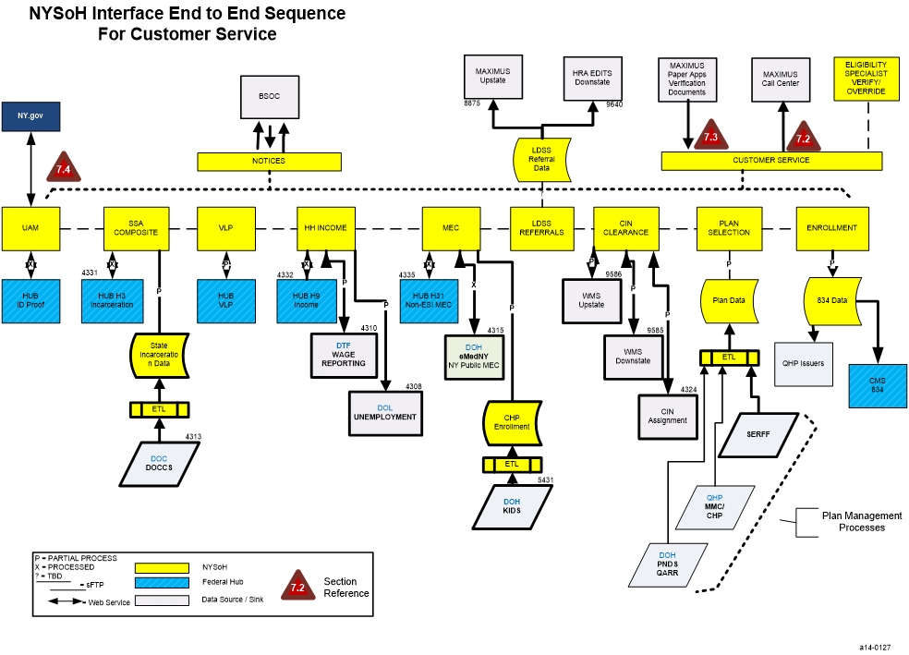
Figure 20. CS High Level Flow

CS Operations Sequence
Table 116 lists the estimated operations sequences for the CS subsystem delineating the logical breaks between the processing steps for CS functionality.

Process Name | Step 1  of Processing |  |  | Step 2  of Processing |  | Step 3  of Processing
Proximal Search to MAXIMUS | On a daily basis at 1:00 a.m., the Proximal_Search_DB_Script is executed to extract user profiles, application information, and member information from the database and creates data storage log tables and search staging tables. |  |  | DB_Proximal_Search.sh is executed to read the proximal search staging tables to create files for individual search information, employee search information, employer search information, and member search information. |  | DS_Proximal_Timestamp.sh is executed to read the output of step 2 and create the search information files.
Paper Application Processing and Documentation Uploads | MQFTE runs continuously to extract application data from the FTP server in the form of .zip files. |  |  | A batch process (paper-job-launcher.sh) is executed to pull apart the .zip files and creates the data in the Paper Transaction tables in the database in the form of envelopes. |  | A batch process (paper-app-spring-batch.sh) processes data in the Paper Transaction tables.  For all files, this process reads the index.xml file and calls the service that posts the Portable Document Format (PDF) to OpenCMIS.  For the ACN files, this process reads the Document_Data.xml and invokes services to process (e.g., HH and income).  A batch process (paper-app-bnc-launcher.sh) is run every night this process serves as a balance and control measure for the Paper Application process.
Customer Service User Batch Loads | This is a manually executed process from the time the file is received from DOH to NYSOH (attached to a PSR). NYSOH reviews the file and processes in the SIT environment prior to executing and processing the file in Production. Each user is put through the user programmatic creation as defined in this document. |  |  | The second step involves updating the Issuer table and/or User Profile table, emailing notification to the user, and updating the log. |  | If the uploaded users are Siebel users, credentials are then updated.
Customer Service: CS Notification Batch | Read all rows from CS_NOTIFICATION_TRANSACTION table. |  |  | Write to file (CSV format):  - Total number of notifications of each type  - Details of Appeal Notifications  - Details of Document Notifications  - Details of G845 Document Notifications  - Details of Verify Lawful Presence (VLP) Case Notifications
Customer Service: Paper App Cancellation Notice Batch | Read from PAPER_TRANSACTION having missing data status and it has been 15 days after Notice035 sent. After data corrections a new N035 would be sent. |  |  | For each record check if the cancellation notice has been sent. If not, send a Cancellation Notice (N17 or N18).
Customer Service: Events Batch | Read EVT_RAW_PERSIST_EVENTS table for records marked as READY_FOR_PROCESSING |  |  | Invoke strategy class to run business logic (i.e., what was changed). |  | - Insert record in EVENTS_TRANSACTION table.  - Update EVT_RAW_PERSIST_EVENTS with SUCCESS/FAILURE based on the strategy class processing.
GetVLP37CaseDetails Batch Job  Job on hold per PSR # 242570 |  | First step of this process will retrieve VLP Case Numbers that are open between 354 and 364 days | Second Step, Invoke GetCaseDetails for all the case numbers retrieved from Step1 |  | - Save the GetCaseDetails Response in the database table (VLP_GET_CASE_DETAILS_RESPONSE)
Table 116: Operations Sequence for Core Processing in CS

CS Operations Procedures
This section includes instructions for each identified state and mode of operation. The paragraphs below describe the operational procedures in terms of inputs, processes, outputs, error locations, frequency of execution, and other pertinent information where applicable. The following figures provide overviews:
- Figure 21. Customer Service - Proximal Search to MAXIMUS
- Figure 22. Customer Service - Paper Application and Documentation Uploads
- Figure 23. Customer Service User Batch Loads

Input/Output Procedures
Table 117 contains a list of input/output jobs in the CS subsystem. Web services are not considered to be input/output jobs and are not included in the list of jobs below.

Customer Service - Proximal Search to MAXIMUS
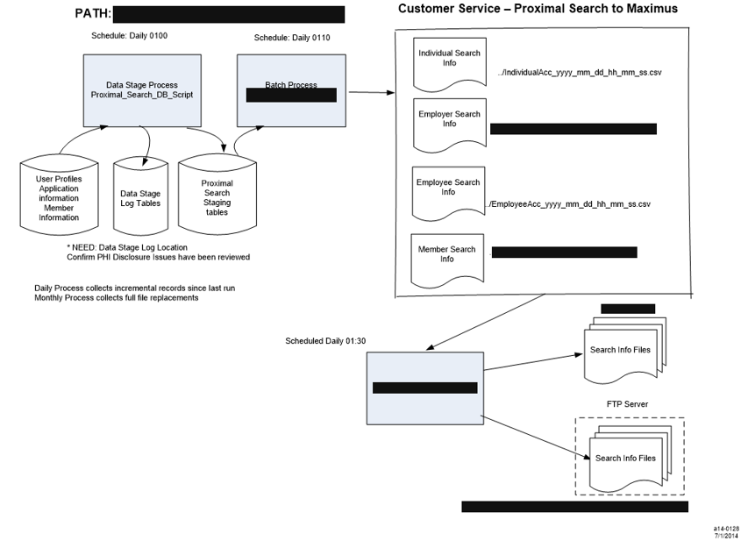
Figure 21. Customer Service - Proximal Search to MAXIMUS

Category | Value
Description | Customer Service – Proximal Search to MAXIMUS  Generation of Data Extract used by MAXIMUS to conduct proximal searches
Mode of Operation | This is an automated job that will run on a schedule. The schedule is defined in the NYSOH Production Job Schedule.  The job will determine if the database is online. If the database is online, the extract file will be generated. If the database is not online, the extract file will not be generated, the job will terminate and an NYSDOH representative will be notified as required.
Job Type | Outbound batch interface.
Systems | Data Stage Process (Proximal_Search_DB_Script)  Batch Process (DS_Proximal-Search.sh)  DS_Proximal_Timestamp.sh
Inputs | The inputs are the user profiles, application information, and member information from the database.  The frequency for all programs executed in this process is found in the Frequency section of this table.  The input and output file names are found in the Naming Convention and Location of Input and Output Files section of this table.
Outputs | The outputs of this process are the Search Information files written to the FTP server.  Details about these files are shown in the Naming Convention and Location of Input and Output Files section of this table.
Frequency | These processes execute in the sequence as shown below on a daily and monthly basis.  The daily process collects incremental records since last run and the monthly process collects full file replacements.  At this time, monthly full file replacements will not be sent automatically and will be done upon request only.  Data Stage Process (Proximal_Search_DB_Script) runs at 1:00 AM daily.  Batch Process (DS_Proximal-Search.sh) runs at 1:10 AM daily.  DS_Proximal_Timestamp.sh runs at 1:30 AM daily.  The average run time of the proximal process is 3-4 hours.
Processing  (High-Level) | Proximal_Search_DB_Script is executed as the first step in the process to extract user profiles, application information, and member information from the database to create Data Storage log tables and Proximal Search Staging tables in the database.  DS_Proximal_Search.sh is executed as the second step of this process to create Individual, Employer, Employee, and Member Search Information files.  DS_Proximal_Timestamp.sh is executed as the third step in the process. This step uses the output of the previous step and writes search information files to the FTP server. Finally, an archive of the processed files is generated.  The frequency for all programs executed in this process is found in the Frequency section of this table.  The input and output file names are found in the Naming Convention and Location of Input and Output Files section of this table.
Distribution of Outputs | Stakeholders will be notified upon the completion or failure of the execution of this process in accordance with the established distribution list.
Naming Convention and Location of Input and Output Files | Data Stage Process (Proximal_Search_DB_Script)  - Input file:  - User Profiles, Application Information, and Member Information from database  - Output  - Data Stage log tables from database  - Proximal Search Staging tables from database  Batch Process (DS_Proximal_Search.sh)  - Input file:  - Proximal Search Staging tables from database  - Output file  - Individual file  - Location – [REDACTED]<env>  - ..Individual_Acc_yyyy_mm_dd_ss.CSV  - Employer file  - Location – [REDACTED]<env>  - EmployerAcc_yyyy_mm_dd_SS.CSV  - Employee file  - Location – [REDACTED]<env>  - EmployeeAcc_yyyy_mm_dd_ss.CSV  - Member file  - Location – [REDACTED]<env>  - MemberAcc_yyyy_mm_dd_ss.CSV  DS_Proximal_Timestamp.sh  - Input files  - Individual file  - Location – [REDACTED]<env>  - ..Individual_Acc_yyyy_mm_dd_ss.CSV  - Employer file  - Location – [REDACTED]<env>  - ..EmployerAcc_yyyy_mm_dd_SS.CSV  - Employee file  - Location – [REDACTED]<env>  - ..EmployeeAcc_yyyy_mm_dd_ss.CSV  - Member file  - Location – [REDACTED]<env>  - ..MemberAcc_yyyy_mm_dd_ss.CSV  - ..EmployerAcc_yyyy_mm_dd_SS.CSV  - Errors are written to an error log  - Audit trail is written to an audit log
Error handling (High-Level) | - If the interface terminates abnormally because of a system exception (e.g., database is down), then:  - NYSOH GDIT System Architecture team will determine root cause, fix issues related to the system exception, and, if applicable, restart the job.
Responsible Teams | - DOH Customer Service team  - NYSOH GDIT System Architecture team  - NYSOH GDIT Application Development team
Table 117: Proximal Search to MAXIMUS

Paper Application and Documentation Uploads
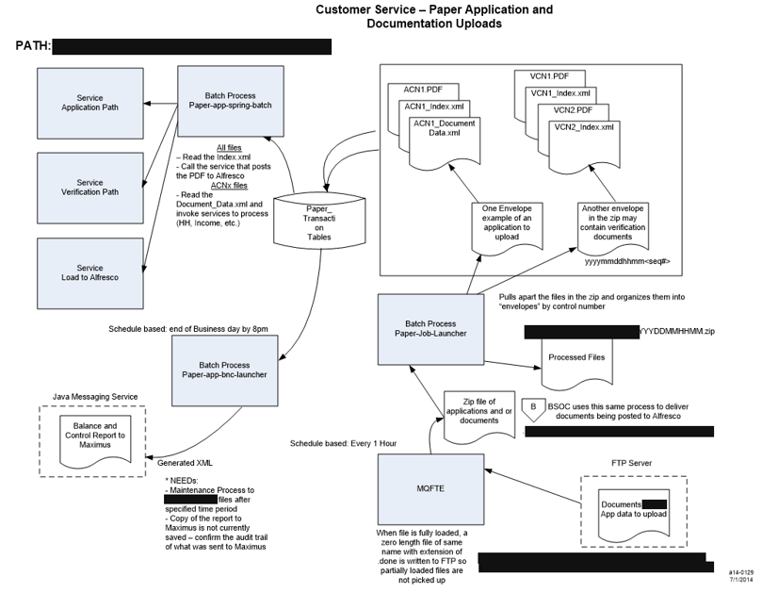
Figure 22. Customer Service - Paper Application and Documentation Uploads

Table 118 contains specific details on the Paper Application and Documentation Upload process.

Category | Value
Description | Paper Application and Documentation Uploads  Uploading of Paper Applications and Documentation.
Mode of Operation | This is an automated job that will run on a schedule.  The schedule is defined in the NYSOH Production Job Schedule.
Job Type | Inbound batch interface.
Systems | paper-app-spring-batch-launcher  paper-bnc-launcher  paper-job-launcher  Service – Application Path  Service – Verification Path  Service – Load to OpenCMIS  Service – Java Messaging for B&C Reports
Inputs | The inputs are the zip files received from MAXIMUS containing paper applications and verification documents.  The frequency for all programs executed in this process is found in the Frequency section of this table.  The input and output file names are found in the Naming Convention and Location of Input and Output Files section of this table.
Outputs | The outputs of this process are the Paper Transaction tables and Balance and Control reports as shown in the Naming Convention and Location of Input and Output Files section of this table.
Frequency | MQFTE – runs every hour  Batch Process (paper-job-launcher.sh)  Batch Process (paper-app-spring-batch.sh)  Batch Process (paper-app-bnc-launcher.sh) – Scheduled to occur at the beginning of the business day between 6-9 AM daily  Service - Application Path  Service - Verification Path  Service - Load to OpenCMIS
Processing  (High-Level) | The first step of this process is the execution every hour of MQ File Transfer Edition (MQFTE) to pull documents and applications in the form of zip files from the File Transfer Protocol (FTP) server. MQFTE writes these zip files to a container. If the file is loaded successfully, MQFTE writes a zero length file with the same name with extension of .done to the FTP server so partially loaded files are not picked up.  The second step of this process is the execution of a batch process (paper-job-launcher.sh) that expands the .zip files and organizes them into envelopes by control number. Then the data in the files is saved to the Paper Transaction table in the database. At this time perfunctory validation is performed on the data and the status field for these database rows is marked to show them as ready for the eligibility process or in need of further information to be entered through the Back Office Data Corrections screen. Finally, the processed files are moved to an output directory.  The third step of this process is a batch process (paper-app-spring-batch.sh). For all records in the database that are marked as ready for the eligibility process this process reads the index information from the database and calls the service that posts the PDF to OpenCMIS, an uploading tool to upload documents for Paper Applications and Notices. For the ACN files, this process reads the Document_data.xml file and invokes services to process (e.g., HH, and income). At the same time the application is validated and sent through the eligibility steps used by the online application. If an exception occurs while processing eligibility the status in the Paper Transaction table is marked as such.  The last batch process of the Paper Application and Documentation Upload process reads the Paper Transaction tables and generates Balance and Control reports via Java Message Service (JMS). This process must be executed at the beginning of each business day.  The frequency for all programs executed in this process is found in the Frequency section of this table.  The input and output file names are found in the Naming Convention and Location of Input and Output Files section of this table.
Distribution of Outputs | Stakeholders will be notified upon the completion or failure of the execution of this process according to the established distribution list.  Balance and Control reports are sent to MAXIMUS.
Naming Convention and Location of Input and Output Files | MQFTE  - Input file:  - ftpserverinboxroot/<MAXIMUS >nyhx/-YYYYDDMMHHMM.zip  - ftpserverinboxroot/<MAXIMUS >nyhx/-YYYYDDMMHHMM.done  - Output file  - ../paper-app-source-folders/hx-YYYYDDMMHHMM.zip  Batch Process (paper-job-launcher)  - Input file:  - Documents and Applications: ../paper-app-source-folders/hx- YYYYDDMMHHMM.zip  - Output file  - Processed files: ../paper-app-dest-folders/nyhx-YYYYDDMMHHMM.zip  - Envelopes by control number: yyyymmddhhmm<seq>.xml  - Paper Transaction tables on database  Batch Process (paper-app-spring-batch)  - Input file:  - Paper Transaction tables from database  - Document_data.xml files  Batch Process (paper-app-bnc-launcher)  - Input file:  - Paper Transaction tables from database  - Output  - Balance and Control report to MAXIMUS via JMS  - Errors are written to an error log  - Audit trail is written to an audit log
Error handling  (High-Level) | If the interface terminates abnormally because of a system exception (e.g., database is down), then:  - NYSOH GDIT System Architecture team will determine root cause, fix issues related to the system exception, and, if applicable, restart the job and notify MAXIMUS Health Services and NYSDOH representative.
Responsible Teams | - DOH Customer Service team  - NYSOH GDIT System Architecture team  - NYSOH GDIT Application Development team
Table 118: Paper Applications and Documentation Uploads

Customer Service User Batch Loads
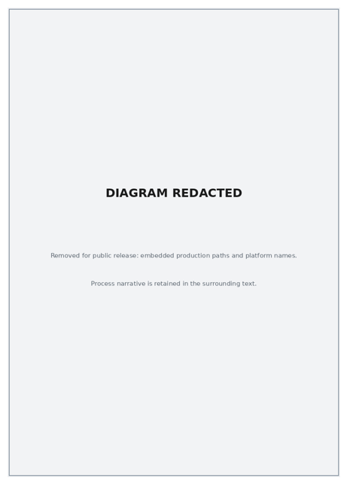
Figure 23. Customer Service User Batch Loads

Table 119 contains the Customer Service User Batch Load process.

Category | Value
Description | Customer Service User Batch Loads.  This batch job maintains the profiles and configurations of the NYSOH system users.
Mode of Operation | This is a manually executed process from the time the file is received from DOH Business to GDIT Operations (attached to a PSR). GDIT Operations reviews the file and processes in the SIT environment prior to executing and processing the file in Production.
Job Type | Batch interface
Systems | Batch Process (userbatchprocess.sh)  SMTP mail service
Inputs | The inputs are the user profiles and configuration files.  The input and output file names are found in the Naming Convention and Location of Input and Output Files section of this table.
Outputs | The outputs of this process are updates to the Issuer table and the User Profile table of the database, email notification to user, and output to the log.  Further details are shown in the Naming Convention and Location of Input and Output Files section of this table.
Frequency | Batch Process (userbatchprocess.sh) – Executed manually on demand, as needed, upon receipt of new user requests.
Processing (High-Level) | The first step of this process is the execution every 15 minutes of userbatchprocess.sh to pull configuration files and users.  The second step involves updating the Issuer table and/or User Profile table, emailing notification to the user, and updating the log.  The frequency for all programs executed in this process is found in the Frequency section of this table.  The input and output file names are found in the Naming Convention and Location of Input and Output Files section of this table.
Distribution of Outputs | Email notifications are sent to user.
Naming Convention and Location of Input and Output Files | Batch Process (userbatchprocess.sh)MQFTE  - Input file:  - List of users and associated information-../source/<user>Profilelist<yyyymmddhhmmss>.CSV  - Configuration files  ../email.config.properties  ../userload.database.properties  - Output file  - Issuer table and/or User Profile table from database  - Log records  ../logs/uam.batchprocess.log  - Source user file moved  ../output/<user>Profilelist<yyyymmddhhmmss>.CSV  - E-mail notifications to user
Error handling (High-Level) | If the interface terminates abnormally because of a system exception (e.g., database is down), then:  - NYSOH GDIT System Architecture team will determine root cause, fix issues related to the system exception and, if applicable, restart the job and notify MAXIMUS Health Services and NYSDOH representative.
Responsible Teams | - DOH Customer Service team  - NYSOH GDIT System Architecture team  - NYSOH GDIT Application Development team
Table 119. Customer Service User Batch Loads

Diagnostic and Problem Handling Procedures for Customer Service
Table 120 describes the diagnostic and error handling procedures.

Category | Value
Scope | - Error handling for input/output jobs.  - System performance monitoring.  - Security vulnerability monitoring.  - GDIT performs automated vulnerability scanning on the NYSOH system at least monthly. Scanning is performed using a Nessus scanner by GDIT MST. Vulnerabilities identified during scans are reviewed and categorized as “Critical”, “High”, “Medium”, “Low” and “Informational”. “Critical” and “High” vulnerabilities are scheduled for remediation As Soon As Possible (ASAP). Remediation is usually achieved through deployment of a software patch or an update. “Medium” vulnerabilities get the next priority, and “Low” or “Informational” vulnerabilities are addressed within compliant timeframes.  - Scans performed by the GDIT MST team use credentials which allow the scanner to log into systems in order to check their patch status. Systems found to be missing patches are reported to the contractor infrastructure support team for remediation. contractor infrastructure support and contractor cybersecurity jointly determine whether the regular patching cycle should be used for remediation or whether an out-of-cycle patch deployment is needed.  - For database and application level patch deficiencies, reports are generated and sent to the NYSOH GDIT Application Development team for remediation. The NYSOH GDIT Application Development team analyzes the reports and determines an approach and schedule for remediation. Remediation results will be verified during the next scan.
Supporting software tools | - Error handling for input/output jobs.  - System performance monitoring.  - Supporting software tools related to system performance monitoring are included in the list of licensed production software contained in the NYSOH Hardware, Software, and Supplies Inventory folder.  - Security vulnerability monitoring.  - Nessus scanner.  - McAfee NIPS.
Responsible Teams | - Error handling for input/output jobs.  - System performance monitoring.  - For teams responsible for system performance monitoring, please refer to “Responsible Teams”.  - Security vulnerability monitoring.  - contractor cybersecurity  - GDIT MST  - contractor infrastructure competency teams  - NYSOH GDIT Application Development team  - NYSOH GDIT System Architecture team
Reference Documents | - Error handling for input/output jobs.  No reference documents are available.  - System performance monitoring.  - For teams responsible for system performance monitoring, please refer to “Responsible Teams”.  - Security vulnerability monitoring. The following documents were either directly referenced for this section of the manual or provide context regarding the contents of this section.  - System Security Plan  - NYSOH Security Policy Handbook- Risk Assessment  - NYSOH Security Procedure & Guidelines Handbook
Table 120: Customer Service Diagnostic and Problem Handling Procedures

Customer Service Restart/Recovery Procedures
The following section describes procedures for restart/recovery in the event of a system failure, including automated restart and recovery procedures.

Table 121 contains Customer Service Restart/Recovery process.

Category | Value
Scope of Automated Restart/Recovery | The following system components are implemented using redundant architecture:  - Virtual server redundancy. Some virtual servers have the capability to automatically move across physical devices. As a result, if a physical device used by an applicable virtual server goes down, the virtual server will automatically move to a different physical device.  - Network redundancy. Some applications on Linux and AIX operating systems have been network load balanced.  - Database redundancy. A DB2 database runs in a multi-node environment. The data is synchronously replicated between two nodes within RDC and asynchronously replicated to the DR environment. If one of the nodes at RDC goes down, the unaffected node at the RDC will automatically take over the database processing initiated after the failure.  - Application redundancy. IBM JBOSS EAP Server and JBOSS Web Server applications run in multi-node environments. If a node at RDC that supports one of these applications goes down, the unaffected corresponding node at RDC will automatically take over the application processing initiated after the failure.
Scope of Manual Restart/Recovery | The above-mentioned system components are implemented using a non-redundant architecture. These components will need to be restarted manually. GDIT technical support team uses GDIT’s Service Now to coordinate and track manual restart / recovery activities.
Responsible Team | - contractor infrastructure support team  - GDIT RDC Mid-Range team  - contractor network support team  - NYSOH GDIT Application Development team  - NYSOH Program Management team
Reference Documents | Business Continuity and Disaster Recovery Plan
Table 121: Customer Service Restart/Recovery Procedures

Individual Marketplace Operations
This section contains the Individual Marketplace Operations Procedures as defined for the NYSOH system. Figure 24 provides an overview.

Individual Marketplace High Level Flow
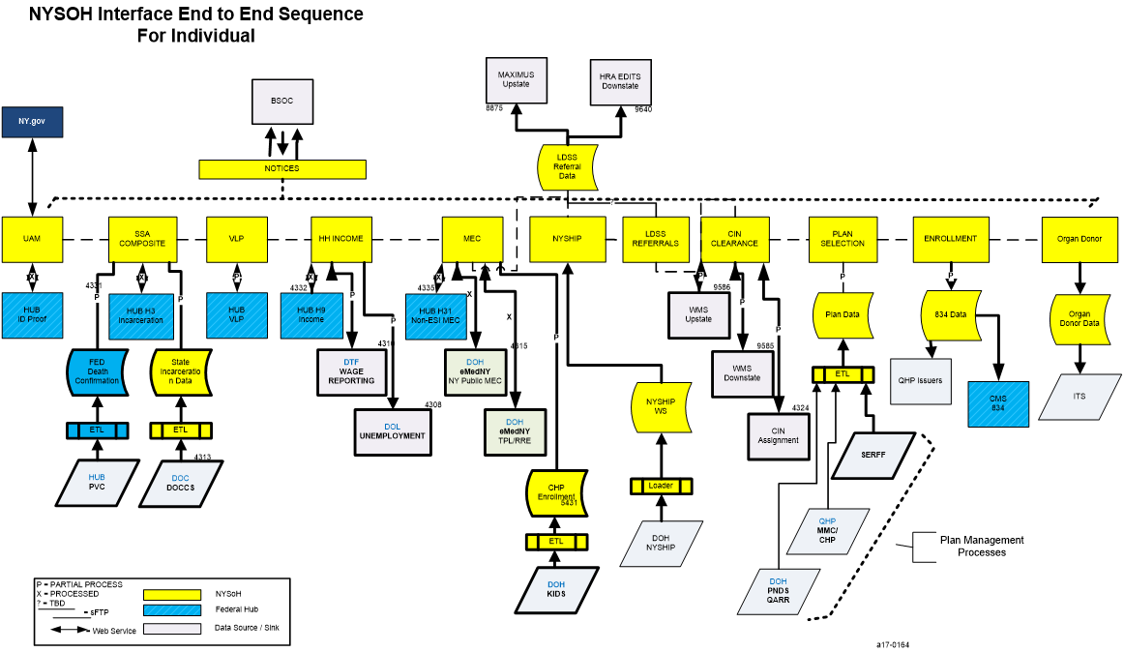
Figure 24. Individual Marketplace High Level Flow

Individual Marketplace Operations Sequence
Table 122 lists the operations sequences for the Individual Marketplace subsystem delineating the logical breaks between the processing steps for Individual Marketplace functionality.

Process Name | Step 1  of Processing | Step 2  of Processing | Step 3  of Processing
Enrollment Message Batch | The job polls the database for individuals who are enrolled in plans and updates the 834 Transaction Detail tables. | The second step of this process is to execute FPS to generate the rejected enrollment records, write to the FPS log tables and provide the acknowledgement and response records to the Issuer Response Service. | N/A
EDI 834 Outbound | The first step of this process is to execute the EDI Outbound Process and generate enrollment records and enrollment metadata records. (File names are found in the Naming Convention and Location of Input and Output File section.) | During the second step of this process, FPS processes the output file of the EDI Outbound Process, creates the enrollment record, and updates the FPS log tables. | For the last step of this process, MQFTE ingests the enrollment records and writes those records to the FTP server for the Issuers, BSOC, MAXIMUS, and some state agencies to capture.
Death Confirmation | The first step of this process the job polls the database for individuals who are eligible in NYSOH, inserts records in DMF_SERVICE_DTA table, creates request files and sends it to CMS for death match. | The second step of this process; once NYSOH receives the response files from CMS, pvc response batch processes the response file and updates the records in DMF_SERVICE_DATA as death confirmed, creates clock and creates events to generate death match notices. | N/A
EDI 834 Inbound (FPS) | The first step of this process is that the MQFTE reads and delivers the files from the Secure File Transfer Protocol (SFTP) server. | The second step of this process is to execute FPS to generate the rejected enrollment records (aka 999), write to the FPS log tables and provide the acknowledgement and response records to the Issuer Response Service. | N/A
Under Custody, Pre Release, Update, Cancel, and Release Files from NYS Department of Corrections and Community Supervision (DOCCS) | - Extract files from DOCCS SFTP location  - Validate the file and data formats  - Cleanup previous day staging data  - Parse, validate and transform DOCCS data into following tables  - NYS_DOCCS_FILE_PROCESSING  - NYS_DOCCS_INCARCERATION_STG  - NYS_DOCCS_RELEASE_STG  - NYS_DOCCS_RECORD_PROCESSING | - Read staging data by following DOCCS Process Type  - UNDERCUSTODY  - PRERELEASE  - UPDATE  - CANCEL  - RELEASE  - Apply weightage and compare data into existing Production data  - Update or Insert data into following production tables  - NYS_DOCCS_INCARCERATION  - NYS_DOCCS_RELEASE  - NYS_DOCCS_RECORD_PROCESSING  - NYS_DOCCS_PROCESS_STATUS | - Read related DOCCS data by NYSID  - Perform CL Level match for UNDERCUSTODY data and CIN level match for other DOCCS Process data  - Apply data validation  - Insert or Update into following production tables  - NYS_DOCCS_INCARCERATION  - NYS_DOCCS_RELEASE  - NYS_DOCCS_RECORD_PROCESSING  - NYS_DOCCS_PROCESS_STATUS  - Call Eligibility API to determine resequencing update, coverage code validation, active manual renewal update and Suspend data add  - Add to Re- sequence  - Add to NYS_DOCCS_SUSPEND table
KIDS from NYSDOH | The first step of this process uses MQFTE to pull current CHIP data from FTP server and writes a current CHIP data file. | The second step of this process uses DS_KIDS_PROD.sh to archive the Current CHIP data and updates the CHIP Current Enrollment table. | N/A
Local District Social Services (LDSS) Referrals | The first step of this process uses Individual-hx-job-LDSS to read the Eligibility tables to obtain all applicants warranting referral to local districts identified by the online NYSOH application in near real time. | A listing of all LDSS referrals for each business day will be captured in two data files, one for applicants residing in NY City counties (downstate), and one for applicants residing in upstate counties as identified by the applicant's residential zip code. | The file containing NY City residents is sent via SFTP to a secure server maintained by the Human Resource Administration (HRA) as part of their Eligibility Data and Image Transfer System (EDITS) application for submitters. The file containing Upstate residents is sent via SFTP to MAXIMUS.
Forced Closure | The first step of this process is to read the upstate and downstate referral files from the SFTP server. | The second step provides the output to the Forced Closure database tables and to the Forced Closure log files. | N/A
NYSHIP Data Loader | The first step reads NYSHIP Master file and split Master file into small chunks. | This step reads and validates file, log file processing and errors.  Parse file and validate data records, log data record and errors.  Compare data against NYSHIP_DATA, insert for new records and update for update records and log audit in NYSHIP_HIST Archive files. | N/A
Organ Donor Extractor | This step reads Organ Donor Data based on the Status.  Validate and log errors.  Create file with current date and add data into the file.  Transfer to organ donor outbound location. | N/A | N/A
Notices Process | Validates the data XML and suppresses specific already sent notices. | Dispositioning notices by mail preference and language preference. | Initialize the notices for email processing and print processing.
NYSHIP Data Processor Job | Identifies all NYSOH –eligible consumers and matches with NYSHIP data and schedules the Account for re-determination to re-sequence. | Re-sequence initiates the re-determination of the eligibility to possibly make consumers in-eligible for CHIP, move Medicaid MMC and EP-Aliessa to FFS, and disqualifies the QHP with financial assistance. | Appropriate 834s are generated and sent.
NY HRA Migration Loader job | Reads the file received from HRA system from the inbound folder.  Conducts a basic validation after loading the RAW data and saves data to the HRA RAW tables. | HraCase, HRACaseMember and HRACaseProcessing tables with the in progress status are updated. | N/A
NY HRA case processor job | Conducts necessary validations and process the HRA population data from HRA stage tables. | An account number shall be generated and map to a HIX to an applicable member, and calls the auto app rest service to create the account, eligibility and push into re-sequence. | Auto app rest service send a response with success or failure.
Deceased Process Job | First step of this process will take all associated accounts of deceased member from deceased event process table and put the records in deceased event process account table for each account. | Second step, Job will take all accounts who have records in deceased event process account table and process each record by inserting into resequence with category code deceased process. | Resequence job runs as per cron and should re-determine eligibility by marking member deceased in the associated accounts and making ineligible for all programs.
Coverage Adjustment Batch Job | Identifies all New records from ENRL_COV_ADJ_REQ for PARIS match end date adjustments and feeds it to the next step | Conducts necessary validations and process the PARIS match population data from Coverage Adjustment tables.  Create adjustment policies based on the transaction decision-making rules.  Persist all applicable Enrollment specific tables for adjustment policy creation for 834 generation.
Table 122: Operations Sequence for Core Processing for Individual Marketplace

Individual Marketplace Operations Procedures
The following section includes instructions for each identified state and mode of operation. The following paragraphs describe the operations procedures in terms of inputs, processes, outputs, error locations, and other pertinent information where applicable.
Where any operations job abends or exceeds limits, operations procedures are:
- a TWS (Tivoli Workload Scheduler) email notification is sent to the teams associated with the job including the Operations team.
- if a Job/Job stream exceeds the Max duration limit/Deadline limit set to the respective process, the Operations team would receive both an email alert and a text alert.
The following diagrams are relevant for this section:
- Figure 25. EDI 834 Outbound Batch
- Figure 26. EDI 834 Inbound (FPS)
- Figure 27. WTX EDI 834 Inbound process
- Figure 28. Custody and Release Files from NYS DOCCS
- Figure 29. NYSOH KIDS
- Figure 30. LDSS Referral
- Figure 31. PVC Service Process Flow (from PVC Service BSD)
- Figure 32. NYSHIP Loader and Service Process Flow
- Figure 33. Organ Donor Extractor Process Flow

Individual Marketplace Input/Output Procedures
The following is a list of input/output jobs in the Individual Marketplace subsystem. Web services are not considered to be input/output jobs and are not included in the list of jobs below.

Enrollment Message Batch
Table 123 contains Enrollment Message Batch processes.

Category | Value
Description | Updates 834 transaction detail
Mode of Operation | This is an automated job that will run on a batch. The schedule is defined in the NYSOH Production Job Schedule.
Job Type | Outbound batch interface. This is an EDI interface.
Systems | EnrollmentMessageBatch.sh
Inputs | 834 Transaction Detail database tables as shown in the Naming Convention and Location of Input and Output Files section of this table.
Outputs | Enrollment records are output to the FTP server for Issuers to extract as shown in the Naming Convention and Location of Input and Output Files section of this table.
Business Frequency | Any day when changes occur which require an updated 834 to be issued for an individual.
Processing (High-Level) | The job polls the database for individuals who are enrolled in plans and updates the 834 transaction detail tables.
Distribution of Outputs | Outputs are not distributed other than as described above.
Naming Convention and Location of Input and Output Files | PATH: [REDACTED]  PATH: [REDACTED]  PATH: [REDACTED]  The following are the programs with their associated input and output that are executed for this process:  EnrollmentMessageBatch.sh  - Input:  - 834 Transaction Detail (I_EDI_TRAN_REQ_TB)  - Output  - 834 Transaction Detail (I_EDI_834_OB_TRAN_DTL)  - 834 Transaction Detail (I_EDI_834_OB_TRAN_DATA)  - 834 Transaction Errors (I_EDI_834_OB_TRAN_ERROR)
Error handling  (High-Level) | The specific error table “EDI_834_OB_TRAN_ERROR“ is maintained for logging all the 834 enrollment message transactions errors.  This table provides complete error details including transaction id, application type, error code, error description and so on.  Below are the list of error code and categories used in the system for Enrollment batch Transaction errors.  1002 Transaction Bypassed - as it is not really a CHANGE transaction.  1003 Transaction Bypassed - as it is an Issuer initiated term/cancel transaction.  1004 Transaction Bypassed - CANCELLED Policy - effectuation transaction.  9000 Duplicate Transaction Id.  9005 Enrollment Member Record Not Found.  9006 HX ID Not Found for Member.  9007 Eligibility Member Record Not Found.  9010 Enrollment Plan Record not Found for Member.  9011 Member Coverage Begin Date Blank.  9012 Terminate Transaction but Member Coverage End Date Blank.  9018 Employer Employee Mapping Record Not Found.  9019 Gender Code Invalid or Empty.  9020 Employer Issuer Group ID Record Not Found.  9023 Issuer Assigned Group Id is blank or null.  9024 Subscriber Id not in Member List.  9028 Relationship Not Found for Dependent.  9029 Medicaid or APTCPP CIN not found.  9032 Rating Area Code Not found or Empty for Plan.  9033 CHP Client Id Not Found.  9038 Non MEDICAID Program and Premium Amount Null.  9040 APTCPP or Medicaid and Issuer MMIS ID Empty or Null.  9043 Unborn member client ID not found.  9044 Unborn member chip ID not found.  9045 Unborn member expected date of birth not found.  9050 APTCPP with non-Silver Plan and State Resp Amount greater than zero.  9053 Aid Cat Code Missing or null.  9054 Medicaid Coverage Code Missing or null.  9055 Medicaid Rate Code Missing or null.  9056 Enrollment Member Record Not Found in Previous Enrollment for Cancel or Terminate  9057 Found Special Characters.  9061 UB Terminate Transaction but UB Member Coverage End Date Blank.  9062 Coverage end date is less than coverage begin date.  9064 Enrollment Status Abandoned.  9065 Invalid Renewal effective date.  9066 Invalid Relationship Code.  9068 Subsidy effective Date is either null or empty.  9069 Duplicate member id in the request.  9069 Member Deceased Date Blank  9070 Coverage Code 30 is not a valid for FFS.  9071 EPP unique id not found.  9071 Enrollment Member EndDate is Missing or null.  9072 Total amounts (i.e. PremAmt or SubsidyAmt or RespAmt or StateSubsidyAmt) are negative.  9999 Appl Exception.  If the interface terminates abnormally because of a system exception (e.g., database is down), then:  - NYSOH GDIT System Architecture team will fix issues related to the system exception, and, if applicable, restart the job.
Responsible Teams | - DOH and GDIT individual and family Marketplace teams  - NYSOH GDIT System Architecture team  - NYSOH GDIT Application Development team  - NYSOH Interface teams
Table 123: Enrollment Message Batch Job

EDI 834 Outbound
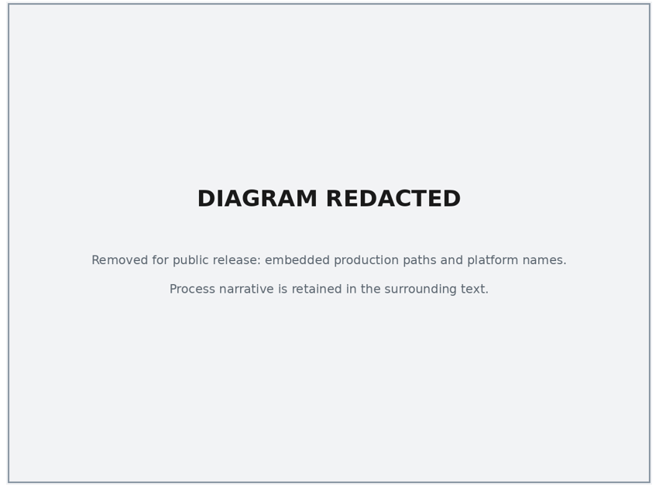
Figure 25. EDI 834 Outbound Batch

Table 124 contains EDI 834 Outbound Batch processes.

Category | Value
Description | Creates 834 outbound records.
Mode of Operation | This is an automated job that will run on a batch. The schedule is defined in the NYSOH Production Job Schedule.
Job Type | Outbound batch interface. This is an EDI interface.
Systems | - ediOutboundBatch.sh  - FPS  - MQ-FTE  - WTX
Inputs | 834 Transaction Detail database tables and Issuer Details as shown in the Naming Convention and Location of Input and Output Files section of this table.
Outputs | Enrollment records are output to the FTP server for Issuers, BSOC, MAXIMUS, and some state agencies to extract as shown in the Naming Convention and Location of Input and Output Files section of this table.
Business Frequency | Any day when changes occur requiring an update 834 to go out for an individual.
Processing (High-Level) | - The first step of this process is to execute the EDI Outbound Process and generate enrollment records and enrollment metadata records. File names are found in the Naming Convention and Location of Input and Output Files section of this table.  - During the second step of this process, FPS processes the output of the EDI Outbound Process, creates the enrollment record, and updates the FPS log tables.  - For the last step of this process, MQFTE ingests the enrollment records and writes those records to the FTP server for the Issuers, BSOC, MAXIMUS, and some state agencies to capture.
Distribution of Outputs | Outputs are distributed only as described above.
Naming Convention and Location of Input and Output Files | PATH: [REDACTED]  PATH: [REDACTED]  WTX 834 Inbound TR file path : [REDACTED]  The following are the programs with their associated input and output that are executed for this process:  EDI 834 Outbound Batch – ediOutboundBatch.sh  - Input:  - 834 Transaction Detail tables from database (I_EDI_834_OB_TRAN_DTL, I_EDI_834_OB_TRAN_DATA)  - Issuer Details - <TPID>,<PGMID>  - [REDACTED]  - Output  - Enrollment record  - ../disppool/ftp/outbound/<issuerid>-/TR.NYHBE.834Q.D.YYMMDDHHMMSS.<seq#>.xml  - Enrollment metadata record.../disppool/ftp/control/<issuerid>-/TR.NYHBE.834Q.D.YYMMDDHHMMSS.<seq#>.txt  Note: Other single letter identifiers may apply, see table below “Naming Conventions” (C,A,M,S, and Q)  FPSf  - Input:  - Enrollment record  - ../disppool/ftp/outbound/<issuerid>- /TR.NYHBE.834Q.D.YYMMDDHHMMSS.<seq#>.xml  - Enrollment metadata records.../disppool/ftp/control/<issuerid>-/TR.NYHBE.834Q.YYMMDDHHMMSS.<seq#>.txt  - Output:  - Enrollment records  - ..disppool/ftp/outpool/<issuerid>/TR.NYHBE.834Q.D.YYMMDDHHMMSS.<seq#>.xml  - FPS log tables  MQFTE  - Input:  - Enrollment records  - ..disppool/ftp/outpool/<issuerid>/TR.NYHBE.834Q.D.  - YYMMDDHHMMSS.<seq#>.xml  - Output:  - Enrollment records to FTP server for Issuer, MAXIMUS, BSOC, and some state agencies to obtain  - <ftpserveroutboxroot>/<issuerid>/TR.NYHBE.834Q.D.YYMMDDHHMMSS.<seq#>.xml
Error handling (High-Level) | The specific error table “I_FPS_FILE_834_EXCEPTION_TB, I_FPS_FILE_REJECT_TB“ is maintained for logging all the 834 inbound and outbound file errors. This tables provides complete error details such as file id, file name, inbound and outbound transaction id, error code, and error description and so on.  If the interface terminates abnormally because of a system exception (e.g., database is down), then:  - NYSOH GDIT System Architecture team will fix issues related to the system exception, and, if applicable, restart the job.
Responsible Teams | - DOH Individual Marketplace team  - NYSOH GDIT System Architecture team  - NYSOH GDIT Application Development team
Table 124: EDI 834 Outbound Batch

EDI 834 Inbound (FPS)
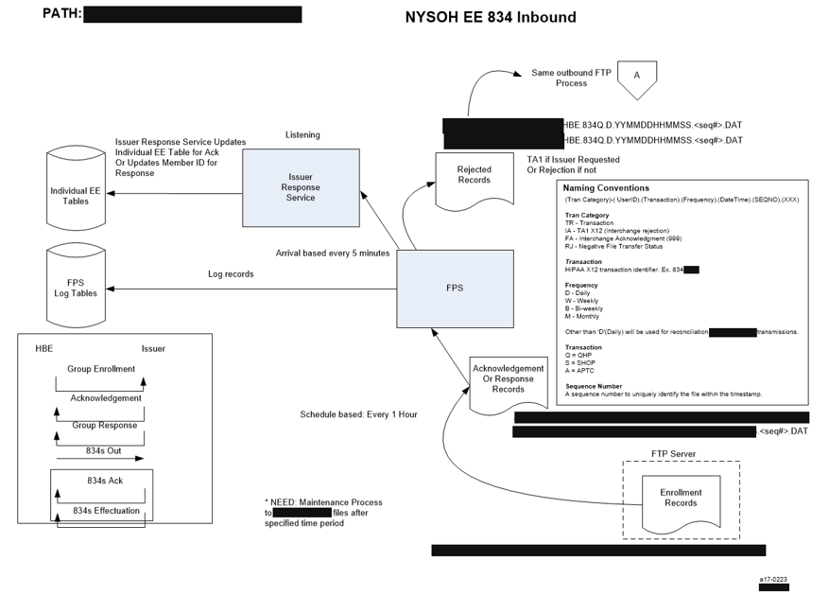
Figure 26. EDI 834 Inbound (FPS)
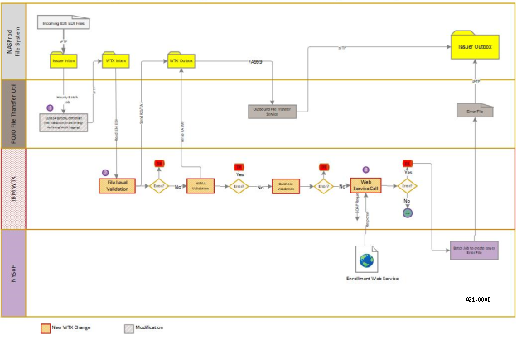
Figure 27. WTX EDI 834 Inbound process

Table 125 contains EDI 834 Inbound processes.

Category | Value
Description | FPS receives inbound 834 EDI files.
Mode of Operation | This is an automated job that will run on a batch. The schedule is defined in the NYSOH Production Job Schedule.
Job Type | Inbound batch interface. This is an EDI interface.
Systems | - FPS  - MQFTE  - WTX
Inputs | FPS ingests the Enrollment records and associated metadata.
Outputs | Enrollment records and FPS log tables are input to the FTP server for Issuers to extract as shown in the Naming Convention and Location of Input and Output Files section of this table.
Business Frequency | Process daily files
Processing (High-Level) | - The first step of this process is that the MQFTE reads and delivers the files from the SFTP server. (File names are found in the Naming Convention and location of input and output file section.)  - The second step of this process is to execute FPS to generate the rejected enrollment records, write to the FPS log tables and provide the acknowledgement and response records to the Issuer Response Service.
Distribution of Outputs | Outputs are distributed only as described above.
Naming Convention and Location of Input and Output Files | Naming Conventions:  (Tran Category)-( UserID).(Transaction).(Frequency).(DateTime).(SEQNO).(XXX)  Transaction Category  TR - Transaction  IA - TA1 X12 (Interchange rejection)  FA - Interchange Acknowledgment (999)  RJ - Negative File Transfer Status  Transaction  HIPAA X12 transaction identifier. Ex. 834 /820  Frequency  D - Daily  W - Weekly  B - Bi-weekly  M - Monthly  Other than 'D'(Daily) will be used for reconciliation (audit/compare) transmissions.  Transaction  Q = QHP  S = SHOP  A = APTC  C = CHIP  M=Managed Medicaid  Sequence Number  A sequence number to uniquely identify the file within the timestamp.  PATH: [REDACTED]  The following are the programs with their associated input and output that are executed for this process:  MQFTE  - Input:  - Enrollment records  - <ftpserverinboxroot>/<issuerID>.FA.NYHBE.834S.YYMMDDHHMMSS.<seq#>.DAT  - Output:  - Acknowledgement Records  - ./inpool/<issuerID>.FA.<TPID>.834Q.D.YYMMDDHHMMSS.<seq#>.DAT  - Response Records  - ./inpool/<issuerID>.TR.<TPID>.834Q.D.YYMMDDHHMMSS.<seq#>.DAT  FPS  - Input:  - Acknowledgement Records  - ./inpool/<issuerID>.FA.<TPID>.834Q.D.YYMMDDHHMMSS.<seq#>.DAT  - Response Records  - ./inpool/<issuerID>.TR.<TPID>.834Q.D.YYMMDDHHMMSS.<seq#>.DAT  - Output:  - Rejected Records  - ./outpool/ftp/<issuerID>.RJ.NYHBE.834Q.D.YYMMDDHHMMSS.<seq#>.DAT  - Issuer Requested Records  - ./inpool/<issuerID>.TA.NYHBE.834Q.D.YYMMDDHHMMSS.<seq#>.DAT  - FPS log tables  - Acknowledgement Records and Response Records to Issuer Response Service which updates the Individual EE tables  WTX  - Input:  - - [REDACTED]  - Output:  - - [REDACTED]
Error Handling (High-Level) | The specific error tables “I_FPS_FILE_834_EXCEPTION_TB, I_FPS_FILE_REJECT_TB“ are maintained for logging all the 834 inbound and outbound file errors. This table contains complete error details such as file ID, file name, inbound and outbound transaction ID, error code, error description, etc.  If the interface terminates abnormally because of a system exception (e.g., database is down), then:  - NYSOH GDIT System Architecture team will fix issues related to the system exception, and, if applicable, restart the job.
Responsible Teams | - DOH Small Business Marketplace team  - NYSOH GDIT System Architecture team  - NYSOH GDIT Application Development team
Table 125: EDI 834 Inbound (FPS)

Custody and Release Files from NYS DOCCS
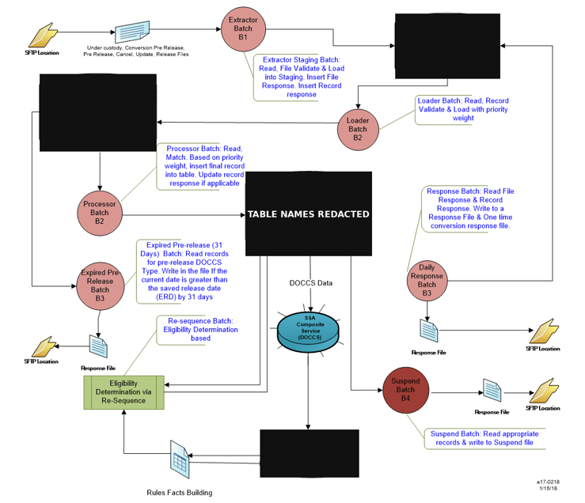
Figure 28. Custody and Release Files from NYS DOCCS

Table 126 contains Custody and Release files from the NYS DOCCS.

Category | Value
Description | NYSOH DOCCS  Processes UnderCustody, Pre Release, Update, Cancel and Release files to update DOCCS data tables in the database.
Mode of Operation | This is an automated job that will run on a batch. The schedule is defined in the NYSOH Production Job Schedule.
Job Type | Autosys
Systems | MQFTE  Pull_R_U_filesFromDoccsServer.sh  NYSDOCCSStagingLoader.sh  NYSDOCCSProcessor.sh  NYSDOCCSExtractor.sh
Inputs | UnderCustody, Pre Release, Update, Cancel and Release files from FTP server
Outputs | DOCCS database tables  - NYS_DOCCS_FILE_PROCESSING  - NYS_DOCCS_INCARCERATION_STG  - NYS_DOCCS_RELEASE_STG  - NYS_DOCCS_RECORD_PROCESSING  - NYS_DOCCS_INCARCERATION  - NYS_DOCCS_RELEASE  - NYS_DOCCS_RECORD_PROCESSING  - NYS_DOCCS_PROCESS_STATUS  - NYS_DOCCS_SUSPEND
Frequency | Daily
Processing (High-Level) | Step 1:  1. Extract files from DOCCS SFTP location  2. Validate the file and data formats  3. Cleanup previous day staging data  4. Parse, validate and transform DOCCS data into following tables  - NYS_DOCCS_FILE_PROCESSING  - NYS_DOCCS_INCARCERATION_STG  - NYS_DOCCS_RELEASE_STG  - NYS_DOCCS_RECORD_PROCESSING  Step 2:  1. Read staging data by following DOCCS Process Type  - UNDERCUSTODY  - PRERELEASE  - UPDATE  - CANCEL  - RELEASE  2. Apply weightage, compare data into existing Production data, apply data validation and Persist  3. Update or Insert data into following production tables  - NYS_DOCCS_INCARCERATION  - NYS_DOCCS_RELEASE  - NYS_DOCCS_RECORD_PROCESSING  - NYS_DOCCS_PROCESS_STATUS  Step 3:  1. Read related DOCCS data by demographics  2. Perform CL Level match for UNDERCUSTODY data and CIN level match for other DOCCS Process data  3. Apply data validation  4. Insert or Update into following production tables  - NYS_DOCCS_INCARCERATION  - NYS_DOCCS_RELEASE  - NYS_DOCCS_RECORD_PROCESSING  - NYS_DOCCS_PROCESS_STATUS  5.Call Eligibility API to determine resequencing update, coverage code validation, active manual renewal update and Suspend data add  6. Add to Resequence  7. Add to NYS_DOCCS_SUSPEND table
Distribution of Outputs | For emails, the distribution list will include members of the DOH Plan Management team, and, potentially, members of other teams.
Naming Convention and Location of Input and Output Files | All files have a path as follows:  [REDACTED]  The following are the programs with their associated input and output that are executed for this process:  MQFTE  Input:  - U.DOCCS.D.<CCYYMMDDhhmmss>.TXT (UNDERCUSTODY file)  - P.DOCCS.D.<CCYYMMDDhhmmss>.TXT (PRERELEASE file)  - M.DOCCS.D.<CCYYMMDDhhmmss>.TXT (UPDATE file)  - C.DOCCS.D.<CCYYMMDDhhmmss>.TXT (CANCEL file)  - R.DOCCS.D.<CCYYMMDDhhmmss>.TXT (RELEASE file)  Output:  - P.NYSOH.D.<CCYYMMDDhhmmss>.TXT (PRE RELEASE response file)  - M.NYSOH.D.<CCYYMMDDhhmmss>.TXT (UPDATE response file)  - C.NYSOH.D.<CCYYMMDDhhmmss>.TXT (CANCEL response file)  - E.NYSOH.D.<CCYYMMDDhhmmss>.TXT (EXPIRED PRE RELEASE response file)
Error handling (High-Level) | If the interface terminates abnormally because of a system exception (e.g., database is down), then NYSOH GDIT System Architecture team will fix issues related to the system exception and, if applicable, restart the job.
Responsible Teams | - DOH Common Services Team and Individual EE team  - NYSOH GDIT System Architecture team  - NYSOH GDIT Application Development team
Table 126: Custody and Release Files from NYS DOCCS

NYSOH KIDS
Figure 29 presents the workflow.

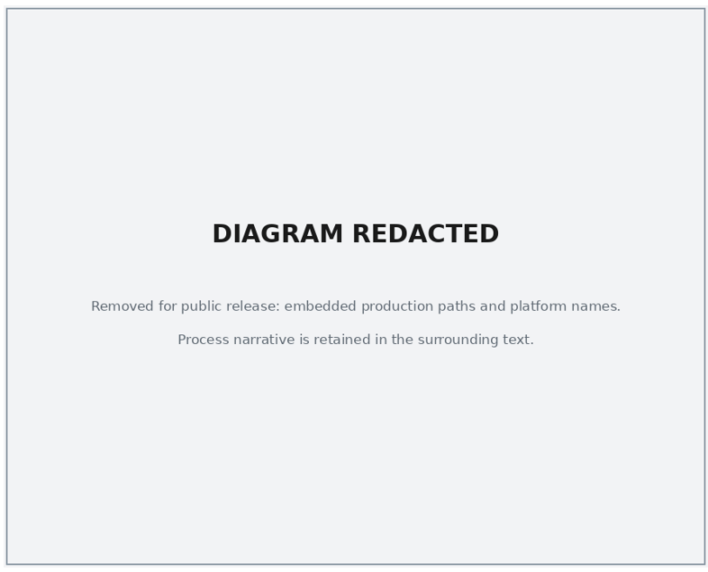
Figure 29. NYSOH KIDS

Table 127 contains the NYSOH KIDS process.

Category | Value
Description | NYSOH KIDS  Processes CHIP Current Enrollment data and updates the CHIP Current Enrollment table
Mode of Operation | This is an automated job that will run on a batch. The schedule is defined in the NYSOH Production Job Schedule.
Job Type | Batch interface
Systems | MQFTE  DS_KIDS_PROD.sh  KIDS_SEQUENCE
Inputs | CHIP Current enrollment file from FTP server
Outputs | CHIP Current Enrollment table (CHILD_HEALTH_PLUS_PGM)
Frequency | DS_KIDS_PROD.sh and KIDS_SEQUENCE are scheduled to run daily  MQFTE runs every hour.
Processing (High-Level) | The first step of this process uses MQFTE to pull current CHIP data from FTP server and writes a current CHIP data file.  The second step of this process uses DS_KIDS_PROD.sh to archive the Current CHIP data and updates the CHIP Current Enrollment table.
Distribution of Outputs | This process does not have any distributable outputs.
Naming Convention and Location of Input and Output Files | All files have a path as follows:  [REDACTED]  The following are the programs with their associated input and output that are executed for this process:  MQFTE  Input:  - CHIP Current Enrollment file from FTP server - <ftpserverroot>/<KIDS>KIDS_DATA_LOAD.txt  Output:  - CHIP Current Enrollment file -  ./Current_Kids_DATA_LOAD.txt  DS_KIDS_PROD.sh and KIDS_SEQUENCE  Input:  - CHIP Current Enrollment file -  ./Current_KIDS_DATA_LOAD.txt  Output:  - Archived files  - ./Archive/KIDS_DATA_LOAD_YYYMMDDHHMMSS.txt  - CHIP Current enrollment database tables as follows:  - CHILD_HEALTH_PLUS_PGM
Error handling (High-Level) | If the interface terminates abnormally because of a system exception (e.g., database is down), then NYSOH GDIT System Architecture team will fix issues related to the system exception and, if applicable, restart the job.
Responsible Teams | - DOH Individual EE team  - NYSOH GDIT System Architecture team  - NYSOH GDIT Application Development team
Table 127: NYSOH KIDS

LDSS Referral
Figure 30 presents the workflow.

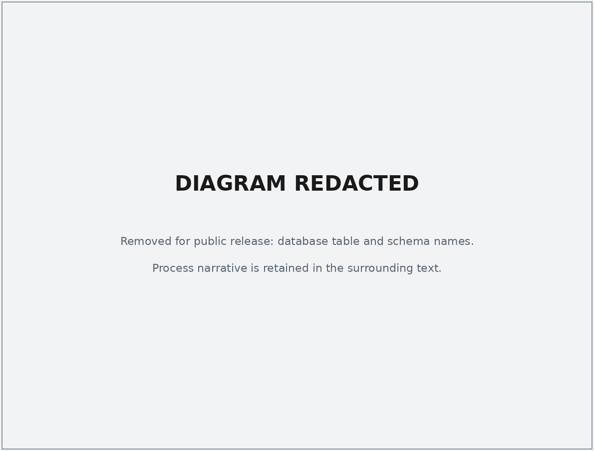
Figure 30. LDSS Referral

Table 128 contains description and value.

Category | Value
Description | LDSS Referral  Generates referral files that are sent to HRA/EDITS (downstate) and MAXIMUS (upstate)
Mode of Operation | This is an automated job that will run on a batch. The schedule is defined in the NYSOH Production Job Schedule.
Job Type | Batch interface
Systems | Individual-hx-job-LDSS  MQFTE
Inputs | EE Eligibility tables
Outputs | MAXIMUS LDSS Referrals (upstate files)  - MAXIMUS-LDSS-Referrals-0040DDMMYYYYHHMM.txt  HR/EDITS Referrals (downstate files)  - 0040DDMMYYYYHHMM.txt  - 0040DDMMYYYYHHMM.EOB
Frequency | Daily
Processing (High-Level) | The first step of this process uses Individual-hx-job-LDSS to read the Eligibility tables to obtain all applicants warranting referral to local districts identified by the online NYSOH application in near real time.  A listing of all LDSS referrals for each business day will be captured in two data files, one for applicants residing in NY City counties (downstate), and one for applicants residing in upstate counties as identified by the applicant's residential zip code. The file containing NY City residents is sent via SFTP to a secure server maintained by HRA as part of their EDITS application for submitters. The file containing upstate residents is sent via SFTP to MAXIMUS.
Distribution of Outputs | This process does not have any distributable outputs.
Naming Convention and Location of Input and Output Files | All files have a path as follows:  [REDACTED]  The following associated input and output files for this process:  Input:  - EE Eligibility tables  Output:  - MAXIMUS LDSS Referrals (upstate files)  MAXIMUS-LDSS-Referrals-0040DDMMYYYYHHMM.txt  - HRA/EDITS LDSS Referrals (downstate files)  0040DDMMYYYYHHMM.EOB  0040DDMMYYYYHHMM.txt
Error handling (High-Level) | If the interface terminates abnormally because of a system exception (e.g., database is down), then NYSOH GDIT System Architecture team will fix issues related to the system exception, and, if applicable, restart the job and notify MAXIMUS Health Services, and NYSDOH representative
Responsible Teams | - DOH Individual EE team  - NYSOH GDIT System Architecture team  - NYSOH GDIT Application Development team
Table 128: LDSS Referral

Forced Closure
Table 129 details the process.

Category | Value
Description | Forced Closure  Generates referral files that are sent to HRA/EDITS (downstate) and MAXIMUS (upstate)
Mode of Operation | This is an automated job that will run on a batch. The schedule is defined in the NYSOH Production Job Schedule.
Job Type | Batch interface
Systems | Individual-hx-job-LDSS  MQFTE
Inputs | Upstate and Downstate Referral files  TR.sFTP.UFC.D.<YYMMDDhhmmss>.<sequence number>.<File Extension>  TR.sFTP.DFC.D.<YYMMDDhhmmss>.<sequence number>.<File Extension>
Outputs | Database tables  FC_Document  FC_Person_DTL  Log files  FC.Batch.Log
Frequency | Daily except holidays
Processing (High-Level) | The first step of this process is to read the upstate and downstate referral files from the SFTP server.  The second step provides the output to the Forced Closure database tables and to the Forced Closure log files.
Distribution of Outputs | This process does not have any distributable outputs.
Naming Convention and Location of Input and Output Files | File Naming Conventions  Forced Closure Inbound file name: <Transaction category>.<Insert User ID>. <Insert Transaction type> FC.<Frequency>.<YYMMDDhhmmss>.<Sequence number>.<File Extension>  Where:  Transaction category is: “TR” – Transaction  User ID - SFTP User ID assigned by NYSOH  Transaction Type - “U” – for Upstate and “D” – for Downstate  Frequency: “D” for Daily  Date/Time stamp: YYMMDDhhmmss represents date and time stamp of file creation.  Sequence number: nnn represents three-digit unique sequence number  File Extension: Three characters to describe the format of the file received.  All files have a path as follows:  [REDACTED]  The following associated input and output files for this process:  Input:  Upstate and Downstate Referral files  ..TR.sFTP.UFC.D.<YYMMDDhhmmss>.<sequence number>.<File Extension>  ..TR.sFTP.DFC.D.<YYMMDDhhmmss>.<sequence number>.<File Extension>  Output: Database tables  Database table update  FC_Document  FC_Person_DTL  Log files  FC.Batch.Log
Error handling (High-Level) | If the interface terminates abnormally because of a system exception (e.g., database is down), then NYSOH GDIT System Architecture team will fix issues related to the system exception and, if applicable, restart the job.  Exit Codes and Details map:
  # | Scenarios | Message | Code
  1. | File not found in the designated location. | Job Exit, No File Found. | 1
  2. | File not valid. | Job Exit, File not valid – <File Name Printed> | 2
  3. | Program Error | Job Failed and Exit. | 3
  4. | File Processed Successful.  Some of the records might have failed validation or not. | Job Exit, Success - <File Name Printed>. | 4
Responsible Teams | - DOH Individual EE team  - NYSOH GDIT System Architecture team  - NYSOH GDIT Application Development team
Table 129: Forced Closure

Death Confirmation
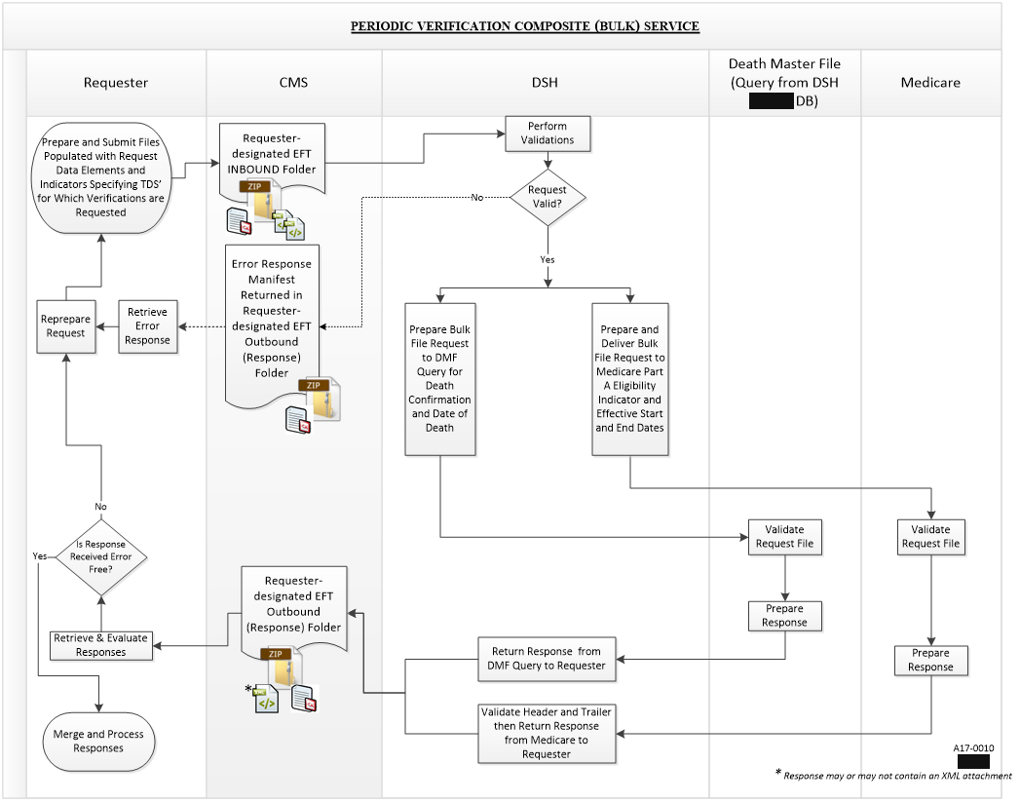
Figure 31. PVC Service Process Flow (from PVC Service BSD)

Table 130 contains category and value for job process. Figure 31 presents the workflow.

Category | Value
Description | FED HUB PVC Death Confirmation  Processes Death Confirmation data and updates the Death Information table
Mode of Operation | This is an automated job that will run on a batch. The schedule is defined in the NYSOH Production Job Schedule.
Job Type | Batch interface
Systems | pvcResponseBatchJob.sh, PVCXMLGenerationJob.sh and PVCXMLConsolidationJob.sh runs on NASPROD.
Inputs | DMF_SERVICE_DATA table and PVC response file from FTP server
Outputs | PVC request files. Updates on DMF_SERVCE_DATA table
Frequency | PVCXMLGenerationJob.sh and PVCXMLConsolidationJob.sh runs 5th of every month. And pvcResponseBatchJob.sh runs once response files received from CMS.
Processing (High-Level) | The first step of this process the job polls the database for individuals who are eligible in NYSOH, inserts records in DMF_SERVICE_DTA table, creates request files and sends it to CMS for death match.  The second step of this process; once NYSOH receives the response files from CMS, PVC response batch processes the response file and updates the records in DMF_SERVICE_DATA as death confirmed, creates clock and creates events to generate death match notices.
Distribution of Outputs | This process does not have any distributable outputs.
Naming Convention and Location of Input and Output Files | All files have a path as follows:  \\the production file share\the production file share\batch_jobs (Extracted an unsupported link: [REDACTED])  The following are the programs with their associated input and output that are executed for this process:  Input file format:  - [REDACTED] (Extracted an unsupported link: [REDACTED])\ FEP0126NY.DSH.PVC1.DYYMMDD.T014853008.P.IN  Output file format:  - [REDACTED] FEP0126NY.PVC4.DYYMMDD.T012044301.P.OUT
Error handling (High-Level) | If the interface terminates abnormally because of a system exception (e.g., database is down), then NYSOH GDIT System Architecture team will fix issues related to the system exception and, if applicable, restart the job.
Responsible Teams | - DOH Individual EE team  - NYSOH GDIT System Architecture team  - NYSOH GDIT Application Development team
Table 130: Death Confirmation

NYSHIP Data Loader
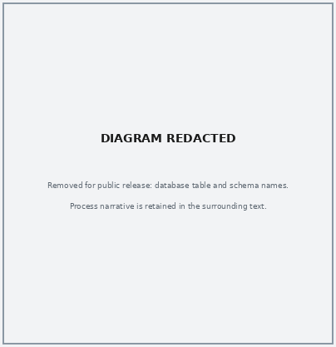
Figure 32. NYSHIP Loader and Service Process Flow

Table 131 contains job category and value. Figure 32 presents a workflow.

Category | Value
Description | NYSHIP Data Loader
Mode of Operation | This is an automated job that will run on a batch. The schedule is defined in the NYSOH Production Job Schedule.
Job Type | Batch interface
Systems | NYSHIPDataLoadJob.sh runs on the production file share.
Inputs | NYSHIP Master file
Outputs | NYSHIP_DATA
Frequency | NYSHIPDataLoadJob.sh runs every Saturday at 1 AM
Processing (High-Level) | 1. Read NYSHIP Master file  2. Split Master file into small chunks  3. Read and Validate file, log file processing and errors  4. Parse file and validate data records, log data record and errors  5. Compare data against NYSHIP_DATA, insert for new records and update for update records and log audit in NYSHIP_HIST  6. Archive files
Distribution of Outputs | This process does not have any distributable outputs.
Naming Convention and Location of Input and Output Files | All files have a path as follows:  [REDACTED] (Extracted an unsupported link: [REDACTED])  Input file format:  - NYSDLR.NYSHIP.W.20170429010006.DAT  Output file format:  - N/A
Error handling (High-Level) | If the interface terminates abnormally because of a system exception (e.g., database is down), then NYSOH GDIT System Architecture team will fix issues related to the system exception and, if applicable, restart the job.
Responsible Teams | - DOH Interface team  - NYSOH GDIT System Architecture team  - NYSOH GDIT Application Development team
Table 131: NYSHIP Data Loader

NYSHIP Data Processor Job
Table 132 contains job category and value.

Category | Value
Description | NYSHIP Data Processor Job
Mode of Operation | This is an automated job that will run on a batch. The schedule is defined in the NYSOH Production Job Schedule.
Job Type | Batch interface
Systems | NYSHIPProcessor.sh runs on the production file share.
Inputs | NYSHIP_DATA
Outputs | RESEQ_RERUN_BUCKET
Frequency | NYSHIPProcessor.sh runs every Saturday at 1 AM
Processing (High-Level) | 1. NYSHIP Batch Job Processor will read all eligible records from database and will try to match the record present in NYSHIP_DATA master table.  2. If match is found, record will be put into Re-sequence for further processing i.e., either to disenroll from NYSOH or moves to FFS or opens the NYSHIP clock for further documentation depends on the program member is eligible for.
Distribution of Outputs | This process does not have any distributable outputs.
Naming Convention and Location of Input and Output Files | N/A
Error handling (High-Level) | If the interface terminates abnormally because of a system exception (e.g., database is down), then NYSOH GDIT System Architecture team will fix issues related to the system exception and, if applicable, restart the job.
Responsible Teams | - DOH Interface team  - NYSOH GDIT System Architecture team  - NYSOH GDIT Application Development team
Table 132: NYSHIP Data Processor Job

Organ Donor Extractor
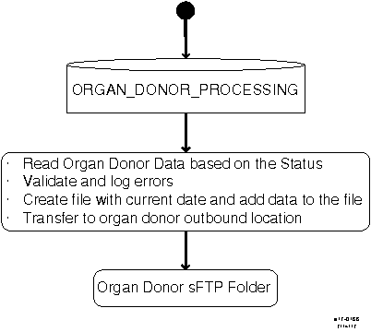
Figure 33. Organ Donor Extractor Process Flow

Table 133 contains job category and value. Figure 33 presents a workflow.

Category | Value
Description | Organ Donor Extractor
Mode of Operation | This is an automated job that will run on a batch. The schedule is defined in the NYSOH Production Job Schedule.
Job Type | Batch interface
Systems | OrganDonorExtractor.sh runs on the production file share.
Inputs | ORGAN_DONOR_PROCESSING
Outputs | NYSDLR.NYSITSOD.D.20170314.DAT
Frequency | OrganDonorExtractor.sh runs every day at 6 AM
Processing (High-Level) | 1. Read Organ Donor Data based on the Status  2. Validate and log errors  3. Create file with current date and add data into the file  4. Transfer to organ donor outbound location
Distribution of Outputs | This process does not have any distributable outputs.
Naming Convention and Location of Input and Output Files | All files have a path as follows:  [REDACTED] (Extracted an unsupported link: [REDACTED])  Input file format:  - N/A  Output file format:  - NYSDLR.NYSITSOD.D.20170314.DAT
Error handling (High-Level) | If the interface terminates abnormally because of a system exception (e.g., database is down), then NYSOH GDIT System Architecture team will fix issues related to the system exception and, if applicable, restart the job.
Responsible Teams | - DOH Interface team  - NYSOH GDIT System Architecture team  - NYSOH GDIT Application Development team
Table 133: Organ Donor Extractor

Notices
Notices are communications from NYSOH providing information to consumers about their eligibility and enrollment for health insurance coverage through NYSOH. Notices are produced daily for the consumer and DOH through a series of batch jobs for activities that occurred on the NYSOH site the previous day. The events created by the prior day’s activities determine which notice template is to be generated. Notices are created in PDF and PostScript, PS, file formats. A PDF is created for all notices in the daily batch and are uploaded to consumer accounts in OpenCMIS, Content Management Interoperability Services, the NYSOH Document Management System, for access by DOH, MAXIMUS, and the consumer. OpenCMIS is an OASIS, Organization for the Advancement of Structured Information Standards, standard enabling information sharing between different content management systems.

Consumers can select their communication preference, either paperless (electronic) or paper, in their account. For consumers that select paperless communications, an email alert is sent informing the consumer that a new notice has been uploaded to their account. For any email returned due to an invalid email address the notice is regenerated in paper format and that consumer will receive notices in paper until their email address has been corrected. The invalid email job is run prior to the start of the notice processing. For consumers that select paper communications, a PostScript version is created in addition to the PDF file. PostScript files are sent to BSOC, Business Services Outsourcing Center operated by GDIT, for printing and mailing.

NYSOH uses the two systems listed below to create the PDF and PostScript files for notices.
- Legacy – a system that was created by NYSOH and has the ability to send notices in English and Spanish only.
- OpenText – a software product that provides the capabilities of creating notices in multiple languages. Currently NYSOH creates notices in the following languages: Arabic, Bengali, Polish, French, Russian, Traditional Chinese, Simplified Chinese, Urdu, Spanish, Korean, Italian, Haitian-Creole and English.

USPS returns mail that is undeliverable. i.e., bad address, customer move, etc. to MAXIMUS. MAXIMUS scans the QR, quick response, code on the notice into a file that is sent to GDIT for processing the next day, i.e., the file created for Monday’s return mail is processed by GDIT on Tuesday. When GDIT processes the undeliverable mail file, tables are updated with an error code per the DOH business rules which determines which notice will be regenerated and resent to the consumer using the address found in Melissa Data. GDIT sends MAXIMUS a response file after processing.

For consumers who selected paperless (electronic) delivery for their notices, NYSOH sends the consumer an email stating a new document is available in their account for viewing. NYSOH receives bounce-back emails for an invalid email address as well as user responses such as “out of office” response, return receipt, etc. For any email returned to NYSOH due to an invalid email address, NYSOH updates that consumer’s communication preference to paper and regenerates the notice with a cover page for delivery in paper. The consumer will continue to receive their notices in paper until they update their email address in their account and change the communication preference back to paperless.

Figure 34 provides a high-level overview of the process for creating notices. Each job that is run is described in subsequent sections.

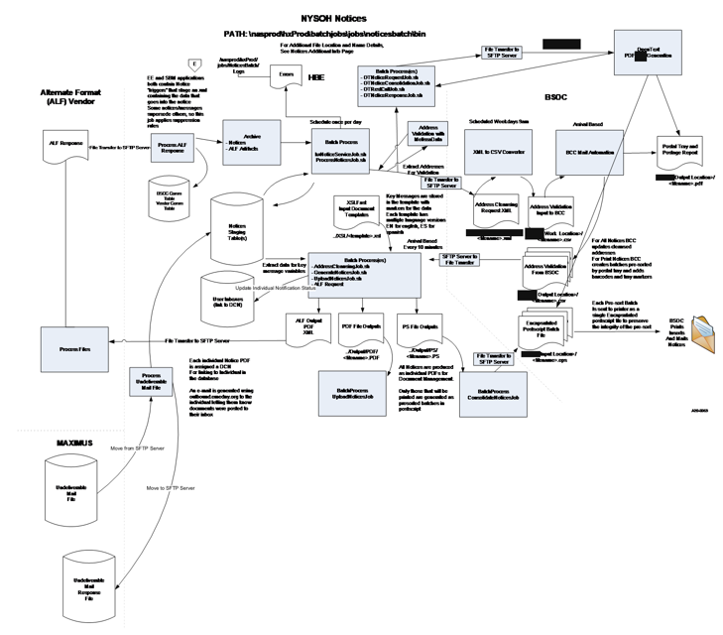
Figure 34. Notice Processing

Table 134 lists all of the batch jobs run daily to produce notices. GDIT has put a time threshold for completion of all the batch jobs listed below. Passing this threshold triggers an email alert to the GDIT Operations team for investigation. The sections that follow the table provide additional information about each of the TWS, Tivoli Workload Scheduler, jobs run for each of the processes to create notices. Besides triggering the jobs as scheduled, the TWS Scheduler also verifies that the job to be triggered in not currently running preventing duplicate runs for all jobs.

Process | TWS Job | Description
Alternate Format Response File Processing | D_BATCH_ALTERNATEFORMATRESPONSEJOB | Processes the Response file received from the Alternate Format, ALF, Vendor and updates the BSOC Communications and Vendor Communication ALF tables with the status of requests sent to the ALF vendor
File Archive | D_BATCH_ARCHIVEARTIFACTSJOB | File Archive – moves all files created and used by the Open Text and Legacy systems for the notices created in the previous day's batch from the daily production area to an archive location.
File Archive | D_BATCH_FILEARCHIVEJOB
File Archive | D_BATCH_OTARCHIVEJOB
Event Request | D_BATCH_PREHXNOTICESERVICE | Determines which notices are to be produced based on the prior day's events created by activity on the site. Suppression rules are applied so the appropriate notice is created and generates the XML for those notices that are to be produced.
Event Request | D_BATCH_HXNOTICESERVICEJOB
Event Request | D_BATCH_POSTHXNOTICESERVICE
Process Notices | D_BATCH_PROCESSNOTICESMINMAXIDS | Extracts demographic information for staged Notices and produces an XML Address Cleansing request file for processing by Melissa Data
Process Notices | D_BATCH_STARTPROCESSNOTICES
Process Notices | D_BATCH_WAITPROCESSNOTICESTOCOMPLETE
Address Validation | D_BATCH_ADDRESSVALIDATIONJOB | For all notices to be created in paper format, a request is sent to Melissa Data to validate the address that will be used on the notice for all accounts whose address has not been verified by the consumer
OpenText Notice Generation and Consolidation | D_BATCH_OTNOTICEREQUESTJOB | Determines what notice gets produced by OpenText and the Legacy system. For notices that will be created by OpenText the NYSOH XML is converted to OpenText XML, and creates the driver XML and IDX files, address cleansing files, and PDF files for consumers with a communication preference of paperless
OpenText Notice Generation and Consolidation | D_BATCH_OTNOTICECONSOLIDATIONJOB
OpenText Notice Generation and Consolidation | D_BATCH_OTNOTICECONSOLIDATIONVALIDATION
OpenText Notice Generation and Consolidation | D_BATCH_OTCOMMANDCENTERCHECK
OpenText Notice Generation and Consolidation | D_BATCH_OTRESTCALLJOB
OpenText Notice Generation and Consolidation | D_BATCH_OTWAITFORDONE
OpenText Notice Generation and Consolidation | D_BATCH_OTDBPAPERDRIVER
OpenText Notice Generation and Consolidation | D_BATCH_OTIDXDRIVERVALIDATION
OpenText Notice Generation and Consolidation | D_BATCH_OTNOTICEIDXCONSOLIDATIONJOB
OpenText Notice Generation and Consolidation | D_BATCH_OTIDXFILEVALIDATION
OpenText BSOC Request and Response | D_BATCH_BSOCOTREQUESTREMOVAL | Creates PDF files for OpenText notices for the consumers with the communication preference of paper, creates the Address Cleansing file for BSOC, sends the file to BSOC for processing and receives and processes the response files from BSOC
OpenText BSOC Request and Response | D_BATCH_OTBSOCOUTBOUNDTRANSFER
OpenText BSOC Request and Response | D_BATCH_OTBSOCREQUESTFILES
OpenText BSOC Request and Response | D_BATCH_OTCOMMANDCENTERCHECK1
OpenText BSOC Request and Response | D_BATCH_OTNOTICEPAPERPDFGENERATIONJOB
OpenText BSOC Request and Response | D_BATCH_OTWAITFORBSOCRESDONE
OpenText BSOC Request and Response | D_BATCH_OTBSOCRESPONSE
OpenText BSOC Request and Response | D_BATCH_OTBSOCINBOUNDTRANSFER
OpenText BSOC Request and Response | D_BATCH_OTBSOCRESPONSEARCHIVE
OpenText BSOC Request and Response | D_BATCH_OTCOMMANDCENTERCHECK2
OpenText BSOC Request and Response | D_BATCH_OTBSOC
OpenText BSOC Request and Response | D_BATCH_PAPERPDFRESPONSEVALIDATION
OpenText BSOC Request and Response | D_BATCH_OTPSFILESVALIDATIONS
OpenText BSOC Request and Response | D_BATCH_OTPSFILESTOBSOC
OpenText BSOC Request and Response | D_BATCH_OTPSSTG2FTPJOB
OpenText BSOC Request and Response | D_BATCH_OTPSARCHIVEDONE
OpenText BSOC Request and Response | D_BATCH_OTDBEMAILDRIVER
OpenText BSOC Request and Response | D_BATCH_EMAILPDFRESPONSEVALIDATION
OpenText BSOC Request and Response | D_BATCH_OTPSRESPONSEFILESMOVE
OpenText BSOC Request and Response | D_BATCH_OTRESPONSEJOB
Legacy BSOC Request and Response | D_BATCH_BSOCOUTBOUNDCYCLESWITCH | Generates the XML request file of addresses for printed notices, transfers the request file to BSOC for processing, and receives the processed response files from BSOC. Response files are used to update the Notices staging tables
Legacy BSOC Request and Response | D_BATCH_BSOCREQUESTJOB
Legacy BSOC Request and Response | D_BATCH_BSOCOUTBOUNDADDRTRANSFER
Legacy BSOC Request and Response | D_BATCH_BSOCINBOUNDCYCLESWITCH
Legacy BSOC Request and Response | D_BATCH_WAITFORADDRESSCLEANSINGFILE
Legacy BSOC Request and Response | D_BATCH_BSOCINBOUNDTRANSFER
Legacy BSOC Request and Response | D_BATCH_ADDRESSCLEANSINGJOB
Legacy BSOC Request and Response | D_BATCH_BSOCINBOUNDCYCLECLOSE
Legacy Notice Generation | D_BATCH_GENERATENOTICESMINMAXIDS | A script that is run prior to the process notice job that queries the database for the Min and Max HX-ID for the current batch and creates multiple groups of Min and Max ID’s and assigns each group to an instance for notice generation
Legacy Notice Generation | D_BATCH_STARTGENERATENOTICES | Job creates PDF files for all staged Notices and individual PostScript files for notices that are to be printed for consumers who have requested to receive their notices in paper format.
Legacy Notice Generation | D_BATCH_WAITGENERATENOTICESTOCOMPLETE | A script that runs during the Generate Notices process that checks for a done file on all instances.
Legacy Notice Consolidation | D_BATCH_CONNOTICESGETFILEIDENTIFIERS | Job batches/consolidates the individual PostScript versions of Notices to be printed. Job outputs batches of up to 2,000 Notices as a single encapsulated PostScript file in tray sequence order and transfers the consolidated PostScript files to BSOC for printing and mailing
Legacy Notice Consolidation | D_BATCH_CREATECONSOLIDATEFILES
Legacy Notice Consolidation | D_BATCH_CONSOLIDATEINSTANCES
Legacy Notice Consolidation | D_BATCH_WAITCONSOLDATENOTICESTOCOMPLETE
Legacy Notice Consolidation | D_BATCH_VALIDATENOTICESBATCH
Legacy Notice Consolidation | D_BATCH_BSOCOUTBOUNDPSTRANSFER
Legacy Notice Consolidation | D_BATCH_BSOCOUTBOUNDCYCLECLOSE
Notices Reports Generation | DB_RPT_NOTICES_REPORTS | Generates daily validation and production reports that are sent to DOH or used to create other reports such as the Notice Detail Report
Alternate Format Request | D_BATCH_ALTERNATEFORMATREQUESTJOB | Job chooses templates that are to be delivered to the Alternate Format vendor for notice creation in consumers preference and moves the PDF and XML files to the Alternate Format Vendors FTP inbox for processing
Alternate Format Request | D_BATCH_SENDALTERNATEFORMATFILES
Upload Notices | D_BATCH_RUNUPLOADNOTICES | Uploads the PDF versions of all notices to OpenCMIS, Open Content Management Interoperability Services, NYSOH’s Document Management System and associates the notice to the consumer’s account
Newborn Institution Reports | D_BATCH_NEWBORNDOWNSTATEREPORTJOB | Locates all the Downstate Newborn Institution Reports, T112 notice, and zips the PDFs into a file and sends to DOH via FTP
Newborn Institution Reports | D_BATCH_MVZIPFILESTOFTP
Email Sender | D_BATCH_RUNEMAILSENDERJOB | Job sends out an email alert to consumers who have selected paperless delivery that a new document has been added to their account
Notice Back Office Key Message Search | D_BATCH_RUNXMLMULTIINSTANCE | Loads the XML for the daily notice batch to the Notices KM tables. This data is accessed through the Back Office to search for notices by KM. Once the XML has been loaded an email alert is sent to DOH and GDIT informing them that today's batch is available for searching
Notice Back Office Key Message Search | D_BATCH_WAITNOTICEXMLLOADERTOCOMPLETE
Notice Back Office Key Message Search | D_BATCH_TRIGGEREMAIL
Archive OpenText Response Files | D_BATCH_OTEPRESPONSEARCHIVE | Moves the OpenText PDF and PostScript Response files to the OpenText Archive location
Archive OpenText Response Files | D_BATCH_OTEPPSRESPONSEFILE
Archive OpenText Response Files | D_BATCH_OTRESPONSEJOB1
Undeliverable Mail | D_FTP_UndelEmail_pullFilesFromMaximus | Pulls the Undeliverable Mail File from MAXIMUS, processes the file, and sends a Response File to MAXIMUS
Undeliverable Mail | D_BATCH_UndelJobLauncher
Undeliverable Mail | D_BATCH_UndelEmail_sendFilesToMaximus
Table 134: List of Notice Batch Jobs

Alternate Format Response File Processing
Consumers can request their notices be created in an alternative format (ALF) – large print, Braille, audio CD, etc. Notices for accounts flagged to receive alternative formats are sent to a vendor who produces the notices in the requested format. The vendor sends a response file to NYSOH acknowledging receipt of the request to produce these notices in the formats requested. This job archives the response file on the FTP site and copies the response file from the FTP area to PROD and processes that response file which updates the BSOC Communication and Vendor Communication ALF tables. Table 135 provides details about the Alternative Format Response job.

Category | Value
Description | Alternative Format Response
Mode of Operation | This is a batch shell job invoking a Java program. The schedule is defined in the TWS Master Schedule.
Job Type | Batch interface
Systems | D_BATCH_AlternateFormatResponseJob
Inputs | Response file received from ALF Vendor
Outputs | Updated BSOC Communications and Vendor Communication ALF tables
Frequency | Daily
Processing (High-Level) | Archives and processes the Response file received from the ALF Vendor and updates the BSOC Communications and Vendor Communication ALF tables with the status of requests sent to the ALF vendor.
Distribution of Outputs | This process does not have any distributable outputs.
Naming Convention and Location of Input and Output Files | The following are the input and output that are executed for this process:  Input:  - [REDACTED]  Output:  - Updated BSOC Communications and Vendor Communications ALF tables
Error handling (High-Level) | If the interface terminates abnormally because of a system exception (e.g., disk space issue, database is down), the NYSOH GDIT System Architecture team will fix issues related to the system exception and restart the job. Failures related to non-system exceptions will be corrected by the NYSOH GDIT Application Development team and the job restarted. If the interface returns an exit code greater than zero, 0, an alert is sent to the GDIT Operations Team for resolution.
Responsible Teams | - NYSOH GDIT System Architecture team  - NYSOH GDIT Application Development team  - NYSOH GDIT Operations team
Table 135: Alternative Format Response

File Archive
The File Archive process archives the files created by the OpenText and Legacy systems for the previous days’ notice batch. Details about the individual TWS jobs run to archive the files are below.

Step 1 - Archive Artifacts
The Archive Artifacts job archives the PDF and XML files that were sent to the Alternate Format (ALF) vendor from the previous day’s batch and stores these files in the archive area on PROD for short term storage. These files will eventually be archived to tape and sent to an offsite storage provider. Table 136 provides details about the Archive Artifacts job.

Category | Value
Description | Archive Artifacts
Mode of Operation | This is a batch shell job invoking a Java program. The schedule is defined in the TWS Master Schedule.
Job Type | Batch interface
Systems | D_BATCH_ArchiveArtifactsJob
Inputs | ALF Notice PDF and XML files from previous notice batch run sent to ALF vendor
Outputs | Archive of ALF Notice PDF and XML files from previous batch run
Frequency | Daily
Processing (High-Level) | Moves the ALF Notice PDF and XML files created in the previous batch to an archive location.
Distribution of Outputs | This process does not have any distributable outputs.
Naming Convention and Location of Input and Output Files | The following are the input and output that are executed for this process:  Input:  - [REDACTED] jobs\destination\NoticesBatch\alf\outbound\  Output:  - [REDACTED] jobs\archieve\NoticesBatch\alf\archive\
Error handling (High-Level) | If the interface terminates abnormally because of a system exception (e.g., disk space issue, database is down), the NYSOH GDIT System Architecture team will fix issues related to the system exception and restart the job. Failures related to non-system exceptions will be corrected by the NYSOH GDIT Application Development team and the job restarted. If the interface returns an exit code greater than zero, 0, an alert is sent to the GDIT Operations Team for resolution.
Responsible Teams | - NYSOH GDIT Systems Architecture team  - NYSOH GDIT Application Development team  - NYSOH GDIT Operations team
Table 136: Archive Artifacts

Step 2 - File Archive
The File Archive job archives the PDF files, the individual and consolidated PostScript files, and the User Demographics Request and Response files created by the Legacy system for the previous day’s batch and stores these files in the Legacy archive area on PROD for short term storage. These files will eventually be archived to tape and sent to an offsite storage provider. Table 137 provides details about the File Archive job.

Category | Value
Description | File Archive
Mode of Operation | This is a batch shell job invoking a Java program. The schedule is defined in the TWS Master Schedule.
Job Type | Batch interface
Systems | D_BATCH_FileArchiveJob
Inputs | Notice PDF, PostScript, and User Demographics files from previous notice batch run
Outputs | Archive of Notice PDF, PostScript, and User Demographics files from previous batch run
Frequency | Daily
Processing (High-Level) | Moves the Notice PDF files, PostScript files, and the User Demographics files created by the legacy system in the previous batch run to an archive location.
Distribution of Outputs | This process does not have any distributable outputs.
Naming Convention and Location of Input and Output Files | The following are the input and output that are executed for this process:  Input:  - [REDACTED]  - [REDACTED]  - [REDACTED]  - [REDACTED]  - [REDACTED]  Output:  - [REDACTED]  - [REDACTED]  - [REDACTED]  - [REDACTED]  - [REDACTED]
Error handling (High-Level) | If the interface terminates abnormally because of a system exception (e.g., disk space issue, database is down), the NYSOH GDIT System Architecture team will fix issues related to the system exception and restart the job. Failures related to non-system exceptions will be corrected by the NYSOH GDIT Application Development team and the job restarted. If the interface returns an exit code greater than zero, 0, an alert is sent to the GDIT Operations Team for resolution.
Responsible Teams | - NYSOH GDIT Systems Architecture team  - NYSOH GDIT Application Development team  - NYSOH GDIT Operations team
Table 137: File Archive

Step 3 - OpenText File Archive
The OpenText File Archive job archives the PDF, PostScript, and all other files created by the OpenText system and BSOC for the previous batch run and stores these files in the OpenText archive area on PROD for short term storage. These files will eventually be archived to tape and sent to an offsite storage provider. Table 138 provides details about the OpenText File Archive job.

Category | Value
Description | OpenText File Archive
Mode of Operation | This is a batch shell job invoking a Java program. The schedule is defined in the TWS Master Schedule.
Job Type | Batch interface
Systems | D_BATCH_OTArchiveJob
Inputs | All files created or used by the OpenText system for creating notices from the previous batch run
Outputs | Archive of all files created or used by the OpenText system for creating notices from the previous batch run
Frequency | Daily
Processing (High-Level) | Moves all files created by OpenText for the previous day’s batch run to an archive location.
Distribution of Outputs | This process does not have any distributable outputs.
Naming Convention and Location of Input and Output Files | All files located in the directories below are archived when this process is executed.  Input:  - [REDACTED]  - [REDACTED]  - [REDACTED]  - [REDACTED]  - [REDACTED]  - [REDACTED]  - [REDACTED]  - [REDACTED]  - [REDACTED]  - [REDACTED]  - [REDACTED]  - [REDACTED]  - [REDACTED]  Output:  - [REDACTED]  - [REDACTED]  - [REDACTED]  - [REDACTED]  - [REDACTED]  - [REDACTED]  - [REDACTED]  - [REDACTED]  - [REDACTED]  - [REDACTED]  - [REDACTED]  - [REDACTED]  - [REDACTED]  - [REDACTED]
Error handling (High-Level) | If the interface terminates abnormally because of a system exception (e.g., disk space issue, database is down), the NYSOH GDIT System Architecture team will fix issues related to the system exception and restart the job. Failures related to non-system exceptions will be corrected by the NYSOH GDIT Application Development team and the job restarted. If the interface returns an exit code greater than zero, 0, an alert is sent to the GDIT Operations Team for resolution.
Responsible Teams | - NYSOH GDIT Systems Architecture team  - NYSOH GDIT Application Development team  - NYSOH GDIT Operations team
Table 138: OpenText File Archive

Event Request
The Event Request jobs determine which notices are to be produced based on prior day’s events on the NYSOH system and applies suppression rules so the appropriate notice is created and generates the XML for each notice. Details about the individual TWS jobs run for the Event Request Process are below.

Step 1 - Pre HX Notice Service
The Pre HX Notice Service job selects events from the event request table(s) and applies suppression rules so the appropriate notice is created. Table 139 provides details about the PreHX Notice Service job.

Category | Value
Description | Pre HX Notice Service
Mode of Operation | This is a batch shell job invoking a Java program. The schedule is defined in the TWS Master Schedule.
Job Type | Batch interface
Systems | D_BATCH_PREHXNOTICESERVICE
Inputs | Notices Staging table(s)
Outputs | Updated Notice Staging table(s)
Frequency | Daily
Processing (High-Level) | Selects events from the events table for the prior day’s activity and applies suppression rules so the appropriate notice is created and updates the Notice Staging table.
Distribution of Outputs | This process does not have any distributable outputs.
Naming Convention and Location of Input and Output Files | The following are the input and output that are executed for this process:  Input:  - Notices Staging table(s)  Output:  - Updated Notice Staging table(s)
Error handling (High-Level) | If the interface terminates abnormally because of a system exception (e.g., disk space issue, database is down), the NYSOH GDIT System Architecture team will fix issues related to the system exception and restart the job. Failures related to non-system exceptions will be corrected by the NYSOH GDIT Application Development team and the job restarted. If the interface returns an exit code greater than zero, 0, an alert is sent to the GDIT Operations Team for resolution.
Responsible Teams | - NYSOH GDIT Application Development team  - NYSOH GDIT Operations team
Table 139: Pre-HX Notice Service

Step 2 - HX Notice Service
The HX Notice Service job creates the XML for all notices selected in the Pre HX Notice Service job. Table 140 provides details about the HX-Notice-Service job.

Category | Value
Description | HX Notice Service
Mode of Operation | This is a batch shell job invoking a Java program. The schedule is defined in the TWS Master Schedule.
Job Type | Batch interface
Systems | D_BATCH_HXNOTICESERVICEJOB  Notice Templates
Inputs | Notices Staging table(s)
Outputs | Updated Notices Staging table(s)
Frequency | Daily
Processing (High-Level) | Creates the XML for all notices flagged for creation in the Pre HX Notice Service job
Distribution of Outputs | This process does not have any distributable outputs.
Naming Convention and Location of Input and Output Files | The following are the input and output that are executed for this process:  Input:  - Notices Staging tables  Output:  - Updated Notice Staging tables  Error Log:  - [REDACTED]
Error handling (High-Level) | If the interface terminates abnormally because of a system exception (e.g., disk space issue, database is down), the NYSOH GDIT System Architecture team will fix issues related to the system exception and restart the job. Failures related to non-system exceptions will be corrected by the NYSOH GDIT Application Development team and the job restarted. If the interface returns an exit code greater than zero, 0, an alert is sent to the GDIT Operations Team for resolution.
Responsible Teams | - NYSOH GDIT Systems Architecture team  - NYSOH GDIT Application Development team  - NYSOH GDIT Operations team
Table 140: HX Notice Service

Step 3 - Post HX Notice Service
The Post HX Notice Service job applies another set of suppression rules to the notices created during the HX Notice Service job by suppressing notice templates that should not be created for release to consumers or review by DOH. Table 141 provides details about the Post HX Notice Service job.

Category | Value
Description | Post HX Notice Service
Mode of Operation | This is a batch shell job invoking a Java program. The schedule is defined in the TWS Master Schedule.
Job Type | Batch interface
Systems | D_BATCH_POSTHXNOTICESERVICE
Inputs | Notices Staging table(s)
Outputs | Updated Notice Staging table(s)
Frequency | Daily
Processing (High-Level) | Applies another set of suppression rules to prevent specific notice templates from being created for either release to consumers or for review by DOH.
Distribution of Outputs | This process does not have any distributable outputs.
Naming Convention and Location of Input and Output Files | The following are the input and output that are executed for this process:  Input:  - Notices Staging tables  Output:  - Updated Notices Staging tables
Error handling (High-Level) | If the interface terminates abnormally because of a system exception (e.g., disk space issue, database is down), the NYSOH GDIT System Architecture team will fix issues related to the system exception and restart the job. Failures related to non-system exceptions will be corrected by the NYSOH GDIT Application Development team and the job restarted. If the interface returns an exit code greater than zero, 0, an alert is sent to the GDIT Operations Team for resolution.
Responsible Teams | - NYSOH GDIT Systems Architecture team  - NYSOH GDIT Application Development team  - NYSOH GDIT Operations team
Table 141: Post-HX Notice Service

Process Notices
The Process Notices jobs extract demographic information for notices that will be sent to consumers in paper format from the notice staging tables and produces an XML Address Cleansing request file for processing by Melissa Data. Details about the individual TWS jobs run for the Process Notices Process are below.

Step 1 - Process Notice Min and Max ID’s
The Process Notice Min and Max ID’s job is a script that is run prior to the process notice job that queries the database for the Min and Max HX ID for the current batch and equally distributes the ID’s to multiple instances for processing. Table 142 provides details about the Process Notice Min and Max ID's job.

Category | Value
Description | Process Notice Min and Max IDs
Mode of Operation | This is a batch shell job invoking an SQL query. The schedule is defined in the TWS Master Schedule
Job Type | Batch interface
Systems | D_BATCH_PROCESSNOTICESMINMAXIDS
Inputs | Notice Staging tables
Outputs | Files of Min and Max ID’s for each instance for the current batch
Frequency | Daily
Processing (High-Level) | Queries the database for the Min and Max HX-ID for the current batch and equally distributes ID’s to multiple instances
Distribution of Outputs | This process does not have any distributable outputs
Naming Convention and Location of Input and Output Files | The following are the input and output that are executed for this process:  Input:  - Notices Staging tables  Output:  - [REDACTED]
Error handling (High-Level) | If the interface terminates abnormally because of a system exception (e.g., disk space issue, database is down), the NYSOH GDIT System Architecture team will fix issues related to the system exception and restart the job. Failures related to non-system exceptions will be corrected by the NYSOH GDIT Application Development team and the job restarted. If the interface returns an exit code greater than zero, 0, an alert is sent to the GDIT Operations Team for resolution.
Responsible Teams | - NYSOH GDIT Systems Architecture team  - NYSOH GDIT Application Development team  - NYSOH GDIT Operations team
Table 142: Process Notice Min and Max IDs

Step 2 - Process Notices
The Process Notices job extracts demographic information for all notices that are to be sent in paper to consumers. Table 143 provides details about the Process Notices job.

Category | Value
Description | Process Notices
Mode of Operation | This is a batch shell job invoking a Java program. The schedule is defined in the TWS Master Schedule.
Job Type | Batch interface
Systems | D_BATCH_STARTPROCESSNOTICES
Inputs | Notices Staging table(s), Min and Max ID files for each instance
Outputs | Address cleansing file
Frequency | Daily
Processing (High-Level) | Extracts demographic information for staged Notices. Produces an XML Address Cleansing request file for Melissa Data
Distribution of Outputs | This process does not have any distributable outputs.
Naming Convention and Location of Input and Output Files | The following are the input and output that are executed for this process:  Input:  - Notices Staging tables  - Min and Max ID files for each instance - [REDACTED]  Output:  Address Cleansing Request File  - [REDACTED]  - [REDACTED]  Error Log  - [REDACTED]
Error handling (High-Level) | If the interface terminates abnormally because of a system exception (e.g., disk space issue, database is down), the NYSOH GDIT System Architecture team will fix issues related to the system exception and restart the job. Failures related to non-system exceptions will be corrected by the NYSOH GDIT Application Development team and the job restarted. If the interface returns an exit code greater than zero, 0, an alert is sent to the GDIT Operations Team for resolution.
Responsible Teams | - NYSOH GDIT Systems Architecture team  - NYSOH GDIT Application Development team  - NYSOH GDIT Operations team
Table 143: Process Notices

Step 3 - Wait for Process Notices to Complete
The Wait for Process Notices to Complete job is a script that is run after the Process Notices job is triggered and checks every 2 minutes for a “Done” file from each server that have been assigned Mix Max ID’s for processing which signifies that the job has completed. Table 144 provides details about the Wait for Process Notices to Complete job.

Category | Value
Description | Wait for the Process Notices to Complete
Mode of Operation | This is a batch shell job invoking a Java program. The schedule is defined in the TWS Master Schedule.
Job Type | Batch interface
Systems | D_BATCH_WAITPROCESSNOTICESTOCOMPLETE
Inputs | Server List text file
Outputs | Done file
Frequency | Daily
Processing (High-Level) | Checks the status of the Process Notices job every 2 minutes for a “Done” file for each server
Distribution of Outputs | This process does not have any distributable outputs.
Naming Convention and Location of Input and Output Files | The following are the input and output that are executed for this process:  Input:  - [REDACTED]  Output:  - [REDACTED]
Error handling (High-Level) | If the interface terminates abnormally because of a system exception (e.g., disk space issue, database is down), the NYSOH GDIT System Architecture team will fix issues related to the system exception and restart the job. Failures related to non-system exceptions will be corrected by the NYSOH GDIT Application Development team and the job restarted. If the interface returns an exit code greater than zero, 0, an alert is sent to the GDIT Operations Team for resolution.
Responsible Teams | - NYSOH GDIT Systems Architecture team  - NYSOH GDIT Application Development team  - NYSOH GDIT Operations team
Table 144: Wait for the Process Notices to Complete

Address Validation Process
For all notices to be created in paper format, a request is sent to Melissa Data to validate the address that will be used on the notice for all accounts whose address has not been verified by the consumer. Melissa Data returns suggested addresses, change of address, or confirms the address is invalid. For consumers found in the change of address database, a T21 notice is created for that consumer and sent to the address on the consumers account and that will be forwarded by the USPS to the new address. Table 145 provides details about the Address Validation Process.

Category | Value
Description | Address Validation
Mode of Operation | This is a batch shell job invoking a Java program. The schedule is defined in the TWS Master Schedule.
Job Type | Batch interface
Systems | D_BATCH_ADDRESSVALIDATIONJOB
Inputs | Demographic information from the Process Notices jobs
Outputs | Updated Notice Staging table(s)
Frequency | Daily
Processing (High-Level) | Validates non confirmed addresses by the consumer with Melissa Data and updates the addresses for paper notices that will be sent to BSOC for further processing
Distribution of Outputs | This process does not have any distributable outputs.
Naming Convention and Location of Input and Output Files | The following are the input and output that are executed for this process:  Input:  Notices Staging tables  Address Cleansing Request File  - [REDACTED]  - [REDACTED]  Output:  - Updated Notices Staging table(s)  - [REDACTED]  Error Log:  - [REDACTED] -YYYYMMDD.txt
Error handling (High-Level) | If the interface terminates abnormally because of a system exception (e.g., disk space issue, database is down), the NYSOH GDIT System Architecture team will fix issues related to the system exception and restart the job. Failures related to non-system exceptions will be corrected by the NYSOH GDIT Application Development team and the job restarted. If the interface returns an exit code greater than zero, 0, an alert is sent to the GDIT Operations Team for resolution.
Responsible Teams | - NYSOH GDIT Systems Architecture team  - NYSOH GDIT Application Development team  - NYSOH GDIT Operations team
Table 145: Address Validation Process

OpenText Notice Generation and Consolidation Process
The OpenText Notice Generation and Consolidation jobs converts the NYSOH XML for notice templates migrated to the OpenText system into OpenText XML, converts into driver XML files, and loads them into Notice staging tables. Details about the individual TWS jobs run for the OpenText Notice Generation and Consolidation Process are below.

Step 1 - OpenText Notice Request
The OpenText Notice Request job reads the NYSOH XML data and converts it into OpenText XML to generate Notices through OpenText for notice templates that have been migrated to the OpenText system. Table 146 provides details about the OpenText Notice Request job.

Category | Value
Description | OpenText Notice Request
Mode of Operation | This is a batch shell job invoking a Java program. The schedule is defined in the TWS Master Schedule.
Job Type | Batch interface
Systems | D_BATCH_OTNOTICEREQUESTJOB
Inputs | Notices Staging table(s)
Outputs | Updated Notices Staging table(s)
Frequency | Daily
Processing (High-Level) | Reads NYSOH XML and converts into OpenText XML.
Distribution of Outputs | This process does not have any distributable outputs.
Naming Convention and Location of Input and Output Files | The following are the input and output that are executed for this process:  Input:  - Notices Staging table(s)  Output  - Updated Notices Staging table(s)  Error Log:  - [REDACTED]
Error handling (High-Level) | If the interface terminates abnormally because of a system exception (e.g., disk space issue, database is down), the NYSOH GDIT System Architecture team will fix issues related to the system exception and restart the job. Failures related to non-system exceptions will be corrected by the NYSOH GDIT Application Development team and the job restarted. If the interface returns an exit code greater than zero, 0, an alert is sent to the GDIT Operations Team for resolution.
Responsible Teams | - NYSOH GDIT Systems Architecture team  - NYSOH GDIT Application Development team  - NYSOH GDIT Operations team
Table 146: OpenText Notice Request Job

Step 2 - OpenText Notice Consolidation
The OpenText Notice Consolidation job reads the OpenText XML data and creates Driver XML file(s) to generate Notices in OpenText. Table 147 provides details about the OpenText Notice Consolidation job.

Category | Value
Description | OpenText Notice Consolidation
Mode of Operation | This is a batch shell job invoking a Java program. The schedule is defined in the TWS Master Schedule.
Job Type | Batch interface
Systems | D_BATCH_OTNOTICECONSOLIDATIONJOB
Inputs | Notices Staging table(s)
Outputs | Driver XML files
Frequency | Daily
Processing (High-Level) | Reads the OpenText XML and converts into Driver XML file(s)
Distribution of Outputs | This process does not have any distributable outputs.
Naming Convention and Location of Input and Output Files | The following are the input and output that are executed for this process:  Input:  - Notices Staging table(s)  Output:  - [REDACTED]  - [REDACTED]  Error Log:  - [REDACTED]
Error handling (High-Level) | If the interface terminates abnormally because of a system exception (e.g., disk space issue, database is down), the NYSOH GDIT System Architecture team will fix issues related to the system exception and restart the job. Failures related to non-system exceptions will be corrected by the NYSOH GDIT Application Development team and the job restarted. If the interface returns an exit code greater than zero, 0, an alert is sent to the GDIT Operations Team for resolution.
Responsible Teams | - NYSOH GDIT Systems Architecture team  - NYSOH GDIT Application Development team  - NYSOH GDIT Operations team
Table 147: OpenText Notice Consolidation Job

Step 3 - OpenText Consolidation Validation
The OpenText Consolidation Validation job runs a DB query against the BSOC Communication and Notice File Batch Detail table(s) to verify that the input and output counts match after the OpenText Notice Consolidation job completes. Table 148 provides details about the Open Text Consolidation Validation job.

Category | Value
Description | OpenText Consolidation Validation
Mode of Operation | This is a batch shell job invoking an SQL query. The schedule is defined in the TWS Master Schedule.
Job Type | Batch interface
Systems | D_BATCH_OTNOTICECONSOLIDATIONVALIDATION
Inputs | BSOC Communication and Notice File Batch Detail table(s)
Outputs | Log file
Frequency | Daily
Processing (High-Level) | Validates that the Input and Output counts match
Distribution of Outputs | This process does not have any distributable outputs.
Naming Convention and Location of Input and Output Files | The following are the input and output that are executed for this process:  Input:  - BSOC Communication table  - Notice File Batch Details table(s)  Output:  - [REDACTED]
Error handling (High-Level) | If the interface terminates abnormally because of a system exception (e.g., disk space issue, database is down), the NYSOH GDIT System Architecture team will fix issues related to the system exception and restart the job. Failures related to non-system exceptions will be corrected by the NYSOH GDIT Application Development team and the job restarted. If the interface returns an exit code greater than zero, 0, an alert is sent to the GDIT Operations Team for resolution.
Responsible Teams | - NYSOH GDIT System Architecture team  - NYSOH GDIT Application Development team  - NYSOH GDIT Operations Team
Table 148: OpenText Consolidation Validation

Step 4 - OpenText Command Center Check
The OpenText Command Center Check job connects to the Command Center server to verify the server is up and running. The Command Center is used in the creation of notices through OpenText. Table 149 provides details about the OpenText Command Center Check job.

Category | Value
Description | OpenText Command Center Check
Mode of Operation | This is a batch shell job invoking a Java program. The schedule is defined in the TWS Master Schedule.
Job Type | Batch interface
Systems | D_BATCH_OTCOMMANDCENTERCHECK
Inputs | Connection request
Outputs | Command center log file
Frequency | Daily
Processing (High-Level) | Verifies that the Command Center server is up and running.
Distribution of Outputs | This process does not have any distributable outputs.
Naming Convention and Location of Input and Output Files | The following are the input and output that are executed for this process:  Input:  - [REDACTED]  Output:  - [REDACTED]
Error handling (High-Level) | If the interface terminates abnormally because of a system exception (e.g., disk space issue, database is down), the NYSOH GDIT System Architecture team will fix issues related to the system exception and restart the job. Failures related to non-system exceptions will be corrected by the NYSOH GDIT Application Development team and the job restarted. If the interface returns an exit code greater than zero, 0, an alert is sent to the GDIT Operations Team for resolution.
Responsible Teams | - NYSOH GDIT System Architecture team  - NYSOH GDIT Application Development team  - NYSOH GDIT Operations Team
Table 149: OpenText Command Center Check

Step 5 - OpenText Rest Call Job
The OpenText Rest Call job triggers a Rest Call to the OpenText Command Center to invoke the OpenText jobs to create the Address Cleansing file for BSOC, the PDFs for consumers with a communication preference of paperless, and the Response IDX files. The address file contains the addresses for all notices for consumers with a communications preference of paper. BSOC will perform address cleansing, standardization, and postal automation on the file and split the large single address cleansing request file into batches of 2,000 notices and segments them into the following groups: Normal – All EE notices except Resend, T99 Resend, T21, and T99. Table 150 provides details about the Open Text Rest Call Job

Category | Value
Description | OpenText Rest Call Job
Mode of Operation | This is a batch shell job invoking a Java program. The schedule is defined in the TWS Master Schedule.
Job Type | Batch interface
Systems | D_BATCH_OTRESTCALLJOB
Inputs | Action XMLfile(s)
Outputs | Address Cleansing files, PDF files, and Response IDX
Frequency | Daily
Processing (High-Level) | Creates an action xml file and triggers the Rest call to the OpenText Command Center to create the address cleansing files for BSOC, PDF files for consumers with a communication preference of paperless, and the Response IDX files.
Distribution of Outputs | This process does not have any distributable outputs.
Naming Convention and Location of Input and Output Files | The following are the input and output that are executed for this process:  Input:  - [REDACTED]the correspondence file share\PROD\otex\notices\actionxml\NYSOH.NOTICES_DATA_P_MMDDYYYY_ACTION.XXXXXX.xml  Output:  - [REDACTED]  - [REDACTED]  - [REDACTED]  Rest call to OpenText Command Center  Error Log:  - [REDACTED]
Error handling (High-Level) | If the interface terminates abnormally because of a system exception (e.g., disk space issue, database is down), the NYSOH GDIT System Architecture team will fix issues related to the system exception and restart the job. Failures related to non-system exceptions will be corrected by the NYSOH GDIT Application Development team and the job restarted. If the interface returns an exit code greater than zero, 0, an alert is sent to the GDIT Operations Team for resolution.
Responsible Teams | - NYSOH GDIT System Architecture team  - NYSOH GDIT Application Development team  - NYSOH GDIT Operations Team
Table 150: OpenText Rest Call Job

Step 6 - OpenText Wait for Done
The OpenText Wait for Done job checks every five minutes for the Done file(s) which is the notification that the Rest Call job has completed, and the PDF’s and the Address Cleansing and IDX files have been created and the counts match before starting the next job. Table 151 provides details about the Open Text Wait for Done job.

Category | Value
Description | OpenText Wait for Done
Mode of Operation | This is a batch shell job invoking a Java program. The schedule is defined in the TWS Master Schedule.
Job Type | Batch interface
Systems | D_BATCH_OTWAITFORDONE
Inputs | OpenText Control file(s)
Outputs | Done file(s)
Frequency | Daily
Processing (High-Level) | Checks every five minutes for the “Done” file(s) which signifies the OpenText Rest Call job has completed
Distribution of Outputs | This process does not have any distributable outputs.
Naming Convention and Location of Input and Output Files | The following are the input and output that are executed for this process:  Input:  - [REDACTED]  Output:  - [REDACTED]
Error handling (High-Level) | If the interface terminates abnormally because of a system exception (e.g., disk space issue, database is down), the NYSOH GDIT System Architecture team will fix issues related to the system exception and restart the job. Failures related to non-system exceptions will be corrected by the NYSOH GDIT Application Development team and the job restarted. If the interface returns an exit code greater than zero, 0, an alert is sent to the GDIT Operations Team for resolution.
Responsible Teams | - NYSOH GDIT System Architecture team  - NYSOH GDIT Application Development team  - NYSOH GDIT Operations Team
Table 151: OpenText Wait for Done

Step 7 - OpenText dB Paper Driver
The OpenText dB Paper Driver job queries the Notice File Request Data table to obtain the names of the Paper Driver XML files for the current batch. Table 152 provides details about the OpenText dB Paper Drive job.

Category | Value
Description | OpenText DB Paper Driver
Mode of Operation | This is a batch shell job invoking an SQL query. The schedule is defined in the TWS Master Schedule.
Job Type | Batch interface
Systems | D_BATCH_OTDBPAPERDRIVER
Inputs | Notice File Request Data table
Outputs | File of Paper driver file names
Frequency | Daily
Processing (High-Level) | Queries the Notice File Request table to obtain the names of the Diver XML files for the current batch and a count of the paper driver files
Distribution of Outputs | This process does not have any distributable outputs.
Naming Convention and Location of Input and Output Files | The following are the input and output that are executed for this process:  Input:  - Notice File Request Data Table  Output:  - [REDACTED]
Error handling (High-Level) | If the interface terminates abnormally because of a system exception (e.g., disk space issue, database is down), the NYSOH GDIT System Architecture team will fix issues related to the system exception and restart the job. Failures related to non-system exceptions will be corrected by the NYSOH GDIT Application Development team and the job restarted. If the interface returns an exit code greater than zero, 0, an alert is sent to the GDIT Operations Team for resolution.
Responsible Teams | - NYSOH GDIT System Architecture team  - NYSOH GDIT Application Development team  - NYSOH GDIT Operations Team
Table 152: OpenText dB Paper Drive
Step 8 - OpenText IDX Driver Validation
The OpenText IDX Driver Validation job determines if the driver XML and the Sort IDX files are available and that the number of driver XML files matches the number of Sort IDX files for the current batch prior to running the OpenText Notice Consolidation job. Table 153 provides details about the Open Text IDX Driver Validation job.

Category | Value
Description | OpenText IDX Driver Validation
Mode of Operation | This is a batch shell job invoking a Java program. The schedule is defined in the TWS Master Schedule
Job Type | Batch interface
Systems | D_BATCH_OTIDXDRIVERVALIDATION
Inputs | Sort IDX and driver XML files
Outputs | File Validation log file
Frequency | Daily
Processing (High-Level) | Determines if the driver XML and Sort IDX files are available and the number of files match
Distribution of Outputs | This process does not have any distributable outputs.
Naming Convention and Location of Input and Output Files | The following are the input and output that are executed for this process:  Input:  - [REDACTED] NYSOH.NOTICES_DATA.P.DDMMYYYY.DRIVER_INDEX.XXXXXN.IDX  - [REDACTED] NYSOH.NOTICES_DATA.P.DDMMYYYY.REQUEST.XXXXXN.XML  Output:  - [REDACTED]
Error handling (High-Level) | If the interface terminates abnormally because of a system exception (e.g., disk space issue, database is down), the NYSOH GDIT System Architecture team will fix issues related to the system exception and restart the job. Failures related to non-system exceptions will be corrected by the NYSOH GDIT Application Development team and the job restarted. If the interface returns an exit code greater than zero, 0, an alert is sent to the GDIT Operations Team for resolution.
Responsible Teams | - NYSOH GDIT System Architecture team  - NYSOH GDIT Application Development team  - NYSOH GDIT Operations Team
Table 153: Open Text IDX Driver Validation

Step 9 - OpenText Notice IDX Consolidation
The OpenText Notice IDX Consolidation job merges all individual Driver Index files for notices to be produced in paper into a single file. The merged Index file, address file, will be sent to BSOC for postal automation. Table 154 provides details about the OpenText Notice IDX Consolidation job.

Category | Value
Description | OpenText Notice IDX Consolidation
Mode of Operation | This is a batch shell job invoking a Java program. The schedule is defined in the TWS Master Schedule.
Job Type | Batch interface
Systems | D_BATCH_OTNOTICEIDXCONSOLIDATIONJOB
Inputs | Individual Index files
Outputs | Merged Index file
Frequency | Daily
Processing (High-Level) | Merges the individual Driver IDX files into a single merged file that will be sent to BSOC
Distribution of Outputs | This process does not have any distributable outputs.
Naming Convention and Location of Input and Output Files | The following are the input and output that are executed for this process:  Input:  - [REDACTED]  Output:  - [REDACTED]  (XXX is a sequence number that increments daily)  Error Log:  - [REDACTED]
Error handling (High-Level) | If the interface terminates abnormally because of a system exception (e.g., disk space issue, database is down), the NYSOH GDIT System Architecture team will fix issues related to the system exception and restart the job. Failures related to non-system exceptions will be corrected by the NYSOH GDIT Application Development team and the job restarted. If the interface returns an exit code greater than zero, 0, an alert is sent to the GDIT Operations Team for resolution.
Responsible Teams | - NYSOH GDIT System Architecture team  - NYSOH GDIT Application Development team  - NYSOH GDIT Operations Team
Table 154: OpenText Notice IDX Consolidation

Step 10 - OpenText IDX File Validation
The OpenText IDX File Validation job validates the counts from the consolidation job to verify that all files have been processed. If the counts do not match, an alert is triggered to the Operations Team for resolution. Table 155 provides details about the OpenText IDX File Validation job.

Category | Value
Description | OpenText IDX File Validation
Mode of Operation | This is a batch shell job invoking a Java program. The schedule is defined in the TWS Master Schedule.
Job Type | Batch interface
Systems | D_BATCH_OTIDXFILEVALIDATION
Inputs | Notice File request Data table
Outputs | File Validations Text file
Frequency | Daily
Processing (High-Level) | Validates the counts from the consolidation job to verify that all files have been processed
Distribution of Outputs | This process does not have any distributable outputs.
Naming Convention and Location of Input and Output Files | The following are the input and output that are executed for this process:  Input:  - Notice File Request Data Table  Output:  - [REDACTED]
Error handling (High-Level) | If the interface terminates abnormally because of a system exception (e.g., disk space issue, database is down), the NYSOH GDIT System Architecture team will fix issues related to the system exception and restart the job. Failures related to non-system exceptions will be corrected by the NYSOH GDIT Application Development team and the job restarted. If the interface returns an exit code greater than zero, 0, an alert is sent to the GDIT Operations Team for resolution.
Responsible Teams | - NYSOH GDIT System Architecture team  - NYSOH GDIT Application Development team  - NYSOH GDIT Operations Team
Table 155: OpenText IDX File Validation

OpenText BSOC Request and Response Process
The OpenText BSOC Request and Response process creates the PDF and PostScript files for consumers with a mail preference of paper and sends the PostScript files to BSOC for printing and mailing. Details about the individual TWS jobs run for the OpenText BSOC Request and Response Process are below.

Step 1 - BSOC OpenText Request Removal
The BSOC OpenText Request Removal job is a housekeeping job that archives the Merge Index file before it is sent to BSOC and removes any files in the BSOC Request and Response folders on the FTP drive. The BSOC folders should only contain the files for the current batch. Table 156 provides details about the BSOC OpenText Request Removal job.

Category | Value
Description | BSOC OpenText Request Removal
Mode of Operation | This is a batch shell job invoking a Java program. The schedule is defined in the TWS Master Schedule.
Job Type | Batch interface
Systems | D_BATCH_BSOCOTREQUESTREMOVAL
Inputs | Merged Index files
Outputs | Merged Index files
Frequency | Daily
Processing (High-Level) | Archives the Merge Index file prior to sending to BSOC and removes any old files from the incoming and outgoing folders in the Notices directory in BSOC’s account on the FTP site
Distribution of Outputs | This process does not have any distributable outputs.
Naming Convention and Location of Input and Output Files | The following are the input and output that are executed for this process:  Input:  - [REDACTED]  (XXX is a sequence number that increments daily)  Output:  - [REDACTED] NYSOH.NOTICES_DATA.P.MMDDYYYY-hhmmss.MERGE_INDEX.XXX.idx
Error handling (High-Level) | If the interface terminates abnormally because of a system exception (e.g., disk space issue, database is down), the NYSOH GDIT System Architecture team will fix issues related to the system exception and restart the job. Failures related to non-system exceptions will be corrected by the NYSOH GDIT Application Development team and the job restarted. If the interface returns an exit code greater than zero, 0, an alert is sent to the GDIT Operations Team for resolution.
Responsible Teams | - NYSOH GDIT System Architecture team  - NYSOH GDIT Application Development team  - NYSOH GDIT Operations Team
Table 156: BSOC OpenText Request Removal

Step 2 - OpenText BSOC Outbound Transfer
The OpenText BSOC Outbound Transfer job transfers the Address Cleansing file for OpenText created notices to the FTP area and updates the balance and control table with the file and time information. This file will eventually be sent to BSOC for processing. Table 157 provides details about the OpenText BSOC Outbound Transfer job.

Category | Value
Description | OpenText BSOC Outbound Transfer
Mode of Operation | This is a batch shell job invoking a Java program. The schedule is defined in the TWS Master Schedule.
Job Type | Batch interface
Systems | D_BATCH_OTBSOCOUTBOUNDTRANSFER
Inputs | Merged Index file
Outputs | Merged Index File and Updated Balance and Control table
Frequency | Daily
Processing (High-Level) | Places the merged index file into the FTP directory for BSOC to process
Distribution of Outputs | This process does not have any distributable outputs.
Naming Convention and Location of Input and Output Files | The following are the input and output that are executed for this process:  Input:  - [REDACTED]  (XXX is a sequence number that increments daily)  Output:  - [REDACTED] NYSOH.NOTICES_DATA.P.MMDDYYYY-hhmmss.MERGE_INDEX.XXX.idx  - Updated Balance and Control table
Error handling (High-Level) | If the interface terminates abnormally because of a system exception (e.g., disk space issue, database is down), the NYSOH GDIT System Architecture team will fix issues related to the system exception and restart the job. Failures related to non-system exceptions will be corrected by the NYSOH GDIT Application Development team and the job restarted. If the interface returns an exit code greater than zero, 0, an alert is sent to the GDIT Operations Team for resolution.
Responsible Teams | - NYSOH GDIT System Architecture team  - NYSOH GDIT Application Development team  - NYSOH GDIT Operations Team
Table 157: OpenText BSOC Outbound Transfer

Step 3 - OpenText BSOC Request Files
The OpenText BSOC Request Files job creates a “Done” file for the OpenText BSOC Outbound Transfer job after the Address Cleansing file has been successfully placed in the FTP area. Table 158 provides details about the OpenText BSOC Request Files job.

Category | Value
Description | OpenText BSOC Request files
Mode of Operation | This is a batch shell job invoking a Java program. The schedule is defined in the TWS Master Schedule.
Job Type | Batch interface
Systems | D_BATCH_OTBSOCREQUESTFILES
Inputs | Merged Index files
Outputs | “Done” file
Frequency | Daily
Processing (High-Level) | Creates a “Done” file in the folder after the Merged Index file has been placed in the folder in BSOC’s account on the FTP site
Distribution of Outputs | This process does not have any distributable outputs.
Naming Convention and Location of Input and Output Files | The following are the input and output that are executed for this process:  Input:  - [REDACTED] NYSOH.NOTICES_DATA.P.MMDDYYYY-hhmmss.MERGE_INDEX.XXX.idx  Output:  - [REDACTED]
Error handling (High-Level) | If the interface terminates abnormally because of a system exception (e.g., disk space issue, database is down), the NYSOH GDIT System Architecture team will fix issues related to the system exception and restart the job. Failures related to non-system exceptions will be corrected by the NYSOH GDIT Application Development team and the job restarted. If the interface returns an exit code greater than zero, 0, an alert is sent to the GDIT Operations Team for resolution.
Responsible Teams | - NYSOH GDIT System Architecture team  - NYSOH GDIT Application Development team  - NYSOH GDIT Operations Team
Table 158: OpenText BSOC Request Files

Step 4 - OpenText Command Center Check 1
The OpenText Command Center Check job connects to the Command Center server to verify the server is up and running. The Command Center is used in the creation of notices through OpenText. Table 159 provides details about the OpenText Command Center Check job.

Category | Value
Description | OpenText Command Center Check
Mode of Operation | This is a batch shell job invoking a Java program. The schedule is defined in the TWS Master Schedule.
Job Type | Batch interface
Systems | D_BATCH_OTCOMMANDCENTERCHECK1
Inputs | Connection Request
Outputs | Command Center Check log
Frequency | Daily
Processing (High-Level) | Verifies that the Command Center server is up and running.
Distribution of Outputs | This process does not have any distributable outputs.
Naming Convention and Location of Input and Output Files | The following are the input and output that are executed for this process:  Input:  - [REDACTED]  Output:  - [REDACTED]
Error handling (High-Level) | If the interface terminates abnormally because of a system exception (e.g., disk space issue, database is down), the NYSOH GDIT System Architecture team will fix issues related to the system exception and restart the job. Failures related to non-system exceptions will be corrected by the NYSOH GDIT Application Development team and the job restarted. If the interface returns an exit code greater than zero, 0, an alert is sent to the GDIT Operations Team for resolution.
Responsible Teams | - NYSOH GDIT System Architecture team  - NYSOH GDIT Application Development team  - NYSOH GDIT Operations Team
Table 159: OpenText Command Center Check 1

Step 5 - OpenText Notice Paper PDF Generation
The OpenText Notice Paper PDF Generation job creates the PDF notice files for consumers with a mail preference of paper. Table 160 provides details about the OpenText Notice Paper PDF Generation job.

Category | Value
Description | OpenText Notice Paper PDF Generation
Mode of Operation | This is a batch shell job invoking a Java program. The schedule is defined in the TWS Master Schedule.
Job Type | Batch interface
Systems | D_BATCH_OTNOTICEPAPERPDFGENERATIONJOB
Inputs | Notices Staging table(s)
Outputs | PDF files
Frequency | Daily
Processing (High-Level) | Creates PDF files for consumers with a mail preference of paper
Distribution of Outputs | This process does not have any distributable outputs.
Naming Convention and Location of Input and Output Files | The following are the input and output that are executed for this process:  Input:  - Notices Staging table(s)  Output:  - [REDACTED] Name_Sequence Number_MM_DD_YYYY_hh_mm_ss_Language.PDF
Error handling (High-Level) | If the interface terminates abnormally because of a system exception (e.g., disk space issue, database is down), the NYSOH GDIT System Architecture team will fix issues related to the system exception and restart the job. Failures related to non-system exceptions will be corrected by the NYSOH GDIT Application Development team and the job restarted. If the interface returns an exit code greater than zero, 0, an alert is sent to the GDIT Operations Team for resolution.
Responsible Teams | - NYSOH GDIT System Architecture team  - NYSOH GDIT Application Development team  - NYSOH GDIT Operations Team
Table 160: OpenText Notice Paper PDF Generation

Step 6 - OpenText Wait for BSOC Response Done
The OpenText Wait for BSOC Response Done job checks every 5 minutes for the “Done” file from BSOC. The “Done” file signifies that BSOC has completed the postal automation for the batch. Table 161 provides details about the OpenText Wait for BSOC Response Done job.

Category | Value
Description | OpenText Wait for BSOC Response Done
Mode of Operation | This is a batch shell job invoking a Java program. The schedule is defined in the TWS Master Schedule.
Job Type | Batch interface
Systems | D_BATCH_OTWAITFORBSOCRESDONE
Inputs | BSOC-All-Split done file
Outputs | Log File
Frequency | Daily
Processing (High-Level) | Checks every 5 minutes for the “Done” file which signifies that BSOC has completed the postal automation for the batch
Distribution of Outputs | This process does not have any distributable outputs.
Naming Convention and Location of Input and Output Files | The following are the input and output that are executed for this process:  Input:  - [REDACTED] BSOC-All-Split.done  Output:  - [REDACTED]
Error handling (High-Level) | If the interface terminates abnormally because of a system exception (e.g., disk space issue, database is down), the NYSOH GDIT System Architecture team will fix issues related to the system exception and restart the job. Failures related to non-system exceptions will be corrected by the NYSOH GDIT Application Development team and the job restarted. If the interface returns an exit code greater than zero, 0, an alert is sent to the GDIT Operations Team for resolution.
Responsible Teams | - NYSOH GDIT System Architecture team  - NYSOH GDIT Application Development team  - NYSOH GDIT Operations Team
Table 161: OpenText Wait for BSOC Response Done

Step 7 - OpenText BSOC Response
As part of the Postal Automation process performed by BSOC, the one large file sent by NYSOH is split into files that contain a maximum of 2,000 notices. Each file BSOC creates during this split is required to have a "Done" file. After the BSOC-All-Split.done file is received the OpenText BSOC Response job counts the number of SortIndex.idx files and the number of SortIndex.done files. If the counts match then notice processing continues. If the counts don't match an alert is sent to the Ops Team. Table 162 provides details about the OpenText BSOC Response job.

Category | Value
Description | OpenText BSOC Response
Mode of Operation | This is a batch shell job invoking a Java program. The schedule is defined in the TWS Master Schedule.
Job Type | Batch interface
Systems | D_BATCH_OTBSOCRESPONSE
Inputs | OpenText BSOC Response files
Outputs | BSOC Response file log
Frequency | Daily
Processing (High-Level) | Verifies that the counts for the sort index IDX files and the sort index Done files match.
Distribution of Outputs | This process does not have any distributable outputs.
Naming Convention and Location of Input and Output Files | The following are the input and output that are executed for this process:  Input:  - [REDACTED] number-categoryYYMMDD-hhmmssmsmsms_sequence number_segment.idx  - [REDACTED] \SortIndex_OHBE_A-BCC-Input-batch number-categoryYYMMDD-hhmmssmsmsms_sequence number_segment.done  Output:  - [REDACTED]
Error handling (High-Level) | If the interface terminates abnormally because of a system exception (e.g., disk space issue, database is down), the NYSOH GDIT System Architecture team will fix issues related to the system exception and restart the job. Failures related to non-system exceptions will be corrected by the NYSOH GDIT Application Development team and the job restarted. If the interface returns an exit code greater than zero, 0, an alert is sent to the GDIT Operations Team for resolution.
Responsible Teams | - NYSOH GDIT System Architecture team  - NYSOH GDIT Application Development team  - NYSOH GDIT Operations Team
Table 162: OpenText BSOC Response

Step 8 - OpenText BSOC Inbound Transfer
The OpenText BSOC Inbound Transfer job transfers the response files BSOC placed in the FTP area for NYSOH to process and updates the status in the balance and control table with the file names and time stamp. Table 163 provides details about the OpenText BSOC Inbound Transfer job.

Category | Value
Description | OpenText BSOC Inbound Transfer
Mode of Operation | This is a batch shell job invoking a Java program. The schedule is defined in the TWS Master Schedule.
Job Type | Batch interface
Systems | D_BATCH_OTBSOCINBOUNDTRANSFER
Inputs | Response files from BSOC
Outputs | Response files and Updated Balance and Control table
Frequency | Daily
Processing (High-Level) | Transfers the Address Response files BSOC placed in the FTP area and moves the files to NYSOH for processing and updates the Balance Control table
Distribution of Outputs | This process does not have any distributable outputs.
Naming Convention and Location of Input and Output Files | The following are the input and output that are executed for this process  Input:  - [REDACTED] number-categoryYYMMDD-hhmmssmsmsms_sequence number_segment.idx  - [REDACTED] \SortIndex_OHBE_A-BCC-Input-batch number-categoryYYMMDD-hhmmssmsmsms_sequence number_segment.done  Output:  - [REDACTED] number-categoryYYMMDD-hhmmssmsmsms_sequence number_segment.idx  - [REDACTED] number-categoryYYMMDD-hhmmssmsmsms_sequence number_segment.done  - Updated Balance and Control table
Error handling (High-Level) | If the interface terminates abnormally because of a system exception (e.g., disk space issue, database is down), the NYSOH GDIT System Architecture team will fix issues related to the system exception and restart the job. Failures related to non-system exceptions will be corrected by the NYSOH GDIT Application Development team and the job restarted. If the interface returns an exit code greater than zero, 0, an alert is sent to the GDIT Operations Team for resolution.
Responsible Teams | - NYSOH GDIT System Architecture team  - NYSOH GDIT Application Development team  - NYSOH GDIT Operations Team
Table 163: OpenText BSOC Inbound Transfer

Step 9 - OpenText BSOC Response Archive
The OpenText BSOC Response Archive job archives the response files created by BSOC prior to processing. Table 164 provides details about the OpenText BSOC Response Archive job.

Category | Value
Description | OpenText BSOC Response Archive
Mode of Operation | This is a batch shell job invoking a Java program. The schedule is defined in the TWS Master Schedule.
Job Type | Batch interface
Systems | D_BATCH_OTBSOCRESPONSEARCHIVE
Inputs | Response files from BSOC
Outputs | Response files from BSOC
Frequency | Daily
Processing (High-Level) | Copies the BSOC Response files to the OpenText archive location prior to processing the Response files
Distribution of Outputs | This process does not have any distributable outputs.
Naming Convention and Location of Input and Output Files | The following are the input and output that are executed for this process:  Input:  - [REDACTED] number-categoryYYMMDD-hhmmssmsmsms_sequence number_segment.idx  - [REDACTED] number-categoryYYMMDD-hhmmssmsmsms_sequence number_segment.done  Output:  - [REDACTED] number-categoryYYMMDD-hhmmssmsmsms_sequence number_segment.idx  - [REDACTED] \SortIndex_OHBE_A-BCC-Input-batch number-categoryYYMMDD-hhmmssmsmsms_sequence number_segment.done
Error handling (High-Level) | If the interface terminates abnormally because of a system exception (e.g., disk space issue, database is down), the NYSOH GDIT System Architecture team will fix issues related to the system exception and restart the job. Failures related to non-system exceptions will be corrected by the NYSOH GDIT Application Development team and the job restarted. If the interface returns an exit code greater than zero, 0, an alert is sent to the GDIT Operations Team for resolution.
Responsible Teams | - NYSOH GDIT System Architecture team  - NYSOH GDIT Application Development team  - NYSOH GDIT Operations Team
Table 164: OpenText BSOC Response Archive

Step 10 - OpenText Command Center Check 2
The OpenText Command Center Check job connects to the Command Center server to verify the server is up and running. The Command Center is used in the creation of notices through OpenText. Table 165 provides details.

Category | Value
Description | OpenText Command Center Check
Mode of Operation | This is a batch shell job invoking a Java program. The schedule is defined in the TWS Master Schedule.
Job Type | Batch interface
Systems | D_BATCH_OTCOMMANDCENTERCHECK2
Inputs | Connection request
Outputs | Command center log file
Frequency | Daily
Processing (High-Level) | Verifies that the Command Center server is up and running.
Distribution of Outputs | This process does not have any distributable outputs.
Naming Convention and Location of Input and Output Files | The following are the input and output that are executed for this process:  Input:  - [REDACTED]  Output:  - [REDACTED]
Error handling (High-Level) | If the interface terminates abnormally because of a system exception (e.g., disk space issue, database is down), the NYSOH GDIT System Architecture team will fix issues related to the system exception and restart the job. Failures related to non-system exceptions will be corrected by the NYSOH GDIT Application Development team and the job restarted. If the interface returns an exit code greater than zero, 0, an alert is sent to the GDIT Operations Team for resolution.
Responsible Teams | - NYSOH GDIT System Architecture team  - NYSOH GDIT Application Development team  - NYSOH GDIT Operations Team
Table 165: OpenText Command Center Check 2

Step 11 - OpenText BSOC
The OpenText BSOC job generates the PostScript files for all paper notices that are being created by OpenText. Table 166 provides details about the OpenText BSOC job.

Category | Value
Description | OpenText BSOC
Mode of Operation | This is a batch shell job invoking a Java program. The schedule is defined in the TWS Master Schedule.
Job Type | Batch interface
Systems | D_BATCH_OTBSOC
Inputs | BSOC Response files
Outputs | PostScript files
Frequency | Daily
Processing (High-Level) | Creates the PostScript files for all paper notices created by the OpenText system
Distribution of Outputs | The PostScript files will be sent to BSOC for printing and mailing.
Naming Convention and Location of Input and Output Files | The following are the input and output that are executed for this process:  Input:  - [REDACTED] number-categoryYYMMDD-hhmmssmsmsms_sequence number_segment.idx  - [REDACTED] number-categoryYYMMDD-hhmmssmsmsms_sequence number_segment.done  Output:  - [REDACTED] \SortIndex_OHBE_A-BCC-Input-batch number-categoryYYMMDD-hhmmssmsmsms_sequence number_segment.ps  - [REDACTED] \SortIndex_OHBE_A-BCC-Input-batch number-categoryYYMMDD-hhmmssmsmsms_sequence number_segment.done
Error handling (High-Level) | If the interface terminates abnormally because of a system exception (e.g., disk space issue, database is down), the NYSOH GDIT System Architecture team will fix issues related to the system exception and restart the job. Failures related to non-system exceptions will be corrected by the NYSOH GDIT Application Development team and the job restarted. If the interface returns an exit code greater than zero, 0, an alert is sent to the GDIT Operations Team for resolution.
Responsible Teams | - NYSOH GDIT System Architecture team  - NYSOH GDIT Application Development team  - NYSOH GDIT Operations Team
Table 166: OpenText BSOC

Step 12 - Paper PDF Response Validation
The Paper PDF Response Validation job validates that all driver files have been processed and created the PDFs for consumers with a communication preference of paper. Table 167 provides details.

Category | Value
Description | Paper PDF Response Validation
Mode of Operation | This is a batch shell job invoking a Java program. The schedule is defined in the TWS Master Schedule.
Job Type | Batch interface
Systems | D_BATCH_PAPERPDFRESPONSEVALIDATION
Inputs | Paper PDF Driver files
Outputs | Paper PDF validation log file
Frequency | Daily
Processing (High-Level) | Validates that all PDFs have been created for consumers with a communication preference of paper have been created
Distribution of Outputs | This process does not have any distributable outputs.
Naming Convention and Location of Input and Output Files | The following are the input and output that are executed for this process:  Input:  - [REDACTED] file  Output:  - [REDACTED]
Error handling (High-Level) | If the interface terminates abnormally because of a system exception (e.g., disk space issue, database is down), the NYSOH GDIT System Architecture team will fix issues related to the system exception and restart the job. Failures related to non-system exceptions will be corrected by the NYSOH GDIT Application Development team and the job restarted. If the interface returns an exit code greater than zero, 0, an alert is sent to the GDIT Operations Team for resolution.
Responsible Teams | - NYSOH GDIT System Architecture team  - NYSOH GDIT Application Development team  - NYSOH GDIT Operations Team
Table 167: Paper PDF Response Validation

Step 13 - OpenText PostScript Files Validations
The OpenText PostScript Files Validations job validates that all PostScript files have been created by the Command Center by checking every 5 minutes for the “Done” file. Table 168 provides details about the OpenText PostScript Files Validations job..

Category | Value
Description | OpenText PostScript Files Validations
Mode of Operation | This is a batch shell job invoking a Java program. The schedule is defined in the TWS Master Schedule.
Job Type | Batch interface
Systems | D_BATCH_OTPSFILESVALIDATIONS
Inputs | PostScript and BSOC Response files
Outputs | "Done" file
Frequency | Daily
Processing (High-Level) | Validates that all PostScript files have been created by comparing the BSOC Response file count with the PS file count
Distribution of Outputs | This process does not have any distributable outputs.
Naming Convention and Location of Input and Output Files | The following are the input and output that are executed for this process:  Input:  - [REDACTED] number-categoryYYMMDD-hhmmssmsmsms_sequence number_segment.idx  - [REDACTED] \SortIndex_OHBE_A-BCC-Input-batch number-categoryYYMMDD-hhmmssmsmsms_sequence number_segment.ps  Output:  - [REDACTED]
Error handling (High-Level) | If the interface terminates abnormally because of a system exception (e.g., disk space issue, database is down), the NYSOH GDIT System Architecture team will fix issues related to the system exception and restart the job. Failures related to non-system exceptions will be corrected by the NYSOH GDIT Application Development team and the job restarted. If the interface returns an exit code greater than zero, 0, an alert is sent to the GDIT Operations Team for resolution.
Responsible Teams | - NYSOH GDIT System Architecture team  - NYSOH GDIT Application Development team  - NYSOH GDIT Operations Team
Table 168: OpenText PostScript Files Validations

Step 14 - OpenText PostScript Files to BSOC
The OpenText PostScript Files to BSOC job removes any old PostScript files that may be in the BSOC location on the FTP site. Then the PostScript files for the current batch are archived. Once the files have been archived, the PostScript files are copied to the BSOC location on the FTP site. Only files for the current batch are to be placed in the BSOC's directory on the FTP site. Table 169 provides details of the OpenText PostScript Files to BSOC job.

Category | Value
Description | OpenText PostScript Files to BSOC
Mode of Operation | This is a batch shell job invoking a Java program. The schedule is defined in the TWS Master Schedule.
Job Type | Batch interface
Systems | D_BATCH_OTPSFILESTOBSOC
Inputs | PostScript files
Outputs | PostScript files
Frequency | Daily
Processing (High-Level) | Removes all old files in the BSOC PostScript folder on the FTP location and archives the PostScript files for the current batch prior to sending to BSOC
Distribution of Outputs | This process does not have any distributable outputs.
Naming Convention and Location of Input and Output Files | The following are the input and output that are executed for this process:  Input:  - [REDACTED] \SortIndex_OHBE_A-BCC-Input-batch number-categoryYYMMDD-hhmmssmsmsms_sequence number_segment.ps  - [REDACTED] \SortIndex_OHBE_A-BCC-Input-batch number-categoryYYMMDD-hhmmssmsmsms_sequence number_segment.done  Output:  - [REDACTED] number-categoryYYMMDD-hhmmssmsmsms_sequence number_segment.ps  - [REDACTED] number-categoryYYMMDD-hhmmssmsmsms_sequence number_segment.done
Error handling (High-Level) | If the interface terminates abnormally because of a system exception (e.g., disk space issue, database is down), the NYSOH GDIT System Architecture team will fix issues related to the system exception and restart the job. Failures related to non-system exceptions will be corrected by the NYSOH GDIT Application Development team and the job restarted. If the interface returns an exit code greater than zero, 0, an alert is sent to the GDIT Operations Team for resolution.
Responsible Teams | - NYSOH GDIT System Architecture team  - NYSOH GDIT Application Development team  - NYSOH GDIT Operations Team
Table 169: OpenText PostScript Files to BSOC

Step 15 - OpenText PostScript Staging to FTP Job
The OpenText PostScript Staging to FTP job moves the PostScript files from the Staging area to the FTP directory to be picked up by BSOC for printing and mailing. Table 170 provides details about the OpenText PostScript Staging to FTP job.

Category | Value
Description | OpenText PostScript Staging to FTP
Mode of Operation | This is a batch shell job invoking a Java program. The schedule is defined in the TWS Master Schedule.
Job Type | Batch interface
Systems | D_BATCH_OTPSSTG2FTPJOB
Inputs | PostScript files
Outputs | PostScript files
Frequency | Daily
Processing (High-Level) | This job moves the PostScript files for the OpenText batch from the staging area to the FTP directory for BSOC
Distribution of Outputs | This process does not have any distributable outputs.
Naming Convention and Location of Input and Output Files | The following are the input and output that are executed for this process:  Input:  - [REDACTED] \SortIndex_OHBE_A-BCC-Input-batch number-categoryYYMMDD-hhmmssmsmsms_sequence number_segment.ps  Output:  - [REDACTED] number-categoryYYMMDD-hhmmssmsmsms_sequence number_segment.ps
Error handling (High-Level) | If the interface terminates abnormally because of a system exception (e.g., disk space issue, database is down), the NYSOH GDIT System Architecture team will fix issues related to the system exception and restart the job. Failures related to non-system exceptions will be corrected by the NYSOH GDIT Application Development team and the job restarted. If the interface returns an exit code greater than zero, 0, an alert is sent to the GDIT Operations Team for resolution.
Responsible Teams | - NYSOH GDIT System Architecture team  - NYSOH GDIT Application Development team  - NYSOH GDIT Operations Team
Table 170: OpenText PostScript Staging to FTP

Step 16 - OpenText PostScript Archive Done
The OpenText PostScript Archive Done job creates a “Done” file to verify that all PostScript files have been transferred. Table 171 provides details about the OpenText PostScript Archive Done job.

Category | Value
Description | OpenText PostScript Archive Done
Mode of Operation | This is a batch shell job invoking a Java program. The schedule is defined in the TWS Master Schedule.
Job Type | Batch interface
Systems | D_BATCH_OTPSARCHIVEDONE
Inputs | PostScript files
Outputs | “Done” file
Frequency | Daily
Processing (High-Level) | Creates a “Done” file in the BSOC FTP location after all files have been copied to the FTP site
Distribution of Outputs | This process does not have any distributable outputs.
Naming Convention and Location of Input and Output Files | The following are the input and output that are executed for this process:  Input:  - [REDACTED] \SortIndex_OHBE_A-BCC-Input-batch number-categoryYYMMDD-hhmmssmsmsms_sequence number_segment.ps  Output:  - [REDACTED]
Error handling (High-Level) | If the interface terminates abnormally because of a system exception (e.g., disk space issue, database is down), the NYSOH GDIT System Architecture team will fix issues related to the system exception and restart the job. Failures related to non-system exceptions will be corrected by the NYSOH GDIT Application Development team and the job restarted. If the interface returns an exit code greater than zero, 0, an alert is sent to the GDIT Operations Team for resolution.
Responsible Teams | - NYSOH GDIT System Architecture team  - NYSOH GDIT Application Development team  - NYSOH GDIT Operations Team
Table 171: OpenText PostScript Archive Done

Step 17 - OpenText dB Email Driver
The OpenText DB Email Driver job finds the driver files for the PDF files created for consumers whose communication preference is paperless. Table 172 provides details about the OpenText dB Email Driver job.

Category | Value
Description | OpenText DB Email Driver
Mode of Operation | This is a batch shell job invoking an SQL query. The schedule is defined in the TWS Master Schedule.
Job Type | Batch interface
Systems | D_BATCH_OTDBEMAILDRIVER
Inputs | Notices Staging Tables
Outputs | Email PDF Driver files
Frequency | Daily
Processing (High-Level) | Creates the list of driver files for consumers with a communication preference of paperless
Distribution of Outputs | This process does not have any distributable outputs.
Naming Convention and Location of Input and Output Files | The following are the input and output that are executed for this process:  Input:  - Notices Staging Table(s)  Output:  - [REDACTED]
Error handling (High-Level) | If the interface terminates abnormally because of a system exception (e.g., disk space issue, database is down), the NYSOH GDIT System Architecture team will fix issues related to the system exception and restart the job. Failures related to non-system exceptions will be corrected by the NYSOH GDIT Application Development team and the job restarted. If the interface returns an exit code greater than zero, 0, an alert is sent to the GDIT Operations Team for resolution.
Responsible Teams | - NYSOH GDIT System Architecture team  - NYSOH GDIT Application Development team  - NYSOH GDIT Operations Team
Table 172: OpenText dB Email Driver

Step 18 - Email PDF Response Validation
The Email PDF Response Validation job validates that the Email response and done files are there for the Email driver files. Table 173 provides details about the Email PDF Response Validation job.

Category | Value
Description | Email PDF Response Validation
Mode of Operation | This is a batch shell job invoking a Java program. The schedule is defined in the TWS Master Schedule.
Job Type | Batch interface
Systems | D_BATCH_EMAILPDFRESPONSEVALIDATION
Inputs | List of Driver files, Driver files
Outputs | Response and "Done" files
Frequency | Daily
Processing (High-Level) | Validates that a response and done file has been created for each driver file
Distribution of Outputs | This process does not have any distributable outputs.
Naming Convention and Location of Input and Output Files | The following are the input and output that are executed for this process:  Input:  - [REDACTED]  - [REDACTED] NYSOH.NOTICES_DATA.P.MMDDYYYY.REQUEST.XXXXXN.xml  Output:  - [REDACTED]  - [REDACTED]  - [REDACTED]
Error handling (High-Level) | If the interface terminates abnormally because of a system exception (e.g., disk space issue, database is down), the NYSOH GDIT System Architecture team will fix issues related to the system exception and restart the job. Failures related to non-system exceptions will be corrected by the NYSOH GDIT Application Development team and the job restarted. If the interface returns an exit code greater than zero, 0, an alert is sent to the GDIT Operations Team for resolution.
Responsible Teams | - NYSOH GDIT System Architecture team  - NYSOH GDIT Application Development team  - NYSOH GDIT Operations Team
Table 173: Email PDF Response Validation

Step 19 - OpenText PostScript Response Files Move
The OpenText PostScript Response Files Move job moves the XML response files received from BSOC for the current batch to the OpenText archive location. Table 174 provides additional details about the OpenText PostScript Response Files Move job.

Category | Value
Description | OpenText PostScript Response Files Move
Mode of Operation | This is a batch shell job invoking a Java program. The schedule is defined in the TWS Master Schedule.
Job Type | Batch interface
Systems | D_BATCH_OTPSRESPONSEFILESMOVE
Inputs | OpenText PostScript Response Files
Outputs | OpenText PostScript Response Files
Frequency | Daily
Processing (High-Level) | Moves the Response files from BSOC to the OpenText Archive area
Distribution of Outputs | This process does not have any distributable outputs.
Naming Convention and Location of Input and Output Files | The following are the input and output that are executed for this process:  Input:  - [REDACTED] number-categoryYYMMDD-hhmmssmsmsms_sequence number_segment.PS.RESPONSE.XML  - [REDACTED] number-categoryYYMMDD-hhmmssmsmsms_sequence number_segment.PS.RESPONSE.done  Output:  - [REDACTED] number-categoryYYMMDD-hhmmssmsmsms_sequence number_segment.PS.RESPONSE.XML  - [REDACTED] number-categoryYYMMDD-hhmmssmsmsms_sequence number_segment.PS.RESPONSE.done
Error handling (High-Level) | If the interface terminates abnormally because of a system exception (e.g., disk space issue, database is down), the NYSOH GDIT System Architecture team will fix issues related to the system exception and restart the job. Failures related to non-system exceptions will be corrected by the NYSOH GDIT Application Development team and the job restarted. If the interface returns an exit code greater than zero, 0, an alert is sent to the GDIT Operations Team for resolution.
Responsible Teams | - NYSOH GDIT System Architecture team  - NYSOH GDIT Application Development team  - NYSOH GDIT Operations Team
Table 174: OpenText PostScript Response Files Move

Step 20 - OpenText Response Job
The OpenText Response job updates notice statuses from GEN – Generated, to SBS – Sent to BSOC, for notices to be printed in the BSOC Communication table. Table 175 provides additional details about the OpenText Response Job.

Category | Value
Description | OpenText Response Job
Mode of Operation | This is a batch shell job invoking a Java program. The schedule is defined in the TWS Master Schedule.
Job Type | Batch interface
Systems | D_BATCH_OTRESPONSEJOB
Inputs | PostScript Response files
Outputs | Updated BSOC Communication table
Frequency | Daily
Processing (High-Level) | Update the status for notices sent to BSOC in the BSOC Communications table
Distribution of Outputs | This process does not have any distributable outputs.
Naming Convention and Location of Input and Output Files | The following are the input and output that are executed for this process:  Input:  - [REDACTED] number-categoryYYMMDD-hhmmssmsmsms_sequence number_segment.PS.RESPONSE.XML  Output:  - Updated BSOC Communications table
Error handling (High-Level) | If the interface terminates abnormally because of a system exception (e.g., disk space issue, database is down), the NYSOH GDIT System Architecture team will fix issues related to the system exception and restart the job. Failures related to non-system exceptions will be corrected by the NYSOH GDIT Application Development team and the job restarted. If the interface returns an exit code greater than zero, 0, an alert is sent to the GDIT Operations Team for resolution.
Responsible Teams | - NYSOH GDIT System Architecture team  - NYSOH GDIT Application Development team  - NYSOH GDIT Operations Team
Table 175: OpenText Response Job

Legacy BSOC Request and Response Process
The Legacy BSOC Request and Response process generates the XML request file of addresses for printed notices, transfers the request file to BSOC for processing, and receives processed response files from BSOC. Response files from BSOC are used to update the Notices staging tables. Details about the individual TWS jobs run for the Legacy BSOC Request and Response Process are below.

Step 1 - BSOC Outbound Cycle Switch
The BSOC Outbound Cycle Switch job opens a new Outbound Cycle in the Balance and Control table that contains the name and time stamp for the address file sent to BSOC. Cycles are used for Balance and Control and SLA reporting. Table 176 provides details about the BSOC Outbound Cycle Switch job.

Category | Value
Description | BSOC Outbound Cycle Switch
Mode of Operation | This is a batch shell job invoking a Java program. The schedule is defined in the TWS Master Schedule.
Job Type | Batch interface
Systems | D_BATCH_BSOCOUTBOUNDCYCLESWITCH
Inputs | Balance and Control Table
Outputs | Updated Balance and Control Table
Frequency | Daily
Processing (High-Level) | Opens a new Outbound Cycle for Outbound files to BSOC
Distribution of Outputs | This process does not have any distributable outputs.
Naming Convention and Location of Input and Output Files | The following are the input and output that are executed for this process:  Input:  - Balance and Control table  Output:  - Updated Balance and Control table
Error handling (High-Level) | If the interface terminates abnormally because of a system exception (e.g., disk space issue, database is down), the NYSOH GDIT System Architecture team will fix issues related to the system exception and restart the job. Failures related to non-system exceptions will be corrected by the NYSOH GDIT Application Development team and the job restarted. If the interface returns an exit code greater than zero, 0, an alert is sent to the GDIT Operations Team for resolution.
Responsible Teams | - NYSOH GDIT System Architecture team  - NYSOH GDIT Application Development team  - NYSOH GDIT Operations Team
Table 176: BSOC Outbound Cycle Switch

Step 2 - BSOC Request Job
The BSOC Request job creates a file of addresses that will be sent to BSOC for address cleansing, standardization, and postal automation. The address file contains the addresses for all notices that are releasable to consumers with a communication preference of paper. During the cleansing process BSOC splits the large single address cleansing request file into batches of 2,000 notices and segments them into the following groups: Normal – All EE and SHOP notices except 1095's and 1095's – Corrected, Financial Assistance, and non-Financial Assistance. Table 177 provides details about the BSOC Request job.

Category | Value
Description | BSOC Request Job
Mode of Operation | This is a batch shell job invoking a Java program. The schedule is defined in the TWS Master Schedule.
Job Type | Batch interface
Systems | D_BATCH_BSOCREQUESTJOB  XML to CSV Converter
Inputs | Notices Staging table(s)
Outputs | Address cleansing file
Frequency | Daily
Processing (High-Level) | Extracts demographic information for staged Notices with a communication preference of paper and produces an XML Address Cleansing request file for BSOC.
Distribution of Outputs | This process does not have any distributable outputs.
Naming Convention and Location of Input and Output Files | The following are the input and output that are executed for this process:  Input:  - Notice Staging Table(s)  Output:  Address Cleansing Request File  - [REDACTED]  - [REDACTED]  Error Log:  - [REDACTED]
Error handling (High-Level) | If the interface terminates abnormally because of a system exception (e.g., disk space issue, database is down), the NYSOH GDIT System Architecture team will fix issues related to the system exception and restart the job. Failures related to non-system exceptions will be corrected by the NYSOH GDIT Application Development team and the job restarted. If the interface returns an exit code greater than zero, 0, an alert is sent to the GDIT Operations Team for resolution.
Responsible Teams | - NYSOH GDIT System Architecture team  - NYSOH GDIT Application Development team  - NYSOH GDIT Operations Team
Table 177: BSOC Request Job

Step 3 - BSOC Outbound Address Transfer
The BSOC Outbound Address Transfer job removes all of the previous day’s files in BSOC’s Address Cleansing folder and then moves the XML and Done file created by the BSOC Request job to BSOC’s account on the FTP site for BSOC to pick up and process. Table 178 provides details about the BSOC Outbound Address Transfer job.

Category | Value
Description | BSOC Outbound Address Transfer
Mode of Operation | This is a batch shell job invoking a Java program. The schedule is defined in the TWS Master Schedule.
Job Type | Batch interface
Systems | D_BATCH_BSOCOUTBOUNDADDRTRANSFER
Inputs | Address Cleansing Request file
Outputs | Address Cleansing Request file
Frequency | Daily
Processing (High-Level) | Removes any old files in the BSOC’s FTP directory and moves the address cleansing request file to BSOC’s BCC Request folder in their account
Distribution of Outputs | This process does not have any distributable outputs.
Naming Convention and Location of Input and Output Files | The following are the input and output that are executed for this process:  Input:  Address Cleansing Request File  - [REDACTED]  - [REDACTED]  Output:  Address Cleansing Request File  - [REDACTED]  - [REDACTED]
Error handling (High-Level) | If the interface terminates abnormally because of a system exception (e.g., disk space issue, database is down), the NYSOH GDIT System Architecture team will fix issues related to the system exception and restart the job. Failures related to non-system exceptions will be corrected by the NYSOH GDIT Application Development team and the job restarted. If the interface returns an exit code greater than zero, 0, an alert is sent to the GDIT Operations Team for resolution.
Responsible Teams | - NYSOH GDIT System Architecture team  - NYSOH GDIT Application Development team  - NYSOH GDIT Operations Team
Table 178: BSOC Outbound Address Transfer

Step 4 - BSOC Inbound Cycle Switch
The BSOC Inbound Cycle Switch job opens a new Inbound Cycle in the Balance and Control table that contains the name and time stamp for the files sent by BSOC. Cycles are used for Balance and Control and SLA reporting. Table 179 provides details about the BSOC Inbound Cycle Switch job.

Category | Value
Description | BSOC Inbound Cycle Switch
Mode of Operation | This is a batch shell job invoking a Java program. The schedule is defined in the TWS Master Schedule.
Job Type | Batch interface
Systems | D_BATCH_BSOCINBOUNDCYCLESWITCH
Inputs | Balance and Control Table
Outputs | Updated Balance and Control Table
Frequency | Daily
Processing (High-Level) | Opens a new Inbound Cycle for Inbound files from BSOC
Distribution of Outputs | This process does not have any distributable outputs.
Naming Convention and Location of Input and Output Files | The following are the input and output that are executed for this process:  Input:  - Balance and Control table  Output:  - Updated Balance and Control table
Error handling (High-Level) | If the interface terminates abnormally because of a system exception (e.g., disk space issue, database is down), the NYSOH GDIT System Architecture team will fix issues related to the system exception and restart the job. Failures related to non-system exceptions will be corrected by the NYSOH GDIT Application Development team and the job restarted. If the interface returns an exit code greater than zero, 0, an alert is sent to the GDIT Operations Team for resolution.
Responsible Teams | - NYSOH GDIT System Architecture team  - NYSOH GDIT Application Development team  - NYSOH GDIT Operations Team
Table 179: BSOC Inbound Cycle Switch

Step 5 - Wait for Address Cleansing File
The Wait for Address Cleansing File job checks the FTP inbound folder every 5 seconds for a “Done” file which signifies that all files have been received from BSOC and the next job can be run. Table 180 provides details about the Wait for Address Cleansing File job.

Category | Value
Description | Wait for Address Cleansing File
Mode of Operation | This is a batch shell job invoking a Java program. The schedule is defined in the TWS Master Schedule.
Job Type | Batch interface
Systems | D_BATCH_WAITFORADDRESSCLEANSINGFILE
Inputs | Address Cleansing Response files
Outputs | "Done" file
Frequency | Daily
Processing (High-Level) | Checks BSOC’s outgoing folder in their FTP account for a “DONE” file
Distribution of Outputs | This process does not have any distributable outputs.
Naming Convention and Location of Input and Output Files | The following are the input and output that are executed for this process:  Input:  - [REDACTED]HBE_A-BCC-Input-batch number-categoryYYMMDD-hhmmssmsmsms_sequence number_segment,XML  Output:  - [REDACTED]  - [REDACTED]
Error handling (High-Level) | If the interface terminates abnormally because of a system exception (e.g., disk space issue, database is down), the NYSOH GDIT System Architecture team will fix issues related to the system exception and restart the job. Failures related to non-system exceptions will be corrected by the NYSOH GDIT Application Development team and the job restarted. If the interface returns an exit code greater than zero, 0, an alert is sent to the GDIT Operations Team for resolution.
Responsible Teams | - NYSOH GDIT System Architecture team  - NYSOH GDIT Application Development team  - NYSOH GDIT Operations Team
Table 180: Wait for Address Cleansing File

Step 6 - BSOC Inbound Transfer
The BSOC Inbound Transfer job moves the files from the BSOC Inbound Folder on the FTP site to the BSOC Response folder on PROD for processing after the “Done” file is found. Table 181 provides additional details about the BSOC Inbound Transfer job.

Category | Value
Description | BSOC Inbound Transfer
Mode of Operation | This is a batch shell job invoking a Java program. The schedule is defined in the TWS Master Schedule.
Job Type | Batch interface
Systems | D_BATCH_BSOCINBOUNDTRANSFER
Inputs | BSOC Response files
Outputs | BSOC Response files
Frequency | Daily
Processing (High-Level) | Moves the BSOC Response Files from the FTP area to NYSOH
Distribution of Outputs | This process does not have any distributable outputs.
Naming Convention and Location of Input and Output Files | The following are the input and output that are executed for this process:  Input:  - [REDACTED] number-YYMMDD-hhmmss-_Pg-category_YYYYMMDD-hhmmssmsmsms_sequence number_section.XML  - [REDACTED] number-YYMMDD-hhmmss-_Pg-category_YYYYMMDD-hhmmssmsmsms_sequence number_section.DONE  Output:  - [REDACTED] number-YYMMDD-hhmmss-_Pg-category_YYYYMMDD-hhmmssmsmsms_sequence number_section.XML  - [REDACTED] number-YYMMDD-hhmmss-_Pg-category_YYYYMMDD-hhmmssmsmsms_sequence number_section.DONE
Error handling (High-Level) | If the interface terminates abnormally because of a system exception (e.g., disk space issue, database is down), the NYSOH GDIT System Architecture team will fix issues related to the system exception and restart the job. Failures related to non-system exceptions will be corrected by the NYSOH GDIT Application Development team and the job restarted. If the interface returns an exit code greater than zero, 0, an alert is sent to the GDIT Operations Team for resolution.
Responsible Teams | - NYSOH GDIT System Architecture team  - NYSOH GDIT Application Development team  - NYSOH GDIT Operations Team
Table 181: BSOC Inbound Transfer

Step 7 - Address Cleansing Job
The Address Cleansing Job processes the cleansed address response files from BSOC and updates the notice staging table(s) with the batch information, the tray and sequence number, and address information. Table 182 provides details about the Address Cleansing job.

Category | Value
Description | Address Cleansing Job
Mode of Operation | This is a batch shell job invoking a Java program. The schedule is defined in the TWS Master Schedule.
Job Type | Batch interface
Systems | D_BATCH_ADDRESSCLEANSINGJOB
Inputs | Notices Staging table(s)  Address Cleansing Response Files
Outputs | Updated Notices Staging table(s)
Frequency | Daily
Processing (High-Level) | Processes the address cleansing response files from BSOC and updates the notice staging table(s)
Distribution of Outputs | This process does not have any distributable outputs.
Naming Convention and Location of Input and Output Files | The following are the input and output that are executed for this process:  Input:  - Notices Staging table  - Address Cleansing Response File  - [REDACTED] number--yymmdd-hhmmss-Normal_Pg-Normal_HOLD_yyyymmdd-hhmmssmsmsms_sequence number_sequence number section.XML  Output:  - Updated Notice Staging table  - [REDACTED] commonservices.noticesbatch.log.yyyy_mm_dd.log
Error handling (High-Level) | If the interface terminates abnormally because of a system exception (e.g., disk space issue, database is down), the NYSOH GDIT System Architecture team will fix issues related to the system exception and restart the job. Failures related to non-system exceptions will be corrected by the NYSOH GDIT Application Development team and the job restarted. If the interface returns an exit code greater than zero, 0, an alert is sent to the GDIT Operations Team for resolution.
Responsible Teams | - NYSOH GDIT System Architecture team  - NYSOH GDIT Application Development team  - NYSOH GDIT Operations Team
Table 182: Address Cleansing Job

Step 8 - BSOC Inbound Cycle Close
The BSOC Inbound Cycle Close job closes the current Inbound Cycle after updating the Balance and Control table with the time stamp of the files received from BSOC after processing. Table 183 provides details about the BSOC Inbound Cycle Close job.

Category | Value
Description | BSOC Inbound Cycle Close
Mode of Operation | This is a batch shell job invoking a Java program. The schedule is defined in the TWS Master Schedule.
Job Type | Batch interface
Systems | D_BATCH_BSOCINBOUNDCYCLECLOSE
Inputs | Balance and Control Table
Outputs | Updated Balance and Control Table
Frequency | Daily
Processing (High-Level) | Closes the Inbound Cycle after the BCC Response files have been received by NYSOH
Distribution of Outputs | This process does not have any distributable outputs.
Naming Convention and Location of Input and Output Files | The following are the input and output that are executed for this process:  Input:  - Balance and Control table  Output:  - Updated Balance and Control table
Error handling  (High-Level) | If the interface terminates abnormally because of a system exception (e.g., disk space issue, database is down), the NYSOH GDIT System Architecture team will fix issues related to the system exception and restart the job. Failures related to non-system exceptions will be corrected by the NYSOH GDIT Application Development team and the job restarted. If the interface returns an exit code greater than zero, 0, an alert is sent to the GDIT Operations Team for resolution.
Responsible Teams | - NYSOH GDIT System Architecture team  - NYSOH GDIT Application Development team  - NYSOH GDIT Operations Team
Table 183: BSOC Inbound Cycle Close

Legacy Notice Generation Process
The Legacy Notice Generation Process consists of three jobs that chooses the template based on Notice number and language and creates a PDF for all staged notices, paper and electronic, and an individual PostScript file for the notices that are to be printed and mailed to customers with a communication preference of paper. PostScript files will be sent to BSOC for printing and mailing. Details about the individual TWS jobs run for the Legacy Notice Generation Process are below.
Step 1 - Generate Notices Min Max ID's
The Generate Notices Min Max ID’s job is a script that is run prior to the generate notice job that queries the database for the Min and Max HX-ID for the current batch and creates multiple groups of Min and Max ID’s and assigns each group to an instance for generating notices. Table 184 provides details about the Generate Min Max ID’s job.

Category | Value
Description | Generate Min Max ID’s
Mode of Operation | This is a batch shell job invoking an SQL query. The schedule is defined in the TWS Master Schedule.
Job Type | Batch interface
Systems | D_BATCH_GENERATENOTICESMINMAXIDS
Inputs | BSOC Communications table
Outputs | Files of Min Max ID's
Frequency | Daily
Processing (High-Level) | Generates Min and Max ID’s for the current batch and evenly distributes the volume over multiple instances
Distribution of Outputs | This process does not have any distributable outputs.
Naming Convention and Location of Input and Output Files | The following are the input and output that are executed for this process:  Input:  - BSOC Communications table  Output:  - [REDACTED]
Error handling (High-Level) | If the interface terminates abnormally because of a system exception (e.g., disk space issue, database is down), the NYSOH GDIT System Architecture team will fix issues related to the system exception and restart the job. Failures related to non-system exceptions will be corrected by the NYSOH GDIT Application Development team and the job restarted. If the interface returns an exit code greater than zero, 0, an alert is sent to the GDIT Operations Team for resolution.
Responsible Teams | - NYSOH GDIT System Architecture team  - NYSOH GDIT Application Development team  - NYSOH GDIT Operations Team
Table 184: Generate Notices Min Max ID's

Step 2 - Start Generate Notices
The Start Generate Notices job creates the PDF files for all notices and the PostScript files for notices to be printed in the legacy system. Table 185 provides details about the Generate Notices job.

Category | Value
Description | Start Generate Notices
Mode of Operation | This is a batch shell job invoking a Java program. The schedule is defined in the TWS Master Schedule.
Job Type | Batch interface
Systems | D_BATCH_STARTGENERATENOTICES
Inputs | Notices Staging table  XSLTemplates  - [REDACTED] <Notice#>_Layout.xsl  Address Cleansing Response File
Outputs | Notices in PDF and PostScript (PS) format.
Frequency | Daily.
Processing (High-Level) | Job chooses template based on Notice number and language.  Job generates PDF versions for all staged Notices and PostScript files for all notices to be printed.
Distribution of Outputs | This process does not have any distributable outputs.
Naming Convention and Location of Input and Output Files | The following are the input and output that are executed for this process:  Input:  - Notices Staging table  XSLTemplates  - [REDACTED] <Notice#>_Layout.xsl  Address Cleansing Response File:  - [REDACTED] number--yymmdd-hhmmss-Normal_Pg-Normal_HOLD_yyyymmdd-hhmmssmsmsms_sequence number_sequence number section.XML  Output:  PDF Output:  - [REDACTED] template number_sequence number_time stamp (mm_dd_yyyy_hh_mm_ss)-language.PDF  PS Output:  - [REDACTED] template number_sequence number_time stamp (mm_dd_yyyy_hh_mm_ss)-language.PS  Error Log:  - [REDACTED]
Error handling (High-Level) | If the interface terminates abnormally because of a system exception (e.g., disk space issue, database is down), the NYSOH GDIT System Architecture team will fix issues related to the system exception and restart the job. Failures related to non-system exceptions will be corrected by the NYSOH GDIT Application Development team and the job restarted. If the interface returns an exit code greater than zero, 0, an alert is sent to the GDIT Operations Team for resolution.
Responsible Teams | - NYSOH GDIT System Architecture team  - NYSOH GDIT Application Development team  - NYSOH GDIT Operations Team
Table 185: Generate Notices

Step 3 - Wait Generate Notices to Complete
The Wait Generate Notices to Complete job checks every 2 minutes for the “Done” file which signifies that all of the notice PDF and PostScript files have been created for the current batch. Table 186 provides details about the Wait Generate Notices to Complete job.

Category | Value
Description | Wait Generate Notices to Complete
Mode of Operation | This is a batch shell job invoking a Java program. The schedule is defined in the TWS Master Schedule.
Job Type | Batch interface
Systems | D_BATCH_WAITGENERATENOTICESTOCOMPLETE
Inputs | Server List
Outputs | File of Instance "Done" files
Frequency | Daily
Processing (High-Level) | Checks every 2 minutes for a “DONE” file for each server which signifies that all PDF and PS files have been created
Distribution of Outputs | This process does not have any distributable outputs.
Naming Convention and Location of Input and Output Files | The following are the input and output that are executed for this process:  Input:  - [REDACTED]  Output:  - [REDACTED]
Error handling (High-Level) | If the interface terminates abnormally because of a system exception (e.g., disk space issue, database is down), the NYSOH GDIT System Architecture team will fix issues related to the system exception and restart the job. Failures related to non-system exceptions will be corrected by the NYSOH GDIT Application Development team and the job restarted. If the interface returns an exit code greater than zero, 0, an alert is sent to the GDIT Operations Team for resolution.
Responsible Teams | - NYSOH GDIT System Architecture team  - NYSOH GDIT Application Development team  - NYSOH GDIT Operations Team
Table 186: Wait Generate Notices to Complete

Legacy Notice Consolidation
The Legacy Notice Consolidation process batches and consolidates the individual PostScript files for notices that are to be printed. Notices are batched with a maximum of 2,000 Notices as a single encapsulated PostScript file in tray sequence order and transfers the consolidated PostScript files to BSOC for printing and mailing. Details about the individual TWS jobs run for the Legacy Notice Consolidation Process are below.

Step 1 - Consolidate Notices Get File Identifiers
The Consolidate Notices Get File Identifiers job queries the BSOC Communication table for the unique file identifiers in the current batch. These identifiers will be used to create the consolidated PostScript files with the file names created by BSOC during Address Cleansing. Table 187 provides details about the Consolidate Notices Get File Identifiers job.

Category | Value
Description | Consolidate Notices Get File Identifiers
Mode of Operation | This is a batch shell job invoking a SQL query. The schedule is defined in the TWS Master Schedule.
Job Type | Batch interface
Systems | D_BATCH_CONNOTICESGETFILEIDENTIFIERS
Inputs | BSOC Communication table
Outputs | BSOC File Identifier List
Frequency | Daily
Processing (High-Level) | Retrieves the file names of the BSOC Response files. The Consolidated PostScript files will use these file names with a .PS file extension
Distribution of Outputs | This process does not have any distributable outputs.
Naming Convention and Location of Input and Output Files | The following are the input and output that are executed for this process:  Input:  - BSOC Communication table  Output:  - [REDACTED] Notices\Instances\ConsolidateNoticesInstances-YYYYMMDD
Error handling (High-Level) | If the interface terminates abnormally because of a system exception (e.g., disk space issue, database is down), the NYSOH GDIT System Architecture team will fix issues related to the system exception and restart the job. Failures related to non-system exceptions will be corrected by the NYSOH GDIT Application Development team and the job restarted. If the interface returns an exit code greater than zero, 0, an alert is sent to the GDIT Operations Team for resolution.
Responsible Teams | - NYSOH GDIT System Architecture team  - NYSOH GDIT Application Development team  - NYSOH GDIT Operations Team
Table 187: Consolidate Notices Get File Identifiers

Step 2 - Create Consolidated Files
The Create Consolidated Files job determines how many instances need to be created and assigns min and max ID’s to each instance. Table 188 provides details about the Create Consolidated Files job.

Category | Value
Description | Create Consolidated Files
Mode of Operation | This is a batch shell job invoking a Java program. The schedule is defined in the TWS Master Schedule.
Job Type | Batch interface
Systems | D_BATCH_CREATECONSOLIDATEFILES
Inputs | Files of Min and Max IDs
Outputs | List of Instances with assigned Min Max ID's
Frequency | Daily
Processing (High-Level) | Determines the number of instances needed for consolidation and assigns Min and Max ID’s to each instance
Distribution of Outputs | This process does not have any distributable outputs.
Naming Convention and Location of Input and Output Files | The following are the input and output that are executed for this process:  Input:  - [REDACTED] Output:  Output:  - [REDACTED] Notices\Instances\ConsolidateNoticesInstances-YYYYMMDD
Error handling (High-Level) | If the interface terminates abnormally because of a system exception (e.g., disk space issue, database is down), the NYSOH GDIT System Architecture team will fix issues related to the system exception and restart the job. Failures related to non-system exceptions will be corrected by the NYSOH GDIT Application Development team and the job restarted. If the interface returns an exit code greater than zero, 0, an alert is sent to the GDIT Operations Team for resolution.
Responsible Teams | - NYSOH GDIT System Architecture team  - NYSOH GDIT Application Development team  - NYSOH GDIT Operations Team
Table 188: Create Consolidated Files

Step 3 - Consolidate Instances
The Consolidate Instances job creates consolidated PostScript files in the same order as the BSOC Response files and use the same file names that BSOC created during Address Cleansing. Maximum number of notices per file is 2,000. Table 189 provides details about the Consolidate Instances job.

Category | Value
Description | Consolidate Instances
Mode of Operation | This is a batch shell job invoking a Java program. The schedule is defined in the TWS Master Schedule.
Job Type | Batch interface
Systems | D_BATCH_CONSOLIDATEINSTANCES
Inputs | Individual PostScript Files
Outputs | Consolidated PostScript files
Frequency | Daily
Processing (High-Level) | Consolidates the individual PostScript files into consolidated PostScript files in the same order as the BSOC Response files
Distribution of Outputs | The PostScript files will be sent to BSOC for printing and mailing.
Naming Convention and Location of Input and Output Files | The following are the input and output that are executed for this process:  Input:  - [REDACTED] template number_sequence number_time stamp (mm_dd_yyyy_hh_mm_ss)-language.ps  Output:  - [REDACTED] number--yymmdd-hhmmss-group name_Pg-group name_group_yyyymmdd-hhmmssmsmsms_sequence number_sequence batch number.ps  - [REDACTED] number--yymmdd-hhmmss-group name_Pg-group name_group_yyyymmdd-hhmmssmsmsms_sequence number_sequence batch number.done
Error handling (High-Level) | If the interface terminates abnormally because of a system exception (e.g., disk space issue, database is down), the NYSOH GDIT System Architecture team will fix issues related to the system exception and restart the job. Failures related to non-system exceptions will be corrected by the NYSOH GDIT Application Development team and the job restarted. If the interface returns an exit code greater than zero, 0, an alert is sent to the GDIT Operations Team for resolution.
Responsible Teams | - NYSOH GDIT System Architecture team  - NYSOH GDIT Application Development team  - NYSOH GDIT Operations Team
Table 189: Consolidate Instances

Step 4 - Wait for Consolidate Notices to Complete
The Wait for Consolidate Notices to Complete job checks every 2 minutes for a “DONE” file for each of the servers. Once a “DONE” file is received from each server, all individual PostScript files have been consolidated. Table 190 provides details about the Wait for Consolidate Notices to Complete job.

Category | Value
Description | Wait for Consolidate Notices to Complete
Mode of Operation | This is a batch shell job invoking a Java program. The schedule is defined in the TWS Master Schedule.
Job Type | Batch interface
Systems | D_BATCH_WAITCONSOLDATENOTICESTOCOMPLETE
Inputs | Server List
Outputs | "Done" files
Frequency | Daily
Processing (High-Level) | Checks every 2 minutes for a “DONE” file for each server
Distribution of Outputs | This process does not have any distributable outputs.
Naming Convention and Location of Input and Output Files | The following are the input and output that are executed for this process:  Input:  - [REDACTED]  Output:  - [REDACTED] Notices\Instances\ConsolidateNotices\YYYY-MM-DD\ nyxsvlalbXXX.DONE
Error handling (High-Level) | If the interface terminates abnormally because of a system exception (e.g., disk space issue, database is down), the NYSOH GDIT System Architecture team will fix issues related to the system exception and restart the job. Failures related to non-system exceptions will be corrected by the NYSOH GDIT Application Development team and the job restarted. If the interface returns an exit code greater than zero, 0, an alert is sent to the GDIT Operations Team for resolution.
Responsible Teams | - NYSOH GDIT System Architecture team  - NYSOH GDIT Application Development team  - NYSOH GDIT Operations Team
Table 190: Wait for Consolidate Notices to Complete

Step 5 - Validate Notices Batch
The Validate Notices Batch job verifies that the count of PostScript files from the BSOC Communication table matches the number of PostScript files in the consolidated files. If the counts differ, an alert is triggered to the Operations Team. Table 191 provides details about the Validate Notices Batch job.

Category | Value
Description | Validate Notices Batch
Mode of Operation | This is a batch shell job invoking an SQL query. The schedule is defined in the TWS Master Schedule.
Job Type | Batch interface
Systems | D_BATCH_VALIDATENOTICESBATCH
Inputs | BSOC Communication table
Outputs | Console log
Frequency | Daily
Processing (High-Level) | Verifies that the count of the PostScript files matches the number of Consolidated files
Distribution of Outputs | This process does not have any distributable outputs.
Naming Convention and Location of Input and Output Files | The following are the input and output that are executed for this process:  Input:  - BSOC Communication table  Output:  - Counts displayed on the console and an alert is generated if there is a difference in the counts
Error handling (High-Level) | If the interface terminates abnormally because of a system exception (e.g., disk space issue, database is down), the NYSOH GDIT System Architecture team will fix issues related to the system exception and restart the job. Failures related to non-system exceptions will be corrected by the NYSOH GDIT Application Development team and the job restarted. If the interface returns an exit code greater than zero, 0, an alert is sent to the GDIT Operations Team for resolution.
Responsible Teams | - NYSOH GDIT System Architecture team  - NYSOH GDIT Application Development team  - NYSOH GDIT Operations Team
Table 191: Validate Notices Batch

Step 6 - BSOC Outbound PostScript Transfer
The BSOC Outbound PostScript Transfer job places the consolidated PostScript files in the BSOC folder on the FTP server for BSOC to pick up for printing and mailing. Table 192 provides details about the BSOC Outbound PostScript Transfer job.

Category | Value
Description | BSOC Outbound PostScript Transfer
Mode of Operation | This is a batch shell job invoking a Java program. The schedule is defined in the TWS Master Schedule.
Job Type | Batch interface
Systems | D_BATCH_BSOCOUTBOUNDPSTRANSFER
Inputs | Consolidated PostScript files
Outputs | Consolidated PostScript files
Frequency | Daily
Processing (High-Level) | Copies the consolidated PostScript files to the BSOC account on the FTP site
Distribution of Outputs | This process does not have any distributable outputs.
Naming Convention and Location of Input and Output Files | The following are the input and output that are executed for this process:  Input:  - [REDACTED] number--yymmdd-hhmmss-group name_Pg-group name_group_yyyymmdd-hhmmssmsmsms_sequence number_sequence batch number.ps  - [REDACTED] number--yymmdd-hhmmss-group name_Pg-group name_group_yyyymmdd-hhmmssmsmsms_sequence number_sequence batch number.done  Output:  - [REDACTED] number--yymmdd-hhmmss-group name_Pg-group name_group_yyyymmdd-hhmmssmsmsms_sequence number_sequence batch number.ps  - [REDACTED] number--yymmdd-hhmmss-group name_Pg-group name_group_yyyymmdd-hhmmssmsmsms_sequence number_sequence batch number.done
Error handling (High-Level) | If the interface terminates abnormally because of a system exception (e.g., disk space issue, database is down), the NYSOH GDIT System Architecture team will fix issues related to the system exception and restart the job. Failures related to non-system exceptions will be corrected by the NYSOH GDIT Application Development team and the job restarted. If the interface returns an exit code greater than zero, 0, an alert is sent to the GDIT Operations Team for resolution.
Responsible Teams | - NYSOH GDIT System Architecture team  - NYSOH GDIT Application Development team  - NYSOH GDIT Operations Team
Table 192: BSOC Outbound PostScript

Step 7 - BSOC Outbound Cycle Close
The BSOC Outbound Cycle Close job captures the time stamp of the outbound files sent to BSOC and updates Balance and Control and SLA data with that information. Table 193 provides details about the BSOC Outbound Cycle Close job.

Category | Value
Description | BSOC Outbound Cycle Close
Mode of Operation | This is a batch shell job invoking a Java program. The schedule is defined in the TWS Master Schedule.
Job Type | Batch interface
Systems | D_BATCH_BSOCOUTBOUNDCYCLECLOSE
Inputs | Balance and Control table
Outputs | Updated Balance and Control table
Frequency | Daily
Processing (High-Level) | Closes the Outbound Cycle after the Post Script files have been sent to BSOC
Distribution of Outputs | This process does not have any distributable outputs.
Naming Convention and Location of Input and Output Files | The following are the input and output that are executed for this process:  Input:  - Balance and Control table  Output:  - Updated Balance and Control table
Error handling (High-Level) | If the interface terminates abnormally because of a system exception (e.g., disk space issue, database is down), the NYSOH GDIT System Architecture team will fix issues related to the system exception and restart the job. Failures related to non-system exceptions will be corrected by the NYSOH GDIT Application Development team and the job restarted. If the interface returns an exit code greater than zero, 0, an alert is sent to the GDIT Operations Team for resolution.
Responsible Teams | - NYSOH GDIT System Architecture team  - NYSOH GDIT Application Development team  - NYSOH GDIT Operations Team
Table 193: BSOC Outbound Cycle Close

Notices Reports Generation Process
The Notices Reports Generation process generates daily validation and production reports that are sent to DOH or used by GDIT to create other reports such as the Notice Detail Report. Details about the individual TWS job run for the Notices Reports Generation Process is below.

Step 1 - Notices Reports
After the daily notice batch has generated all of the PDF and PostScript files and the PostScript files have been sent to BSOC for printing and mailing, this job runs a number of queries against the databases to generate a series of reports. Some reports are created for DOH and these reports are copied to the DOH share drive. For reports created for DOH or BSOC, headers are added the reports and manually copied to the DOH shared drive or emailed to BSOC. The other reports are internal reports used by GDIT to create the other reports. Table 194 provides details about the Notices Reports job. Below is a listing of the reports created by this process.
- Query 1 – EE MTD XREF Report – internal
- Query 2 – SHOP YTD XREF Report – sent to DOH
- Query 3 - SHOP YTD XREF Report – New Format – sent to DOH
- Query 4 – Notice counts by Template and Format – internal – used to create the Daily Notices Report
- Query 5 – Notice counts by Template, Format, and Language for released notices – internal – used to create the Daily Notices Report
- Query 5A - Notice count by Template, Format, and Language for review notices – internal – used to create the Daily Notices Report
- Query 6 – Notices created by day for each notice template and format since the beginning of the contract - internal
- Query 7 – Failed notices – sent to BSOC
- Query 8 – Failed notices – sent to DOH
- Query 9 – Template Not Found – sent to DOH
- Query 10 – Renewal Report – sent to DOH
- Query 11 – Daily Program Based Report – sent to DOH
- Query 12 – WMS MTD XREF Report – sent to DOH
- Query 13 – Failed Events – sent to DOH
- Query 14 – Daily DAI report
- Query 15 – Prior Month DAI report
- Query 16 – T21 information by language and track - internal
- Query 17 – Processed undeliverable mail - internal
- Query 18 – Listing of Resend Notices – internal

Category | Value
Description | Notices Reports
Mode of Operation | This is a batch shell job invoking multiple SQL queries. The schedule is defined in the TWS Master Schedule.
Job Type | Batch interface
Systems | DB_RPT_NOTICES_REPORTS
Inputs | BSOC Communication table
Outputs | Notices Reports
Frequency | Daily
Processing (High-Level) | Creates various daily and MTD reports for notices that are used by DOH, BSOC and GDIT
Distribution of Outputs | Reports are copied to the DOH shared drive, sent to BSOC or used by GDIT to create the Daily Notices Report.
Naming Convention and Location of Input and Output Files | The following are the input and output that are executed for this process:  Input:  - BSOC Communication table  Output:  - [REDACTED]
Error handling (High-Level) | If the interface terminates abnormally because of a system exception (e.g., disk space issue, database is down), the NYSOH GDIT System Architecture team will fix issues related to the system exception and restart the job. Failures related to non-system exceptions will be corrected by the NYSOH GDIT Application Development team and the job restarted. If the interface returns an exit code greater than zero, 0, an alert is sent to the GDIT Operations Team for resolution.
Responsible Teams | - NYSOH GDIT System Architecture team  - NYSOH GDIT Application Development team  - NYSOH GDIT Operations Team
Table 194: Notice Reports Generation

Alternate Format Request Process
The Alternate Format Request Process chooses the templates that are to be delivered to the Alternate Format vendor for notice creation in consumer’s preference and moves the PDF and XML files to the Alternate Format Vendors FTP inbox for processing. Details about the individual TWS jobs run for the Alternate Format Request Process are below.

Step 1 - Alternate Format Request Job
This job accumulates notices, PDF and XML files, for consumers that have selected to receive notices in an alternate format, i.e. Braille, Audio CD, Data CD, or Large Print. Table 195 provides details about the Alternate Format Request Job.

Category | Value
Description | Alternate Format Request Job
Mode of Operation | This is a batch shell job invoking a Java program. The schedule is defined in the TWS Master Schedule.
Job Type | Batch interface
Systems | D_BATCH_ALTERNATEFORMATREQUESTJOB
Inputs | Notices Staging table  Vendor Communication ALF table  PDF and XML files
Outputs | Notice PDF and XML files to be delivered to the Alternate Format Vendor for processing
Frequency | Daily.
Processing (High-Level) | Job chooses template that are to be delivered to the Alternate Format vendor for notice creation in consumers preference  Job moves the XML and PDF files to a holding area to send to the Alternate format vendor for further processing
Distribution of Outputs | Notice PDF and XML files will be sent to the ALF vendor for production in the requested formats.
Naming Convention and Location of Input and Output Files | The following are the input and output that are executed for this process:  Input:  - Notices Staging Table  - Vendor Communication ALF table  - PDF and XML files  Output:  - [REDACTED] template number_sequence number_time stamp (mm_dd_yyyy_hh_mm_ss)-language.PDF  - [REDACTED] template number_sequence number_initial_p_in.XML  Error Log:  - [REDACTED]
Error handling (High-Level) | If the interface terminates abnormally because of a system exception (e.g., disk space issue, database is down), the NYSOH GDIT System Architecture team will fix issues related to the system exception and restart the job. Failures related to non-system exceptions will be corrected by the NYSOH GDIT Application Development team and the job restarted. If the interface returns an exit code greater than zero, 0, an alert is sent to the GDIT Operations Team for resolution.
Responsible Teams | - NYSOH GDIT System Architecture team  - NYSOH GDIT Application Development team  - NYSOH GDIT Operations Team
Table 195: Alternate Format Request Job

Step 2 - Send Alternate Format Files
This job copies the accumulated PDF and XML files in the daily batch for conversion to an alternate format to the FTP site for the Alternate Format Vendor, (not GDIT) to download. The Alternate Format Vendor will convert the PDF and XML files to the format requested by the consumer and mail to the consumers. Table 196 provides details about the Send Alternate Format Files job.

Category | Value
Description | Send Alternate Format Files
Mode of Operation | This is a batch shell job invoking a Java program. The schedule is defined in the TWS Master Schedule.
Job Type | Batch interface
Systems | D_BATCH_SENDALTERNATEFORMATFILES  File Transfer script
Inputs | Notice PDF and XML files for consumers requesting an alternate format
Outputs | Notice PDF and XML files for consumers requesting an alternate format placed in the Alternate Format Vendor’s folder on the FTP site
Frequency | Daily.
Processing (High-Level) | Copies the PDF and XML files accumulated for production in Alternate Formats to the FTP server for the Alternate File vendor to download, convert to the requested format, and mail to the consumer. The file Transfer script picks up the files and delivers the files to the FTP server
Distribution of Outputs | This process does not have any distributable outputs.
Naming Convention and Location of Input and Output Files | The following are the input and output that are executed for this process:  Input:  - [REDACTED] template number_sequence number_time stamp (mm_dd_yyyy_hh_mm_ss)-language.PDF  - [REDACTED] template number_sequence number_initial_p_in.XML  - [REDACTED]  Outputs:  - [REDACTED] template number_sequence number_time stamp (mm_dd_yyyy_hh_mm_ss)-language.PDF  - [REDACTED] template number_sequence number_initial_p_in.XML  - [REDACTED]  Error Log:  - [REDACTED]
Error handling (High-Level) | If the interface terminates abnormally because of a system exception (e.g., disk space issue, database is down), the NYSOH GDIT System Architecture team will fix issues related to the system exception and restart the job. Failures related to non-system exceptions will be corrected by the NYSOH GDIT Application Development team and the job restarted. If the interface returns an exit code greater than zero, 0, an alert is sent to the GDIT Operations Team for resolution.
Responsible Teams | - NYSOH GDIT System Architecture team  - NYSOH GDIT Application Development team  - NYSOH GDIT Operations Team
Table 196: Send Alternate Format Files

Upload Notices Process
The Upload Notices process takes the PDF files created by OpenText and the Legacy systems for the current batch, assigns a Document Control Number to the PDF, uploads the PDF file to OpenCMIS, the NYSOH Document Management System, and associates the PDF the consumers account. Details about the individual TWS job run for the Notice Upload Process is below.

Step 1 - Run Upload Notices Job
The Upload Notices job queries the BSOC Communications table to find the min and max ID for the current batch, assigns groups of ID’s to multiple processes, and uploads the PDF files for the daily batch to OpenCMIS, NYSOH’s Document Management System. Table 197 provides details for the Upload Notices Job.

Category | Value
Description | Run Upload Notices Job
Mode of Operation | This is a batch shell job invoking a Java program. The schedule is defined in the TWS Master Schedule.
Job Type | Batch interface
Systems | D_BATCH_RUNUPLOADNOTICES
Inputs | PDF files for the current batch
Outputs | Updated OpenCMIS
Frequency | Daily
Processing (High-Level) | Finds the min and max ID’s for the current batch and assigns the volume evenly across multiple instances and then uploads the PDF files to OpenCMIS
Distribution of Outputs | This process does not have any distributable outputs.
Naming Convention and Location of Input and Output Files | The following are the input and output that are executed for this process:  Input:  - [REDACTED]notice template number_sequence number_time stamp (mm_dd_yyyy_hh_mm_ss)-language.PDF  - [REDACTED] notice template number_sequence number_time stamp (mm_dd_yyyy_hh_mm_ss)-language.PDF  Output:  - Updated OpenCMIS
Error handling (High-Level) | If the interface terminates abnormally because of a system exception (e.g., disk space issue, database is down), the NYSOH GDIT System Architecture team will fix issues related to the system exception and restart the job. Failures related to non-system exceptions will be corrected by the NYSOH GDIT Application Development team and the job restarted. If the interface returns an exit code greater than zero, 0, an alert is sent to the GDIT Operations Team for resolution.
Responsible Teams | - NYSOH GDIT System Architecture team  - NYSOH GDIT Application Development team  - NYSOH GDIT Operations Team
Table 197: Upload Notices Job

Newborn Institution Reports Process
The Newborn Institution Reports process locates all the Downstate Newborn Institution Reports, T112 notice, and zips the PDFs into a file and sends to DOH via FTP. Details about the individual TWS jobs run for the Newborn Institution Reports Process are below.

Step 1 - Newborn Downstate Report
The Newborn Downstate Report job locates and creates a zip file of all Newborn notices, Template T112, for Downstate. Table 198 provides details about the Newborn Downstate Report job.

Category | Value
Description | Newborn Downstate Report
Mode of Operation | This is a batch shell job invoking a Java program. The schedule is defined in the TWS Master Schedule.
Job Type | Batch interface
Systems | D_BATCH_NEWBORNDOWNSTATEREPORTJOB
Inputs | PDF files, Notice tables
Outputs | Zipped file of the T112 notice PDF files for all Downstate Newborn hospitals
Frequency | Daily
Processing (High-Level) | Creates a zip file of Newborn notice PDF’s for Downstate
Distribution of Outputs | Reports and Notice zip file will be sent to DOH
Naming Convention and Location of Input and Output Files | The following are the input and output that are executed for this process:  Input:  - [REDACTED]  - Notices tables  Outputs:  - [REDACTED]  Error Log:  - [REDACTED]
Error handling (High-Level) | If the interface terminates abnormally because of a system exception (e.g., disk space issue, database is down), the NYSOH GDIT System Architecture team will fix issues related to the system exception and restart the job. Failures related to non-system exceptions will be corrected by the NYSOH GDIT Application Development team and the job restarted. If the interface returns an exit code greater than zero, 0, an alert is sent to the GDIT Operations Team for resolution.
Responsible Teams | - NYSOH GDIT System Architecture team  - NYSOH GDIT Application Development team  - NYSOH GDIT Operations Team
Table 198: Newborn Downstate Report

Step 2 - Move Zip Files to FTP
The Move Zip Files to FTP job archives any zip files in the FTP area to the archive location on the FTP site and then moves the current notices zip file of the Downstate Hospital Reports, T112 notice, to the FTP location for pickup by DOH. Table 199 provides details about the Move Zip Files to FTP job.

Category | Value
Description | Move Zip Files to FTP
Mode of Operation | This is a batch shell job invoking a Java program. The schedule is defined in the TWS Master Schedule.
Job Type | Batch interface
Systems | D_BATCH_MVZIPFILESTOFTP
Inputs | Zip file of Downstate PDF's
Outputs | Zip file of Downstate PDF's
Frequency | Daily
Processing (High-Level) | Moves the Downstate Hospital notice zip file to the FTP site for DOH to download
Distribution of Outputs | This process does not have any distributable outputs.
Naming Convention and Location of Input and Output Files | The following are the input and output that are executed for this process:  Input:  - [REDACTED]  Outputs:  - [REDACTED]
Error handling (High-Level) | If the interface terminates abnormally because of a system exception (e.g., disk space issue, database is down), the NYSOH GDIT System Architecture team will fix issues related to the system exception and restart the job. Failures related to non-system exceptions will be corrected by the NYSOH GDIT Application Development team and the job restarted. If the interface returns an exit code greater than zero, 0, an alert is sent to the GDIT Operations Team for resolution.
Responsible Teams | - NYSOH GDIT System Architecture team  - NYSOH GDIT Application Development team  - NYSOH GDIT Operations Team
Table 199: Move Zip Files to FTP

Email Sender Process
The Email Sender Process sends out an email alert to consumers with a communication preference of paperless that a new document has been added to their account. Details about the individual TWS job run for the Email Sender Process is below.

Step 1 - Email Sender Job
The Email Sender job updates the BSOC communication table with the Document Control Number assigned to the PDF and for consumers whose communication preference is paperless, an email alert is generated and sent to the consumer notifying them that a new document has been added to their account. Table 200 provides details for the Email Sender job.

Category | Value
Description | Email Sender Job
Mode of Operation | This is a batch shell job invoking a Java program. The schedule is defined in the TWS Master Schedule
Job Type | Batch interface
Systems | D_BATCH_RUNEMAILSENDERJOB
Inputs | BSOC Communication table
Outputs | Updated BSOC Communications table, Email alerts to consumers
Frequency | Daily
Processing (High-Level) | Sends an email alert to consumers with a communication preference of paperless informing them that a new document is available
Distribution of Outputs | Emails sent to Consumers informing them a new item has been added to their account
Naming Convention and Location of Input and Output Files | The following are the input and output that are executed for this process:  Input:  - BSOC Communications table  Output:  - Updated BSOC Communication table  - Email alerts to consumer
Error handling (High-Level) | If the interface terminates abnormally because of a system exception (e.g., disk space issue, database is down), the NYSOH GDIT System Architecture team will fix issues related to the system exception and restart the job. Failures related to non-system exceptions will be corrected by the NYSOH GDIT Application Development team and the job restarted. If the interface returns an exit code greater than zero, 0, an alert is sent to the GDIT Operations Team for resolution.
Responsible Teams | - NYSOH GDIT System Architecture team  - NYSOH GDIT Application Development team  - NYSOH GDIT Operations Team
Table 200: Email Sender Job

Notice Back Office Key Message Search Process
After the notice PDF files have been uploaded to Open CMIS, the XML is uploaded into the Notice KM table(s) and the status in the BSOC Communication table is updated allowing DOH the ability to search the repository for notices they want to review by Notice Status, Key Messages/Key Headers, Template ID, Language, Data Range, Eligibility ID, Enrollment ID, or Account ID. The search feature allows DOH to select a notice template within a date range and narrow the search by key message, account ID, or eligibility ID. Details about the individual TWS jobs run for the Notice Back Office Key Message Search Process are below.

Step 1 - XML Multi Instance
The XML Multi Instance job assigns the notice XML to multiple instances and then begins uploading the XML and updating the BSOC Communication table to allow DOH to search the repository using the XML. Table 201 provides details for the XML Multi Instance job.

Category | Value
Description | XML Multi Instance
Mode of Operation | This is a batch shell job invoking a Java program. The schedule is defined in the TWS Master Schedule.
Job Type | Batch interface
Systems | D_BATCH_RUNXMLMULTIINSTANCE
Inputs | Notice KM table(s), BSOC Communication table
Outputs | Updated Notice KM table(s) and BSOC Communication table
Frequency | Daily
Processing (High-Level) | Determines the volume of XML for the daily notice batch and distributes the volume across multiple instances, uploads the XML and updates the BSOC Communication table.
Distribution of Outputs | This process does not have any distributable outputs.
Naming Convention and Location of Input and Output Files | The following are the input and output that are executed for this process:  Input:  - Notice KM table(s)  - BSOC Communications table  Output:  - Updated Notice KM table(s)  - Updated BSOC Communication table
Error handling (High-Level) | If the interface terminates abnormally because of a system exception (e.g., disk space issue, database is down), the NYSOH GDIT System Architecture team will fix issues related to the system exception and restart the job. Failures related to non-system exceptions will be corrected by the NYSOH GDIT Application Development team and the job restarted. If the interface returns an exit code greater than zero, 0, an alert is sent to the GDIT Operations Team for resolution.
Responsible Teams | - NYSOH GDIT System Architecture team  - NYSOH GDIT Application Development team  - NYSOH GDIT Operations Team
Table 201: XML Multi Instance

Step 2 - Wait for Notice XML Loader to Complete
The Wait for Notice XML Loader to Complete job checks every 60 seconds to see if all instances of the XML Loader job have completed. Upon completion the next job in the stream trigger. Table 202 provides details for the Wait for Notice XML Loader to Complete job.

Category | Value
Description | Wait for Notice XML Loader to Complete
Mode of Operation | This is a batch shell job invoking a Java program. The schedule is defined in the TWS Master Schedule.
Job Type | Batch interface
Systems | D_BATCH_WAITNOTICEXMLLOADERTOCOMPLETE
Inputs | Notice KM table(s), BSOC Communication table
Outputs | Updated Notice KM table(s) and BSOC Communication table, Log File
Frequency | Daily
Processing (High-Level) | Checks all instances every 60 seconds for job completion. After all instances have finished uploading the XML the next job is triggered
Distribution of Outputs | This process does not have any distributable outputs.
Naming Convention and Location of Input and Output Files | The following are the input and output that are executed for this process:  Input:  - Notice KM table(s)  - BSOC Communications table  Output:  - Updated Notice KM table(s)  - Updated BSOC Communication table  - [REDACTED] notice-xml-loader.log.YYYY-MM-DD.txt
Error handling (High-Level) | If the interface terminates abnormally because of a system exception (e.g., disk space issue, database is down), the NYSOH GDIT System Architecture team will fix issues related to the system exception and restart the job. Failures related to non-system exceptions will be corrected by the NYSOH GDIT Application Development team and the job restarted. If the interface returns an exit code greater than zero, 0, an alert is sent to the GDIT Operations Team for resolution.
Responsible Teams | - NYSOH GDIT System Architecture team  - NYSOH GDIT Application Development team  - NYSOH GDIT Operations Team
Table 202: Wait for Notice XML Loader to Complete

Step 3 - Trigger Email
The Trigger Email job sends an email alert notifying GDIT and DOH that the XML has been loaded and the notices for the current batch are now available for searching. Table 203 provides details for the Trigger Email job.

Category | Value
Description | Trigger Email
Mode of Operation | This is a batch shell job invoking a Java program. The schedule is defined in the TWS Master Schedule.
Job Type | Batch interface
Systems | D_BATCH_TRIGGEREMAIL
Inputs | Updated BSOC Communication table
Outputs | Email to DOH and GDIT
Frequency | Daily
Processing (High-Level) | After all instances have completed uploading the XML, DOH and GDIT are informed via an email alert that the current batch is available for searching thru the Back Office
Distribution of Outputs | Email to DOH and GDIT
Naming Convention and Location of Input and Output Files | The following are the input and output that are executed for this process:  Input:  - Updated BSOC Communication table  Output:  - Email alert to DOH and GDIT
Error handling (High-Level) | If the interface terminates abnormally because of a system exception (e.g., disk space issue, database is down), the NYSOH GDIT System Architecture team will fix issues related to the system exception and restart the job. Failures related to non-system exceptions will be corrected by the NYSOH GDIT Application Development team and the job restarted. If the interface returns an exit code greater than zero, 0, an alert is sent to the GDIT Operations Team for resolution.
Responsible Teams | - NYSOH GDIT System Architecture team  - NYSOH GDIT Application Development team  - NYSOH GDIT Operations Team
Table 203: Trigger Email

Archive OpenText Response Files Process
The Archive OpenText Response Files Process moves the BSOC response files for the current batch to the OpenText archive location and updates the BSOC Communication table. Details about the individual TWS jobs run for the File Archive Process are below.

Step 1 - OpenText EP Response Archive
The OpenText EP Response Archive job moves the BSOC response files for paper PDF files for the current batch to the OpenText archive location. Table 204 provides details for the OpenText EP Response Archive job.

Category | Value
Description | OpenText EP Response Archive
Mode of Operation | This is a batch shell job invoking a Java program. The schedule is defined in the TWS Master Schedule.
Job Type | Batch interface
Systems | D_BATCH_OTEPRESPONSEARCHIVE
Inputs | OpenText PDF response files in PROD
Outputs | OpenText PDF response files in Archive location
Frequency | Daily
Processing (High-Level) | Moves the OpenText Paper PDF response files to the OpenText archive location
Distribution of Outputs | This process does not have any distributable outputs.
Naming Convention and Location of Input and Output Files | The following are the input and output that are executed for this process:  Input:  - [REDACTED]  - [REDACTED]  - [REDACTED] NYSOH_NOTICES_DATA_P_MMDDYYY_PDF.RESPONSE.XXXXXN.XML [REDACTED] NYSOH_NOTICES_DATA_P_MMDDYYY_PDF.RESPONSE.XXXXXN.DONE  Output:  - [REDACTED]  - [REDACTED]  - [REDACTED]  - [REDACTED]
Error handling (High-Level) | If the interface terminates abnormally because of a system exception (e.g., disk space issue, database is down), the NYSOH GDIT System Architecture team will fix issues related to the system exception and restart the job. Failures related to non-system exceptions will be corrected by the NYSOH GDIT Application Development team and the job restarted. If the interface returns an exit code greater than zero, 0, an alert is sent to the GDIT Operations Team for resolution.
Responsible Teams | - NYSOH GDIT System Architecture team  - NYSOH GDIT Application Development team  - NYSOH GDIT Operations Team
Table 204: OpenText EP Response Archive

Step 2 - OpenText EPPS Response File
The OpenText EPPS Response File job moves the BSOC response files for the PostScript files for the current batch to the OpenText archive location. Table 205 provides details about the OpenText EPPS Response File job.

Category | Value
Description | OpenText EPPS Response File
Mode of Operation | This is a batch shell job invoking a Java program. The schedule is defined in the TWS Master Schedule.
Job Type | Batch interface
Systems | D_BATCH_OTEPPSRESPONSEFILE
Inputs | OpenText Post Sort Response files in Production Area
Outputs | OpenText Post Sort Response files in Archive Area
Frequency | Daily
Processing (High-Level) | Moves the OpenText PostScript Response files to the OpenText archive location
Distribution of Outputs | This process does not have any distributable outputs.
Naming Convention and Location of Input and Output Files | The following are the input and output that are executed for this process:  Input:  - [REDACTED]  - [REDACTED]  Output:  - [REDACTED]  - [REDACTED]
Error handling (High-Level) | If the interface terminates abnormally because of a system exception (e.g., disk space issue, database is down), the NYSOH GDIT System Architecture team will fix issues related to the system exception and restart the job. Failures related to non-system exceptions will be corrected by the NYSOH GDIT Application Development team and the job restarted. If the interface returns an exit code greater than zero, 0, an alert is sent to the GDIT Operations Team for resolution.
Responsible Teams | - NYSOH GDIT System Architecture team  - NYSOH GDIT Application Development team  - NYSOH GDIT Operations Team
Table 205: OpenText EPPS Response File

Step 3 - OpenText Response Job
The OpenText Response job updates the statuses in the BSOC Communication table to either SBS – sent to BSOC for printed notices or ESS – Email successfully sent for electronic delivery. Table 206 provides details for the OpenText Response Job.

Category | Value
Description | OpenText Response Job
Mode of Operation | This is a batch shell job invoking a Java program. The schedule is defined in the TWS Master Schedule.
Job Type | Batch interface
Systems | D_BATCH_OTRESPONSEJOB1
Inputs | OpenText Response files
Outputs | Updated BSOC Communication table
Frequency | Daily
Processing (High-Level) | Updates the statuses in the BSOC Communication table to indicate that the notice has been sent to BSOC for printing or the email was successfully sent to consumers receiving notices in electronic format
Distribution of Outputs | This process does not have any distributable outputs
Naming Convention and Location of Input and Output Files | The following are the input and output that are executed for this process:  Input:  - OpenText Response files  Output:  - Updated BSOC Communication table
Error handling (High-Level) | If the interface terminates abnormally because of a system exception (e.g., disk space issue, database is down), the NYSOH GDIT System Architecture team will fix issues related to the system exception and restart the job. Failures related to non-system exceptions will be corrected by the NYSOH GDIT Application Development team and the job restarted. If the interface returns an exit code greater than zero, 0, an alert is sent to the GDIT Operations Team for resolution.
Responsible Teams | - NYSOH GDIT System Architecture team  - NYSOH GDIT Application Development team  - NYSOH GDIT Operations Team
Table 206: OpenText Response Job

Undeliverable Mail Process
On each business day MAXIMUS creates a file of the paper notices returned by the USPS as undeliverable due to an address issue. Each paper notice contains a QR, quick response, code that is scanned and the information contained in this code is added to the daily file. File is available for downloading by GDIT by 2:00 AM the following morning. For example, for the mail returned to MAXIMUS on Monday the file would be available on Tuesday. Details about the individual TWS jobs run for the Undeliverable Mail Process are below.

Step 1 - Undeliverable Mail Pull Files from MAXIMUS
Downloads the file of undelivered mail processed by MAXIMUS the previous business day for processing by NYSOH. This file will be used to regenerate the notices that have been returned for BSOC to print and mail. Table 207 provides details about the Undeliverable Mail Pull Files from MAXIMUS job.

Category | Value
Description | Undeliverable Mail Pull Files from MAXIMUS
Mode of Operation | This is a batch that invokes a script to download the Undeliverable Mail File from the MAXIMUS site. The schedule is defined in the TWS Master Schedule.
Job Type | Batch interface
Systems | D_FTP_UNDELEMAIL_PULLFILESFROMMAXIMUS
Inputs | Undeliverable Mail File stored at MAXIMUS site
Outputs | Undeliverable Mail File stored on NYSOH site
Frequency | Tuesday thru Saturday
Processing (High-Level) | Job downloads the Undeliverable Mail File from MAXIMUS to GDIT
Distribution of Outputs | This process does not have any distributable outputs
Naming Convention and Location of Input and Output Files | The following are the input and output that are executed for this process:  Input:  - Undeliverable Mail File stored at MAXIMUS  Output:  - [REDACTED]
Error handling (High-Level) | If the interface terminates abnormally because of a system exception (e.g., disk space issue, database is down), the NYSOH GDIT System Architecture team will fix issues related to the system exception and restart the job. Failures related to non-system exceptions will be corrected by the NYSOH GDIT Application Development team and the job restarted. If the interface returns an exit code greater than zero, 0, an alert is sent to the GDIT Operations Team for resolution.
Responsible Teams | - NYSOH GDIT System Architecture team  - NYSOH GDIT Application Development team  - NYSOH GDIT Operations Team
Table 207: Undeliverable Mail File Download

Step 2 - Undeliverable Job Launcher
After the undeliverable mail file is downloaded from MAXIMUS the file is then processed. For each record in the file, the notice event for the returned notice is reset in order to regenerate this notice. The original notice and a cover page stating that the notice is being resent is created in the following days’ notice batch. Table 208 provides details about the Undeliverable Mail File Processing job.

Category | Value
Description | Undeliverable Job Launcher
Mode of Operation | This is a batch shell job invoking a Java program. The schedule is defined in the TWS Master Schedule.
Job Type | Batch interface
Systems | D_BATCH_UNDELJOBLAUNCHER
Inputs | Undeliverable Mail File
Outputs | Updated Notice Staging Table(s)  Undeliverable Mail Response File
Frequency | Tuesday thru Saturday
Processing (High-Level) | Job processes the Undeliverable Mail file received from MAXIMUS and resets the flag to regenerate the notice and creates a response file that is sent to MAXIMUS.
Distribution of Outputs | This process does not have any distributable outputs.
Naming Convention and Location of Input and Output Files | The following are the input and output that are executed for this process:  Input:  - [REDACTED]  Output:  - Updated Notice Staging Table(s)  - [REDACTED]
Error handling (High-Level) | If the interface terminates abnormally because of a system exception (e.g., disk space issue, database is down), the NYSOH GDIT System Architecture team will fix issues related to the system exception and restart the job. Failures related to non-system exceptions will be corrected by the NYSOH GDIT Application Development team and the job restarted. If the interface returns an exit code greater than zero, 0, an alert is sent to the GDIT Operations Team for resolution.
Responsible Teams | - NYSOH GDIT System Architecture team  - NYSOH GDIT Application Development team  - NYSOH GDIT Operations Team
Table 208: Undeliverable Mail File Processing

Step 3 - Undeliverable Mail send Files to MAXIMUS
After the undeliverable mail file is processed, GDIT sends a response file to MAXIMUS for processing. Table 209 provides details about the Undeliverable Mail Response File job.

Category | Value
Description | Undeliverable Mail send Files to MAXIMUS
Mode of Operation | This is a batch that invokes a script to transfer the Undeliverable Mail Response File to the MAXIMUS FTP site. The schedule is defined in the TWS Master Schedule.
Job Type | Batch interface
Systems | D_BATCH_UNDELEMAIL_SENDFILESTOMAXIMUS
Inputs | Undeliverable Mail Response File
Outputs | Undeliverable Mail Response File
Frequency | Tuesday thru Saturday
Processing (High-Level) | Job transfers the Undeliverable Mail Response File to the MAXIMUS FTP site
Distribution of Outputs | This process does not have any distributable outputs.
Naming Convention and Location of Input and Output Files | The following are the input and output that are executed for this process:  Input:  - [REDACTED]  Output:  - Undeliverable Mail Response File at MAXIMUS.
Error handling (High-Level) | If the interface terminates abnormally because of a system exception (e.g., disk space issue, database is down), the NYSOH GDIT System Architecture team will fix issues related to the system exception and restart the job. Failures related to non-system exceptions will be corrected by the NYSOH GDIT Application Development team and the job restarted. If the interface returns an exit code greater than zero, 0, an alert is sent to the GDIT Operations Team for resolution.
Responsible Teams | - NYSOH GDIT System Architecture team  - NYSOH GDIT Application Development team  - NYSOH GDIT Operations Team
Table 209: Undeliverable Mail Response File

Locations for Notice Files
Table 210 provides a listing of the locations of the files used by or created during the daily notice processing.

Category | Value
Template Location | - [REDACTED]
Schema Location | - [REDACTED]
Scripts Location (To run batch jobs) | - [REDACTED]  - [REDACTED]  - [REDACTED]NewbornBatchJobs\
Batch Library Location | - [REDACTED]
Image Location | - [REDACTED]
Fonts Location | - [REDACTED]
Legacy PDF File Name | - [REDACTED] template number_sequence number_time stamp (mm_dd_yyyy_hh_mm_ss)-language.PDF
Legacy PostScript File Name | - [REDACTED] template number_sequence number_time stamp (mm_dd_yyyy_hh_mm_ss)-language.PS
Legacy Address Cleansing Request (Generation Location) | - [REDACTED]  - [REDACTED]
Legacy Address Cleansing Request (Location to push to BSOC) | - [REDACTED]  - [REDACTED]
Legacy Address Cleansing Response | - [REDACTED] number--yymmdd-hhmmss_Pg-Normal_yyyymmdd-hhmmssmsmsms_sequence number_sequence number section.XML  - \the production file share\[REDACTED]\destination\NoticesBatch\User_Demographic_Request\ HBE_A-BCC-Input---batch number--yymmdd-hhmmss_Pg-Normal_yyyymmdd-hhmmssmsmsms_sequence number_sequence number section.done
Legacy Consolidated Postscript Files | File naming conventions are defined by BSOC as per their rules, but will be generated under:  - [REDACTED] number--yymmdd-hhmmss-group name_Pg-group name_group_yyyymmdd-hhmmssmsmsms_sequence number_sequence batch number.ps  - \the production file share\the production file share\batch_jobs\destination\NoticesBatch\MergedPS\HBE_A-BCC-Input---batch number--yymmdd-hhmmss-group name_Pg-group name_group_yyyymmdd-hhmmssmsmsms_sequence number_sequence batch number.done
Alternate Format Files | - [REDACTED]  - [REDACTED]
Legacy Archive | Files that are generated (PDF, PS, Encapsulated PS) by NYSOH and files sent to and received from BSOC are being archived in:  - [REDACTED]  - [REDACTED]  - [REDACTED]  - [REDACTED]  - [REDACTED]  - [REDACTED]
OpenText Consolidate Files (Feed to OpenText) | [REDACTED]
OpenText Rest Call (payload) | [REDACTED]
OpenText PDFs | [REDACTED]
OpenText PostScript Files | [REDACTED]
OpenText Response Files | [REDACTED]
OpenText Archive | Files that are generated (PDF, PostScript) by NYSOH thru OpenText and files sent to and received from BSOC are archived in:  - [REDACTED]  - [REDACTED]  - [REDACTED]  - [REDACTED]  - [REDACTED]  - [REDACTED]  - [REDACTED]  - [REDACTED]  - [REDACTED]  - [REDACTED]  - [REDACTED]  - [REDACTED]  - [REDACTED]  - [REDACTED]
Table 210: Locations for Notice Files

Complete HRA Process
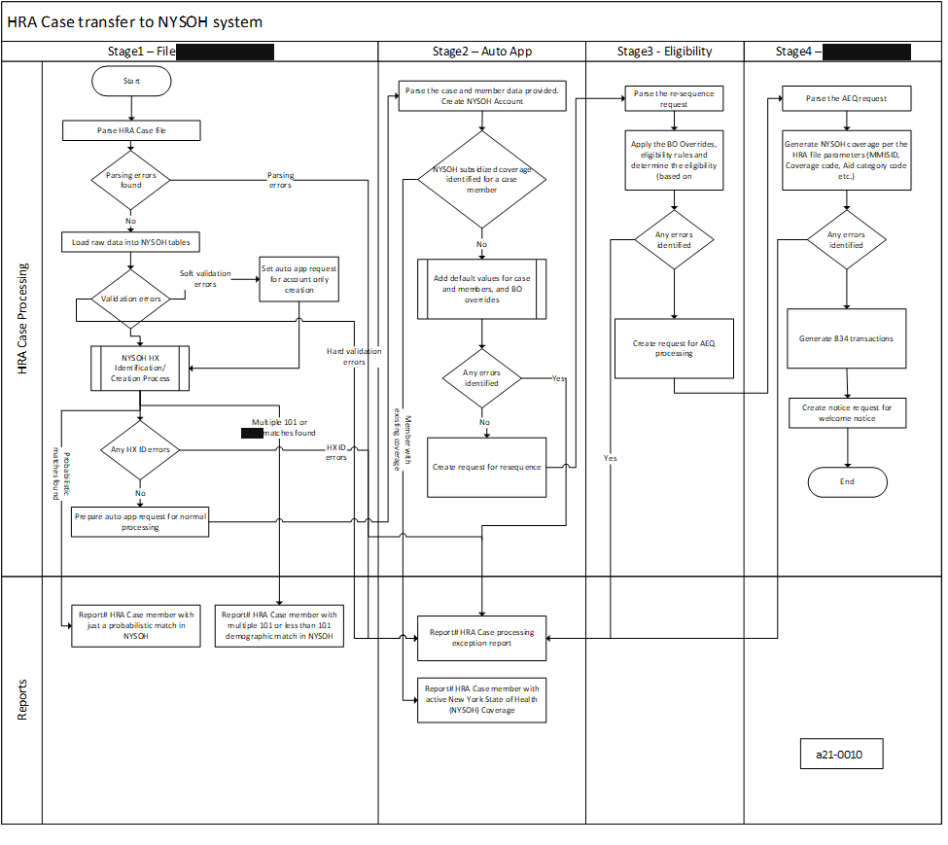
Figure 35. Complete HRA Case Transfer Process
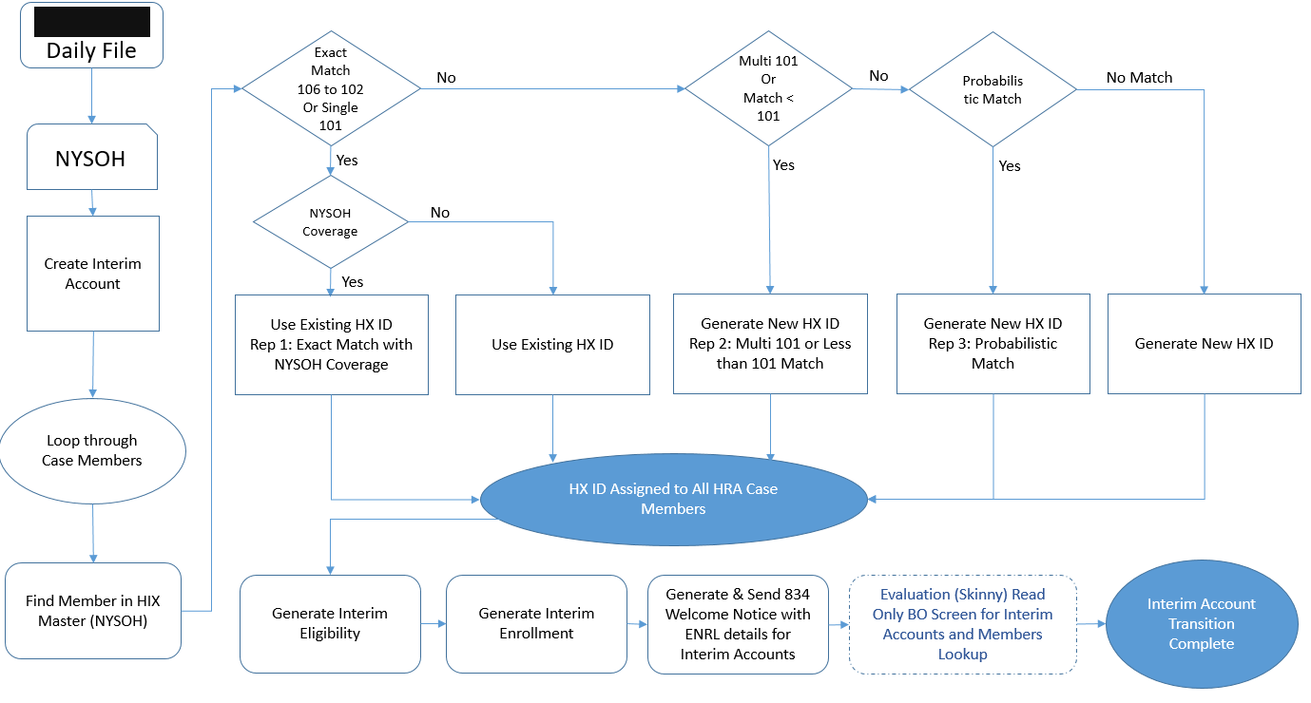
Figure 36. Complete HRA Process Flow

As part of stage 1 (HRA Loader and Process), system will begin the process of integrating HRA case/member information into NYSOH tables. This utility process will borrow the characteristics of existing paper application process. Following steps are done as part of this processing and are described in Table 211; Figure 35; and Figure 36.
- System will perform demographic search to find or create HX Number (NYSOH unique identifier). System will be using compressed/truncated name matching logic from CIN clearance process.
- Once all members are assigned a HX Identifier (existing or newly generated), system will assign a new AC# (NYSOH Account Identifier).
- System will then perform a coverage search in the NYSOH system. A case with at least one member having NYSOH coverage will be marked as “Pending” for policy review.
- System will create Skinny account (means only User Profile will be created) if HRA sends null as per the document attached.
- All the remaining cases (without NYSOH coverage) will be processed for next step – Adding default values.

As part of the stage 2 (Auto Application), the system will begin the process of integrating HRA case/member information into the NYSOH tables. This utility process will borrow the characteristics of the existing paper application process. The following steps are done as part of this process.
- The system will perform a demographic search to find or create an HX number (NYSOH unique identifier). The system will be using compressed/truncated name-matching logic for identifying HX.
- All members are assigned an HX identifier (existing or newly generated), and a new AC# (NYSOH Account Identifier) is assigned.
- The system will perform a coverage search in the NYSOH system. An HRA case with at least one member having NYSOH coverage will be marked as “Pending” for policy review.
- Any HRA case with soft validations will be marked for Account creation only (no member information or eligibility).
- All the remaining cases (without NYSOH coverage) will be processed for the next step: Adding default values.
- The system shall send the H1 RRE code for Health and Recovery Plans (HARP) enrollment to eMedNY via RRE Interface on the 1st of month that NYSOH coverage is initiated in eMedNY (following month after the HRA file is processed) for HARP eligible individuals on the NYC HRA Transfer Accounts File.

Category | Value
Description | HRA Migration Loader /HRACase Processor  HRA Loader job processes the file received from HRA and stores the file data in the Staging tables creating the HRA Case tables. Processor Fetches records from HRA_CASE_PROCESSING table, which are in “IN_PROGRESS” status and updates to appropriate status after process.
Mode of Operation | These jobs follow a pre-decided schedule. The schedule is decided by WMS, HRA and NYSOH.
Job Type | Batch interface
Systems | NYSOH
Inputs | HRAMigrationLoader ,HRACaseProcessingBatch
Outputs | Updates on HRACase tables
Frequency | On Demand
Processing (High-Level) | Job will fetch records which are in “IN_PROGRESS” status from HRA_CASE_PROCESSING table.  - System will perform demographic search to find or create HX Number (NYSOH unique identifier). System will be using compressed/truncated name matching logic from CIN clearance process.  - System will assign existing HIX for the members found in NYSOH (i.e. Match score 106- 101). For Multi101 or No Match or Probable Match (CL 99,98,97,95 and 87) or Probabilistic Match system will create new HIX.  - If member has active coverage in NYSOH the case will be marked as “Pending” for Policy review.  - System will create Skinny account (means only User Profile will be created) if HRA sends null as per the document attached.  - In case of reprocessing of case system will use the existing account and HIX (if generated/assigned else will create new HIX).  - System will call Autoapp rest service to send data for establishing Eligibility and Enrollment.  - Based on rest response system updates appropriate status (SUCCESS/PENDING/FAILED) in HRA_CASE_PROCESSING table.
Distribution of Outputs | This process does not have any distributable outputs.

Naming Convention and Location of Input and Output Files | Input Files:  [REDACTED]  NYCHRA.D.HRA.D.YYYYMMDDHHMMSS.######.TXT  [REDACTED]  Output Files:  [REDACTED]
Error handling (High-Level) | If the interface terminates abnormally because of a system exception (e.g., database is down), then NYSOH GDIT System Architecture team will fix issues related to the system exception, and, if applicable, restart the job and notify HRA System, and NYSDOH representative
Responsible Teams | - DOH Individual EE team  - NYSOH GDIT System Architecture team  - NYSOH GDIT Application Development team
Table 211: Individual Marketplace HRA Migration Loader/HRA Case Processor

NYSOH SMS Loader Job
Table 212 contains information about NYSOH SMS Loader Job.

Category | Value
Description | NYSOH SMS Loader Job  This batch Job is responsible to load cell phone numbers data of consumers for which DOH has requested NYSOH to send SMS communication. Batch Job reads data using a configurable SQL Query from GIT properties file processes it and inserts into SMS_SERVICE_REQ_RESP_DATA table.
Mode of Operation | This Batch Job is executed on demand basis when DOH requests NYSOH to send SMS communication to consumers.
Job Type | Batch interface
Systems | NYSOH  Job run script - SmsJobLoader.sh
Inputs | 1) Property “SmsLoaderJob.sql“ from properties file. This property holds SQL query to read consumers data from NYSOH Database based on the query criteria provided by DOH.  2) Property “Sms.templateType“ from properties file. This property hold template type value for the template that is to be used to send SMS.
Outputs | SMS_SERVICE_REQ_RESP_DATA  NYSOH_CELL_NUMBER_REPOSITORY
Frequency | On Demand
Processing (High-Level) | Insert SMS template data in SMS_TEMPLATE_MASTER table if data not already exists.  NYSOH SMS Loader Job high-level processing:  1) NYSOH SMS Loader Job reads the consumer data from NYSOH system using SQL query with property “SmsLoaderJob.sql” from properties file. It also reads the template data using the property “Sms.templateType” from properties file.  2) Data from Step 1 is consolidated into requests and validated for identifying DUPLICATE CELL PHONE NUMBERS, INVALID AREA CODES and INVALID CELL PHONE NUMBERS  3) Requests created from Step 2 are persisted into SMS_SERVICE_REQ_RESP_DATA with “INITIATED” status in SMS_SERVICE_STATUS_TEXT column.
Distribution of Outputs | This process does not have any distributable outputs.
Naming Convention and Location of Input and Output Files | N/A
Error handling (High-Level) | If the batch job terminates abnormally because of a system exception (e.g., database is down, invalid configuration), then NYSOH GDIT System Architecture team will fix issues related to the system exception and, if applicable, restart the job. Failures related to non-system exceptions will be corrected by the NYSOH GDIT Application Development team and the job restarted
Responsible Teams | - DOH/DOS team involved  - NYSOH GDIT System Architecture team  - NYSOH GDIT Application Development team
Table 212: NYSOH SMS Loader Job

NYSOH SMS Processor Job
Table 213 contains information about NYSOH SMS Processor Job.

Category | Value
Description | NYSOH SMS Processor Job  This batch Job is responsible to process SMS requests generated by NYSOH SMS Loader Job from SMS_SERVICE_REQ_RESP_DATA table. Batch Job reads data from SMS_SERVICE_REQ_RESP_DATA table and invokes Mule soft TWILIO endpoint to send SMS requests to TWILIO.
Mode of Operation | This Batch Job is executed on demand basis when DOH requests NYSOH to send SMS communication to consumers.
Job Type | Batch interface
Systems | NYSOH, TWILIO  Job run script - SmsJobProcessing.sh
Inputs | SMS_SERVICE_REQ_RESP_DATA
Outputs | SMS_SERVICE_REQ_RESP_DATA  Send SMS Requests to TWILIO via TWILIO Mule soft endpoint
Frequency | On Demand
Processing (High-Level) | NYSOH SMS Processor Job high-level processing:  1) NYSOH SMS Processor Job reads the records from SMS_SERVICE_REQ_RESP_DATA with “INITIATED” status in SMS_SERVICE_STATUS_TEXT column.  ( Note: Number of records to be picked up/requests to be sent out can be controlled using properties  SmsProcessingJob.processingLimitEnabled=true  SmsProcessingJob.numberOfRecordsToBeProcessed=  )  2) After reading data, it prepares SMS Request with cell phone number, Sms template and invokes Mule soft TWILIO endpoint.  3) It receives a synchronous response from Mule soft TWILIO endpoint indicating the status of request (e.g.- queued, accepted, error)  4) After receiving response, it updates the status in SMS_SERVICE_REQ_RESP_DATA as received in response.
Distribution of Outputs | This process does not have any distributable outputs.
Naming Convention and Location of Input and Output Files | N/A
Error handling (High-Level) | If the batch job terminates abnormally because of a system exception (e.g., database is down, invalid configuration, TWILIO interface down), then NYSOH GDIT System Architecture team will fix issues related to the system exception and, if applicable, restart the job. Failures related to non-system exceptions will be corrected by the NYSOH GDIT Application Development team and the job restarted
Responsible Teams | - DOH/DOS team involved  - NYSOH GDIT System Architecture team  - NYSOH GDIT Application Development team
Table 213: NYSOH SMS Processor Job

NYSOH SMS Inbound Job
Table 214 contains information about NYSOH SMS Inbound Job.

Category | Value
Description | NYSOH SMS Inbound Job  This batch Job is responsible to process WEBHOOK responses received from TWILIO. These are the SMS sent by the consumers. Batch reads WEBHOOK data from SMS_SERVICE_INBOUND_STAGING_DATA table process it and update NYSOH application table.
Mode of Operation | This Batch Job is scheduled to execute at 8 p.m. everyday
Job Type | Batch interface
Systems | NYSOH  Job run script - SmsJobInbound.sh
Inputs | SMS_SERVICE_INBOUND_STAGING_DATA
Outputs | Update SMS_SERVICE_INBOUND_STAGING_DATA table  Update PHONE_NUMBER_DTL ( if applicable )  Insert into EVT_EVENTS_TRANSACTION ( if applicable )
Frequency | Everyday @8 p.m.
Processing (High-Level)s | NYSOH SMS Inbound Job high-level processing:  1) NYSOH SMS Inbound Job reads the records from SMS_SERVICE_INBOUND_STAGING_DATA of type “WEBHOOK” with “INITIATED” status in TWILIO_REQUEST_PROCESSING_STATUS_TEXT column.  2) After picking up the records, batch parses the data, validates it and evaluates if further processing required.  3) If cell phone number is identified in NYSOH system, SMS Opt In/Out information is updated in NYSOH DB.  4) BO Event is also created if evaluated.
Distribution of Outputs | This process does not have any distributable outputs.
Naming Convention and Location of Input and Output Files | N/A
Error handling (High-Level) | If the batch job terminates abnormally because of a system exception (e.g., database is down, invalid configuration), then NYSOH GDIT System Architecture team will fix issues related to the system exception and, if applicable, restart the job. Failures related to non-system exceptions will be corrected by the NYSOH GDIT Application Development team and the job restarted
Responsible Teams | - DOH/DOS team involved  - NYSOH GDIT System Architecture team  - NYSOH GDIT Application Development team
Table 214: NYSOH SMS Inbound Job

Deceased Process Job
The System shall run the daily offline deceased process, described in Table 215, to re-determine eligibility for consumers with associated accounts upon expiration of deceased clock in primary account, and meeting the following criteria:
- Consumer is alive and has neither attested to being alive nor been overridden to alive (Living Indicator Override) since the last renewal.
- Consumer is applying for coverage
- Consumer can be either eligible, or be ineligible
- Consumer does NOT have an active deceased clock

The System shall run daily offline deceased process job to re-determine eligibility for consumers with associated accounts upon deceased (OTHER THAN deceased clock and can be from sources/user attested/BO Override) in primary account, and meeting the following criteria:
- Consumer is alive but if due to a valid BO Person Living Indicator Override or individual attestation, then the marking of deceased on the death matched account must have been due to a newer BO Person Living Indicator Override or individual attestation
- Consumer is applying for coverage
- Consumer can be either eligible or be ineligible

Category | Value
Description | Deceased Process Job
Mode of Operation | This is an automated job that will run on a batch. The schedule is defined in the NYSOH Production Job Schedule.
Job Type | Batch Job
Systems | DeceasedProcessJob.sh
Inputs | Deceased event process Table
Outputs | Inserts record into resequence table, deceased event process account and deceased event table.
Business Frequency | Everyday
Processing (High-Level) | If a member is found deceased in an account, this job pulls all accounts this member is associated with and marks this member as deceased in those accounts irrespective of their eligibility status.
Distribution of Outputs | Outputs are not distributed other than as described above.
Naming Convention and Location of Input and Output Files | The following are the programs with their associated input and output that are executed for this process:  DeceasedProcessJob.sh  - Input:  - Deceased event process Table  - Output  - Deceased event process account Table  - Resequence table  - Deceased event table
Error handling (High-Level) | If the interface terminates abnormally because of a system exception (e.g., database is down), then:  - NYSOH GDIT System Architecture team will fix issues related to the system exception, and, if applicable, restart the job.
Responsible Teams | - NYSOH GDIT System Architecture team  - NYSOH GDIT Application Development team
Table 215: Deceased Process Job

Medicare Periodic Data Matching (PVC)
Figure 37. PVC Service Process Flow (from PVC Service BSD)
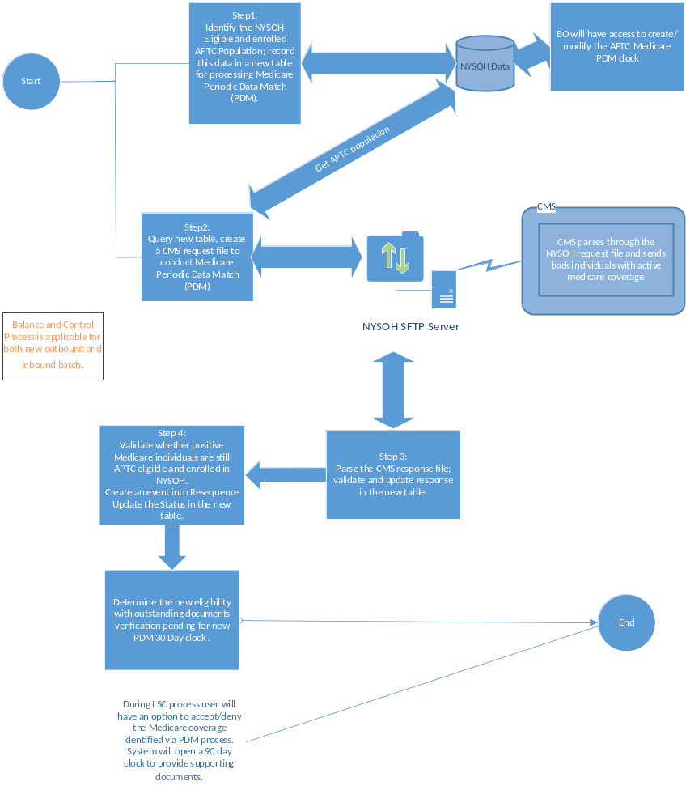
Figure 38. PVC High level flow for PVC – Medicare process

Figure 37 and Figure 38 present the workflow. Table 216 describes the process.

Category | Value
Description | FED HUB PVC Medicare Match  State-Based Exchanges are required to conduct Medicare Periodic Data Matching (PDM) at least once a year to determine whether enrollees in a Qualified Health Plan (QHP) with Advance Payment Tax Credit (APTC) or Cost Sharing Reductions (CSRs) have been determined eligible for or enrolled in other qualifying coverage
Mode of Operation | This is an automated job that will run on a batch. The schedule is defined in the NYSOH Production Job Schedule.
Job Type | Batch interface
Systems | MedicarePVCXMLGenerationJob.sh, MedicarePVCXMLConsolidationJob.sh and MedicarePVCResponseBatchJob.sh runs on NASPROD.
Inputs | MEDICARE_SERVICE_DATA table and PVC Medicare response file from FTP server
Outputs | PVC Medicare request files. Updates on MEDICARE_SERVICE_DATA and MEDICARE_SERVICE_INSURANCE_DATA tables
Frequency | MedicarePVCXMLGenerationJob.sh, MedicarePVCXMLConsolidationJob.sh will be executed when a PSR (Production Support Request) is created by Dev around the month of June or July every year. And MedicarePVCResponseBatchJob.sh runs once response files received from CMS.
Processing (High-Level) | The first step of this process the job polls the database for individuals who are falling in the specified criteria in NYSOH, inserts records in MEDICARE_SERVICE_DATA table, creates request files and sends it to CMS for Medicare Match.  The second step of this process; once NYSOH receives the response files from CMS, PVC Medicare response batch processes the response file and updates the records in MEDICARE_SERVICE_DATA and MEDICARE_SERVICE_INSURANCE_DATA, creates clock and creates events to generate notices.
Distribution of Outputs | This process does not have any distributable outputs.
Naming Convention and Location of Input and Output Files | All files have a path as follows:  \\the production file share\the production file share\batch_jobs  The following are the programs with their associated input and output that are executed for this process:  Input file format:  - [REDACTED] (Extracted an unsupported link: [REDACTED])\ FEP0126NY.DSH.PVC1.DYYMMDD.T014853008.P.IN  Output file format:  - [REDACTED] FEP0126NY.PVC4.DYYMMDD.T012044301.P.OUT
Error handling (High-Level) | If the interface terminates abnormally because of a system exception (e.g., database is down), then NYSOH GDIT System Architecture team will fix issues related to the system exception and, if applicable, restart the job.
Responsible Teams | - DOH Individual EE team  - NYSOH GDIT System Architecture team  - NYSOH GDIT Application Development team
Table 216: PVC Medicare Match

Individual Marketplace Diagnostic and Problem Handling Procedures
Table 217 describes the diagnostic and error handling procedures.

Category | Value
Scope | - Error handling for input/output jobs.  - System performance monitoring.  - Security vulnerability monitoring.  - GDIT performs automated vulnerability scanning on the NYSOH system at least monthly. Scanning is performed by the contractor cybersecurity team using a Nessus scanner or by GDIT MST using McAfee NIPS. Vulnerabilities identified during scans are reviewed and categorized as “Critical”, “High”, “Medium”, “Low”, and “Informational”. “Critical” and “High” vulnerabilities are scheduled for remediation ASAP. Remediation is usually achieved through deployment of a software patch or an update. “Medium” vulnerabilities get the next priority, and “Low” or “Informational” vulnerabilities are addressed as resources allow.  - Scans performed by the GDIT MST team use credentials that allow the scanner to log into systems in order to check their patch status. Systems found to be missing patches are reported to the contractor infrastructure support team for remediation. contractor infrastructure support and contractor cybersecurity jointly determine whether the regular patching cycle should be used for remediation or whether an out-of-cycle patch deployment is needed.  - For database and application level patch deficiencies, reports are generated and sent to the NYSOH GDIT Application Development team for remediation. The NYSOH GDIT Application Development team analyzes the reports and determines an approach and schedule for remediation. Remediation results will be verified during the next scan.
Supporting software tools | - Error handling for input/output jobs.  - System performance monitoring.  - Supporting software tools related to system performance monitoring are included in the list of licensed production software contained in the NYSOH Hardware, Software, and Supplies Inventory folder.  - Security vulnerability monitoring.  - Nessus scanner.  - McAfee NIPS.
Responsible Teams | - Error handling for input/output jobs.  - NYSOH GDIT Application Development team.  - System performance monitoring.  - For teams responsible for system performance monitoring, please refer to “Responsible Teams”.  - NYSOH GDIT System Architecture team.  - Security vulnerability monitoring.  - contractor cybersecurity.  - GDIT MST.  - contractor infrastructure competency teams.  - NYSOH GDIT Application Development team.  - NYSOH GDIT System Architecture team.
Reference Documents | - Error handling for input/output jobs.  - No reference documents are available.  - System performance monitoring.  - For teams responsible for system performance monitoring, please refer to “Responsible Teams”.  - Security vulnerability monitoring.  - NYSOH Security Policy Handbook- Risk Assessment  - NYSOH Security Procedure & Guideline Handbook
Table 217: Individual Marketplace Service Diagnostic and Problem Handling Procedures

Individual Marketplace Restart/Recovery Procedures
Table 218 describes procedures for restart/recovery in the event of a system failure, including automated restart and recovery procedures.

Category | Value
Scope of Automated Restart/Recovery | Some system components are implemented using redundant architecture.  - Virtual server redundancy. Some virtual servers have the capability to automatically move across physical devices. As a result, if a physical device used by an applicable virtual server goes down, the virtual server will automatically move to a different physical device.  - Network redundancy. Some applications on Linux and AIX operating systems have been network load balanced.  - Database redundancy. A DB2 database runs in a multi-node environment. The data is synchronously replicated between two nodes within RDC and asynchronously replicated to the DR environment. If one of the nodes at RDC goes down, the unaffected node at the RDC will automatically take over the database processing initiated after the failure.  - Application redundancy. IBM JBOSS EAP Server and JBOSS Web Server applications run in multi-node environments. If a node at RDC that supports one of these applications goes down, the unaffected corresponding node at RDC will automatically take over the application processing initiated after the failure.
Scope of Manual Restart/Recovery | Some system components are implemented using a non-redundant architecture. These components will need to be restarted manually. GDIT technical support team uses GDIT’s Service Now to coordinate and track manual restart / recovery activities.
Responsible Team | - contractor infrastructure support team  - GDIT RDC Mid-Range team  - contractor network support team  - NYSOH GDIT Application Development team  - NYSOH Program Management team  - NYSOH Security Team  - NYSOH Operations Team  - NYSOH Middleware Team
Reference Documents | Business Continuity and Disaster Recovery Plan
Table 218: Individual Marketplace Restart/Recovery Procedures

Financial Management Operations
This section contains the Financial Management Operations Procedures as defined for the NYSOH system.

Note: FM will continue to operate the General Ledger (GL) module and the associated manual Interface (26) to “NYS SFS” post May 2020. The information and figures throughout the document are updated with the current FMS operations.

FM Diagnostic and Problem Handling Procedures
Table 219 contains the diagnostic and error handling procedures for the Financial Management System PeopleSoft Application Development Team.

Category | Value
Scope | - Error handling for input/output jobs.  - System performance monitoring.  - Security vulnerability monitoring.  - GDIT performs automated vulnerability scanning on the NYSOH system at least monthly. Scanning is performed by the contractor cybersecurity team using a Nessus scanner or by GDIT MST using McAfee NIPS. Vulnerabilities identified during scans are reviewed and categorized as “Critical”, “High”, “Medium”, “Low” and “Informational”. “Critical” and “High” vulnerabilities are scheduled for remediation ASAP. Remediation is usually achieved through deployment of a software patch or an update. “Medium” vulnerabilities get the next priority, and “Low” or “Informational” vulnerabilities are addressed as resources allow.  - Scans performed by the GDIT MST team use credentials that allow the scanner to log into systems in order to check their patch status. Systems found to be missing patches are reported to the contractor infrastructure support team for remediation. contractor infrastructure support and contractor cybersecurity jointly determine whether the regular patching cycle should be used for remediation or whether an out-of-cycle patch deployment is needed.  - For database and application level patch deficiencies, reports are generated and sent to the NYSOH GDIT Application Development team for remediation. The NYSOH GDIT Application Development team analyzes the reports and determines an approach and schedule for remediation. Remediation results will be verified during the next scan.
Supporting software tools | - Error handling for input/output jobs.  - PeopleSoft Process Scheduler errors  - Application built in error checking  - PeopleSoft tracing tools  - Test editors to examine file records System performance monitoring.  - Security vulnerability monitoring.  - Nessus scanner.  - McAfee NIPS.
Responsible Teams | - Error handling for input/output jobs.  - NYSOH GDIT PeopleSoft Application Development Team  - NYSOH GDIT System Architecture Team  - System performance monitoring.  - For teams responsible for system performance monitoring, please refer to “Responsible Teams”.  - Security vulnerability monitoring.  - NYSOH contractor cybersecurity  - GDIT MST  - contractor infrastructure competency teams  - NYSOH GDIT PeopleSoft Application Development team  - NYSOH GDIT System Architecture team
Reference Documents | - Error handling for input/output jobs.  - No reference documents are available.  - System performance monitoring.  - Security vulnerability monitoring. The following document was either directly referenced for this section of the manual or provides context regarding the contents of this section.  - NYSOH Security Policy Handbook- Risk Assessment.  - NYSOH Security Procedure & Guideline Handbook
Table 219: Diagnostic and Problem Handling Procedures for FMS

FM Restart/Recovery Procedures
The following section describes procedures for restart/recovery in the event of a system failure, including automated restart and recovery procedures.

Table 220 contains FM Restart and Recovery Procedures.

Category | Value
Scope of Automated Restart/Recovery | Some system components are implemented using redundant architecture.  - Virtual server redundancy. Some virtual servers have the capability to automatically move across physical devices. As a result, if a physical device used by an applicable virtual server goes down, the virtual server will automatically move to a different physical device.  - Network redundancy. Applications on AIX operating systems have been network load balanced.  - Database redundancy. An Oracle database runs in a multi-node environment. The data is synchronously replicated between two nodes within RDC and asynchronously replicated to the DR environment. If one of the nodes at RDC goes down, the unaffected node at the RDC will automatically take over the database processing initiated after the failure.  - Application redundancy. IBM JBOSS EAP Server and JBOSS Web Server applications run in multi-node environments. If a node at RDC that supports one of these applications goes down, the unaffected corresponding node at RDC will automatically take over the application processing initiated after the failure.
Scope of Manual Restart/Recovery | Some system components are implemented using a non-redundant architecture. These components will need to be restarted manually.  Examples of such components are:  - DataStage software tool  - Certain virtual servers  NYSOH GDIT PeopleSoft Application Development team uses GDIT’s Service Now to coordinate and track manual restart / recovery activities.
Responsible Team | - contractor infrastructure support team  - GDIT RDC Mid-Range team  - contractor network support team  - NYSOH GDIT PeopleSoft Application Development team  - NYSOH Program Management team  - DOH Financial Management team
Reference Documents | Business Continuity and Disaster Recovery Plan
Table 220: FM Restart and Recovery Procedures

NYSOH Interfaces
The NYSOH platform has several interfaces that provide inbound and outbound services. Each Interface has an associated Memorandum of Understanding (MOU) and an Interface Control Document (ICD). These agreements with State and Federal agencies are reviewed annually. During the review, appropriate updates are made to reflect any requirements changed by current State and/or Federal law as well as any which have matured over the course of the current year. This section provides details of the interfaces used during the course of normal business operations.

NYSOH is required to validate information entered by NYSOH users. Data is needed from Federal Agencies to support Individual Marketplace Operations (Eligibility and Enrollment) and Small Business Marketplace Operations (SHOP) functionality.

Initial and ongoing requirements can be found in the Requirements Specification Documents (RSD).

NYSOH State Agency Interfaces
Table 221 lists the Table of NYS Agency Interfaces.

Acronym | Full Name
NAIC SERFF | National Association of Insurance Commissioners – System for Electronic Rate and Form Filing
NYC HRA (DOH) | New York City Human Resources Administration
NYS DFS | New York State Department of Financial Services
NYS DOCCS | New York State Department of Corrections and Community Supervision
NYS DOH | New York State Department of Health
NYS DOL | New York State Department of Labor
NYS DTF | New York State Department of Tax and Finance
NYS DOH eMedNY | New York State Department of Health
NYS DOH KIDS | New York State Department of Health Child Health Plus
NYS OTDA (DOH) | New York State Department of Health Office of Temporary and Disability Assistance
NYSITS | New York State Office of Information Technology Services
NYSHIP | New York State Health Insurance Program
NYSDMV | New York State Department of Motor Vehicles
NYSDEMI | New York State Division of Eligibility and Marketplace Integration
NYS Translation Vendor | New York State Translation Vendor
Table 221: Table of NYS Agency Interfaces

Federal Interfaces
NYSOH has interaction with the Federal Services hub which will provide various kinds of data and validations for the NYSOH system. NYSOH utilizes and validates the information supplied by the Individual / SHOP applications with the related Federal Agencies at many different levels (see Table 222).

Business Partner | Description | Responsibility | ICD Applicable | ICD Available | Remark
Federal Hub | (H1) - Identity Proofing  Experian questions / validation | Common Services | No | No | BSD
Federal Hub | (RJ3) - SSA Composite  Verify SSN, Citizenship, Incarceration, Title II Benefits, Quarters of Coverage | Common Services | No | No | BSD
Federal Hub | (RJ9) - Verify Household Income | Common Services | No | No | BSD
Federal Hub | (RJ19.2T) - Advance Payment Computation  Maximum APTC allowed | Common Services | No | No | BSD
Federal Hub | (RJ31) - Verify non-ESI MEC  Verify Medicaid, CHIP, BHP, Medicare, VHA, Tricare, Peace Corps | Common Services | No | No | BSD
Federal Hub | EDI 834 to CMS, 999 from CMS. Changes, Enrollment (Indiv, SHOP), Disenrollment. | Enrollment/SHOP | No | No | Companion Guide / BSD
Federal Hub | EDI 834 to CMS, 999 from CMS  Monthly Reconciliation | Enrollment/SHOP | No | No | Companion Guide / BSD
Federal Hub | EDI 834 from CMS, EDI TA1 to CMS Reconciliation / Disenrollment | Enrollment | No | No
Federal Hub | (H36) - Monthly 1095 Report to IRS | Common Services | No | No | BSD
Federal Hub | Shop EPD - Monthly Report to IRS | Common Services | No | No | BSD
Federal Hub | (H43) Periodic Verification Medicare/Death Confirmation | Common Services | No | No | BSD
Federal Hub | (H41) - Annual 1095 Report to IRS | Common Services | No | No | BSD
Federal Hub | (RX142.1)VLP InitialVerificationv37.1 | Common Services | No | No | BSD
Federal Hub | (RX142.2)VLP InitiateAdditionalVerifv37.1 | Common Services | No | No | BSD
Federal Hub | (RX142.3)VLP InitiateThirdVerifv37.1(Step3) | Common Services | No | No | BSD
Federal Hub | (RX142.4) VLP Close Case v37.1 | Common Services | No | No | BSD
Federal Hub | (RX142.5) VLP Get Case Details v37.1 | Common Services | No | No | BSD
Federal Hub | (RX142.6) VLP Retrieve Step 2 Case Resolution v37.1 (Step 2)(State-Hosted Callback Service) | Common Services | No | No | BSD
Federal Hub | (RX142.7)VLP Retrieve Step 3 Case ResolutionV37.1 (Step 3)(State-Hosted Callback Service) | Common Services | No | No | BSD
CMS (Federal Data Services Hub) – Remote Identity Proofing and Fraud Archive Reporting Service | (RJ139)Remote Identity Proofing and Fraud Archive Reporting Service | EE | Yes | Yes | Available to authorized personnel
Table 222: Federal Interfaces

BSOC Interfaces
Table 223 lists the BSOC Interfaces.

Business Partner | Description | Responsibility | ICD Applicable | ICD Available | Remark
BSOC | Notices - Post Script file | Common Services | Yes | No
BSOC | Notices - Addr Check & PostNet | Common Services | Yes | No
Table 223: BSOC Interfaces

Issuer Interfaces
Table 224 lists the Issuer Interfaces.

Business Partner | Description | Responsibility | ICD Applicable | ICD Available | Remark
Issuer | Enrollment  EDI 834 to Issuer 1, 999 from Issuer 1 | Enrollment | No | No | Companion Guide
Issuer | Effectuation/Confirmation  EDI 834 from Issuer 1 and 999 to Issuer 1 | Enrollment | No | No | Companion Guide
Issuer | Reconciliation  EDI 834 to Issuer 1 and 999 from Issuer 1 | Enrollment | No | No | Companion Guide
Issuer | Non Payment Termination  EDI 834 from Issuer 1 and 999 to Issuer 1 | Enrollment | No | No | Companion Guide/Supplemental Guide
Issuer | Reinstatement  EDI 834 from Issuer 1 and 999 to Issuer 1 | Enrollment | No | No | Companion Guide/Supplemental Guide
Issuer | Employer data - Group Setup File | Common Services | Yes | Yes | Configuration management repository – supplemental interface documents
Table 224: Issuer Interfaces

MAXIMUS Interfaces
Table 225 lists the MAXIMUS Interfaces. Prior versions of interface documents can be found using the change sets associated with the links.

Business Partner | Description | Responsibility | ICD Applicable | ICD Available | Remark
MAXIMUS | Customer Service Master | Back Office | Yes | Yes | Available to authorized personnel
MAXIMUS | IVR Current Contact Data | Back Office | Yes | Yes | Available to authorized personnel
MAXIMUS | Contact Search Member Identification | Back Office | Yes | Yes | Available to authorized personnel
MAXIMUS | Proximal Search Document Association | Back Office | Yes | Yes | Available to authorized personnel
MAXIMUS | Appeals - Workflow trigger | Back Office | Yes | Yes | Available to authorized personnel
MAXIMUS | Paper Process File Transfer | Back Office | Yes | Yes | Available to authorized personnel  App_v_8_05_2013.docx (available to authorized personnel)
MAXIMUS | Eligibility Referral to LDSS - Upstate | Eligibility | Yes | Yes | FDD_Referrals_to_LDSS.pdf (available to authorized personnel)
Table 225: MAXIMUS Interfaces

State Agency Interfaces
Table 226 lists the State Agency Interfaces. Prior versions of interface documents can be found using the change sets associated with the links.

Business Partner | Description | Responsibility | ICD Applicable | ICD Available | Remark
NYS DMV | Department of Motor Vehicles (DMV) | Common Services | Yes | Yes | Available to authorized personnel
NYS DFS | Receive Broker data | Common Services | Yes | Yes | Available to authorized personnel
NYS DFS | Send Broker Certification data | Common Services | Yes | Yes | Available to authorized personnel
NYS DFS | Broker Validate Certificate | Common Services | Yes | Yes | Available to authorized personnel
NYS DOCCS | Incarceration Data | Common Services | Yes | Yes | Available to authorized personnel
NYS DOH | Plan Quality Data - QARR | PM | No | No
NYS DOH | Unpaid Employer Premiums | SHOP | No | No
NYS DOH | KIDS - CHP Public MEC | Common Services | Yes | Yes | Available to authorized personnel
NYS DOH | CHIP & MMC Plans (SERFF Templates) | PM | No | Yes | Available to authorized personnel  Available to authorized personnel
NYS DOH | eMedNY - Public MEC | Common Services | Yes | Yes | Available to authorized personnel
NYS DOH | eMedNY - EDI 834 to eMedNY - Enrollment 999 from eMedNY | Enrollment | No | No | Companion Guide
NYS DOH | eMedNY - TPL / RRE | Common Services | Yes | Yes | Pull - Available to authorized personnel  Push - Available to authorized personnel
NYS DOH | eMedNY - Effectuation 834 | Enrollment | No | No | Companion Guide
NYS DOH | KIDS-CHP transition, Premiums, Maint | Enrollment | Yes | Yes | Available to authorized personnel
NYS DOL | Unemployment Insurance | Common Services | Yes | Yes | Available to authorized personnel
NYS DTF | EIN Validation | Common Services | Yes | Yes | Available to authorized personnel
NYS DTF | Wage Reporting | Common Services | Yes | Yes | Available to authorized personnel
NYS OTDA | CIN Assignment (Spawn) | Common Services | Yes | Yes | Available to authorized personnel
NYS OTDA | WMS Dn Clearance | Common Services | Yes | Yes | Available to authorized personnel
NYS OTDA | WMS Up Clearance | Common Services | Yes | Yes | Available to authorized personnel
NYS OTDA | Data Extract to OTDA for PARIS | Architecture Team | Yes | Yes | Available to authorized personnel
NYS OTDA | WMS CBIC | Common Services | Yes | Yes | Available to authorized personnel
NYS OTDA | Newborn Processing | Common Services | Yes | Yes | Available to authorized personnel
NYS OTDA | Transfer Enrollee to/from WMS | Common Services | Yes | Yes | Available to authorized personnel
NYS OTDA | PARIS Return Data Process | Common Services | Yes | Yes | Available to authorized personnel
NYS OTDA | OTDA SNAP Data | Common Services | Yes | Yes | ICD NYSOH OTDA SNAP Data_R43.docx - Change and Configuration Management (emedny.org)
NYS | NY.GOVID | Architecture Team | Yes | No | Available to authorized personnel
NYS WMS | Transition WMS Individuals into NYSOH | Common Services | Yes | Yes | Available to authorized personnel
NYS HRA | Transition HRA Individuals into NYSOH | Common Services | No | No | Due to the expedited nature of the CR2010 information was captured in RSD itself
NYS HRA | LDSS Referral file to Downstate WMS | Common Services | Yes | Yes | Available to authorized personnel
NYS DOH | NYSHIP Data File to NYSOH | Common Services | Yes | Yes | Available to authorized personnel
NYS ITS | Organ Donor extract from NYSOH to ITS. | Common Services | Yes | Yes | Available to authorized personnel
eMedNY- HARP | eMedNY- HARP | Common Services | Yes | Yes | Available to authorized personnel
eMedNY | 1095B Meta Data Transfer and API | Common Services / DataStage | Yes | Yes | Available to authorized personnel
Table 226: State Agency Interfaces

Other Interfaces
Table 227 lists Other Interfaces.

Business Partner | Description | Responsibility | ICD Applicable | ICD Available
Melissa (Vendor) | Melissa | Verify Addresses | Common Services | Yes | Available to authorized personnel
Twillio(Vendor) | SMS | Common Services | Yes | Available to authorized personnel
SendGrid(Vendor) | Email | Common Services | Yes | Available to authorized personnel
iPRO | PNDS – Provider Network Data | Common Services | Yes | Available to authorized personnel
Table 227: Other Interfaces

Encounters Interfaces
The following documents provide information about these interfaces:
- EIS Interface Control Document for MDW Medicaid Data Warehouse
- EIS Interface Control Document for OHIP Office of Health Insurance Programs

Alternative Format Notice Interfaces
Table 228 provides the Alternative Format Notice Interface.

Business Partner | Description | Responsibility | ICD Applicable | ICD Available | Remark
T base | Alternate Format Notices Generation | Common Services | Yes | Yes
Table 228: Alternative Format Notices Interface

Interface Security
Transmission of all web services will be secured using Transport Layer Security (TLS) encryption. File transmissions will use SFTP. Security certificates will be managed and applied by the Enterprise Service Gateway (ESG). All testing will utilize self-signed certificates. Production operations utilize certificates obtained from VeriSign.

Overall Interface data flow
Figure 39 represents the NYSOH System Business Context.

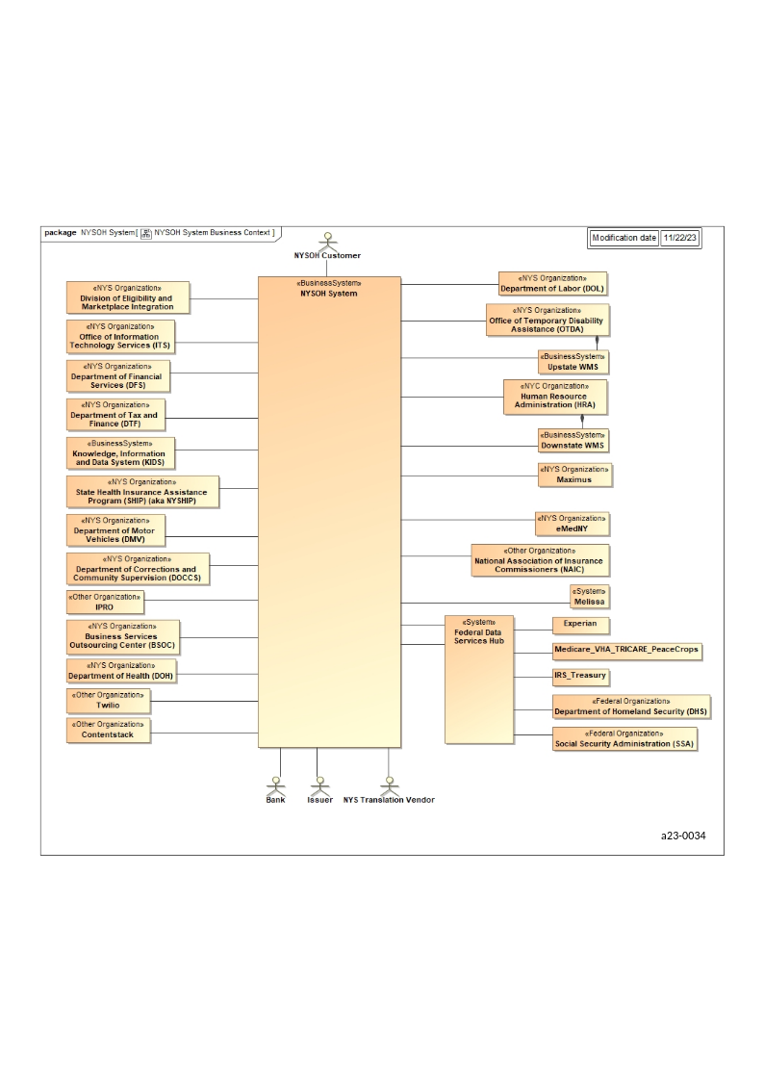
Figure 39. NYSOH System Business Context

Outbound FPS File workflow
Figure 40 represents the Outbound Interface FPS File Workflow.

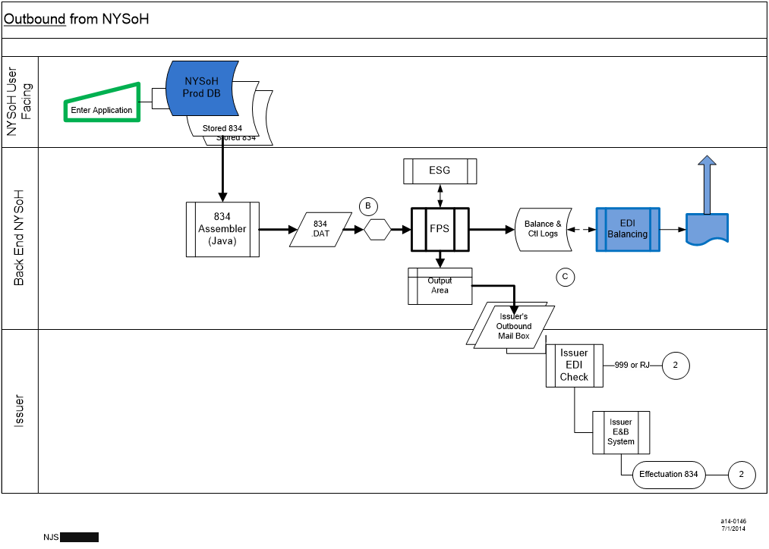
Figure 40. Outbound from NYSoH

Inbound FPS File workflow
Figure 41 represents the Inbound FPS Interface File Workflow.

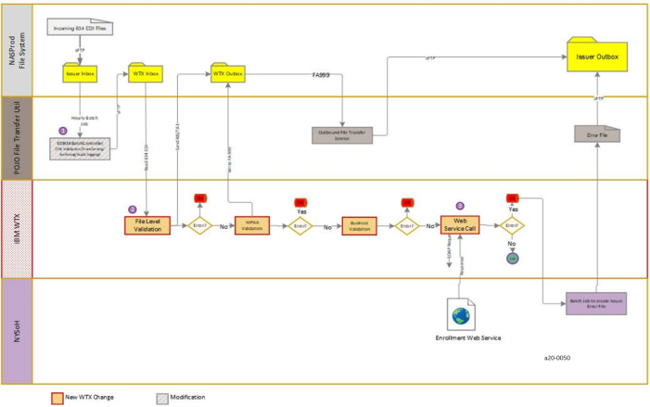
Figure 41. Inbound Interface File Workflow

Special Processes

eMedNY
Generally, NYSOH produces 834s for consumption by eMedNY and delivers daily by 7:00 a.m. to eMedNY's pick-up location. eMedNY transmits a request every hour for an 834 emergency Fee For Service (FFS) enrollment. If an 834 Emergency FFS Enrollment File is transmitted to eMedNY, the emergency FFS enrollments are processed on the following half-hour. All other enrollment types are processed daily at 7:00 p.m. Refer to Table 229 for the transactions for these Special Processes.

Transaction | Entity | Transmission / Processing Frequency | Transmission / Processing Time
834 enrollment transactions for eMedNY | NYSOH | Daily | Early Morning (usually completing by approximately 7:00 a.m.)
*834 'emergency' FFS enrollments from NYSOH¹ | eMedNY | Hourly | *Picked up on the hour, processed on the half-hour
*834 non-emergency FFS, MC, CHP, or EP enrollments from NYSOH | eMedNY | Hourly / Daily | *Picked up on the hour, processed daily at 7:00 p.m.
Table 229: Special Processes
¹Because the vast majority of Fee-For-Service enrollments are either current date or back-dated, virtually all Fee-For-Service enrollments are considered 'emergency'.

Oversight Reporting Platform
Oversight is the business area that maintains the reporting systems required by all NYSOH (Marketplace) tracks; Individual Marketplace, Small Business Marketplace, Plan Management, and Customer Service.

Oversight is responsible for the Marketplace reporting function, which is divided into three primary areas:

- Federal Reporting Requirements – Production and Post-Production;
Those reports required by CMS to be reported by each State Based Marketplace nationwide
- State Reporting Requirements – Production and Post-Production;
Those reports required by NYS to be reported by the NYSOH Marketplace
- Ad hoc Reporting Functionality
Ad hoc reporting functionality will include the production and access of pre-run and canned reports. Reports will be run from either from the Reporting Database (RPT) or the Production environment and loaded to the Cognos Portal.
All documents associated with Oversight and reporting can be found within the Oversight Team area of the program's controlled document repository.

Federal Requirements for Reporting to CMS
Center for Consumer Information and Insurance Oversight (CCIIO) required submission of Marketplace data (called the “SBM Data Submission”) beginning in January 2014. States may elected to submit this data to CCIIO using the Centers for Medicare & Medicaid Services (CMS) Enterprise File Transfer (EFT) system in Extensible Markup Language (XML), Tab Separated Values (TSV), or Excel (XLSX) spreadsheet format. States are required to provide quarterly submissions containing the data relating to the preceding three months of SBM activity. States are required to provide data within 30 days subsequent to the end of the reporting period. States may also submit amended data quarterly to correct errors from a previous submission.

Timeline for SBM Data Submissions
Reports are those that have been identified by CMS as project requirements and include SBM data report submissions which are reported every quarter as outlined in Table 230.

Submission # | Reporting Period | Submission Period
1 | October 1 – December 31 | January 1 – January 31
2 | January 1 – March 31 | April 1 – April 30
3 | April 1 – June 30 | July 1 – July 31
4 | July 1 – September 30 | October 1 – October 31
Table 230: Timeline for SBM Data Submissions

Key Interactions Required
Table 231 outlines key services in support of the reporting requirements as well as key resources to provide information included in the reports.

Category | Description
Interactions and data needs | Oversight requires Plan data from the Plan Management (PM) team; enrollment and eligibility data from EE; Employer and Employee enrollment and eligibility data from SHOP and CS related data from Customer Service.
Users interacting with the Oversight area of the NYSOH system | - GDIT testers  - Oversight team – GDIT/DOH  - State NYSOH leadership  - Independent Verification and Validation (IV&V) testers  - NYSOH Marketplace DOH staff
Record Management | Data will reside on the GDIT Marketplace Development, User Acceptance Testing (UAT), and System Integration Testing (SIT) environments until such time as the product is deployed to production.  Data will reside on Operational Data Base (ODB) until appropriate tables are copied onto the RPT
Master files | All the MQT queries are stored in the configuration management repository under the Oversight stream
Retention | Generally reporting data will be refreshed and replaced each night.  Reports will reside on the Cognos portal until such time as they are deleted/purged in accordance with the schedule established by DOH. Most of reports and 1095 A DB will be stored as backup for 10 years. Only last 12 months’ information will be available online.  A copy of the 1095 reporting database for will be stored for ten years, in accordance with our data retention guidelines.
Table 231: Key Interactions Required

Oversight Record and Retention Management
Table 232 below outlines the record retention requirements for all reporting and associated data.

Category | Description
Record Management | - Cognos Reports – There is no retention requirement identified yet. All reports are available online until asked by DOH to archive it.  - 1095 A data will be stored as backup using Database management process. It will be stored 10 years.  - The monthly and yearly XMLs are archived on the file system on the production file share as per the file retention rules.  - CMS Quarterly metrics data are backed up and stored for 10 years as part of data management process.  - Any other reports which are delivered through file transfers are stored on file system as per file management rules.
Master files | The Report Design database mapping document links report design specifications to the database elements with the aid of transformation rules/assumptions.  This document is maintained in the program's controlled document repository.
Retention | Reporting data will be refreshed and replaced each night.  Reports will reside on the Cognos portal until such time as they are deleted/purged in accordance with the schedule established by DOH.  A copy of the RPT will be made quarterly for use in CMS reporting. At any given time, two quarters will remain in storage. A copy of the 1095 reporting database for will be stored, in accordance with our data retention guidelines, for ten years.
Table 232: Oversight Record and Retention Management

Oversight Work Context
In Figure 42, all data flows to the Marketplace, which in context of Oversight reporting, represents the Production database (ODB). The applicable tables from the ODB are copied after midnight each night onto the RPT for reporting on the day’s activities. Reports out of Cognos contain data that is 24 hours old.

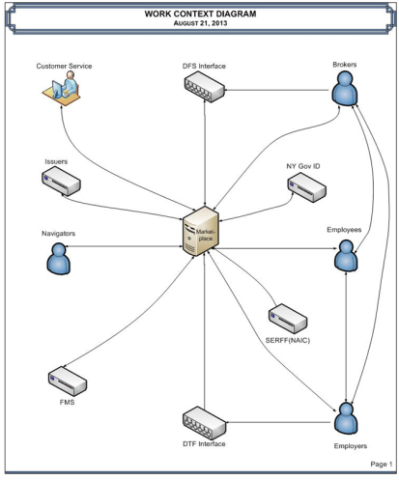
Figure 42. Work Content Diagram

Oversight Workflow
Figure 43 shows the scope and functional workflow encompassed by this document and includes the general flow for all pre-defined reports.

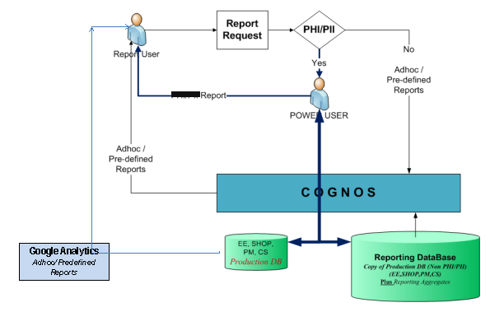
Figure 43. Oversight Workflow

End-to-End Oversight Reporting Architecture
Figure 44 depicts the functions in the end-to-end Oversight Reporting Architecture.

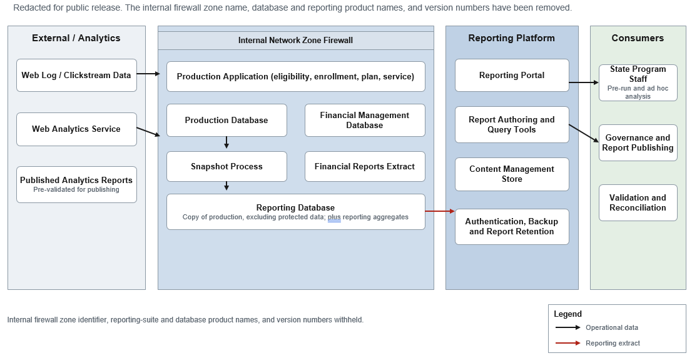
Figure 44. Oversight Reporting Architecture

Key Oversight Processes
Table 233 displays information regarding the key oversight processes.

Category | Value
Description | Oversight Reporting Process Workflow – Pre-defined  - Nightly, all applicable files from the ODB, less PHI and PII, are copied into the Cognos RPT.  - The user accesses the applicable folder within Cognos and chooses a report.  - If the report is a pre-run report containing no PII/PHI, the users access the Cognos database.  - The reports are run / accessed and may be saved onto a desktop or emailed to another source.  - Users requiring reports containing PHI and/or PII need to submit a report request to a Power User / Reports Administrator for review and evaluation.  - Reports will be stored indefinitely until such time as DOH develops a purge/delete process.  CMS Quarterly Reports  - At end of quarter all applicable files from the CDB, less PHI and PII, are copied onto the reporting database.  - Developers run queries off the database and results are delivered to a tab-Separated Value (TSV) file.  - TSV file is transferred electronically to NYSDOH for further enhancements and delivery to CMS.  - Reporting database will be stored for two quarters and then overwritten.
Development and delivery of reports operational process | - All reports require a Reports Specification Document which details the requirements for reporting, the layout of the report, and the business rules governing the report.  - That design is used in the coding of the report; mapping the desired data to the database column containing that data.  - The report is reviewed and analyzed to determine whether it is available through the RPT (NYHBERPT) or directly off of ODB (NYHBEODB - all reports containing PHI/PII).  - Reports run off NYHBEODB will be built and delivered by a power user who has access to both the RPT and ODB.  - Reports requesting PHI/PII will have to be further evaluated to assess impact on the ODB (i.e., scheduling).  - The reports are unit tested, and then loaded to the Cognos Portal Report Studio for access by NYSDOH Reports Admin.  - Should the Cognos database be unavailable for over 24 hours, “Plan B” is instituted whereby reports are run directly from Production using the same report queries developed for use by Cognos. The reports, run from the ODB are delivered to the DOH via email with the encrypted report file attached.
Google Analytics Workflow | A tracking code (Java Server Pages (JSP)) is embedded in each NYSOH webpage. Google Analytics will recognize the tracking code and collect the data associated with that particular page in real time. The data will be available for manipulation by the Google Analytics management reports. Users can log into Google Analytics to view Standard Reports at will, or reports can be scheduled to be emailed to users.
Internal Daily Reporting | Each morning (Monday through Friday) Oversight sends out the “NYSOH Daily Statistics <<Date - Time>>.xlsx” via email to a predefined list of people.  The email will contain the report and the subject line will read as follows “NYSOH***Covered Under Privilege***”  Sample Report Format  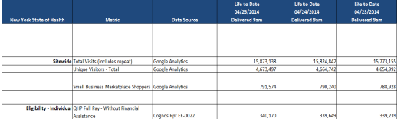
Weekly System reporting to NYSDOH | Each week (representing the previous Sunday to Saturday) a “Planned vs. Unplanned Outage” report will be submitted to NYSDOH Oversight manager by 12:00pm on Mondays. This report contains any specific outages including date, time, total elapsed time and reason.  The report will be generated by GDIT PMO based on information received from the Operations Manager. Once completed, the report will be submitted to the Chief Enterprise Architect for review and approval.  Once approved, the report will be sent to the NYSDOH Oversight manager.  Sample Report format  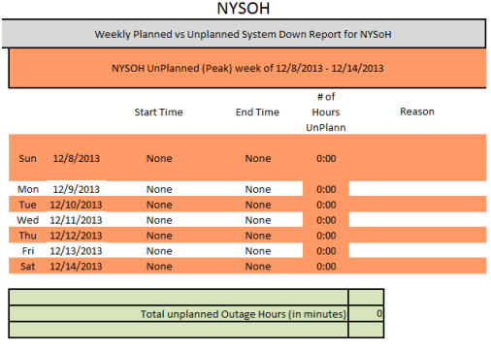
Table 233: Oversight Key Processes

IRS 1095A Process
The NYSOH is required to submit IRS related reporting data regarding consumer tax information used for APTC determinations. For details of this requirement please refer to CR2098 TSD Generate and Send1095 Form to Consumer.doc located in the configuration management repository under the applicable release baseline. The following are key expectations for 1095A reporting:

Oversight and Reporting for 1095A to IRS/CMS
- The NYSOH sends End of Year (EOY) reports to CMS Data Service Hub (the Hub), for transfer to IRS sufficiently prior to January 31st of every calendar year. The EOY Report will contain QHP enrollment (with or without financial assistance) data through December 31 of the preceding year.
- The NYSOH sends yearly reports to the Hub sufficiently in advance of January 31st to allow for immediate corrections if IRS rejects a file or files in the yearly submission.
- The Hub accepts EOY files at any time and does not reject any untimely transmissions.
- The Hub does not initiate sending an EOY file to IRS until it receives all batch files from the NYSOH.
- If the NYSOH receives a file rejection, purging file, or missing file notification, the NYSOH re-generates the file and/or report and re-initiates the transmission process.
- The NYSOH, on its own, does not initiate a retransmission or resubmission without receiving a file rejection, purging file, or missing file notification.
- Each year, the IRS will determine the earliest date by which they are able to accept ANY transmission of the 1095A file.

Oversight and Reporting for 1095A to Consumers
- The NYSOH also generates a 1095-A Notice and delivers to the Tax Filer or Other Relevant Adult (TF/RA) through BSOC via surface mail. The notice will include data through the end of December for each calendar year. It will be sent annually, by January 31st (or alternate date set by IRS) for QHP policies purchased during the prior calendar (tax) year.
- Each tax filer or responsible adult receiving a 1095-A is enrolled in a QHP at the Bronze/Silver/Gold/Platinum metal levels and/or other members of the account are enrolled in a QHP at the Bronze/Silver/Gold/Platinum levels.
- Reporting will exclude catastrophic plan enrollees.
- The NYSOH delivers to all QHP enrollees the Second Lowest Cost Silver Plan (SLCSP) premium information within the 1095-A Notice.
- The NYSOH will deliver corrected 1095-A forms to TF/RA when required for errors in reporting, either by the System or the TF/RA. Such changes will be prioritized by DOH based on impact to tax filing.

1095A Workflow
The 1095A workflow is displayed in Figure 45.

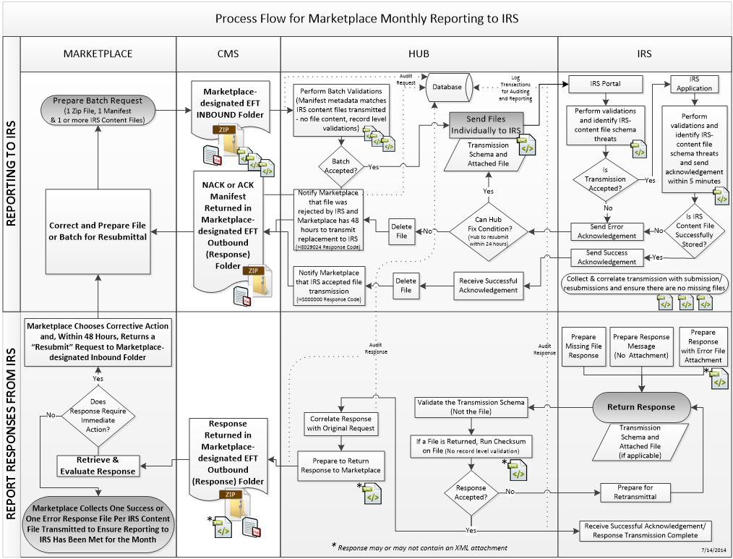
Figure 45. Process Flow for Marketplace Monthly reporting to IRS

Figure 46 displays the workflow for the NYSOH Generation EOY feed to CMS.

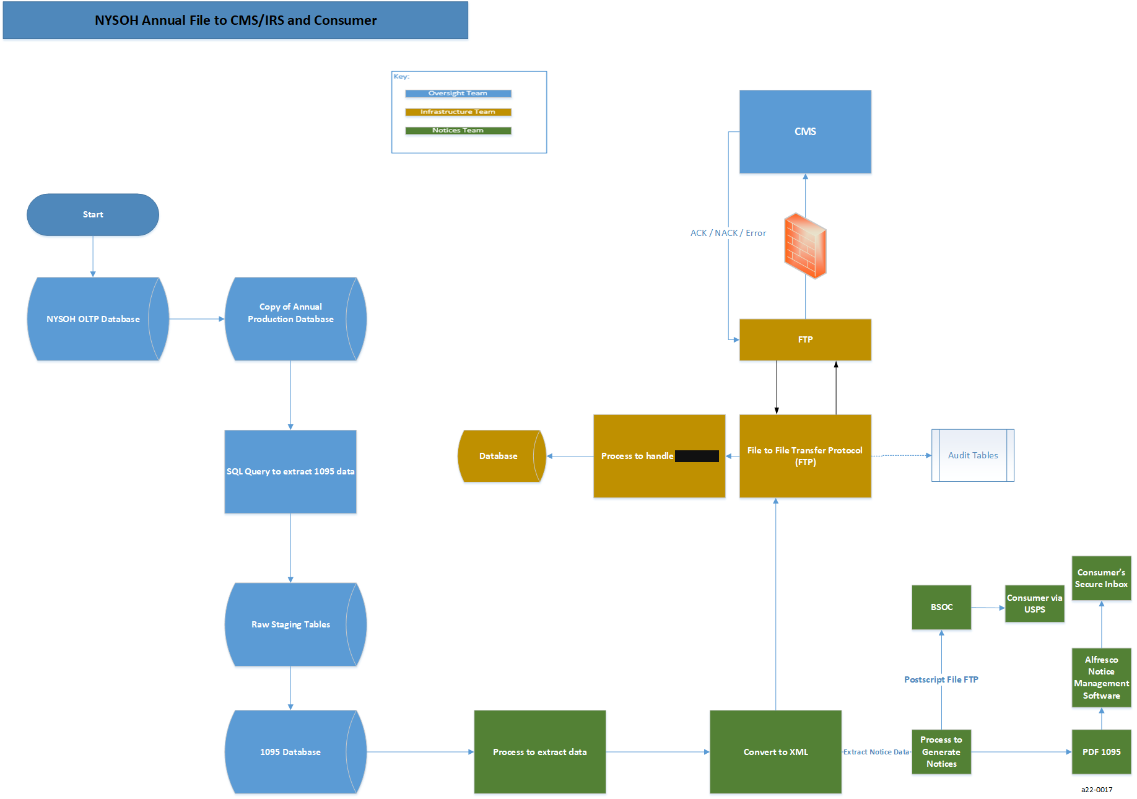
Figure 46. NYSOH Annual File to CMS/IRS and Consumer

IRS Monthly (with CMS)
Table 234 provides information regarding the IRS and CMS monthly 1095 interaction.

Category | Value
Description | The IRS requires a monthly Exchange Period Data (EPD) report that will report all information applicable to APTC and QHP Full Pay enrollees. The file is generated and sent once a month to IRS through the CMS. It becomes the basis for the annual End of Year (EOY) report file to the IRS.  A similar file, the Annual Enrollment Data File, as above with the addition of the QHP ID, is submitted to CMS monthly on a schedule that follows that of the IRS file.
Mode of operation | This is an automated job that will run on a batch. The schedule is defined in the NYSOH Production Job Schedule.  The job will poll the database for consumers who are enrolled in QHP plans. Results will be stored in 1095-A database.
Job type | Example:  Outbound batch interface. This is an EDI interface.
Systems | Example:  - Small Business Marketplace Batch Process (GroupEnrollmentProcessJob.sh)  - ESG Service (GroupSetupRequest)  - FPS  - MQFTE
Inputs | PROD data is copied to a 1095 DB and procedures/SQL scripts are executed to transform the data to a per month per year schema which is used to generate 1095 reports for IRS and CMS.
Outputs | Enrollment records are output to the CMS outbound mailbox for CMS and IRS to extract and validate.
Business Frequency | Once per month at or around the eighth of each month
Processing (high-level) | - The purpose of this process is to send a file to IRS (via CMS) which contains the output of the data used to calculate the APTC and SLCSP.  - The first step of this process is to execute a job to populate the 1095 database with tables from production database  - The second step of this process is to run SQL queries against data to populate the data elements required by the IRS  - The data elements are extracted into an xml file which is transferred (EFT) to CMS which, in turn, transfers the file(s) to IRS  - CMS does a preliminary validation of file(s) and notifies NYSOH of any manifest errors that would prohibit CMS from transferring to IRS  - IRS sends response files reflecting their own data validation and outlining any errors  - Errors need to be corrected either a) within forty-eight hours or b) with next month’s submission depending on severity of error as defined by IRS error codes
Distribution of outputs | Outputs are distributed only as described above.
Naming convention and location of input and output files | The NYSOH will exchange the data with the CMS using the EFT data transfer Process.  The File naming conventions for the Monthly Report EFT Zip Files to IRS are:  Inbound Folder: SOURCEID.APP.FUNC.DATE(Tp).TIME(Tp).ENV.IN  Outbound Folder (for NACK): SOURCEID.FUNC.DATE(Tp).TIME(Tp).ENV.OUT  Outbound Folder (for ACK): SOURCEID.FUNC.DATE(Tp).TIME(Tp).ENV.OUT  Outbound Folder (for Response): SOURCEID.FUNC.DATE(Tp).TIME(Tp).ENV.OUT  The File naming conventions for the Monthly Report EFT Zip Files to CMS:  Trading Partner ID-FEP0126NY: The SBM’s unique trading partner ID for transmitting files with CMS  Target Application ID- 02.NY*.HIX001.001 MID (for MIDAS)  Function Code-EOm: SDBI  Date: DYYMMDD where the first character 'D' is static text and the rest is the date in 'YYMMDD' format  Time: THHMMSSmmm where the first character 'T' is a static text and the rest is the time in 'HHMMSSmmm' format  Environment Code: P for Production, T for Test  Direction: IN
Error handling (high-level) | - The NYSOH will send monthly files to IRS via CMS Data Service Hub.  - The file will be an EFT, XML format. CMS will return acknowledgment or error codes. Response to error codes will be returned within 48 hours of receipt.  - The NYSOH Interface team will retrieve the mail consisting of IRS-generated error codes from the CMS inbox.  - If IRS notifies the Marketplace via the Hub that IRS rejects a transmission that relates to schema errors within the IRS content file, the Marketplace corrects the condition and retransmits to IRS via the Hub.  - The NYSOH will send additional report to CMS as requested identical to the 1095 Monthly Submission with an additional data element, Plan ID, for each QHP enrollees.
Responsible teams | - DOH Oversight team  - NYSOH GDIT System Architecture team  - NYSOH GDIT Oversight team  - NYSOH GDIT Notices team
Table 234: IRS Monthly (with CMS)

IRS EOY report and 1095A to Consumer
Table 235 contains information regarding the EOY report.

Category | Value
Description | The 1095A database produces an output file that is sent to BSOC to a) store in OpenCMIS in the individuals’ secure inbox and; b) produce and deliver (via USPS) a 1095A notice to the Consumer. The file of all of the notices is delivered to IRS via EFT
Mode of Operation | This is an automated job that will run on a batch. The schedule is defined in the NYSOH Production Job Schedule.  The job will poll the database for tables associated with QHP individuals who are requesting financial assistance; including QHP full pays.
Job type | Outbound batch interface. This is an FTP interface.
Systems | - Small Business Marketplace Batch Process (GroupEnrollmentProcessJob.sh)  - ESG Service (GroupSetupRequest)  - FPS  - MQFTE
Inputs | Employer_issuer and Employer_plan tables from the database as shown in the Naming convention and location of input and output files section of this table.
Outputs | Enrollment records are output to the FTP server for Issuers to extract as shown in the Naming convention and location of input and output files section of this table.
Business Frequency | Once Annually, to be no later than January 31 following the end of the calendar (tax) year. Updates based on changes to initial submission may be made monthly through April.
Processing (high-level) | - The purpose of this process is to request a Group ID from Issuers for those applications missing a Group ID. The frequency for all programs executed in this process is found in the Frequency section of this table. The input and output file names are found in the Naming convention and location of input and output files section of this table.  - The first step of this process is to execute a Shop Batch Process – GroupEnrollmentProcessJob.sh to extract data from the Small Business Marketplace tables according to frequency in this table.  - The second step of this process is that the ESG service GroupSetupRequest consumes this extract data to create enrollment records and enrollment metadata records (file names are found in the Naming Convention and location of input and output file).  - During the third step of this process, FPS processes the output of the ESG service, creates the enrollment record, and updates the FPS log tables.  - For the last step of this process, MQFTE ingests the enrollment records and writes those records to the FTP server for the Issuers to capture.
Distribution of outputs | Outputs are distributed only as described above.
Naming convention and location of input and output files | N/A
Error handling (high-level) | - The NYSOH will send annual files to IRS via CMS Data Service Hub.  - The file will be an EFT, XML format. CMS will return acknowledgment or error codes. Response to error codes will be returned within 48 hours of receipt.  - The NYSOH Interface team will retrieve the mail consisting of IRS-generated error codes from the CMS inbox.  - If IRS notifies the Marketplace via the Hub that IRS rejects a transmission that relates to schema errors within the IRS content file, the Marketplace corrects the condition and retransmits to IRS via the Hub.  - Errors found on mail copies of the 1095A to consumer will flow through the Customer Service area  - The consumer corrections will be addressed within a timeframe to be defined by the DOH and new forms, where applicable, will be transmitted to the Consumer.
Responsible teams | - DOH Oversight team  - NYSOH GDIT System Architecture team  - NYSOH GDIT Oversight team  - NYSOH GDIT Notices team
Table 235: IRS EOY report and 1095A to Consumer

Oversight and Reporting for SBMI to CMS
The CMS Marketplace aims to create an end-to-end solution for plan management, eligibility & enrollment, and financial management functions, as required by the Patient Protection and Affordable Care Act (PPACA). The Enrollment and Payment System (EPS) within the Marketplace compiles enrollment data from the Federally-facilitated Marketplace (FFM) and SBMs and determines advance payments of the premium tax credit (APTC) and advance cost-sharing reduction (CSR) payments to issuers. To facilitate automated APTC and advance CSR payments to SBM issuers, CMS must receive, and process SBM enrollment data at a policy level each month, in a cycle that coincides with the CMS monthly payment cycle.

The state of New York has chosen to submit initial enrollments on the SBMI to CMS so that CMS can calculate and pay an upper bound adjustment to SBE issuers. SBM file submissions will be cumulative for a coverage year and include all previously reported policies and members (by state or by state Issuer) that have coverage for any period during the specified coverage year.

For details of this requirement please refer to NYSOH CR1210 RSD_SBM_Monthly Data Submission_R14.doc located in the configuration management repository under the applicable release baseline
- SBMs will maintain and provide unique Exchange Assigned Policy IDs in the SBMI files for use in reporting and payment.
- CMS requires a new Exchange Assigned Policy ID when a plan or product changes within a specific issuer because that will change the 14 digit QHP ID.
- SBMs will only include individual market major medical and standalone dental QHP enrollments in SBMI submissions. SBMs will not send SHOP enrollment data to CMS in the SBMI.
- NYSOH can submit files any day between 12.00 AM Eastern times on the 1st to 11.59 PM Eastern Time on 10th of every month.
- SBMR for each complete file is generated and transmitted to NYSOH once the file received by CMS has completed the inbound file processing. For example, if an issuer file set is made up of twelve files, one record level SBMR will be generated after all twelve files from that file set are received and processed.

SBMI Workflow
An overview of the SBMI Workflow is shown in Figure 47.

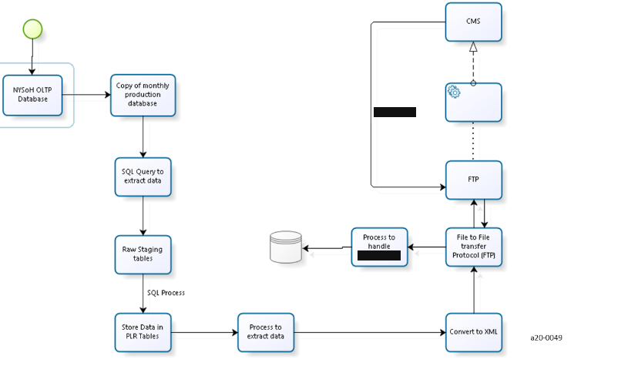
Figure 47. NYSOH Generation of SBMI Feed to CMS

SBMI Monthly (with CMS)
Table 236 provides information regarding the CMS monthly SBMI interaction.

Category | Value
Description | NYSOH will transmit a monthly outbound file to CMS. The file transmitted will have the Initial enrollment data also at a policy level of the members who are receiving APTC/CSR benefits.
Mode of operation | This is an automated job that will run on a batch. The schedule is defined in the NYSOH Production Job Schedule.  The job will poll the database for consumers who are enrolled in QHP plans. Results will be stored in 1095-A database.
Job type | Example:  Outbound batch interface. This is an EDI interface.
Systems | Example:  - Small Business Marketplace Batch Process (GroupEnrollmentProcessJob.sh)  - ESG Service (GroupSetupRequest)  - FPS  - MQFTE
Inputs | PROD data is copied to a 1095 DB and procedures/SQL scripts are executed to transform the data to a per month per year schema which is used to generate 1095 reports for IRS and CMS.
Outputs | Enrollment records are output to the CMS outbound mailbox for CMS to extract and validate.
Business Frequency | Once per month at or around the tenth of each month
Processing (high-level) | - The purpose of this process is to send a file to CMS which contains the output of the data used to calculate the APTC and SLCSP.  - The first step of this process is to execute a job to populate the 1095 database with tables from production database  - The second step of this process is to run SQL queries against data to populate the data elements required by the CMS  - The data elements are extracted into an xml file which is transferred (EFT) to CMS.  - CMS does a validation of file(s) and notifies NYSOH of any errors that would prohibit CMS from processing of records.  - Errors need to be corrected either a) within forty-eight hours or b) with next month’s submission depending on severity of error as defined by CMS error codes
Distribution of outputs | Outputs are distributed only as described above.
Naming convention and location of input and output files | The NYSOH will exchange the data with the CMS using the EFT data transfer Process.  All files will follow a consistent naming convention (including files within a zipped file) defined as follows:  File Name=TradingPartnerID.AppId.FuncCode.Date.Time.EnvCode.Direction  SBMI files must be named according to the EFT file naming convention below.  - Trading Partner ID - SBM Source ID (for source)  - App ID - EPS  - Function Code - SBMI  - Date - DYYMMDD where the first character ‘D’ is static text and the rest is the date in ‘YYMMDD’ format  - Time - THHMMSSmmm where the first character ‘T’ is a static text and the rest is the time in ‘HHMMSSmmm’ format  - Environment Code - P for production, T for testing, R for production readiness  - Direction - IN
Error handling  (high-level) | - The NYSOH will send monthly files to CMS via CMS Data Service Hub.  - The file will be an EFT, XML format. CMS will return acknowledgment or error codes. Response to error codes will be returned within 48 hours of receipt.  - The NYSOH Interface team will retrieve the mail consisting of CMS-generated error codes from the CMS inbox.  - If any errors in the response file, data will be corrected and resubmitted in the next month submission.
Responsible teams | - DOH Oversight team  - NYSOH GDIT System Architecture team  - NYSOH GDIT Oversight team  - NYSOH GDIT Notices team
Table 236: SBMI Monthly (with CMS)

Oversight Reports
Below is the list of Cognos reports currently in Production. Table 237 represents the report ID, name, and any description of the report.

Report ID | Report Name | Report Description
NY-HPM-ADHOC-EE-0090 | Navigators 10/1/13 – 12/31/14 | This report will display  Navigator Agency/Organization, Navigator Name, Certification Number, Email Address  and Phone number for all Navigators registered at any point during the following timeframe, 10/1/13 – 12/31/14
NY-HPM-NYS-AD HOC-0077 | Individuals and Issuers at Renewal | This report will display the number of Individuals and Issuers at Renewal;  For the Individual Market (QHPs, Medicaid, and CHP), display:  - The number of Individuals who remain in the same Program at renewal and who continue with the same issuer.  -The number of Individuals who remain in the same Program at renewal but change issuer.  - The number of Individuals who change Programs at renewal and continue with the same issuer.  -The number of Individuals who change Programs at renewal but change issuer.  Individual QHP enrollment is defined as the 834 enrollment transaction sent to the issuer.  QHP population: Consider QHP individuals enrolled as of 11/30/14 or 12/31/14 who renew coverage in Jan/Feb/Mar of 2015  MA and CHP: Consider Individuals enrolled 1/1/14 with an end date greater than 12/31/14.  If someone is enrolled in a QHP in December 2014 and also has coverage in February 2015 and does not have coverage for March, and the report is run in March or after: yes, count the person.  Business Rules:  • Individuals who did not have Coverage in Jan, Feb or March of 2015 should not be considered  • Individuals should be counted uniquely  • Only latest Program Id within the coverage year for Jan, Feb or March should be used considered  • Consider Jan-March coverage and transaction data only,  • Individuals retro covered back to Jan/Feb/March are not considered after March in this report.  Report A and B: 1/1/14 with an end date greater than 12/31/14  Report C and D : MA/CHP Coverage Start Date = 6/1/14 with an end date greater than 5/31/15
NY-HPM-NYS-AD HOC-0086 | Ad Hoc Zip Code by Group Type | This report displays by Zip Code the number of Individuals enrolled by Age, Race  Hispanic/Latino, Preferred Spoken Language, Channel and  Insurance Status  Individual Market (All Program Types MA (Use Eligibility for MA), CHP , QHP APTC/CSR, QHP APTC w/o CSR, QHP APTC PP, QHP APTC Full Pay)
NY-HPM-NYS-ADHOC_0001 | Registered Brokers and Navigators | Number of Brokers and Number of Navigators that have registered through the Exchange
NY-HPM-NYS-ADHOC-0002 | Eligibility by Age Group | Eligibility counts by age group for program types: Medicaid, CHP, QHP APTC w/o CSR, QHP with APTC/CSR, QHP Full Pay. Age groups are CCIIO and NYS depending on program
NY-HPM-NYS-ADHOC-0003 | Navigator Submitted Apps | This One Time Report will display Submitted Application Account Numbers and HX # on Submitted Application for Agency Community Service Society Navigators Elisabeth Benjamin and Alexandra San Juan
NY-HPM-NYS-ADHOC-0004 | Certified Application Counselor | This One Time Report will display Submitted Application Account Numbers and HX # on Submitted Application for Agency Name = Health First , Fidelis Care  CACs = Emilia Forgione, Eduhin Diaz
NY-HPM-NYS-ADHOC-0005 | Navigators -incomplete apps | This One Time Report will display by Agency Name and Navigator Name the Account number (AC#) for Incomplete Applications, the HX# on Incomplete Applications and Initiation Date for Incomplete App  (the AC and HX numbers for all incomplete apps for all Navigators)
NY-HPM-NYS-ADHOC-0007 | Cumulative Number of Individuals Determined Eligible for QHP who required manual Verification | This Report will display Cumulative Number of Individuals Determined Eligible, of those who required manual verification , and those that required additional documentation by defined areas
NY-HPM-NYS-ADHOC-0008 | List the Enrollees in CHPlus Products from Health Now and MVP | Description: Defect/Task Number: 17242  Need a query to find enrollees in CHPlus products from Health Now and MVP and allow subscribers the opportunity to change their coverage.
NY-HPM-NYS-ADHOC-0015 | Report - Number of User Account Profiles where ID Proofing Failed but have Application Data Present | Report of Individuals who were not ID Proofed
NY-HPM-NYS-ADHOC-0016 | Report - Pediatric Dental Coverage being Offered to those above the Allowed age | Report of Individuals who have been offered pediatric dental but who do not qualify
NY-HPM-NYS-ADHOC-0017 | Report - EE PROD - Limited Dental options are Displayed | Report of Individuals to whom limited dental options offered
NY-HPM-NYS-ADHOC-0018 | Issuer Enrollment by Age and Gender | This report will detail enrollment for each Issuer broken out by age and gender within each Issuer. Report will include data for QHPs only
NY-HPM-NYS-ADHOC-0019 | AD Hoc Oxford | This report will display the Number of individuals with an APTC Increase and Decrease by Defined Amount
NY-HPM-NYS-ADHOC-0020 | Ad Hoc Zip Code Reports | This report displays  By Zip Code Medicaid Enrollment Counts broken out by Age Group  By Zip Code CHP Enrollment Counts  By Zip Code QHP Enrollment Counts broken out by Age Group  By Zip Code the Individual Market Enrollment Counts broken out by Age Group  And FPL for those Enrolled and uninsured at the time of the application
NY-HPM-NYS-ADHOC-EE0-0088 | Ad Hoc- 2016 SILVER AND BRONZE Plan Data | This ad hoc report will display the 2016 EHB Premium by Coverage tier for the SLCSP and LCB by County , Issuer and Plan ID
NY-HPM-NYS-ADHOC-EE0-0091 | 2015 BRONZE Plan Data | This ad hoc report will display the 2015 Bronze Lowest Cost Plan Premium by Coverage Tier  • Premiums need to be the 2015 premiums  • Full premium (e.g. not the portion of the premium that is EHB)
NY-HPM-NYS-ADHOC-EE-0027 | Number of Employers for 2015 QHP Enrollees with APTC v5 | This report will display the number of employers for individuals who meet the following criteria:  • 2015 QHP Eligible (including individuals determined conditionally eligible) who have a program type of any of the following:  o APTC+CSR;  o APTC+Premium Assistance; or  o APTC only.  • APTC amount is equal to or greater than $0  • Include Auto Renewals  • Only count Employers where Individuals attest to employment  • exclude non job related income  • Consider only the most recent eligibility record and only employers the individual is currently employed  • Count all the Cancel and Void enrollments  • If the employer name and address is an exact match, count as one employer but if different count as separate employers.  • From this population of individuals (criteria listed above), capture the number of employers in the income information section of the application only at the time of 2015 eligibility
NY-HPM-NYS-CS-0001 | Status Aging Report | By status, length of time application has been in status at the time of reporting (Number of Days Aging, e.g., 0-10, 11-20, 21-30, >30)
NY-HPM-NYS-CS-0003 | Cases in resequence queue by reason code | This report will display by Reason Code the number of cases individuals in the resequence queue
NY-HPM-NYS-EE-0007 | Timeliness of Applications Initiated and Submitted by Avenue | This report displays number of applications initiated and submitted by avenue; Broker, CAC, Navigator, Paper, Phone, Web. Applications are counted cumulative from Marketplace Enrollment Year 1.
NY-HPM-NYS-EE-0008 | Request for Health Insurance | This report displays number of applications submitted: a) seeking financial assistance and; b) not seeking financial assistance. Applications are counted cumulative from Marketplace Enrollment Year 1.
NY-HPM-NYS-EE-0010 | Eligibility Determinations Medicaid | This report displays the number of unique eligibility determinations for Medicaid by FPL, Age Group, Gender, Race, Hispanic/Latino, and Ethnicity by County.  This will display MA eligibility for individuals with an active eligibility on the date the report is run.
NY-HPM-NYS-EE-0011 | Eligibility Determinations CHP | This report displays number of eligibility determinations for CHP by FPL, Age group, gender and race/ethnicity by County.  This will display CHP eligibility for individuals with an active eligibility on the date the report is run.
NY-HPM-NYS-EE-0012 | Eligibility Determinations QHP APTC with CSR | This report displays number of eligibility determinations for QHP APTC with CSR by FPL, Age group, gender and race/ethnicity by County.  This will display eligibility for the current enrollment year only.
NY-HPM-NYS-EE-0013 | Eligibility Determinations QHP APTC w/o CSR | This report displays number of eligibility determinations for QHP APTC w/o CSR by FPL, Age group, gender and race/ethnicity by County.  This will display eligibility for the current enrollment year only.
NY-HPM-NYS-EE-0014 | Eligibility Determinations QHP Full Pay | This report displays number of eligibility determinations for QHP Full Pay by Age group, gender and race/ethnicity by County.  This will display eligibility for the current enrollment year only.
NY-HPM-NYS-EE-0017 | Enrollment by Medicaid | This report displays the number of active Medicaid enrollments.  This will display enrollment active on the date the report is run.  Eligibility numbers from EE-10 or EE-22 should be used for enrollment instead of numbers from this report
NY-HPM-NYS-EE-0018 | Enrollment by CHP | This report displays number of enrollments for CHP by FPL, Age group, gender and race/ethnicity by County.  This will display enrollment active on the date the report is run.
NY-HPM-NYS-EE-0019 | Enrollment by QHP APTC with CSR | This report displays number of enrollments for QHP APTC with CSR by FPL, Age group, gender and race/ethnicity by County.  This will display enrollment for the current enrollment year only.
NY-HPM-NYS-EE-0020 | Enrollment by QHP APTC w/o CSR | This report displays number of enrollments for QHP APTC w/o CSR by FPL, Age group, gender and race/ethnicity by County.  This will display enrollment for the current enrollment year only.
NY-HPM-NYS-EE-0021 | Enrollment by QHP Full Pay | This report displays number of enrollments for QHP Full Pay by Gender, Age group and Race by County.  This will display enrollment for the current enrollment year only.
NY-HPM-NYS-EE-0022 | Following Individuals from Eligibility Determination through Effectuated Coverage | This report displays by Program Type, (MA, CHP, APTC/CSR, APTC Only, APTC PA, QHP Full Pay and EP)  1)# Determined Eligible  2)Of those Determined Elig, cumulative # who selected a plan before  3)Of those Determined Elig, the % who selected a plan before  4)Of those who selected a plan, cumulative # covered for first month of coverage before  5)Of those who selected a plan, the % who were covered for first month of coverage before  QHP Program Types: This will display eligibility and enrollment for the current enrollment year only.  MA, CHP and EP this will display eligibility and enrollment active on the date the report is run.
NY-HPM-NYS-EE-0023 | Individual Enrollment by QHP | This report displays number of QHP Enrollments by Rating Region/County/Market/Issuers/Metal Level/QHP. Enrollment for individual is defined as 834s sent to Issuer.  This will display enrollment for the current enrollment year only.
NY-HPM-NYS-EE-0024 | Medicaid Enrollment by Issuer | This report displays number of Medicaid Individuals enrolled by County and Issuer  This will display enrollment active on the date the report is run.
NY-HPM-NYS-EE-0025 | CHP Enrollment by Issuer | This report displays number of CHP Individuals enrolled by County and Issuer  This will display enrollment for the current enrollment year only.  This will display enrollment active on the date the report is run.
NY-HPM-NYS-EE-0027 | Transition between QHP Programs | This report displays number of individuals eligible, enrolled and effectuated that transition between QHP Programs.  FULL PAY QHP -> QHP WITH APTC + CSR  FULL PAY QHP -> QHP WITH APTC ONLY  FULL PAY QHP -> QHP WITH APTC PA  QHP WITH APTC + CSR -> FULL PAY QHP  QHP WITH APTC + CSR -> QHP WITH APTC ONLY  QHP WITH APTC + CSR -> QHP WITH APTC PA  QHP WITH APTC ONLY -> FULL PAY QHP  QHP WITH APTC ONLY -> QHP WITH APTC + CSR  QHP WITH APTC ONLY -> QHP WITH APTC PA  QHP WITH APTC PA -> FULL PAY QHP  QHP WITH APTC PA -> QHP WITH APTC + CSR  QHP WITH APTC PA -> QHP WITH APTC ONLY  This will display eligibility and enrollment for the current enrollment year only.
NY-HPM-NYS-EE-0038 | Navigator Application Status | This report displays by Navigator Organization and Navigator Name the number of # Applications Initiated and not yet submitted # Applications Submitted. Applications are counted cumulative from Enrollment Year 1.
NY-HPM-NYS-EE-0039 | Certified Application Counselor Application Status | This report displays by Certified Application Counselor Organization and Certified Application Counselor Name the number of # Applications Initiated and not yet submitted # Applications Submitted. Applications are counted cumulative from Enrollment Year 1.
NY-HPM-NYS-EE-0047 | Timeliness of Eligibility Determinations | This report displays Median Timeliness of Determinations & timeliness of eligibility determination (after submission how long before determination) by program type.
NY-HPM-NYS-EE-0048 | Insurance Status at time of application | This report will display the unique number of eligibility determinations and enrollments (834 sent to Issuer) by FPL for Individuals Not Enrolled in Any Coverage When the Application was Submitted
NY-HPM-NYS-EE-0049 | APTC Premium Assistance | Report will display the number of unique eligibility determinations, Enrollments and Effectuated Enrollments for Program Type APTC Premium Assistance by FPL, Age Group, Gender, Race Hispanic/Latino and Ethnicity within a Region/County.  This will display eligibility and enrollment for the current enrollment year only.
NY-HPM-NYS-EE-0050 | Hispanic/Latino and Ethnicity Report(Enhancement-add Count Distribution) | This report displays by program type the unique number of eligibility determinations, enrollments (834 sent to Issuer) and Effectuated Enrollments (834 received back from Issuer) by Group Type (Hispanic/Latino, and Ethnicity)  QHP Program Types: This will display eligibility and enrollment for the current enrollment year only.  MA, CHP and EP: This will display eligibility and enrollment active on the date the report is run.
NY-HPM-NYS-EE-0051 | Preferred Method of Filing Application by Program Type | This report displays preferred method of filing application (Broker, CAC, Navigator, Paper, Phone, Web) of the unique number of eligibility determinations and enrollments (834 sent to Issuer) by program type  QHP Program Types: This will display eligibility and enrollment for the current enrollment year only.  MA, CHP and EP: This will display eligibility and enrollment active on the date the report is run.
NY-HPM-NYS-EE-0052 | Preferred Spoken and Preferred Written Language by Program Type | This report displays preferred spoken and preferred written language of the unique number of eligibility determinations and enrollments (834 sent to Issuer) by program type.  QHP Program Types: This will display eligibility and enrollment for the current enrollment year only.  MA, CHP and EP: This will display eligibility and enrollment active on the date the report is run.
NY-HPM-NYS-EE-0054 | Enrolled by Metal Level and Deductible Amount | This report displays Cumulative Number of Individuals Enrolled in QHPs in the Individual Marketplace, by Metal Level by Deductible amount.  This will display enrollment for the current enrollment year only.
NY-HPM-NYS-EE-0055 | QHP APTC/CSR Enrolled by Metal Level | This report displays number of individuals QHP APTC/CSR Enrolled by Metal Level.  This will display enrollment for the current enrollment year only.
NY-HPM-NYS-EE-0057 | Electronic versus Electronic and Paper Notices | This report displays number of individuals eligible and enrolled by Electronic versus Electronic and Paper Notices by Program type.  QHP Program Types: This will display eligibility and enrollment for the current enrollment year only.  MA, CHP and EP: This will display eligibility and enrollment active on the date the report is run.
NY-HPM-NYS-EE-0058 | Pended for MA Income Inconsistency | This report will display the number of individuals Pended for MA Income Inconsistency  and of those Pended for MA Income Inconsistency the number of final eligibility determinations by Program type
NY-HPM-NYS-EE-0059 | Enrollment by FPL and Metal Level | This report displays number of individuals enrolled by FPL and then by Metal Level.  This will display enrollment for the current enrollment year only.
NY-HPM-NYS-EE-0060 | Enrollment by Navigator and CAC Organization | This report displays for Navigator and CAC by Organization and Program Type the number of individuals enrolled.  This will display enrollment for the current enrollment year only.
NY-HPM-NYS-EE-0061 | SEP Eligibility and Enrollment | This report displays the following Special Enrollment Period requests by Reason Code  # SEP Requests  # of QHP SEP Eligible Individuals (Note: Capture eligibility based on the date the SEP Plan Selection clock starts Eligibility date to be greater than or equal to 03/01/15 and eligibility date to be less than the run date or 12/31/15)  This will display eligibility and enrollment for the current enrollment year only.
NY-HPM-NYS-EE-0063 | Determinations by Org and CAC Name | This report displays number of Determination by CAC Name.  This will display eligibility for the current enrollment year only.
NY-HPM-NYS-EE-0064 | Determinations by Org and Navigator Name | This report displays number of Determination by Navigator Name.  This will display eligibility for the current enrollment year only.
NY-HPM-NYS-EE-0067 | Individuals Redetermined for CHP | This report will display:  1) the number of individuals enrolled in any QHP program that were redetermined for CHP and  2) the number of individuals effectuated who have been Redetermined for CHP  This will display enrollment for the active enrollments only.
NY-HPM-NYS-EE-0069 | Covered Lives by Month | This report displays number of Individuals Covered by Month  (This report uses actual coverage month)
NY-HPM-NYS-EE-0071 | Number of Newly Enrolled Individuals for 2015 | This report displays  Number of Newly Enrolled Individuals for 2015.  QHP Program Types: This will display enrollment for the current enrollment year only.  MA, CHP and EP: This will display enrollment active on the date the report is run.
NY-HPM-NYS-EE-0073 | Individuals moving from Medicaid to QHP | This report displays number of Individuals moving from Medicaid to QHP  Include all QHP Program types
NY-HPM-NYS-EE-0074 | Enrollment by Issuer and Income  QHP Program types only | This report displays number of individuals enrolled by plan and income level.  This will display enrollment for the current enrollment year only.
NY-HPM-NYS-EE-0075 | Medicaid Eligibility by Aid category and Income | This report displays number of Medicaid Individuals Eligible by aid Category and Income Level.  Displays eligibility active on the date the report is run.
NY-HPM-NYS-EE-0076 | Navigator and CAC Organization Enrollment Counts by Issuer | This report displays by Program Type the Navigator and CAC Organization Enrollment Counts by Issuer  Navigator and CAC organizations active as of the report run date.  Enrollments from unique HIX IDs. If a unique HIX ID has overlapping coverage in two program types at the time the report is run, that individual should be counted twice.
NY-HPM-NYS-EE-0078 | Number of Unique Individuals Cancelled and Terminated for the current Coverage year. | This report displays number of Unique Individuals Cancelled and Terminated for the current Coverage year by QHP and by SADP Issuer.  This report displays Type of Cancellation/Termination  • Cancellation for Non Payment  • Terminated for Non Payment  • Voluntary Cancellations  • Voluntary Terminations  Termination of a Qualified Health plan (or QHP) or Stand Alone Dental Plan (SADP) can be initiated by an issuer or by a consumer. Individuals can only be counted once in QHP cancellations/terminations and once in SADP cancellations/terminations.  Issuer Cancellation for Non Payment  If the enrollee did not pay the initial binding premium for the coverage year, an issuer will send an 834 to cancel the consumer for Non Payment, and this cancel will void the consumer’s coverage segment. The 834 from the carrier to cancel the plan will have the same start and end date for the policy.
NY-HPM-NYS-EE-0079 | Essential Plan (EP) Eligibility, Enrollment and Effectuation | This report displays Eligibility, Enrollment and Effectuation for the Essential Plan (EP) by gender, age, FPL and race.
NY-HPM-NYS-EE-0080 | EP Enrollees Cancelled and Terminated for Non-Payment | This report displays number of EP Enrollees Cancelled and Terminated for Non-Payment. The population captured in this report is the population of EP enrollees that must pay a monthly premium for their coverage.  This report will count the number of people affected by each scenario described below. This report will not count the number of transactions sent by a plan to the Marketplace.  • Cancellation for Nonpayment: A consumer is determined eligible for EP, selects an EP plan and must pay a monthly premium to effectuate coverage. The consumer does not make the binder payment and is cancelled.  • Termination for Nonpayment: A consumer is determined eligible for EP, selects an EP plan, must pay a premium for coverage and has at least one covered month in the plan before failing to make a premium payment.  Business Rule : EP Coverage Start date must be equal to or within 13 months prior to report Run Date
NY-HPM-NYS-EE-0081 | EP Enrollment by Issuer | This report displays number of EP Enrollment by County, Issuer and cost share.  This will display enrollment active on the date the report is run.
NY-HPM-NYS-EE-0082 | EP Voluntary Cancellations/Terminations | This report displays number of EP Voluntary Cancellations/Terminations by Issuer and Essential Level  • Voluntary Cancellation: a consumer is determined eligible for EP, selects a EP health plan, but coverage is cancelled at the request of the consumer and the consumer no longer has any Marketplace coverage.  o The cancellation will be counted when a consumer cancels enrollment in a EP plan and is no longer enrolled in a Marketplace program.  o If a consumer selects one EP plan, and then voluntarily switches to a different EP plan, the cancellation of the first plan will not be counted in this report.  o Cancellations typically occur prior to the coverage start date, but in some cases, coverage may be retroactively cancelled, such that coverage is voided after what would have been the coverage start date.  • Voluntary Termination: a consumer is determined eligible for EP, selects a EP health plan, has at least one covered month in the plan, and then prospectively opts to discontinue coverage in this EP plan.  o The termination will be counted when a consumer terminates enrollment in a EP plan and is no longer enrolled in a Marketplace program.  o If a consumer selects one EP plan, has a covered month in that plan, and then voluntarily switches to a different plan, the termination of the first plan will not be counted in this report.  Not covered in this report:  • Consumers who enroll in a EP plan and are subsequently determined eligible for and enroll in Medicaid or a QHP are tracked in a separate report.  • Consumers who enroll in an EP plan, and have to pay a premium for the plan, and are terminated for nonpayment in the plan, are tracked in a separate report.
NY-HPM-NYS-EE-0083 | Individuals redetermined for EP | This report displays number of Individuals enrolled at point in time and the number of individuals redetermined for EP.  Note: For Program Type = Medicaid, Use Medicaid enrollment for effectuation
NY-HPM-NYS-EE-0084 | EP Enrollments by Issuer and level | This report will display the number of EP Enrollments by HIOS ID, Issuer and EP level  Display current year enrollment Only.  Enrollment Rule: If the enrollment end date is greater than or equal to the report run date, then count the individual.  Enrollment is defined as 834 transaction sent to the issuer.  This will display EP enrollment active on the date the report is run.
NY-HPM-NYS-EE-0087 | Number of Newly Eligible Individuals | This report displays Cumulative number of Newly Eligible Individuals and Point in time number of Newly Eligible Individuals by Individual Program type.  Business Rules:  • Program type QHP and EP – Newly Eligible = Individuals who do not have an eligibility start date in 2014 and/or 2015  • Program type Medicaid and CHP – Newly Eligible = Individuals who do not have an eligibility start date prior to 11/1/2015.
NY-HPM-NYS-EE-0092C | Enrollment and Effectuation by Age and Gender - Cumulative - Weekly | This report will display the Enrollment and Effectuation for each QHP Program Type by Age and Gender for the current coverage year
NY-HPM-NYS-EE-0104C | Accounts in the Auto Enrollment Queue - Cumulative - Weekly | This report will display the number of accounts that remain in the Auto Enrollment Queue by Reason Code Description after their initial, AEQ panned execution date
NY-HPM-NYS-EE-0117C | EP Plan Level and Age - Cumulative - Weekly | The report will display the number the number of Individuals by EP Plan Level and Age
NY-HPM-NYS-EE-0118C | APTC Calculation - Cumulative - Weekly | The report will provide the Max/Median/Min APTC amounts on a weekly basis for each county divided between age groups
NY-HPM-NYS-EE-0094C | QHP Coverage Length by Coverage Year - Cumulative - Weekly | This report will display the Number of Months Individuals are enrolled in the current coverage year.
NY-HPM-NYS-EE-0093C | Gross Plan Selection - Cumulative - Weekly | This report will display the Gross Plan Selection by QHP Program Type for the current coverage year  • Includes anyone who ever submitted to be enrolled in a QHP Program Type for the current enrollment/Plan year, this includes people who were covered for one or more months (including those termed and cancelled) and also people whose coverage was cancelled, so they had zero months of coverage.  • The report only counts individuals once.  Scenarios:  1. If an individual enrolled and selected a plan, cancels that plan, and then re-enrolls in another plan at a later date, the individual would only be counted once in the program type he/she is currently enrolled in.  2. If an individual selects a plan during open enrollment and then cancels that plan and is never enrolled in coverage, the individual is counted in the most recent program type he/she was in when he/she selected a QHP.  3. If an individual is enrolled for Jan-June and then terminates his/her coverage, the individual is counted in the most recent program type he/she was in when he/she was enrolled in a QHP.  4. If an individual is enrolled in a QHP, experiences a life status change, and is redetermined eligible for Medicaid, the individual is counted in the most recent program type he/she was in when he/she was enrolled in a QHP.
NY-HPM-NYS-EE-0112C | Assistors Registered/ Not Registered (Active and Inactive) - Cumulative - Monthly | This report will display  Account Number, Assistor Type (Navigator/CAC), Agency/Organization Name , Assistor Name, Assistor Status, NY Gov User Name , Certification Number, Email Address, Phone Number, Client Count, Direct Supervisor, Assistor Oversight Manager and Invitation Code Used for all Assistors registered/not registered at any point. (include active and inactive assistors)  Business Rule: Include all Navigators and Application Counselors that have been uploaded in the system regardless of if they are registered or not.
NY-HPM-NYS-EE-0102 | - Prospective Total Number of Renewals by Renewal Type (Admin v Manual) - Cumulative - Monthly | This report will display the prospective total Number of Renewals by Renewal Type (Admin v Manual) by month.
NY-HPM-NYS-EE-0108C | Admin Watcher Job - Cumulative - Monthly | This report will display the  Report 1 - Number of Accounts by Renewal Type  Report 2 - Number of Accounts with Eligibility that changed from “PROPOSED” to “DETERMINED” by Admin Watcher job  Report 3 - Number of Members by Renewal Type  Report 4 - Number of Eligibilities that changed from “PROPOSED” to “DETERMINED” by Admin Watcher job  Report 5 - Number of Eligibilities that changed from “PROPOSED” to “DETERMINED” SUCCESSFULLY by Program Post Admin watcher job  Report 6 - Number of Individuals who will be Admin renewed and Auto-enrolled  Report 7 - Number of individuals auto enrolled with No Program Change and with Program Change by their After Program Type
NY-HPM-NYS-EE-0110C | Admin Renewal Summary Report - Cumulative - Monthly | This report will display the  • Number of Individuals Renewed by:  o Program type prior to renewal  o Renewal type  o Program type after renewal  • Note report will reflect current enrollment when report is run  • Report will only count those individuals who are applicable for the renewal  Two separate reports will be created one for Admin renewal and other for Manual Renewal
NY-HPM-NYS-EE-0111C | Manual Watcher - Cumulative - Monthly | This report will display the  • Number of Individuals Renewed by:  o Program type prior to renewal  o Renewal type  o Program type after renewal  • Note report will reflect current enrollment when report is run  • Report will only count those individuals who are applicable for the renewal  Two separate reports will be created one for Admin renewal and other for Manual Renewal
NY-HPM-NYS-EE-0109 | Renewal Post RML - Cumulative - Monthly | This report will display the  Number of Accounts picked up by RML  Number of Individuals picked up by RML  Number of Individuals picked up for Admin Renewal by  Number of Individuals picked up for Manual Renewal by  Number of Individuals who will be Admin renewed  Number of T99's generated by renewal type as part of RML job  Accounts picked up by RML job by Renewal Type
NY-HPM-NYS-EE-0098C | Newburgh - Cumulative - Quarterly | This report will display for the city of Newburgh NY , zip code = 12550:  • Report A : Total Number of newly enrolled Individuals for all Marketplace program types;  • Report B : Total Marketplace Enrollment by Program Type ; and  • Report C: Total Marketplace Enrollment by  o FPL  o Race  o Ethnicity  o Age  o Gender  o Preferred language  o Channel  o Insurance status at time of application
NY-HPM-NYS-PLAN-0103 | QHP Enrollment and Effectuation by Issuer and Age - Cumulative - Weekly | This report displays the Number of Individuals enrolled and effectuated by Issuer and Age for the current Coverage year.
NY-HPM-NYS-SHOP-0085C | Employer Choice - Cumulative - Weekly | This report will display the number of:  Employers who offer a single carrier across all metal levels;  Employers offering all plans across a single metal level – (Meaning offer all available plans at just Bronze or just Silver etc.)  Employers offering all available plans;  Employers who have multiple classes of employees;  Employers who offer different options to different classes;  ; and  Medical QHP’s Offered (Employers Offering 1 medical QHP; 2-5 medical QHPs; 6-10 medical QHPs; and 11+ medical QHPs) – (When offers differ by Class for an Employer always report on the highest number of QHP’s offered)
NY-HPM-NYS-SHOP-0107C | SHOP Employer Enrollment - Cumulative - Weekly | Report A: SHOP Employer Enrollment  This report will provide information the employers
NY-HPM-NYS-SHOP-0109C | SHOP New and Termed Employers - Cumulative - Weekly | Report A: SHOP New Employers  New Employers are those employers who are currently active AND are either  a. First time in SHOP Marketplace  OR  b. Had a gap in coverage  Report B: SHOP Employers who Actively Terminated Coverage  • Only those employers will be reported who have been terminated from the exchange. If the employer was termed and then reactivated those employers will not be reported. The report should include a termination date associated with each employer. The report should look back 3 months from run date to include retro terminations.  Report C: SHOP Employers who Passively Terminated Coverage  • All employees show as terminated on the plans tab(there are no actively enrolled employees). In this case the roster does not matter only the status on the plans tab (terminated vs. active/enrolled) If the employer was termed and then reactivated those employers will not be reported. The report should include a termination date associated with each employer. The report should look back 3 months from run date to include retro terminations.
NY-HPM-NYS-PLAN-0001 | Offerings by County | This report displays by Issuer the number of offerings by Metal level in the Individual and Small Business markets
NY-HPM-NYS-PLAN-0002 | QHP Market Share on the Exchange | This report displays market share on the NYS Health Benefits Exchange. For each issuer, display the # and % of QHP unique enrollees on the Individual market and in SHOP.  Individual QHP enrollment is defined as the 834 transaction sent to the issuer. NOTE: SHOP enrollment is defined as employee applications submitted.
NY-HPM-NYS-PLAN-0005 | Average value of premium subsidies in the exchange | This report displays Average maximum value of premium subsidies (per household), the total premium subsidies, and the # of Individuals receiving APTC
NY-HPM-NYS-PLAN-0011 | Individual QHP Enrollment by Metal Level | This report displays number of Issuer enrollments and effectuations by Metal Level.  This will display enrollment for the current enrollment year only.
NY-HPM-NYS-PLAN-0012 | QHP Dental Plan Enrollment | This report displays QHP Enrollment, QHP Enrollment with Dental, QHP Enrollment w/o Dental and also individuals enrolled in Stand Alone Dental Plans by Age breakouts 0-18 and 19 +
NY-HPM-NYS-PLAN-0013 | Stand Alone Dental Plan Enrollments and Effectuations | This report displays stand-alone dental enrollments and effectuations in the Individual market as well as the SHOP.  This will display enrollment for the current enrollment year only.
NY-HPM-NYS-PLAN-0014 | Consumers with duplicate dental benefits accessible | This report displays by the Individual Market and the Small Business Market the Number of Children or Adults with QHP Enrollment in Medical with Dental and also enrolled in Stand Alone Dental (Child, Family or Adult)
NY-HPM-NYS-SHOP-0018 | SHOP Employer and Employee Enrollment - Day 1 | This report will display Employer and Employee Enrollment.
NY-HPM-NYS-SHOP-0019 | SHOP Enrollment by Effective Date | This report will display the number of Employer Enrollments Offered, Employees on Roster for classed offered, Enrolled Employees and Enrolled Participants (representing the total of all family members on an employee’s application) grouped by coverage effectuation date.
NY-HPM-NYS-SHOP-0020 | Top 10 TPAs for Employers by rating region - Day 1 | This report will display the Top 10 Third Party Assistors (TPA) by Rating Region/TPA Category utilized by SHOP employers
NY-HPM-NYS-SHOP-0021 | Request for Health Insurance in SHOP - Day 1 | This report will display the number of SHOP employees + dependents and employee applications submitted by avenue. (SHOP Logic Change)
NY-HPM-NYS-SHOP-0022 | SHOP Enrollment by QHP | This report will display the number of SHOP QHP Enrollments by Rating Region/County/Market/Issuers/Metal Level/QHP. Enrollment for SHOP is defined as: employee submitted an application
NY-HPM-NYS-SHOP-0030 | Employer Medical QHPs Offered | This report will display employer enrollment, employer classes offered, employer classes offered with 1 medical QHP and employer classes offered with 2+ medical QHPs.
NY-HPM-NYS-SHOP-0031 | Employers Offering Insurance Carrier | This report will display total number of employers offering any QHP from a single insurance carrier across all metal levels of coverage and total number of employers offering all available insurance carriers across two contiguous metal levels of coverage.
NY-HPM-NYS-SHOP-0032 | Employers Offering All Available QHPs At Single Metal Or All Metal Levels Of Coverage | This report will display total number of employers offering all QHPs at a single metal level of coverage and total number of employers offering all QHPs at all metal levels of coverage.
NY-HPM-WEB-01 | Browser & OS | By Browser , Number Visits Pages / Visit, Average Visit Duration, Percentage of New Visits, Bounce Rate, Average session duration across the site as a whole, per section, tool, and top pages
NY-HPM-WEB-02 | Browser & Key Words | By Browser, Key Phrases and Key Word Searches
NY-HPM-WEB-03 | Browser and Connection /Sources of Traffic | Numbers of traffic inbound, split by type (i.e., search engines, referrals sites, widgets, badges, direct linking)  By Browser , # Key Connections (i.e., email link, Search Engine, DOH Web Page)
NY-HPM-WEB-04 | Site Speed Page Timings | By Page, Number of Page Views , Avg. Document  Interactive Time (sec),  Avg. Document  Content Loaded Time  (sec),  Avg. Page Load Time  (sec)
NY-HPM-WEB-05 | Site Speed Overview | By Browser , Avg. Page Load Time (sec), Avg. Redirection Time (sec),  Avg. Domain Lookup Time (sec), Avg. Server Connection Time (sec),  Avg. Server Response Time (sec),  Avg. Page Download Time (sec)
NY-HPM-WEB-06 | Frequency & Recency | By Count of Visits, Visits and Page Views
NY-HPM-WEB-09 | Exits | Between Pages track where users exit the application. For Example between the Eligibility Results page and the Plan Selection Page and between the Plan Selection and Checkout
NY-HPM-WEB-11 | On Line Help Accessed | Track points in application where online help is accessed (for example when person clicks on "chat" button
NY-HPM-WFM-EE-0001 | Median Individual Premium by Age | This report displays the Median Individual Premium by Age
NY-HPM-WFM-EE-0004 | Average APTC payment taken at a point in time | This report displays the Average APTC payment taken at a point in time
NY-HPM-WFM-EE-0005 | Median and average premiums, w/ & w/o APTCs, by Coverage Tier | This report displays following by Coverage Tier  Median Premium with APTC  Median Premium without APTC  Average Premium with APTC  Average Premium without APTC
NY-HPM-NYS-EE-0062 | Individuals Redetermined for Medicaid - Cumulative - Weekly | This report will display the number of individuals enrolled and effectuated who have been Redetermined for Medicaid Compare to Previous Transaction
NY-HPM-NYS-EE-0116 | SEP Report | Report A:  The system shall report on number applicants enrolled with a same or different metal level after successfully performing LSC.  Report B:  The system shall report on the number of applicants enrolled for each SEP for the given month  Report C:  The report shall display the counts of applicants to become eligible and who enrolled when they performed an Loss of Current Health coverage LSC.  Report D:  The system shall report on the count of SEP enrollment against each issuer  Report E:  The system shall report on user who were enrolled and performed an LSC to add new member to policy or members who were not enrolled and performed an LSC to get enrolled in NYSOH.
NY-HPM-NYS-EE-0125 | Poughkeepsie & Orange - Cumulative - Quarterly | System will generate two different reports that will display number of individuals enrolled in marketplace in Orange County and in city of Poughkeepsie
NY-NYS-EE-0120 | Effectuation Report | The report will count the number of active effectuated enrolled individuals where the start date of the effectuation is less than the run date
NY-NYS-EE-0123 | New,LSC account Count by Channel Report | Report A:  The report shall provide the count of the new accounts created by different channel in the system and the count of the plan selection by different channel in the system  Report B:  The report shall provide the count of the LSC performed by different channel in the system and the count of the plan selection performed by different channel in the system.  Where Channel is referred to Paper Application; Web Interface; Broker; Navigator; CAC; Phone
NY-NYS-EE-0124 | Metal Level Report | Report A:  The system shall report the number of individuals enrolled in different metal levels for all the QHP flavors.  Report B:  The system shall report the number of individuals enrolled in different metal levels for all QHP program type based on their age groups.  Report C:  The system shall report the number of individuals enrolled in different metal levels for all QHP program type for all issuers.
NY-NYS-EE-0126 | Coverage Tier Report | The report shall count the QHP enrollees by coverage tier. All the flavors of the QHP will be included in the report.
NY-NYS-EE-0132 | Appeals Report | A monthly report will be generated to provide the details on number of appeals filed by a consumer.
NY-NYS-EE-0133 | Processing Time for Determinations | This Report will display the timeline of an individual from submission of an eligibility to determination sorted by program type.
NY-NYS-EE-0136 | Medicare Application Clock Impact Report | This report will be generated to provide in information for about the individuals who had a Medicare Application clock opened and which is now currently either Satisfied, Expired, Cancelled or still actively open. It will also include the clock’s open date, and the date of the current clock status. Additionally, it will also have the information about which program the individual was eligible for when the clock opened and also which program they were eligible for after the clock was either satisfied or expired. It will also include the “Ineligible reason code” whenever available.  This report will also include an aggregated or summarized information about the following  #/Count of Satisfied Medicare Application Clocks  #/Count of Expired Medicare Application Clocks  #/Count of people who become Ineligible for MA due to expiration of this clock  #/Count of these people who are now eligible for another program
NY-NYS-EE-0137 | NYSOH Disenrollment Report | A daily report of list of individuals who are disenrolled from any NYSOH program from the last report run until the new report run time. It will include their account number, HXID, name of the program they are disenrolled from, Reason code for disenrollment, Source of reason code and reason code priority number.  This report will also have an additional tab which will have a summary of total number of HXIDs disenrolled from each program from the last report run until the new report run time.
NY-NYS-EE-0138 | Active EP with active Self-Funded Student Insurance | This report will be generated to identify and list the Individuals who are enrolled in EP and actively have Self-funded Student Insurance.  This report will include account number, HXID, first name, last name, eligibility start date, eligibility end date, Enrollment Start Date, Enrollment End Date, and the total count summary.
NA | NYSOH Daily Statistics | NYSOH Daily Statistics for every day
NA | Organ Donor Report | This is an SQL query based report, which runs against PROD database
NA | PARIS Processing Report | The report is required to provide a count of accounts that were closed by PARIS match; remain eligible for benefits in NY and Closed/Removed prior to match breakdown by fiscal county and a second report will provide the details of the closure due to the match.
NA | Reinstatement Report | The report will capture the accounts where reinstatements are rejected because one or more members are found to have Minimum Essential Coverage (MEC) that overlaps with some or part of the reinstatement period.
NA | Report 1: Manually Assigned or Generated HX ID | A quarterly report will need to be generated which will display the list of all the consumers who have had a HX ID manually assigned or generated by a Back Office user.
NA | Report 1288_A | The first section of the report will display the number of applicants or members who have enrolled in a Health And Recovery Plan (HARP) as a part of plan selection. The plan selection can be done by both a new applicant or an existing applicant. The second part of the report will display the number of members who has voluntarily disenrolled from HARP and selected a new non-HARP product or was disenrolled from HARP by the system when an event such as TPL (with a non-HARP RRE code) was received for the member.
NA | Report 1288_B | The system will perform a quarterly sweep to identify any consumers who are eligible for HARP but is currently enrolled in MMC. After the identification of the consumers, the system will send a notice asking the consumer to select a HARP plan. If the consumer does not respond in the timeframe, the system then will do a passive enrollment into a corresponding sister HARP plan. This report will count the number of members who were passively enrolled by system during a reporting quarter.
NA | Report 2: Duplicate HX IDs | The first section of the report will display the number of applicants or members who have enrolled in a Health And Recovery Plan (HARP) as a part of plan selection. The plan selection can be done by both a new applicant or an existing applicant. The second part of the report will display the number of members who has voluntarily disenrolled from HARP and selected a new non-HARP product or was disenrolled from HARP by the system when an event such as TPL (with a non-HARP RRE code) was received for the member.
NA | Returned Mail Report | Report A:  The system shall report on how many pieces of undeliverable NYSOH mail were returned to MAXIMUS and what was the action taken by NYSoH automated system  Report B:  The system shall generate a report on the number of times users have used the suggested address; or the original address which was input during the account creation or updated the address via LSC
NA | SADP Age and Gender Report | The new report will count individuals who are currently enrolled in Standalone dental QHP and EP. The report will be divided by age group of enrolled. Age groups:  • Age Of enrollee 18 and under  • Age of enrollee 19 and over
NA | SNAP Email Volume Report | To provide volume information to DOH regarding the SNAP email question
NA | TPHI Disenrollment Report | This report will be generated to report all the individuals whose latest determined eligibility in the prior month is Medicaid and have access to Employer-based coverage.
NA | Uninsured Report | This report will be generated with Percentage of uninsured at time of original application by program wise
NA | Unmatched Newborns Daily Report | This report will display a list of all newborn records presented to NYSOH from OTDA for processing via the Newborn File Interface which were not added to an account on NYSOH.
NA | Upstate Force Close Report | This report will display three reports containing the following information  • Force Closures Match/No Match/Multi Match (Failed verse Successful Matches)  o If the Multiple HX ID is Match is found = Yes then Multi Match  • Subscriber Force Closed (Household is Closed therefore Individuals on Policy are disenrolled)
NA | Voters Registration | This is an SQL query based report, which runs against PROD database
NA | WeeklyDelinquencyReportforPharmacySubmissions | This report is from Encounters team on issuer files data
NA | WeeklyTierIIEditSummaryReport | This report is from Encounters team on issuer files data
NA | WMS Records | To track and maintain receipt of WMS transition files to monitor the NYSOH Notice
NA | 1398A | A daily report will be generated for DOH Division of Systems to monitor and track the accuracy of action taken on each record on the pre-release, update and cancel files and responses that are sent to DOCCS. This report will provide information of pre-release notices and CBIC cards that are generated and issued to the individuals appearing on each pre-release file. This report also will include all the records that are received in the release file.
NA | 1398B | This report will be used to list all the members that were sent in the Pre-release, Update and cancel file from DOCCS to NYSOH. The 3 files from DOCCS are daily files. The report will help DOH to monitor the files that have been processed successfully and the ones that had any error while processing. The report will also provide information on the members for whom CBIC cards and pre-release notices were generated. This report also will include all the records that are received in the release file.
NA | 1398C | This report will be used to list all the members that were sent in the Pre-release, Update and cancel file from DOCCS to NYSOH. The 3 files from DOCCS are daily files. The report will help DOH to monitor the files that have been processed successfully and the ones that had any error while processing. The report will also provide information on the members for whom CBIC cards and pre-release notices were generated. This report also will include all the records that are received in the release file.
NA | 1594 Daily Reports | On a daily basis, an oversight report will be produced consisting of information about individuals with coverage through who are on the NYS DOCCS Daily Release File with release code Codes 07 (Released to OMH) and 09 (Released to OCFS or other agency).
NA | 1682_Accounts with Yes to Nursing Home Question | The report generated will be reporting on the accounts in which one of the members (multi household) or a single household have said yes to the Nursing home question. The business behind the report generation is to identify on quarterly what population is left in the system who have said yes before the new rules are added. Note: This report will not be required once the population identified who have said yes to the nursing home question becomes zero
NA | 9am history - through today | This report was created as per the Adhoc request from DOH users and discontinued
NA | Address updates by consumer | This report runs on every 1st of the month and created as part of CR1449 to list out all the address updates that were done by consumer
NA | APDDataDeliveryStatusReport | This report is from Encounters team on issuer files data
NA | Authorized Representative Report | A report will be developed which captures information about individual accounts with an active or inactive AR, both 24 hour and Permanent. The report shall present data that allows DOH to monitor Authorized Representatives who appear on multiple accounts. Each AR will be on a separate row. (An account with more than one AR will appear in the report on as many rows as ARs on that account.)
NA | Auto-enrollment in a plan when consumer changes program | Provide a monthly report that shows the number of individuals by ending program type that were auto-enrolled based on the functionality implemented in CR1201 during late renewal and system generated re-run of eligibility
NA | Broker Recertification | This is a SHOP report and discontinued
NA | CAC Apps and Determinations | This report will display the number of Determinations
NA | Count of T65s | Record and track all received WMS transition files sent to NYSOH to monitor NYSOH Notices (i.e. T65 Notice Template) generated from these files.
NA | CR 1740_Verification Grace Period Report | The report will be created to provide information of accounts for which the clock has been extended. The report will consist of account number; the type of clock which has extended and the new scheduled date.
NA | CR1605 Report | The report is required to help DOH determine those cases which have a current gap or will have a gap in coverage for individuals transitioning from MA to EP ALIESSA or MA to NON-ALIESSA or MA to CHP
NA | DAI Report | This is a SQL query based report, which runs against PROD database
NA | Daily_IssuerFileSubmissionReport | This report is from Encounters team on issuer files data
NA | Daily_WeeklyTierIIEditSummaryReport | This report is from Encounters team on issuer files data
NA | Deemed Newborn with Mothers MEC Response | Report on the deemed newborn where mother was reported deceased with any of the following conditions: A. Status code 13.B. Case reason code and individual reason code is one of the following: “D00, E95, G39, G95, F50, F51, 808” C. Date of death is available
NA | Details of WMS file | Record and track all received WMS transition files sent to NYSOH to monitor NYSOH Notices (i.e. T65 Notice Template) generated from these files.
NA | DMI | The report will generate count of the Data matching inconsistency based on income; immigration; AI/AN; MEC and incarceration. The report will provide the total resolved Data matching inconsistency counts and unresolved Data matching inconsistency. The system will only report on the QHP program type with metrics capturing data from the Open Enrollment Start date of 11/1 to the end of that coverage year.
NA | Downstate Force Close Report | Downstate Force Close Report
NA | Duplicate HX IDs | A Monthly report will be generated which will list all active HX IDs associated with an SSN if there is more than one ACTIVE HX ID for that SSN.
NA | Duplicate Undelivered Mails Report | This report will generate on monthly basis with list of account id's where mail was undelivered and sent for rescan
NA | Force closure report | Individuals who were force closed
NA | Foreclosed Individuals | Individuals who were force closed after their positive MEC response was overridden and before their 12 month time period elapsed or before they were picked for renewals.
NA | Individual with MEC Override | Individuals whose positive MEC response was overridden by authorized back office user.
NA | IssuerFileSubmissionReport | This report is from Encounters team on issuer files data
NA | IssuerMonthlyActivityReport | This report is from Encounters team on issuer files data
NA | MAGI Eligibles Aged 65 and Over to Apply for Medicare Report | The report shall provide details of the consumer who have provided a Medicare approval document (which includes Medicare Card or Medicare Award letter of Acceptance) but NYSOH did not receive at least one positive Medicare hit from Fed HUB or eMedNY on the eligibility that was run (due to LSC) at least 30 days after the Medicare approval verification document.
NA | MemberEffectuations | This monthly report will provide HX ID of member who are currently enrolled but not effectuated for the following programs:  EP; QHP and CHPMA  Note: SHOP will no longer part of the effectuation report
NA | MonthlyDelinquencyReportforNon-PharmacySubmissions | This report is from Encounters team on issuer files data
NA | Navigators Apps and Determinations | This report will display the number of Determinations by Navigator Name
NA | Newborn Exception Daily Report | This report will display a list of newborn records presented to NYSOH from OTDA for processing via the Newborn File Interface which were not added to an account on NYSOH. The two categories of newborn records included on this report are deceased newborn records and newborn records where the mother is currently part of a two generation non-tax-filing household where a generation exists above the birth mother.
NA | Newborns Deemed Due to Mothers MA Coverage in WMS Report | A monthly report will be generated to list all newborns who was added to the mother account via online (application interface) and NB was considered deemed and added to the mothers account based on the mothers MA coverage in WMS on the month of birth or any of the three months prior to DOB .
NA | Newborns with DOB during Mothers Retro Coverage Period report | A monthly report will be generated on the first day of every month which will list all newborns on accounts in NYSOH who do not have MA coverage (i.e. enrollment) on their DOB because the mother did not have MA coverage on the newborn’s DOB or within 3 months prior to the newborn’s DOB but where retro coverage has since been approved for the mother on the newborn’s DOB or within 3 months prior to the newborn’s DOB.
NY-HPM-CMS-Oper-0007 | Number of Registered User Accounts Established | Report on the number of registered user accounts established on the New York State of Health (NYSOH) system. This should report on Applicants only (SHOP Employer, SHOP Employee, and Individual).
NY-HPM-NYS-EE-0015C | Ineligible Determinations - Cumulative - Weekly | There are two sub-reports as part of this, which are:  Report A : This Report Displays the number of individuals determined Ineligible by Ineligibility Reason  Report B : This Report Displays the number of individuals determined Ineligible by Program Type and Ineligibility Reason
NY-HPM-NYS-EE-0015C | Ineligible Determinations - Cumulative - Weekly – Outbound | This report is same as Ineligible Determinations - Cumulative - Weekly report, but this report is created as outbound report for DOH users to receive the report as e-mail attachment.
NY-HPM-NYS-EE-0042C | Temporary Eligible - Cumulative - Weekly | These reports will display a list of those applicants that have been determined temporarily eligible for coverage but are missing documentation to confirm that eligibility. This will exclude pends. Counts will show, by program type, the cumulative number (from open enrollment) of qualifying individuals. Another report will show, of those who are temporarily eligible, how many have actually submitted documentation. A third report will show by reason code, the reason for the determination. When an applicant qualifies under more than one reason, each is counted once and no weight is given to a particular reason(s).  Report A: Current Unique Number of Temporarily Eligibles by Program Type  Report B: *Final Eligibility Determination for Cumulative Number of Individuals determined Temporarily Eligible (Documents Submitted and No documents and Automated Determination ) – Defer until Further Notice from DOH
NY-HPM-NYS-EE-0042C | Temporary Eligible - Cumulative - Weekly – Outbound | This report is same as Temporary Eligible - Cumulative - Weekly report, but this report is created as outbound report to distribute to DOH users on their e-mail box.
NA | Newborns not added during active manual renewal | A monthly report will be generated on the first day of every month that would list all the newborns that were reported via the hospital interface for mother’s account which are in active manual renewal.
NA | Coronavirus SEP Data Report | This report reflects all SEPs that were granted via customer service override (on or after 03/16/20) and these may include reasons other than the Coronavirus.
NA | SEP Eligibility and Enrollment - Cumulative - Daily_AdHoc | This report displays the following Special Enrollment Period requests by Reason Code  # SEP Requests  # of QHP SEP Eligible Individuals  This will display eligibility and enrollment for the current enrollment year only.
NA | EP Count ALERT E-mail | This is an Alert e-mail report that was requested by DOH. As DOH users would like to receive an alert e-mail when there is a variance in Essential Plan Eligibility/Enrollment counts for the day. (i.e. Eligibility/Enrollment Change<= -0.1% OR Eligibility/Enrollment Change >= 0.5%)
NA | Medicare Question Yes Report | Generate a monthly report on the MA eligible population that answered “Yes” to the Medicare question on the NYSOH application but did not have a hit from the federal hub or a push from eMedNY. This report will also include the information about the reason code due to which they become MA eligible in the system.
NA | Medicaid with Tricare Report | Generate a monthly report on the MA eligible individuals who have active Tricare coverage. This report will also include information about the reason code due to which they become FFS eligible whenever available. This reason should be corresponding to the ineligibility reason on the summary screen of the back office account that indicates “FFS due to Tricare”.
NA | EP Cancels/Terms Dashboard | DOH needs to review a total count of current EP eligibilities by Issuer.
NA | Disenrollment Dashboard | This Dashboard will have the information of individuals who are disenrolled and changed the programs. It will always show the data for the last three days
NA | Disenrollment Dashboard from 0301 | This Dashboard will have the information of individuals who are disenrolled and changed the programs. It will have the data from 3/1/2020
NA | Enrollment Metrics dashboard 02/07/2020 | This will have the Enrollment counts for the year 2020. Data measures will include FPL, Gender, CCIIO Age Group, Issuer, County, Race, Hispanic Ethnicity, Written Language Preference, Coverage Tier, and Metal Tier.
NA | Enrollment Metrics Dashboard 1/31 | This will have the Enrollment counts for the year 2019. Data measures will include FPL, Gender, CCIIO Age Group, Issuer, County, Race, Hispanic Ethnicity, Written Language Preference, Coverage Tier, and Metal Tier.
NA | Metrics Dashboard 1 | The system shall have a counts of Eligible and Enrollment Counts as of date for all the programs and this includes individual eligibility and enrollment tabs for QHP and EP Programs. Data measures will include FPL, Gender, CCIIO Age Group, Issuer, County, Race, Hispanic Ethnicity, Written Language Preference, Coverage Tier, and Metal Tier.
NA | Metrics Dashboard 2 | This Dashboard will have the visualizations with the tabs Enrollment Metrics, Enrollment Trends, Enrollment- County, Enrollment - Issuer, Eligibility Metrics and Eligibility trends for all programs
NA | Trend Dashboard | This Dashboard will have the counts of both eligibility and enrollment by year and date for all the programs from the year 2015.
NA | Women who are actively Pregnant with Medicaid by income and by immigrations status | This Cognos report will the total count of all the individuals, total count of all the accounts, total count of all the accounts with children and total count of all the children in an account with a member enrolled either in EP3, EP4, or MA with RRE code of B7.
NA | People actively in these 4 Aid Cat pregnancy codes by Issuer | This report was created as per the Adhoc request from DOH users
NA | Citizen_Non Citizen Counts_Report | The report is required to help DOH determine those cases which have a possibilities of fraudulent MA coverages which were obtained by working around the citizenship status clocks.
NA | Public Charge Report | This report was created as per the Adhoc request from DOH users
NA | Terms Cancels for non payment | This report is required to display a total count of current EP eligibilities by Issuer.
NA | NY-HPM-NYS-EE-0116C - SEP Dental Report | A system shall generate a weekly Stand-alone Dental plan enrollment report displaying total count of individuals enrolled in SADP on or after 03/16/2020 until the day prior to the report run date.
NA | NY-HPM-NYS-EE-0116C - SEP Report_AdHoc_03162020 | Report A:  The system shall report on number applicants enrolled with a same or different metal level after successfully performing LSC.  Report B:  The system shall report on the number of applicants enrolled for each SEP for the given month  Report C:  The report shall display the counts of applicants to become eligible and who enrolled when they performed a Loss of Current Health coverage LSC.  Report D:  The system shall report on the count of SEP enrollment against each issuer  Report E:  The system shall report on user who were enrolled and performed an LSC to add new member to policy or members who were not enrolled and performed an LSC to get enrolled in NYSoH.
NA | CINPend Status 7 Days or Greater | The system shall create a report to inform DOH of volume information regarding individuals in CINPend status for 7 days or greater.
NY-HBE-NYS-EE-0160 | Race and Ethnicity Report | This report will be generated weekly and display a total count of individuals eligible and enrolled in one of the NYSOH offered programs. The reported counts will be grouped by –  Program Type,  Gender,  Age,  Channel,  Race, and  Ethnicity (This attribute is listed here as – “Individuals with reported  Hispanic/Latino = Y or N”).  Eligible – Individuals eligible for one of the NYSOH programs as of the report run date.  Enrolled - Individuals enrolled in one of the NYSOH offered programs as of the report run date.
NY-NYS-EE-0140 | EP 3, EP 4 and MA B7 Report | A monthly cognos report shall be generated to report a total count of accounts, accounts with children, individuals and children in an account with a member either enrolled in EP3, EP4, or MA with RRE code of B7 as of the day when the report is run.
NY-NYS-EE-0141 | TPHI Report I - Medicaid Individuals with an Access to Employer offered Coverage | This report will be generated to report all the individuals whose latest determined eligibility in the prior month is Medicaid and have access to Employer-based coverage.
NY-NYS-EE-0141 | TPHI Report II - Medicaid Individuals with TPHI (Student, No-Fault, or Workers Compensation) | This report will be generated to report all the individuals whose latest determined eligibility in the prior month is Medicaid and are enrolled in one of the following this –  • Student  • No-Fault  • Workers Compensation coverage
NY-NYS-ADHOC-EE-X130 | Citizen_Non Citizen Counts_Report | The report will detail on active eligibility in the system broken out by Temp non-immigrant visa holder2: Immigrant Non-Citizens: Not met 5-yr bar3: Immigrant Non-Citizens: Met 5-yr bar4: Residual PRUCOL4: US Citizen Children of #1-4 For the following program type: Medicaid CHP EP 1 EP 2 EP 3 EP 4 APTC+CSR APTC Only Full Pay Total Note: For the Programs will be based of Eligibility of a member.
NY-NYS-EE-0159 | Public Charge Report | DOH needs a monthly report with a count of immigrants by their five-year bar applicability, eligible program type, and immigrant status. An additional tab is also required to show the count of US citizen children of such immigrants.
NA | Invalid Document Report | The system shall generate a report providing detail of the account when the document has been marked invalid by the BO user.
NA | Individual Conditional Eligible Report | The reports will help users (DOH) to identify if the individuals were able to perform an LSC and become eligible even though a data inconsistency was found on the account. Report A provides for how many individuals a clock was opened by authorized BO users and Report B provide the details of how many individuals were able to perform LSC and got eligible in a program even though they were made ineligible due to a data inconsistency.
NA | CINManually Assigned/Spawned when no match to User Entered CIN | To provide volume information to DOH regarding the number of CINs that are entered on an application by the user but are not assigned. This report will contain 2 tabs:  Tab A – will display the number of user provided CINs that were entered on an application but were not assigned to the individual due to no match to multiple 101. CSR or Back Office selected a different CIN.  Tab B - will display the number of user provided CINs that were entered on an application but were not assigned to the individual due to no match to multiple 101. Authorized Back Office user generated a new CIN.
NA | EP Aliessa CINPend to Medicaid CINPend | A monthly report will be produced showing the number of individuals that have changed from EP Aliessa CINPend to Medicaid CINPend and were Medicaid when the CINPend was resolved and may have experienced a gap in coverage
NA | Medicaid CINPend to EP Aliessa CINPend | The system shall create a report to inform DOH of volume information regarding individuals that have changed from Medicaid CINPend to EP Aliessa CINPend and were EP Aliessa when the CINPend was resolved.
NA | User Entered CIN Assignment Volume | A monthly report will be produced showing the number of user provided CINs that were entered on an application and were assigned to an individual.
NY-NYS-EE-0157 | APTC-CSR with FPL between 250 – 300 | The system shall generate a report providing details of the members with FPL between 250 – 300% and from program APTC-CSR
NY-NYS-EE-0164 | AI/AN 250 – 300 Open Clocks with Scheduled on Dates in the Past | The system shall generate a monthly report displaying all the AI/AN attested individuals with currently determined eligibility as APTC-CSR, an FPL level greater than 250% and less than or equal to 300%, and an open AI/AN clock with the “Scheduled on” date in the past.
NY-NYS-ADHOC-EE-0146 | Immigration Clock Report | The report is required to help DOH determine those cases which have a possibilities of fraudulent MA coverages which were obtained by working around the citizenship status clocks.
NA | QA Quarterly Paris Match report | The report will provide details on the count of accounts that were matched with PARIS.
NY-NYS-EE-0165 | WMS Transition Summary Report | A consolidated summary report should be generated for each year, starting from the year of 2019, and months to display a count of total WMS transitioned individuals along with the counts of enrollment and eligibility activities related data.
NY-NYS-EE-0166 | Terms Cancels for Non-payment | The system shall generate a weekly report displaying counts of individuals, terminated or canceled from the NYSOH programs, grouped by the issuers and program types.
NY-NYS-EE-0169 | HARP Sweep Report | This Report will have the information of all the individuals that are picked up during the bi-monthly HARP Sweep where their H9 RRE code is ending within the 60 days of the HARP sweep.
NY-NYS-EE-0170 | QHP Enrollment Summary Report | The system shall generate a weekly report with the total counts of individuals enrolled in QHP for the current and previous years along with the counts of those who moved from EP, MA, or CHP or newly enrolled and disenrolled from QHP and moved to EP, MA, CHP or no coverage.
NY-NYS-EE-0171 | SEP denials during OEP Report | A report of individuals denied a SEP will be generated each year during the OEP (December 15th – January 31st ). The report will run on a weekly basis during the Open Enrollment period and will contain the data only for the past seven days of OEP.  The last report that will be generated at the OEP end date will reflect activities as of the last day of OEP and will generate a cumulative report in addition to the weekly report.
NY-NYS-EE-0172 | CSS and Healthfirst Cohort Analysis Report | These reports give a count of individuals who are part of an application assisted by one of the CSS and Healthfirst CACs/Navigators, who – A. are active and B. have completed the training between December 2020 and February 2021 (A list of this has been provided by DOH which is not attached here as it contains PII) Two separate files will be provided – One with the specifics for CSS assistors and the other with the Healthfirst assistors. The counts will show the 2020 eligibilities performed counts compared to the eligibilities performed for the year 2021, by the Race and Ethnicity Question Answers. When the questions are not answered, those will be counted under the category of “unknown” in each of the three tabs
CR 2010 - Report 1 | HRA Case members with the active New York State of Health (NYSOH) Coverage | This report will provide a list of individuals who were transitioned from HRA to NYSOH, whose HX-IDs were identified as having an active FA - NYSOH coverage, and their member demographic data matched with either a 106 to 102 score or a single 101 score at the time of transition.
CR 2010 - Report 2 | HRA Case member with multiple 101 or less than 101 demographic match in NYSOH | This report will provide a list of individuals transitioned from HRA to NYSOH whose case member demographic data had multiple 101 match scores or less than a 101 match scores at the time of transition.
CR 2010 - Report 3 | HRA Case member with just a probabilistic match in NYSOH | Run a report to detect individuals transitioning from HRA with no matches found in “Regular search” but found in “Probabilistic” match(es).
CR 2010 - Report 4 | HRA Case processing exception report | The system shall generate a report with a list of all the HRA cases which failed during the transition process.
CR 2010 - Report 5 | HRA Case details report | This report will provide the case processing state of all HRA Cases that came through the batch processing. It will display all the cases including the failed ones.
CR 2010 - Report 6 | HRA Cases with active SSN/Citizenship clock | This report will provide the list of HRA cases with member information that has  • Valid SSN/Citizenship code sent on the HRA file and  • An active SSA/Citizenship clock in “Open” status on the NYSOH super shell Account was created for the HRA case.
CR 1652 | Individuals Impacted by the NYSHIP Process | A monthly report generated to include:  1) Medicaid enrolled individuals who were disenrolled from MA (30) coverage,  2) EP-Aliessa enrolled individuals moved to Medicaid FFS (01) coverage, and  3) Push-to-CHP enrolled individuals moved to the emergency Medicaid (07) coverage,  due to active NYSHIP coverage.
NY-NYS-EE-0173 | Open Enrollment Executive Summary Report | Each year, for the Open Enrollment Period (OEP), business users need a daily report, which would provide an overview of eligibilities, enrollments, activities, renewals, outreach activities, notices, online traffic, and other relevant demographic information for their observation and oversight.
NY-NYS-EE-0174 | NYSHIP Clock and Disenrollment Report | Business requested a monthly report on the number of open NYSHIP clocks and Disenrollments due to the NYSHIP rules, by program types, alongside cumulative counts for the past twelve months, for comparison and oversight.
NY-NYS-EE-0175 | Weekly Enrollments Report by Metal Level and Age Group | This weekly report will generate counts of enrollments in the Qualified Health Plan (QHP) program by Metal level and Age group.
NY-NYS-EE-0176 | QHP Race and Ethnicity Breakout Report | A monthly report is required for the business to analyze the plan enrollments in QHP, QHP APTC with CSR, and QHP APTC without CSR programs, by the Race and Ethnicity breakouts.
NY-NYS-EE-0177 | QHP APTC Net Premium Up To $10 Report | This report will display a count of unique individuals with a non-canceled current year QHP APTC plan (with or without CSR) where the consumer’s monthly premium after the consumer selected APTC amount is less than or equal to $10.
NY-NYS-EE-0178 | Opt-In to Text Messages Report | This weekly report will have two tabs –  The first tab will display the counts of individuals who opted-in for text messages by the channel they opted-in through.  The second tab will display the counts of individuals who opted-in for text messages by the channel they opted-in through and the preferred written language.
NY-NYS-EE-0179 | QHP Market Share Report | Tab 1: Total Enrollment  The first tab will report the weekly total number of Full-pay QHP enrollments by the issuer.  Tab 2: # and % change week to week  The second tab will report the weekly change in Full-pay QHP enrollments by their total count and percentage for each issuer.  Tab 3: Change in enroll since 11_20  The third tab will report the change (numerical count and percentage) in Full-pay QHP enrollments for each week compared to the enrollments as of 11.20.2021 This will also be reported for each issuer.
NY-NYS-EE-0180 | APTC Enrollees with incomes above vs below 400% Report | A weekly report will generate the counts of APTC enrollees, grouped by –  The APTC Type (with Cost Sharing Reductions (CSR) or without CSR) and  The Income FPL.  The total for each breakout will also be provided along with the total counts of above and below 400% FPL.
NY-NYS-EE-0181 | CMS COVID Unwind metrics | Medicaid and CHIP enrollment has grown to historic levels during the COVID-19 Public Health Emergency (PHE) due in large part to the continuous enrollment requirement. The PHE is coming to an end and states will have a large volume of eligibility and enrollment actions to complete. CMS is requiring states to report on specific metrics described in the “Unwinding Eligibility and Enrollment Data Reporting Template” (Unwinding Data Report). These metrics are designed to demonstrate a state’s progress towards restoring timely application processing and initiating and completing renewals of eligibility for all Medicaid and CHIP enrollees.
NY-NYS-EE-0182 | Unwind Managerial Status Report | System to generate a report to track a NYSOH’s pending eligibility and enrollment actions that the New York (NY) state will need to address when the NY state begins its unwinding period. The system should generate a summary report to track renewals and cohort progress for each cycle.
NY-NYS-EE-0183 | CCIIO Monthly metrics | The baseline report is meant to serve as a starting point to track a NYSOH’s pending eligibility and enrollment actions that the New York (NY) state will need to address when the NY state begins its unwinding period. NYSOH will be required to report summary data on pending applications, and renewals, (reporting Fair hearings is not applicable for NYSOH).
NY-NYS-EE-0184 | Undeliverable Mail Report | This report will list all the individuals NYSOH system puts in the Resequence after receiving them on the undeliverable MAXIMUS files. These are the individuals who has not updated their address between the time when the undeliverable mail was sent and the MAXIMUS undeliverable mail file has been received by NYSOH. Note: T99 Notices are exempt from the undeliverable mails process.
NY-NYS-EE-0185 | CHP Individuals with $0 premium prior to 10_01_22 | Weekly report until 10/1/2023 of those with a $0 premium prior to 10/1/22 and are actively enrolled in CHP.
NY-NYS-EE-0186 | New Enrollments by Issuer | The system shall generate a weekly report to provide a count of new enrollees by their program type and the issuer in which they are enrolled.
NY-NYS-ADHOC-EE-187 | VLP Data Request Report | The system shall report the members who was eligible for EP within the past twelve months, with citizenship status of either “IMMIGRANT_NON_CITIZEN”, “NON_IMMIGRANT_VISA_HOLDER” or “OTHER”, and an open immigration clock with the VLP Step 2 response. The system shall report the members who was eligible for EP within the past twelve months, with citizenship status of either “IMMIGRANT_NON_CITIZEN”, “NON_IMMIGRANT_VISA_HOLDER” or “OTHER”, and an open immigration clock with the VLP Step 2 response and a back office VLP override.
NA | Undocumented Age 65 and Older Individuals Report | A monthly report will be generated after identifying consumers that meet the following criteria:  - Age 65 years or over.  - Are a parent/caretaker relative  - Eligible for MA – emergency only coverage (coverage code 07).  - Not a temporary non-immigrant and does not pass the residency review with the above criteria. Note: These NYSOH consumers may be flagged as undocumented but that is only to get them to 07 coverage. They are not to be included as they’re not New York State (NYS) residents and should not be referred to the LDSS.  - Not in active Incarceration or Release status (NOT with the following coverage codes: 07 pre-release, 07 incarcerated).  Do not have an open BO clock or system clock.
NA | Quarterly Paris Medicaid Terminations Report | This report will display the details of those consumers, who were terminated or cancelled from MMC, and the MMC end date was modified, after the PARIS quarterly file run.  Business Requirements for MMC terminations and cancellations from CR2103’s RSD are copied here –  “NYSOH MMC will be terminated and termination date will be set retroactive to the end of the month prior to the PARIS start date in the other state file if start date on PARIS response file is after NYSOH MMC and FFS start dates.”  “NYSOH MMC will be cancelled and MMC end date will be set same as the NYSOH MMC start date if start date on PARIS response file is prior to NYSOH MMC start date but same as or after NYSOH FFS start date.”  “NYSOH MMC will be cancelled and MMC end date will be set same as the NYSOH MMC start date if start date on PARIS response file is prior to both NYSOH MMC and FFS start date.”  “Note: In case start date on PARIS Response file is missing, system will process the termination as per existing rules for when PARIS residency clock expires.”  A spreadsheet with the name ‘CR_2103_Retro MMC Scenarios’ can be found in CR2103’s RSD for more detailed scenarios and outcomes.
Table 237: Oversight Reports

SBM Quarterly Reporting Requirements
The following is a special note for SBM Quarterly Reporting: INFORMATION IS NOT RELEASABLE TO THE PUBLIC UNLESS AUTHORIZED BY LAW: This information has not been publicly disclosed and may be privileged and confidential. It is for internal Government use only and must not be disseminated, distributed, or copied to persons not authorized to receive the information. Unauthorized disclosure may result in prosecution to the fullest extent of the law. Table 238 provides details.

Report/Metric Source | Report  ID | Track | Report Name | Report Description
Weekly Fed Metric | NY-HPM-CMS-Oper-0007 | EE/SBM | Number of Registered User Accounts Established | Report on the number of registered user accounts established on the NYSOH system. This should report on Applicants only (SBM Employer, SBM Employee, and Individual).
Weekly Fed Metric | NY-HPM-WFM-EE-0001 | EE | Median Individual Premium by Age For QHPs before APTC is applied | This report will display the Median Individual Premium by Age. Median Premium (before APTC is applied) or the Raw Premium Amount. Individual Market Only -For One Person Policies Only.
Weekly Fed Metric | NY-HPM-WFM-EE-0004 | EE | Average APTC payment at point in time | This report will display the Average APTC payment taken at a point in time.  Calculation= APTC Taken /Number of Applications members who qualify for APTC.
Weekly Fed Metric | NY-HPM-WFM-EE-0005 | EE | Median & average premiums, w/ & w/o APTCs, by Single Adult policies (only). | This report will display the Median and Average Premiums, with and without APTCs, by (Single Adult policies (only), +1, Family). For Individual Market only. Counts unique policies only.
Weekly Fed Metric | NY-HPM-WFM-SHOP-0001 | SBM | Employer Premium Contribution | Employer Contribution Divide by Total Premium Cost
Outcome Fed Metric | NY-HPM-CMS-EE-0001 | EE | Current Health coverage (Cvg) at time of App - Not enrolled in any cvg | By FPL and Total: Individuals Not Enrolled in Any Coverage When Application Submitted
Outcome Fed Metric | NY-HPM-CMS-EE-0002 | EE | Current Health Cvg at time of App - Employer-based cvg | By FPL and Total: Individuals Enrolled in Employer-Based Coverage When Application Submitted
Outcome Fed Metric | NY-HPM-CMS-EE-0003 | EE | Current Health Cvg at time of App - Medicaid/CHP | By FPL and Total: Individuals Enrolled in Medicaid/CHIP When Application Submitted
Outcome Fed Metric | NY-HPM-CMS-EE-0004 | EE | Current Health Cvg at time of App - Medicare | By FPL and Total: Individuals Enrolled in Medicare When Application Submitted
Outcome Fed Metric | NY-HPM-CMS-EE-0005 | EE | Current Health Cvg at time of App - TRICARE | By FPL and Total: Individuals Enrolled in TRICARE When Application Submitted
Outcome Fed Metric | NY-HPM-CMS-EE-0006 | EE | Current Health Cvg at time of App- Peace Corp | By FPL and Total: Individuals Enrolled in Peace Corp coverage When Application Submitted
Outcome Fed Metric | NY-HPM-CMS-EE-0007 | EE | Current Health Cvg at time of App- VA | By FPL and Total: Individuals Enrolled in VA coverage When Application Submitted
Outcome Fed Metric | NY-HPM-CMS-EE-0008 | EE | Current Health Cvg at time of App- NonGroup | By FPL and Total: Individuals Enrolled in Non-Group Coverage When Application Submitted
Outcome Fed Metric | NY-HPM-CMS-EE-0010 | EE | Medicaid CHP Eligibility (Non-MAGI) | Total Number: Medicaid Eligibility based on Non-MAGI
Outcome Fed Metric | NY-HPM-CMS-EE-0011 | EE | Medicaid CHP Eligibility - Medicaid Only | Total Number: Medicaid Eligibility
Outcome Fed Metric | NY-HPM-CMS-EE-0012 | EE | Medicaid CHP Eligibility-CHP Only | Total Number: CHP eligibility
Outcome Fed Metric | NY-HPM-CMS-EE-0015 | EE | Medicaid CHP Eligibility-Transferred to MA/CHP | Total Number: Transferred from NYSOH to MA/CHP
Outcome Fed Metric | NY-HPM-CMS-EE-0016 | EE | QHP Applications and Eligibility - Completed Apps | Completed Applications by: Age, Channel, Application Assistance, Members of a Tribe, Total
Outcome Fed Metric | NY-HPM-CMS-EE-0017 | EE | QHP Applications and Eligibility - QHP, APTC/CSR | MA/CHP Ineligible, Eligible for QHP, w/ APTC/CSR by: FPL, Age, Channel, Application Assistance, CSR Eligible, Total
Outcome Fed Metric | NY-HPM-CMS-EE-0018 | EE | QHP Applications and Eligibility - QHP, w/o APTC/CSR | MA/CHP ineligible, Eligible for QHP, Ineligible for APTC/CSR by: Age, Channel, Application Assistance, Total
Outcome Fed Metric | NY-HPM-CMS-EE-0019 | EE | QHP Applications and Eligibility - No FA requested | QHP Eligible - No Request for Financial Assistance: Age, Channel, Application Assistance, Total
Outcome Fed Metric | NY-HPM-CMS-EE-0020 | EE | QHP Applications and Eligibility - QHP Eligible | QHP eligible: Age, Channel; Application Assistance, Member of a Tribe, Total
Outcome Fed Metric | NY-HPM-CMS-EE-0021 | EE | QHP Applications and Eligibility - QHP Ineligible | Ineligible for QHP: Age, Channel, Application Assistance, Total
Outcome Fed Metric | NY-HPM-CMS-EE-0022 | EE | QHP Enrollment - Cancel for other than Non-Pmt | Canceled for Other Reason: Total
Outcome Fed Metric | NY-HPM-CMS-EE-0023 | EE | QHP Effective Enrollment - Financial Assistance | Effective Enrollment- Financial Assistance by: FPL, Age, Channel, Application Assist, member of a Tribe, Total
Outcome Fed Metric | NY-HPM-CMS-EE-0024 | EE | QHP Effective Enrollment - No Financial Assistance | Effective Enrollment- NO Financial Assistance by: FPL, Age, Channel, Application Assistance, Total
Outcome Fed Metric | NY-HPM-CMS-EE-0025 | EE | QHP Effectuated Enrollment-Financial Assistance | Effectuated Enrollment- Financial Assistance by: FPL; Age, Channel, Application Assistance, Policy Structure, Member of a Tribe, Total
Outcome Fed Metric | NY-HPM-CMS-EE-0026 | EE | QHP Effectuated Enrollment - NO Financial Assistance | Effectuated Enrollment- NO Financial Assistance by: Age, Channel, Application Assistance, Policy Structure, Total
Outcome Fed Metric | NY-HPM-CMS-EE-0032 | EE | APTC-Median Eligible | Median APTC Eligible Amount by: FPL, Application Assistance, Median Across all Tax Households
Outcome Fed Metric | NY-HPM-CMS-EE-0033 | EE | APTC-Median Selected | Median APTC Selected Amount by: FPL, Application Assistance, Median Across all Tax Households
Outcome Fed Metric | NY-HPM-CMS-EE-0034 | EE | APTC -Median Percentage | Median Percentage APTC Selected by: FPL, Application Assistance, Median Across all Tax Households
Outcome Fed Metric | NY-HPM-CMS-EE-0035 | EE | Financial Assistance - Determination Time | Eligibility - Median Time by: FPL, Channel, Application Assistance, Total
Outcome Fed Metric | NY-HPM-CMS-EE-0036 | EE | Effectuated Time - Financial Assistance | Effectuated Enrollment- Median Time, Financial Assistance by: Channel, Application Assistance, Total
Outcome Fed Metric | NY-HPM-CMS-EE-0037 | EE | Effectuated Time - NO Financial Assistance | Effectuated Enrollment- Median Time, NO Financial Assistance by: Channel, Application Assistance, Total
Outcome Fed Metric | NY-HPM-CMS-EE-0038 | EE | QHP Eligible Application Submission - By Type of Assistance - Any | QHP Eligible - Any Assistance
Outcome Fed Metric | NY-HPM-CMS-EE-0039 | EE | QHP Eligible Application Submission - By Type of Assistance - None | QHP Eligible - No Assistance
Outcome Fed Metric | NY-HPM-CMS-EE-0040 | EE | QHP Eligible Application Submission - By Type of Assistance - Navigator | QHP Eligible - Navigator by: FPL, Channel, Total
Outcome Fed Metric | NY-HPM-CMS-EE-0041 | EE | QHP Eligible Application Submission - By Type of Assistance - In-Person Assistor (IPA) | QHP Eligible - IPA by: FPL, Channel, Total
Outcome Fed Metric | NY-HPM-CMS-EE-0042 | EE | QHP Eligible Application Submission - By Type of Assistance- CAC | QHP Eligible - CAC by: FPL, Channel, Total
Outcome Fed Metric | NY-HPM-CMS-EE-0043 | EE | QHP Eligible Application Submission - By Type of Assistance - Broker | QHP Eligible - Broker by: FPL, Channel, Total
Outcome Fed Metric | NY-HPM-CMS-EE-0044 | EE | QHP Eligible Application Submission - By Type of Assistance - Auth Rep | QHP eligible - Authorized Rep by: FPL, Channel, Total
Outcome Fed Metric | NY-HPM-CMS-EE-0045 | EE | QHP Eligible - Other Assistance | QHP Eligible - Other Assistance: FPL, Channel, Total
Outcome Fed Metric | NY-HPM-CMS-EE-0046 | EE | Canceled for Other Reason | Number of individuals that cancelled for reasons other than non-payment during the reference period
Outcome Fed Metric | NY-HPM-CMS-SHOP-0001 | SBM | SHOP Activity - Completed Application for Enrollment | Completed Application for Enrollment Employers: Total, by Group Size, Enrolled Employees, Number Offering Medical Coverage, and Number Offering Stand-Alone Dental
Outcome Fed Metric | NY-HPM-CMS-SHOP-0002 | SBM | SHOP Activity - Employee Choice | Employee Choice - Total offerings by: 1 choice, 2 choices, All QHPs at Single Metal Level, All Metal Levels, QHPs by Single Carrier, All Carriers
Outcome Fed Metric | NY-HPM-CMS-SHOP-0003 | SBM | SHOP Activity - Employees | Employees: Total Number on Roster, Avg Number on Roster, Number Enrolled from Roster, Average Enrollment from Roster, Average Participation Rate
Outcome Fed Metric | NY-HPM-CMS-SHOP-0004 | SBM | SHOP Activity-Employer Contribution | Contribution: Average Percent Employer Premium Contribution for Employees that Enrolled by Group Size and Total
Outcome Fed Metric | NY-HPM-CMS-SHOP-0005 | SBM | SHOP Activity - Assistance Employers | Assistance - Employers; Total Number of Agents & Brokers Registered, Applications submitted by Group Size, Number Submitted by Navigators, Number Submitted by Other than Navigator, Number Submitted with no Assistance
Outcome Fed Metric | NY-HPM-CMS-SHOP-0006 | SBM | SHOP Activity - Premiums | Premiums by Group Size and Average Across All: Average Employee Contribution for Individual Coverage, Average Employee contribution for Family Coverage, Average Employer Contribution for Individual Coverage, Average Employer Contribution for Family Coverage
Outcome Fed Metric | NY-HPM-CMS-SHOP-0007 | SBM | SHOP Activity - Rates | Rates by Metal Tier: Lowest Individual Rate (27 y/o);,Highest Individual Rate (27 y/o), Lowest Family Rate (30 y/o Employee, 30 y/o Spouse, 2 Children), Highest Family Rate (30 y/o Employee, 30 y/o Spouse, 2 Children)
Table 238: SBM Quarterly Reporting Requirements

Encounter Intake System

CR 2195: Encounter Intake System (EIS) Archive

Objective:
Migrate EIS data sets, related information, and knowledge transfer documentation to CMA systems and resources located at Corporate Woods, Albany, NY. Long term Archive retention of EIS artifacts will be housed within CMA systems and processes, GDIT will have no role in EIS Archive support after migration.

Introduction:
The EIS system operated from 2015 through March of 2023 and contains all the original Encounter data submitted during that period. The Department requires this data and the related artifacts to be retained for audit and analytics purposes for at least 10 years. The Department wishes to establish this Archive with its existing Medicaid Data Warehouse (MDW) vendor, CMA, within its data center facilities.

NOTE: CR2195 is currently being worked on with target end date of November 2024. The below information is being kept for historical purposes until the next O&M Manual review.

Finally, there are two interfaces that were implemented/modified as part of the Encounters Archive that need to continue running in NYSOH per DOH. These are still pending final support documentation from DOH as part of CR2195.

Interface 1: TWS Job Stream: PR_NSH_W_APDMFT: pass through of member validation data from DOS to the Office of Quality and Patient Safety (OQPS)

Interface 2: TWS Job Stream: PR_NEC_M_OHIPTRF: NYSOH DB2 table data extract to OQPS

The Encounter Intake System (EIS) is a part of the NYSOH platform. NYSOH provides member data to other NYSDOH systems, including the Medicaid Data Warehouse (MDW) and the NYS Office of Health Insurance Programs (OHIP) data mart. This program has, to date, completed the intake for the Qualified Health Plan (QHP), the Medicaid Managed Care (MMC) / Child Health Plus (CHP), and Essential Plan (EP) markets. Remaining is the intake system for the commercial market. The following provides a high-level overview of the EIS:

NYSOH QHP, MMC/CHP, and EP Issuers are required to submit encounter data for all contracted services obtained by their members. New York State enacted legislation in spring 2011 which allowed for the creation of an All Payer Database (APD) for collection of post adjudicated claims data (“Encounters”). Encounter data provides critical health care information about insured individuals, their diagnoses, services received and the costs of their care. Examples of how encounter data can be used are:
- Risk adjustment/risk based payment/payment reform
- Evaluation of clinical risk
- Quality measurement
- Price and cost transparency
- Access to care evaluation and longitudinal health services research

Data Intake Solution
The EIS will develop a Data Intake System in conjunction with the NYSOH system which will be expanded to receive data from other sources.

Data Warehousing Solution
The Data Warehousing Solution is being implemented as follows:
- Interim: Data will be loaded into the OHIP Data Mart (DM).
- Permanent: On December 21, 2015 Optum Government Solutions, Inc. (Optum) was named the winning bidder of the Request for Proposal (RFP) issued for a permanent storage solution. The transition from the interim to permanent solution has been pushed to November 2022.

Analytics Platform Solution
The Analytics Platform Solution is being implemented as follows:
- Interim: Data will be loaded into the OHIP DM where it will be available for reporting and analytics.
- Permanent: Data stored in the OHIP DM will be moved to the APD Analytics Data Store and new data will be stored.

The following Logical Solution Architecture diagram depicted in below Figure 48 outlines the end-to-end process and data transfer process. All external interfaces will be performed using SFTP. Only non-PHI data will be provided through the Issuer and Administrator Portals.
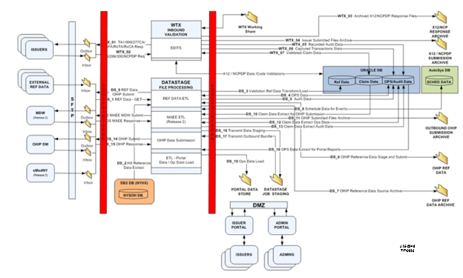
Figure 48. Encounter Intake End-to-End Process

Table 239 depicts the details of the Enterprise Logical Solution Architecture.

Category | Value
Process | The EIS, using DataStage and WebSphere Transformation Extender (WTX), will perform the Extract / Transform / Load (ETL) on inbound and outbound reference and encounter data. Statistics will be gathered and stored for file transfers. All inbound transaction files and outbound data feeds will be archived for the period of time required by the Data Retention Policies mandated by DOH.  Reference data will be collected from external sources and the NYSOH Exchange DB2 database. Additional Reference data will be collected from eMedNY. Reference data will be validated, transformed as required, and loaded into the appropriate repositories for use by the EIS as well as distribution to OHIP. Operational and Audit data will be stored in database tables.  Post Adjudicated Claims Data Reporting (PACDR) files in 837 and National Council for Prescription Drug Programs (NCPDP) PACDR formats will be received via SFTP into the Issuer’s inbound mailbox. The file will be picked up and moved to the appropriate folder for processing. The EIS will determine what type of inbound file has been received and begin processing. The EIS will perform editing and compliance checking for the inbound encounter formats and directly load the two-year Historical Database.  Acknowledgements for file receipt and processing reports will be sent to the Issuers’ outbound mailbox in compliance with the business processing rules as defined in the Implementation and Companion guides.  All data that is received, processed and stored in the EIS will be logged and audited in accordance with the security and data audit requirements.  Based upon an agreed-upon schedule, the EIS will extract, prepare, and transmit encounter and reference data to the OHIP DM. A separate file of all accepted MMC/CHP and EP encounters in Medicaid Analytical Extract for Encounters (MAEE) format will be made available for SFTP transfer to the MDW.  Issuer Encounter data submission statistics and data processing operational information will be stored in the database table and presented via the Portal. Encounter submission statistics will be available to both the Issuers and Administrators. The data processing operation information will be available via the Administrator Portal only, for use by the DOH PM staff.
Responsible Team | Encounters Team
Reference Documents | CR188 PDD Encounter Intake System for Release 1 and 2  CR1181 Changes to EIS for BHP
Table 239: Encounters Logical Solution Architecture

Figure 49 depicts the functions in the end-to-end EIS workflow and user experience.

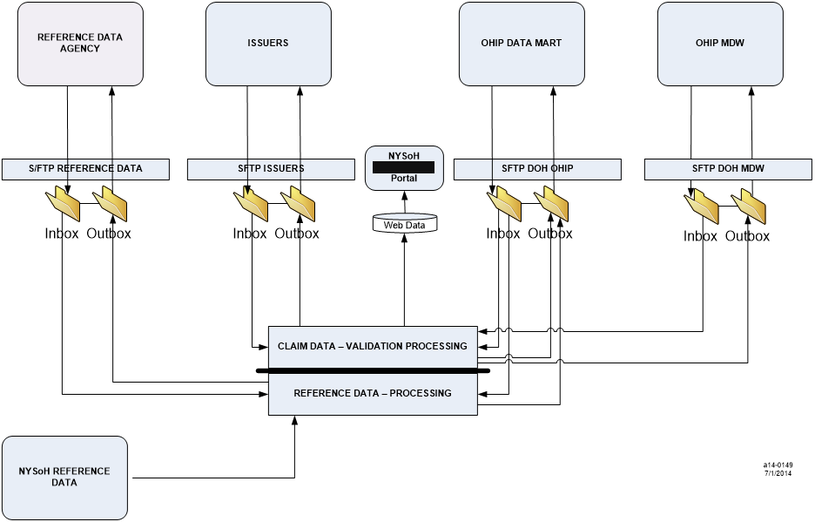
Figure 49. EIS Data Transfer Patterns

EIS Reference Data Flow
Reference Data will be retrieved from several sources. Data will be used by the EIS for Post Adjudicated Data Claims Report (PACDR) validation and also distributed to the OHIP Data Mart (DM). Some data files will be sent directly to the OHIP DM, other data files will be transformed within the EIS before being distributed.

Figure 50 describes how reference data flows from the data source to the EIS and OHIP Data Mart. Arrows moving from the Data Source to Encounter Intake show that data will be stored in the EIS for encounter validation. Arrows moving from Data Source to OHIP Data Mart indicate that the data is straight from the source. Arrows moving from Encounter Intake System to OHIP Data Mart indicate that the EIS will be involved with extracting necessary data from the source content for use by the OHIP Data Mart. Table 240 provides details.

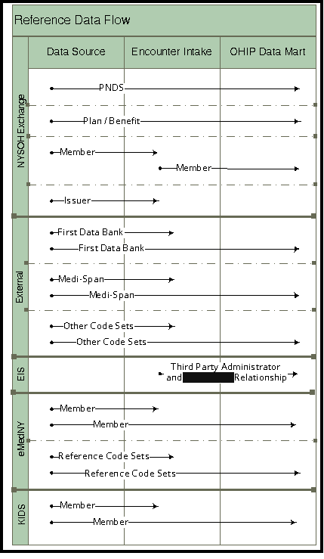
Figure 50. EIS Reference Data Flow

Category | Value
Process | Plan/Benefit data will not be needed within the EIS, the data will be passed directly through from NYSOH to the OHIP DM.  Member data in the NYSOH environment contains confidential information, including Federal Tax Information. Only specific data needed for EIS validation will be selected from the NYSOH environment and loaded into the EIS Oracle database. Federal Tax information will not be accessed by the EIS nor included in the tables that are sent to OHIP Data Mart The extracted member data distributed to the OHIP DM will be limited.  The EIS will only use the Issuer Identification Number or NYSOH New York Health Exchange (NYHX) ID from the Exchange Issuer data. The extracted Issuer data distributed to the OHIP DM will be limited.  External code sets will be used in two ways. The EIS will source, model, and maintain its own version of the data for encounter submission validation. Full sets of data will be distributed to the OHIP DM.  Files being distributed to the OHIP DM will be compressed and bundled using Tape Archive (TAR) and ZIP. The EIS will expect a proprietary response to confirm the file has been received. A response is expected for each file, even when multiple files are distributed within the same TAR/ZIP package.
Responsible Team | Encounters Team
Reference Documents | CR188 PDD Encounter Intake System for Release 1 and 2  CR 1497 Use NYHX ID for QHP Member Validation
Table 240: EIS Reference Process

Encounter File Submission Process
The EIS will accept 837 PACDR transactions in 298 Professional, 299 Institutional, 300 Dental, and NCPDP Post-Adjudication Standard Version 4.2 formats from Issuers. Figure 51 describes how encounter data flows from the Issuer to the EIS. For X12 transaction files, a Rejection (RJ) response will be returned for files where the Interchange Control Header (ISA), Functional Group Header (GS), Functional Group Trailer (GE), or Interchange Control Trailer (IEA) segments do not meet ‘form and fit’ or cannot be parsed. 837 PACDR transactions will return an RJ, or a TA1 and either a 999 or 277CA. NCPDP PACDR transactions will return an Rx Healthcare File Acknowledgement (RxFA) and either an Rx Healthcare Transaction Acknowledgement (RxTA) or Rx Healthcare Claim Acknowledgement (RxCA). Table 241 provides details.

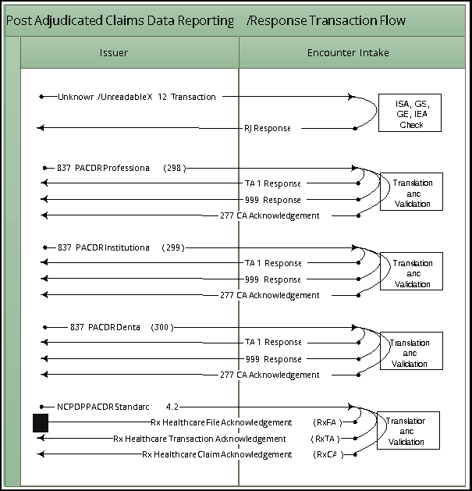
Figure 51. Transaction Flow for Encounter Intake Release

Category | Value
Process | Validation will be performed on the USERID within the file name. The IDs within the USERID must be valid and must match the Sender ID and Code within the file’s data. Overall file size and transaction counts will be evaluated against size restrictions. Verification will be done to validate the 837 Interchange Control and Functional Group segments (ISA/IEA and GS/GE envelopes) and NCPDP History Header and Trailer records. Readable transaction files (accepted or rejected) at this level will receive a TA1 or Rx Healthcare File Acknowledgement (RxFA).  Editing to confirm Implementation Guide form and fit (field format, required presence) will be performed. Only encounter transaction files failing form and fit will receive a 999 Acknowledgment for Health Care Insurance or Rx Healthcare Transaction Acknowledgement (RxTA). Encounter transaction files passing form and fit will be further validated against rules from the Implementation and Companion Guides. Encounter transactions reaching this level of validation will return a 277CA Health Care Claim Acknowledgement or Rx Healthcare Claim Acknowledgement (RxCA) with an acknowledgement code indicating an accepted or rejected status at the ‘claim’ level.
Responsible Team | Encounters Team
Reference Documents | CR188 PDD Encounter Intake System for Release 1 and 2  CR 1181 Changes to EIS for BHP  CR 1497 Use NYHX ID for QHP Member Validation  CR 1698 EIS Release 5 Sprint 3  CR 1874 EIS Release 6 Sprint 4/5  CR 1893 EIS Release 7 Sprint 6/7  CR 1901 EIS Release 8 Sprint 8/9  CR 1910 EIS Release 9 Sprint 10  CR 1919 EIS Release 10 Sprint 11/12  CR 1922 EIS Release 11 Sprint 13  CR 2062 EIS Release 17
Table 241: Transaction Flow for Encounter Intake System Process

Reference Data
External and NYSOH reference data encompasses the sourcing, modeling and maintenance of reference data received from external and NYSOH DB2 database sources. Two shell script processes will be used; one will load reference data into the Oracle database for WTX to use for validation and the other will prepare reference data for OHIP.

External Reference Data
External reference data is obtained from several sources as detailed in Table 242. The flow for EIS validation data will begin with a manual process to convert any files not in CSV into CSV file format. The CSV files will be placed in the In-box folder. DataStage will use this external reference data to load to the EIS Oracle database. WTX will access the EIS Oracle database for Encounter validation. Figure 52 provides an overview.

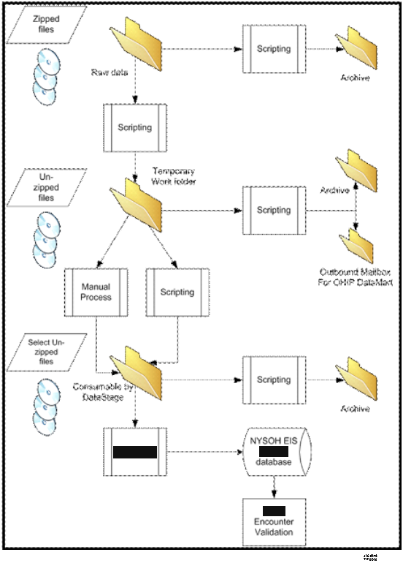
Figure 52. Transaction Flow for Encounter Intake System

Category | Value
Process | External reference data will be sourced using various methods depending on the media type. Data in its original raw format will be placed on the Network Attached Storage (NAS) server. Operational (Ops) data will be established, recording the file name and date received. The NYSOH Exchange DB2 database will be accessed for, Plan / Benefit, Member, and Issuer data.  Member and Issuer data will be stored in their own set of tables. A single table will be used to store all other external reference code sets.  External reference data for EIS validation is limited to just code values. The single table will include a field indicating the code set and the code value. WTX will access this table on the EIS Oracle database for Encounter validation.  Full versions (all columns) of the external reference data sets will be distributed to the OHIP DM.
Responsible Team | Encounters Team
Reference Documents | CR188 PDD Encounter Intake System for Release 1 and 2  CR 1497 Use NYHX ID for QHP Member Validation  CR 1698 EIS Release 5 Sprint 3  CR 1874 EIS Release 6 Sprint 4/5  CR 1893 EIS Release 7 Sprint 6/7  CR 1901 EIS Release 8 Sprint 8/9  CR 1910 EIS Release 9 Sprint 10  CR 1919 EIS Release 10 Sprint 11/12  CR 1922 EIS Release 11 Sprint 13  CR 2062 EIS Release 17
Table 242: External Reference Data

NYSOH Exchange Reference Data
The NYSOH Exchange DB2 database will be accessed for Issuer Plan/Benefit, Member, and Issuer data. Figure 53 provides an overview.

WTX will access the NYSOH Exchange DB2 database to utilize Issuer and Member data. WTX will use the information for encounter data validation. Table 243 provides details.

Data from the Issuer Plan/Benefit and Member reference areas will be extracted for the OHIP Data Mart.

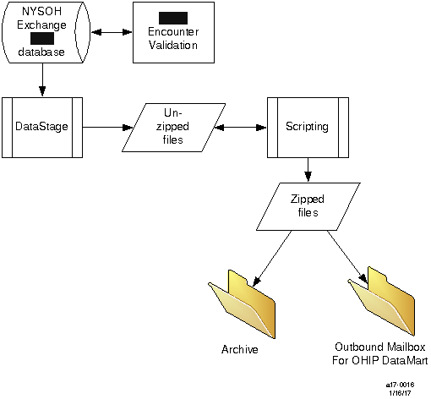
Figure 53. NYSOH Exchange Reference Data

Category | Value
Process | Issuer Plan/Benefit data includes details like the rates, benefits, costs for deductible, and maximum out of pocket amounts. Issuer Plan/Benefit data is not needed by the EIS for encounter validation. Issuer Plan/Benefit data will be supplied to the OHIP Data Mart.  Member data in the Exchange environment contains confidential information, including Federal Tax Information (FTI). Only specific data needed for EIS validation will be access by WTX for Encounter validation. The extracted member data distributed to the OHIP Data Mart will be limited. Federal Tax Information (FTI) will not be used by the EIS or distributed to the OHIP Data Mart.
Responsible Team | Encounters Team
Reference Documents | CR188 PDD Encounter Intake System for Release 1 and 2  CR 1181 Changes to EIS for BHP  CR 1497 Use NYHX ID for QHP Member Validation  CR 1698 EIS Release 5 Sprint 3  CR 1874 EIS Release 6 Sprint 4/5  CR 1893 EIS Release 7 Sprint 6/7  CR 1901 EIS Release 8 Sprint 8/9  CR 1910 EIS Release 9 Sprint 10  CR 1919 EIS Release 10 Sprint 11/12  CR 1922 EIS Release 11 Sprint 13  CR 2062 EIS Release 17
Table 243: NYSOH Exchange Reference Data Process

NYSOH EIS Reference Data
Information for Third Party Administrators (TPA) and their relationship with Issuers will be stored in the EIS Oracle database. Figure 54 shows the flow of data to be used by WTX and extracted for the OHIP DataMart. Table 244 provides details.

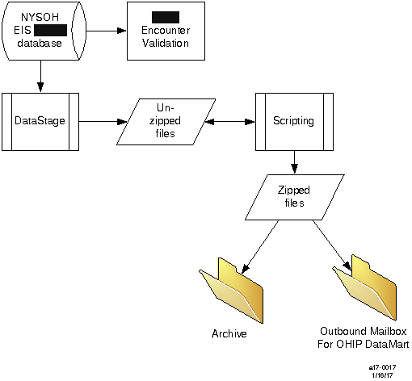
Figure 54. NYSOH EIS Reference Data

Category | Value
Process | Information for Third Party Administrators and their relationship with Issuers will be stored in the EIS Oracle database.  One table will be used to maintain the relationship between an Issuer and its TPAs. Separate tables will be used to store individual TPA information.  The Issuer TPA subject area will be used by WTX for the validation of Third Party Administrators and to verify a relationship between an Issuer and a TPA.  Information on both TPAs and Issuer’s relationship with the TPA’s will be provided to the OHIP Data Mart.
Responsible Team | Encounters Team
Reference Documents | CR188 PDD Encounter Intake System for Release 1 and 2  CR 1497 Use NYHX ID for QHP Member Validation  CR 1698 EIS Release 5 Sprint 3  CR 1874 EIS Release 6 Sprint 4/5  CR 1893 EIS Release 7 Sprint 6/7  CR 1901 EIS Release 8 Sprint 8/9  CR 1910 EIS Release 9 Sprint 10  CR 1919 EIS Release 10 Sprint 11/12  CR 1922 EIS Release 11 Sprint 13  CR 2062 EIS Release 17
Table 244: NYSOH EIS Reference Data

Encounter Operational Processing
The Encounter Processing business area encompasses: Encounter File Submission architecture; Encounter Data (modeling and maintenance); Encounter File Translation and Validation.

The Encounter File Submission is a process that manages the files submitted by Issuers. Table 245 describes the transactions received from and responses sent to Issuers, and the levels of editing performed.

Category | Value
Encounter File Submission | The system accepts Issuer submitted encounter files for processing in accordance with Trading Partner instructions. The acceptable encounter transaction formats are:  - Post Adjudicated Claims Data Reporting: Professional (837) 005010X298  - Post Adjudicated Claims Data Reporting: Institutional (837) 005010X299  - Post Adjudicated Claims Data Reporting: Dental (837) 005010X300  - NCPDP Post-Adjudication Standard Version 4.2 Post Adjudication History  In return, the Issuers can expect the following transactions:  - Interchange Acknowledgement (TA1)  - Implementation Acknowledgement for Health Care Insurance (999) 005010X231  - NCPDP Report (proprietary)  - Health Care Claim Acknowledgement (277CA) 005010X214  Each Issuer's File is picked up and the envelope sections will be verified (ISA/GS for X12 and Header/Trailer for NCPDP).
Editing Process | Tier I and Tier II editing is performed, which encompasses HIPAA Compliance Types 1 through 5.  Tier I file level editing includes Compliance Types 1 through 4:  - Type 1 (EDI Standard Integrity Testing) validates the basic syntactical integrity of the EDI submission. Type 1 conducts a test for valid segments, segment order, element attributes, numeric values in numeric data elements, validation of X12 or NCPDP syntax, and compliance with X12 rules.  - Type 2 (HIPAA Implementation Guide Requirement Testing) involves testing for HIPAA Implementation Guide specific syntax requirements, like limits on repeat counts, used and not used qualifiers, codes, elements, and segments.  - Type 3 (HIPAA Balance Testing) checks transaction balanced field totals, financial balancing of claims or remittance advice, balancing summary fields etc. Transaction balancing will occur within WTX. This will ensure the encounter Total Claim Charge balances with the sum of line level payments and claim level adjustments.  - Type 4 (HIPAA Inter-Segment Situation Testing) involves testing of specific inter-segment situations described in the HIPAA implementation guides, such that if A occurs then B must be populated, etc.  Tier II encounter level editing includes Compliance Type 5 and DOH requirements:  - Type 5 (HIPAA external code set testing) involves testing for valid Implementation Guide specific code set values and other code sets adopted as HIPAA standards such as ICD-9-CM or NDC code sets.  A 999 Acknowledgement (for X12 transactions) or NCPDP Report (proprietary) will be returned, containing any Tier I errors. Level 1 thru 4 errors will result in a complete file rejection. If no Tier I errors are found, the system will check the file for Tier II edits. A 277CA transaction will be returned detailing all accepted and rejected encounters subjected to Tier II editing.  For each WTX map in the system flows, a Map Execution Log file will be created containing summary results for every map execution in each system. A Monitoring System will read the Map Log file for errors, and archive each log file on NAS. If any errors are found in the log file for the map execution, then that Log file containing the map errors is archived into an Error Archive folder on NAS, and an email is generated to alert the appropriate team members of the potential issue.
Responsible Team | Encounters Team
Reference Documents | CR188 PDD Encounter Intake System for Release 1 and 2  CR 1181 Changes to EIS for BHP  CR 1497 Use NYHX ID for QHP Member Validation  CR 1698 EIS Release 5 Sprint 3  CR 1874 EIS Release 6 Sprint 4/5  CR 1893 EIS Release 7 Sprint 6/7  CR 1901 EIS Release 8 Sprint 8/9  CR 1910 EIS Release 9 Sprint 10  CR 1919 EIS Release 10 Sprint 11/12  CR 1922 EIS Release 11 Sprint 13  CR 2062 EIS Release 17
Table 245: Encounter Operational Processing

X12 Submission / Response / Acknowledgement Process
Figure 55 shows the full data path for when WTX first receives X12 data from the Issuers until a response has been returned to them. Table 246 provides details.

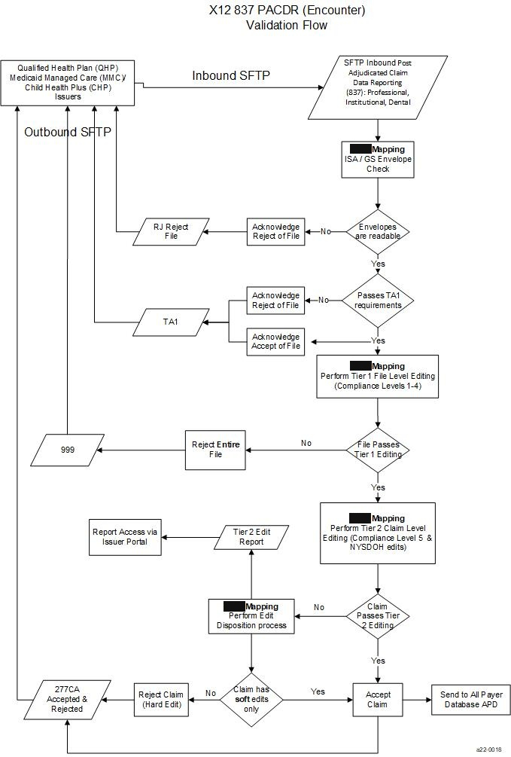
Figure 55. X12 Submission Process Workflow

Category | Value
X12 837 PACDR Validation Flow | TA1: An issuer sends an X12 Post Adjudicated Claim file via SFTP. If the filename or ISA/GS envelope information is incorrect, a TA1 handshake response will not be generated.  A TA1 will be immediately returned as confirmation that we successfully received the transmission and the envelope contents were valid and readable. If a duplicate Control Number is received in the ISA13 Interchange Control Number, then the TA1 will be sent with File Rejected. The file is staged for encounter validation which will be run as the processing schedule permits.  999: A batch job will process the issuer’s PACDR file. A 999 acknowledgement will be created when at least one Tier I error is found. Tier I edits on X12 transactions will contain all Type 1 through Type 4 HIPAA compliance types.  Any syntactical errors or Tier I errors in the file will result in a complete file rejection. The purpose of the 999 Functional Acknowledgement is to report whether the file passed standard level syntax and structure editing Tier I (Type 1 through Type 4) HIPAA compliance checks. Since any file failing Tier I edits will be completely rejected, the 999 response will only contain error information. A 999 will not include accepted transactions.  277CA: The EIS process will check to ensure functional edits are met (external code sets and logical validation). The 277CA will be created with the results of Tier II editing. Each claim will be reported on the 277CA:  - A = Accepted  - S = Accepted (Soft Edit) Incorrect, but allow to pass through at this time  - H = Rejected (Hard Edit) Incorrect and claim rejected.
Responsible Team | Encounters Team
Reference Documents | CR188 PDD Encounter Intake System for Release 1 and 2  CR1181 Changes to EIS for BHP  CR 1497 Use NYHX ID for QHP Member Validation  CR 1698 EIS Release 5 Sprint 3  CR 1874 EIS Release 6 Sprint 4/5  CR 1893 EIS Release 7 Sprint 6/7  CR 1901 EIS Release 8 Sprint 8/9  CR 1910 EIS Release 9 Sprint 10  CR 1919 EIS Release 10 Sprint 11/12  CR 1922 EIS Release 11 Sprint 13  CR 2062 EIS Release 17
Table 246: X12 Submission Process

NCPDP Submission / Response / Acknowledgment Process
Figure 56 shows the full data path for when WTX first receives NCPDP data from the Issuers until a response has been returned to them. Table 247 describes the NCPDP submission process and validation.

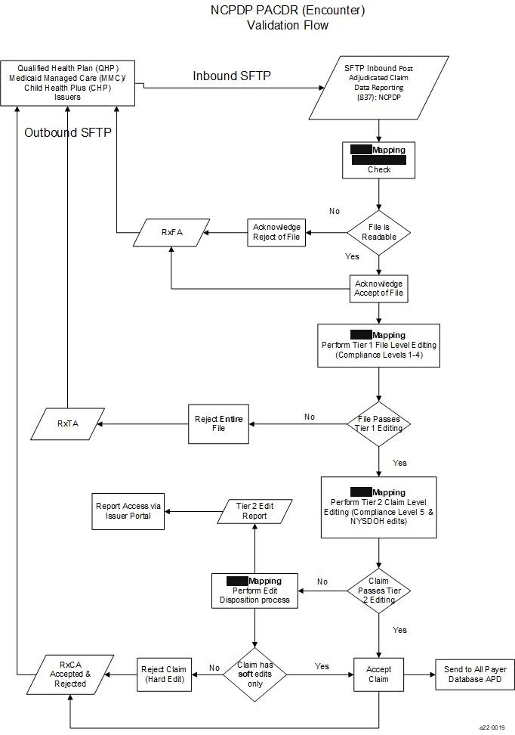
Figure 56. NCPDP Submission Process Diagram

Category | Value
NCPDP PACDR Validation Flow | An issuer sends an NCPDP Post Adjudicated Claim file via SFTP.  Rx Healthcare File Acknowledgement (RxFA): An RxFA will immediately be sent back indicating the file was accepted or rejected.  To ensure the transaction is intended for the EIS, the file name and Header record will be interrogated.  The USERID within the file name is matched against the data content. The Third Party Administrator ID (if applicable) and Issuer’s HIOS will be compared to the Sending Entity Identifier. If the file name USERID does not match the field within the data, the RxFA will be sent rejecting the file.  The USERID will contain either a Third Party Administrator ID and HIOS ID, or just the Issuer’s HIOS ID. The Third Party Administrator ID must exist on the table and must have an established relationship with the Issuer. The Issuer’s HIOS ID must exist on the table. If either ID is not on the table, or the two do not have a valid relationship, the RxFA will be sent rejecting the file.  The Receiver ID must be NYSOH-ENC. If the file is not intended for the EIS, the RxFA will be sent rejecting the file.  Overall file size and transactions counts will be evaluated against size restrictions. If the overall file size exceeds a predefined limit (50 mb), or if the transaction count exceeds a predefined limit, the TA1 will be sent with File Rejected.  The RxFA process will ensure that only one Header record, at least one Detail record, and only one Trailer record are included in the file. If the required records are not included, the RxFA will be sent with File Rejected.  If a duplicate Batch Number is received in the Header Record 806-5C Batch Number or problems are found within the Header or Trailer records, then the RxFA will be sent with File Rejected.  The RxFA will indicate whether the file was rejected or accepted for processing in the Encounter Intake System. If the file is rejected, the appropriate error code will be returned. If the file is accepted for processing, it will be staged for encounter validation which will be run as the processing schedule permits.  Rx Healthcare Transaction Acknowledgement (RxTA): A batch job will process the Issuer’s PACDR file. The RxTA proprietary report will be created as an acknowledgement for Tier I errors only.  Tier I edits on NCPDP transactions will only contain Type 1 and 2 HIPAA compliance types. Unlike an X12 999, the report will send back rejected records indicating the record type, transaction, and field in error.  Any syntactical errors or Tier I errors in the file will result in a complete file rejection; the report will contain only rejected claims. The report will not include accepted transactions.  Rx Healthcare Claim Acknowledgement (RxCA): The EIS process will check to ensure functional edits are met (external code sets and logical validation). The RxCA will be created with the results of Tier II editing. Each claim will be reported on the RxCA with a status code indicating the overall claim status. If errors are found during validation, the RxCA will include the field in error, an edit description, and whether the edit status is soft or hard.  If the filename or Header information is incorrect, a TA1 handshake response will not be generated.  A TA1 will immediately be returned as confirmation that EIS successfully received the transmission and the envelope contents were valid and readable. If a duplicate Batch Number is received in the Header Record 806-5C Batch Number, then the TA1 will be sent with File Rejected. The file is staged for encounter validation which will be run as the processing schedule permits.  Report (proprietary): A batch job will process the Issuer’s PACDR file; a proprietary report will be created as an acknowledgement for Tier I errors only. The report will not include accepted transactions.  Tier I edits on NCPDP transactions will only contain Type 1 HIPAA compliance types. Unlike a 999, the report will send back rejected records, but will not provide detail information as to the Type 1 errors.  Any syntactical errors or Tier I errors in the file will result in a complete file rejection; the report will contain only rejected claims. The report will not include accepted transactions.  277CA: The EIS process will check to ensure functional edits are met (external code sets and logical validation). The 277CA will be created with the results of Tier II editing. Each claim will reported on the 277CA:  - A = Accepted  - S = Accepted (Soft Edit) Incorrect, but allow to pass through at this time  H = Rejected (Hard Edit) Incorrect and claim rejected.
Responsible Team | Encounters Team
Reference Documents | CR188 PDD Encounter Intake System for Release 1 and 2  CR1181 Changes to EIS for BHP  CR 1497 Use NYHX ID for QHP Member Validation  CR 1698 EIS Release 5 Sprint 3  CR 1874 EIS Release 6 Sprint 4/5  CR 1893 EIS Release 7 Sprint 6/7  CR 1901 EIS Release 8 Sprint 8/9  CR 1910 EIS Release 9 Sprint 10  CR 1919 EIS Release 10 Sprint 11/12  CR 1922 EIS Release 11 Sprint 13  CR 2062 EIS Release 17
Table 247: NCPDP Submission Process

APD Data Delivery
APD Data Delivery encompasses the creation and delivery of encounter and reference extract files to the OHIP DM. Table 248 provides details.

Category | Value
Data Extract Creation and Distribution | The EIS will create and distribute encounter and reference data extracts for the OHIP DM on a weekly basis. Each week, data is assigned to a cycle number. The cycle number will be generated and incremented by 1 so that each week data is identified with a unique cycle number. To accommodate downstream processes, the EIS cycle number will be in sync with eMedNY.  X12 and NCPDP encounter data extracts will be created from PACDR data stored in the Oracle database. Each database table will be managed as one flat file. Each row will contain a processing indicator to designate data to be extracted for the cycle. Extracted data will be compressed and bundled using TAR and ZIP. X12 Professional, Institutional, and Dental will be in one bundle, NCPDP will be in a separate bundle. The encounter extract bundles will be placed in the OHIP DM outbound mailbox.  Reference data will come from either the NYSOH Exchange DB2 database or external sources. Data sourced from the Exchange DB2 database will include Member, Plan/Benefit, and Issuer. Data acquired from other sources will include First DataBank, Medi-Span, National Uniform Billing Committee (NUBC), and Centers for Medicare & Medicaid Services (CMS), and Washington Publishing Company (WPC). The complete list of reference datasets are in Attachment 1 Reference Code Sets.  NYSOH Member Data will contain enrollment information for all members that have been enrolled or changed their enrollment information during the month. The fields extracted for OHIP will exclude sensitive data such as Social Security Number.  Plan/Benefit data from the NYSOH Exchange will contain information on the plans and benefits available through NYSOH during the period.  Reference data received from external sources comes in many formats. The format will be converted into Comma Separated Value (CSV) for distribution. The content of the sourced data will be intact.  Data from the reference Staging In-box and the Exchange DB2 database will be compressed and bundled using TAR and ZIP. OHIP will retrieve the Reference data from the OHIP DM folder.  The EIS will perform tracking and monitoring of the distribution of the encounter and reference extract files to the OHIP DM.  DataStage  There are three different types of jobs performed in the ETL DataStage tool:  - ‘X12’ Flat-File Generation: ETL job to pull X12 encounter data from the Oracle database and generate flat files.  - ‘NCPDP’ Flat-File Generation: ETL job to pull NCPDP encounter data from the Oracle database and generate flat files.  - Reference Data Transformation: ETL job to pull reference data from the DB2 database and generate the flat file for OHIP DM.  The DataStage jobs are stored in the DataStage local project repository. The jobs can be exported in the .dsx file from DataStage to move into the configuration management repository work space to check-in.  The DataStage jobs are executed using DataStage execution script. Archiving is performed using the Archive script. These scripts are scheduled in the AutoSys scheduling tool to run at a specific time on a weekly basis.
Responsible Team | Encounters Team
Reference Documents | CR188 PDD Encounter Intake System for Release 1 and 2  CR1181 Changes to EIS for BHP  CR 1497 Use NYHX ID for QHP Member Validation  CR 1698 EIS Release 5 Sprint 3  CR 1874 EIS Release 6 Sprint 4/5  CR 1893 EIS Release 7 Sprint 6/7  CR 1901 EIS Release 8 Sprint 8/9  CR 1910 EIS Release 9 Sprint 10  CR 1919 EIS Release 10 Sprint 11/12  CR 1922 EIS Release 11 Sprint 13  CR 2062 EIS Release 17
Table 248: APD for EIS process

MAEE Data Delivery
MAEE Data Delivery encompasses the creation and delivery of the Medicaid Analytical Extract for Encounters (MAEE) to the Medicaid Data Warehouse (MDW). Table 249 provides details.

Category | Value
Data Extract Creation and Distribution | The EIS will create and distribute the MAEE file for the MDW on a weekly basis. Each week, data is assigned to a cycle number. The cycle number will be generated and incremented by 1 so that each week data is identified with a unique cycle number. To accommodate downstream processes, the EIS cycle number will be in sync with eMedNY.  DataStage ETL jobs pull Encounters data from EIS Oracle database, uses Member data from NYSOH – DB2 database, and accesses translation tables in the EIS Oracle database to perform necessary transformations. MAEE DataStage jobs are run daily, the master file is generated weekly for each cycle on Thursday.  The DataStage jobs are stored in the DataStage local project repository. The jobs can be exported in the .dsx file from DataStage to move into the configuration management repository work space to check-in.  The DataStage jobs are executed using DataStage execution script. Archiving is performed using the Archive script. These scripts are scheduled in the AutoSys scheduling tool to run at a specific time on a weekly basis.  The EIS will perform tracking and monitoring of the distribution of the encounter and reference extract files to the OHIP DM.
Responsible Team | Encounters Team
Reference Documents | CR188 PDD Encounter Intake System for Release 1 and 2  CR1181 Changes to EIS for BHP  CR 1497 Use NYHX ID for QHP Member Validation  CR 1698 EIS Release 5 Sprint 3  CR 1874 EIS Release 6 Sprint 4/5  CR 1893 EIS Release 7 Sprint 6/7  CR 1901 EIS Release 8 Sprint 8/9  CR 1910 EIS Release 9 Sprint 10  CR 1919 EIS Release 10 Sprint 11/12  CR 1922 EIS Release 11 Sprint 13  CR 2062 EIS Release 17
Table 249: DataStage Extract Process

Quarantine Process for Issuer/TPA File Transfer
As part of the EIS data management activities, Issuers and their Third Party Administrators send raw 837/NCPDP files to a designated mailbox on an SFTP site. In the event of an issue with the data a program via WTX investigates the file programmatically to determine if there are issues. If there are a quarantine process is invoked to ensure the questionable data does not get loaded into the system. The following process is in place once a file is quarantined.

Test File Submission Quarantine Process
If a file fails the check for non-compliant test member IDs, it is quarantined on the server. Then, an email is sent to ISSO (Security and Compliance), Program Manager, Issuer Support Services and NYSDOH representative. Security and Compliance takes the following actions:
- Assigns a reference number for the event
- Notifies NYSDOH Legal Affairs and DOH Information Security Officer.
- Security and Compliance completes the form detailing information about the event and sends that with his recommendation to NYSDOH Legal.
- Security and Compliance notifies GDIT Architecture team that the file should be deleted from the server and all backups.
- After receiving confirmation that the file has been removed, Security and Compliance notifies NYSDOH Legal that it has been removed.
- The offending Issuer is notified via email and a follow up meeting is set up with the Issuer and/or TPA.
- Security and Compliance team, along with Issuer Support staff hold a conference call with the Issuer to reinforce the serious nature of the event and determine if the data contained in the file came from their test or production environment.
- Once the resolution and remediation is complete, Security and Compliance closes the tracking of the event.
Draft Encounter Quarantine Email Message:
The file submitted has failed the test member ID editing and validation. This edit is in place to ensure that the file contains test member data. The submitted file has been quarantined and will not be processed by the Encounter Intake System.
Please have your Information Security Officer respond to the GDIT BML Account ([REDACTED], [REDACTED] ) and cc the APD Team ([REDACTED]) within one business day to advise us whether the submitted member information was test or production data.
Thank you,
GDIT Issuer Support
Encounter Intake System

NYSOH Operational Security (OPSEC) and Compliance
As the NYSOH operational environment changes, the Security, Compliance and Privacy team has transitioned into an Operational Security (OPSEC) mode and executes processes initially developed during the pre-go live and first year of operations for NYSOH. To this extent this section outlines all the operational standards and processes in place for day-to-day security operations.

The OPSEC process is most effective when fully integrated into all planning and operational processes of the NYSOH including production, and development.

This OPSEC Plan constitutes the "Standard Operating Procedures" relating to physical, cyber, operational and procedural security across the enterprise. It contains a comprehensive overview of the security program, and in some sections, makes reference to other relevant plans and procedures.

The purpose of the OPSEC O&M plan is to provide an overview of the security requirements and standard of the system and describe the controls in place or planned for meeting those operational requirements and in direct support of the NYSOH SSP and SSR. The OPSEC plan also delineates responsibilities and expected behavior of all individuals who access the system. This section of the O&M should be viewed as documentation of the structured process of planning adequate, cost-effective security protection for a system. It reflects input from various managers with responsibilities concerning the system, including information owners, the system owner, and the Agency (NYSDOH) Chief Information Security Officer (CISO) and also significant input from the agency Legal Affairs office. The following sections provide all the latest implementations, operational activities and requirements in order to meet CMS and IRS mandated controls.

System and Data Center Security Incident Management

Systems Incident Management
When it has been determined that a security incident has occurred, both DOH and GDIT Management will work in cooperation to investigate and resolve the incident based on the Incident Response Procedures.

The following events may qualify as Security Incidents:
- System failure / Loss of service
- Malicious Code incidents (viruses, worms, other malware)
- Loss of integrity of software or other system components
- Breaches of confidentiality or integrity
- Misuses of system
- Inappropriate physical access to sensitive data

GDIT Incident Response Control Center and RDC Incident Response Management
When a security incident has been identified the risk level will be assigned based on information obtained by discussion with the identifier, review of the Response alerts, and review of vendor-based alerts. The identifier information is in the Business Continuity and Disaster Recovery Plan document. Appendix A (Disaster Recovery Procedures) and Appendix B (NYSOH Emergency Call List (ECL)) of this O&M Manual contain the points of contact for any incident. The risk levels will be determined from these personnel. Risk levels, the general level of impact they categorize, and the recommended timeframe for taking action on them, are as follows in Table 250 . Steps and procedures for security incident responses are in Section 17.1.2 and presented in Table 251.

Security Impact Assessment (SIA):
The Patch and Vulnerability Group (PVG) reviews the vulnerability details of infrastructure scanning results: exploits, Common Vulnerability Scoring System (CVSS), National Vulnerability Database (NVD) score, network mappings, domains, segments, and the entire application environment, and makes a determination based on the NVD score and the NYSoH environmental mitigating factors to the vulnerabilities impact and severity. Once the severity is identified: Critical, High, Medium or Low by the PVG we have a path to remediation. Recurring reviews with the DOH Security Team provide information on current vulnerability status. Internal remediation schedules are discussed with all stakeholders which consider vulnerability categories and Exchange priorities.

Category | Value
Critical | Requires immediate action for containment and communication. Threat is impacting the GDIT environment. Must be managed with a detailed plan and high priority. This level will always result in escalation to the Program Executive, GDIT Program ISSO, Cyber Security Engineering, Privacy, Resiliency Operations (CSEPRO) Cyber Security Manager and Product Line leads with scheduled status and information calls.
High | Requires rapid response. May or may not require immediate escalation to the Program Executive, GDIT Program ISSO, CSEPRO Cyber Security Manager and Product Line Leads, but will always require email and pager notification of the threat.
Medium | Management responsibility must be specified. To be included in next regularly scheduled patch.
Low | Requires an email communication be sent to the Product Lines leads.
Table 250: Incident Risk Levels

Steps and Procedures for system and Data Center Security Incident Response
Category | Value
Activity 1: Incident Reporting | - Report from employee or other person identifying that an incident has occurred.  - Alarm(s) from Network Intrusion Detection System (NIDS)  - Firewall Log Monitoring, or IPS identifying that an incident has occurred (identified by MST).
Steps if Identified by a Person | NOTE: GDIT or NYSDOH backend users, employees, contractors, and managers are responsible for ensuring that the NYSOH system is not compromised in any way and for reporting all known incidents as outlined and agreed to in the Rules of Behavior document.  - The person identifying the incident reports this to his or her manager and to the RDC Cyber Security Director or Cyber Security Senior Manager, (TSS CSEPRO).  - The manager or CSEPRO Data Security team reports the incident to the GDIT Program Information System Security Officer (ISSO) and the CSEPRO Data Security Manager.  - The GDIT Program ISSO reports the incident to NYSDOH CISO and to the MST SOC.  - If the incident involves a potential breach of PHI, the GDIT Program ISSO reports the incident to the NYSDOH CISO as soon as possible, but no later than 24 hours after learning of the incident. The NYSDOH CISO will then follow the notification guidelines for potential breaches of PHI. If the incident involves a potential breach of FTI, the GDIT Program ISSO reports the incident to the NYSDOH CISO, who in turn may request that GDIT legal representative report the incident to the Treasury Inspector General for Tax Administration (TIGTA) and the IRS Office of Safeguards. IRS rules require that TIGTA and the IRS Office of Safeguards be notified immediately, but no later than 24-hours after identification of a possible issue involving FTI. (Pub. 1075, 1.8.4)
Steps if Identified by MST | - The MST person identifying the compromise reports it to the MST manager and the MST manager reports to the RDC Data Security team and the GDIT Program ISSO.  - The ISSO reports the incident to the NYSDOH CISO.  - If the incident involves a potential breach of PHI, the ISSO reports the incident to the GDIT Program ISSO ASAP (as soon as possible). The NYSDOH CISO will then follow the notification guidelines for potential breaches of PHI. If the incident involves a potential breach of FTI, the GDIT Program ISSO reports the incident to the NYSDOH CISO, who in turn may request that GDIT report the incident to the TIGTA and the IRS Office of Safeguards. IRS rules require that TIGTA and the IRS Office of Safeguards be notified immediately, but no later than 24 hours after identification of a possible issue involving FTI (Pub. 1075, 1.8.4).
Output | Incident is Noted.
Reference Documents | GDIT Security Incident Management Procedures
Activity 2: Incident Reporting | NOTE: The degree and intensity with which GDIT reacts to an event varies by alert category.  - Automated alerts generated by the MST are categorized as Critical, Warning, or Informational and are defined based on a number of factors, which, when combined, determine the overall severity level of an event. To determine the level of response, the following factors are used: assessing the event to ascertain the likelihood of attack and system risk of exposure; the level of threat posed by, or possible consequence resulting from, the event; the ability of the event to compromise the confidentiality, integrity, or availability of information; and the severity level as assigned by the technology used in the detection or correlation of the event (i.e., IDS Vendor Alert Category).  - Incidents reported by staff are evaluated by the CSEPRO staff and the GDIT Program ISSO, who will designate a criticality rating.
Input | Incident Information, e.g., person or machine affected, time of incident, initial observations
Steps | NOTE: GDIT provides an incident response support resource in the form of a User Help Desk. Help Desk personnel are trained in incident response procedures and can assist end users by detailing the steps the end users must take.  - CSEPRO validates incident; accumulates and obtains incident data; reports incident and identifies escalation actions taken to the GDIT Program ISSO and NYSDOH CISO.  - GDIT Senior Management initiates Service Restoration Team (SRT) or Collaborative Work Bridge (CWB) activity, if appropriate, by notifying the Command Center.  - CSEPRO captures any NYS ticket numbers or other information from NYSDOH Security Representative for each reported incident.  Note: If the incident has not escalated and the GDIT Cyber Security team determines that it can be readily contained without affecting the NYSOH system, CSEPRO performs necessary remediation and informs the GDIT Security and Privacy Team who informs the NYSDOH CISO of measures taken and results. If escalation is required, steps 3 and 4 are performed.  - GDIT Cyber security directs NYSOH Security personnel on mitigation and remediation options.  - The GDIT Security and Privacy Team reports the incident to NYSDOH CISO.  - GDIT Security and Privacy Team directs NYSOH Security personnel on mitigation and remediation options.  - Incident report made available on web portal.  - NYSDOH CISO determines any additional steps for the MST or local GDIT Cyber security resources. GDIT Security and Privacy Team requests that MST or local GDIT Cyber Security resources perform additional steps, attain results, and contain incident.  - Incident is contained.  NOTE: An incident report is made available to the GDIT Program Information System Security Officer (ISSO) and authorized personnel via the GDIT MST web portal, within one hour of the incident occurrence if the incident has been escalated. This report documents Alert activity and response suggestions. In the event an alert should be repeated, an updated report is provided, detailing the new information relative to the event. Repeating alerts are reported a maximum of three times within a 24 hour period. MST staff includes a ticket number noted within the Reference Number section of each incident report. It is the responsibility of the NYSDOH Security Representative to provide the GDIT Security and Privacy Lead (who provides the information to MST) with any updates to the incident to be added to the ticket for inclusion in the incident report.
Output | Incident Report is filed and Incident is contained.
Reference Documents | NYSOH Security Policy Handbook  NYSOH Security Procedure & Guideline Handbook
Activity 3: Root Cause Analysis (RCA)
Input | Incident is contained.
Steps | - Perform RCA procedure and determine cause of incident.  - Assign RCA report responsibility to appropriate Line of Service  - Evaluate and adjust/refine sensor policy based on results of any post mortem (MST).
Output | RCA report (See RCA procedures for more information on the RCA report.)
Reference Documents | NYSOH Security Policy Handbook  NYSOH Security Procedure & Guideline Handbook
Table 251: Steps and Procedures for Security Incident Responses

Operational Security Incident Management
This section outlines the operational processes associated with day to day Incident Management at the business and operational levels.

Pursuant to the NY State of Health’s data sharing agreements with the Centers for Medicare and Medicaid Services (CMS)², the terms “Incident,” “Breach” and “PII” (personally identifiable information) are specifically defined as set forth below.

² Computer Matching Agreement between CMS and State-Based Administering Entities for The Disclosure of Insurance Affordability Programs Information Under the Patient Protection and Affordable Care Act, Computer Matching Agreement No. 2018-10, HHS No. 1302, §III (Definitions), §13; Master Interconnection Agreement between CMS and Connecting Entities to the CMS Data Services Hub (2019-2022), §13.

- “Incident” means the act of violating an explicit or implied security policy, which includes attempts (failed or successful) to gain unauthorized access to a system or its data, unwanted disruption or denial of service, the unauthorized use of a system for the processing or storage of data; and changes to system hardware, firmware or software characteristics without the owner’s knowledge, instruction or consent.

Incidents include the loss of data through theft or device misplacement, loss or misplacement of hardcopy documents, and misrouting of mail, all of which may have the potential to put the data at risk of unauthorized access, use, disclosure, modification or destruction. While certain adverse events (e.g., floods, fires, electrical outages, excessive heat, etc.) can cause system crashes, they are not considered incidents.

An incident becomes a breach when there is the loss of control, compromise, unauthorized disclosure, unauthorized acquisition, unauthorized access, or any similar term referring to situations where persons other than authorized users and for an other than authorized purpose have access or potential access to personally identifiable information [PII] or personal health information [PHI], whether physical or electronic.
- “Breach” is defined by Office of Management and Budget (OMB) Memorandum M-17-12, Safeguarding and Responding to the Breach of Personally Identifiable Information, January 3, 2017, as the loss of control, compromise, unauthorized disclosure, unauthorized acquisition, or any similar occurrence where (1) a person other than an authorized user accesses or potentially accesses personally identifiable information or (2) an authorized user accesses or potentially accesses personally identifiable information for an other than authorized purpose.
- “PII” means personally identifiable information as defined by OMB Memorandum M-17-12 (January 3, 2017). (“The term PII refers to information that can be used to distinguish or trace an individual’s identity, either alone or when combined with other information that is linked or linkable to a specific individual. Because there are many different types of information that can be used to distinguish or trace an individual’s identity, the term PII is necessarily broad. To determine whether information is PII, the agency shall perform an assessment of the specific risk that an individual can be identified using the information with other information that is linked or linkable to the individual. In performing this assessment, it is important to recognize that information that is not PII can become PII whenever additional information becomes available – in any medium or from any source – that would make it possible to identify an individual. ”).

NYSOH (as a State-based Administering Entity or AE) is required to:
“report suspected or confirmed incidents affecting loss or suspected loss of PII within one hour of discovery to their designated CCIIO State Officer who will then notify the affected Federal agency sources * * * Additionally, AEs shall contact the office of the appropriate special agent in charge, Treasury Inspector General for Tax Administration (TIGTA), and the IRS Office of Safeguards within 24 hours of discovery of any potential breach, loss, or misuse of return information…” [See, Computer Matching Agreement § XI (B)(2), Safeguards and Incident Reporting, Emphasis added.]

NOTIFICATION / RESPONSE PROCEDURE
1. Notification:
A) DOH and GDIT
Any potential security issue identified by DOH or GDIT staff should be reported to the appropriate supervisor and the NY State of Health Security team by completing the attached Security and Privacy Concern Form and attaching it to an e-mail as follows:
Security e-mail address: [REDACTED]
cc: Supervisor
Subject Heading: Concern Form
Body of e-mail: Form attached.
Staff will be trained not to include PII in the Security and Privacy Concern Form.
B) MAXIMUS
MAXIMUS personnel manning the Customer Service Center have been trained by and will report to MAXIMUS Privacy and Security Personnel, which shall report to DOH.
2. Response
A) Investigation
The NY State of Health Security Team which includes information security officers with the support of legal will investigate individual issues and concerns to:
- Determine if PII is involved,
- Analyze the issue as outlined in these Guidelines, including determining whether each issue:
1) Is an “Incident” affecting loss or suspected loss of PII³ as defined by CMS, which must be reported to CMS by calling [REDACTED] or by email [REDACTED] and to the NY State of Health’s designated CCIIO State Officer within one (1) hour of discovery⁴;
³ See, CMA §§ XI (B)(2)
⁴ See, CMA §XI(B)(2)
OR is a “Breach” (involving PII) as defined by CMS / OMB M-17-12, also requiring reporting to CMS within one (1) hour.
2) Involves Federal Tax Information or “FTI” which requires reporting to the IRS Treasury Inspector General for Tax Administration “TIGTA” immediately, but no later than 24 hours after the identification of the possible incident ([REDACTED]). The direct number for the Local TIGTA Field Division Office is maintained in the access-controlled incident-response annex.
3) Is defined as a “Breach” (involving PHI) under HIPAA;
4) Is an “infraction” or “concern”, which requires that the manager of the program area be notified and the employee(s) involved be counseled.
When an issue is categorized as outlined herein the appropriate notification (if any) will be identified and completed, and the issue will be tracked. Table 252 lists the current members for notification.

New York State of Health - Security and Privacy Team
The members of the NYSOH Security and Privacy Team are show in Table 252.

Name | Affiliation | Phone | eMail
[REDACTED] | NYSDOH CISO | [REDACTED] | [REDACTED] – monitored group inbox
[REDACTED] | GDIT Program ISSO | [REDACTED] | [REDACTED] – monitored group inbox
[REDACTED] | NYSOH Legal | [REDACTED] | [REDACTED] – monitored group inbox
[REDACTED] | NYSOH Business Owner | [REDACTED] | [REDACTED] – monitored group inbox
Table 252: NYSOH Security and Privacy Team 2024

Classification of Security Issues and Concerns
Historically, NYSOH has referred to security issues generally as “incidents.” To comply with CMS guidelines and facilitate tracking, NYSOH’s Security team will classify security issues and concerns that are identified as set forth in Table 253.

Level | Category | Description | Example | Internal Reporting (other than security team) | External Reporting
0 | Concern | Any Issue that challenges an approved policy, but no loss of PII | Sensitive papers left on a desk or printer in a secure program area. | Supervisor of program area involved | No
1 | Infraction | Any lack of compliance with an approved policy that may or may not involve PII; but no loss of PII | Unencrypted email sent to authorized users containing a file that should be encrypted.  Use of a USB device, CD/ROM or External Hard Drive without an approved exception. | Supervisor of program area involved. | No
2 | Incident as defined by CMS | An act of violating an explicit or implied security policy, which includes attempts (failed or successful) to gain unauthorized access to a system or its data.  Unwanted disruption or denial of service.  Unauthorized use of a system.  Changes to hardware or software w/o consent.  Loss of data through theft or misplacement, including misrouting of mail. | Malicious Code; Scans, probes, attempted unauthorized access to system.  Unauthorized access or use by an individual user;  Loss of hardcopy documents or device (i.e. laptop). | Supervisor of program area involved.  IT Systems team if a system issue.  If suspected loss of PII, DOH HIPAA Privacy Officer. | Suspected or confirmed incidents affecting loss or suspected loss of PII must be reported to CMS within 1 hour of discovery and confirmation  If FTI is involved, IRS must be notified immediately, but not more than 24 hours after discovery.
3 | Breach of PII  (CMS / OMB definition) | Loss of control, Compromise, unauthorized disclosure, unauthorized acquisition, unauthorized access  or other situation where persons other than authorized users have access or potential access to PII or PHI whether physical or electronic. | USB thumb drive misplaced or stolen that contains PII  Document containing PII accessible to person other than authorized user | Supervisor of program area involved  DOH’s HIPAA Privacy Officer for review | Suspected or confirmed incidents affecting loss or suspected loss of PII must be reported to CMS within 1 hour of discovery and confirmation  If FTI is involved, IRS must be notified immediately, but not more than 24 hours after discovery  Consumer if required
4 | HIPAA Breach (involving PHI) | Acquisition, access, use or disclosure of PHI in a manner not permitted by HIPAA |  | Supervisor of Program Area involved  DOH HIPAA Privacy Officer | Suspected or confirmed incidents affecting loss or suspected loss of PII must be reported to CMS within 1 hour of discovery and confirmation  If FTI is involved, IRS must be notified immediately, but not more than 24 hours after discovery  If more than 500 people affected, notice to HHS within 60 days. Also media notification requirements if greater than 500.  If less than 500, notice to HHS within 60 days following end of calendar year.  Consumer notification
Table 253: Operational Security Incident Category Table
Information security officers will investigate incoming issues and concerns and in collaboration with NYSDOH legal affairs officers will classify each issue as set forth above.

Key Requirements Upon Investigation by Program Information Security Officer(s)
- Upon a review and validation by the program Information Security Officer and NYSDOH Legal that a reported concern is an “Incident” or “Breach” as defined by CMS, NYSDOH will contact CMS.
- Upon identification and validation of NYSDOH Legal Affairs of a possible issue involving Federal Tax Information NYSDOH Legal Affairs shall contact the TIGTA and the IRS Office of Safeguards.
- Upon a review and validation by the program Information Security Officer of a reported concern or infraction, the employee(s) involved will be counseled on compliance with security policy.

For details on Security Incident Response, see the following documents in Table 254.

NYSOH Policies and Procedures
NYSOH Security Policy Handbook
NYSOH Security Procedure & Guideline Handbook
CMS Security and Privacy Incident Report Template
CMS Incident Handling Procedure-CMS Chapter-8-RMH-Incident-Response
Table 254: Applicable NYSOH Policies

Security and Privacy Incident Reporting
All forms used for NYSOH Security and Privacy are located in Appendix I NYSOH Operational Security Forms of this document.

Operational Security Incident Processes
Figure 57 outlines the processes when a potential concern or incident is identified.

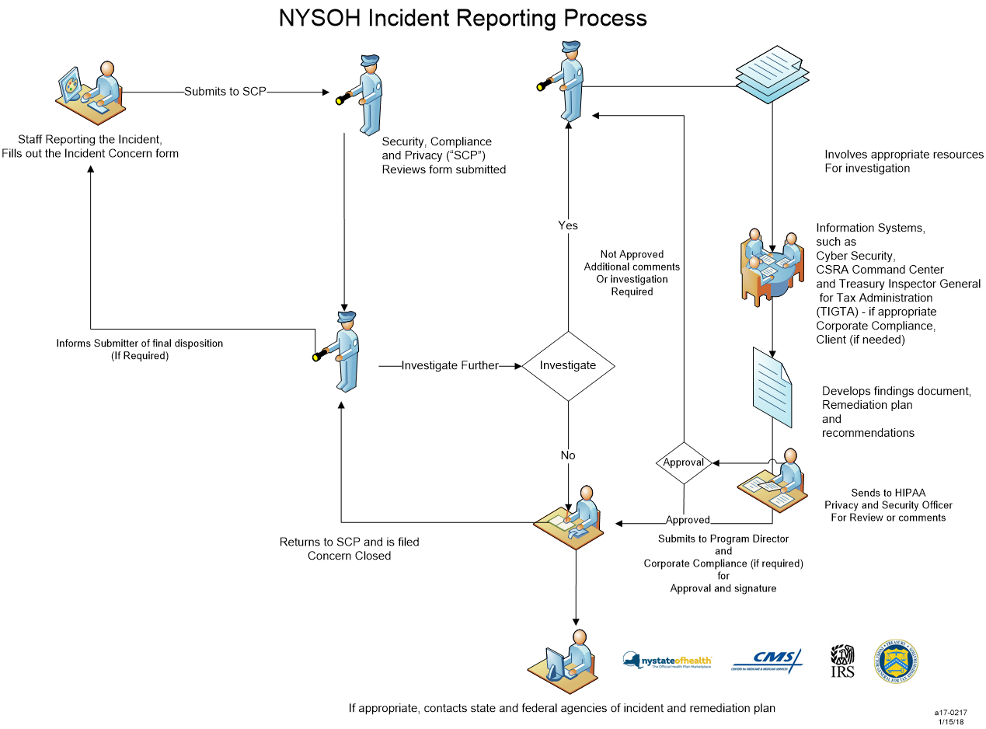
Figure 57. NYSOH Operational and Reporting of an Incident

Figure 58 depicts the process when an incident is identified and the process for completing the investigation and submitting the transmittals.

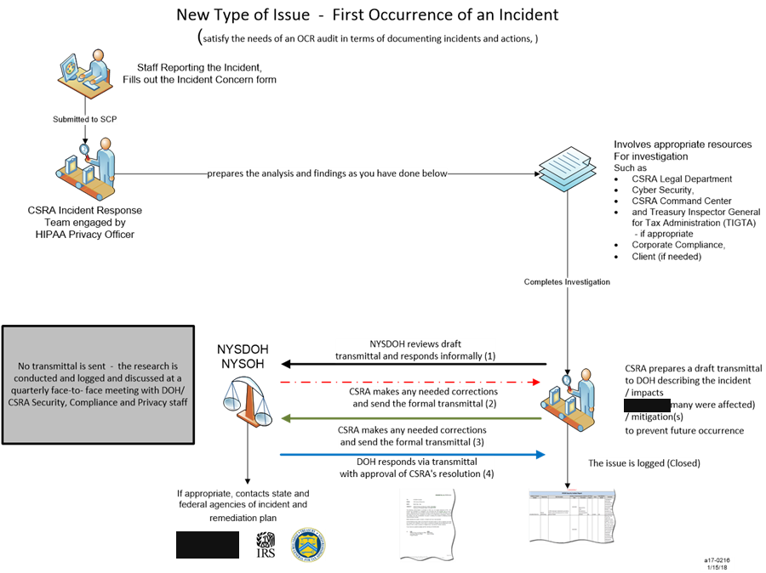
Figure 58. Transmittal Workflow for Security Incident Response

This section provides operational process associated with information security and compliance procedures for the NYSOH. Table 255 provides details.

Security and Privacy (Incident) Management and Monitoring Detailed Process
Category | Value
Incident Monitoring and Reporting | - SCP provides oversight of security incidents reported into either NYSDOH or to the GDIT Program ISSO.
Steps | - Once an incident or concern report is sent, ISSO’s review the report.  - The incident, along with the details is recorded.  - Record on the weekly NYSOH Incident Report Summary.  - Incident form is sent to individual who reported the incident.  - Copy to appropriate NYSOH program senior leadership.  - Investigation begins.
Investigation | - Acquire all necessary emails, documentation and the resources involved in the incident.  - Document all material received.
Depending on Severity | If the severity is “Critical/High” contact the NYSOH Program ISSO, the GDIT NYSOH Program Management Office and GDIT Legal department.
Develop Findings Report | Document all chronology, findings, mitigations, and preliminary conclusions.
Review | Send all material collected from the investigation to the HIPAA Privacy Officer and GDIT Legal for review and determination of notification (if required)
Transmittal | After submitting the package to the above, develop a transmittal letter and collect a transmittal number from the GDIT Executive Administrator.
Final Program Management Review | Submit the final package including the transmittal letter to the GDIT program Executive
Submit to NYSDOH | Upon approval from GDIT Program executive, provide the package to the GDIT Program Executive Administrator for submission to client via the transmittal process.
Table 255: Incident Management and Monitoring

Refer to the Communication Plan for additional details and reference.

Back Office and Active Directory User Access and Provisioning for MAXIMUS
This section provides details on the Back Office User Access and applies only to Back Office support personnel for MAXIMUS.

How to add MAXIMUS Siebel Users for NYSOH
MAXIMUS Request: The detailed step-by-step provisioning procedure, including portal paths, directory and organizational-unit structure, and password handling, is maintained in an access-controlled runbook and has been removed from this distributed copy.
- [REDACTED]

- [REDACTED] See Figure 59.
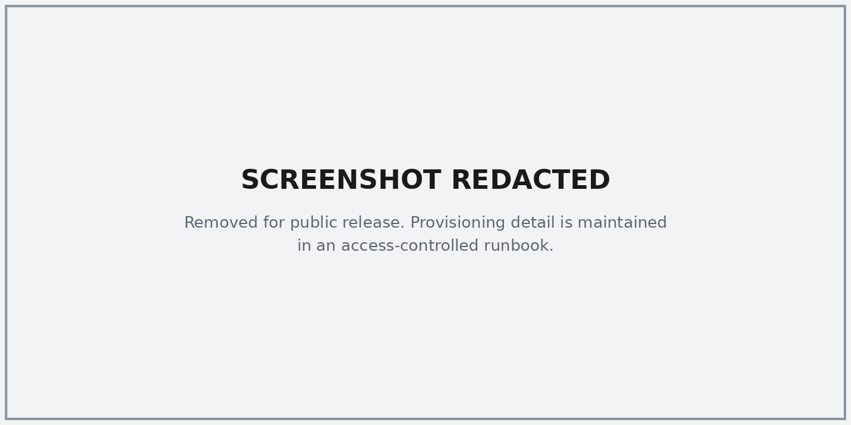
Figure 59. [REDACTED]

- [REDACTED] See Figure 60.

- [REDACTED] See Figure 61.
Figure 60. [REDACTED]

Figure 61. [REDACTED]

- [REDACTED]

- [REDACTED]

- [REDACTED]

- [REDACTED]
  - [REDACTED]

- [REDACTED]

- [REDACTED]

Back Office Support Access and Provisioning for GDIT and DOH
GDIT and NYSDOH users requiring back office or system resources are required to fill out a User Access Request (UAR) form regardless of their position. The process for requesting access to NYSOH resources is documented in the QRG for Requestors and QRG for Approvers available to program personnel on the program's document repository Site:

NYSOH User Access Request Form Procedures doc.

x"

Requesting Access to Federal Tax Information (FTI) Database Tables or Application Tab
Access to FTI is limited to a few authorized individuals on the NYSOH program. Access Requests for FTI must contain all appropriate signatures and is reviewed by the NYSOH Security, Privacy, and Compliance Team and the NYSDOH CISO. Personnel requesting access to FTI must follow the UAR process documented beginning in Section 17.3.

Enhanced Back Office Access
NYSOH now uses Active Directory services to manage all Back Office Accounts; this includes GDIT, NYSDOH and MAXIMUS.

In addition to implementing this new structure, the system now contains fine grain permissions that are managed by the database. Active Directory validates the user request, then sends the credentials to the database to retrieve the permissions. Once the permissions are validated, the user will have access to the appropriate screens.

Read-only role
- Update role
- Elevated support role
- Additional add-on privileges are assigned within the database in accordance with least-privilege requirements
- Add on functions (Privileges) in the DB2 database for Back Office

For the specific details of Role permissions, refer to the NYSOH Back_Office_Role_Provisioning document within NYSOH Configuration_Items in the configuration management repository:

Additional Support Roles:
- System Administrators
- Database Administrators
- System Developers
- Operations Support
- QA Support
- Users – will be maintained in Active Directory
- Roles – will be maintained in Active Directory

There are three (3) types of accounts supported by Active Directory:
- Normal access permissions – Provides access to the back office, the configuration management repository, and the document repository.
- The term “Locked” refers to scenarios where a password reset is required or when the user is forced to answer the 3 security questions to reset their password.
- The term “Disabled” refers to scenarios where an account has not been accessed within the inactivity period defined in the NYSOH access-control policy. The user must submit a UAR to have an account enabled.

Context Diagram for Role Assignment and Password Management
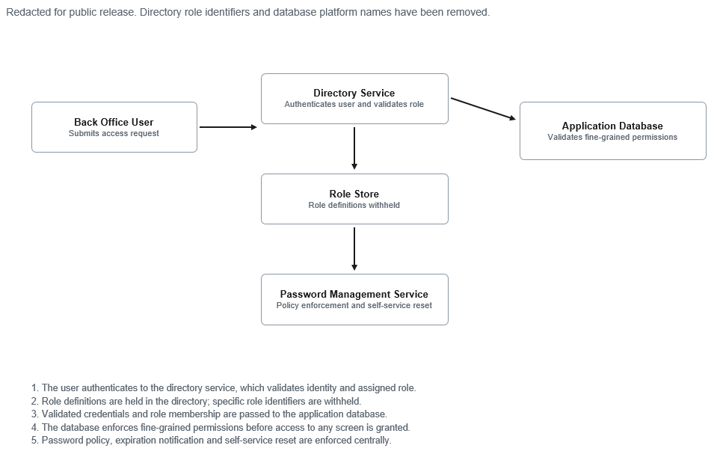
Figure 62. Active Directory Role Assignment

Naming conventions for all Back Office Accounts
NYSDOH and MAXIMUS Users must ensure the username request is unique for the respective requests, in the event a request contains a userID that is already in the system (the Active Directory), it will be rejected by Active Directory and sent back to NYSDOH.

Table 256 below outlines the standards that will be used for the NYSOH Information system.

Organization | Format | Example | Description
MAXIMUS (non-Siebel) | [REDACTED] | [REDACTED] | - A standardized, organization-specific user ID convention is defined for this population. Existing IDs comply with the convention and are portable to the directory service as is.  - The convention derives part of the identifier from an internal employee identifier.  - A separate variant of the convention distinguishes application-specific accounts.  - The convention includes a defined exception for re-hired personnel.
DOH, GDIT and Other User ID’s | [REDACTED] | [REDACTED] | - Organization indicators are drawn from a controlled list. The convention is extensible to additional organizations participating in the program.  - New DOH IDs are created under this convention and existing document and configuration management repository access is migrated to them; superseded IDs are disabled.
Table 256: Back Office Naming Conventions

Password Reset and Expiration Notification Process
The Active Directory Services send a notification email via ADSS (Active Directory Self Service) to the user when the user’s password is approaching the expiration date for the current password starting 15 days prior to the expiration then five days prior to expiration. Email frequency to be mutually agreed to.

Notification to the users
Active Directory Services emails the password expiration notification directory to the user whose credentials will expire. Figure 63 below is the sample of the letter.

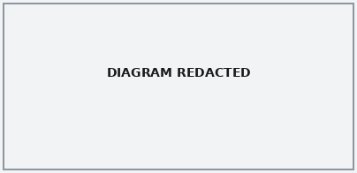
Figure 63. Password Notification Form email

NYSOH enforces strict and complex password conventions as defined below.

ADSS will be used for policy enforcement.
- Recommended.
- User creates a new password using Best Practices and follows the constructs below.
- System checks to ensure it meets the minimum acceptable password format standards.
  - Minimum of 14 Characters
  - Uppercase characters (A through Z)
  - Lowercase characters (a through z)
  - Numbers (0 through 9)
  - Non-alphanumeric characters (e.g. ~ ‘ ! @ # $ % ^ & * ( ) _ + = { } [ ] ; : “ ‘ < > , . ? )
  - Exception is the use of (\) or the (-) characters
  - The password must not contain the user’s e-mail name, user ID or the full name.
  - For security to function, you must choose a password you can remember and yet is complex. For example, Msi5!Yold (My son is 5 years old) or IhliNyf5#yN (I have lived in New York for 5 years now).
  - The previous 24 passwords cannot be reused.
  - Minimum password age is 1 day.

Enhanced Fine Grain Permissions
- Active Directory will be used for user authentication i.e., user id and password validation when a user logs on to system, the role which the user-id is assigned.
- Groups/Roles, are defined in AD
- NYSOH Role Assignment and permissions by User Type
- Specific AL-3 Roles using Active Directory Security Groups define rights and system permissions for privilege access to NYSOH System Resources

For the specific details of Role permissions, refer to the NYSOH Back_Office_Role_Provisioning document within NYSOH Configuration_Items in the configuration management repository.

Back Office Termination Process
The NYSOH Security Policy Handbook and the NYSOH Security Procedure & Guideline Handbook establishes requirements for managing access to information and systems by internal and external users. This Policy requires that authorized access to the Marketplace information technology system (the “Marketplace System”) be terminated promptly when an individual user no longer requires such access to complete his or her job responsibilities.

The Marketplace System includes accounts on the Marketplace application platform for users who have been authorized by their supervisor in writing (each an “Authorized User”) to have such access to support consumers, perform analytics, perform system maintenance, or complete other specific job responsibilities. These accounts are referred to herein as “Back Office” accounts. The Back Office accounts are managed and monitored in accordance with CMS/IRS requirements.

- Testing accounts are used to test specific production scenarios in QA System environments. Generic user IDs or shared passwords are not permitted without approval from Senior Management.

When an Authorized User no longer requires access to their Back Office account on the application platform for purposes of their job responsibilities (i.e. due to re-assignment, separation from employment), the User’s Supervisor shall submit a UAR form to remove access. Supervisors shall request the removal of access no later than five (5) business days following the change in status of the User.

Notice of Termination
Supervisors should submit a Notice(s) of termination as indicated in Table 257.

Authorized User(s) | Supervisors Send Notice of Termination to: | Email / phone
NYSDOH | Joseph Mantova  Cc: Jameson Louis (backup) | Joseph Mantova [REDACTED]  [REDACTED]  Jameson Louis [REDACTED]  [REDACTED]
GDIT | Resource Management Team | [REDACTED]  [REDACTED]
Table 257: Term Notice Supervisors

Termination Request(s)
Termination requests are processed through the UAR form in the program's access request portal.

Expedited Termination Request
In the event that special circumstances require expedited termination of an account or individual, the following must be notified immediately dependent on availability: GDIT Program Resource Management Team, GDIT Program ISSO or RDC Data Security, and RDC Facilities Security.

The GDIT Information Security Officer may be reached at: [REDACTED].

Summary of Process for Terminating Users or Changing User Account Status
Table 258 displays user account management, type of account, system, timing and necessary process steps to complete.

Organization or Partner | Type Account | System Role or Group | Timing of Notification | Steps/Process
NYSDOH | Domain | All NYHX Active Directory Accounts and Group Memberships  Non Domain system and application accounts | No later than (5) business days following user’s role change Weekly (standard) unless a supervisor requests an expedited termination due to special circumstances and completed within 1 hour of notification. | NYSDOH must notify GDIT Operations Manager via encrypted email of the change and should include Employer (DOH) Type, User name, First name, Last name, Date submitted, User email address, Role(s) (i.e. plan management), Action, Effective date of account change.
GDIT | Domain and System/Application Administrative Accounts | All NYHX Active Directory Accounts and Group Memberships  Non Domain system and application accounts  DBA Administrator  System Admin | No later than five (5) business days of following user’s role change Weekly (standard) unless a supervisor requests an expedited termination due to special circumstances and completed within 1 hour of notification. | Must notify NYSDOH program director, Database Manager or Senior Enterprise Architect via email and include Employer (GDIT) Type, User name, First name, Last name, Date submitted, User email address, Role(s), Action, Effective date of account change.
MAXIMUS | Customer Service Representative (CSR) or any support staff | All NYHX Active Directory Accounts and Group Memberships | No later than five (5) business days following user’s role change Weekly (standard) unless a supervisor requests an expedited termination due to special circumstances and completed within 1 hour of notification. | MAXIMUS Manager should notify GDIT Resource Management for all terminations with access to NYSOH Resources.
Auditors | Domain | All NYHX Active Directory Accounts and Group Memberships | As soon as possible following one business day of completion of a pre-defined audit | NYSDOH must notify GDIT Operations Manager via encrypted email of the change and should include Employer (i.e. OSC), User name, First name, Last name, Date submitted, User email address, Role(s), Action, Effective date of account change.
Table 258: User Account Organization or Partner Management

Audit and Retention
All files submitted to GDIT for a user account change should be maintained for a period no less than 10 years and are stored in a secure directory on the GDIT network.

All files should be available for inspection by NYSDOH, NYSOH Program Security and Compliance, and Federal and State auditors.

Inspections and Assessments

Security Oversight and Monitoring
In accordance with CMS requirements, Security Oversight against all Major system changes is required to be enforced; non-compliance with safeguards controls (Plan of Action and Milestones - POA&M) and provides an annual attestation against our security controls.

Change Management:
Table 259 below is an example of the types of change needs to be reported as part of the change notification process and the type of information to be provided to CMS.
- CM-3, Configuration Change Control, requires that the organization determine the types of changes to the information system that are configuration controlled. Configuration change control for the information system involves the systematic proposal, justification, implementation, test/evaluation, review, and disposition of changes to the system, including upgrades and modifications. The organization is also required to test, validate, and document changes to the information system before implementing the changes on the operational system.
- CM-4, Security Impact Analysis, requires that a security impact analysis be conducted that may include reviewing information system documentation such as the security plan to understand how specific security controls are implemented within the system and how the changes might affect the controls. Security impact analysis may also include an assessment of risk to understand the impact of the changes and to determine if additional security controls are required. In addition, the organization, after the information system is changed, needs to check the security functions to verify that the functions are implemented correctly, operating as intended, and producing the desired outcome with regard to meeting the security requirements for the system.

Type of Change | Internal Configuration Management Process | SSP Revision | Security Testing | Submit security artifacts to CMS | AE  System CN Form
Software upgrade (different version of product) | X | X
Major software change (e.g. establishing a Software as a Service contract to handle ACA business function) | X | X | X | X | X
Internal architecture or hardware change; with no impact to external connection | X | X
Architecture or network configuration change, impacts connection to CMS | X | X | X | X | X
Change of physical processing site and IT infrastructure | X | X | X | X | X
Modification of business functions (adding or moving functions) resulting in the change of system boundary, as defined in the System Security Plan or resulting in changes in data sharing and external connections | X | X | X | X | X
Table 259: Security Oversight and Monitoring Requirements

The following are key areas that trigger a security impact analysis and/or Change notification to CMS.
- Supporting major software changes
- Adding services which modify the infrastructure supporting the system
- Modifying the connection to the federal HUB
- Data (PII) collection, use, or disclosure (such as the initiation or termination of the use of Federal Tax Information)
- Major Infrastructure change, such as deployment of cloud technology
- Change of processing site or outsourcing of data center operations
- Adding or modifying applications supporting ACA which may impact security

POA&M
As part of compliance program with CMS the NYSOH is required to regularly submit POA&Ms.

The NYSOH POA&Ms provide CMS Information Security (IS) Management and Business Owners with the necessary information and instructions for developing, maintaining, and reporting our weaknesses in IS as it relates to the NYSOH.

Information included in the POA&M accounts for the emphasis that has been placed on formalizing the weakness mitigation process and ensuring weaknesses are appropriately prioritized for mitigation.

Effective remediation of security weaknesses is essential to building a mature and sound IS program for the NYSOH. Evidence of the proper implementation and use of the POA&Ms process is a critical element in the assessment of IS program performance.

CMS requires an updated POA&M be submitted on a quarterly basis and expects items from the previous reporting period to be updated to reflect current status. Table 260 is the 2024 POA&M deliverable schedule.

Month/Day
January 15, 2024
April 15, 2024
July 15, 2024
October 15, 2024
Table 260: 2024 POA&M Schedule

Record Retention Schedule for the NYSOH
Record retention is a very important part of our system as it has major impact to meeting minimum acceptable standards as defined by HIPAA/HITECH, the IRS, and Code of Federal Regulations Title 45 (45 CFR) 155.1210. It applies to all functions and activities associated with the NYSOH program and include sub-functions such as appeals processing and all required audits whether State or Federal.

This represents the program’s policy in accordance with Federal and State requirements regarding the retention and disposal of sensitive information whether in electronic form or paper documents.

Any copies made of PHI, PII or FTI or any other copies maintained for the purpose of the Marketplace or as part of a data feed must be maintained in accordance with NYSOH’s policies on safeguarding sensitive information as outlined below.

Record Retention Schedule is as follows:
Note: the schedule shown below in Table 261 is based on HIPAA/HITECH, IRS, 45 CFR 155.1210.

2024 Regulatory Retention Schedule
Document Type | Required Document Elements | Retention Schedule
Electronic and Non-  Electronic FTI Logs  Section 3.2 | Taxpayer name  · Tax year(s)  · Type of information (e.g., revenue agent reports,  Form 1040, work papers)  · Reason for request  · Date requested  · Date received  · Exact location of FTI  · Person(s) with access to the data, and  · Date and method of disposition, if disposed of | 10 Years
Converted Media  Section 3.2 | Requirements listed for FTI in its current form  (electronic or non-electronic) | 10 Years
State Auditor  Disclosures  Section 3.4 | Approximate number of records, date of inspection, description of records, name of individual making inspection | 10 Years
Visitor Access Logs  Section 4.3.1 | Name and organization of visitor  · Signature of visitor  · Form of identification  · Date of access  · Time of entry and departure  · Purpose of visit  · Name and organization of person visited | 5 Years
Disclosure  Awareness  Certification  Section 6.3 | Signed disclosure awareness confidentiality statement that certify understanding of FTI security requirements | 10 Years
Internal Inspections  Section 6.4 | Internal Inspections  · Record keeping  · Secure storage  · Disposal  · Limited access  · Computer systems security  · POA&M | 10 Years
Audit Trail Logs  Section [REDACTED] | See Section [REDACTED], Audit Events (AU-2), | 10 Years
All data and records relating to the NYSOH Marketplace | Information concerning management and operation of the State Exchange's financial and other record keeping systems;  Financial statements, including cash flow statements, and accounts receivable and matters pertaining to the costs of operations;  Any financial reports filed with other Federal programs or State authorities;  Data and records relating to the State Exchange's eligibility verifications and determinations, enrollment transactions, appeals, and plan variation certifications; and  Qualified health plan contracting (including benefit review) data and consumer outreach and Navigator grant oversight information.  For NYSOH  Records are defined as ( 45 155.1210)- The State Exchange and its contractors, subcontractors, and agents must ensure that the records specified in paragraph (a) of this section include, at a minimum, the following:  (1) Information concerning management and operation of the State Exchange's financial and other record keeping systems;  (2) Financial statements, including cash flow statements, and accounts receivable and matters pertaining to the costs of operations;  (3) Any financial reports filed with other Federal programs or State authorities;  (4) Data and records relating to the State Exchange's eligibility verifications and determinations, enrollment transactions, appeals, and plan variation certifications; and  (5) Qualified health plan contracting (including benefit review) data and consumer outreach and Navigator grant oversight information. | 10 Years
Appeals Data and Documents | All evidence, queries or printouts from an Appeals Decision including electronic and non-electronic files to enable the recreation of computer-related accesses to both the operating system and to the application wherever FTI is stored | 10 Years
MFD Content | MFD access enforcement controls must be configured correctly, including access controls for file shares, administrator and non-administrator privileges, and document retention functions | 10 Years
Control schedule | A record retention and disposal schedule established by the agency | N/A
Database and Log reports | Audit and Accountability (AU-3 and AU-3) | 10 years
Security Awareness Training Records | Individual training records for the program | 5 Years
Inspection Reports | Inspection reports, including a record of corrective actions, must be retained by the agency for a minimum of five years from the date the inspection was completed | 10 Years
Table 261: 2024 Regulatory Retention Schedule

Security and Risk Monitoring
A risk assessment of security controls is conducted annually to coincide with the NYSOH annual attestation and SSR submission.

Scanning
Application Discovery and Vulnerability scanning / Application scanning will be performed as required by regulatory governing organizations and whenever major application changes are made.

Penetration Testing
Penetration testing is conducted on a recurring basis in accordance with program policy. The specific test types, report names, and cadence are maintained in the System Security Plan (SSP) and have been removed from this distributed copy. Table 262 outlines the various tests that must be performed and the frequency of each.

Type | Output | Document Name | Frequency
Application Scans | Report in PDF form | [REDACTED] | [REDACTED]
ITS Application Scanning | Report in PDF form | [REDACTED] | [REDACTED]
External Penetration Testing | Report in PDF form | [REDACTED] | [REDACTED]
Edge boundary monitoring | Vendor portal |  | [REDACTED]
GDIT MST Monitoring | Report in PDF form and .zip files  [REDACTED] | [REDACTED] | [REDACTED]
GDIT MST Monitoring | Report in PDF form and .zip files  [REDACTED] | [REDACTED] | [REDACTED]
GDIT MST Monitoring | Report in PDF form and .zip files  [REDACTED] | [REDACTED] | [REDACTED]
Table 262: Scanning Schedule

Appendix A Disaster Recovery Procedures
Refer to the Business Continuity and Disaster Recovery Plan.

Appendix B NYSOH Emergency Call List (ECL)
In case of emergency, contact the Help Desk Command Center. They will reach out to required individuals. Help Desk Command Center is available 24/7.
Table 263 contains the Help Desk contact information.
Help Desk Contact Information | Response Data
Name: GDIT Command Center | [REDACTED] or  Alternate: [REDACTED]
For general communications email [REDACTED]
[REDACTED]
For escalations contact [REDACTED] | [REDACTED] – escalate via the NYSOH Operations group inbox
OITS Data Power web services | Service desk is [REDACTED].
State Exchange Resource & Virtual Information System (SERVIS)  [REDACTED] | [REDACTED] ([REDACTED])
MAXIMUS | [REDACTED] – contact via the GDIT Command Center
Table 263: Help Desk Information

Appendix C Primary Operations Contact List
The contact lists for O&M is below.

System Identifier | Response Data
Official System Name: | New York State of Health Marketplace
System Acronym: | NYSOH
System of Records (SOR): | NYSOH, Enterprise System Catalog (ESC) System ID is 2022.

Responsible Organization

Internal | Response Data
Name of Organization: | NYSDOH Office of Health Insurance Programs
Address: | One Commerce Plaza
City, State, Zip: | Albany, New York 12210
Contract Name: | NYSOH
External | Response Data
Name of Organization: | CSRA State and Local Solutions – LLC, a General Dynamics Information Technology Company (GDIT)
Address: | 327 Columbia Tpke
City, State, Zip: | Rensselaer, NY 12144

Designated Contacts

Business Owner | Response Data
Name: | [REDACTED]
Title: | Director, Division of Eligibility and Marketplace Integration
Organization: | NYSDOH Office of Health Insurance Programs
Address: | New York State Department of health  90 Church Street
City, State, Zip: | New York, New York 12237
E-Mail: | [REDACTED] – monitored group inbox
System Developer/Maintainer | Response Data
Name: | [REDACTED]
Title: | CIO and Director, OHIP Division of Operations and Systems
Organization: | NY State Department of Health
Address: | 431 Broadway
City, State, Zip: | Menands, NY 12204
E-Mail: | [REDACTED] – monitored group inbox
NYSOH Primary Contact | Response Data
Name: | [REDACTED]
Title: | NYSOH Director of Systems
Organization: | NYSDOH Office of Health Insurance Programs
Address: | 431 Broadway
City, State, Zip: | Menands, NY 12204
E-Mail: | [REDACTED] – monitored group inbox
Individual[s] Responsible for Security | Response Data
Name: | [REDACTED]
Title: | NYSOH Information Security Officer
Organization: | NY State Department of Health  Office of Health Insurance Programs  Division of Systems
Address: | 431A Broadway
City, State, Zip: | Menands, NY 12204
E-mail: | [REDACTED] – monitored group inbox
Phone Number: | [REDACTED]
Emergency Contact (daytime): (name, phone & email) | [REDACTED] – contact the 24/7 Command Center (Appendix B)
Individual[s] Responsible for Security | Response Data
Name: | [REDACTED]
Title: | GDIT NYSOH Information System Security Officer
Organization: | GDIT
Address: | 327 Columbia Turnpike
City, State, Zip: | Rensselaer, NY 12144
E-mail: | [REDACTED] – monitored group inbox
Phone Number: | [REDACTED]
Emergency Contact (daytime): (name, phone & email) | Cyber Security Director – [REDACTED] -
Individual[s] Responsible for System Architecture | Response Data
Name: | [REDACTED]
Title: | GDIT Program Architect
Organization: | GDIT
Address: | 327 Columbia Turnpike
City, State, Zip: | Rensselaer, NY 12144
E-mail: | [REDACTED] – monitored group inbox
Phone Number: | [REDACTED]
Emergency Contact (daytime): (name, phone & email) | [REDACTED] – contact the 24/7 Command Center (Appendix B)
Individual[s] Responsible for Operations | Response Data
Name: | [REDACTED]
Title: | GDIT NYSOH Operations Manager
Organization: | GDIT
Address: | 327 Columbia Turnpike
City, State, Zip: | Rensselaer, NY 12144
E-Mail: | [REDACTED] – monitored group inbox
Phone Number: | [REDACTED]

Appendix D Special Considerations for Agency Services and Issues
NYS Department of Tax and Finance
Problems related specifically to the New York State Department of Tax and Finance (DTF) web services being down should follow a new procedure in order to make sure they get attention as quickly as possible. This is not intended to cover incidents with the ITS web service gateway. Problems can be reported by yourself or Health/GDIT designee.

Call the DTF Help Desk at [REDACTED]⁵ noting that there is an issue with the DTF services supporting Health Exchange. During Help Desk business hours, DTF staff will open and route the ticket to the appropriate groups.

⁵ Also listed in the Help Desk Contact section of this document

If the call occurs after DTF business hours, the message on the DTF helpdesk line will refer the caller to the Command Center at [REDACTED]. The Command Center has an After Hours Call List and has been made aware of the group to calls to investigate Health Exchange issues. They will be starting with our Middleware technical group.

It is very important to have DOH/GDIT supply the following information:
- Time the outage occurred.
- Confirmation that it is only the DTF service(s) not working.
- Whether there is a percentage of requests going through (this may point to one cluster member having an issue).
- Whether both services are out or only one.

It is important to check the TI (Tax Information) if wage reporting is out, although this is called less frequently. DTF services are supported by different databases, so the application and DB groups may be involved when one service is out, but if both databases are out, it is more likely a problem in web or application services or the network.

OITS Data Power web services escalation procedures
NYSOH/GDIT should call the NYS CCC⁶ and open a ticket when there are problems with Marketplace consumption of web services coming through ITS Web Services Gateway. If there are issues with services provided by a specific cluster/agency only, NYSOH Operation Center should implement escalation procedures specific for the agency and keep the Gateway team in the loop. If the issues are with all services, the Gateway team is contacted/assigned the CCC ticket. These escalation procedures are outlined in Figure 64.

⁶ Also listed in the Help Desk Contact section of this document
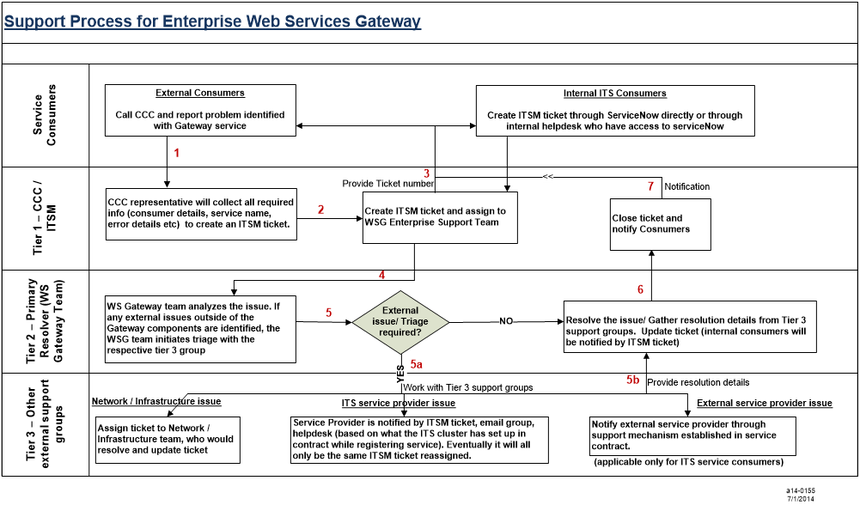
Figure 64. Enterprise Web Services Gateway Escalation Procedures 2014

- External Consumers are service consumers/ external systems outside of ITS and Internal Consumers are service consumers/systems within ITS (across clusters).
- Gateway Support Team will be a dedicated team responsible for the web services Gateway and the ITS Service Registry (similar to NYSDS team). Gateway Team will be responsible for the implementation and the operational support of the Gateway / Registry. The Gateway components will be moved to the new Datacenter and become an ITS Enterprise shared service. Web Services Gateway will be added as a shared service within Service Catalog (under application services) for ITS clusters to consume.
- Adding a new service by ITS (as a service provider) will only require registering artifacts in the ITS registry with required security level. Adding an externally provided service will require the Gateway team to implement the security requirements provided by the external service provider, that are minimal configurations in the Gateway. Adding a new consumer will require creating/ entitling the service account in NYSDS. The Gateway Team will manage these services through IT service management tickets.

Appendix E Center for Medicare and Medicaid System Outage Schedule for 2024
Each year CMS publishes a schedule for all the HUB services for NYSOH. No formal 2024 outage schedule has been published as of the submission of this O&M manual.

Appendix F Acronyms and Glossary
Refer to the Glossary/Acronyms process group within the program's controlled document repository.

.

Appendix G Referenced Documents
Table 264 shows the Referenced Documents with associated links if available.

Document Name | Description/Reference | Reference Link
Business Continuity and Disaster Recovery Plan | NYSOH Disaster Recovery Plan | Available to authorized personnel
NYSOH System Security Plan | System Security Plan | Limited Access to this document due to the sensitivity on the content
IRS_SSR_v2.1 | IRS Safeguards Procedures Report | Limited Access to this document due to the sensitivity on the content
NYSOH System Design Document | NYSOH System Design Document | Available to authorized personnel
NYSOH Production Job Schedule | NYSOH schedule of jobs to be run | Limited Access to this document due to the sensitivity on the content
NYSOH Configuration Management Plan | Configuration Management Plan | Available to authorized personnel
NYSOH Security Policy Handbook - IR | Policy outlining our processes for Security Incident Response | Available to authorized personnel
NYSOH Security Procedure & Guideline Handbook | Procedure outlining our processes for Security Incident Response | Available to authorized personnel
CMS Security and Privacy Incident Report Template  CMS Incident Handling Procedures - RMH-Chapter-8-Incident-Response. | Documents provide guidance on how we test and validate our Incident Response. Documents used to outline the procedures for reporting an incident. | Limited Access to this document due to the sensitivity on the content
CR1947 UAR Training Outline DOH | Detailed information on setting up User access and controls. | Limited Access to this document due to the sensitivity on the content  Available to authorized personnel
State-based Marketplace (SBM) Quarterly Data Collection for Reporting- Federal Fiscal Year 2015  Submission Guide v2.0 | This guide includes detailed description of the SBM Data Submission, as well as instructions for formatting and transmitting the quarterly data | Limited Access to this document due to the sensitivity on the content
Report Design Database Mapping.xls | Details of the mapping for each report | Limited Access to this document due to the sensitivity on the content
Table 264: Referenced Documents

Appendix H NYSOH Policies and Procedures Reference
All Security and Operational Policies for NYSOH are located at:

Available to authorized personnel

For all NYSOH Security Policies please refer to the NYSOH Security Policy Handbook and NYSOH Security Procedure & Guideline Handbook.

Appendix I NYSOH Operational Security Forms
CMS Security Incident Reporting Form
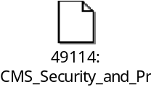
NYSOH Security, Compliance and Privacy (SCP) Monitoring and Audit Scripts

This is a special Security script used to assist NYSDOH Legal to investigate specific login when an event occurs. Table 265 provides an example.

These sets of queries are used to determine the last time an account was accessed online (Either by Broker/CSR or by himself/herself).
Example: Account AC0000708293 got accessed on 02/13/2014 and 02/14/2014.
If you have a date range please change the static dates. Then below are the queries to find out if the particular Individual (EE) account has been accessed through online (Either by Broker/CSR or by himself/herself).

Step# 1:
With the given account use the step 1 query to get username.
SELECT ID, USERNAME, CREATED_DATE, CREATED_BY, UPDATED_DATE, UPDATED_BY, FIRST_NAME, MIDDLE_NAME, LAST_NAME
FROM NYHBEODB.USER_PROFILE AS UP
WHERE UP.ACCOUNT_ID = 'AC0000708293'
WITH UR;

Step # 2:
Query in LOGIN_HISTORY, just remove the _INDIVIDUAL suffix from username column of USER_PROFILE table. Use LOGIN_ATTEMPT_TIME column to filter for any given date range.
SELECT * FROM LOGIN_HISTORY LH
WHERE LH.USERNAME='arecio95'
AND (LH.LOGIN_ATTEMPT_TIME > '2014-02-13-00.00.00.000000') AND (LH.LOGIN_ATTEMPT_TIME < '2014-02-14-23.59.59.999999')
WITH UR

If no record is found in Login History for the given date range then there is no access on the account for the given date range.

Table 265: Example of Account Access Online Queries

Appendix J Version Description History
This appendix contains the version description history as only the recent five versions are included in the Revision History table at the beginning of this document.

Version | Date | Change Implemented By | Change Approved By | Description of Changes
1.0 | 8/12/13 | R. Schrimp, T. Silvious, S. Malkov | J. Wood | Initial Draft version updated for Plan Management (PM).
2.0 | 10/11/13 | J. Wood, T. Silvious | R. Schrimp | Reorganized the document by moving common sections to the front of the document, updated PM to refine file names, and added the Small Business Marketplace section.
2.1 | 1/16/14 | J. Wood |  | Added Customer Service (CS). Drafted Individual Marketplace and Financial Management (FM). Incorporated informal comments from Cognosante.
3.0 | 2/05/14 | Ron Schrimp | Tom Silvious | Updated to reflect current operations for CS track and corrected dates and references.
3.1 | 2/21/14 | Ron Schrimp | Tom Silvious | Updated to reflect comments from NYSDOH and Cognosante. Updated several tables and included updates from CSC Customer Service team.
3.2 | 3/3/14 | Ron Schrimp | Ron Schrimp | Added two new appendices to provide Help Desk phone numbers and to outline specific requirements for support on NYS Agency information.
3.2 | 3/14/14 | Ron Schrimp | Ron Schrimp | Updated contact information and updated SLA information.
3.3 | 4/12/14 | Ron Schrimp | Ron Schrimp | Updates for June release of document, added 4 new sections.
3.3 | 5/1/14 | Ron Schrimp | Ron Schrimp | Additional sections have been added to align with the recommended CMS O&M template.
3.3 | 7/1/14 | Ron Schrimp | Ron Schrimp | Updates to Customer Service, Individual Marketplace and new addition of the Encounter Intake System.
13.0 | 1/15/15 | Ron Schrimp | Ron Schrimp | Renumbered Version to align with all other enterprise documentation. Added Password reset and account creation validation, updated interfaces and master schedule. Updated Password Reset and began adding termination process. Added new section on Security and Incident management, added updated section on Defect Management and procedures. Added section on Alfresco procedures for removal of bad images in FMS. Added new section for 1095a reporting and processing.  Added all Security monthly scripts to Appendix.
14.0 | 7/1/15 | Ron Schrimp | Ron Schrimp | Updates for Release 7
15.0 | 1/15/16 | Ron Schrimp | Ron Schrimp | Updates for January 2016 deliverables including changes in Releases 8 and 9 Build 1 and inputs from Rachel Gartenberg’s review.
15.1 | 5/13/16 | Linda Dorsey | Linda Dorsey | Updated CSC and NYSOH Security.
16.0 | 7/15/16 | Rebecca Magers | Rebecca Magers | Multiple changes made throughout the document, to include updates for R10.
17.0 | 1/16/17 | Rebecca Magers | Rebecca Magers | Updates for January 2017 submission to include all sections requiring updates as of January 2017.
18.0 | 7/14/17 | Rebecca Magers | Rebecca Magers | Updates for July 2017 submission to include all sections requiring updates up to Release 13 and to incorporate DOH comments on the July 2016 submission.
19.0 | 1/15/18 | Rebecca Magers | Rebecca Magers | Updates for January 2018 submission to include all sections requiring updates up to Release 15 and to incorporate DOH comments on the July 2017 submission.
20.0 | 1/15/19 | Rebecca Magers | Rebecca Magers | Updates for January 2019 submission to include all sections requiring updates up to Release 21.1.2 and to incorporate new SLA Attachment into this document.
21.0 | 7/15/19 | Rebecca Magers | Rebecca Magers | Updates for July 2020 submission to include all sections requiring updates up to Release 24.2.
22.0 | 2/14/20 | Sowmya Allani | Mani Sharma | Updates for January 2020 submission to include all sections requiring updates up to Release 27.2.
22.1 | 4/20/20 | Sowmya Allani | Mani Sharma | Updated in response to DOH comments.
23.0 | 7/15/20 | Sowmya Allani | Mani Sharma | Updates for July 2020 submission to include all sections requiring updates up to Release 27.6.5.
24.0 | 1/15/21 | Sowmya Allani | Mani Sharma | Updates for January 2021 submission to include all sections requiring updates up to Release 30.2.
24.1 | 1/28/21 | Sowmya Allani | Mani Sharma | Updated in response to DOH comment.
25.0 | 7/15/21 | Sowmya Allani | Mani Sharma | Updates for July 2021 submission to include all sections requiring updates up to Release 31.5.
26.0 | 2/1/2022 | Mani Sharma | Naresh Yalamanchili | Document was updated for the February 2022 deliverable.
27.0 | 7/15/2022 | Mani Sharma | Naresh Yalamanchili | Release 36.3 through Release 37.1 details.
28.0 | 3/1/2023 | Shahana Dudekula | Vijay Veeraraghavan | Release 37.1 through Release 40.2 details.

