Request for Proposals

RFP #C043776

Converged Eligibility and Enrollment (E&E) System and Appeals Management System (AMS)

Exhibit G.04
Medicaid Eligibility and Client Management (MECM) System Functional Topology Diagram

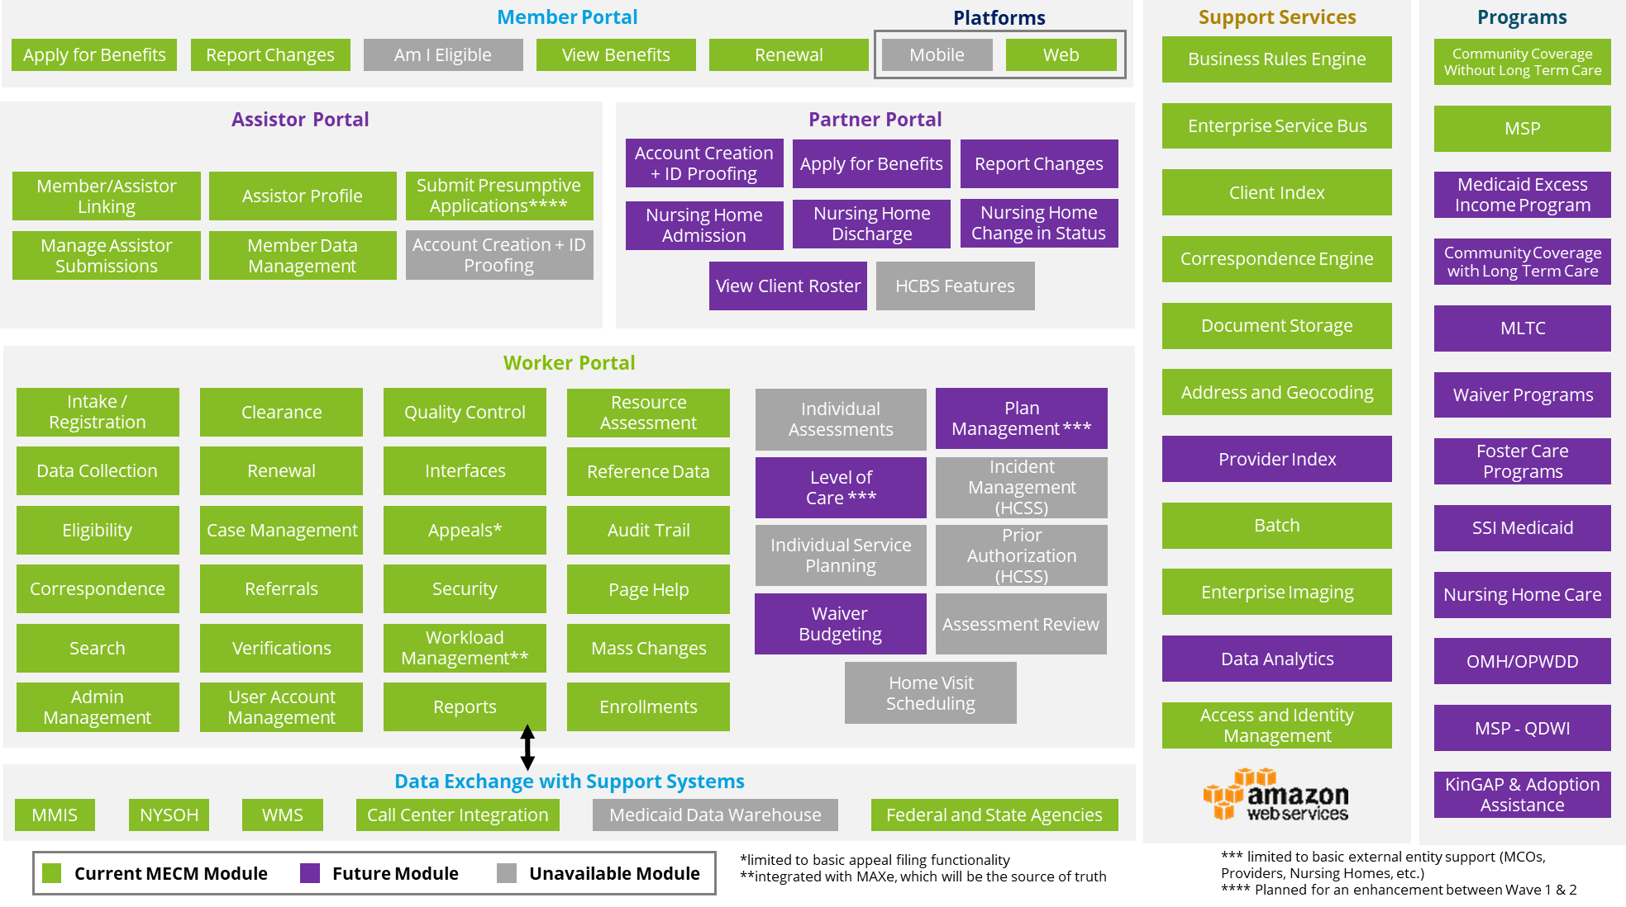
Table 1 provides brief descriptions of the modules within the MECM System.
Table 1 – MECM System Functional Topology Modules
Module | Description
Member Portal
Apply for Benefits | Enables an applicant, authorized representative, Assistor, or customer service center worker to submit an application with required data to apply for health insurance and receive an eligibility determination
Report Changes | Allows a member, authorized representative, Assistor, or customer service center worker to report changes to an existing case that may initiate a redetermination
Am I Eligible | Allows applicants and members to view, apply for, and renew health insurance and report changes to an existing case through consumer-facing portal services
View Benefits | Provides a member, authorized representative, assistor or customer service center worker with the ability to view health insurance information
Renewal | Enables a member, authorized representative, assistor or customer service center worker to submit a renewal form with required data to determine continuation of eligibility and health insurance
Platforms | Provides access to the Member Portal and facilitates user interactions, data exchange, and service delivery across enabled devices and applications using responsive web design without a native mobile application version
Web | Allows access to the Member Portal through the public Internet via a Uniform Resource Locator (URL)
Assistor Portal
Member/ Assistor Linking | Provides access for Assistors to manually delink from a member through the Assistor Portal dashboard and for Department administrators to bulk reassign and bulk unlink members from Assistors as needed
Manage Assistor Submissions | Allows Assistors to search for in-progress applications and Department administrators to search for submitted applications using defined search criteria
Assistor Profile | Allows Assistors to view personal profile data and enables Department administrators to update the Assistor access level for a given Assistor
Member Data Management | Provides Assistors with a consolidated dashboard to view required case actions and key information, such as renewal due dates and document due dates, enabling quick identification of cases requiring action
Submit Presumptive Applications | Allows Assistors with Presumptive Eligibility (PE) screening privileges (similar to qualified providers evaluating individuals for PE for Pregnant Consumers) to capture the minimum information required to determine PE
Account Creation and Identification (ID) Proofing | Allows certified Assistors to create an account in the MECM System and complete ID proofing (functionality only exists in the NY State of Health (NYSOH) System, and the MECM System receives Assistor profiles from the NYSOH System)
Partner Portal
Account Creation and ID Proofing | Allows authorized provider representatives, based on eMedNY data, to create an account in the MECM System and complete ID proofing
Apply for Benefits | Enables providers to submit an application with required data to apply for health insurance and receive an eligibility determination on behalf of a member in their facility
Report Changes | Enables providers to report changes to an existing case that may initiate a redetermination on behalf of a member in their facility
Nursing Home Admission | Allows providers to access an online version of the Local Departments of Social Services (LDSS)-3559 form to admit MECM System members to their facility
Nursing Home Discharge | Allows providers to access an online version of the LDSS-3559 form to discharge MECM System members from their facility
Nursing Home Change in Status | Allows providers to access an online version of the LDSS-3559 form to report changes in placement status, including upgrades to permanent placement, readmissions, transfers, discharges, or deaths, for MECM System members in their facility
View Client Roster | Enables providers to view a dashboard of MECM System members associated with their facility or plan and take related actions
HCBS Features | Allows Home and Community Based Services (HCBS) providers to access the Partner Portal and take action on their populations
Worker Portal
Worker Portal | Allows Department, LDSS, and Customer Service Center workers to process applications from various intake channels (e.g., online, phone), determine health insurance eligibility, and review and update eligibility determination results (e.g., date ranges)
Intake/ Registration | Enables receipt of applications from multiple sources (e.g., paper, online, fax, phone) and registers them in the Worker Portal to generate a system application number
Data Collection | Enables capture of individual data, including demographics, income, resources, and expenses
Eligibility | Executes business rules against collected data to determine health insurance eligibility outcomes such as eligible, denied, or pending
Correspondence | Manages system-generated notices that communicate information related to an individual or case, application status, or eligibility status
Search | Supports lookup and retrieval of case and individual data within an application
Administrative Management | Supports administrative functions such as workload management, scheduling, task management, and staff management
Clearance | Tracks interfaced data and processes information reviewed and cleared automatically or by a worker prior to eligibility determination by the MECM System
Renewal | Supports sending, receiving, and processing renewal packets and enables renewal of individual health insurance
Management | Allows workers to view, manage, and update case data
Referrals | Enables transfer of individual or case information to external systems for evaluation under different programs or eligibility bases
Verifications | Identifies required verification types, associated due dates, and acceptable documentation
User Account Management | Allows authorized staff to manage user accounts, including granting access and defining user roles
Quality Control | Enables workers to perform and track case record reviews
Interfaces | Connects the MECM System with external partners to obtain information required for case processing
Appeals | Allows consumers to request appeals to dispute system decisions, including health insurance levels or eligibility determinations, with support provided through the AMS as described in Section 3.3.3 – Appeals Management System
Security | Manages system access, user roles, application holding services, and data sharing
Workload Management | Supports assignment, tracking, and routing of worker tasks based on due dates and capacity
Reports | Generates reports automatically or manually based on defined schedules (e.g., daily, monthly, annually)
Resource Assessment | Supports assessment of reported resources to determine eligibility against Medicaid resource limits
Reference Data | Allows authorized staff to configure and maintain reference data (e.g., income limits, resource limits, disregard limits, verification lists) stored in configurable MECM System reference tables
Audit Trail | Captures historical actions performed on individual and case data
Page Help | Provides system-generated guidance to workers during case processing
Mass Changes | Processes bulk changes and determines eligibility without worker intervention, such as yearly Cost-of-Living Adjustment (COLA) updates
Enrollments | Allows workers to select and manage Medicaid plan enrollments
Individual Assessments | Supports functional or clinical assessments for members seeking Long-Term Care (LTC) services
Level of Care | Captures required levels of care as an outcome of individual assessments for eligibility and service determination
Individual Service Planning | Supports planning of LTC services based on assessed levels of care
Waiver Budgeting | Applies Medicaid budgeting rules based on waiver enrollment
Home Visit Scheduling | Supports scheduling and management of home visits related to level-of-care assessments and service planning
Incident Management (Home and Community Support Services [HCSS]) | Supports documentation, management, and reporting of incidents, restraints, and medication occurrences across the full incident life cycle, from initial logging through supervisor review, investigation, finalization, and notification of required follow-up actions
Prior Authorization (PA) (HCSS) | Supports administrative approval and funding authorization of HCBS through Individual Support Plans (ISPs) prior to service delivery, with authorized services establishing allowable units and funding required for provider payment
Assessment Review | Supports ongoing review of member level-of-care assessments
Plan Management | Supports configuration, maintenance, and member enrollment for MLTC plans
Support Services
Support Services | Includes various services that support the MECM System, including the business rules engine (BRE), corresponding processing, and batch processing
BRE | Defines and executes all business rules required to determine eligibility
Enterprise Service Bus (ESB) | Integrates applications and services across the MECM System Environment
Client Identification Number (CIN) Clearance | Identifies and selects a previously assigned CIN across systems or assigns a new CIN for applicants who are new to the Medicaid program (CIN Clearance may not be the specific process or terminology used once the Welfare Management System [WMS] is retired and will be referred to generically as “Clearance” throughout the RFP, with CINs referred to as “Clearance Numbers”)
Notice Engine | Generates notices and manages printing, enveloping, and interfaces with external vendors
Document Storage | Collects and stores documents submitted by consumers in a centralized repository
Address and Geocoding | Validates addresses to confirm accuracy and validity
Provider Index | Provides a list of authorized providers for LTC services
Batch | Processes data for large sets of transactions in an automated manner based on defined business needs and requirements
Enterprise Imaging | Performs document scanning
Data Analytics | Provides aggregated data and reporting to support visibility into program operations and performance and enable monitoring, insight generation, and informed decision-making
Access and Identity Management | Manages user access and authentication, including single sign-on (SSO)
Data Exchange with Support Systems
Data Exchange with Support System | Exchanges data with support systems, including the Medicaid Management Information System (MMIS), the Customer Service Center, and federal and State agencies
MMIS | Serves as a complex system that processes more than two million (2,000,000) transactions per day, including the following:  - Institutional, professional, dental, pharmacy, and transportation claims transactions  - PAs  - Eligibility inquiries
NYSOH | Exchanges data with the NYSOH System which is a web-based health insurance E&E system created pursuant to the Affordable Care Act (ACA) that enrolls applicants into Medicaid, Child Health Plus (CHPlus), Basic Health Plans (BHP), and Qualified Health Plans (QHPs).
Welfare Management System (WMS) | Exchanges data with WMS Upstate and WMS Downstate. WMS Upstate and WMS Downstate are legacy systems that receive, maintain, and process information relating to persons who have applied and been determined eligible for benefits under the following:  - Temporary Assistance for Needy Families (TANF)  - Safety Net Assistance (SNA)  - Home Energy Assistance Program (HEAP)  - Supplemental Nutrition Assistance Program (SNAP)  - Other human services and programs (e.g., Adoption Subsidy, Foster Care)
Call Center Integration | Interfaces with the Customer Service Center to support worker assistance for consumers and authorized individuals applying for and renewing health insurance coverage offered through the MECM System
MDW | Exchanges data with the MDW
Federal and State Agencies | Exchanges data with federal and State agencies, such as the Centers for Medicare and Medicaid Services (CMS), the Social Security Administration (SSA), the Internal Revenue Service (IRS), the Office of Temporary and Disability Assistance (OTDA), Office of Children and Family Services (OCFS), Office for People with Developmental Disabilities (OPWDD), and Department of Corrections and Community Supervision (DOCCS)

