Request for Proposals

RFP #C043776

Converged Eligibility and Enrollment (E&E) System and Appeals Management System (AMS)

Exhibit G.07
Medicaid Eligibility and Client Management (MECM) System Technology Stack

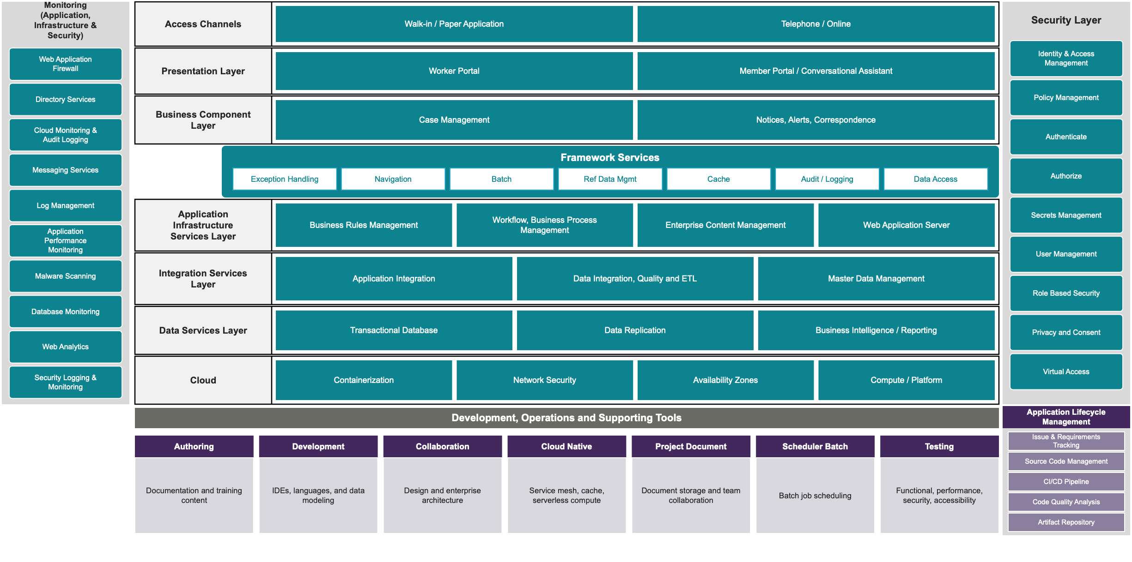
The MECM System technology stack consists of the Deployment, operations, and supporting tools listed in Table 1 through Table 16.
Table 1 – MECM System Authoring Tools
Tool | Description
Microsoft Project, Office, and Visio | Microsoft products:  - Project – Project management (PM) software designed to help users plan, schedule, manage, and track project components, such as tasks, resources, and timelines  - Office – Suite of productivity applications designed to enhance efficiency, such as Word, Excel, PowerPoint, and Outlook  - Visio – Diagramming and vector graphics application used to create detailed flowcharts, organizational charts, network diagrams, and other visuals
Adobe RoboHelp | Tool used to generate online help content for the MECM System
Adobe Captivate | Authoring tool used to create e-learning content for training
Table 2 – MECM System Development Tools
Tool | Description
Eclipse | Integrated Development Environment (IDE) software platform used by developers to set up workspaces and design, develop, and unit test MECM System applications
IntelliJ | IDE for Spring boot Microservices
Erwin Data Modeler | Tool used for logical and physical data modelling and for creating Entity Relationship Diagrams (ERDs) of MECM System applications
Visual Studio (VS) Code | IDE tool used by developers to set up workspaces to design, develop, and unit test MECM System applications and to support Angular development
Tableau Desktop | Software used by developers to design and develop MECM System reports
Structured Query Language (SQL) Developer | Open-source software used by database administrators, developers, and analysts to view, manage, and maintain MECM System Oracle databases
OpenText Exstream Designer | Commercial Off-the Shelf (COTS) product used for designing notice templates
Oracle Policy Modeling | COTS product used for modeling, developing, and maintaining MECM System business rules
Java | Object-oriented programming (OOP) language used to develop the MECM System
NodeJS | Programming language used to write test scripts for browser automation using Selenium.
Node Package Manager (NPM) | Software development tool used manage application dependencies and artifacts for components built with NodeJS
GitHub Copilot | Artificial intelligence (AI) assistant to generate the code for developers
Table 3 – MECM System Collaboration Tools
Tool | Description
Figma | Requirements collaboration tool for designing wireframes
Orbus iServer | Unified software platform that supports business and information technology (IT) transformation projects through Enterprise Architecture; business process assessment; and Governance, Risk, and Compliance (GRC) activities and may be upgraded to Orbus Infinity at the discretion of the Department
Table 4 – MECM System Cloud Native Tools
Tool | Description
GitHub Copilot | Refer to Table 2 – MECM System Development Tools
Service Mesh | Used for authenticated and secured internal communication between microservices
Cache Service | Used for cache layer management
Serverless Compute Service | An event-driven, serverless computing platform primarily used to automate operational tasks including managing backups, handling system monitoring, and executing scheduled tasks
Table 5 – MECM System Schedule Batch Tools
Tool | Description
CA Automic | COTS product used as the job scheduler for automating MECM System batch processing
Table 6 – MECM System Project Document Tools
Tool | Description
Microsoft SharePoint | Web-based collaboration platform that allows users to create, store, and organize deliverables, design documents, and other artifacts in a centralized online environment
Microsoft Teams | Collaboration platform that provides chat, video meetings, file storage, and app integration to support teamwork and communication
Table 7 – MECM System Testing Tools
Tool | Description
Selenium | Open-source software used for automated testing of MECM System applications
Dynamic Application Security Testing (DAST) Tool | Dynamic Application Security Testing (DAST) tool for the MECM System that performs dynamic live scans of web applications and is used to perform automated security assessments
Jira Xray | Test case management tool within Jira to support the entire testing life cycle used for test planning, design, execution, and reporting
Screen Reader | Screen reader used in the MECM System to test web accessibility and confirm adherence to Section 508 of the Rehabilitation Act compliance
Web Accessibility Evaluation Tools | A suite of web accessibility evaluation tools to ensure MECM System web content adheres to Web Content Accessibility Guideline (WCAG) standards
Static Application Security Testing (SAST) Tool | Static Application Security Testing (SAST) tool for the MECM System that performs static code scans to identify security vulnerabilities in MECM System applications and generate reports
CA Service Visualization | Tool used for developing and hosting mock services in the MECM System lower environments by creating, managing, and provisioning virtualized services
Microfocus LoadRunner Enterprise | Software used to execute performance testing of MECM System applications
Table 8 – MECM System Application Life Cycle Management Tools
Tool | Description
Atlassian Jira | Application Lifecycle Management (ALM) tool for MECM System used to manage the Solution Development Life Cycle (SDLC), track issues, and support requirements management, PM, staff assignments, and reporting using the Requirements for Jira (R4J) plugin
Atlassian Jira Service Management (JSM) | Core information technology service management (ITSM) tool to support the MECM System
R4J | Jira plugin used for requirements management throughout the SDLC and for producing the Requirements Traceability Matrix (RTM) for the MECM System
GitLab Software as a Service (SaaS) | Source code repository used for version control of MECM System and AMS source code
Jenkins | Tool used for implementing continuous integration/continuous delivery/deployment (CI/CD) in the MECM System
Argo CD | Deployment of Docker images to the containerization platform
SonarQube | Platform used for static code assessment to provide insights into MECM System code quality, security, and maintainability
Sonatype Nexus Repository | Artifact repository used to manage software packages and artifacts in the MECM System
Table 9 – MECM System Security and Monitoring Tools
Tool | Description
Web Application Firewall (WAF) | Security service used to implement geographic access restrictions for MECM System applications
Directory Services | Primary identity store for system-level access, providing user-level authentication and authorization to cloud consoles, servers, and virtual desktops within the MECM System Environment
Cloud Monitoring and  Audit Logging Services | Cloud security logging and monitoring services:  - Infrastructure Monitoring – Monitoring service that provides critical metrics and actionable insights regarding the infrastructure’s performance and health  - Audit Logging – Enables auditing and security monitoring by tracking user activity and API usage across the cloud infrastructure
Notification and Message Queue Services | Cloud messaging services that enable scalable, cost-effective communication:  - Notification Service – Notification service used for sending messages to distributed systems, mobile devices, and email  - Message Queue Service – Application integration service that enables decoupling and scaling by allowing for the sending, storage, and retrieval of messages between software components
Log Management Platform | Log management and application performance monitoring tool with custom dashboards and alerts configured for the MECM System
Application Performance Monitoring Platform | Infrastructure and application performance monitoring tool that provides insights into system health, application performance, and page response
Malware Scanning Service | Software used for scanning user-uploaded files in the Member Portal
Database Management Platform | Platform that combines a graphical console, agents, common services, and tools to provide an integrated systems management environment used to capture statistics, events, and errors for MECM System databases
Web Analytics | Collects Member Portal web analytics and event statistics including current user count, page actions that the end-user is viewing and acting upon
Security Logging and Monitoring Service | Security monitoring platform that provides endpoint protection and host intrusion detection and protection services.
Identity and Access Management (IAM) Service | Service used for Identity and Access Management (IAM) in the MECM System and the AMS that integrates with external identity repositories to provide a modern single sign-on (SSO) implementation enabling secure access for various user groups
Centralized Secrets Management Service | Services used to securely store sensitive data, such as application programming interface (API) keys and passwords, and ensure the availability of cryptographic keys
Virtual Access Platform | Platform that provides secure virtual access to MECM Member Portal for Local Departments of Social Services (LDSS) users
Table 10 – MECM System Analytics Layer Components
Product/System | Description
NGINX | Web server that forward Hypertext Transfer Protocol (HTTP) requests to application servers for the Worker Portal and Member Portal
Angular | Frontend User Interface (UI) framework for the Worker Portal and Member Portal
Conversational Assistant | Chatbot within the Member Portal that assists users by interpreting their requests and interacting with backend systems via APIs to provide personalized support in thirteen (13) languages
Table 11 – MECM System Business Component Layer Components
Product/System | Description
Case Management | Worker Portal UI and backend corresponding to case management activities
OpenText Exstream | COTS product used as the Multichannel Customer Communication Management (CCM) platform for generating MECM System notices for correspondence
Granicus | Multichannel communication platform used to communicate with MECM System consumers via email and text messaging
Table 12 – Framework Components
Product/System | Description
Framework Services | Framework that provides base services for the MECM System, including session management, logging, auditing, reference table management, and exception handling
Table 13 – MECM System Application Infrastructure Services Layer Components
Product/System | Description
Business Rules Engine (BRE) | COTS SaaS product used for executing business rules in the MECM System
Document Management System | Cloud-native object storage solution used for document management and for storing and retrieving MECM System documents.
J2EE Application Runtime | COTS product used as the Java 2 Platform, Enterprise Edition (J2EE) runtime environment for the MECM System Worker Portal application artifacts that renders application functionality, manages transactions against the MECM System database, and integrates with other MECM System COTS products
NGINX | Refer to Table 10 – MECM System Analytics Layer Components
Java Web Application Server | Open-source Java web application server runtime environment for the MECM System Member Portal application that interacts with the MECM System database for transaction processing
Table 14 – MECM System Integration Services Layer Components
Product/System | Description
Enterprise Service Bus (ESB) | COTS product used as the ESB for integrating trading partner services with the MECM System
Managed Secure File Transfer (SFTP) Solution | Cloud-native managed service used to securely transfer files to and from MECM System partners
Cloud Data Integration Platform | Platform as a Service (PaaS) used as the ETL tool for populating required data for MECM System reports
Identity Matching Service | COTS product used for Client Identification Number (CIN) clearance.
Master Data Management (MDM) Solution | API-based solution used as MDM solution for the MECM System (refer to Section 3.3.2.8 – Master Data Management Strategy for additional details)
Data Orchestration and Analytics Platform | The orchestration layer between the MDM solution and the source systems integrated with data analytics (refer to Section 3.3.2.8 – Master Data Management Strategy and the Medicaid Eligibility and Client Management System Data Flow and Relationships subsection within Section 5.2.5.4.A – Background for additional details)
Table 15 – MECM System Data Services Layer Components
Product/System | Description
Databases (current vendor-supported releases) | Databases hosted on a managed cloud relational database service for the Worker Portal and Member Portal, respectively, that store transactional data, reporting data, and audit logging
Database Replication Service | Feature used to synchronize data from a Primary region to a Disaster Recovery (DR) region
Data Replication Software | Software used to replicate data to the reporting database as well as the analytics platform
Reporting and Dashboard Platform | COTS product used as the reporting tool for generating and managing MECM System reports that connects with the MECM System database to retrieve data for populating dashboards
Cloud Data Integration Platform | Refer to Table 14 – MECM System Integration Services Layer Components
Table 16 – MECM System Cloud Components
Product/System | Description
Container Orchestration Platform | Orchestrates and hosts the MECM System’s containerized microservices for scalability
Network Firewall | Firewall deployed across multiple availability zones (AZs) to secure access to applications hosted on compute instances within virtual private clouds (VPCs) in the cloud environment
AZs | Infrastructure for the MECM System built in the following cloud environments:  - FedRAMP-Authorized Government Cloud Platform  - Primary Region – Hosts production workloads  - Disaster Recovery (DR) Region – Geographically separate from the primary region  - Secondary Cloud Platform  - Primary Tenant – Managed cloud tenant/environment  - Secondary Tenant – Managed cloud tenant/environment
Cloud Compute Instances | Primary infrastructure for hosting core MECM System portals within the government cloud environment
Enterprise Linux Operating System | Operating system used for the MECM System
Secondary Cloud Compute Platform | Infrastructure that hosts the conversational assistant

