TAS_E&E 015_Exhibit G.09 - MECM System ITS Shared Services_DRAFT redacted
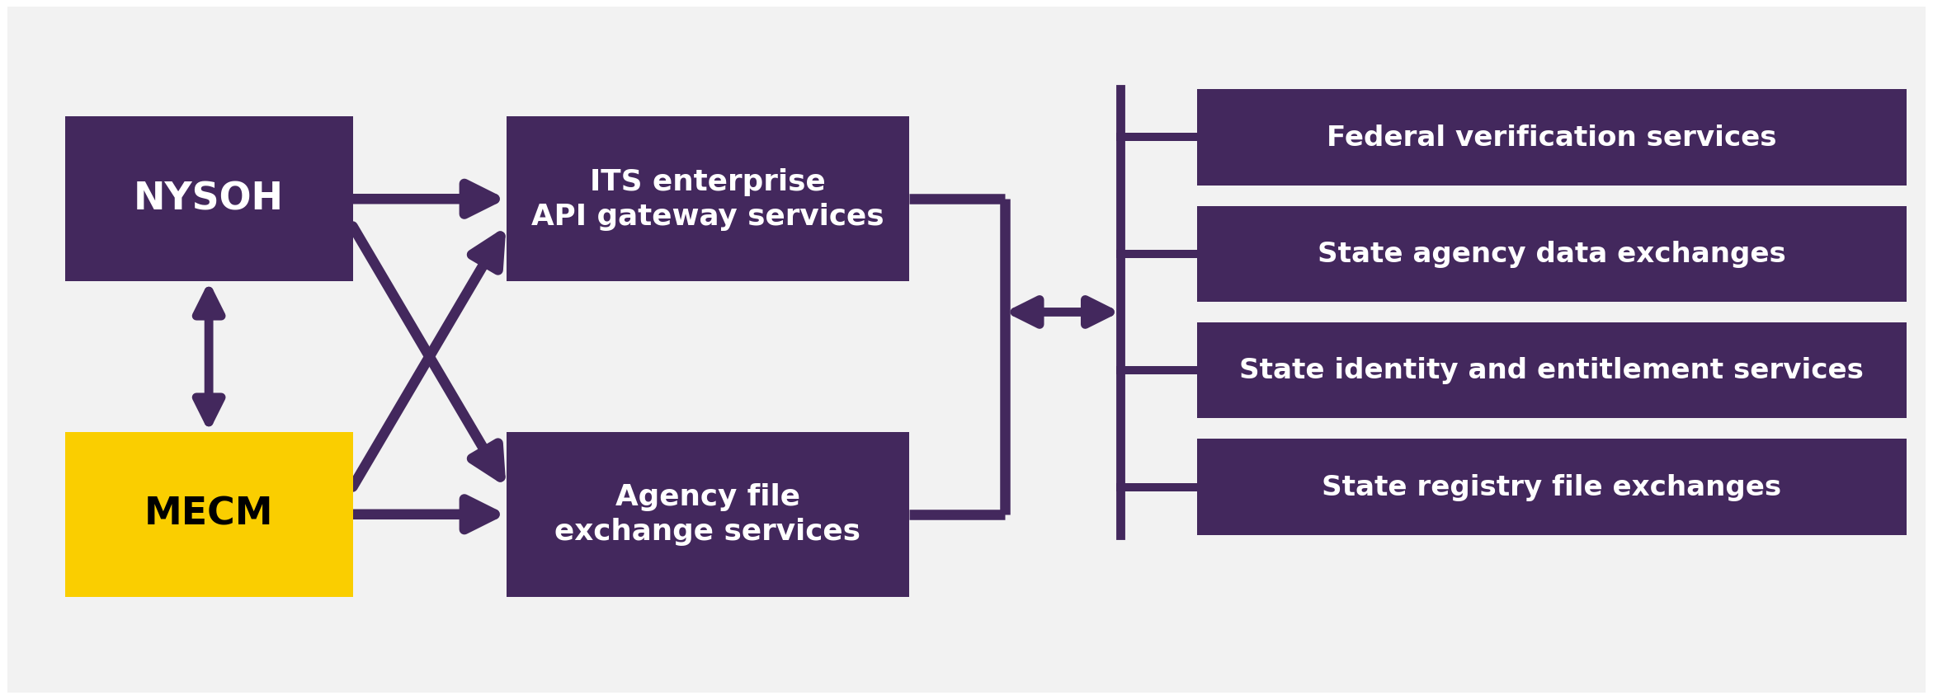
Shared Service Categories
- Federal verification services
- State agency data exchanges
- State identity and entitlement services
- State registry file exchanges

