New York State
Department of Health

Continuing Medicaid Eligibility Modernization

DEL-16 System Architecture Design Document_redacted

May 15, 2025
Version 2.1

Document Control Information

Document Information
Document Identification | Master Statement of Work (MSOW) Deliverable #16
Document Name | System Architecture Design Document
Project Name | Continuing Medicaid Eligibility Modernization
Client | New York State Department of Health Office of Health Insurance Programs (DOH OHIP)
Document Author | [REDACTED]
Document Version | v2.1
Document Type | MSOW Deliverable

Document Edit History
Version | Date | Addition/Modifications | Prepared/ Revised by
v0.1 | 02/19/2025 | Walkthrough submission | [REDACTED]
v0.2 | 04/15/2025 | Addressed DOH review comments | [REDACTED]
v0.3 | 04/25/2025 | Updated GCP section to reflect Deterministic Flow | [REDACTED]
v1.0 | 05/02/2025 | Prepared for transmittal | [REDACTED]
v2.0 | 05/13/2025 | Addressed DOH comments from prior transmittal in preparation for resubmission | Prabha Parte
v2.1 | 05/15/2025 | Addressed DOH transmittal comment | Prabha Parte

Table of Contents
1 Introduction 1
2 Purpose 1
3 System Architecture Design Document Overview 1
3.1 System Architecture 2
3.1.1 Conceptual Architecture 2
3.1.2 Logical Architecture 8
3.1.3 Physical Architecture 10
3.2 Infrastructure and Platform Architecture 11
3.2.1 Multi-Account Architecture 12
3.2.2 Network Architecture 15
3.2.3 Identity Management 15
3.2.4 Active Directory 15
3.2.5 Active Directory Federated Services 15
3.2.6 Red Hat Identity Management 15
3.2.7 Infrastructure Automation 16
3.2.8 MECM System's Naming and Tagging Standards 20
3.2.9 AWS Native Services 20
3.2.10 Cloud Managed Platform Components 23
3.2.11 MECM System Environments Overview 25
3.2.12 Google Cloud Platform Architecture Overview 25
3.2.12.1 Google Dialog Flow 34
3.2.12.2 Technical Conversation Flow 35
3.2.12.3 Integration with Member Portal 36
3.2.12.4 Deterministic Flows 37
3.2.12.5 Enabling Security Settings for Redacting Data 37
3.2.12.6 Sensitive Data Protection Purpose and Characteristics 39
3.2.12.7 Conversational Analytics Data 41
3.2.12.8 Configuration to Enable Export to BigQuery 41
3.2.12.9 BigQuery Table Creation 41
3.3 Application Architecture 42
3.3.1 Worker Portal 42
3.3.1.1 Overview 42
3.3.1.2 Architecture 44
3.3.1.3 Presentation Layer 45
3.3.1.4 Business Layer 45
3.3.1.5 Service Layer 45
3.3.1.6 Business Process Orchestration 45
3.3.1.7 Transaction Management 47
3.3.1.8 Session Management 48
3.3.1.9 Exception Handling 48
3.3.1.10 Logging 48
3.3.2 Member Portal 49
3.3.2.1 Overview 49
3.3.2.2 Architecture 50
3.3.2.3 Transaction Management 52
3.3.2.4 Exception Handling 52
3.3.2.5 Logging 52
3.4 Database Design and Management 53
3.4.1 Application Database Overview 53
3.4.2 Design Features 56
3.4.3 Data Management 57
3.4.4 Data Structures and Attributes 58
3.4.5 Data Classification 58
3.4.6 Database Management 58
3.4.7 Data Migration Architecture 59
3.4.8 Data Sync between Member Portal and Worker Portal 59
3.4.9 Backup Retention Rules and Data Archival Policies 59
3.5 Business Rules Architecture 60
3.5.1 Overview 60
3.5.2 Architecture 60
3.5.2.1 Rules Life Cycle Management 61
3.5.3 Business Rules Execution 63
3.5.4 Transaction Management 63
3.5.5 Exception Handling 64
3.5.6 Logging 64
3.6 Batch Framework Architecture 64
3.6.1 Overview 64
3.6.2 Batch Framework Architecture View 65
3.6.3 Batch Framework Artifacts 66
3.6.3.1 Readers 66
3.6.3.2 Processors 67
3.6.3.3 Batchlet and Chunk 68
3.6.4 Transaction Management 68
3.6.5 Multithreading 68
3.6.6 Exception Handling 69
3.6.7 Logging 70
3.6.8 Batch Scheduler 71
3.6.8.1 Scheduling Exception Handling 71
3.6.9 Scripting Framework 72
3.6.10 Tools 72
3.7 Reporting Architecture 73
3.7.1 Overview 73
3.7.2 Architecture View 73
3.7.3 Reports Generation 75
3.7.4 Transaction Management 75
3.7.5 Multi-Environment Support 75
3.7.6 Exception Handling 76
3.7.7 Logging 76
3.8 Notices Architecture 76
3.8.1 Overview 76
3.8.2 Architecture View 76
3.8.3 Multi-Environment Support 77
3.8.4 Notice Design 77
3.8.4.1 What is OpenText Exstream? 78
3.8.4.2 Multi-Lingual Support 78
3.8.5 Notice Generation 79
3.8.5.1 On-Demand Mode 79
3.8.5.2 Batch Mode 79
3.8.5.3 Sorting and Bundling 79
3.8.6 End To End Mail-Piece Tracking 80
3.8.7 Exception Handling 81
3.8.8 Logging 81
3.9 Integration Architecture 82
3.9.1 Overview 82
3.9.2 Architecture View 82
3.9.3 Integration Architecture Components 83
3.9.4 Integration Patterns 83
3.9.5 Services Orientation Integration 84
3.9.6 File Transfer Oriented Integration 85
3.9.7 Data Flow Diagrams 85
3.10 Document Management 86
3.10.1 Overview 86
3.10.2 Architecture View 87
3.10.3 Multi-Environment Support 89
3.10.4 Document Management Solution Integration 89
3.11 Master Data Management 90
3.11.1 Master Data Management Function 90
3.11.2 Master Data Management Architecture 91
3.11.3 High Availability 92
3.12 Enrollment Architecture 93
3.12.1 Overview 93
3.12.2 Architecture Overview 93
3.12.3 Electronic Data Interchange Architecture 95
3.12.4 EDI 834 Outbound Architecture 96
3.12.5 EDI Inbound Architecture 96
3.12.6 EDI Batches 97
3.12.7 IBM ITX Tool 98
3.13 Security Architecture 99
3.13.1 Overview 99
3.13.2 Security Logging and Monitoring 99
3.13.2.1 Security Logging and Monitoring Technical Design Components 99
3.13.2.2 Security Logging and Monitoring Deployment 102
3.13.2.3 Health Monitoring 104
3.13.2.4 Updates to Security Logging and Monitoring SaaS Components 104
3.13.2.5 SL&M Service Level Agreements 104
3.13.2.6 SL&M Operations and Maintenance 106
3.13.3 Identity and Access Management Security Design 107
3.13.3.1 Authentication Mechanism 109
3.13.3.2 Session Management 122
3.13.3.3 Password Management 123
3.13.3.4 Authorization Mechanism 123
3.13.3.5 Provisioning Mechanism 126
3.13.3.6 Multi-Factor Authentication and ID Proofing 127
3.13.3.7 Process/Requirements of Day Zero Data Load of WP Users 129
3.13.3.8 IAM Environment Mapping 129
3.13.3.9 MECM Okta Integration with Tableau 130
3.13.3.10 MECM Okta Integration with Splunk 131
3.13.4 Multi-Environment Support 132
3.13.5 Federal Tax Information Labelling Methodology 134
3.13.5.1 Oracle Database Security Implementation 134
3.13.6 Web Services Security 134
3.13.6.1 Transport-Level Security 135
3.13.6.2 Message-Level Security 135
3.13.6.3 Web Services Security for Inbound Services to MECM 135
3.13.6.4 Web Services Security for Outbound Services from MECM 135
3.13.7 MECM Environments Hardening Process 136
3.13.7.1 Approach 136
3.13.7.2 Exception Process 137
3.14 System Monitoring Design 137
3.14.1 Splunk 137
3.14.1.1 Overview 137
3.14.1.2 Multi-Environment Support 139
3.14.1.3 Splunk Dashboards 140
3.14.1.4 SLA Reporting 141
3.14.1.5 Notification 141
3.14.2 Oracle Enterprise Manager 141
3.14.2.1 Overview 141
3.14.2.2 Multi-Environment Support 142
3.15 DevOps Architecture 142
3.15.1 Configuration Repository 142
3.15.2 Branching and Merging Strategy for Parallel Releases 143
3.15.2.1 The Main Branches 144
3.15.2.2 Merge Process 145
3.15.3 Release Management 146
3.15.4 Build Approach 146
3.15.4.1 Build Readiness 147
3.15.4.2 Build Migration Strategy 148
3.15.4.3 Build Deployment Process 149
3.16 Final Software BOM 150
3.17 Non-Functional Requirements 150
4 Appendix 151
4.1 Appendix A: Terms and Definitions 151
4.2 Appendix B: Referenced Documents 159
4.3 Appendix C: URLS Monitoring List 161

Table of Tables
Table 3-1: MECM System Components 4
Table 3-2: MECM System Security and Monitoring Tools 5
Table 3-3: MECM System Application Lifecycle Management Tools 6
Table 3-4: MECM System Collaboration Tools 6
Table 3-5: MECM System Development Tools 7
Table 3-6: MECM System Testing Tools 8
Table 3-7: MECM System's AWS Account 15
Table 3-8: MECM Environment Repositories in GitLab 17
Table 3-9: Naming Standards for Identity and Access Management Services 17
Table 3-10: Naming Standards for Networking Services 18
Table 3-11: Naming Standards for Compute and Service Resources 19
Table 3-12: Naming Standards for Storage Services 19
Table 3-13: Naming Standards for Management Tools 20
Table 3-14: Naming Standards for Relational Database Service 20
Table 3-15: AWS Services Utilized 23
Table 3-16: AWS Hosted Tools 25
Table 3-17: GCP Organization OU Policies 34
Table 3-18: Components Used in Architecture 36
Table 3-19: BigQuery Table Structure 42
Table 3-20: NextGen Driver Component Critical Tasks 47
Table 3-21: Oracle Database Mapping and Schemas 55
Table 3-22: Postgres Database Mapping and Schemas 56
Table 3-23: Data Management Environments 58
Table 3-24: Data Management Activity 59
Table 3-25: Business Rules Server Details 61
Table 3-26: MECM OPA Project List 63
Table 3-27: Batch Job Logging 70
Table 3-28: Batch Execution Status Codes 72
Table 3-29: Batch Development and Execution Tools 73
Table 3-30: Tableau Services by Node 73
Table 3-31: Tableau Service Purpose 74
Table 3-32: Tableau to MECM Environments Mapping 76
Table 3-33: OpenText Exstream to MECM Environments Mapping 77
Table 3-34: End-to-End Mail Piece Quality Assurance and Tracking 81
Table 3-35: Severe Exceptions in Notice Generation 81
Table 3-36: Data Element Logging 82
Table 3-37: Integration Component Architecture 83
Table 3-38: MECM System Integration Approach Requirements 84
Table 3-39: Mapping of MECM System Environments to DocuEdge 89
Table 3-40: SL&M Modules 99
Table 3-41: SL&M Products 100
Table 3-42: CrowdStrike Host Type Prerequisites 102
Table 3-43: Operations Monitoring Service Level Agreement - System Uptime 104
Table 3-44: Detection and Response SL&M Service Levels 105
Table 3-45: Detection and Response Priority Levels 105
Table 3-46: Detection and Response Service Level Categories 106
Table 3-47: MECM System Integration Federation Protocol 110
Table 3-48: Maximus Entra ID Group Names and the MECM WP Roles 117
Table 3-49: Mapping of ITS ESSO AD Group Names to MECM WP Roles 120
Table 3-50: MECM WP Environment URLs 121
Table 3-51: Account Deactivation/Deletion 127
Table 3-52: IAL and AAL Assessment Summary for MECM MP/AP 129
Table 3-53: IAM Environment Mapping for MECM WP 129
Table 3-54: IAM Environment Mapping for MECM MP/AP 130
Table 3-55: Splunk Role Description 132
Table 3-56: MECM WP/Okta Environment Mapping 133
Table 3-57: MECM MP/AP Environment Mapping 134
Table 3-58: Patching Schedule 136
Table 3-59: Nessus Vulnerability Scan 137
Table 3-60: Splunk Components 139
Table 3-61: Mapping of MECM System Environments to Splunk 139
Table 3-62: Splunk Integration 140
Table 3-63: Worker Portal Dashboards 140
Table 3-64: Member Portal Dashboards 141
Table 3-65: Monitoring Process and Frequency 141
Table 3-66: OEM to MECM Environments Mapping 142
Table 3-67: SIT Build/Deployment Environments and Approvers 148
Table 4-1: Terms and Definition 158
Table 4-2: Referenced Documents 160
Table 4-3: URLs Monitoring List 161

Table of Figures
Figure 3-1: MECM Conceptual Architecture 2
Figure 3-2: Logical Architecture Diagram 9
Figure 3-3: MECM Wave 1 Physical Architecture Diagram 10
Figure 3-4: MECM AWS Infrastructure and Platform Architecture Diagram 12
Figure 3-5: Google Cloud Platform Architecture 26
Figure 3-6: GCP Organizations OU Structure 27
Figure 3-7: High-Level Google Dialog Flow Architecture 35
Figure 3-8: GCP Cloud Platform Dialog Flow CX Agent Architecture Diagram 35
Figure 3-9: Integration Points Between Member Portal, Chatbot, and Worker Portal 37
Figure 3-10: Security Setting Configuration (Step 1) 38
Figure 3-11: Security Setting Configuration (Step 2) 38
Figure 3-12: Security Setting Configuration - Redaction 39
Figure 3-13: Cloud Sensitive Data Protection Characteristics 40
Figure 3-14: Cloud Sensitive Data Protection Configuration 40
Figure 3-15: Settings to Enable Export of Conversation History to BigQuery Database 41
Figure 3-16: High-Level Worker Portal Application MVC Design Architecture 43
Figure 3-17: High-Level Worker Portal Application Architecture 43
Figure 3-18: Worker Portal Application Architecture 44
Figure 3-19: NextGen Framework Architecture 46
Figure 3-20: High-Level Member Portal Architecture 49
Figure 3-21: Member Portal UI Framework Architecture 50
Figure 3-22: Member Portal Backend Application Architecture 51
Figure 3-23: Schema Breakdown 54
Figure 3-24: Database Instance 57
Figure 3-25: OPA Architecture 61
Figure 3-26: Oracle Policy Modeling 62
Figure 3-27: Intelligent Advisor Hub Login Screen 62
Figure 3-28: Intelligent Advisor Hub Projects Screen 63
Figure 3-29: Batch Application Architecture 65
Figure 3-30: Batch Reader Class Information 66
Figure 3-31: Batch Processor Class Information 67
Figure 3-32: Batch Writer Class Information 67
Figure 3-33: Sample Command Line 68
Figure 3-34: Batch Exception Handling Information 70
Figure 3-35: MECM System Batch Scheduler Process Flow 71
Figure 3-36: Sample Batch Scripting Framework 72
Figure 3-37: Reports Architecture 75
Figure 3-38: On-Demand Document Generation Workflow/Architecture 76
Figure 3-39: Batch Document Generation Workflow/Architecture 77
Figure 3-40: Notice Example 78
Figure 3-41: The Multi-Lingual Support in HP Exstream 79
Figure 3-42: MECM System Integration Architecture 83
Figure 3-43: Worker Portal Modules High Level Data Flow 85
Figure 3-44: Member Portal to Worker Portal Application Data Flow 86
Figure 3-45: MECM System Application Flow 86
Figure 3-46: DocuEdge Architecture Diagram 88
Figure 3-47: Document Management Solution Architecture 90
Figure 3-48: IBM MDM Architecture 92
Figure 3-49: Enrollment Architecture Diagram 93
Figure 3-50: Enrollment Module Member Portal Functional Flow 94
Figure 3-51: Enrollment Module Worker Portal Functional Flow 95
Figure 3-52: EDI Outbound Architecture 96
Figure 3-53: EDI Inbound Architecture 97
Figure 3-54: IBM ITX Tool Design Studio 98
Figure 3-55: SL&M High Level Architecture 100
Figure 3-56: Response Matrix Example 106
Figure 3-57: MECM IAM Solutions Architecture Design 108
Figure 3-58: SAML Authentication Flow Diagram 111
Figure 3-59: Authorization Code Flow for OIDC Protocol Diagram 112
Figure 3-60: Authorization Code Flow with PKCE Flow Diagram 113
Figure 3-61: Authorization Code Flow with PKCE Flow Diagram 115
Figure 3-62: User Login Workflow (Valid Session in IDP) 121
Figure 3-63: DOH/Maximus Users RBAC Flow for MECM WP 124
Figure 3-64: LDSS Users RBAC Flow for MECM WP 125
Figure 3-65: Splunk Cloud Architecture 138
Figure 3-66: Bitbucket Repository 143
Figure 3-67: Contributor Branch Workflow 144
Figure 3-68: Main Branches 144
Figure 3-69: Code Merge Process 146
Figure 3-70: Code Promotion Process Flow 147
Figure 3-71: Build Migration Considerations 149
Figure 3-72: CI/CD Workflow 150

Introduction
This document illustrates the initial solution for the New York Medicaid Eligibility and Client Management (MECM) system, which is being produced based on Tennessee Eligibility Determination System (TEDS) with a key focus on functional and technical design modifications to accommodate initial requirements of New York State Department of Health Office of Health Insurance Programs (DOH OHIP).

Purpose
The purpose of this document is to provide an overview of initial functional and technical scope for the MECM system while the final set of requirements for the MECM solution are being captured as a part of Deliverable #18 Requirements Specifications Document and Deliverable #16 System Architecture Design Document (SADD).

System Architecture Design Document Overview
This deliverable contains the following sections:
                - System Architecture - This section provides the overview of the MECM system architecture
                - Infrastructure And Platform Architecture - This section outlines the high-level design of the AWS cloud infrastructure for the MECM system
                - Application Architecture - This section provides the general guidelines for the Worker and Member Portal Application Architectures and provides the high-level view of the framework
                - Database Design and Management - This section provides an overview of the approach to designing and managing databases
                - Business Rules Architecture - This section details the approach for capturing, managing, and deploying complex legislation and other document-based policies across channels and processes
                - Batch Framework Architecture - This section provides an overview of the batch framework and how batch processing is implemented in MECM
                - Reporting Architecture - The Transactional database will be used as the source for Reporting and will be replicated to the Reporting Database from which Tableau will extract data for populating the required MECM system dashboards
                - Notices Architecture - This section provides a high-level overview of how OpenText Exstream is used to design and generate notices for the MECM system
                - Integration Architecture - This section provides an overview of the MECM Integration Architecture and how it enables exchange of information with DOH and external trading partners in real-time and batch processing manners
                - Document Management - This section provides an overview of DocuEdge which is used for Document Management within MECM. DocuEdge is a cloud native solution built on top of Amazon Web Services (AWS) Simple Storage Service (S3)
                - Master Data Management - This section of the deliverable provides a high-level overview of Master Data Management (MDM) and provides details about MDM Architecture
                - Enrollments Architecture - This section of the deliverable provides an overview of the Enrollments module for the MECM System Project. This section also describes how the Electronic Data Interchange (EDI) 834 triggers will be processed and how the EDI 834 transactions are sent to Electronic Medicaid System of New York (eMedNY)
                - Security Architecture - This section describes design goals and considerations, provides a high-level overview of the system security, and provides details about MECM Managed Extended Detection and Response (MXDR) Security Logging and Monitoring, Identity and Access Management (IAM) and web services security, and documents security policies applicable to the MECM system architecture
                - System Monitoring Design - This section provides an overview of System monitoring in MECM. MECM leverages Splunk and Oracle Enterprise Manager to capture statistics, events, and errors for MECM solution
                - DevOps Architecture - This section provides an overview of the Continuous Integration and Continuous Deployment (CI/CD) architecture
                - Final Software and Cloud Bill of Materials (BOM) - This section includes the latest Software BOM and Cloud BOM
                - Non-Functional Requirements - This section of the deliverable describes the expected quality of service of the NY MECM system. This includes Availability, Reliability, Scalability, Performance, Security and Compliance requirements

System Architecture

Conceptual Architecture
This section describes the system components of the Worker Portal (WP) and Member Portal (MP) applications in the MECM system. The MECM system Conceptual Architecture diagram highlights the key components of the solution. The below MECM Conceptual Architecture diagram illustrates the solution, including the cross-cutting aspects in the columns on the left and right sides, as well as the supporting tools along the bottom.
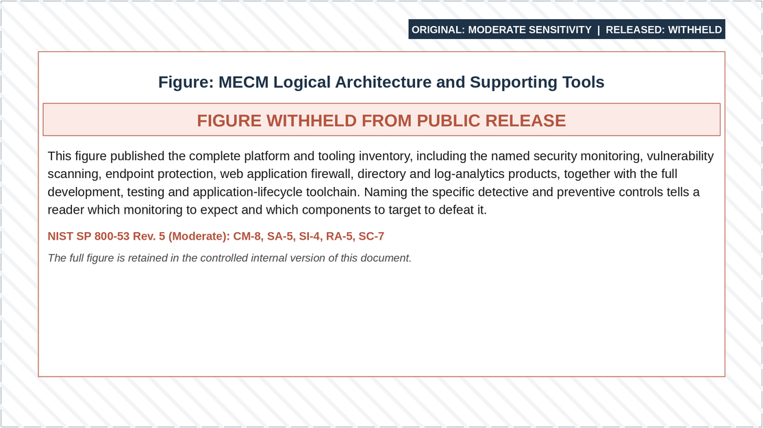
Figure 3-1: MECM Conceptual Architecture
Refer to the MECM Conceptual Architecture with Detailed Components Revision PowerPoint (link to document location: MECM Conceptual Architecture with Detailed Components Revision.pptx) for the original MECM system Conceptual Architecture diagram.
The following tables outline each component of the MECM Conceptual Architecture Diagram including system components, security and monitoring tools, application lifecycle management tools, collaboration tools, development tools, and testing tools.
Product/System | Description
International Business Machines Corporation (IBM) Hypertext Transfer Protocol (HTTP) Server (IHS) and Nginx | IHS and Nginx are web servers that forward HTTP requests to Application servers for the WP and MP, respectively.
IBM WebSphere Application Server (WAS) Network Deployment Edition | IBM WAS Network Deployment Edition is a commercial off the shelf (COTS) product used as the Java 2 Platform Enterprise Edition (J2EE) runtime environment for MECM WP application artifacts. WAS renders application functionality, manages transactions against the MECM database, and integrates with other MECM COTS products.
Apache Tomcat | Apache Tomcat is an open-source Java web application server runtime environment for the MECM MP Spring Boot application. Tomcat interacts with the MECM database for transaction processing.
Oracle Policy Automation (OPA) | OPA is a COTS product used as the business rule engine for executing business rules in the MECM system.
OpenText Exstream | OpenText Exstream is a COTS product used as the Multichannel Customer Communication Management (CCM) platform for generating MECM notices for correspondence.
Certificate Authority (CA) Automic | CA Automic is a COTS product used as the job scheduler for automating the MECM system’s batch processing.
Tableau | Tableau is a COTS product used as the reporting tool for generating and managing the MECM system’s reports. Tableau connects to the MECM system’s database to pull data for populating dashboards.
Informatica Intelligent Cloud Services (IICS) | IICS is Platform as a Service (PaaS) used as the Extract, Transform, and Load (ETL) tool for populating the required data for the MECM system’s reports.
Deloitte DocuEdge | DocuEdge is a proprietary Deloitte Cloud Native Solution (built on top of AWS S3) used as the document management solution for storing and retrieving the MECM system’s documents.
IBM InfoSphere MDM | IBM InfoSphere MDM is a COTS product used for the Master Data Management for Client Identification Number (CIN) clearance.
Google Dialog Flow | Google Dialog Flow is the chatbot solution that has been hosted on Google Cloud Platform.
Experian Address Validation | Experian Address Validation is a COTS product used as the address validation service for verifying the accuracy and validity of addresses.
Granicus | Granicus is a multi-channel communication platform for communicating via email and text messages Short Message Service (SMS).
IBM App Connect Enterprise (ACE) | IBM ACE is a COTS product used as the Enterprise Service Bus (ESB) for integrating trading partner services with the MECM system.
AWS File Transfer Secure File Transfer Protocol (SFTP) Solution | AWS File Transfer SFTP Solution is an AWS native service used as the file transfer solution for secure and reliable file transfers to and from trading partners.
NextGen Framework Services | NextGen Framework Services is Deloitte’s proprietary framework providing base services for the MECM system. Framework services include session management, logging, auditing, reference table management, and the exception mechanism for the MECM WP.
Oracle Enterprise Edition 19c and PostgreSQL 15.8 Databases | Oracle Enterprise Edition 19c and PostgreSQL 15.8 are database management systems (DBMS) hosted on AWS Relational Database Service (RDS) for the WP and MP, respectively. These databases include transactional, reporting and audit data.
AWS GovCloud | Infrastructure for the MECM system is built on the AWS GovCloud Platform. The primary and disaster recovery (DR) regions are geographically separate; the specific regions are withheld ([REDACTED]). MECM workloads will be deployed to AWS Elastic Compute Cloud (EC2) instances. Operating Systems for the MECM system are RedHat Enterprise Linux and Microsoft Windows.
Google Cloud | Google Cloud Platform is being leveraged for hosting Google Dialog Flow chatbot solution.
Table 3-1: MECM System Components
Product/System | Description
Oracle Enterprise Manager (OEM) | OEM is used to capture statistics, events, and errors for the MECM system’s Oracle databases. OEM combines a graphical console, agents, common services, and tools to provide an integrated, comprehensive systems management platform.
Splunk Enterprise | Splunk Enterprise (Splunk) is the log management and application performance monitoring tool for the MECM system. Custom Dashboards and Alerts will be configured in Splunk.
Security Logging and Monitoring Service | The Security Logging and Monitoring Service is Deloitte’s proprietary security monitoring platform that provides endpoint protection and host intrusion detection and protection services.
Tenable Nessus | Tenable Nessus is a network security solution used for compliance and vulnerability scanning in the MECM system.
Okta | Okta is used for IAM in the MECM system for both WP and MP applications. Okta integrates with external identity repositories to provide a modern single sign-on (SSO) experience to allow various user groups to securely access the WP and MP.
Symantec Antivirus | Symantec Antivirus is used for scanning user-uploaded files in the MP.
Active Directory | Active Directory is used as the primary identity store for all Windows system-level access and provides user-level authentication and authorization to AWS Console, Windows servers, and AWS Workspace workstations within the MECM system.
Web Application Firewall (WAF) | WAF enables Geographic access restrictions for the MECM systems’ applications. WAF performs Geo Blocking for the traffic from Application Load Balancer.
Palo Alto | Palo Alto is configured across multiple availability zones (AZ) to secure access to the applications that are deployed on EC2 instances within virtual private cloud (VPC) in AWS accounts.  Ingress: Palo Alto also does perform Geo Blocking for the traffic from Network Load Balancer. All the Trading Partner’s Internet Protocol (IP) addresses will be whitelisted for accessing the MECM system.  Egress: Palo Alto also does perform Geo Blocking for the traffic from Network Load Balancer. The egress traffic will be blocked for IP addresses outside US and for blacklisted sites.
Table 3-2: MECM System Security and Monitoring Tools
Product/System | Description
Atlassian Jira | Jira is the application lifecycle management (ALM) Tool for the Continuing Medicaid Eligibility Modernization project to manage the software development life cycle (SDLC) and issue tracking for the MECM system.
Requirements for Jira (R4J) | R4J is a Jira plugin for requirements management throughout the SDLC and is used to produce the Requirements Traceability Matrix (RTM) for the MECM system.
Atlassian Bitbucket (Bitbucket) | Bitbucket is used as the source code repository for hosting the MECM system’s source code.
Atlassian Bamboo (Bamboo) | Bamboo is used to implement CI/CD in the MECM system.
SonarQube | SonarQube is used for static code analysis to gain insights into the MECM system’s code quality, security, and maintainability.
Sonatype Nexus Repository | Sonatype Nexus Repository is an artifact repository used to manage software packages and artifacts in the MECM system.
Apache Ant | Apache Ant is an open-source Java build automation tool used to compile Java-based applications in the MECM system.
Table 3-3: MECM System Application Lifecycle Management Tools
Product/System | Description
Deloitte ChangeScout | ChangeScout is a Deloitte web-based solution designed to plan and execute change management activities for a wide range of impacted users. It features dashboards and tracking capabilities.
Figma | Figma is requirements collaboration tool for designing wireframes.
Deloitte Navigator (Navigator) | Navigator is a browser-based training solution that provides in-app dynamic process and navigation guidance overlaid on a web environment.
Orbus iServer | Orbus iServer is a tool to support organizations in business and IT transformation projects by providing a unified software platform for enterprise architecture, business process analysis, and governance, risk, and compliance.
Table 3-4: MECM System Collaboration Tools
Product/System | Description
MyEclipse Integrated Development Environment (IDE) | MyEclipse IDE is used by developers to set up workspaces to design, develop, and unit test the MECM system applications.
Oracle Policy Modelling | Oracle Policy Modelling is a COTS product used for developing and modelling the MECM system’s business rules.
OpenText Exstream Designer | OpenText Exstream Designer is a COTS product used for designing Notice templates.
pgAdmin | pgAdmin is an open-source software used by database administrators, developers, and analysts to view, manage, and maintain the MECM system’s PostgreSQL databases.
Structured Query Language (SQL) Developer | SQL Developer is an open-source software used by database administrators, developers, and analysts to view, manage, and maintain MECM Oracle databases.
Java | Java is an Object-Oriented Programming Language used for developing the MECM system.
CA Erwin Data Modeler | CA Erwin Data Modeler is used for logical and physical data modelling and entity-relationship diagramming (ERD) of the MECM system’s applications.
Tableau Desktop | Tableau Desktop is a data visualization tool used for creating interactive and sharable dashboards for the MECM system.
Adobe RoboHelp and Captivate | Adobe RoboHelp is used to generate online Help content for the MECM system.
Adobe Captivate | Adobe Captivate is an authoring tool that is used for creating eLearning content for training.
IBM InfoSphere MDM Workbench | IBM InfoSphere MDM includes a workbench for deploying and managing MDM solutions across various environments.
Amazon Workspace | Amazon Workspaces are being used as developer workspaces for accessing AWS Development (DEV) Account.
Table 3-5: MECM System Development Tools
Product/System | Description
Selenium HQ | Selenium HQ is an open-source software used to automate the testing of the MECM system’s applications.
Freedom Scientific Job Access with Speech (JAWS) | JAWS is a screen reader used in the MECM system’s applications to test and confirm adherence to web accessibility.
Web Accessibility Evaluation Tools  (WAVE) | WAVE is a browser plugin used for evaluating and testing web accessibility.
BrowserStack | BrowserStack is a cloud-based testing platform that allows developers to test websites and mobile applications across a wide range of browsers, operating systems, and devices to compatibility and performance.
Microfocus Load Runner | Microfocus Load Runner is used to execute performance testing of the MECM system’s applications.
Fortify | Fortify is the static application security testing (SAST) tool for the MECM system which performs static code scans for identifying security vulnerabilities in MECM applications. It automatically scans the MECM system according to the open worldwide application security project (OWASP) Top 10 and generates reports.
Burp Suite | Burp Suite is the dynamic application security testing (DAST) tool for the MECM system performing dynamic scans of web applications for both the WP and MP. This DAST tool also performs automatic assessments following the OWASP Top 10 and Application Security Verification Standard (ASVS) 4.2 Framework.
CA Service Virtualization | CA Service Virtualization is used for developing and hosting mock services in the MECM system’s lower environments by creating, managing, and provisioning virtualized services.
Table 3-6: MECM System Testing Tools

Logical Architecture
The communication and data flow among the MECM system’s components, as well as its interactions with external interfaces including state, federal, and external third-party agencies, are detailed in this section.
The MECM system employs N-tier architecture, also known as layered architecture, to implement the Separation of Concerns (SoC) design principle by organizing code into distinct layers. The architecture enhances system maintainability, scalability, modularity, and reusability. The MECM system uses N-tier architecture to comply with federal and state regulatory requirements, including the Centers for Medicare and Medicaid Services (CMS) Minimum Acceptable Risk Standards for Exchanges (MARS-E) v2.2 and Internal Revenue Service (IRS) 1075 Rev 11-2021.

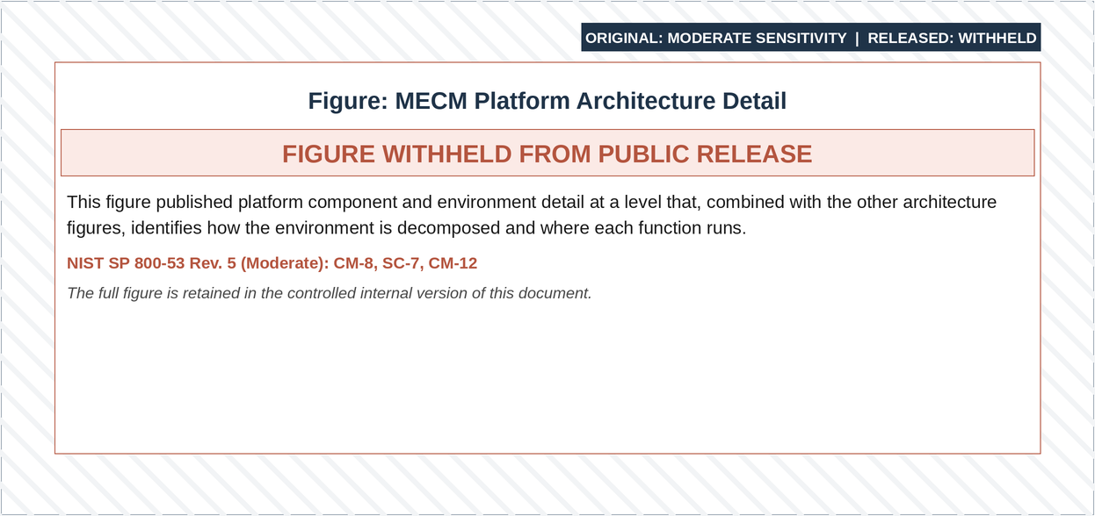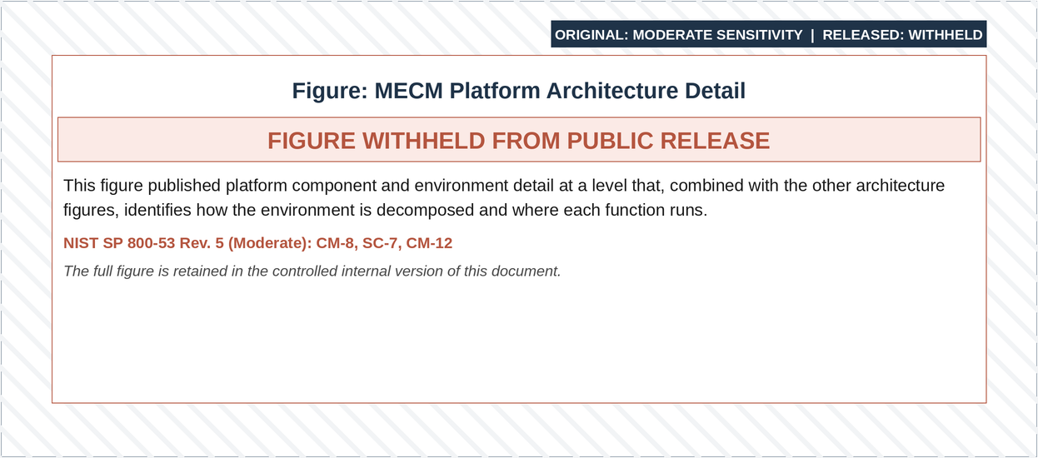
Figure 3-2: Logical Architecture Diagram
As shown in the above figure the MECM Logical Zone is comprised of Web, Application, Integration, and Data Layers hosted on the AWS GovCloud Platform. These layers address Presentation, Business, Integration and Persistence Logic, respectively.
- The MECM Web layer follows the Americans with Disabilities Act (ADA) and Web Content Accessibility Guidelines
- The MECM Application layer implements business logic by interacting with databases and back-end services
- The MECM Integration layer uses the following integration patterns:
  - ESB for web services
  - SFTP for file transfer
- The MECM system interfaces with the trading partners including state, federal & third-party systems
- The MECM Data layer persists successful business transactions performed by users into the MECM database, which acts as the single source of truth for transaction, analytics, and audit data
- MECM leverages cloud-based software as a service (SaaS) and PaaS services for implementing back-end services including monitoring and reporting
- DOH employees will access WP through New York State’s (NYS) Network
- Maximus, NYSOH and Local Departments of Social Services (LDSS) users will access the WP through the State network
- New York state residents and assistors will access MP through the public internet
Refer to Appendix B for the original Logical Architecture Diagram of the MECM system.

Physical Architecture
The server layout, network communication paths, and system architecture boundaries are outlined in the Physical Architecture Diagram. The figure below depicts the Physical Architecture Diagram of the planned network layout and the deployment model for COTS products for the Wave 1 MECM production environment on the AWS GovCloud platform.
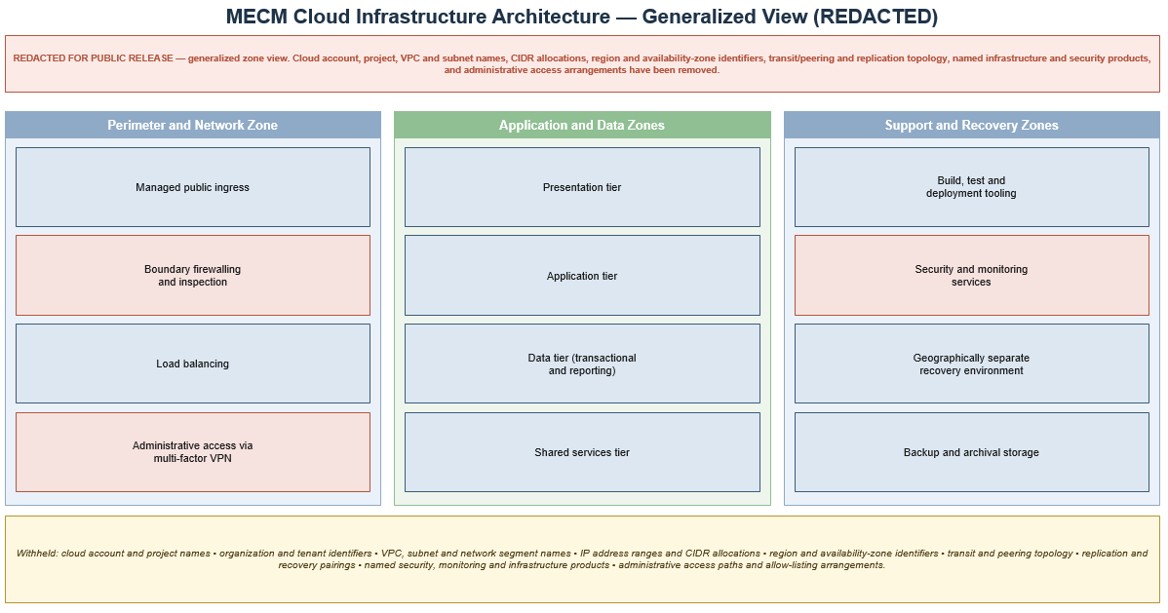
Figure 3-3: MECM Wave 1 Physical Architecture Diagram
The MECM system is built as high available environment spanning across two availability zones within a region. Components marked in green, on the diagram, operate in an Active - Active configurations, while components marked in yellow, such as RDS, will be in Active–Standby configuration with replication enabled.
When a case worker accesses the WP application, the request is routed to through the external ALB, WAF, and then through the Palo Alto firewalls. It enters the production VPC via the transit gateway, and then proceeds to the internal ALB. The internal ALB then routes the requests to the WP Web Servers in any of the AZ, which in turn forward the request to the WebSphere Application Server.
When a New York resident or assistor accesses the MP application, the request passes through the external ALB, WAF, and then through the Palo Alto firewalls. It enters the production VPC via the transit gateway and then proceeds to the internal ALBs. The internal ALB routes the request to the customer portal Web Servers in any of the AZ.
Refer to Appendix B for the original Physical Architecture Diagram.

Infrastructure and Platform Architecture
The MECM system Infrastructure Platform Diagram outlines the high-level design of the AWS cloud infrastructure for the MECM system. It presents the platform architecture, including cloud infrastructure, firewall configurations, network traffic management, and services that enable scalable, flexible, and cost-effective solutions. Refer to Appendix B for the Infrastructure and Platform Diagram.
The figure below shows the NY MECM Infrastructure production (PROD), and DR Diagram outlines the PROD and DR Infrastructure. Refer to Appendix B for the Infrastructure and Platform Diagram original diagram.

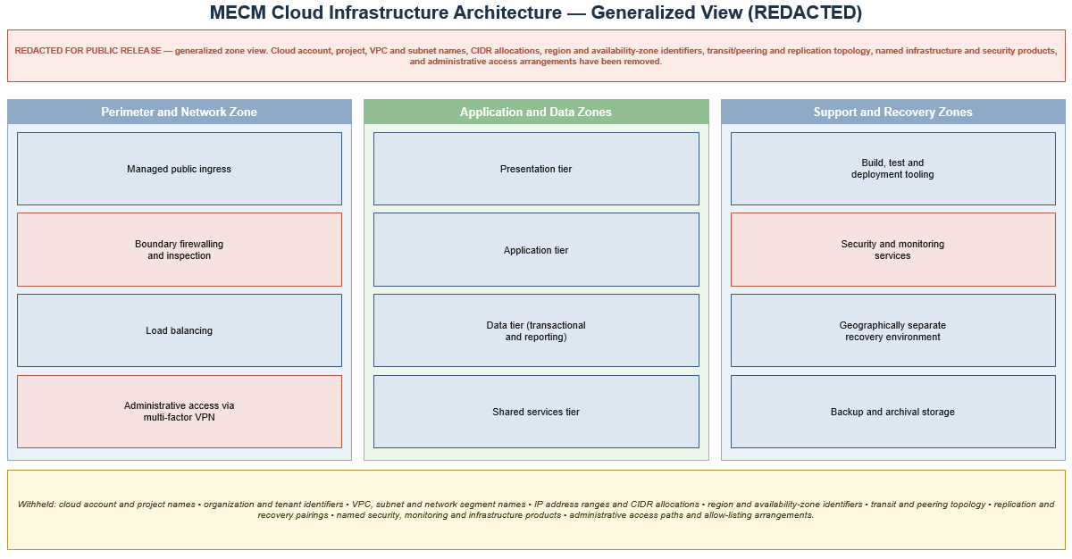
Figure 3-4: MECM AWS Infrastructure and Platform Architecture Diagram

Multi-Account Architecture
Deloitte manages the AWS root account that supports the MECM system. We use an industry-standard, multi-account architecture to manage all accounts, creating and provisioning multiple accounts under different organizational units (OU). This approach enforces a least privileged security posture, confirming that services in one account do not implicitly access services in other accounts.
We use AWS Control Tower to set up a landing zone for the MECM system, providing a well-architected, multi-account environment based on security and compliance best practices. This landing zone, following the AWS Well-Architected Framework, offers centralized governance and security, including identify and access management. It implements AWS Service Control Policies (SCPs) to enforce security standards, such as bucket policies, tagging policies, and the blocking of prohibited services. Cross-account access must be explicitly granted via policies and roles.
The MECM system has landing zones in both Commercial Master Payer and GovCloud Managed accounts, with SCPs applied to all OUs. Each GovCloud account is associated with a commercial account used solely for billing purposes.
The NY MECM Multi-Acct sheet illustrates the multi-account design, detailing the overall account structure for the NY MECM System. This structure supports flexibility and scalability, enabling OHIP to seamlessly incorporate additional applications and accounts, and expand its cloud infrastructure as needed.
The Commercial and GovCloud multi-account design diagram illustrate the structure and relationships among AWS accounts and OUs. Below is a list of AWS account names, descriptions, and the associated VPCs.
Each AWS account can host multiple VPCs to separate various environments and services, improving security, streamlining management, and validating resource isolation. The following table details the MECM system's AWS accounts and their corresponding cloud environment, description, and VPC.
AWS Account | AWS Cloud Environment | Description | VPC
Master Payer Account | Commercial | Control Tower Central management and administration | N/A
Logging Account | GovCloud | Centralized logging | N/A
Logging Account | Commercial | Centralized logging | N/A
Security Account | GovCloud | Centralized Security Hub/Guard duty | N/A
Security Account | Commercial | Centralized Security Hub/Guard duty | N/A
Billing Account | GovCloud | Billing Account for end client Access | N/A
Billing Account | Commercial | Billing Account for end client Access | NA
Network (STUB) Account | Commercial | Route53 public hosted zone | N/A
Network (STUB) Account | GovCloud | Network and Identity components like Palo, Active Directory (AD) Active Directory Federation Services (ADFS), Identity Management (IdM), Syslog | NY-MECM-NETWORK-VPC  NY-MECM-IDENTITY-VPC  NY-MECM-NETWORK-DR-VPC  NY-MECM-IDENTITY-DR-VPC  NY-MECM-AD-DR-VPC
Network (STUB) Account | Commercial | Network and Identity components like Palo, AD ADFS, IdM, Syslog | N/A
Cloud Managed Platform (CMP) Account | GovCloud | Nessus Vulnerability Management Account | NY-MECM-CMP-VPC  NY-MECM-CMP-DR-VPC
CMP Account | Commercial | Nessus Vulnerability Management Account | N/A
Fortress Account | GovCloud | Auto remediation framework (Security Logging and Monitoring (SL&M)) | N/A
Fortress Account | Commercial | Auto remediation framework (SL&M) | N/A
Non-Prod Account | GovCloud | Non-Prod account includes User Acceptance Testing (UAT) and DEV environments | MECM-UAT-VPC  MECM-DEV-VPC
Non-Prod Account | Commercial | Non-Prod account includes UAT and DEV environments | N/A
Dev Account | GovCloud | Development Account | NY-MECM-DEV-WKSP-VPC
Dev Account | Commercial | Development Account | N/A
Development Operations (DevOps) Account | GovCloud | Development, Security, and Operations (DEVSECOPS)/UTIL | NYMECM-DEVSECOPS-VPC  MECM-UTIL-VPC
DevOps Account | Commercial | DEVSECOPS/UTIL | N/A
Staging (STG) Account | GovCloud | STG Account includes listed environments SHRD, System Integration Testing for Conversion (SITC), System Integration Testing (SIT)3, SIT4, UAT1, UAT2, UATC, TRNDL, TRNDEV | NY-MECM-STG-VPC
STG Account | Commercial | STG Account includes listed environments SHRD, SITC, SIT3, SIT4, UAT1, UAT2, UATC, TRNDL, TRNDEV | N/A
PRE-PROD Account | GovCloud | Pre-Production Account | NY-MECM-PRE-PROD-VPC
PRE-PROD Account | Commercial | Pre-Production Account | N/A
PROD Account | GovCloud | Production Account | NY-MECM-PROD-VPC  NY-MECM-DR-VPC
PROD Account | Commercial | Production Account | N/A
Table 3-7: MECM System's AWS Account

Network Architecture
This section details the proposed network design, including interfaces between Network, PROD and DR environments, Transit gateways, and traffic flow through firewalls. It adopts a security-centric approach that meets MARS-E 2.2, National Institute of Standards and Technology (NIST) 800, and IRS 1075 compliance requirements, enables layer-7 network inspection, fulfils the performance and functional requirements of the NY MECM application.
The objectives of the network design are to:
- Meet MARS-E 2.2, NIST 800, and IRS 1075 compliance requirements
- Provide data isolation by data sensitivity and administrative domain
- Enable layer-7 packet inspection capabilities
- Offer a single secure entry/exit point to the cloud environment
- Verify secure connectivity to on-premises workloads, as needed
- Create a highly available (HA) architecture for business continuity

Identity Management
System-level access to MECM cloud-based resources is implemented using Microsoft AD, Microsoft ADFS, and Red Hat IdM.

Active Directory
Active Directory is used as the primary identity store for all Window’s system-level access and provides user-level authentication and authorization to the AWS Console, ServiceNow, Palo Alto Firewalls, Global Protect Virtual Private Network (VPN), Windows servers, and AWS WorkSpace within the MECM environment.

Active Directory Federated Services
ADFS connects to the AD store to authenticate web-based authentication requests. Successful authentication provides role-based access to the AWS Console, ServiceNow, Palo Alto Firewalls, Global Protect VPN, and any other resources to which users have been granted access.

Red Hat Identity Management
Red Hat IdM provides a centralized and unified way to manage MECM Linux-based identities, user authentication, and policy enforcement within the Linux-based domain. Permitted users authenticate themselves to their respective Linux instances in the MECM environment using their RedHat IdM credentials. This verifies that access to Linux-based resources is governed by the centralized identity management policies enforced by RedHat IdM.
The cloud security team will track user access, including user access requests, approvals, and system access auditing.
System access will be managed by the Cloud Operations team. The Cloud Operations team will be responsible for provisioning access, along with the tools and methods used to facilitate secure access to each application and/or service.

Infrastructure Automation
The MECM Cloud environment leverages infrastructure-as-code (IaC) practices to verify configuration consistency, compliance, and accountability. AWS infrastructure services are built using Terraform and GitLab, with the GitLab CI/CD pipeline and Aqua Security Terraform Security (tfsec) which is a static code analysis of Terraform code to spot security misconfigurations to securely automate provisioning and management of AWS resources.
Aqua Security tfsec is a tool that enhances the security of Terraform code by performing static analysis to identify potential vulnerabilities and misconfigurations. In the MECM environment, tfsec is integrated into the GitLab pipeline to automate and standardize security checks. The tfsec job runs and scans the code during each deployment across all environments, proactively identifying security risks based on predefined custom rules. Regular review and remediation of issues identified by tfsec are essential to maintaining a secure infrastructure.
Environment | Repository URL
BOT | [URL REDACTED]
BOT | [URL REDACTED]
CMP | [URL REDACTED]
CMP-DR | [URL REDACTED]
DEV | [URL REDACTED]
DEV-WKSP | [URL REDACTED]
DEVSECOPS | [URL REDACTED]
DOPS | [URL REDACTED]
DOPS-DR | [URL REDACTED]
FRT | [URL REDACTED]
GCP | [URL REDACTED]
GCP | [URL REDACTED]
GCP | [URL REDACTED]
GCP | [URL REDACTED]
GCP | [URL REDACTED]
GCP | [URL REDACTED]
GCP | [URL REDACTED]
LOG | [URL REDACTED]
NPD | [URL REDACTED]
OIA | [URL REDACTED]
PPRD | [URL REDACTED]
PROD | [URL REDACTED]
PROD_DR | [URL REDACTED]
SEC | [URL REDACTED]
STG | [URL REDACTED]
STUB | [URL REDACTED]
STUB | [URL REDACTED]
STUB-DR | [URL REDACTED]
Table 3-8: MECM Environment Repositories in GitLab
Naming Standards:
To manage the environment consistently, the MECM environment follows a naming standard that starts with the state, project name, and environment name and followed by the service name:
- Use a combination of uppercase and lowercase letters
- Use "-" as a delimiter to separate the state acronym, project name, environment name, description, and service
- Acceptable characters include alphanumeric characters and underscores (_)
- S3 bucket names must not contain underscores (_)
- For multiple resources of the same type, such as EC2 instances, use 2-digit numbers that increment by one (e.g., NY-MECM-PROD-BES02-EC2 and NY-MECM-PROD-BES02-EC2r)
The tables below contain examples of the commonly used AWS services naming conventions and example values to illustrate the MECM naming standards.
Service | Designator | Nomenclature | Example
Groups | grp | <projectname>-<groupname>-grp | ny-mecm-****-grp
Instance Profile | ipr | <projectname>-<policyname>-ipr | ny-mecm-****-ipr
Policies | pol | <projectname>-<policyname>-pol | ny-mecm-*****-pol
Roles | rol | <projectname>-<rolename>-rol | ny-mecm-*****-rol
Table 3-9: Naming Standards for Identity and Access Management Services
Service | Designator | Nomenclature | Example
Internet Gateways | igw | <projectname>-<vpcname>-igw | NY-MECM-PROD-IGW
Security Groups* | scg | <projectname>-<vpcname>-  <securitygroupname>-scg | NY-MECM-PROD-IICS01-ScG
Subnets | snt | <projectname>-<vpcname>-  <subnetname>-snt-<az id> | NY-MECM-PROD-Db-Snt-w2b
Transit Gateway (TGW) Attachment | tgw-attach | <projectname>-<tgwname#>-tga | NY-MECM-Network01-TGA
TGW Route Table | rtb | <projectname>-<vpcname>-  <tgwroutetablename>-route-table | NY-MECM-PROD-VPC-RTB
TGW | tgw | <projectname>-<tgwname#>-tgw | NY-MECM-STUB-VPC-TGW
Virtual Private Gateways | vpg | <projectname>-<vpcname>-vpg | NY-MECM-PROD-VPG
DHCP Option Sets | dopt | <projectname>-<vpcname>-dopt | NY-MECM-PROD-DOPT
Network ACL’s | acl | <projectname>-<vpcname>-acl | NY-MECM-STG-ACL
VPC | vpc | <projectname>-<vpcname>-vpc | NY-MECM-STUB-VPC  NY-MECM-DOPS-VPC  NY-MECM-PROD-VPC  NY-MECM-DR-VPC
VPC Route Tables | rtb | <projectname>-<vpcname>-  <vpcroutetablename>-RTB | NY-MECM-PROD-VPC-RTB
VPC Endpoints | vpce | <projectname>-<vpcname>-  <servicename>-vpce | NY-MECM-PROD-S3-VPCE
*Security groups that are shared across multiple applications and services should have descriptive names, based on the access provided.
**Type: Private, public or transit<br>Gateway – tgw,vpg
Table 3-10: Naming Standards for Networking Services
Service | Designator | Nomenclature | Example
Application Load Balancer | alb | <projectname>-<vpcname>-  <albname>-alb | NY-MECM-PROD-APP01-ALB
EC2 | ec2 | <projectname>-<vpcname>-  <applicationname>-ec2 | NY-MECM-PROD-BES01-EC2  NY-MECM-PROD-WEB02-EC2
Key Pairs | kpr | <projectname>-<vpcname>-  <applicationname>-kpr | NY-MECM-PROD-RHEL-KPR
Lambda | lbd | ny-mecm-<vpcname>-<applicationname>-lbd | NY-MECM-PROD-CW-Alarm-lbd
Network  Interfaces | eni | <projectname>-<vpcname>-  <applicationname>-<eth#>-eni | NY-MECM-PROD-Adobe-E01-ENI
Network Load Balancers | nlb | <projectname>-<vpcname>-  <nlbname>-nlb | NY-MECM-PROD-Customerportalext-NLB
Target Groups | tg | <projectname>-<vpcname>-  <applicationname>-tgr | NY-MECM-PROD-Customerportal-TG
Table 3-11: Naming Standards for Compute and Service Resources
Service | Designator | Nomenclature | Example
AMI’s | ami | <projectname>-<vpcname>-  <osname>-<builddate/buildnumber>-  ami | NYMECM-PROD-WINDOWS19-CIS-20240212-AMI
EBS Volumes | ebs | <projectname>-<vpcname>-  <applicationname>-<volname>-<ebstype>-ebs | NY-MECM-SHRD-CASM02-EBS
EFS | efs | <projectname>-<vpcname>-<efsname>-efs | NY-MECM-STG-Utility-EFS
S3* | s3b | <projectname>-<vpcname>-  <applicationname>-<accountnumber>-s3b (for application storage use)  or  <projectname>-<bucketname>-  <accountnumber>-s3b | NY-MECM-APP-Artifacts--009116661978-s3b
AWS Backup | backup | All backup copies/snapshots have same name as its resource name (EC2/EBS/EFS/RDS) with date creation | NY-MECM-PROD-Backup
Table 3-12: Naming Standards for Storage Services
Service | Designator | Nomenclature | Example
Cloud Watch  Alarm | cwa | <Alarm description>-<ResourceName>-  <instance> | Critical - System Status Check Failure on PROD NY-MECM-PROD-CPT04- EC2
KMS | kms | <projectname>-<vpcname>-<servicename>- kms | NY-MECM-S3-kms
SNS | sns | <projectname>-<vpcname>-<P1/P2/P3>-sns | NY-MECM-PROD-P1-CWA
SES | ses | <projectname>-<vpcname>-<service>-ses | NY-MECM-DEV-SMTP-SES
Event Bridge Rule | event | <projectname>-<vpcname>-<service>-event | NY-MECM-PROD-Oslogs-Exporter-Event
Table 3-13: Naming Standards for Management Tools
Service | Designator | Nomenclature | Example
Oracle | dbname | <projectname>-<service>-dbname | ny-mecm-oracl-nyprdwp
Aurora PGSQL | dbname | <projectname>-<service>-dbname | ny-mecm-pgsql-nyprdcp
Table 3-14: Naming Standards for Relational Database Service

MECM System's Naming and Tagging Standards
The MECM system’s tagging and naming standards are detailed in Deliverable #27, the Cloud Finance and Operations Management Plan and defines how metadata tags will be named and defined for all AWS resources deployed to support the MECM system. Refer to DOH_OHIP_NY_FinOps_TaggingStandards in Appendix B for the tagging standards.

AWS Native Services
AWS Services are the foundation of the MECM system’s infrastructure. In the table below the service’s category and description are provided.
Service Name | Service Category | Description
VPC | Networking & Content Delivery | VPC is virtual network dedicated to NY MECM account, VPCs are isolated from each other, ensuring that resources in one VPC cannot communicate with resources in another VPC unless explicitly allowed.
AWS Lambda | Compute | AWS Lambda is an event-driven, serverless computing platform provided by Amazon. In the NY-MECM environment, we utilize AWS Lambda to automate operational tasks such as backups, system monitoring, and scheduled tasks.
TWG | Networking & Content Delivery | A TGW is a network transit hub that interconnects attachments (VPCs and VPNs) within the same account or across accounts for connectivity.
Elastic Load Balancer (ELB) | Networking & Content Delivery | The Elastic Load Balancer distributes incoming application or network traffic across multiple targets, such as Amazon EC2 instances, containers, and IP addresses, in multiple Availability Zones.
Route 53 | Networking & Content Delivery | Route 53 is a highly available and scalable Domain Name System (DNS) web service.
Amazon EC2 | Compute | EC2 instances are virtual servers that are launched within each AWS environment.
Amazon S3 | Storage | S3 is a scalable object storage service in the AWS cloud that seamlessly integrates with other AWS services.
Amazon Elastic File System (EFS) | Storage | EFS is a scalable, elastic, fully managed, cloud-native Network File System (NFS) for Linux-Based systems.
Amazon Elastic Block Store (EBS) | Storage | EBS Provides block-level storage that can be attached to EC2 instances and is also utilized by Amazon RDS.
AWS Backup Service | Storage | AWS Backup Service will orchestrate backups of the following gateway-specific services: EC2, EBS, EFS, and RDS.
Certificate Manager | Security,  Identity & Compliance | Certificate Manager provisions, manages, and deploys Secure Sockets Layer/Transport Layer Security (SSL/TLS) private certificates.
Key Management Service (KMS) | Security, Identity & Compliance | KMS securely generates and manages encryption keys.
AWS Control Tower | Management & Governance | AWS Control Tower sets up and governs secure, multi-account AWS environments.
Amazon CloudWatch | Management & Governance | CloudWatch monitors and tracks metrics for AWS resources and applications in real time.
AWS CloudFormation | Management & Governance | CloudFormation creates and configures AWS resources using templates.
AWS CloudTrail | Management & Governance | CloudTrail tracks user activity and API usage.
AWS Config | Management & Governance | Config provides a detailed view of AWS resources, configuration history, and configuration changes to increase visibility and governance of the AWS infrastructure.
AWS System Manager (SSM) | Management & Governance | SSM provides a centralized platform to view operational data from multiple AWS services and automate operational tasks across your AWS resources.
AWS Resource Group | Management & Governance | AWS Resource Group simplifies operations by enabling the centralized management and automation of resource collections using tag-based groupings and defined criteria.
Amazon Simple Notification Service (SNS) | Application Integration | SNS is a notification service that provides high-throughput, push-based, many-to-many messaging between distributed systems, microservices, and event-driven serverless applications.
Amazon Simple Email Service (SES) | Email Service | SES provides high-volume automated notification and transactional emails.
Amazon Simple Queue Service (SQS) | Application Integration | SQS enables decoupling and scaling by allowing you to send, store, and receive messages between software components at any volume, without losing messages or needing other services to be available.
AWS Billing Conductor | Cost Management | AWS Billing Conductor provides a customizable view of AWS costs to provide greater control and transparency over financial management and cost optimization.
AWS Cost Explorer | Cost Management | AWS Cost Explorer allows users to visualize, understand, and manage their AWS costs and usage over time to increase cost visibility, optimization, budget forecasting, anomaly detection, etc.
Amazon EventBridge | Event Bridge service | EventBridge is a serverless event bus service that facilitates event-driven architectures, allowing them to react to changes in data or state, and integrate with SaaS applications and AWS services.
IAM | Security, Identity, Compliance | IAM securely controls access to AWS services by managing user and group permissions, ensuring only authorized individuals can access specific resources.
AWS CloudFormation | Management and Governance | CloudFormation provisions all infrastructure resources in the MECM cloud environment to verify resources are provisioned in a reliable, repeatable, and automated manner.
Elastic Container Services (ECS) | Containers | ECS runs and manages Docker containers on a cluster of EC2 instances or using AWS FarGate, which is a serverless compute engine for containers.
Elastic Container Registry (ECR) | Containers | ECR allows developers to store, manage, and deploy Docker container images securely and at scale by integrating ECS and other AWS services.
AWS Transfer Family | Migration and Transfer | AWS Transfer Family SFTP is used to transfer files to and from MECM. AWS Transfer Family includes transfer connectors that facilitate the integration of existing file transfer workflows with AWS storage services and Amazon S3 SFTP.
Amazon RDS | Database | Amazon RDS is a fully managed service that simplifies the deployment, operation, and scaling of relational databases in the cloud (e.g., MECM utilizes Oracle and Aurora PostgreSQL).
Table 3-15: AWS Services Utilized

Cloud Managed Platform Components
The Cloud Operations team leverages tools to effectively manage applications, infrastructure, and security procedures.
Tool | Description
Microsoft Directory Service | Microsoft Directory Service provides server infrastructure & user management. Deloitte admin and application Users and Groups in Directory Service enable server access based on the least privilege access requirements.
ADFS | ADFS connects to the AD store to authenticate web-based authentication requests; successful authentication provides role-based access to AWS Console, ServiceNow, PaloAlto Firewalls, Global Protect VPN, and any other resources which they have been granted access.
AWS Route53 | Route 53 is a highly available and scalable cloud DNS web service. It provides hostnames to IP resolution within the NY-MECM AWS environment.
GitLab | GitLab is a source control versioning tool used to store Infrastructure as a code which is written using Ansible and Terraform.
GitLab runner | Gitlab Runner is an application that executes the jobs to automate the build of all the non-PROD and PROD AWS accounts by executing the Ansible and Terraform scripts.
Nessus Tenable | Nessus Tenable will be configured to utilize the latest IRS Security Configuration and Evaluation Management (SCEM) for vulnerability scanning, aimed at identifying and remediating vulnerabilities and ensuring configuration compliance in application operating systems. This includes activities such as vulnerability scanning and Security Content Automation Protocol (SCAP) scans.
SL&M | SL&M is composed of Endpoint Prevention, Detection and Response (EPDR), Identity Prevention, Detection and Response (IPDR), Extended Detection and Response (XPDR), and Cloud Security, Prevention, Detection and Response (CSPDR). Each are defined below:  EPDR: EDPR is a cybersecurity approach that combines traditional endpoint protection (antivirus, anti-malware, etc.) with advanced detection and response capabilities.  IPDR: IPDR is a cybersecurity framework that combines various protection mechanisms with advanced detection and response capabilities to provide a comprehensive security solution.  XPDR: XPDR is an advanced cybersecurity approach that integrates multiple security products into a cohesive system to provide comprehensive threat detection, investigation, and response capabilities across an organization’s entire IT environment.  CSPDR: CSPDR is a cybersecurity framework specifically designed to manage and enhance the security posture of cloud environments. CSPDR integrates various security tools and practices to continuously monitor, detect, and respond to security threats and misconfigurations in cloud infrastructures.
Palo Alto Virtual Machine (VM)-300 | Palo Alto Networks VM-300 is a virtual next-generation firewall offering advanced security in virtualized environments, part of the VM-Series tailored for various performance and deployment needs.  Palo Alto Firewalls perform geo-blocking to restrict access from non-US users by utilizing a geo-location database that maps IP addresses to their respective countries. Administrators configure security policies to allow only IP addresses from the United States. When traffic reaches the firewall, it checks the source or destination IP address against the geo-location database and enforces the configured policies. If the IP address is from a non-US country, the traffic is blocked.
RedHat IdM | RedHat IdM facilitates authentication and authorization against Microsoft AD for user access on Linux or Windows systems within the cloud environment.
Table 3-16: AWS Hosted Tools

MECM System Environments Overview
Refer to the NYS MECM Environment Details_04.30.2025 PowerPoint (link to document location: [URL REDACTED] for the MECM system environment details.
This has been added to Appendix B.

Google Cloud Platform Architecture Overview
The Google Cloud Platform (GCP) diagram below outlines the platform architecture that is designed to support scalable chatbot and AI-driven solutions while enabling future expansion for additional workloads. The architecture also integrates MECM’s AWS GovCloud connectivity, ensuring seamless cross-cloud interoperability.
High-Level Architecture:
The infrastructure follows a multi-VPC design, segmenting workload for security, scalability, and operational efficiency. It consists of:
- AWS External Connectivity: Traffic originates from AWS, reaching GCP via a secure connection
- Network VPC: Centralized networking layer managing routing and connectivity
- GlobalProtect VPN: Secure remote access
- PROD, DEV, STG VPCs: Isolated environments for different deployment stages
- Load Balancers (LBs): Managing external and internal traffic
- Routing Tables and Peering Configurations: Allows secure routable communication between resources
Purpose: Google Dialogflow and Chatbot Scalability
This infrastructure is primarily designed to support Google Dialogflow, a conversational AI service for building chatbots and virtual agents. The setup provides:
- Scalability: Modular in design to support onboarding future Artificial Intelligence (AI)/Machine Learning (ML)- workloads and other cloud solutions
- Security & Isolation: Separate environments (PROD. DEV, STG) for controlled and secure deployments
- Cross-Cloud Integration: AWS-to-GCP connectivity allows hybrid cloud flexibility
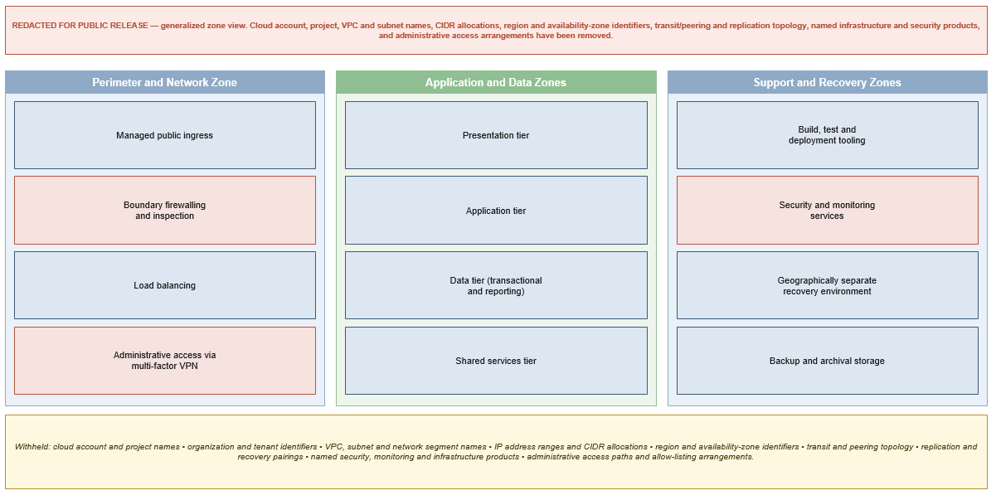
Figure 3-5: Google Cloud Platform Architecture
GCP Organizational Structure:
The GCP OU structure diagram, below, illustrates an overview of the GCP organizational structure, designed for managing scalable AI/chatbot solutions while ensuring robust security, governance, and operational efficiency.
High-Level Architecture:
The architecture follows a Management Landing Zone approach, where all GCP-managed resources are structured under a centralized GCP organization.
GCP Organizational Hierarchy:
- GCP Organizational Root - This is the highest-level entity, managing all projects and resources
- Management Landing Zone - Controls governance, security, and compliance policies
- GCP Managed Resources – Logical folders used for structuring workloads:
  - STUB – Includes networking and authentication (future) resources
  - DevOps – Infrastructure and automated tooling
  - Security (Sec) – Dedicated for security-related services and IAM controls
  - Logging – Centralized logging infrastructure
  - OHIP > MECM > Dialogflow Customer Experience (CX) (DFCX) – AI/Chatbot workload environments
  - STG/DEV/PROD – Segregated environments for staged deployments
  - Monitoring – Centralized observation and telemetry
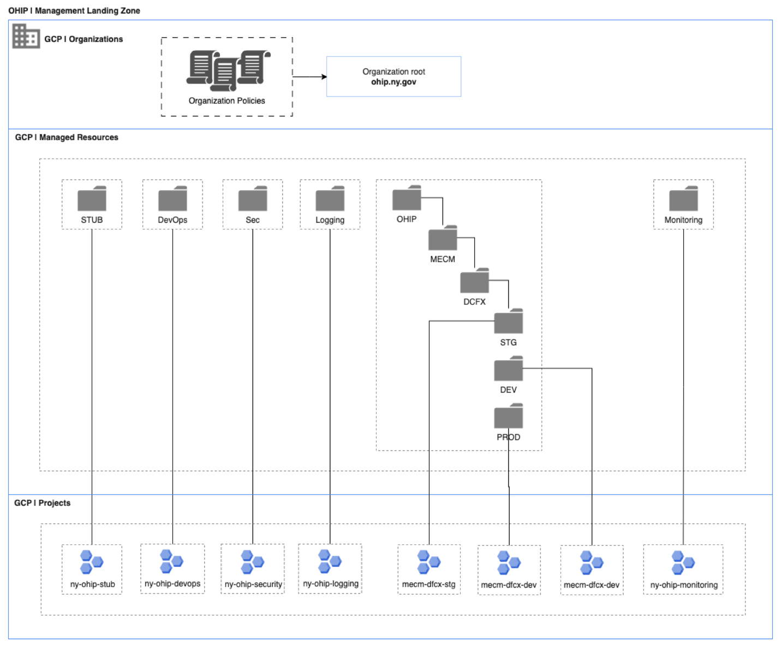
Figure 3-6: GCP Organizations OU Structure
The following table lists out the Policy name, ID and description of the policies that can be applied at various levels including OU level.
Policy Name | Policy ID | Description
Allow extending lifetime of OAuth 2.0 access tokens to up to 12 hours | iam.allowServiceAccountCredentialLifetimeExtension | This list constraint defines the set of service accounts that can be granted OAuth 2.0 access tokens with a lifetime of up to 12 hours. By default, the maximum lifetime for these access tokens is one hour. The allowed/denied list of service accounts must specify one or more service account email addresses.
Allowed Destinations for Exporting Resources | resourcemanager.allowedExportDestinations | This list constraint defines the set of external organizations to which resources can be moved and denies all moves to all other organizations. By default, resources cannot be moved between organizations. If this constraint is applied to a resource, the resource can be moved only to organizations that are explicitly allowed by this constraint. Moves within an organization are not governed by this constraint. The move operation will still require the same IAM permissions as normal resource moves. Values specified in allow/deny lists must be in the form: under organizations/ORGANIZATION_ID.
Allowed Sources for Importing Resources | resourcemanager.allowedImportSources | This list constraint defines the set of external organizations from which resources can be imported and denies all moves from all other organizations. By default, resources cannot be moved between organizations. If this constraint is applied to a resource, imported resources directly under this resource must be explicitly allowed by this constraint. Moves within an organization are not governed by this constraint. The move operation will still require the same IAM permissions as normal resource moves. Values specified in allow/deny lists must be in the form: under organizations/ORGANIZATION_ID.
Define allowed external IPs for VM instances | compute.vmExternalIpAccess | This list constraint defines the set of Compute Engine VM instances that are allowed to use external IP addresses. By default, all VM instances are allowed to use external IP addresses. The allowed/denied list of VM instances must be identified by the VM instance name, in the form: projects/PROJECT_ID/zones/ZONE/instances/INSTANCE
Disable Automatic IAM Grants for Default Service Accounts | iam.automaticIamGrantsForDefaultServiceAccounts | This Boolean constraint, when enforced, prevents the default App Engine and Compute Engine service accounts that are created in your projects from being automatically granted any IAM role on the project when the accounts are created. By default, these service accounts automatically receive the Editor role when they are created. To learn about default service accounts, see [URL REDACTED]t. To learn which roles to grant instead of the Editor role, see [URL REDACTED]
Disable Create Default Service Account (Cloud Build) | cloudbuild.disableCreateDefaultServiceAccount | This Boolean constraint, when enforced, prevents the legacy Cloud Build service account from being created.
Disable Service Account Key Upload | iam.disableServiceAccountKeyUpload | This Boolean constraint disables the feature that allows uploading public keys to service accounts where this constraint is set to True. By default, users can upload public keys to service accounts based on their Cloud IAM roles and permissions.
Disable VM nested virtualization | compute.disableNestedVirtualization | This Boolean constraint disables hardware-accelerated nested virtualization for all Compute Engine VMs belonging to the organization, project, or folder where this constraint is set to True. By default, hardware-accelerated nested virtualization is allowed for all Compute Engine VMs running on Intel Haswell or newer Central Processing Unit (CPU) platforms.
Disable VM serial port access | compute.disableSerialPortAccess | This Boolean constraint disables serial-port access to Compute Engine VMs belonging to the organization, project, or folder where this constraint is set to 'True'. By default, customers can enable serial-port access for Compute Engine VMs on a per-VM or per-project basis using metadata attributes. Enforcing this constraint will disable serial-port access for Compute Engine VMs, regardless of the metadata attributes.
Disable VPC External IPv6 usage | compute.disableVpcExternalIpv6 | This Boolean constraint, when set to True, disables the creation of or update to subnetworks with a stack_type of IPV4_IPV6 and ipv6_access_type of EXTERNAL. By default, anyone with appropriate Cloud IAM permissions can create or update subnetworks with stack_type of IPV4_IPV6 in any projects, folders, and organizations.
Domain restricted contacts | essentialcontacts.allowedContactDomains | This list constraint defines the set of domains that email addresses added to Essential Contacts can have. By default, email addresses with any domain can be added to Essential Contacts. The allowed/denied list must specify one or more domains of the form @example.com. If this constraint is active and configured with allowed values, only email addresses with a suffix matching one of the entries from the list of allowed domains can be added in Essential Contacts. This constraint has no effect on updating or removing existing contacts.
Domain restricted sharing | iam.allowedPolicyMemberDomains | This list constraint defines one or more Cloud Identity or Google Workspace customer IDs whose principals can be added to IAM policies. By default, all user identities are allowed to be added to IAM policies. Only allowed values can be defined in this constraint. Denied values are not supported. If this constraint is active, only principals that belong to the allowed customer IDs can be added to IAM policies. You do not need to add the google.com customer ID to this list in order to interoperate with Google services. Adding google.com allows sharing with Google employees and non-production systems and should only be used for sharing data with Google employees.
public-access-prevention | storage.publicAccessPrevention | Secure your Cloud Storage data from public exposure by enforcing public access prevention. This governance policy prevents existing and future resources from being accessed via the public Internet by disabling and blocking ACLs and IAM permissions that grant access to allUsers and allAuthenticatedUsers. Enforce this policy on the entire organization (recommended), specific projects or specific folders to certify that no data is publicly exposed.  This policy overrides existing public permissions. Public access will be revoked for existing buckets and objects after this policy is enabled.  For more details on the effects of changing enforcement of this constraint on resources, refer to the public access prevention link (see link in the first column).
Enforce uniform bucket-level access | storage.uniformBucketLevelAccess | This Boolean constraint requires buckets to use uniform bucket-level access where this constraint is set to True. Any new bucket in the organization resource must have uniform bucket-level access enabled, and no existing buckets in the organization resource can disable uniform bucket-level access. Enforcement of this constraint is not retroactive: existing buckets with uniform bucket-level access disabled continue to have it disabled. The default value for this constraint is False. Uniform bucket-level access disables the evaluation of ACLs assigned to Cloud Storage objects in the bucket. Consequently, only IAM policies grant access to objects in these buckets.
Require Enabled Services Allow List for Cross-Organization Move | resourcemanager.allowEnabledServicesForExport | This list constraint acts as a check to verify that a project with a service enabled is eligible for cross-organization move. A resource with a supported service enabled must have this constraint enforced and that supported service must be included in the allowed values to be eligible for a cross-organization move. The current list of allowed values for supported services that can be used is: [SHARED_VPC]. This constraint provides an additional control on top of constraints/resourcemanager.allowedExportDestinations. This list_constraint is empty by default and will not block cross-organization moves unless a supported service is enabled on the resource to be exported. This constraint allows more fine-grained control over resources using features that require more caution when being moved to another organization. By default, a resource with a supported service enabled cannot be moved across organizations.
Require OS Login | compute.requireOsLogin | This Boolean constraint, when set to true, enables OS Login on all newly created projects. All VM instances created in new projects will have OS Login enabled. On new and existing projects, this constraint prevents metadata updates that disable OS Login at the project or instance level. By default, the OS Login feature is disabled on Compute Engine projects. GKE instances in private clusters running node pool versions 1.20.5-gke.2000 and later support OS Login. GKE instances in public clusters do not currently support OS Login. If this constraint is applied to a project running public clusters, GKE instances running in that project may not function properly.
Restrict access on marketplace services | commerceorggovernance.marketplaceServices | This list constraint defines the set of services allowed for marketplace organizations and can only include values from the list below: [PRIVATE_MARKETPLACE, IAAS_PROCUREMENT]. If the IAAS_PROCUREMENT is in the allowed value list, the IaaS procurement governance experience is enabled for all products. By default, the IaaS procurement governance experience is turned off. The IAAS_PROCUREMENT policy works independently from the request procurement governance capability, which is specifically for SaaS products listed on cloud Marketplace. Note: The PRIVATE_MARKETPLACE value is no longer supported and using it has no effect. To turn on Google private marketplace, you must follow the instructions at [URL REDACTED].
Restrict Authorized Networks on Cloud SQL instances | sql.restrictAuthorizedNetworks | This Boolean constraint restricts the addition of Authorized Networks for unproxied database access to Cloud SQL instances, where this constraint is set to True. This constraint is not retroactive, Cloud SQL instances with existing Authorized Networks will still work even after this constraint is enforced. By default, Authorized Networks can be added to Cloud SQL instances.
Restrict Protocol Forwarding Based on type of IP Address | compute.restrictProtocolForwardingCreationForTypes | This list constraint defines the type of protocol forwarding rule objects with target instance that a user can create. When this constraint is enforced, new forwarding rule objects with target instance will be limited to internal and/or external IP addresses, based on the types specified. The types to be allowed or denied must be listed explicitly. By default, creation of both internal and external protocol forwarding rule objects with target instance are allowed. The list of allowed or denied values can only include values from the list below: [INTERNAL, EXTERNAL].
Restrict Public IP access on Cloud SQL instances | sql.restrictPublicIp | This Boolean constraint restricts configuring Public IP access on Cloud SQL instances where this constraint is set to True. This constraint is not retroactive; Cloud SQL instances with existing Public IP access will still work even after this constraint is enforced. By default, Public IP access is allowed in Cloud SQL instances.
Restrict shared VPC project lien removal | compute.restrictXpnProjectLienRemoval | This Boolean constraint restricts the set of users that can remove a Shared VPC host project lien without organization-level permission where this constraint is set to 'True'. By default, any user with permission to update liens can remove a Shared VPC host project lien. Enforcing this constraint requires that permission be granted at the organization level.
Runtime Deployment Exemption (App Engine) | appengine.runtimeDeploymentExemption | This list constraint defines the set of App Engine Standard legacy runtimes (Python 2.7, PHP 5.5, and Java 8) allowed for deployments past end of support. App Engine Standard legacy runtimes will reach end of support on 30 January 2024. Generally, attempts to deploy applications using legacy runtimes after this date will be blocked. See App Engine Standard runtime support schedule. Setting this constraint to 'Allow' unblocks App Engine Standard deployments for the legacy runtime(s) that you specify until the runtime deprecation date. Setting this constraint to 'Allow all' unblocks App Engine Standard deployments for all legacy runtime(s) until the runtime deprecation date. Runtimes that have reached the end of support do not receive routine security and maintenance patches. We strongly encourage you to upgrade your applications to use a generally available runtime version.
Service account key exposure response | iam.serviceAccountKeyExposureResponse | This list constraint defines the response taken if Google detects that a service account linked key is exposed publicly. Keys that are monitored include long-lived service account keys and API keys that are bound to a service account. If not set, defaults to the behavior described for DISABLE_KEY. The allowed values are DISABLE_KEY and WAIT_FOR_ABUSE. Values not explicitly part of this list cannot be used. Only one allowed value can be specified, and denied values are not supported. Allowing the DISABLE_KEY value automatically disables any publicly exposed service account key and creates an entry in the audit log. Allowing the WAIT_FOR_ABUSE value opts out of this protection and does not disable exposed service account keys automatically. However, Google Cloud may disable exposed service account keys if they are used in ways that adversely affect the platform but makes no promise to do so. To enforce this constraint, set it to replace the parent policy in the Google Cloud Console, or set inheritFromParent=false in the policy file if using the gcloud CLI. This constraint cannot be merged with a parent policy.
Sets the internal DNS setting for new projects to Zonal DNS Only | compute.setNewProjectDefaultToZonalDNSOnly | When set to True, newly created projects will use Zonal DNS as default. By default, this constraint is set to False and newly created projects will use the default DNS type.
Shared Reservations Owner Projects | compute.sharedReservationsOwnerProjects | This list constraint defines the set of projects that are allowed to create and own shared reservations in the org. A shared reservation is similar to a local reservation, except that instead of being consumable by only owner projects, they can be consumed by other Compute Engine projects in the resource hierarchy. The list of projects allowed to access the shared reservation must be in the form: projects/PROJECT_NUMBER or under projects/PROJECT_NUMBER.
Skip default network creation | compute.skipDefaultNetworkCreation | This Boolean constraint skips the creation of the default network and related resources during Google Cloud Platform Project resource creation where this constraint is set to True. By default, a default network and supporting resources are automatically created when creating a Project resource.
Use Compute Engine Service Account by Default (Cloud Build) | cloudbuild.useComputeServiceAccount | This Boolean constraint, when enforced, allows the Compute Engine service account to be used by default.
Use default service account (Cloud Build) | cloudbuild.useBuildServiceAccount | This Boolean constraint, when enforced, allows the legacy Cloud Build service account to be used by default.
Table 3-17: GCP Organization OU Policies
Purpose: GCP Dialogflow & AI Chatbot Deployment
The hierarchical GCP structure is designed to support the Google Dialogflow chatbot and future tooling.
- Scalability – Seamlessly onboard future AI/ML workloads
- Security & Governance – Managed through distinct projects and IAM policies
- Operational Efficiency – Centralized monitoring, logging, and automation provide smooth chatbot deployment and expansion

Google Dialog Flow
The Google Dialog flow solution will have three environments that will be hosted in the GCP environment. These environments consist of Development, STG, and PROD. Additionally, high availability and multi-server capacity will be available for the production environment. The Chatbot functionality is not in scope for DR.

Technical Conversation Flow
The below illustration shows how an end-user will interact with the chatbot and furthermore the MP. A user will log into the system with their MP login through a web browser. When inside the MP, the user will engage the embedded chatbot to accomplish certain tasks.
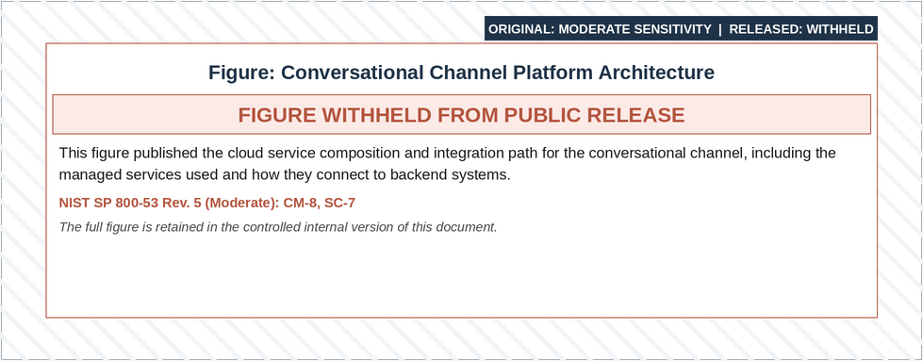
Figure 3-7: High-Level Google Dialog Flow Architecture
The Google Dialog Flow CX Agent Chatbot solution will be hosted in the NYS DOH-managed Google Cloud Tenant/Environment.
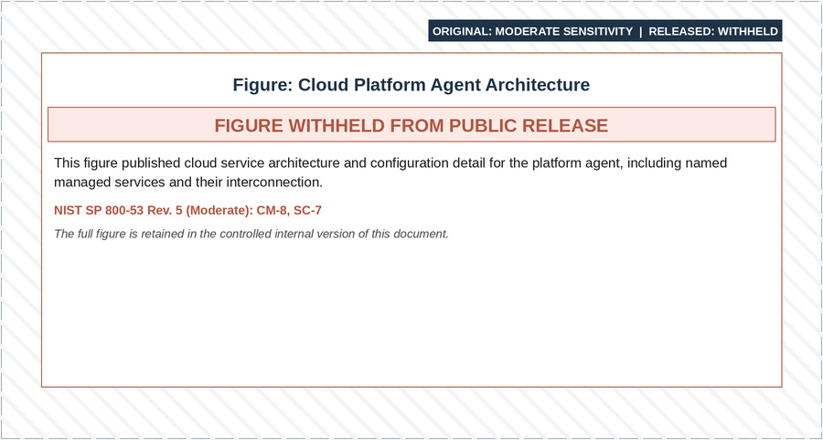
Figure 3-8: GCP Cloud Platform Dialog Flow CX Agent Architecture Diagram
Listed below are components as illustrated in the GCP Cloud Platform Dialog Flow CX Agent Diagram Architecture.
Component | Description
Cloud Firewall | Provides security by allowing or denying traffic to or from virtual machine instances in a VPC network.
Cloud Armor | Provides pre-defined rules to help defend against attacks such as cross-site scripting (XSS), and SQL injection (SQLi) attacks.
Google Dialogflow CX Agent | CX agent to design and integrate the conversational unit interface into the website that can understand and respond to end user requests/utterances.
Cloud Run | Serverless execution environment for building and connecting cloud services.
Cloud Functions | Service to run code in response to events and integrations.
Apigee/API Gateway | API management platform to manage APIs.
Secret Manager | Service that securely stores API Keys, Passwords, Certificates, and other sensitive data.
Natural Language | Service that analyzes human language in text.
Monitoring | Service that collects, analyzes, and acts on data to monitor health and performance.
Logging | Fully managed service that allows to store, search, analyze, monitor, and alert on logging data and events.
Sensitive Data Protection | Service that helps identify, classify, and protect sensitive data.
BigQuery | Data warehouse and analytics platform that enables the storage, analysis, and management of data.
Table 3-18: Components Used in Architecture

Integration with Member Portal
The following figure details integration points between the MECM system Member Portal, Chatbot, and Worker Portal.

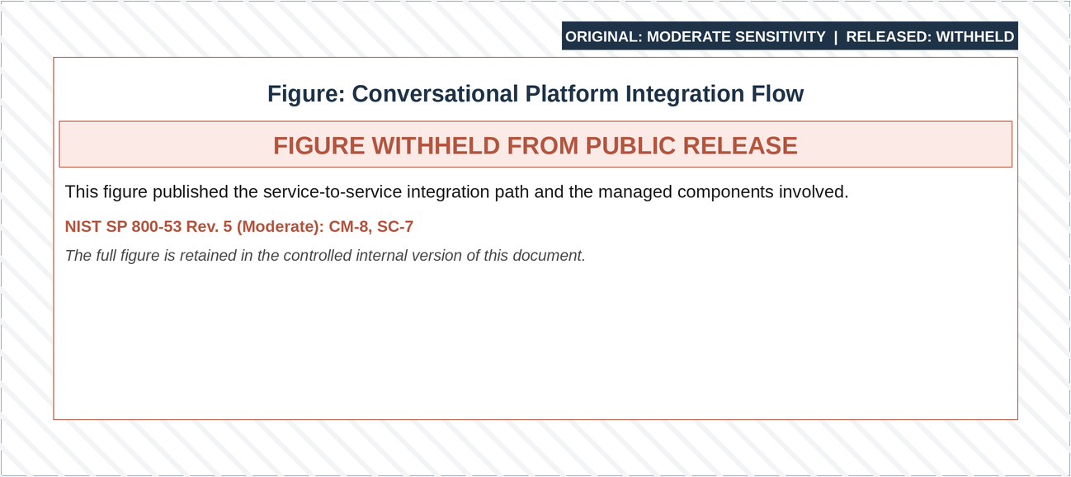

Figure 3-9: Integration Points Between Member Portal, Chatbot, and Worker Portal
- MECM Member Portal authenticates the member and displays the chatbot to the authenticated member
- Session Storage, which is already being used by Member portal, will be used by Dialogflow to read key parameters like:
- SessionId
- UserId
- UserName
- indivID
- Parameters read by Google Dialogflow will then be used within the playbook for the different use cases.

Deterministic Flows
Google Dialogflow development will leverage the deterministic approach for designing solutions which relies on the pre-translated language text to cater to different language. Two languages in scope for Wave which are English and Spanish.

Enabling Security Settings for Redacting Data
To enable Data Loss Prevention (DLP) on a Dialogflow project, navigate to the Dialogflow agent settings, go to the "Security" tab, and select "Manage Security Settings".
Complete the following key steps:
- Access DLP settings: Go to your Dialogflow agent settings and navigate to the "Security" tab
- Manage Security Settings: Click "Manage Security Settings" to access the configuration options
- Create Security Settings: In the Contact Center AI (CCAI) console, create a new security setting

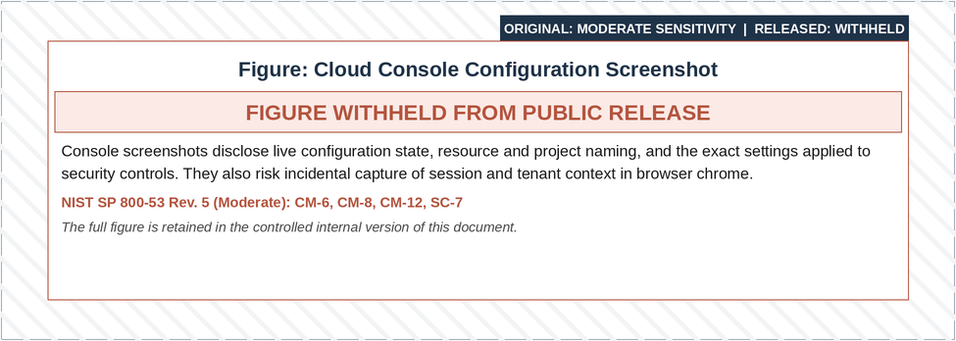
Figure 3-10: Security Setting Configuration (Step 1)
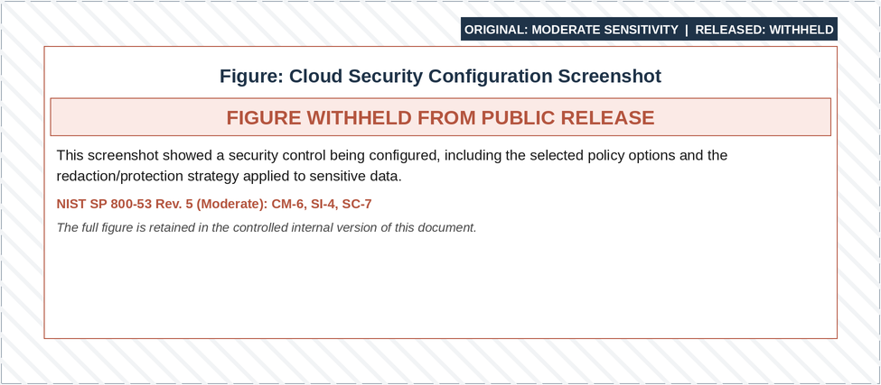
Figure 3-11: Security Setting Configuration (Step 2)
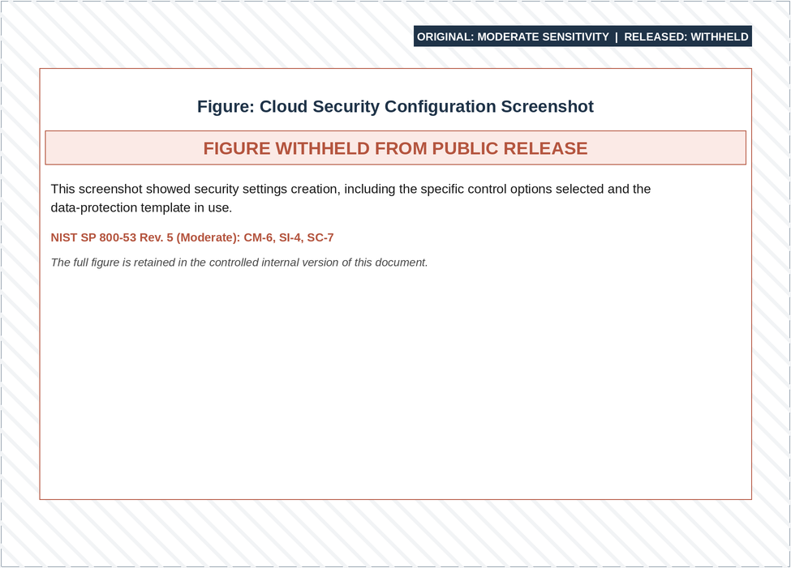
Figure 3-12: Security Setting Configuration - Redaction

Sensitive Data Protection Purpose and Characteristics
Leverage cloud Sensitive Data Protection (SDP) API to identify sensitive and personal identifiable data.
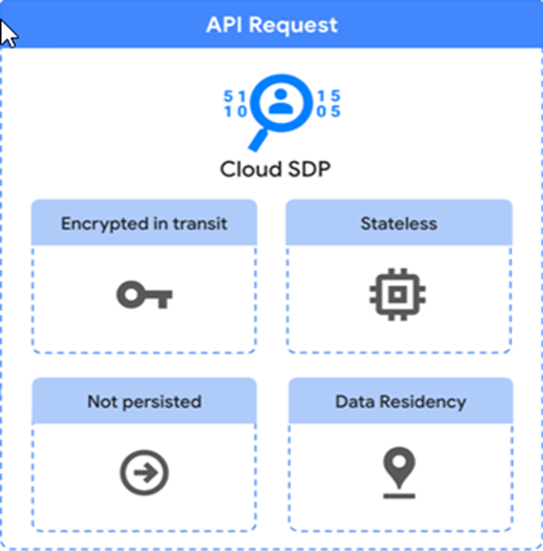
Figure 3-13: Cloud Sensitive Data Protection Characteristics
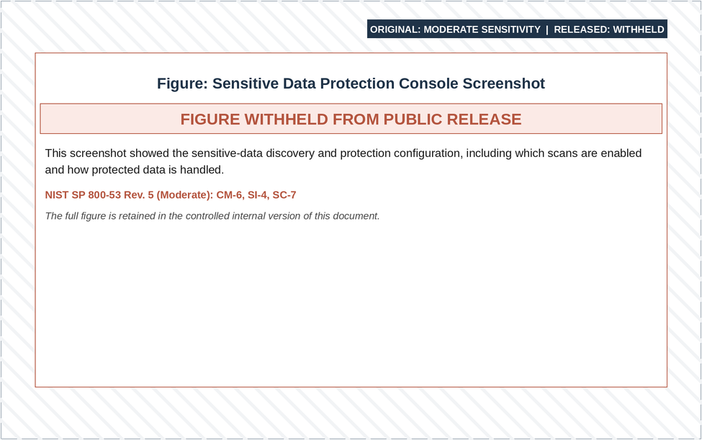
Figure 3-14: Cloud Sensitive Data Protection Configuration

Conversational Analytics Data
Google Dialogflow provides out-of-the-box data model to export data from chat conversations to BigQuery database for reporting. The following section provides details on configuration needed to enable exporting data to BigQuery database.

Configuration to Enable Export to BigQuery
The figure below provides an overview of the IAM permission for the BigQuery dataset in the BigQuery Google Cloud project - roles/bigquery.dataEditor.

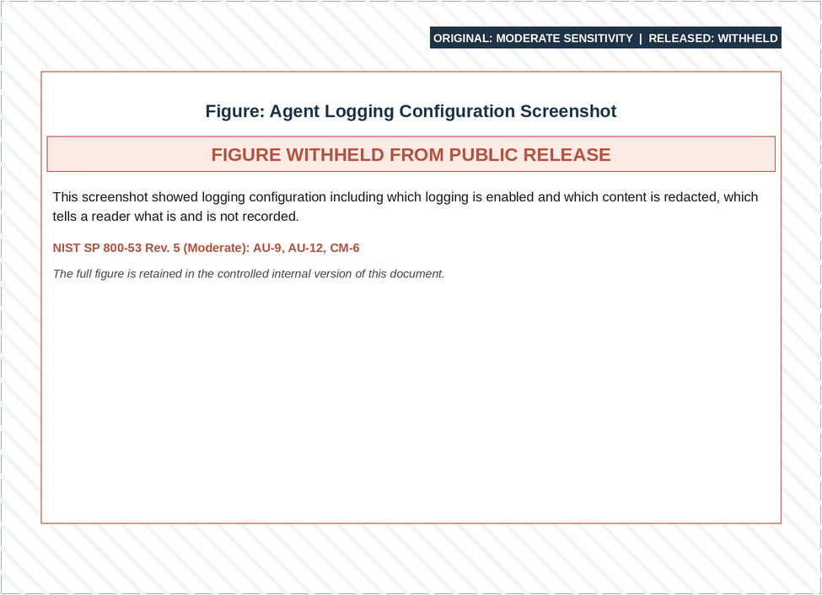
Figure 3-15: Settings to Enable Export of Conversation History to BigQuery Database

BigQuery Table Creation
Each row of the Dialogflow table contains one conversational turn with the following columns:
Conversational turn is defined as one interaction between a human and virtual agent. The human provides some input, and the virtual agent provides a response.

Column | Type | Description
project_id | STRING | The project ID
agent_id | STRING | The agent ID
conversation_name | STRING | The fully qualified resource name for the session
turn_position | INTEGER | The conversational turn number
request_time | TIMESTAMP | The time of the conversational turn
language_code | STRING | The language tag
request | JSON | The detect intent request
response | JSON | The detect intent response
partial_responses | JSON | Partial responses if applicable
derived_data | JSON | Additional metadata for this conversational turn
conversation_signals | JSON | NLU related analytics data. See ConversationSignals for the JSON schema
bot_answer_feedback | JSON | Answer feedback if provided
Table 3-19: BigQuery Table Structure
Data Definition Language (DDL) for table:
Follow the BigQuery table creation guide to create a table with a SQL schema definition. Use the following SQL statement for creation:
CREATE TABLE <your_dataset_name>.dialogflow_bigquery_export_data(project_id STRING, agent_id STRING, conversation_name STRING, turn_position INTEGER, request_time TIMESTAMP, language_code STRING, request JSON, response JSON, partial_responses JSON, derived_data JSON, conversation_signals JSON, bot_answer_feedback JSON)

Application Architecture
This section provides the general guidelines for the Worker and Member Portal application architectures and provides a high-level view of the framework.

Worker Portal

Overview
This section outlines the general guidelines for the WP application architecture and offers a high-level overview of the framework. The conceptual view of the application architecture, illustrated in the High-level “Worker Portal Application Architecture” diagram below, provides an understanding of the complete life cycle of a user request. The architecture adheres to Java Enterprise Edition (JEE) Model-View-Controller (MVC) design pattern, allowing for a modular and maintainable architecture that effectively separates presentation, business & service logics.
The following figure details the high-level Worker Portal application architecture and its components.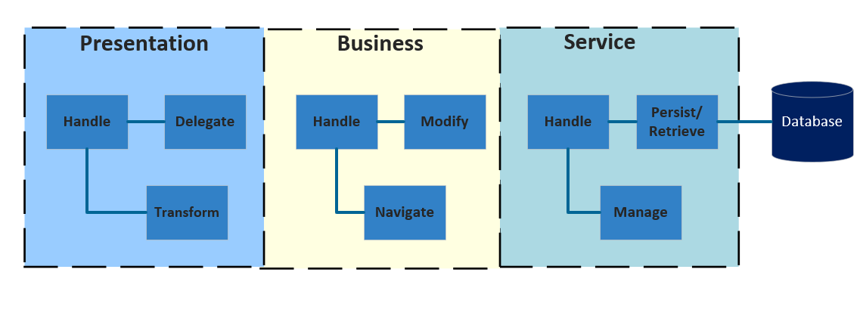
Figure 3-16: High-Level Worker Portal Application MVC Design Architecture

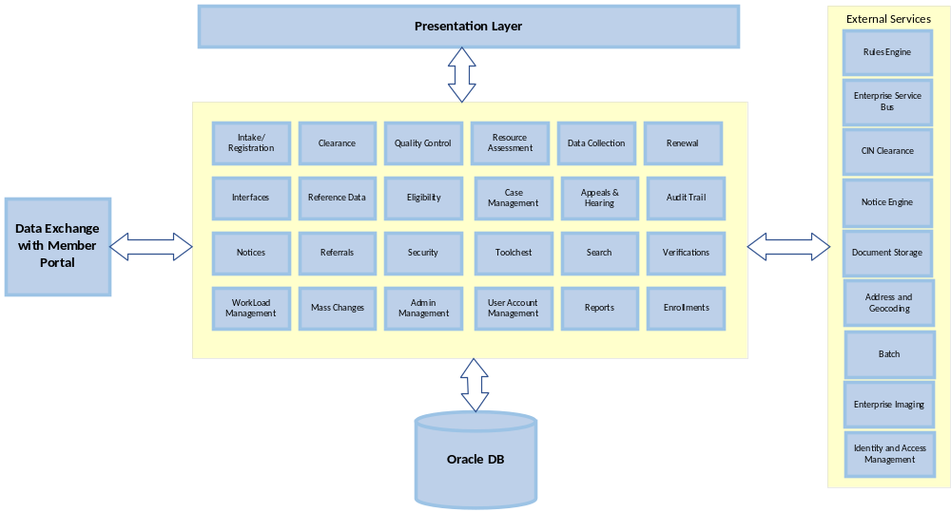
Figure 3-17: High-Level Worker Portal Application Architecture
All web requests flow through the presentation layer. The presentation layer uses request and response objects communicated via a servlet. This servlet, the primary entry point for all web requests, transforms the request into a transfer object. The transfer object design pattern provides a common data structure passed through all layers within the architecture. If a new presentation layer client is introduced, the architecture must handle the device-specific or system-specific request and transform it into a transfer object. The Business Layer and Service Layer should not differentiate between client connections and should focus solely on business processing.
The business layer executes processes and logic to modify data sent from the client (Browser). The goal is to isolate specific business processes, such as calculations or data manipulation. This business logic is written once but called from multiple places, promoting rapid development and minimal impact when changes are made. Applicability to other programs, analysis for common use, and experience drive the task of deciding which logic to put into common components. This Common functionality is part of Common.jar that will be leveraged by all other modules.
The service layer provides common services to the business layer, handling connection management, data transformation, exception handling, and other responsibilities. Data is passed to the service layer using a common data structure. When the service is complete, data is returned to the business layer using a common data structure.

Architecture
The following diagram “Worker Portal Application Architecture” illustrates the conceptual and MECM system application architecture. This section details the Presentation layer, Business Layer and Service Layer from a developer’s perspective, highlighting each layer’s implementation.
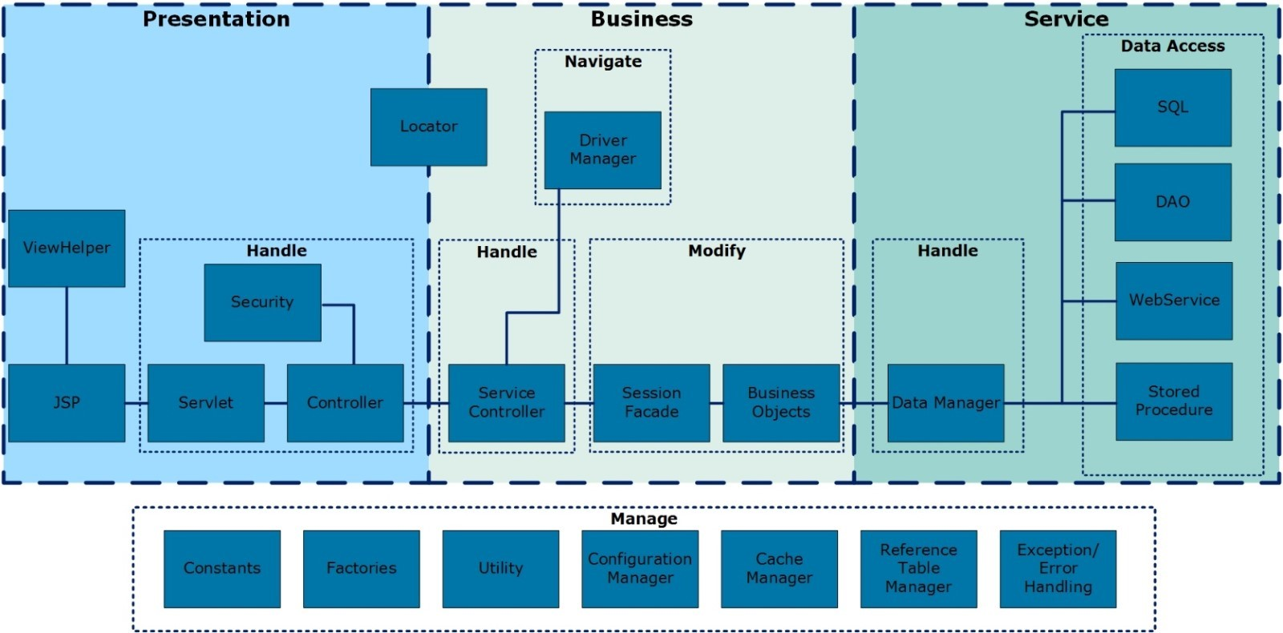
Figure 3-18: Worker Portal Application Architecture
The view helper includes custom tags, images, Cascading Style Sheets (CSS), and other presentation support classes and files. Servlet and controller classes handle tasks such as validating sessions and setting the next page Uniform Resource Locator (URL).
The locator class, a common Java pattern, provides a Java Naming and Directory Interface (JNDI) lookup function for calling stateful/stateless session beans. It also looks up business class and success information based on a page action. The ServiceController executes the specified service based on the request and returns a response, primarily for Servlet-based requests. The response contains either the service response or a collection of errors returned to the screen.
Application navigation is controlled by the ServiceController, FwNavigation, and DriverManager classes. This information includes the next page ID, next page action, navigation class and method, or a call to the driver manager. The data manager handles requests coming to the service layer, directing it to the appropriate service manager, establishing a connection, and other tasks before calling a service. Once completed, control passes to a service manager implementation, such as a SQL Manager for SQL statement. Each manager class calls its relevant service and manages post-service tasks.
The MECM application supports vertical scalability by adding resources (CPUs/ Random Access Memory (RAM)) or creating additional application instances on WAS servers. It supports horizontal scalability by adding servers to application clusters managed by WAS. The cluster has the nodes spread across two Availability Zones AZ1 and AZ2 for High Availability as depicted in the Infrastructure and Platform Architecture Diagram. Refer MECM Software BOM for the number of nodes in the WebSphere cluster. Both scaling methods may impact licensing and configurations. The IBM licensing metric being Processor Value Unit (PVU), the number of additional PVUs for scaling will be 70 times multiplied by the number of cores that are being added to the cluster. And the cluster needs to be reconfigured to let Deployment Manager (DMGR) manage the new nodes.

Presentation Layer
The presentation layer of the MECM system follows the MVC pattern. Value objects implement the model, Java Server pages (JSP) and Hyper Text Markup Language (HTML) pages implement the view, and Servlets implement the controller. The MECM presentation layer comprises JSP pages and custom tags with page elements that render the form fields and other data onto the page.

Business Layer
The business layer is responsible for processing the business logic, interacting with persistence objects to retrieve and update data, and passing the result back to the presentation layer. In MECM, session beans and business objects implement the business layer. The session beans follow the session façade pattern and act as workflow components. In the non-driver navigation scenario, the framework invokes the corresponding session bean and method after receiving a request. In the driver scenario, the framework hands control to the data collection driver class, which is then responsible for invoking the session bean.

Service Layer
The Service Layer, sometimes referred to as the Persistence Layer or Data Layer, retrieves and sends data to the Business Layer. An Entity Java Beans (EJB) invokes the business objects, which in turn access the database through the cargos (value objects) and collections (collection of value objects), if required. Data may be stored in or retrieved from a variety of external sources. These sources may include external databases, files, or access to other systems.
The Service Layer provides a level of abstraction that facilitates a one-method signature, for example “select,” which eliminates concern over the data’s origins. It handles selecting, persisting, or executing a service.
Framework classes implement the Service Layer, supported by code-generated objects such as Cargos, Collections, and Data Access Objects (DAOs). Each database table representing a Business Object must have a corresponding Cargo, Collection, and DAO to access the table data.

Business Process Orchestration
The business process orchestration is facilitated by the NextGen Framework’s Driver Component. The Driver Component is extensively used throughout the application to queue up an appropriate set of web pages to be visited by the user in a particular sequence so that a workflow is established. Every page is given a unique page ID and a unique page number. When a user logs into the MECM Worker Portal application, the Driver queues the pages based on the page numbering, page ID, and the functional area code for that specific module. The page details can be referred to from FW_PAGE database table. The queued pages are then stored into the table DC_DRIVER_QUEUE for a particular user and rendered in a sequence set by the Driver. As the user progresses through the application, the queue gets updated as necessary depending on input. For example, when the user first signs onto Data Collection Intake, the Expedited Screening Page would not be queued. However, if the user later indicates that an applicant wishes to apply for Medicare, the Expedited Screening Page gets added to the queue and the page gets scheduled appropriately.
The following diagram “NextGen Framework Architecture” illustrates NextGen framework architecture:
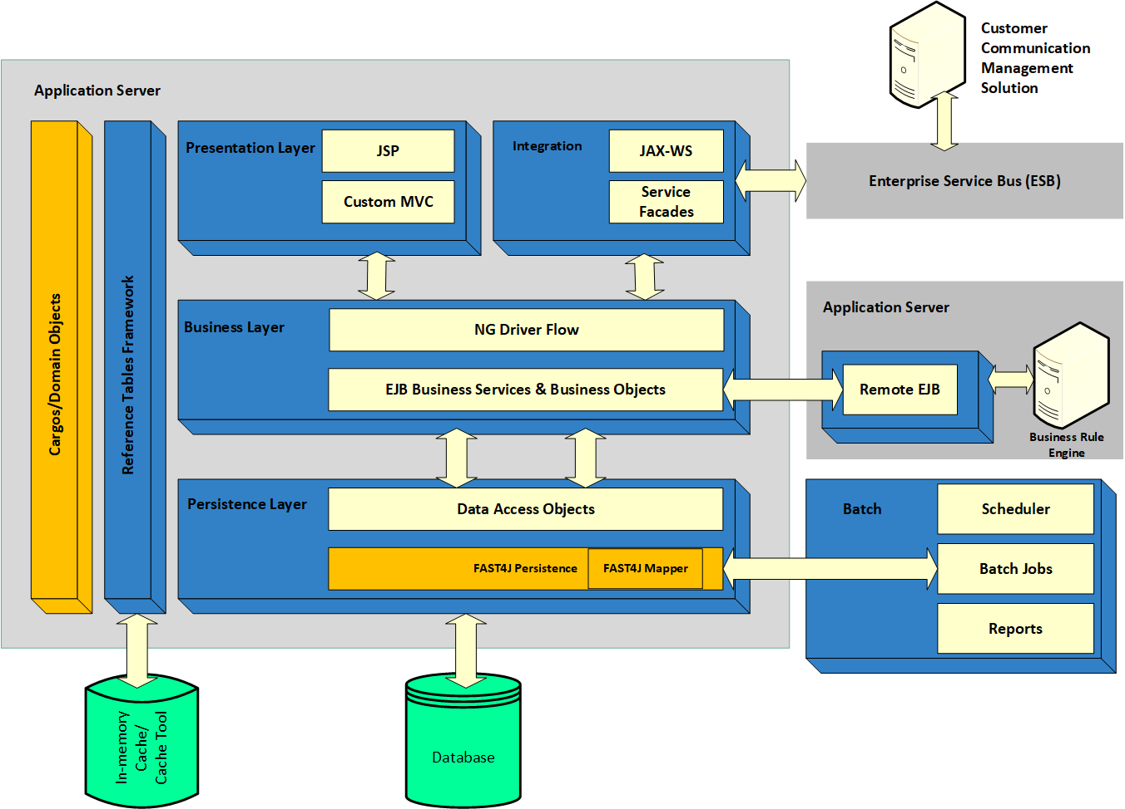
Figure 3-19: NextGen Framework Architecture
The following table outlines some of the critical tasks performed by the NextGen Driver Component.
Task | Description
Add new pages to driver flow | Setting the options in the “FW_PAGE” table and “FW_BUSINESS_RULES” table adds a set of pages as a logical unit of work (LUW) in the navigation flow.
Looping pages | Use this feature when the same set of information is collected for all entities. For example, if there are four individuals in the case, queue the individual LUW four times, once for each individual.
Maintain screen data in session variables for LUW | The session variables are used to store previous screen data until the end of LUW of a sub module is reached before persisting in the database.
Maintain a session across data collection and eligibility | The Driver persists case and individual information across LUWs maintains case data across sub-functional areas.
Manage completion of the sub-module | Based on user’s data, the Driver completes a sub-module. For example, if a sub-module consists of mandatory and optional pages, the Driver decides when the persist logic executes for a sub-module.
Maintain security information | The Driver coordinates with the security layer and adds pages to the queue based on the user’s profile.
Map page specific actions to standard set of buttons | Driver pages will have the following action buttons:  - Next: Navigate the user to the next page in the flow  - Previous: Navigate the user to the previous page in the flow  - Edit: This action is available on the summary page and the pages which have dynatable. Clicking the “Edit” action on the summary page navigates the user to the details page for the selected record  - Delete: This action is only available on the summary page. Clicking this action displays a confirmation popup. If the user selects “Yes,” then the record is deleted; otherwise, it remains  - Cancel: Takes the user to the summary screen  - Search: Triggers the search action and returns the user to the same page where the search results are displayed in a table below the search fields
Manage Case actions | The Driver supports two modes of navigation:  - Intake: The Driver sets the next page in the queue, preventing the user from selecting future pages from the left navigation menu. For example, after navigating from page 1 to page 4, the user cannot jump to page 6 Without completing pages 4 and 5. However, the user can revisit previously accessed pages, such as page 3  - On-going: In this mode, the Driver does not control navigation, allowing the user is freely access any page using the left navigation menu
Table 3-20: NextGen Driver Component Critical Tasks

Transaction Management
The MECM NextGen application, for transaction management, uses container managed transaction (CMT), creating a new transaction before invoking a method if none exists. EJB also supports bean-managed transactions (BMT), but the NextGen Application does not use BMT as they cannot propagate between EJBs. Session Beans invoke Business Objects, which call Fast4J components and propagate the bean’s transaction state. Using EJB transaction demarcation, no Fast4J persistence operations are committed until the transaction ends, which occurs at the end of the EJB method. The container’s transaction manager commits all transactional resources at this point. In case of any exceptions from remote methods, the container may roll back the transaction. For Application exceptions, transactions need to be rolled back programmatically. Web service invocations within the original transaction from an EJB Bean will not be rolled-back, nor will the external web services invoked from the MECM system.

Session Management
Sessions in the MECM WP identify users and track their information across multiple page requests. MECM WP uses session stickiness for session management.
Session data is stored in the HTTP Session Java object, a standard web project object created by the application server and placed in a session cookie on the user’s browser. The JSP and Servlet specifications require that the HTTP request be encapsulated in an HttpServletRequest object and all the session data to be encapsulated in an HttpSession object.
To facilitate data sharing and decouple the presentation layer, MECM Controller Servlets parse incoming requests and create their own data structures for request and session data. They extract data from the HttpServletRequest and HttpSession instances and store key-value pairs in java.util.Map. A separate HashMap is created for every request. The back-end controller class extracts the values from the HashMap and saves it as part of requests and session objects. Since a new HashMap is created as part of every request, the session object will be updated for every request. The session object, if unused, will be cleared as part of garbage collection process or when the session time of 30 minutes has expired.

Exception Handling
MECM captures and communicates errors to the end-user via the Presentation Layer. It has a nested, hierarchical exception framework that logs all identified exceptions. A top-level exception handler then returns an appropriate error message to the user.
The MECM system has four different types of exceptions:
- Framework Exceptions – Used by the framework to report any exception that occurs during the framework process. These exceptions are thrown by reference tables and Business Rules Engine processing
- Application Exceptions - Provides a wrapper for all the application exceptions. This is the superclass for all application-level exceptions
- Validation Exceptions – Occurs during business validation checks. It is used to report any exception related to the validation of WP data, including server-side and framework history validations
- Runtime Exceptions – The GenericRuntimeExceptions provides a wrapper for all exceptions that may occur at runtime

Logging
Logging provides a way to capture information regarding user actions and system responses. Once the information is captured by Log4j, an open-source logging framework, it is used for debugging and troubleshooting. The MECM Application uses the Log4j framework for logging or tracing key events of the application. First, it can provide precise context about the running of the application. Second, Log4j automatically logs output to flat files based on the properties defined in the Log4j configuration. The log level will vary based on the environment and is defined in the framework/logging properties under Build-Dependencies repository (Refer BitBucket location [URL REDACTED]). MaxBackupIndex defines the number of log files that will be kept at any point of time. Once inserted into the code, the generation of logging output requires no human intervention.

Member Portal

Overview
This section outlines the general guidelines and high-level framework of the Member Portal Application Architecture. The following diagram, “High-level Member Portal Architecture,” illustrates the conceptual architecture modules of the MECM MP application.
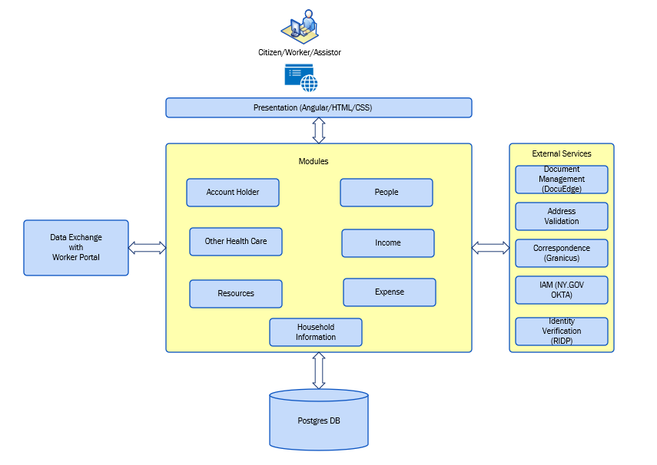
Figure 3-20: High-Level Member Portal Architecture
The architecture follows a stateless RESTFUL design. The Presentation Layer built using Angular, communicates through REST web services hosted on a Spring Boot backend application. These REST web services are based on GET and POST HTTP methods. The known challenge with Angular Frontend and SpringBoot Backend Architecture is Cross Origin Resource Sharing (CORS). MECM uses the single ALB for both Angular Frontend and SpringBoot backend to resolve CORS issue. The CORSFilter in the Member Portal backend adds necessary HTTP headers to the response. The backend services interact with other services along with an Online Transaction Processing (OLTP) Postgres database. The backend also interacts with Worker Portal for data exchange.
All web requests flow through the Angular frontend to the backend Spring Boot controllers via Java Script Object Notation (JSON) objects. The backend controller processes the request, performing conversions or mappings to objects as needed, and passes these objects to the business and DAO layer for further processing.
The business layer handles core business logic operations, including any internal/external webservice calls. Common functionalities are centralized for reusability by other APIs or modules.
The DAO layer communicates with the Postgres database via IBatis Object Relational Mapping (ORM) framework.

Architecture
The NY MECM MP application utilizes Angular for User Interface (UI) and Spring Boot for the backend application.

UI Framework
The diagrams below illustrate the architecture of Member Portal application.
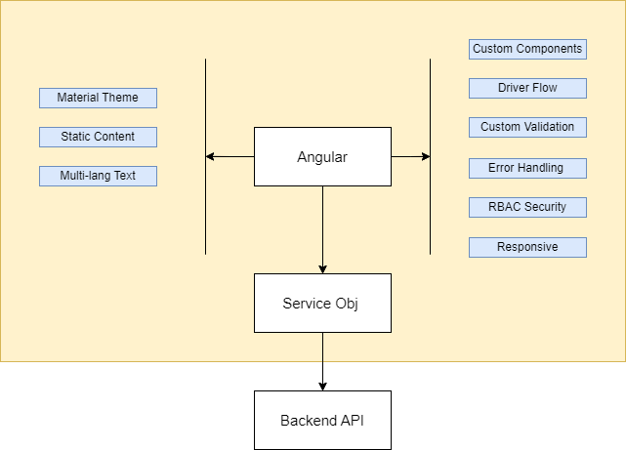
Figure 3-21: Member Portal UI Framework Architecture
The NY MP UI framework is built using Angular and leverages the Angular Material Design Library to implement its UI elements and components. This approach maintains consistent styling and behavior of form elements across all pages.
The MECM Presentation Layer comprises HTML/CSS with custom components designed using the material theme. The Angular UI framework is compliant to CSS3 & HTML5.
                - Material Theme: Uses Material UI library to get CSS/styles for standardizing look and feel throughout the application
                - Static Content: Framework externalizes all the static content in their respective configuration files. The configuration files are loaded on application load. Appropriate page labels, field labels and error messages are read from the configuration files
                - Multi-lang Text: Framework leverages Angular internalization feature and static text JSON files for muti-lang support
                - Custom Components: Framework leverages Angular Material UI component library and has built-in tag library to include standard UI elements like Text Fields, Drop Downs etc. These components are customized to create reusable components like Address Component or multi select checkboxes. The tag library of components helps in adding or modifying any feature/functionality at a single place rather than having to change every HTML
                - Driver Flow: Framework has a built-in driver flow logic implemented to decide what the next page user shall be directed to. Refer to Portals Functional Design Document (FDD) for more details on the driver flows. The driver flow allows pages to be queued conditionally based on the case. For more details, refer to Appendix – Portals FDDs
                - Custom Validation: Framework allows to add custom field level validation & page level validations in addition to supporting standard inbuilt Angular validations. The field level validation is triggered when the focus is out of the field & page level validation are triggered before user submits/saves or triggers Next/Previous flows
                - Message Handlers: Framework uses interceptors to intercept error/warning responses coming from backend services. It transforms the response message code to meaningful message which is shown on the UI to the user. The framework classifies errors as Internal Server Error and Invalid data based on the HTTP Status codes. The Error thrown by the backend is wrapped with the specific status code and appropriate error message to the frontend
                - RBAC Security: This will add role-based security to the application as well as role-based functionalities for citizen/worker/assistor users
                - Responsive: The Framework layout is responsive & supports multi desktop resolutions and handheld devices

Backend Framework
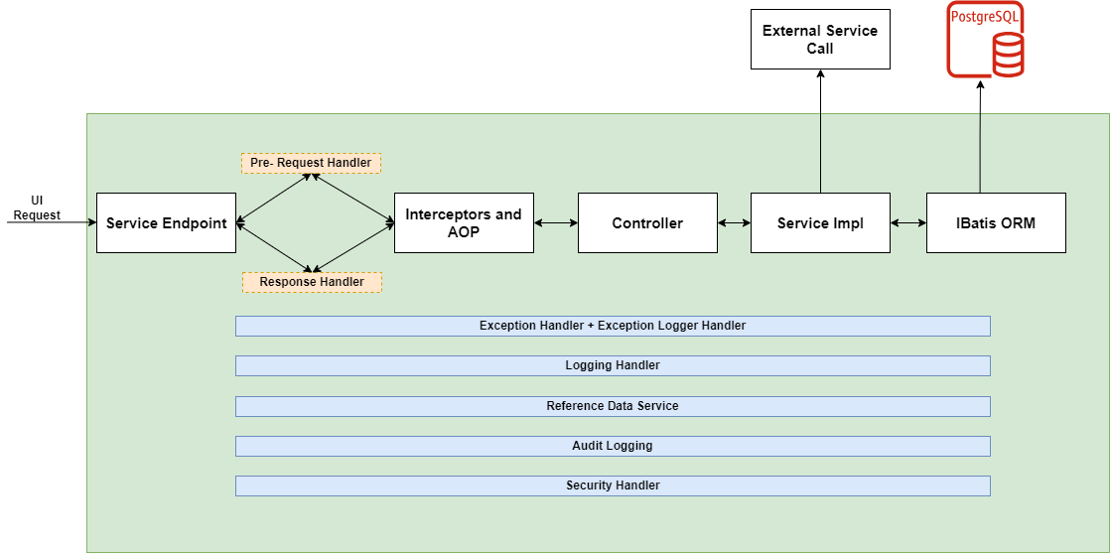
Figure 3-22: Member Portal Backend Application Architecture
The NY MP backend Framework is developed using Spring Boot applications and follows the Controller-Service-Repository pattern.
The Controller layer serves as the API entry point from the UI layer or any external service, configuring all module-related APIs. The Service layer contains business logic, handles data fetching and saving via the Repository layer, and makes external third-party service calls if needed. Business logic is accessible only through the Controller layer. The Repository/DAO layer manages data storage and retrieval in Postgres OLTP via Ibatis ORM. Interceptors and Aspect Oriented Programming (AOP) handle request authentication logic and transaction management. Below are few features of the application framework:
                - Exception Handler: Exception handler captures exceptions occurred during API execution, it sets appropriate response code and returns API response back to caller
                - Logger: Logging provides a way to capture information regarding the user action and system response. The application's default logging provider is log4j, which is utilized by the framework to centrally manage the logging framework and provide a consistent log format. It can provide precise context about a run of the application. Log4j automatically logs output to flat files. Once inserted into the code, the generation of logging output requires no human intervention
                - Reference Data Service: Reference data is fetched from the database at the application startup and is cached in the In-Memory for further reference by the application
                - Audit Logging: Framework has interceptors to intercept each API call’s request and response and publish audit event. The audit event is persisted in appropriate audit table
                - Security Handler: After authentication with okta on frontend, authentication tokens are sent to backend with the request in the header which are again verified with Okta. A custom JSON Web Token (JWT) token is created on backend after successful verification of authentication tokens. The custom JWT token is exchanged between frontend and backend going forward with every request. This custom JWT is always validated on backend on every request to provide the authenticity of the originating request

Transaction Management
All transactions are handled using Spring AOP in the backend for each request. When a request is sent from frontend to backend controller, it first reaches the AOP where a transaction begins. After the business logic has been executed using the controller, service and repositories, the transaction is committed and closed in the same AOP.

Exception Handling
The MECM Member Portal Application captures errors and exceptions, regardless of where they occur, and communicates the errors to the end-user in an understandable format via the Presentation Layer.
The `RestExceptionHandler` class is a central component designed to manage and respond to various types of exceptions that may occur during API operations. It uses `@ControllerAdvice` to globally handle exceptions across all controllers. The class provides specialized methods (`@ExceptionHandler`) to address different categories of exceptions. The RestExceptionHandler enhances error handling and response consistency in the application, delivering robust error reporting aligned with RESTful best practices.

Logging
Logging provides a way to capture information regarding the user action and system response. The application's default logging provider is log4j, which is utilized by the framework to centrally manage the logging framework and provide a consistent log format. It can provide precise context about a run of the application. Log4j automatically logs output to flat files based on the properties defined in the log4j configuration. Refer to Build-Dependencies repository from Bitbucket for more specific log4J configuration. MaxBackupIndex defines the number of log files that will be kept at any point of time. Once inserted into the code, the generation of logging output requires no human intervention.

Database Design and Management
This section provides an overview of the approach to designing and managing databases.

Application Database Overview
This section of the deliverable provides an overview of the database objects, schemas, users, profiles, and resource configuration.
The structural design and methodology of a database system form the core of a Database Management System (DBMS). This architecture dictates how data is stored, organized, and retrieved, playing a crucial role in the efficiency and effectiveness of data management. It also describes how a DBMS will be integrated with the application, which will subsequently impact application design.
A database schema is a logical container for data structures called schema objects. Each Oracle Database user account owns a single schema, which has the same name as the user. The database also stores other objects not contained in a schema, such as database user accounts, roles, contexts, and dictionary objects.
At the physical level, the database stores schema objects in data files. At the logical level, it allocates data across the data files with tablespaces. There is no relationship between schemas and tablespaces: a tablespace can contain objects from different schemas, and objects of a single schema can be contained in different tablespaces. The data of each object is physically contained in one or more data files.
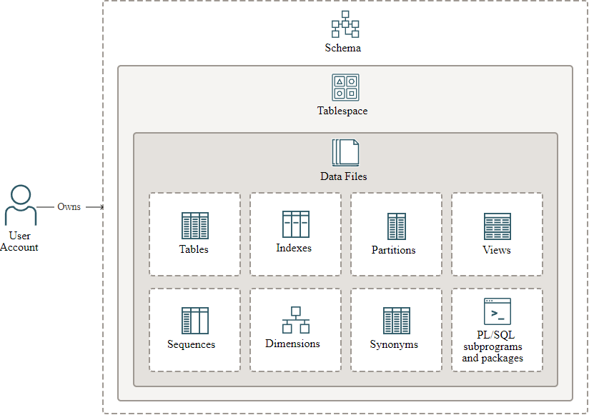
Figure 3-23: Schema Breakdown
Schemas include the following principal types of objects:
- Tables store data in rows. Tables are the most important schema objects in a relational database
- Indexes contain an entry for each indexed row of the table or table cluster and provide direct, fast access to rows
- Partitions are pieces of large tables and indexes. Each partition has its own name and may optionally have its own storage characteristics
- Views are customized presentations of data in one or more tables or other views. You can think of them as stored queries. Views do not actually contain data
- Sequences can be shared by multiple users to generate integers. Typically, you use sequences to generate primary key values
- Dimensions define parent-child relationships between pairs of column sets, where all the columns of a column set must come from the same table. However, columns in one column set (called a level) can come from a different table than columns in another set. You might use dimensions to categorize data such as customers, products, and time
- Synonyms are aliases for other schema objects. Because a synonym is simply an alias, it requires no storage other than its definition in the data dictionary
- PL/SQL is the Oracle procedural extension of SQL. A PL/SQL subprogram is a named PL/SQL block that you can invoke with a set of parameters. A PL/SQL package groups logically related PL/SQL types, variables, and subprograms
Physical Environments | Logical Environments | Schemas
DEVELOPMENT | PRE-DEV 1 WP | IE_APP_ONLINE (for Worker Portal)  IE_APP_INBOX (For Member Portal and Worker Portal integration)  IE_SSP_OWNER (Just got from base solution, but not in use)  IE_RP_ODS (For reports)  IE_RP_PRST (For reports extracts)  OPAUSER (For OPA)  IE_APP_ONLINE_READ (Readonly user)  APP_USR_IE_SSP_OWNER (ReadWrite user)  APP_USR_IE_APP_ONLINE (ReadWrite user)
DEVELOPMENT | PRE-DEV 2 WP
DEVELOPMENT | DEV 1 WP
DEVELOPMENT | DEV 2 WP
DEVELOPMENT | SIT 1 WP
DEVELOPMENT | SIT 2 WP
DEVELOPMENT | MDM DEV
STAGING | SIT3 WP
STAGING | SIT4 WP
STAGING | SITC WP
STAGING | UAT1 WP
STAGING | UAT2 WP
STAGING | UATC WP
STAGING | TDEV WP
STAGING | TDL WP
STAGING | STG MDM
PRE-PROD | PRDT WP
PRE-PROD | PRDP WP
PRE-PROD | PERF WP
PRE-PROD | MDM PRE-PROD
PRODUCTION | WP database - RDS Oracle OLTP Active
PRODUCTION | WP database - RDS Oracle Reporting
PRODUCTION | MDM PROD
Table 3-21: Oracle Database Mapping and Schemas
Physical Environments | Logical Environments | Database Names | Schemas
DEVLOPMENT | PRE-DEV CP CLUSTER | NYPDEVCP, NYPDV1CP, NYPDV2CP | TCC  TCC_APP  TCC_READ  AUTOMIC  DE_VAULT
DEVLOPMENT | DEV-SIT CP Cluster | CPDEV1, CPDEV2, CPSIT1, CPSIT2 | TCC  TCC_APP  TCC_READ  AUTOMIC  DE_VAULT
DEVLOPMENT | TOOLS Cluster | NPRODTLS1 | TCC  TCC_APP  TCC_READ  AUTOMIC  DE_VAULT
STAGING | STG CP CLUSTER | NYSIT3CP, NYSIT4CP, NYSITCCP, NYUAT1CP, NYUAT2CP, NYUATCCP, NYTDEVCP, NYTDLCP | TCC  TCC_APP  TCC_READ  AUTOMIC  DE_VAULT
STAGING | STG TOOLS CLUSTER | NYSTGTLS, NYSTGCA | TCC  TCC_APP  TCC_READ  AUTOMIC  DE_VAULT
PRE-PROD | PRE-PROD CLUSTER | NYPRDTCP, NYPRDPCP | TCC  TCC_APP  TCC_READ  AUTOMIC  DE_VAULT
PRE-PROD | PERFORMANCE | NYPRFCP | TCC  TCC_APP  TCC_READ  AUTOMIC  DE_VAULT
PRE-PROD | DOCU-EDGE | NYPREPDOC | TCC  TCC_APP  TCC_READ  AUTOMIC  DE_VAULT
PRODUCTION | CP database - RDS Aurora Postgres Primary Cluster | NYPRDCP | TCC  TCC_APP  TCC_READ  AUTOMIC  DE_VAULT
PRODUCTION | DMS - DocuEdge - Aurora PostgreSQL - Serverless - Primary Cluster | NYPRDDOC | TCC  TCC_APP  TCC_READ  AUTOMIC  DE_VAULT
PRODUCTION | CA Atomic database Aurora Cluster | NYPRDCA | TCC  TCC_APP  TCC_READ  AUTOMIC  DE_VAULT
PRODUCTION | Tools Database - RDS Postgres - Primary Cluster | NYPRDBMB | TCC  TCC_APP  TCC_READ  AUTOMIC  DE_VAULT
Table 3-22: Postgres Database Mapping and Schemas

Design Features
This section of the deliverable describes the general design considerations which apply to the overall data model.
An Oracle database consists of at least one database instance and one database. In Oracle database, a database instance is a set of processes and memory structures that manage database files. The main memory structures are the system global area (SGA) and the program global areas (PGAs). The background processes operate on the database files and use the memory structures to do their work. A database instance exists only in memory.
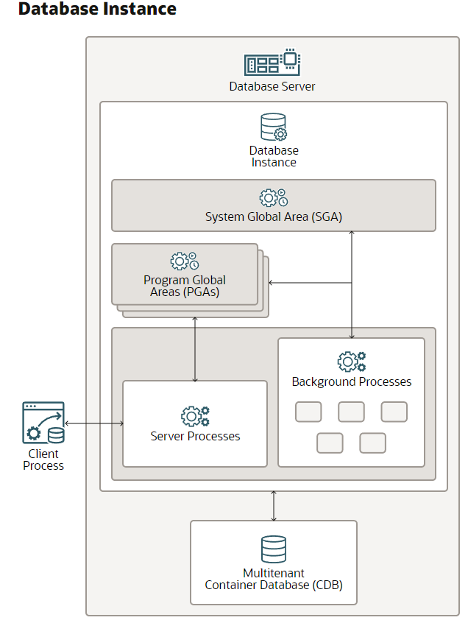
Figure 3-24: Database Instance
The listener is a database server process. It receives client requests, establishes a connection to the database instance, and then hands over the client connection to the server process. The listener can run locally on the database server or remotely.
The SGA is the memory area that contains data and control information for one Oracle Database instance. All server and background processes share the SGA. When you start a database instance, the amount of memory allocated for the SGA is displayed.
The PGA is a nonshared memory region within the database instance that contains data and control information exclusively for use by a server or background process. Oracle Database creates server processes to handle connections to the database on behalf of client programs.
In a dedicated server environment, Oracle Database creates one PGA for each server and background process that starts. Oracle Database deallocates a PGA when the associated server or background process is terminated.

Data Management
This section of the deliverable provides details around how the data is being managed (Multi AZ deployment, cross region Read Replica, Aurora global database) along with the Database features like Active Data Guard, etc., that will be leveraged for data maintenance.
Environments | Data Management
Multi AZ deployment | High availability
Read replica | To reduce the load on writer instance for select statements
Golden gate | Used to sync the application schemas from PROD to Reporting database
Cross region | Worker Portal - Oracle Active Data Guard used to sync data from primary to DR site
Global database | Member Portal - DR solution for Postgres
Table 3-23: Data Management Environments

Data Structures and Attributes
The data structures (tables) and their attributes (columns) can be found in Deliverable #21 Data Model and Data Dictionary.
Data Modeler works with one open database design, consisting of one logical model, optionally one or more relational models based on the logical model, and optionally one or more physical models based on each relational model. The database design can also include a data model, and business information.
Data Models:
Link to document location: WP DATA MODELS MECM
Link to document location: CP DATA MODELS
Data Structures:
Link to document location: WP DATA STRUCTURES
Link to document location: WP FTI DATA STRUCTURES
Link to document location: CP DATA STRUCTURES.

Data Classification
This section of the deliverable provides the approach for classifying the data elements based on type of data and users in the NY MECM system. This classification includes Federal Tax Information (FTI), Social Security Administration (SSA), Protected Health Information (PHI), Personally Identifiable Information (PII)
A new approach is developed by using REMAP_DATA parameter in the export statement to minimize the time taken for scrambling.
We are using REMAP_DATA parameter in the Export statement which allows you to specify a remap function that takes the original value of the designated column and returns a remapped value into the dump file. The same function can be applied on multiple tables and multiple columns being dumped. ￼
Refer to the Interface Control Documents (ICDs) for FTI and SSA Interfaces. Also refer to the Data Protection Plan (link to document location: Data Protection Plan).

Database Management
This section of the deliverable provides details about the scheduled Database Maintenance activities.
Database Maintenance is required for both Oracle (Worker Portal) and Postgres (Member Portal).
Frequency | Maintenance Activity | Type of Environment | Activity Type
Weekly | Collect Object Statistics | Oracle & Postgres | Online
Quarterly | check the fragmentation levels | Oracle & Postgres | Online
Quarterly | Table Re-org and Rebuilding the Indexes | Oracle & Postgres | Offline
Quarterly | Patching the Databases | Oracle & Postgres - N/A | Offline
Table 3-24: Data Management Activity

Data Migration Architecture
Refer to the Data Migration Plan Deliverable for details about the data migration approach in the MECM system.

Data Sync between Member Portal and Worker Portal
Refer to the Data Models Flows and Architecture Walkthrough deck (link to document location: NY_Technology_Data Models Flows and Architecture Walkthrough_10.01.2024.pptx) for details about how the data flow happens from MP to WP.

Backup Retention Rules and Data Archival Policies
This section of the deliverable provides details regarding backups, retention, and data archival policies.
Amazon RDS includes features for automating database backups. Amazon RDS creates a storage volume snapshot of your database instance, backing up the entire DB instance, not only individual databases. Using Amazon RDS, you can establish a backup window for automated backups, create database instance snapshots, and share and copy snapshots across regions and accounts.
Amazon RDS provides two different options for backing up and restoring your DB instances:
- Automated backups provide point-in-time recovery (PITR) of your DB instance and are enabled by default when you create a new DB instance
Amazon RDS performs a full daily backup of your data during a backup window that you define when you create the DB instance. You can configure a retention period of up to 30 days for the automated backup. Amazon RDS also uploads the transaction logs for DB instances to Amazon S3 every 5 minutes. Amazon RDS uses your daily backups along with your database transaction logs to restore your DB instance. You can restore the instance to any second during your retention period, up to the latest restorable time (typically, the last five minutes).
To find the latest restorable time for your DB instances, use the DescribeDBInstances API call. Or look on the Description tab for the database on the Amazon RDS console.
When you initiate a PITR, transaction logs are combined with the most appropriate daily backup to restore your DB instance to the requested time.
- DB snapshots are user-initiated backups that you can use to restore your DB instance to a known state as frequently as you like. You can restore it to that state at any time. You can create DB snapshots using the Amazon RDS console or the CreateDBSnapshot API call. These snapshots are kept until you explicitly delete them using the console or the DeleteDBSnapshot API call
Current backup policies for databases:
- Daily RDS Snapshots for each RDS Instance (Oracle & Postgres)
- Point in time data recovery (AWS Feature)
- Logical backups
- Data pump (Oracle)
- PG Dump (Postgres
The Backup retention period is for 30 Days, during which all RDS snapshots will be preserved. The backup from the first day will be replaced by the backup from the current day.
To utilize the point-in-time data recovery feature for RDS databases, this feature must be enabled. This functionality allows for the restoration and recovery of backups to a specific point in time.
By using the Data pump & PG Dump, we can do the object-level restore instead of restoring the complete Database.
The Data Archival policy is yet to be decided, based on the business requirement, obsolete data should be archived into separate tables that are not accessed by the application. his archival process should be executed periodically through the implementation of batch jobs.

Business Rules Architecture
This section details the approach for capturing, managing, and deploying complex legislation and other document-based policies across channels and processes.

Overview
OPA is an end-to-end solution for capturing, managing, and deploying complex legislation and other document-based policies across channels and processes. OPA’s presence in the MECM system will enable the transformation of legislation and policy documents into executable and maintainable rules. These rules will then be used to determine whether an applicant is eligible for one or more type of Assistance. The rules will identify the specific type of Assistance/Coverage that provides the highest level of benefit for the applicant.
In the MECM implementation, OPA will be deployed as a Simple Object Access Protocol (SOAP) based web service. As such, it will be called at the appropriate decision points in the overall eligibility determination process to provide a status of the application.

Architecture
The architecture for OPA consists of one cluster of OPA hubs on six servers to achieve high availability. The service is invoked as needed by application, batch processes, or developers. The sets of servers sit behind a load balancer, which then distributes web requests (via a round-robin approach). Requests from all sources (MECM online and MECM batch) are directed to the same set of servers. OPA metadata is stored in a database encrypted with Advanced Encryption Standard (AES) 256 algorithm and is configured to run on six-node cluster. The following figure details the MECM system OPA architecture.
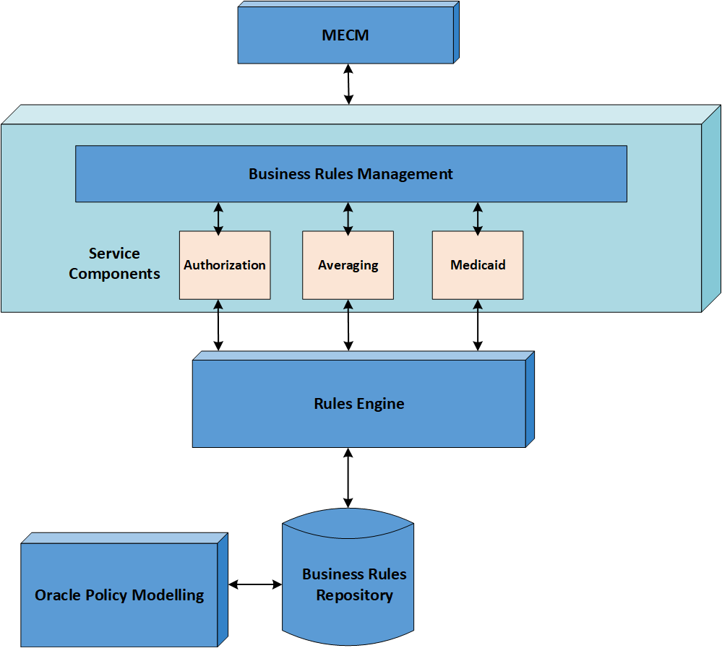
Figure 3-25: OPA Architecture
The table below explains the Business Rules server details.
Server Type | Servers/Sizing | Major Installed Products
OPA | 6 | OPA version=[REDACTED]  WebLogic Server version=[REDACTED]
AWS RDS | 2 (1 Active and 1 Standby) | Oracle Database Enterprise Edition — version [REDACTED]
Table 3-25: Business Rules Server Details
OPA supports scalability both vertically and horizontally. Vertically, it scales through the addition of resources (CPUs/RAM) and/or through the creation of additional instances on the OPA servers. Horizontally, it scales through the addition of servers to the OPA cluster, which is managed by WebLogic. Scaling either way may have impacts on licensing and other configurations. Based on the number of cores that are being added to the Cluster, the additional licensing quantity needs to be calculated and go through the process of procurement with the DOH Approval.

Rules Life Cycle Management
Tools:
Oracle Policy Modeling (OPM) is the OPA Intelligent Advisor tool designed to deliver consistent and auditable advice across channels and business processes by capturing rules in natural language Microsoft Word and Excel documents and building interactive customer service experiences called interviews around those rules.
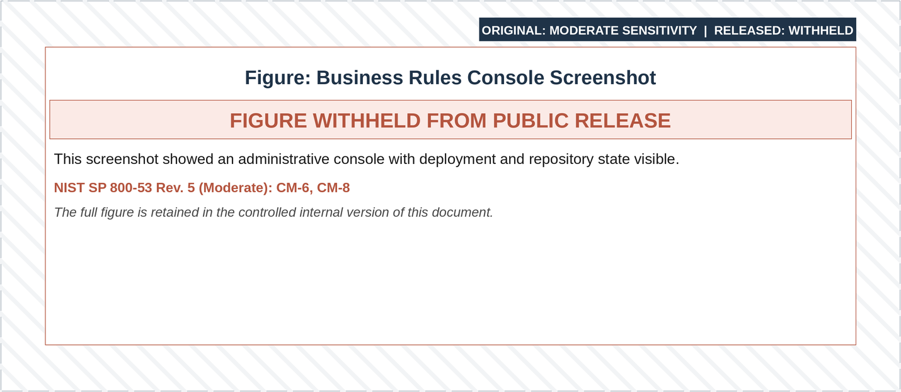
Figure 3-26: Oracle Policy Modeling
OPA HUB Manager: Intelligent Advisor Hub is where policy models are managed, shared, and deployed. It is also used to configure user permissions and connections.
The Intelligent Advisor Hub REST API for deployments provides a flexible mechanism to automate certain tasks such as inspecting the contents of policy models moving through development to production, and integrating those steps with other authorization actions, if needed.
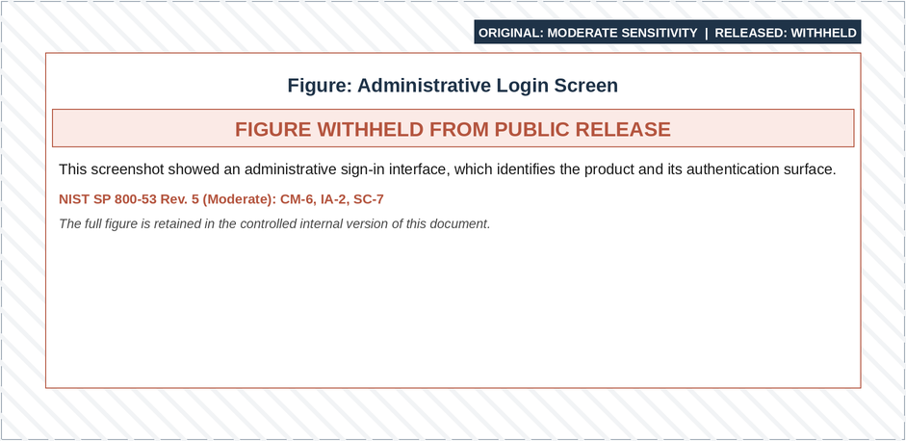
Figure 3-27: Intelligent Advisor Hub Login Screen
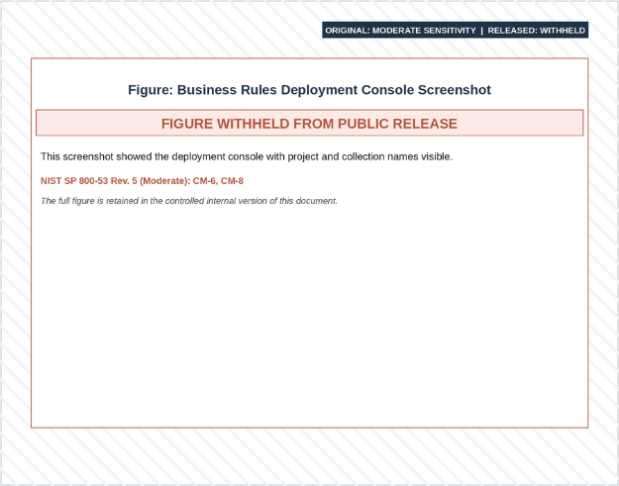
Figure 3-28: Intelligent Advisor Hub Projects Screen

MECM OPA Project List
Below table provides the list of projects that are being leveraged in NY MECM.
Project | Description
Medicaid | Consists of authored rules in word and excel related to TOA determination through program specific, non-financial and financial requirements.
Authorization | Consists of authored rules in word and excel related to TOA finalization and notice trigger requirements.
Averaging | Consists of authored rules in word and excel related to TOA financial budgeting requirements.
Common Data Model | Consists of authored rules in word and excel common to all the projects. Example (Date related rules).
Table 3-26: MECM OPA Project List

Business Rules Execution
The rule archive file is the physical representation of the files required to deploy the rules to the rules’ execution server. A rule archive file contains a set of rules and the rule flow that will be executed by the business rules engine.
A Rule Application is a ‘container’ a deployable management unit that contains one or more rulesets. Rule Applications normally contain rulesets that share the same object model.
Each ruleset in a Rule Application can be invoked using a ruleset path. The ruleset path acts as the entry point for clients to access the business logic encapsulated in the Rule Application. Rule Applications deployed on a supported application server can be accessed by multiple, concurrent, distributed clients. An application can invoke one or more rulesets contained in different Rule Applications.

Transaction Management
Transactions are managed by the OPA for rules execution. From the time that OPA receives the rules execution call to the time that the results are returned, the transaction is managed internally within the OPA rules engine. Once the transaction is complete and a result has been returned, none of the transactional data is persisted within OPA.

Exception Handling
In business rules engines, exceptions during rule invocation or metadata retrieval are managed using a unified handling framework, and Log4J logging. These measures enable effective identification, logging, and communication of exceptions, minimizing disruption to users and operations.
An exception can arise in the following situations:
- Exceptions occur while invoking the business rules engine
- Exceptions occur while retrieving metadata from the business rules engine repository
- The following standards and process are implemented to prevent and handle exceptions:
- Exceptions are handled in the participating system in the eligibility determination module using a try-catch block
- Exception handling is managed in a common way as part of the rule’s invocation framework. The exception handling in the RulesManager class provides standard identification and logging of the exception so that this does not need to be handled by the developer
- The Java utility, Log4J, is used to log the exceptions thrown and write the message to the eligiblityException.log file. The exception details include the severity and stack trace of the exception
- In a typical scenario, if there is an exception with the business rules engine, it will be thrown back to the Worker Portal and the end user would receive appropriate business message at the top of their screen

Logging
The Message Logs tab on Policy Automation Hub displays a list of errors including web service errors and communication errors. By default, the Message Logs tab shows the 1,000 most recent error messages from Policy Automation Hub. The log files for OPA will be captured on the centralized Splunk server for aggregation and reporting purposes.

Batch Framework Architecture
This section provides an overview of the batch framework and how batch processing is implemented in MECM.

Overview
This section of the deliverable provides an architectural overview of the batch framework, batch framework components, and its implementation in the MECM system. The MECM system requires bulk processing to execute various business operations in batch mode without user interaction, interfacing with both internal and external systems.
These operations include automated, complex processing of large volumes of information, which is most efficiently executed without user intervention. Typical operations encompass time-based events (e.g., month-end calculations, notices), periodic application of complex business rules processed repetitively across very large data sets (e.g., benefit determination), and the integration of information from internal and external systems, requiring formatting, validation, and transactional processing into the system of record in a batch mode.
The JSR352-based Spring Batch framework provides a programming model, job specification language, and runtime environment for batch application development for the Java platform. These concepts can be summarized as:
- Implement: A programming model for implementing batch artifacts
- Orchestrate: A job specification language (Extensible Markup Language (XML)-based) that orchestrates the execution of batch artifacts within a job
- Execute: A runtime environment for executing batch jobs according to a defined lifecycle
- The Batch processing does retrieve batch parameters from the database table Batch_Fw_Job_PARAM.
- This is the place holder for default values when no specific parameter has been passed for a batch.

Batch Framework Architecture View
The batch architecture comprises an enterprise scheduler, batch servers, and an access point, structured into six layers. The six layers of the batch application architecture are listed below:
- Initiation Layer (Scheduler, Shell Scripts)
- Domain Layer (Cargos, Collections)
- Batch Layer (Readers, Processors, Writers)
- Business Layer (Business Objects)
- Services Layer (DAOs, Web Service, Rules Invocation)
- Data Layer
The following diagram illustrates the interaction of these six layers.
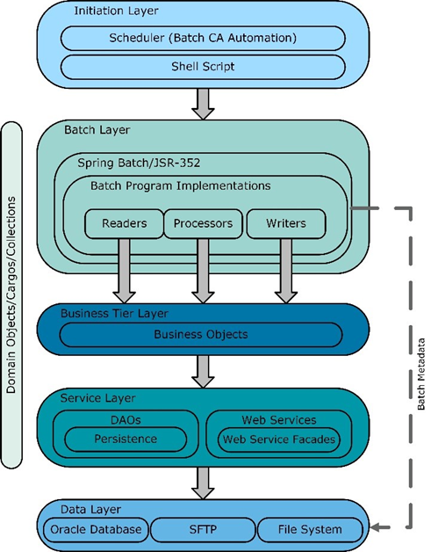
Figure 3-29: Batch Application Architecture
Batch operations supports both vertical and horizontal scalability. Vertically, it scales by adding resources (CPUs/RAM) to batch servers. Horizontally, it scales by adding servers for batch execution. Scaling in either direction may impact licensing and other configurations. The new additional servers need to be configured at CA scheduler to be able to trigger batch job execution at these new servers. Also, BOM needs to get updated with the additional EC2 instances.

Batch Framework Artifacts
This section of the deliverable describes the main artifacts that will be built from the batch framework to support the batch processing in the MECM system.

Readers
The main purpose of a Reader class is to fetch the required number of triggers (i.e., records) from the database and/or file for a given functionality, such as fetching the list of triggers to be processed by an Interface Batch Job. The readers can be configured to read a specific number of records in one transaction. Reader classes themselves do not contain any data access logic for the job. Instead, they utilize a business object class, which in turn uses various Data Access Layer components (i.e., collections and cargos) to retrieve all data. All interaction with the Business Object is conducted through its interface. The following figure details the batch reader class.
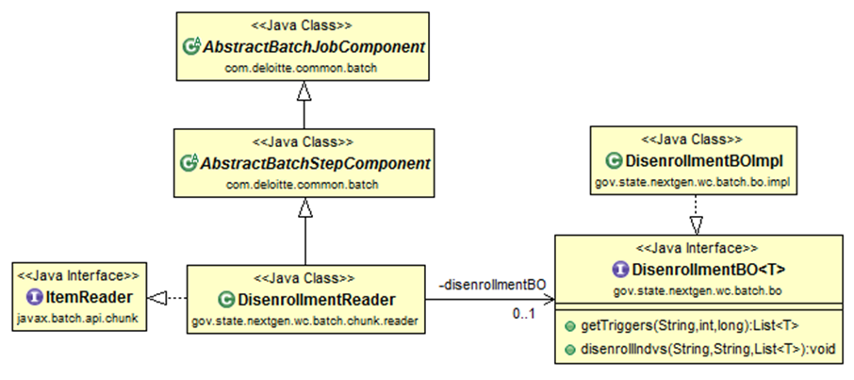
Figure 3-30: Batch Reader Class Information

File Processing
The reader is responsible for reading transactions in the database or records from the file. It reads the records at once and creates business objects that will be processed by the processors, depending on the batch job design.

Checkpoint and Restart
Depending on the job details, some Readers will need to implement custom Checkpoint interface to facilitate smart restarts of the job. This will only be necessary where the status field is not present in the batch data, or there is no other way to determine the location at which a previous job execution failed based on the state of the data. This is usually the case where the data that needs to be processed by the job is identified by some external inputs, such as a run date indicating that all records from a table with a timestamp of X must be processed.
The Checkpoint interface allows the job to record the last record processed at the final checkpoint, so that if a failed job is restarted, the job resumes from the last record which was successfully processed. The specific Readers that will require the use of the custom Checkpoint interface will be determined as part of the detailed design for each job.

Processors
The following figure details the batch processor class.
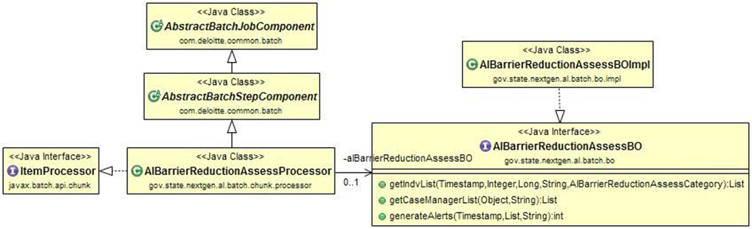
Figure 3-31: Batch Processor Class Information
The main purpose of a Processor class is to process one record at a time. Records read by Reader classes will be passed individually to the Processor for the necessary business processing.
Processors will not directly contain the business logic for the job. Instead, they will reference a business object class that encapsulates all the business logic for the job. A Processor class collects the necessary information related to the trigger, sets the required data on the business object to invoke the Web Service, and is also responsible for the transformations required from/to source/destination systems.

Writers
The following figure details the batch writer class.
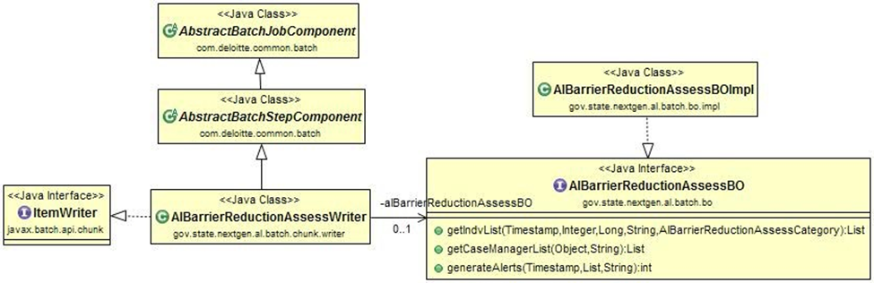
Figure 3-32: Batch Writer Class Information
The main purpose of the Writer class is to take the list of successfully processed records from the Processors and then invoke the corresponding Business Object and Data Access objects to persist the data to the database. The Writer is also capable of reading the dataset from the database and writing multiple records to the output file.

Batch Metadata XML
Each batch job developed using the JSR-352-based Spring framework will contain batch metadata XMLs that outline the various components (readers, writers, and processors), partitioning logic, exception handlers, listeners, checkpoint policy, and properties used by the batch.

Batchlet and Chunk
Batch jobs consist of two types of steps as defined by JSR-352, Batchlet and Chunk.
A Batchlet is a Java class that implements the Batchlet interface, providing a simple self-contained batch process and is designed to perform a specific type for task or operation such as Data processing, file manipulation, database updates and report generation.
A Chunk is a unit of work within the batch process consisting of a group of items to be processed as a single, atomic unit.
A Batchlet can process multiple chunks, and each chunk is processed independently. The Chunk process is typically done within a Batchlet.

Transaction Management
The transaction handling within the batch framework is described as the built-in transaction handling capabilities of the framework.
All framework-level transactions are handled natively by the JSR-352 implementation (Spring Batch framework) and are defined by the chunk size (commit interval) in the application. The JSR-352-based Spring Batch framework provides an out-of-the-box transaction handling mechanism, which is configured centrally as part of the JobRepository.
In addition to the built-in transaction handling capabilities of the Spring Batch framework, there are APIs available for customizing the transaction handling behavior. These APIs offer the development team significant flexibility to implement batch jobs as required by the business functional requirements.

Multithreading
Multi-threading is facilitated during the execution of batch cycle, enabling parallel processing for high performance.
The Java Spring framework, along with Fast4J custom classes for NextGen application, facilitates multi-threading in batch job execution. The number of threads required to execute the batch is determined by the number of partitions required (based on number or triggers/records to be processed). This number is either passed as a command-line parameter or retrieved from the Batch parameter table by default. Refer to the sample commandline with the numberOfPartitions parameter:
Figure 3-33: Sample Command Line
Once the batch job starts on a batch server node, multi-threading begins within the batch server for execution.
CA Automic Scheduler monitors CPU utilization on batch servers. If a server’s CPU utilization exceeds the threshold value (e.g., 80%; actual value will be determined during the performance testing), it prevents new batch jobs from running on that busy server. Instead, it either allows the job to run on another batch server node or queues the job for execution if all batch servers are at the threshold CPU utilization. Once the CPU utilization normalizes, CA Automic Scheduler automatically balances the load for new jobs.
The Java Spring Batch framework’s multi-threaded step concept allows a batch job to use Spring’s TaskExecutor abstraction to execute each chunk in its own thread. A step in a job can be configured to perform within a thread pool, processing each chunk independently. As chunks are processed, Spring Batch keeps track of progress accordingly. If an error occurs in any thread associated with a Chunk, the chunk’s processing is rolled back according to the standard Spring Batch functionality.

Exception Handling
The custom exceptions and the process of handling exceptions by the batch framework are described here. All checked exceptions (i.e., business exceptions) will be managed by the Batch job application, while all unchecked exceptions (i.e., system exceptions) will be managed by the batch framework.
The JSR-352-based Spring Batch framework supports exception handling at various levels such as job level or step level. Custom exceptions will be created to track issues during batch job execution. Additionally, skipped records and their exception will be recorded in a framework database table, allowing job operators to access job exceptions even after the job is completed.
Since the NextGen solution wraps most exceptions as Application Exception or Framework Exception, the following new exceptions are defined for the batch:
- NGBatchException is the root batch exception
- NGBatchSystemException extends the NGBatchException and representing FrameworkException and any other configuration-level exception thrown by batch jobs
- NGBatchBusinessException extends NGBatchException representing ApplicationException and any other business logic related exception
- NGBatchRetryRecordException extends NGBatchBusinessException representing records or action that must be retried by the batch runtime environment
- NGBatchSkipRecordException extends NGBatchBusinessException representing records that must be skipped during the processing if those records throw an exception
The following figure details batch exception handling.
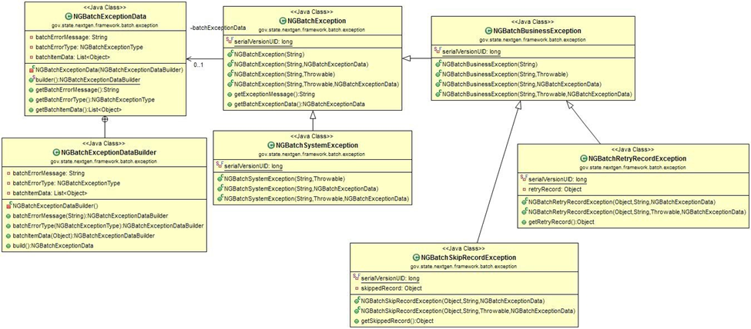
Figure 3-34: Batch Exception Handling Information
Logging for all batch jobs will be implemented using Log4J. For skipped exceptions, the approach is to use a database Table Name: BATCH_FW_ITEM. The components of this table are detailed in Table 3-26.
Column Name | Description
ERROR_MESSAGE | Detailed error message which caused the individual record to get skipped during the processing
ITEM | The actual record that got skipped, which will help in detailed analysis
JOB_EXECUTION_ID | Every Batch Job instance will have its unique job execution ID which differentiates itself from other jobs. This identification is named Job Execution ID.  This table does not have the job name but using the Job_Execution_ID the table Batch_Job_Execution can be queried to get the Jobname using the column Job Configuration location.
STEP_EXECUTION_ID | Batch jobs may have one or more steps. This column will be used to mention which step had issue and what the issue was during the processing of the batch job.
Table 3-27: Batch Job Logging

Logging
The logging mechanism within the batch framework is implemented using the Log4J logging API. This API will be used for various levels of logging in the application. Each batch job execution will result in multiple logs that follow the format: <JOB_NAME>_<TIMESTAMP>_<LOG_TYPE>.log in the logs folder of the batch servers.

Batch Scheduler
The CA Automic Scheduler is used to schedule batch jobs in the MECM system. CA Automic requires CA Automic Agents to be installed on the servers where the batch jobs are executed. Refer the Batch Run Book (link to document location: NY MECM - Batch Run Book) for the list of the batch jobs.
The CA Automic automation tool is used to configure the application and reporting batch jobs. It necessitates the installation of CA Automic Agents on the servers where those batch jobs run from. The CA Automic Agent is installed on batch servers to trigger Java-based batch jobs and on Informatica ETL servers to trigger ETL reporting scripts for extracting data into reporting data sources: Operational Data Store (ODS) and Data Warehouse (DW). For Java-based batch jobs, build scripts, all the required modules, and necessary libraries will be copied to the CA Agent. The batch jobs are run as a standalone Java Virtual Machine (JVM) application. The following figure details the MECM system batch scheduler process flow.
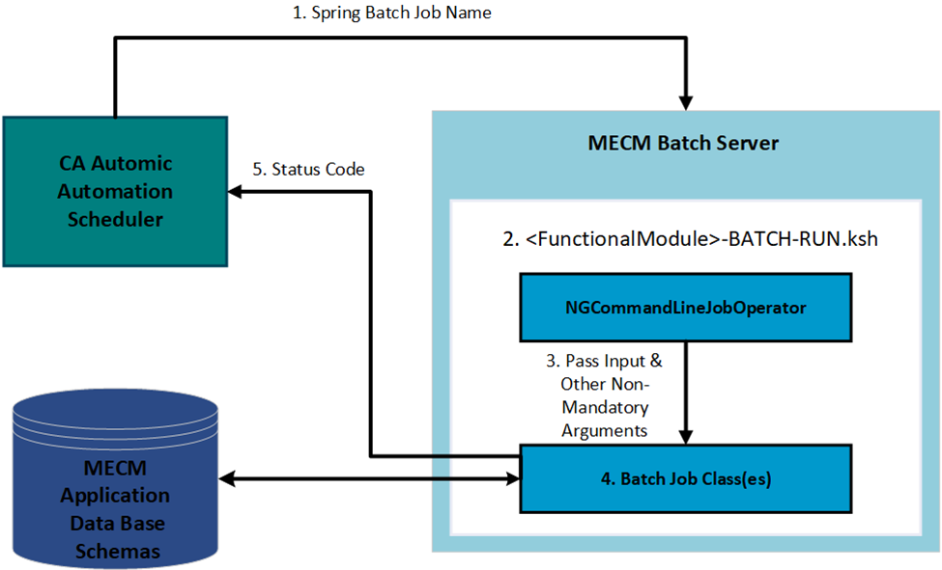
Figure 3-35: MECM System Batch Scheduler Process Flow
At runtime, when a batch job is triggered from the CA Automic scheduler, the batch job name and any additional input parameters will be passed to the script <FunctionalModule-BATCH-RUN.ksh>. For example, for Eligibility batch jobs, the shell script name will be ED-BATCH-RUN.ksh. In this command file, the framework instantiates the required batch job class based on the job name and passed job ID, parallel run number, and any additional arguments. The batch jobs are executed on either of two batch servers dedicated to each physical environment, based on the load factored by the CA Automic Automation Agent.

Scheduling Exception Handling
The CA Automic Automation tool is configured to generate email alerts for late, missing, or failed jobs and allows for the automatic restart of jobs upon abnormal conditions that may occur in the batch process. The status codes and descriptions used during batch execution are listed in Table 3-18.
Status Code | Description
0 | Completed
1 | Partially Completed
2 | Generic Error
3 | File Not Found
4 | Pre-validation Failed
5 | Post-validation Failed
6 | Empty File
Table 3-28: Batch Execution Status Codes
These status code values are reported back to the CA Automic Automation for reporting purposes. Based on the status code, the CA Automic automation tool will execute or put a hold on the dependent jobs.

Scripting Framework
The scripting framework for executing batch jobs is implemented using .SH/.KSH script files.
The Java batch jobs are executed by .SH/.KSH script files. Each logical grouping of batches, based on the functionality (e.g., Notices, Interfaces, ARDC), has a script file (e.g., CO-BATCH-RUN.ksh for executing Notices jobs) that accepts the batch job name as the parameter corresponding to the functional module. A sample batch script outlining the scripting framework is shown in the figure below.
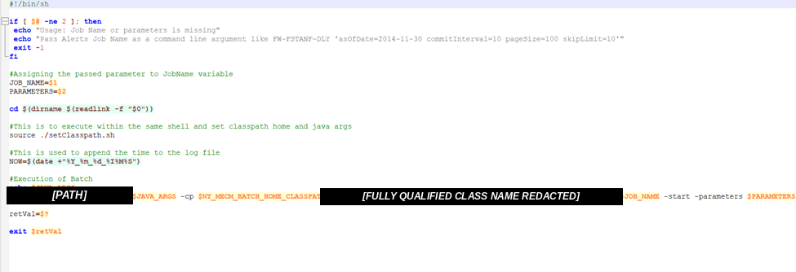
Figure 3-36: Sample Batch Scripting Framework
These scripts are developed and maintained in the source repository and packaged into batch servers (/Data/MECM_BATCH/scripts). These scripts are configured in CA Automic Automation for batch scheduling. Script execution errors are reported to CA Automic Automation for reporting purposes.

Tools
The tools that will be used during batch development and execution along with their respective use are detailed in the table below.
Tool | Use
CA Automic Automation Server | Batch scheduling software
Eclipse IDE, SQL Developer | Development Tools
Java Virtual Machine | Java runtime for batch job execution
Table 3-29: Batch Development and Execution Tools

Reporting Architecture

Overview
The MECM system leverages Tableau for implementing Reporting Functionality. Tableau provides a full set of reporting functionality by generating and managing reports for the MECM system. The Transactional database will be used as the source for Reporting and will be replicated to the Reporting Database from which Tableau will extract data for populating the required MECM system Dashboards.

Architecture View
The logical architecture for reports includes one Tableau server cluster per reporting environment, accessible via a web interface or a desktop client, provided the workstation has a developer license and the appropriate client installation. Each cluster consists of three nodes.
The following table explains the various Tableau services running on each node. A HA installation of Tableau Server is a special type of distributed installation designed to maximize the availability of Tableau Server. Services deployed in an HA configuration on each node are marked with an ‘X.’
Process | Node 1 | Node 2 | Node 3
Cluster Controller | X | X | X
Gateway | X | X | X
Application Server | X | X | X
VizQL Server | X | X | X
Cache Server | X | X | X
Search & Browse | X | X | X
Backgrounder | X | X | X
Coordination Service | X
Data Server | X | X | X
Data Engine | X | X | X
File Store | X | X | X
Repository |  | X | X (Passive)
Table 3-30: Tableau Services by Node
The minimum supported configuration for HA is a three-node system based on the Tableau standards & Recommendations.
The table below explains the functionality of each service in Tableau.
Process | Component Executable | Purpose
Application Server | vizportal.exe | Handles the web application, processes representational state transfer (REST) API calls, and supports browsing and searching.
Backgrounder | backgrounder.exe | Executes server tasks, including extract refreshes, subscriptions, ‘Run Now’ tasks, and tasks initiated from the command line utility ‘tabcmd.’
Cache Server | redis-server.exe | The Cache Server is a query cache distributed and shared across the server cluster.
Cluster Controller | clustercontroller.exe | Responsible for monitoring various components, detecting failures, and executing failovers when needed.
Coordination Service | zookeeper.exe | In distributed installations, responsible for ensuring there is a quorum for making decisions during failover.
Data Engine | tdeserver64.exe | Creates data extracts and processes queries.
Data Server | dataserver.exe | Manages connections to Tableau Server data sources.
File Store | filestore.exe | Automatically replicates extracts across data engine nodes.
Repository | postgres.exe | Tableau Server database, stores data sources and user metadata.
Search & Browse | searchserver.exe | Handles fast search, filter, retrieval, and display of content metadata on the server.
VizQL Server | vizqlserver.exe | Loads and renders views, computes, and executes queries.
Gateway | Httpd.exe | Web server that handles all requests to Tableau Server from browsers, Tableau Desktop, and other clients.
Table 3-31: Tableau Service Purpose
Tableau supports scalability both vertically and horizontally. Vertically it scales through the addition of resources (CPUs/RAM), Horizontally it scales through the addition of servers to the Tableau cluster. Scaling either way may have an impact on licensing and other configurations.
Tableau has an inbuilt Authentication mechanism for authenticating user to access dashboards. The user information is stored in the Tableau Repository. In MECM the Tableau authentication is being implemented using SSO setup with Okta. Refer to the MECM Okta Integration with Tableau subsection of Security Architecture.

Reports Generation
All reports generation is managed within Tableau. Tableau connects with the MECM Reporting Database and builds visual dashboards as required. All Reports users will have a single role to view the dashboards. The following figure details the MECM system Reports Architecture.
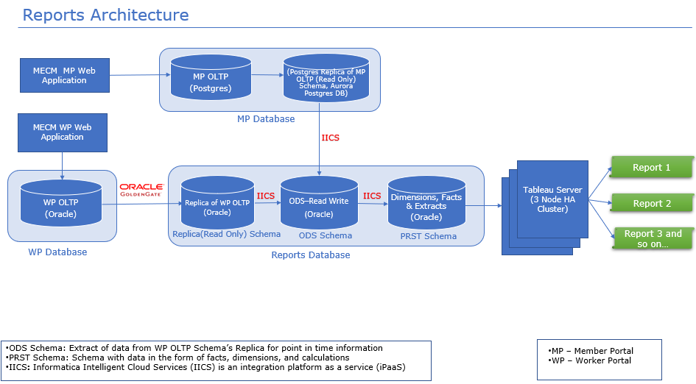
Figure 3-37: Reports Architecture

Transaction Management
Transactions are submitted and managed by the Tableau infrastructure for reporting. As a standalone reporting application, Tableau is responsible for managing all of its transactions.

Multi-Environment Support
The Tableau server supports multitenancy by allowing server administrators to create multiple sites on the server for different sets of users and content. Each site has its own URL and its own set of users, and each site has completely segregated content, projects, and data sources. You can set permissions per user or group on a project, workbook, view, or data source. All server content is published, accessed, managed, and controlled on a per-site basis. The following reporting instances will be created for the MECM environment.
Tableau Setup | MECM Environments
Development | DEV01, DEV02, SIT01, SIT02
Staging | SIT3, SIT4, SITC, UAT1, UAT2, UATC, TRNDEV, TRND1, TRND2
Production | PROD
PreProd | PRDT, PRDP
Disaster Recovery | DR
Table 3-32: Tableau to MECM Environments Mapping

Exception Handling
Tableau natively handles exceptions within the application.

Logging
Tableau Server routinely creates log files of the following activities to:
                - Review the server configuration file (\config\tabsvc.yml) for a basic understanding of the server environment
                - Review the admin log (\logs\tabadmin.log) to understand any maintenance that has been done on the server
                - Review the Apache logs (data\tabsvc\logs\httpd\access.yyyy_mm_dd _00_00_00.log and data\tabsvc\logs\httpd\error.log) for requests that may be related to any issues being investigated
All logs will be forwarded to Splunk for aggregation.

Notices Architecture

Overview
This document provides a high-level overview of how OpenText Exstream is used to design and generate notices for the New York MECM. In this section, we will dive into how OpenText Exstream utilizes designed templates to generate standardized MECM notices. We will explore Exstream's notice generation process and how notice service seamlessly integrates with the application in on-demand and batch mode.

Architecture View
OpenText Exstream has been set up for High Availability across Availability zones.
The following diagram shows the high-level workflow of preview functionality from WP to HP Exstream.
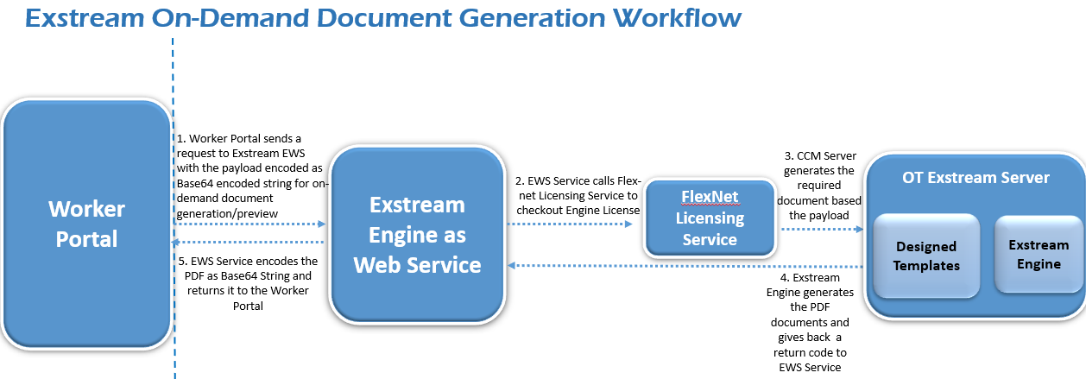
Figure 3-38: On-Demand Document Generation Workflow/Architecture
The following diagram shows the high-level workflow of Batch document generation functionality from Worker Portal to HP Exstream.
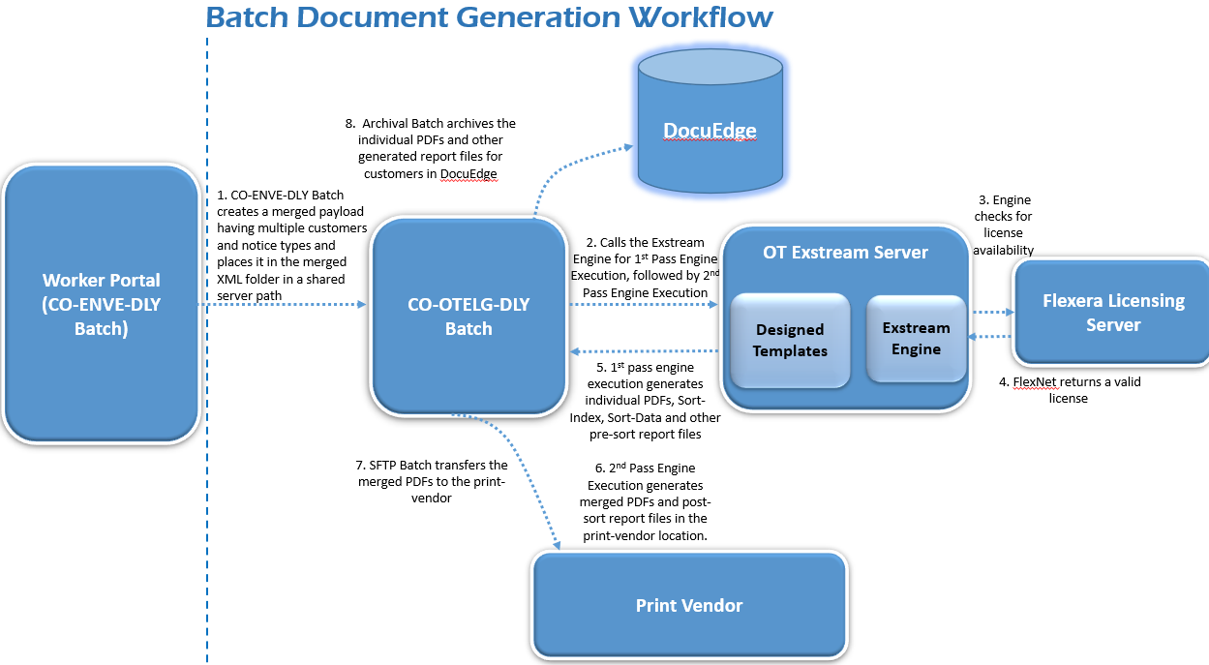
Figure 3-39: Batch Document Generation Workflow/Architecture

Multi-Environment Support
This section of the deliverable provides details of the Logical environments of Exstream servers that support multiple physical MECM environments and thus the OpenText Exstream is being used as a shared component in MECM.
It includes a table that maps various MECM environments with specific OpenText Exstream setup.
OpenText Exstream | MECM Environments
Development | DEV01, DEV02, SIT01, SIT02
Staging | SIT3, SIT4, SITC
Staging | UAT1, UAT2, UATC
Staging | TRNDEV, TRND1, TRND2
Pre-Production | PRODT, PRODP
Production | Prod
Disaster Recovery | DR
Table 3-33: OpenText Exstream to MECM Environments Mapping

Notice Design
The MECM system Utilizes OpenText Exstream (Exstream) CCM platform for Notice Design and Generation.

What is OpenText Exstream?
OpenText Exstream is a multichannel CCM platform used to create and produce documents for mailing and electronic distribution. In the MECM system, Exstream consumes the data in XML format and generates notices in PDF format.
All notices follow a standard template established by New York State as shown in the sample screenshot below. The main body of each notice is built from reusable blocks of content called "Key Messages" (KMs). These KMs act like building blocks and are chosen based on the recipient's specific eligibility for different benefits and services. When a notice is generated, the system automatically selects the relevant KMs and assembles them to create the final message for each recipient.
The following figure shows the sample standard notice template.
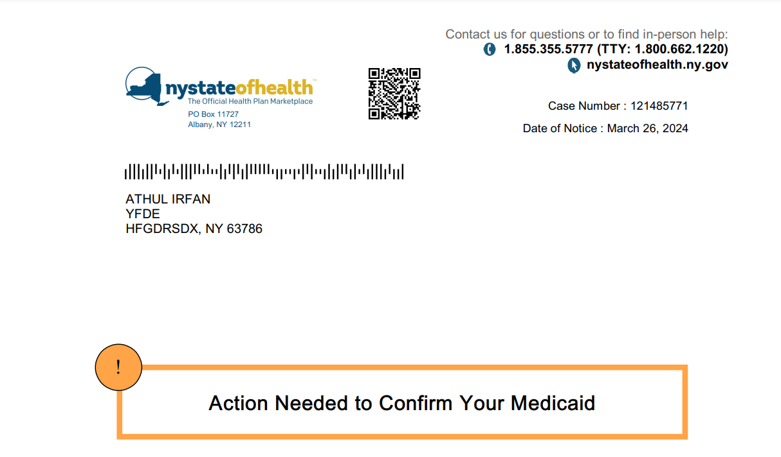
Figure 3-40: Notice Example
There are two types of KMs used to create notices:
- Notice-Specific KMs: These are KMs unique to a particular notice and provide details relevant to that specific message. They are included directly within the notice template itself
- Reusable KMs: These are common phrases or paragraphs that apply to many different notices. They are designed as separate units and stored as a reusable paragraph in the Design Manager Library. This makes it easy to update or reuse them across multiple notices
The Key Messages will be designed from the OpenText Exstream Designer.

Multi-Lingual Support
To efficiently cater to diverse language requirements, MECM leverages the OpenText Exstream Language Layer functionality. This feature eliminates the need for separate design templates for each supported language.
Within the Design Manager library, each page or paragraph can be configured with language-specific layers. These layers hold the translated content for each supported language. Updates to content in a specific language are then isolated to the corresponding layer, promoting efficient content management, and resulting in lesser number of design objects and nimbler application.
The Language Layer offers significant advantages, particularly for languages with complex character sets, such as those found in Asian languages, or right-to-left script, like Arabic and Urdu. This approach simplifies the management of multilingual content and reduces the overhead associated with maintaining duplicate templates for each language.
The following figure shows the multilingual support implementation in HP Exstream.
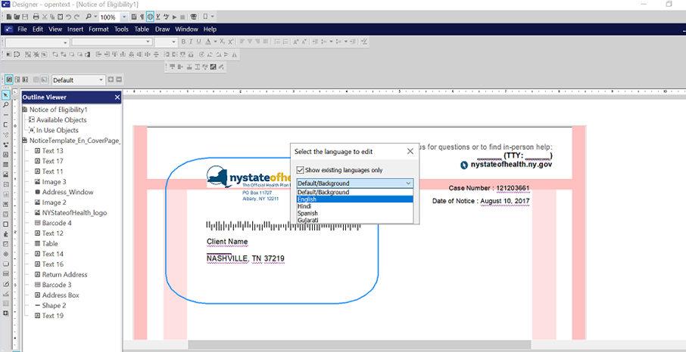
Figure 3-41: The Multi-Lingual Support in HP Exstream

Notice Generation
MECM utilizes Exstream in two primary modes: On-Demand and Batch.

On-Demand Mode
MECM uses the Exstream EWS (Engine as a Web-Service) module to directly call the Exstream Engine via a SOAP request. Exstream receives the SOAP request, executes its engine, and processes the PUB file (".pub") containing the design and logic to generate the Notices. Notices are generated in PDF format. The generated PDF is sent back to MECM as a Base64 encoded response.

Batch Mode
A merged XML file containing data for multiple customers and notices is created and placed in a shared folder. The CO-OTELG-DLY batch job in MECM consumes this merged XML file. Exstream processes the XML data using the templates and generates two sets of PDFs: merged PDFs are sent to the print vendor for bulk printing. Individual Customer PDFs are stored electronically in DocuEdge.

Sorting and Bundling
Sorting and bundling involve the reordering and grouping of customer communications into cohesive 'bundles' after document composition but before the final output is generated. This process introduces additional post-processing controls, potentially saving costs on postage. Furthermore, it allows for the creation of cover and trailer pages around these bundles, complete with barcodes alongside the documents. The use of Output Sorting and Bundling provides access to features that enhance flexibility in high-volume production processing, simplifying operations and improving overall processing efficiency.

PDF Bundling and Enveloping
Merged PDF files are categorized into four distinct envelope types (A, B, and C). Bundling is determined by the number of sheets in each bundle (each customer) and the type of envelope. The following outlines PDF file categorization:
- TotalPhysicalSheetInBundles <= 5: Envelope Type A
- TotalPhysicalSheetInBundles =6 to 14: Envelope Type B
- TotalPhysicalSheetInBundles =15 to 80: Envelope Type C

PDF Files for Print Vendor
Four large PDF files can be generated for each type of Notice (Eligibility, Appeals and Renewals and Others), each representing one of the envelope types. These files are dispatched to the designated print vendor via SFTP.

End To End Mail-Piece Tracking
Each notice is tracked from the time of generation in the MECM system to the point Mailing Vendor picks up the notice from Venture Communication’s print facility.
Print Facility: Daily Notices will be printed in the main facility. Monthly Renewals will be split across all the facilities.
After the mail piece is picked up by Mailing Vendor, it is processed for delivery according to standard Mailing Vendor co-mingling processes and is therefore considered in the custody of Mailing Vendor. The table below discusses the overall End-to-End Mail Piece Quality Assurance (QA) and Tracking throughout the phases in the Document Output Management Process:
Phase | Description | Owner | QA/Tracking
Notices Generation | MECM will generate the notices including a QR Case Barcode that is unique to each mail piece. The notices will be logically organized into 12 different PDF files before transferring to Venture Communications. | Deloitte | QR Case Barcode (Including Unique Mail Piece ID)
File Transfer | MECM will use the SFTP process to transfer the files to Venture Communications following PDF size limits established. | Deloitte | Standard MECM SFTP processes
Printing and Enveloping | Venture Communications will apply a 2D Barcode for QC purposes and the IMB for mailing vendor mailing prior to printing. They will then print the individual mail pieces and envelope based on the number of pages. Venture will scan the 2D Barcode one last time following enveloping. | Venture Communications | 2D Barcode for QA
Co-Mingling | Co-Mingling will pick up the mail pieces from Venture Communications and perform co-mingling steps before delivery to mailing vendor. | Co-Mingling Vendor | Work Order Level
Mailing | Mailing Vendor will pick up the mail pieces and scan the IMB before transferring to the recipient address. | Mailing Vendor | N/A
Reconciliation/Reporting | Venture Communications will send back Daily Reconciliation reports that show closed work orders. Venture will send back processed PDFs to store on the batch server. Venture will send back files with the first scan report and estimated in home report for nonpriority mail pieces. | All | Unique Mail Piece ID
Table 3-34: End-to-End Mail Piece Quality Assurance and Tracking

Exception Handling
This section of the deliverable describes the exceptions and the process of handling exceptions during generation of a notice by OpenText Exstream.
The following table describes the severe exceptions that need to be addressed.
Exception Type | Exception Code | Exception Error | Action
System | Return Code 12 | There are no driver files for the selected application. | Validate if the merged file is placed in the path.
System | Return Code 12 | Invalid XML Input, element tag not ended correctly. | Validate the merged XML content to make sure XML has valid syntax.
Table 3-35: Severe Exceptions in Notice Generation

Logging
This section of the deliverable describes the log file pattern and path of log files for the logs that get generated in the notice generation process and how these logs get forwarded to centralized log monitoring tool. The table below mentions which data elements will be logged.
Log File(s) | Description
Messages.dat | This is the Exstream Engine log file generated for each preview request inside the [SERVER PATH REDACTED]/work/{transaction folder}/messages.dat
EWS Console Log | This is the Exstream Web Service log found in the same path [SERVER PATH REDACTED]/work/{transaction folder}/EWSConsole.log
ElgFirstPassLog.dat | This is the Exstream Engine log for the 1st pass engine run for ENVE-OTELG Batch. This is located in the following path: [SERVER PATH REDACTED]/Batch/eligibility/error/ElgFirstPassLog.dat
ElgSecondPassLog.dat | This is the Exstream Engine log for the 2nd pass engine run for ENVE-OTELG Batch. This is located in the following path: [SERVER PATH REDACTED]/Batch/eligibility/error/ElgFirstPassLog.dat
ElgAltLangToEngRun.dat | This is the Exstream Engine log for the alternate language to English conversion engine run for ENVE-OTELG Batch. This is located in the following link: Del. #22 Interface Technical Design Document.
Table 3-36: Data Element Logging

Integration Architecture

Overview
This section of the deliverable provides an overview of the MECM Integration Architecture and how it enables exchange of information with DOH and external trading partners in real-time and batch processing manners. For more details on a specific interface refer to Del. #22 Interface Technical Design Document, see Section 4.2 Appendix B.

Architecture View
This section of the deliverable describes the MECM integration with upstream and downstream systems. Integration architecture view identifies the MECM components and their integration points with key upstream and downstream internal and external systems and entities that send/receive information. System components are represented by boxes, while interactions are represented by arrows connecting the system components which interact. Refer to the Interface Integration Logical Architecture for the MECM Logical Interface Integration Architecture. The following figure details the MECM system integration architecture.
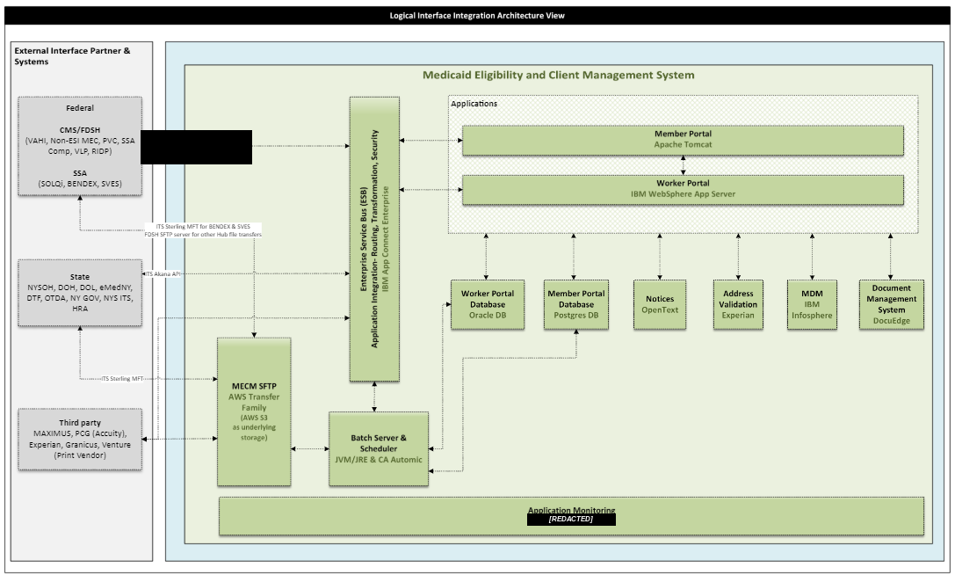
Figure 3-42: MECM System Integration Architecture

Integration Architecture Components
The Integration architecture components enable stateless web service invocations. These web services are invoked by the MECM system to enable the end-to-end business process flows. Also, the external systems will invoke the MECM hosted webservices for exchanging data. The table below describes the key integration architecture components involved in the MECM system.
Component | Integration Design
IBM App Connect Enterprise | IBM ACE is a COTS product used as the ESB for integrating trading partner services with the MECM system via Webservices.
SFTP Servers | AWS File Transfer SFTP Solution is an AWS Native Service used as the File Transfer solution in MECM for secure and reliable file transfer to/from Trading Partners.
CA Automic | CA Automic is a COTS product used as the Job Scheduler for automating MECM batch processing.
Table 3-37: Integration Component Architecture

Integration Patterns
This section outlines the integration approach for the MECM system, based on requirements and leading practices for automated batch file transfers and service-oriented architecture (SOA). The table below provides the approach, description, integration standards, and tools and techniques for each integration pattern.
Approach | Description | Integration Standards | Tools and Techniques
Service Oriented Integration | MECM leverages Web services for implementing Service Oriented Architecture. MECM Integration Architecture leverages both SOAP and RESTful webservices. | - HTTP over SSL - Transport level security  - WS Security - Message-level security for SOAP based services  - Basic Authentication – Message-Level security for RESTful services | - IBM ACE
File Transfer Oriented Integration | Batch processing will initiate File transfers using Secure File Transfer Protocols (SFTP) for both MECM inbound and MECM outbound. File transfers are triggered by scheduled jobs and therefore are not considered real-time integration. | - SSH File Transfer Protocol (SFTP) using SSH public/private keys  - File layouts defined by federal and state interface partner systems | - AWS File Transfer Family SFTP solution  - Flat file scheme for file layouts  - CA Automic
Queue Approach | MECM leverages Java-based messaging API for creating, sending, receiving, and reading messages between two or more system components. | - Java Messaging Services (JMS) | - Amazon SQS
Table 3-38: MECM System Integration Approach Requirements

Services Orientation Integration
The real-time data exchange between the MECM system and state, federal and external third-party trading partner systems will happen using web services interfaces hosted and executed in the MECM system, following the Service Oriented Architecture (SOA) using the MECM ESB. IBM ACE is being used as ESB for the MECM system. Below are the standards that the MECM system follows:
- All MECM inbound and outbound web service calls with the trading partner MECM must go via IBM ACE ESB
- No direct call between MECM and external trading partners
- Every call must get audited in ESB
- Security policy should be configured and validated in ACE for all incoming and outgoing webservice invocations
- Public signed certificates are imported to IBM ACE’s Trust Store and certificates are validated against the trust store during SSL handshake
- ACE Password vault is being leveraged for securing credentials
- Log level should be properly used

File Transfer Oriented Integration
The MECM system leverages the AWS File Transfer Family SFTP solution for secure file transfer between the MECM system and DOH interface trading partner systems that need to exchange data files. CA Automic Scheduler is used to implement SFTP process automation for all batch interfaces in MECM System. Below are the MECM system’s standards for network connectivity, authentication, and protocol for secure file transfers:
- Network Connectivity
  - Connectivity to SFTP servers will be over the public internet and restricted to Whitelisted IPs for Trading Partners
  - The MECM System IP range will be provided for IP whitelisting at trading partner side as needed
- Authentication Mechanisms
  - MECM SFTP solution supports both a username and password combination and key exchange between Trading Partners and the MECM system
- MECM SFTP policy dictates that a key exchange will be used whenever allowed by Trading Partner
- The SSH Key pair should be generated with the following specification:
  - type of the key to generate RSA (not SSH-1) rsa-sha2-512 and
  - Number (No.) of bits in generated key: 2048
- Protocols
- SFTP only over port 22 will be allowed on the MECM SFTP server for Trading Partners
  - Port for the Trading Partner’s SFTP server will be dictated by the Trading Partner

Data Flow Diagrams
The following diagrams illustrate the data flow for the MECM system internally between the Worker Portal and Member Portal and the data flow within Worker Portal Modules. The following figure represents the high-level data flow within Worker Portal among the various modules of Worker Portal.
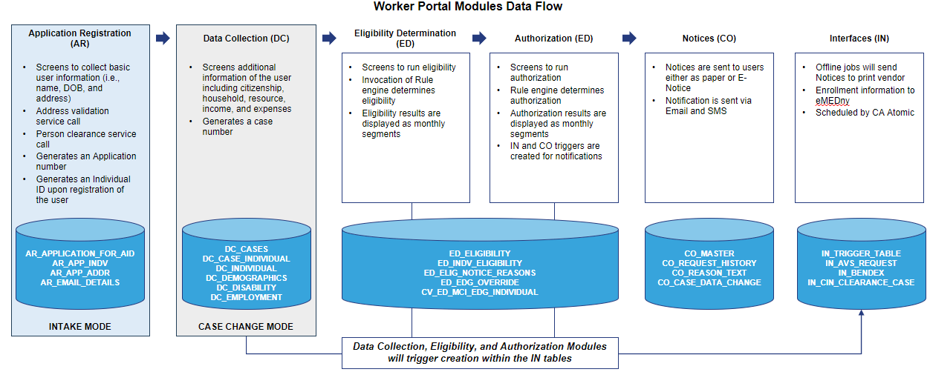
Figure 3-43: Worker Portal Modules High Level Data Flow
The below figure provides details about how the data flow between the two portals, Worker Portal, and Member Portal.
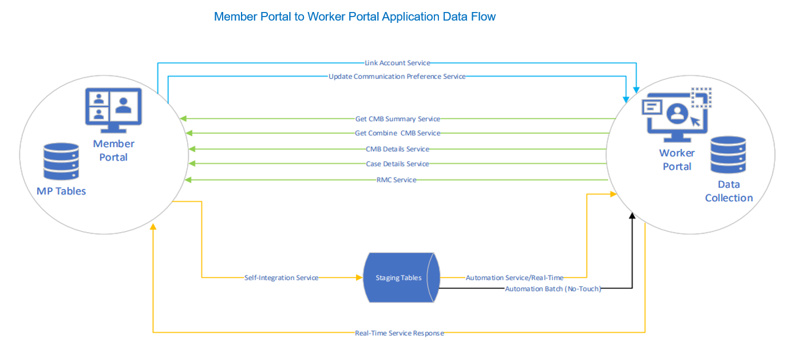
Figure 3-44: Member Portal to Worker Portal Application Data Flow
The below diagram in Figure “MECM System Application Flow shows” represents the high-level data flow for an individual, two member and mixed households. Refer to the Data Architecture, Models, and Integrity​ PowerPoint (link to document location: NY_Technology_Data Models Flows and Architecture Walkthrough_10.01.2024) for more details.
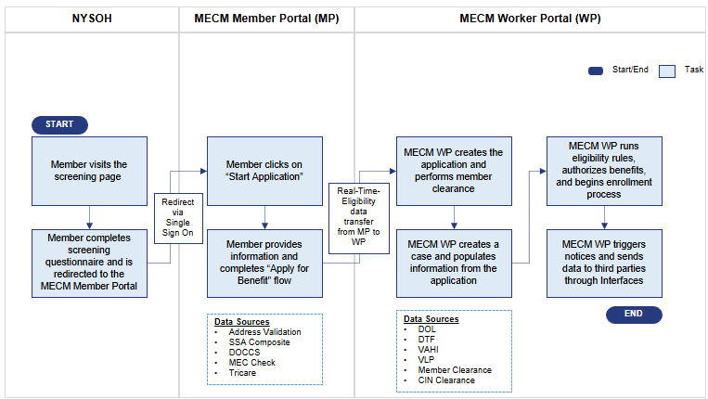
Figure 3-45: MECM System Application Flow

Document Management

Overview
This section of the deliverable provides an overview of DocuEdge which is used for Document Management within MECM. DocuEdge is a cloud native solution built on top of AWS S3 with the below design specification:
- Cloud-Native and Serverless
- The DocuEdge is entirely cloud-based, relying on serverless technologies that auto-scale resources based on demand. This reduces the need for managing complex infrastructure and operational costs
- Cost Efficiency and Scalability
  - The DocuEdge architecture eliminates user-based licensing fees and leverages cloud efficiencies to scale seamlessly as demands grow
- Integration and Customization
  - DocuEdge provides secure and seamless integration through REST-based APIs
- Security and Compliance
  - DocuEdge can be integrated with AWS Identity and Access Management (IAM) and AWS Cognito services to manage document access securely and maintain compliance with regulatory requirements
- Advanced Data Handling and Analytics
- DocuEdge utilizes Amazon Elasticsearch for robust data indexing and search capabilities, enabling powerful analytics and quick information retrieval
- Document Lifecycle Support
  - The DocuEdge architecture facilitates every phase of document management
    - Integration: Easily integration with any system via APIs
    - Store: Utilizes secure, scalable cloud storage to keep documents accessible and safe
    - Process: Employs microservices for efficient document processing, including version management, and metadata tagging
    - Access: Provides seamless document retrieval through RESTful APIs, facilitating easy integration with existing systems
    - Archive and Dispose: Manages document archiving and disposal in compliance, ensuring data integrity and security

Architecture View
This section of the deliverable provides the architecture and design of DocuEdge system. The following figure details the DocuEdge architecture.
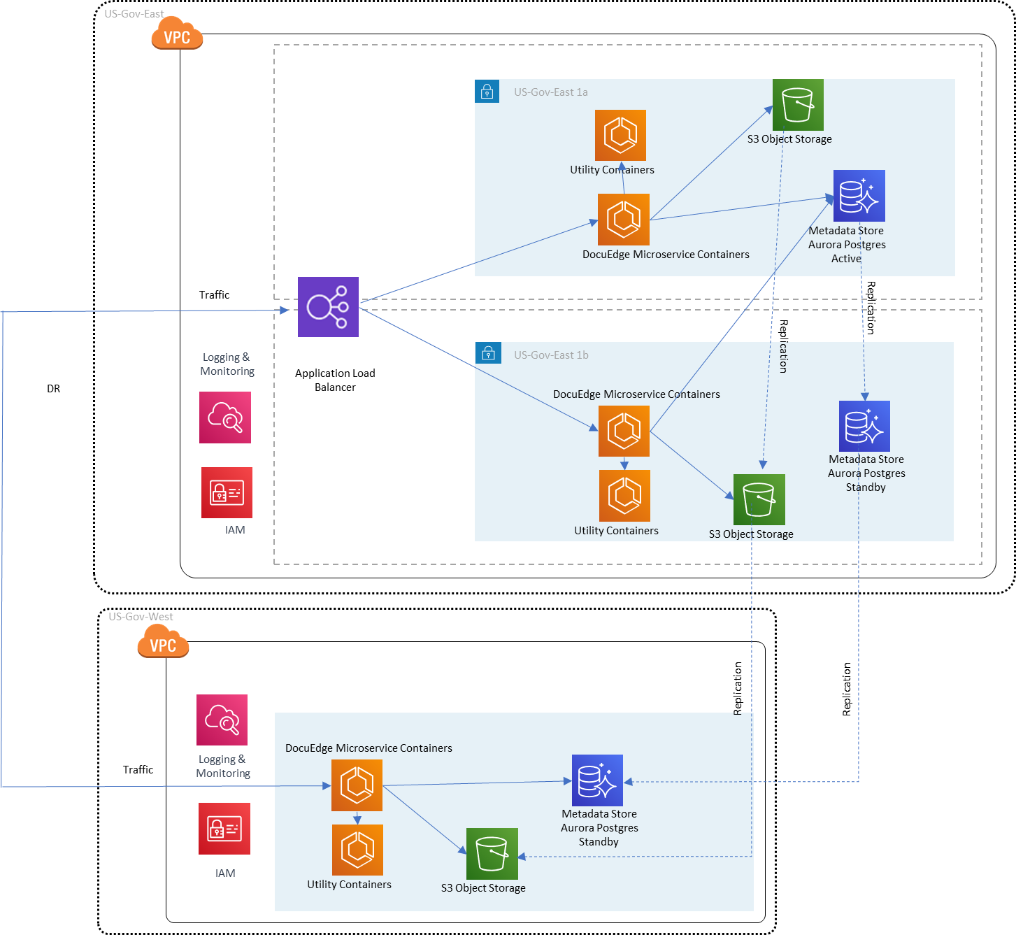
Figure 3-46: DocuEdge Architecture Diagram
The main components in this DocuEdge Architecture Diagram are:
DocuEdge Microservice Containers: The DocuEdge Microservice containers contain the core functionality and development for the DocuEdge Product; coordinating AWS features to match our client needs. This is run time for the DocuEdge Microservices including uploadDocument() and retrieveDocument().
Utility Containers: Utility services contain functionality that works both to support the DocuEdge Microservices containers and provide additional functionality. These solutions would be things like redaction, notification services, event-based triggers, full-text search, OCR, and other functionality.
Indexing Service: Indexing service is used to index files that are uploaded to the S3 and used in coordination with OpenSearch to provide full text file search on all documents stored in the DocuEdge repo. Lambda function will be leveraged to initiate the indexing as soon a file is uploaded.
DocuEdge UI: The UI interface provides a landing page to both interact with and customize your DocuEdge environment. Depending on access of the user, you may perform admin level configurations for the repository as well as basic level user tasks. Admin level configurations would include changes to things such as taxonomy, metadata, security, infrastructure level settings, and the like. Basic user level features would include retrieving the category tree, retrieving a document you have access to, viewing content, etc.
Metadata Store: Aurora Postgres DB is used to organize content, establish security rules on access, provide general configurations, and to store our content metadata.
S3: AWS S3 is where the actual files and content are stored. MECM uses SSE-KMS (Server-Side Encryption with AWS KMS) for Amazon S3, where the encryption algorithm used is AES-256. MECM implements the least privilege for an AWS S3 bucket by applying deny for all others except the needed one. And Public access is always blocked on all S3 buckets.
DocuEdge application is containerized using Docker, the vault code docker image is pushed to the Elastic Container Registry for secure and scalable storage. Amazon Elastic Container Service (ECS) plays a crucial role in orchestrating microservices. These micro services are deployed on two AZs for high availability. ECS manages task definitions specifying how they should run, including resource allocations and network configurations. When a specific endpoint is called ECS confirms that the corresponding containerized microservice is launched and executed efficiently. The microservices communicate over well-defined APIs often interacting with AWS resources especially AWS S3, RDS, and CloudWatch in this architecture. The DocuEdge can be plugged in with Elastic Search, SQS, and Lambda as per the business need. The microservices architecture allows for better scalability, maintainability, and integrating with AWS resources.
Refer to the Appendix for more details about DocuEdge features.

Multi-Environment Support
This section of the deliverable provides details on the multiple environments in which DocuEdge would be set up. The following table details the mapping of DocuEdge to MECM system environments.
DocuEdge Setup | MECM System Environment
DMES | DEV1, DEV2, SIT1, SIT2
STG | SIT3, SIT4, SITC, UAT1, UAT2, UATC, TRNDEV, TRNDL, TRNDL2
PREPROD | PRDT, PRDP
PROD | PROD
Table 3-39: Mapping of MECM System Environments to DocuEdge

Document Management Solution Integration
This section of the deliverable provides system flow diagram which shows the document management integration, how each component interacts and how the documents will be uploaded to DocuEdge and retrieved by Worker Portal and Member Portal. This section also provides details around how the generated notices will get stored into the Document Management System using the DocuEdge REST API invocation. Any external system that needs to invoke DocuEdge API will come through IBM ACE which is being MECM ESB.
In Member Portal, documents will be uploaded to and retrieved from DocuEdge through REST API services. Each time a document is uploaded to DocuEdge, a unique 32 character Universally Unique Identifier called DocID will be generated and returned to Member Portal, where it will be stored in the Member Portal Database. For document retrieval, the necessary DocID will be fetched from the Member Portal Database and used to access the document from DocuEdge.
In Worker Portal, documents will solely be retrieved from DocuEdge. To retrieve a document in Worker Portal, the specific DocID will be obtained from the Worker Portal Database and then utilized to access the document from DocuEdge.
Within Worker Portal Batches, MECM generated Notices and the scanned documents from Maximus will be uploaded to the DocuEdge, and the generated DocIDs for each document will subsequently be stored in the Worker Portal Database.

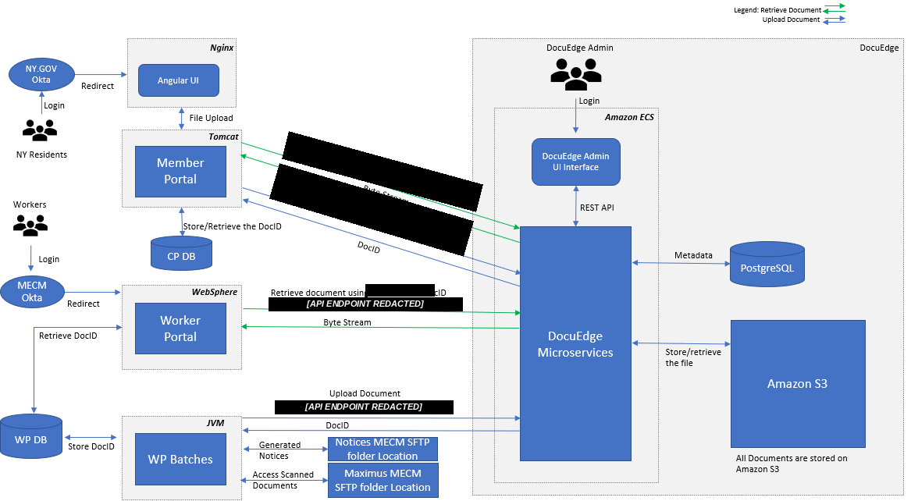
Figure 3-47: Document Management Solution Architecture
Worker Portal and Member Portal being the internal components of MECM hosted in the same VPC, will communicate directly through HTTPS endpoint. External systems can invoke DocuEdge APIs only through the MECM ESB which is IBM ACE.

Master Data Management
This section of the deliverable provides a high-level overview of MDM and provides details about MDM Architecture. MECM leverages IBM InfoSphere MDM for effective management of the client demographic data. During the application intake process, the match service is activated to ascertain whether an incoming member already exists in the system. If not found, MECM triggers the Add member service to add the individual to system.

Master Data Management Function
Integrating the MECM system with MDM provides significant advantages, confirming that critical data related to individuals is accurate, consistent, and properly governed across all systems. Below is a detailed breakdown of how MDM enhances the member ID clearance process:
- Improved Data Accuracy and Consistency
MDM provides a single, unified version of each individual’s demographic data, such as name, social security number (SSN), date of birth, and address. This central repository confirms the member ID clearance process in the MECM system always operates with the most up-to-date and accurate information. This results in fewer errors and mismatches during the clearance process, reducing delays in benefits distribution and increasing confidence in eligibility determinations.
- Reduction of Duplicate Records
One of the key features of MDM is duplicate detection and resolution. By identifying and merging duplicate records, MDM helps maintain a single, consistent record for each individual in the system. In the context of member ID clearance, this prevents the approval of duplicate benefits under different variations of a name or personal details. MDM uses advanced algorithms to detect and merge potential duplicates.
- Accelerated Eligibility Verification
MDM improves the efficiency of member ID clearance by confirming all necessary data is clean, centralized, and accessible. The MDM system provides an accurate and verified data source; caseworkers can quickly determine if an individual qualifies for benefits. The clearance process benefits from real-time access to validated data, reducing the time required for cross-referencing and manual verification. This leads to faster processing of benefits, reducing wait times for eligible recipients and improving the overall experience for individuals applying for assistance.

Master Data Management Architecture
MDM Architecture has the following components:
- WAS Admin Console:
The Admin Console is an administration platform for the MDM application, primarily used for deploying the MDM application, security management, cluster management, and authorization as needed.
- MDM Inspector:
The MDM Inspector is a data stewardship platform that integrates data resolution, relationship management, and data management. This portal helps data stewards manage and resolve quality issues such as duplicate and inaccurate information. It identifies data quality issues so that records involved can be reviewed, data relationships managed, and errors corrected.
- MDM Workbench:
The MDM Workbench is an Eclipse-based platform for MDM development, primarily used for designing MDM algorithms, defining members, entities, and sources, setting task threshold levels, and creating composite views (Golden Record).
- MDM (base) Services:
MDM Base Services are SOAP-based Application Programming Interfaces (APIs) that enable business applications to perform the following operations:
- Search and retrieve member
- Edit, add, and delete member
- Merge and unmerge member data
- MDM Custom Services:
MDM Custom Services are developed specifically to meet MECM system needs. These custom services will leverage the MDM base functionality. Here is the list of custom services in MECM:
- Search (searchForRecipientEntityList)
- Create & Update (createOrUpdateRecipient)
- Get (getRecipientList)
- Merge (mergeRecipient)
- UnMerge (unmergeRecipient)
- MDM Server:
The operational server includes data models, business rules, and functions that support entity management, security, auditing, and event detection capabilities. Functions that support entity management include data loads, cleansing, linkage, and deduplication.
- MDM Database:
IBM MDM Service requires a backend database to store the master data. In the MECM system, AWS RDS Oracle will be leveraged as the MDM backend database.
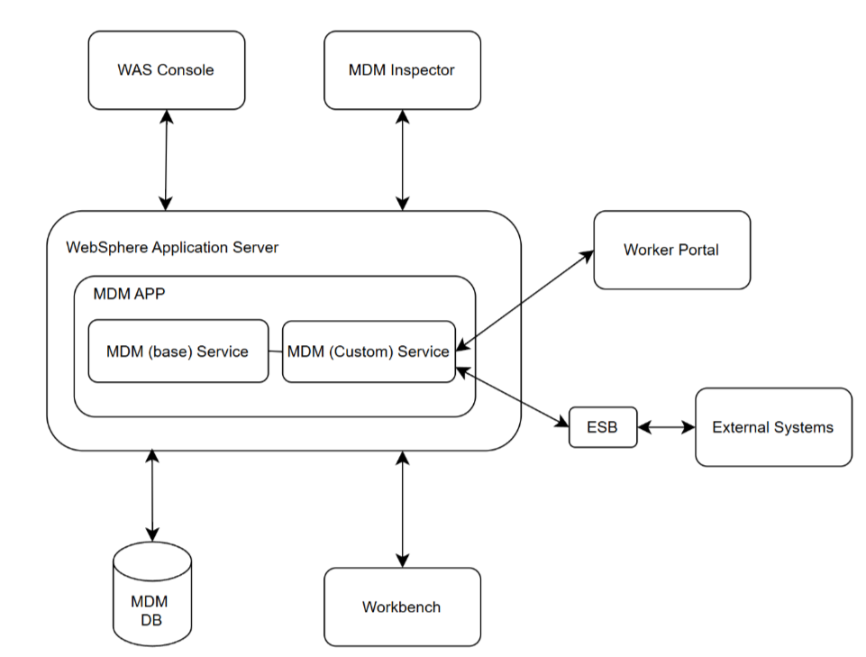
Figure 3-48: IBM MDM Architecture
External Systems that require MECM MDM services access will go through the Enterprise Service Bus as per the MECM standard for any real time interface.

High Availability
The IBM MDM InfoSphere component is made highly available through a cluster setup across two availability zones. MDM supports scalability both vertically and horizontally. Vertically, it scales through the addition of resources (CPUs/RAM) and/or through the creation of additional JVMs on the MDM servers. Horizontally, it scales through the addition of nodes to the MDM cluster, which is managed by WebSphere.

Enrollment Architecture

Overview
This section of the deliverable presents the finalized Enrollments Architecture, Detailing the comprehensive structure and design of the Enrollments module. It includes an overview of the functional flow, accompanied by the Enrollments Architecture Diagram.

Architecture Overview
The Enrollments Application architecture diagram below documents the confirmed components and integration services essential for the development and operations of the Enrollments module.
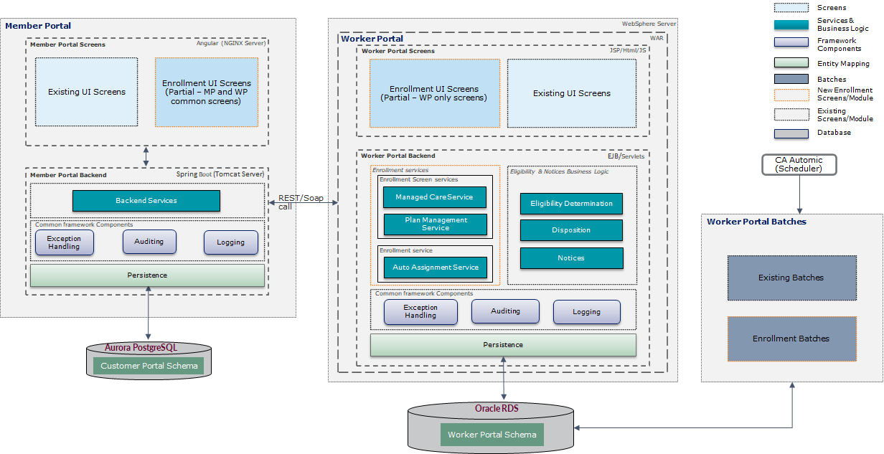
Figure 3-49: Enrollment Architecture Diagram
Key architectural considerations include:
- The database for the Enrollment module resides in the Worker Portal Schema
- Consequently, enrollment services and batches run from the Worker Portal Schema
- Screens, however, are split between the MP and WP. MP utilizes API services with WP to, for example, display available plans to users. When MP user’s complete actions, the data persisted by those actions persists only into the WP Schema
- Triggers for downstream actions like notices and 834 transactions are inserted in WP Schema.
- Enrollment screens are not duplicated across portals. In other words, each screen in the Enrollment Module is present only in MP or only in WP but not in both
Below are the functional flows for Enrollments module, categorized by worker and member access to the system. The MP Function Flow illustrates how members can access the Enrollments module through the MP to select the provided plans, view Enrollment history, and utilize other functionalities.
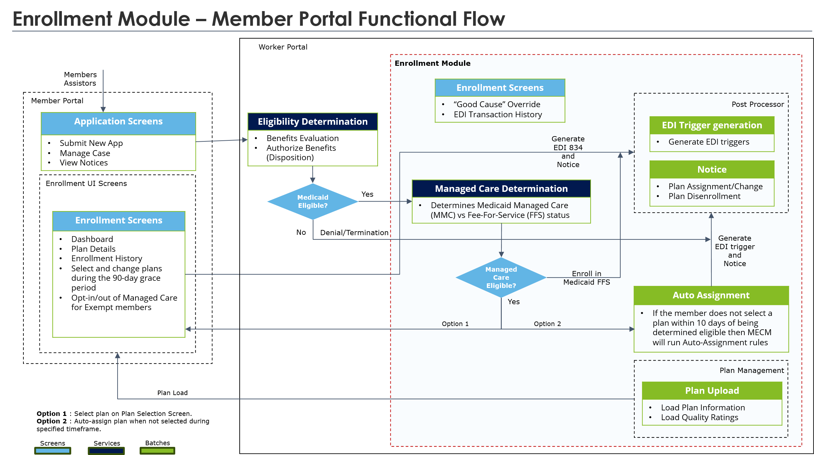
Figure 3-50: Enrollment Module Member Portal Functional Flow
When a member is eligible for Managed Care, then the member will go through the Plan Selection process as shown in the above Enrollment Module Member Portal Functional Flow.
Either the member will participate in this process and proactively select a plan from the Member Portal screens, or the member will be auto assigned to a plan based on certain rules. In both cases, the relevant EDI trigger will be generated and processed. Refer to the Topic 12 Enrollments FDD (link to document location: Del.20_FDD_W1_B5_Topic 12_Enrollments_FDD for more details.
The Worker Portal Function Flow illustrates how workers can access the Enrollments module through the Worker Portal. This includes accessing worker-specific screens developed in the Worker Portal’s framework, as well as common Enrollment screens developed in the Member Portal, which are accessible via the Worker Portal. This base implementation for workers allows them to perform any necessary actions.
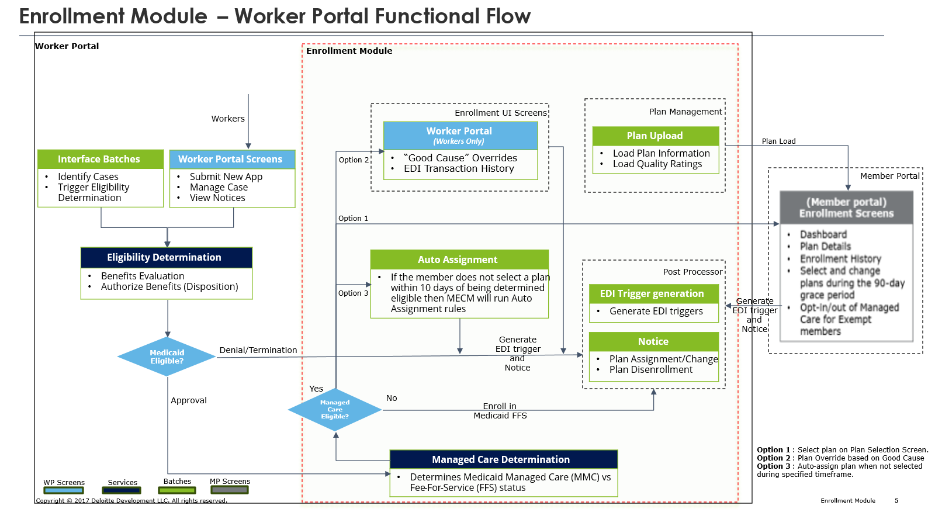
Figure 3-51: Enrollment Module Worker Portal Functional Flow
As shown in the above Figure 3-45: Enrollment Module Worker Portal Functional Flow, the Worker Portal provides an option for workers to perform “Good Cause Overrides” in the event, that a member seeks to make a change that is not usually permitted and has good cause to do so. The plans available in the MECM system at any given time are defined by a process known as the Plan Management Service.
Irrespective of how the member receives their (dis) Enrollment, the MECM system will generate triggers. These triggers are primarily used to send Enrollment notices to the member, to send 834 EDI transactions to eMedNY to effectuate the (dis) Enrollment, or to run auto-assignment if no choice is made. Refer to the Topic 12 Enrollments FDD (link to document location: Del.20_FDD_W1_B5_Topic 12_Enrollments_FDD) for more details.
Plan Management
The Plan Management details will be supplied by DOH to the MECM. DOH picks up the Plan details & quality details from NYSOH Plan Management (PM) Portal and supplies it to MECM in .csv format. MECM batch processing loads the details into WP Database. WP hosts all the enrollment services including Managed Care services which will also be invoked by MP. For more details refer to the Topic 12 Enrollments FDD (link to document location: Del.20_FDD_W1_B5_Topic 12_Enrollments_FDD).

Electronic Data Interchange Architecture
This section outlines the processing of EDI 834 triggers and the transmission of EDI 834 transactions to eMedNY. The EDI 834 transaction set is utilized for all benefit Enrollment and maintenance transactions. The MECM system will receive an implementation acknowledgement (999) response from eMedNY, confirming receipt and providing feedback on the file’s acceptance.

EDI 834 Outbound Architecture
An EDI 834 outbound file will be generated in the MECM system that will be sent to eMedNY when EDI batches are executed using the Batch framework. These batches will use the IBM Transformation Extender (ITX), component, transforming case and Enrollments data to the EDI 834 format.
JSON data containing Enrollment information is converted to Application XML, then to Canonical XML, then then finally transformed into an EDI 834 file sent to eMedNY. The following figure details the MECM system EDI outbound architecture.
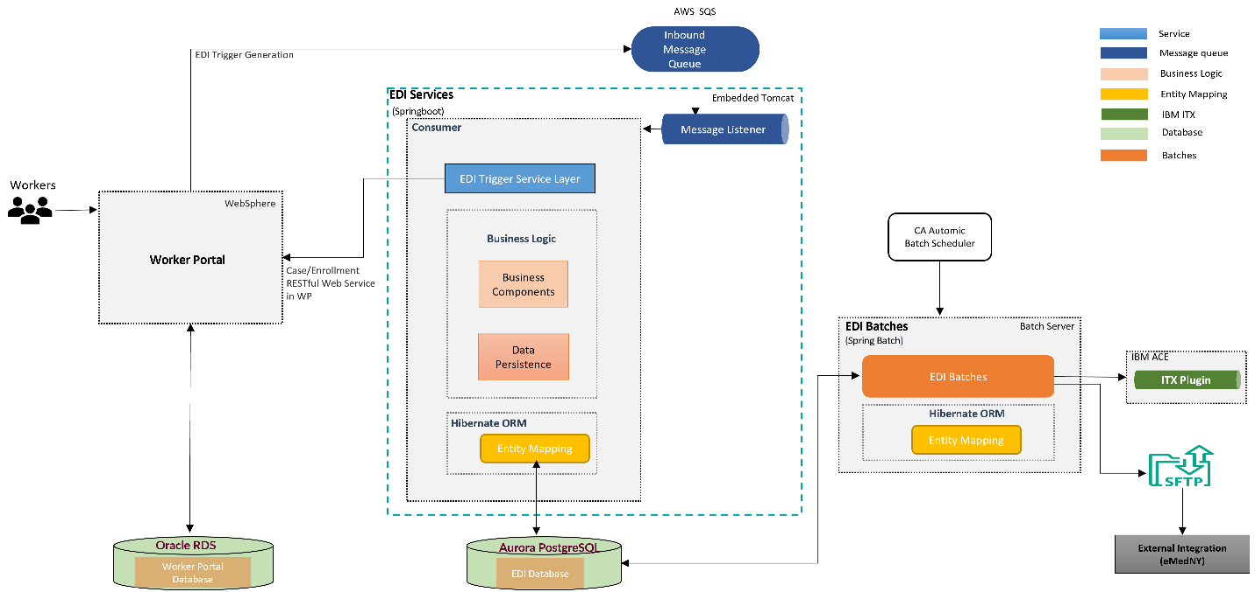
Figure 3-52: EDI Outbound Architecture

EDI Inbound Architecture
The MECM system will receive a response EDI 834 file from eMedNY. The MECM system will transform and process the EDI 834 file to store data into the respective Enrollment tables. The following figure details the MECM system EDI inbound architecture.
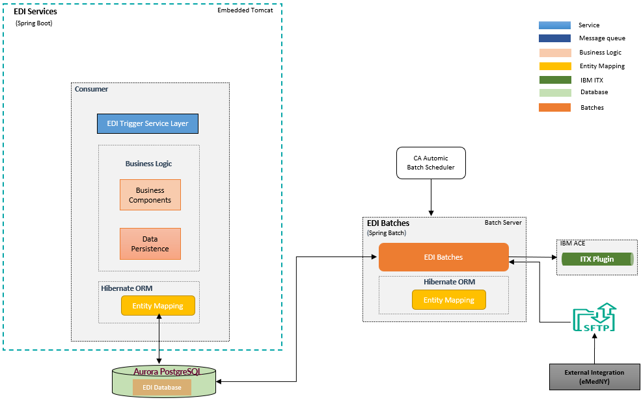
Figure 3-53: EDI Inbound Architecture

EDI Batches
The EDI process within MECM encompasses the following:
- The EDI 834 file serves as an outbound interface transmitted from MECM to eMedNY
- The 834 daily file includes records for individuals in New York State who have, for example, newly acquired Medicaid, experienced a change in their enrollment or identifying information, been terminated from Medicaid benefits, or are in the process of renewing or reinstating their benefits
- On receipt and processing of the EDI 834 file, eMedNY sends the TA1 and/or Implementation Acknowledgment (999) transaction back to MECM to confirm that the structure and syntax of the EDI 834 file comply with the Health Information Portability Accountability Act (HIPAA) 5010 X12 834 EDI standards
- eMedNY also provides the 834 Response file to confirm the successful processing of eligibility and enrollment records, as well as to report any issues related to specific business edits or guidelines that the EDI 834 file did not meet
- The failure records sent by eMedNY assist the MECM team in identifying and resolving issues that extend beyond the structural and syntax validations addressed by the TA1 and 999 acknowledgments
The following is the step-by-step process involved with processing EDIT triggers:
- MECM initiates a daily EDI 834 file generation process
- Once the EDI file is generated, the MECM system places it in a known and accessible file location to the SFTP process
- The SFTP process transmits the file to eMedNY
- The File reaches a defined location accessible to eMedNY
- eMedNY picks up and validate the file
- eMedNY generates TA1/999 file after validation
- TA1/999 file reaches a defined file location accessible to the MECM system
- MECM system batch processes pick up the file and process the file
- The EDI batch job updates the EDI triggers with the status received from eMedNY
For more details refer Section 5 834 EDI Transactions (IN09) of the Enrollments FDD from Bundle 5 Topic 12, and the 834 ICD.

IBM ITX Tool
IBM ITX, also known as IBM Sterling Transformation Extender, is a software tool specializing in data integration and transformation. It helps businesses handle data movement and manipulation across various systems and formats.
- It can transform any type of data, structured (e.g., databases) or unstructured (e.g., text files), without manual coding, simplifying complex data management tasks
- ITX is designed to handle large volumes of data efficiently, making it suitable for enterprise-level deployments
- The software offers a web-based interface for data mapping, allowing users to visually define how data should be transformed, eliminating the need for extensive programming knowledge
- ITX can works seamlessly with cloud platforms, enabling data transformation regardless of whether the data resides on-premises or in the cloud
The MECM system uses ITX to transform the Canonical XML (created by batch) into the EDI 834 format which is sent to eMedNY. ITX contains maps with input and output structures for EDI 834 file creation. The figure below details an example of EDI 834 file generation.
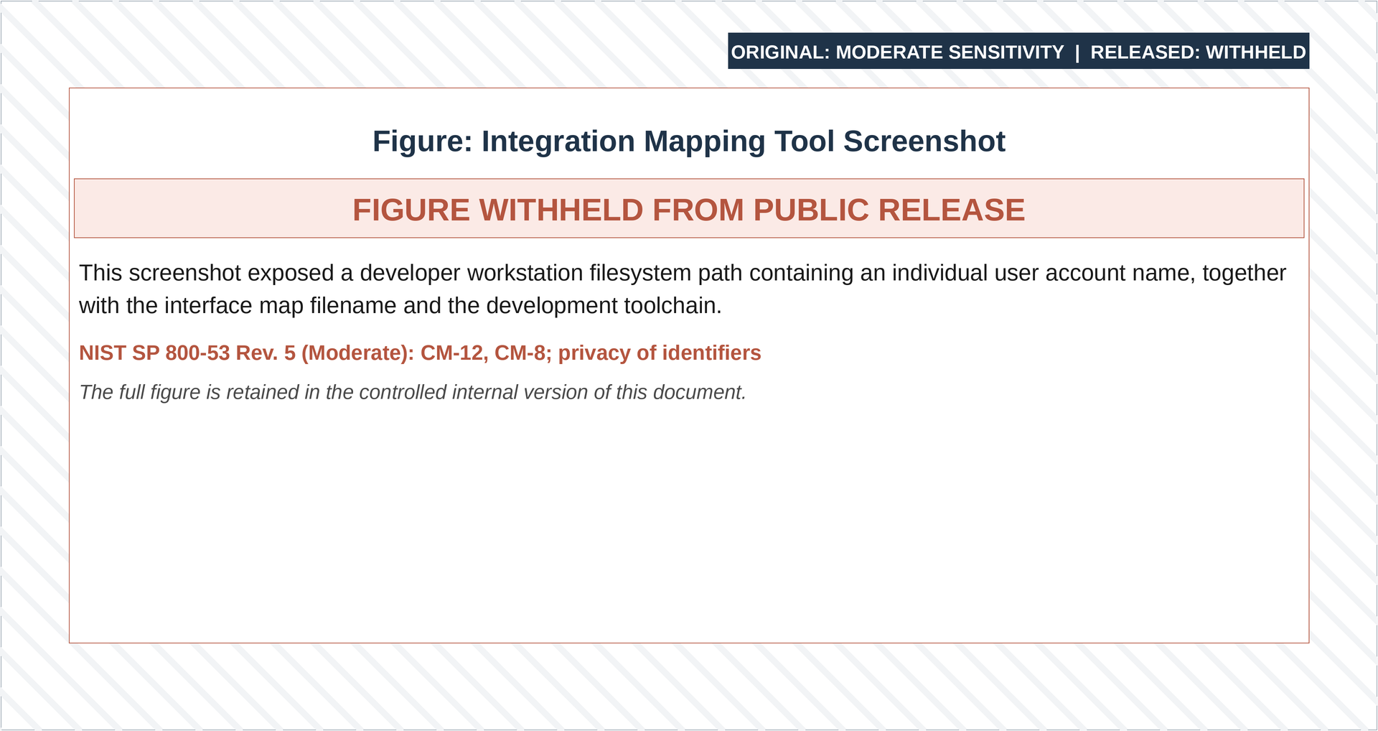
Figure 3-54: IBM ITX Tool Design Studio

Security Architecture

Overview
This section of the deliverable describes design goals and considerations, provides a high-level overview of the system security, and provides details about MECM SL&M, IAM and web services security, and documents security policies applicable to the MECM system architecture.

Security Logging and Monitoring
The MECM system SL&M is a 24/7/365 security monitoring service built on an integrated cloud SaaS platform using industry leading components. It provides real-time protection for hosts and users through a lightweight agent installed on DOH MECM endpoints, servers, and Domain Controllers, including virtual machines (VM) and virtual desktop infrastructure (VDI) environments. The system collects logs from network traffic, cloud, and SaaS applications, Refining sentence with “The system collects logs from network traffic, cloud and SaaS applications utilizing NextGen AI technology and Mark-up Language (ML) algorithms to analyze vast amounts of data to identify malicious patterns and anomalies that may indicate potential threats.”
Detection rules alert on suspicious or anomalous activity. For detections that can be auto remediated, the system addresses issues based on established security policies within the endpoint detection or the cloud. If auto-remediation is not possible, the detection triggers an alert, which is normalized, aggregated, and delivered to a ticket queue. The security operations center (SOC) reviews alert notifications, assign to L1 and triage alerts on a 24/7/365 schedule. The Deloitte SOC operates according to the mutually agreed SL&M service level agreements (SLA) outlined in the MECM system contract.

Security Logging and Monitoring Technical Design Components
For MECM, the scope of SL&M managed services includes the following modules:
SL&M Module | Capability Description
Enterprise Prevention, Detection and Response (EPDR) - CrowdStrike | Visibility, prevention, detection, containment, remediation, and response for laptops, desktops, servers, data centers and private clouds.
Cloud Security: Prevention, Detection and Response - CrowdStrike | Visibility and SL&M into multi-cloud workloads, containers, VMs; cloud security posture management (CSPM); cloud workload protection platform (CWP), & serverless.
Extended Detection and Response (XDR) - Chronicle & Splunk | Central extended detection & response (EDR Agent Data & Agentless log data) data fusion logging/analytics bringing together all data sources.
Identity Prevention, Detection and Response (IPDR) - CrowdStrike | Visibility, detection, and prevention into active directory and identity management systems to determine identify based attacks, lateral movement, and system services account compromise.
Cybersecurity Intelligence | Insider, outsider, and adversary tactics, techniques, and procedures (TTPs); malware.
Table 3-40: SL&M Modules
The SL&M modules are delivered using the SL&M platform, which integrates four main components—CrowdStrike, Chronicle, Splunk, and ServiceNow—to provide security monitoring and operations managed services. Below is an integrated SL&M high-level architecture diagram that illustrates the various solution components and log sources.
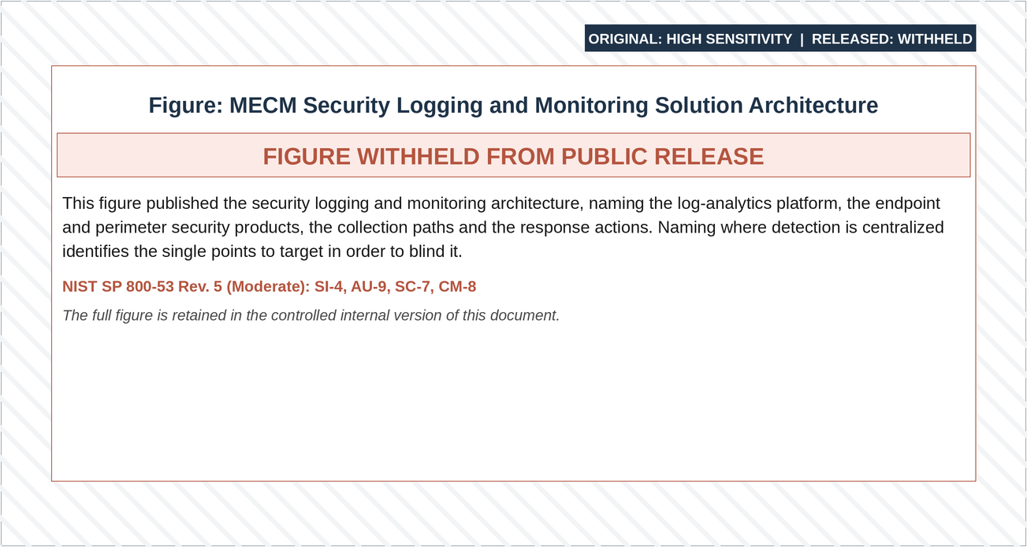
Figure 3-55: SL&M High Level Architecture
The SL&M platform is built on FedRAMP-authorized SaaS products.
Product | Deployment Model | Authorization Impact Level | FedRamp Package ID
CrowdStrike | Government Community Cloud | Moderate | FR1807853629
Splunk | Public Cloud | Moderate | F1607197917
ServiceNow | Government Community Cloud | High | F1305072116
Google Cloud Platform Chronicle | Public Cloud | High | FR1805751477
Okta | Public Cloud | Moderate | F1512167750
Table 3-41: SL&M Products
The CrowdStrike Falcon component provides endpoint, cloud, and identity prevention, detection, and response capabilities. CrowdStrike Falcon sensors collect all activity from each host where the sensors are installed. The CrowdStrike event data is continuously pushed into the CrowdStrike Falcon Cloud Platform while the hosts are online. If a host is not online, event data is cached locally on the host until it can connect to the CrowdStrike Falcon Cloud Platform.
Raw CrowdStrike telemetry is sent to the Chronicle component using a secure API connection for further data correlation with non-agent-based log sources. The CrowdStrike component sends alerts for malicious or suspicious activity through the Splunk component into the ServiceNow ticketing system.
The Chronicle component provides non-agent-based and correlated endpoint and log source detection capabilities. Log data is ingested into Chronicle from non-agent log sources in various ways. For SL&M-supported SaaS solutions and AWS log sources, an API pull can be used. For most other sources, such as system logs (syslog) or local log files, a Chronicle Forwarder needs to be installed.
The Chronicle Forwarder is a lightweight program using a docker image and can be installed on either Windows or Linux, although Linux is preferred. Use cases in Chronicle that match malicious or suspicious activity will generate alerts, which will be sent through the Splunk component into the ServiceNow ticketing system. Refer to MECM SL&M Runbook in Appendix B for a list of MECM Use Cases for the list of planned use cases. SL&M Use Cases will be reviewed and updated accordingly every six months by the SL&M team.
The Splunk component offers health monitoring visualization and allows tuning of ticket volume based on ticket priorities, ensuring that only actionable tickets are created in ServiceNow for the SOC to address. Splunk aggregates all incoming alerts based on basic criteria such as hostname or user. It then formats these alerts and opens security incident tickets within ServiceNow. If additional alerts for the same issue arrive while a security incident ticket is still open, Splunk suppresses the subsequent alerts. Integration links from CrowdStrike and Chronicle are placed in the Source URL field within the security incident ticket. This enables the SOC analyst to quickly access detailed information that triggered the alert.
The ServiceNow ticketing system offers a case management platform for the SOC to perform threat monitoring and remediation. It serves as the single pane of glass for SOC analysts as they triage and address tickets. When SOC analysts’ close tickets, the corresponding CrowdStrike detection record is also closed within the CrowdStrike platform. Additionally, ServiceNow functions as the Computer Management Database (CMDB) for the onboarded environment and provides the capability to generate reports and dashboards to manage the SL&M managed service. MECM Jira ticketing system will be integrated with SL&M ticketing solution before MECM Wave 1 Go-Live.
Encryption and key management for the SL&M platform are provided as follows:
- Data in transit is encrypted using TLS (1.2 or higher), while data at rest is protected with the industry-standard AES-256 encryption algorithm. Encryption methods comply with FIPS 140.2 standards for both data at rest and in transit, utilizing native services. Cloud-native tools and services such as Amazon S3, KMS, and third-party applications safeguard robust security for data at rest and in transit. Data is accessed through VPN using SSH over HTTPS web connections. Access to data is strictly controlled and limited to authorized personnel, enforced with RBAC permissions and MFA
- Amazon KMS stores and manages encryption keys. We encrypt the underlying storage that hosts operational data in AWS GovCloud with custom keys provisioned in AWS KMS. We store logs in AWS S3 buckets and encrypt the underlying objects. AWS backups occur via volume snapshots, which are also encrypted. AWS EBS Volume Encryption uses AWS KMS. We encrypt Operating System (OS) logs stored in AWS S3 using AWS KMS. The snapshots are encrypted with the same key as the volumes using AWS KMS
API security for the SL&M platform is provided as follows:
- AWS API Gateway handles API security
- API connections use secure, encrypted communications over HTTPS on port 443
- Chronicle log ingestion and third-party feed APIs use the OAuth 2.0 protocol for authentication and authorization. Data in transit is encrypted using TLS 1.2 or higher
- ServiceNow can authenticate with external systems using either OAuth or basic authentication (user ID/password). Data transmitted during API calls is encrypted using TLS 1.2 or higher

Security Logging and Monitoring Deployment
The SL&M team will set up the SL&M platform. During the setup, the SL&M Team will work closely with the Deloitte CMS team to onboard the MECM environment. The CMS team will deploy CrowdStrike sensors to the VDI and AWS Elastic Compute Cloud (EC2) GovCloud endpoints. They also configure the AWS environment, network, and authentication non-agent-based security log sources to send telemetry into the SL&M platform. Details on the effort required by the CMS team to perform the sensor and log-based deployment are provided below.

CrowdStrike Censors
The following table outlines CrowdStrike Sensor prerequisites that must be met, depending on the MECM host type (Windows, Linux, network communications):
Host Type | Prerequisite
Windows | The following services must be installed and running on all hosts:  - LMHosts (Note: LMHosts might be disabled if TCP/IP NetBIOS Helper is disabled.)  - Network Store Interface (NSI)  - Windows Base Filtering Engine (BFE)  - Windows Power Services (Power)
Windows Hosts with Proxies | Additional services for hosts using proxies:  - WinHTTP AutoProxy  - DHCP Client (only required if using Web Proxy Automatic Discovery (WPAD) through DHCP)
Linux | The following library files are required for all hosts:  - libssl  - libc, or  - libcrypto
Network Communications | - The Falcon sensor requires TLS 1.2 to communicate with the CrowdStrike cloud. Other protocols, including SSL or earlier versions of TLS, are not supported.  - Allow TLS traffic to and from via port 443:
Table 3-42: CrowdStrike Host Type Prerequisites
The SL&M team will review the prerequisites and discuss the requirements for deploying CrowdStrike sensors into the MECM environment. The CMS team will commence sensor deployment. Sensors will be deployed in detect-only mode. It is advised to keep the sensors in detect-only mode for two weeks after deployment. Initial deployments will be assigned to the “default” policy for 2-3 days to validate sensor compatibility before moving to Phase 1 detect-only.
Following two weeks in detect-only mode, Phase 2 “moderate” prevention will be configured and rolled out to all managed hosts. During Phase 2 prevention, the SL&M Team will collaborate with the CMS Team to determine custom tuning/preferences for additional prevention settings. Applications will be tuned for exclusions, Indicators of Attack/Compromise, and false positives.
Once onboarding tuning is completed, the SL&M team will begin steady-state tuning and operations. The Prevention Policy will be increased to “aggressive,” and dashboards for steady-state reporting will be configured.

Non-Agent Based Log Source Configuration
Security syslog data from non-agent-based cloud log sources are forwarded to the Chronicle component of the SL&M Platform. The CMS team will work with the SL&M team to configure and send in-scope log source data into the SL&M platform. As data begins to be ingested, each log source connection will be validated by the SL&M team, use cases will be applied, and applicable use case detection content will be reviewed and tuned.
For logs that need to be sent from an on-premises log source, the CMS team will install Chronicle forwarders according to Chronicle vendor guidelines. If a Chronicle Forwarder is required, the SL&M team will supply a forwarder configuration file. This file will include the data type, Transmission Control Protocol (TCP)/User Datagram Protocol (UDP) port number for each on-premises log source, and authentication and destination information for the Chronicle instance. The CMS team will configure the remote logging destination to the IP address of the forwarder and the individual port for each log source using the product’s user interface. The data should then start forwarding to Chronicle.
For logs that need to be forwarded from cloud log sources, the CMS team will create API credentials for each application within its UI. Each cloud application will require specific API permissions, which the SL&M Team will provide following the log source discussion with the CMS Team. After the SL&M Team establishes the API connection using the credentials provided by the CMS Team, the data will begin forwarding to Chronicle.
The following non-agent-based log sources are planned for ingestion into the MECM SL&M platform:
- AWS CloudTrail logs (for each AWS account)
- AWS CloudWatch logs (for each AWS account)
- AWS GuardDuty logs
- AWS WAF logs
- AWS Elastic Load Balancer logs
- AWS S3 Server Access logs
- AWS Config logs
- AWS RDS, PostgreSQL, Aurora
- AWS Windows and Linux OS logs
- Palo Alto NGFW logs
- Tenable logs
- Red Hat Directory Server LDAP logs
- MECM Okta logs
- Salesforce Event logs
- Google Chatbot & Dialog Flow
- Flow (GCP)

Health Monitoring
During the initial platform integration and configuration, the SL&M team will deploy system health monitoring content designed to identify and alert on logging and log collection anomalies, processing issues, system performance, licensing, and overall health. SL&M’s Health Monitoring package includes a broad range of use cases that check for indicators of conditions that could impact the ability of the monitored infrastructure to report events to the delivery platforms. These conditions include event flooding, rule deactivation, and collectors being down or caching.
The SL&M platform is monitored for integration and data streaming errors, data collection errors, data parsing errors, data latency errors, resource utilization errors, and licensing errors. SL&M client data integrations are monitored for agent errors, forwarder errors, log latency, dropped log types, dropped source types, and data collection errors. The SL&M team tunes health monitoring rule thresholds for client data integrations based on initial log source integration configurations and client inputs on expected activity.
The Threat Management team will monitor this content, along with any modifications or deactivations, 24/7/365 as part of Threat Monitoring operations. SL&M SOC analysts and the SL&M team investigate any health monitoring-related incidents and escalate them to the Deloitte CMS team as required for troubleshooting.
Health alert tickets are generated through ServiceNow and triaged by the SL&M SOC. Following triage, tickets are assigned to the SL&M platform team for action.

Updates to Security Logging and Monitoring SaaS Components
Updates, such as occasional patches or upgrades to the SL&M platform SaaS components (CrowdStrike, Chronicle, Splunk, ServiceNow), are applied on an as-needed basis as deemed appropriate by the platform application vendors. Patches include urgent vendor-provided exceptions to remedy security or other functional issues in the platform that could potentially result in an outage or impact security monitoring.
In addition to vendor managed updates, the SL&M team applies third-party vendor-provided patches to platform components on a quarterly basis and implements third-party vendor-provided system version upgrades to the platform once per year.

SL&M Service Level Agreements
This section of the deliverable provides details on monitoring system uptime and detection and response service level agreement timeframes.

Operations Monitoring System Uptime Service Level Agreement
The SL&M team makes every reasonable effort for the SL&M platform to comply with the availability SLA as per the MECM contract. Should an SL&M platform outage occur, the SL&M team will address the outage in accordance with the priority of the event as provided in the table below.
Platform Operations | Initial Response | Target Response
Operational Incident—Critical | 30 minutes | 1 hour
Operational Incident—High | 2 hours | 4 hours
Operational Incident—Medium | 4 hours | 8 hours
Table 3-43: Operations Monitoring Service Level Agreement - System Uptime
Priority is the urgency assigned to a specific outage and is used to prioritize engineering effort to restore systems or services.
Initial response is measured by the time an outage is identified (indicated on the outage ticket) to the time a service ticket is assigned to an engineer to troubleshoot and/or restore systems or services.
Notification is measured by the time an outage is initially identified (indicated on the outage ticket) to the time the Client/CMS Team is notified of the outage as documented in a service ticket.

Detection and Response Service Level Agreement
The SL&M team will make every reasonable effort to triage and respond to security incident tickets in the SL&M platform according to the following:
Priority | Time to Acknowledge | Time to Escalate | Time to Act | Service-level Compliance Target
S1 — Critical | 15 min | 30 min | 60 min | Response goal 95 percent compliance within target.
S2 — High | 1 hour | 2 hours | 3 hours | Response goal 95 percent compliance within target.
S3 — Medium | 4 hours | 6 hours | 8 hours | Response goal 95 percent compliance within target.
S4 — Low | 12 hours | 24 hours | 2 business days | Response is governed and scheduled based on capacity and utilization.
Table 3-44: Detection and Response SL&M Service Levels
Priority is the urgency assigned to a specific alert or event and is used to prioritize service workflows to address the most urgent activity at a given time. The priority levels are defined as follows.
Priority | Definition
Critical | Potentially confirmed compromise, unauthorized access, or failure of a critical security device or service. This event has an increased likelihood of stopping operations, causing significant business/financial loss, or negatively affecting client users.
High | An urgent threat, denial of service, or issue regarding security device or service and likelihood that the event could interrupt operations, cause some business/financial loss, or negatively affect client users.
Medium | An isolated event that could negatively affect the functions of the serviced device. There is no immediate negative effect on day-to-day business operations. The incident could cause isolated interruption to operations or could be a chained progression of malicious activities to perform more disruptive attacks.
Low | Benign event but should be addressed in future remediation planning. There is no immediate negative effect on day-to-day business operations.
Table 3-45: Detection and Response Priority Levels
The following SLA categories are tracked for alerts within the SL&M platform.
SLA Category | Definition
Acknowledge | Acknowledgement is measured as the time from when the ticket is generated in the SL&M Platform to when it is assigned to an analyst to begin investigation.
Escalation | Escalation time is captured from assignment to the analyst to when a ticket is escalated internally or back to the Client/CMS Team for actions or notifications
Act | Captured from when the ticket moves from the Containment phase to either internal escalation, to the Client/CMS Team, or the ticket is marked complete.
Table 3-46: Detection and Response Service Level Categories

SL&M Operations and Maintenance
This section of the deliverable provides details on the operations and maintenance of the SL&M platform post-deployment.

Operations Monitoring
As mentioned in the SL&M Overview section, SL&M by Deloitte is a 24/7/365 security monitoring service. Detections that cannot be addressed by built in auto-remediation are delivered to a ticket queue to be triaged by the SL&M SOC on a 24/7/365 schedule.
Upon receipt of a ticket the Level 1 (L1) SOC analyst performs ticket triage and responds in accordance with the MECM Detection and Response Matrix. This matrix will be mutually developed during the time of SL&M onboarding. An example of the Detection and Response Matrix is provided below for reference.
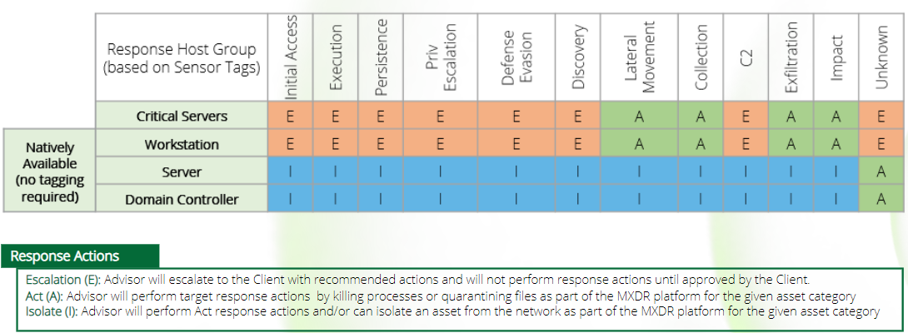
Figure 3-56: Response Matrix Example
Should an incident require additional investigation the L1 SOC analyst escalates the ticket to a Level 2 (L2) SOC analyst for further research and action. The L2 SOC analyst addresses the issue based on the Detection and Response Matrix. After further research by the L2 analyst, should the incident require remediation of the MECM cloud infrastructure the ticket is escalated to the Deloitte Tech CMS team to address the problem. Should the Detection and Response Matrix specify direct escalation to the Deloitte Tech CMS team for any issues, the tickets will be triaged and escalated to the MECM team.

Identity and Access Management Security Design
Okta is the IAM Service for the MECM system’s WP and MP/AP applications. Integrated with external identity repositories, MECM Okta provides authentication, authorization, and a modern single sign-on solution, discussing secure access for employees, workforce, and state users to the MECM WP application. The NY.GOV Okta platform (also known as NYSDS) serves as an identity provider limited to MECM Members/Consumers (Personal), Local District Social Services (LDSS - Government), and Assistors (Business). NYS DOH Agency users utilize the Information Technology Services AD Enterprise Single Sign On (ITS ESSO) as their identity provider, while Contact Center (CSS) users use the Maximus Entra ID as their identity provider.
Coarse-grained Role-Based Access Control (RBAC) is managed within respective Identity Providers (IDPs), which are then integrated into the MECM Okta platform. Fine-grained authorization for the MECM Work Portal is defined within the application; Where the coarse-grained RBAC roles received from the IDP are mapped to business functions, and the business functions are mapped to the actual screens within the WP. The approach for Role based Access for MECM WP is documented in Section 4.5 in the Topic 4 IAM FDD Additionally, the approach for mapping the Role-Based Access Control to business function, business function to screens, and field-level access controls is documented in MECM WP Role-Based Access Matrix sheet.
Okta has been procured under OHIP, and it is shared service across systems, MECM and AMS. Okta facilitates the following end-user identity lifecycle management processes:
- Onboarding a new user to the MECM system
- Implementing coarse-grained role-based access controls
- Managing user identity lifecycle management within the MECM system
- Offboarding a user and deactivation in the MECM system
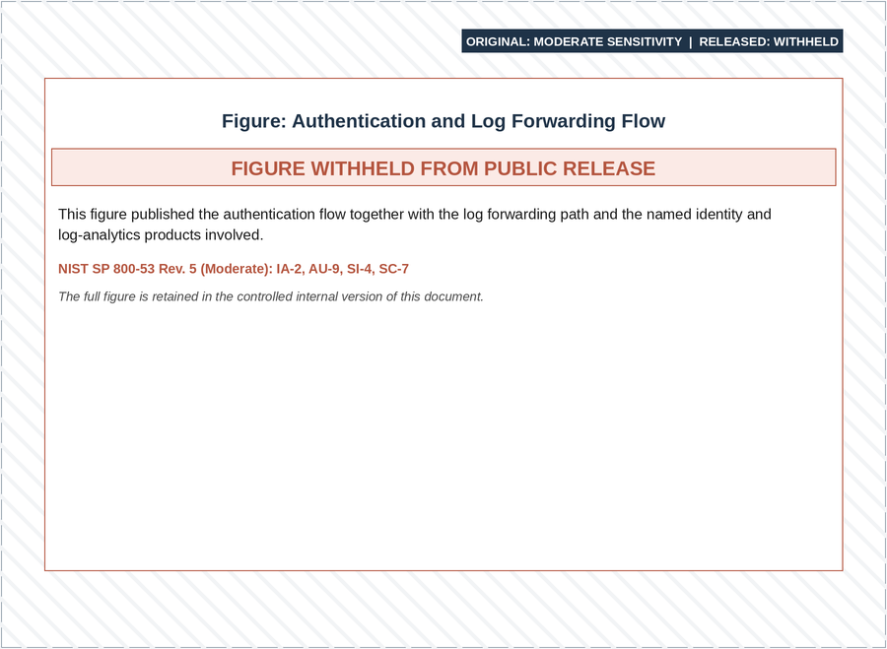
Figure 3-57: MECM IAM Solutions Architecture Design
The architecture diagram features the following concepts:
- Maximus Entra ID - MECM Okta Integration
  - Maximus Entra ID integrates with MECM Okta using Security Assertion Markup Language (SAML) authentication to provide seamless single sign-on for Contact Center users
- Maximus Admins are responsible for onboarding and offboarding users and managing MECM roles within Entra ID
  - Contact Center users are Just-In-Time (JIT) provisioned from Maximus Entra ID to MECM Okta
  - Contact Center users can access MECM WP and MECM MP through MECM WP
- ITS ESSO - MECM Okta Integration
  - ITS ESSO integrates with MECM Okta via OpenID Connect (OIDC) authentication to provide seamless single sign-on for DOH users
- DOH Admins are responsible for onboarding/offboarding ITS ESSO user and managing users within ITS ESSO
- DOH admins can perform administrative tasks in MECM Okta
  - DOH users are JIT provisioned from ITS ESSO to MECM Okta
  - DOH users may access MECM WP, and MECM MP through MECM WP
- NY.GOV – MECM Okta Integration for LDSS Workers
- LDSS Participating Organization Delegated Security Administrator (PODSA)/Participating Organization Delegated Administrator (PODA’s) within the districts are responsible for onboarding/offboarding the MECM NY.GOV Government branch LDSS users by using the ITS NY.GOV Delegated Admin tool
  - NY.GOV Okta integrates with MECM Okta via OIDC authentication to provide seamless SSO for LDSS workers accessing MECM WP with their government NY.GOV ID
  - LDSS users are JIT provisioned from NY.GOV Okta to MECM Okta
  - LDSS users’ access MECM WP, but they will not access MECM MP through MECM WP
  - MECM Okta is integrated with MECM WP via OIDC protocol for single sign-on to MECM WP
  - A custom JWT facilitates MECM WP to MECM MP access for authentication
  - NY.GOV integrates with MECM MP via OIDC protocol with Proof Key for Code Exchange (PKCE) flow for LDSS workers to use single sign on to the MECM MP using their NY.GOV ID
- The LDSS DA will use the [APPLICATION IDENTIFIER REDACTED] entitlement attribute to the MECM user which will result in the display of MECM tile as a distinct application for the user in NY.GOV
- NY.GOV – MECM MP/AP Integration
  - NY.GOV Okta integrates with MECM MP/AP applications via OIDC authentication with PKCE flow to provide seamless single sign-on for users accessing MP/AP applications with NY.GOV ID
  - Users are JIT provisioned from NY.GOV Okta to MECM MP/AP applications upon first login
  - NY.GOV Business branch Assistor users are onboarded/offboarded to NYSOH which passes the NY.GOV user updates to MECM by using the IN48 NYSOH to MECM Assistor Sync interface
  - MP consumer Individuals are onboarded to MECM after self-registering to create their unique NY.GOV Personal branch user ID
- The ITS NY.GOV Delegated Administration Web Service (DAWS) is used to entitle both Assistors and Individuals to MECM within NY.GOV using nyapphbeaccess as the MECM entitlement attribute which is the same entitlement as NYSOH and is required by NY.GOV for NYSOH and MECM to use the same NY.GOV tile
The process narratives and compliance requirements for the MECM WP and MECM MP/AP are documented in Tables 4-1 and 5-2 of the Topic 04 Identity and Access Management FDD (link to document location: Del.20_FDD_W1_B1_Topic 04_MP + WP Identity and Access Management_FDD).

Authentication Mechanism
This section details the various types of authentications and how the MECM WP and MECM MP/AP handle user authentication for each user type.
- MECM WP uses MECM Okta for authentication
- MECM MP/AP uses NY.GOV for authentication
User authentication is a key security component for the MECM Okta solution, which relies on three identity providers for user provisioning and authentication into the MECM WP:
- ITS ESSO
- Maximus Microsoft Entra ID
- NY.GOV Okta
In contrast, the MECM MP/AP relies entirely on NY.GOV for user authentication. MECM applications primarily use two federation protocols: SAML and OIDC. The following table identifies the federation protocol used for different integration in the MECM system.
Integration Point | Federation Protocol
MECM WP – MECM Okta | OIDC
MECM Okta – Maximus Entra ID | SAML
MECM Okta – NY.GOV (LDSS Workers) | OIDC
MECM Okta – ITS ESSO | OIDC
MECM MP/AP – NY.GOV | OIDC
Table 3-47: MECM System Integration Federation Protocol

Protocol Details
SAML Authentication
To provide secure IAM, MECM Okta employs various user authentication mechanisms, including SAML. SAML is a standard for exchanging authentication and authorization data between an IDP and a service provider (SP). MECM Okta supports SAML, enabling seamless integration with SAML-enabled applications and services. The following steps and diagram depict the SAML authentication flow:
- User Accesses the Service Provider: The user attempts to access a SAML-enabled application or service that is configured to use Okta for authentication
- Redirect to User’s Browser: The Service Provider recognizes that the user needs to be authenticated and redirects the user to Okta's SAML authentication endpoint
- User Authentication at the Identity Provider: Okta, acting as the SP, sends a SAML authentication request to the designated Identity Provider specified in the SP's configuration. The IDP could be a separate system or another service that handles user authentication
- User Login at the IDP: The user is redirected to the IDP's login page and enters their credentials (username and password) to authenticate
- SAML Assertion Generation: Upon successful authentication, the IDP generates a SAML assertion, which contains information about the user and their authentication status. The assertion is digitally signed by the IDP to confirm its integrity and authenticity
- SAML Assertion Delivery to Okta: The IDP sends the SAML assertion back to Okta by redirecting the user's browser to Okta's Assertion Consumer Service (ACS) URL. The SAML assertion is included in the redirect request as a parameter
- Assertion Validation: Okta, acting as the SP, receives the SAML assertion from the IDP. Okta validates the assertion by verifying the digital signature to confirm its authenticity
- User Authorization: After validating the SAML assertion, Okta extracts the user's identity and any relevant attributes from the assertion. Okta then uses this information to determine the user's authorization level and grants access to the requested application or service
- User Session Establishment: Okta establishes a session for the user, allowing them to access the SP's resources without the need for further authentication during that session
- Access Granted: With a valid session established, the user is redirected back to the originally requested application or service, where they can now access the protected resources
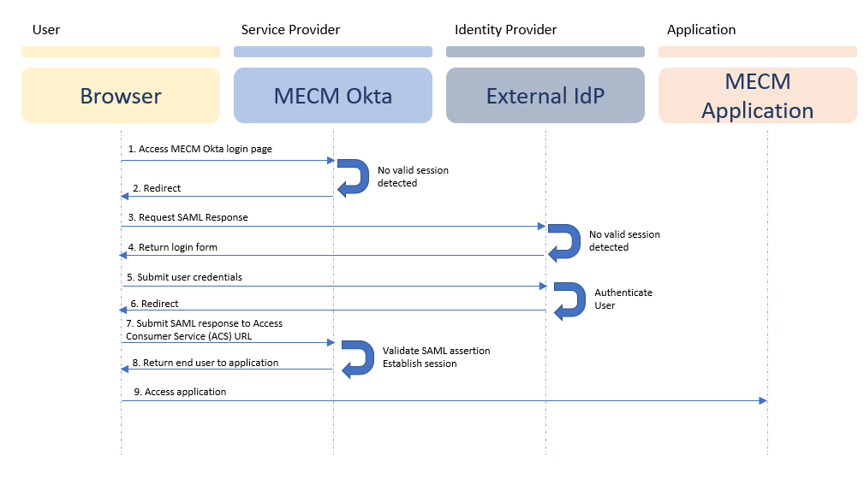
Figure 3-58: SAML Authentication Flow Diagram
OIDC Authentication:
MECM Okta uses OIDC authentication to enable secure user authentication within the MECM system. OIDC, built on top of the OAuth 2.0 protocol, allows web applications (i.e., relying parties (RPs)) to authenticate users with an external server (i.e., OpenID Connect Provider, or OP). This server receives user information from an IDP.
The OAuth 2.0 authorization code flow is widely used, with JWT being a common standard that utilizes this grant type. Instead of requesting tokens directly from the API, the authorization code flow protects a client secret by redirecting a request for a token through an authorization server. The authorization server authenticates the user and provides a temporary authorization code, which is then used with user credentials to request a token:
- The end user navigates to a website or web application via a browser
- The application directs the end user to the authorization server with a request that includes the client ID, response type, redirect URI, scope, and state
- The end user logs in to the authorization server via a login form on the authorization server’s page
- The authorization server authenticates the user and obtains the authorization
- After a successful login, the authorization server redirects the user-agent back to the client using the redirect URI provided earlier. The redirect includes an authorization code in the URL
- The web application (Client) sends a request to the authorization server with the authorization code, client ID and client secret
- The authorization server validates the authorization code, client ID, and client secret
- If the authorization code and client credentials are valid, the authorization server returns an ID Token and an Access Token to the web application (Client)
- The web application can send a request with the Access Token to the API endpoint
- The API Endpoint sends a response by returning claims about the end user to the web application (Client)
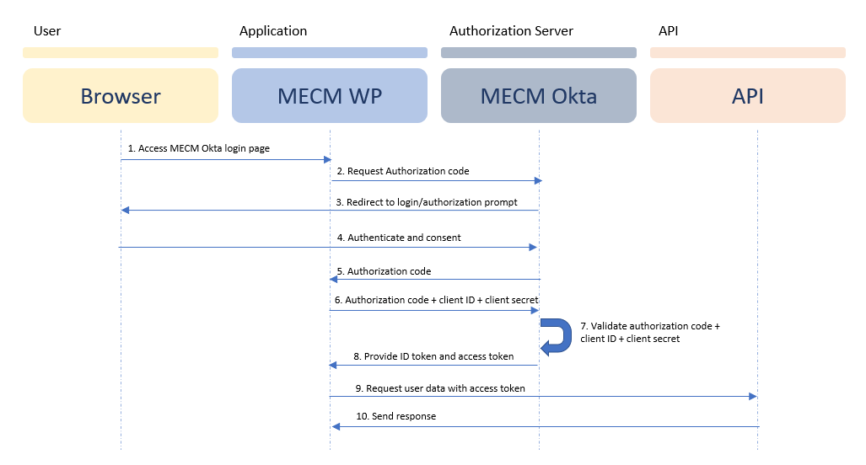
Figure 3-59: Authorization Code Flow for OIDC Protocol Diagram
With PKCE flow enabled, the authentication flow is as follows:
- The application randomly generates a one-time unique code (Code Verifier)
- The application transforms and hashes the Code Verifier as the Code Challenge
- The application sends the Code Challenge to the authorization server
- The authorization server stores the Code Challenge for later verification, and since the user is already authenticated, the authorization server redirects back to the application with an authorization code
- The application initiates a request to exchange the authorization code for an access token and sends the Code Verifier to the authorization server
- Now, the authorization server hashes the Code Verifier and compares it to the Code Challenge that it stored earlier
- Assuming the hashed values match, the application server will return an access token, granted to the user
Upon successful verification of the hashed codes, the user is granted an access token which serves as a secure key for the user to access and get redirected to the application. Here is a diagram that shows the complete PKCE flow:
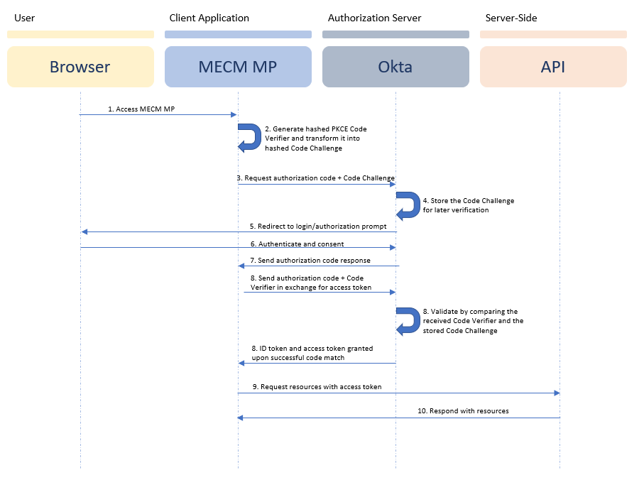
Figure 3-60: Authorization Code Flow with PKCE Flow Diagram
The PKCE flow enhances security by mitigating authorization code interception attacks. It certifies that the application that initiated the request is the one that exchanges the authorization code for tokens, using the code verifier and code challenge mechanism.
This flow is particularly useful for public clients, such as mobile or single-page applications, where the client secret cannot be stored securely. Steps 1-6 of the flow are managed by the Okta Library.
AP and WP integrations between MECM Okta and ITS ESSO, as well as NY.GOV (LDSS), also use this flow. For WP, the exchange occurs directly between the SaaS products, specifically between MECM Okta and ITS ESSO, and MECM Okta and NY.GOV (LDSS).
The PKCE flow is as follows:
- Code Verifier and Code Challenge Generation:
  - Okta library generates a code verifier, which is a high-entropy cryptographic random string
  - Here, the code verifier is a random URL-safe string with a minimum length of forty-three (43) characters
  - The application then creates a code challenge which is a Base64-encoded SHA-256 hash of the code verifier
- Authorization Code Request:
- The MECM MP app initiates an authorization request to Okta, including the following parameters:
- client_id: The client identifier issued to the app
- response_type: Set to code to indicate a request to get an authorization code
  - Redirect Uri: The URI to which Okta will redirect the user after authentication
  - Scope: The scope of the access request (e.g., OpenID profile email)
- State: An opaque value used to maintain state between the request and callback
  - Nonce: Randomly generated sequence of characters
- code_challenge: The generated code challenge
- code_challenge_method: The method used to generate the code challenge (e.g., S256)
- User Authentication:
  - Okta presents the authentication prompt (Okta sign-in page) to the user's browser
  - The user authenticates with Okta by providing their credentials and any required consent
- Authorization Code Redirection:
  - Upon successful authentication, Okta redirects the user's browser back to the MECM MP app's specified redirect Uniform Resource Indicator (URI)
  - The redirection includes an authorization code and the original state parameter
- Token Exchange:
  - The MECM MP application sends a token request to Okta, including the following parameters:
- client_id: The client identifier issued to the app
- Grant type: Set to authorization code to indicate that an authorization code is exchanged
  - Code: The authorization code received from Okta
- redirect_uri: The same redirect URI used in the authorization request
  - code verifier: The original code verifier generated in Step 1
- Token Issuance:
  - Okta verifies the code verifier against the code challenge
  - Upon successful verification, Okta issues access and ID tokens to the MECM MP application
- Resource Server Access:
  - The MECM MP application uses the access token to make authenticated requests to the resource server (e.g., an API) on behalf of the user
- The resource server validates the access token upon first logon request, on subsequent calls to the resource server, a custom JWT used for validation
The role of state and nonce in ensuring the OIDC Security State are listed below:
- State:
- The client generates a unique state value and includes it in the authentication request. The authorization server returns this value, and the client verifies it to validate the response is legitimate. This protects against Cross-Site Request Forgery (CSRF) attacks
  - Validates the response is related to the original request, preventing unauthorized actions
- Nonce:
  - The client generates a nonce and includes it in the request. The authorization server adds it in the ID token, and the client verifies it
  - Prevents replay attacks
  - Validates the ID token is fresh and valid for the specific session
Upon successful verification of the hashed codes, the user receives an access token, which serves as a secure key to access and be redirected to the application.
An illustration of the complete PKCE flow is shown below.
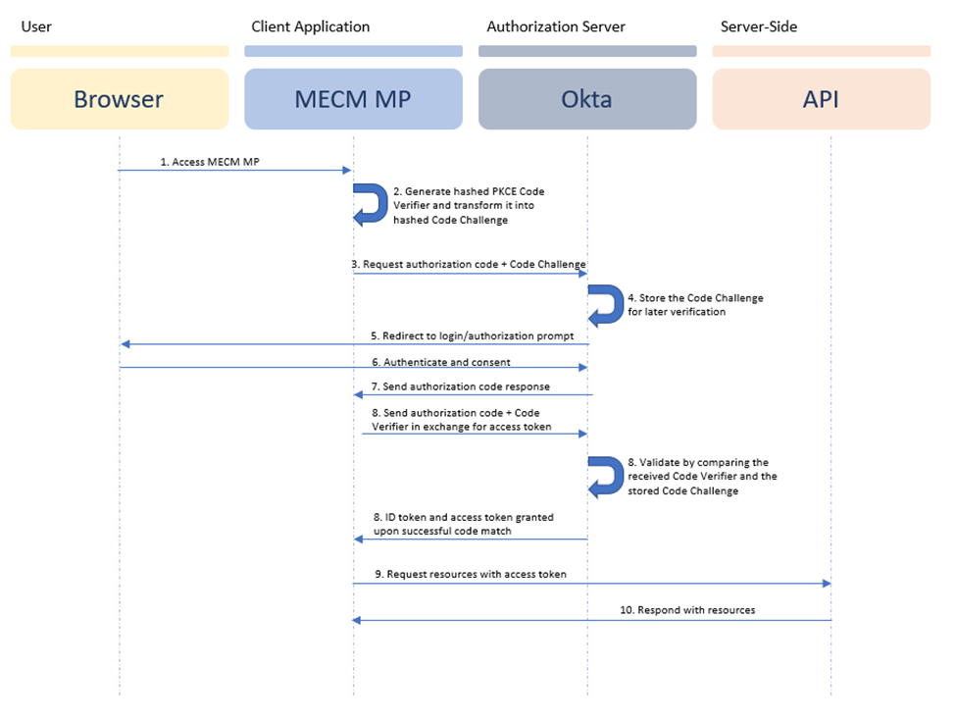
Figure 3-61: Authorization Code Flow with PKCE Flow Diagram

Maximus Entra ID and MECM Okta Integration
The integration between Maximus Entra ID and MECM Okta provides a seamless SSO experience for contact center users within the MECM system. Maximus Entra ID is configured as an external identity provider, while Okta acts as the service provider using the SAML protocol. This setup provides a secure and user-friendly IAM solution, allowing users to authenticate once with Maximus Entra ID and access the MECM WP application without re-authenticating.
SSO Integration:
To configure the SAML integration, the Maximus team first creates an application in the Azure Portal. For metadata exchange and the SSO handshake, Maximus provides the login URL, Entra ID identifier, and SAML signing certificate to the MECM IAM team. In MECM Okta, the team sets up the identity provider configuration and routing rule so that all users with the email domain “maximus.com” can authenticate using Entra ID. The team generates the SAML metadata in the IDP configuration, including the entity ID, single sign-on URL, and public X.509 certificate, and then provides the metadata to the Maximus team to complete their application configuration.
Within the SAML application configuration in Entra ID, the team enables assertion encryption, allowing Entra ID to encrypt the SAML claims using the public X.509 certificate provided by MECM Okta. Entra ID then sends the encrypted SAML assertion back to MECM Okta's ACS URL. MECM Okta validates the assertion by verifying the digital signature and decrypting it using the public X.509 certificate, ensuring the assertion’s integrity and accuracy. Once validated, MECM Okta extracts the user's identity and relevant attributes, determines the user's authorization level, and grants access to the requested application or service. This robust encryption mechanism secures the authentication process for Maximus users, protecting sensitive information from potential threats.
The same public X.509 certificate used for encryption is also used to sign the SAML assertions with the RSA-SHA256 algorithm by adding the assertion signature setting in the SAML application configuration.
Group and Attribute Claims:
Once Entra ID and MECM Okta complete the initial integration configuration, Entra ID sends attribute claims containing user information via the SAML token to MECM Okta. MECM Okta then validates the token to sign the user into the WP without prompting for re-authentication. During a user’s first login to MECM Okta, Entra ID passes the groups and the attribute claims: first name, last name, and email address to MECM Okta and the WP application, creating the user through JIT provisioning.
Initially, Maximus Entra ID passes groups to MECM Okta as group IDs. In the MECM WP application configuration within MECM Okta, a group claims expression is set up using Okta’s expression language to transform the group IDs into group names. This confirms that recognizable group names are passed to the MECM WP application through the OpenID Connect ID token. The Maximus group names are documented in Section 4.5 of the Topic 4 IAM FDD.
Below table shows the mapping between Maximus Entra ID group names and the MECM WP roles.
EntraID Group | Code | Role | Description
[GROUP NAME REDACTED] | CSR-L1 | Call Center Customer Support Specialists – CSSes – Level 1 | This role is the standard setup for a “Tier 1” Call Center Agent. They are expected to support members by completing actions in the MP. Though CSS’s will have access to both portals, they are expected to carry out most of their day-to-day tasks in the MP (accessed via WP login).  CSR-L1 will access MECM through Siebel iFrames.
[GROUP NAME REDACTED] | CSR-L2 | Call Center Customer Support Specialists – CSSes – Level 2 | This role has the same access as a Level 1 CSR, plus a few additive WP capabilities like generating Common Benefits Identification Cards (CBICs).  CSR-L2 will access MECM through the Siebel iFrames.
[GROUP NAME REDACTED] | ES-L1 | Call Center Eligibility Specialists – Eses – Level 1 | This role has WP access to complete eligibility actions like reviewing most verification documents.  ES-L1 will access MECM directly and not through the Siebel iFrames.
[GROUP NAME REDACTED] | ES-L2 | Call Center Eligibility Specialists – Eses – Level 2 | This role has the same access as a Level 1 ES, plus a few additive capabilities like reviewing immigration verification documents.  ES-L2 will access MECM directly and not through the Siebel iFrames.
Table 3-48: Maximus Entra ID Group Names and the MECM WP Roles
User Account Updates:
Okta’s JIT provisioning feature handles the syncing of user status, roles, and profile changes between Entra ID and MECM Okta. When a contact center user’s role, profile attribute, or status changes, the MECM WP application reflects these changes only when the user next logs in to MECM Okta and MECM WP. Therefore, roles updated in Entra ID may remain outdated in MECM Okta and MECM WP until the user logs in again. Each successful login to MECM WP updates the user in MECM Okta. Deactivated users in Maximus Entra ID will not be permitted to login; therefore, a separate deactivation process is established in sections Account Deactivation for Worker Portal and Account Reactivation for Worker Portal.

NY.GOV Okta and MECM Okta Integration for LDSS Workers
MECM Okta integrates with NY.GOV to enhance the LDSS Worker’s user experience by allowing access to MECM WP using their NY.GOV ID. This integration enables LDSS Workers to log in to NY.GOV Okta and access the MECM WP through the NY.GOV Government Dashboard.
SSO Integration:
In the NY.GOV ID and MECM Okta integration, NY.GOV Okta is configured as the OIDC provider, and MECM Okta acts as the relying party via the OIDC protocol. To configure the OIDC integration, create an OIDC application in NY.GOV Okta with the authorization code flow grant type and PKCE flow enabled. The NY.GOV ID team provides the client ID, client secret, and the following OIDC endpoints: Authorization, Token, JSON Web Key Sets (JWKS), and User Info, which are added to the configuration in MECM Okta. The identity provider configuration and routing rules are established so that users are directed to the appropriate identity provider; the routing predicates are withheld ([REDACTED]). All IDP users will be added to the Back Office – LDSS (BO-LDSS) Worker Role group in MECM Okta because JIT provisioning is enabled and configured.
Group and Attribute Claims:
After the base configuration is complete in NY.GOV and MECM Okta, NY.GOV passes user attributes: first name, last name, email address, county information, and GOV ID to MECM Okta. When an LDSS Worker logs in to MECM Okta for the first time and on subsequent logins, NY.GOV passes the user attribute statements to MECM Okta, which then forwards them to the WP application for creation or updating through JIT provisioning. NY.GOV does not pass any group claims to MECM Okta, as MECM Okta assigns all LDSS users to the Back Office – LDSS Worker Role group.
User Account Updates:
The syncing process for user profile changes between NY.GOV and MECM Okta uses the JIT Provisioning feature of MECM Okta. When a user’s profile attribute(s) change, the MECM WP application reflects these changes only upon the subsequent user login to MECM Okta and the WP. Every successful login to MECM Okta updates the user in both MECM Okta and WP. Section 4.5 of Topic 4 IAM FDD details these requirements for updating user accounts. Below are additional key points that are finalized based on discussions with DOH.
- NY.GOV will send the NY county (“nycounty” attribute) information as part of the ID Token
- LDSS workers are already ID proofed prior to being assigned a Government NY.GOV ID
- Access and identity token lifetimes are set per policy; the interval is withheld ([REDACTED])
- NY.GOV enforces a 50 characters limit for first and last names, and a 100 characters limit for email addresses
- [REDACTED]
- The username ID redirects the user to authenticate to NY.GOV; the format for the ID is an alphanumeric username

NY.GOV Okta and MECM MP Application Integration
The integration between NY.GOV Okta and MECM MP provides a seamless SSO experience for users between NYSOH applications and MECM MP. Users only need to authenticate with NY.GOV to access the MECM MP.
SSO Integration:
NY.GOV Okta integrates with the MECM MP application using the OIDC protocol. The OIDC application is configured with the authorization code flow grant type and PKCE flow in NY.GOV Okta. The redirect URIs and endpoints for the MP and AP are added to the application configuration. The client ID and NY.GOV OIDC redirection are then configured in the MECM MP application.
The approach for screened applications, redirected application and returning users that are redirected to MECM from NYOH are documented in Topic 3 Screening + Branding FDD in Section 5.3.2 Routing Approach, in the ICD document, and in Topic 7 Case Transfer in Section 8 Application Redirection from NYSOH to MECM.
Attribute Claims:
NY.GOV passes multiple attributes to MP through the ID Token. Only the below attributes are stored in MP: first name, last name, email, USERID, phone number, city, zip code, state and nyssoguid.
User Account Updates:
When the user logs in for the first time, MP displays the verify page to the user and prompts them to verify or update the information that was received from NY.GOV. ID Token, it then will update the attributes stored based on the user input.
On subsequent login to MP, only the email address will be updated (if it has been changed).

ITS ESSO and MECM Okta Integration
The integration between ITS ESSO and MECM Okta provides a seamless SSO experience for DOH users in the MECM system. In this integration, ITS ESSO, which is an ADFS, is configured as an external identity provider, and MECM Okta acts as the relying party using the OIDC protocol, providing a secure and user-friendly IAM solution. Users only need to authenticate once with ITS ESSO to be able to access MECM WP.
SSO Integration:
In the ITS ESSO and MECM Okta integration, ITS ESSO is configured as the OIDC provider, and MECM Okta acts as the relying party through the OIDC protocol. To configure the OIDC integration, an OIDC application is created in ITS ESSO with the authorization code flow grant type and PKCE flow enabled. The ITS ESSO team will provide the client ID, client secret, and the following OIDC endpoints: Authorization, Token, and JWKS, to be added to the configuration in MECM Okta. The identity provider configuration and routing rules are established so that users are directed to the appropriate identity provider; the routing predicates are withheld ([REDACTED]). Upon a user’s first-time login, the groups and attribute claims are passed to MECM Okta and the WP application and created within MECM Okta and WP through JIT provisioning.
Group and Attribute Claims:
Once the initial integration configurations are complete in ITS ESSO and MECM Okta, groups, and attribute claims: first name, last name, and email address are configured to be sent from ITS ESSO to Okta through the user profile in the ID Token. Upon an ITS ESSO user’s first and subsequent logins to MECM Okta, user attribute statements are passed from ITS ESSO to MECM Okta and the MECM WP application and created for the user through JIT provisioning.
Initially, ITS ESSO groups are passed to MECM Okta through the user’s profile. In MECM Okta, a group rule is set up using the Okta expression language to assign the group name received from ITS ESSO into an MECM Okta group, which is then passed to the MECM WP application through the OpenID Connect ID token.
Below table shows the mapping of the ITS ESSO AD group names to the MECM WP roles.
AD Group | Code | Role | Description
[GROUP NAME REDACTED]1 | BO-L1 | Back Office – Read-Only Role | This role can access the WP and MP (via WP) in a read-only mode to view but no change case data.
[GROUP NAME REDACTED]2 | BO-L2 | Back Office – Update Role | This role can access the WP and MP (via WP) in an update mode and complete most functions, except those reserved for super-users.
[GROUP NAME REDACTED]3 | BO-L3 | Back Office – Super-User Role | This role can access the WP and MP (via WP) in an update mode and complete all functions, including eligibility and enrolment overrides.
[GROUP NAME REDACTED] | BO-FTI | Back Office – FTI Access Role | This role, reserved for those with Division Director approval, has the same access as BO-L3 but is the only role that can access restricted FTI data.
[GROUP NAME REDACTED]i | BO-SOLQi | Back Office – SOLQi Access Role | This role, which requires additional approvals, allows workers to invoke SOLQi requests. This role can be combined with other roles as add-on.
[GROUP NAME REDACTED] | AP-ADMIN | DOH Assistor Admin Role | This role can access the Assistor Portal (AP) via WP Login to create and manage assistor profiles.
[GROUP NAME REDACTED] | VENDOR | MECM System Vendor Role | This role, with sufficient DOH approvals, can access the portals in a read-only mode to facilitate production triage activities.
[GROUP NAME REDACTED] | BO-Tableau | Back Office – Tableau Reports Role | This role can access Tableau for MECM reports. This role should not have access to any other module in MECM
[GROUP NAME REDACTED] | WP-ADMIN | Back Office – Administrator Role | This role can access certain administrative functions not related to managing case data.
Table 3-49: Mapping of ITS ESSO AD Group Names to MECM WP Roles
User Account Updates:
The syncing process for user roles and profile changes between ITS ESSO and MECM Okta is done through Okta’s JIT provisioning feature. When a user’s role or profile attributes change, the MECM WP application reflects these changes only upon the user’s subsequent login to MECM Okta and the MECM WP. Therefore, roles may be updated in ITS ESSO but remain outdated in MECM Okta and the MECM WP until the DOH users log in to MECM Okta and the MECM WP after the changes. Each login to MECM Okta updates the user in both MECM Okta and the MECM WP. Deactivated users in ITS ESSO will not be permitted to login; therefore, a separate deactivation process is established in sections Account Deactivation for Worker Portal and in Account Reactivation for Worker Portal.

Authentication Mechanism for Worker Portal
User authentication for Employee/Workforce/State Users accessing the MECM WP is managed by Maximus Entra ID, NY.GOV (LDSS Workers) and ITS ESSO. ITS ESSO, a Microsoft ADFS, is configured as an identity provider in Okta for delegated authentication. Maximus Microsoft Entra ID (formerly Azure Active Directory) is configured as an identity provider in MECM Okta for Maximus users accessing the MECM WP. NY.GOV is also configured as an identity provider in MECM Okta to enable LDSS Workers to access MECM Okta and the MECM WP with their NY.GOV ID. The respective identity providers, ITS ESSO, Maximus Entra ID, and NY.GOV, perform user authentication for MECM WP access.
The customization of the NY MECM Okta login page leverages Okta’s out-of-the-box capabilities for customizing the default Okta login page. The requirements and design are specified in Section 4 of the Topic 04 Identity and Access Management FDD (Link to document location: Del._FDD_W1_B1_Topic 04_MP + WP Identity and Access Management_FDD).
The following table outlines MECM Okta environments and their corresponding URLs.
MECM System WP Environment | URL
Development | [HOSTNAME REDACTED]
Pre-Production | [HOSTNAME REDACTED]
Production | [HOSTNAME REDACTED]
Table 3-50: MECM WP Environment URLs
User Login to MECM Okta/Worker Portal
The approach for DOH and Maximus users log to the MECM Okta/MECM WP is documented in Sections 4.3.1 and 4.3.2 of the Topic 4 IAM FDD.
The following diagram depicts the login flow for LDSS users.
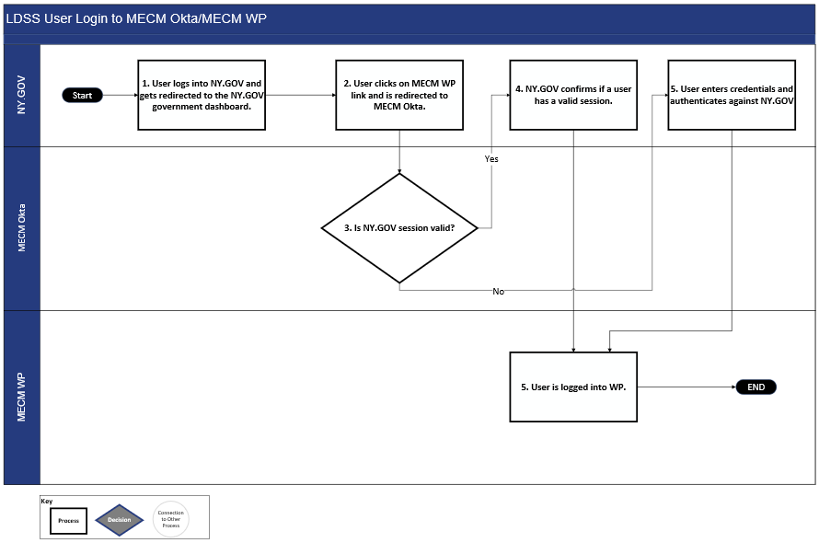
Figure 3-62: User Login Workflow (Valid Session in IDP)
In cases when the LDSS user does not have a valid session in NY.GOV (i.e., the user did not authenticate with NY.GOV) and accesses the MECM WP directly via URL or through the MECM Okta login page, they will be redirected to NY.GOV to authenticate to log in.
User Logout for Worker Portal:
The approach for DOH, Maximus, and LDSS user Logout from the MECM WP is documented in Section 4.9 of the Topic 4 IAM FDD.

Authentication Mechanism for Member Portal
Users who attempt to access the MECM MP directly through NY.GOV are required to authenticate with NY.GOV Okta. The MECM MP is integrated with NY.GOV Okta using the OIDC protocol, which enables single sign-on between the MECM MP and other systems integrated with NY.GOV, if the proper authorization is configured in each application. This enables a NYSOH-MECM SSO for seamless navigation between the NYSOH MP and MECM MP without having to sign in again.
User Login to MECM MP:
The approach for User Login to the MECM MP is documented in Section 5.3 of the Topic 4 IAM FDD. Additional details about the technical approach for Worker’s user login to the MECM MP is documented below:
For MECM WP users, indirect access to MECM MP is possible based on user roles and a custom JWT that facilitates portal redirection. After a user is authenticated in the MECM WP, a redirection is initiated when the user clicks on the GO TO MEMBER PORTAL button on the MECM WP homepage.
Since the user is already logged in to the WP, clicking the redirection triggers the following authentication flow:
- The system establishes a signed, encrypted assertion for the redirection and the receiving application validates it before granting access. The conveyance mechanism and its parameters are withheld ([REDACTED])
Upon successful verification of the custom JWT token, the user may proceed to the MECM MP.
User Logout for MECM MP:
The approach for User Logout for MECM MP is documented in Section 5.3.7 of the Topic 4 IAM FDD.

Session Management
This section provides details on session timeout policies for both the MECM WP and MECM MP, per the MARS-E v2.2.

Session Management for MECM WP
The approach for Session Management for the MECM WP is documented in Section 4.8 of the Topic 4 IAM FDD.

Concurrent Session for MECM WP
The approach for Concurrent Sessions for the MECM WP is documented in Section 4.8.1 of the Topic 4 IAM FDD.

Session Management for MECM MP
The approach for Session Management for the MECM MP is documented in Section 5.7.1 of the Topic 4 IAM FDD.

Concurrent Session for MECM MP
The approach for Concurrent Sessions for the MECM MP is documented in Section 5.7.2 of the Topic 4 IAM FDD.

Password Management
This section outlines the policies and controls for password management in MECM applications, including user account management policies like account lockout, forgot Password, and other account management functionalities.

Password Management for MECM WP
The approach for Password Management for the MECM WP is documented in Section 4.10 of the Topic 4 IAM FDD.

Password Management for MECM MP
The approach for User Login to the MECM MP is documented in Section 5.7.4 of the Topic 4 IAM FDD.

Authorization Mechanism
The authorization mechanism for MECM employs a hybrid approach of coarse-grained and fine-grained access control models. These sections cover both models for the MECM WP and MP/AP.
More details on authorization mechanisms for MP and AP user access are documented in Section 5.4 of the Topic 4 IAM FDD, and in the Topic 13 Contact Center FDD where the roles matrix is defined for fined grain authorization.
Note: The MECM system generates a unique Invitation Code for each case registered in the Application Registration module. This code, starting with MC followed by 13 digits, identifies it as an MECM invitation code. It enables MP users to link their MP account to relevant cases on a self-service basis. More details can be referenced in Topic 07 Case Transfer FDD.

Role-Based Access for MECM WP
The approach for Role based Access for MECM WP is documented in Section 4.5 in the Topic 4 IAM FDD. The technical approach of Role Based Access in the MECM WP is documented below.
Authorization for MECM WP is managed by ITS ESSO, Maximus Entra ID, and NY.GOV through role-based access control. Roles within ITS ESSO, Entra ID, and NY.GOV are mapped into MECM Okta and configured into the MECM WP application. The roles grant users access to functions within the MECM WP. Further internal role configurations made within the MECM WP application determine access to specific pages and fields.
The MECM WP grants authorization based on the role assigned to each user within their IDP. Each user is assigned one or more roles, which are configured within the MECM application to access groups of functions consisting of various pages and fields. Users with the same role will receive identical MECM access, with no additional onboarding required within the MECM system. Certain roles allow indirect access to the MECM MP or MECM AP via the MECM WP login, as noted in the table below.
There is no role overlap among NY.GOV, Maximus, and ITS ESSO users. For example, DOH users cannot be assigned Maximus or NY.GOV roles, and Maximus users cannot be assigned DOH or NY.GOV roles.
The below workflow describes the RBAC for DOH and Maximus users.
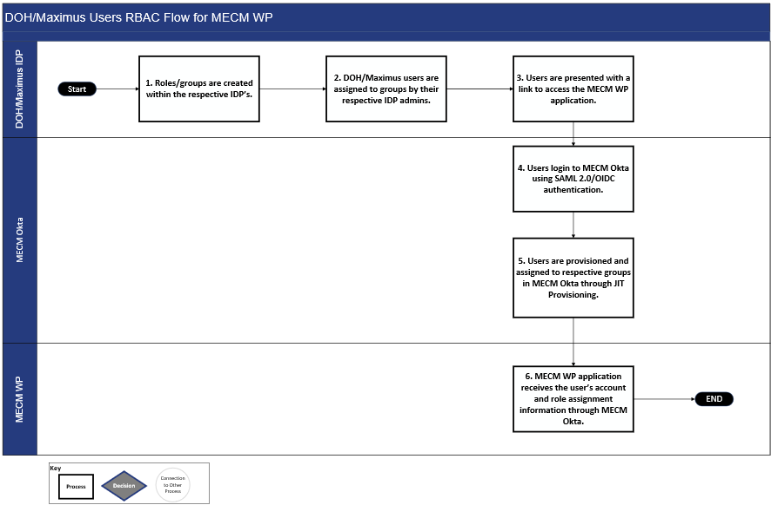
Figure 3-63: DOH/Maximus Users RBAC Flow for MECM WP
- Respective IDP administrators create the roles required for the MECM WP within their IDP
- DOH and Maximus administrators assign the users their MECM WP role
- When users click the link to access MECM WP, the single sign-on trust established between the IDP and MECM Okta provisions the user’s group JIT
- JIT provisioning verifies the group is updated on every successful login to MECM Okta/MECM WP
- MECM Okta passes the user’s role assignment to MECM WP, along with other user details, via the OIDC ID token and MECM Okta user information endpoint
- MECM WP further defines fine-grained authorization control within the application using the role information received from MECM Okta
The below workflow describes the RBAC for LDSS users.
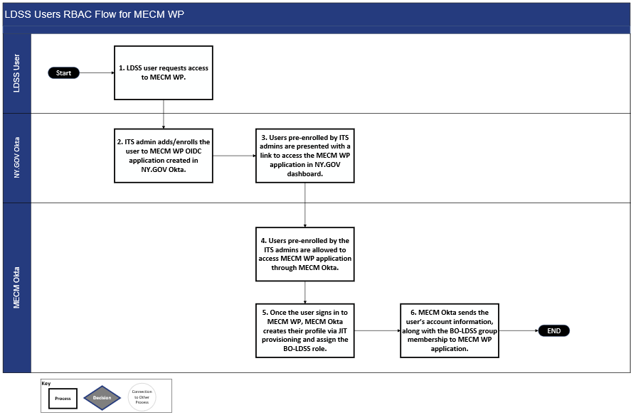
Figure 3-64: LDSS Users RBAC Flow for MECM WP
- An LDSS user requests ITS for access to MECM WP
- If needed, the ITS administrator creates a new Government ID for the LDSS user and administers the user’s Government ID to the MECM WP application created in NY.GOV Okta
- Any LDSS user requesting access to the MECM WP must be pre-enrolled to NY.GOV MECM WP application by an the ITS administrator
- An LDSS user who is not pre-enrolled to NY.GOV will not be able to access the MECM WP, even when they try to access the MECM WP directly
- Once a pre-enrolled LDSS user accesses the link to the MECM WP, MECM Okta enables single sign on using the OIDC token to allow the user to login seamlessly without having to login again
- Since, only an LDSS workers pre-enrolled by ITS admin can login to the MECM WP, the MECM BO-LDSS role gets assigned to user’s profile by MECM Okta
- User role and profile information is available to the MECM WP via the OIDC ID token and MECM Okta user info endpoint
Role Management:
- The following concepts apply to all roles used in the authorization mechanism for MECM WP access within the MECM system:
- Users assigned the same role receive identical access in the MECM WP
- Certain roles enable indirect access to the MECM MP/AP after successful login to the MECM WP
- User roles are mutually exclusive across ITS ESSO, Maximus Entra ID, and NY.GOV Okta IDPs, so that there is no role overlap among the IDPs. DOH users cannot be assigned Maximus or NY.GOV roles, and vice versa
ITS ESSO, Maximus Entra ID, and NY.GOV, as identify provides, contain all users, groups, and roles allowed access to the MECM WP. Roles within the IDPs are mapped to corresponding groups in MECM Okta via the Okta Admin console by linking each IDP group’s unique Group ID to a corresponding group name in MECM Okta. Each group in MECM Okta is uniquely configured for ITS ESSO, Maximus Entra ID or NY.GOV. Any update to roles or groups within the IDPs are reflected in MECM Okta and subsequently in the MECM WP. The mapping process verifies that after user authentication with their IDP, the IDP's group assignments are accurately mapped to corresponding MECM WP groups.

Role-Based Access for Member Portal
The approach for Role Based Access for the MECM MP is documented in Section 5.6 of the Topic 4 IAM FDD.

Role-Based Access for Assistor Portal
The approach for Role Based Access for the MECM MP is documented in Section 5.6 of the Topic 4 IAM FDD.

Provisioning Mechanism
The MECM System employs a technology and process-based solution to manage the creation, modification, and revocation of user accounts in accordance with defined security policies. This section offers a unified view of user accounts and permissions across applications/systems and provides guidance on role assignment for the MECM WP and MECM MP/AP applications.

Account Creation for MECM Okta/Worker Portal
The approach for Role Based Access for the MECM WP is documented in Section 4.1.1 of the Topic 4 IAM FDD.

Account Modification for MECM Okta/Worker Portal
The approach for Account Modification for MECM Okta and the MECM WP is documented in Section 4.10 of the Topic 4 IAM FDD.

Account Deactivation for Worker Portal
MECM Okta user accounts are deactivated, not deleted, to meet compliance requirements. Deactivation is initiated by the identity provider (i.e., ITS ESSO, Maximus Entra ID, or NY.GOV). MECM Okta then calls the MECM WP application API to update user status to the MECM WP. The profile synchronizing process verifies data consistency between ITS ESSO, Maximus Entra ID, NY.GOV, MECM Okta, and the MECM WP. Manual user deprovisioning in MECM Okta is facilitated by a ticketing process. The table below details the deactivation process for ITS ESSO and Maximus Entra ID.
Section | Description
Scenario | Account Deactivation in ITS ESSO, Maximus Entra ID, and NY.GOV
Actors | - ITS ESSO  - Maximus Entra ID  - NY.GOV  - MECM Okta  - MECM WP
Triggers | Manual ticket for account deactivation or 60 days inactivity
Basic Flow | - MECM WP user account is deactivated in ITS ESSO, Maximus Entra ID, or NY.GOV using their current process. Respective IDPs will have an additional manual ticketing process to send the deactivation request to DOH (MECM-3411)  - MECM Okta will call the MECM WP application API to send the user status to the MECM WP. (This will make certain that there is no data discrepancy between ITS ESSO/Maximus Entra ID/NY.GOV, MECM Okta and MECM WP.)  - Note: If a user account has been inactive in MECM Okta for 60 days, their account will be deactivated in MECM Okta, no trigger will be sent to respective IDP
Table 3-51: Account Deactivation/Deletion

Account Reactivation for MECM Worker Portal
Account reactivation for MECM WP users is managed manually through a ticketing system. Manual user reactivation in MECM Okta is facilitated by a ticketing process.

Account Creation for NY.GOV/Member Portal
The approach for account creation for NY.GOV/MP is documented in Section 5.3.1.2.2 of the Topic 4 IAM FDD, and in Section 5 of the ICD IN22 NY.GOV ID documents.
Upon the first-time attempt to access the MECM MP or AP, the MP or AP users will be redirected to authenticate with NY.GOV. After successful authentication, MECM calls DAWS to enroll the members and assistors within NY.GOV using [APPLICATION IDENTIFIER REDACTED] as the MECM application identifier, which will associate the MECM user with the current NYSOH tile. The NYSOH tile will be displayed in the MY.NY.GOV dashboard and directs the MY.NY.GOV user to the NYSOH portal.

Account Modification for Member Portal
The approach for account modification for NY.GOV/MP is documented in Section 5.7.4 of the Topic 4 IAM FDD.

Account Deactivation/Deletion for Member Portal
The approach for account deactivation/deletion for NY.GOV/MP is documented in Section 5.8 of the Topic 4 IAM FDD.

Account Retention Policy for MECM Okta/Worker Portal
The approach for Account Retention for MECM Okta/WP is documented in Section 4.11.1 of the Topic 4 IAM FDD.

Account Retention Policy for Member Portal
The approach for Account Retention Policy is documented in Section 5.8.1 of the Topic 4 IAM FDD.

Multi-Factor Authentication and ID Proofing
This section details the Multi-Factor Authentication (MFA) and ID proofing process, as well as information on the user types/roles in the MECM system for whom MFA, ID, or both are required.

Multi-Factor Authentication for MECM WP
The approach for MECM WP MFA is documented in Section 4.7 of the Topic 4 IAM FDD.

Multi-Factor Authentication for MECM MP
The approach for MECM MP MFA is documented in Section 5.3.1.3 of the Topic 4 IAM FDD.

Identity Proofing for MECM WP
All users undergo manual ID proofing through their respective identity provider (ITS ESSO, Maximus Entra ID, or NY.GOV) before onboarding to their specific system. The existing ID proofing process for ITS ESSO, Maximus Entra ID, and NY.GOV, for LDSS users, remains the same. Remote ID proofing (RIDP) is not required for MECM WP users, as they complete ID proofing during their first account access through the established process of their identity providers.
- The ID proofing process for each identity provider for MECM WP access is detailed below:
- Maximus Entra ID: Maximus users will follow their existing I-9 verification process before onboarding to Maximus Entra ID
- ITS ESSO: DOH users will follow their existing ID proofing process before accessing ITS ESSO
- NY.GOV: LDSS users will follow the manual ID proofing process by County Participating Organization Delegated Administrator (PODA) or Information Security Office (ISO) before accessing NY.GOV Government ID

Identity Proofing and Multi-Factor Authentication for MECM MP- Identity Assurance Level and Authenticator Assurance Level Assessment Summary
The purpose of ID proofing is to verify the identities of MECM MP users, protecting users from unauthorized access to their personal information. All roles will have access to PHI and PII. The table below summarizes the coarse-grained roles and their respective Identity Assurance Level (IAL) and Authenticator Assurance Level (AAL) for MECM MP roles. All MECM WP roles are defined at IAL1 and AAL2 level as they are enforced IAL2 standard ID proofing and AAL2 standard MFA as defined in sections above.
Portal | Role | Identity Assurance Level | Authenticator Assurance Level
MECM MP | Account Holders | IAL2 | AAL2
MECM MP | Authorized Representative | IAL2 | AAL2
MECM MP | Other Household Members aged eighteen (18) or older | IAL2 | AAL2
MECM MP | Notice Recipient | IAL2 | AAL2
MECM MP | Assistors | IAL2 | AAL2
MECM MP | Workers | IAL2 | AAL2
MECM MP | Regular Assistors | IAL2 | AAL2
MECM MP | Primary Assistor Oversight Managers (AOMs) | IAL2 | AAL2
MECM MP | Secondary AOMs | IAL2 | AAL2
MECM MP | DOH Assistor Admin Role | N/A | N/A
MECM MP | MECM System Vendor Role | N/A | N/A
Table 3-52: IAL and AAL Assessment Summary for MECM MP/AP

Process/Requirements of Day Zero Data Load of WP Users
The approach for process/requirements of Day Zero Data Load of MECM WP users is documented in Section 4.6 of the Topic 4 IAM FDD.

IAM Environment Mapping
MECM WP Map | MECM Okta Environment | MECM Okta and Third-Party Providers Integration
Dev 1  Dev 2  SIT 1  SIT 2 | MECM Okta Dev | Maximus Dev Entra ID  Prod ITS ESSO  QA NY.GOV Okta
SIT 3  SIT 4  UAT 1  UAT 2  DEVC  SITC  UATC  TRNDEV  TRNDL  PERF  PRDT  PRDP | MECM Okta PRE-PROD | Maximus Pre-Prod Entra ID  Prod ITS ESSO  QA NY.GOV Okta
PROD  DR | MECM Okta Prod | Maximus Prod Entra ID  Prod ITS ESSO  Prod NY.GOV Okta
Table 3-53: IAM Environment Mapping for MECM WP
MECM MP/AP App Environments | NY.GOV Okta Environment
Dev 1  Dev 2  SIT 1  SIT 2 | QA NY.GOV
SIT 3  SIT 4  UAT 1  UAT 2  DEVC  SITC  UATC  TRNDEV  TRNDL  PERF  PRDT  PRDP | QA NY.GOV
PROD  DR | Prod NY.GOV
Table 3-54: IAM Environment Mapping for MECM MP/AP

MECM Okta Integration with Tableau
The Tableau integration with MECM Okta is currently pending and will be discussed and finalized in the next iteration of SADD review. Once finalized, it will be added to the architecture diagram in Section 3.1 of Deliverable #16, the Systems Architecture Design Document, and the flow will be explained in this section.
High level approach is as below.
SSO Approach:
Tableau application is integrated with MECM Okta using OIDC protocol. For the configuration, an OIDC application is configured in MECM Okta as a Web Application with Authorization Code grant type. The Sign-in redirect URI provided by the Tableau application team is configured within the OIDC application created in MECM Okta. After this is completed, the Client ID, Client secret and Configuration URL is provided by the IAM Team to the Tableau Application Team to be configure within the application using the Tableau Services Manager (TSM) web interface to complete the SSO integration.
After successful authentication to MECM WP application, the user clicks on Tableau link within the WP application. The user is redirected to Tableau Server with an ID token containing user’s information as key-pairs following the Authorization Code Flow. Tableau Server application then validates the ID token. Upon successful validation, it creates a session for the user, granting access based on their roles and permissions within Tableau. The user will be able to access the Tableau dashboard and reports without needing to login again.
Provisioning Approach:
User provisioning to Tableau application will be done by WP application through Tableau API. Users will access the Tableau application via the WP application. After a user successfully authenticates and logs into the WP application, it will verify whether the user's ID token from MECM Okta includes a Tableau role. If the tableau role is present, WP application will call the Tableau API and creates the user in Tableau through the Tableau API call.
MFA Approach:
Since users will access the Tableau application through the WP application, the WP application will rely on the respective IDP (ITS ESSO for DOH users) to enforce users to perform multi factor authentication during login. After successful 2nd factor authentication, users will be redirected to MECM WP portal and will be able to access the Tableau dashboard through WP.
Role Based Access Control Approach:
Authorization for Tableau application will be managed by the respective IDP i.e., ITS ESSO for DOH users through role-based access. [GROUP NAME REDACTED]ableau group/role is configured within ITS ESSO and is mapped to Back Office – Tableau Reports Role in MECM Okta through group rules. Once the user logs into the WP and has [GROUP NAME REDACTED]ableau role coming from ITS ESSO, the user will automatically get assigned to Back Office – Tableau Reports Role in MECM Okta through the group rule which gets sent to the WP application through the ID token. WP application will check if the user has a Tableau Role and if present, it will call the Tableau API and create the user in Tableau through JIT provisioning. This certifies that only users who need access to the Tableau application will be granted access.
Logout is not configured as per requirement, if required logout may be configured to redirect the users to Okta login page upon user logout.

MECM Okta Integration with Splunk
SSO Approach:
Splunk application is integrated with MECM Okta using SAML protocol. In MECM Okta a SAML app was created and configured with the Splunk login URL and entity ID. In Splunk Cloud, SSO is enabled, and MECM Okta metadata is uploaded to establish trust. The SAML metadata includes the entity ID, SSO URL, and the public X.509 certificate.
Provisioning Approach:
User provisioning to Splunk will be done by JIT Provisioning via a SAML connection between Splunk Cloud and MECM Okta to create and update user attributes based off the attribute mapping within MECM Okta to Splunk. When a DOH user successfully authenticates into MECM Okta for the first time the user is provisioned into MECM Okta and to the Splunk Cloud based on the corresponding Splunk groups within ITS ESSO. This means a user’s profile is created in MECM Okta upon first login, with updates occurring on subsequent logins. When a user logs into Splunk Cloud, they are redirected to Okta for authentication. Upon successful login, Okta sends a SAML assertion to Splunk Cloud, which creates or updates the user account and assigns roles based on the received attributes from ITS ESSO and MECM Okta.
MFA Approach:
The Splunk application will rely on the MFA provided by ITS ESSO IDP to enforce multi factor authentication during login. Only after successful authentication with ITS ESSO and MFA, users will be able to access Splunk Cloud.
RBAC Approach:
RBAC authorization for Splunk Cloud application will be managed by ITS ESSO. Groups/roles are configured within ITS ESSO and are mapped in MECM Okta through group rules. Roles in Splunk are mapped to the groups passed from ITS ESSO and MECM okta through the SAML Assertion. Upon logging in using ITS ESSO IDP, the groups will be passed from ITS ESSO to MECM Okta, to Splunk through the SSO setup.
Below is the group mapping between the Splunk roles and the AD Group names that will be managed by the DOH Administrator:
AD Group | Splunk Role | Role Description
[GROUP NAME REDACTED]plunk_Power | power | This role lets users edit all shared objects (saved searches, etc.) and alerts, tag events, and perform other similar tasks.
[GROUP NAME REDACTED]plunk_User | user | This role lets users create, edit, and run their own searches, save those searches, edit their own preferences, create, and edit event types, and perform other similar tasks.
[GROUP NAME REDACTED]plunk_Can_Delete | can_delete | This role lets users delete keywords. This capability is necessary when using the delete search operator.
[GROUP NAME REDACTED]plunk_SC_Admin | sc_admin | This role lets users create other users and roles but does not grant any other administrative capabilities.
[GROUP NAME REDACTED]plunk_Tokens_Auth | tokens_auth | This role lets users activate authentication on the Splunk platform instance using tokens. It does not grant any other administrative capabilities.
Table 3-55: Splunk Role Description
Logout Approach:
Logout is not configured as per requirement, if required logout may be configured to redirect the users to Okta login page upon user logout.

Multi-Environment Support
This section of the deliverable describes the environment readiness and mapping. The following table aligns the relevant MECM Worker, Member, and Partner Portals to the corresponding IAM environments. The following table outlines the MECM system WP/Okta environment mapping.
App Environment | WP IAM Environment | Total # of Users
Dev1 | WP Okta Dev | ~300 users
Dev2 | WP Okta Dev | ~300 users
SIT1 | WP Okta Dev | ~300 users
SIT2 | WP Okta Dev | ~300 users
SIT3 | WP Okta Pre-Prod | ~2000 + 1500** (for Performance)
SIT4 | WP Okta Pre-Prod | ~2000 + 1500** (for Performance)
UAT1 | WP Okta Pre-Prod | ~2000 + 1500** (for Performance)
UAT2 | WP Okta Pre-Prod | ~2000 + 1500** (for Performance)
DEVC | WP Okta Pre-Prod | ~2000 + 1500** (for Performance)
SITC | WP Okta Pre-Prod | ~2000 + 1500** (for Performance)
UATC | WP Okta Pre-Prod | ~2000 + 1500** (for Performance)
TRNDEV | WP Okta Pre-Prod | ~2000 + 1500** (for Performance)
TRNDL | WP Okta Pre-Prod | ~2000 + 1500** (for Performance)
PERF | WP Okta Pre-Prod | ~2000 + 1500** (for Performance)
PRDT | WP Okta Pre-Prod | ~2000 + 1500** (for Performance)
PRDP | WP Okta Pre-Prod | ~2000 + 1500** (for Performance)
PROD | WP Okta Prod | ~4000
DR | WP Okta Prod | ~4000
Table 3-56: MECM WP/Okta Environment Mapping
The table below provides an outline for the MECM system MP/AP environment mapping.
App Environment | MP IAM Environment | Total # of Users
Dev1 | NY.GOV Dev | ~3000 Users
Dev2 | NY.GOV Dev | ~3000 Users
SIT1 | NY.GOV Dev | ~3000 Users
SIT2 | NY.GOV Dev | ~3000 Users
SIT3 | NY.GOV Pre-Prod | ~9000 + 1500 (Performance Env*) Users
SIT4 | NY.GOV Pre-Prod | ~9000 + 1500 (Performance Env*) Users
UAT1 | NY.GOV Pre-Prod | ~9000 + 1500 (Performance Env*) Users
UAT2 | NY.GOV Pre-Prod | ~9000 + 1500 (Performance Env*) Users
DEVC | NY.GOV Pre-Prod | ~9000 + 1500 (Performance Env*) Users
SITC | NY.GOV Pre-Prod | ~9000 + 1500 (Performance Env*) Users
UATC | NY.GOV Pre-Prod | ~9000 + 1500 (Performance Env*) Users
TRNDEV | NY.GOV Pre-Prod | ~9000 + 1500 (Performance Env*) Users
TRNDL | NY.GOV Pre-Prod | ~9000 + 1500 (Performance Env*) Users
PERF | NY.GOV Pre-Prod | ~9000 + 1500 (Performance Env*) Users
PRDT | NY.GOV Pre-Prod | ~9000 + 1500 (Performance Env*) Users
PRDP | NY.GOV Pre-Prod | ~9000 + 1500 (Performance Env*) Users
PROD | NY.GOV Prod | ~150000
DR | NY.GOV Prod | ~150000
Table 3-57: MECM MP/AP Environment Mapping

Federal Tax Information Labelling Methodology
This section of the deliverable provides guidelines on the methodology and techniques for the appropriate labelling of FTI in MECM solution. IRS Publication 1075 (Rev. 11 2021) provides guidance on an FTI labelling methodology. Below are the components involved in FTI labelling:
- Policy Name: FTI_POL_01
- FTI User: FTI_ACCESS
- Non FTI User: NO_FTI_ACCESS
- Policy Enforcement options: The policy enforcement options enable administrators to fine-tune users' abilities to read or write data or labels
- READ_CONTROL: Applies policy enforcement to all queries. Only authorized rows are accessible for SELECT, UPDATE, and DELETE operations
- WRITE_CONTROL: Determines the ability to INSERT, UPDATE, and DELETE data in a row
- CHECK_CONTROL: Applies READ_CONTROL policy enforcement to INSERT and UPDATE statements to declare that the new row label is read-accessible
- HIDE: It hides the label column

Oracle Database Security Implementation
This section of the deliverable provides explains how MECM achieves IRS compliance for FTI data using data labelling and encryption.
We have different layers of security implemented for our production database in NY-MECM which covers data encryption at rest, data labelling for sensitive data. Below are the details for the same:
Transparent Data Encryption (TDE) - Amazon RDS supports Oracle TDE, a feature of the Oracle Advanced Security option available in Oracle Enterprise Edition. This feature automatically encrypts data before it is written to storage and automatically decrypts data when the data is read from storage. All our tablespaces in Oracle databases are TDE encrypted which safeguards data encryption at rest.
Oracle Labelling Security (OLS) - Amazon RDS supports OLS for the enterprise edition of Oracle Database through the use of the OLS option. OLS provides fine-grained control of access to individual table rows. For example, you can use label security to enforce regulatory compliance with a policy-based administration model. You can use label security policies to control access to sensitive data and restrict access to only users with the appropriate clearance level.
OLS will be used to label the FTI data in the production database. All FTI tables will be labelled using the OLS strategy. Attached is the list of FTI tables in the NY Prod database. Refer FTI Data Labelling.pdf for more details.

Web Services Security
This section of the deliverable provides details about how web services (WS) security will be implemented for SOAP based and RESTful inbound & outbound webservices in MECM. Refer to Del #22 Interface Standards Documents (ISD) Section 2.4 for latest updates on security for real-time services.
For the real-time Services exposed by MECM, SOAP based interfaces shall be secured with WS security 1.1, and RESTful services shall be secured with authentication mechanism. Credentials required to connect to partner web-service shall be applied through User Defined Properties (UDP).

Transport-Level Security
The Hypertext Transfer Protocol Secure (HTTPS) traffic between service provider and consumer will be secured using the TLS 1.3/1.2 with digital certificates signed by a trusted certificate authority. Trusted certificates will be imported in the trust store, and the MECM certificate will be stored in key store on IBM ACE server. The certificate is validated against the trust store during SSL handshake. Server may request MECM certificate in some cases, then it must pass MECM certificate alias as a property on HTTP/SOAP nodes in IBM ACE. The TLS will be used to secure both SOAP and REST based web services.

Message-Level Security
For SOAP services that MECM will expose, XML Message security will be implemented using WS Security 1.1. As REST leverages the security infrastructure of the Web, it relies on HTTPS and TLS for transport-level security and typically, message-level encryption is not used. For services that MECM will consume, XML message security will be implemented using the Service security defined in the Web Service Description Language (WSDL) contract provided by the service provider.
The below CMS recommendation will be followed for SOAP based web services:
- Leverage WS-Security 1.1 to provide message level Username Token
- Leverage WS-Security 1.1 to provide message level Timestamp
- Leverage WS-Security 1.1 to provide message level XML encryption
- Leverage WS-Security 1.1 to provide message level digital signature

Web Services Security for Inbound Services to MECM
Inbound real-time traffic to MECM shall be allowed only from whitelisted (on external application load balancer’s security group and Palo Alto firewall) server IP addresses. External ALB in the public subnet will route real-time traffic to internal AWS ALB in private subnet with appropriate security groups in place.
For external services that consume the MECM services, following is the security model:
- Leverage ACE as ESB for all incoming traffic
- Require SSL/TLS 1.2 to protect transport layer security
- X.509 public key certificates (recommended practice at CMS)
- Leverage WS-Security 1.1 to provide Username Token and Timestamp
- Leverage WS-Security 1.1 to provide message level XML encryption and digital signature
- Leverage service account authentication for REST services

Web Services Security for Outbound Services from MECM
The web service security for outbound services from MECM is determined by the external party (service providers) that provides the service.
Each service provider typically has their own standards for web services. MECM follows industry standards and CMS recommendations whenever possible.
- Use HTTPS (TLS 1.2)
- Uses WS Security 1.1 username token and Timestamp
- Uses WS Security 1.1 Signature with x.509 certificate
- Uses WS Security 1.1 XML Encryption
- REST services with basic authentication
- Sensitive data should never be cached or put into a visible URI
Refer to the Interface Network Access Tracker spreadsheet that has more detailed information about each service and the standards used for those services.

MECM Environments Hardening Process
This section provides an overview of the approach for hardening within MECM, encompassing ongoing vulnerability scanning, remediation procedures, identification of false positives, presentation of evidence, and revalidation. Additionally, this section provides information about security patch management.

Approach
A three-pronged approach is used to harden MECM software components consisting of security patch management, application of hardened baseline configurations and periodic vulnerability scanning activities. The following sections describe each of the approaches in greater detail.
Security Patch Management:
- The AWS Systems Manager is used to schedule the maintenance windows for security patch management using the AWS Patch baseline for Amazon Linux, RHEL and Windows EC2s
- Maintenance window is scheduled monthly for all the EC2s to install the required security patches from the AWS Patch baseline
- Lower Environment is scheduled for patch a week before the PROD environment is patched
Item | Frequency | Time/Window (Placeholder) | Timing (Before Go Live)
Infra Non-Prod Patching | Monthly | 1st Thursday - DMES Environment.  2nd Thursday - other non-prod and Rest of the Non-prod. | DMES Environment and – 12 pm to 4 pm ET.  Other Non-Prod client facing environments (UAT and TRNDL) – 4 pm - 8 pm ET.
Infra Prod Patching | Monthly | 3rd Thursday | 12 pm - 4 pm ET.
Table 3-58: Patching Schedule
Hardened Baseline Configuration:
- Servers should be deployed and configured per Security Configuration Baselines
- New servers should be built and/or configured using a pre-built base image (“gold images”) that meets security configuration baselines
- Packer is used to create the base AMIs that are hardened according to the CIS and IRS 1075 benchmarks
- Packer is executed from a GitLab repository, with variables set to target the DOPS account for the creation of the base hardened Golden AMI (Amazon Machine Images)
- Once the Golden AMI is successfully created, it will be shared with the other NY-MECM AWS accounts to use as the Golden AMI (Amazon Machine Images) for all the EC2s
- Maintain and Update base server images (“gold images”) at least monthly. The cybersecurity team should review and approve the changes prior to implementation
Periodic Vulnerability Scanning, Identification, Analysis and Remediation:
A weekly Nessus vulnerability scan will run every Monday against all the EC2s joined to the Nessus server and remediate all the vulnerabilities.
Item | Frequency | Time/Window
Vulnerability scan | every 72 hours | Monday
Vulnerability scan review | 1 day | Tuesday
Non-prod Patching (High/Critical) Infra Placeholder - Just High or Critical |  | Tuesday
Non-prod Patching (High/Critical) Infra Placeholder - Just High or Critical | within 7 days | Thursday
Non-prod Patching (Moderate) Infra Placeholder |  | can be part of monthly patching
Prod Patching (Moderate) Infra Placeholder | With in 15 days | can be part of monthly patching
Non-prod Patching (Low) Infra - Regular Monthly |  | 3rd week
Prod Patching (Low) Infra - Regular Monthly | With in 30 days | 4th week
Application validation after patching | After every patching
Table 3-59: Nessus Vulnerability Scan

Exception Process
If a particular configuration identified in a hardened baseline negatively impacts the MECM application performance, an exception can be requested and approved by the security team.

System Monitoring Design
This section of the deliverable provides an overview of system monitoring in the MECM system. The MECM system leverages Splunk and Oracle Enterprise Manager to capture statistics, events, and errors for the MECM solution.

Splunk

Overview
Splunk Enterprise is a platform that gathers specific event data and provides a holistic view of the events. Splunk will be utilized to create customizable dashboards, which will provide real-time insights and visualization of the MECM application logs and metrics based on the indexed events and also will be configured to generate notifications and alerts. It collects and indexes events from various components of the MECM system.
The diagram below provides an overview of the Splunk Cloud Architecture describing how Splunk collects and indexes events.
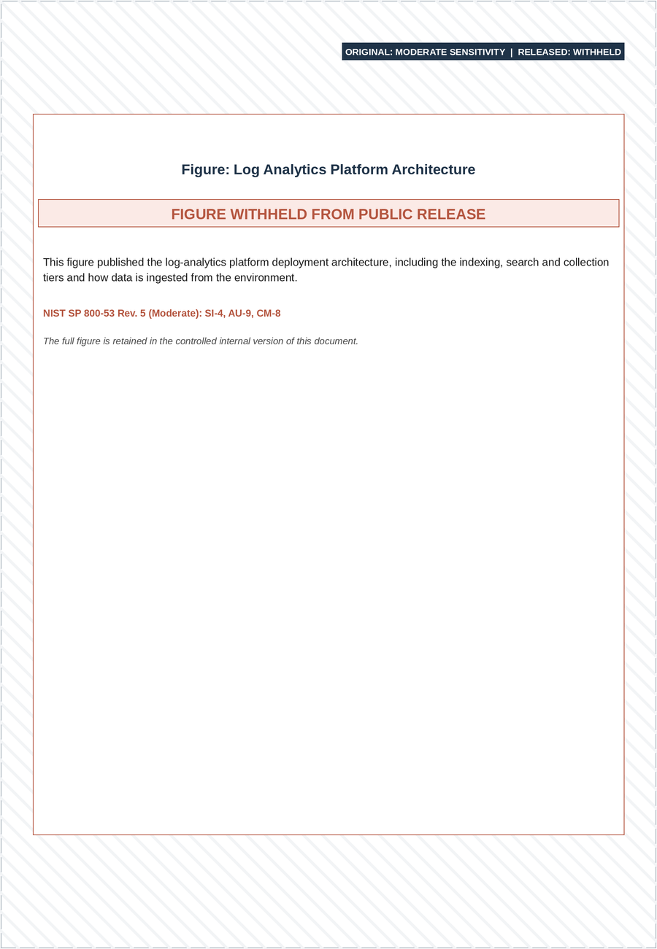
Figure 3-65: Splunk Cloud Architecture
The Splunk Enterprise forwarder is used for collecting events from defined sources. The forwarder is an agent that is installed on the target server where the events are generated. The forwarder gathers and sends the events to centralize Splunk Enterprise server. Splunk Enterprise also provides Splunk Connector and plugins for collecting the logs from the target systems (e.g., Splunk DBConnect application for database connectivity).
Splunk Component | Purpose
License Manager | Manages Splunk Licenses.
Cluster Master | Manages the Splunk clusters and confirms that consistent code is deployed across the cluster.
Deployment Server | Manages deployments of configurations, apps, and content updates to Splunk instances.
Search Head | Responsible for executing searches and reports against the indexed logs and events.
Indexer | Responsible for indexing all incoming logs and events, from the forwarders, according to pre-defined logic. This information is then stored within the Splunk repository.
Forwarder | Responsible for forwarding logs/events from servers or applications to the centralized Splunk set-up.
Table 3-60: Splunk Components

Multi-Environment Support
Splunk is a shared service that will be leveraged for multiple environments in MECM. This section provides an overview of multi environment setup in Splunk and lists the sources of events from various MECM environments that will be logged, collected, and indexed by Splunk.
This section of the deliverable provides details on the multiple environments in which Splunk would be set up.
Splunk Setup | MECM System Environment
MECM Splunk | DEV1, DEV2, SIT1, SIT2
MECM Splunk | SIT3, SIT4, SITC, UAT1, UAT2, UATC, TRNDEV, TRNDL, TRNDL2
MECM Splunk | PRDT, PRDP
MECM Splunk | PROD
Table 3-61: Mapping of MECM System Environments to Splunk
Setting up Multi-Environment in Splunk Cloud:
Separate Indexes: A separate index will be created for each MECM environment to confirm data isolation and simplify the management.
Environment Specific Configurations: Configurations will be set specific to environment, such as data inputs, outputs, and alerts to meet the unique requirements of each MECM environment.
Access Controls: Access controls will be implemented to confirm that users only have access to the authorized environments.
Splunk integrates with the MECM components to collect, index and report events. The following table outlines the sources of events that are logged, collected, and indexed by Splunk.
MECM Component | Collection Method
IBM HTTP Server | Forwarder
Nginx Web Server | Forwarder
IBM WebSphere Application Server | Forwarder
Apache Tomcat Application Server | Forwarder
Oracle Policy Automation | Forwarder
IBM App Connect Enterprise | Forwarder
OpenText Exstream | Forwarder
CA Automic Job Scheduler/Agents | Forwarder
Tableau | Forwarder
Informatica Intelligent Cloud Services | Forwarder
IBM InfoSphere Master Data Management | Forwarder
Experian Address Validation | Forwarder
Table 3-62: Splunk Integration

Splunk Dashboards
This section provides a list of the dashboards that will be implemented using Splunk based on the logs generated in the MECM system. The following table provides a list of performance dashboards that will be implemented for the MECM worker portal.
Worker Portal:
Performance Dashboards
Total Login Users
Unique Login Users
Avg. Response Time
Top 20 pages by Avg. Response Time
Top 20 pages by Max Response Time
Total Pages Visited
Distinct Pages Visited
Eligibility metrics
Performance Bottlenecks and Exceptions
Table 3-63: Worker Portal Dashboards
The following table provides a list of performance dashboards that will be implemented for the MECM member portal.
Member Portal:
Performance Dashboards
Total Login Users
Unique Login Users
Avg. Response Time
Top 20 pages by Avg. Response Time
Top 20 pages by Max Response Time
Total Pages Visited
Distinct Pages Visited
Performance Bottlenecks and Exceptions
Table 3-64: Member Portal Dashboards

SLA Reporting
In addition to the performance dashboards developed for monitoring, MECM utilizes Splunk to generate SLA reports that focus on application performance in accordance with the SLAs outlined in the MSOW.
1. Defining SLAs: Following the SLAs specified in the MSOW, MECM will determine and utilize MECM logs, Splunk queries, and dashboard functionalities to produce SLA reports
2. Monitoring Performance: After defining the SLAs and creating the dashboards, MECM monitors performance in relation to the SLAs
3. Report Generation: MECM produces reports detailing SLA performance and shares these reports to stakeholders at agreed-upon intervals as specified in the MSOW

Notification
This section describes the MECM Application-level alert mechanism that will be implemented in Splunk based on the log files generated in MECM and other inputs. This alert mechanism notifies the designated resources through an email to the defined distribution group. The following table details the Splunk monitoring process and frequency.
Monitoring Service/Process | Polling Frequency
Application URL status | Periodic Interval (5 minutes)
Out of Memory | Event Occurrence
Hung threads | Event Occurrence
Specific Application Exceptions | Event Occurrence
Table 3-65: Monitoring Process and Frequency

Oracle Enterprise Manager

Overview
OEM is a system management tool which provides an integrated solution for managing and monitoring Oracle databases in MECM. It combines a graphical console, agents, common services, and tools to provide an integrated, comprehensive systems management platform for managing Oracle products.
The key capabilities of Enterprise Manager include:
- A comprehensive Database management solution that facilitates administration, and support of enterprise cloud infrastructures as well as conventional Oracle Database environments, encompassing everything from applications to storage
- OEM provides optimal solutions for the intelligent management of Oracle Databases and their associated back-end components, ensuring real-time integration of Oracle's knowledge base within each specific environment
- Best service levels for traditional and cloud applications through business-driven application management
Enterprise Manager monitoring functionality permits automated monitoring of MECM Oracle Database environment. Enterprise Manager comes with a comprehensive set of performance and health metrics that allows monitoring of Database components in all the MECM environments as well as the back-end components on which they rely (such as hosts, operating systems, storage).
The Management Agent installed on each monitored host is responsible for overseeing the status, health, and performance of all managed components (targets) present on that host. If a target goes down, or if a performance metric crosses a warning or critical threshold, an event is triggered and sent to Enterprise Manager. MECM Database Administrators will be notified of the triggered events through the Enterprise Manager notification system.

Multi-Environment Support
OEM is a shared service in the MECM system. OEM will be a shared service that will be used for multiple environments to achieve cost optimization. The OEM to MECM Environment Mapping table below displays mapping for various MECM environments with specific OEM setup.
OEM Setup | MECM System Environment
All environments expect PROD | DEV1, DEV2, SIT1, SIT2, PDV1, PDV2
All environments expect PROD | SIT3, SIT4, SITC
All environments expect PROD | UAT1, UAT2, UATC
All environments expect PROD | TRNDEV, TRNDL, TRNDL2
All environments expect PROD | PRDT, PRDP, PERF
Production | PROD, RPT and DR
Table 3-66: OEM to MECM Environments Mapping

DevOps Architecture
This section of the deliverable provides an overview of the CI/CD architecture. Bitbucket serves as the source code repository for NY MECM. CI/CD processes will be implemented using Atlassian Bamboo. The compiled artifacts will be stored in the Nexus Artifact Repository, from which Bamboo retrieves these artifacts for deployment. Additionally, this section offers insights into the source code scanning process to enforce code quality standards for NY MECM.

Configuration Repository
The configuration repository setup for MECM consists of one or more Bitbucket repositories. Administrators should maintain the Bitbucket repository size at a manageable level. Large repository sizes can adversely affect development activities, causing cloning, gated check-ins, and build processes to take much longer than expected. The following list provides some guidelines to help maintain a manageable Bitbucket repository size:
- Components with their own development lifecycle are candidates for independent repository, e.g., SSP and WP, etc.
- Logical grouping of application-specific components – the logical grouping may need to consider the following:
- Types of artifacts being managed for configuration, e.g., binaries vs source code
- Variation in build processes, e.g., SQL code may require a different build process versus Java code
- Interdependent sub-components of the application may reside in the same repository, such as WP App and batch
Refer to Deliverable #26 System Source Code for all the MECM system Repository details.

Branching and Merging Strategy for Parallel Releases
Bitbucket is a decentralized version control system (DVCS) where each developer has their own branches in a repository (also known as a repo) and maintains a local copy of the repository. For NY MECM projects, using Bitbucket with a branching strategy is the simplest form of repository management.
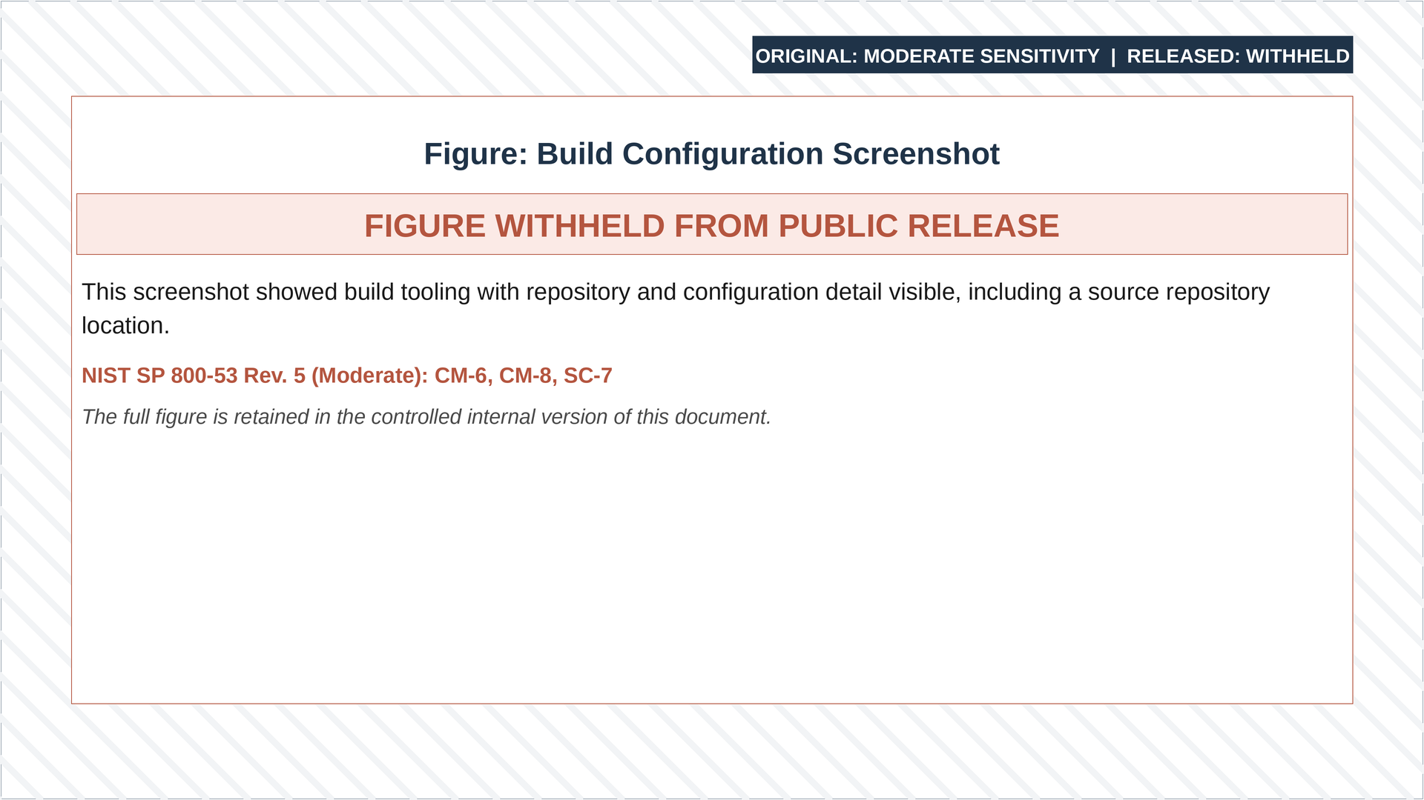
Figure 3-66: Bitbucket Repository
Moderators are the core developers of the project. They are the only users with write and merge access to the parent branch (DEV1/DEV2). Moderators are responsible for reviewing, approving, and merging every commit made to the parent branch. Every commit must be reviewed and approved by a moderator.
Contributors have read-only access to the parent branch. They branch the NY MECM repository into their accounts and are responsible for keeping their branch updated with the parent branch. Contributors can collaborate across branches and send pull requests back to the parent branch.
By introducing the roles of Moderators and Contributors to the project, this approach allows us to have an unlimited number of collaborators without the need to manage each user individually.
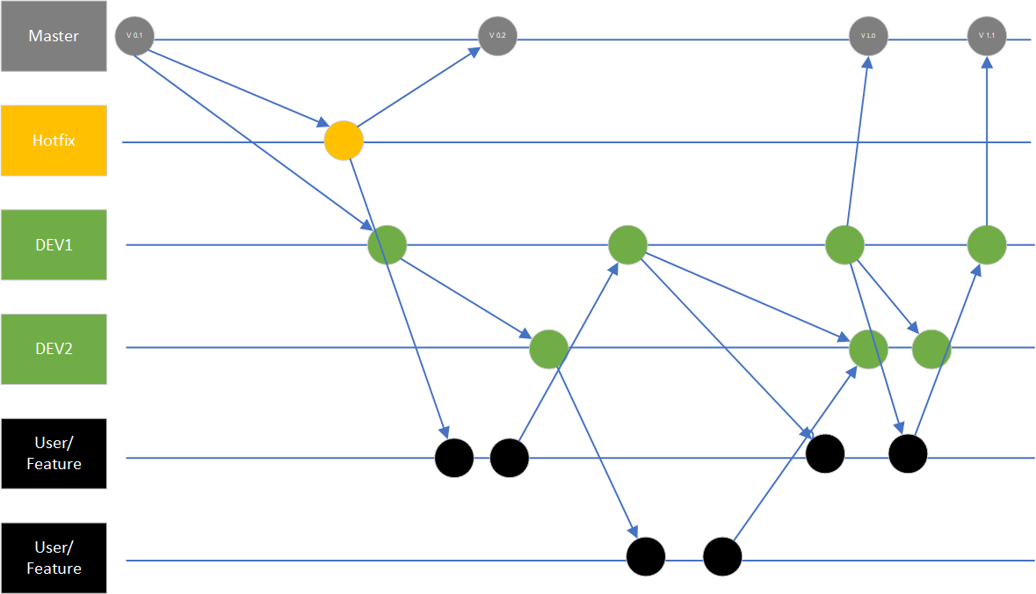
Figure 3-67: Contributor Branch Workflow
The diagram above represents the basic workflow with contributor branches. There is a proper release mechanism that is explained below.

The Main Branches
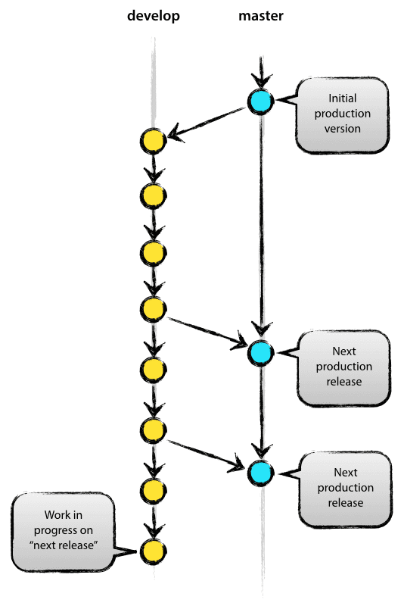
Figure 3-68: Main Branches
At the core, existing models inspire the development model. The central repo holds two main branches with an infinite lifetime:
- Master
- Develop (In our case DEV1, DEV2)
The master branch at origin should be familiar to every Git user. Parallel to the master branch, there is another branch called develop.
The origin/master is the main branch where the source code at HEAD always reflects a production-ready state.
The origin/develop is the main branch where the source code at HEAD always reflects the latest development changes for the next release. This may be referred to as the “integration branch.” This is where any automatic builds are generated.
When the source code in the develop branch reaches a stable point and is ready to be released, all changes should be merged back into master and then tagged with a release number. The detailed process for this will be discussed further on.
Therefore, each time changes are merged back into master, it constitutes a new production release. This will be strictly adhered to. However, a Git hook script can be used to automatically build and deploy software to production servers every time there is a commit on master.

Merge Process
When a branch is created for parallel development, developers will merge changes made in a branch to the trunk when the development and unit testing are completed.
- There are two branches created for parallel Development (DEV1/DEV2), developers will merge changes made from their feature branch to the Development Branches via Pull Requests that would require approval from their leads
- These development branches are used for creating the deployable artifacts for higher environments
- The merge process between the two development branches is automated. For example, any code committed in release n from branch DEV1 is automatically synced with the Bitbucket pipeline for release n+1 in branch DEV2. Therefore, Dev2 (release n+1) will always contain the code from Dev1
- In case of conflicts, an email from the Bitbucket pipeline is sent to the developer indicating that the pipeline has failed. The email includes a link to view the log and see the conflicted files. Developers resolve the conflicts and re-trigger the pipeline for a successful sync
- After every production release, the code is synced from the respective DEV branch to the master branch to keep the master branch in sync with the production code base
The following figure details the Code Merge Process.
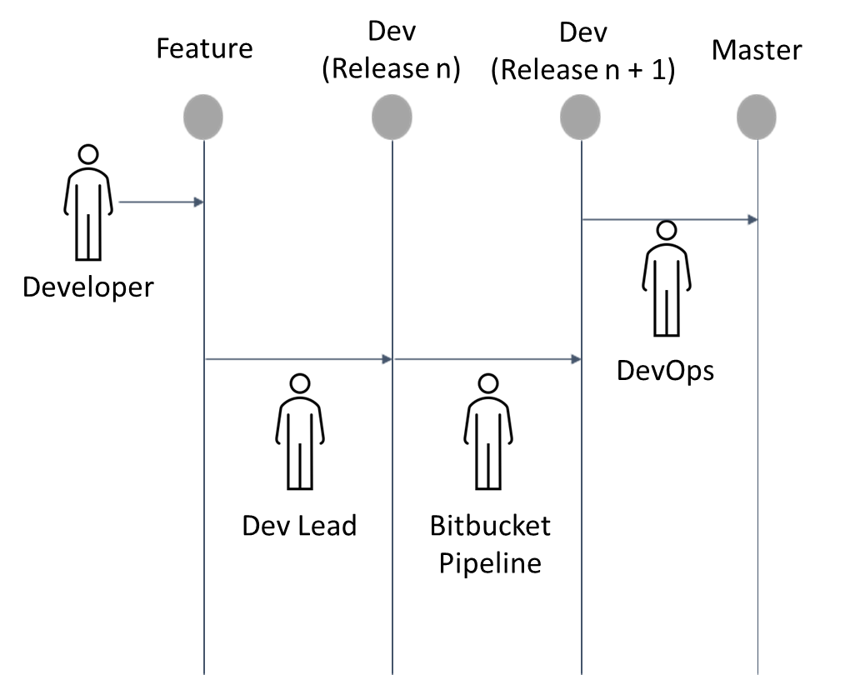
Figure 3-69: Code Merge Process

Release Management
The Release management process is planning, scheduling, and controlling a software build through different stages of releases and environments.

Build Approach
The build strategy employed is to create builds solely derived from the code promoted to the release-specific DEV branch. The code promotion process flow, described below, verifies that the delivery of code does not break the build. The build process generates the deployment artifacts independent of the environment. The environment-specific attributes required to deploy the build artifacts successfully are automatically generated via the environment-specific property injection steps defined in Bamboo for each environment, including production.
By employing this strategy, the risk of recreating build artifacts for each environment is mitigated, which decreases the amount of regression and smoke testing required to validate the build.
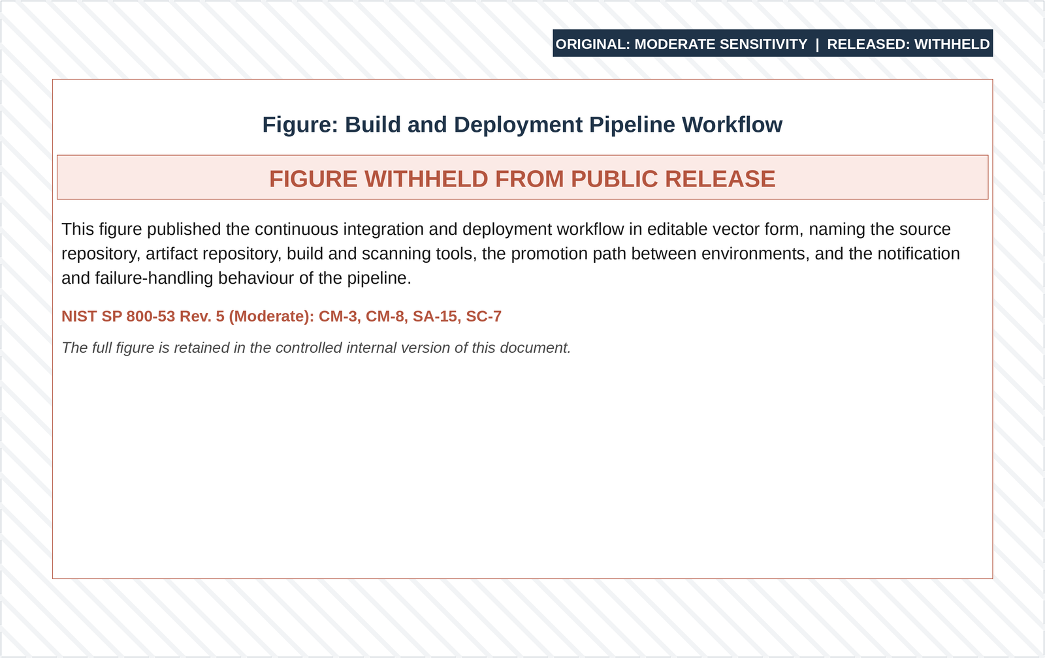
Figure 3-70: Code Promotion Process Flow

Build Readiness
The build readiness considerations listed below are used to kick off a build and safeguard a successful deployment.

General Checklist
            - Successful build
            - Successful smoke testing
- Note: Smoke Test is automated through the Selenium Scripts.

Non-Production Environment
- Continuous integration is performed in the development environment
- Scheduled builds are performed periodically via Bamboo in the development and SIT environments only. All scheduled/planned builds are followed by deployment
- Ad hoc builds are initiated via Bamboo for the development and SIT environments
- Application builds for SIT are generated from the DEV branch and deployed in higher environments
- All builds and/or deployments in SIT and higher environments require approval. The approval can be given by the approver through Jira or by sending an approval email to the Tech Team. The following table provides the applicable approver role for each environment:
# | Environment Name | Approver
1. | Development Environment | Deloitte Development Lead of APP Lead
2. | SIT | Deloitte SIT Lead of AppDev Lead
3. | UAT | UAT Lead
4. | Staging | UAT Lead
5. | Training | Deloitte/State Training Lead
6. | Performance Test | Deloitte Performance Test Lead or AppDev Lead
7. | Conversion | Deloitte Conversation Lead
8. | Production | State
Table 3-67: SIT Build/Deployment Environments and Approvers

Build Migration Strategy
The build migration strategy considers the development of multiple releases and provides the SDLC path for production deployment. The following section describes the migration process for major and minor Releases. This process has been reviewed and agreed upon by DOH.
During major releases, the core-build migration path will use the following sequence (i.e., DEV1, SIT1, UAT, and Production):
- DEV1 (Development) upon successful completion of development iteration, code is delivered from DEV branch
- Upon completion of DEV1 activities, the build is migrated to the SIT1
- Upon completion of SIT1 activities, the build is migrated to the UAT environment. As in SIT, UAT releases are also named and promoted by the same Naming convention
- Upon successful completion of UAT, the build is approved for migration to production by the UAT leads
Below, and in the figure Build Migration Considerations, are key considerations for build migrations:
- Build artifacts from DEV1 may be deployed to SIT1, Training (TRN1), Performance (PRF), and Conversion (CNV)
- STG maintains the same codebase that is deployed to Production (PRD)
- DEV1 and SIT1 are the primary development and test environments for Deloitte
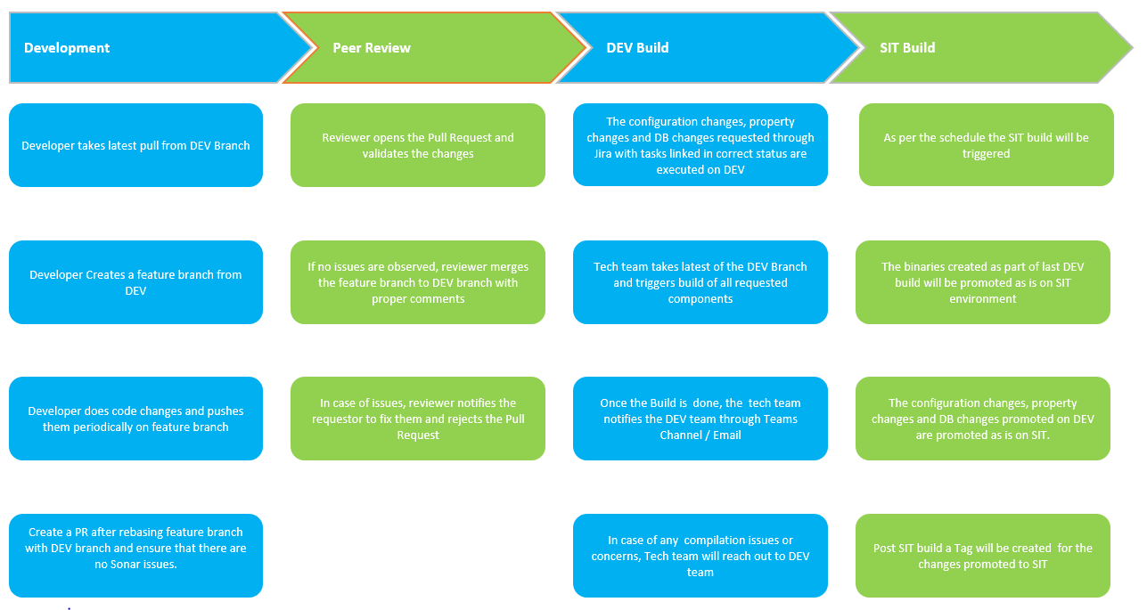
Figure 3-71: Build Migration Considerations

Build Deployment Process
The NY MECM Project has decided to have SIT deployment on planned dates/schedule. Deployment tasks are triggered only for builds smoke tested in Dev Environments the previous day, ensuring the build is stable before being pushed to SIT. Below is the build and deployment process.
- The code is first checked into the feature branch of the developer
- A PR is raised from the developer to the lead for approval for update
- Once a PR is raised and the code is merged, the code is sent for building and deploying the artifacts, with a respective Infra ticket, Property ticket and DB ticket
- Once all the tickets are applied and marked complete for the environment, the CI/CD is triggered for code propagation. Following are the steps that are triggered in build pipeline
- The source code with its relative dependencies’ checkout
- The application is built on the bamboo server with its relative compiler, e.g., ant, maven, ace, node, etc.
- The third-party jar scans are triggered using OWASP
- The Created artifacts are uploaded to the artifactory with the naming convention of MajorRelease.MinorRelease.Patch(Hotfix).BuildID
- Once the build pipeline is complete, it triggers the deployment pipeline, where the following happens:
- The deployed application has all dependencies injected
- The artifacts are then downloaded from the artifactory
- The running application stops, and the downloaded artifacts are published
- Afterwards, the application restart is initiated
- This triggers the automation suite that provides results on environment stability. If the smoke test results fail, the fallback plan is implemented, or the changes are reverted as expected
- To promote to higher environments, all the infrastructure tasks from Jira are pulled and configured in higher environments. Followed by the database scripts that are pending from last deployment to that environment to the current stable deployments are executed in order, i.e., tracked and sequence is maintained in the bitbucket repository. All the deployment tasks for each artifact are then deployed in higher, followed by Automation suite checking the sanity of each environment. A basic flow of CI/CD is shown in the figure below
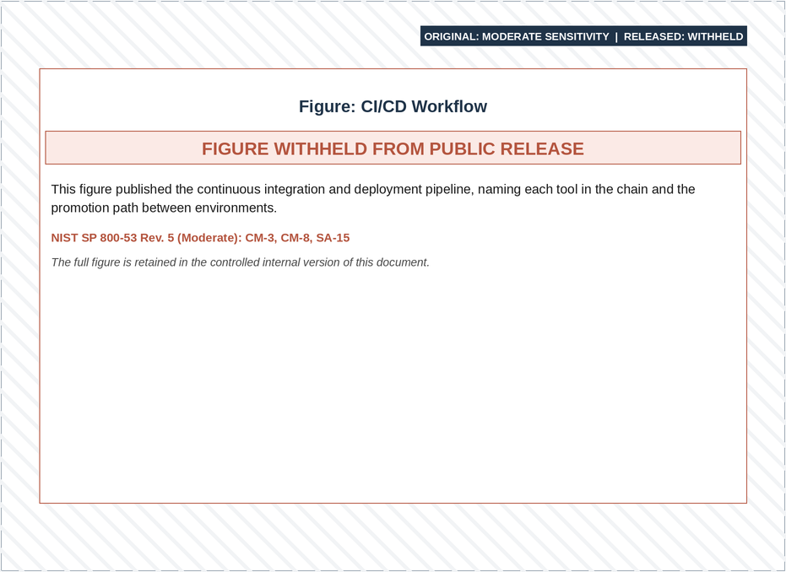
Figure 3-72: CI/CD Workflow

Final Software BOM
Refer to the NY_MECM_Wave0 and Wave 1_Initial_Software_BOM (link to document location: NY_MECM_Wave0 and Wave 1_Initial_Software_BOM.xlsx).

Non-Functional Requirements
Refer to the Non-Functional Requirements RTM (link to document location: Non-Functional Requirements RTM).

Appendix

Appendix A: Terms and Definitions
The following table outlines terms used throughout the document and their corresponding definition.
Term | Definition
AAL | Authenticator Assurance Level
ACE | App Connect Enterprise
ACS | Assertion Consumer Service
AD | Active Directory
ADA | Americans with Disabilities Act
ADFS | Active Directory Federation Services
AES | Advanced Encryption Standard
AI | Artificial Intelligence
ALB | Application Load Balancer
ALM | Application Lifecycle Management
AOM | Assistor Oversight Managers
AOP | Aspect Oriented Programming
AP | Assistor Portal
API | Application Programming Interface
ASVS | Application Security Verification Standard
AWS | Amazon Web Services
AZ | Availability Zones
BFE | Base Filtering Engine
BMT | Bean Managed Transaction
BO-LDSS | Back Office – LDSS
BOM | Bill of Materials
BRE | Business Rules Engine
CA | Certificate Authority
CCAI | Contact Center AI
CCM | Customer Communication Management
CI/CD | Continuous Integration and Continuous Deployment
CIN | Client Identification Number
CMDB | Computer Management Database
CMP | Cloud Managed Platform
CMS | Centers for Medicare and Medicaid Services
CMT | Container Managed Transaction
CNV | Conversion
CORS | Cross Origin Resource Sharing
COTS | Commercial-Off-The-Shelf
CPU | Central Processing Unit
CSPDR | Cloud Security, Prevention, Detection and Response
CSPM | Cloud Security Posture Management
CSRF | Cross-Site Request Forgery
CSS | Cascading Style Sheets
CWP | Cloud Workload Protection
CX | Customer Experience
DAO | Data Access Objects
DAST | Dynamic Application Security Testing
DAWS | Delegated Administration Web Service
DBMS | Database Management System
DDL | Data Definition Language
DEV | Development
DevOps | Development Operations
DevSecOps | Development, Security, and Operations
DFCX | DialogflowCX
DLP | Data Loss Prevention
DMGR | Deployment Manager
DNS | Domain Name Service
DOH OHIP | Department of Health Office of Health Insurance Programs
DOH | Department of Health
DR | Disaster Recovery
DW | Data Warehouse
DVCS | Decentralized Version Control System
EBS | Elastic Block Store
EC2 | Elastic Compute Cloud
ECR | Elastic Container Registry
ECS | Elastic Container Service
EDI | Electronic Data Interchange
EDR | Extended Detection & Response
EFS | Elastic File System
EJB | Enterprise JavaBeans
ELB | Elastic Load Balancer
eMedNY | Electronic Medicaid System of New York
EPDR | Endpoint Prevention, Detection and Response
ERD | Entity-Relationship Diagramming
ESB | Enterprise Service Bus
ESSO | Enterprise Single Sign-On
ETL | Extract, Transform, Load
FDD | Functional Design Document
FTI | Federal Tax Information
GCP | Google Cloud Platform
HA | Highly Available
HIPAA | Health Information Portability Accountability Act
HTML | Hyper Text Markup Language
HTTP | Hypertext Transfer Protocol
HTTPS | Hypertext Transfer Protocol Secure
IaC | Infrastructure-as-code
IAL | Identity Assurance Level
IAM | Identity and Access Management
IBM | International Business Machines Corporation
ICD | Interface Control Document
IDE | Integrated Development Environment
IdM | Redhat Identity Management
IDPs | Identity Providers
IHS | IBM HTTP Server
IICS | Informatica Intelligent Cloud Services
IP | Internet Protocol
IPDR | Identity Prevention, Detection and Response
IRS | Internal Revenue Service
ISD | Interface Standards Documents
ISO | Information Security Office
ITS | Information Technology Services
ITX | IBM Transformation Extender
JEE | Java Enterprise Edition
J2EE | Java 2 Platform Enterprise Edition
JAWS | Job Access with Speech
JIT | Just in Time
JWKS | JSON Web Key Sets
JNDI | Java Naming and Directory Interface
JSON | JavaScript Object Notation
JSP | Java Server Pages
JVM | Java Virtual Machine
JWT | JSON Web Token
KM | Key Message
KMS | Key Management Service
L1 | Level 1
L2 | Level 2
LB | Load Balancers
LDSS | Local Departments of Social Services
LUW | Logical Unit of Work
MARS-E | Minimum Acceptable Risk Standards for Exchanges
MDM | Master Data Management
MECM | Medicaid Eligibility Continuing Modernization
MFA | Multi-Factor Authentication
ML | Machine Learning
ML | Mark-up Language
MP | Member Portal
MVC | Model-View-Controller
MXDR | Managed Extended Detection and Response
NFS | Network File System
NIST | National Institute of Standards and Technology
NSI | Network Store Interface
NYS | New York State
ODS | Operational Data Store
OEM | Oracle Enterprise Manager
OIDC | OpenID Connect
OLS | Oracle Labelling Security
OLTP | Online Transaction Processing
OPA | Oracle Policy Automation
OPM | Oracle Policy Modeling
ORM | Object Relational Mapping
OS | Operating System
OU | Organizational Unit
OWASP | Open Worldwide Application Security Project
PaaS | Platform as a Service
PGA | Program Global Area
PHI | Protected Health Information
PII | Personally Identifiable Information
PITR | Point-In-Time Recovery
PKCE | Proof Key for Code Exchange
PODA | Participating Organization Delegated Administrator
PODSA | Participating Organization Delegated Security Administrator
PRD | Production
PRDP | Pre-Production Performance
PRDT | Pre-Production Test
PRF | Performance
PROD | Production
PVU | Processor Value Unit
QA | Quality Assurance
R4J | Requirements for Jira
RAM | Random Access Memory
RBAC | Role Based Access Control
RDS | Relational Database Service
REST | Representational State Transfer
RIDP | Remote Identity Proofing
RP | Relying Party
RTM | Requirements Traceability Matrix
Sec | Security
S3 | Amazon Simple Storage Service
SaaS | Software as a Service
SADD | Security Architecture Design Deliverable
SAML | Security Assertion Markup Language
SAST | Static Application Security Testing
SCAP | Security Content Automation Protocol
SCEM | Security Configuration and Evaluation Management
SCP | Amazon Service Control Policy
SDLC | Software Development Life Cycle
SDP | Sensitive Data Protection
SES | Simple Email Service
SFTP | Secure File Transfer Protocol
SGA | System Global Area
SIT | System Integration Testing
SITC | System Integration Testing for Conversion
SL&M | Security Logging and Monitoring
SLA | Service Level Agreement
SMS | Short Message Service
SNS | Simple Notification Service
SP | Service Provider
SOA | Service Oriented Architecture
SOAP | Simple Object Access Protocol
SoC | Separation of Concerns
SOC | Security Operations Center
SQL | Structured Query Language
SQLi | SQL injection
SQS | Simple Queue Service
SSA | Social Security Administration
SSL | Secure Sockets Layer/Transport Layer Security
SSM | AWS System Manager
SSN | Social Security Number
SSO | Single Sign-On
STG | Staging
TCP | Transmission Control Protocol
TDE | Transparent Data Encryption
TEDS | Tennessee Eligibility Determination System
tfsec | Aqua Security Terraform Security
TLS | Transport Layer Security
TRN | Training
TSM | Tableau Services Manager
TTP | Tactics, Techniques, and Procedures
TWG | Transit Gateways
UAT | User Acceptance Testing
UDP | User Datagram Protocol
UDP | User Defined Properties
UI | User Interface
URL | Uniform Resource Locator
VDI | Virtual Desktop Infrastructure
VM | Virtual Machine
VPC | Virtual Private Cloud
VPN | Virtual Private Network
WAF | Web Application Firewall
WAS | WebSphere Application Server
WAVE | Web Accessibility Evaluation Tools
WP | Worker Portal
WPAD | Web Proxy Automatic Discovery
WS | Web Service
WSDL | Web Service Description Language
XDR | Extended Detection and Response
XML | Extensible Markup Language
XSS | Cross-Site Scripting
Table 4-1: Terms and Definition

Appendix B: Referenced Documents
S. No. | Document | SharePoint Location
 | Conceptual Architecture with detailed Components | MECM Conceptual Architecture with Detailed Components Revision.pptx
 | Infrastructure and Platform Architecture Diagram | NY-MECM-design_v8.vsdx
 | CP DATA MODELS | CP DATA MODELS
 | CP DATA STRUCTURES | CP DATA STRUCTURES
 | Data Flow & Architecture | NY_Technology_Data Models Flows and Architecture
 | Data Models Flows and Architecture Walkthrough Deck | Data Models flows and Architecture Walkthrough Deck_10.01.2024
 | Del. #20 Function Design Document Topic 12 – Enrollments Bundle #5 | Del.20_FDD_W1_B5_Topic 12_ Enrollments_FDD.docx
 | Del. #22 Interface Technical Design Document | Del.22 Interface Technical Design Document
 | IN09 834 Interface Control Document | Del.22_ICD_IN09_EDI_834.docx
 | Interface Integration Diagram | Interface Integration Diagram
 | MECM Environments Overview | NYS MECM Environment Details_04.30.2025.pptx
 | MECM Logical Architecture Diagram | NY_MECM_Wave1_Logical_Architecture_Diagram.vsdx
 | MECM Physical Architecture Diagram | NY_MECM_Wave1_Physical_Architecture_Diagram.vsdx
 | MECM Tagging Standards | DOH OHIP NY FinOps Tagging Standards.docx
 | NY MECM Wave 1 Logical Architecture Diagram | NY MECM Wave 1 Logical Architecture Diagram
 | System Source Code | Del 26. System Source Code
 | WP DATA MODELS MECM | WP DATA MODELS MECM
 | WP DATA STRUCTURES | WP DATA STRUCTURES
 | WP FTI DATA STRUCTURES | WP FTI DATA STRUCTURES
 | DOH Access to MECM Gitlab | DOH Access to MECM Gitlab SOP v1_0.docx
 | Batch Control Documents | Batches
 | Batch Run Book | NY MECM - Batch Run Book.xlsm
 | DocuEdge Features | NY MECM Filenet Alternatives Options 1.pdf
 | Portals FDDs | 1. Intake: Portals Track  2. Renewals: 08. Renewals  3. Changes + Other Case Modes: 10. Changes + Other Case Modes
 | NY MECM SL&M Runbook | NY MECM SL&M Runbooks.pptx
Table 4-2: Referenced Documents

Appendix C: URLS Monitoring List
Component | URL Pattern
MP | [URL REDACTED][ENDPOINT PATTERN REDACTED]
MP Backend | [URL REDACTED]
WP | [URL REDACTED][ENDPOINT PATTERN REDACTED]
BRE | [URL REDACTED]
CCM | [URL REDACTED]
ESB | [URL REDACTED]
Analytics | [URL REDACTED]
EDM | [URL REDACTED]
Symantec | [URL REDACTED]
Address  Validation | [URL REDACTED]
Table 4-3: URLs Monitoring List
Note: Note: Environment naming convention withheld ([REDACTED]).

