New York State
Department of Health

Continuing Medicaid Eligibility Modernization

DEL-05 Project Management Plan (PMP)

March 14, 2025
Version 2.1

Document Control Information

Document Information
Document Identification | Master Statement of Work (MSOW) Deliverable #5
Document Name | Project Management Plan (PMP)
Project Name | Continuing Medicaid Eligibility Modernization
Client | New York State Department of Health Office of Health Insurance Programs (DOH OHIP)
Document Author | Redacted
Document Version | v2.1
Document Type | MSOW Deliverable

Document Edit History
Version | Date | Addition/Modifications | Prepared/ Revised by
v0.1 | January 3, 2024 | Walkthrough Submission | Redacted
v1.0 | January 29, 2024 | Deliverable Submission | Redacted
v1.1 | September 27, 2024 | Deliverable Resubmission for CR MECM-19564 and MECM-27107 | Redacted
v1.2 | December 24, 2024 | Deliverable Resubmission Addressing DOH comments | Redacted
v2.0 | February 14, 2025 | Deliverable Submission | Redacted
v2.1 | March 14, 2025 | Addressed DOH comments | Redacted

Table of Contents
Preface 1
1 Governance Structure 3
1.1 Introduction 3
1.2 Purpose 3
1.3 Approach 3
1.3.1 Executive Governance 6
1.3.1.1 Executive Steering Committee 6
1.3.2 Managerial Governance 6
1.3.2.1 Project Steering Committee 6
1.3.2.2 Change Advisory Board 6
1.3.2.3 Change Review Board 7
1.3.2.4 Architecture Review Board 7
1.3.3 Project Administration and Execution (PAE) 7
1.3.3.1 Project Management Office 7
1.3.3.2 Technology, Change Management, Security Compliance, Quality Assurance, and Functional Tracks 8
1.4 References 8
1.4.1 Integrated Change Control Process 8
1.4.2 Project Controls Plan 8
1.4.3 Schedule Management Plan 8
1.4.4 Resource/Staff Management Plan 8
1.4.5 Stakeholder Engagement Plan 8
1.4.6 Communications Management Plan 9
1.4.7 Quality Management Plan 9
1.4.8 Deliverable Management Plan 9
2 Software Development Life Cycle Methodology 11
2.1 Introduction 11
2.2 Purpose 11
2.3 MECM SDLC Methodology Overview 11
2.4 MECM SDLC Methodology Detail 20
2.5 Project Wave Planning Phase 20
2.5.1 Phase Entry Criteria 20
2.5.2 Process Flow Diagram 21
2.5.3 Process Flow Narrative 21
2.5.4 Roles and Responsibilities 23
2.5.5 Phase Exit Criteria 23
2.5.6 Supporting Application Lifecycle Management (ALM) Tools 24
2.6 Business Process Analysis Phase 24
2.6.1 Phase Entry Criteria 24
2.6.2 Process Flow Diagram 25
2.6.3 Process Flow Narrative 25
2.6.4 Roles and Responsibilities 28
2.6.5 Phase Exit Criteria 28
2.6.6 Supporting Application Lifecycle Management (ALM) Tools 28
2.7 Requirements Gathering Phase 28
2.7.1 Phase Entry Criteria 28
2.7.2 Process Flow Diagram 29
2.7.3 Process Flow Narrative 29
2.7.4 Roles and Responsibilities 34
2.7.5 Phase Exit Criteria 34
2.7.6 Supporting Application Lifecycle Management (ALM) Tools 34
2.8 Prioritization and Iteration/Bundle Planning 34
2.8.1 Phase Entry Criteria 34
2.8.2 Process Flow Diagram 34
2.8.3 Process Flow Narrative 35
2.8.4 Roles and Responsibilities 38
2.8.5 Phase Exit Criteria 39
2.8.6 Supporting Application Lifecycle Management (ALM) Tools 39
2.9 Design Phase 39
2.9.1 Phase Entry Criteria 39
2.9.2 Process Flow Diagram 40
2.9.3 Process Flow Narrative 40
2.9.4 Roles and Responsibilities 45
2.9.5 Phase Exit Criteria 45
2.9.6 Supporting Application Lifecycle Management (ALM) Tools 45
2.10 Development Phase 46
2.10.1 Phase Entry Criteria 46
2.10.2 Process Flow Diagram 46
2.10.3 Process Flow Narrative 46
2.10.4 Roles and Responsibilities 51
2.10.5 Phase Exit Criteria 51
2.10.6 Supporting Application Lifecycle Management (ALM) Tools 52
2.11 System Integration Test (SIT) Phase 52
2.11.1 Phase Entry Criteria 52
2.11.2 Process Flow Diagram 53
2.11.3 Process Flow Narrative 53
2.11.4 Roles and Responsibilities 59
2.11.5 Phase Exit Criteria 59
2.11.6 Supporting Application Lifecycle Management (ALM) Tools 59
2.12 Solution Exploration Phase 60
2.12.1 Phase Entry Criteria 60
2.12.2 Process Flow Diagram 60
2.12.3 Process Flow Narrative 60
2.12.4 Roles and Responsibilities 62
2.12.5 Phase Exit Criteria 62
2.12.6 Supporting Application Lifecycle Management (ALM) Tools 63
2.13 Operational Readiness Test (ORT) Phase 63
2.13.1 Functional-Related End to End Testing 63
2.13.2 Phase Entry Criteria (Functional ORT) 64
2.13.3 Security and Failover Testing 65
2.13.4 Phase Entry Criteria (Security and Failover ORT) 65
2.13.5 Process Flow Diagram 67
2.13.6 Process Flow Narrative 67
2.13.7 Roles and Responsibilities 74
2.13.8 Phase Exit Criteria (Functional ORT) 75
2.13.9 Phase Exit Criteria (Security and Failover ORT) 75
2.13.10 Supporting Application Lifecycle Management (ALM) Tools 76
2.14 User Acceptance Test (UAT) Phase 76
2.14.1 Phase Entry Criteria 77
2.14.2 Process Flow Diagram 77
2.14.3 Process Flow Narrative 78
2.14.4 Roles and Responsibilities 82
2.14.5 Phase Exit Criteria 82
2.14.6 Supporting Application Lifecycle Management (ALM) Tools 83
2.15 Rollout Phase 83
2.15.1 Phase Entry Criteria 83
2.15.2 Process Flow Diagram 84
2.15.3 Process Flow Narrative 84
2.15.4 Roles and Responsibilities 85
2.15.5 Phase Exit Criteria 85
2.15.6 Supporting Application Lifecycle Management (ALM) Tools 85
2.16 SDLC High-Level Process 86
2.16.1 Process Flow Narrative 86
2.17 ALM Tools 95
2.18 Continuing Medicaid Eligibility Modernization SharePoint 100
2.18.1 ALM Tool Roles and Permissions 100
2.18.2 ALM Tool Workflows 101
2.18.3 Accessing ALM Tool 101
2.19 Figma Organization 101
2.19.1 ALM Tool Roles and Permissions 102
2.19.2 ALM Tool Workflows 102
2.19.3 Accessing ALM Tool 102
2.20 The ALM tool 102
2.20.1 ALM Tool Roles and Permissions 102
2.20.2 ALM Tool Workflows 103
2.20.3 Accessing ALM Tool 103
2.21 the source-code repository 103
2.21.1 ALM Tool Roles and Permissions 104
2.21.2 ALM Tool Workflows 104
2.21.3 Accessing ALM Tool 105
2.22 the static code analysis tool 105
2.22.1 ALM Tool Roles and Permissions 105
2.22.2 ALM Tool Workflows 105
2.22.3 Accessing ALM Tool 106
2.23 the build server 106
2.23.1 ALM Tool Roles and Permissions 106
2.23.2 ALM Tool Workflows 107
2.23.3 Accessing ALM Tool 107
2.24 artifact repository 107
2.24.1 ALM Tool Roles and Permissions 108
2.24.2 ALM Tool Workflows 108
2.24.3 Accessing ALM Tool 109
2.25 Selenium 109
2.25.1 ALM Tool Roles and Permissions 110
2.25.2 ALM Tool Workflows 110
2.25.3 Accessing ALM Tool 111
2.26 WAVE 111
2.26.1 ALM Tool Roles and Permissions 111
2.26.2 ALM Tool Workflows 111
2.26.3 Accessing ALM Tool 111
2.27 JAWS 111
2.27.1 ALM Tool Roles and Permissions 111
2.27.2 ALM Tool Workflows 112
2.27.3 Accessing ALM Tool 112
2.28 The test management tool 112
2.28.1 ALM Tool Roles and Permissions 112
2.28.2 ALM Tool Workflows 112
2.28.3 Accessing the Test Management Tool 115
2.29 Checkmarx SAST 115
2.29.1 ALM Tool Roles and Permissions 115
2.29.2 ALM Tool Workflows 115
2.29.3 Accessing ALM Tool 117
2.30 Burp Suite Pro 117
2.30.1 ALM Tool Roles and Permissions 117
2.30.2 ALM Tool Workflows 117
2.30.3 Accessing ALM Tool 118
2.31 LoadRunner Enterprise 118
2.31.1 ALM Tool Roles and Permissions 119
2.31.2 ALM Tool Workflows 119
2.31.3 Accessing ALM Tool 119
2.32 Splunk 119
2.32.1 ALM Tool Roles and Permissions 119
2.32.2 ALM Tool Workflows 119
2.32.3 Accessing ALM Tool 120
2.33 BrowserStack 121
2.33.1 ALM Tool Roles and Permissions 121
2.33.2 ALM Tool Workflows 121
2.33.3 Accessing ALM Tool 122
2.34 The requirements management tool 122
2.34.1 ALM Tool Roles and Permissions 122
2.34.2 ALM Tool Workflows 123
2.34.3 Accessing ALM Tool 124
3 Stakeholder Engagement Plan 126
3.1 Introduction 126
3.2 Purpose 126
3.3 Stakeholder Engagement Approach 126
3.3.1 Stakeholder Identification and Analysis 126
3.3.2 Communications Management 127
3.3.3 Governance Structure 127
4 Communications Management Plan 129
4.1 Introduction 129
4.2 Purpose 129
4.3 Communications Approach 129
4.3.1 Project Management Communication Channels 129
4.3.2 Project Management Communication Types 130
4.3.3 Guiding Principles of Communications 132
4.3.4 Virtual Meeting Communication Guide 133
4.3.5 In-Person Meeting Communication Guide 134
4.3.6 Schedule of Communications Throughout Delivery Phases 134
4.4 Communications Processes 134
4.4.1 Project Status Report Process Flow Narrative 135
4.4.2 Work Plan Updates Process Flow Narrative 136
4.4.3 SIT/UAT Test Metrics Process Flow Narrative 137
4.4.4 Release Plans Process Flow Narrative 137
4.4.5 Technical Deployment Checklists Process Flow Narrative 137
4.4.6 End-User Training Materials Process Flow Narrative 137
4.4.7 Critical Communication Process Flow Narrative 137
4.5 Communication Review and Approval Process 138
4.5.1 Communication Review and Approval Process Flow Narrative 138
5 Deliverable Management Plan 140
5.1 Introduction 140
5.2 Purpose 140
5.3 Deliverable Expectation Documents and Deliverables 140
5.4 Non-Design Deliverable Management Approach 141
5.4.1 DED/Deliverable Management Process Flow 141
5.4.2 DED/Deliverable Management Process Flow Narrative 142
5.4.3 Collaboration Review Cycle Oversight 144
5.4.4 Collaboration Process for DEDs/Deliverables 144
5.4.5 PMO Review Following Completion of Collaboration Review 144
5.4.6 Final Review and Disposition 146
5.4.7 Modifying Deliverables Post Transmittal Approval 146
5.4.8 Deliverable Approval Criteria 146
5.5 Design Document Deliverable Management Approach 147
5.5.1 Design Document DED/Deliverable Management Process Flow 148
5.5.2 Design Document DED/Deliverable Management Process Flow Narrative 148
5.5.3 Design Document Collaboration Review Cycle Oversight 151
5.5.4 Collaboration Process for Design Document DEDs/Deliverables 151
5.5.5 Final Review and Disposition 151
5.5.6 Modifying Design Deliverables Post Transmittal Approval or Post Concurrence 151
5.5.6.1 Design Updates to FDD Post Transmittal Approval Diagram 152
5.5.6.2 Design Updates to FDD Post Transmittal Approval Narrative 152
5.5.7 Storing Design Documentation in DOH SharePoint 156
5.5.8 Deliverable Approval Criteria 156
5.6 Work Products 156
5.7 Application Lifecycle Management (ALM) Tools 157
6 Budget Management Plan 159
6.1 Introduction 159
6.2 Purpose 159
6.3 Budget Management Approach 159
6.3.1 Initial Budget Allocation Process 159
6.3.1.1 Budget Allocation Process Flow Diagram 159
6.3.1.2 Initial Budget Allocation Process Flow Narrative 160
6.3.1.3 Budget Maintenance 161
6.3.2 Invoicing 161
6.3.2.1 Invoicing Process Flow Diagram 162
6.3.2.2 Invoicing Process Flow Narrative 162
6.3.3 Budget Reporting 163
6.3.4 Budget Adjustments 163
6.4 Tool and Descriptions 164
6.5 State Of New York Claim for Payment Form 165
6.6 OHIP Invoice Submission FAQ 166
7 Quality Management Plan 168
7.1 Introduction 168
7.2 Purpose 168
7.3 Quality Assurance Approach 168
7.3.1 Implementing the Quality Management Plan 169
7.3.2 Quality Management to Meet State and Federal Regulations 169
7.3.3 Quality Assurance Reviews 169
7.3.4 Project Quality Standards 170
7.3.5 Standard Verification 171
7.3.6 Standard Verification Checklists 173
7.3.7 Quality Assurance Reporting 173
7.3.7.1 Contract Compliance 173
7.3.7.2 Evaluation of Standards 173
7.3.8 Continuous Process Improvement 174
7.4 Quality Control Plan 174
7.4.1 Transmittal Management 174
7.4.1.1 Transmittal Process – Inbound Flow Diagram 175
7.4.1.2 Transmittal Process – Inbound Process Flow Narrative 175
7.4.1.3 Transmittal Process – Outbound Flow Diagram 177
7.4.1.4 Transmittal Process – Outbound Process Flow Narrative 177
7.4.2 Components of DED/Deliverable Quality Reviews 178
7.4.3 Approval Process 179
7.4.3.1 Approved 179
7.4.3.2 Approved with Comments 179
7.4.3.3 Rejected 179
7.4.4 Quality Control Tools 179
7.5 Quality Support Plan 180
7.5.1 Engagement Review Program 180
7.5.2 Delivery Excellence Program 181
7.5.3 Guest Star Program 181
7.5.4 External Training and Tools Support 182
7.6 DED Checklist 182
7.7 Deliverable Quality Checklist 183
7.8 References 183
7.8.1 SDLC Methodology 183
7.8.2 Deliverable Management Plan 183
7.8.3 Project Controls Plan 183
7.8.4 Test Management Plan 183
7.8.5 Maintenance and Operations Run Book 183
8 Resource Management Plan 185
8.1 Introduction 185
8.2 Purpose 185
8.2.1 Organizational Structure 185
8.3 Resource/Staff Management Approach 185
8.3.1 Staffing Process 185
8.3.1.1 Staffing Process Flow Diagram 186
8.3.1.2 Staffing Process Flow Narrative 186
8.3.2 Staffing Management 188
8.3.3 Personnel Transition 188
8.3.4 Onboarding 188
8.3.5 Offboarding 189
8.3.6 Application Lifecycle Management Tools 189
9 Project Controls Plan 191
9.1 Introduction 191
9.2 Purpose 191
9.3 Risk Management Approach 191
9.3.1 Risk Management Process Summary 191
9.3.2 Risk Management Process Flow Diagram 192
9.3.3 Risk Management Process Flow Narrative 193
9.3.4 Risk Status 195
9.3.5 Risk Attributes, Types, and Tracks 196
9.3.6 Escalation Level 196
9.3.7 Risk Probability, Impact, and Severity 197
9.3.8 Risk Monitoring and Reporting 198
9.3.9 Lessons Learned 199
9.4 Issue Resolution Approach 199
9.4.1 Issue Identification Summary 199
9.4.2 Issue Resolution Process Summary 199
9.4.3 Issue Resolution Process Flow Diagram 200
9.4.4 Issue Resolution Process Flow Narrative 200
9.4.5 Issue Status 201
9.4.6 Issue Attributes, Types, and Tracks 202
9.4.7 Escalation Level 202
9.4.8 Issue Monitoring and Reporting 203
9.5 Action Item (AI) Management 204
9.5.1 Action Item Management Process Flow 204
9.5.2 Action Item Management Process Flow Narrative 204
9.5.3 Action Item Attributes 205
9.5.4 Action Item Types 206
9.5.5 Action Item Priorities 206
9.5.6 Action Item Status 206
9.5.7 Close Action Item 207
9.5.8 Action Item Monitoring and Reporting 207
9.6 Decision Management 207
9.6.1 Decision Management Process Flow Diagram 208
9.6.2 Decision Management Process Flow Narrative 208
9.6.3 Decision Attributes 208
9.6.4 Decision Monitoring and Reporting 209
10 Integrated Change Control Process 211
10.1 Integrated Change Control Overview 211
10.2 Introduction and Purpose 211
10.3 Objectives 211
10.4 Integrated Change Control Process Roles and Responsibilities 212
10.5 Integrated Change Control Process 212
10.6 Identifying and Requesting Changes 212
10.6.1 Prioritizing Change Requests for Impact Assessment and Decision 218
10.6.2 Change Request Statuses 219
10.7 Change Request Evaluation/Authorization 219
10.7.1 Change Request Implementation 220
10.7.2 Procedures for Emergency Change 221
10.8 Tools 221
10.9 ALM Tool Attributes 221
10.9.1 ALM Tool Workflow 222
11 Schedule Management Plan 224
11.1 Introduction 224
11.2 Purpose 224
11.3 Schedule Management Approach 224
11.3.1 Schedule Management Process Flow Diagram 224
11.3.2 Schedule Management Process Flow Narrative 225
11.4 Schedule Performance Monitoring 227
11.4.1 Background and Purpose 227
11.4.2 Schedule Performance Index 227
11.4.3 Variance 228
11.4.4 Stakeholder Engagement 228
11.4.5 Sample SPI Dashboard 228
11.5 Work Plan 229
11.5.1 Core Contents 229
11.5.2 Work Plan Fields 230
11.5.3 Monitoring and Managing Updates 231
11.5.4 Operational Quality 231
11.6 Task Creation and Maintenance 233
11.6.1 Establishing the Overall Work Plan Structure 233
11.6.2 Creating a Task 234
11.6.3 Removing or Cancelling a Task 235
11.6.4 Assigning a Task 235
11.6.5 Leveling and Resource Balancing 235
11.6.6 Controlling the Schedule 235
11.6.6.1 Adding Notes to a Task 237
11.6.7 Flagging Tasks for Discussion 237
11.6.8 Baselining the Project 237
12 Requirements Management Plan 239
12.1 Introduction 239
12.2 Purpose 239
12.3 Requirements Management Approach 239
12.3.1 Requirement Types 240
12.3.2 Requirements Status Reporting 240
12.4 Initial Requirements Approval Process 240
12.4.1 Initial Requirements Approval Process Flow 240
12.4.2 Initial Requirements Approval Process Flow Narrative 241
12.5 Post Transmittal Approval Requirements Modifications 242
12.5.1 Post Transmittal Approval Requirements Modification Process Flow 243
12.5.2 Post Transmittal Approval Requirements Modification Process Narrative 243
12.6 Requirements Traceability 245
12.6.1 Requirements Management Tool 245
12.6.2 Requirements Attributes in the ALM tool 245
12.7 Requirements Versioning Control 246
13 Appendix 248
13.1 Appendix A: Terms and Definitions 248
13.2 Appendix B: Acronyms 251
13.3 Appendix C: Roles and Responsibilities 254
13.4 Appendix D: ALM Tool Field Attributes and Workflows 276
13.5 Appendix E: DED/Deliverable Quality Checklists 277
13.6 Appendix F: Best Practices for Writing Clear System Requirements 278
13.7 Appendix G: Collaboration Process for DEDs/Deliverables 280
13.8 Appendix H: Design Document Storage on DOH SharePoint 280
13.9 Appendix I: Change Tracker for Modifying Deliverables Post Transmittal Approval 280

Table of Figures
Figure 1-1: Governance Structure 4
Figure 2-1: Approach to Application SDLC 13
Figure 2-2: Project Wave Planning Phase Process Flow 21
Figure 2-3: Business Process Analysis Phase Process Flow 25
Figure 2-4: Requirements Gathering Phase Process Flow 29
Figure 2-5: Prioritization and Iteration/Bundle Planning Phase Process Flow 35
Figure 2-6: Design Phase Process Flow 40
Figure 2-7: Development Phase Process Flow 46
Figure 2-8: SIT Process Flow 53
Figure 2-9: Solution Exploration Process Flow 60
Figure 2-10: Operational Readiness Test Phase Process Flow 67
Figure 2-11: User Acceptance Test (UAT) Process Flow Diagram 78
Figure 2-12: Rollout Phase Process Flow 84
Figure 2-13: SDLC High-Level Process Flow 86
Figure 2-14: Overview of ALM Tools Utilized for MECM 96
Figure 2-15: ALM Tools Supporting SDLC Methodology 100
Figure 2-16: Source-Code Repository Workflow 104
Figure 2-17: Static Code Analysis Workflow 105
Figure 2-18: Build Server Workflow 107
Figure 2-19: artifact repository Workflow 108
Figure 2-20: Selenium High-Level Process 110
Figure 2-21: Test Case Workflow 113
Figure 2-22: Test Run Workflow 114
Figure 2-23: Checkmarx SAST Workflow 116
Figure 2-24: Burp Suite Workflow 117
Figure 2-25: Splunk Workflow 120
Figure 2-26: BrowserStack Workflow 121
Figure 2-27: Requirements Traceability Conceptual Design 123
Figure 4-1: Communications Process Flow 135
Figure 5-1: PMO Review Following Completion of Collaboration Review Process 145
Figure 6-1: Initial Budget Allocation Process Flow Diagram 160
Figure 6-2: Invoicing Process Flow Diagram 162
Figure 6-3: State Of New York Claim for Payment Form 165
Figure 6-4: OHIP Invoice Submission FAQ 166
Figure 7-1: Transmittal Process - Inbound 175
Figure 7-2: Transmittal Process - Outbound 177
Figure 7-3: Six Categories of Project Review 181
Figure 8-1: Staffing Process Flow Diagram 186
Figure 9-1: Risk Management Process Flow 193
Figure 9-2: Sample Risk Dashboard 198
Figure 9-3: Issue Resolution Process Flow 200
Figure 9-4: Sample Issue Dashboard 204
Figure 9-5: Action Item Management Process Flow Diagram 204
Figure 9-6: Decision Management Process Flow 208
Figure 11-1: Schedule Management Process Flow Diagram 225
Figure 11-2: Sample SPI Dashboard 229
Figure 12-1: Requirements Management Process Flow Diagram 240
Figure 12-2: Post Transmittal Approval Requirements Modification Process Flow Diagram 243

Table of Tables
Table 1-1: Governance Structure Membership 5
Table 2-1: NYS ITS SDLC Guideline to Continuing Medicaid Eligibility Modernization Document/Deliverable Mapping 12
Table 2-2: SDLC High-Level Process Key Inputs and Outputs 18
Table 2-3: MECM Key Stakeholders 20
Table 2-4: Project Wave Planning Phase Entry Criteria 20
Table 2-5: Project Wave Planning Phase Process Flow Narrative 23
Table 2-6: Project Wave Planning Phase Exit Criteria 24
Table 2-7: Business Process Analysis Phase Entry Criteria 24
Table 2-8: Business Process Analysis Process Flow Narrative 27
Table 2-9: Business Process Analysis Phase Exit Criteria 28
Table 2-10: Requirements Gathering Phase Entry Criteria 29
Table 2-11: Requirements Gathering Phase Process Flow Narrative 33
Table 2-12: Requirements Gathering Phase Exit Criteria 34
Table 2-13: Prioritization and Iteration/Bundle Planning Phase Entry Criteria 34
Table 2-14: Prioritization and Iteration/Bundle Planning Phase Process Flow Narrative 38
Table 2-15: Prioritization and Iteration/Bundle Planning Phase Exit Criteria 39
Table 2-16: Design Phase Entry Criteria 40
Table 2-17: Design Phase Process Flow Narrative 45
Table 2-18: Design Phase Exit Criteria 45
Table 2-19: Development Phase Entry Criteria 46
Table 2-20: Development Phase Process Flow Narrative 51
Table 2-21: Development Phase Exit Criteria 52
Table 2-22: SIT Phase Entry Criteria 52
Table 2-23: SIT Phase Process Flow Narrative 59
Table 2-24: SIT Phase Exit Criteria 59
Table 2-25: Solution Exploration Phase Entry Criteria 60
Table 2-26: Solution Exploration Phase Process Flow Narrative 62
Table 2-27: Solution Exploration Phase Exit Criteria 63
Table 2-28: Functional Testing Entry Criteria 65
Table 2-29: Security and Failover Testing Entry Criteria 66
Table 2-30: Operational Readiness Test Phase Process Flow Narrative 74
Table 2-31: Operational Readiness Test Testing Types 75
Table 2-32: Functional Testing Exit Criteria 75
Table 2-33: Security and Failover Testing Exit Criteria 76
Table 2-34: User Acceptance Test (UAT) Phase Entry Criteria 77
Table 2-35: User Acceptance Test (UAT) Phase Process Flow Narrative 82
Table 2-36: User Acceptance Test (UAT) Phase Exit Criteria 82
Table 2-37: Rollout Phase Entry Criteria 83
Table 2-38: Rollout Process Flow Narrative 85
Table 2-39: Rollout Phase Exit Criteria 85
Table 2-40: SDLC High-Level Process Narrative 95
Table 2-41: ALM Tools and Artifacts 99
Table 2-42: ALM Tool Roles and Permissions 101
Table 2-43: Continuing Medicaid Eligibility Modernization SharePoint Links for MECM System 101
Table 2-44: SharePoint Access 101
Table 2-45: Figma Roles and Responsibilities 102
Table 2-46: Figma Access 102
Table 2-47: ALM Tool Roles and Responsibilities 103
Table 2-48: ALM Tool Access 103
Table 2-49: Source-Code Repository Roles and Permissions 104
Table 2-50: Source-Code Repository Workflow Narrative 104
Table 2-51: Source-Code Repository Access 105
Table 2-52: Static Code Analysis Roles and Permissions 105
Table 2-53: Static Code Analysis Workflow Narrative 106
Table 2-54: Static Code Analysis Access 106
Table 2-55: Build Server Roles and Permissions 106
Table 2-56: Build Server Workflow Narrative 107
Table 2-57: Build Server Access 107
Table 2-58: artifact repository Roles and Permissions 108
Table 2-59: artifact repository Workflow Narrative 109
Table 2-60: artifact repository Access 109
Table 2-61: Selenium Roles and Responsibilities 110
Table 2-62: Selenium Workflow Narrative 110
Table 2-63: WAVE Roles and Responsibilities 111
Table 2-64: JAWS Roles and Responsibilities 112
Table 2-65: Test Management Tool Roles and Permissions 112
Table 2-66: Test Case Workflow Narrative 113
Table 2-67: Test Run Workflow Narrative 114
Table 2-68: Test Management Tool Access 115
Table 2-69: Checkmarx Roles and Permissions 115
Table 2-70: Checkmarx SAST Workflow Narrative 116
Table 2-71: Checkmarx Access 117
Table 2-72: Burp Suite Roles and Permissions 117
Table 2-73: Burp Suite Workflow Narrative 118
Table 2-74: Burp Suite Access 118
Table 2-75: LoadRunner Roles and Permissions 119
Table 2-76: LoadRunner Access 119
Table 2-77: Splunk Roles and Permissions 119
Table 2-78: Splunk Workflow Narrative 120
Table 2-79: Splunk Access 121
Table 2-80: BrowserStack Roles and Permissions 121
Table 2-81: BrowserStack Workflows 122
Table 2-82: Requirements Management Tool Roles and Permissions 123
Table 2-83: Requirements Traceability Conceptual Design Narrative 124
Table 2-84: ALM Tool Access 124
Table 4-1: Project Management Communication Channels 130
Table 4-2: Project Management Communication Types 132
Table 4-3: Communication Approach Guiding Norms 133
Table 4-4: Virtual Meeting Guide 133
Table 4-5: In-Person Meeting Guide 134
Table 4-6: Project Status Report Process 136
Table 4-7: Work Plan Updates 136
Table 4-8: Critical Communication Process Flow Narrative 138
Table 4-9: Communication Review and Approval Process Flow Narrative 138
Table 5-1: Summary of Continuing Medicaid Eligibility Modernization Non-Design Documentation 141
Table 5-2: DED/Deliverable Management Process Flow Narrative 143
Table 5-3: PMO Review Post Collaboration 146
Table 5-4: Summary of MECM Design Documentation 148
Table 5-5: FDD and Related Documentation Development Process Narrative 151
Table 5-6: ICCP Approval for Design Documentation 152
Table 5-7: Design Updates Post FDD Approval Narrative 156
Table 6-1: Initial Budget Allocation Process Narrative 161
Table 6-2: Invoicing Process Flow Narrative 163
Table 6-3: Tools and Descriptions 164
Table 7-1: Standard Verification 171
Table 7-2: Document Review Types 172
Table 7-3: Methods of Measuring Standards 173
Table 7-4: MECM Transmittal Process - Inbound Flow Narrative 176
Table 7-5: MECM Transmittal Process - Outbound Flow Narrative 178
Table 7-6: Deliverable Review Process Components 178
Table 7-7: Quality Control Tools 180
Table 7-8: Guest Star Support Plan 182
Table 8-1: Staffing Process Flow Narrative 187
Table 9-1: Risk Management Process Flow Narrative 195
Table 9-2: Risk Status 196
Table 9-4: Probability Values of Risks 197
Table 9-5: Impact Values of Risks 197
Table 9-6: Impact x Probability Matrix to Calculate Risk Severity 197
Table 9-7: Issue Resolution Process Flow Narrative 201
Table 9-8:Issue Status 202
Table 9-9: Action Item Management Process Flow Narrative 205
Table 9-11: Action Item Types 206
Table 9-12: Action Item Status 207
Table 9-13: Decision Management Process Flow Narrative 208
Table 10-1: Process Steps for Initiation/Change Identification of Change Requests 214
Table 10-2: Process Steps for Change Request Evaluation 218
Table 10-3: Change Request Implementation Process 218
Table 10-4: Change Request Statuses 219
Table 10-5: Change Control Tools 221
Table 11-1: Schedule Management Process Flow Narrative 227
Table 11-2: SPI Variance Types 228
Table 11-3: Standard Fields 231
Table 11-4: Quality Checks 233
Table 11-5: Example Deliverable Development Tasks in Work Plan 234
Table 11-6: Example Deliverable Transmittal Tasks in Work Plan 234
Table 11-7: Schedule Techniques 237
Table 12-1: Initial Requirements Approval Process Flow Narrative 242
Table 12-2: Post Transmittal Approval Requirements Modification Process Flow Narrative 245
Table 12-3: Versioning 246
Table 13-1: Terms and Definitions 250
Table 13-2: Acronyms 253
Table 13-3: SDLC Roles and Responsibilities 261
Table 13-4: Stakeholder Engagement Roles and Responsibilities 265
Table 13-5: Communications Management Plan Roles and Responsibilities 266
Table 13-6: Deliverable Management Plan Roles and Responsibilities 267
Table 13-7: Budget Management Plan Roles and Responsibilities 268
Table 13-8: Quality Management Plan Roles and Responsibilities 270
Table 13-9: Resource Management Plan Roles and Responsibilities 271
Table 13-10: Project Controls Plan Roles and Responsibilities 272
Table 13-11: Integrated Change Control Process Roles and Responsibilities 273
Table 13-12: Schedule Management Plan Roles and Responsibilities 274
Table 13-13: Requirements Management Plan Roles and Responsibilities 275
Table 13-14: ALM Tool Workflows 276
Table 13-15: DED/Deliverable Quality Checklists 277
Table 13-16: Writing Style Guide and Quality 278
Table 13-17: PMI PMBOK® Requirements Criteria 279
Table 13-18: Requirement Examples Based on CMS/PMBOK Guidelines 279

Preface
This Project Management Plan (PMP) provides a comprehensive overview of the management approaches for the New York State Department of Health Office of Health Insurance Programs (DOH OHIP), Continuing Medicaid Eligibility Modernization project. This project could have multiple sub-projects including the Medicaid Eligibility and Client Management (MECM) system, Appeals Solution, and future enhancements. It serves as a baseline any associated projects and details ███████’s and DOH OHIP’s approach and plan for project management of the Continuing Medicaid Eligibility Modernization project. The document outlines the strategic approach and methodologies employed to promote the successful planning, execution, and monitoring of the project.
The PMP documents the structure, processes, and resources that are used to execute the project; covers the project organization, approach and timeline, work planning and controls, resource management, tools, and communication plans; and serves as a single reference point for policies and procedures for project management responsibilities. The PMP serves as the foundation for the project team to organize, prioritize, coordinate, integrate, and monitor project activities.
The PMP provides project team members, stakeholders, and decision-makers with a clear roadmap to navigate the complexities of the Continuing Medicaid Eligibility Modernization project and achieve the desired outcomes. The PMP, which is organized into twelve sections, addresses the following areas of project management:
- Governance Structure
- Software Development Life Cycle (SDLC) Methodology
- Stakeholder Engagement Plan
- Communications Management Plan
- Deliverable Management Plan
- Budget Management Plan
- Quality Management Plan
- Resource Management Plan
- Project Controls Plan
- Integrated Change Control Process
- Schedule Management Plan
- Requirements Management Plan

Upon approval by DOH OHIP, the PMP will be updated and maintained throughout the duration of the project to reflect the current, agreed-upon project management approach.

Section 1 – Governance Structure

Governance Structure

Introduction
The Governance Structure provides the framework to effectively align key functions, leadership, and execution to deliver project success. The Governance structure intends to support the Continuing Medicaid Eligibility Modernization project by standardizing processes and improving efficiency. This document outlines how committees, processes, and cadences interact to form a comprehensive Governance Structure.

Purpose
The Governance Structure outlines key components of how the project will be governed. The right team structure, supported by a decision authority and escalation framework, is essential for defining successful project governance. Project escalation procedures are directly aligned with the project governance hierarchy.
The objective of the Governance Structure is to provide a structure that achieves the following:
- Outlines the overall governance approach to achieve project analysis, control, review, and decision making
- Identifies the responsibilities of each governance body: Executive Governance, Managerial Governance, and Project Administration and Execution
- Defines processes for how governance bodies escalate and address items

Approach
The Governance Structure is comprised of three levels: Executive Governance, Managerial Governance, and Project Administration and Execution. Within each governance level, committees maintain responsibilities across activities throughout the project life cycle. Committees include members of both, ███████ and New York State DOH OHIP teams, to confirm that decisions align with project priorities and with team expertise. The subsequent sections describe the committees in detail.
Figure 1-1 illustrates how the various governance committees share information and contribute to the project’s overall escalation framework.

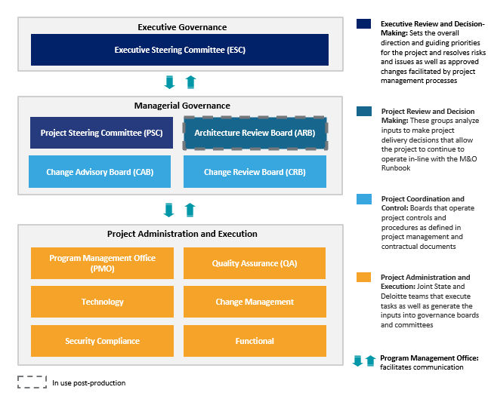
Figure 1-1: Governance Structure
Table 1-1 illustrates the membership of each level of the Governance Structure:
Role | Executive Governance | Managerial Governance | Project Administration and Execution
Medicaid Director | ✔
Medicaid Chief Operating Officer (COO) | ✔
Division of Eligibility and Marketplace Integration (DEMI) Director | ✔ | ✔
DEMI Deputy Director | ✔ | ✔ | ✔
eMedNY Bureau Director | ✔
NY State of Health (NYSOH) Bureau Director | ✔
Division of Operations and Systems (DOS) Chief Information Office (CIO) | ✔ | ✔
DOS Chief Technology Officer (CTO) | ✔ | ✔
DOS Deputy CIO | ✔ | ✔ | ✔
DOS Deputy Director/Security and Privacy Bureau Director | ✔ | ✔
DOS Project Director | ✔ | ✔ | ✔
DOS Program Manager |  | ✔ | ✔
DOH OHIP Implementation and Organizational Change Management (OCM) Manager |  | ✔ | ✔
DOS Functional Manager |  | ✔ | ✔
MECM Quality Assurance (QA) Manager |  | ✔ | ✔
DOS Technical Director | ✔ | ✔ | ✔
DOS Technical Manager |  | ✔ | ✔
███████ Human Services Transformation Practice Leader | ✔
███████ New York State (NYS) Account Consulting Leader | ✔
███████ Project Executive | ✔ | ✔
███████ Project Director | ✔ | ✔
███████ OCM Director | ✔ | ✔ | ✔
███████ Technical Director |  | ✔ | ✔
███████ Project Management Office (PMO) Manager |  | ✔ | ✔
███████ Functional Manager |  | ✔ | ✔
███████ Implementation & OCM Manager |  |  | ✔
███████ QA Manager |  |  | ✔
███████ Technical Manager |  |  | ✔
███████ Security Manager |  |  | ✔
███████ Application Development Manager |  |  | ✔
Table 1-1: Governance Structure Membership

Executive Governance
Executive Governance, made up of DOH OHIP and ███████ leadership, is the highest level of control and authority in the Governance Structure. Executive Governance members convene monthly as the Executive Steering Committee (ESC).

Executive Steering Committee
The ESC provides a monthly forum for strategic discussions between ███████ and DOH OHIP leadership. Representatives from both organizations review program goals, business priorities, and outcomes. In doing so, the ESC sets overall direction for the Continuing Medicaid Eligibility Modernization project and oversees resource alignment. If necessary, the ESC can gather outside of the scheduled monthly meetings.
ESC members are also responsible for making decisions on escalated risks, issues, or change requests, in accordance with the Integrated Change Control Process (ICCP) (refer to Section 10) and the Project Controls Plan (refer to Section 9), summarized in Sections 1.4.1 and 1.4.2 below. When items are escalated out of Managerial Governance committees, the Project Management Office (PMO) facilitates ESC review by working with project teams to compile necessary information and coordinate presentations and discussions. The PMO communicates outcomes from ESC meetings to Managerial Governance entities and Project Administration and Execution teams.

Managerial Governance
Managerial Governance, which is made up of Project Administration and Execution team leadership, is the second highest level of the Continuing Medicaid Eligibility Modernization Project Governance Structure. Managerial Governance includes the Project Steering Committee (PSC), the Architecture Review Board (ARB), the Change Advisory Board (CAB), and the Change Review Board (CRB). These committees are responsible for analyzing potential risks, issues, and change requests and making project decisions or recommendation to Executive Governance that emerge from Project Administration and Execution activities.
When an item requires escalation to Managerial Governance, as determined by the ICCP and Project Controls Plan, the PMO facilitates this process by working with the project teams to compile the necessary information and present it to the appropriate Managerial Governance committees. If further escalation to Executive Governance is necessary, the PMO also liaises in that process.

Project Steering Committee
The PSC, which is comprised of representatives from ███████ and DOH OHIP project leadership, sets project priorities and discusses escalated risks, issues, and change requests (CRs) that could impact project objectives but do not require ESC input. The PSC meets on a weekly cadence during the Project Status Report Meeting to discuss the previously outlined topics. In addition, the PSC controls and monitors each project’s critical path schedule and monitors project progress, as outlined in the Schedule Management Plan (refer to Section 11) summarized in Section 1.4.3 below, to promote compliance with the project schedule, budget, and scope. PSC members, having holistic oversight over managerial activities, also support the other Managerial Governance committees with decisions.

Change Advisory Board
The CAB is responsible for the oversight and management of Contract Administration and Release Planning.
Contract Administration: This involves contracting, procurement, and budget management as well as reviewing and approving contract administration documents for contract compliance. In addition, contract administration includes oversight of contract life cycle management and the tracking of counterparties, terms and conditions, contract financials, staff, contractual risk, contract security and access, and contract management key performance indicators (KPIs). The CAB meets as necessary to discuss contractual items as they arise and require discussion and input. The CAB is responsible for monitoring contract compliance, service level agreement reports, invoices, and Individual Statement of Work (ISOW) processing and execution.
Release Planning: This involves project leadership across tracks and oversees the project’s Release Planning process. Release Planning requires stakeholders to effectively collaborate and commit to a plan for delivering a product increment by a given deadline. Project Administration and Execution teams present objectives, priorities, technical specifications, and dependencies to the CAB and then work with the CAB members to reach a shared plan based on available resources. This method creates a platform for cross-functional collaboration throughout the project.
As part of Release Planning, the CAB maintains the project release runway and project release plan for the Project Administration and Execution teams and coordinates non-critical path release and deployment schedules. The CAB also validates release readiness for technical and business items or maintenance releases and assesses proposed changes to the release plan to identify risks and secure approvals when needed.

Change Review Board
The CRB reviews, assesses, and dispositions all Change Requests for the project.

Architecture Review Board
The ARB, which is made up of technical leadership and business leadership across project tracks, manages technical changes in accordance with the ICCP, and is responsible for enterprise architecture governance. This includes approving and publishing target architecture, assessing compliance with target architecture, and engaging stakeholders to correct noncompliance.
When items are escalated from the Project Administration and Execution teams, the ARB reviews and approves technical and security changes in the MECM environments, including patches, product upgrades, maintenance, and architectural changes related to major system enhancements or technical upgrades. Given this scope, the ARB is responsible for proactively managing patching and upgrading calendars and changes to software and cloud bill of materials (BOM), if there are any.

Project Administration and Execution (PAE)
Project Administration and Execution includes the PMO, the Technology team, the Change Management team, the Security Compliance team, and the Functional team. These teams are responsible for developing and executing Continuing Medicaid Eligibility Modernization tasks, and thus, also identifying items that need escalation to Managerial Governance or Executive Governance during project planning and execution. The PAE meets, at minimum, weekly to discuss the progress, action items, and milestones for their respective tracks.
The PMO supports all track teams by working with them to monitor and report on ongoing progress, present regular updates, and navigate project escalations, in accordance with the ICCP and Project Controls Plan. The PMO helps by tracking and compiling the necessary information and delivering it to the appropriate Managerial and Executive committees.

Project Management Office
The PMO is comprised of dedicated project management staff from both ███████ and DOH OHIP. The PMO facilitates effective governance execution in accordance with this Governance Structure and enables cross-program integration in alignment with the Stakeholder Engagement Plan (refer to Section 3) and the Communications Management Plan (refer to Section 4), summarized in Sections 1.4.5 and 1.4.6 below.
The PMO administers the change request process and escalates items to Managerial Governance and Executive Governance. Technology, Change Management, Security Compliance, and Functional tracks partner with the PMO to receive leadership reviews and approvals, in accordance with the Quality Management Plan (refer to Section 7) and the Deliverable Management Plan (refer to Section 5), summarized in Sections 1.4.7 and 1.4.8 below.

Technology, Change Management, Security Compliance, Quality Assurance, and Functional Tracks
The Technology, Change Management, Security Compliance, Functional, and QA tracks include subject matter advisors and team members from ███████ and DOH OHIP. Each track team is responsible for managing their respective scopes, schedules, and budgets to achieve the shared goals of the project.
When needed, these teams provide inputs for Executive and Managerial committees that need escalation. The PMO assists in the development and delivery of such items.

References
The Governance Structure has project-wide implications and applicability. As such, the Governance Structure relies on several other sections of the Continuing Medicaid Eligibility Modernization PMP. The following section outlines the various PMP sections referenced in the Governance Structure.

Integrated Change Control Process
The ICCP (refer to Section 10) has a detailed workflow for how Executive Governance, Managerial Governance, and Project Administration and Execution groups escalate and address items. The ICCP includes a process flow diagram and narrative that outline critical steps, decision points, and outputs for change management. The process flow diagram and narrative also identify the responsible parties, which are defined in the Governance Structure.

Project Controls Plan
The Project Controls Plan (refer to Section 9) details how risks and issues (see DEL-08 Risk and Issue Register), as well as action items and decisions, are identified, escalated, and addressed by the project team. The risks, issues, action items, and decisions process flows detailed in this section of the PMP include responsibilities for the Executive Governance, Managerial Governance, and Project Administration and Execution governance groups.

Schedule Management Plan
The Schedule Management Plan (refer to Section 11) outlines how Executive Governance, Managerial Governance, and Project Administration and Execution groups are responsible for contributing to the Work Plan (see DEL-06 Baselined Work Plan and Schedule) and maintaining it throughout the project. This section of the PMP includes the process flows that create and manage the project schedule.

Resource/Staff Management Plan
The process for engaging key and non-key project personnel is outlined in the Resource Management Plan (refer to Section 8). Key personnel require Executive Governance approval before committing and initiating project onboarding.

Stakeholder Engagement Plan
The Stakeholder Engagement Plan (refer to Section 3) is a collection of processes for stakeholders to build trust, enhance collaboration, and achieve positive outcomes for the project. The Governance Structure establishes the processes, channels, and methods to support stakeholder engagement in informing and/or escalating items to various stakeholders and governing bodies across the Continuing Medicaid Eligibility Modernization project. Effective stakeholder engagement enables project governance to drive accountability and decision-making with relevant parties to achieve with business objectives.

Communications Management Plan
The Communications Management Plan (refer to Section 4) outlines planned communications, which are primarily developed and executed by relevant tracks in the Project Administration and Execution group. The Governance Structure becomes critical when unplanned communications are required. These unplanned communications have their own review and approval process, especially when the communication is to be expedited, in which case project leadership will be involved in development and approval.

Quality Management Plan
Performing internal quality project reviews requires updates and discussions with Executive and Managerial Governance bodies, as described in the Quality Management Plan (refer to Section 7). Internal reviews require participation from both the Managerial and Executive Governance levels.

Deliverable Management Plan
The Deliverable Management Plan (refer to Section 5) summarizes the processes involved in the drafting, submission, collaboration review, approval, and transmittal of the deliverables which are referenced in each respective ISOW. When additional approvals and input are required, deliverables cycle through all levels of governance before finalization.

Section 2 – Software Development Life Cycle (SDLC)

Software Development Life Cycle Methodology

Introduction
Defining and documenting the SDLC methodology is critical to aligning expectations across all project stakeholders to ‘how’ the MECM system will be implemented. It will serve as a guide during the execution of the project and a key component of the Project Management Plan (DEL-05) deliverable.

Purpose
The purpose of this document is to define the SDLC methodology to be used for the implementation of Continuing Medicaid Eligibility Modernization projects. It defines how the MECM system will operate throughout the life cycle across each of its phases including the scope, inputs, outputs, roles and responsibilities. Process flows and process flow narratives supporting each of the phases further elaborate how the project will execute the SDLC along with supporting tools and resources.
Objectives of the MECM SDLC methodology include:
- Establishing consistency of processes and standards used across each Wave and the various stakeholders for the project
- Demonstrating incremental progress through iterations or bundles while maintaining the rigor that SDLC phase gates provide
- Educating project staff that will execute the methodology with their responsibilities and available resources to set them up for success
- Promoting collaboration across teams while clearly defining responsibilities that support an efficient use of project stakeholders’ time

MECM SDLC Methodology Overview
To achieve these goals, the MECM SDLC methodology will follow a hybrid SDLC approach. As such, certain phases of the SDLC in a Wave will be completed in sequence where a phase gate is used to exit one phase and begin the next while other Wave phases will occur iteratively and in parallel to each other. Respective exit criteria will define the project artifacts and deliverables requiring completion and or approvals necessary to pass the phase gate. It is possible that phases in different iterations/bundles may be worked in parallel, considering the stakeholder engagement needed. For example, the Development phase of a bundle may be worked in parallel with the Design phase of a subsequent bundle. It may not be optimal for the same phase(s) of a Wave across multiple iterations/bundles to be worked in parallel (e.g., Bundle 1 System Integration Test (SIT) and Bundle 2 SIT activities) due to the inputs needed from the same stakeholder groups.
This approach benefits from the discipline and rigor of the waterfall and phase gates between key phases while adopting flexibility and allowing early access to working software for the Design, Development, and SIT phases of the SDLC through an iterative process, as illustrated in the Figure 2-1. As part of this approach, Solution Exploration will also take place using the same iterative process leveraged for Design, Development, and SIT for each iteration/bundle. Solution Exploration allows stakeholders and end users to provide feedback for each iteration/bundle, and these design updates will be incorporated iteratively prior to User Acceptance Testing (UAT). Solution Exploration helps validate that the system aligns with the Integrated Joint Application Development (JAD) sessions and provides stakeholders the ability to verify that the system meets requirements prior to the UAT phase of the project. Throughout this process, the SDLC methodology will follow principles set forth in the New York State (NYS) Information Technology Services (ITS) Secure SDLC Standards, which define the security standards that must be considered and addressed within every SDLC.
The table below shows the traceability of each NYS ITS SDLC Guideline and corresponding Continuing Medicaid Eligibility Modernization documents or deliverables that most closely align with those guidelines. There is not necessarily a one to one match between the listed security activities and the Secure (SSDLC) phases, as security activities are performed iteratively throughout the SSDLC. NOTE: Each activity of the NYS ITS SDLC Guidelines and their corresponding start and end dates are maintained in the Baselined Work Plan and Schedule and subject to change.
No. | NYS ITS SDLC Guideline | Corresponding Continuing Medicaid Eligibility Modernization Documents/Deliverables that Satisfies Criteria
1 | Classify Information and Establish a System Criticality Level | Data Use Agreement (DUA) between ███████ and DOH OHIP
2 | Establish Digital Identity Requirements | Identity and Access Management – System Architecture Design Document (SADD)
3 | Create a System Profile and Decompose the System | System Security Plan (SSP)
4 | Assess Risks | System Security Plan
5 | Select, Document, and Test Security Controls | Test Management Plan
6 | Create Test Data | Test (test, interfaces, conversion teams)
7 | Perform Certification and Accreditation | Third Party Verification (April/May 2025)
8 | Release & Maintenance Support | Combination of what is being implemented for Wave 1 and M&O services
9 | System Disposal | Not applicable for Wave 1; consider for M&O
Table 2-1: NYS ITS SDLC Guideline to Continuing Medicaid Eligibility Modernization Document/Deliverable Mapping

Figure 2-1 depicts the major phases of a Wave and how the hybrid SDLC methodology will operate.
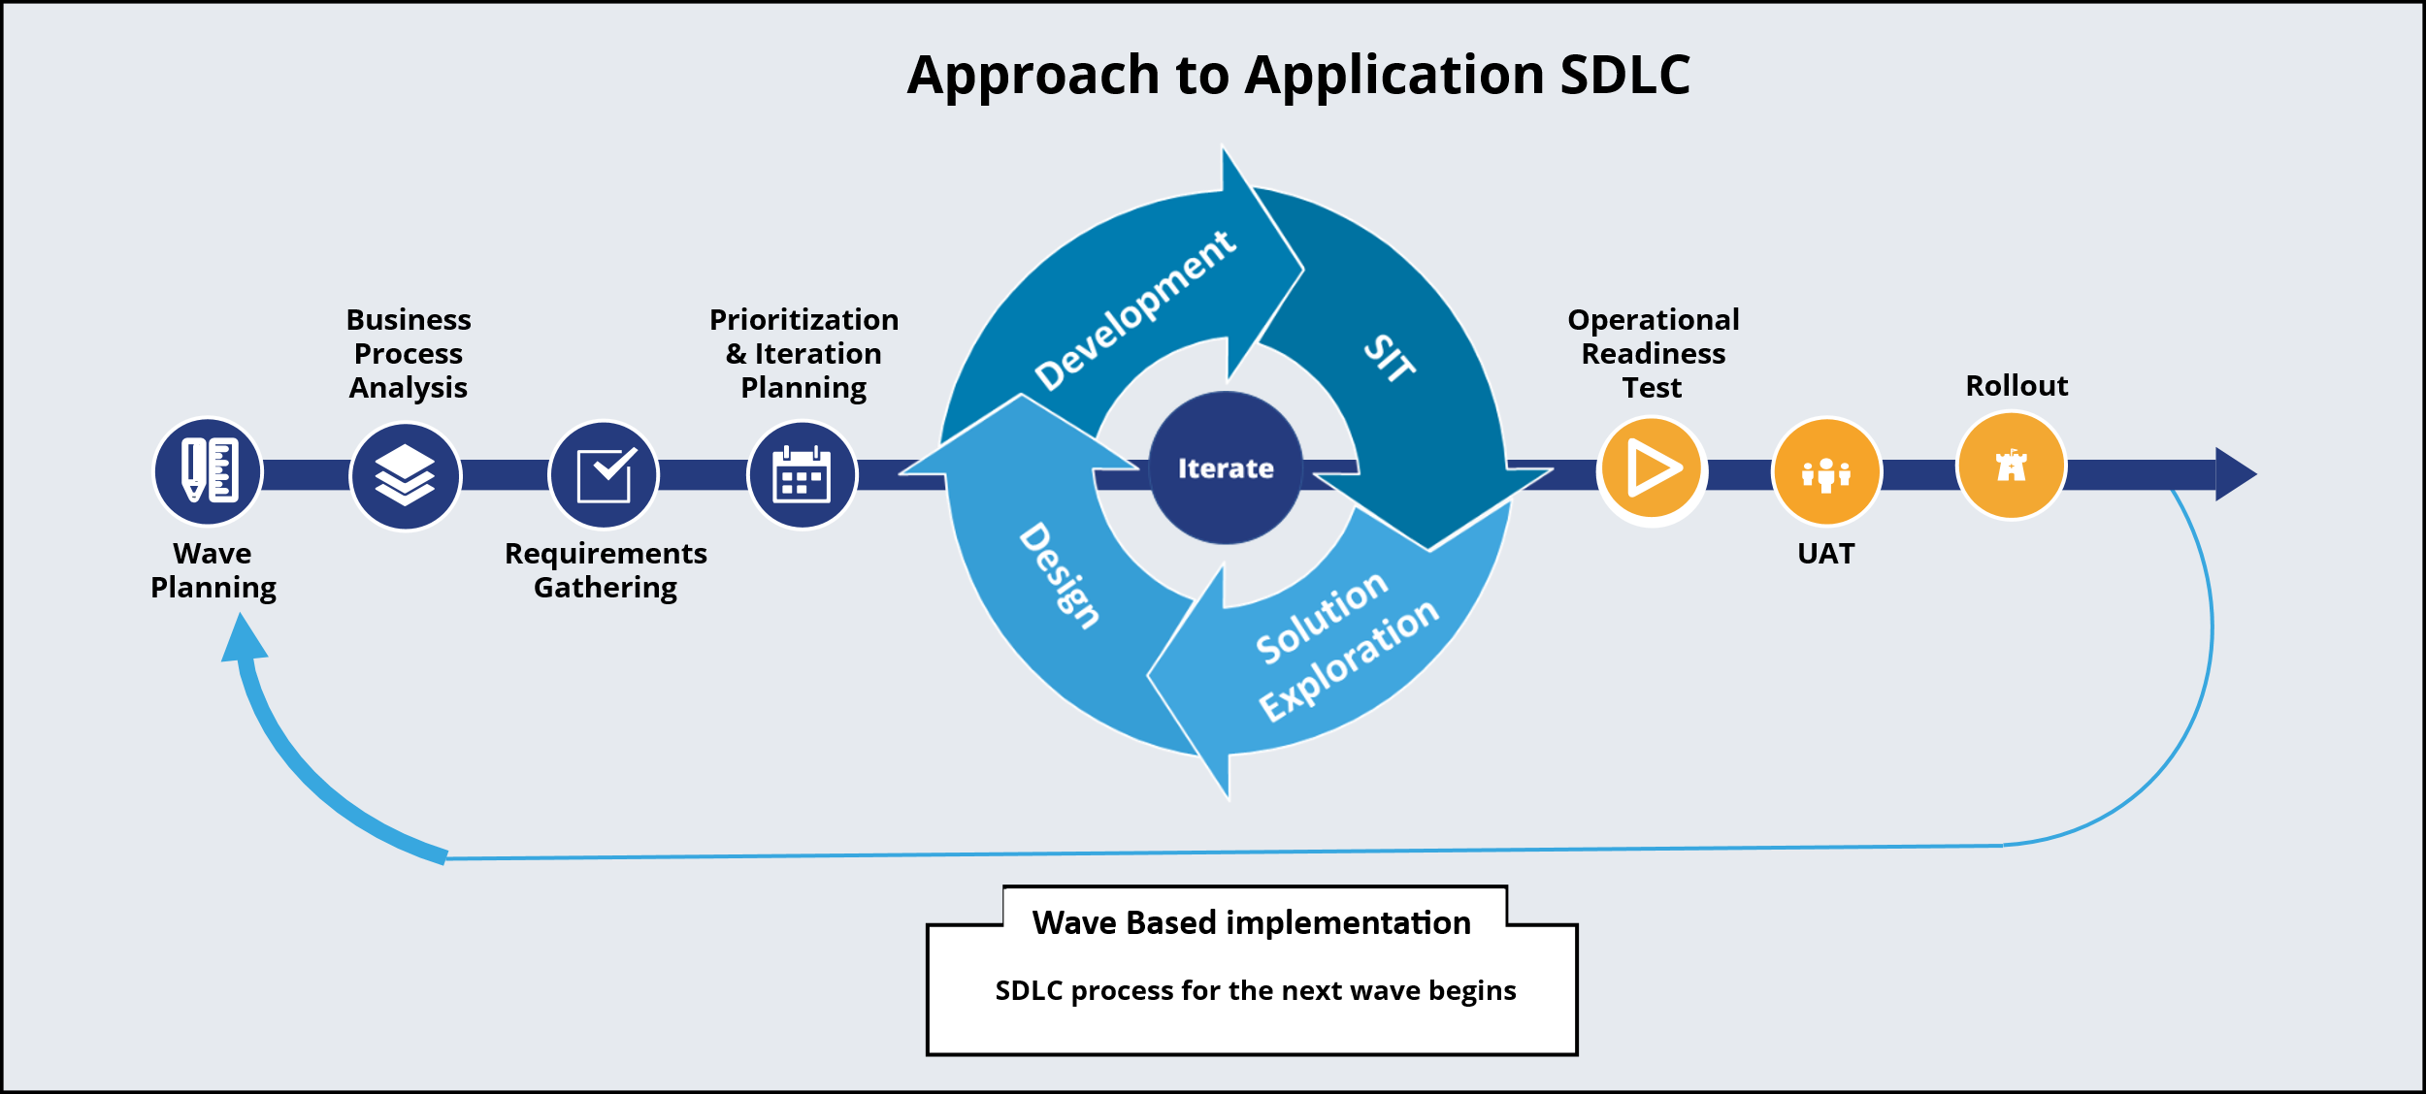
Figure 2-1: Approach to Application SDLC
For each Wave and major release, a full SDLC sequence is executed as depicted in the above figure. During the SDLC sequence, the Design, Development, and SIT phases are organized into iterations or bundles. Iterations and bundles are a means to deliver working software incrementally during the SDLC allowing project stakeholders to see tangible results from SDLC activities earlier than in a traditional waterfall SDLC methodology. Iterations were initially implemented to organize JAD topics by a system track/module driven approach. Iterations were transitioned to bundles which organize JAD topics in a more holistic, end-to-end business process across design, interfaces, change management, and technology tracks. JADs are more logically organized, creating Functional Design Documents (FDDs) that are easier for stakeholders to consume when they review and approve. Each iteration and bundle will include a Design, Development, and SIT phase within it. Iterations and bundles allow for overlapping SDLC activities within the Design, Development, and SIT phases and will have their own entry and exit criteria. As depicted in the figure above, the Solution Exploration phase takes place iteratively at the conclusion of SIT for each iteration or bundle. The ‘Iterate’ activities above follow requirements prioritization and approval. Any potential changes to approved deliverables and work products will be managed through ICCP. This allows approved incremental designs to move more quickly into Development and subsequent SIT processes. As depicted in Figure 2-1 above, the dark blue arrow represents the full SDLC sequence within a Wave. Within this, the circular arrow with Design/Development/SIT represents the iterative steps for these activities. The light blue arrow represents the return to the beginning of the SDLC process for the next Wave.
In support of a comprehensive project governance structure, phase gates are integrated into the SDLC to provide oversight and alignment with project objectives. In accordance with the Responsible, Accountable, Consulted, Informed (RACI) chart, phase owners assess the predefined entry and exit criteria at the conclusion of each phase to demonstrate readiness to move on to the next stage. Given their importance to successful product delivery and production implementation, an additional layer of governance is introduced between the exit and entrance of the following two phases and a dedicated meeting will be held to gain concurrence prior to proceeding:
- Operational Readiness Test (ORT) → UAT
- UAT→ Rollout
Phase gates are integrated into the SDLC to provide oversight and confirm alignment with project objectives.
Once the associated documentation and deliverables have been approved and the corresponding entry/exit criteria have been satisfied for each project phase, two key decisions will be logged: one for the completion of the current phase’s exit criteria and another for the commencement of the next phase’s entry criteria. These decisions will include the collection of deliverable approvals and associated documents, in accordance with the guidelines outlined in Section 7.4.1 Transmittal Management.
The following table describes the purpose of each phase along with the key inputs and outputs of the phase. In Appendix C-1 Roles and Responsibilities, each phase is defined in more detail.
Phase | Purpose | Key Inputs | Key Outputs
Continuing Medicaid Eligibility Modernization Wave Planning | The Continuing Medicaid Eligibility Modernization Wave Planning phase defines the high-level objectives and scope for a Wave, including functional, business, and technical impacts. High-level conceptual design and high-level architecture design will take place during Wave Planning while the Amazon Web Services (AWS) team reviews the initial BOM and the Cloud Cost Management plan and plans for any resizing based on changes to business usage/assumptions on a quarterly basis. These are utilized as inputs for the development of the Initial Solution Definition (ISD). | - Business Strategy Document  - Master Statement of Work (MSOW)  - Individual Statements of Work (ISOWs) | - Approved high-level scope, goals, and objectives for the Wave  - Initial Solution Definition (ISD) (DEL-01)
Business Process Analysis | The Business Process Analysis allows to-be business processes (including system workflows) across the different end user types to be defined and optimized to achieve business objectives for the Wave. Personas are used to create and validate business process flows. From Wave-2 onwards, ███████ will submit an NYS- specific Use Case Document for client approval. | - Existing workforce procedure documentation  - Interviews with business stakeholders  - Site visits to workforce offices | - As-Is/To-Be Business Process Maps (DEL-17)  - Defined personas based on target population for the Wave  - Detailed business objectives and high-level scope for the Wave
Requirements Gathering | Requirements define ‘what’ the system will do. During the Requirements Gathering phase, the project objectives, to-be process flows, and other business requirements/needs are used to conduct requirements discussions that result in specific system requirements or changes needed to the base solution. System requirements are documented in both narrative form and in a detailed inventory that forms the basis of the Requirements Traceability Matrix (RTM). | - To-Be Business Process Maps  - Base solution documentation  - Program policy documentation  - Business requirements input documents | - Requirements Specification Document (DEL-18)  - Requirements Traceability Matrix (DEL-19) (including recommended prioritization for Waves)
Prioritization and Iteration/Bundle Planning | Once system requirements are known, the effort must be estimated to determine feasibility to implement within the timeline and capacity of the Wave timeline and budget. Prioritizing requirements may be needed to align their scope to the available timeline and budget. Once prioritization has occurred, system requirements can be allocated across iterations/bundles for the build phases. | - Requirements Traceability Matrix (DEL-19)  - System requirement estimation (refined estimates and impact on resources, budget, and timeline) | - Updated RTM (DEL-19) with Wave and iteration/bundle assignment to each system requirement
Design (Iterative) | The Design phase defines the specifications for the MECM solution for a set of system requirements within a Wave and iteration/bundle and answers the question ‘how’ will the solution work. This is addressed both for functional and non-functional system requirements. | - Initial Requirements Specification Document (DEL-18) and Requirements Traceability Matrix (DEL-19) with Wave and iteration/bundle assignment to each system requirement  - Base solution design specification documents  - Legacy system documentation  - Initial Solution Definition (ISD) (DEL-01) | - Functional Design Documents (DEL-20)  - Interface/Batch/ Notice/Automation Control Documents (DEL-22)  - System Architecture Design Document (SADD) (DEL-16)  - Training Plan (DEL-10)  - Business Continuity and Disaster Recovery Plan (DEL-14)  - Draft System Security Plan (SSP) (DEL-15)
Development (Iterative) | During the Development phase, the MECM solution software and/or configuration is updated to provide functionality defined in the approved design specifications for the iteration/bundle. | - Functional Design Documents (DEL-20)  - Interface Control Documents (DEL-22)  - Notice Control Documents  - Batch Control Documents (DEL-22)  - System Architecture Design Document (DEL-16)  - Training Plan (DEL-10) | - System Source Code (DEL-26)  - Unit Test Results  - Data Dictionary and Data Model (DEL-21)  - Training Materials or Manuals  - System Security Plan (SSP) (DEL-15)  - Test Management Plan (DEL-09)
SIT (Iterative) | The SIT phase serves to validate that the MECM solution software conforms to the approved design specifications for the iteration or bundle. This phase includes both, vendor performed testing and business stakeholder exploratory testing, and is the final phase within an iteration or bundle. Test scripts developed and used in this phase are based on approved design documentation and in accordance with the Test Management Plan. During this phase, the Rollout Plan will be developed in preparation for operational readiness, UAT, and go-Live activities. Solution Exploration will also take place after SIT. | - Functional Design Documents (DEL-20)  - Interface/Batch/ Notice/Automation Control Documents (DEL-22)  - System Architecture Design Document (DEL-16)  - Defined personas based on target population for the Wave  - Training Plan (DEL-10) | - SIT test scripts  - SIT test results  - Training Materials or Manuals  - MECM System Rollout Plan (DEL-13), developed during the SIT phase, includes the roll back and verification approach
Solution Exploration (Iterative) | The Solution Exploration phase occurs iteratively after SIT and serves to validate that the solution aligns with the design inputs and decisions resulting from Integrated JAD sessions. This is the final phase within an iteration/bundle. | - Test Management Plan (DEL-09)  - SIT Test Report | - All the valid observations are categorized as: Valid defects to be addressed, Potential design updates, or Potential Enhancements  - Requirements Traceability Matrix (DEL-19)
Operational Readiness Test | The Operational Readiness Test phase occurs when all iterations/bundles of Design/Development/SIT/Solution Exploration are complete and the entire functionality for a Wave can be tested together. This phase also includes the following testing types that benefit from being executed when the Wave’s functionality and software is complete: Regression testing, Security testing, Performance testing, and Failover testing. | - Business Continuity and Disaster Recovery Plan (DEL-14)  - System Security Plan (DEL-15)  - System Architecture Design Document (SADD) (DEL-16)  - Capacity Plan  - SIT test scripts  - Test Management Plan (DEL-09) | - System Test Results (DEL-24)  - Regression test results  - Security test results  - Performance test results  - Failover test results
UAT | UAT is performed by business stakeholders to validate the MECM solution functionality aligns with their business requirements and objectives for the Wave. It serves to immerse those stakeholders in the functionality for a Wave to allow them to prepare end users for the Wave’s rollout. | - Updated Requirements Traceability Matrix (DEL-19) with traceability across requirements, design, development, and test cases  - Test Management Plan (DEL-09)  - Functional Design Documents (DEL-20)  - Interface/Batch/ Notice/Automation Control Documents (DEL-22)  - System Architecture Design Document (DEL-16)  - Defined personas based on target population for the Wave  - SIT test scripts  - Training Plan (DEL-10) | - UAT test scripts  - UAT test summary  - Production Ready System Source Code (DEL-26)  - Training Materials or Manuals
Rollout | The rollout phase serves to reduce risk through a more methodical introduction of the Wave to the target end users with time built into the schedule for corrections/changes to functional and/or technical artifacts as a result of changes or recommendations derived from UAT feedback. The MECM System Rollout Plan, developed during the SIT phase, includes the roll back and verification approach. | - UAT test scripts  - UAT test summary  - MECM System Rollout Plan (DEL-13)  - Production Ready System Source Code (DEL-26)  - Maintenance and Operations (M&O) Run Book (DEL-33) | - Delivery of Training and Training Completion Report
Table 2-2: SDLC High-Level Process Key Inputs and Outputs
Key stakeholders and their roles and responsibilities throughout the MECM SDLC can be found in Appendix C-1 with a clear delineation of roles to help understand specific duties and tasks. The structure enhances accountability, improves communication, and ultimately contributes to the successful planning and execution of the MECM system.
The following table is a list of all key executive, business, technology, functional, and project management stakeholders as further elaborated in the roles and personas table in Appendix C-1.
Executive Stakeholders | Functional Stakeholders | Technical Stakeholders | Business Stakeholders | PMO
Medicaid Director | DOS Functional Manager | DOS Technical Director | DOH OHIP Implementation and OCM Manager | DOS Tool Administrator
Division of Eligibility and Marketplace Integration (DEMI) Director | DOS Functional Architect | DOS Technical Manager | DOH OHIP Business Process Analysis, Requirements, Design Session, and UAT Participants | Functional PM
DEMI Deputy Director | DOS Interface/Batch Track Lead | DOS Technical Architect | ███████  OCM Director | Technical PM
Division of Operations and Systems (DOS) Chief Information Officer (CIO) | MECM QA Manager | DOS Information Architect | ███████ Implementation and OCM Manager | Change Management PM
DOS Deputy CIO | DOS Integrated JAD Approach Track Lead | Third Party Integration Point of Contact | ███████  Human Centered Design and Business Process Lead | ███████ Tool Administrator
DOS Chief Technology Officer (CTO) | DOS Test Lead | DOS Security and Privacy Bureau Director |  | ███████ Functional PM
eMedNY Bureau Director | ███████  Functional Manager | DOS Deputy Director/Security and Privacy Bureau Director |  | ███████ Technical PM
New York State of Health (NYSOH) Bureau Director | ███████  Functional Architect | DOS Data Conversion Lead |  | ███████ PMO Lead
DOS Program Manager | ███████  Interface/Batch Track Lead | ███████  Technical Director |  | ███████ QA Lead
DOS Project Director | ███████  Eligibility Track Lead | ███████  Technical Manager
███████  Project Executive | ███████  Notices Track Lead | ███████  Technical Architect
███████  Human Services Transformation Practice Leader | ███████  Portals Track Lead | ███████  Security Manager
███████  NYS Account Consulting Leader | ███████  Reports Track Lead | ███████  Application Development Manager
███████ PMO Manager | ███████  Enrollment Track Lead | DOS Deputy Director/Security and Privacy Bureau Director
███████ Project Director | ███████  Workload Management Track Lead | AWS Architect
Medicaid Chief Operating Officer (COO) | ███████  Quality Assurance (QA) Manager | AWS Accounts Reviewer
DOS Deputy Director/Security and Privacy Bureau Director | ███████  Test Lead
Table 2-3: MECM Key Stakeholders

MECM SDLC Methodology Detail
The SDLC High-Level Process Flow can be found in Section 2.16. It represents the high-level process flow for the MECM SDLC methodology based on the phases defined previously. It includes the phase gates and iterations/bundles that will be used to accomplish several of the methodology objectives. Where activities in process flows are shared across two or more stakeholder groups – the relevant step box is positioned across the respective swim lanes to reflect this.
In the following subsections, the MECM SDLC Methodology is decomposed into each of its phases including the following:
- Phase Entry Criteria
- Process Flow Diagram
- Process Flow Narrative (including inputs and outputs where relevant)
- Roles and Responsibilities (including resources or tools used to perform those responsibilities)
- Phase Exit Criteria
- Supporting Application Lifecycle Management (ALM) Tools

Project Wave Planning Phase
The Project Wave Planning phase defines the high-level scope for a Wave, including the documentation of goals and objectives of the Wave. The functional and technical scope are defined, and the functional and technical impacts of Wave objectives and scope are assessed. These are subsequently utilized as inputs for the development of the ISD for the Wave. A change impact assessment is developed to evaluate the impacts of any changes or additions to the ISD that occurred in the Wave Plan, and the Executive team evaluates whether these changes require a revised scope, timeline, or budget. Finally, the ISD and Wave Plan are finalized and approved. The activities within the Project Wave Planning Phase serve as the entry criteria for the Business Process Analysis Phase.

Phase Entry Criteria
# | Entry Criteria | Related Document(s)/Artifact(s)
1 | Executive leadership decision to initiate Wave planning | - Scope, goals, and objectives for the Wave
Table 2-4: Project Wave Planning Phase Entry Criteria

Process Flow Diagram
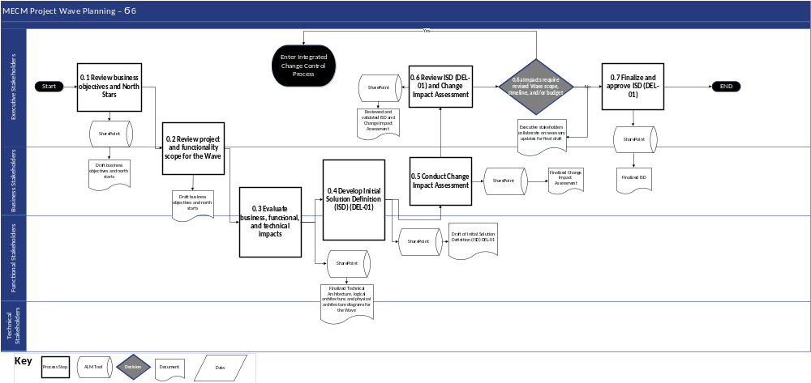
Figure 2-2: Project Wave Planning Phase Process Flow

Process Flow Narrative
Project Wave Planning
Step # | Process Step | Description | Stakeholder Group(s) | Inputs (Documents/ Work Products) | Outputs (Documents/ Work Products)
0.1 | Review business objectives and North Stars | The strategic high-level goals of the Wave are delineated, and overarching objectives are defined and validated. | - Executive Stakeholders | - Business Strategy Document  - MSOW  - ISOW | - Approved High-level scope, goals, and objectives for the Wave
0.2 | Review project and functionality scope for the Wave | The scope of the project and functional capabilities are defined and outlined for the Wave. | - Executive Stakeholders  - Business Stakeholders | - Approved high-level scope, goals, and objectives for the Wave  - Requirements | - Approved project and functionality scope for the Wave  - Initial functional impacts  - Initial technical impacts
0.3 | Evaluate business, functional, and technical impacts | The overall business, functional, and technical impacts to achieve the objectives and scope are evaluated. This includes impacts due to change in the technical stack, BOM, cost, capacity, user base, and cybersecurity requirements. | - Business Stakeholders  - Functional Stakeholders  - Technical Stakeholders | - Approved project and functionality scope for the Wave  - Initial business impacts  - Initial functional impacts  - Initial technical impacts  - Estimated impact to cost, capacity, user base, and cybersecurity requirements | - Technical architecture diagram for Wave  - Logical architecture diagram for Wave  - Physical architecture diagram for Wave
0.4 | Develop Initial Solution Definition (ISD) (DEL-01) | A draft ISD (DEL-01) is developed, with a key focus on functional and technical design modifications to accommodate initial requirements of DOH OHIP. | - Business Stakeholders  - Functional Stakeholders  - Technical Stakeholders | - Technical architecture diagrams for Wave  - Logical architecture diagram for Wave  - Physical architecture diagram for Wave  - Security Requirements  - Cost/pricing information | - Draft Initial Solution Definition (DEL-01)
0.5 | Conduct Change Impact Assessment | ███████ develops an impact assessment to evaluate the operational impacts of the proposed scope for the Wave. | - Business Stakeholders | - Draft Initial Solution Definition (DEL-01)  - Analysis of proposed modifications | - Finalized Change Impact Assessment
0.6 | Review ISD (DEL-01) and Change Impact Assessment | ███████ executive stakeholders review and validate the ISD (DEL-01) and impact assessment before submitting to DOH OHIP for review. | - Executive Stakeholders | - Draft Initial Solution Definition (DEL-01)  - Finalized Change Impact Assessment | - Reviewed and validated Initial Solution Definition (DEL-01) and Change Impact Assessment
0.6a | Impacts require revised Wave scope, timeline, and/or budget | DOH OHIP and ███████ decide if impacts require a revised Wave scope, timeline, and/or budget  - If yes, proceed to enter the ICCP  - If no, proceed to Step #0.7 Finalize and approve ISD (DEL-01) | - Executive Stakeholders | - N/A | - N/A
0.7 | Finalize and approve ISD (DEL-01) | ███████ will finalize the ISD (DEL-01) and submit to DOH OHIP in accordance with the Deliverable Management Plan.  Deloitte will finalize quotes from product vendors and submit to DOH OHIP for license procurement approval to purchase license(s). | - Executive Stakeholders | - Initial Solution Definition (DEL-01) with suggested modifications based on Change Impact Assessment and Executive Stakeholder review | - Finalized Initial Solution Definition (DEL-01)
Table 2-5: Project Wave Planning Phase Process Flow Narrative

Roles and Responsibilities
The SDLC RACI Matrix and roles and responsibilities can be found in Appendix C-1.

Phase Exit Criteria
Key stakeholders from ███████ and DOH OHIP identified in the RACI matrix as Accountable or Responsible will collectively agree on the conclusion of the current phase and the commencement of the next phase. The ███████ owner, as designated in the RACI matrix, provides a comprehensive status update, specifically addressing the entry and exit criteria for the concluded phase, and allowing for questions. Upon satisfying phase exit criteria, a decision to exit the current phase will be logged to document the closure of the phase.
# | Exit Criteria | Related Document(s)/Artifact(s)
1 | Business, technical, and functional impacts of Wave planning are evaluated | - Technical architecture diagrams for Wave  - Logical architecture diagram for Wave  - Physical architecture diagram for Wave  - Security Requirements  - Change Impact Assessment
2 | Initial Solution Definition (DEL-01) will include high-level scope, goals and objectives for the Wave. It is reviewed, finalized, and approved. | - Initial Solution Definition (DEL-01)
Table 2-6: Project Wave Planning Phase Exit Criteria

Supporting Application Lifecycle Management (ALM) Tools
During the Project Wave Planning phase, ALM tools will help manage the planning of each Wave by providing version control for the ISD, high-level conceptual architecture, and initial BOM estimates. In addition, tools offer collaboration features to coordinate efforts between tracks, maintain traceability between wave activities and project requirements, and establish reporting and monitoring metrics to assess the progress and success of each Wave.
Tools and workflows pertaining to the Wave Planning phase:
- SharePoint (refer to Section 2.18 Continuing Medicaid Eligibility Modernization SharePoint)

Business Process Analysis Phase
The Business Process Analysis phase builds on the north star objectives identified during Wave Planning. It also allows to-be business processes (including system workflows) across the different end user types to be defined and optimized to achieve business objectives for the Wave.

Phase Entry Criteria
Personas are used to create and validate business process flows.
# | Entry Criteria | Related Document(s)/Artifact(s)
1 | A Project Wave has been defined including high-level scope, ISD (DEL-01) goals, objectives, and a draft timeline | - Initial Solution Definition (ISD) (DEL-01)  - MECM Master Statement of Work (MSOW)  - Implementation Schedule Overview (DEL-02)
2 | An initial budget has been defined for the Wave along with budget assumptions | - MECM Master Statement of Work (MSOW)  - MECM System and Project – Budget Planning
3 | Business stakeholders are identified and have availability during the planned Business Process Analysis phase | - Stakeholder Engagement Plan (PMP DEL-05, Section 3)  - SDLC Methodology – Roles and Responsibilities Matrix
4 | An ISOW is executed for the Wave | - Master ISOW Integrated Project Schedule
Table 2-7: Business Process Analysis Phase Entry Criteria

Process Flow Diagram
The following process flow depicts the Business Process Analysis phase of the MECM SDLC.
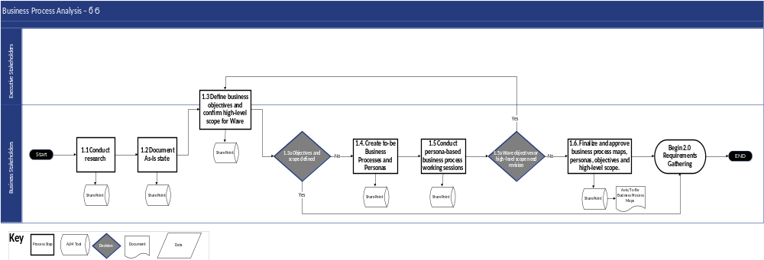
Figure 2-3: Business Process Analysis Phase Process Flow

Process Flow Narrative
The following table describes each process step illustrated above.
Business Process Analysis
Step # | Process Step | Description | Stakeholder Group(s) | Inputs (Documents/ Work Products) | Outputs (Documents/ Work Products)
1.1 | Conduct research | Gather, review, and assess DOH OHIP-provided inputs to current business processes and challenges relevant to the high-level scope and goals for the Wave. | - Business Stakeholders | - Stakeholder operating procedures or process documentation  - Interviews  - Site visit notes | - As-Is Assessment or Analysis
1.2 | Document As-Is state | Where documentation does not exist, ███████ will produce As-Is Business Processes and Journey Maps that create a baseline of the current state processes relevant to the Wave. | - Business Stakeholders | - As-Is Assessment or Analysis | - Draft As-Is Business Process Maps
1.3 | Define business objectives and confirm high-level scope for Wave | Facilitate a strategic workshop with business, executive, functional and technical stakeholders to define business objectives for the Wave and confirm high-level scope and goals based on the as-is state and current challenges. | - Executive Stakeholders  - Business Stakeholders | - Current process and procedures documentation  - As-Is Assessment or Analysis  - Draft As-Is Business Process Maps | - Business objectives or North Stars for the Wave
1.3a | Objectives and scope defined | DOH OHIP will review and decide if the business objectives and scope are defined enough to begin the Requirements Gathering phase.  - If yes, proceed to Step#2.0 Requirements Gathering phase  - If no, proceed to Step #1.4 Create To-Be Business Processes and Personas | - Business Stakeholders | - N/A | - N/A
1.4 | Create to-be business processes and personas | ███████ will draft to-be business processes and journey maps relevant to the Wave along with personas of typical end users that will interact with MECM when the Wave is rolled out. | - Business Stakeholders | - As-Is Business Process Maps  - Business objectives  - High-level scope for the Wave | - Draft To-Be Business Process Maps
1.5 | Conduct persona-based business process working session | ███████ will facilitate to-be business process map walkthroughs utilizing personas with business, functional, and technical stakeholders and gather feedback. | - Business Stakeholders | - Personas  - Draft As-Is/To-Be Business Process Maps (DEL-17) | - Meeting minutes  - Updated Business Process Maps
1.5a | Wave objectives or high-level scope need revision | DOH OHIP will review and decide if the business processes and journey maps require revision.  - If yes, Deloitte will proceed to Step #1.3 Define business objectives and confirm high-level scope for Wave  - If no, proceed to Step #1.6 Finalize and approve business processes maps, personas, objectives, and high-level scope | - Business Stakeholders | - Meeting Minutes  - Updated Business Process Maps | - Yes/No Decision
1.6 | Finalize and approve business process maps, personas, objectives, and high-level scope | ███████ will finalize the business process analysis deliverables and submit deliverables to DOH OHIP in accordance with the Deliverable Management Plan. | - Business Stakeholders | - Draft To-Be Business Process Maps  - Draft As-Is Business Process Maps  - Deliverable Management Plan | - As-Is/To-Be Business Process Maps (DEL-17)
Table 2-8: Business Process Analysis Process Flow Narrative

Roles and Responsibilities
The SDLC RACI Matrix and roles and responsibilities can be found in Appendix C-1.

Phase Exit Criteria
Key stakeholders from ███████ and DOH OHIP identified in the RACI matrix as Accountable or Responsible will collectively agree on the conclusion of the current phase and the commencement of the next phase. The ███████ owner, as designated in the RACI matrix, provides a comprehensive status update, specifically addressing the entry and exit criteria for the concluded phase, and allowing for questions. Upon satisfying phase exit criteria, a decision to exit the current phase will be logged to document the closure of the phase.
# | Exit Criteria | Related Document(s)/Artifact(s)
1 | As-Is/To-Be Business Process Maps (DEL-17) and personas are reviewed and approved by DOH OHIP | - As-Is/To-Be Business Process Maps (DEL-17)
2 | Business requirements or high-level scope are defined and documented | - Requirement Logic Flows/System Requirements Input Documents
3 | Business objectives for the Wave are defined and documented | - Business Objectives Documentation
Table 2-9: Business Process Analysis Phase Exit Criteria

Supporting Application Lifecycle Management (ALM) Tools
In the Business Process Analysis phase, ALM tools will facilitate the documentation and assessment of existing business processes. They enable the documentation of current workflows, identification of pain points, and the mapping of potential enhancements.
Tools and workflows pertaining to the Wave Planning phase:
- SharePoint (refer to Section 2.18 Continuing Medicaid Eligibility Modernization SharePoint)

Requirements Gathering Phase
Requirements define what the system will do. During requirements gathering, the project objectives, to-be process flows, and other business requirements/needs are used to conduct requirements discussions that result in specific system requirements or changes needed to the base solution. System requirements are documented in both narrative form and in a detailed inventory that forms the basis of the traceability matrix.

Phase Entry Criteria
# | Entry Criteria | Related Document(s)/Artifact(s)
1 | Business objectives and high-level scope for the Wave are defined and agreed upon | - Requirement Logic Flows/System Requirements Input Documents
2 | An initial, Baselined Work Plan for the Wave exists and is agreed upon | - Baselined Work Plan and Project Schedule (DEL-06)
3 | Business stakeholders are identified and have availability during the Requirements Gathering phase | - Change Management Plan (DEL-30) Stakeholder Engagement Plan (refer to Section 3)  - Project Management Plan (DEL-05) SDLC Methodology (refer to Section 2) – Roles and Responsibilities Matrix (refer to Appendix C-1)
Table 2-10: Requirements Gathering Phase Entry Criteria

Process Flow Diagram
The following process flow depicts the Requirements Gathering phase of the MECM SDLC.
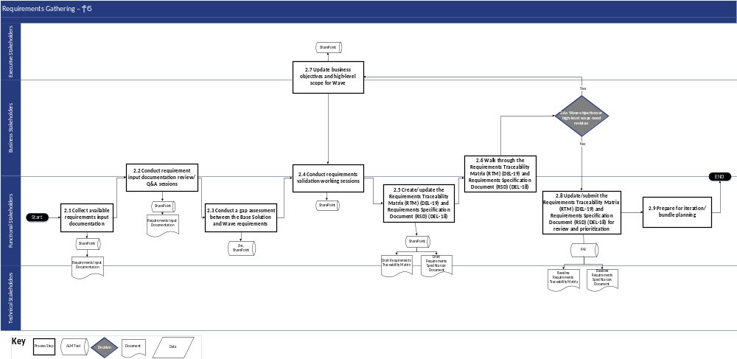
Figure 2-4: Requirements Gathering Phase Process Flow

Process Flow Narrative
The following table describes each process step illustrated above.
Requirements Gathering
Step # | Process Step | Description | Stakeholder Group(s) | Inputs (Documents/ Work Products) | Outputs (Documents/ Work Products)
2.1 | Collect available requirements input documentation | - Develop request list for applicable requirements input documents (e.g., flows, processes, legacy documentation)  - Gather and review applicable requirements input documents to support requirements relevant to the high-level scope and goals for the Wave  - Develop process flow showing high-level project requirements  - Develop initial draft of applicable specifications from legacy system | - Functional Stakeholders | - High-level objectives  - Existing legacy system documentation  - Policy manuals | - Process flow showing high-level project requirements  - Initial draft of applicable specifications from legacy system  - Question Log (tracking any questions on flows, processes, legacy documentation, etc.)
2.2 | Conduct requirement input documentation review/Q&A sessions | - Conduct joint State/███████ meeting to discuss, review, and confirm understanding of NY specific input documentation  - Identify items that require further clarification from functional and business stakeholders (technical stakeholders if the item requires technical feasibility discussion) | - Functional Stakeholders  - Business Stakeholders | - Question Log (seeking clarifications on input documents)  - Process flow showing high-level project requirements | - Updated Question Log with clarifications
2.3 | Conduct a gap assessment between the Base Solution and Wave requirements | - Identify, confirm, and document gaps with Base Solution, including technical solution, to identify changes required  - Assign Base Solution comparison mapping (meets out of box, customization, configurable) | - Functional Stakeholders | - Process flow showing high-level project requirements  - Initial draft of applicable specifications from legacy system  - Updated Question Log with clarifications  - As-Is/To-Be Business Process Maps (DEL-17)  - Base Solution Architectural Information | - Documented Base Solution gaps and required changes  - Base Solution comparison mapping
2.4 | Conduct requirements validation working session | Validate and confirm requirements/ business objectives via working sessions by leveraging input documents, demos from Base Solution, and high-level flows | - Functional Stakeholders  - Business Stakeholders | - Documented Base Solution gaps and required changes  - Base Solution comparison mapping  - Base Solution Live Demos  - As-Is/To-Be Business Process Maps (DEL-17) | - Documented requirements/ business objectives
2.5 | Create/update the RTM (DEL-19) and Requirements Specification Document (RSD) (DEL-18) | Create/Update RSD (DEL-18) and RTM (DEL-19) based on requirements received from input documents and comparison with Base Solution | - Functional Stakeholders | - Documented requirements/ business objectives  - As-Is/To-Be Business Process Maps (DEL-17) | - Draft Requirements Specification Document (DEL-18)  - Draft Requirements Traceability Matrix (DEL-19)
2.6 | Walk through the Requirements Traceability Matrix (DEL-19) and Requirements Specification Document (DEL-18) | Collaborate with functional and business stakeholders to review the RTM (DEL-19) and RSD (DEL-18) | - Functional Stakeholders  - Business Stakeholders | - Draft Requirements Specification Document (DEL-18)  - Draft Requirements Traceability Matrix (DEL-19) | - Updated Draft Requirements Specification Document (DEL-18)  - Updated Draft Requirements Traceability Matrix (DEL-19)
2.6a | Wave objectives or high-level scope need revision | Review the objectives and high-level scope and decide if they need to be revised  - If yes, proceed to Step #2.7 Update business objectives and high-level scope for Wave  - If no, proceed to process Step #2.8 Update and submit the Requirements Traceability Matrix (DEL-19) and Requirements Specification Document (DEL-18) for review and prioritization | - Business Stakeholders | - N/A | - N/A
2.7 | Update business objectives and high-level scope for Wave | - Review business objectives before requirements approval  - If adjustments need to be made, collaborate with the Executive stakeholders to understand the impact on scope, timeline, and budget  - Update the business objectives, if needed  - Develop initial solution roadmap and estimated cost of ownership based on high-level scope for Wave | - Executive Stakeholders  - Business Stakeholders | - High-Level Business Objectives and North Stars | - Revised Objectives, North Stars, and Wave Plan
2.8 | Update and submit the Requirements Traceability Matrix (DEL-19) and Requirements Specification Document (DEL-18) for review and prioritization | - Document final requirements in RSD and RTM and submit to DOH OHIP for review, prioritization, and approval  - Publish DOH OHIP approved requirements in the ALM tool  - Link approved requirements to design artifact(s) in the ALM tool | - Functional Stakeholders | - Draft Requirements Traceability Matrix (DEL-19)  - Draft Requirements Specification Document (DEL-18) | - Baseline Requirements Traceability Matrix (DEL-19)  - Baseline Requirements Specification Document (DEL-18)
2.9 | Prepare for iteration/ bundle planning | Publish DOH OHIP approved requirements in the ALM tool | - Functional Stakeholders | - Approved Requirements Traceability Matrix (DEL-19) | - Requirements loaded in the ALM tool  - Requirements Traceability Matrix (DEL-19) generated in the requirements management tool
Table 2-11: Requirements Gathering Phase Process Flow Narrative

Roles and Responsibilities
The SDLC RACI Matrix and roles and responsibilities can be found in Appendix C-1.

Phase Exit Criteria
Key stakeholders from ███████ and DOH identified in the RACI matrix as Accountable or Responsible will collectively agree on the conclusion of the current phase and the commencement of the next phase. The ███████ owner, as designated in the RACI matrix, provides a comprehensive status update, specifically addressing the entry and exit criteria for the concluded phase, and allowing for questions. Upon satisfying phase exit criteria, a decision to exit the current phase will be logged to document the closure of the phase.
 | # |  | Exit Criteria |  | Related Document(s)/Artifact(s)
1 |  | Requirements Specification Document (DEL-18) and Requirements Traceability Matrix (RTM) (DEL-19) including recommended prioritization is submitted for DOH OHIP review |  | - Requirements Specification Document (DEL-18)  - Requirements Traceability Matrix (DEL-19)  - Documented Base Solution gaps and required changes
Table 2-12: Requirements Gathering Phase Exit Criteria

Supporting Application Lifecycle Management (ALM) Tools
During the Requirements Gathering phase, the primary purpose of ALM tools is to document and maintain the requirements through gathering and preparation for prioritization so stakeholders have a single source of truth throughout the process.
Workflows pertaining to requirements gathering phase:
- The requirements management tool requirements workflow (refer to Section 2.34 the requirements management tool)
- The ALM tool requirements workflow (refer to Section 2.20 the ALM tool)

Prioritization and Iteration/Bundle Planning
Once system requirements are known, the effort must be estimated to determine feasibility to implement within the timeline and budget for the Wave. Prioritizing requirements, the decision to defer certain requirements to a future Wave, may be needed to align their scope to the available timeline and budget. Once prioritization has occurred, system requirements can be allocated across iterations/bundles for the build phases of the SDLC.

Phase Entry Criteria
# | Entry Criteria | Related Document(s)/Artifact(s)
1 | A recommended Wave priority for each requirement is documented in the Requirements Traceability Matrix (DEL-19) | - Requirements Traceability Matrix (DEL-19)
Table 2-13: Prioritization and Iteration/Bundle Planning Phase Entry Criteria

Process Flow Diagram
The following process flow depicts the Prioritization and Iteration/Bundle Planning phase of the MECM SDLC.
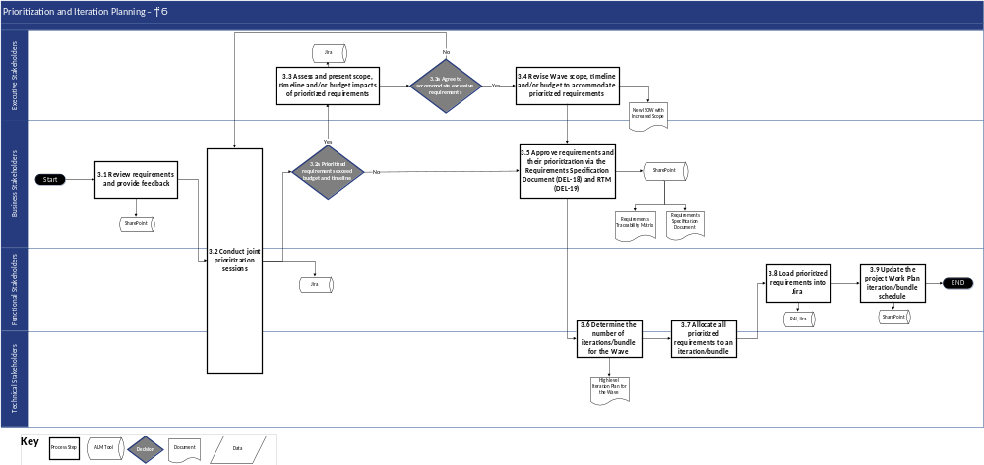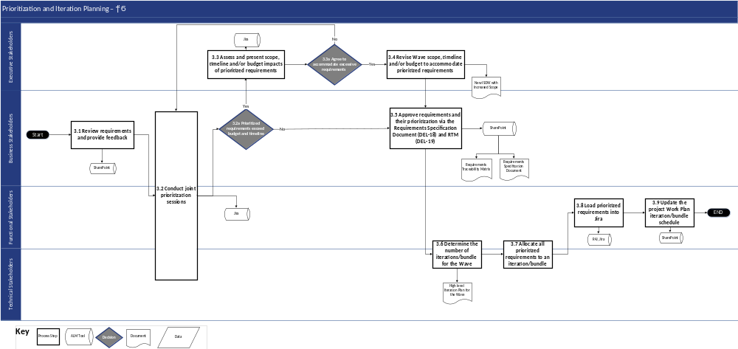
Figure 2-5: Prioritization and Iteration/Bundle Planning Phase Process Flow

Process Flow Narrative
The following table describes each process step illustrated above.
Prioritization and Iteration/Bundle
Step # | Process Step | Description | Stakeholder Group(s) | Inputs (Documents/ Work Products) | Outputs (Documents/ Work Products)
3.1 | Review requirements and provide feedback | Conduct review of the submitted RTM (DEL-19) and RSD (DEL-18) and provide comments per the Deliverable Management Plan and the agreed upon review cycle | - Business Stakeholders | - Submitted Requirements Specification Document (DEL-18)  - Submitted Requirements Traceability Matrix (DEL-19) | - Requirements Specification Document (DEL-18) Updated with Feedback  - Requirements Traceability Matrix (DEL-19) Updated with Feedback
3.2 | Conduct joint prioritization sessions | - Conduct joint prioritization working session(s) for items recommended for a future Wave  - Discuss rationale behind future Wave recommendation, review pros/cons, any applicable workarounds and establish final prioritization for Wave mapping | - Business Stakeholders  - Functional Stakeholders  - Technical Stakeholders | - Requirements Specification Document (DEL-18) Updated with Feedback  - Requirements Traceability Matrix (DEL-19) Updated with Feedback | - Key decisions summarizing outcomes from prioritization session logged in the ALM tool  - Updated Requirements Traceability Matrix (DEL-19)
3.2a | Prioritized requirements exceed budget and timeline | Review the prioritized requirements to determine if they exceed the budget or timeline constraints  - If yes, proceed to Step #3.3 Assess and present scope, timeline and/or budget impacts of prioritized requirements  - If no, proceed to process Step #3.5 Approve requirements and their prioritization via the Requirements Specification Document (DEL-18) and RTM (DEL-19) | - Business Stakeholders | - Key decisions summarizing outcomes from prioritization session logged in the ALM tool  - Updated Requirements Traceability Matrix (DEL-19) | - Yes/No Decision
3.3 | Assess and present scope, timeline and/or budget impacts of prioritized requirements | For requirements exceeding budget and timeline constraints, document and present the impact to the Executive Stakeholders for effective decision making | - Executive Stakeholders | - Draft Requirements Traceability Matrix (DEL-19)  - Latest Baselined Work Plan and Schedule | - Decisions logged in the ALM tool  - Updates to Requirements Traceability Matrix (DEL-19), if applicable
3.3a | Agree to accommodate excessive requirements | Executive Stakeholders decide if the Prioritized Requirements can be accommodated in the project Wave  - If yes, proceed to Step #3.4 Revise Wave scope, timeline and/or budget to accommodate prioritized requirements  - If no, proceed to Step #3.2 conduct joint prioritization sessions | - Executive Stakeholders | - Decisions logged in the ALM tool  - Updates to Requirements Traceability Matrix (DEL-19), if applicable | - Yes/No Decision
3.4 | Revise Wave scope, timeline and/or budget to accommodate prioritized requirements | For requirements where a decision is made to accommodate excessive requirement, adjust the Wave scope, timeline and/or budget by leveraging agreed upon contract vehicle | - Executive Stakeholders | - ISOW | - Required scope, timeline and/or budget changes
3.5 | Approve requirements and their prioritization via the Requirements Specification Document (DEL-18) and RTM (DEL-19) | Provide formal approval on RSD (DEL-18) and RTM (DEL-19) per the Deliverable Management Plan | - Business Stakeholders | - Updated Requirements Specification Document (DEL-18)  - Updated Requirements Traceability Matrix (DEL-19) | - Requirements Specification Document (DEL-18)  - Requirements Traceability Matrix (DEL-19)
3.6 | Determine the number of iterations/ bundles for the Wave | For approved requirements, perform an analysis of number of SDLC iterations/bundles needed for the Wave | - Functional Stakeholders  - Technical Stakeholders | - Requirements Specification Document (DEL-18)  - Requirements Traceability Matrix (DEL-19) | - High-level Iteration/Bundle Plan for the Wave
3.7 | Allocate all prioritized requirements to an iteration/ bundle | Assign SDLC iteration and bundle against each RTM (DEL-19) requirement | - Functional Stakeholders  - Technical Stakeholders | - Requirements Traceability Matrix (DEL-19) | - Requirements Traceability Matrix (DEL-19) with iteration and bundle mapping
3.8 | Load prioritized requirements into the ALM tool | Load and sync approved and prioritized requirements for a Wave to maintain future traceability to design, development and SIT test cases | - Functional Stakeholders | - Requirements Traceability Matrix (DEL-19) (in Excel) | - Requirements in the ALM tool
3.9 | Update the project Work Plan iteration/ bundle schedule | - Update the project Work Plan to reflect iteration/bundle schedule, dependencies, and task owners  - Finalize a solution roadmap and estimated cost of ownership based on approved and prioritized requirements | - Functional Stakeholders | - High-level Iteration/ Bundle Plan for the Wave | - Updated Project Work Plan
Table 2-14: Prioritization and Iteration/Bundle Planning Phase Process Flow Narrative

Roles and Responsibilities
The SDLC RACI Matrix and roles and responsibilities can be found in Appendix C-1.

Phase Exit Criteria
Key stakeholders from ███████ and DOH identified in the RACI matrix as Accountable or Responsible will collectively agree on the conclusion of the current phase and the commencement of the next phase. The ███████ owner, as designated in the RACI matrix, provides a comprehensive status update, specifically addressing the entry and exit criteria for the concluded phase, and allowing for questions. Upon satisfying phase exit criteria, a decision to exit the current phase will be logged to document the closure of the phase.
# | Exit Criteria | Related Document(s)/Artifact(s)
1 | Requirements are approved and assigned to a Wave (or deferred) | - Requirements Specification Document (DEL-18)  - Requirements Traceability Matrix (DEL-19) including Wave assignment
2 | The project Work Plan is updated to reflect the iteration and bundle schedule | - Baselined Work Plan and Project Schedule (DEL-06)
3 | An ISOW is drafted for the Wave iterations and bundles | - Master ISOW Integrated Project Schedule
Table 2-15: Prioritization and Iteration/Bundle Planning Phase Exit Criteria

Supporting Application Lifecycle Management (ALM) Tools
During the Prioritization and Iteration/Bundle Planning phase, the primary purpose of ALM tools is to coordinate feedback on the RSD and RTM, conduct and document results of joint prioritization sessions, and assess and adjust present scope, timeline and / or budget changes relative to prioritized requirements.
Workflows pertaining to the Prioritization and Iteration/Bundle Planning phase:
- The requirements management tool Requirements Traceability workflow (refer to Section 2.34 the requirements management tool)
- The ALM tool Design workflow (refer to Section 2.20 the ALM tool)

Design Phase
The design phase defines the specifications for the MECM solution for a set of system requirements within a Wave and iteration/bundle and answers the question of how the solution will work. This is addressed both for functional and non-functional system requirements.

Phase Entry Criteria
# | Entry Criteria | Related Document(s)/Artifact(s)
1 | The requirements are approved for design to begin | - Requirements Specification Document (DEL-18)  - Requirements Traceability Matrix (DEL-19) including Wave assignment serves as inventory
2 | Design plan and design schedule is drafted and shared with DOH OHIP | - Baselined Work Plan and Schedule (DEL-06)  - Design Calendar and Schedule
3 | An ISOW is executed for the Wave iterations / bundles | - Master ISOW Integrated Project Schedule
4 | Functional resources are defined in the project organization and aligned across ███████/DOH using a 2-in-a-box approach | - Medicaid Transformation Modernization – ███████ and NYS Team Alignment Excel
Table 2-16: Design Phase Entry Criteria

Process Flow Diagram
The following process flow depicts the Design phase of the MECM SDLC.
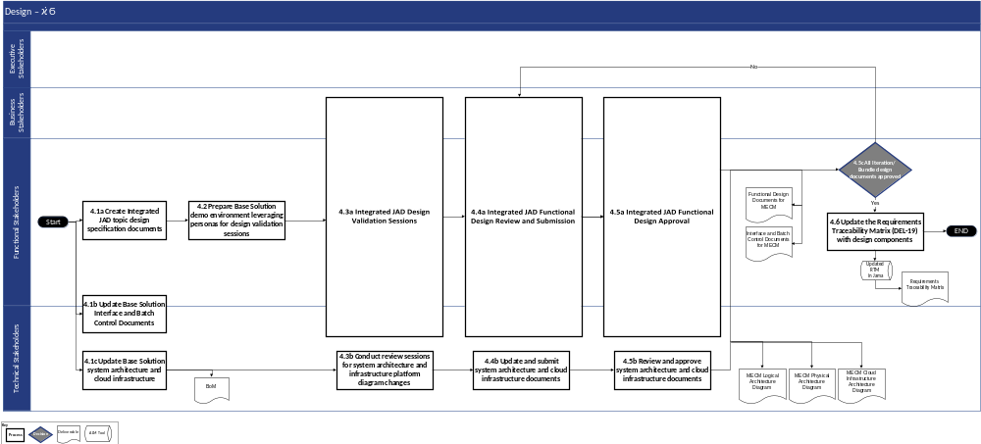
Figure 2-6: Design Phase Process Flow

Process Flow Narrative
The following table describes each process step illustrated above.
Design
Step # | Process Step | Description | Stakeholder Group(s) | Inputs (Documents/ Work Products) | Outputs (Documents/ Work Products)
4.1a | Create Integrated JAD topic design specification documents | - Update FDD (DEL-20) to reflect integrated JAD topics  - The FDD (DEL-20) can be in Word, Excel storyboard format, or PDF flows | - Functional Stakeholders | - Functional Design Document (DEL-20) from Base Solution | - Draft NY MECM Functional Design Document (DEL-20)
4.1b | Update Base Solution Interface and Batch Control Documents | Update the Interface Control Documents (ICDs) and Batch Control Documents (BCDs) from Base Solution to reflect NY-specific requirements | - Technical Stakeholders  - Functional Stakeholders | - Base Solution ICDs and BCDs | - Draft NY MECM ICDs and NY MECM BCDs
4.1c | Update Base Solution system architecture and cloud infrastructure | - Update Base Solution logical and physical system architecture  - Update Base Solution cloud infrastructure platform architecture diagrams to account for MECM changes  - If the design phase results in additions or changes to the technology stack, update the BOM accordingly  - Develop Business Continuity and Disaster Recovery Plan (DEL-14), and System Security Plan (DEL-15) in accordance with NY ITS Secure SDLC | - Technical Stakeholders | - Base Solution Logical System Architecture Diagram  - Base Solution Physical System Architecture  - Base Solution Infrastructure Platform Diagram | - Draft MECM System Architecture Design Document  - BOM (if applicable)  - Draft Business Continuity and Disaster Recovery Plan (DEL-14)  - Draft System Security Plan (SSP) (DEL-15)
4.2 | Prepare Base Solution demo environment leveraging personas for design validation sessions | Prepare Wave 0 Base Solution environment to facilitate demos (when necessary) to support the design validation sessions | - Functional Stakeholders | - Wave 0 environment  - Logical and Physical System Architecture Diagram  - Infrastructure Platform Architecture Diagram  - BOM (if applicable) | - Solution demo environment ready for design validation sessions
4.3a | Integrated JAD Design Validation Sessions | Conduct design validations for the Integrated JAD topics assigned for the Wave. Design validations are conducted across Portals, Eligibility, Interfaces, Notices, Enrollment, and Workload Management | - Business Stakeholders  - Functional Stakeholders  - Technical Stakeholders | - Solution demo environment ready for design validation sessions  - Draft NY MECM Functional Design Document (DEL-20)  - Draft NY MECM ICDs and BCDs | - Draft Functional Design Document (DEL-20)  - Draft Interface/Batch/Automation Control Documents (DEL-22) with updates from the design validation sessions
4.3b | Conduct review sessions for system architecture and infrastructure platform diagram changes | - Conduct architecture review sessions to provide a walkthrough of logical and physical system architecture changes, cloud infrastructure  - Update platform diagrams, as needed  - Update BOM, if applicable  - Review Business Continuity and Disaster Recovery Plan (DEL-14), and System Security Plan (DEL-15) in accordance with NY ITS Secure SDLC | - Technical Stakeholders | - Draft MECM System Architecture Design Document  - BOM (if applicable)  - Draft Business Continuity and Disaster Recovery Plan (DEL-14)  - Draft System Security Plan (DEL-15) | - Draft MECM System Architecture Design Document (DEL-16) with modifications to architecture diagrams requested in the review session  - Updated Business Continuity and Disaster Recovery Plan (DEL-14)  - Updated System Security Plan (DEL-15)  - Updated BOM (if applicable)
4.4a | Integrated JAD Functional Design Review and Submission | Review and submit Integrated JAD functional design for the Integrated JAD topics assigned for the Wave. Design reviews are conducted across Portals, Eligibility, Interfaces, Notices, Enrollment, and Workload Management | - Technical Stakeholders  - Business Stakeholders  - Functional Stakeholders | - Draft NY MECM Functional Design Document (DEL-20)  - Draft Interface/  Batch/  Automation Control Documents (DEL-22) with updates from the design validation sessions | - Draft NY MECM Functional Design Document (DEL-20)  - Interface/Batch/Automation Control Documents (DEL-22)
4.4b | Update and submit system architecture and cloud infrastructure documents | - Update system architecture and cloud platform architecture based on feedback from the review sessions and submit for approval  - Update Business Continuity and Disaster Recovery Plan (DEL-14), and System Security Plan (DEL-15) in accordance with NY ITS Secure SDLC | - Technical Stakeholders | - Draft MECM System Architecture Design Document (DEL-16) with modifications to architecture diagrams requested in the review session  - Draft Business Continuity and Disaster Recovery Plan (DEL-14) | - MECM System Architecture Design Document (DEL-16)  - Business Continuity and Disaster Recovery Plan (DEL-14)
4.5a | Integrated JAD Functional Design Approval | Approve Integrated JAD functional design for the Integrated JAD topics assigned for the Wave | - Business Stakeholders  - Functional Stakeholders  - Technical Stakeholders | - Functional Design Document (DEL-20)  - Interface/  Batch/  Automation Control Documents (DEL-22) | - Approved Functional Design Document (DEL-20)  - Approved Interface/Batch/Automation Control Documents (DEL-22)
4.5b | Review and approve system architecture and cloud infrastructure documents | - Review and approve logical and physical system architecture and cloud platform architecture  - Review and approve Business Continuity and Disaster Recovery Plan (DEL-14), and System Security Plan (DEL-15) in accordance with NY ITS Secure SDLC | - Technical Stakeholders | - MECM System Architecture Design Document (DEL-16)  - Business Continuity and Disaster Recovery Plan (DEL-14)  - System Security Plan (DEL-15) | - Approved MECM System Architecture Design Document (DEL-16)  - Approved Business Continuity and Disaster Recovery Report (DEL-14)  - Approved System Security Plan (DEL-15)
4.5c | All iteration/bundle design documents approved | - If yes, proceed to Step #4.6 Update the Requirements Traceability Matrix (DEL-19) with design components  - If no, proceed to Step #4.4a Integrated JAD Functional Design Review and Submission | - Functional Stakeholders | - Functional Design Document (DEL-20)  - Interface/  Batch/  Automation Control Documents (DEL-22) | - Approved Functional Design Document (DEL-20)  - Approved Interface/Batch/Automation Control Documents (DEL-22)
4.6 | Update the Requirements Traceability Matrix (DEL-19) with design components | Update linkages in the ALM tool where design widgets are mapped against previously loaded approved requirements | - Functional Stakeholders | - Approved Functional Design Documents (DEL-20)  - Approved Interface/  Batch/  Automation Control Documents (DEL-22) | - Updated Requirements Traceability Matrix (DEL-19)
Table 2-17: Design Phase Process Flow Narrative

Roles and Responsibilities
The SDLC RACI Matrix and roles and responsibilities can be found in Appendix C-1.

Phase Exit Criteria
Key stakeholders from ███████ and DOH identified in the RACI matrix as Accountable or Responsible will collectively agree on the conclusion of the current phase and the commencement of the next phase. The ███████ owner, as designated in the RACI matrix, provides a comprehensive status update, specifically addressing the entry and exit criteria for the concluded phase, and allowing for questions. Upon satisfying phase exit criteria, a decision to exit the current phase will be logged to document the closure of the phase.
# | Exit Criteria | Related Document(s)/Artifact(s)
1 | Functional Design Documents (DEL-20) and Interface/Batch/Automation Control Documents (DEL-22) are approved | - Functional Design Document (DEL-20)  - Interface/Batch/Automation Control Documents (DEL-22)
2 | RTM updated in the requirements management tool with approved Functional Design Documents (DEL-20) and Interface/ Batch/Automation Control Documents (DEL-22) | - Updated Requirements Traceability Matrix (DEL-19) with design components
Table 2-18: Design Phase Exit Criteria

Supporting Application Lifecycle Management (ALM) Tools
During the Design phase, ALM tools help manage, and track requirements gathered during the initial phases of the project, facilitate the creation and management of design documents, facilitate collaboration among stakeholders, establish traceability between requirements, design elements, and other artifacts, and create development work items.
Below is the list of tools and workflows applicable to the Design phase:
- Figma Organization (refer to Section 2.19 Figma Organization)
- SharePoint (refer to Section 2.18 Continuing Medicaid Eligibility Modernization SharePoint)
- The requirements management tool Requirements traceability workflow (refer to Section 2.34 Requirements Management for the ALM tool (the requirements management tool))
- Design workflow in the ALM tool (refer to Section 2.20 the ALM tool)

Development Phase
During the Development phase, the MECM solution software and/or configuration is updated to provide functionality defined in the approved design specifications for the iteration/bundle.

Phase Entry Criteria
# | Entry Criteria | Related Document(s)/Artifact(s)
1 | Approved Functional Design Document (DEL-20), Interface/Batch/Automation Control Documents (DEL-22), and Requirements Traceability Matrix (DEL-19) with design components | - Functional Design Document (DEL-20)  - Interface/Batch/Automation Control Documents (DEL-22)  - Requirements Traceability Matrix (DEL-19)
Table 2-19: Development Phase Entry Criteria

Process Flow Diagram
The following process flow depicts the Development phase of the MECM SDLC.
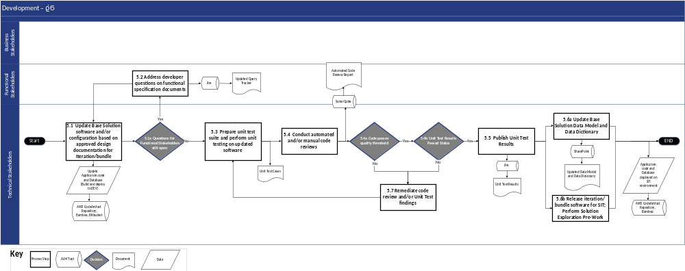
Figure 2-7: Development Phase Process Flow

Process Flow Narrative
The following table describes each step illustrated above.
Development
Step # | Process Step | Description | Stakeholder Group(s) | Inputs (Documents/ Work Products) | Outputs (Documents/ Work Products)
5.1 | Update Base Solution software and/or configuration based on approved design documentation for iteration/bundle | Customize / configure the Base Solution during each iteration/ bundle per the approved design documents to meet the signed off requirements as per the RSD (DEL-18) and RTM (DEL-19) documents | - Technical Stakeholders | - Approved Functional Design Documents for MECM (DEL-20)  - Interface/  Batch/  Automation Control Documents for MECM (DEL-22)  - MECM System Architecture Design Document (DEL-16)  - Requirements Traceability Matrix (DEL-19)  - Requirements Specification Document (DEL-18)  - System Security Plan (DEL-15) | - Updated Application Code and Database
5.1a | Questions for Functional Stakeholders still open | Technical Stakeholders verify if there are questions on Functional Specification Documents not answered  - If yes, proceed to Step #5.2 Address developer questions on functional specification documents  - If no, proceed to Step #5.3 Prepare unit test suite and perform unit testing on updated software | - Technical Stakeholders | - N/A | - N/A
5.2 | Address developer questions on functional specification documents | - Log queries in the query tracker in case of ambiguity, gaps, or clarifications required for the requirements to be implemented in the current iteration/bundle  - The Functional team will work with the relevant DOH OHIP stakeholders to resolve those queries | - Functional Stakeholders | - Approved Functional Design Document (DEL-20) for MECM | - Query tracker with open and resolved queries specific to the ongoing iteration/ bundle
5.3 | Prepare unit test suite and perform unit testing on updated software | - Create unit test cases for the features built in the current iteration/bundle to confirm the software complies with the signed-off requirements for the current iteration/bundle scope  - Once a feature is developed, the developer will unit test the feature per the test cases identified in accordance with the Test Management Plan (DEL-09) | - Technical Stakeholders | - Updated Application Code and Database  - Requirements Traceability Matrix (DEL-19)  - Requirements Specification Document (DEL-18)  - Test Management Plan (DEL-09) | - Unit Test Cases  - Unit Test Results updated with the iteration/bundle test results
5.4 | Conduct automated and/or manual code reviews | - Conduct peer/lead code review of the implemented code to confirm that development is per the industry best practices  - Additionally, an automated code review tool will be configured with industry recommended ruleset which will be run every time before the code is checked-in to the source repository  - Code will be checked-in and promoted to higher environments only when it passes the code review quality checks | - Technical Stakeholders | - Unit Test Cases  - Unit Test Results updated with the iteration/  bundle test results  - Application Code, Automated Code Review Ruleset, Code Review Checklist | - Automated Code Review Report
5.4a | Code passes quality threshold | Technical Stakeholders determine if the code passes the quality tests in accordance with the Test Management Plan (DEL-09)  - If yes, proceed to Step #5.4b Unit Test Results Passed Status  - If no, proceed to Step #5.7 Remediate code review and/or unit test findings | - Technical Stakeholders | - N/A | - N/A
5.4b | Unit Test Results Passed Status | Technical Stakeholders verify if the Unit Test results are a ‘Pass’ in accordance with the Test Management Plan (DEL-09)  - If yes, proceed to Step #5.5 Publish Unit Test Results  - If no, proceed to Step #5.7 Remediate code review and/or unit test findings | - Technical Stakeholders | - N/A | - N/A
5.5 | Publish Unit Test Results | Publish the Unit Test Results to document application code passing the unit testing exit criteria (refer to Test Management Plan (DEL-09)) as a sign-off for the code to be deployed to SIT environment | - Technical Stakeholders | - Unit Test Results with iteration/ bundle test results  - Automated Code Review Report | - Unit Test Results
5.6a | Update Base Solution Data Model and Data Dictionary | Revise the Base Solution data model and data dictionary documents at the end of the development phase | - Technical Stakeholders | - Solution data models  - Data dictionary documents | - Updated Data Models and Data Dictionary (DEL-21)
5.6b | Release iteration/bundle software for SIT; Perform Solution Exploration Pre-Work | Deploy application code to the SIT environment for SIT once it passes the code review and unit tests and meets the exit criteria; conduct appropriate Solution Exploration pre-work, as needed | - Technical Stakeholders | - SIT environment ready  - Application Code and Database | - Application code and database deployed in SIT and Solution Exploration environments
5.7 | Remediate code review and/or Unit Test findings | Address and resolve issues identified during code review and unit testing by making necessary code changes, re-running tests, and updating documentation to confirm that the code meets quality standards and functions as intended. | - Technical Stakeholders | - Updated Application Code and Database  - Requirements Traceability Matrix (DEL-19)  - Requirements Specification Document (DEL-18)  - Test Management Plan (DEL-09) | - Unit Test Cases  - Unit Test Results updated with the iteration/bundle test results
Table 2-20: Development Phase Process Flow Narrative

Roles and Responsibilities
The SDLC RACI Matrix and roles and responsibilities can be found in Appendix C-1.

Phase Exit Criteria
Key stakeholders from ███████ and DOH OHIP identified in the RACI matrix as Accountable or Responsible will collectively agree on the conclusion of the current phase and the commencement of the next phase. The ███████ owner, as designated in the RACI matrix, provides a comprehensive status update, specifically addressing the entry and exit criteria for the concluded phase, and allowing for questions. Upon satisfying phase exit criteria, a decision to exit the current phase will be logged to document the closure of the phase.
# | Exit Criteria | Related Document(s)/Artifact(s)
1 | Approved and published Unit Test Results | - Unit Test Results
2 | Updated Data Model and Data Dictionary (DEL-21) | - Data Model and Data Dictionary (DEL-21)
3 | Application code and database deployed in SIT and Solution Exploration environments | - Communication of SIT and Solution Exploration environment availability
Table 2-21: Development Phase Exit Criteria

Supporting Application Lifecycle Management (ALM) Tools
In the Development phase, ALM tools will enable version control, code collaboration, code review, unit test, and deployment across the development process. ALM tools also assist in tracking and managing issues and bugs, integrating with development environments and testing tools, and automating build and deployment processes.
Below are the ALM tools and workflows that pertain to the Development phase:
- The artifact repository workflow (refer to Section 2.24 artifact repository)
- The build server workflow (refer to Section 2.23 the build server)
- The source-code repository workflow (refer to Section 2.21 the source-code repository)
- Development, Incident, Change Request, and Service Request workflows in the ALM tool (refer to Section 2.20 the ALM tool)
- SharePoint (refer to Section 2.18 Continuing Medicaid Eligibility Modernization SharePoint)
- the static code analysis tool workflow (refer to Section 2.22 the static code analysis tool)

System Integration Test (SIT) Phase
The SIT phase serves to validate that the MECM software conforms to the approved design specifications for the iteration/bundle. This phase includes an application walkthrough with appropriate DOH stakeholders.

Phase Entry Criteria
# | Entry Criteria | Related Document(s)/Artifact(s)
1 | Unit Test Results published | - Unit Test Results
2 | SIT environment available | - Communication of SIT environment availability
Table 2-22: SIT Phase Entry Criteria

Process Flow Diagram
The following process flow depicts the SIT phase of the MECM SDLC.
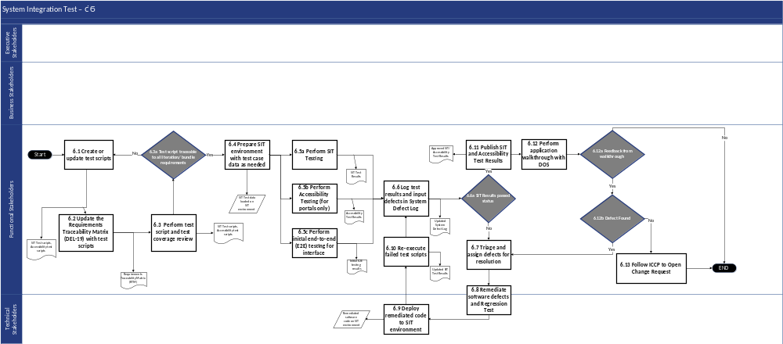
Figure 2-8: SIT Process Flow

Process Flow Narrative
The following table describes each process step illustrated above.
SIT
Step # | Process Step | Description | Stakeholder Group(s) | Inputs (Documents/ Work Products) | Outputs (Documents/ Work Products)
6.1 | Create or update test scripts | Document test scenarios from JAD sessions to create test scripts or make updates to existing ones. Test scripts are based on approved design documentation for the iteration/bundle in accordance with the Test Management Plan (DEL-09) | - Functional Stakeholders | - Application code and database deployed in the SIT environment  - Data Models and Data Dictionary (DEL-21)  - Unit Test Results  - Approved Functional Design Document (DEL-20)  - Interface/  Batch/  Automation Control Documents (DEL-22)  - System Architecture Design Document (DEL-16)  - Requirements Traceability Matrix (DEL-19)  - Requirements Specification Document (DEL-18)  - Test Management Plan (DEL-09)  - System Security Plan (DEL-15) | - SIT test scripts  - Accessibility test scripts
6.2 | Update the Requirements Traceability Matrix (DEL-19) with test scripts | Update the RTM (DEL-19) with the test case IDs to link them to the design documents and requirements | - Functional Stakeholders | - Requirements Traceability Matrix (DEL-19)  - SIT test scripts | - Requirements Traceability Matrix (DEL-19) updated with test scripts information
6.3 | Perform test script and test coverage review | Review test cases and scripts internally with Functional team to identify any test gaps and coverage gaps of functionality | - Functional Stakeholders | - SIT test scripts | - Revised SIT test scripts
6.3a | Test script traceable to all iteration/ bundle requirements | Functional Stakeholders determine if all requirements are traceable to test cases  - If yes, proceed to Step #6.4 Prepare SIT environment with test case data as needed  - If no, proceed to Step #6.1 Create or update test scripts | - Functional Stakeholders | - N/A | - N/A
6.4 | Prepare SIT environment with test case data as needed | SIT test data is created in the environment that will be used for testing | - Functional Stakeholders | - Data Models and Data Dictionary (DEL-21)  - SIT test scripts | - SIT test data loaded on SIT environment
6.5a | Perform SIT Testing | SIT is executed during this phase. Test cases are executed according to the Test Management Plan (DEL-09). Test execution results are documented. Test case execution statuses are updated based on the outcome of the execution | - Functional Stakeholders | - Test Management Plan (DEL-09)  - SIT test cases  - SIT data  - SIT test scripts | - SIT test results
6.5b | Perform Accessibility Testing (for Portals only) | Accessibility testing/ Americans with Disabilities Act (ADA) compliance testing is conducted in this phase. The portals are tested for accessibility compliance. The test cases statuses are updated based on the outcome of the execution. Test results are documented | - Functional Stakeholders | - Test Management Plan (DEL-09)  - Accessibility test cases  - Accessibility test scripts | - Accessibility test results
6.5c | Perform initial end-to-end (E2E) testing for interface | Initial test with trading partners before beginning E2E SIT. For each iteration/bundle, the interfaces are tested individually before the fully E2E integrated testing with the trading partners | - Functional Stakeholders | - SIT test cases  - SIT data | - Initial E2E testing results
6.6 | Log test results and input defects in System Defect Log | Based on the triage, defects with test results are logged into the defect log management tool | - Functional Stakeholders | - SIT test results  - Accessibility test results  - Initial E2E testing results | - Updated System Defect Log with SIT detected defects  - SIT Test Results Log
6.6a | SIT Test Results passed status | SIT Test Results met the criteria defined in the Test Management Plan (DEL-09)  - If yes, proceed to Step #6.11 Publish SIT and Accessibility Test Results  - If no, proceed to Step #6.7 Triage and assign defects for resolution | - Functional Stakeholders | - N/A | - N/A
6.7 | Triage and assign defects for resolution | Defects are assigned for resolution. The severity and priority of the defects are logged in the defect management tool | - Functional Stakeholders | - System Defect Log with SIT detected defects | - Updated System Defect Log with severity and priority
6.8 | Remediate software defects and Regression Test | Corrective actions are taken to fix the issues in the defect | - Functional Stakeholders  - Technical Stakeholders | - Update System Defect Log with severity and priority | - Remediated Software Code
6.9 | Deploy remediated code to SIT environment | Deploy remediated code in the SIT environment for testing | - Technical Stakeholders | - Remediated software code | - Updated test scripts
6.10 | Re-execute failed test scripts | The failed test cases are re-executed, and the results are documented. The statuses of the defect and the test cases are updated based on the outcome of the execution | - Functional Stakeholders | - SIT test scripts | - Updated SIT test results
6.11 | Publish SIT and Accessibility Test Results | SIT and Accessibility test results are published and shared with the stakeholders | - Functional Stakeholders | - SIT test results  - Accessibility test results | - Published SIT and Accessibility test results
6.12 | Perform application walkthrough with DOS | Walkthrough the application developed in the iteration/bundle with DOS | - Functional Stakeholders | - Data Models and Data Dictionary (DEL-21)  - Approved Functional Design Document (DEL-20)  - Interface/  Batch/  Automation Control Documents (DEL-22)  - System Architecture Design Document (DEL-16)  - Requirements Traceability Matrix (DEL-19)  - Requirements Specification Document (DEL-18) | - Approved SIT and Accessibility test results  - Walkthrough feedback if any
6.12a | Feedback from walkthrough | After the walkthrough, determine if there is any feedback  - If yes, proceed to Step #6.12b Defect found  - If no, process ends and proceeds to the Solution Exploration Phase | - Functional Stakeholders | - N/A | - N/A
6.12b | Defect found | Determine whether the feedback from walkthrough detected a defect  - If yes, proceed to Step #6.9 Triage and assign defects for resolution  - If no, proceed to Step #6.13 Follow Integrated Change Control Process (ICCP) to open Change Request | - Functional Stakeholders | - N/A | - N/A
6.13 | Follow ICCP to open Change Request | If the walkthrough feedback results in an application change unrelated to defects, a change request is opened and evaluated by the CRB | - Functional Stakeholders | - Walkthrough feedback | - Change Request
Table 2-23: SIT Phase Process Flow Narrative

Roles and Responsibilities
The SDLC RACI Matrix and roles and responsibilities can be found in Appendix C-1.

Phase Exit Criteria
Key stakeholders from ███████ and DOH identified in the RACI matrix as Accountable or Responsible will collectively agree on the conclusion of the current phase and the commencement of the next phase. The ███████ owner, as designated in the RACI matrix, provides a comprehensive status update, specifically addressing the entry and exit criteria for the concluded phase, and allowing for questions. Upon satisfying phase exit criteria, a decision to exit the current phase will be logged to document the closure of the phase.
# | Exit Criteria | Related Document(s)/Artifact(s)
1 | SIT test results for all iterations/bundles of a Wave meet the thresholds for a ‘pass’ result as defined in the Test Management Plan (DEL-09) | - Test Management Plan (DEL-09)  - SIT Test Report
Table 2-24: SIT Phase Exit Criteria

Supporting Application Lifecycle Management (ALM) Tools
In the SIT phase, the ALM tools will help facilitate the integration, and testing of different software components and systems by providing version control for integration code, automating integration testing, and tracking and managing integration-related issues. These tools also support collaboration among integration teams, promote traceability between integration activities and requirements, and provide reporting and monitoring capabilities to track the progress and quality of system integration efforts.
Below are the ALM tools and workflows that pertain to the SIT phase:
- The artifact repository workflow (refer to Section 2.24 artifact repository)
- The build server workflow (refer to Section 2.23 the build server)
- The source-code repository workflow (refer to Section 2.21 the source-code repository)
- The requirements management tool Requirements traceability workflow (refer to Section 2.34 the requirements management tool)
- Incident, Change Request, and Service Request workflows in the ALM tool (refer to Section 2.20 the ALM tool)
- JAWS (refer to Section 2.27 JAWS)
- SharePoint (refer to Section 2.18 Continuing Medicaid Eligibility Modernization SharePoint)
- WAVE (refer to Section 2.26 WAVE)
- Test Case and Test Run workflows in the test management tool (refer to Section 2.28 the test management tool)

Solution Exploration Phase
The Solution Exploration phase serves to validate that the solution aligns to design inputs and decisions resulting from Integrated JAD sessions. This phase is the final phase within an iteration/bundle.

Phase Entry Criteria
# | Entry Criteria | Related Document(s)/Artifact(s)
1 | SIT test results for all iterations/bundles of a Wave meeting the thresholds for a ‘pass’ result as defined in the Test Management Plan (DEL-09) | - Test Management Plan (DEL-09)  - SIT Test Report
2 | UAT environments are ready for use and each environment has passed an initial set of predefined test cases | - N/A
Table 2-25: Solution Exploration Phase Entry Criteria

Process Flow Diagram
The following process flow depicts the Solution Exploration phase of the MECM SDLC.
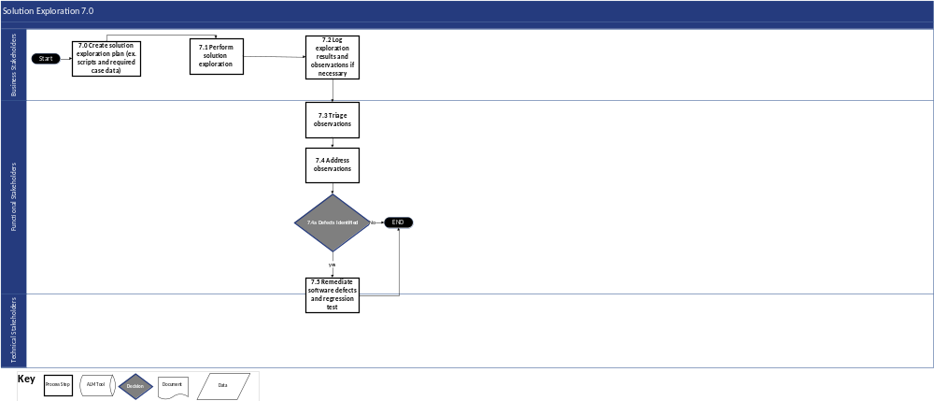
Figure 2-9: Solution Exploration Process Flow

Process Flow Narrative
The following table describes each process step illustrated above.
Solution Exploration
Step # | Process Step | Description | Stakeholder Group(s) | Inputs (Documents/ Work Products) | Outputs (Documents/ Work Products)
7.0 | Create solution exploration plan (ex. scripts and required case data) | The solution exploration scripts are identified, elaborated, and written | - Business Stakeholders | - Data Models and Data Dictionary (DEL-21)  - Approved Functional Design Document (DEL-20) for MECM  - Interface/  Batch/  Automation Control Documents (DEL-22) for MECM  - System Architecture Design Document (DEL-16)  - Requirements Traceability Matrix (DEL-19)  - Requirements Specification Document (DEL-18) | - Solution exploration test plan  - Solution exploration test scripts  - Solution exploration test data
7.1 | Perform solution exploration | Solution exploration testing is executed in this phase. The test case execution results are documented. Test case statuses are updated based on the outcome of the execution | - Business Stakeholders | - Solution exploration test plan  - Solution exploration test scripts  - Solution exploration test data | - Results of solution exploration
7.2 | Log exploration results and observations if necessary | Solution exploration test results are documented and logged into the test case management tool | - Business Stakeholders | - Solution exploration testing results  - Solution exploration testing observations | - Logged solution exploration test results and observations
7.3 | Triage observations | Observations deviating from the design are triaged with Functional and Development teams | - Functional Stakeholders | - Logged solution exploration test results and observations | - Updated solution exploration observations
7.4 | Address observations | Take corrective actions for approved observations | - Functional Stakeholders | - Updated solution exploration observations | - Updated System Defect Log with observations deemed as defects
7.4a | Defects identified | Determine if there are defects identified within the solution exploration observations  - If yes, proceed to Step #7.5 Remediate software defects and regression test  - If no, proceed to End | - Functional Stakeholders | - N/A | - N/A
7.5 | Remediate software defects and regression test | Complete fixes for the identified defects and perform Regression Testing for the changes | - Functional Stakeholders  - Technical Stakeholders | - Updated System Defect Log with observations deemed as defects | - Approved solution exploration signoff
Table 2-26: Solution Exploration Phase Process Flow Narrative

Roles and Responsibilities
The SDLC RACI Matrix and roles and responsibilities can be found in Appendix C-1.

Phase Exit Criteria
Key stakeholders from ███████ and DOH identified in the RACI matrix as Accountable or Responsible will collectively agree on the conclusion of the current phase and the commencement of the next phase. The ███████ owner, as designated in the RACI matrix, provides a comprehensive status update, specifically addressing the entry and exit criteria for the concluded phase, and allowing for questions. Upon satisfying phase exit criteria, a decision to exit the current phase will be logged to document the closure of the phase.
# | Exit Criteria | Related Document(s)/Artifact(s)
1 | The Solution Exploration observations are properly dispositioned and prioritized | - All the valid observations are categorized as: valid defects to be addressed, potential design updates, or potential enhancements
2 | The Requirements Traceability Matrix (DEL-19) is updated with traceability of all Wave requirements through test script coverage | - Requirements Traceability Matrix (DEL-19)
Table 2-27: Solution Exploration Phase Exit Criteria

Supporting Application Lifecycle Management (ALM) Tools
In the Solution Exploration phase, the ALM tools will help the solution explorers to conduct testing needed to verify the system aligns with design and decisions agreed-upon during Integrated JAD sessions. These tools provide reporting and monitoring capabilities to track the progress and disposition of Solution Exploration observations.
Below are the ALM tools and workflows that pertain to the Solution Exploration phase:
- Solution Exploration Observation, Incident, Change Request, and Service Request workflows in the ALM tool (refer to Section 2.20 the ALM tool)

Operational Readiness Test (ORT) Phase
Operational Readiness Test occurs when all iterations/bundles of Design/Development/SIT are complete and the entire functionality for a Wave can be tested together. This phase includes the following testing types that benefit from being executed when the Wave’s functionality and software is complete: Pre-UAT, End-to-End (E2E) Testing, Regression Testing, Performance Testing, Security Testing and Failover Testing.
Entry and exit criteria are crucial for a structured and effective testing process. Entry criteria determine if the system is ready for a testing phase by confirming preconditions like environment setup and test case preparation. Exit criteria define the conditions for concluding a testing phase, such as successful test case completion and resolution of critical defects. These criteria provide a clear framework for assessing system readiness, facilitating a controlled progression through the testing lifecycle, and contributing to the delivery of a reliable and high-quality system.
The following section describes the functional testing types included in ORT.

Functional-Related End to End Testing
Pre-UAT, E2E Testing, Regression Testing, and Performance Testing are essential functional testing because each collectively validate the system's functional integrity, integration, stability, and performance under expected load conditions. These tests confirm that the system is robust and meets the necessary requirements before proceeding to the final stages of testing.
E2E validates the interactions between integrated components within the entire application workflow. Establishing clear entry criteria for E2E is crucial to confirm system stability, environment readiness, and resource availability, thereby reducing risks and enhancing software quality.

Phase Entry Criteria (Functional ORT)
The following table describes the entry criteria with the associated document/artifacts for functional testing:
# | Entry Criteria | Related Document(s)/Artifact(s)
1 | 100% SIT test cases up to Bundle 6 are executed with an 80% pass rate. | - SIT Test Results
2 | No open critical or high SIT defects up to Bundle 6, and resolution plan for all medium and low defects. | - SIT Test Results
3 | All interface testing up to Bundle 4 is complete. All high and critical defects have been resolved.  All Critical (Priority 1) interfaces need to go through/complete trading partner testing and be available for SIT end to end testing. | - SIT Test Results
4 | There should be no new CRs that impact the foundational solution after SIT E2E begins.  Ancillary CRs tied to non-foundational items, such as reports or language changes, can be approved following discussion. | - N/A
5 | Connectivity is established for all interfaces in scope until Bundle 5. | - N/A
6 | The following conversion activities must be complete:  - Receive synthetic data from GDIT NYSOH  - Obtain production data to be used in SIT C environment  - Collect the complete backlog data GDIT NYSOH  - Conduct a thorough data quality (DQ) assessment on the complete backlog data and share the DQ report with GDIT NYSOH  - Receive the full backlog file to initiate the first mock run from GDIT NYSOH  - Execute the first mock run and prepare a detailed mock run report to be shared with GDIT NYSOH  - Execute first round of conversion case lifecycle test cases | - N/A
7 | Approvals of all design documentation  - Clearly define concurrence has been reached for FDDs and ICDs  - Post-concurrence/approval design updates and where designs may be at this time | - Iteration 1-2, Bundle 1-6 FDDs and ICDs
8 | Batch Scheduling and Running: Automating tasks to run at specific times for optimal system performance | - Batch Schedule
9 | Infrastructure and security items such as file transfer, encryption, security testing, data masking, and logging and monitoring must be completed. | - Infrastructure and Security
Table 2-28: Functional Testing Entry Criteria

Security and Failover Testing
Security Testing identifies vulnerabilities and protects the organization against unauthorized access, while Failover Testing verifies the system's ability to maintain continuity and recover from failures. Conducting these tests confirms that the system is not only functional but also resilient and ready for production.
Security Testing is a critical process aimed at identifying vulnerabilities, threats, and risks within a software application. This type of testing focuses on uncovering potential security flaws, thereby protecting the system from unauthorized access, data breaches, and other security threats. Techniques such as vulnerability scanning, security auditing, and code review are employed to thoroughly examine the system's defenses. By addressing the identified issues, Security Testing fortifies the application's security, safeguards sensitive data, and maintains the integrity and confidentiality of the system.
Failover Testing is a vital component of a robust disaster recovery strategy, designed to verify the continuity and reliability of IT systems in the event of a failure. This process involves simulating a failure and confirming that the backup system can seamlessly take over operations without data loss or significant downtime. By rigorously testing the failover mechanisms, ███████ and DOH can identify potential weaknesses, validate recovery procedures, and demonstrate that the system can maintain operational integrity under adverse conditions. Effective Failover Testing enhances system resilience and builds confidence among stakeholders that the organization is well-prepared to handle unexpected disruptions.

Phase Entry Criteria (Security and Failover ORT)
The following table describes the entry criteria with the associated document/artifacts for Security and Failover Testing:
# | Entry Criteria | Related Document(s)/Artifact(s)
1 | Static Application Security Testing (SAST), Dynamic Application Security Testing (DAST), Manual Penetration Testing, and Security Functional Testing for Bundle 6 comprising of a comprehensive test of the entire Member Portal and Worker Portal applications. | - SAST and DAST Report
2 | Infrastructure Security Testing and Amazon Machine Image (AMI) Compliance Hardening conducted in accordance and cadence with the applied security standards. | - the infrastructure vulnerability scanning tool Vulnerability Report  - AMI Compliance Hardening Report
3 | All critical, high, and medium, vulnerabilities are resolved from all vulnerability reports or justification for delay in the timeframe of resolution in accordance with the applied security standards is provided. Timeframes for resolution for low vulnerabilities will be provided as well as justifications for any False Positives identified. | - SAST / DAST Report  - the infrastructure vulnerability scanning tool Vulnerability Report  - AMI Compliance Hardening Report
Table 2-29: Security and Failover Testing Entry Criteria

Process Flow Diagram
The following process flow depicts the ORT phase of the MECM SDLC.
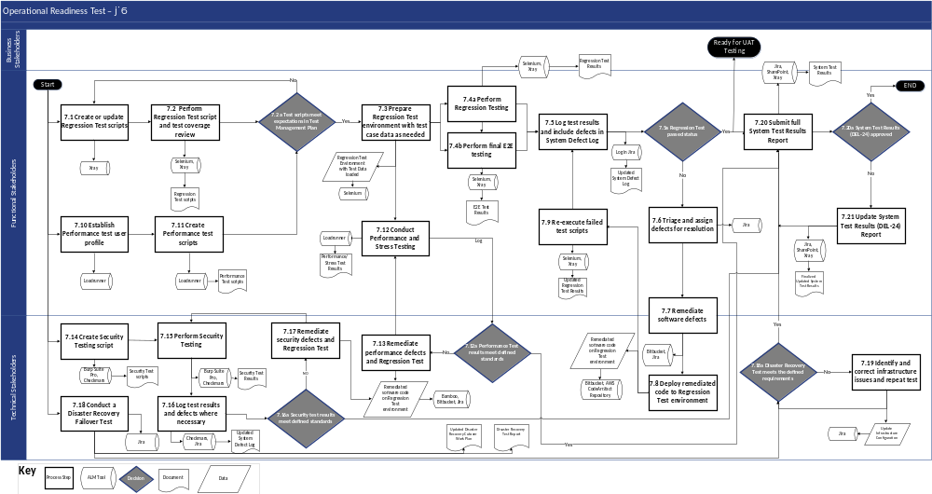
Figure 2-10: Operational Readiness Test Phase Process Flow

Process Flow Narrative
The following table describes each process step illustrated above.
Operational Readiness Test
Step # | Process Step | Description | Stakeholder Group(s) | Inputs (Documents/ Work Products) | Outputs (Documents/Work Products)
7.1 | Create or update Regression Test scripts | Develop test scripts for the in-scope components based on the design documents and the Regression Test approach in the Test Management Plan (DEL-09). This process supports the retest of previously validated components that may have been impacted by other changes | - Functional Stakeholders | - SIT test scripts  - Test Management Plan (DEL-09) (Regression Test Approach) | - Regression test scripts
7.2 | Perform Regression Test script and test coverage review | Review test cases and test coverage with Functional team and identify any test coverage gaps | - Functional Stakeholders | - Regression Test scripts | - Revised and approved Regression test scripts
7.2a | Test scripts meet expectations in Test Management Plan | Determine if the Regression test and Performance test scripts met the defined criteria in the Test Management Plan (DEL-09)  - If yes, proceed to Step #7.3 Prepare Regression test environment with test case data as needed  - If no, proceed to Step #7.1 Create or update regression test scripts | - Functional Stakeholders | - N/A | - N/A
7.3 | Prepare Regression Test environment with test case data as needed | Create and load Regression test data in the environment that will be used for testing. The Regression test environment enables functional users to confirm the end-to-end process testing across the system after changes are made | - Functional Stakeholders | - Regression test environment  - Test Management Plan (DEL-09) (Regression Test approach)  - Regression test data | - Regression test environment with test data loaded  - Test automation scripts
7.4a | Perform Regression Testing | Perform Regression Testing according to the Test Management Plan (DEL-09) to confirm that the modifications have not caused unintended effects. Confirm that the production system or component still complies with its specified requirements | - Functional Stakeholders | - Regression test environment ready  - Test Management Plan (DEL-09) | - Regression test results
7.4b | Perform final E2E testing | Perform interface testing with trading partners | - Functional Stakeholders | - Regression test results | - Final E2E testing results
7.5 | Log test results and include defects in System Defect Log | Log all defects and the status of each defect in the System Defect Log | - Functional Stakeholders | - Final E2E testing results  - Regression test results  - Operational Readiness test results  - System Defect Log | - System Defect Log updated with E2E, and Regression Testing detected defects  - Operational Readiness test results updated with E2E and Regression test results
7.5a | Regression Test passed status | Determine if Regression Testing results pass the criteria defined in Test Management Plan (DEL-09)  - If yes, proceed to Step #7.20 Submit full System Test Results Report  - If no, proceed to Step #7.6 Triage and assign defects for resolution | - Functional Stakeholders | - N/A | - N/A
7.6 | Triage and assign defects for resolution | Assign defects that impact end-to-end use of the production system to Functional and Development teams for resolution. Document the severity, the priority of the defects, and the estimated date of fix | - Functional Stakeholders | - System Defect Log updated with Regression Testing detected defects | - Defect resolution assignment
7.7 | Remediate software defects | Take corrective actions to resolve the issues identified in the defect | - Functional Stakeholders  - Technical Stakeholders | - System Defect Log  - Defect resolution assignment | - Remediated software code
7.8 | Deploy remediated code to Regression Test environment | Deploy code changes to the Regression test environment | - Technical Stakeholders | - Remediated software code | - Remediated software code deployed at Regression Test environment
7.9 | Re-execute failed test scripts | Re-execute the failed test cases once the defect fixes are deployed to Regression test environments. Document the test execution results and update the statuses of the defects and the test cases based on the outcome of the re-execution | - Functional Stakeholders | - Updated Regression test plan  - Remediated software code deployed | - Updated Regression test results
7.10 | Establish Performance test user profile | Set up security roles and user access to Performance Testing | - Functional Stakeholders | - Test Management Plan (DEL-09) | - Performance test user profiles
7.11 | Create Performance test scripts | Develop the Performance test scripts based on the Test Management Plan (DEL-09) | - Functional Stakeholders | - Test Management Plan (DEL-09) (Performance and Stress Testing approach)  - Performance test user profiles | - Performance test scripts
7.12 | Conduct Performance and Stress Testing | Monitor the target environment to extract, extrapolate results from each cycle of the test execution, and analyze the test results to conform to service level standards and deliver tuning recommendations | - Functional Stakeholders | - Test Management Plan (DEL-09) (Performance and Stress Testing approach)  - Performance and Stress test environment | - Performance and Stress test results
7.12a | Performance test results meet defined standards | Determine if Performance test results meet standards defined in Test Management Plan (DEL-09)  - If yes, proceed to Step #7.20 Submit full System Test Results (DEL-24) report  - If no, proceed to Step #7.13 Remediate performance defects and Regression test | - Technical Stakeholders | - N/A | - N/A
7.13 | Remediate performance defects and Regression Test | Take corrective actions to resolve the performance test issues in the defect | - Technical Stakeholders | - Performance and Stress test results | - Remediated software code or configuration
7.14 | Create Security Testing script | Develop the Security test scripts for the in-scope components based on the Test Management Plan (DEL-09) | - Technical Stakeholders | - Test Management Plan (DEL-09) (System Security Test Plan) | - Security test script  - Role-based Security test cases
7.15 | Perform Security Testing | Perform Security Testing and capture results. Categorize security risks and assess their potential impact and severity if realized in the production environment | - Technical Stakeholders | - Security test scripts  - Role-based Security test cases | - Security test results
7.16 | Log test results and defects where necessary | Security team logs all defects and the status of each defect in the System Defect Log | - Technical Stakeholders | - Security test results | - Updated System Defect Log with Security test results
7.16a | Security test results meet defined standards | Determine if Security test results meet standards defined in System Security Plan (DEL-15)  - If yes, proceed to Step #7.20 Submit full System Test Results (DEL-24) Report  - If no, proceed to Step #7.17 Remediate security defects and Regression Test | - Technical Stakeholders | - N/A | - N/A
7.17 | Remediate security defects and Regression Test | Take corrective actions to resolve the security issues in the System Defect Log | - Technical Stakeholders | - Updated System Defect Log | - Remediated code  - Updated Security test results
7.18 | Conduct a Disaster Recovery Failover Test | - Conduct a Disaster Recovery Failover test in accordance with the Business Continuity and Disaster Recovery Plan (DEL-14)  - It should in support the business continuity in the event of a system interruption to maintain service, for critical business areas  - Validate planned application backup and recovery procedures by exercising them in full | - Technical Stakeholders | - Business Continuity and Disaster Recovery Plan (DEL-14)  - Disaster Recovery (DR) Cutover Work Plan  - Recovery Point Objective (RPO)/ Recovery Time Objective (RTO)  - Disaster Recovery Test Cases | - Updated Disaster Recovery Cutover Work Plan  - Measured RPO and RTO  - Disaster Recovery test results
7.18a | Disaster Recovery Test meets the defined requirements | Determine if the Disaster Recovery test results meet the requirements defined in the BCDR (i.e., RTO and RPO targets)  - If yes, proceed to Step #7.20 Submit full System Test Results (DEL-24) report  - If no, proceed to Step #7.19 Identify and correct infrastructure issues and repeat test | - Technical Stakeholders | - N/A | - N/A
7.19 | Identify and correct infrastructure issues and repeat test | Deploy infrastructure fixes and re-execute the failed test cases to confirm issues have been corrected | - Technical Stakeholders | - Measured RPO and RTO  - Disaster Recovery test report | - Root cause analysis  - Updated infrastructure configuration  - Updated DR test results
7.20 | Submit full System Test Results Report | - Submit full package of System Test Results (DEL-24) with stakeholders’ feedback  - Produce information needed to support iterative renewal of Disaster Recovery procedures and infrastructure | - Functional Stakeholders | - Security test results  - DR test results  - Regression test results | - Submitted System Test Results (DEL-24)
7.20a | System Test Results (DEL-24) approved | Determine if the test results in the System Test Results (DEL-24) are approved  - If yes, the phase is concluded  - If no, proceed to Step #7.21 Update System Test Results (DEL-24) report | - Functional Stakeholders | - N/A | - N/A
7.21 | Update System Test Results (DEL-24) Report | Utilize feedback from stakeholders on the System test results (DEL-24) to update the system test results report per the Deliverable Management Plan | - Functional Stakeholders | - System Test Results (DEL-24) with stakeholders’ feedback  - Updated System Test Results (DEL-24) | - Finalized System Test Results (DEL-24)
Table 2-30: Operational Readiness Test Phase Process Flow Narrative

Roles and Responsibilities
The SDLC RACI Matrix and roles and responsibilities can be found in Appendix C-1.
Testing Type | Description
Pre-UAT (Pre-User Acceptance Testing) | Pre-UAT is conducted to validate the system's readiness for formal User Acceptance Testing (UAT). It involves checking the functionality, usability, and stability of the system to confirm it meets the business requirements and is prepared for end-user testing.
End-to-End (E2E) Testing | E2E Testing verifies the complete flow of the application from start to finish, confirming that all integrated components and systems work together as expected. This testing type validates that the entire process, including data flow and interactions between different systems, functions correctly.
Regression Testing | Regression Testing involves re-running previously conducted tests to confirm that new changes or enhancements have not negatively impacted the existing functionality. This testing type helps in identifying any unintended side effects of recent code changes.
Performance Testing | Performance Testing evaluates the system's responsiveness, stability, and scalability under various load conditions. It helps in identifying performance bottlenecks and confirms that the system can handle the expected user load.
Security Testing | Security Testing assesses the system's security measures to identify vulnerabilities and confirm that data is protected against unauthorized access, breaches, and other security threats. This testing type is crucial for safeguarding sensitive information and maintaining compliance with security standards.
Failover Testing | Failover Testing verifies the system's ability to switch to a backup system or redundant components in case of a failure. This testing type confirms that the system can maintain continuity and minimize downtime during unexpected disruptions.
Table 2-31: Operational Readiness Test Testing Types

Phase Exit Criteria (Functional ORT)
To confirm the successful completion of Functional Testing, the following exit criteria must be met. These criteria validate that the integrated components within the entire application workflow have been thoroughly tested, and the system is stable, functional, and ready for the next phase of deployment.
# | Exit Criteria | Related Document(s)/Artifact(s)
1 | 100% Execution of E2E Test Cases with a 90% Pass Rate | - Test Results
2 | No Open Critical or High E2E Defects | - Defect Log, Test Results
3 | Resolution Plan for All Medium and Low E2E Defects | - Defect Log, Test Results
4 | All Interface Testing Completed and All High and Critical Defects Resolved | - Interface Test Results, Defect Resolution Reports
5 | Successful Completion of Data Conversion Activities | - Data Conversion Reports, Mock Run Reports, Data Quality (DQ) Assessment Reports
6 | Approval of All Design Documentation | - Finalized and Approved FDDs, ICDs, Design Update Logs
7 | Batch Scheduling and Running Successfully Implemented | - Batch Scheduling Logs, Performance Reports
8 | All Connectivity Issues Resolved for Interfaces in Scope | - Connectivity Test Results, Issue Resolution Logs
9 | Stakeholder Sign-off on E2E Test Results and Defect Resolution | - Stakeholder Sign-off Documents, Meeting Minutes
10 | Performance and Load Testing Completed with Acceptable Results | - Performance Test Results, Load Test Results
Table 2-32: Functional Testing Exit Criteria

Phase Exit Criteria (Security and Failover ORT)
The following table describes the exit criteria with the associated document/artifacts for Security and Failover Testing:
# | Exit Criteria | Related Document(s)/Artifact(s)
1 | Static Application Security Testing (SAST), Dynamic Application Security Testing (DAST), Manual Penetration Testing, and Security Functional Testing for Bundle 6 comprising of a comprehensive test of the entire Member Portal and Worker Portal applications. | - SAST and DAST Report
2 | Infrastructure Security Testing and AMI Compliance Hardening conducted in accordance and cadence with the applied security standards. | - the infrastructure vulnerability scanning tool Vulnerability Report  - AMI Compliance Hardening Report
3 | All critical, high, and medium, vulnerabilities are resolved from all vulnerability reports or justification for delay in the timeframe of resolution in accordance with the applied security standards is provided. Timeframes for resolution for low vulnerabilities will be provided as well as justifications for any False Positives identified. | - SAST / DAST Report  - the infrastructure vulnerability scanning tool Vulnerability Report  - AMI Compliance Hardening Report
Table 2-33: Security and Failover Testing Exit Criteria
Key stakeholders from ███████ and DOH identified in the RACI matrix as Accountable or Responsible will collectively agree on the conclusion of the current phase and the commencement of the next phase. The ███████ owner, as designated in the RACI matrix, provides a comprehensive status update, specifically addressing the entry and exit criteria for the concluded phase, and allowing for questions. Upon satisfying phase exit criteria, a decision to exit the current phase will be logged to document the closure of the phase.

Supporting Application Lifecycle Management (ALM) Tools
In the ORT phase, ALM tools help manage the testing and verification of the software’s operational readiness by providing version control for test scripts and configurations, automating ORT test execution, and tracking and managing any issues or discrepancies that arise during testing. ALM tools also enable effective collaboration among ORT teams, maintain traceability between ORT activities and project requirements, and offer reporting and monitoring capabilities to assess the software’s readiness for deployment.
Below are the ALM tools and workflows that pertain to the ORT phase:
- The build server workflow (refer to Section 2.23 the build server)
- The source-code repository workflow (refer to Section 2.21 the source-code repository)
- The SAST Assessment Workflow in Checkmarx (refer to Section 2.29 Checkmarx SAST)
- The DAST Assessment Workflow in Burp Suite Pro (refer to Section 2.30 Burp Suite Pro)
- Defect, Change Request, and Service Request workflows in the ALM tool (refer to Section 2.20 the ALM tool)
- LoadRunner (refer to Section 2.31 LoadRunner Enterprise)
- Selenium (refer to Section 2.25 Selenium)
- SharePoint (refer to Section 2.18 Continuing Medicaid Eligibility Modernization SharePoint)
- Test Case and Test Run workflows in the test management tool (refer to Section 2.28 the test management tool)

User Acceptance Test (UAT) Phase
UAT is performed by business stakeholders to validate the MECM solution functionality aligns with their business requirements and objectives for the Wave. It serves to immerse those stakeholders in the functionality for a Wave to allow them to prepare end users for the Wave’s rollout. This is inclusive of technical, functional, and security requirements further detailed in the Business Continuity and Disaster Recovery Plan (DEL-14) and the System Security Plan (DEL-15) in adherence to the NYS ITS Secure SDLC Standard.
To facilitate a structured and collaborative approach to this key phase, the ███████ team schedule one comprehensive meeting for effective communication, decision-making, and to gain concurrence from DOH OHIP Leadership prior to the start of UAT.
This meeting, scheduled at least two weeks before the planned initiation of the UAT phase associated with the final iteration/bundle, will serve multiple purposes:
- The focus will be on familiarizing DOH OHIP leadership with the relevant checklist(s) associated with the entry criteria and reviewing the current status of checklist completion
- Stakeholders, including governance-level management, will engage in discussions to collectively agree on the go/no-go decision for transitioning into the subsequent phase
During this meeting, two key decisions will be made and documented:
- Completion of the exit criteria for the current phase gate
- Creation of a decision signifying the commencement of the UAT phase entry
Additionally, specific checklists applicable to the UAT entry criteria will be established. The Test Management Plan will provide the Testing Readiness Checklist, complemented by a broader checklist encompassing Yes/No items across the entire phase.

Phase Entry Criteria
 | # |  | Entry Criteria |  | Related Document(s)/Artifact(s)
1 |  | Business stakeholders have been identified and confirmed to have availability to perform UAT |  | - Stakeholder Engagement Plan  - SDLC Methodology – Roles and Responsibilities Matrix
2 |  | System Test Results meet acceptance criteria defined in the Test Management Plan |  | - Test Management Plan (DEL-09)
3 |  | An ISOW is executed for the UAT and Rollout phases of a Wave |  | - Master ISOW Integrated Project Schedule
Table 2-34: User Acceptance Test (UAT) Phase Entry Criteria

Process Flow Diagram
The following process flow depicts the UAT phase of the MECM SDLC.
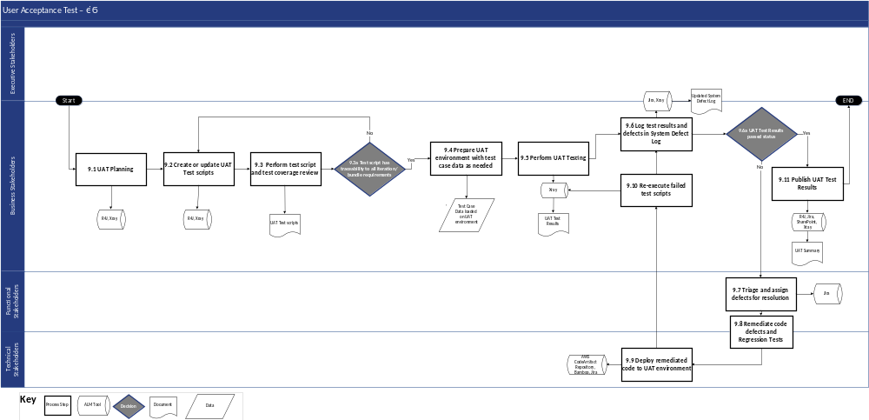
Figure 2-11: User Acceptance Test (UAT) Process Flow Diagram

Process Flow Narrative
The following table describes each process step illustrated above.
UAT
Step # | Process Step | Description | Stakeholder Group(s) | Inputs (Documents/ Work Products) | Outputs (Documents/ Work Products)
9.1 | UAT Planning | - Plan and confirm schedule of test scenarios and scripts to be executed in the UAT cycle  - Conduct kick-off meetings to communicate details of UAT plan, execution approach, and other key information to the entire UAT team  - Identify audience for training and tools that will be covered in accordance with Test Management Plan (Del #9) | - Business Stakeholders | - Test Management Plan (Del #9)  - As-Is/To-Be Business Process Maps (DEL-17)  - Requirements Specification Document (DEL-18)  - Requirements Traceability Matrix (DEL-19)  - Functional Design Document (DEL-20)  - System Test Results (DEL-24) | - N/A
9.2 | Create or update UAT test scripts | - Create or update UAT test scripts to support user-driven testing  - User-acceptance testing focuses on site user readiness and validation of cutover correctness  - Define UAT steps for each UAT test case, based on approved requirements and design documentation and in accordance with the Test Management Plan (DEL-09) | - Business Stakeholders | - Configuration Unit test cases  - Functional Object test approach  - High-Level Process Design  - Integration test cases  - Requirements Traceability Matrix (DEL-19)  - Role-based Security test cases  - User Acceptance test approach | - UAT test scripts
9.3 | Perform test script and test coverage review | Review test cases and scripts with Business Stakeholders to identify any test gaps and coverage gaps of functionality | - Business Stakeholders | - UAT test scripts | - Revised UAT test scripts
9.3a | Test script has traceability to all iteration/ bundle requirements | Determine if all test scripts are traceable to their originated requirements  - If yes, proceed to Step #9.4 Prepare UAT environment with test case data as needed  - If no, proceed to Step #2.2 Create or update UAT test scripts | - Business Stakeholders | - N/A | - N/A
9.4 | Prepare UAT environment with test case data as needed | Prepare the dedicated User Acceptance Test environment and populate with gold configurations, conversion data, interfaced systems data, and transactional data required to support user acceptance testing | - Business Stakeholders | - Test Management Plan (DEL-09)  - Data Migration Plan (DEL-25)  - UAT environment ready | - UAT test data loaded in the UAT environment
9.5 | Perform UAT Testing | Perform UAT Testing to verify that the business is ready to cutover to the new solution. Document the test execution results. Update the statuses of the test cases | - Business Stakeholders | - UAT scripts  - UAT test data loaded in the UAT environment | - UAT test results
9.6 | Log test results in and defects in System Defect Log | Log all defects identified through UAT and the status of each in the System Defect Log | - Business Stakeholders | - UAT test results  - System Defect Log | - UAT test results in the ALM tool  - Updated System Defect Log with UAT results
9.6a | UAT test results passed status | Determine if all UAT tests have passed  - If yes, proceed to process Step #9.11 Publish UAT Test Results  - If no, proceed to process Step# 9.7 Triage and assign defects for resolution | - Business Stakeholders | - N/A | - N/A
9.7 | Triage and assign defects for resolution | Assign observations that impact end-to-end use of the production system to Functional and Development teams to be mitigated. Document the severity, priority and the estimated fix dates for defects | - Functional Stakeholders | - Updated System Defect Log with UAT results | - Updated System Defect Log with resolution assignments
9.8 | Remediate code defects and Regression tests | - Take corrective actions to fix the end-user issues  - Perform Regression tests on the remediated code | - Functional Stakeholders  - Technical Stakeholders | - Updated System Defect Log with resolution assignments | - Remediated code
9.9 | Deploy remediated code to UAT environment | - Perform Regression test in the remediated code  - Redeploy the remediated code to the UAT environment | - Technical Stakeholders | - Remediated code | - Remediated code deployed to UAT environment
9.10 | Re-execute failed test scripts | - UAT testers re-test the remediated code against original test scripts for to validate functionality  - Document the test execution results. Update the statuses of the test cases and the defects based on the outcome of the re-execution | - Business Stakeholders | - UAT test scripts  - Test Management Plan (DEL-09)  - UAT test results | - Updated UAT results  - Updated System Defect Log with UAT results
9.11 | Publish UAT Test Results | Socialize UAT results with appropriate stakeholders | - Business Stakeholders | - Updated UAT results | - UAT summary
Table 2-35: User Acceptance Test (UAT) Phase Process Flow Narrative

Roles and Responsibilities
The SDLC RACI Matrix and roles and responsibilities can be found in Appendix C-1.

Phase Exit Criteria
The UAT phase exit criteria will serve as the final steps before proceeding into the Rollout phase. To facilitate a structured and collaborative approach to this key phase gate, the ███████ team schedules several meetings for effective communication, decision-making, and to gain concurrence from DOH OHIP Leadership.
- The first meeting, scheduled at least two weeks before the planned completion of the UAT phase, serves as an orientation. During this session, the focus will be on familiarizing DOH OHIP leadership with the relevant checklist(s) associated with the phase gate and reviewing the current status of checklist completion.
- The second meeting, scheduled at least one week before the planned completion of the UAT phase, is dedicated to concurrence. Here, stakeholders, including DOH OHIP leadership, will engage in discussions to collectively agree on the go/no-go decision for transitioning into the subsequent phase and advancing the Wave workflow in the ALM tool.
  - During this meeting, two key decisions will be made and documented:
    - Completion of the UAT entry criteria
    - Creation of a decision signifying the commencement of the UAT phase exit
- As a contingency measure, a third meeting may be scheduled at least two business days before the planned completion of the UAT phase. This meeting, only convened if necessary, aims to address any outstanding items and obtain concurrence before entering the next phase.
Additionally, specific checklists applicable to this key phase gate will be established. The Change Management Plan will provide the Operational Readiness Checklist and the MECM System Rollout Plan will provide the Tech Readiness Checklist; both documents will be complemented by a broader checklist encompassing Yes/No items across the entire phase.
# | Exit Criteria | Related Document(s)/Artifact(s)
1 | UAT test results have met the acceptance criteria defined in the Test Management Plan | - Test Management Plan (DEL-09)  - UAT summary
2 | Test results reviewed and approved by State | - Formal Go/No-Go Decision
Table 2-36: User Acceptance Test (UAT) Phase Exit Criteria

Supporting Application Lifecycle Management (ALM) Tools
In the UAT phase, the ALM tools assist in managing the UAT process by providing version control for test cases and scripts, automating test execution, and tracking and managing UAT issues and defects. ALM tools facilitate collaboration among UAT teams, maintain traceability between UAT activities and project requirements, and offer reporting and monitoring features to assess the readiness for end-user acceptance.
Below are the ALM tools and workflows that pertain to the UAT phase:
- The artifact repository workflow (refer to Section 2.24 artifact repository)
- The build server workflow (refer to Section 2.23 the build server)
- The requirements management tool Requirements traceability workflow (refer to Section 2.34 the requirements management tool)
- Defect, Change Request, and Service Request workflows in the ALM tool (refer to Section 2.20 the ALM tool)
- SharePoint (refer to Section 2.18 Continuing Medicaid Eligibility Modernization SharePoint)
- Test Case and Test Run workflows in the test management tool (refer to Section 2.28 the test management tool)

Rollout Phase

Phase Entry Criteria
# | Entry Criteria | Related Document(s)/Artifact(s)
1 | MECM System Rollout Plan (DEL-13) has been reviewed and approved, including plans for rollout supports (for example, site support and Tier 2 support) | - MECM System Rollout Plan (DEL-13)
Table 2-37: Rollout Phase Entry Criteria

Process Flow Diagram
The following process flow depicts the Rollout phase of the MECM SDLC.
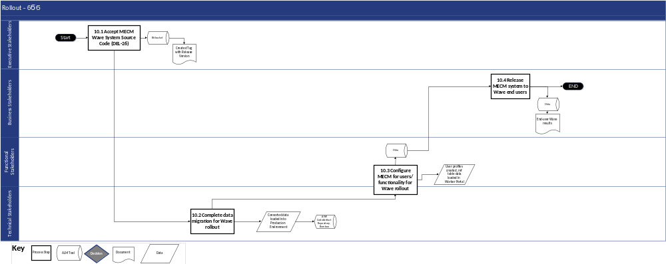
Figure 2-12: Rollout Phase Process Flow

Process Flow Narrative
The following table describes each process step illustrated above.
Rollout
Step # | Process Step | Description | Stakeholder Group(s) | Inputs (Documents/ Work Products) | Outputs (Documents/ Work Products)
10.1 | Accept MECM Wave System Source Code (DEL-26) | Tag the DOH OHIP approved MECM source code as the gold copy for production deployment | - Executive Stakeholders | - Source code repository | - Created tag with release version
10.2 | Complete data migration for Wave rollout | Execute data conversion in the MECM Production environment for the targeted wave population | - Technical Stakeholders | - Source system data extract | - Converted data loaded into Production environment
10.3 | Configure MECM for users/ functionality for Wave rollout | Set up security roles and user access for Wave end users | - Functional Stakeholders  - Technical Stakeholders | - User profiles for the Wave | - Assignment of security roles  - End users given user access for Wave rollout
10.4 | Release MECM systems to Wave end users | Grant access for Wave users to the MECM production environment | - Business Stakeholders | - MECM system | - End user Wave results
Table 2-38: Rollout Process Flow Narrative

Roles and Responsibilities
The Master MECM SDLC Methodology RACI Matrix (refer to Appendix C-1) defines the requirements of each of the project roles or personas.

Phase Exit Criteria
All stakeholders identified in the RACI matrix will convene in a meeting to collectively agree on the completion of Rollout. The ███████ owner, as designated in the RACI matrix, will take the lead in providing a comprehensive status update, specifically addressing the exit criteria for the Rollout phase, allowing for questions, and seeking concurrence from DOH OHIP. Upon concurrence of phase exit criteria, a transmittal will be sent to DOH requesting formal approval to document the acceptance and approval of the phase.
# | Exit Criteria | Related Document(s)/Artifact(s)
1 | System Source Code (DEL-26) has been accepted by Continuing Medicaid Eligibility Modernization Executive Stakeholders | - System Source Code (DEL-26)
2 | The Release Management Plan (DEL-34) has been created, reviewed, and approved and is ready to manage post-production releases | - Release Management Plan (DEL-34)
Table 2-39: Rollout Phase Exit Criteria

Supporting Application Lifecycle Management (ALM) Tools
In the Rollout phase, the ALM tools assist in managing the deployment and rollout of the software by providing version control for rollout plans, configuration settings, and deployment scripts. ALM tools help automate the deployment process, ensuring consistency and reliability across different environments. They also track and manage issues or discrepancies that may arise during the rollout phase, facilitating swift resolution.
Below are the ALM tools and workflows that pertain to the UAT phase:
- artifact repository workflow (refer to Section 2.24 artifact repository below)
- The build server workflow (refer to Section 2.23 the build server below)
- The source-code repository workflow (refer to Section 2.21 the source-code repository below)

SDLC High-Level Process
The following process flow depicts the High-Level process for SDLC.
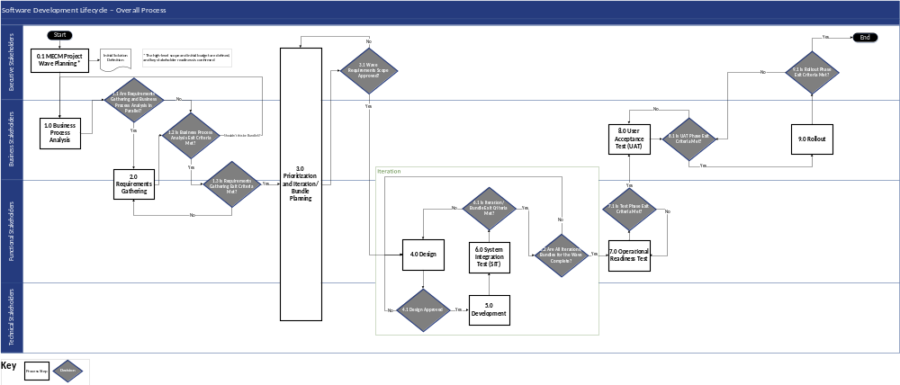
Figure 2-13: SDLC High-Level Process Flow

Process Flow Narrative
The following table describes each process step illustrated above.
Step # | Process Step | Description | Stakeholder  Group(s) | Inputs (Documents/ Work Products) | Outputs (Documents/ Work Products)
0.1 | Continuing Medicaid Eligibility Modernization Wave Planning*  Initial Solution Definition.  *The high-level scope and initial budget are defined, and key stakeholder readiness is confirmed | Executive stakeholders start Continuing Medicaid Eligibility Modernization wave planning | - Executive Stakeholders | - Scope, goals, and objectives for the Wave | - Technical architecture diagrams for Wave  - Logical architecture diagram for Wave  - Physical architecture diagram for Wave  - Security Requirements  - Change Impact Assessment  - Initial Solution Definition (DEL-01)
1.0 | Business Process Analysis | Business stakeholders lead the business process analysis | - Business Stakeholders | - Initial Solution Definition (ISD) (DEL-01)  - MECM Master Statement of Work (MSOW)  - Implementation Schedule Overview (DEL-02)  - MECM System and Project – Budget Planning  - Stakeholder Engagement Plan (PMP DEL-05, refer to Section 3)  - SDLC Methodology – Roles and Responsibilities Matrix  - Master ISOW Integrated Project Schedule | - As Is/To-Be Business Process Maps (DEL-17)  - Requirement Logic Flows/System Requirements Input Document  - Business Objectives Documentation
1.1 | Are Requirements Gathering and Business Process Analysis in Parallel? | Business and Executive stakeholders decide if requirements gathering, and business process analysis are being done in parallel.  - If it is parallel, proceed to Step #2.0 Requirements Gathering  - If it is not parallel, proceed to Step #1.2 Is Business Process Analysis Exit Criteria Met? | - Executive Stakeholders  - Business Stakeholders | - N/A | - N/A
2.0 | Requirement Gathering | Business and Functional stakeholders gather requirements | - Business Stakeholders  - Functional Stakeholders | - Requirement Logic Flows/System Requirements Input Documents  - Baselined Work Plan and Project Schedule (DEL-06)  - Change Management Plan (DEL-30) Stakeholders Engagement (refer to Section 3)  - Project Management Plan (DEL-05) SDLC Methodology (Section 2)– Roles and Responsibilities Matrix (Appendix C-1) | - Requirements Specification Document (DEL-18)  - Requirements Traceability Matrix (DEL-19)  - Documented Base Solution gaps and required changes
1.2 | Is Business Process Analysis Exit Criteria Met? | Business stakeholders decide if business process analysis exit criteria are met  - If the criteria are met, proceed to Step #1.3 Is Requirements Gathering Exit Criteria Met?  - If the criteria are not met, proceed to Step # 1.0 Business Process Analysis | - Business Stakeholders | - As-Is/To-Be Business Process Maps (DEL-17) and personas are reviewed and approved by DOH OHIP  - Business requirements or high-level scope are defined and documented  - Business objectives for the Wave are defined and documented | - As Is/To-Be Business Process Maps (DEL-17)  - Requirement Logic Flows/System Requirements Input Document  - Business Objectives Documentation
1.3 | Is Requirements Gathering Exit Criteria Met? | Business and Functional stakeholders decide if the requirements gathering exit criteria is met  - If the criteria are met, proceed to Step # 3.0 Prioritization and Iteration/Bundle Planning  - If the criteria are not met, proceed to Step #2.0 Requirements Gathering | - Functional Stakeholders  - Business Stakeholders | - Requirements Specification Document (DEL-18) and Requirements Traceability Matrix (DEL-19) including recommended prioritization is submitted for DOH OHIP review | - Requirements Specification Document (DEL-18)  - Requirements Traceability Matrix (DEL-19)  - Documented Base Solution gaps and required changes
3.0 | Prioritization and Iteration/Bundle Planning | All stakeholders work on prioritization and iteration/bundle planning | - Executive Stakeholders  - Business Stakeholders  - Functional Stakeholders  - Technical Stakeholders | - Requirements Traceability Matrix (DEL-19) | - Requirements Specification Document (DEL-18)  - Requirements Traceability Matrix (DEL-19) including Wave assignment  - Baselined Work Plan and Project Schedule (DEL-06)  - Master ISOW Integrated Project Schedule
3.1 | Wave Requirements Scope Approved? | Executive stakeholders decide if wave requirements scope is approved  - If it is approved, proceed to Step #4.0 Design  - If it is not approved, proceed to Step #3.0 Prioritization and Iteration/Bundle Planning | - Executive Stakeholders | - Requirements are approved and assigned to a Wave (or deferred)  - The project Work Plan is updated to reflect the iteration and bundle schedule  - An ISOW is drafted for the Wave iterations and bundles | - Requirements Specification Document (DEL-18)  - Requirements Traceability Matrix (DEL-19) including Wave assignment  - Baselined Work Plan and Project Schedule (DEL-06)  - Master ISOW Integrated Project Schedule
4.0 | Design | Functional stakeholders work on design | - Functional Stakeholders | - Requirements Specification Document (DEL-18)  - Requirements Traceability Matrix (DEL-19) including Wave assignment serves as inventory  - Baselined Work Plan and Schedule (DEL-06)  - Design Calendar and Schedule  - Master ISOW Integrated Project Schedule  - Medicaid Transformation Modernization – Deloitte and NYS Team Alignment Excel | - Functional Design Document (DEL-20)  - Interface/Batch/Automation Control Documents (DEL-22)  - Updated Requirements Traceability Matrix (DEL-19) with design components
4.1 | Design Approved? | Technical stakeholders decide if design is approved  - If it is approved, proceed to Step # 5.0 Development  - If it is not approved, proceed to Step # 6.2 Are All Iterations/Bundles for the Wave Complete? | - Technical Stakeholders | - Functional Design Documents (DEL-20) and Interface/Batch/Automation Control Documents (DEL-22) are approved  - RTM updated in the requirements management tool with approved Functional Design Documents (DEL-20) and Interface/ Batch/  Automation Control Documents (DEL-22) | - Functional Design Document (DEL-20)  - Interface/Batch/Automation Control Documents (DEL-22)  - Updated Requirements Traceability Matrix (DEL-19) with design components
5.0 | Development | Technical stakeholders work on development | - Technical Stakeholders | - Functional Design Document (DEL-20)  - Interface/Batch/Automation Control Documents (DEL-22)  - Requirements Traceability Matrix (DEL-19) | - Unit Test Results  - Data Model and Data Dictionary (DEL-21)  - Communication of SIT and Solution Exploration environment availability
6.0 | System Integration Test (SIT) | Functional stakeholders work on SIT | - Functional Stakeholders | - Unit Test Results  - Communication of SIT environment availability | - Test Management Plan (DEL-09)  - SIT Test Report
6.1 | Is Iteration/ Bundle Exit Criteria Met? | Functional stakeholders decide if the iteration/bundle exit criteria is met.  - If it is met, proceed to Step # 6.2 Are all Iterations/ Bundles for the Wave Complete?  - If it is not met, proceed to Step #4 Design | - Functional Stakeholders | - SIT test results for all iterations/  bundles of a Wave meet the thresholds for a ‘pass’ result as defined in the Test Management Plan (DEL-09) | - Test Management Plan (DEL-09)  - SIT Test Report
6.2 | Are all Iterations/ Bundles for the Wave Complete? | Functional stakeholders decide if all iterations/bundles for the wave are complete.  - If it is complete, proceed to Step # 7.0 Operational Readiness Test  - If it is not complete, proceed to Step # 4.1 Design Approved | - Functional Stakeholders | - N/A | - N/A
7.0 | Operational Readiness Test | Functional stakeholders work on Operational Readiness Test | - Functional Stakeholders | - Business Continuity and Disaster Recovery Plan (DEL-14)  - System Security Plan (SSP) (DEL-15)  - System Architecture Design Document (SADD) (DEL-16)  - Test Management Plan (DEL-09)  - SIT Test Report | - System Test Results  - Master ISOW Integrated Project Schedule  - Requirements Traceability Matrix (DEL-19)  - UAT test cases  - All the valid observations are categorized as: valid defects to be addressed, potential design updates, or potential enhancements
7.1 | Is Test Phase Exit Criteria Met? | Functional stakeholders decide if the Test Phase exit criteria is met.  - If it is met, proceed to Step # 8.0 User Acceptance Test (UAT)  - If it is not met, proceed to Step # 7.0 Operational Readiness Test | - Functional Stakeholders | - The System Test Results (including E2E SIT, Accessibility, Regression, Security, Performance, and Failover test types) meet the acceptance criteria defined in their relevant plans (Test Management Plan (DEL-09), BCDR plan, System Security Plan (DEL-15)) and have been approved  - An ISOW is drafted for the UAT and Rollout phases of a Wave  - The Requirements Traceability Matrix (DEL-19) is finalized with traceability of all functional and non-functional Wave requirements through test script coverage  - UAT test cases are drafted and agreed-upon with DOH stakeholders  - The E2E Solution Exploration observations are properly dispositioned and prioritized | - System Test Results  - Master ISOW Integrated Project Schedule  - Requirements Traceability Matrix (DEL-19)  - UAT test cases  - All the valid observations are categorized as: Valid defects to be addressed, Potential design updates, or Potential Enhancements
8.0 | User Acceptance Test (UAT) | Business stakeholders conduct UAT. | - Business Stakeholders | - Stakeholder Engagement Plan  - SDLC Methodology – Roles and Responsibilities Matrix  - Test Management Plan (DEL-09)  - Master ISOW Integrated Project Schedule | - Test Management Plan (DEL-09)  - UAT summary  - Formal Go/No Go Decision
8.1 | Is UAT Phase Exit Criteria Met? | Business stakeholders decide if the UAT exit criteria is met.  - If it is met, proceed to Step # 9.0 Rollout  - If it is not met, proceed to Step # 8.0 User Acceptance Test (UAT) | - Business Stakeholders | - UAT test results have met the acceptance criteria defined in the Test Management Plan  - Test results reviewed and approved by State | - Test Management Plan (DEL-09)  - UAT summary  - Formal Go/No Go Decision
9.0 | Rollout | Business stakeholders work on Rollout. | - Business Stakeholders | - MECM System Rollout Plan (DEL-13) | - System Source Code (DEL-26)  - Release Management Plan (DEL-34)
9.1 | Is Rollout Phase Exit Criteria Met? | Executive stakeholders decide if the Rollout phase exit criteria is met.  - If it is met, proceed to End process.  - If it is not met, proceed to Step # 8.1 Is the UAT Phase Exit Criteria Met? | - Executive Stakeholders | - System Source Code (DEL-26) has been accepted by Continuing Medicaid Eligibility Modernization Executive Stakeholders  - The Release Management Plan has been created, reviewed, and approved and is ready to manage post-production releases | - System Source Code (DEL-26)  - Release Management Plan (DEL-34)
Table 2-40: SDLC High-Level Process Narrative

ALM Tools
ALM tools facilitate the management, monitoring, and reporting of each phase of the SDLC process. A number of tools are utilized to achieve the objectives of the project, and this section serves as an overview of the ALM tools utilized, their purposes, and the affiliated roles and workflows required to effectively operationalize each tool.
The following diagram illustrates the ALM tools utilized for various activities across each phase of the SDLC:
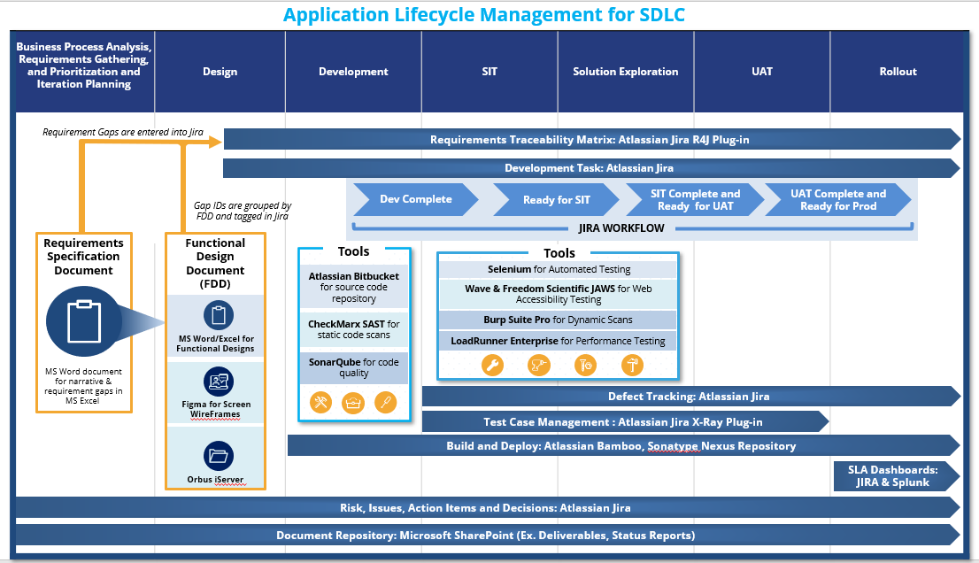
Figure 2-14: Overview of ALM Tools Utilized for MECM
The following table describes the purpose and how each of the tools within the ALM diagram supports the MECM SDLC Methodology.
ALM Tool | Vendor | Phase | Purpose
SharePoint | Microsoft | All | SharePoint serves as the central document repository for all Continuing Medicaid Eligibility Modernization Deliverables and artifacts. It will be used to facilitate the workflows associated with the Deliverable Management Plan.
Figma Organization | Figma | Design | Figma Organization is a modern collaboration tool that allows functional stakeholders to create high-fidelity wireframes for new screens during the design phase of the SDLC.
The ALM tool | Atlassian | All | The ALM tool is utilized in three primary ways on the Continuing Medicaid Eligibility Modernization project. First, it provides a workflow and ticket tracking system for PMO artifacts such as risks, issues, action items and decisions. Second, it tracks all development artifacts through the development process steps in the SDLC methodology. Third, once the MECM solution is in Production, the ALM tool is also used for incident and problem management tickets as defined further in the Maintenance & Operations (M&O) Run Book (DEL-33).
the source-code repository | Atlassian | Development | The source-code repository serves as the MECM software code repository providing version control, check in/out features, traceability to the ALM tool and integration with the overall continuous integration/continuous deployment pipeline.
the static code analysis tool | SonarSource | Development | The static code analysis tool is used to perform static code quality scans on changes made to the MECM base solution as part of the SDLC methodology and M&O processes.
the build server | Atlassian | Development, SIT, Regression Test, UAT, Rollout | The build server is part of the continuous integration/continuous deployment pipeline and orchestrates code build and deployment steps.
artifact repository | Amazon Web Services (AWS) | Development, SIT, Regression Test, UAT, Rollout | artifact repository is a repository manager that centralizes and automates the management of software artifacts and dependencies. This boosts the build performance, encourages the use of secure components, and enhances overall application security.
Selenium | Selenium | SIT, Regression Test | The Selenium tool provides automation capabilities to be used during testing steps in the SDLC methodology, such as performance testing and regression testing.
WAVE | WebAIM | SIT, Regression Test | Wave is used to scan static HTML during accessibility testing to identify non-compliance with section 508 HTML standards.
JAWS | Freedom Scientific | SIT, Regression Test | JAWS is an accessibility screen reader tool that is used during accessibility testing to identify non-compliance with section 508 standards for the visually impaired.
The test management tool | The test management tool | SIT, ORT, UAT | The test management tool is a complete Test Management tool for the ALM tool. It is a full-featured app that does not require any other software to run. The test management tool supports the entire testing life cycle: test planning, test design, test execution, and test reporting for MECM.
Checkmarx SAST | Checkmarx | Development | Checkmarx SAST is used to perform static code scans on changes made to the MECM base solution as part of the SDLC methodology and M&O processes to identify security vulnerabilities for remediation.
Burp Suite Pro | PortSwigger | SIT, Regression Test | Burp Suite Pro is used to perform dynamic (runtime) code scans on changes made to the MECM base solution as part of the SDLC methodology and M&O processes to identify security vulnerabilities for remediation.
LoadRunner Enterprise | Micro Focus | SIT, Regression Test | LoadRunner Enterprise is used for the performance testing to evaluate performance, stability, and scalability to confirm it can withstand the expected volume.
Splunk | Splunk | Rollout | Splunk is used for active monitoring of the MECM solution environment including server health monitor, configurable alerts, trending/historical reports, and dashboard/visualization capabilities.
iServer | Orbus Software | All | iServer serves as an integrated platform designed to support various aspects of enterprise architecture, business process analysis, and IT governance. Future use by business will be determined at a future date.
Oracle Policy Automation (OPA) | Oracle | UAT, Post-Go-Live | OPA is used to automate edits to business processes, rules, regulations, and policies to deliver up-to-date accurate advice. The utilization of the tool to support business team processes will be determined at a later date.
OpenText | OpenText | UAT, Post-Go-Live | OpenText is used to effectively capture, store, manage, and leverage enterprise information, specifically Notices, and other content types. The utilization of the tool to support business team processes will be determined at a later date.
BrowserStack | BrowserStack | SIT, Regression Test | BrowserStack is a cloud-based testing service that provides access to a vast array of real devices and browsers for testing web and mobile applications. It enables developers and QA teams to verify that their applications work seamlessly across different environments without the need for maintaining an in-house device lab.
The requirements management tool | ease Solutions | Design, Development  SIT, Regression Test,  UAT | The requirements management tool is utilized to produce a requirements traceability matrix based on linkages to various SDLC components captured in the ALM tool. Functional specifications will reside in SharePoint but are referenced in the ALM tool as part of that traceability. The requirements management tool is an ALM tool plug-in.
Table 2-41: ALM Tools and Artifacts
The following Commercial-off-the-Shelf (COTS) products are part of the MECM solution’s technical stack, and not considered ALM tools:
- Oracle Policy Automation (OPA) is an Oracle product that is used to capture, manage, and deploy complex legislation and other document-based policies. The utilization of the tool to support future SDLC processes will be determined at a later date
- OpenText is a Client Communication Management (CCM) platform used to design Templates and to generate the notices based on standard templates. The utilization of the tool to support future SDLC processes will be determined at a later date
The following conceptual flow depicts how requirements proceed through the ALM toolset within the SDLC phases following the phase-based processes defined within this SDLC narrative. It is not meant to be a comprehensive view of the workflows for the ALM tools but an executive view to demonstrate how the ALM toolset works together within the SDLC methodology to trace requirements for a release end-to-end. Subsequent to this conceptual flow, each ALM tool is defined below including the workflows for those applicable tools that will require direct interaction from project stakeholders (e.g., business stakeholders reviewing requirements traceability).
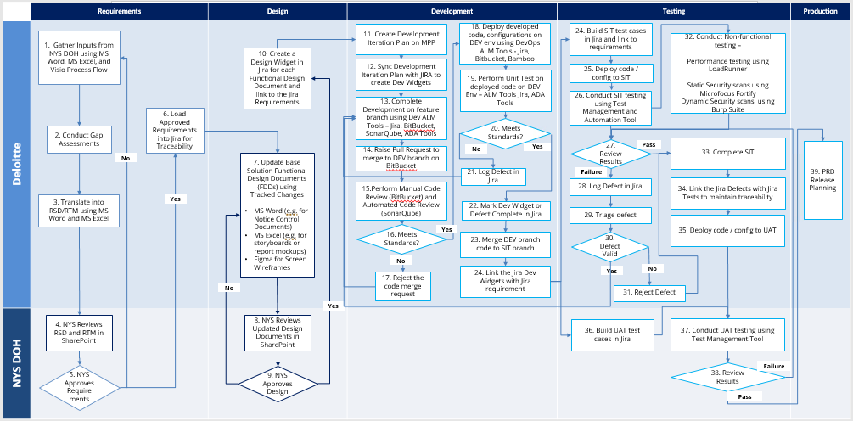
Figure 2-15: ALM Tools Supporting SDLC Methodology
The following subsections provide additional detail regarding configuration of each of the ALM tools that support the SDLC methodology based on the table and figure above.

Continuing Medicaid Eligibility Modernization SharePoint
SharePoint is a web-based collaboration platform designed to facilitate document management, content sharing, and team collaboration for the Continuing Medicaid Eligibility Modernization project. It allows users to create, store, and organize deliverables, design documents, and other artifacts in a centralized online environment, making it easy for teams to collaborate and access information from anywhere with an internet connection.

ALM Tool Roles and Permissions
Tool Role | Project RACI Role | Key Permissions
Continuing Medicaid Eligibility Modernization SharePoint Project Administrator | - DOS Tool Administrator | - Create/edit folder structure  - Manage configuration; user access; maintenance
Continuing Medicaid Eligibility Modernization SharePoint Admin User | - ███████ Tool Administrator  - Deloitte Business leads and managers  - Deloitte Functional leads and managers  - Deloitte Technical leads and managers  - Deloitte PMO leads and managers | - Upload, edit, move, delete files within defined folder structure  - Download read-only files to local machine
Continuing Medicaid Eligibility Modernization SharePoint Standard User | - All Functional Stakeholders  - All Business Stakeholders | - Upload, edit files within defined folder structure  - Download read-only files to local machine
Table 2-42: ALM Tool Roles and Permissions

ALM Tool Workflows
Workflow(s) does not apply.

Accessing ALM Tool
Below is a table of Continuing Medicaid Eligibility Modernization SharePoint libraries used for the MECM system. ███████ will update this table as additional sites are activated. User training content and tool walkthroughs will not apply for this ALM tool.
SharePoint Link | Purpose
PMO | Repository of all project management documents related to PMO
Functional | Repository of all design documents related to the Functional track
Technology | Repository of all documents related to the Technology track
Quality Assurance | Repository of all test documents related to the Testing track
Change Management | Repository of all documents related to the Change Management track
3rd Party Vendor | Repository of all documents related to 3rd party vendors
Appeals Solution | Repository of all documents related to the Appeals solution
Table 2-43: Continuing Medicaid Eligibility Modernization SharePoint Links for MECM System
The table below outlines the steps for accessing the SharePoint site(s).
# | Access Step | Owner
1 | Request access to Continuing Medicaid Eligibility Modernization SharePoint | Requestor
2 | Admin Approves Request | System Admin
3 | Once approved, gain access to SharePoint (user’s specific account) | User
Table 2-44: SharePoint Access
For troubleshooting login or access issues, reach out to the DOH OHIP SharePoint administrator.

Figma Organization
Figma Organization is a collaborative design platform that enables design teams to work together seamlessly, providing a unified environment for creating, sharing, and iterating on digital designs. It offers features like version control, design libraries, and user permissions to streamline the design process within an organization.

ALM Tool Roles and Permissions
Tool Role | Project RACI Role | Key Permissions in Figma
Administrator | - ███████ Tool Administrator | - Grant access
Owner | - ███████ Functional Lead | - Create/edit design documents
Editor | - ███████ Functional Team | - Create/edit design documents
Table 2-45: Figma Roles and Responsibilities

ALM Tool Workflows
Workflow(s) does not apply

Accessing ALM Tool
Access to Figma Organization is limited to ███████ resources. User training for DOH users is not required for this ALM tool.
# | Access Step | Owner
1 | Submit PMO Service Request in the ALM tool for access to Figma Organization | Requestor
2 | Admin Approves Request | System Admin
3 | Once approved, gain access to Figma (user’s specific account) | User
Table 2-46: Figma Access

ALM Tool
The ALM tool serves several purposes and integrates with various ALM tools throughout the SDLC process. The ALM tool manages and streamlines the design artifacts, development work items, and traceability to requirements and test artifacts. Further, the ALM tool also produces dashboards and reports for project monitoring through the SDLC.

ALM Tool Roles and Permissions
Tool Role | Project RACI Role | Key Permissions in the ALM Tool
ALM Tool Site Administrator | - ███████ Tool Administrator  - DOS Tool Administrator | - Create/edit workflows  - Manage workflow configuration; user access; maintenance  - Updating workflows
ALM Tool Project Administrator | - ███████ Functional Architect  - Deloitte Functional PM  - Deloitte Functional Manager  - Deloitte Technical Manager  - Deloitte Test Lead  - Deloitte PMO Lead | - Configure Custom Fields  - Configure workflows  - Create, edit, delete issue types  - Override status
ALM Tool Standard User | - All Functional Stakeholders  - All Business Stakeholders  - Deloitte Development Team  - Deloitte Test Team  - Deloitte Technology Team | - Create, edit issue types  - Change status on work items
Table 2-47: ALM Tool Roles and Responsibilities

ALM Tool Workflows
The field attributes and corresponding workflows for various ticket types within the ALM tool are defined and continuously maintained in the ALM Tool User Guide and ALM Tool Reference Guide. Reference materials can be found in Appendix D: ALM Tool Field Attributes and Workflows:
- Design Workflow (Design Document, Design Component, Design Update)
- Development Widget Workflow (Confirmed in the ALM tool)
- Database Change Request (DBCR) Workflow (test environments only)
- Incident Workflow
- Technology Operations (Tech Ops) Service Request Workflow (test environments only)
- Change Request Workflow (refer to Section 10 Integrated Change Control Process)
- Deliverable Management Workflow (Confirmed in the ALM tool)
- Requirements Workflow

Accessing ALM Tool
Access to the ALM tool is open to all ███████ teams and DOH stakeholders. User training content and tool walkthroughs for specific workflows will be available at respective relevant SDLC phases (e.g., Design workflow prior to the start of Design Phase; Development workflow prior to the start of Development Phase, etc.) for impacted DOH stakeholders.
Access to The ALM tool
# | Access Step | Owner
1 | Submit a request to the PMO support mailbox | Requestor
2 | Admin Approves Request | System Admin
3 | Once approved, gain access to the ALM tool (user’s specific account) | User
Table 2-48: ALM Tool Access
For troubleshooting login or access issues, contact the PMO support mailbox

Source-Code Repository
The source-code repository serves as the MECM software code repository providing version control, check in/out features, traceability to the ALM tool and integration with the overall continuous integration/continuous deployment pipeline. For further details regarding the code branch and merge strategy, refer to Release Management Plan (DEL-34).

ALM Tool Roles and Permissions
NY-MECM
Tool Role | RACI Role | Key Permissions in the source-code repository
Administrator | - ███████ Tool Administrator | - Edit/Read, Admin settings, User Access, Repo Access
Developer | - ███████ Technical Manager  - Developers  - Automation Testers  - Technology Team | - Edit/Read to Repo
the source-code repository Read-Only | - DOH Stakeholders | - Read Only Access
Table 2-49: Source-Code Repository Roles and Permissions

ALM Tool Workflows
The following workflow within the source-code repository tool supports each phase of the MECM SDLC.
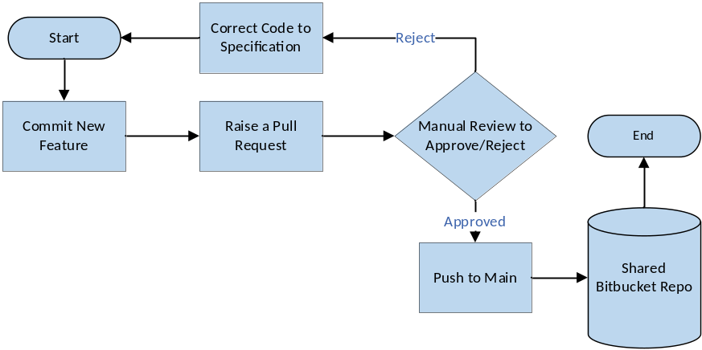
Figure 2-16: Source-Code Repository Workflow

The following table describes each workflow step illustrated above.
# | Workflow Step | Description | Step Owner
1 | Commit New Feature | User edits/creates new Feature | - Developer
2 | Raise a Pull Request | Create a Pull request from Feature branch to Dev branch in the source-code repository | - Developer
3 | Manual Review | - If approved, pushed to Repository  - If rejected, correct code to specification | - ███████ Tool Administrator
4 | Push to Main | Edit/Change is approved | - ███████ Tool Administrator
Table 2-50: Source-Code Repository Workflow Narrative

Accessing ALM Tool
Access to the source-code repository is open to ███████ technology team and DOH stakeholders. User training content and tool walkthroughs will be available prior to the start of Development Phase for impacted DOH stakeholders.
Access to the source-code repository
# | Access Step | Owner
1 | Submit an access request through the approved project access-request process | Requestor
2 | Admin Approves Request | System Admin
3 | Once approved, gain access to the source-code repository (user’s specific account) | User
Table 2-51: Source-Code Repository Access
For troubleshooting login or access issues, contact the PMO support mailbox

Static Code Analysis Tool
The static code analysis tool is used to perform static code quality scans on changes made to the MECM base solution as part of the SDLC methodology and M&O processes. The static code analysis tool integrates with the source-code repository to enable automatic scanning of code repositories.

ALM Tool Roles and Permissions
Tool Role | RACI Role | Key Permissions in the static code analysis tool
Admin | - ███████ Tool Administrator | - Edit rules and profiles
Developer | - ███████ Technical Manager  - Developer | - Run, review, push to main
the static code analysis tool Read-Only | - DOH Stakeholders | - Read-only access
Table 2-52: Static Code Analysis Roles and Permissions

ALM Tool Workflows
The following workflow within the static code analysis tool tool supports each phase of the MECM SDLC.
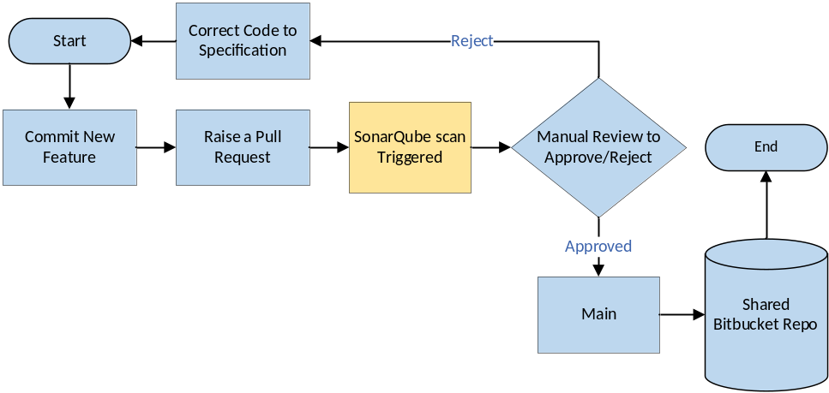
Figure 2-17: Static Code Analysis Workflow
The following table describes each workflow step illustrated above.
# | Workflow Step | Description | Step Owner
1 | Commit New Feature | User edits code or adds new code to commit with the feature branch in the source-code repository | - Developer
2 | Raise a Pull request | Create a pull request from Feature branch to Dev branch in the source-code repository, integrate with the static code analysis tool | - Developer
3 | the static code analysis tool Scan | the static code analysis tool code scans triggered for incremental code change | - Automated Scan
4 | Manual Review | - If approved, pushed to Repository  - If rejected, correct code to specification | - ███████ Tool Administrator
5 | Push to Main | Edit/Change is approved, and code is published to shared the source-code repository repository | - ███████ Tool Administrator
Table 2-53: Static Code Analysis Workflow Narrative

Accessing ALM Tool
Access to the static code analysis tool is open to ███████ Technology team and approved DOH stakeholders. User training content and tool walkthroughs will be available prior to the start of Development Phase for impacted DOH stakeholders.
Access to the static code analysis tool tool is restricted. A unique link will be provided to each user by the ███████ Technology team once access is granted.
# | Access Step | Owner
1 | Submit PMO Service Request in the ALM tool for access to the static code analysis tool | Requestor
2 | Admin approves request | System Admin
3 | Once approved, gain access to the static code analysis tool (user’s specific account) | User
Table 2-54: Static Code Analysis Access
For troubleshooting login or access issues, contact the PMO support mailbox

Build Server
The build server is part of the continuous integration/continuous deployment pipeline and orchestrates code build and deployment steps.

ALM Tool Roles and Permissions
Tool Role | RACI Role | Key Permissions in the build server
the build server Admin | - System Admin | - Read/Write/Configure
Dev-Ops | - Developers | - Read/Write
Table 2-55: Build Server Roles and Permissions

ALM Tool Workflows
Workflow does not apply for this tool; however, the illustration below depicts the build server conceptual design that supports integration and deployment.
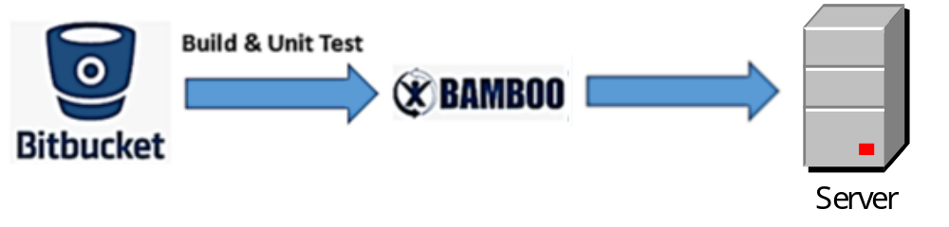
Figure 2-18: Build Server Workflow
The following table describes each workflow step illustrated above.
# | Workflow Step | Description | Step Owner
1 | the source-code repository Commit | New Feature Commit approved, and Pull Request accepted | - Developer/System Admin
2 | Build and Unit Test | the build server orchestrates code build and deployment steps | - the build server
3 | Integrates into Dev Environment | the build server acts as integration pipeline and deploys feature into Dev Environment | - the build server
Table 2-56: Build Server Workflow Narrative

Accessing ALM Tool
Access to the build server will be limited to ███████ resources. User training for DOH users is not applicable for this ALM tool.
# | Access Step | Owner
1 | Submit PMO Service Request in the ALM tool for access to the build server | Requestor
2 | System Admin send request to Operations Lead | System Admin
3 | Operations Lead approves/denies | ███████ Technical Manager
4 | If approved, System Admin creates account and adds to the build server | System Admin
Table 2-57: Build Server Access

Artifact Repository
artifact repository is a secure, highly scalable, managed artifact repository service that allows us to store and share software packages for application development.

ALM Tool Roles and Permissions
Tool Role | RACI Role | Key Permissions in CodeArtifact
Admin Tool Access | - System Admin | - Create, edit, delete  - User Interface Access
Functional Tool Access | - Developer | - Create, edit, delete
artifact repository  Read-Only | - DOH Stakeholders | - Read-only access
Table 2-58: artifact repository Roles and Permissions

ALM Tool Workflows
The following workflow within the artifact repository tool supports each phase of the NY MECM SDLC.
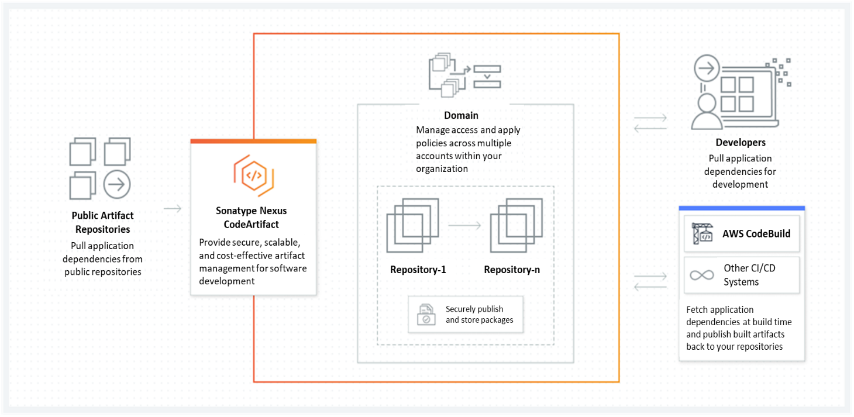
Figure 2-19: artifact repository Workflow

The following table describes each workflow step illustrated above.
# | Workflow Step | Description | Step Owner
1 | NY-MECM Artifact Repositories | Pull application dependencies from NY MECM artifact repositories | - Developer  - System Admin
2 | artifact repository | Provide secure, scalable, and cost-effective artifact management for software development | - AWS
3 | Access Domain | Manage access and apply policies across multiple accounts within NY MECM | - System Admin
4 | Securely Publish and Store Packages | Store packages inside of the repositories in the NY MECM domain | - Developer  - System Admin
5 | Pull Dependencies | Pull application dependencies for development | - Developers
Table 2-59: artifact repository Workflow Narrative

Accessing ALM Tool
Access to artifact repository is open to ███████ technology team and DOH stakeholders. User training content and tool walkthroughs will be available prior to the start of Development Phase for impacted DOH stakeholders.
Access the artifact repository tool via this link: [link to be provided once available]
# | Access Step | Owner
1 | Submit an access request through the approved project access-request process | Requestor
2 | Approve Request | System Admin
3 | Log into the build server | User
4 | Communicate with tool for access | User
Table 2-60: artifact repository Access
For troubleshooting login or access issues, contact the PMO support mailbox

Selenium
Selenium is an open-source suite of tools and libraries that is used for browser automation for MECM. It provides a single interface that lets you write test scripts in programming languages like Ruby, Java, NodeJS, PHP, Perl, Python, JavaScript, and C#, among others. Selenium is very extensible and can integrate with other tools and frameworks like TestNG, Junit, Cucumber, etc.
Selenium IDE is a Chrome and Firefox plugin. The primary use of a Selenium IDE is to record user interactions such as clicks, selections etc. in the browser and plays them back as automated tests.
It then generates the test script (of the automated tests) in programming languages like C#, Java, Python, and Ruby and Selenese (Selenium’s own scripting language).
Selenium IDE helps in:
- Creating automated test scripts for MECM and validating them at speed
- Identifying and highlighting errors during the replay of interactions
- Cross Browser Testing
MECM uses WebDriver APIs for running the automation scripts. WebDriver uses browser automation APIs provided by browser vendors to control the browser and run tests. This is as if a real user is operating the browser. Since WebDriver does not require its API to be compiled with application code; It is not intrusive. Hence, you are testing the same application which deploys to an environment.

ALM Tool Roles and Permissions
Tool Role | RACI Role | Key Permissions in Selenium
Tester | - Automation Test Lead  - Automation Tester | - Create, edit, delete scripts  - Execute scripts
Table 2-61: Selenium Roles and Responsibilities

ALM Tool Workflows
Workflow(s) does not apply. High-level process steps are as follows. Additional detail can be found in the Test Management Plan (DEL-09)
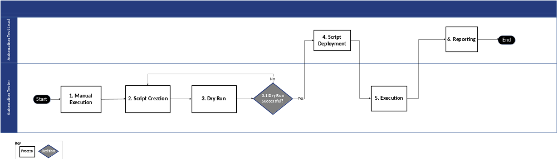
Figure 2-20: Selenium High-Level Process
The following table describes the high-level step process steps in detail.
# | High-Level Process | Description | Step Owner
1 | Manual Execution | Tester performs manual testing to understand the functionality of the system | - Automation Tester
2 | Script Creation | Automation script is created by the Tester | - Automation Tester
3 | Dry Run | Tester performs Dry Run on the automated script | - Automation Tester
3.1 | Dry Run Successful? | Automation tester decides if the dry run is successful.  - If it is successful, proceed to Step #4 Script Deployment  - If it is not successful, proceed to Step #2 Script Creation | - Automation Tester
4 | Script Deployment | Automation script is reviewed by the Automation lead and pushed to Tester repository | - Automation Test Lead
5 | Execution | Script is executed | - Automation Tester
6 | Reporting | Execution results are analyzed and published | - Automation Test Lead
Table 2-62: Selenium Workflow Narrative

Accessing ALM Tool
Access to Selenium will be limited to ███████ resources. User training for DOH users is not required for this ALM tool. Additional details for access to Selenium can be found in the Test Management Plan (DEL-09).

WAVE
WAVE is a suite of evaluation tools that helps MECM make its web content more accessible to individuals with disabilities. WAVE can identify many accessibilities and Web Content Accessibility Guideline (WCAG) errors in adherence to WCAG 2.1 AA standards, but also facilitates human evaluation of web content.
WAVE Chrome, Firefox, and Edge browser extensions are available for testing accessibility directly within the web browser – handy for checking password protected, locally stored, or highly dynamic pages.

ALM Tool Roles and Permissions
NY-MECM
Tool Role | RACI Role | Key Permissions in WAVE
Accessibility SIT Test Lead | - ███████ Test Lead | - N/A
Accessibility SIT Tester | - ███████ Tester | - N/A
Accessibility UAT Test Lead | - DOS Test Lead | - N/A
Accessibility UAT Tester | - DOS Tester | - N/A
Table 2-63: WAVE Roles and Responsibilities

ALM Tool Workflows
Workflow(s) does not apply.

Accessing ALM Tool
Access to WAVE is open to ███████ test team and DOH stakeholders. User training plans can be found in the Test Management Plan (DEL-09).
WAVE is an extension to the web browser and does not request special access for the tool.

JAWS
JAWS, Job Access With Speech, is the world’s most popular screen reader, developed for computer users whose vision loss prevents them from seeing screen content or navigating with a mouse. JAWS provides speech and Braille output for MECM application on the user PC. MECM users will be able to navigate the application using JAWS.

ALM Tool Roles and Permissions
NY-MECM
Tool Role | RACI Role | Key Permissions in JAWS
Accessibility tester | - ███████ Test Lead  - Deloitte Tester  - DOS Test Lead  - DOS Tester | - Perform screen reading accessibility testing
Table 2-64: JAWS Roles and Responsibilities

ALM Tool Workflows
Workflow(s) does not apply.

Accessing ALM Tool
Access to JAWS is open to ███████ test team and DOH stakeholders. User training plans can be found in the Test Management Plan (DEL-09).
JAWS needs to be downloaded and configured to the SIT and UAT testers’ Laptop.

Test Management Tool
The test management tool is a complete Test Management tool for the ALM tool. It is a full-featured app that does not require any other software to run. The test management tool supports the entire testing life cycle: test planning, test design, test execution and test reporting for MECM. Link to access the test management tool: The ALM tool.

ALM Tool Roles and Permissions
Tool Role | RACI Role | Key Permissions in the Test Management Tool
Admin | - ███████ Tool Administrator  - DOS Tool Administrator | - Edit/Update, update all capabilities
Power User | - ███████ QA Manager  - Deloitte Test Lead  - MECM QA Manager  - DOS Test Lead | - Edit/Update
Standard User | - ███████ SIT Testers  - DOS UAT Testers | - Edit/Update test cases  - Execute test scripts
Table 2-65: Test Management Tool Roles and Permissions

ALM Tool Workflows
The following workflows within the test management tool tool support SIT, UAT, and Operational Readiness phases of the MECM SDLC.
- Test Case Workflow
- Test Run Workflow

Test Case Workflow
The test case workflow serves as a framework for planning, designing, executing, and tracking software tests. This streamlined process empowers teams to efficiently manage their testing efforts and encourage comprehensive software quality assurance.

Figure 2-21: Test Case Workflow
The table below describes each step of the test case workflow.
# | Workflow Step | Description | Step Owner
1 | New | Tester identifies test scenarios and starts writing test cases | - Tester
2 | Authoring | Tester authors the test cases and test cases are reviewed by the test lead | - ███████ Test Lead
3 | Review in Progress | Functional track lead reviews and approves the test cases | - ███████ Functional Manager
4 | Finalized | Tester updates the test cases as per comments received by functional team | - Tester
Table 2-66: Test Case Workflow Narrative
Test Run Workflow
The test run workflow is a fundamental framework that enables teams to initiate, execute, and monitor test cycles with precision.
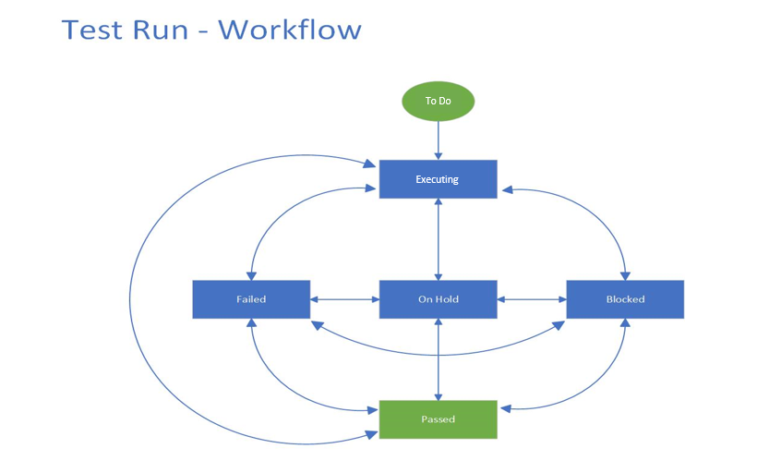
Figure 2-22: Test Run Workflow
The table below describes each step of the test case workflow.
# | Workflow Step | Description | Step Owner
1 | To Do | Test Run is ‘TO DO’ when it is pulled into an execution cycle in X-Ray | - SIT Tester  - UAT Tester
2 | Executing | Test Run is in ‘Executing’ status when Tester moves test cases to Executing status upon starting the Execution | - SIT Tester  - UAT Tester
3 | Failed | Test Run is ‘Failed’ if the test case validation fails. A defect is raised and linked to the TC | - SIT Tester  - UAT Tester
4 | Passed | Test Run is ‘Passed’ if tester is successfully able to verify all test steps | - SIT Tester  - UAT Tester
5 | On-hold | Test Run is ‘On-hold’ if the test case requires partner validation or has some partner dependency | - SIT Tester  - UAT Tester
6 | Blocked | Test Run is ‘Blocked’ If the test case cannot be executed due to a linked defect | - SIT Tester  - UAT Tester
Table 2-67: Test Run Workflow Narrative

Accessing the Test Management Tool
Access to the test management tool is open to ███████ test team and DOH stakeholders. User training plans can be found in the Test Management Plan (DEL-09)
Access the test management tool tool via this link: The ALM tool. User training plans can be found in the Test Management Plan (DEL-09)
# | Access Step | Owner
1 | Create Ticket request in the ALM tool for Tracking Purposes | Requestor
2 | Admin provides access | System Admin
3 | Close Ticket in the ALM tool | Requestor
Table 2-68: Test Management Tool Access
For troubleshooting login or access issues, contact the PMO support mailbox

Checkmarx SAST
Checkmarx is security tool designed and developed to take in and code, analyze the code, and determine if any security flaws exist. The tool takes in static code, runs this code through its engine packs with the computing assistance of a SQL server instance, and publishes results to the server housing the application.

ALM Tool Roles and Permissions
Tool Role | RACI Role | Key Permissions in Checkmarx
Admin | - ███████ Tool Administrator | - Oversee licensing and all testing/config
Application Admin | - Security Tester | - Edit/Update
Checkmarx Security Service Account | - ███████ Security Manager | - Access to code repository  - Edit/Update
Security Tester | - Security Tester | - Edit/Update
Table 2-69: Checkmarx Roles and Permissions

ALM Tool Workflows
The SAST Assessment is a process for analyzing the source code of an application to identify and mitigate security vulnerabilities. It helps identify and address vulnerability in the early stages of development, reducing the risk of breaches and ensuring overall security.
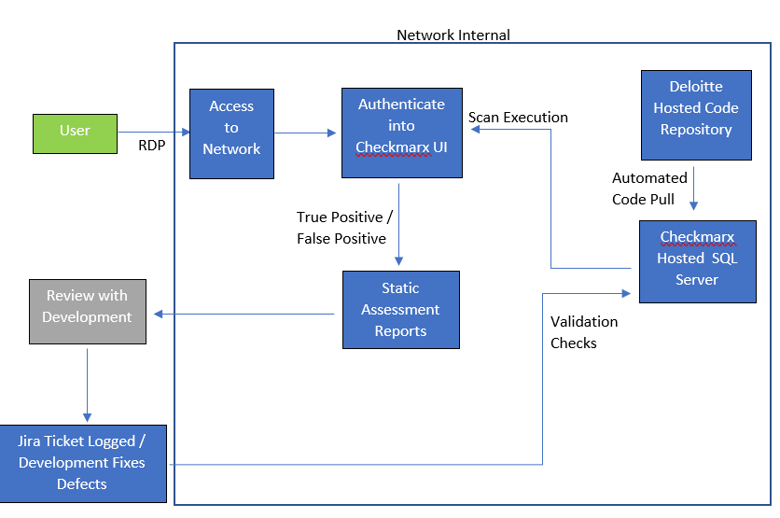
Figure 2-23: Checkmarx SAST Workflow
The table below describes each step of the test case workflow.
# | Workflow Step | Description | Step Owner
1 | Execute Code Pull | Checkmarx executes an automated and predetermined code pull for execution of a scan | - Checkmarx Security Service Account
2 | Code Assessment | Checkmarx Assess Code through built in engine pack | - Checkmarx Security Service Account
3 | Review of Assessment | Performs True Positive / False Positive Analysis on the Checkmarx scan to identify vulnerabilities for remediation | - Security Tester
4 | Agreement on Changes | Discussion between Security and development to identify vulnerabilities and track targeted fixes | - Security Tester  - Developer
5 | ALM Tool Ticketing | A ALM tool ticket is logged for identified vulnerabilities | - Developer
6 | Remediation | Code vulnerabilities are remediated by development within the scoped timeline | - Developer
7 | Retesting of Remediation | Retesting is done on the remediated items to assess that fixes were made successfully | - Security Tester
Table 2-70: Checkmarx SAST Workflow Narrative

Accessing ALM Tool
Access to Checkmarx SAST is limited to ███████ resources. User training for DOH users is not required for this ALM tool.
# | Access Step | Owner
1 | Authenticate through RDP into the hosted Checkmarx server | Security Tester
2 | Access the Checkmarx user interface through a web browser such as Chrome, Firefox, Edge (not compatible with IE) | Security Tester
3 | Authenticate into the Checkmarx UI with Checkmarx local credentials | Security Tester
Table 2-71: Checkmarx Access

Burp Suite Pro
Burp Suite Professional Scanning Agent and Burp Suite Professional Runners identifies inherent weaknesses in the design, implementation, and security controls of the MECM application. The security testing process also evaluates the applications for controls and potential exposures in the authentication process, user input processing, session management, error handling, and encryption

ALM Tool Roles and Permissions
Tool Role | RACI Role | Key Permissions in Burp Suite Pro
Security Tester | - License Holder/Tester | - Authority to Operate
Table 2-72: Burp Suite Roles and Permissions

ALM Tool Workflows
DAST is a security testing methodology that focuses on identifying vulnerabilities in a web application while it is running. DAST assesses the application from the outside, simulating how a malicious user would interact with it.
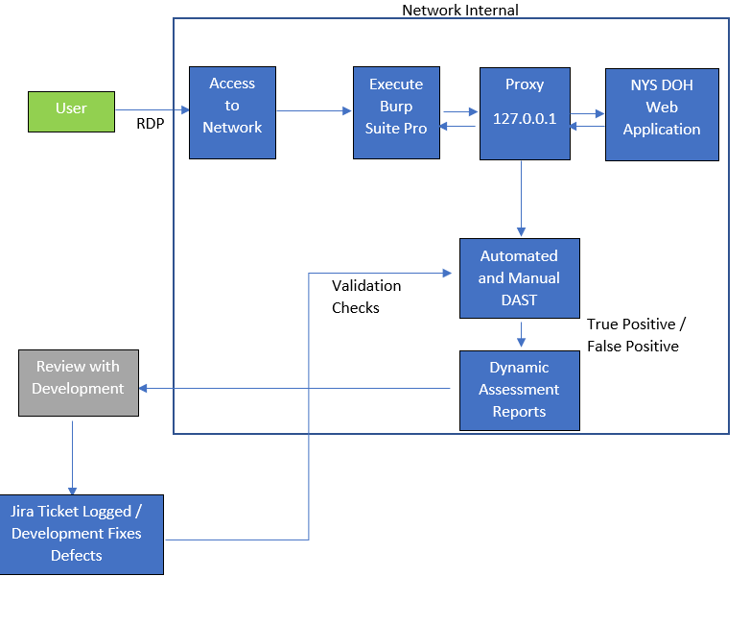
Figure 2-24: Burp Suite Workflow
The following table describes each workflow step illustrated above.
# | Workflow Step | Description | Step Owner
1 | Establish Network Proxy Connection | Confirm Burp Suite Pro has authenticated Network connection to the target web application and that proxy is working between the tester, browser, and server | - Security Tester
2 | Automated / Manual Testing | Automated and Manual Assessment of the web application | - Security Tester
3 | Review of Assessment | Performs True Positive / False Positive Analysis on the Burp Suite automated scan to identify vulnerabilities for remediation | - Security Tester
4 | Agreement on Changes | Discussion between Security and development to identify vulnerabilities and track targeted fixes | - Security Tester  - Developer
5 | ALM Tool Ticketing | A ALM tool ticket is logged for identified vulnerabilities | - Developer
6 | Remediation | Code vulnerabilities are remediated by development within the scoped timeline | - Developer
7 | Retesting of Remediation | Retesting is done on the remediated items in order to assess that fixes were made successfully | - Security Tester
Table 2-73: Burp Suite Workflow Narrative

Accessing ALM Tool
Access to Burp Suite Pro is limited to ███████ resources. User training for DOH users is not required for this ALM tool.
# | Access Step | Owner
1 | Authentication into hosted server with Network Access to the SIT environment for NYS MECM | Security Tester
2 | Tester opens the Burp Suite Pro application on the hosted server, with valid license tied to their user within the hosted Windows Active Directory | Security Tester
3 | Tester runs Burp Suite Pro in conjunction with web browser to establish a proxy session and execute automated test scripts and manual penetration assessment techniques | Security Tester
Table 2-74: Burp Suite Access

LoadRunner Enterprise
LoadRunner Enterprise provides performance trending information across multiple tests for MECM. You can define a baseline and set up reports that help you quickly see how the application performance is trending over subsequent iterations and bundles, and how the application is performing against the defined SLAs.

ALM Tool Roles and Permissions
Tool Role | RACI Role | Key Permissions in LoadRunner
Admin Tool Access | - System Admin | - Create, edit, delete  - User Interface Access
Performance Tool Access | - Developer | - Create, edit, delete
Table 2-75: LoadRunner Roles and Permissions

ALM Tool Workflows
Workflow(s) does not apply.

Accessing ALM Tool
Access to LoadRunner Enterprise is limited to ███████ resources. User training for DOH users is not required for this ALM tool.
# | Access Step | Owner
1 | Fill out LoadRunner Enterprise Request (see Test Management Plan (DEL-09)) and send to ███████ Technical Manager | Requestor
2 | Approve Request | System Admin
3 | Configure LoadRunner and provide access | User
4 | Communicate with tool for access | User
Table 2-76: LoadRunner Access

Splunk
Splunk is used for active monitoring of the MECM solution environment including server health monitor, configurable alerts, trending/historical reports, and dashboard/visualization capabilities.

ALM Tool Roles and Permissions
Tool Role | RACI Role | Key Permissions in Splunk
Admin | - ███████ Tool Administrator | - Edit/Update, update all capabilities
Power User | - ███████ Technical Manager | - Edit/Update
Standard User | - ███████ Technology Team | - Read-only access
Splunk Read-Only | - DOH Stakeholders | - Read-only access
Table 2-77: Splunk Roles and Permissions

ALM Tool Workflows
The following workflow within the Splunk tool supports each phase of the MECM SDLC.
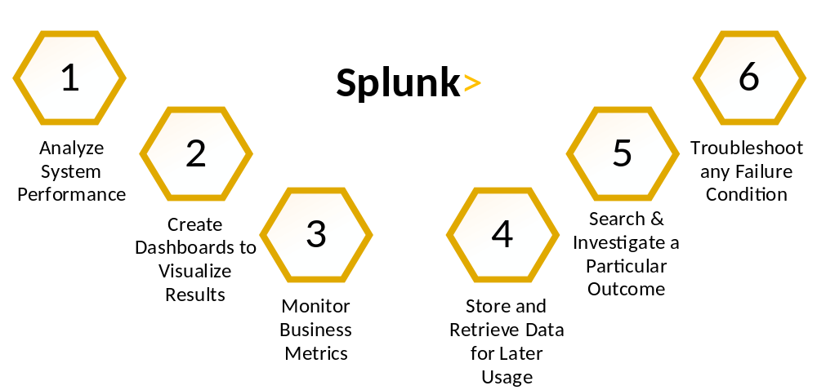
Figure 2-25: Splunk Workflow
The following table describes each workflow step illustrated above.
# | Workflow Step | Description | Step Owner
1 | Analyze System Performance | Splunk will analyze the system performance | - Splunk
2 | Create Dashboards | Use Filters to create dashboards and visualize results | - Admin/Power User
3 | Monitor Business Metrics | View and monitor business metrics via dashboards | - Admin/Power User/User/Splunk Read Only
4 | Store/Retrieve Data | Store and retrieve data for later usage | - Splunk
5 | Investigate Outcome | Search and Investigate a Particular Outcome | - Admin/Power User
6 | Troubleshoot | Troubleshoot any failure conditions | - Admin/Power Users
Table 2-78: Splunk Workflow Narrative

Accessing ALM Tool
Access to Splunk is open to ███████ resources and DOH stakeholders as defined in Section 2.32.1 above. User walkthrough or training for the tool will be available prior to the start of Development Phase for impacted DOH stakeholders.
User training sessions and/or materials will be made available for users to access reports and dashboards.
Access the Splunk tool via this link: [link to be provided once available]
# | Access Step | Owner
1 | Create Ticket request in the ALM tool for Tracking Purposes | Requestor
2 | Admin provides access | System Admin
3 | Close Ticket in the ALM tool | Requestor
Table 2-79: Splunk Access
For troubleshooting login or access issues, contact the PMO support mailbox

BrowserStack
BrowserStack is a cloud-based testing service that provides access to a vast array of real devices and browsers for testing web and mobile applications. It enables developers and QA teams to verify that their applications work seamlessly across different environments without the need for maintaining an in-house device lab. The following explains the features of BrowserStack:
- Cross-Browser Testing:
  - Test websites and web applications across multiple browsers and versions, including Chrome, Firefox, Safari, Edge, and Internet Explorer
  - Supports testing on different operating systems like Windows, macOS, and Linux
- Real Device Cloud:
  - Access to a wide range of real mobile devices for testing, including Ios and Android devices
  - Ensures accurate testing by using real devices rather than emulators or simulators
- Automated Testing:
  - Integrates with popular automation frameworks like Selenium, Appium, and Cypress
  - Supports parallel testing to speed up the testing process
MECM uses BrowserStack for running the automation scripts. It uses mobile devices to run tests.

ALM Tool Roles and Permissions
Tool Role | RACI Role | Key Permissions in BrowserStack
Tester | - Automation Test Lead  - Automation Tester | - Review Script Execution  - Push & Execute scripts
Table 2-80: BrowserStack Roles and Permissions

ALM Tool Workflows
The following workflow within the BrowserStack tool supports each phase of the MECM SDLC.
Figure 2-26: BrowserStack Workflow
The following table describes each workflow step illustrated above.
Step # | High-Level Process | Description | Step Owner
1 | Manual Execution | Tester performs manual testing on BrowserStack to understand the functionality of the system | - Automation Tester
2 | Script Creation | Automation script is created by the tester using supported frameworks like Selenium or Appium | - Automation Tester
3 | Dry Run | Tester performs a dry run on the automated script using BrowserStack’s cloud infrastructure | - Automation Tester
3.1 | Dry Run Successful? | Automation Tester decides if the dry run is successful.  - If it is successful, proceed to Step #4 Script Deployment  - If it is not successful, proceed to Step #2 Script Creation | - Automation Tester
4 | Script Deployment | Automation script is reviewed by the automation lead and pushed to the repository | - Automation Test Lead
5 | Execution | Script is executed on BrowserStack’s real devices and browsers | - Automation Tester
6 | Reporting | Execution results are analyzed and published, including screenshots and video recordings from BrowserStack | - Automation Test Lead
Table 2-81: BrowserStack Workflows

Accessing ALM Tool
Access to BrowserStack will be limited to ███████ Testers. User training for DOH users is not required for this tool.

Requirements Management Tool
The requirements management tool is an ALM tool plug-in utilized to manage requirements traceability across the ALM tool work items throughout the SDLC methodology. Requirements reside in the ALM tool and are linked to design artifacts, development work items, test cases, and test results. For full details of requirements traceability across SDLC phases and ALM toolset, refer to Section 12 Requirements Management Plan.

ALM Tool Roles and Permissions
Tool Role | RACI Role | Key Permissions in the ALM Tool
Site Administrator | - ███████ Tool Administrator | - Create/configure issues in the ALM tool  - Create/configure linkages in the ALM tool
Standard User | - All Functional Stakeholders  - All Business Stakeholders  - Deloitte Functional Architect  - Deloitte Functional PM  - Deloitte Functional Manager  - Deloitte Technical Manager  - Deloitte Test Lead  - Deloitte PMO Lead  - Deloitte Development Team  - Deloitte Test Team  - Deloitte Technology Team | - Create/edit issues in the ALM tool  - Create/edit linkages in the ALM tool
Table 2-82: Requirements Management Tool Roles and Permissions

ALM Tool Workflows
Workflow does not apply for requirements traceability; however, the following diagram depicts the conceptual design for requirements traceability across the MECM SDLC.
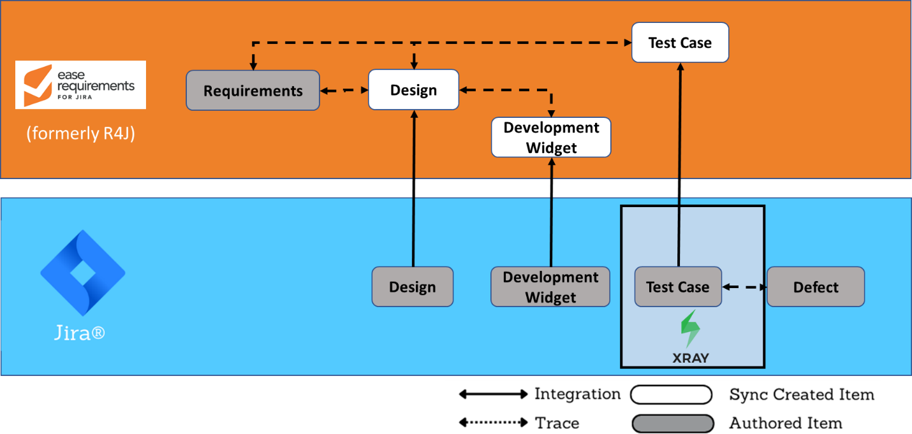
Figure 2-27: Requirements Traceability Conceptual Design
The following table describes each workflow step illustrated above.
Step # | High-Level Process | Description | Step Owner
1 | Load Requirements to the ALM tool | Baselined requirements are loaded to the ALM tool | - ███████ Functional Lead
2 | Create Design Documents | Design work items are created and managed in the ALM tool to track review and approval processes | - ███████ Functional Lead
3 | Finalized Design Items are mapped to Requirements in the ALM tool | At the end of the Design phase, an RTM linking finalized Design Documents to baselined requirements is submitted in the ALM tool | - ███████ Functional Lead
4 | Create design items and link to requirement in the ALM tool | Automated sync creates design item in the ALM tool and traces back to the requirement in the ALM tool | - N/A
5 | Create Development Widgets | Development widgets are created and managed in the ALM tool through the development and unit testing processes | - ███████ Dev Lead
6 | Map finalized Development widgets to Design items in the ALM tool | At the end of the Development phase, an RTM linking finalized Development widgets to design items is submitted in the ALM tool | - ███████ Dev Lead
7 | Create Development Widgets and link to design item in the ALM tool | Automated sync creates the development widget and traces back to the design item in the ALM tool | - ███████ Dev Lead
8 | Create Test Case | Test cases are created via the test management tool, a Test Management plug-in for the ALM tool | - ███████ Tester
9 | Map Test Cases to Requirements in the ALM tool | At the end of the Testing phase, an RTM linking test cases and test case results to requirements is submitted in the ALM tool | - ███████ Testing Lead
10 | Create Test Cases and link to design and requirements in the ALM tool | Automated sync creates the test case record in the ALM tool and traces back to both the design item and the requirement in the ALM tool | - ███████ Testing Lead
Table 2-83: Requirements Traceability Conceptual Design Narrative

Accessing ALM Tool
Access to the requirements management tool is available to select ███████ teams and DOH stakeholders and requires existing access to the ALM tool. Tool walkthroughs will be available for impacted DOH stakeholders.
Access the requirements management tool tool vian ALM tool: The ALM tool
# | Access Step | Owner
1 | Submit a request to the PMO support mailbox | Requestor
2 | Admin Approves Request | System Admin
3 | Once approved, gain access to the requirements management tool (user’s specific account) | User
Table 2-84: ALM Tool Access
For troubleshooting login or access issues, contact the PMO support mailbox

Section 3 – Stakeholder Engagement Plan

Stakeholder Engagement Plan

Introduction
The Stakeholder Engagement Plan includes the approach to plan, manage, and monitor stakeholder engagement within the New York State DOH OHIP and external entities, and reinforce the Governance Structure that will be involved in the MECM system implementation. The Stakeholder Engagement Plan is constructed to aid in a successful system transition that is aligned with the goals and organizational vision of DOH OHIP stakeholders.

Purpose
Formal planning and management of stakeholder involvement is vital to meeting project goals and objectives, particularly when external resources can influence the direction or outcome of project results. For this reason, the project defines the activities and levels of participation required by critical stakeholders and establishes operational processes to encourage their participation and engagement effectiveness.
The objective of this plan is to document how Continuing Medicaid Eligibility Modernization stakeholders will provide input and remain engaged on MECM system implementation efforts. To meet this objective, the plan will do the following:
- Outline the stakeholder groups represented in MECM implementation
- Define responsibilities for stakeholder groups that participate in developing and upholding the stakeholder engagement plan

Stakeholder Engagement Approach
The stakeholder engagement approach is a collection of processes and cadences for the project and its stakeholders to build trust, enhance collaboration, and achieve positive outcomes. The stakeholder engagement approach is comprised of three sections: Stakeholder Identification and Analysis (Section 3.3.1), Communications Management (Section 3.3.2), and Governance Structure (Section 3.3.3).
The stakeholder engagement approach is supported by processes and principles described in other sections of the PMP Deliverable (DEL-05) related to stakeholder engagement. These include:
- Section 3.3.1 Stakeholder Identification and Analysis references the Software Development Life Cycle (SDLC) (refer to Section 2)
- Section 3.3.2 Communications Management references the Communications Management Plan (refer to Section 4)
- Section 3.3.3 Governance Structure references the Governance Structure (refer to Section 1)

Stakeholder Identification and Analysis
Project stakeholders may include internal project stakeholders (i.e., DOH OHIP, ███████) or external project stakeholders (i.e., third party trading partners, other impacted parties). Project stakeholders are identified and analyzed to determine their role on the project as well as the level of impact the project imposes on the stakeholder. Critical stakeholders identified as essential for project success, may have their roles, responsibilities, and applicable escalation processes defined.
███████ has developed a Master MECM SDLC Methodology RACI Matrix in Excel to provide clarity on the stakeholder roles and responsibilities for each process step in the SDLC (refer to Appendix C-1 for Master MECM SDLC Methodology RACI Matrix). For a given process step, the Master MECM SDLC Methodology RACI Matrix identifies stakeholder group(s) which will be responsible, accountable, consulted, and informed. This matrix will be maintained to accurately reflect the universe of stakeholders and roles and responsibilities over the course of the engagement.
For more details, reference the following guidelines set forth in SDLC:
- Refer to Appendix C-1 for the Master MECM SDLC Methodology RACI Matrix

Communications Management
Developing a clear communications management plan that outlines how and when information will be shared with each stakeholder group is critical for effectively disseminating project updates and escalations across stakeholders of varying interests. Tailoring communication methods and messages to meet the needs of various stakeholders encourages transparency and builds trust amongst all parties involved.
███████ has developed a detailed Communications Management Plan (refer to Section 4) to define the communication approach, processes, and guidelines for the MECM system.
For more details, reference the following guidelines set forth in the Communications Management Plan:
- Section 4.3.3 Guiding Principles of Communications
- Section 4.3.6 Schedule of Communications Throughout Delivery Phases
- Section 4.4.1 Project Status Reports (PSRs) Process Flow Narrative
- Section 4.5.1 Communication Review and Approval Process Flow Narrative

Governance Structure
The Governance Structure (refer to Section 1) establishes the processes, channels, and methods to support stakeholder engagement in informing and/or escalating items to various stakeholders and governing bodies across the MECM system. Effective stakeholder engagement enables project governance to drive accountability and decision-making with relevant parties to achieve business objectives.
███████ has developed the Governance Structure to outline the governance committees, roles, responsibilities, and individual committee members supporting the MECM implementation.
For more details, reference the following guidelines set forth in the Governance Structure:
- Section 1.3.1 Executive Governance
- Section 1.3.2 Managerial Governance
- Section 1.3.3 Project Administration and Execution

Section 4 – Communications Management Plan

Communications Management Plan

Introduction
The Communication Management Plan defines the overall communication strategy used to effectively disseminate communications throughout the MECM system. Disciplined communications management is critical to the overall success of the project because project communications will be distributed throughout the project life cycle.

Purpose
The purpose of the Communications Management Plan is to define how project communications are planned, structured, monitored, and controlled for all stakeholders. The Communications Management Plan defines the specific recurring meetings, protocols, means, frequencies, and communication methods for the duration of the project. Delivery of the communication messages will be through mechanisms such as virtual and in-person meetings, project SharePoint site, presentations and reports, conference calls, and emails.
The objective of this plan is to explain how all stakeholders will use project communications to:
- Define the approach for individual project teams to manage communications
- Standardize the regular communication processes and responsibilities
- Describe how project communications are structured, monitored, and controlled
- Establish methods of communication, including meeting minutes, agendas, and standards

Communications Approach
The success of the MECM solution is not only dependent on its planning and execution but also on effective communication. This section outlines the communication approach for the project, describing the communication channels, communication types, guiding principles, virtual meeting communication guide, in-person meeting communication guide, and schedule of communications.

Project Management Communication Channels
Communication channels describe how information will be sent or received. For Continuing Medicaid Eligibility Modernization, the communication channels include those detailed in the table below.
Channel | Description
E-mail | E-mails will be used for several types of communications – minor announcements, invitations to MECM system project meetings, deliverable submissions, and updates on the New York DOH OHIP initiatives.
Project Intranet (SharePoint) | Project files including meeting minutes, deliverables, and meeting decks will be uploaded to the project SharePoint site.
Collaboration Tools (the ALM tool, the requirements management tool) | The ALM tool is used to manage issues, risks, activities, dependencies, schedule, and effort. Dashboards will help manage work and track specific items with identified owners and approvers. The change management control log, detailed in the Integrated Change Control Process (refer to Section 10) will be maintained and managed in the ALM tool. The requirements management tool produces requirements traceability matrix based on linkages to Software Development Life Cycle (SDLC) components in the ALM tool to keep track of project requirements, as outlined in the Requirements Management Plan (refer to Section 12) and reflects any changes that are requested.
In-Person/Virtual Meetings | In-person and virtual meetings will be used for tasks such as conducting status reporting with DOH OHIP, finalizing project requirements and planned activities, troubleshooting issues affecting delivery, and feedback sessions for deliverables.
Responsible, Accountable, Consulted, and Informed (RACI) | Document used to clarify and define roles and responsibilities for deliverables. Depending on the deliverable, a RACI may be required to provide additional guidance.
Table 4-1: Project Management Communication Channels

Project Management Communication Types
Communication types describe communications activities or documents. For Continuing Medicaid Eligibility Modernization, the communication types include those detailed in the table below.
Communication Type | Description | Channel
Communication Management Plan | This Communication Management Plan describes how all project stakeholders communicate throughout the duration of the project, the frequency of communication, and with whom they communicate. Revisions to this plan can occur throughout the program to incorporate changes in personnel and/or refinements to program processes to improve the quality and efficiency of DOH OHIP and partner communication. | - SharePoint  - RACI
Status Reports | The Project Status Report (or other cadence as agreed to by all stakeholders) provides an executive view of the progress from the prior week and a summary of the planned tasks ahead for the team in the coming week.  The Deloitte and DOS Project Management Offices (PMOs) will conduct a walkthrough of the PSR one business day prior to the PSR meeting. The Deloitte PMO will submit the updated PSR to the DOS PMO the morning of the PSR meeting for a final quality review. Upon dispositioning of any feedback received, the Deloitte PMO will distribute the PSR DOH OHIP at least 1 hour prior to the scheduled PSR meeting.  In addition to a summary of weekly achievements and upcoming planned activities, the Project Status Report covers the risks, issues, deliverable statuses, schedule updates, and open items escalated for management attention. | - Project Status Report meeting  - The ALM tool
Monthly Compliance Report | ███████ sends a monthly report on compliance items and performance targets. | - E-mail
Agenda and Meeting Materials | ███████ sends out an agenda and relevant meeting materials to meeting invitees 24 business hours in advance of a meeting. Based on the nature of the meeting, the runway leading up to the meeting, and the MECM system project priorities at the time, ███████ and DOH OHIP may mutually agree to share and review agendas and meeting materials in a shorter or longer timeframe than 24 business hours in advance of the meeting. Any expected deviations from the 24 business hours in advance for recurring or ongoing meetings must be logged as a decision issue type in the ALM tool. Materials for the JAD sessions will be distributed the week prior to the JAD session.  Agenda items will include any action items remaining from previous discussions to facilitate follow up discussion to resolve those action items. | - E-mail
Meeting Minutes | Meeting minutes are provided by the ███████ PMO to meeting invitees within 24 business hours following the meeting occurrence. Meeting minutes will include action items identified during the meeting. Upon receipt of the meeting minutes, DOH OHIP reviews and provides additional feedback or clarification, as necessary. In the event updates are requested, ███████ PMO will update and resend the meeting minutes. | - E-mail  - SharePoint  - The ALM tool
Deliverable Review Submissions (Collaboration) | Deliverables include those listed in the MSOW and subsequent ISOW. Deliverables are socialized and shared in a format that is previously agreed upon by DOH OHIP and the submitting partner. | - E-mail  - SharePoint
Presentations | Presentations may occur in-person or virtually and will be based on the MECM Solution PowerPoint Template as well as the Writing Style Guide. Similar to meeting materials, all presentations are provided to invitees beforehand for review. Presentations can come in the form of PowerPoint slides or other visual formats and can be used to workshop content, walkthrough timeline, and/or other applications. | - E-mail  - SharePoint  - Meetings
Deliverable Expectations Document (DED) | Prepared in advance of each deliverable outlined in the MSOW and subsequent ISOWs, DEDs are used to obtain agreement on the purpose, content, and structure of the deliverable ███████ prepares for DOH OHIP’s evaluation and acceptance.  In the event that the DED and Deliverable are being worked on concurrently, Deliverables will be revised to align to the comments and feedback provided in the DEDs. | - SharePoint
Deliverables | Defined by each respective ISOW, deliverable submissions specify the date of submission, the date a response to the deliverable acceptance request is due, and the files that are included with the deliverable submission.  Final sign-off approval by DOH OHIP and Deloitte is documented in accordance with the Deliverable Management Plan (refer to Section 5). | - E-mail  - SharePoint
Work Plan Updates | The Work Plan is a Microsoft Project file that is used to track the completion of each task needed to complete the scope of work and address updates made on planned work activities.  If changes to the Work Plan are needed, refer to the Schedule Management Plan (refer to Section 11) and Integrated Change Control Process (refer to Section 10). | - E-mail  - SharePoint
Risk and Issue Log | The Risk and Issue Log is a shared document to track potential risks and ongoing issues throughout the project life cycle. More detail can be found in the Project Controls Plan (refer to Section 9) specifically Sections 9.3 and 9.4. | - SharePoint  - The ALM tool
Variance | If project execution deviates from the Work Plan, a Variance is noted and shared in the Project Status Report. | - E-mail  - SharePoint
Lessons Learned | Lessons learned will be tracked in the ALM tool throughout the project life cycle to enable iterative development. New lessons learned can be logged in the ALM tool by any team member. ███████ will log the lessons learned in the ALM tool which will be available for ongoing review. The ███████ and DOS PMOs will review the logged lessons learned on a quarterly basis. | - SharePoint  - Email  - The ALM tool
Table 4-2: Project Management Communication Types
Additional project communications regarding change management and stakeholder engagement are defined in the Integrated Change Control Process (refer to Section 10) and Stakeholder Engagement Plan (refer to Section 3).

Guiding Principles of Communications
The communications approach is founded on several guiding principles. When consistently followed, they help a project team realize the most value from the efforts put into a communications effort. The table below outlines these guiding principles and the associated key activities or norms to achieve the results for successful communication.
Guiding Principle | Key Activities or Norms
Use Existing Communication Channels | Communicate using existing channels, especially those that are known to be effective. Where possible, use meetings already set aside on people’s calendars to show respect for everyone’s time.
Push vs. Pull Channels | Communication through push channels will be used for meeting invites, agendas, meeting minutes, etc. Pull channels will be used for documentation requiring feedback and access to a larger audience (e.g., SharePoint).
Use Multiple Communication Channels | Provide stakeholders with multiple ways to receive information, ask questions, and get answers. Individuals vary in the way they like to receive and digest information. Project Management Communication Types (refer to Section 4.3.2) is used to determine how to use existing methods of communication.
Communicate in a Steady Cadence | Communication will be employed using the “tell them three times” method. This is demonstrated by telling people once, telling them again, and then telling them repeatedly thereafter. Build expectations so that key events are well-anticipated by leaders and staff.
Set and Manage Expectations | Provide clear context for your communications indicating what information you are providing or asking for and why. Indicate any planned follow-up steps with associated timelines.
Keep It Simple | Use simple and straightforward language to convey each message. Remove any unnecessary information to keep the communications focused and concise.
Leaders First | Equip leadership with information and tools to enable them to be successful in their role as change advocates for their respective teams.
Know the Target Audience | Deliver communications from leaders that “speak the language” of and are targeted to specific stakeholder groups. Key messages must be customized for their intended stakeholder, and for levels within the group.
Keep the Message Consistent | Use consistent templates, logos, words, and actions in messages that are associated with the project.
Align Communications with Key Milestones | Forecast communication needs to be based on key project timelines. Deliver messaging at the right time with a clear and accurate message.
Table 4-3: Communication Approach Guiding Norms

Virtual Meeting Communication Guide
Meetings are conducted remotely and in person. The following table outlines the guiding principles for remote meeting facilitation.
Guiding Principle | Key Activities or Norms
Define Technology | ███████ uses WebEx to host DOH OHIP meetings. All meetings include a WebEx connection with shared video and audio capability and are accessible via PC or by phone.
Define Purpose | The purpose and agenda for any meeting is provided in advance where possible to confirm that the appropriate participants are included and allow for any preparation.
Limit Background Noise | Attendees mute their line when not in use to prevent background noise.
Encourage Video Sharing | Attendees are encouraged to show their video when able as long as there is no bandwidth limitation or technical issue.
Clarify Rules | The meeting facilitator introduces attendees and stakeholders at the beginning of the meeting and establishes guidelines for attending virtually (e.g., muting/unmuting lines, asking questions). Status of action items happens at the beginning and a review of action items and owners at the end of every meeting.
Table 4-4: Virtual Meeting Guide

In-Person Meeting Communication Guide
Meetings are conducted remotely and in person. The following outlines the guiding principles for in-person meeting activities.
Guiding Principle | Key Activities
Define Purpose | A meeting purpose with adequate detail should be identified and provided in the meeting invite to confirm all attendees clearly understand the goal of the meeting and their role.
Book an Appropriate Venue | A location to accommodate all attendees should be identified in advance and shared in the meeting invite.
Invite the Right Attendees | The meeting invitees should generally be limited to key individuals to promote productivity.
Share Meeting Agenda and Presentation Materials Ahead of Time | An agenda and presentation materials should be developed prior to scheduling and attached to the meeting invite 24 hours in advance of the meeting unless otherwise agreed upon by ███████ and DOH OHIP. Agenda items should be time boxed whenever possible to keep everyone focused and complete meeting goals in the scheduled time.
Table 4-5: In-Person Meeting Guide

Schedule of Communications Throughout Delivery Phases
For detail on when and why particular communications are distributed across the project, refer to the following sections of the PMP:
- Section 2.11.5: Phase Exit Criteria (SIT Phase)
- Section 2.14.5: Phase Exit Criteria (UAT Phase)
- Section 2.15.5: Phase Exit Criteria (Rollout Phase)
- Section 4.3.2: Project Management Communication Types
- Section 4.4.1: Project Status Report Process Flow Narrative
- Section 7.3.7.1: Contract Compliance
- Section 8.3.4: Onboarding
- Section 8.3.5: Offboarding
- Section 9.3.6: Escalation Level
- Section 11.4.3: Variance

Communications Processes
This section describes processes and guidelines for developing and distributing communications to the appropriate stakeholder groups prior to a meeting. For each method of communication, this section identifies the responsible parties for each process step leading up to and including publishing the communication for the intended audience. Roles and responsibilities may vary based on type of communication.
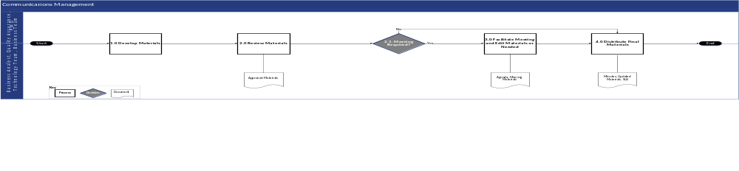
Figure 4-1: Communications Process Flow

Project Status Report Process Flow Narrative
Below is the process for communicating Project Status Report updates.
Step # | Process Step | Description | Stakeholder Group(s)
1 | Develop Materials | ███████ PMO works with track leads and PMO liaisons to compile updates for the Project Status Report, which is used to relay updates to the team and guide discussion during weekly meetings.  More information about the contents of the Project Status Report can be found in Section 4.3.2 Project Management Communication Types. | - PMO  - Impacted Stakeholder Group
2 | Review Materials | DOS PMO and relevant stakeholders review the Project Status Report before ███████ PMO distributes it to the meeting attendees.  DOH OHIP can provide additions or comments to the Project Status Report in the window between Deloitte’s dissemination of content and up to 2 hours in advance of the meeting. This provides time for Deloitte to make and Quality Assurance/Quality Control (QA/QC) updates as well as clarify updated with DOH OHIP. For the Project Status Report, this would be a window of 2.5 hours. | - PMO  - Impacted Stakeholder Group
2.1 | Meeting Required? | - If during the review of the status report it is determined that a meeting with stakeholders is required to discuss the content, proceed to Step #3 Facilitate Meeting and Edit Materials as Needed  - If a meeting is not required, proceed to Step #4 Distribute Final Materials | - PMO  - Impacted Stakeholder Group
3 | Facilitate Meeting and Edit Materials as Needed | If a meeting is required, ███████ PMO facilitates a status report meeting with DOH OHIP stakeholder groups to discuss completed and planned activities and edit agenda and meeting materials. | - PMO  - Impacted Stakeholder Group
4 | Distribute Final Materials | ███████ PMO attaches the finalized status report and relevant meeting materials to the invite. | - PMO  - Impacted Stakeholder Group
Table 4-6: Project Status Report Process

Work Plan Updates Process Flow Narrative
Below is the process for communicating Work Plan updates.
Step # | Process Step | Description | Stakeholder Group(s)
1 | Develop Materials | ███████ PMO collaborates with PMO liaisons to make updates to applicable items in the Work Plan. | - PMO  - Impacted Stakeholder Group
2 | Review Materials | ███████ PMO then shares the revised Work Plan that incorporates additions. Relevant stakeholders have an opportunity to review the updated Work Plan and indicate any further suggestions. | - PMO  - Impacted Stakeholder Group
2.1 | Meeting Required? | - If during the review of the Work Plan updates it is determined that a meeting with stakeholders is required to discuss the content, proceed to Step #3 Facilitate Meeting and Edit Materials as Needed  - If a meeting is not required, proceed to Step #4 Distribute Final Materials | - PMO  - Impacted Stakeholder Group
3 | Facilitate Meeting and Edit Materials as Needed | If a meeting is needed, ███████ PMO reviews the Work Plan with track leads to discuss outstanding items. ███████ PMO then makes updates to the document. | - PMO  - Impacted Stakeholder Group
4 | Distribute Final Materials | ███████ PMO saves a copy of the file on the project SharePoint site for team members to access on a weekly cadence. | - PMO  - Impacted Stakeholder Group
Table 4-7: Work Plan Updates

SIT/UAT Test Metrics Process Flow Narrative
The process for communicating SIT/UAT test metrics during the SIT and UAT test phases is detailed in the Test Management Plan (DEL-09).

Release Plans Process Flow Narrative
The process and schedule for communicating release plans are defined in the Release Management Plan (DEL-34).

Technical Deployment Checklists Process Flow Narrative
The process for communicating technical deployment checklists is defined in the Release Management Plan (DEL-34).

End-User Training Materials Process Flow Narrative
The process for communicating end-user training is defined in the Training Plan (DEL-10).

Critical Communication Process Flow Narrative
In addition to the planned communications, there are times when unplanned communications are required. These critical communications require expedited turnaround time, but they follow the same Communications Management process flow.
Step # | Process Step | Description | Stakeholder Group(s)
1 | Develop Materials | ███████ PMO and stakeholders prepare unplanned communication requests for review.  The request also includes a proposed review and release timeline tailored to the urgency of the request. | - PMO  - Impacted Stakeholder Group
2 | Review Materials | If turnaround time is longer than one (1) business day, review unplanned communication request and determine next steps.  If turnaround time is less than one (1) business day, review unplanned communication request and approve. | - PMO  - Impacted Stakeholder Group
2.1 | Meeting Required? | - If during the review of the communication it is determined that a meeting with stakeholders is required to discuss the content, proceed to Step #3 Facilitate Meeting and Edit Materials as Needed  - If a meeting is not required, proceed to Step #4 Distribute Final Materials | - PMO  - Impacted Stakeholder Group
3 | Facilitate Meeting and Edit Materials as Needed | PMO will facilitate a meeting with relevant stakeholders to review the draft communication and edit it, as needed, prior to distribution. | - PMO  - Impacted Stakeholder Group
4 | Distribute Final Materials | Once the critical communication materials are finalized, they are transmitted to relevant parties. | - PMO  - Impacted Stakeholder Group
Table 4-8: Critical Communication Process Flow Narrative

Communication Review and Approval Process
Communications will be developed at specific times throughout the project to align with key milestones and events. All communications must be reviewed and approved prior to distribution. The review process for each communication will follow a structured approach to validate accuracy, quality, and consistency in messaging. This will be further defined in the Quality Management Plan (refer to Section 7).

Communication Review and Approval Process Flow Narrative
The communication review process aims to promote timely development and delivery of communications. Note, the overall process may be repeated to involve multiple cycles of reviews, depending on the degree of feedback.
Step # | Process Step | Description | Stakeholder Group(s)
1 | Develop Materials | Draft communication in line with project standards for review. | - PMO  - Impacted Stakeholder Group
2 | Review Materials | Validate accuracy, quality, and consistency in messaging of communication. | - PMO  - Impacted Stakeholder Group
2.1 | Meeting Required? | - If during the review of the communications it is determined that a meeting with stakeholders is required to discuss the content, proceed to Step #3 Facilitate Meeting and Edit Materials as needed  - If a meeting is not required, proceed to Step #4 Distribute Final Materials | - PMO  - Impacted Stakeholder Group
3 | Facilitate Meeting and Edit Materials as Needed | PMO will facilitate a meeting with relevant stakeholders to review the communication and edit it, as needed, prior to distribution. | - PMO  - Impacted Stakeholder Group
4 | Distribute Final Materials | Once the communication materials are finalized, they are transmitted to relevant parties. | - PMO  - Impacted Stakeholder Group
Table 4-9: Communication Review and Approval Process Flow Narrative

Section 5 – Deliverable Management Plan

Deliverable Management Plan

Introduction
The Deliverable Management Plan outlines project guidelines and procedures for developing and steering deliverables through the DOH OHIP approval process, as well as the review and tracking processes between the ███████ PMO, DOS PMO, ███████ deliverable stakeholders, and DOH OHIP deliverable stakeholders. All deliverables tie directly to project scope tasks and satisfy project requirements, and deliverables are referenced in each respective Individual Statement of Work (ISOW). The iterative process described in this document includes review timelines, tracking procedures, and filing mechanisms to confirm deliverables meet project standards. Processes for deliverable management include the review, transmittal, and approval of Deliverable Expectation Documents (DEDs)/Deliverables, which are listed in the Baselined Work Plan (DEL-06) and referenced in each project ISOW. Additional quality-related processes in tandem with deliverable management, including deliverable transmittal and review, deliverable quality expectations, and others, are outlined in detail in the Quality Management Plan (QMP) (refer to Section 7).

Purpose
This document describes the processes, tools, and expectations to develop and manage project deliverables through DOH OHIP acceptance and which are referenced in each respective ISOW. The deliverable submission process is tracked using the Deliverable Management process for which more details are outlined in the QMP (refer to Section 7).
The objectives of this plan are to:
- Outline the deliverable review process and subsequent stakeholders’ roles
- Document the process for logging and tracking deliverables throughout the deliverable review cycle
- Outline the Design Update process for Functional Design documents (FDDs) post transmittal approval

Deliverable Expectation Documents and Deliverables
- This section describes the distinction between DEDs and Deliverables. Both DEDs and Deliverables are equally subject to the protocols surrounding collaboration, concurrence, and final approval by DOH.
- A DED is a template for a deliverable that contains defined review and/or acceptance criteria for the deliverable. Prior to deliverable submission, ███████ works with DOH OHIP to finalize the templates and expected content of the deliverables. A DED is created by tailoring ███████ methodologies and reference materials to meet project-specific needs and further refined in collaboration with the DOH OHIP team members responsible for review and sign-off of the deliverable acceptance criteria.
- A Deliverable is directly tied to project scope tasks and meeting project requirements. All contractual deliverables are defined in the applicable ISOW for each project.
  - ISOW #1 Amendment contains the Continuing Medicaid Eligibility Modernization-specific list of deliverables
  - ISOW #2 contains the Appeals project-specific list of deliverables
  - NOTE: Contractual deliverables may be subject to change based on ISOW amendments and deliverable revisions subject to change request approval

Non-Design Deliverable Management Approach
Non-design documents are deliverables that provide comprehensive documentation that supports non-functional requirements, project management, technology, security, and change management operations. This approach outlines the process for developing, reviewing, and managing non-design documents throughout the project lifecycle. The documents are crafted, collaboratively reviewed, and thoroughly updated to reflect associated content and feedback. By following a structured approach, the project team maintains high standards of quality and consistency, facilitating clear communication and alignment among all stakeholders. This section details the process flow, roles, and responsibilities involved in the submission and management of non-design documents, promoting an efficient workflow from initial planning to final approval.
The table below summarizes the types of Continuing Medicaid Eligibility Modernization non-design deliverables, as well as the organization structure, format, and general purpose each document type.
Non-Design Document Type | Organized By | Purpose
Technology | Track/System Module | These documents describe the technical architecture, specifications, and operational procedures necessary to support the system’s functionality and performance. These documents also provide comprehensive details for the development and operations teams and may include release management processes for planning, scheduling, and controlling releases to production, with guidance for smooth deployment and issue management.
Project Management | Track/System Module | These documents describe the processes and tools used to plan, execute, and monitor project activities. The documents may include the project management plan, workplan and schedule, project status report, and the risk register.
Change Management | Track/System Module | These documents describe the processes and procedures for managing changes to the project scope, requirements, or deliverables. The evaluation, approval, and implementation of changes in a controlled manner are facilitated, minimizing disruption, and maintaining project integrity.
Security | Track/System Module | These documents describe the security measures, policies, and protocols implemented to protect the system and its data. Details are provided on how security requirements are met and how the system is safeguarded against threats and vulnerabilities.
Table 5-1: Summary of Continuing Medicaid Eligibility Modernization Non-Design Documentation

DED/Deliverable Management Process Flow
Link to Process Flow Diagram: DED/Deliverable Management Process

DED/Deliverable Management Process Flow Narrative
The following table outlines the steps detailed in the diagram linked above.
Step # | Process | Description | Stakeholder Group(s)
1.0 | Conduct meeting to align on expectations and QA/QC timeline for upcoming submission | The ███████ track and ███████ PMO conduct meeting to align on expectations and QA/QC timeline for upcoming submission. | - ███████ Tracks  - Deloitte PMO
2.0 | Complete DED/Deliverable draft | The ███████ track completes the DED/Deliverable draft. | - ███████ Tracks
3.0 | Conduct internal QA/QC, proofread, and fill out QA/QC Checklist | The ███████ track conducts internal QA/QC, proofreads, and fills out the QA/QC Checklist. | - ███████ Tracks
4.0 | Send email to PMO with link to DED/Deliverable and QA/QC Checklist | The ███████ track sends an email to the ███████ PMO with the link to the DED/Deliverable and completed QA/QC Checklist. | - ███████ Tracks
5.0 | Conduct QA/QC and fill out checklist | The ███████ PMO conducts QA/QC and fills out the QA/QC Checklist. | - ███████ PMO
5.1 | Ready for collaboration? | The ███████ PMO decides if the DED/Deliverable is ready for collaboration.  - If the DED/Deliverable is not ready for collaboration, proceed to Step #6 Address PMO QA/QC feedback  - If the DED/Deliverable is ready for collaboration, proceed to Step #7 Initiate collaboration with DOH stakeholders | - ███████ PMO
6.0 | Address PMO QA/QC feedback (as needed) | The ███████ track addresses ███████ PMO’s QA/QC feedback. | - ███████ Tracks
7.0 | Initiate collaboration with DOH stakeholders | The ███████ track initiates collaboration with DOH stakeholders.  If requested and agreed upon by Deloitte and DOH stakeholders, the collaboration phase may begin with a walkthrough of the DED/Deliverable (walkthroughs are conducted upon request by Deloitte or DOH). | - ███████ Tracks
8.0 | Review DED/Deliverable and provide feedback to ███████ | DOH stakeholders review the DED/Deliverable and provide feedback to ███████. | - DOH Stakeholders
9.0 | Address DOH stakeholder feedback and update DED/Deliverable | The ███████ track addresses DOH stakeholder feedback. | - ███████ Tracks
10.0 | Review updated DED/Deliverable | DOH stakeholders review the updated DED/Deliverable. | - DOH Stakeholders
10.1 | Review completed? | DOH stakeholders decide if the review of the DED /Deliverable is completed. This is based on the completion of the collaboration and review of the deliverable once all comments are addressed.  - If the review of the DED/Deliverable is not completed, go back to Step #9 Address DOH stakeholder feedback and update DED/Deliverable  - If the review of the DED/Deliverable is completed, proceed to Step #11 Create clean copy; send to PMO for final QA/QC | - DOH Stakeholders
11.0 | Create clean copy; send to PMO for final QA/QC | The ███████ track creates a clean copy and sends it to ███████ PMO for final QA/QC. | - ███████ Tracks
12.0 | Conduct QA/QC review | The ███████ PMO conducts QA/QC review. | - ███████ PMO
12.1 | Ready for transmittal? | The ███████ PMO determines if the DED/Deliverable is ready for transmittal.  - If the DED/Deliverable is not ready for transmittal, proceed to Step #11 Create clean copy; send to PMO for final QA/QC  - If the DED/Deliverable is ready for transmittal, proceed to Step #13 Send via Transmittal | - ███████ PMO
13.0 | Send via Transmittal | The ███████ PMO sends the DED/Deliverable via transmittal.  Refer to Section 7.4.1 Transmittal Management for more details on the transmittal process. | - ███████ PMO
Table 5-2: DED/Deliverable Management Process Flow Narrative

Collaboration Review Cycle Oversight
As part of the DED/Deliverable Management Approach mentioned above, DOH OHIP and ███████ mutually agree on a review cycle as part of the collaboration approach based on the nature and complexity of the DED/Deliverable or the review cycle may be modified on a case-by-case basis as needed.
The default (baseline) review cycle for DEDs/Deliverables is 5-5-3, however the respective ███████/DOH owner and/or Lead may agree on a review cycle that deviates from the standard (default) 5-5-3 review cycle for a given DED/Deliverable. The Work Plan will be updated with the latest agreed upon DED/Deliverable review cycles.
- DOH OHIP has five (5) business days to review the initial DED/Deliverable submission and submit comments to ███████ via comments in the document
- ███████ has five (5) business days to provide a response to DOH OHIP’s comments and edit the document
- DOH OHIP has three (3) business days to provide a response to ███████ indicating concurrence or providing additional comments. If additional DOH OHIP comments are provided, the respective ███████/DOH owner and/or lead will mutually determine the added review cycle response times for a given DED/Deliverable

Collaboration Process for DEDs/Deliverables
The collaboration process for DEDs/Deliverables specifies the roles, responsibilities, and timeline for the Continuing Medicaid Eligibility Modernization projects.
The general collaboration process begins with the ███████ Deliverable Lead coordinating with the ███████ PMO for an initial quality review of the document prior to initiating collaboration with the designated stakeholders. Upon conclusion of the quality review, the ███████ Delivery Lead sends the deliverable to the designated stakeholders to initiate collaboration.
The designated stakeholders review the deliverable and either indicate the deliverable is concurred and ready to proceed to transmittal or provide comments for ███████ to adjudicate. If comments are provided, the ███████ team addresses the comments, typically by updating the document and responding to the comments provided, and resubmits the deliverable for stakeholder review. The designated stakeholders review the responses and confirm whether all comments have been sufficiently addressed or if further updates are required. If no further comments are provided, DOH provides written confirmation that the deliverable is concurred, and all comments have been addressed. If further comments are provided, the review cycle repeats until the stakeholders have acknowledged that all comments have been sufficiently addressed.
Refer to Appendix G: Collaboration Process for DEDs/Deliverables that describes the collaboration process for Non-Design Document Deliverables.

PMO Review Following Completion of Collaboration Review
Following the conclusion of the collaboration review cycle, the ███████ team responsible for the deliverable provides a clean copy of the DED/Deliverable to the ███████ PMO for a final PMO QA/QC review prior to transmittal.
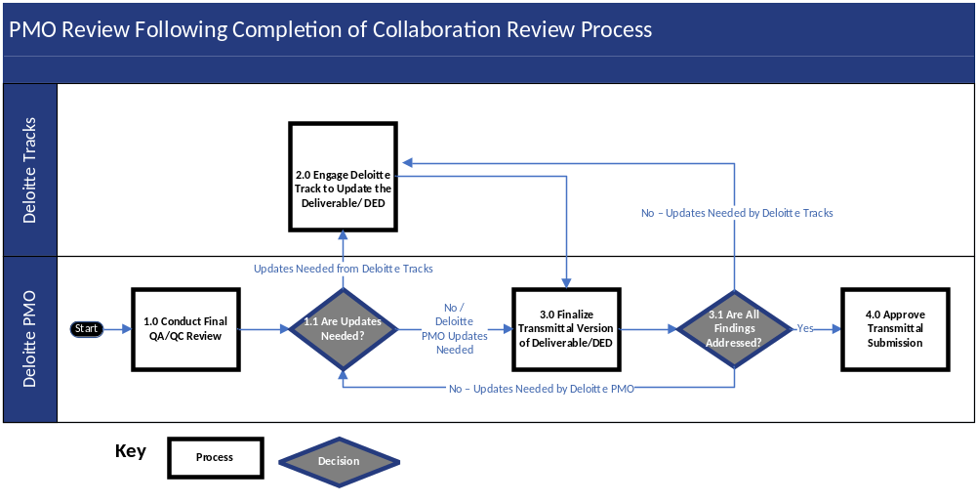
Figure 5-1: PMO Review Following Completion of Collaboration Review Process
The steps outlined below are taken by the ███████ PMO and ███████ Track prior to transmittal once a DED/Deliverable is concurred:
Step # | Process | Description | Stakeholder Group(s)
1.0 | Conduct Final QA/QC Review | The ███████ PMO conducts the final QA/QC review. The PMO uses the clean copy of the latest concurred DED/Deliverable version. | - ███████ PMO
1.1 | Are Updates Needed? | The ███████ PMO determines if any additional updates are needed to the DED/Deliverable.  - If the DED/Deliverable requires collaboration from the Deloitte track to address the QA/QC findings, proceed to Step #2.0 Engage Deloitte Track to Update the DED/Deliverable  - If the Deliverable/DED QA/QC updates can be addressed by the Deloitte PMO, proceed to Step #3.0 Finalize Transmittal Version of DED/Deliverable | - ███████ PMO
2.0 | Engage ███████ Track to Update the DED/Deliverable | The ███████ track reviews and addresses the QA/QC findings from the ███████ PMO and notifies the ███████ PMO once the associated updates have been completed. | - ███████ Track
3.0 | Finalize Transmittal Version of DED/Deliverable | The ███████ PMO finalizes updates to the document in preparation for transmittal. | - ███████ PMO
3.1 | Are All Findings Addressed? | The ███████ PMO determines if all the findings have been addressed by the team.  - If all findings have been sufficiently addressed, proceed to Step #4.0 Approve Transmittal Submission  - If further updates are required by the Deloitte PMO, proceed to Step #1.1 Are Updates Needed?  - If further updates are required by the Deloitte track, proceed to Step #2.0 Engage Deloitte Track to Update the DED/Deliverable | - ███████ PMO
4.0 | Approve Transmittal Submission | The ███████ PMO leads do a final spot check of the updated DED/Deliverable and confirm whether it is ready for transmittal.  If the DED/Deliverable is ready for transmittal, the review process ends. | - ███████ Track
Table 5-3: PMO Review Post Collaboration

Final Review and Disposition
The final review and disposition process of DEDs/Deliverables takes place via the transmittal process. Refer to Section 7 Quality Management Plan for more details on final dispositioning of DEDs/Deliverables.

Modifying Deliverables Post Transmittal Approval
If a deliverable needs to be updated after being approved by DOH OHIP, the DED related to the deliverable will not be updated post transmittal approval. Only the updated deliverable will be re-submitted via transmittal. The updated deliverable will be accompanied by a change tracker indicating the updates made to the approved deliverable, including the section number, section title, original language/content, updated language/content, type of action performed (e.g., addition, removal, update), and change rationale. Refer to Appendix I for the template of the Change Tracker.
Refer to Section 7 Quality Management Plan for more details on final dispositioning of DEDs/Deliverables.

Deliverable Approval Criteria
The following baseline criteria are used to determine the approval of deliverables. Further acceptance criteria may be referenced in the deliverable itself.
- The deliverable should address and be consistent with the criteria identified in the DED as presented to and approved by DOH OHIP, in preparation for development of the deliverable
- All required documentation, as specified by DOH OHIP is delivered according to the accepted Work Plan
- Deliverable documents should be organized in a structured manner and be professional in presentation
- Deliverable documents should adhere to leading practices and be consistent in style and quality
- The deliverable and related documents should undergo a thorough quality assurance review before submission
- The DED/Deliverable shall be developed and submitted through the Formal Deliverable Review Process, as outlined in the PMP, and agreed upon by ███████ and DOH OHIP

Design Document Deliverable Management Approach
Design documents are deliverables that provide comprehensive documentation that supports functional requirements. These documents enhance the system’s design, development, and operations. This approach outlines the process for developing, reviewing, and managing design documents within the project lifecycle. The documents are crafted, collaboratively reviewed, and thoroughly updated to reflect system requirements and feedback. By following a structured approach, the project team maintains high standards of quality and consistency, facilitating clear communication and alignment among all stakeholders. This section details the process flow, roles, and responsibilities involved in the submission and management of FDDs and related documentation, promoting an efficient workflow from initial planning to final approval.
The table below summarizes the types of MECM system design documentation, as well as the organization structure, format, and general purpose of each document type.
Design Document Type | Organized By | Format(s) | Purpose
Iteration 1 & 2 FDDs | Track/System Module | Word Docs | These documents contain narrative and functional design specifications only for the scope belonging to a specific track within a specific iteration.
Integrated JAD Topic FDDs | Topic, as defined as a holistic, cross-track bundle approach | Word Docs | These documents contain narrative and functional design specifications for each business process. Each business process is described chronologically in the same order that users would experience the system, across every system track that supports the process.  This supports ease of understanding the holistic system design, the user experience, and outcomes in different business scenarios. These documents are more business focused than technical.
Component-Level Specification Documents | Track/System Module | Excel, Word Docs | These detailed specification documents are referenced in the FDDs and define how each individual component of the MECM system (e.g., each screen, notice, etc.) works in isolation.  This supports ease of development, maintenance, and operation of the system. These documents capture technical details that supplement the FDDs.
Interface Control Documents (ICDs) | System Interface | Word Docs | These documents describe the relationship between the MECM system and the designated trading partner interface. ICDs specify the interface requirements to be met by the participating systems and how those requirements will be implemented. The ICD also describes the concept of operations for the interface, defines the message structure and protocols that govern the interchange of data, and identifies the communication paths or modes along which the data is expected to flow.
Table 5-4: Summary of MECM Design Documentation

Design Document DED/Deliverable Management Process Flow
The Design Document DEDs follow the same process as Non-Design DEDs. Refer to Section 5.4.1 for the DED Management Process Flow. Design Document Deliverables deviate from this process flow and have different responsibilities as well.
Link to Process Flow: Design Document Development Process

Design Document DED/Deliverable Management Process Flow Narrative
Refer to Section 5.4.2 for the process flow narrative for Non-Design DED Management Process Flow for DEDs. The narrative for Design Document Deliverables is detailed further in Table 5-5:

Step # |  | Process |  | Description | Stakeholder Group(s)
1.0 | Conduct meeting to align on expectations and QA/QC timeline for upcoming submission |  | The ███████ track and ███████ PMO conduct a meeting to align on expectations and the QA/QC timeline for upcoming submission. |  | - ███████ PMO  - Deloitte Track
2.0 | Complete Design Document draft |  | The ███████ track completes the design document draft. |  | - ███████ Track
3.0 | Conduct Internal QA/QC, Proofread, and Fill Out QA/QC Checklist |  | The ███████ track conducts internal QA/QC, and proofreads, and fills outs the QA/QC Checklist. |  | - ███████ Track
4.0 |  | Send Email to PMO with Link to Design Document and QA/QC Checklist |  | The ███████ track sends an email to the ███████ PMO with a link to the design document and accompanying QA/QC Checklist. | - ███████ Track
5.0 | Conduct QA/QC and Fill out Checklist |  | The ███████ PMO conducts QA/QC and fills out the QA/QC Checklist. |  | - ███████ PMO
5.1 | Ready for Collaboration? |  | The ███████ PMO determines if the design document is ready for collaboration.  - If the document is ready for collaboration, proceed to Step #7 Send Design Document and Other Related Documentation for Collaboration to DOS PMO  - If the document is not ready for collaboration, proceed to Step #6 Address PMO QA/QC Feedback |  | - ███████ PMO
6.0 | Address PMO QA/QC Feedback |  | The ███████ track addresses the QA/QC feedback from the ███████ PMO. |  | - ███████ Track
7.0 | Send Design Document and Other Related Documentation for Collaboration to DOS PMO |  | The ███████ PMO sends the design document (e.g., FDD and/or ICD) and other related documentation for collaboration to DOS PMO. |  | - ███████ PMO
8.0 | Receive Documents and Send to DOH Stakeholders |  | The DOS PMO receives the document and sends to the appropriate DOH stakeholders. |  | - DOS PMO
9.0 | Review Design Documents and Provide Feedback Back to DOS PMO |  | The DOH stakeholders review the FDD and provide feedback to ███████ via the DOS PMO. |  | - DOH Stakeholders
9.1 |  | Does DOH provide feedback on the Design Documents? |  | DOH stakeholders determine whether to provide feedback on the FDD.  - If DOH stakeholders provide feedback, proceed to Step #10 Receive Feedback and Send to Deloitte PMO  - If DOH stakeholders do not provide feedback, proceed to Step #9.2 Does DOH Concur that All Comments Have Been Addressed | - DOH Stakeholders
9.2 |  | Does DOH Concur that All Comments Have Been Addressed? |  | The DOH stakeholders decide if they concur that all comments have been addressed.  Once we have reached concurrence, Deloitte does not expect to receive any DOH comments impacting development.  - If the FDD is not concurred, proceed to Step #9.1 Does DOH Provide Feedback on FDD  - If the FDD is concurred, proceed to Step #13 Request Clean Copy from Deloitte | - DOH Stakeholders
10.0 |  | Receive Feedback and Send to ███████ PMO |  | The DOS PMO receives feedback and sends it to the ███████ PMO. | - DOS PMO
11.0 |  | Receive Feedback, Save New Version, and Share with ███████ Track |  | The ███████ PMO receives feedback, saves a new version of the file, and shares it with the appropriate ███████ track. | - ███████ PMO
12.0 |  | Address DOH Stakeholder Feedback |  | The ███████ track addresses DOH stakeholder feedback. | - ███████ Track
13.0 | Request Clean Copy from ███████ |  | The DOS PMO requests a clean copy from ███████. |  | - DOS PMO
14.0 | Save New Version, and Send Clean Copy Request to ███████ Track |  | The ███████ PMO sends clean copy request to the ███████ track. |  | - ███████ PMO
15.0 | Create Clean Copy; Send to ███████ PMO |  | The ███████ track creates a clean copy and sends it to the ███████ PMO. |  | - ███████ Track
16.0 | Send Clean Copy to DOS PMO |  | The ███████ PMO sends the clean copy to the DOS PMO. |  | - ███████ PMO
17.0 | Review Design Document Clean Copy |  | DOS PMO reviews the design document clean copy. |  | - DOS PMO
17.1 | Review Complete? |  | DOS PMO decides if FDD review is complete.  - If the FDD review is not complete, proceed to Step #18 Receive Feedback and Share with Deloitte Track  - If the FDD review is complete, proceed to Step #20 Conduct Final QA/QC |  | - DOS PMO
18.0 | Receive Feedback and Share with ███████ Track |  | The ███████ PMO receives feedback and shares it with the appropriate ███████ track. |  | - ███████ PMO
19.0 | Complete Requested Updates on Clean Copy; Send to ███████ PMO |  | The ███████ track completes the requested updates and sends the updated document back to the ███████ PMO. |  | - ███████ Tracks
20.0 | Conduct Final QA/QC |  | The ███████ PMO conducts final QA/QC. |  | - ███████ PMO
20.1 | Ready for Transmittal? |  | The ███████ PMO decides whether the FDD is ready for transmittal.  - If the FDD is not ready for transmittal, proceed to Step #21 Update the Design Document and Send Back to Deloitte PMO  - If the FDD is ready for transmittal, proceed to Step #22 Initiate Transmittal Process |  | - ███████ PMO
21.0 |  | Update the Design Document and Send Back to ███████ PMO |  | The ███████ Track completes the requested updates and sends it back to the Deloitte PMO for a final QA/QC. | - ███████ Tracks
22.0 |  | Initiate Transmittal Process |  | The ███████ PMO initiates the transmittal process.  Refer to Section 7.4.1. Transmittal Management for more details on the transmittal process. | - ███████ PMO
Table 5-5: FDD and Related Documentation Development Process Narrative

Design Document Collaboration Review Cycle Oversight
Design Document Deliverables follow the same collaboration review cycle as Non-Design Deliverables. Refer to Section 5.4.3 for details.

Collaboration Process for Design Document DEDs/Deliverables
Refer to Appendix G: Collaboration Process for DEDs/Deliverables that describes the collaboration process for Design Document Deliverables.

Final Review and Disposition
The final review and disposition of DEDs/Deliverables takes place via the transmittal process. Refer to Section 7 Quality Management Plan for more details on final dispositioning of DEDs/Deliverables.

Modifying Design Deliverables Post Transmittal Approval or Post Concurrence
After a design document reaches concurrence, there are several events or sources that can cause a design document to require further revisions across the project lifecycle. The majority of post concurrence design updates will result from one or more of the following source categories:
- Defects that result in changes to system code and/or associated design documentation
- Observations or JAD-related discussions to provide confirmation or additional clarity to designs
- Solution Exploration Observations resulting in changes to system code and/or design documentation
- Design Update Management (DUM) meeting items that result in design update decisions. DUM meetings are held between ███████ and DOH to discuss parking lot items from JADs and other meetings that require further discussion. As part of the DUM meeting, the updates are evaluated to determine if the update is necessary and if it needs to be routed to the Integrated Change Control Process (ICCP)
When a design document requires post concurrence updates, the document approval status needs to be evaluated before changes are made to the design document. If the design documents are transmittal approved, the ICCP must be completed before the changes to the design document are made and sent for review. If the post collaboration design document has not yet been approved via transmittal, the design update can be submitted without an accompanying CR (unless the update is out of scope and requires a change request to be initiated).
The table below indicates whether ICCP approval is required to implement a design update for an FDD, Design Component, or ICD.
Design Document Status | Design Update is in Scope? | ICCP Approval Required Before Updates are Made?
Transmittal Approved | Yes | Yes
Transmittal Approved | No | Yes
Concurred | Yes | No
Concurred | No | Yes
Table 5-6: ICCP Approval for Design Documentation

Design Updates to FDD Post Transmittal Approval Diagram
Link to process flow diagram: Post Transmittal Approval Post Concurrence Design Update Process Flow

Design Updates to FDD Post Transmittal Approval Narrative
The following table details the steps outlined in the link to the diagram mentioned above.

Step # | Process | Description | Stakeholder Group(s)
1.0 | Design Document Needs Updates | Design documents could be requiring post transmittal approval/concurrence for several reasons. Common examples include defects, Solution Exploration Observations, JAD sessions, DUM process, etc. | - ███████ Functional team  - DOH OHIP
1.1 | Change Request Required? | If ███████ and DOH OHIP determine that a Change Request is necessary for the design update and/or the design update is already transmittal approved, then the ICCP process is followed to make the design update.  - If the update requires a change request, proceed to Step #1.2 Follow ICCP to Initiate Design Update  - If the update does not require a change request, proceed to Step #1.3 System Code Change Required? | - ███████ Functional team  - DOH OHIP
1.2 | Follow ICCP to Initiate Design Update | Create CR ticket, documentation, and follow ICCP to initiate the design update. | - ███████ Functional team
1.3 | System Code Change Required? | Determine whether the design update will result in a system code change.  - If the update to the design document will result in a system code change, proceed to Step #2 Create Design Update (Doc + Code) the ALM tool Ticket  - If the design update does not require a system code update, proceed to Step #3 Create Document Update (Doc only) the ALM tool Ticket | - ███████ Functional team
2.0 | Create Design Update (Doc + Code) the ALM tool Ticket | The ███████ Functional team creates a Design Update (Doc + Code) ALM tool ticket and fills out the relevant fields. The team links the ticket to the source ticket and corresponding design artifact (i.e., Design Document, Design Component, or ICD). | - ███████ Functional team
3.0 | Create Document Update (Doc Only) the ALM tool Ticket | The ███████ Functional team creates a Document Update (Doc only) ALM tool ticket and fills out the relevant fields. The team links the ticket to the source ticket and corresponding design artifact (i.e., Design Document, Design Component, or ICD). | - ███████ Functional team
4.0 | Update ALM tool status to Triaged | The ███████ Functional team updates status of ticket to ‘Triaged’ while analyzing the updates required. | - ███████ Functional team
5.0 | Initiate Design Updates | The ███████ Functional team obtains the latest version of the design document from either the ADR (if approved via transmittal) or the CDR (if concurred, but not yet approved).  Changes are made to the design document with tracked changes turned on, and the version history is advanced by .1 with a description indicating the source of the update and summarizing changes made. | - ███████ Functional team
6.0 | Save Document in Designated DOH SharePoint Location | The ███████ Functional team saves the design document with tracked changes on while design updates are ongoing in the designated DOH SharePoint folder. Design documents are temporarily stored in this folder throughout the review cycle between DOH and ███████. The hyperlink to the document should be included in the ALM tool ticket. | - ███████ Functional team
7.0 | Complete Design Update Changes | The ███████ Functional team makes changes to the design document to complete the design update. | - ███████ Functional team
8.0 | Conduct QA Review of Updated Document | The ███████ Functional team performs QA checks on the updated design document before it is shared with DOH.  The ALM tool status is updated to QA Review in Progress. | - ███████ Functional team
9.0 | Assign to DOH Reviewer | Once ███████ completes the QA review, and the design document is ready to be shared with DOH, ███████ update the ALM tool status to DOH Review.  Deloitte notifies and re-assigns the ticket to the designated DOH reviewer. The Target Close Date is updated in the ticket so that Deloitte and DOH can target finishing the review of the design update. | - ███████ Functional team
10.0 | Conduct Design Update Document Review | DOH OHIP reviews the assigned design update document. | - DOH OHIP
10.1 | Comments/Feedback Provided by DOH? | DOH OHIP determines whether to provide any feedback/comments for ███████ to address  - If there are comments/feedback for Deloitte to address, proceed to Step #11 Provide Comments/Feedback  - If there are no comments or feedback for Deloitte to address and the design update is approved, proceed to Step #12.0 Update ALM tool status to DOH Approval | - DOH OHIP
11.0 | Provide Comments/Feedback | DOH OHIP posts comments and feedback directly in the design document. DOH OHIP updates the ALM tool status to Comment Response Pending and reassigns the ALM tool ticket to ███████ to review. | - DOH OHIP
11.1 | Address DOH Comments/Feedback | The ███████ Functional team reviews and addresses DOH feedback in the design document, with tracked changes on.  For each review cycle, the file version is rounded up to the next 0.1 version  (e.g., 1.1 version updated to 1.2).  Steps # 9.0, 10.0, 10.1, 11.0 and 11.1 are repeated until Deloitte addresses all comments in the document. | - ███████ Functional team
12.0 | Update ALM tool status to DOH Approval | DOH OHIP notifies ███████ and updates the ALM tool status to DOH Approval. | - DOH OHIP
13.0 | Update ALM tool status to ADR File Sync In Progress | ███████ updates the ALM tool status to ADR File Sync in Progress. | - ███████ Functional team
14.0 | Create Clean Copy and Store in CDR/ADR | The ███████ Functional team prepares the associated clean copies and stores them in the respective DOH SharePoint folders.  The Deloitte Functional team loads a copy of the latest DOH Approved document (with tracked changes/comments) into the designated location on DOH SharePoint. If there was a previous version in the folder, it is placed in an archive folder.  The team next creates a clean copy of the latest approved design, which involves accepting/removing tracked changes/comments and advancing the document version to the next whole number. This version is loaded into the CDR folder if the design document status is concurred, or the ADR if the design document that was updated was transmittal approved. Previous versions are archived. | - ███████ Functional team
15.0 | Design Update Resulted in System Code Impact? | The ███████ Functional team updates the corresponding ALM tool status depending on whether the design update had a system code impact.  - If the design update did not result in a system code impact, proceed to Step #16.0 Update ALM tool status to Document Only Update Completed  - If the design update resulted in a system code impact and the design needs to be added to the development backlog, proceed to Step #17.0 Update ALM tool status to Ready for Development | - ███████ Functional team
16.0 | Update the ALM tool status to Document Only Update Completed | The ███████ Functional team updates the ALM tool status to Document Only Update Completed. | - ███████ Functional team
17.0 | Update the ALM tool status to Ready for Development | The ███████ Functional team updates ALM tool status to Ready for Development to add updated design to ███████’s development backlog as it is ready for development. | - ███████ Functional team
17.1 | Update the ALM tool status to Development in Progress | The ███████ Development team works on the system code changes and updates ticket status to Development in Progress. | - ███████ Development team
17.2 | Complete Code Change and Update the ALM tool status to Ready for SIT | Once development is completed, the design update is ready for System Integration Testing (SIT) in testing environment. The ███████ Development team updates the ALM tool status to Ready for SIT. | - ███████ Development team
17.3 | Conduct SIT and Update the ALM tool status to SIT In Progress | ███████ conducts SIT and updates ticket status to SIT In Progress. | - ███████ Testing team
17.4 | Update the ALM tool status to Ready for UAT | Once ███████ completes SIT, the design update is ready for UAT. The ███████ Testing team updates the ALM tool status to Ready for UAT. | - ███████ Testing team
Table 5-7: Design Updates Post FDD Approval Narrative

Storing Design Documentation in DOH SharePoint
The DOH SharePoint is used to store, update, and collaborate on design documentation.
Refer to Appendix H: Design Document Storage on DOH SharePoint for details regarding folder types used to store design documents throughout the design lifecycle.

Deliverable Approval Criteria
Design Document Deliverable approval criteria mirrors Non-Design Document Deliverable approval criteria. Refer to Section 5.4.8 for details.

Work Products
Work products are documents created in support of the project that are not considered contractual deliverables and therefore are not subject to the standard deliverable approval processes. If ███████ and DOH OHIP determine that a work product should be submitted via transmittal or requires formal feedback, ███████ and DOH OHIP stakeholders will mutually agree to the expected review timelines and whether formal approval is needed.

Application Lifecycle Management (ALM) Tools
The ALM tool is the standard ALM tool for tracking review and approval processes for all DED/Deliverable types. For additional detail on ALM tool statuses, configuration, and roles and responsibilities, refer to Section 2.20 the ALM tool.

Section 6 – Budget Management Plan

Budget Management Plan

Introduction
The Budget Management Plan includes the processes needed to manage, track, and report project costs within the project budget. The initial project budget is set forth in the MSOW. Upon delivery of the first ISOW, an ISOW budget will be created, reviewed, and baselined.

Purpose
The Continuing Medicaid Eligibility Modernization project is expected to be delivered within the available project budget as defined in the MSOW. The project objectives, high level scope, and timeline defined in the MSOW were used to estimate the initial project budget, but that estimate will be refined as the project progresses through the creation and execution of each ISOW.
Over the term of this project, ███████ and the New York State DOH OHIP will draft and implement ISOWs. Each ISOW will be allocated a portion of the overall budget to provide the services and deliverables specified in each ISOW. For this reason, the project budget must be managed carefully.
The objective of the Budget Management Plan is to provide a budget management process that achieves the following:
- The overall project budget management approach, including initial budget tracking, budget adjustment, and payment process
- Identification of a process for budget and invoice reporting

Budget Management Approach
Budget management includes the creation of the initial ISOW budget and the management of that budget throughout the project. Events that can initiate the budget management process include annual or periodic budget reviews, the creation of new ISOWs that need to draw down from the project budget, and changes that occur via the Integrated Change Control Process (refer to Section 10) that may result in project budget impacts.

Initial Budget Allocation Process
The MSOW contains an overall budget for the MECM system based on an initial estimation of the effort and associated fees to complete the services outlined in the contract. DOH OHIP and ███████ expect this initial budget to be sufficient to deliver Wave 1. In each ISOW, the budget will be refined and allocated to a specific scope.

Budget Allocation Process Flow Diagram
The following diagram depicts the initial budget allocation process for the Continuing Medicaid Eligibility Modernization project. The diagram conveys an overview of responsibilities across ███████ Leadership, DOH OHIP, and MECM Quality Assurance.
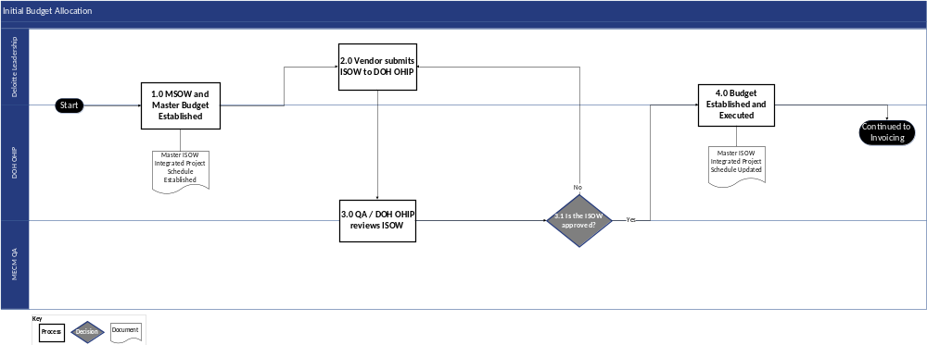
Figure 6-1: Initial Budget Allocation Process Flow Diagram

Initial Budget Allocation Process Flow Narrative
The following table describes each process step illustrated above.
Step # | Process Step | Description | Stakeholder Group(s)
1 | MSOW and Master Budget Established | ███████ Leadership and DOH OHIP establish the MSOW and the Master Budget for each Wave. This also establishes the Master ISOW Integrated Project Schedule (see 4.1 Terms and Definitions). | - ███████ Leadership  - DOH OHIP
2 | Vendor Submits ISOW to DOH OHIP | For each new trigger (e.g., change in scope, budget, schedule, etc.), an ISOW must be developed detailing the scope of services, timeline, staffing model, deliverables, payment schedule, and payment trigger conditions. | - ███████ Leadership
3 | QA / DOH OHIP Reviews ISOW | DOH OHIP reviews the draft ISOW for alignment with DOH OHIP priorities and applicable expectations and regulations. DOH OHIP can provide feedback, in the form of comments and questions, for ███████ to address prior to approval.  The ISOW is then returned to Deloitte Leadership for updates. The QA process may require multiple iterations or working sessions. | - MECM QA  - DOH OHIP
3.1 | Is the ISOW approved? | - If DOH OHIP approves the ISOW without any outstanding comments or questions, proceed to Step #4 Budget Established and Executed  - If the ISOW is not approved, return to Step #2 Vendor Submits ISOW to DOH OHIP to update the ISOW in preparation for another submittal | - MECM QA  - DOH OHIP
4 | Budget Established and Executed | Once the ISOW is approved, ███████ and DOH OHIP establish a mutually accepted budget plan based on the approved ISOW. The Master ISOW Integrated Project Schedule will be updated to reflect change.  Deloitte can then proceed to invoicing, outlined in Section 6.3.2 Invoicing. | - ███████ Leadership  - DOH OHIP
Table 6-1: Initial Budget Allocation Process Narrative

Budget Maintenance
After initial budget allocation, ███████ will monitor and maintain the budget for each ISOW on an ongoing basis. ███████ will maintain an ISOW Invoice Catalog in Excel (a component of the Master ISOW Integrated Project Schedule) representing the status of all ISOW invoices. Additionally, ███████ will leverage the Project Status Report PowerPoint document to report on the project budget, including total contract amount, percent complete of deliverables, project costs (planned vs. actual), and financial change request details, as required by the MSOW.

Invoicing
Each ISOW will be organized by service area, each of which will be categorized as fixed fee or variable fee costs. The fixed fee costs will remain as-is during execution of the project once they are established through the execution of an ISOW. These fixed fee costs will be tracked through invoice and payment tracking of each ISOW. Variable fee costs will require additional tracking and periodic review to assess trends and potential impacts to the project budget as these costs are based on actual progress, which can vary from the initial estimate used to budget for the variable costs.
As part of budget tracking, the ███████ PMO, Business Operations, and MECM QA will conduct regular reviews of the budget and funding availability. During this meeting, the ███████ PMO and MECM QA will discuss upcoming deliverable submissions, subsequent invoicing, the availability of funding for the invoices, and revise budgets and purchase orders, as necessary and as mutually agreed upon between ███████ and DOH OHIP.

Invoicing Process Flow Diagram
The following diagram depicts the invoicing process for the Continuing Medicaid Eligibility Modernization project. The diagram conveys an overview of responsibilities across the ███████ PMO and DOH OHIP.
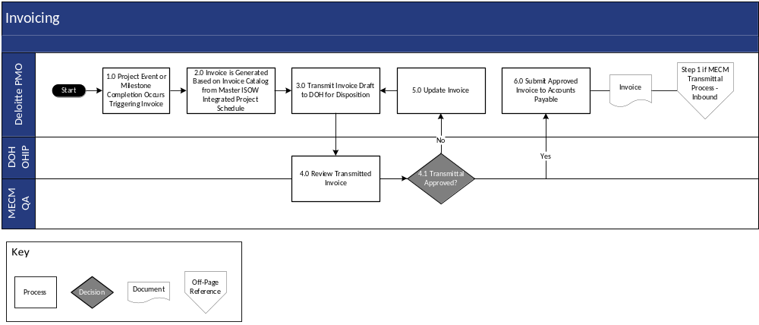
Figure 6-2: Invoicing Process Flow Diagram

Invoicing Process Flow Narrative
The following table describes each step of the process illustrated above.
Step # | Process Step | Description | Stakeholder Group(s)
1 | Project Event or Milestone Completion Occurs Triggering Invoice | When ███████ completes a project event or milestone (based on the Master ISOW Integrated Project Schedule), it will trigger an invoice to be delivered to DOH OHIP (see Appendix C-5 Budget Management Roles & Responsibilities). | - ███████ PMO
2 | Invoice is Generated Based on Invoice Catalog from Master ISOW Integrated Project Schedule | Following DOH OHIP approval, ███████ generates an invoice for the deliverable by leveraging the Claim for Payment (refer to Section 6.5 State Of New York Claim for Payment). | - ███████ PMO
3 | Transmit Invoice Draft to DOH for Disposition | Upon compiling an invoice, the ███████ PMO will transmit the draft invoice with DOH OHIP for review and discussion prior to formally transmitting the invoice for payment. | - ███████ PMO
4 | Review Transmitted Invoice | Upon receipt of the draft invoice, DOH OHIP will review the draft invoice for accuracy and completion. | - MECM QA  - DOH OHIP
4.1 | Transmittal Approved? | DOH OHIP will review draft invoice and add any comments, questions, or edits if necessary.  - If the invoice is approved without any changes, proceed to Step #6 Submit Approved Invoice to Accounts Payable  - If the invoice is not approved and requires further updates, proceed to Step #5 Update Invoice | - MECM QA  - DOH OHIP
5 | Update Invoice | Address DOH OHIP feedback and concerns. Proceed to Step #4 Review Transmitted Invoice. | - ███████ PMO
6 | Submit Approved Invoice to Accounts Payable | ███████ submits the invoice via the Transmittal Process-Inbound process per the Quality Management Plan (refer to Section 7.4.1.1). Upon approval from DOH OHIP via transmittal, ███████ submits the invoice and Claim for Payment via email, as instructed in the OHIP Invoice Submission FAQ (refer to Section 6.6). After the invoice is paid, ███████ updates the Invoice Catalogue to reflect funding drawdowns. | - ███████ PMO
Table 6-2: Invoicing Process Flow Narrative

Budget Reporting
As outlined in the MSOW and subsequent ISOWs, ███████ will include budget updates in the weekly Project Status Report (PSR). It will include the following details:
- Total contract amount
- Percent complete of deliverables
- Project costs (planned vs. actual)
- Financial change request details
- Topline MSOW figure with subsequent breakout of ISOWs

Budget Adjustments
Adjustments may be made to the initial project budget based on mutual agreement between DOH OHIP and ███████ using the contract amendment process. This may be required if additional scope, schedule, or resource needs are identified and agreed upon beyond what is documented within the initial project budget as defined in the MSOW or ISOWs.
When this occurs, ███████ will update the ISOW budget with the newly available project budget, including the identification of new ISOWs, and if applicable, within the Master ISOW Integrated Project Schedule and facilitate a review of the new ISOW budget. The remainder of the budget management process steps will be followed to complete the process.

Tool and Descriptions
Tool | Format | Description
ISOW Invoice Catalog | Excel | Document representing the status of all ISOW invoices. This is a component of the Master ISOW Integrated Project Schedule.
Project Status Report | PowerPoint | Document distributed weekly, including project updates for discussion during regular meetings between DOH OHIP and ███████ teams. The PSR will report on the project budget, including total contract amount, percent complete of deliverables, project costs (planned vs. actual), and financial change request details, as required by the MSOW.
Table 6-3: Tools and Descriptions

State Of New York Claim for Payment Form
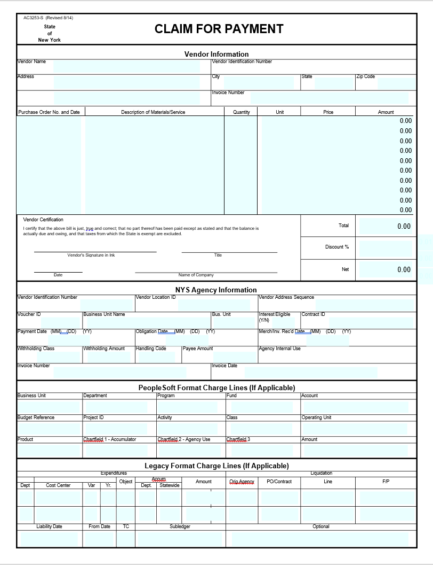
Figure 6-3: State Of New York Claim for Payment Form

OHIP Invoice Submission FAQ
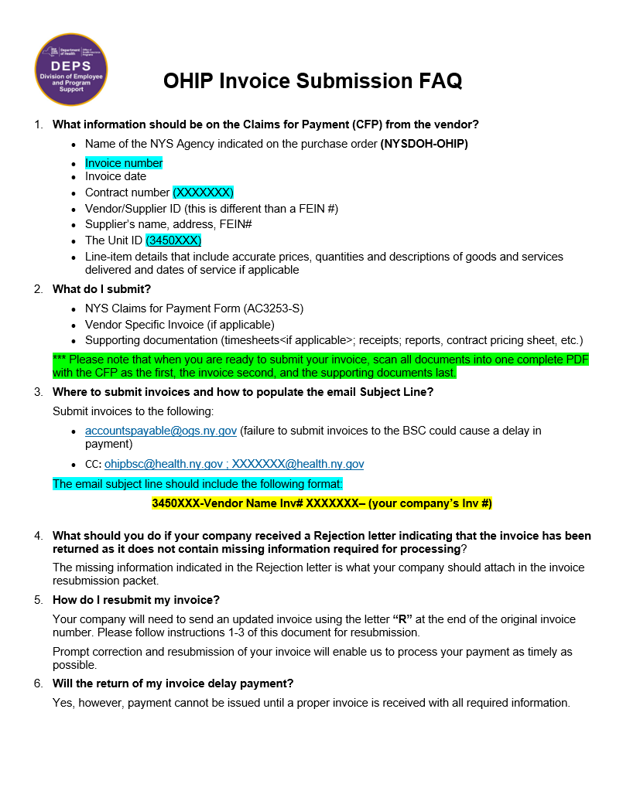
Figure 6-4: OHIP Invoice Submission FAQ

Section 7 – Quality Management Plan

Quality Management Plan

Introduction
The QMP outlines project guidelines and procedures for assessing and confirming the quality of project deliverables, DEDs, and processes. The QMP establishes a shared understanding of quality standards, verification processes, and project controls to be implemented and managed throughout the project lifecycle.

Purpose
The purpose of the QMP is to define the objectives, processes, tools, and roles and responsibilities required to manage quality throughout the project lifecycle. The QMP provides consistency across the project through adherence to project methods, processes, templates, and tools. The scope of the QMP applies to the quality control of deliverables and work products to help confirm they meet project requirements. In addition, the QMP scope applies to the quality assurance processes, standards, tools, and techniques used to create those subsequent work products.
The ███████ team will leverage the QMP to enhance teamwork, organizational efficiency, and commitment to quality at every stage of the project. An example of the QMP being utilized is within the SDLC Roles and Responsibilities. To support and promote quality in every stage of the project, ███████ includes in Appendix C-1 SDLC Roles and Responsibilities and an accompanying RACI matrix that outlines stakeholder group(s) involved in quality assurance activities.
The objectives of this QMP are to:
- Define the approach to effectively use project processes, checklists, style guides, and tools to support the project team in delivering quality throughout the project
- Define the approach to verify that deliverables are meeting project standards and quality expectations to match the needs of DOH OHIP
- Define what additional groups outside the core project team will be supporting the project to help achieve these quality objectives
- Establish processes for continuous improvement, which draws on lessons learned throughout the life cycle of the project to continue to drive the highest project standards and quality expectations

Quality Assurance Approach
The Quality Assurance Approach section of the QMP provides detail on the internal quality review process and the escalation process. It also summarizes how lessons learned are incorporated into future quality planning. This quality management document is focused on deliverables, associated documentation, and other project work products. Quality management approaches associated with test management activities are supported by the Test Management Plan (DEL-09).
███████ will designate a QA/QC Lead to collaborate with the QA/QC counterpart from the DOS PMO to plan, manage, and monitor quality processes across the ███████ team. The QA/QC Lead will help confirm that project-defined processes, cadences, and expectations around quality are implemented and followed throughout the duration of the project. As part of their role, the QA/QC Lead will oversee the rollout and implementation of key process-defining documents, such as the PMP, Test Management Plan, and ISD. In addition, the QA/QC Lead will leverage the SDLC RACI to define and hold accountable stakeholder group(s) that are also involved in QA tasks throughout the SDLC phases. The QA/QC Lead and relevant stakeholders will leverage processes, tools, and standards referenced in the QMP to drive continuous quality improvement. Additional roles can be found in Appendix C-6 Quality Management Plan Roles and Responsibilities.

Implementing the Quality Management Plan
Successful implementation of the QMP is the shared responsibility of the entire project team. Every member of the project team is responsible for following the quality standards, processes, and requirements identified in this QMP. It is the responsibility of the Quality Assurance stakeholder group to identify and implement required revisions to the project’s QMP to keep it current and relevant.
Additionally, the reviewers assigned at each deliverable submission, or resubmission, review the revised document. The QMP will be maintained on and uploaded to the DOH SharePoint along with other DOH OHIP-approved deliverables.

Quality Management to Meet State and Federal Regulations
Successful implementation of the QMP also requires that the entire project team meet State and Federal regulations. The NextGen based solution, implemented as part of MECM, supports DOH OHIP’s need to satisfy the requirements of the Affordable Care Act (ACA) and the Centers for Medicare and Medicaid Services (CMS) 7 Standards and Conditions including Medicaid Information Technology Architecture (MITA) and federal security compliance requirements.
The NextGen solution is an Enterprise Platform, built on a flexible and modular technical architecture, and is based upon open standards and Service Oriented Architecture (SOA) leading practices as well as the MITA 3.0 framework.
As part of ███████’s effort to align to MITA 3.0, which reflects new and recently updated legislation, including: Health Information Technology for Economic and Clinical Health Act (HITECH), Children’s Health Insurance Program Reauthorization Act (CHIPRA), Affordable Care Act (ACA), and Health Insurance Portability and Accountability Act (HIPAA), the ███████ team performs the following:
- Provide technical resources with knowledge of CMS’s MITA 3.0 standards to support the technical services within this ISOW
- Review the Enterprise and Solution Architecture deliverables for alignment with CMS MITA 3.0 standards
- Demonstrate to DOH OHIP the alignment of the MECM Enterprise and Solution Architecture with CMS MITA 3.0 standards
- Address CMS requirements as part of the System a Plan (SSP)
- Adhere to CMS Outcome-Based Certification (OBC) requirements
- Confirm data quality meets Transformed Medicaid Statistical Information System (T-MSIS) standards

Quality Assurance Reviews
Quality assurance reviews will be performed to evaluate the major project processes. These reviews may include both project management processes (e.g., risk management, deliverable management) and technology processes (e.g., requirements management, test case development). Relevant stakeholder groups will perform quality assurance reviews to confirm that the project team follows the processes and standards. These reviews will focus on addressing whether the documented processes are being followed, are working, and are efficient. ███████ and DOH OHIP align early on as part of this review process. As quality assurance reviews are performed, the project team will evaluate the results and determine what, if any, actions should be taken. Actions might include additional training, process enforcement, or process refinements.
███████ places a strong emphasis on continuous improvement through regular reviews and lessons learned sessions. These sessions would be conducted at the conclusion of each project phase, serving as a core element of our iterative and collaborative process. These reviews may take the form of internal assessments conducted by our project team or external sessions involving stakeholder participation.
During these sessions, ███████ will identify areas for improvement and acknowledge successes – activities to sustain. Lessons learned encompass a broad spectrum of knowledge, ranging from process efficiencies and leading practices to specific challenges and solutions. This comprehensive approach promotes a holistic view of the project’s journey. The accrued knowledge and insights are documented and integrated into our project management tool, the ALM tool. This step is instrumental in preserving the institutional memory of the projects and enables easy retrieval and reference in the future. Each new phase or iteration/bundle begins with a review of these lessons, so past experiences inform our future actions. This iterative approach confirms that we actively incorporate our insights into our processes, leading to increased efficiency, effectiveness, and ultimately, a higher level of quality and project satisfaction.

Project Quality Standards
The purpose of this section is to define the project’s plans for performing quality assurance reviews. Quality standards are the basis for measuring quality on a project, and they help the team determine whether project deliverables meet pre-defined criteria regarding content presentation.
Quality standards can be defined by different sources, including:
- Stakeholder Defined Standards – Approved standards specific to DOH OHIP and/or the project
- Industry Standards – Globally accepted and applied standards in a particular domain
- ███████ Standards – Standards developed based on relevant experience and applicable industry standards
Although many standards apply across most technology projects, it is important to define standards specific to the Continuing Medicaid Eligibility Modernization project to meet project-specific requirements. Standards will continue to be added, removed, and redefined throughout the course of the project.
███████’s quality framework is built around two core sets of standards, which are listed below.
- Project Management Institute’s (PMI) Project Management Body of Knowledge (PMBOK®) – PMI is the world’s leading not-for-profit membership association for the project management profession and provides global project management standards, including the PMBOK® guide. PMBOK focuses on three primary components of quality management: overall quality philosophy, quality assurance, and quality control. ███████’s project-level PMP draws upon the core tenets of these components
- ███████ Enterprise Value Delivery for Systems Integration (EVD for SI) – Based on the Software Engineering Institute’s (SEI) Capability Maturity Model Integration (CMMI®) and PMBOK®, the EVD for SI method supports all activities that are executed during the project life cycle, from project initiation and planning to deployment of the final product and project closure. The EVD for SI is compliant to CMMI Level 3 process maturity expectations, which a focus on being proactive, rather than reactive. ███████’s SDLC Methodology (refer to Section 2) is based on and adherences to standards outlined in the EVD for SI
All quality management standards outlined in the QMP and implemented on the Continuing Medicaid Eligibility Modernization project will be mutually agreed upon by ███████ and DOH OHIP through the review and approval of this document. The project will use quality checklists and review cycles to adhere to contract requirements; industry standard tools to drive consistency and uniformity across the project; and thorough cycles of quality planning, assurance, monitoring, and support to get feedback that promotes continuous improvement.

Standard Verification
Defined standards in documentation will be maintained on the DOH SharePoint site; any updates to the documentation will be tracked as decisions to update these documentation standards. Once the initial standards for the project are defined, an approach will be specified to measure each standard and verify that it is met. The project will use the following definitions for standard verification:
Term | Description
Standard | The documented source of guidelines, criteria, or specifications established to provide a common framework for executing and assessing project-related activities
Standard Reference | The source of the standard, including a reference number, if applicable
Wave | The phase of the project that the standard applies to; some standards may apply to all phases
Process/Product | Identifies if the standard is a process standard (e.g., Integrated Change Control Process) or a product standard (e.g., Requirements Management Plan)
Product/Process Name | The name of the product or process
Verification Method | The method that will be used to verify the standard
Verification Checklist | The name of the checklist that will be used in the verification process, if applicable
When Verification Performed | The timing of the verification (e.g., weekly, when a document is complete)
Information Required (Tracking Mechanism) | The information that is required to verify the standard, and the way the information is tracked (e.g., the ALM tool/the requirements management tool)
Metric to Track | The metric that will be tracked for the standard
Standard/Verification Owner | The person responsible for ensuring that the standard is verified
Table 7-1: Standard Verification
The project will use the following verification methods, based on ███████’s internal leading practices:
- Inspection – An independent inspection or measurement of a product or work process. In software, for example, quality control personnel can perform (or observe others performing) tests on system functionality. Inspections and measurements are generally recorded to provide an audit trail
- Document Review – A document review that applies project quality standards. A document review can and should be performed at all stages of document development, so that standards can be verified early in the document development process. Document reviews are performed at all levels of the project organization, and the required reviewers will be defined for each deliverable
The different types of document reviews are listed in the table below.
Type | Description | Timeframe
Pre-Collaboration Review
███████ Draft Review | ███████ conducts internal QA/QC review(s) of the document draft ahead of DOH OHIP collaboration. | Iterative process until document is ready for DOH OHIP collaboration
Initial Draft Review Prior to Collaboration | ███████ submits the initial draft document for DOH OHIP review and feedback.  Note: This typically applies to FDDs and ICDs. | As needed for the creation of document
Pre-Collaboration ███████ QA/QC | ███████ reviews the deliverable against the applicable checklist(s) to prepare for collaboration. | Immediately prior to the initiation of collaboration
Collaboration with DOH OHIP | ███████ updates the document to incorporate any feedback or input received from DOH OHIP to make the document ready for review by DOH OHIP or other designated stakeholders.  The collaboration phase may start with an informal walkthrough (optional and conducted as needed). | All deliverables require DOH OHIP collaboration
Informal Walkthrough | If requested and agreed upon by ███████ and DOH OHIP stakeholders, the collaboration phase starts with an informal walkthrough (optional) as requested to facilitate document content alignment.  This review is conducted by the deliverable owner or designee. | The timing of informal walkthroughs is mutually agreed by ███████ and DOH OHIP stakeholders
Post Collaboration Review
Formal QA/QC Review | ███████ creates a clean copy of the document after collaboration is completed and conducts QA/QC review ahead of drafting transmittal for final document approval. | After collaboration is completed but prior to initiating transmittal
Submit Transmittal for DOH OHIP Review | ███████ confirms the document is ready for transmittal.  The final review and approval of documents takes place via the transmittal process. | Once all comments and feedback are addressed and DOH OHIP consider the review of the document complete
DOH OHIP Final Review During Transmittal | The DOS PMO completes a QA/QC review using established quality checklists and provides a disposition recommendation to DOH OHIP. | As agreed to by DOH OHIP/███████ and specified in the transmittal. This is typically 5 business days
Table 7-2: Document Review Types
- Code Review – A review of the system code that applies project quality standards. Code reviews occur as part of unit testing and are done in accordance with project approved Unit Test Checklists. The details on how when code reviews occur will be defined in the Test Management Plan (DEL-09)
- Process Review – A review of a project process that applies project quality standards. Processes, like products (e.g., documents and code), need to be controlled. Processes on the project will be required to meet defined standards

Standard Verification Checklists
A verification checklist is a common and effective way to control document quality. Checklists are used as part of any of the verification methods and are incorporated from the very beginning of product development (document or code) or a controlled process.
The product author/process owner and the relevant stakeholders discuss what standards apply to each product or process at the beginning of the planning stage for each product/process.
The verification checklists for DEDs/Deliverables can be found in Appendix E: DED/Deliverable Quality Checklists.

Quality Assurance Reporting
The output of quality assurance reviews will be a set of suggested actions. Once these actions are identified, the project team will discuss at the project status meeting and mutually determine which, if any, actions will be undertaken. Actions that are approved for implementation will be documented in the ALM tool (Risk, Action Item, Issue, Decision (RAID) Log Dashboard) and tracked to completion according to the Project Controls Plan (refer to Section 9).

Contract Compliance
The ███████ team includes a dedicated Contract Manager who will assume the responsibility of managing and monitoring our contractual obligations. This role is critical in confirming that ███████ upholds commitments, maintain compliance, and foster a collaborative and transparent relationship. The Contract Manager will reference the M&O Run Book and track Service Level Agreements (SLA’s) as part of contract compliance.
To maintain open and ongoing communication, ███████ will institute a structured meeting with the Change Advisory Board on a mutually agreed upon cadence. These meetings are designed to provide a platform for robust and transparent discussions surrounding our contractual obligations. By adhering to this proactive governance structure, ███████ aims to address any emerging issues, align on project milestones, and explore opportunities for continuous improvement.

Evaluation of Standards
When completing quality assurance and quality control, the ███████ team may use several different industry standards to measure standards:
Method | Description
Adherence to Requirements | Assess the extent to which project activities, processes, and deliverables comply with specified requirements and standards
Quality of Deliverables | Evaluate the quality of project deliverables and work products by measuring the occurrence of defects, errors, or deviations from established standards
Timeline and Schedule Adherence | Measure how well the project adheres to the established schedule and timeline outlined in the baselined project plan
Stakeholder Satisfaction | Collect feedback from project stakeholders to gauge their satisfaction with project outcomes, communication, and agreed-upon standards
Table 7-3: Methods of Measuring Standards

Continuous Process Improvement
███████ manages continuous process improvement and quality improvement processes in projects through a Quality Management Framework that includes practices to manage project delivery standards, monitor results, and identify improvement actions. Standard metrics for measuring project delivery on time and on budget will be included in regular reviews with DOH OHIP. ███████ has a process for delivery standardization, which allows for the application of the latest standards and leading practices. Furthermore, ███████ identifies opportunities for increased standardization through internal quality reviews. With these tools, along with lessons learned sessions at the end of each phase, ███████ will provide continuous learning in process improvement and skills enhancement to maintain standards and quality for the project.
As part of continuous process improvement, ███████ will conduct a lesson learned session with DOH OHIP at the end of each phase of the SDLC. ███████ will present and be ready to discuss lessons learned from the previous phase and will drive to confirm that those lessons learned are applied in the next phase as well as next wave, as applicable.

Quality Control Plan
Quality control involves monitoring project-specific results for quality, and identifying corrective, preventive, or improvement actions when results are unsatisfactory or do not meet expected standards and requirements. This section of the QMP identifies the project quality standards, describes the verification approach and methods, supplies the project quality methods, and provides the process for addressing quality issues.
Note that ███████’s overall testing strategy, approach to performing solution testing, identifying and managing defects, and providing UAT support is discussed in detail in the Test Management Plan (DEL-09).

Transmittal Management
Transmittal management is the set of activities the project uses to review and obtain appropriate levels of DOH OHIP approval for project deliverables and work products subject to the transmittal process. ███████ and DOH OHIP will transfer or “transmit” work products and deliverables, and the artifacts associated with the deliverables according to the transmittal process mentioned below. The DOS PMO oversees the final review and disposition via email transmittal.

Transmittal Process – Inbound Flow Diagram
The following diagram depicts the inbound transmittal flow for the Continuing Medicaid Eligibility Modernization project.
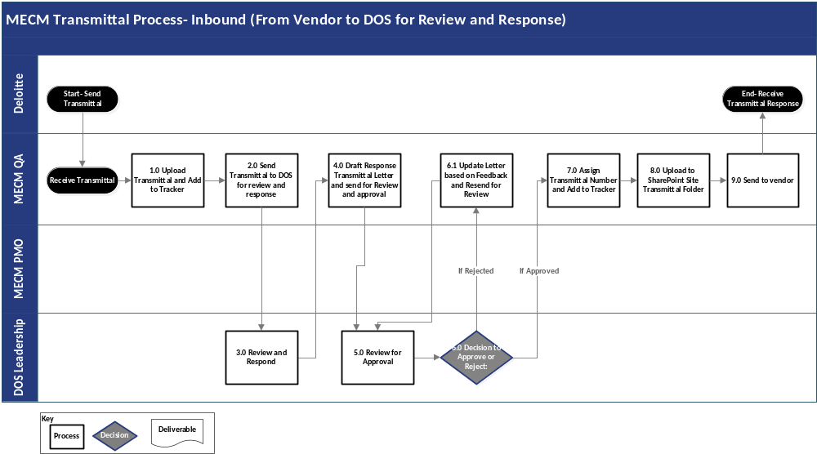
Figure 7-11: Transmittal Process - Inbound

Transmittal Process – Inbound Process Flow Narrative
The following table describes each process step illustrated above.
Step # | Process Step | Description | Stakeholder Group(s)
1 | Upload Transmittal and Add to Tracker | Upon receipt of a transmittal, MECM QA will upload the transmittal to the Transmittal Repository, which is a folder used for storing and dissemination transmittals between ███████ and DOH OHIP and is located on the DOH SharePoint. ███████ will add the transmittal to the Transmittal Tracker Spreadsheet, which is an Excel file that tracks details of transmittals, including time and date, between DOH OHIP and ███████. | - MECM QA
2 | Send Transmittal to DOS for Review and Response | After the document has been uploaded to the Transmittal Repository and added to the Transmittal Tracker Spreadsheet, MECM QA will notify DOH OHIP Leadership to review and respond to the transmittal. | - MECM QA
3 | Review and Respond | DOH OHIP Leadership will initiate the review process and begin QA, in accordance with the timelines identified in the Deliverable Management Plan (refer to Section 5) and will develop/gather feedback to be included in the response to MECM QA. | - DOH OHIP Leadership
4 | Draft Response Transmittal Letter and Send for Review and Approval | Using the input from DOH OHIP Leadership, MECM QA will draft a response letter to ███████. The letter will include relevant QA feedback and suggestions from DOH OHIP Leadership and other DOH OHIP stakeholders involved in the QA. | - MECM QA
5 | Review for Approval | DOH OHIP Leadership will review and approve the draft response letter before MECM QA sends the draft response letter to ███████. | - DOH OHIP Leadership
6 | Decision to Approve or Reject | DOH OHIP Leadership will either approve or reject the draft response letter.  - If DOH OHIP Leadership rejects the letter, proceed to Step #6.1 Update Letter based on Feedback and Resend for Review  - If DOS Leadership approves the letter, proceed to Step #7 Assign Transmittal Number and Add to Tracker | - DOH OHIP Leadership
6.1 | Update Letter Based on Feedback and Resend for Review | If DOH OHIP Leadership rejects the letter, MECM QA will update the draft response letter to incorporate the feedback provided by DOH OHIP Leadership.  Once the edits are completed, proceed to Step #5 Review for Approval. | - MECM QA
7 | Assign Transmittal Number and Add to Tracker | If DOH OHIP Leadership approves the letter, MECM QA will assign the draft response letter a transmittal number and add it to the Transmittal Tracker Spreadsheet. | - MECM QA
8 | Upload to SharePoint Site Transmittal Folder | MECM QA will then upload the completed transmittal to the Transmittal Repository. | - MECM QA
9 | Send to Vendor | MECM QA will send the transmittal to ███████ via email link to the Transmittal Repository. | - MECM QA
Table 7-4: MECM Transmittal Process - Inbound Flow Narrative

Transmittal Process – Outbound Flow Diagram
The following diagram depicts the outbound transmittal flow for the Continuing Medicaid Eligibility Modernization project.
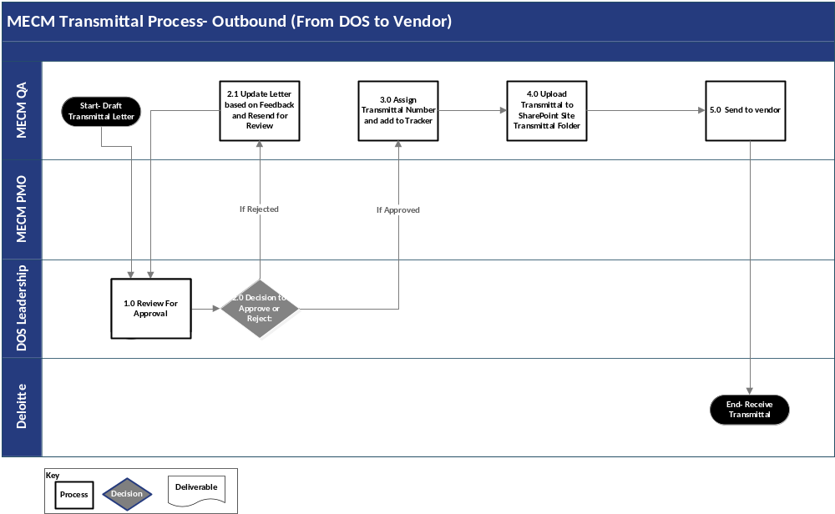
Figure 7-222: Transmittal Process - Outbound

Transmittal Process – Outbound Process Flow Narrative
The following table describes each process step illustrated above.
Step # | Process Step | Description | Stakeholder Group(s)
1 | Review For Approval | DOH OHIP Leadership will review the transmittal letter developed by MECM QA. Once the review has been completed, DOH OHIP Leadership will either approve or reject the letter. | - DOH OHIP Leadership
2 | Decision to Approve or Reject | DOH OHIP Leadership will approve or reject the draft response letter as written.  - If DOH OHIP Leadership rejects the letter, proceed to Step #2.1 Update Letter based on Feedback and Resend for Review  - If DOH OHIP Leadership approves the letter, proceed to Step #3 Assign Transmittal Number and add to Tracker | - DOS Leadership
2.1 | Updated Letter Based on Feedback and Resend for Review | MECM QA will update the letter based on feedback provided by DOH OHIP Leadership. Once the edits are completed, proceed to Step #2 Decision to Approve or Reject. | - MECM QA
3 | Assign Transmittal Number and Add to Tracker | After the letter has been approved, MECM QA will assign the transmittal letter a transmittal number and add the transmittal letter to the Transmittal Tracker Spreadsheet. | - MECM QA
4 | Upload to SharePoint Site Transmittal Folder | MECM QA will then upload the completed transmittal letter to the Transmittal Repository on the DOH SharePoint site. | - MECM QA
5 | Send to Vendor | MECM QA will then send the completed transmittal to the vendor. | - MECM QA
Table 7-5: MECM Transmittal Process - Outbound Flow Narrative

Components of DED/Deliverable Quality Reviews
Table 7-6 lists key elements that a reviewer verifies when conducting a review of a given deliverable/DED. These checks must be verified in addition to all the items listed in the Deliverable Checklist outlined in Appendix E: DED/Deliverable Quality Checklists of this document.
Action | Description
Verify content aligns with contract | Verify that the content of a deliverable satisfies the requirements in the MSO) and the ISOW
Verify content aligns with DED | Verify that the content of a deliverable aligns with the respective DED
Verify content complete | Verify the completeness of the deliverable content
Verify project standards | Verify that a deliverable meets project standards (for example, using the right template), as well as any deliverable-specific or custom requirements. Additionally, verifying that it meets the following project standards for:  - Professional appearance  - Appropriate terms for reader(s)  - Clarity and consistency  - Organization  - Readability  - Spelling, grammar, punctuation, and pagination
Table 7-6: Deliverable Review Process Components

Approval Process
The DOS PMO oversees the final review and disposition of DEDs/Deliverables via the transmittal process. ███████ submits a formal transmittal of the finalized deliverable. Upon review, the DOS PMO provides approval to ███████ via the transmittal process. If the DED/Deliverable is approved, it is posted to the DOH SharePoint site.
The ███████ PMO emails the transmittal for a given DED/Deliverable to DOS PMO, then posts the document(s) in the DOH SharePoint.
The review period to determine the disposition of the transmittal begins the next business day after the transmittal submission date. The review period for the transmittal is indicated within the transmittal email. During the designated review period, the DOS PMO reviews and documents feedback within a comments matrix. The DOS PMO coordinates, manages, and monitors the review as well as acts as a central body for consolidating comments from DOH OHIP staff.
The DOS PMO oversees the final review and approval, or notice of rejection, via transmittal. The transmittal consists of the following statuses for final decision/disposition of a given DED/Deliverable:
- Approved
- Approved with Comments
- Rejected

Approved
If the deliverable is Approved, no further updates to the deliverable are required by ███████ or DOH OHIP. The DOS PMO stores the approved deliverable documentation within the designated location in DOH SharePoint.

Approved with Comments
If the Deliverable/DED is Approved with Comments, ███████ makes updates to the deliverable and resubmits it to the DOS PMO within 5 business days. Upon resubmission, the DOS PMO reviews the updates and confirms whether all of the comments have been sufficiently addressed. If so, the DOS PMO responds with approval via email (outside of the transmittal process).
Note: This status is not applicable for Invoice transmittals.

Rejected
If the deliverable is Rejected, the DOS PMO and ███████ work together to determine the appropriate timeline for ███████ to modify/update the deliverable to meet acceptance criteria. Deliverable rejections are accompanied by a comments matrix identifying specific components of the deliverable that do not confirm with the deliverable acceptance criteria.
The cycle will continue until the DOS PMO provides an approval transmittal for the deliverable. If there are multiple cycles, it may be necessary to conduct a walkthrough of the deliverable to gain clarity on expectations for the deliverable and walk stakeholders through changes to gain consensus for resolution. Once consensus is reached, the transmittal process will be reinitiated.

Quality Control Tools
The table below provides a summary of the tools that are utilized for the quality management process:
# | Tool | Value
1 | Microsoft Project | Used to build project Work Plan which provides the project schedule and timeline for DED/Deliverable reviews as well as the schedule and timeline for planned QA and QC activities.
2 | The ALM tool | The ALM tool streamlines quality control through its versatile workflow management and tracking capabilities. The ALM tool enables the Continuing Medicaid Eligibility Modernization project to promote quality standards throughout the project life cycle. In addition, the ALM tool provides the ability to create quality-related reports and dashboards including, but not limited to, action item resolution, risk and issue reporting, and defect resolution.
3 | Project Checklists | Checklists provides guidelines on how documents, reports, presentations, work products, DEDs/Deliverables, and other project-related materials should be formatted to drive, consistency in appearance and structure. In addition, checklists provide direction on version control and document management. During quality control reviews, checklists serve as a reference to check if products conform to the established standards. These guides will evolve over time based on lessons learned from previous phases.
4 | MECM Templates Repository | The templates repository will streamline the implementation of the quality plan by offering standardized, efficient, and compliance document structures. It enforces adherence to quality standards, helps teams work more effectively, and helps confirm that documentation meets or exceeds the established quality criteria. The templates repository will be based on templates, designs, and styles provided by DOH OHIP.
5 | Confidential Information Management Plan (CIMP) | The Continuing Medicaid Eligibility Modernization CIMP defines a method for effectively mitigating confidentiality risks pertaining to the project. It outlines leading practices and processes to prevent, detect, and respond to potential confidentiality incidents. It defines technical, administrative and physical safeguards for the project to protect stakeholder data throughout the SDLC.
Table 7-7: Quality Control Tools

Quality Support Plan
In addition to the quality assurance and quality control activities planned for the project, additional project reviews will occur across the delivery timeline. These reviews will include specific support personnel that will aid in the review of these projects. These individuals will have specialist support or outside expertise to assist in the refinement of the quality reviews. These activities include:
- Engagement Review Program
- Delivery Excellence (DE) Program
- Guest Star Program
- External Training / Tool Support

Engagement Review Program
███████ will perform internal quality project reviews, which are formal, objective reviews to evaluate the status of the project in six categories:
- Project Leadership
- Solution and Deliverables
- Estimation, Planning, and Timeline
- Project Staffing
- Monitor & Control
- Approach
These reviews and this process are standard across all ███████ projects. Additional details about each of the six categories are included in the figure below.
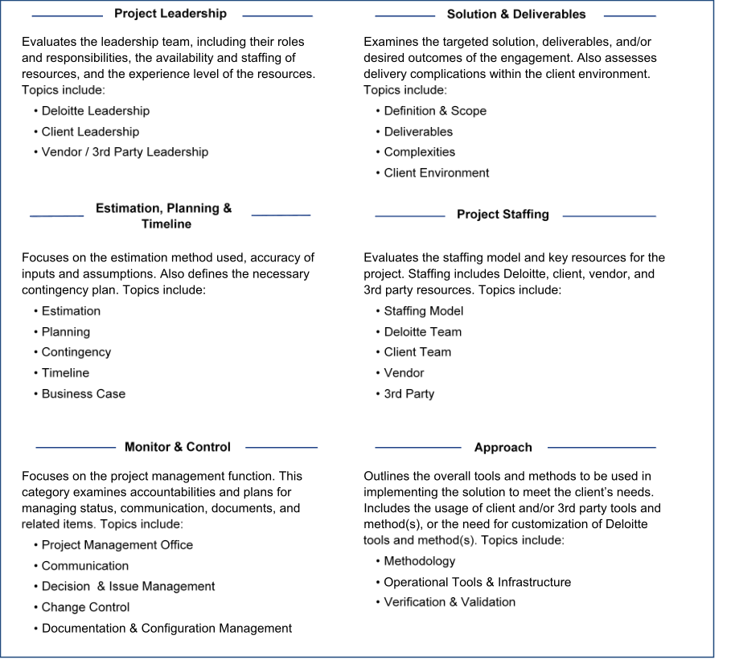
Figure 7-3: Six Categories of Project Review

Delivery Excellence Program
███████ project leadership will engage on a recurring agreed upon cadence, with other ███████ leaders for insights related to specific subject matter. Given the complexity and multi-faceted nature of the Continuing Medicaid Eligibility Modernization project, ███████ project leadership will look to solicit insights and reviews from subject matter advisors (SMAs) related to specific areas, including design, development, testing, and Go-Live activities of the project.

Guest Star Program
The Continuing Medicaid Eligibility Modernization project will leverage guest stars or specialists periodically to augment the project team. These highly skilled resources provide deep industry knowledge about a specific topic or technology and will be available to the project for short durations, or periodically based upon identified needs. This section describes the plan for leveraging specialists on this project.
The guest stars support plan for the project is defined in the table below.
# | Specialist Area | Frequency | Objectives
1 | Policy / Functional Advisors | During requirements and design | Provide Subject Matter Experts (SMEs) to assist in requirements validation and design validation sessions
2 | Technical / Infrastructure | During design | Provide SMEs to assist in technical requirements validation and design validation sessions
3 | Implementation / Go- Live | During planning for Go-Live | Provide SMEs to help with implementation and Go-Live planning
Table 7-8: Guest Star Support Plan
Guest stars will be used in other areas of the project and are brought on to assist the ███████ team in recognizing national impacts and to assist with project execution.

External Training and Tools Support
Quality support includes quality training for project staff and the implementation of quality tools to support Section 7.4 Quality Control Plan and Section 7.3 Quality Assurance Approach. This section describes the approach to quality training and how project tools are used for quality management.
The following training sessions and learning opportunities will be provided as needed for the team to train staff on project-specific quality processes:
- Industry Training – Although not specifically about quality, the project team may be required to take industry training courses that are relevant to the Continuing Medicaid Eligibility Modernization project, such as the Eligibility and Enrolment (EE) Bootcamp. The EE Bootcamp is a 4-day program to equip ███████ practitioners with deep foundational knowledge of Health and Human Services programs, such as various Public Assistance programs, their features, benefits, and funding sources to deliver a quality complex EE solution. Trainings, such as the EE Bootcamp and others, help improve quality by giving the staff a greater understanding of the subject matter
- ███████ EVD for SI Method –Technology consultants at ███████ are up-to-speed on the latest version of ███████’s EVD for SI. Many of the standards specified in the EVD for SI will be utilized on the Continuing Medicaid Eligibility Modernization project, specifically in the development of the SDLC Methodology. EVD is ███████’s framework for consistently delivering value on business transformation and technology implementation engagement. EVD for SI encompasses leading practices in project management, change management, requirements and design, development, testing, deployment, and support and is aligned with CMMI and PMBOK
- Project Management Professional (PMP) Certification – Several of the ███████ staff on the Continuing Medicaid Eligibility Modernization project are PMP-certified with PMI. The PMP certified professionals are adept at the ever-changing requirements of project management including quality management

DED Checklist
The DED checklist is used to verify the quality of the DED for the project. The DED checklist is an evolving document and continuously refined. Any expected deviations from the DED checklist or standards will be documented in the transmittal letter.
The latest version of the DED checklist can be found in Appendix E.

Deliverable Quality Checklist
The Deliverable checklist is used to verify the quality of the deliverables for the Continuing Medicaid Eligibility Modernization project. The Deliverable checklist is an evolving document and continuously refined. Any expected deviations from the Deliverable checklist or standards will be documented in the transmittal letter.
The latest version of the Deliverable checklist can be found in Appendix E.

References
The Quality Management Plan has project-wide implications and applicability. As such, it relies on several other sections of the PMP and Deliverables. The following section outlines the various PMP sections and deliverables referenced in the QMP.
    - SDLC Methodology
The SDLC Methodology (refer to Section 2) defines the SDLC approach to be used for the implementation of the MECM solution. It defines how the Continuing Medicaid Eligibility Modernization project will operate throughout the life cycle across each of its phases including the scope, inputs, outputs, roles and responsibilities. This deliverable includes an SDLC RACI Matrix, which defines stakeholder group(s) involved in QA activities across the life cycle of the project.
    - Deliverable Management Plan
The Deliverable Management Plan (refer to Section 5) describes the processes, tools, and expectations to develop and manage project deliverables through DOH OHIP acceptance. For the purposes of the QMP, it defines review cadences for DEDs/Deliverables to which ███████ and DOS Leadership adhere.
    - Project Controls Plan
The Project Controls Plan (refer to Section 9) defines the overall strategy and methodology used to manage risks, issues, action items, and decisions throughout the course of the Continuing Medicaid Eligibility Modernization project. One output of quality assurance reviews will be a set of suggested actions. Once these actions are identified, the project team will discuss at the project status meeting and mutually determine which, if any, actions will be undertaken. Actions that are approved for implementation will be documented in the ALM tool and tracked to completion according to the Project Controls Plan (refer to Section 9).
    - Test Management Plan
The Test Management Plan (DEL-09) outlines the approach that will be employed to test the MECM system and evaluate the results of that testing. Quality management approaches associated with test management activities will be supported by the Test Management Plan. ███████’s approach to identifying and managing defects, UAT support, and overall testing strategy is discussed in detail in this deliverable.
    - Maintenance and Operations Run Book
The M&O Run Book (DEL-33) describes standard operating procedures for batches, interfaces, notices, deployments, and data activities (e.g., data fixes, data extracts). In addition, it lists production defect and incident management processes, security management process, and the approach to performing technical maintenance. This deliverable will outline how ███████ will track, compile source data, and report findings to DOH OHIP on SLA compliance.

Section 8 – Resource Management Plan

Resource Management Plan

Introduction
The Resource Management Plan identifies the staffing requirements and processes per the Continuing Medicaid Eligibility Modernization ISOWs. The Resource Management Plan outlines the procedures and processes to onboard, offboard, and transition resources as needed throughout the project.

Purpose
The Resource Management Plan identifies the preliminary and ongoing staffing and monitoring processes, including future staff needs and associated decisions for release or renewal of personnel. The objective of this plan is to provide a guideline for the below items:
- Describe the process for staffing considerations, including initial and ongoing project resource needs, resource levels and assignments, number of key and non-key personnel, and information on how personnel will be deployed throughout the project
- Describe the staff management process to onboard, offboard, train, and transition staff members on the project
- Provide an overview of the initial staff planning and roster maintenance processes

Organizational Structure
The Project Team has developed an organizational structure for the team. While changes in project staffing may occur over the project life cycle, the organizational structure will remain constant. The primary components of the organizational structure are:
- Project Executive: Leads the Continuing Medicaid Eligibility Modernization project with input from other members of project leadership who have relevant expertise
- Project Director: Oversees all project tracks, which include Implementation and Change Management, Technical, PMO, Test, and Functional
- Managers: Managers will be responsible for their respective project track deliverables and accompanying tasks. Managers will lead staff in support of the execution of work products
- Staff: Staff will be responsible for performing day-to-day tasks and activities to support their managers in the delivery of their respective tracks

Resource/Staff Management Approach
The following section outlines how ███████ will initiate staffing and manage resources throughout the project.

Staffing Process
Effective resource management requires a process to identify and appropriately fill evolving staffing needs. This section defines the approach.

Staffing Process Flow Diagram
The diagram below outlines the staffing process.
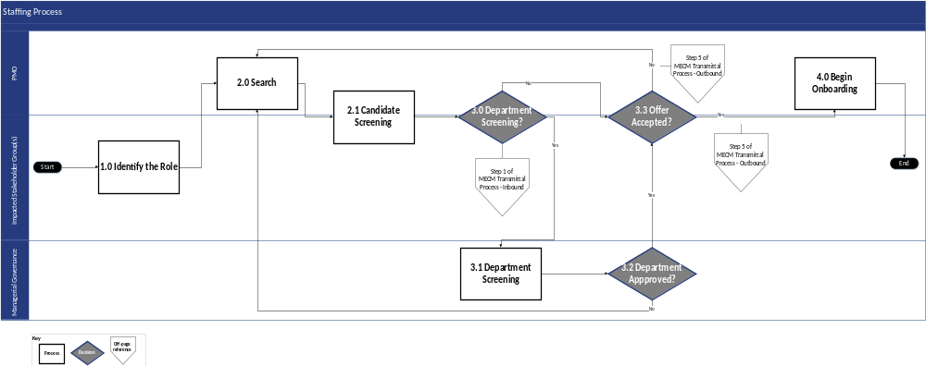

Figure 8-1: Staffing Process Flow Diagram

Staffing Process Flow Narrative
The steps identified below document this process and the responsible stakeholder group(s), as defined by DOH OHIP.
Step # | Process | Description | Stakeholder  Group(s)
1 | Identify the Role | Project leads identify the need for the role. Prior to initiating a resource search, project leads must clearly define the responsibilities of that role. | - Impacted Stakeholder Group(s)
2 | Search | The ███████ PMO leads the search to find appropriate candidates. The ███████ PMO looks across the national ███████ staff resource pool with a focus and emphasis on local State of New York resources. | - ███████ PMO
2.1 | Candidate Screening | The ███████ PMO and the track leads conduct interviews (in-person or virtual) for the candidates identified in Step #2 Search. | - ███████ PMO  - Impacted Stakeholder Group(s)
3 | Department Screening? | - For key personnel and subcontractors, DOH OHIP must screen candidates. This is outlined in Step #3.1 Department Screening. ███████ will submit the key personnel through the Transmittal Process-Inbound Flow defined in Section 7.4.1. The DOS PMO will engage in candidate credentialing as part of the OHIP screening of candidate  - For non-key personnel, DOH OHIP has the option to screen or review the resume, but if it is determined that it is not necessary, the Deloitte PMO and Impacted Stakeholder Group(s) can make the candidate an offer, which is outlined in Step #3.3 Offer Accepted?. | - ███████ PMO  - DOS PMO  - Impacted Stakeholder Group(s)
3.1 | Department Screening | For key personnel and subcontractors, DOH OHIP Managerial Governance must review the candidate’s resume and assess the candidate’s fit for the role. In addition, candidates may be subject to credentialing and interviews by DOH OHIP. | - Managerial Governance
3.2 | Department Approved? | - If DOH OHIP Managerial Governance approves the key personnel candidate or subcontractor, proceed to Step #3.3 Offer Accepted?. DOH OHIP Managerial Governance will send the transmittal based on the Transmittal Process-Outbound Flow  - If DOH OHIP Managerial Governance does not approve the key personnel or subcontractor candidate, return to Step #2 Search. DOH OHIP Managerial Governance will send the transmittal based on the Transmittal Process-Outbound Flow defined in Section 7.4.1 | - Managerial Governance
3.3 | Offer Accepted? | - If the selected individual, whether key personnel and non-key personnel, accepts the offer, proceed to Step #4 Begin Onboarding  - If the selected individual does not accept the offer, return to Step #2 Search, and the Deloitte PMO will initiate another search of the Deloitte talent pool | - ███████ PMO  - Impacted Stakeholder Group(s)
4 | Begin Onboarding | After the individual accepts the offer, the ███████ PMO onboards them to the team. Follow the onboarding procedure outlined in Section 8.3.4 Onboarding. | - ███████ PMO
Table 8-1: Staffing Process Flow Narrative

Staffing Management
███████ will develop and maintain a project roster, which includes initial and ongoing project resource needs, resource levels and assignments, number of key and non-key personnel, and information on how personnel will be deployed throughout the project. The project roster includes team roll-on and roll-off schedules to forecast upcoming resourcing needs and a Paid Time Off (PTO) tracker to mitigate absence of resources and coordinate coverage when needed. ███████ will also develop and maintain a Key Staff Resumes file, which will be uploaded to the DOH SharePoint. ███████ will maintain, update, and share the project roster and Key Staff Resumes file with DOH OHIP at least once per quarter and as requested by DOH OHIP.
Once onboarded, resources report to the relevant track lead who oversees their work and manages their performance. Any performance issues flagged by DOH OHIP or ███████ track leads are addressed immediately. If there are performance issues with a Continuing Medicaid Eligibility Modernization resource, a new member is onboarded immediately, and a thorough knowledge transfer takes place to promote a seamless transition.

Personnel Transition
Staffing levels will be monitored and adjusted throughout the project life cycle so that they are closely aligned with the project’s needs. The ███████ team will address changes and turnover on an ongoing basis and conduct knowledge transfer when needed. Relevant project leads and ███████ leadership, in collaboration with DOH OHIP, authorize resource changes. As such, personnel are expected to roll on and roll off as the project progresses through its different Waves in accordance with the guidelines outlined in Section 8.3.1 Staffing Process.
According to the MSOW, ███████ may not substitute key personnel, other than by extraordinary circumstances, without the prior written approval of DOH OHIP. To replace any key personnel, ███████ shall submit an explanation of the reasons for the substitution request and the resumes of the proposed substitute personnel. ███████ shall make this submission at least two weeks prior to the substitution.

Onboarding
Once a suitable resource is identified, interviewed, and confirmed, they are formally allocated to the relevant team in the Continuing Medicaid Eligibility Modernization project, and the onboarding process is executed. Onboarding is critical to the success of stakeholders, especially project team members.
The Continuing Medicaid Eligibility Modernization project onboarding processes include collaboration with the appropriate liaisons to troubleshoot issues and continue to implement leading practices to improve the onboarding process. The resources are tracked against key onboarding milestones, which include paperwork submission, DOH email and SharePoint access, and badging (as needed). Resources undergoing onboarding receive helpful materials that are managed and stored in the ███████ SharePoint site. Onboarding materials include:
- Onboarding Deck
- Project Overview
- Project Related Training Support
- Overview of Project Tools
- Project Logistics
- Project Process Overview
- Project Contract Overview
- Confidential Information Management Plan and Training
As resources begin work on the project, the ███████ PMO will communicate their role, team, physical and logical security needs, and contact information to the DOS PMO. The ███████ PMO will adjust capacity and task assignments as the team changes throughout the project.

Offboarding
Track leads will communicate any personnel offboarding to the ███████ PMO. When personnel roll off, the ███████ PMO will provide notice to the DOS PMO and MECM QA via email within 24 hours of the individual’s last day for purposes of decommissioning DOH emails and SharePoint access. In addition, the ███████ PMO will initiate a security rights expiration and reassign resources, as necessary. The ███████ PMO will notify DOH OHIP logistics and copy the DOS PMO to return badges. The ███████ PMO will then collect badges and return to the DOS PMO. Offboarding activities will be tracked and captured in the staff roster maintained by ███████ PMO.

Application Lifecycle Management Tools
Project resources will be required to use a variety of ALM tools to achieve the objectives of the Continuing Medicaid Eligibility Modernization project. During onboarding, project resources will gain access and training to the ALM tools. For an overview of the ALM tools utilized, their purposes, and affiliated roles and workflows required to effectively operationalize each tool, refer to the Software Development Life Cycle Methodology Section 2.17 ALM tools.

Section 9 – Project Controls Plan

Project Controls Plan

Introduction
The Project Controls Plan defines the overall strategy and methodology used to manage risks and issues, as well as action items and decisions, throughout the course of the Continuing Medicaid Eligibility Modernization project. Project risks and issues may become apparent at any point during the project life cycle and disciplined management of those risks and issues is critical to the overall success of the project. Action items and decisions capture the planned mitigations to risks and relative resolutions to issues. Action items also capture project activities needed to support delivery of the project. Decisions log conclusions, responses to questions, and judgments made during the course of project delivery.

Purpose
The purpose of the Project Controls Plan is to define how risks and issues will be identified, evaluated, reported, managed, mitigated and/or resolved. The plan also defines the process to manage action items and decisions. In addition, the Risk Management Approach outlines how risk management activities will be performed, recorded, and monitored throughout the project and provides templates and practices for prioritizing risks to confirm that they are escalated appropriately and resolved in a timely manner.
The ALM tool will be used as the tool for maintaining the risk log as a component of the RAID Log. The project management tool includes functionality for tracking, reporting, and dashboarding the RAID management process.
Objectives of the Continuing Medicaid Eligibility Modernization Controls Plan include:
- Establish the review cadence and roles and responsibilities for project RAID management
- Illustrate the workflow associated with entering and managing RAID items throughout their life cycles
- Outline the procedures including meetings, stakeholders, and reports involved to proactively monitor RAID
- Define how risks and issues associated with the project are identified, evaluated, reported, managed, and mitigated
- Identify the key attributes, including probability and impact, used in the ALM tool to document risks and issues

Risk Management Approach
The following section illustrates how risks associated with the project will be identified, evaluated, reported, managed, and mitigated going forward. It outlines how risk management activities will be performed throughout the life cycle of the project using the ALM tool.
A risk is defined as an event or a condition that might occur in the future. If a risk does occur, it can negatively impact a project.​

Risk Management Process Summary
The ALM tool is the tool to manage the Risk Management Approach. The risk management process includes:
- Identify Risk – A team member raises a risk. Anyone from either team can raise a risk for documentation and discussion. When logging the risk, team member will analyze the risk severity on a scale of Low to High and the score is based on multiplying Impact by Probability to produce a numerical measure on severity. The probability, impact, and overall risk severity will be included for the risks included in the PSR and reported to project leadership
- Document Risk – The identifier of the risk as well as risk stakeholders then work with the PMO to log the risk status in the ALM tool
- Address Risk – A risk response plan and associated mitigation strategies are required as part of risk management/mitigation. A risk response plan contains the actionable steps to manage the risk, as well as a contingency plan, and indicates if the risk will be mitigated, accepted, or transferred. The PMO will work with the Risk Owner and respective track to produce and socialize the risk response plan to the applicable stakeholder(s). PMO includes open risks in the PSR and discusses the open risks during Project Status meetings with ███████ and DOH OHIP. The team defines the action items required to resolve the risk and develops, socializes, and executes a risk response plan and associated management/mitigation plan (as applicable)
- Monitor Risk – The PMO maintains the ALM tool RAID Log with appropriate risk status and updates the PSR prior to meetings with changes
- Resolve Risk – A risk is resolved when the issue or challenge posed by the risk has been adequately manage or mitigated, which means that measures have been implemented to reduce the likelihood or impact of the risk. This may involve implementing mitigation strategies, preparing contingency plans, or accepting the risk
- Cancel Risk – This occurs when it is determined that the risk is no longer applicable or relevant. This may also occur if the conditions that initially led to the identification of the risk have changed, or if the risk is found unlikely to occur or have significant impact. If a risk cannot be mitigated and will likely result in adverse impacts, the risk may be transferred to a third party. Once the risk is transferred, it is considered cancelled
- Escalate Risk – If after review, the risk is determined to be high priority and unmitigated, it should be escalated and converted to an issue and go through the issue resolution process
- Resolve (Close) Risk – Once the risk has been mitigated, transferred, or avoided, it is considered resolved (closed)
The process outlined in Section 9.3.2 and 9.3.3 below show the current process.

Risk Management Process Flow Diagram
The following diagram depicts the risk management the ALM tool workflow for the Continuing Medicaid Eligibility Modernization project. The diagram conveys an overview of responsibilities across the ███████ functional, business, and technical stakeholders, and the PMO, which includes the ███████ PMO and DOS PMO teams.
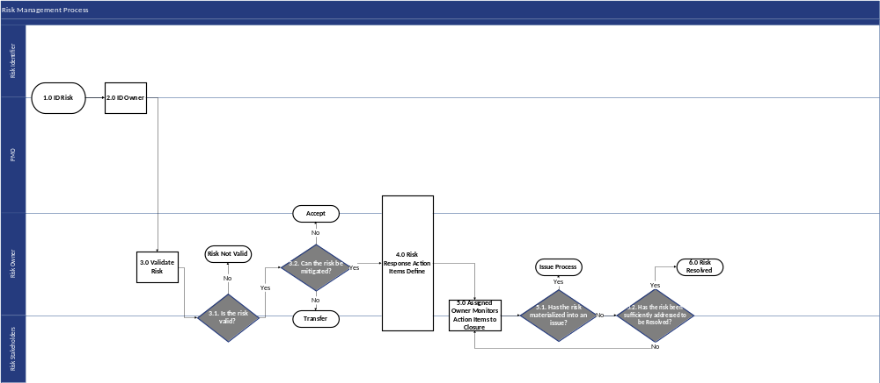
Figure 9-1: Risk Management Process Flow

Risk Management Process Flow Narrative
The following table describes each process step illustrated above.
Step # | Process Step | Description | Stakeholder Group(s)
1 | ID Risk | The designated PMO, along with the Risk Identifier, logs the item in the ALM tool, which serves as the project tracking software. Anyone from the project team can raise a risk for documentation and discussion. | - ███████/DOS PMO  - Risk Identifier
2 | ID Owner | The designated PMO and Risk Identifier coordinate to identify a Risk Owner (Assignee), who will manage/address the risk process for the item through to close. | - ███████/DOS PMO  - Risk Identifier
3 | Validate Risk | All risks must be reviewed for their probability of occurrence, estimated impact to project scope and/or budget, and mitigation approach. A valid risk is characterized by one or more of the following attributes:  Likelihood: Does the risk have a reasonable chance of occurring?  Impact: If a risk does materialize, does it have the potential to cause negative consequences?  Identifiability: Can the risk be clearly defined, described, and documented?  Manageability: Can a mitigation strategy or response plan be developed to reduce the likelihood or impact? | - Risk Owner
3.1 | Is the risk valid? | - If after review, a risk is considered invalid, it transitions to the “Risk Not Valid” status  - If after review, a risk is considered valid, the Risk Owner and Stakeholders will proceed to Step #3.2 Can the risk be mitigated? | - Risk Owner  - Risk Stakeholders
3.2 | Can the risk be mitigated? | If a risk cannot be mitigated and will result in adverse impacts on the project, the risk is escalated and transitioned to the “Risk Closed, Turned to Issue” status. Escalation will create transparency and help confirm that risks are handled at an adequate decision-making level. Managerial Governance will develop a Risk Response of Mitigate, Accept or Transfer. The ESC will be informed of the risk, as necessary and applicable.  - If a risk cannot be mitigated but will not result in adverse impacts on the project, the risk will be accepted and reflect an “Open” status in the ALM tool  - If a risk cannot be mitigated and will likely result in adverse impacts, the risk may be transferred to a third party. Transferring the risk gives another party responsibility for its management it does not eliminate it. For example, the DOH OHIP may purchase warranties to cover risks after purchase of a tool or system. If a risk is transferred, the Risk Owner transitions the risk to “Risk Cancelled” status  - If a risk can be mitigated, then the appropriate risk response will be defined | - Risk Owner
4 | Risk Response Action Items Define | A risk response plan is required as part of risk mitigation. A risk response plan contains the actionable steps to mitigate the risk, as well as a contingency plan. The response also indicates if the risk will be mitigated, accepted or transferred. The designated PMO will work with the Risk Owner and respective track to produce and socialize the risk response plan to the applicable stakeholder(s). Mitigation steps will be monitored weekly during the Project Status meeting. | - ███████/DOS PMO  - Risk Owner  - Risk Stakeholders
5 | Assigned Owner Monitors Action Items to Closure | The Stakeholders continue to monitor the risk according to the risk response plan. The risk response plan is monitored to closure.  Upon the closure of the risk response plan, the risk is closed (resolved). | - Risk Owner  - Risk Stakeholders
5.1 | Has the risk materialized into an issue? | - If a risk has been realized, it is transitioned to an issue and the Risk Owner initiates the Issue Resolution Approach (outlined in Section 9.4). A risk may become an issue when certain conditions occur including the following scenarios:  - Risk has been materialized and becomes an issue  - Risk severity, meaning the threshold, for the impact/consequences has been surpassed  - Risk cannot be effectively managed or mitigated with current management plan.  - If the risk has not materialized into an issue, the Risk Owner and Stakeholders continue to monitor the risk through resolution. Proceed to Step #5.2 Has the risk been sufficiently addressed to be Resolved? | - Risk Owner  - Risk Stakeholders
5.2 | Has the risk been sufficiently addressed to be Resolved? | - If the risk has been sufficiently addressed through the prescribed action items, the Risk Owner and Stakeholders will proceed to Step #6 Risk Resolved.  - If the risk has not been sufficiently addressed, proceed to Step #5 Assigned Owner Monitors Action Items to Closure and the team continues to monitor the risk through resolution. | - Risk Owner  - Risk Stakeholders
6 | Risk Resolved | Once a risk is addressed through the response plan or is cancelled, the Risk Owner updates the status in the ALM tool to “Risk Resolved”. | - Risk Owner
Table 9-1: Risk Management Process Flow Narrative

Risk Status
Risk status indicates the risk’s current point in the risk management process. Depending on the risk status, the risk owner takes respective actionable steps to manage the risk to closure. The following table describes the risk statuses used in the risk management process.
Risk Status | Description
Risk Cancelled | If the triage process determines that the risk does not meet one or more of the characteristics of a valid risk, or that it is no longer relevant, then the risk will not be addressed further, and the risk is cancelled.
Risk Open | This is the initial status a risk assumes when it is first entered into the ALM tool. A risk assumes this status when it has been identified and accepted as a risk to the project. The risk is either monitored (if low priority) and left in “Open” status or a risk response/mitigation strategy is developed and reviewed with DOH OHIP.
Risk On Hold | A risk assumes this status if there is uncertainty or a lack of information that needs to be addressed before making decision on how to address the risk. This also means that mitigation efforts have been paused for a specific reason.
Risk Closed, Turned to Issue | If, after review, the risk is determined to be high priority and unmitigated, it is closed and should be converted to an issue that requires further attention and is escalated through the Issue Resolution Approach (outlined in Section 9.4).
Risk Resolved | A risk assumes this status if the risk is Mitigated which means it was successfully managed and measures have been implemented to reduce the likelihood or impact of the risk; if the risk is Transferred or Accepted; or if the risk is overtaken by other events and is no longer applicable.
Table 9-2: Risk Status

Risk Attributes, Types, and Tracks
The most updated attributes used for Risks in the ALM tool can be found in the ALM Tool Reference Guide in the following location: The ALM tool

Escalation Level
Under the Risk Management Approach, risks are addressed by Management Level (Project Administration and Execution teams) by default, as defined in the Governance Structure (refer to Section 1) because risks impact individual components or functional areas and do not pose an immediate impact to operations or policies. The types of escalation levels include the following:
- Management – Items we are managing day to day at the project level
- Leadership – Items requiring project leadership awareness/input which are items with high severity that will be flagged at the project status report level
- Executive – Items requiring executive project leadership awareness/input at the steering committee level
If the risk cannot be mitigated or resolved by the project team, it must be escalated to an issue and proceed with the Issue Resolution Approach outlined in Section 9.4.
A risk may be escalated to an issue when certain conditions or events occur. One or more of the following scenarios may trigger the escalation.
- Risk Materialization – A risk may be escalated to an issue if the event or condition that was originally identified as a risk has occurred. When a potential risk becomes a reality, it is no longer a risk but an issue that needs to be addressed
- Risk Severity – If the impact or consequences of the risk increase beyond a predefined threshold, it may be escalated to an issue. This can happen when the potential harm or disruption becomes significant
- Manageability – A risk may be escalated to an issue if it is determined that the risk cannot be effectively managed or mitigated within the current risk management approach
Risks are communicated in the PSR and discussed during recurring PSR meetings. Upon review of the escalated risks, ███████ and DOH OHIP will identify those that would need discussion in the upcoming ESC meeting. If the escalated risk poses an immediate negative impact and cannot wait until the next scheduled ESC meeting, the track lead will contact the Managerial Governance group to review the escalated risk on an emergency basis and determine a recommended course of action.

Risk Probability, Impact, and Severity
The values and definitions in the following table will be used to assign the probability of risks occurring:
Probability Value | Description
1-Low (0-33%) | Very unlikely to occur
2-Medium (34-66%) | Some chance of occurring
3-High (67-99%) | Very likely to occur
Table 9-4: Probability Values of Risks
The table below describes the impact values ascribed to the various risks identified in the project:
Impact Value | Description
1-Low | Insignificant impacts to timescale and cost, some re-planning may be necessary
2-Medium | Substantial delay increases cost; key resources/deliverable impacted
3-High | Inability to deliver; objectives cannot be achieved
Table 9-5: Impact Values of Risks
When risks are identified, they will be qualitatively analyzed in terms of impact and probability. Impact will be assessed on a range of 1 – 3, with 1 being Low, 2 being Medium, and 3 being High. Similarly, probability will be assessed on a range of 1 – 3, with 1 indicating low probability of occurring, 2 indicating medium probability of occurring, and 3 indicating high probability of occurring.
The two values will then be multiplied by the ALM tool to compute an overall risk severity. The probability, impact, and overall risk severity will be included for the risks included in the PSR.
The table below outlines the complete set of values and the risk severity level for each combination.
Impact | Probability
Impact |  | 1 – Low | 2 – Medium | 3 – High
Impact | 3 – High | Low (3) | Medium (6) | High (9)
Impact | 2 – Medium | Low (2) | Medium (4) | Medium (6)
Impact | 1 – Low | Low (1) | Low (2) | Low (3)

Score | Severity
1 – 3 | Low
4 – 6 | Medium
7 – 9 | High
Table 9-6: Impact x Probability Matrix to Calculate Risk Severity

Risk Monitoring and Reporting
Open risks tagged at the leadership escalation level will be tracked and published in the PSR.
the ALM tool’s dashboard feature will be used to support the PMO in facilitating the recurring Project Status meeting. The dashboards in the ALM tool will allow the Project team to review risks in real time. The objectives of the risk review of the Project Status meeting are to:
- Validate new risks
- Determine/update the risk owner, priority, probability and impact, or risk response as necessary
- Approve submitted risk response plans
- Determine if, or when, a risk needs to be escalated; risks will be discussed as part of the PSR meetings and participants both from ███████ and DOH OHIP will discuss the need to escalate open risks during this time
The following risk dashboard panels will be provided in the risk dashboard in the ALM tool to monitor and control project risks:
- Cumulative Risks by Status
- Risks by Severity and Status
- Open Risks by Severity
- Open Risk Aging by Severity
Below is an example dashboard which displays the number of risks categorized by status. Note that the dashboard was created using test data. ███████ will collaborate with DOH OHIP to generate and modify dashboards to meet DOH OHIP expectations. Upon agreement on dashboard format and data, ███████ will include the dashboards in the PSR.
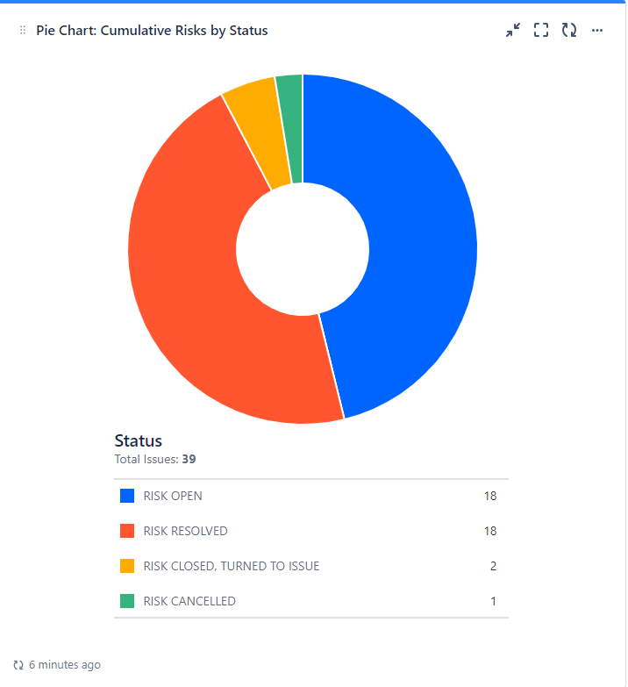
Figure 9-2: Sample Risk Dashboard

Lessons Learned
███████ promotes continuous improvement through regular reviews and lessons learned sessions. These sessions will be conducted at the conclusion of each project phase, serving as a core element of our iterative and collaborative process. A log of all project risks, mitigation plans applied, and lessons learned are documented and integrated into our project management tool, the ALM tool. The documented lessons learned will be shared with DOH OHIP on a quarterly basis.
Using this information, ███████ will identify areas for improvement and acknowledge successes – activities to sustain. Lessons learned encompass a broad spectrum of knowledge, ranging from process efficiencies and leading practices to specific challenges and solutions. This comprehensive approach helps promote a holistic view of the project’s journey.

Issue Resolution Approach
The following section illustrates how issues associated with the project are identified, evaluated, reported, managed, and mitigated. It outlines how issue resolution activities will be performed throughout the life cycle of the project using the ALM tool as an IT enabler.

Issue Identification Summary
A risk may be escalated to an issue when certain conditions or events occur. One or more of the following scenarios may trigger the escalation.
- Risk Materialization – A risk may be escalated to an issue if the event or condition that was originally identified as a risk has occurred. When a potential risk becomes a reality, it is no longer a risk but an issue that needs to be addressed
- Risk Severity – If the impact or consequences of the risk increase beyond a predefined threshold, it may be escalated to an issue. This can happen when the potential harm or disruption becomes significant
- Manageability – A risk may be escalated to an issue if it is determined that the risk cannot be effectively managed or mitigated within the current risk management approach

Issue Resolution Process Summary
███████ and DOH OHIP has established the ALM tool to manage the Issue Resolution Process including identifying and resolving project issues.
The issue resolution process includes:
- Document Issue – ███████ or DOH OHIP team member identifies issue among project activities or from existing risk. The identifier of the issue as well as the issue stakeholders then work with the PMO to update item status in the ALM tool
- Address Issue – The PMO includes issues in PSR and discusses them during Project Status meeting with ███████ and DOH OHIP. During the Project Status meeting, ███████ and DOH OHIP create a plan for addressing issues
- Monitor Issue –The PMO maintains the ALM tool with appropriate issue status and updates the PSR prior to meetings with changes
The process uses the ALM tool for logging and tracking issues. The process outlined in Sections 9.4.3 and 9.4.4 below explain the Issue Resolution Process Flow and Narrative.

Issue Resolution Process Flow Diagram
The following diagram depicts the issue resolution process for the project. The diagram conveys an overview of responsibilities across the ███████ functional, business, and technical stakeholders, and the PMO, which includes the ███████ and DOS PMO teams.
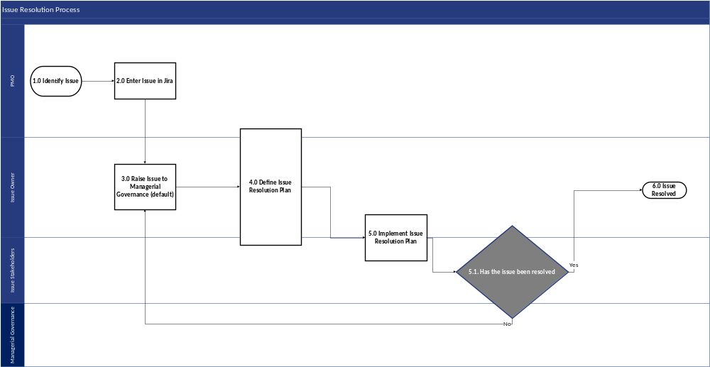
Figure 9-3: Issue Resolution Process Flow

Issue Resolution Process Flow Narrative
The following table describes each process step illustrated above.
Step # | Process Step | Description | Stakeholder Group(s)
1 | Identify Issue | Stakeholders a raise new issue, or existing risk is realized and escalated to issue. | - ███████  - DOH OHIP
2 | Enter Issue in the ALM tool | If it is a new issue,  - Log the issue in the ALM tool and populate issue entry data fields  - Identify an Issue Owner  - If it is a realized risk:  - Update the status of the risk item to “Risk Closed, Turned to Issue”. Link the new issue and risk and log the item in the ALM tool  - Leverage details and data fields from risk item to populate the issue entry  - Validate all data fields to promote accuracy. For example: Is the owner of the issue the same as the risk owner? Has the priority changed?  - Identify an Issue Owner, if different from the Risk Owner | - ███████  - DOH OHIP
3 | Raise Issue to Managerial Governance (default) | Issue is automatically tagged by default to the Managerial Governance group as part of the escalation level.  The Issue Owner adds the Issue to the PSR for weekly discussion and review if the item is escalated to the Leadership Governance group as part of the project status meeting. The Issue remains on the PSR until it is resolved. If the Leadership Governance group is unable to resolve the issue, the issue is then escalated to the Executive level. | - Issue Owner
4 | Define Issue Resolution Plan | An Issue Resolution Plan contains the actionable steps to address the issue. The PMO will work with the Issue Owner to produce and socialize the issue resolution plan to the applicable stakeholder(s). | - Issue Owner  - Deloitte/DOS PMO  - Issue Stakeholders
5 | Implement Issue Resolution Plan | The Issue Owner works with relevant stakeholders to complete action items outlined in the issue resolution plan. | - Issue Owner  - Issue Stakeholders
5.1 | Has the issue been resolved? | - If an issue is not resolved, the item remains open to be reviewed and discussed weekly until resolution. Proceed to Step #3 Raise Issue to Managerial Governance (Default)  - If the issue is resolved, then proceed to Step #6 Issue Resolved | - Issue Owner  - Issue Stakeholders  - Managerial Governance
6 | Issue Resolved | The Issue Owner updates the status in the ALM tool to “Issue Resolved”. | - Issue Owner
Table 9-7: Issue Resolution Process Flow Narrative

Issue Status
Issue status indicates the current point the issue is in the issue resolution process. Depending on the issue status, the issue owner takes respective actionable steps to manage the issue to closure. The following table describes the issue statuses used in the issue resolution process.
Issue Status | Description
Issue Open | An issue is in an open state when initially logged in the ALM tool, indicating that it has been identified and logged, but has not yet been resolved.  An issue can also assume this status when it has been transitioned from a risk to an issue and work begins pursuant to resolving the issue.
Issue On-Hold | An issue can be temporarily on hold, meaning work to address issue is delayed, paused or disrupted for a specific reason and requires that an issue be placed on hold.
Issue Resolved | An issue assumes this status if the issue is closed, meaning that the root cause has been identified and addressed, and any necessary corrective actions have been implemented.
Issue Reopened | When an issue is resolved in error, it can be reopened by project members. This will then be reviewed for validity and follow the normal issue workflow. A reason for reopening must be provided.
Issue Cancelled | An issue is cancelled when it will not be addressed further, or it is no longer relevant.
Table 9-8:Issue Status

Issue Attributes, Types, and Tracks
The most updated attributes used for Issues in the ALM tool can be found in the ALM Tool Reference Guide in the following location: The ALM tool

Escalation Level
Escalation Level details the process that escalates a risk into an issue. This happens when the event that was originally identified occurs (Risk Materialization); if the impact of the risk increases beyond a predefined threshold (Risk Severity); or if the risk cannot be effectively managed within the current risk management approach (Manageability).
When a risk becomes an issue and a new ALM tool ticket is created, a reconciliation will occur to confirm details are carried from the risk over to the newly opened issue.
As part of the Issue Resolution Approach, the Leadership Governance group discusses escalated issues during the PSR meetings until the issues are resolved. If the Leadership Governance group is unable to resolve the issue, the issue is then escalated to the Executive level. The types of escalation levels include the following:
- Management – Items we are managing day to day at the project level
- Leadership – Items requiring project leadership awareness/input which are items with high severity that will be flagged at the project status report level
- Executive – Items requiring executive project leadership awareness/input at the steering committee level
Issues escalated to the ESC will be first discussed in recurring ESC meetings. If the escalated issue poses an immediate negative impact and cannot wait until the next scheduled ESC meeting, the Continuing Medicaid Eligibility Modernization PM will contact the ESC to review the issue on an emergency basis and determine a recommended course of action.

Issue Monitoring and Reporting
Open issues that require project leadership attention will be tracked and published in the PSR.
the ALM tool’s dashboard feature will be used to support the PMO in facilitating the recurring PSR review meeting. The dashboards in the ALM tool will allow the Project team to review issues in real time. The objectives of the issue review of the Project Status meeting are to:
- Validate new issues
- Determine/update the issue owner, priority and impact, or issue resolution as necessary
- Secure Project Executive Committee (PEC) approval of submitted issue resolution plans
- Determine if, or when, an issue needs to be escalated
The following issue dashboard panels are provided in the issue dashboard in the ALM tool and are used to monitor and control project issues:
- Cumulative Issues by Status
- Issues by Severity and Status
- Open Issues by Severity
- Open Issues Aging by Severity
Below is an example dashboard which displays the number of risks categorized by status. Note that the dashboard was created using test data. ███████ will collaborate with DOH OHIP to generate and modify dashboards to meet DOH OHIP expectations. Upon agreement on dashboard format and data, ███████ will include the dashboards in the PSR.
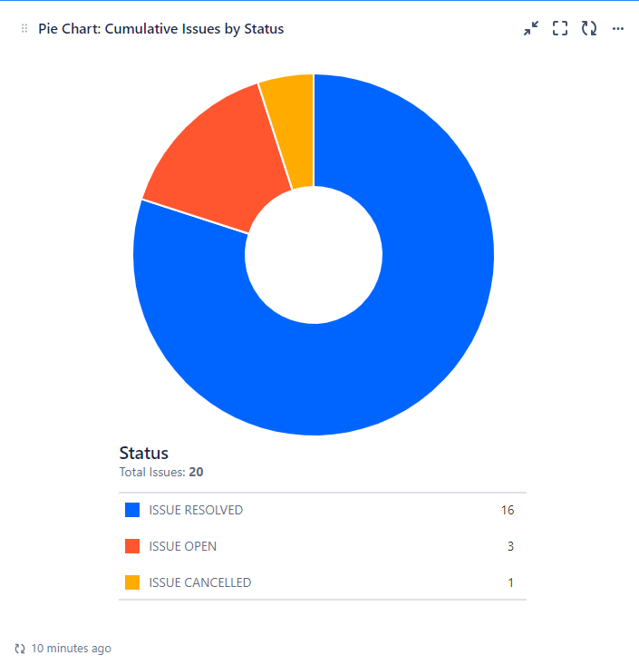
Figure 9-4: Sample Issue Dashboard

Action Item (AI) Management
This section documents the process and tools the project will use to log action items and manage them to closure throughout the life of the project.
The Continuing Medicaid Eligibility Modernization project will use the ALM tool, a project tracking software tool, to manage action items, track action items, and generate action item reports and dashboards.

Action Item Management Process Flow
Action items arise when a specific task or action needs to be undertaken to address an issue, complete a project phase, or achieve a goal. The action item life cycle describes the allowed states and workflow for action items. The timely address of action items is critical for maintaining project standards and quality. The following process flow describes the status changes of action items through the life cycle of the project.
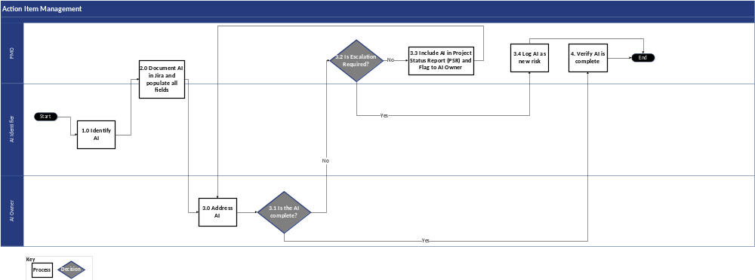
Figure 9-5: Action Item Management Process Flow Diagram

Action Item Management Process Flow Narrative
The following narrative describes the status changes of action item through the life cycle of the project.
Step # | Process | Description | Stakeholder Group(s)
1 | Identify AI | AI Identifier, through project delivery, identifies an AI. | - AI Identifier
2 | Document AI in the ALM tool and Populate All Fields | The designated PMO will work with the AI Identifier to log the item in the ALM tool and confirm that an AI Owner is identified. | - ███████/DOS PMO  - AI Identifier
3 | Address AI | AI Owner performs necessary steps to complete the action item and make the updates needed in the ALM tool.  Under certain circumstances, the AI Owner may not be able to complete the tasks required to close the action item. In this scenario, the AI Owner escalated the item to receive additional resources. | - AI Owner
3.1 | Is the AI Complete? | - If the AI Owner completes the AI, proceed to Step #4 Verify AI is Complete and close out in the ALM tool  - If the AI owner does not complete the AI, proceed to Step #3.2 Is Escalation Required? | - AI Owner
3.2 | Is Escalation Required? | If the AI Owner is unable to complete the tasks, the designated PMO must determine if escalation is required.  - If escalation is required, proceed to Step #3.4 Log AI as New Risk  - If the AI owner does not complete the AI but does not require escalation, proceed to Step #3.3 Include AI in Project Status Report (PSR) and Flag to AI Owner | - ███████/DOS PMO
3.3 | Include AI in Project Status Report (PSR) and Flag to AI Owner | If the AI requires escalation, the designated PMO includes the unresolved AI in the PSR, notifies the AI Owner of its inclusion, and continues to monitor the item.  This item will remain on the PSR and discussed during Project Status Report meetings until it is resolved. | - ███████/DOS PMO
3.4 | Log AI as New Risk | If the AI Owner is not able to address the AI and requires escalation to another Stakeholder Group or member of project leadership, the designated PMO logs a new risk, and the new risk follows the Risk Management process. | - ███████/DOS PMO
4 | Verify AI is Complete | Once the AI is completed, the designated PMO verifies that the AI is complete before it is closed out in the ALM tool. | - ███████/DOS PMO
Table 9-9: Action Item Management Process Flow Narrative
When the action item is submitted, the creator must select an assignee and manually add any stakeholders to be informed by email notification. The notification contains high-level details of the action item, as well as a hyperlink to the action item itself for the assignee to take proper action.

Action Item Attributes
The most updated attributes used for Action Items in the ALM tool can be found in the ALM Tool Reference Guide in the following location: The ALM tool

Action Item Types
An action item can be categorized in the following ways:
Action Item Type | Action Item Type Description
Contract | Any action item related to the contracts of the project (such as a signed agreement between ███████ and the State or subcontractors)
External | Any action item related to environmental factors largely outside the control of the project (such as cultural, legal, or regulatory)
Financial | Any action item related to the budget or cost structure of the project (e.g., increase or decrease in the budget)
Functional | Any action item related to the overall function of the product (such as requirements or design) being developed by the project
Quality | Any action item related to the quality requirements of the project
Organization | Any action item related to internal, State, or third-party organizational or business changes (such as Executive Leadership role changes)
Performance | Any action item associated with the performance of the application (such as response time, stress testing, and development environments)
Project Management | Any action item related to the management of the project (such as communications, status reporting, and issues management)
Resource | Any action item related to project resources (such as the addition or removal of resources)
Schedule | Any action item related to the Work Plan and related tasks (such as extensions or reductions of the project timeline)
Scope | Any action item related to project scope (such as process, module, and development objects)
Technical | Any action item related to software or hardware, including infrastructure related to the project
General | Any action item that cannot be categorized into one of the above categories
Table 9-11: Action Item Types

Action Item Priorities
Action items can be prioritized through the following categories:
- High – The action item must be addressed immediately or in an expedited manner to prevent negative impacts to the project outcomes or objectives (e.g., cost overruns or milestone delays)
- Medium – The action item will be addressed, monitored, and controlled following regular project action item management processes
- Low – The action item will be addressed as cost and schedule permits

Action Item Status
An action item status can be categorized in the following ways:
Action Item Type | Action Item Type Description
Open | This is the initial status a proposed action item assumes when it is first entered into the ALM tool.
In Progress | An action item assumes this status when it has been accepted as required for the project and is being worked on by the responsible party. The action item is continuously monitored, and status and comments are updated accordingly.
Cancelled | An action item is cancelled when the triage process determines that the action item is not required for the project.
Complete | An issue assumes this status once PMO verifies that the action item has been completed.
On Hold | The action item has been put on hold.
Table 9-12: Action Item Status

Close Action Item
An action item must be confirmed as resolved before it can be closed in the ALM tool. The following actions and checks are carried out as part of the resolution confirmation process.
- MECM system project will confirm that the action item steps have been completed satisfactorily during project status meeting
- The appropriate stakeholder(s) identified for the action item should help confirm the issue resolution
- For action items where resolution is confirmed, set the status to “Complete” in the ALM tool
- Action items where the resolution results were not confirmed will go back to “In Progress” status and assigned back to the owner so that they can successfully complete the required action
- Action items that were closed in error can be reopened by any project member

Action Item Monitoring and Reporting
- Open action items (any status that is not “Cancelled” or “Complete”) will be tracked and published in the PSR and the monthly executive steering committee report, both of which are stored on the Continuing Medicaid Eligibility Modernization SharePoint site.

Decision Management
Managing decisions includes identifying, documenting, prioritizing, assigning, and tracking the results of decisions throughout the phases of the project. This section documents the process and tools the project will use to log and manage day-to-day decisions, as well as formal project decisions.
Day-to-day decisions are decisions that project management deems necessary to document and track for future reference. Formal decisions are decisions that impact project schedule and/or scope. The decision criteria for making a formal decision versus a day-to-day decision must be understood by team members.
Any decisions impacting the scope of the project will be referred to the Review Board for evaluation of impact on the scope, cost, schedule, and quality of the project.
The Continuing Medicaid Eligibility Modernization project will utilize the ALM tool, an issue and project tracking software tool, to manage and track project decisions. The ALM tool has built-in reporting and dashboard functionality.

Decision Management Process Flow Diagram
The workflow below summarizes the project’s decision management process.
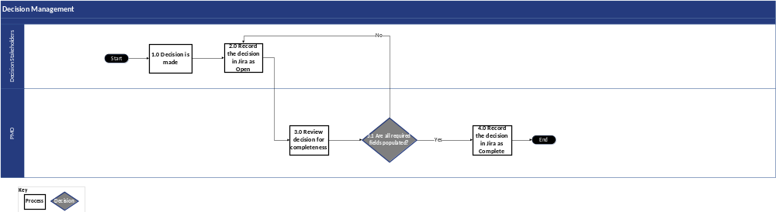
Figure 9-6: Decision Management Process Flow

Decision Management Process Flow Narrative
The narrative below summarizes how the project’s decision management process is completed.
Step # | Process | Description | Stakeholder Group(s)
1 | Decision is Made | Decision Stakeholders discuss an open item and decide to address the open item. | - Decision Stakeholders
2 | Record the Decision in the ALM tool as Open | Decision Stakeholders log the decision in the ALM tool and with the status to ‘Open’. | - Decision Stakeholders
3 | Review Decision for Completeness | The designated PMO reviews the decision entered by the Decision Stakeholders and confirms whether there is enough information available to confirm the decision. | - ███████/DOS PMO
3.1 | Are All Required Fields Populated? | - If the decision is not complete, return to Step #2 Record the decision in the ALM tool as Open to re-assess decision and gather additional input to complete all fields  - If the decision is complete, proceed to Step #4 Record the decision in the ALM tool as Complete | - ███████/DOS PMO
4 | Record the Decision in the ALM tool as Complete | The designated PMO updates the decision status to ‘Complete’ and closes out the open action item for the decision to be made, as applicable. | - ███████/DOS PMO
Table 9-13: Decision Management Process Flow Narrative

Decision Attributes
The most updated attributes used for Decisions in the ALM tool can be found in the ALM Tool Reference Guide in the following location: The ALM tool

Decision Monitoring and Reporting
Open decisions (any status that is not “Cancelled” or “Complete”) will be tracked and published in the PSR, which will be uploaded to the DOS SharePoint site. Open decisions will be monitored daily by PMO; the PMO will engage Decision Stakeholders for updates, clarifications, and next steps as part of the decision monitoring.

Section 10 – Integrated Change Control Process

Integrated Change Control Process

Integrated Change Control Overview
The ICCP defines the overall strategy and methodology for managing scope via the integrated change control process throughout the course of the Continuing Medicaid Eligibility Modernization project. This document also describes the technology-specific change control activities, processes, and procedures.
Project changes can occur at any point during the project life cycle. Disciplined management of these project changes is critical to the overall success of the project and helps to reduce risk across the project timeline.

Introduction and Purpose
The ICCP defines a framework for the project to plan and control changes to the scope, schedule, resources, budget, objectives, or baselined documentation. The change control process includes the criteria for requesting a change, the change control process, prioritization guidelines, categorization to determining governance, and the tools that support the ICCP. The change control process is at the heart of this plan and establishes an orderly and effective procedure for tracking the submission, prioritization, review, evaluation, categorization, and approval for release of all changes to the project baselines. These baselines may include contract documents (e.g., MSOW and ISOWs), deliverables, or controlled project working documents (e.g., the Master ISOW Integrated Project Schedule).
A common use case for change control includes modifications to system requirements and, over time, modifications to the MECM solution. While the baseline requirements provide a starting point for defining and building the MECM solution, changes are also identified during the SDLC process. Changes during the SDLC may be driven by legislation or policy, incorporating new opportunities for optimization, items that arise from reviews of legacy documentation, or business-requested functionality changes. Although not all changes of this nature are approved, it is important that changes can be requested. The ICCP provides a process to manage change throughout the project.
Every change request in the project triggers the change control process. A change can be for scope, resources, and project schedule. A change request must capture key information on the proposed change such as, but not limited to, the reason for change, description of change, financial impact, and associated risks/issues. Once a change to the project is identified, the change control process is initiated to evaluate, track, manage, and disposition the change. These changes are submitted to the ███████ and DOS PMOs for analysis and review. The PMOs mutually agree on which change requests are eligible to be presented to the CRB after analyzing the impact on scope, schedule, level of effort, associated business benefit, and whether they are a business driver. The CRB evaluates change requests and renders a disposition, which can be approved, rejected, placed on hold, or additional information is needed.

Objectives
The ICCP focuses on the following objectives to support the program goals:
- Defines processes and procedures that determine how project change is defined, documented, verified, managed, and controlled
- Validates that all scope updates are escalated appropriately and addressed in a timely manner
- Establishes the process to identify the scope baseline and the procedures used if there are any potential changes to the baseline identified
- Defines processes and procedures to manage and control changes, including the roles and responsibilities of the CRB

Integrated Change Control Process Roles and Responsibilities
The Integrated Change Control Process Roles and Responsibilities table can be found in Appendix C-9. This table identifies the roles and responsibilities associated with the ICCP.

Integrated Change Control Process
The ICCP establishes an orderly and effective procedure for tracking the submission, prioritization, review, evaluation, categorization, and approval of all changes to the project’s baselines. The ICCP is designed so as to apply a consistent approach that each change introduced is analyzed and vetted by DOH OHIP, ███████, and the CRB prior to implementation. Documents related to Change Requests (CRs) and ICCP are stored and maintained in the following location in the DOH SharePoint: Change Requests.
The link to the diagram ‘Integrated Change Control Process Flow’ mentioned below depicts the change control process for the Continuing Medicaid Eligibility Modernization project. The diagram conveys an overview of responsibilities across the Requestor, ███████ Tracks/Stakeholders, and the PMO, which includes the ███████ PMO and DOS PMO teams. The diagram also shows responsibilities for the CRB. The CRB evaluates, reviews, and approves all proposed changes to the project that would impact the project scope, schedule, resources, budget, and objectives. The ARB reviews and approves technical and security changes in the MECM environments that do not initiate a change request. Any changes that result in impacts to the project will be routed through the ICCP. More information can be found in Section 1 Governance Structure.
The ███████ and DOS PMOs determine the appropriate target audience to review each change request based on the proposed CR impacts and funding source.
Depending on the cost, scope, and budget impacts of the CR, the PMOs may recommend that the CR be directed to executive stakeholders following consultation and confirmation with project leadership according to the governance level as defined in Section 1 Governance Structure.
CRs fall into four different funding sources:
- Cost: Any CR that requires additional funds not otherwise allocated within an ISOW to implement
- No Cost: Any CR that will be delivered at no cost – meaning it is not utilizing any reserve or enhancement hours from an ISOW
- No Cost ISOW: Any change request that utilizes reserve hours from the respective system change’s ISOW
- No Cost Future Wave: Any change request that utilizes enhancement hours from a planned future wave
Link to Change Request Process flow diagram: Change Request Process Diagram

Identifying and Requesting Changes
A change is defined initially as any variance from the scope finalized as a part of the baselined requirements. As the project progresses, the definition of change incorporates any variance from a previously approved (“Accepted”) project document. This includes the following examples: contract documents (MSOW or ISOW), project deliverables, and project working documents (e.g., Master ISOW Integrated Schedule).
Although change typically impacts the solution design or project activities, a requested change might impact schedule, effort, budget, resources, or objectives and must be evaluated and approved through this formal process prior to dispositioning and implementation, if applicable. Changes can be identified at any time after requirement validation including in design, development, testing phases, and production. The change control process helps control unapproved change to avoid scope creep, costly delays, and decreased quality in the solution.
Any project stakeholder may submit a change request through the ALM tool which triggers the ICCP process. A CR is completed by the member(s) of the project team and distributed to the ███████ PMO or DOS PMO teams for review.
In addition to logging a CR ticket in the ALM tool, the project stakeholder initiating the change will also complete and submit a corresponding Change Request Approach and Impact form. When initiating the change request, the requestor will complete the Solution Approach tab of the form. Once the change request is reviewed by the ███████ and DOS PMOs, if the CR is valid, then the requestor will provide the relevant impact information on the Impact Analysis tab in the same linked form.
The most updated Change Request Approach and Impact form can be accessed here: TEMPLATE_Change Request Approach and Impact.
The CR form and associated reference materials are uploaded to and maintained in a CR-specific folder in the Change Request folder within the DOH SharePoint site. The link to the corresponding CR folder will be posted in the CR ticket in the ALM tool. The CR folder will contain the Change Request Approach and Impact form as well as any applicable supplementary materials.
Once all of the CR initiation materials are drafted, the ███████ PMO drafts an accompanying CR Summary slide. This slide serves as a supplemental file to the CR submission to provide an overview of the CR when it is presented to the CRB. It summarizes key information provided in the ALM tool, reference materials, and the Change Request Approach and Impact form. The slide also has placeholders to capture comments and/or questions arising during the CR review session and a CR disposition if the CRB chooses to disposition the CR during the review session.
The table below describes the process steps for initiation and identification of changes to Change Requests.
Step # | Process Step | Description | Stakeholder Group(s)
1 | Log Change Request in the ALM tool and Assign to Corresponding PMO Lead | - The requestor logs the Change Request capturing the high-level information for the proposed change in the ALM tool and assigns to corresponding PMO Lead  - A requestor can be any Deloitte/DOH stakeholder  - Status of change request is set to “Opened” | - Requestor (███████/DOH Stakeholders)
2 | Review CR and Coordinate with Requestor to Provide Any Missing Details | The ███████ and DOS PMOs conduct an initial assessment of the CR and coordinate with the requestor to provide any missing details. | - ███████/DOS PMOs
2.1 | Additional Information Required? | The ███████ and DOS PMOs determine whether additional information is required for the CR.  - If additional information is required, proceed to Step #3 Update CR Based on Feedback  - If additional information is not required, proceed to Step #4 Review CR and Confirm Readiness and Completeness of the ALM tool ticket and Solution Approach(es) | - ███████/DOS PMOs
3 | Update CR Based on Feedback | The requestor updates the CR (ALM tool ticket and/or Change Request Approach and Impact form) based on feedback. | - Requestor (███████/DOH Stakeholders)
4 | Review CR and Confirm Readiness and Completeness of the ALM tool ticket and Solution Approach(es) | The ███████ and DOS PMOs review the CR and confirm readiness and completeness of the ALM tool ticket and supporting documentation. | - ███████/DOS PMOs
4.1 | Initial Assessment of CR Complete? | The ███████ and DOS PMOs determine whether the initial assessment of the CR is complete.  - If the initial assessment of the CR is not complete, proceed to Step #3 Update CR Based on Feedback  - If the initial assessment of the CR is complete, proceed to Step #5 Review and Confirm Validity to Proceed with CR | - ███████/DOS PMOs
5 | Review and Confirm Validity to Proceed with CR | The ███████ and DOS PMOs assess the CR documentation, confirm whether the CR is valid and determine whether the CR should proceed to the impact assessment activities. | - ███████/DOS PMOs
5.1 | CR Ready for Impact Assessment? | The ███████ and DOS PMOs decide whether the CR is ready for impact assessment.  - If the CR is not ready for impact assessment, proceed to Step #6.1 Update CR Status to Ready for Impact Assessment and Set Assessment Due Date to Future Date  - If the CR is ready for impact assessment, proceed to Step #6 Update CR Status to Ready for Impact Assessment and Set Assessment Due Date to 10 Business Days | - ███████/DOS PMOs
Table 10-1: Process Steps for Initiation/Change Identification of Change Requests
The table below describes the process steps for evaluating Change Requests.
Step # | Process Step | Description | Stakeholder Group(s)
5.1 | CR Ready for Impact Assessment? | The ███████ and DOS PMOs decide if the CR is ready for impact assessment.  - If the CR is ready for impact assessment, proceed to Step #6 Update CR Status to Ready for Impact Assessment and Set Assessment Due Date to 10 Business Days  - If the CR is not ready for impact assessment, proceed to Step #6.1 Update CR Status to Ready for Impact Assessment and Set Assessment Due Date to Future Date | - ███████/DOS PMOs
6.0 | Update CR Status to Ready for Impact Assessment and Set Assessment Due Date to 10 Business Days | The ███████ PMO updates CR status to Ready for Impact Assessment and sets assessment due date to 10 business days | - ███████ PMO
6.1 | Update CR Status to Ready for Impact Assessment and Set Assessment Due Date to Future Date | The ███████ and DOS PMOs update CR status to Ready for Impact Assessment and set assessment due date to future date | - ███████/DOS PMOs
6.2 | CR Ready for Impact Assessment? | The ███████ and DOS PMOs decide if the CR is ready for impact assessment.  - If the CR is not ready, proceed to Step #6.3 Keep CR Status as Ready for Impact Assessment and Revise Assessment Due Date as Needed  - If the CR is ready, proceed to Step #7 Gather Information to Complete Impact Assessment. Update CR Status to Impact Assessment In Progress | - ███████/DOS PMOs
6.3 | Keep CR Status as Ready for Impact Assessment and Revise Assessment Due Date as Needed | ███████/DOS PMOs keep CR status as Ready for Impact Assessment and revise assessment due date as needed | - ███████/DOS PMOs
7 | Gather Information to Complete Impact Assessment. Update CR Status to Impact Assessment In Progress | The ███████ Track gathers information to complete the impact assessment and updates the CR status to Impact Assessment In Progress | - ███████ Track
8 | Complete Impact Assessment and Submit Associated Documentation | The ███████ Track completes impact assessment and submits associated documentation | - ███████ Track
9 | Review Impact Assessment and Update CR Status to Impact Assessment Review in Progress | The ███████ PMO reviews the impact assessment and updates the CR Status to Impact Assessment Review in Progress | - ███████ PMO
9.1 | Ready for Review with DOS PMO? | The ███████ PMO decides if the CR is ready for review with DOS PMO.  - If the CR is not ready for DOS PMO review, proceed to Step #9.1.1 Update CR Form and the ALM tool Based on Feedback  - If the CR is ready for DOS PMO review, proceed to Step #10 Review Solution Approach(es) and Impact Assessment Draft | - ███████ PMO
9.1.1 | Update CR Form and the ALM tool Based on Feedback | The ███████ Track updates the CR Form and the ALM tool based on feedback. | - ███████ Track
10 | Review Solution Approach(es) and Impact Assessment Draft | The ███████ and DOS PMOs review the Change Request Approach and Impact form. | - ███████/DOS PMO
10.1 | Ready for CRB Review? | The ███████ and DOS PMO decide if the CR is ready for CRB review.  - If the CR is not ready for CRB review, proceed to Step #9.1.1 Update CR Form and the ALM tool Based on Feedback  - If the CR is ready for CRB review, proceed to Step #11 Schedule Review with CRB (if needed) and Send CR Materials to CRB | - ███████/DOS PMOs
11 | Schedule Review with CRB (if needed) and Send CR Materials to CRB | - The ███████ and DOS PMOs schedule review with CRB (if needed) and send CR materials to CRB. | - ███████/DOS PMOs
12 | Review CR and Supporting Documents, and Determine Disposition of CR | - The Review Board assess the CR and supporting documents, and determines the disposition of the CR. | - Review Board
12.1 | Additional Information Required? | The Review Board decides if additional information required.  - If additional information is required, proceed to Step #12.1.1 Set CR Status to Information Pending and Update Comments to Reflect Information Requested  - If additional information is not required, proceed to Step #12.2 Put CR On Hold? | - Review Board
12.1.1 | Set CR Status to Information Pending and Update Comments to Reflect Information Requested | - The ███████/DOS PMOs set CR status to Information Pending and update comments to reflect information requested. | - ███████/DOS PMOs
12.2 | Put CR On Hold? | The Review Board decides if the CR should be placed on hold.  - If the CR is placed on hold, proceed to Step #12.2.1 Set CR Status to Change On Hold and Specify Revisit Date  - If the CR is not placed on hold, proceed to Step #12.4 Approve CR? | - Review Board
12.2.1 | Set CR Status to Change On Hold and Specify Revisit Date | - The ███████ and DOS PMOs set the CR status to Change On Hold and specify the date to revisit the CR. | - ███████/DOS PMOs
12.3 | Reopen CR? | The ███████ and DOS PMOs decide if CR should be reopened.  - If the CR is not opened, proceed to Step #12.3.1 Keep CR On Hold  - If the CR is opened, proceed to Step #12.3.2 Set CR Status as Information Pending and Review and Update CR As Needed | - ███████/DOS PMOs
12.3.1 | Keep CR On Hold | - ███████/DOS PMOs decide to CR On Hold. | - ███████/DOS PMOs
12.3.2 | Set CR Status as Information Pending and Review and Update CR As Needed | - The ███████ Track sets CR status as Information Pending and review and update CR as needed. | - ███████ Track
12.4 | Approve CR? | The Review Board decides if CR should be approved.  - If the CR is not approved, proceed to Step #13 Record CRB Decision and Update CR Status to Change Rejected  - If the CR is approved, proceed to Step #14 Record CRB Decision and Update CR Status to Change Approved | - Review Board
13 | Record CRB Decision and Update CR Status to Change Rejected | - The ███████ and DOS PMOs record the CRB decision and update CR Status to Change Rejected. | - ███████/DOS PMO
14 | Record CRB Decision and Update CR Status to Change Approved | - The ███████ and DOS PMOs record the CRB decision and update CR Status to Change Approved. | - ███████/DOS PMO
Table 10-2: Process Steps for Change Request Evaluation
The table below describes the process steps for implementing Change Requests.
Step # | Process Step | Description | Stakeholder Group(s)
15 | Perform Updates to Work Plan/the ALM tool/Etc. to Implement CR | The ███████ Track performs updates to Work Plan/the ALM tool/Etc. to Implement CR. | - ███████ Track
16 | Update CR Status to Closed | Upon closure of all associated action items and incorporation of updates into the Work Plan, the ███████ PMO updates the CR Status to Closed, which ends the process. | - ███████ PMO
Table 10-3: Change Request Implementation Process

Prioritizing Change Requests for Impact Assessment and Decision
The task of assessing a CR may require project staff to reassess the planned activities in the Baselined Work Plan and Schedule. Therefore, one of the roles of the ███████ and DOS PMOs is to review and prioritize which CRs undergo an impact assessment. The review is completed leveraging the CR business case included in its submission and the general knowledge that the ███████ and DOS PMO teams have for a particular change request. The ███████ PMO also obtains input from ███████ leadership regarding the capacity available to perform the impact assessment. The decision to prioritize change requests for impact assessment is a mutual ███████ and DOS PMO decision and, if approved for impact assessment, the ███████ PMO will coordinate with the appropriate stakeholders to initiate the assessment.

Change Request Statuses
A CR can take on different statuses throughout its life cycle, as shown in the table below.
Change Request Status | Description
Opened | The CR has been logged within the ALM tool, but the PMO team has not started their initial review.
Ready for PMO Review | The CR is ready for the PMO team to begin its initial review or review has already begun.
Ready for Impact Assessment | The CR has been validated and is ready for the impact assessment to be initiated.
Impact Assessment in Progress | The impact assessment to define impacts to items such as cost, effort, and schedule is in progress.
Impact Assessment Review in Progress | The PMO team is assessing the details of the impact assessment and confirming whether the CR is ready for the CRB to review and disposition.
Ready for CRB | The PMO team has determined that the change request is ready for the CRB to review and disposition or the CR is currently being evaluated by the CRB, but no additional information has been requested.
Information Pending | Additional information has been requested and the CR owner must provide this information.
Change Approved | The change request has been approved by the CRB. Project baselines can now be updated, and activities required to implement the CR can be initiated.
Closed | Any ad hoc activities not already incorporated into the Work Plan required to implement the CR have been completed.  The required project baseline documents associated with the CR have been validated and approved.
Change Rejected | The CR has been rejected by the CRB indicating that the associated changes will not be implemented.
Change on Hold | The CR has been placed on hold meaning it has been deferred for future consideration.
Change Cancelled | The CR is cancelled as it is no longer needed.
Table 10-4: Change Request Statuses

Change Request Evaluation/Authorization
Once the go ahead is provided for the CR impact assessment, the Change Owner coordinates with the necessary teams to collect and document the CR impacts. The impact assessment should be completed within 10 business days from when the go ahead is provided. The Change Request Approach and Impact form is updated by the Change Owner and the updated CR is provided to the ███████ and DOS PMOs for review. The PMOs review the CR documentation in its entirety and determine whether the CR is complete and ready to be presented to the CRB. The CR Summary slide is updated as needed to reflect any information added or modified during impact assessment.
If the CR is not ready, the PMOs communicate any additional information needed to the Change Owner and await the information prior to re-evaluating the CR. Any required updates from this analysis are entered in the ALM tool as an update to the ALM tool change request item and the CR is reassigned to the Change Owner.
If the CR is ready to present to the CRB, the CR materials, including the Change Request Approach and Impact form, CR Summary slide, and supporting documentation are distributed to the CRB stakeholders in advance of the CR being presented. During the CRB meeting, the CR Summary slide is displayed and the PMOs present the change request for review and dispositioning.
The following link lists the process steps, task descriptions, and stakeholder group(s) involved for the evaluation process of CRs undergoing an impact assessment: Change Request Process Diagram
The CRB reviews each completed change request and discusses the item at a CRB meeting. The ███████/DOS PMOs propose target meeting dates to present the CRs that are ready for CRB disposition. If ad hoc meetings are required, the PMOs coordinate to find a time that is mutually available for the required CRB stakeholders to attend. Attendees include CRB members or their delegates. The ███████ PMO presents the CRs to the members who validate the necessity of the change as well as consider the impact of the change.
The meeting participants then determine how to disposition the CR. There are four possible outcomes for the CR at this point:
- Approved – denotes the change is authorized and can be implemented
- Rejected – denotes the change is declined and will not be implemented
- On Hold – denotes the CRB is not ready to provide a disposition
- Additional Information Required – denotes the CRB requires additional information or updates to disposition the CR. In this case, the ███████ and DOS PMOs reassign the CR to the Change Owner until the information is provided back to the CRB
During the CRB meeting, the ███████ and DOS PMOs document questions, information requests, and the CR disposition, as applicable, within the designated fields in the CR Summary slide. After the meeting, the CR Summary slide is attached to the CR in the ALM tool and comments are added to the ticket summarizing the outcome of the discussion. If the CR is not dispositioned during the meeting and the CRB requests to review and disposition the CR offline, the ███████ and DOS PMOs will address any pending actions and set a target due date for the disposition. Once a disposition is provided via email, the CR in the ALM tool is updated accordingly and the DOS PMO sends a transmittal with the disposition to ███████.
After a CR is dispositioned, the Change Request summary is included in the Project Status Report.

Change Request Implementation
The Baselined Work Plan and Schedule and other relevant project documentation are updated reflecting the impact of the change on the project scope, timeline, budget, and quality after the CR is approved for implementation. Any associated ad hoc activities not otherwise incorporated into the Work Plan are logged as action items in the ALM tool. If testing of the change is required, the testing is conducted according to the procedures outlined in the Test Management Plan.
The activities associated with the CR that have been incorporated into the Work Plan will be tracked through the Work Plan. Any ad hoc activities resulting from the CR will be tracked via action items in the ALM tool. Once all ad hoc activities tied to the CR are completed, the CR ticket will be closed, and any remaining scheduled tasks will be tracked and updated via the Work Plan.
The following link identifies the activities, tasks, and responsibilities associated with the CR implementation process: Change Request Process Diagram

Procedures for Emergency Change
As each CR that is complete and ready for discussion at the CRB meetings, emergency CRB meetings can be scheduled to address CRs more quickly (less than ten (10) business days of analysis of the change request) if required.
If an emergency project change is required, the same project change control method and processes are followed but may require an ad hoc DOH OHIP-approved meeting with the appropriate board for the emergency project change request.
A change is classified as an emergency if the change is responding to a critical business incident that is disrupting service or violating a service level agreement.
The change requestor must identify urgency when logging the CR in the ALM tool. CR timeline expectations are determined on a case-by-case basis and approved by DOH OHIP. The ███████ team works with the appropriate stakeholders to address emergency change requests and approvals as the need arises.

Tools
The table below shows the set of tools used throughout the change control process:
Tool | Uses
The requirements management tool (the requirements management tool) | If CRs result in changes to contract or project requirements, the project team will update the requirements in the ALM tool following the documentation procedures defined in the Requirements Management Plan portion of the Project Management Plan. The RTM add-on for the ALM tool, the requirements management tool, will be used to generate the updated RTM documentation resulting from approved requirement changes.  Once the requirements are confirmed, finalized, and loaded into the tool, they are separated and grouped into each of the sub-systems, establishing links between the related requirements. These links provide users with real-time visibility into the interrelations between requirements.
The ALM tool | The ALM tool manages issues, risks, activities, dependencies, schedule, and effort. This tool uses dashboards to help manage work and uniquely track specific work items with identified owners and approvers. The change control log will be maintained and managed in the ALM tool.  The project uses the ALM tool to log and track the CRs. The ALM tool is configured to allow the change control process represented in the workflow. Changes to scope are primarily identified, reviewed, and evaluated as “Change Requests” in the ALM tool before they are processed by the CRB and determined to require a formal change request.  The ALM tool also is used for the maintenance of the requirements log and to manage the requirements throughout the project implementation phases.
DOH SharePoint | The DOH SharePoint is leveraged for accessing, storing, and version-controlling content and the PMP.
Table 10-5: Change Control Tools

ALM Tool Attributes
The most updated fields used for Change Request issue type in the ALM tool can be found in the ALM Tool Reference Guide in the following location: The ALM tool

ALM Tool Workflow
The ALM tool workflow and statuses are subject to change – refer to the following file location for the latest workflow:
The ALM tool

Section 11 – Schedule Management Plan

Schedule Management Plan

Introduction
The Schedule Management Plan defines the framework to create and maintain the Baselined Work Plan and Schedule (DEL-06) (“Work Plan”). The Work Plan serves as the schedule and roadmap for project execution and provides the project team and stakeholders with a picture of the project’s production status at any given time. As indicated in the MSOW, the Work Plan is managed in an appropriate project management tool, with sufficient detail to support the projected durations. The Continuing Medicaid Eligibility Modernization project Work Plan will be managed in Microsoft Project, a project management tool.

Purpose
The Schedule Management Plan outlines and identifies the procedures and processes necessary to create and maintain the Work Plan. It also describes the integration of the multiple component schedules within the Continuing Medicaid Eligibility Modernization project and the proactive communication between project teams and stakeholders.
The objective of this plan is to provide a schedule management process that achieves the following:
- Describes an approach and activities for planning, scheduling, and documenting project work
- Establishes the standards used for schedule structure, data elements, and ongoing schedule maintenance
- Describes how changes to the schedule, and any related corrective actions, will be documented and managed
- Defines the Microsoft Project format, schedule milestones, and schedule development roles and responsibilities

Schedule Management Approach
The Continuing Medicaid Eligibility Modernization project requires the coordination of multiple schedules. This section outlines an approach to develop a Work Plan that remains consistent across all schedules and teams.

Schedule Management Process Flow Diagram
The process flow below identifies necessary schedule development and management steps.
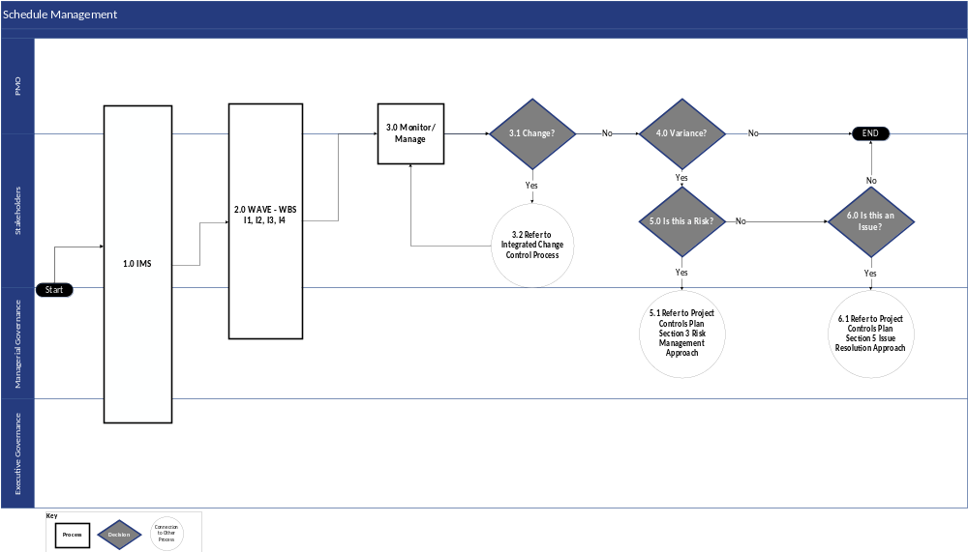
Figure 11-1: Schedule Management Process Flow Diagram

Schedule Management Process Flow Narrative
The following table details the steps outlined in the diagram above.
Step # | Work Plan Process | Description | Stakeholder Group(s)
1 | Integrated Master Schedule (IMS) | Prior to initiating the development of the Work Plan, develop a Master ISOW Integrated Project Schedule. This document is based on the current project scope, IMS, as outlined in the MSOW, and anticipated future project Waves. The Master ISOW Integrated Project Schedule is a baselined work plan that provides the overall project schedule; key milestones; and work effort, resource, and cost estimates, by Wave.  The Master ISOW Integrated Project Schedule informs the more detailed Work Plan, or Work Breakdown Structure (WBS), which will be created at the beginning of every Wave for work to be performed in that Wave. The Baselined Work Plan and Schedule (DEL-06), which will be a Microsoft Project file, will be the single project schedule that represents the full schedule and status across all project waves for Deloitte and DOH. | - PMO  - Stakeholders  - Managerial Governance  - Executive Governance
2 | Wave – WBS  I1, I2, I3, I4 | Develop the WBS for the current Wave. The WBS should contain the detailed schedule, resource assignments, dependencies, and constraints for the deliverables.  The WBS is used to direct project execution and delivery of the Wave deliverables contributing to the project solution. | - PMO  - Stakeholders  - Managerial Governance
3 | Monitor / Manage | Compare actual project progress against the Work Plan on a weekly basis through the duration of the project. Share findings at Project Status Report meeting, or alternative weekly meeting for schedule management items to be arranged between DOH OHIP and ███████. | - PMO  - Stakeholders
3.1 | Change? | Based on the outcome of regular Monitor/Manage reporting, changes to the Work Plan to reflect the latest project updates could be needed.  - If there are needed changes to the Work Plan, proceed to Step #3.2 Refer to Integrated Change Control Process  - If there are no changes to the Work Plan, proceed to Step #4 Variance? | - PMO  - Stakeholders
3.2 | Refer to Integrated Change Control Process | The ICCP (refer to Section 10) outlines the process for submitting and reviewing a Change Request. | - Stakeholders
4 | Variance? | Based on the outcome of regular Monitor/Manage reporting, the project team could identify a variance. A variance occurs when project execution deviates from the Work Plan.  - If there is a variance, proceed to Step #5 Is this a Risk?  - If there is no variance, proceed to End | - PMO  - Stakeholders
5 | Is this a Risk? | If there is a variance between project execution and the Work Plan, stakeholders must determine if the variance poses a risk. Stakeholders will complete the process defined in the Project Controls Plan (refer to Section 9) to determine if the variance is a risk and address it according to the Risk Management Approach.  - If the variance is a risk, proceed to Step #5.1 Refer to Project Controls Plan Section 9.3 Risk Management Approach  - If the variance is not a risk, continue to Step #6 Is this an Issue? | - Stakeholders
5.1 | Refer to Project Controls Plan Section 9.3 Risk Management Approach | Section 9 Project Controls Plan outlines the process for addressing project risks. If, after review, it is determined that the variance is a risk to the project, Section 9.3 Risk Management Approach provides the necessary procedure. | - Managerial Governance
6 | Is this an Issue? | If there is a variance between project execution and the Work Plan, but it is not a risk, stakeholders must also determine if the variance is an issue. Stakeholders will complete the process defined in the Project Controls Plan (refer to Section 9) to determine if the variance is an issue and address it according to the Risk management Approach.  - If the variance is an issue, proceed to Step #6.1 Refer Project Controls Plan Section to 9.4 Issue Resolution Approach  - If the variance is not an issue, proceed to End | - Stakeholders
6.1 | Refer to Project Controls Plan Section 9.4 Issue Resolution Approach | Section 9 Project Controls Plan outlines the process for addressing project issues. If, after review, it is determined that the variance is an issue for the project, Section 9.4 Issue Resolution Approach provides the necessary procedure. | - Managerial Governance
Table 11-1: Schedule Management Process Flow Narrative

Schedule Performance Monitoring

Background and Purpose
Schedule performance monitoring includes tracking schedule status and progress, monitoring schedule performance, and reviewing and discussing schedule performance measurements with the DOH OHIP stakeholders. As schedule performance is measured and monitored, the results become inputs into schedule monitoring and control, implementation of changes or modifications to the schedule, and/or escalation of schedule risks or issues.
Schedule performance monitoring includes status reporting as well as more specific schedule reviews in preparation for key milestones as designated in the Work Plan. ███████ will leverage the Project Status Report to report on schedule performance. The recurring cadence of the PSR provides a proactive mode to discuss the current state of schedule performance prior to any schedule risks or issues.

Schedule Performance Index
For the Continuing Medicaid Eligibility Modernization project, ███████ will leverage the Schedule Performance Index (SPI) as the Key Performance Indicator (KPI) to measure schedule performance. ███████ will include SPI as part of the PSR.
SPI provides a quantitative measure of schedule performance that measures the efficiency of time utilization in a project. SPI functions as a real-time system, allowing ███████ to identify potential schedule issues before they escalate. By analyzing SPI values, ███████ can proactively address schedule slippages, reallocate resources, and implement corrective actions promptly.

Variance
To effectively gauge the performance of the project schedule, variance and threshold values are set for the SPI. By having defined, agreed-upon values for variance and threshold, ███████ and DOH OHIP can measure the progress of the project schedule through the same lens. Variance refers to any SPI value that is not 1. Throughout the duration of the Continuing Medicaid Eligibility Modernization project, the ███████ PMO will monitor and communicate the project’s SPI. As part of effective performance monitoring, the ███████ PMO will establish variance thresholds to monitor and manage against. Based on the variance threshold, the ███████ PMO will take the appropriate next steps to communicate the project schedule status to DOH OHIP. The SPI variance thresholds are subject to change based on mutual agreement between ███████ and DOH on the updated metrics. The following table outlines the SPI variance thresholds with subsequent details.
Variance Type | Threshold | Description
On-Track | SPI ≥ 0.95 or  SPI ≤ 1.05 | The goal of schedule performance monitoring is to maintain the project schedule within the thresholds of the On-Track variance, which indicates that the project is effectively on schedule.
At-Risk | 0.91 ≤ SPI ≤ 0.94 or  1.06 ≤ SPI ≤ 1.09 | When an At-Risk variance in the SPI occurs, this indicates that the project schedule needs corrective action. ███████ will leverage this threshold to serve as real-time indicators for potential proactive corrective actions to prevent the SPI from reaching an Off-Track variance. ███████ will log the SPI as a risk and take appropriate actions to get the project back on track.
Off-Track | SPI ≤ 0.90 or  SPI ≥ 1.10 | When an Off-Track variance in the SPI occurs, this indicates that the project requires immediate mitigation measures. ███████ will log the SPI as an issue and implement mitigation actions to get the project schedule back on track (i.e., to At-Risk and ultimately On-Track status).  An SPI ≥ 1.10 Indicates that the project is ahead of schedule. In these instances, Deloitte will conduct a review and assessment as to why the SPI is not more closely aligned with the On-Track variance.
Table 11-2: SPI Variance Types

Stakeholder Engagement
███████ will include SPI in the PSR. During the PSR meeting, ███████ and DOH OHIP will discuss the SPI, contributing factors, and mitigation measures for any potential risks or realized issues. The inclusion of SPI in the PSR helps confirm that schedule performance monitoring is not a one-time assessment but rather a continuous improvement process throughout the life cycle of Continuing Medicaid Eligibility Modernization.

Sample SPI Dashboard
Below is an example of an SPI dashboard used to depict project schedule performance within the bounds of the agreed-upon threshold and variance metrics. Upon finalizing the SPI dashboard for the Continuing Medicaid Eligibility Modernization project, it will be included as part of the PSR.
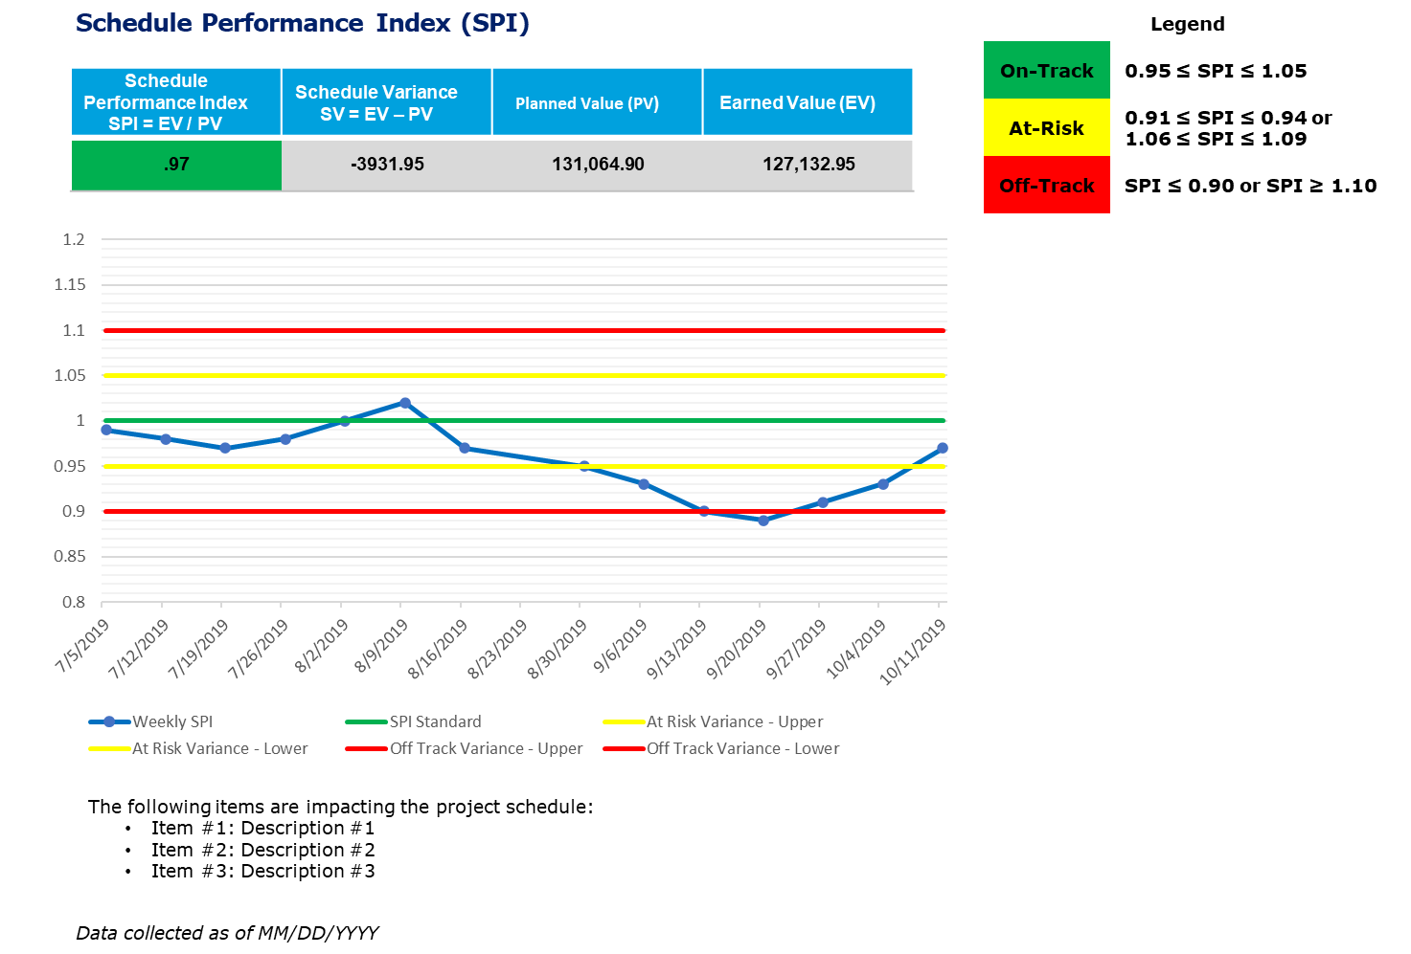
Figure 11-2: Sample SPI Dashboard

Work Plan
The Work Plan uses all holidays from the NY State holiday calendar as the basis for working day exceptions. Additionally, the ███████ holiday calendar is factored in for tasks owned by ███████. The guidelines to account for State-specific holidays are in Section 11.5.4 Operational Quality, under “Holiday Check.”

Core Contents
The Work Plan defines the planned timeline for the completion of project work activities, deliverables, and milestones throughout the project life cycle. The team uses this to monitor schedule variances during the project and to identify tasks that may cause the timeline to change.
The Work Plan will provide a “baselined” description of the work and scheduled deliverables for the Continuing Medicaid Eligibility Modernization project. Once the Work Plan is baselined, it is controlled in accordance with Section 11.3.2 Schedule Management Process Flow Narrative Step #3.2 Refer to Integrated Change Control Process and Section 11.6.6 Controlling the Schedule.
The Continuing Medicaid Eligibility Modernization Work Plan contains the following:
- Tasks
- Phases
- Project Initiation
- Planning
- Monitor and Control
- Requirements
- Development
- Interfaces
- Data Conversion
- Technology
- Security and Privacy
- Testing
- UAT
- Production Implementation
- Project Close-Out
- Enhancements
- Wave 1 Change Management
- Milestones
- Project Start and Project Finish
- Phase completions
- Deliverables
- Key events (e.g., Go-Lives, Kick-Offs)
- Duration (the span in days between the Start and Finish date of each task)
- Dependencies (a set of predecessors and successors)
- Responsible resources (███████ and/or State Team(s) responsible for tasks and/or deliverables)
- Critical Path Tasks

Work Plan Fields
The table below includes the list of fields included in the Work Plan.
Item | Details
WBS | A Work Breakdown Structure (WBS) is a hierarchy of the work that will be done for a project. It represents the project team’s understanding of the composition of work and includes the size and duration of each component.
SPI | The Schedule Performance Index (SPI) is a performance indicator that measures the efficiency of time utilization in a project. It is calculated by dividing the hours spent, based on percent complete, by the total planned number of hours for each task. The Work Plan allocates 8 hours per day per team for each task to calculate the total hours worked.
% Complete | This is a Microsoft Project default attribute and is tracked in percentage (%).
Status | This field indicates the current status of a task based on SPI, specifying whether the task is Complete, On Schedule, Late, or a Future Task.
Task Name | Tasks should be formulated as a phrased length synopsis of the activity being performed and utilizes Verb-Noun form. The description of an activity or milestone is brief, but specific enough to differentiate it from other similar activities in the schedule.
Duration | This is a Microsoft Project default attribute and is tracked in days. Duration is the amount of working time, displayed in days, from the start to finish of an activity (task). It is the total span of active working time for an activity (task) as entered or calculated automatically based on start date, finish date, calendars, and other scheduling factors, like dependencies.
Start | This is a Microsoft Project default attribute and is formatted in the Microsoft Project Default setting of abbreviated day and mm/dd/yyyy date. It denotes the intended start date of a task. An Activity Start Date is the date a project activity is expected to begin and/or actually begins. Activity Start Date may also represent the date when a predecessor activity may end, which serves as the start date for a successor activity.
Finish | This is a Microsoft Project default attribute and is formatted in the Microsoft Project Default setting of abbreviated day and mm/dd/yyyy date. The Activity Finish Date is the date a project activity is expected to be completed and/or actually completed.
Predecessors | This is a Microsoft Project default attribute. This denotes an activity that must be completed and/or started before this task is undertaken. Predecessor and successor activities include activities with dependencies on another activity, which will be able to take place once the activity is started or completed.
Successors | This is a Microsoft Project default attribute. This denotes an activity that will be started after this task is completed.
Resource Names | This is a Microsoft Project default attribute that references the resource responsible for completing the task. The resource has ultimate accountability for executing and reporting the task. For this project, the named resource will be set to the organization and team responsible for completing the task.
Notes | This is a Microsoft Project default attribute and is used to record any pertinent information regarding the task as necessary. Additional information including detailed descriptions of an activity, or comments relating to it, can be included in the “Notes” data field of an activity within the project schedule.
Baseline Start | The planned beginning date for a task at the time a project baseline is set.
Baseline End | The planned completion date for a task at the time a project baseline is set.
Actual Start | The date that a task has actually begun.
Actual End | The date that a task has actually been completed.
Table 11-3: Standard Fields

Monitoring and Managing Updates
On a bi-weekly cadence, or more frequently if requested by DOH OHIP, progress is tracked in the Work Plan and performance will be analyzed and reported in project status reports. DOH OHIP and ███████ meet to discuss the milestones and outstanding tasks requiring discussion in the weekly schedule management meeting. This meeting helps to identify and remediate any tasks in the Work Plan prior to the updates to the PSR.

Operational Quality
The following activities will take place prior to the submission of the Work Plan and throughout the various updates made to the Work Plan. These operational quality checks will help improve the ongoing quality of the plan.
Quality Check | Description
Resource Check | Filter on Resource Name  - If Resource Name = “ “ (blank), then determine the appropriate resource and populate the field.  - Resources should only be assigned to the lowest-level tasks in the Work Plan
Milestone Check | Filter = Milestone (0-duration tasks)  - For each milestone, check to see if there has been any change in the milestone date. If there is a change, identify the corresponding task, or set of tasks, that caused the milestone to move beyond the baseline finish date
Actual Start Check | Filter on Actual Start Date and (Planned) Start Date  - If the planned start date is in the past (meaning the work was supposed to have started) and the actual start date is blank, identify the actual start date  - If the planned start date is in the past and the actual start date is blank and the work has not started, then highlight the associated activity to flag it for discussion with the appropriate resource
Planned Finish Check (tasks that are late) | Filter on (Planned) Finish Date  - If the planned finish date is in the past, then identify the latest status of the task. If the task is late, then highlight the associated activity to flag it for discussion with the appropriate resource
Actual Finish Check (tasks that are late) | Filter on Actual Finish Date  - If the actual finish date is blank, then work with the appropriate resource to identify if the task is complete. If the task is complete, populate the actual finish date
Predecessor Check | Filter on Predecessor  - If the predecessor is blank, then determine the appropriate predecessor for the task  - A predecessor should be assigned to the lowest level task  - Predecessor can be left blank if it is a recurring task or if it is the first task of the project
Successor Check | Filter on Successor  - If the successor is blank, then determine the appropriate successor for the task  - A successor should be assigned to the lowest level task  - Successor can be left blank if the task has no dependent tasks following it or if it is the last task of the project
Holiday Check | Filter on State Specific Holidays  - New Year’s Day  - Dr. Martin Luther King, Jr. Day  - Washington’s Birthday (President’s Day)  - Memorial Day  - Juneteenth  - Independence Day  - Labor Day  - Columbus Day  - Election Day  - Veterans Day  - Thanksgiving Day  - Christmas Day  Note: The list of observed State holidays is subject to change and will be reconciled with the legal holiday calendar released by New York State (NYS) each year.  If a date for the task needs to be adjusted, put the date that the task will be completed on, in the Due Date column.  - Rules like the Deliverable socialization date and DED/Deliverable walkthrough dates will need to be made on how we adjust the due date.
Percent Complete | The following standards will be used when updating the % Complete column in the Work Plan.  - 25% - Task has been started  - 50% - Task is in progress  - 75% - Task is completed, but requires updates due to reviews/comments received  - 100% - Task is complete
Table 11-4: Quality Checks

Task Creation and Maintenance
The following sub-sections describe the detailed processes for the creation and maintenance of tasks.

Establishing the Overall Work Plan Structure
The structure of the Work Plan should adhere to the following guidelines:
- Each phase and subphase ends with a completion milestone that follows the Phase/Subphase Name + “Completed” format (e.g., Plan Requirements Completed, this will be tracked in Requirements Traceability Matrix (DEL-19))
- For requirements and design sessions planning in the Work Plan, the start and finish of each session for each functional area are tracked; the Work Plan is not used as a calendaring tool to plan out each individual session, rather, the JAD Calendar is used for this purpose
- For displaying contractual deliverables in the Work Plan, the drafting and planning activities are in the individual workstream’s section. The submission, review, and invoicing activities of the deliverable are in the Monitor and Control section of the Work Plan under “Deliverable Transmittals and Invoices”, organized by Deliverable number. Below is an example of a single deliverable in the Work Plan:
Develop Deliverable (in Workstream section)
Develop [Deliverable Name] Deliverable
Submit [Deliverable Name] Deliverable to DOH for Collaboration
DOH Provides Comments [Deliverable Name]
███████ Responds to Comments on [Deliverable Name]
DOH Reviews Comments on [Deliverable Name]
[Deliverable Name] Review Complete and Ready for Transmittal
Table 11-5: Example Deliverable Development Tasks in Work Plan
Transmit Deliverable (in Monitor and Control section)
███████ Prepares [Deliverable Name] Deliverable Transmittal
███████ Submits [Deliverable Name] to DOH
DOH Reviews [Deliverable Name]
███████ Completes Updates and Re-Submits [Deliverable Name] to DOH
DOH Approves [Deliverable Name] Transmittal
Table 11-6: Example Deliverable Transmittal Tasks in Work Plan

Creating a Task
The following are guidelines for the creation of all tasks in the Work Plan.
- Start all tasks with a verb or action
- Populate the following fields:
- Task Name
- Resource Name
- Duration
- Predecessors
- Notes, if applicable
- (Planned) Start Date (auto populated)
- (Planned) Finish Date
- Each task added to the Work Plan will be set to auto-schedule and Fixed Duration
- Where possible, custom fields are used with discretion and only if there is an agreement with ███████ and DOH OHIP
- If a task or activity has a predecessor dependency to a contractual deliverable, establish the dependency with the SUBMISSION milestone for that deliverable rather than the APPROVAL milestone
- If a task is required to achieve a milestone within a specific phase, it should always be structured under that phase, even if it means that it will start before the previous phase(s) are completed (by leveraging lag/slack in its task dependencies if necessary)
- The duration of a task should be an accurate estimation of the anticipated number of days needed to complete the task

Removing or Cancelling a Task
Once the plan is baselined, a task should never be removed from the Work Plan. If a task is determined to be no longer necessary, then the steps below should be followed:
- Determine if the removal of the task warrants a CR per the ICCP (refer to Section 10)
- Update the duration of the task to 0 days
- Update the percent complete to 100%
- Update the task name as CANCELLED on [Date] with the date the task was cancelled, as well as the reason for task cancellation
- Update the notes section with the original task name

Assigning a Task
Maintaining a standardized list of available team and resource names allows the Work Plan task to be assigned to the proper team and task owner. Resources will be maintained by the ███████ PMO in collaboration with DOH OHIP.
Assign the “Resource Name” of each lowest-level task in the Work Plan to a designated team of people responsible for completing the task; this allows the Work Plan to be sorted by project workstream. Individual tasks within teams are decided upon by team leads. The responsibility for completion falls to the lead of the assigned team.

Leveling and Resource Balancing
Since each assigned “resource” in the Work Plan represents a team of people performing the task, resource balancing will not be performed.
- Each team lead is responsible for managing the allocation of effort by the team’s respective members to manage to the due dates set forth in the work plan. If the team lead identifies that their team may not be able to complete activities as planned due to resource constraints, they will consult with the team managing the work plan, draft a schedule risk per the Project Controls Plan, and present remediation options to ███████ and DOH OHIP project leadership. Once a remediation approach is confirmed, any resulting schedule changes will be incorporated into the Work Plan.

Controlling the Schedule
Schedule control processes serve to minimize schedule changes. Some control techniques reveal the status of the schedule where others suggest action to bring the project back on schedule. The table below lists some control techniques that may be used to control the Work Plan.
Technique | Definition
Performance Reviews | Performance reviews measure, compare, and analyze schedule performance such as actual start and finish dates, percent complete, and remaining duration for the work in progress.
Scenario Analysis | Allows decision makers to explore the implications of several alternative future states thus avoiding the danger of single-point forecasts. Conducted in a nonthreatening group setting, participants express beliefs, challenge assumptions, and alter their viewpoints to ultimately arrive at a strategic direction that is flexible and will remain so as actual events unfold.
Forward-Pass Analysis | Calculation of early start dates and early finish dates for uncompleted portions of all network activities. Determined by working forward through the network logic from the project’s end date.
Backward-Pass Analysis | Calculation of late finish dates and late start dates for uncompleted portions of all network activities. Determined by working backward through the network logic from the project’s begin date.
Critical Path Method | Predicts project duration by analyzing the sequence of activities (network path) that has the least amount of scheduling flexibility (i.e., float). Early dates are calculated by a forward pass using a specified start date. Late dates are calculated by a backward pass starting from a specified completion date (usually forward pass’s calculated early finish date for the project.)
Monte Carlo Simulation | A technique in which the project team leader or project team computes and/or quantifies the complete and total project cost and/or project schedule a number of times through the use of input values that are selected at random through the careful utilization of probability distributions or potential costs and/or potential durations. The purpose of utilization of the Monte Carlo analysis is for the sake of calculating a defined distribution scenario of possible total costs associated with the project as well as a range of possible completion dates of the project.
Variance Analysis | The goal is to determine the causes of a variance (that is to say, the difference between an expected result and an actual result).
Schedule Compression | Shortening of the schedule without reducing the project scope. Often requires an increase in project cost.
Fast Tracking | Compressing the project schedule by overlapping activities normally performed in sequence, such as Design and Build/Construction.
Free Float & Total Float (or Slack) | Free float is the amount of time an activity can be delayed without delaying the early start of any immediately succeeding activities. Also called secondary float.  Total float is the amount of time an activity can deviate from its early start without delaying the project end date. Derived by subtracting the early start from the late start, or the early finish from the late finish, and may change as the project progresses and as changes are made to the project plan. Also called slack, float, and path float.
Adjust Leads and Lags | Lead: A modification of a logical relationship that allows an acceleration of the successor activity such as when a task has a finish-to-start dependency with a ten-day lead, the successor activity can start ten days before the predecessor activity has finished.  Lag: The modification of a logical relationship that directs a delay in the successor activity such as when a task has a finish-to-start dependency with a ten-day lag, the successor activity cannot start until ten days after the predecessor activity has finished.  Adjusting leads and lags is used to find ways to bring project activities that are behind into alignment with the plan.
Table 11-7: Schedule Techniques

Adding Notes to a Task
Tasks should include notes when additional information or updates are provided. The structure of notes will adhere to a chronological order with the most recent note at the top. As such, an example is provided below:
- 01/02/2024: requires an update from the technical team
- 12/27/2023: awaiting the return of networking staff – updated duration of the task from 10 to 12 days
- 12/20/2023: task identified to assist with technical coordination
Notes can be used to identify action items. If the note contains an action item, the identifier “Action:” will be used to identify the note as an action item. Action items identified in the notes field should also be logged in the ALM tool.

Flagging Tasks for Discussion
In some instances, a task may need to be flagged for discussion. To identify a task that requires discussion, highlight the tasks in yellow. The tasks flagged for discussion will be reviewed during the weekly schedule management meeting as indicated in Section 11.5.3 Monitoring and Managing Updates.

Baselining the Project
The project’s schedule baseline defines the planned, agreed, and approved timeline for completion of project work activities, deliverables, and milestones throughout the project life cycle. This baseline is used to monitor schedule variances during the project and to identify tasks that may cause the timeline to slip. The updates to the tasks and the re-baselining of a project will be discussed if needed during weekly project management meetings, and then submitted and approved by the Change Control Board in consultation with Executive Governance.

Section 12 – Requirements Management Plan

Requirements Management Plan

Introduction
A requirement is a specific condition or capability that must be included in a product, service, or outcome to meet a business need. Requirements can range from broad, overarching statements, like those in a business case, to very detailed descriptions, such as the acceptance criteria for a particular system component (PMBOK, 2021). To implement the MECM solution, requirements must be stated in a clear, concise way and managed accordingly. Refer to Appendix F for resources on best practices for drafting requirements. The Requirements Management Approach in Section 12.3 outlines the processes necessary for the DOH OHIP to verify that the project requirements are managed and that traceability across phases is documented. This section addresses how the MECM system will be designed, developed, and implemented based on the requirements.
Requirement traceability for the Continuing Medicaid Eligibility Modernization project will be tracked and reported through the ALM tool (refer to Section 12.6.1 Requirements Management Tool).

Purpose
The Requirements Management Plan lays out how requirements (including Functional and Non-Functional) will be validated and managed throughout the project. Additionally, the Requirements Management Plan prescribes the tools and methodologies for capturing, standardizing, classifying, monitoring, reporting, maintaining, and managing requirements as well as downstream traceability to design, development, and testing.
The objectives of the Requirements Management Plan are to:
- Provide a plan that guides and governs stakeholders in collecting requirements during the Planning phase of the project
- Help parties involved in the process understand their role and the outcomes that will be achieved
- Specify outputs for the Requirements Traceability Matrix (DEL-19) and the Requirements Specification Document (DEL-18)
- Describe the methodology and processes used for requirements validation

Requirements Management Approach
There are specific tasks that are performed to manage and maintain a requirement through its life cycle, including establishing relevant relationships between requirements to design documents and components, development widgets, test cases (which include test results) as well as assessing, analyzing, and gaining consensus on proposed changes to requirements. Deloitte analyzes the MECM requirements applicable for a particular iteration or bundle and then clarifies them in preparation for validation sessions. The requirements are then reviewed and validated with DOH OHIP. During the requirements validation sessions, ███████ will work with DOH OHIP to understand the priority and business needs of requirements and how each requirement relates to the specific iteration/bundle and the overall system. As requirements are baselined for an iteration/bundle, ███████ may analyze requirements and assist DOH OHIP to defer or deprecate requirements. Deferred requirements may be placed in a backlog to be considered for future bundle planning.

Requirement Types
Requirements are defined to be usable representations of business needs. The project requirements are classified into the following categories:
- Functional Requirements: Defines the expected functionality of the solution; these requirements are categorized into Appeals, Assistor Portal, Eligibility, Enrollment, Interfaces, Member Portal, Notices, Reports, Support Functions, Worker Portal, and Workload Management
- Non-functional Requirements: Defines the specific technical requirements that must exist in the solution to deliver the business functionality, the operational objectives of the solution, and the methodology and processes to manage the solution delivery; these include Application Architecture, Integration Architecture, Data Architecture, Infrastructure Architecture, Data Conversion, Accessibility, Manageability, Reliability, Scalability, Sustainability, Usability, Security and Privacy, Organizational Change Management, and Operations and Maintenance

Requirements Status Reporting
The status of the requirements will be reported in the Continuing Medicaid Eligibility Modernization PSR delivered weekly to DOH OHIP. This report will be discussed during the project status meeting. As requirements are in the ALM tool, ad-hoc reports and queries can be created to address questions or provide additional status.

Initial Requirements Approval Process
An organized initial approval process flow and RTM are crucial for capturing comprehensive and accurate project requirements. The process begins with gathering detailed input documents and performing gap assessments to identify additional needs, making sure no requirement is overlooked. Validation sessions clarify and confirm requirements, aligning all stakeholders. Assessing the impact on timeline, budget, and schedule helps manage potential project risks. Approved and baselined requirements provide a reference point for future changes, enabling effective tracking. The RTM maintains traceability, accountability, and continuous stakeholder feedback, fostering a transparent and collaborative project environment.

Initial Requirements Approval Process Flow
The process flow below identifies the initial requirement approval steps.
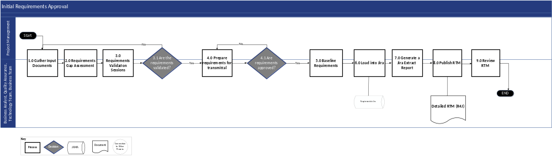
Figure 12-1: Requirements Management Process Flow Diagram

Initial Requirements Approval Process Flow Narrative
The following table describes each process step illustrated above. NOTE: The stakeholder groups involved in post transmittal approval of requirements include, but are not limited to Project Management, Business Analysts, Quality Assurance, Technology team, and Business team.
Step # | Process | Description | Stakeholders
1 | Gather Input Documents | Input documents cover the high-level process flows, rules and expected system behavior for the project.  All team members from DOS can source input documents to inform requirements. | - ███████/DOS PMO  - Business Analyst  - Quality Assurance  - Technology Team  - Business Team
2 | Requirements Gap Assessment | Relevant stakeholder groups will perform requirements gap assessment activity to compare expected functionality with the baseline Medicaid Transformation programs used to inform MECM.  The team will then be able to select requirements from the base solution and identify additional needs that do not exist in the current solution. | - ███████/DOS PMO  - Business Analyst  - Quality Assurance  - Technology Team  - Business Team
3 | Requirements Validation Sessions | All requirements must be validated prior to inclusion in the RTM.  The Project Management team and stakeholder groups will conduct Requirements Validation sessions where requirement gaps identified in the requirements gap assessment are discussed in detail, items are clarified by policy and a better understanding of requirements is established. | - ███████/DOS PMO  - Business Analyst  - Quality Assurance  - Technology Team  - Business Team
3.1 | Are the Requirements Validated? | During the Requirements Validation sessions, attendees determine whether the requirements are validated and can be included in the RTM.  - If the requirements are validated during the Requirements Validation sessions, proceed to Step #4 Prepare requirements for transmittal  - If the requirements are not validated, return to Step #1 Gather Input Documents | - ███████/DOS PMO  - Business Analyst  - Quality Assurance  - Technology Team  - Business Team
4.0 | Prepare Requirements for Transmittal | Once the requirements are validated, prepare the deliverables for transmittal approval (including Requirements Specification Document (DEL-18) and Requirements Traceability Matrix (DEL-19)). | - ███████/DOS PMO  - Business Analyst  - Quality Assurance  - Technology Team  - Business Team
4.1 | Are Requirements Approved? | Requirements must be approved prior to inclusion in the RTM.  - If the requirements are approved, proceed to Step #5 Baseline Requirements  - If the requirements are not approved, return to Step #4 Prepare requirements for transmittal to perform adjustments as needed for re-submission | - ███████/DOS PMO  - Business Analyst  - Quality Assurance  - Technology Team  - Business Team
5 | Baseline Requirements | The approved requirements serve as the established baseline requirements for the Wave. | - ███████/DOS PMO  - Business Analyst  - Quality Assurance  - Technology Team  - Business Team
6 | Load into the ALM tool | Baselined requirements are loaded into the ALM tool for traceability going forward. They are also used to drive design and implementation processes. | - ███████/DOS PMO  - Business Analyst  - Quality Assurance  - Technology Team  - Business Team
7 | Generate an ALM tool Extract Report | This report creates the RTM. The extract is reviewed and validated to verify all test cases and design documents are linked. | - ███████/DOS PMO  - Business Analyst  - Quality Assurance  - Technology Team  - Business Team
8 | Publish RTM | In the RTM, each requirement is assigned an identification number and, if possible, mapped to the baseline Medicaid solution.  The RTM is then published via the requirements management tool for all stakeholders to review. (The format of the RTM extract is subject to the capabilities of the requirements management tool) | - ███████/DOS PMO  - Business Analyst  - Quality Assurance  - Technology Team  - Business Team
9 | Review RTM | Project Management and relevant stakeholder groups review the RTM and provide feedback and comments, if needed. | - ███████/DOS PMO  - Business Analyst  - Quality Assurance  - Technology Team  - Business Team
Table 12-1: Initial Requirements Approval Process Flow Narrative

Post Transmittal Approval Requirements Modifications
Changes to requirements can significantly impact the project lifecycle, often dependent upon updates to design documents. These changes may arise from various sources, such as defects discovered during testing, which require modifications to system code and corresponding design documentation. In addition, observations, or discussions during Integrated JAD sessions may highlight the need for further clarification or confirmation of designs, prompting updates. Solution Exploration activities can also lead to adjustments in system code and design documents to better align with the desired outcomes. DUM meetings, where ███████ and DOH OHIP discuss unresolved items from JADs and other meetings, may result in decisions that call for design updates. Project timelines and resource availability can impact requirements, as constraints or extensions may require re-evaluation and adjustment of the project scope to align with overall objectives. Changes are evaluated for their potential impact on the project's quality, schedule, budget, and resources, thereby mitigating risks and maintaining project quality. This evaluation process requires the ICCP, which is discussed further in Section 10.
Maintaining requirements is a critical aspect of project management, involving several key activities to keep them accurate, relevant, and aligned with project objectives. This process includes regular reviews and updates to reflect changes in project scope, stakeholder needs, or external factors. Effective communication and collaboration between ███████ and DOH are essential to promptly identify and address any discrepancies or new requirements. Documentation practices, such as version control (highlighted in Section 12.7 Requirements Versioning Control) and traceability, are employed to track changes and maintain a clear history of requirement evolution. In addition, validation and verification activities are conducted to confirm that the requirements continue to meet the project's goals and can be feasibly implemented within the given constraints. By systematically managing requirements, projects can achieve better alignment with business objectives, reduce risks, and enhance overall project success.

Post Transmittal Approval Requirements Modification Process Flow
The process flow below identifies the post transmittal approval requirement modification steps.
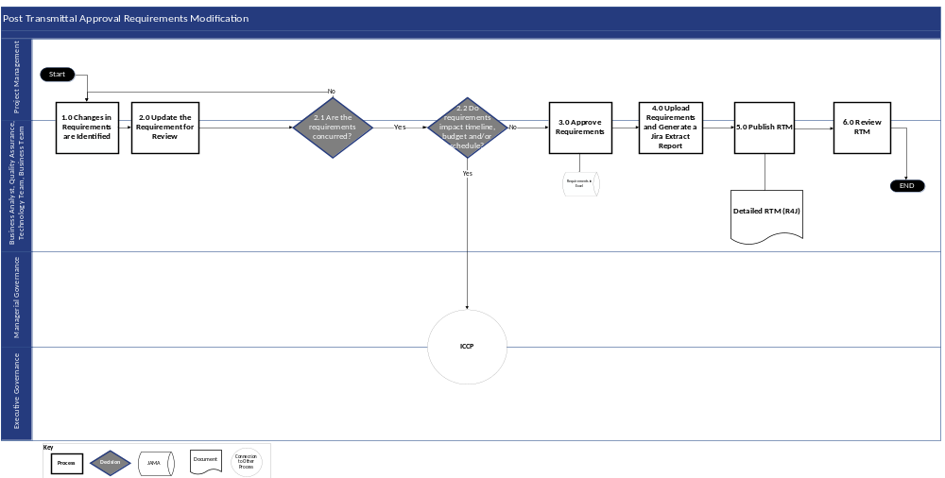
Figure 12-2: Post Transmittal Approval Requirements Modification Process Flow Diagram

Post Transmittal Approval Requirements Modification Process Narrative
The following table describes each process step illustrated above. NOTE: The stakeholder groups involved in post transmittal approval of requirements include, but are not limited to Project Management, Business Analysts, Quality Assurance, Technology Team, and Business team.
Step # | Process | Description | Stakeholder
1 | Changes in Requirements are Identified | Identify whether the requirement needs to be changed, updated, or if a new requirement needs to be created. | - ███████/DOS PMO  - Business Analyst  - Quality Assurance  - Technology Team  - Business Team
2 | Update the Requirement for Review | Once the necessary changes are identified, the impacted requirement(s) are updated accordingly. | - ███████/DOS PMO  - Business Analyst  - Quality Assurance  - Technology Team  - Business Team
2.1 | Are the Requirements Concurred? | During the review, DOH OHIP will determine whether they concur with requirements and if the requirements can be included in the RTM.  - If the requirements are concurred, proceed to Step #2.2 Do Requirements Impact Scope, Budget, and/or Schedule?  - If the requirements are not concurred, return to Step #2 Update the Requirement for Review to gather more inputs | - ███████/DOS PMO  - Business Analyst  - Quality Assurance  - Technology Team  - Business Team
2.2 | Do Requirements Impact Scope, Budget, and/or Schedule? | Determine if the requirements impact timeline, budget, and/schedule for the project.  - If requirements impact scope, schedule and/or budget, initiate a change request via the ICCP (refer to Section 10) to obtain approval and proceed to Step #4 Upload Requirements and Generate an ALM tool Extract Report  - If requirements do not impact timeline, schedule, and/or budget, proceed to Step #3 Approve Requirements | - ███████/DOS PMO  - Business Analyst  - Quality Assurance  - Technology Team  - Business Team
3 | Approve Requirements | Stakeholders validate and approve the requirement updates. | - ███████/DOS PMO  - Business Analyst  - Quality Assurance  - Technology Team  - Business Team
4 | Upload Requirements and Generate an ALM tool Extract Report | The approved Excel versions of the requirement updates are uploaded into the ALM tool and an extract of the requirements is generated from the ALM tool.  This report creates the RTM. The extract is reviewed and validated to verify all test cases and design documents are linked. | - ███████/DOS PMO  - Business Analyst  - Quality Assurance  - Technology Team  - Business Team
5 | Publish RTM | In the RTM, each requirement is assigned an identification number and, if possible, mapped to the baseline Medicaid solution.  The RTM is then published via the requirements management tool for all stakeholders to review. (The format of the RTM extract is subject to the capabilities of the requirements management tool.) | - ███████/DOS PMO  - Business Analyst  - Quality Assurance  - Technology Team  - Business Team
6 | Review RTM | Project Management and relevant stakeholder groups review the RTM and provide feedback and comments, if needed. | - ███████/DOS PMO  - Business Analyst  - Quality Assurance  - Technology Team  - Business Team
Table 12-2: Post Transmittal Approval Requirements Modification Process Flow Narrative

Requirements Traceability
Traceability in this project involves making sure that each requirement is clearly linked to the relevant design documents or components and the corresponding test cases. This process helps to confirm that every requirement is implemented correctly and avoid the addition of any unnecessary requirements. In addition, design documents and components should be connected to both development tasks and test cases to provide thorough coverage and verification throughout the project lifecycle. Occasionally, requirements can also be linked to other related requirements.
It's important to understand that the requirements management tool in the ALM tool is a tool that helps us visualize these connections in an easy-to-understand way, but it doesn't create the connections. Therefore, achieving traceability means to actively create and maintain these connections, rather than just relying on the requirements management tool to show them. If requirements, design documents, components, and test cases are not systematically linked, or if there is sole reliance on the requirements management tool without manual verification and documentation, true traceability will not be achieved.

Requirements Management Tool
The ALM tool will be used to manage requirements as well as associated design, development, and testing activities for the MECM system. Initially, the list of requirements defined in the Continuing Medicaid Eligibility Modernization MSOW as well as those approved during the Requirements phase will be bulk loaded into the ALM tool. Any subsequent additions, modifications, or removal of approved requirements will be managed via the ICCP process (refer to Section 10). Once the requirements are loaded, they serve as the foundation that supports downstream project activities including design, development, and testing. Traceability in the ALM tool is established by linking each approved requirement to the applicable design, development, and testing tickets. The traceability of these ticket types is visualized using the requirements management tool the ALM tool plug-in (refer to Section 2.34). Approved updates to requirements are performed and maintained in the ALM tool.

Requirements Attributes in the ALM tool
When documenting requirements in the ALM tool, attributes for both Functional and Non-Functional requirements are captured. These attributes are utilized within the ALM tool requirements management tool.
Access the field attributes in the ALM tool, defined and continuously maintained in the ALM Tool User Guide and ALM Tool Reference Guide via this link: The ALM tool

Requirements Versioning Control
To monitor and track the requirement deliverable submissions, standards and document versioning are defined for the MECM system, as follows:
- Pre-work for requirements will begin as v0.1
- Every subsequent submission post discussion with DOH OHIP will be incremented by 0.1 versions, i.e., validation sessions submissions will be incremented as 0.2, 0.3 etc.
- Once the requirements are approved, the baselined version submission is v1.0
- Re-submissions based on change requests increment by 0.1
- Version tracking will include the change requests included for every increment
v0.1 | v1.0 | v1.1
Requirements pre-work and validation session submissions versions will begin with v0.1 and increment by 0.1 | Baselined requirements once approved will be v1.0 | Requirements re-submissions based on change requests will be v1.1 and increment by 0.1
Table 12-3: Versioning

Appendices

Appendix

Appendix A: Terms and Definitions
Term | Definition
Activity | An activity is defined as a summary level task.
Action Item Identifier | An Action Item Identifier (AI Identifier) can be anyone involved in the quality assessment process who identifies actions to be taken by the Action Item (AI) Owner.
Action Item Owner | An Action Item Owner (AI Owner) is the individual selected by the Action Item (AI) Identifier that manages an item and provides the ALM tool updates on its resolution status.
Baselined Work Plan | This is a work plan and schedule that is managed in an appropriate project management tool, with sufficient detail to support the projected durations
Bundles | Bundles are subsets of iterations that are further broken down which break topics logically and creates more FDDs which are easier for stakeholders to consume when they review and approve
Deliverable Acceptance Criteria | Conditions that a deliverable must meet for DOH OHIP approval.
Deliverable Expectations Document | A template for a deliverable that also contains defined review and/or acceptance criteria for the deliverable.
Deliverable Management | Guidelines and procedures for developing and steering deliverables through the DOH OHIP approval process
Deliverable Management RACI | Document that details the key deliverable management roles and responsibilities that helps the project team monitor task progress to inform project leadership and guide resources
Issue | A validated risk that materializes.
Issue Resolution Plan | A narrative documented in the ALM tool for a specific issue to document resolution steps.
Iteration | An iteration is a means to deliver working software incrementally during the SDLC. Each iteration will include a Design, Development and SIT phases within it.
Key Personnel | Vendor project leadership, as identified in the MSOW.
Managers | Each project track and accompanying tasks will be led by a manager and their corresponding staff.
Master ISOW Integrated Project Schedule | The Master ISOW Integrated Project Schedule is based on the current project scope, as outlined in the MSOW, and anticipated future project Waves. The Master ISOW Integrated Project Schedule provides the overall project schedule; key milestones; and work effort, resource, and cost estimates, by Wave. This document is required in the MSOW.
Master Transmittal Tracker Spreadsheet | An Excel document that tracks details of document transfers with DOS such as the date and time of the transmittal and the version of the document.
MITA | Medicaid Information Technology Architecture
Phase Gate | Set of criteria to be met in each phase before continuing to the next phase.
Project Director | Oversees all project tracks, which include Implementation and Change Management, Technical, PMO, Test, and Functional.
Project Executive | Leads the Continuing Medicaid Eligibility Modernization project with input from other members of project leadership who have relevant expertise.
Project Status Report | The Project Status Report (PSR) includes project updates for discussion during regular meetings between DOH OHIP and ███████ teams.
Quality Assurance | Quality assurance is the process of performing planned, systematic activities to verify that the project is using the proper methods, templates, standards, and guidelines, as well as implementing the right processes to produce high-quality deliverables that satisfy project requirements.
Responsibility Assignment Matrix (RACI) | A type of responsibility assignment matrix (RAM) in project management. In practice, it’s a simple spreadsheet or table that lists all stakeholders on a project and their level involvement in each task, denoted with the letters R, A, C or I.
Requirements Management | Requirements management is the planning, execution, monitoring, and controlling of the work associated with requirements analysis and validation and the associated requirements process.
Requirements Traceability | Requirements traceability is the process of documenting the links between the requirements & the artifacts developed to implement & verify those requirements.
Review Cycle | The cadence through which ███████ and OHIP will coordinate the initial deliverable, review, and re-submission process.
Risk | An event that has a probability of occurrence and if it does occur, will impact the project schedule, scope, budget, or quality.
Risk and Issue Log | A Risk and Issue Log is a shared document to track potential risks and ongoing issues throughout project life cycle.
Risk Response Plan | A narrative documented in the ALM tool for a specific risk to document mitigation steps as well as contingency steps.
Schedule Management | Schedule Management identifies a scheduling method and Microsoft Project sets the format and establishes criteria for developing and controlling the project schedule.
Slack | Slack is the amount of time a task can start early (positive slack) or slip (negative slack) before it affects another task or the project’s finish date.
Solution Exploration | Solution Exploration allows stakeholders/end users to validate that implementation of the design aligns with the JADs and provide the ability to verify that the configuration of the solution matches the policy definitions. This will ultimately allow DOH to provide feedback and be comfortable with the system prior to the pre-UAT phase of the project.
Stakeholders | Stakeholders are defined as a person or group of people, internal or external to the organization that have a vested interest in the project and are involved in and/or impacted by the Continuing Medicaid Eligibility Modernization project.
Transmittal Repository | A folder that is located on the DOH SharePoint and is used for storing and disseminating Transmittals between ███████ and DOH OHIP. This folder will include:  - Master Transmittal Tracker Spreadsheet  - DLTT Transmittal Subfolder: All transmittals from Deloitte to DOS are stored in this subfolder  - MECM Transmittal Subfolder: All transmittals from DOS to Vendor are stored in this subfolder  - Transmittal Templates Subfolder: All transmittal templates are maintained and saved in this subfolder  - Transmittal Process Documents Subfolder: All process related documentation and training materials are maintained and saved in this subfolder.
Variance | A variance occurs when project execution deviates from the Work Plan.
Wave | A set of requirements that needs to be met during a rolling planning with interactive design, development, and implementation of a system.
Work Breakdown Structure (WBS) | The WBS is used to direct project execution and delivery of the Wave deliverables contributing to the project solution.
Table 13-1: Terms and Definitions

Appendix B: Acronyms
Acronyms used in this document are listed below for reference.
Acronym | Term
ACA | Affordable Care Act
AI | Action Item
ALM | Application Lifecycle Management
AMI | Amazon Machine Image
ARB | Architecture Review Board
BCD | Batch Control Document
BCDR | Business Continuity and Disaster Recovery Plan
BOM | Bill of Materials
CAB | Change Advisory Board
CCM | Client Communication Management
CHIPRA | Children’s Health Insurance Program Reauthorization Act
CIO | Chief Information Officer
CM | Change Management
CMMI | Capability Maturity Model Integration
CMS | Centers for Medicare and Medicaid Services
COTS | Commercial-off-the-Shelf
CR | Change Request
CRB | Change Review Board
CTO | Chief Technology Officer
DAST | Dynamic Application Security Testing
DED | Deliverable Expectations Document
DEMI | Division of Eligibility and Marketplace Integration
DOH OHIP | Department of Health Office of Health Insurance Programs
DOS | Division of Operations and Systems
DUM | Design Update Management
E2E | End to End
ESC | Executive Steering Committee
EVD | Enterprise Value Delivery
FDD | Functional Design Document
HIPAA | Health Insurance Portability and Accountability Act
HITECH | Health Information Technology for Economic and Clinical Health Act
ICCP | Integrated Change Control Process
ICD | Interface Control Document
IMS | Integrated Master Schedule
ISD | Initial Solution Definition
ISOW | Individual Statement of Work
ITS | Information Technology Services
KPI | Key Performance Indicator
M&O | Maintenance & Operations
MECM | Medicaid Eligibility and Client Management
MITA | Medicaid Information Technology Architecture
MSOW | Master Statement of Work
Non-MAGI | Short for Non-Modified Adjusted Gross Income. Non-MAGI population groups were not included in ACA’s Medicaid expansion and continue to operate under the eligibility guidelines, application and renewal procedures in place prior to the implementation of the ACA. include those aged 65 and over, disabled with Medicare, and/or Blind with Medicare.
NYS | New York State
NYSOH | New York State of Health
OBC | Outcome based Certification
OCM | Organizational Change Management
OHIP | Office of Health Insurance Programs
OPA | Oracle Policy Automation
ORT | Operation Readiness Test
PAE | Project Administration and Execution
PMBOK | Project Management Body of Knowledge
PMI | Project Management Institute
PMO | Project Management Office
PMP | Project Management Plan
PSC | Project Steering Committee
PSR | Project Status Report
QA | Quality Assurance
QA/QC | Quality Assurance/Quality Control
QMP | Quality Management Plan
RACI | A type of responsibility assignment matrix (RAM) in project management. In practice, it’s a simple spreadsheet or table that lists all stakeholders on a project and their level involvement in each task, denoted with the letters R, A, C or I. Responsible, Accountable, Consulted, and Informed
RAID | Risks, Assumptions, Issues, Dependencies
RPO | Recovery Point Objective
RSD | Requirements Specification Document
RTM | Requirements Traceability Matrix
RTO | Recovery Time Objective
SAST | Static Application Security Testing
SDLC | Software Development Life Cycle
SEI | Software Engineering Institute
SEQ | Security Evaluation Questionnaire
SI | Systems Integration
SIT | System Integration Test
SLA | Service Level Agreement
SOA | Service Oriented Architecture
SPI | Schedule Performance Index
SRTM | Security Requirements Traceability Matrix
SSA | Social Security Administration
SSP | System Security Plan
TMP | Test Management Plan
T-MSIS | Transformed Medicaid Statistical Information System
UAT | User Acceptance Test
Table 13-2: Acronyms

Appendix C: Roles and Responsibilities
Appendix C -1 SDLC Roles and Responsibilities Matrix
Many project roles or personas will be required to participate in the MECM SDLC Methodology, performing steps in the processes defined within each of the phases of the methodology. These roles or personas will have varying levels of responsibilities which will be defined through a RACI matrix applicable to the activities of each phase. In addition, the resources, or tools available to these roles or personas that will support them in carrying out these activities will be defined in the MECM SDLC RACI Matrix.
Stakeholder Group | Responsibilities
Executive Stakeholders
Medicaid Director | - Serves as the Executive Advisor for the program  - Participates in the ESC when needed  - Participates in Project Wave scope and decisions
Medicaid Chief Operating Officer (COO) | - Serves as the Executive Advisor for the program  - Participates in the ESC when needed  - Participates in Project Wave scope and decisions
Division of Eligibility and Marketplace Integration (DEMI) Director | - Serves as the Executive Sponsor for the program  - Heads the ESC and participates in ESC decision-making activities throughout the SDLC  - Serves as a business process advisor and point of escalation for the Director of Eligibility System Modernization role  - Participates in Project Wave scope and decisions
DEMI Deputy Director | - Oversees review and provide feedback for business process analysis and Change Management deliverables  - Authority to make CM decisions on behalf of the business for their functional area  - Authority to approve CM deliverables  - Responsible for bringing the appropriate policy, operations, or business stakeholders to business process analysis, CM tasks, and design working sessions when needed  - Identify stakeholders to participant in UAT, triage defects and validate test results
DOS Chief Information Office (CIO) | - Participates in the ESC  - Consulted for acquiring DOS resources and assigning roles and responsibilities to those resources  - Accountable for program management decisions that affect the MECM SDLC Methodology or other Project Management Plan (DEL-05) processes  - Participates in Project Wave scope and decisions
DOS Deputy CIO | - Participates in the ESC  - Responsible for acquiring DOS resources and assigning roles and responsibilities to those resources  - Accountable for program management decisions that affect the MECM SDLC Methodology or other Project Management Plan (DEL-05) processes  - Participates in Project Wave scope and decisions
DOS Deputy Director/Security and Privacy Bureau Director | - Participates in the ESC  - Provides oversight and is consulted on system privacy and security  - Participates in Project Wave scope and decisions
DOS Chief Technology Officer (CTO) | - Participates in the ESC  - Provides oversight and is consulted on system architecture design and business continuity  - Participates in Project Wave scope and decisions
DOS Project Director | - Participates in the ESC  - Provides program oversight and is accountable for DOS team tasks in the project work plan  - Is the DOH OHIP responsible party for each of the SDLC phase decisions to exit/enter a new phase  - Participates in Project Wave scope and decisions
DOS Technical Director | - Participates in the ESC  - Provides leadership and decision making on system architecture design and business continuity in collaboration with DOS CTO  - Review and provide feedback on architectural deliverables  - Authority to make architectural decisions (for example, approve sizing of cloud infrastructure)  - Available for working sessions to assist Deloitte in producing architectural deliverables  - Authority to approve technical deliverables  - Authority to approve software procurements  - Participates in Project Wave scope and decisions
███████ Project Executive | - Provides executive program oversight and is accountable for ███████’s services, performance, and work on the Continuing Medicaid Eligibility Modernization Project  - Advises the team on key aspects of the program, technical solution, and provides subject matter expertise  - Has contractual authority on behalf of Deloitte  - Participates in Project Wave scope and decisions
███████ Project Director | - Provides program oversight and is responsible for ███████’s services, performance, and work on the Continuing Medicaid Eligibility Modernization Project  - Manages quality of delivery, supports resource acquisition, provides support to and makes decisions for contract administration  - Is the Deloitte responsible party for each of the SDLC phase decisions to exit/enter a new phase  - Participates in Project Wave scope and decisions
███████ Human Services Transformation Practice Leader | - Participates in the ESC  - Serves as a senior advisor to the project and point of access to the Deloitte Humans Services Transformation practice
███████ NYS Account Consulting Leader | - Participates in the ESC  - Supports the Deloitte Project Executive with contract administration and decisions
Business Stakeholders
DOS Implementation and CM Manager | - Manages the timely review and approval of business process analysis, design, and rollout deliverables  - Tracks open action items, decisions, risks, and issues related to CM activities to resolution  - Secures resource availability to attend business process and design sessions and coordinates schedule with the Deloitte Implementation and CM Manager  - Supports Business Stakeholders during UAT and training
DOH OHIP Business Process Analysis, Requirements, Design Session, and UAT Participants | - Participate in working sessions and provide documentation for the business process analysis, functional requirements, design sessions, and UAT  - Validates the requirements and design aligned to the business objectives
███████ CM Director | - Oversees CM activities for the MECM solution and Change Management  - Responsible for the timely review and quality control of CM deliverables
███████ Implementation and CM Manager | - Manages CM activities for the MECM solution and Change Management  - Recommends solutions for CM activities  - Validates the CM activities align to the business objectives  - Coordinates with the DOS Implementation and CM Manager for stakeholder support during CM tasks  - Coordinates with DOS Implementation and CM Manager for timely reviews and approvals of CM deliverables
███████ Human Centered Design and Business Process Lead | - Responsible for drafting business process analysis and supporting design sessions  - Recommends solutions for complex design challenges  - Validates the business process analysis aligns to the business objectives
Functional Stakeholders
DOS Functional Manager | - Manages timely review and approval of functional design documentation  - Tracks open action items, decisions, risks, and issues related to functional design to resolution  - Secures resource availability to attend design working sessions and coordinates schedule with the Deloitte Functional Manager  - Supports Business Stakeholders during UAT
DOS Functional Architect | - Responsible for addressing cross-track functional requirements, design decisions, action items, risks and issues owned by DOH  - Validates the requirements and design align to the business objectives
DOS Interface/Batch Track Lead | - Review and provide feedback for interface and batch control document deliverables  - Authority to make design decisions on behalf of the business for their functional area  - Authority to approve deliverables for their functional area  - Responsible for bringing the appropriate policy, operations, or business stakeholders to design working sessions when needed  - Participate in UAT, triage defects and validate test results for their functional area
DOS Integrated JAD Track Lead | - Reviews and provides feedback for specific documentation deliverables for the Integrated JAD Approach  - Responsible for coordinating on completion of Integrated JAD Topics and Bundles  - Authority to make design decision on behalf of the business for the Integrated JAD functional areas  - Authority to approve deliverables for the Integrated JAD Approach  - Responsible for bringing the appropriate policy, operations, or business stakeholders to design working sessions when needed.  - Participate in UAT, triage defects, and validate tests results
MECM QA Manager | - Reviews and approves the Test Management Plan (DEL-09)  - Reviews and approves unit test and system test results  - Manages DOS testing resources and test activities owned by DOS  - Manages business stakeholders to execute UAT  - Supports the Deloitte Test Manager to execute the Test Management Plan (DEL-09)
DOS Test Lead | - Reviews and provides input to the Test Management Plan (DEL-09) (provides details for DOH owned test activities)  - Reviews and provides input into the unit test and system test results  - Leads DOS testing resources and test activities owned by DOS  - Supports the Deloitte Test Lead in executing the Test Management Plan (DEL-09)
███████ Functional Manager | - Manages requirements and functional design for the MECM solution  - Coordinates with the Development Manager for functional support during development tasks  - Coordinates with the QA Manager for functional support during testing tasks  - Coordinates with DOS Functional Manager for timely reviews and approvals of functional deliverables
███████ Functional Architect | - Responsible for drafting cross-track functional requirements and design  - Recommends solutions for complex design challenges  - Validates the requirements and design align to the business objectives  - Validates the requirements and design align to base solution functionality where possible
███████ Interface/Batch Track Lead | - Responsible for drafting interface and batch control documents  - Facilitates design validation sessions with functional stakeholders  - Manages functional design decisions and action items for their functional area  - Supports development team for their area during development tasks  - Support testing team for their area during testing tasks
███████ Eligibility Track Lead | - Responsible for drafting eligibility rules design specifications  - Facilitates design validation sessions with functional stakeholders  - Manages functional design decisions and action items for their functional area  - Supports development team for their area during development tasks  - Support testing team for their area during testing tasks
███████ Notices Track Lead | - Responsible for drafting notice control documents  - Facilitates design validation sessions with functional stakeholders  - Manages functional design decisions and action items for their functional area  - Supports development team for their area during development tasks  - Support testing team for their area during testing tasks
███████ Portals Track Lead | - Responsible for drafting portals design specifications  - Facilitates design validation sessions with functional stakeholders  - Manages functional design decisions and action items for their functional area  - Supports development team for their area during development tasks  - Support testing team for their area during testing tasks
███████ Reports Track Lead | - Responsible for drafting reports control documents  - Facilitates design validation sessions with functional stakeholders  - Manages functional design decisions and action items for their functional area  - Supports development team for their area during development tasks  - Support testing team for their area during testing tasks
███████ Enrollment Track Lead | - Responsible for drafting enrollment design specifications  - Facilitates design validation sessions with functional stakeholders  - Manages functional design decisions and action items for their functional area  - Supports development team for their area during development tasks  - Support testing team for their area during testing tasks
███████ Workload Management Track Lead | - Responsible for drafting workload management design specifications  - Facilitates design validation sessions with functional stakeholders  - Manages functional design decisions and action items for their functional area  - Supports development team for their area during development tasks  - Support testing team for their area during testing tasks
███████ QA Manager | - Responsible for creation of the Test Management Plan (DEL-09)  - Manages Deloitte owned test activities throughout the SDLC  - Coordinates with the Development Manager for timely defect handoffs and resolution  - Supports the MECM QA Manager during DOH owned test activities
███████ Test Lead | - Authors the Test Management Plan (DEL-09)  - Leads and performs Deloitte owned test activities throughout the SDLC  - Execute test management processes to manage timely test execution and defect resolution  - Responsible for defect triage and coordinating with development and functional teams as needed  - Responsible for conducting the SIT Walkthrough
Technical Stakeholders
eMedNY Bureau Director | - Review and provide feedback on the interface design for eMedNY  - Authority to approve eMedNY interface development
NYSOH Bureau Director | - Review and provide feedback on the interface design for NYSOH  - Authority to approve NYSOH interface development
DOS Information Architect | - Review and provide feedback on architectural deliverables  - Authority to make architectural decisions (for example, approve sizing of cloud infrastructure)  - Available for working sessions to assist Deloitte in producing architectural deliverables  - Authority to approve technical deliverables  - Authority to approve software procurements
Third Party Integration Point of Contact | - Provide decision on timing and integration tasks for third parties  - Participate and contribute to interface design  - Participate and contribute to end-to-end testing of the interface
DOS Deputy Director/DOS Security and Privacy Bureau Director | - Authority to approve security deliverables  - Provide a point of escalation for overdue security decisions/action items and risks/issues  - Available for working sessions to inform operational and management processes to assist Deloitte in producing security deliverables  - Coordinate with NYSOH Security Team in mapping CMS, IRS, and Social Security Administration (SSA) notification and compliance requirements; provide oversight, approval, and submit required artifacts in relation to requirements  - Authority to represent the State’s security compliance and data privacy rules and policies  - Authority to make decisions on behalf of the State regarding security compliance and data privacy rules  - Provides a communication channel to Federal agencies (CMS, SSA, etc.) for security compliance decisions/action items  - Manages Federal agencies (CMS, SSA, etc.) responsibilities and timeline for their work plan tasks.  - Available for working sessions to inform operational and management processes to assist Deloitte in producing security deliverables  - Oversees compliance with the NYS ITS Secure SDLC Standard throughout the SDLC and related documentation
DOS Data Conversion Lead | - Review and provide feedback on data conversion deliverables  - Authority to make data conversion decisions (for example, data mapping decisions within the source system data model)  - Available for working sessions to assist Deloitte in producing data conversion deliverables  - Reviews data conversion dry run results and validates accuracy  - Authority to sign off on data conversion dry run results on behalf of DOH
███████ Technical Director | - Advises on technical solutions and architecture to support DOH objectives  - Responsible for final solution architecture  - Authority to make production operations decisions and provide production change/maintenance approvals (in conjunction with DOH OHIP approvals as needed)
███████ Technical Manager | - Advises on technical solutions and architecture to support DOH OHIP objectives  - Responsible for final solution architecture  - Authority to make production operations decisions and provide production change/maintenance approvals (in conjunction with DOH OHIP approvals as needed)
███████ Technical Architect | - Advises on the technical architecture to support DOH OHIP objectives  - Coordinates with the Deloitte Technical Manager on the final solution architecture
███████ Security Manager | - Leads security planning, testing and remediation for the solution  - Coordinates with appropriate State POCs to confirm security meets State requirements  - Responsible for obtaining final security authorizations prior to solution roll-out  - Has the authority to advise DOH OHIP on security compliance, planning and monitoring  - Oversees compliance with the NYS ITS Secure SDLC Standard throughout the SDLC and in related documentation
███████ Application Development Manager | - Responsible for the application development activities and adherence to SDLC processes
DOS Deputy Director/Security and Privacy Bureau Director | - Leads cybersecurity compliance workstream and oversee that the solution complies with security and privacy requirements for applicable federal and state regulations  - Responsible to support the security authorization process and required artifact development
AWS Architect | - Reviews software BOM for the cloud managed platform  - Reviews Initial Solution Definition (ISD)  - Reviews AWS cost management and FinOps, including billing, budgets, and reports
AWS Accounts Reviewer | - Reviews AWS organization and accounts
Table 13-3: SDLC Roles and Responsibilities

Appendix C-2 Stakeholder Engagement Roles and Responsibilities
The following table identifies roles and responsibilities associated with Section 3 Stakeholder Engagement Plan:
Stakeholder Group | Responsibilities
Project Management | Project Management’s role is central in orchestrating efforts across project team(s) and stakeholders throughout the MECM implementation. Project Management will develop and execute the stakeholder engagement plan, including:  - Initiate the identification of potential stakeholders, internal and external to the project, who can influence or be impacted by the project  - Plan stakeholder alignment to project points of contact based on stakeholders’ interests  - Execute a clear communication plan that outlines the communication channels and methods used to engage stakeholders of varying governing bodies, as outlined in the Communications Management Plan (refer to Section 4)  - Control stakeholder engagement activities to verify efficacy of the process and implement adjustments to processes, as needed  - Verify deliverables and provide communications according to the Communications Management Plan (refer to Section 4)
Business Analyst | Business Analysts gather, document, and manage requirements representing various stakeholder groups affected by the MECM implementation. Business analysts will engage internal and appropriate external stakeholders to:  Collect and document requirements in tandem with Business stakeholders  - Conduct requirements prioritization, and facilitate collaborative workshops with relevant Business and Technology stakeholders  - Drive decisions pertinent to requirements prioritization and iteration/bundle planning discussions  - Collect feedback from stakeholders regarding project deliverables and requirements  - Business Analysts help to deliver communications essential for informing project team(s) and stakeholders on project progress, risks, issues, and other items that impact the MECM implementation. Business Analysts follow standards outlined in the Communications Management Plan (refer to Section 4)
Quality Assurance | The Quality Assurance (QA) Team helps verify and validate the MECM solution meets the requirements defined by various stakeholders during the Requirements phase. The QA Team engages internal and appropriate external stakeholders to:  - Understand stakeholders’ expectations of requirements in collaboration with business analysts and product owners to verify that the requirements are clear, complete, and testable  - Socialize the test plan, objectives, and strategies in collaboration with project managers and relevant stakeholders  - In partnership with the Business team, conduct UAT and report UAT progress for each iteration/bundle  The QA Team also participates in regularly scheduled project communications to:  - Proactively identify and communicate potential risks related to quality and functionality  - Confirm that change management requests and outcomes are properly documented, tested, and shared with all relevant stakeholders  - Review communications according to the Communications Management Plan (refer to Section 4)
Technology | The Technology Team translates stakeholder requirements into technical solutions and develops a solution to meet MECM solution standards. The Technology Team engages internal and appropriate external stakeholders to:  - Thoroughly analyze and understand project requirements  - Provide feasibility assessments to help stakeholders make informed decisions about prioritization and scope of requirements for an iteration/bundle  - Review and validate the proposed technical designs align with business objectives articulated by the Business Team  - Demonstrate a working solution to stakeholders, gather feedback, and incorporate it into subsequent iterations/bundles  - Address security and compliance requirements  The Technology Team proactively communicates updates, risks, and dependencies related to the technical solution through the following actions:  - Share the results of feasibility assessments to inform decision making  - Coordinate the review and validation of technical designs  - Facilitate iterative development working sessions by participating in sprint planning and review meeting  - Promote adherence to security and compliance regulations and standards  - Document technical implications of changes to stakeholders  - Monitor and share updates on solution performance relative to goals
Business Team | The Business Team supports project track teams’ enterprise-level operational changes to processes impacted by the MECM implementation. The Business Team engages internal and appropriate external stakeholders to:  - Articulate the desired business outcomes and benefits expected from the solution  - Assess the impact(s) of change requests and facilitate informed decision making  - Validate change requests align with business objectives and communicate those changes  - Confirm that the solution remains focused on delivering value to all stakeholders  - Assess the impact of the solution on day-to-day operations and business objectives  - Communicate feedback from users on areas of improvement and optimization  - Participate in resource allocation discussions to support project success
Third Parties and Trading Partners | As part of stakeholder engagement, DOH OHIP may require input from and collaboration with external third parties. Such groups include but not limited to eMedNY, Maximus, IES Core groups, and interface trading partners.
Table 13-4: Stakeholder Engagement Roles and Responsibilities

Appendix C-3 Communications Management Plan Roles and Responsibilities
The following table outlines the roles and responsibilities associated with the Section 4 Communications Management Plan:
Stakeholder Group | Responsibilities
Project Management (PMO) | - Draft and disseminate planned project-level communications pertaining to project status updates, meetings, deliverables and deliverable submissions, as well as unplanned project-level communications pertaining to general project announcements and updates  - Coordinate with appropriate stakeholders to draft and review project-level communication requests originating from Track teams, Managerial Governance and/or Executive Steering Committee, and validate for accuracy, quality, and consistency within established Continuing Medicaid Eligibility Modernization standards  - Work with the appropriate governing body, Managerial Governance and/or Executive Steering Committee, to obtain approval for enterprise-level and project-level communications  - Disseminate enterprise-level and project-level communications to appropriate stakeholder groups
Stakeholder Groups | - Coordinate with PMO to draft planned and unplanned project-level communications pertaining to project updates and general project announcements, as needed  - Work with PMO and appropriate stakeholders to review project-level communication requests and validate for accuracy, quality, and consistency within established Continuing Medicaid Eligibility Modernization standards  - Work with PMO and the appropriate governing body, Managerial Governance and/or Executive Steering Committee, to obtain approval for enterprise-level and project-level communications  - Disseminate enterprise-level and project-level communications to appropriate stakeholder groups
Table 13-5: Communications Management Plan Roles and Responsibilities

Appendix C-4 Deliverable Management Plan Roles and Responsibilities
The following table outlines the roles and responsibilities associated with the Section 5 Deliverable Management Plan:
Stakeholder Group | Responsibilities
PMO | - Assist in preparation, review, and acceptance of Deliverable Expectation Documents (DEDs)  - Review and provide initial feedback on draft deliverables  - Acknowledge receipt of deliverable packages and post to the project SharePoint site  - Coordinate, manage, and monitor the review of deliverables and act as a central body for consolidation of comments by DOH OHIP staff  - Identify a review panel for each deliverable and coordinate the review process  - Coordinate and attend walkthroughs, if necessary
███████ | - Draft, submit and update DEDs as needed  - Create draft deliverables  - Update and re-submit deliverables based on DOH OHIP feedback  - Conduct walkthrough of deliverables with DOH OHIP, as needed
Deliverable Stakeholders | - Provide feedback on DEDs and deliverables  - Conduct walkthrough of DED and deliverables, as needed  - Review submitted DEDs and deliverables for approval or additional comments
Table 13-6: Deliverable Management Plan Roles and Responsibilities

Appendix C-5 Budget Management Plan Roles and Responsibilities
The following table outlines the roles and responsibilities associated with the Section 6 Budget Management Plan:
Stakeholder Group | Responsibilities
███████ Leadership | - Lead efforts to execute MSOW(s) and ISOW(s)  - Lead efforts to estimate that the initial budget is sufficient to deliver the scope outlined in the MSOW  - Provide budget updates via the Master ISOW Integrated Project Schedule
███████ PMO | - Gather input from stakeholders on impacts that requests will have on design, technology, and business requirements  - Review, QA/QC, and submit deliverables to DOH OHIP  - Review and submit invoices to DOH OHIP  - Responsible for managing the overall budget including budget revisions and subsequent impact  - Provide forum for strategic discussions with the executive leadership to review business priorities/outcomes, set overall direction, and verify that resources are aligned accordingly  - Monitoring resource allocations to guard against potential overruns
DOH OHIP (3.1 Budget Allocation Process)  Includes DOS PMO, MECM QA, DOS Technology, DOS Leadership, DOS Vendor Oversight, Business Operations | - Assess the impact to project budget of change requests and decide whether to approve the request  - Review draft ISOW’s for alignment with DOH OHIP priorities and applicable expectations and regulations
DOH OHIP (3.2 Invoicing Process)  Includes MECM QA, DOS Leadership, DPS Vendor Oversight, DOS Finance Office, Business Operations | - Review and approve project budget and invoices  - Monitor and manage changes to budget for compliance with contract  - Review Project Purchase Order to confirm that the project is fully funded.
MECM Quality Assurance (QA) | - Implement controls to help promote adherence to budget management policies and leading practices  - Complete QA activities of budget and invoice requests on behalf of DOH OHIP  - Review deliverables prior to finalization
Table 13-7: Budget Management Plan Roles and Responsibilities

Appendix C-6 Quality Management Plan Roles and Responsibilities
The following table outlines the roles and responsibilities associated with the Section 7 Quality Management Plan:
Stakeholder Group | Responsibilities
Project Management | - Project Management includes ███████ PMO and DOS PMO teams  - Review products and processes for quality and provide feedback, when necessary  - Assist other stakeholders plan and schedule quality assurance reviews  - Prepare for, and participate in, quality reviews, project reviews, and specialist support visits (where applicable)  - Support in resolving quality issues by implementing action items from quality reviews, project reviews, and specialist support visits  - Oversee quality reports and assist in resolution of escalated issues
Business Team/Stakeholder Group | - Business Teams and Stakeholder Groups represent particular project tracks on both ███████ and DOH OHIP teams  - Bring experience-based insights to provide quality assurance, help identify areas for improvement, and recommend enhancements  - Prepare for, and participate in, quality reviews, project reviews, and specialist support visits (where applicable)  - Implement action items resulting from quality reviews, project reviews, and specialist support visits  - Identify potential risks that could impact project quality, assess their impact and probability, and develop mitigation plans  - Identify inefficiencies, bottlenecks, and areas where quality issues may arise in business processes  - Help promote adherence to project quality standards across all work products
MECM Quality Assurance (QA) | - QA includes members of ███████ and DOS PMO teams responsible for carrying out QA, in accordance with this QMP  - Develop and maintain the QMP throughout project life cycle  - Track all standards, associated verifications, and metrics  - Bring experience-based insights to provide quality assurance, identify areas for improvement, and recommend enhancements  - Drive the preparation for internal quality project reviews  - Perform internal quality project reviews via verbal monthly and quarterly quality status reports and discuss the project review findings with Executive and Managerial Governance bodies  - Support in resolving quality issues by implementing action items from quality reviews, project reviews, and specialist support visits  - Track non-compliance issues to closure, and escalate them
Action Item Identifier | - Individual from any team that identifies QA task  - Participates in analyzing AI and selecting AI Owner to complete the process
Action Item Owner | - Individual owner responsible for QA task  - Bring experience-based insights to identify areas for improvement and carry out action item  - Prepare for, and participate in, quality reviews, project reviews, and specialist support visits (where applicable)  - Implement action items resulting from quality reviews, project reviews, and specialist support visits
DOS Leadership | - Review, respond to, and approve MECM Transmittals  - Support MECM QA in the drafting and approval of response letters  - Approve or reject recommendations from deliverable reviews
MECM Business Area | - Review documents and send comments if applicable
Decision Stakeholders | - Discuss an open item and come to a decision
Table 13-8: Quality Management Plan Roles and Responsibilities

Appendix C-7 Resource Management Plan Roles and Responsibilities
The following table outlines the roles and responsibilities associated with the Section 8 Resource Management Plan:
Stakeholder Group | Responsibilities
PMO | PMO leads the search and onboarding processes for project resources across all tracks. PMO identifies potential candidates for review by ███████ track leads and DOH OHIP Managerial Governance, if necessary. PMO then participates in offer discussions and provides new resources with the materials and tools needed to initiate work on the project.  During the offboarding process, PMO is also responsible for removing resources from project materials, tools, and resources.
Impacted Stakeholder Group(s) | Impacted Stakeholder Groups are project teams in need of resources. After identifying the resource need and developing a scope of work for the vacant role, Impacted Stakeholder Groups work with PMO to administer necessary reviews and approvals of potential candidates.  Impacted Stakeholder Groups are also responsible for ongoing training and management of resources throughout the project life cycle.
Managerial Governance | When key personnel are transitioned on to the project, the MECM QA team will complete a credentialing review by reviewing the candidate’s resume against contract requirements and role qualifications. After MECM QA completes the credentialing review, it will make a recommendation to approve or reject to DOS Leadership. If DOS Leadership does not approve of the proposed candidate, ███████ PMO must re-initiate the search process.
Table 13-9: Resource Management Plan Roles and Responsibilities
If ███████ determines additional position(s) are necessary, ███████ will identify these positions and detail the services they are to provide to DOH OHIP.
Appendix C-8 Project Controls Plan Roles and Responsibilities
The following table outlines the roles and responsibilities associated with the Section 9 Project Controls Plan:
Stakeholder Group | Responsibilities
Project Management | - Maintain risk and issue reporting and monitoring in the ALM tool  - Collect risks and issues from stakeholder groups to log them in the ALM tool and include in PSR  - Support other stakeholder groups in logging risks and issues in the ALM tool and include high-priority risks and issues in the PSR  - Escalate risks and issues to executive leadership when needed  - Facilitate risk review sessions to validate new risks and RAID review sessions during Project Status meetings  - Support the development and execution of risk responses, risk response plans and issue resolution plans  - Update risk and issue statuses in the ALM tool as steps toward resolution occur
Risk Identifier | - Identify risks from activities, notify PMO of risks to include in PSR, and submit risks in the ALM tool  - Participate in risk review sessions to validate new risks and determine their probability, impact, and severity  - Propose risk responses  - Propose mitigation and solution approaches for risk response plans
Risk/Issue Owner | - Participate in risk review sessions to validate new risks and determine their probability, impact, and severity  - Develop, socialize, and execute risk responses, risk response plans and issue resolution plans  - Define action items required to resolve risks and issues  - Assign action item owner and monitor risks and issues  - Update risk and issue statuses in the ALM tool as steps toward resolution occur
Risk/Issue Stakeholder(s) | - Identify risks from activities, notify PMO of risks to include in PSR  - Develop, socialize, and execute risk responses, risk response plans and issue resolution plans  - Define action items required to resolve risks and issues  - Monitor risk and issue resolutions
Table 13-10: Project Controls Plan Roles and Responsibilities

Appendix C-9 Integrated Change Control Process Roles and Responsibilities
The following table outlines the roles and responsibilities associated with the Section 10 Integrated Change Control Process:
Stakeholder Group | Responsibilities
CRB | - Participates in CRB decision-making  - Participates in project wave scope change decisions  - Provides approval for the implementation of CRs
ARB | - Participates in ARB decision-making  - Participates in project wave scope change decisions  - Provides oversight and is consulted on changes impacting system architecture design and business continuity
PMO | - Drives and maintains the overall CR process  - This includes Deloitte and DOS PMOs  - Updates the master project work plan to implement approved CRs  - Communicates the status of CRs to stakeholders  - Serves as the primary liaison with project staff and project team  - Manages communications related to CRs  - Participates in project wave scope change decisions  - Validates CRs and escalates CRs to CRB or ARB based on the nature of the CR  - Presents CRs for discussion in the PSR as part of the Project status Meeting
███████ Tracks (Functional, Business, and Technical) and Stakeholders | - Participates in project wave scope change decisions  - Analyzes change requests to determine impact  - Provides input to change request impact assessments for specified field of expertise or track/workstream  - Provides recommendations on next steps for change requests for specified field of expertise or track/workstream
Table 13-11: Integrated Change Control Process Roles and Responsibilities

Appendix C-10 Schedule Management Plan Roles and Responsibilities
The following table outlines the roles and responsibilities associated with the Section 11 Schedule Management Plan:
Stakeholder Group | Responsibilities
PMO | With input from Stakeholders, Managerial Governance, and Executive Governance, PMO is responsible for developing the Master ISOW Integrated Project Schedule based on the MSOW and estimates for future project Waves.  PMO is also responsible for working with Stakeholders and Managerial Governance on the Work Plan, which includes schedules, resources, dependencies, and constraints for deliverables. PMO then manages updates to the Work Plan throughout the project life cycle and participates in project decisions around schedule management.
Stakeholders | Stakeholders contribute to the development of the Master ISOW Integrated Project Schedule and Work Plan. During Step #3 Monitor / Manage, Stakeholders identify potential variances, Risks, and Issues throughout the project life cycle.  According to the Integrated Change Control Process (refer to Section 10), Stakeholders participate in Risk Management and Issue Resolution processes.
Managerial Governance | Managerial Governance provides critical guidance and project inputs during the creation of the Master ISOW Integrated Project Schedule and Work Plan at the beginning of the Wave.  Throughout the project life cycle, Managerial Governance manages the Risk Management and Issue Resolution processes that arise during Step #3 Monitor / Manage.
Executive Governance | Executive Governance, as the project sponsor and group responsible for determining project goals and objectives, guides the creation of the Master ISOW Integrated Project Schedule prior to the initiation of the Work Plan.  Executive Governance is then involved in any schedule-related items that get escalated during the Integrated Change Control Process (refer to Section 10) process.
Table 13-12: Schedule Management Plan Roles and Responsibilities

Appendix C-11 Requirements Management Plan Roles and Responsibilities
The following table outlines the roles and responsibilities associated with the Section 12 Requirements Management Plan:
Stakeholder Group | Responsibilities
Project Management | During interim and planned Requirements Management Plan, Project Management is responsible for developing and maintaining the RTM in the requirements management tool.  During input collection, Project Management is responsible for collecting input documents from relevant stakeholder groups. If needed, Project Management can assist stakeholder groups to identify and collect documents.  If during the project life cycle, changes to the requirements are necessary, Project Management will manage the transition to the ICCP and participate in that program as needed.
Stakeholder Groups | Relevant stakeholder groups identify input documents based on their activities, transmit input documents to Project Management, and submit updates to the RTM, or the ALM tool once it is established.  Stakeholder groups participate in the development of the RTM and subsequent review sessions to validate requirements and determine their impact on timeline, budget, and schedule.  Provide feedback on the RTM and incorporate feedback from other stakeholder groups.  Participate in gap assessment to baseline requirements.
Managerial Governance | If during the project life cycle, changes to the requirements are necessary, Project Management will manage the transition to the ICCP, which requires participation and input from Managerial Governance.
Executive Governance | If during the project life cycle, changes to the requirements are necessary, Project Management will manage the transition to the ICCP, which requires participation and input from Executive Governance if items are escalated accordingly.
Table 13-13: Requirements Management Plan Roles and Responsibilities

Appendix D: ALM Tool Field Attributes and Workflows
The following table outlines the various workflows associated with the Section 2.20.2 ALM Tool Workflows:
Item | Description
ALM Tool Field Attributes and Workflows | The field attributes and corresponding workflows for various ticket types within the ALM tool are defined and continuously maintained in the ALM Tool User Guide and ALM Tool Reference Guide. Reference materials can be found here: The ALM tool  A list of ALM Tool Workflows include the following:  - Design Workflow (Design Document, Design Component, Design Update, Document Update)  - Development Widget Workflow (Confirmed in the ALM tool)  - Database Change Request (DBCR) Workflow (test environments only)  - Defect Incident Workflow (TBD)  - Technology Operations (Tech Ops) Service Request Workflow (test environments only)  - PMO Service Request Workflow (TBD)  - Change Request Workflow (reference Section 10 Integrated Change Control Process)  - Deliverable Management Workflow (Confirmed in the ALM tool)  - Requirements Workflow
Table 13-14: ALM Tool Workflows

Appendix E: DED/Deliverable Quality Checklists
The following table outlines the various quality checklists associated with the Section 7.6 DED Checklist and Section 7.7 Deliverable Quality Checklist:
Item | Description
DED Checklist | The DED checklist is used to verify the quality of the DEDs for the Continuing Medicaid Eligibility Modernization project. The DED checklist is an evolving document and continuously refined. The latest version of the DED checklist can be found here: DED Checklist
Deliverable Quality Checklist | The Deliverable checklist is used to verify the quality of the deliverables for the Continuing Medicaid Eligibility Modernization project. The Deliverable checklist is an evolving document and continuously refined. The latest version of the Deliverable checklist can be found here: Deliverable Checklist
Table 13-15: DED/Deliverable Quality Checklists

Appendix F: Best Practices for Writing Clear System Requirements
The resource below serves as a comprehensive guide to assist in the development of clear and precise system requirements. It provides structured methodologies and best practices to capture necessary specifications accurately. A requirement may be connected to a process flow or a design document (i.e., FDDs or ICDs). The requirements are documented in Requirements Traceability Matrix (DEL-19).
Access best practices for writing a requirement document via this link: Best Practices for Writing Clear System Requirements
As per the Centers for Medicare & Medicaid Services (CMS) Requirements Writer’s Guide, below are references for writing good, thorough requirements. In general, a requirement should reflect the following characteristics.
Reference | Description
Complete | Fully describe the functionality to be delivered or the needs of the business.
Unambiguous | Enables readers of a requirement statement to arrive at a single interpretation.
Consistent | Requirements should not conflict with other requirements of the same type or with higher-level requirements.
Correct | Accurately describe the functionality to be built.
Feasible | Can be implemented within the known capacities and limitations of the system and its operating environment.
Necessary | Documents a needed capability or one required to comply with an external system requirement or a standard.
Prioritized | Is assigned an implementation priority (in the case of each functional requirement) to indicate how essential it is to the business.
Verifiable | Indicates through tests or other verification approaches, such as inspection or demonstration, that it implements the required action properly.
Testable | The requirements must be testable in the solution.
Traceable | Can be linked backward to its origin and forward to the design elements.
Table 13-16: Writing Style Guide and Quality
Another reference for requirements is based on the Project Management Institute’s (PMI) Project Management Body of Knowledge (PMBOK®). Like the CMS standards above, a requirement should include the following criteria:
Criteria | Description
Clear and Concise | Use precise and unambiguous language; write in simple, straightforward sentences.
Verifiable | The requirement should be testable and have clearly defined acceptance criteria.
Complete | The requirement must fully describe the necessary functionality or characteristic and provide enough context.
Consistent | Requirements should not conflict with each other or with higher-level business objectives; use consistent terminology.
Verifiable | The requirement should be testable and have clearly defined acceptance criteria.
Feasible | The requirement must be realistically achievable within the project constraints.
Traceable | Assign a unique identifier to each requirement; document the origin and linkage to project objectives and deliverables.
Table 13-17: PMI PMBOK® Requirements Criteria
Below is a table that includes an example of a generic requirement along with best practices for writing clear system requirements, as outlined by Centers for Medicare & Medicaid Services (CMS) Requirements Writer’s Guide and Project Management Institute’s (PMI) Project Management Body of Knowledge (PMBOK®).
Requirement Example | Criteria Description
The system shall check if a spouse’s record was added during the current renewal. | This requirement specifies that the system must verify whether a spouse's record has been added during the renewal process. It is standalone, clear, concise, feasible, and testable.
Table 13-18: Requirement Examples Based on CMS/PMBOK Guidelines

Appendix G: Collaboration Process for DEDs/Deliverables
For the complete collaboration process for Non-Design and Design Documents, access the Collaboration Process via this link: DEDs/Deliverables Collaboration Process

Appendix H: Design Document Storage on DOH SharePoint
For the details regarding Design Document Storage locations and protocols, refer to the following link: Design Documentation Storage in DOH SharePoint

Appendix I: Change Tracker for Modifying Deliverables Post Transmittal Approval
For accessing the Change Tracker which is required when modifying deliverables post transmittal approval, refer to the following link: Deliverable Change Tracker

