Request for Proposals

RFP #C043776

Converged Eligibility and Enrollment (E&E) System and Appeals Management System (AMS)

Exhibit G.21
Appeals Management System (AMS) Technology Stack

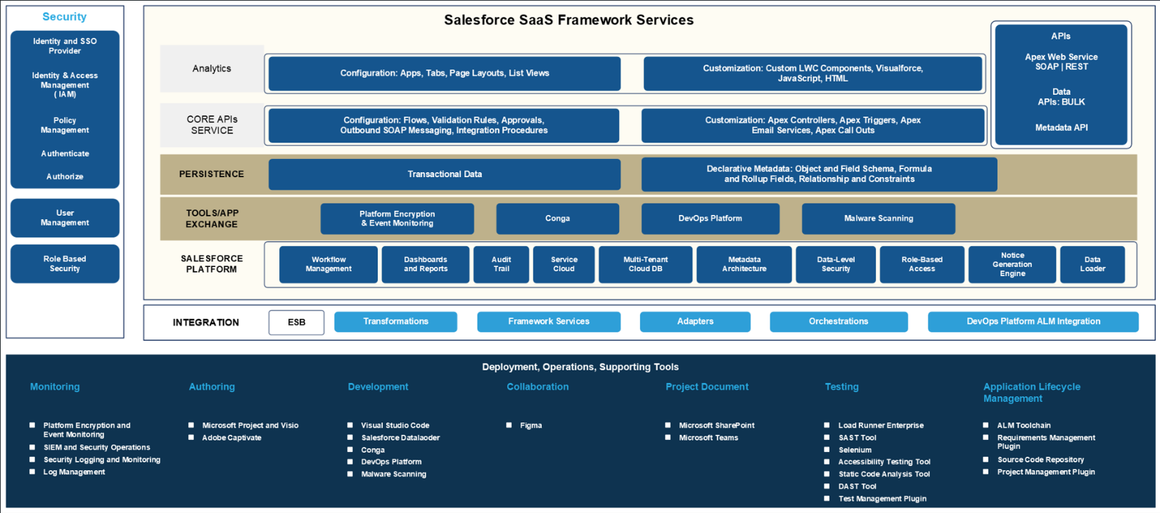
Table 1 through Table 3 outline the tools in the AMS technology stack.
Table 1 – AMS Technical Modules
Technical Module | Description
Analytics Layer | Renders the UI through Lightning Web Components (LWC) and pages to support creation of a user experience (UX) that complies with Office of Health Insurance Programs (OHIP) needs
Core Application Programming Interfaces (APIs) Service Layer | Facilitates integration and provides a variety of APIs to address different use cases, including Service, Experience, and AppExchange APIs
Persistence Layer | Stores and manages data within Salesforce and incorporates the Salesforce data model, including objects and their relationships
Tools/AppExchange | Provides the Contractor and third-party vendors with a platform to create and publish Salesforce extensions and enables Salesforce administrators to select and install solutions that comply with OHIP needs
Salesforce Platform | Supports workflow management, dashboards, reports, audit trails, Service Cloud, the multi-tenant cloud database, metadata architecture, data-level security, role-based access, and notice generation engine components
Table 2 – AMS Salesforce Tools
Tool | Description
Service Cloud Licensing | Enables users to automate processes, streamline workflows, and deliver more personalized services and requires internal users to be on the applicable Service Cloud license
Dedicated Government Cloud Infrastructure | Provides a physically dedicated, isolated, FedRAMP-authorized government cloud infrastructure for handling sensitive and unclassified data, offering enhanced security and compliance controls in accordance with Federal Risk and Authorization Management Program (FedRAMP) requirements and serving as a prerequisite for Platform as a Service (PaaS)
Platform Licenses | Enables Division of Eligibility and Marketplace Integration (DEMI) staff to perform quality assurance (QA) and policy checks through platform licenses
Platform Encryption and Event Monitoring | Delivers additional trust, compliance, and governance controls for critical business applications through platform encryption, event monitoring, and field audit trail capabilities
Malware Scanning | Protects against advanced threats with real-time antivirus protection; blocks ransomware, malware, and viruses; guards against phishing links; scans files on upload and download; and scans uniform resource locators (URLs) when users upload or click them
Workflow Management | Automates actions when specific criteria are met through a business logic engine
Dashboards and Reports | Enables users to access real-time and historical data using Salesforce reporting capabilities and displays reports in dashboards to support workload management
Audit Trails | Records changes made to an organization, including who made the change, when it was made, and what was changed
Service Cloud | Automates service processes and workflows to help support teams resolve applicant inquiries and member issues
Multi-Tenant Cloud Database | Allows multiple tenants, such as companies or departments, to share a single database and application through multi-tenant cloud database architecture
Metadata Architecture | Defines how the system handles and displays data as a core component of the Salesforce platform
Data Level Security | Protects data at multiple levels to confirm that only authorized users can access it
Role-Based Access | Controls which resources users can access and what functions they can perform by assigning role-based permissions
Notice Generation Engine | Generates and sends notices when specified criteria are met
Static Code Analysis Tool | Performs automated static code analysis
Table 3 – AMS Non-Salesforce Tools
Tool | Description
Identity and SSO Provider for Appeals | Integrates with external identity repositories to provide a modern single sign-on (SSO) implementation that allows user groups to securely access the AMS Worker Portal using IAM in the AMS for internal users
Identity and SSO Provider for Application Lifecycle Management (ALM) Tools | Integrates with external identity repositories to provide a modern SSO implementation that allows user groups to securely access AMS ALM tools using IAM
Identity and Access Management (IAM) | Identifies each individual and the level of access in the system
User Management | Creates user accounts with appropriate roles, profiles, and permissions using Just-in-Time (JIT) provisioning to enable access to applicable records
Role-Based Security | Controls who can access resources and what they can do by assigning users to roles and granting access to users higher in the hierarchy
Enterprise Service Bus (ESB) Integration | Functions as the enterprise service bus (ESB) for integrating trading partner services with the AMS
Middleware Plugin (Representational State Transfer [REST] or Simple Object Access Protocol [SOAP]) | Functions as middleware
Security Information and Event Management (SIEM) and Security Operations Platform | Serves as the AMS Security Information and Event Management (SIEM) and Security Operations platform
Log Management Platform | Provides log management and application performance monitoring for the AMS and configures custom dashboards and alerts
Security Logging and Monitoring Service | Provides endpoint protection and host intrusion detection and protection through the security monitoring platform
Microsoft Project and Visio | Includes the following Microsoft products:  - Project – Project management (PM) software designed to help users plan, schedule, manage, and track project components, such as tasks, resources, and timelines  - Visio – Diagramming and vector graphics application used to create detailed flowcharts, organizational charts, network diagrams, and other visuals
Adobe Captivate | Enables users to create e-learning content for training
Visual Studio (VS) Code | Allows developers to set up workspaces to design, develop, and unit test the AMS
Conga | Uses a third-party AppExchange tool to generate notices in Salesforce
DevOps Platform | Helps users build, test, and deploy applications through a Development and Operations (DevOps) platform
DevOps Platform ALM Integration | Integrates the DevOps platform with the ALM toolchain
Figma | Provides a requirements collaboration tool for designing wireframes and supporting user interface (UI)/UX
Malware and Phishing Detection for File Uploads | Detects malware and phishing during file uploads
Microsoft SharePoint | Provides a web-based collaboration platform used in the AMS that allows users to create, store, and organize deliverables; design documents; and access other artifacts in a centralized online environment
Microsoft Teams | Serves as a collaboration platform with chat, video meetings, file storage, and app integration to facilitate teamwork and communication
Micro Focus LoadRunner | Executes performance testing of AMS applications
Static Application Security Testing (SAST) Tool | Serves as a Static Application Security Testing (SAST) tool for the AMS to perform static code scans to identify security vulnerabilities in Salesforce applications
Selenium | Provides open source automated testing of scripts and applications
Accessibility Testing Tool | Functions as a screen reader used in the AMS to test web accessibility and confirm adherence to Section 508 compliance
Dynamic Application Security Testing (DAST) Tool | Performs DAST for the AMS to run live scans of web applications as well as automatic assessments following industry-standard application security criteria
Test Management Plugin | Supports the testing life cycle, including test planning, test design, test execution, and test reporting, and is used for ALM
ALM Toolchain | Functions as the ALM tool for the AMS to manage Solution Development Life Cycle (SDLC) and issue tracking
Requirements Management Plugin | Serves as a plugin for requirements management throughout the SDLC, produces the RTM for the AMS, and is used for ALM
Source Code Repository | Serves as the source code repository for hosting AMS source code
Project Management Plugin | Functions as an ALM toolchain plugin to facilitate PM

