Request for Proposals

​​RFP #C043776​

Converged Eligibility and Enrollment (E&E) System and Appeals Management System (AMS)

Exhibit G.24 – Converged E&E System and AMS Business Capability Model and Definitions

Heat Maps of the OHIP (and NYSOH) Capability Model
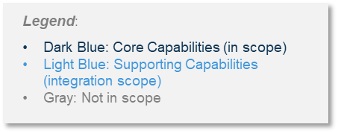

Converged E&E Heat Map of the OHIP (& NYSOH) Capability Model
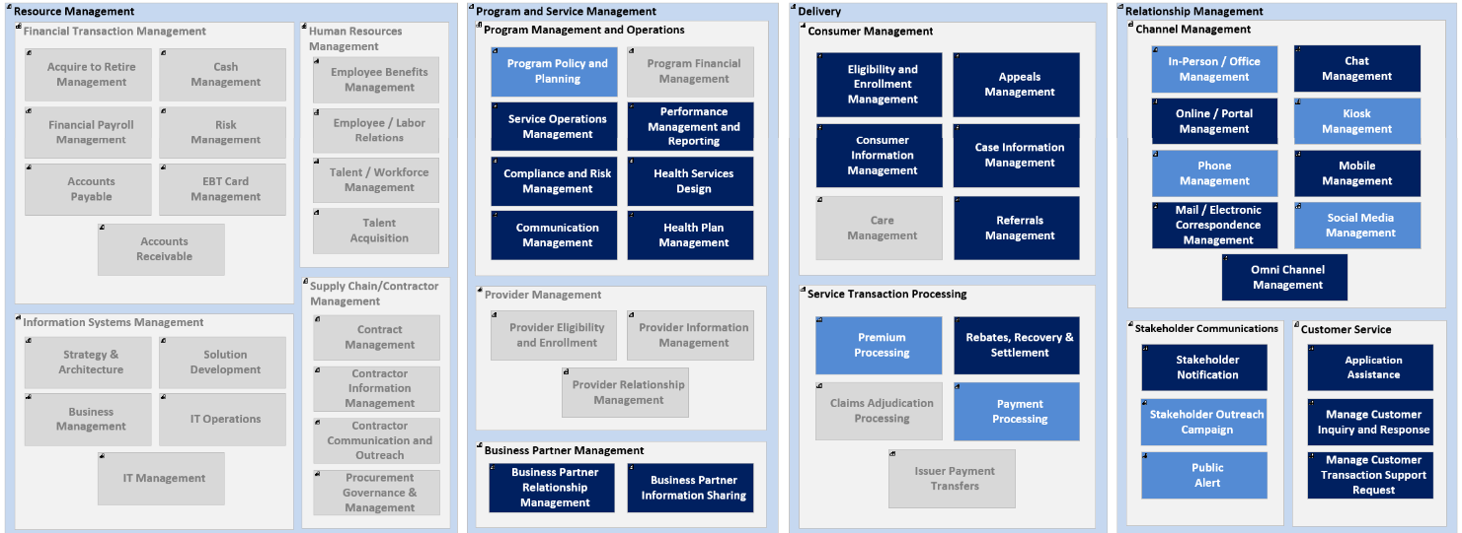

Channel Management Details

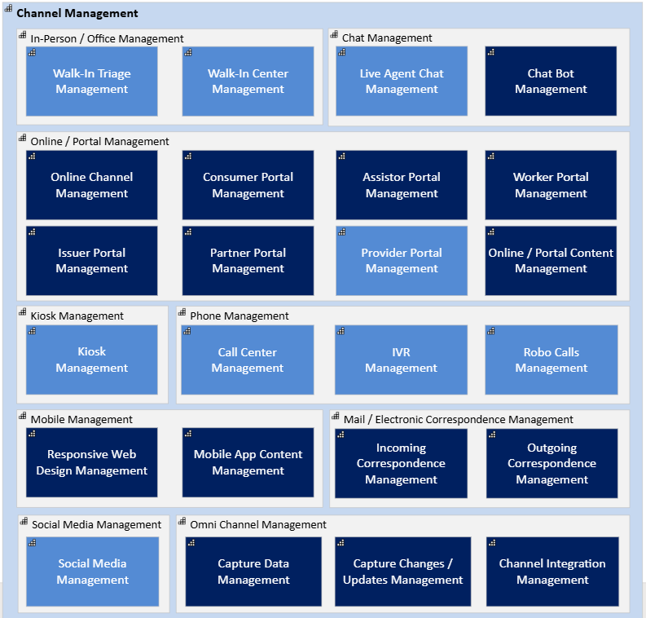

Customer Service
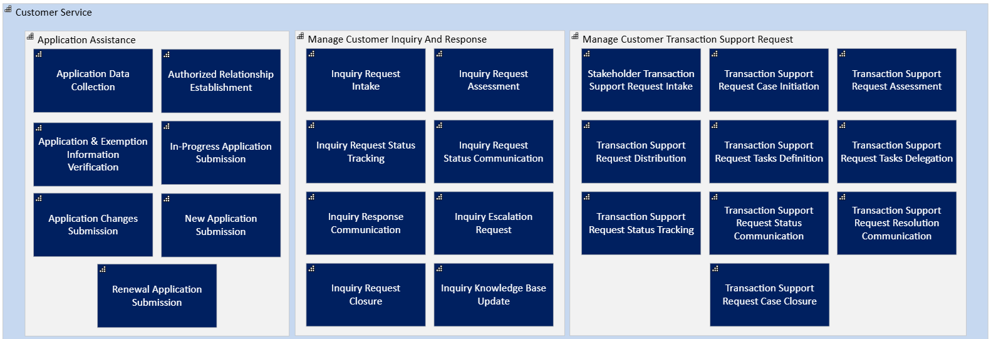

Stakeholder Communications
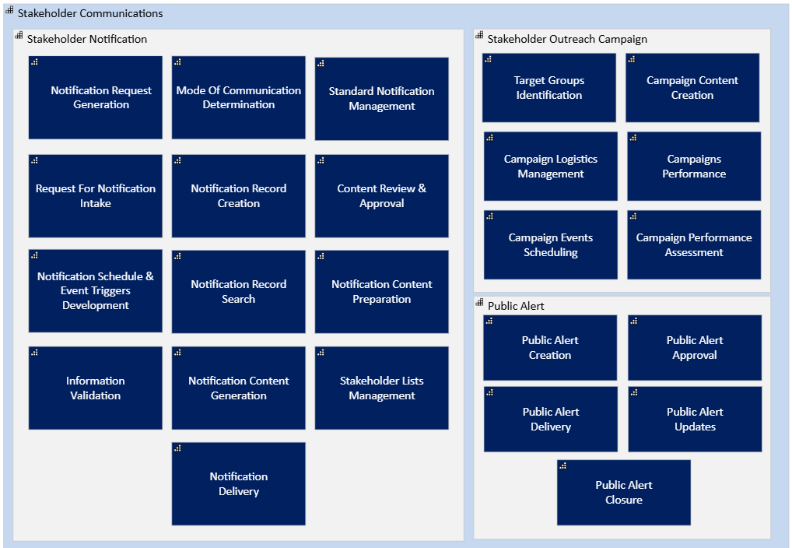

Consumer Management
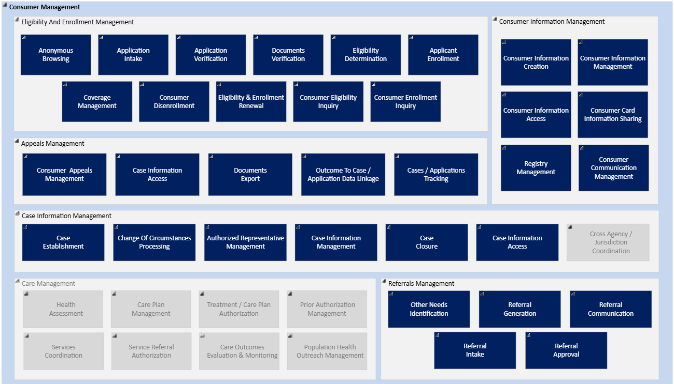

Service Transaction Processing
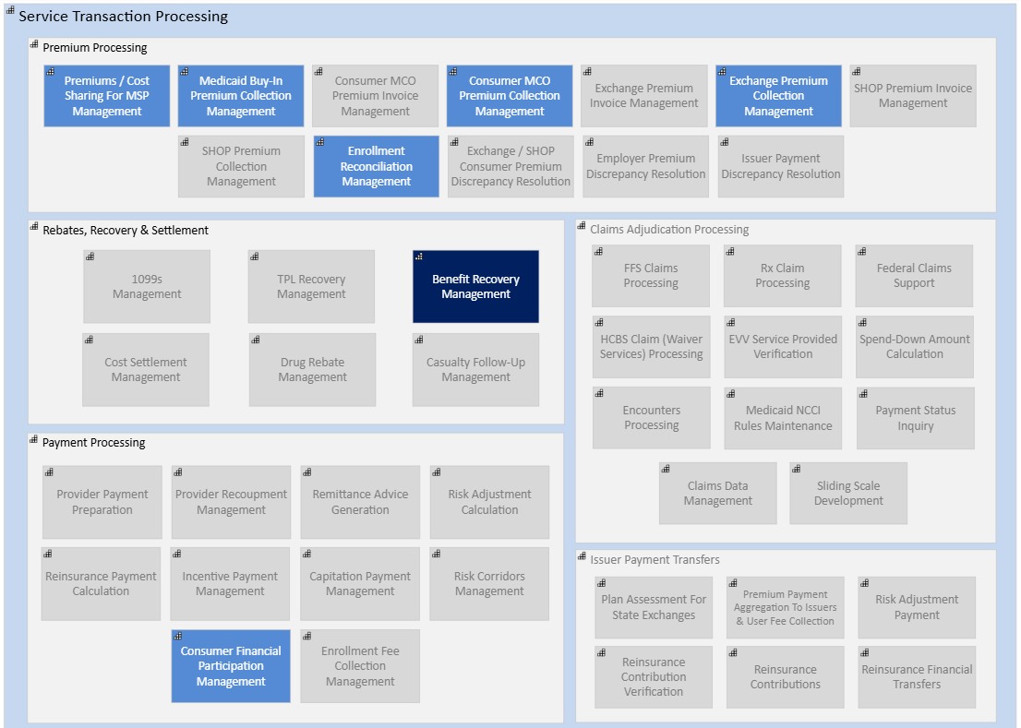

Program Management and Operations
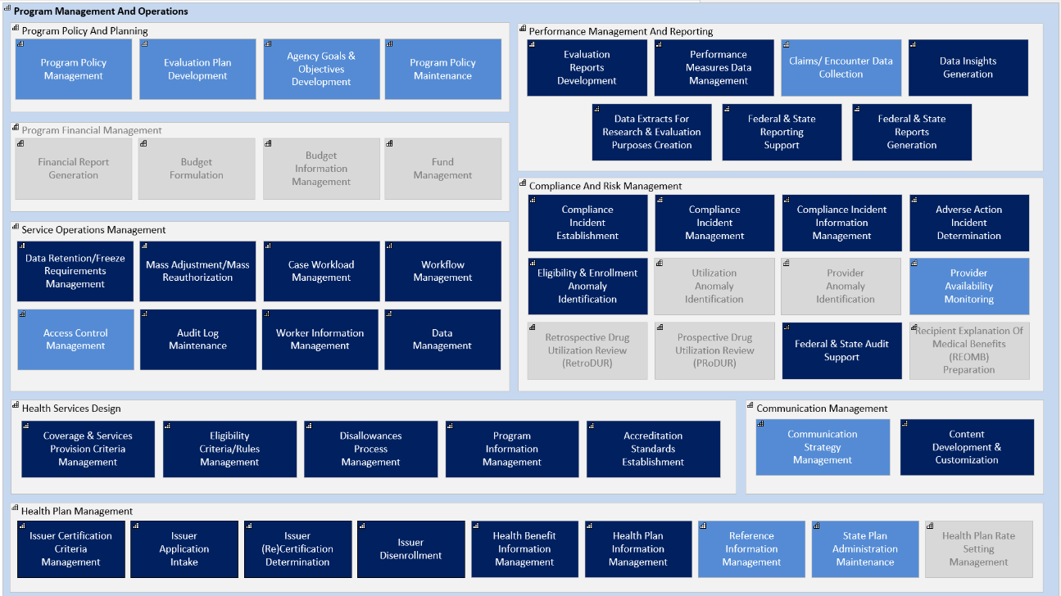

Business Partner Management
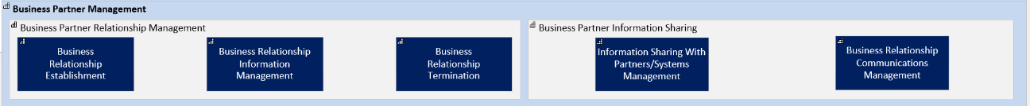

Definitions

Level 1 Capability Definitions
# | ID | Class | L0 Capability Name | L1 Capability Name | L1 Capability Definition
1 | CH-1 | Relationship Management | Channel Management | In Person / Office Management | This capability is focused on those capabilities needed in order to manage the in-person channel (e.g., an office location) associated with activities in scope for the business area.
2 | CH-2 | Relationship Management | Channel Management | Chat Management | This capability is focused on managing the "Chat" channel regardless of the way that functionality is presented (e.g., embedded in other channels such as portals, mobile, or kiosks or stand allows).
3 | CH-3 | Relationship Management | Channel Management | Online / Portal Management | This capability includes capabilities focused on the management of the online channel and associated functionality, including corporate or specialized websites, self-service portals.
4 | CH-4 | Relationship Management | Channel Management | Kiosk Management | This capability reflects capabilities focused on managing the touch-screen kiosks as a channel for receipt and delivery of communications to stakeholders or assisting with processing transactions.
5 | CH-5 | Relationship Management | Channel Management | Phone Management | This capability includes capabilities focused on management of the phone channel as a channel for receipt and delivery of communications to stakeholders.
6 | CH-6 | Relationship Management | Channel Management | Mobile Management | This capability is focused on management of the mobile channel and related functionality, including mobile applications. This communication can be standardized (content for a generic, unidentified audience), customized or personalized.
7 | CH-7 | Relationship Management | Channel Management | Mail / Electronic  Correspondence  Management | This capability is focused on management of the channels that support physical and electronic correspondence (e.g., mail, email, SMS, and fax) and enables asynchronous, one-way push communications where there is an intentional lag between the inquiry and response due to the nature of the channel.
8 | CH-8 | Relationship Management | Channel Management | Social Media Management | This capability is focused on management of and participation in the social media platforms as a way to communicate and to get involved in conversations with stakeholders that are or could be open to the general public.
9 | CH-9 | Relationship Management | Channel Management | Omni Channel Management | This capability is focused on managing across channels so that the constituent can develop a seamless and integrated experience no matter where the contact has been initiated or continued.
10 | CS-1 | Relationship Management | Customer Service | Application Assistance | This capability involves assisting consumers with their application (new or renewal, complete or partial) and submitting the application/renewal for further processing in the name of the consumer.
11 | CS-2 | Relationship Management | Customer Service | Manage Customer Inquiry and Response | This capability is focused on intaking, properly documenting, maintaining, organizing, responding, closing and archiving inquiries received from consumers and the general public as well as the responses offered.
12 | CS-3 | Relationship Management | Customer Service | Manage Customer Transaction Support Request | This capability is focused on intaking, properly documenting, maintaining, organizing, responding, closing and archiving transaction requests from consumers as well as the resolution.
13 | SC-1 | Relationship Management | Stakeholder Communication | Stakeholder Notification | This capability is focused on managing stakeholder notifications.
14 | SC-2 | Relationship Management | Stakeholder Communication | Stakeholder Outreach Campaign | This capability is focused on dealing with general and targeted outreach to stakeholders.
15 | SC-3 | Relationship Management | Stakeholder Communication | Public Alert | This capability is focused on alerting the public to emergencies, relevant news, etc.
16 | CM-1 | Delivery | Consumer Management | Eligibility and Enrollment Management | This capability is focused on determining consumer eligibility and on managing the enrollment process.
17 | CM-2 | Delivery | Consumer Management | Appeals Management | This capability is focused on creating new cases for appeals and processing them through to resolution. This capability is designed to intake, record, manage, process, document, and facilitate a resolution.
18 | CM-3 | Delivery | Consumer Management | Consumer Information Management | This capability grouping deals with client information management, including gathering, sharing, and finding information.
19 | CM-4 | Delivery | Consumer Management | Case Information Management | This capability is focused on managing information associated with cases inclusive of creation, updating, closing cases.
20 | CM-6 | Delivery | Consumer Management | Referrals Management | This capability is focused on supporting referrals (internal, to other agencies and to other partners and business partners as needed).
21 | ST-1 | Delivery | Service Transaction Processing | Premium Processing | This capability is focused on processing premiums.
22 | ST-2 | Delivery | Service Transaction Processing | Rebates, Recovery & Settlement | This capability is focused on Rebates, Recovery & Settlement.
23 | ST-4 | Delivery | Service Transaction Processing | Payment Processing | This capability is focused on processing payments.
24 | PO-1 | Program and Service Management | Program Management and Operations | Program Policy and Planning | This capability is focused on governance and management support as pertaining to the development of program and service delivery policies, privacy and security, reporting requirements from partners and providers, as well as monitoring through key performance indicators.
25 | PO-3 | Program and Service Management | Program Management and Operations | Service Operations Management | This capability is focused on managing the agency's own operations and ensuring quality standards are known and met.
26 | PO-4 | Program and Service Management | Program Management and Operations | Performance Management and Reporting | This capability is focused on tracking performance against key performance indicators as well as performance reporting.
27 | PO-5 | Program and Service Management | Program Management and Operations | Compliance and Risk Management | This capability is focused on compliance and risk management. This might include comprehensive reviews that the agency, provider/contractors, and/or related third party adhere to regulatory guidelines.
28 | PO-6 | Program and Service Management | Program Management and Operations | Health Services Design | This capability is focused on the design effort of the Health services.
29 | PO-7 | Program and Service Management | Program Management and Operations | Communication Management | This capability is focused on how the organization approaches its communications within and outside of the organization and how it coordinates communications across all channels.
30 | PO-8 | Program and Service Management | Program Management and Operations | Health Plan Management | This capability is focused on the design effort to administer, oversee, and evaluate health plans that provide services to beneficiaries.
31 | BP-1 | Program and Service Management | Business Partner Management | Business Partner Relationship Management | This capability deals with managing the relationship with the business partners.
32 | BP-2 | Program and Service Management | Business Partner Management | Business Partner Information Sharing | This capability allows for information sharing with business partners.

Level 2 Capability Definitions

# | ID | Class | L0 Capability Name | Level 1 Capability Name | Level 2 Capability  Name | L2 Capability Definition
1 | CH-1.1 | Relationship Management | Channel Management | In Person/Office Management | Walk-In Triage Management | This capability is focused on efficiently managing visitor queues within physical centers, including prioritizing individuals and resolving operational bottlenecks to ensure smooth service flow.
2 | CH-1.2 | Relationship Management | Channel Management | In Person/Office Management | Walk-In Center Management | This capability involves the operational management and direct customer service provision within physical walk-in center locations, encompassing daily activities, resource allocation within the center.
3 | CH-2.1 | Relationship Management | Channel Management | Chat Management | Live Agent Chat Management | This capability manages the service delivery of real-time, human-operated chat channels to provide direct support and issue resolution for consumers.
4 | CH-2.2 | Relationship Management | Channel Management | Chat Management | Chat Bot Management | This capability governs the lifecycle of automated chatbot systems, including configuration, maintenance, and performance optimization, to provide automated support for inquiries and transactions.
5 | CH-3.1 | Relationship Management | Channel Management | Online / Portal Management | Online Channel Management | This capability manages the overall online channel, including content integration, performance monitoring, and security oversight, to ensure a secure and effective digital presence.
6 | CH-3.2 | Relationship Management | Channel Management | Online / Portal Management | Consumer Portal Management | This capability focuses on the administration and user experience management of a dedicated online portal for consumers (individuals, guardians, or legal representatives), supporting account registration, application submission and tracking, documentation submission, profile management, renewal processes, and secure communication for Medicaid, QHP, and SHOP.
7 | CH-3.3 | Relationship Management | Channel Management | Online / Portal Management | Assistor Portal Management | This capability involves the comprehensive management and maintenance of a dedicated online portal for Assistors, enabling them to submit and follow up on applications, manage accounts and profiles, submit documentation, and access customer support functions on behalf of consumers for Medicaid, QHP, or SHOP.
8 | CH-3.4 | Relationship Management | Channel Management | Online / Portal Management | Worker Portal Management | This capability provides for the management of a secure web portal for various levels of agency workers, enabling them to manage cases, review and process applications, determine eligibility, manage member information, handle documents and verifications, assign and complete tasks, and communicate with applicants/members, supported by integrated reporting and analytics.
9 | CH-3.5 | Relationship Management | Channel Management | Online / Portal Management | Issuer Portal Management | This capability involves the management of an online portal specifically for Issuers, facilitating account creation, profile management, support for QHP binder submissions (e.g., via SerFF), and ensuring compliance and certification processes are met through online application submission.
10 | CH-3.6 | Relationship Management | Channel Management | Online / Portal Management | Partner Portal Management | This capability focuses on the administration and user experience management of a dedicated online portal for partners (nursing homes, psychiatric centers, etc.), supporting creation and management of their partner profile and supporting roster management for Medicaid members in programs such as Medicaid Long Term Care and Advanced Long Term Care associated with their facility.
11 | CH-3.7 | Relationship Management | Channel Management | Online / Portal Management | Provider Portal Management | This capability manages the Provider online portal's functionality and user experience, enabling self-service for account management, application processing, and secure communications.
12 | CH-3.8 | Relationship Management | Channel Management | Online / Portal Management | Online / Portal Content Management | This capability governs the content lifecycle from creation to retirement for all online channels.
13 | CH-4.1 | Relationship Management | Channel Management | Kiosk Management | Kiosk Management | This capability manages the deployment, content, and technical operations of public-facing kiosks, including features for transaction processing, information exchange, content updates, and user technical support.
14 | CH-5.1 | Relationship Management | Channel Management | Phone Management | Call Center Management | This capability manages call center operations, including staffing, technology, and performance, to deliver effective and efficient phone-based stakeholder support.
15 | CH-5.2 | Relationship Management | Channel Management | Phone Management | IVR Management | This capability manages the lifecycle of the Interactive Voice Response (IVR) system, including its configuration, maintenance, and optimization, to enable effective self-service and call routing.
16 | CH-5.3 | Relationship Management | Channel Management | Phone Management | Robo Calls Management | This capability manages the creation and execution of automated outbound calling campaigns to deliver targeted, pre-recorded messages to consumers with or without an option for a two way communication in an immediate response to the campaign.
17 | CH-6.1 | Relationship Management | Channel Management | Mobile Management | Responsive Web Design Management | This capability enforces responsive web design standards to ensure a consistent and optimal user experience across all digital devices.
18 | CH-6.2 | Relationship Management | Channel Management | Mobile Management | Mobile App Content Management | This capability manages the full lifecycle of mobile applications, including their creation, content management, maintenance, and technical support, enabling users to manage profiles, process transactions, receive information, submit applications/renewals, and communicate changes of circumstances.
19 | CH-7.1 | Relationship Management | Channel Management | Mail / Electronic Correspondence Management | Incoming Correspondence Management | This capability manages the end-to-end process for all incoming physical and electronic correspondence, from intake and digitization to routing and tracking for resolution. This includes, but is not limited to, correspondence such as mail, email, SMS, and fax.
20 | CH-7.2 | Relationship Management | Channel Management | Mail / Electronic Correspondence Management | Outgoing Correspondence Management | This capability manages the production and distribution of official outgoing physical and electronic correspondence to consumers. This includes, but is not limited to, correspondence such as mail, email, SMS, and fax.
21 | CH-8.1 | Relationship Management | Channel Management | Social Media Management | Social Media Management | This capability manages and coordinates the organization's presence and activities across social media platforms, including content strategy, posting, audience engagement, comment monitoring, and response management.
22 | CH-9.1 | Relationship Management | Channel Management | Omni Channel Management | Capture Data Management | This capability captures, validates, and unifies stakeholder data from all interaction channels into a single, consistent profile to enable a seamless omnichannel experience.
23 | CH-9.2 | Relationship Management | Channel Management | Omni Channel Management | Capture Changes / Updates Management | This capability enables consumers to interact with the agency through any channel, ensuring real-time synchronization and data consistency across all systems.
24 | CH-9.3 | Relationship Management | Channel Management | Omni Channel Management | Channel Integration Management | This capability manages the technical and operational integration of all communication channels to ensure seamless data sharing and a consistent, uninterrupted user journey.
25 | CS-1.1 | Relationship Management | Customer Service | Application Assistance | Application Data Collection | This capability manages the collection of all necessary application information for Medicaid, QHP, and SHOP via customer service or assistors.
26 | CS-1.2 | Relationship Management | Customer Service | Application Assistance | Authorized Relationship Establishment | This capability manages the secure establishment and verification of authorized relationships between applicants (for Medicaid, QHP, or SHOP) and their representatives (E.g., assistors) or agency entities (E.g., customer service agents), ensuring appropriate permissions for acting on the applicant's behalf during the application process.
27 | CS-1.3 | Relationship Management | Customer Service | Application Assistance | Application & Exemption Information Verification | This capability ensures the completeness of Medicaid, QHP, and SHOP applications by verifying provided information, including citizenship, immigration, incarceration status, and exemption details, against trusted data sources to prepare for eligibility determination.
28 | CS-1.4 | Relationship Management | Customer Service | Application Assistance | In-Progress Application Submission | This capability allows applicants, authorized representatives, or Assistors to save in-progress Medicaid, QHP, or SHOP applications, and later retrieve, review, update, validate, and submit them on behalf of the consumer.
29 | CS-1.5 | Relationship Management | Customer Service | Application Assistance | Application Changes Submission | This capability enables Medicaid, QHP, or SHOP customer service / assistors to access, modify, verify, and submit updates or changes to specific sections or fields within existing applications or to consumer profile for further processing.
30 | CS-1.6 | Relationship Management | Customer Service | Application Assistance | New Application Submission | This capability enables customer service and assistors entities to initiate, enter data, verify information, and formally submit new applications for Medicaid, QHP, or SHOP programs on behalf of themselves or the represented applicant.
31 | CS-1.7 | Relationship Management | Customer Service | Application Assistance | Renewal Application Submission | This capability enables customer service and assistors entities to initiate, enter data, verify information, and formally submit renewal applications for Medicaid, QHP, or SHOP programs on behalf of themselves or the represented applicant.
32 | CS-2.1 | Relationship Management | Customer Service | Manage Customer Inquiry and Response | Inquiry Request Intake | This capability focuses on accurately documenting, initiating tracking, and managing the initial intake of various customer inquiry requests received through different channels.
33 | CS-2.2 | Relationship Management | Customer Service | Manage Customer Inquiry and Response | Inquiry Request Assessment | This capability involves evaluating incoming inquiry requests to determine their nature, complexity, and appropriate course of action, often assigning priority and routing.
34 | CS-2.3 | Relationship Management | Customer Service | Manage Customer Inquiry and Response | Inquiry Request Status Tracking | This capability provides the functionality to monitor and report on the real-time status and progression of customer inquiry requests from submission to resolution, ensuring transparency and accountability.
35 | CS-2.4 | Relationship Management | Customer Service | Manage Customer Inquiry and Response | Inquiry Request Status Communication | This capability enables locating and communicating the current status of inquiry requests to relevant stakeholders through various methods, adapting to the request type and recipient.
36 | CS-2.5 | Relationship Management | Customer Service | Manage Customer Inquiry and Response | Inquiry Response Communication | This capability encompasses the formulation and delivery of comprehensive responses, including resolutions or answers, to inquiries and requests submitted by various stakeholders.
37 | CS-2.6 | Relationship Management | Customer Service | Manage Customer Inquiry and Response | Inquiry Escalation Request | This capability facilitates the appropriate routing of complex inquiry requests to subject matter experts (SMEs) or designated teams for specialized input and action.
38 | CS-2.7 | Relationship Management | Customer Service | Manage Customer Inquiry and Response | Inquiry Request Closure | This capability ensures the formal closure of inquiry or request cases upon resolution, including proper documentation and archival for record-keeping and future reference.
39 | CS-2.8 | Relationship Management | Customer Service | Manage Customer Inquiry and Response | Inquiry Knowledge Base Update | This capability involves systematically documenting insights, solutions, and resolutions derived from inquiry requests to build a knowledge base for future reference and continuous improvement.
40 | CS-3.1 | Relationship Management | Customer Service | Manage Customer Transaction Support Request | Stakeholder Transaction Support Request Intake | This capability focuses on accurately recording details of customer transaction support requests, including structured data elements, required documentation, and associated details.
41 | CS-3.2 | Relationship Management | Customer Service | Manage Customer Transaction Support Request | Transaction Support Request Case Initiation | This capability allows for the formal initiation of a transaction support request, enabling users to begin monitoring its real-time progress and status.
42 | CS-3.3 | Relationship Management | Customer Service | Manage Customer Transaction Support Request | Transaction Support Request Assessment | This capability involves evaluating incoming customer transaction support requests to determine the required actions and appropriate processing.
43 | CS-3.4 | Relationship Management | Customer Service | Manage Customer Transaction Support Request | Transaction Support Request Distribution | This capability manages the allocation and processing of complex transaction support requests across multiple internal systems, teams, or external entities.
44 | CS-3.5 | Relationship Management | Customer Service | Manage Customer Transaction Support Request | Transaction Support Request Tasks Definition | This capability involves precisely defining the required tasks for each transaction support request, including aligning these tasks with policies and procedures and the relevant context (program context: Medicaid, QHP, SHOP, transaction type, leading practices that might have been defined for that specific type of inquiry transaction support request).
45 | CS-3.6 | Relationship Management | Customer Service | Manage Customer Transaction Support Request | Transaction Support Request Tasks Delegation | This capability facilitates the routing of transaction support requests, along with their full context, to appropriate specialized parties (either internal or external: e.g., health plan issuers, certified brokers) when actions fall outside of direct customer service scope, ensuring a seamless and accountable handoff.
46 | CS-3.7 | Relationship Management | Customer Service | Manage Customer Transaction Support Request | Transaction Support Request Status Tracking | This capability enables the comprehensive tracking of transaction support requests and their status across various systems and platforms, ensuring transparency, accountability, and efficient delivery of services.
47 | CS-3.8 | Relationship Management | Customer Service | Manage Customer Transaction Support Request | Transaction Support Request Status Communication | This capability enables communication of the current status of the transaction support requests to the requestor through various methods, tailored to the transaction type and requester's preferences.
48 | CS-3.9 | Relationship Management | Customer Service | Manage Customer Transaction Support Request | Transaction Support Request Resolution Communication | This capability ensures the effective delivery of resolution outcomes and detailed information regarding transaction support requests back to the originating individual or entity.
49 | CS-3.10 | Relationship Management | Customer Service | Manage Customer Transaction Support Request | Transaction Support Request Case Closure | This capability allows for the formal closure of transaction support requests once resolved, ensuring proper documentation and finalization of administrative actions.
50 | SC-1.1 | Relationship Management | Stakeholder Communications | Stakeholder Notification | Notification Request Generation | This capability allows authorized users to formally initiate and submit requests for (or trigger) specific stakeholder notifications manually or automatically (e.g., event driven).
51 | SC-1.2 | Relationship Management | Stakeholder Communications | Stakeholder Notification | Mode of Communication Determination | This capability tracks the preferred modes of communication (e.g., email, SMS, mailing) reflecting the individual user’s preference for communication.
52 | SC-1.3 | Relationship Management | Stakeholder Communications | Stakeholder Notification | Standard Notification Management | This capability creates, updates, and deletes standard notification templates and language.​ If a repository is in use, this business capability supports the management of standard notifications that are in such a repository.
53 | SC-1.4 | Relationship Management | Stakeholder Communications | Stakeholder Notification | Request for Notification Intake | This capability involves receiving requests for notification. This includes understanding what notice needs to be sent, to whom, and with what information.
54 | SC-1.5 | Relationship Management | Stakeholder Communications | Stakeholder Notification | Notification Record Creation | This capability deals with creating the notification records to be sent out.​
55 | SC-1.6 | Relationship Management | Stakeholder Communications | Stakeholder Notification | Content Review & Approval | This capability allows for the review and approval of notification content.​
56 | SC-1.7 | Relationship Management | Stakeholder Communications | Stakeholder Notification | Notification Schedule & Event Triggers Development | This capability develops notification schedules and event triggers based on statute, regulations, past practice, and industry leading standards.​
57 | SC-1.8 | Relationship Management | Stakeholder Communications | Stakeholder Notification | Notification Record Search | This capability deals with searching for notification records.​
58 | SC-1.9 | Relationship Management | Stakeholder Communications | Stakeholder Notification | Notification Content Preparation | This capability prepares and drafts notification content.​
59 | SC-1.10 | Relationship Management | Stakeholder Communications | Stakeholder Notification | Information Validation | This capability validates information contained in the communication/notification.​
60 | SC-1.11 | Relationship Management | Stakeholder Communications | Stakeholder Notification | Notification Content Generation | This capability generates notification content. ​
61 | SC-1.12 | Relationship Management | Stakeholder Communications | Stakeholder Notification | Stakeholder Lists Management | This capability manages lists of stakeholders for various communication efforts.
62 | SC-1.13 | Relationship Management | Stakeholder Communications | Stakeholder Notification | Notification Delivery | This capability sends the notification in the approved manner, e.g., email that includes a prompt to view an update in user’s account, mail, push notification, etc.​
63 | SC-2.1 | Relationship Management | Stakeholder Communications | Stakeholder Outreach Campaign | Target Groups Identification | This capability involves the process of identifying and segmenting specific target groups that will be the focus of outreach campaigns.
64 | SC-2.2 | Relationship Management | Stakeholder Communications | Stakeholder Outreach Campaign | Campaign Content Creation | This capability focuses on the development and production of all content materials specifically designed for stakeholder outreach campaigns.
65 | SC-2.3 | Relationship Management | Stakeholder Communications | Stakeholder Outreach Campaign | Campaign Logistics Management | This capability involves the strategic planning, coordination, and execution of all logistical elements required for the successful implementation of campaigns (e.g., public awareness, open enrollment awareness).
66 | SC-2.4 | Relationship Management | Stakeholder Communications | Stakeholder Outreach Campaign | Campaigns Performance | This capability executes the planned stakeholder outreach campaign activities, directly involving the practical implementation and ongoing management of campaign logistics.
67 | SC-2.5 | Relationship Management | Stakeholder Communications | Stakeholder Outreach Campaign | Campaign Events Scheduling | This capability manages the scheduling and coordination of various events and activities that comprise a stakeholder outreach campaign.
68 | SC-2.6 | Relationship Management | Stakeholder Communications | Stakeholder Outreach Campaign | Campaign Performance Assessment | This capability involves the collection and analysis of data to systematically measure the effectiveness, outcomes, and overall performance of stakeholder outreach campaigns.
69 | SC-3.1 | Relationship Management | Stakeholder Communications | Public Alert | Public Alert  Creation | This capability involves the development and drafting of public alert messages, often utilizing specialized software and adhering to standards like the Common Alerting Protocol (CAP).
70 | SC-3.2 | Relationship Management | Stakeholder Communications | Public Alert | Public Alert  Approval | This capability ensures the formal authorization and approval from leadership for official public alert communications regarding potential program-related issues before dissemination.
71 | SC-3.3 | Relationship Management | Stakeholder Communications | Public Alert | Public Alert  Delivery | This capability facilitates the dissemination of approved public alerts through integrated Public Alert & Warning Systems or other designated communication channels.
72 | SC-3.4 | Relationship Management | Stakeholder Communications | Public Alert | Public Alert  Updates | This capability enables the modification and revision of previously issued public alert messages with updated or evolving information.
73 | SC-3.5 | Relationship Management | Stakeholder Communications | Public Alert | Public Alert  Closure | This capability manages the process of securing leadership approval to formally conclude or end previously issued public alert communications related to program issues.
74 | CM-1.1 | Delivery | Consumer Management | Eligibility and Enrollment Management | Anonymous Browsing | This capability enables consumers to search for and compare health insurance plans without revealing personal information. This feature allows users to explore different plans and their associated costs, premiums, and coverage details.
75 | CM-1.2 | Delivery | Consumer Management | Eligibility and Enrollment Management | Application Intake | This capability manages the initial collection and validation of consumer information through a single, streamlined application, for individuals, families, employer groups, and employees seeking coverage through Medicaid, QHP, or SHOP. This capability also supports presumptive eligibility intake.
76 | CM-1.3 | Delivery | Consumer Management | Eligibility and Enrollment Management | Application Verification | This capability systematically verifies all information provided on Medicaid, QHP, and SHOP applications (e.g., citizenship, immigration, incarceration status) against trusted and authoritative data sources to ensure accuracy for eligibility determination.
77 | CM-1.4 | Delivery | Consumer Management | Eligibility and Enrollment Management | Documents Verification | This capability validates the authenticity and sufficiency of all submitted documents (from individuals, employers, or employees) against established standards to resolve data discrepancies, complete outstanding verifications, and finalize eligibility and enrollment decisions.
78 | CM-1.5 | Delivery | Consumer Management | Eligibility and Enrollment Management | Eligibility Determination | This capability encompasses the comprehensive process of requesting, receiving, and applying established criteria to applicant/consumer-related information to determine eligibility for Medicaid (MAGI and non-MAGI), QHP (with APTC/CSR), or SHOP for individuals, households, and businesses, based on financial and non-financial requirements.
79 | CM-1.6 | Delivery | Consumer Management | Eligibility and Enrollment Management | Applicant Enrollment | This capability manages the full enrollment process for eligible consumers in Medicaid, QHP, or SHOP, including securing enrollment approval, plan selection and/or assignment, and updating consumer and case records.
80 | CM-1.7 | Delivery | Consumer Management | Eligibility and Enrollment Management | Coverage Management | This capability allows authorized users to assess and determine consumer coverage eligibility, including qualifications for exemptions, managing household-level determinations, and the ability to modify, void, or cancel issued coverage.
81 | CM-1.8 | Delivery | Consumer Management | Eligibility and Enrollment Management | Consumer Disenrollment | This capability manages the entire process of terminating a consumer’s enrollment In Medicaid, QHP, or SHOP, including processing disenrollment requests, validating compliance with policies, updating consumer records.
82 | CM-1.9 | Delivery | Consumer Management | Eligibility and Enrollment Management | Eligibility & Enrollment Renewal | This capability manages the periodic process of redetermining if a consumer (for Medicaid, QHP, or SHOP) continues to meet program eligibility criteria, including annual redeterminations for MAGI Medicaid, periodic recertifications for non-MAGI, annual QHP reassessments, and SHOP employer group/employee renewals.
83 | CM-1.10 | Delivery | Consumer Management | Eligibility and Enrollment Management | Consumer Eligibility Inquiry | This capability manages real-time eligibility verification requests from authorized third parties, providing a comprehensive response on the consumer's coverage and benefits.
84 | CM-1.11 | Delivery | Consumer Management | Eligibility and Enrollment Management | Consumer Enrollment Inquiry | This capability manages requests for detailed consumer enrollment information in Medicaid (e.g., FFS Plans, MCO details, effective/termination dates), facilitating the sharing of this enrollment status across agencies, systems, and jurisdictions.
85 | CM-2.1 | Delivery | Consumer Management | Appeals Management | Consumer Appeals Management | This capability manages the entire lifecycle of consumer appeals, from creating new cases and processing them through resolution, ensuring policies and procedures are correctly leveraged and enforced.
86 | CM-2.2 | Delivery | Consumer Management | Appeals Management | Case Information Access | This capability allows authorized users to securely access all consumer information, including eligibility, enrollment verification, and supporting documentation.
87 | CM-2.3 | Delivery | Consumer Management | Appeals Management | Documents Export | This capability provides the functionality to generate and securely export/transmit relevant documents to authorized users, such as workers and appeal specialists.
88 | CM-2.4 | Delivery | Consumer Management | Appeals Management | Outcome to Case / Application Data Linkage | This capability enables the linking of appeal outcomes to the case/application, tracking of adjournment requests, and triggering any associated actions in follow up of the Appeals recorded outcomes.
89 | CM-2.5 | Delivery | Consumer Management | Appeals Management | Cases / Applications Tracking | This capability provides authorized users, such as the consumer, workers and appeal specialists, with the ability to monitor the real-time status and progress of cases or applications actively undergoing the appeal process.
90 | CM-3.1 | Delivery | Consumer Management | Consumer Information Management | Consumer Information Creation | This capability establishes new consumer records and associated case participant records across Medicaid, QHP, and SHOP programs. It also governs merging consumer records
91 | CM-3.2 | Delivery | Consumer Management | Consumer Information Management | Consumer Information Management | This capability governs and maintains comprehensive, ongoing consumer data (demographics, contacts, preferences, delegates) across Medicaid, QHP, and SHOP programs, managing updates, corrections, preferences and consent for all relevant consumer information.
92 | CM-3.3 | Delivery | Consumer Management | Consumer Information Management | Consumer Information Access | This capability locates and retrieves specific consumer information from accessible electronic resources in response to authorized requests, preparing comprehensive data sets while adhering to strict access control rules for Medicaid, QHP, and SHOP programs.
93 | CM-3.4 | Delivery | Consumer Management | Consumer Information Management | Consumer Card Information Sharing | For Medicaid consumers, this capability facilitates the sharing of relevant consumer and case information with external entities responsible for benefit card processing and issuance, including managing Medicaid benefit cards. For QHP/SHOP, this capability highlights the need to exchange minimal card metadata with Carriers/Issuers as they are the system or record for QHP / SHOP consumers' ID cards.
94 | CM-3.5 | Delivery | Consumer Management | Consumer Information Management | Registry Management | This capability manages specific consumer registries (e.g., immunization, cancer, certain diseases) by receiving information on health outcome, identity information. This capability is responsible for processing updates to registries, performing deduplication, adding/removing/updating relationships across Medicaid, QHP, and SHOP programs.
95 | CM-3.6 | Delivery | Consumer Management | Consumer Information Management | Consumer Communication Management | This capability manages historical communication records within a shared repository, enabling consistent use and access across multiple programs, and systems for efficient stakeholder interaction.
96 | CM-4.1 | Delivery | Consumer Management | Case Information Management | Case Establishment | This capability focuses on the initial creation and setup of a case record for a consumer or group of consumers.
97 | CM-4.2 | Delivery | Consumer Management | Case Information Management | Change of Circumstances Processing | This capability processes changes in consumer circumstances or life events that may impact their case, potentially triggering a re-eligibility determination.
98 | CM-4.3 | Delivery | Consumer Management | Case Information Management | Authorized Representative Management | This capability allows authorized users (applicants, consumers, or workers) to add, modify, or revoke authorized representatives associated with a case, thereby managing access and permissions for case information.
99 | CM-4.4 | Delivery | Consumer Management | Case Information Management | Case Information Management | This capability comprehensively manages the collection, updating, sharing, and organization of all case-related data and documents, creating a complete case portfolio for each consumer. Includes functionalities for uploading, categorizing, indexing, and secure access.
100 | CM-4.5 | Delivery | Consumer Management | Case Information Management | Case Closure | This capability involves determining the completion of a case and executing the necessary procedures for managing and archiving all related information for closed cases.
101 | CM-4.6 | Delivery | Consumer Management | Case Information Management | Case Information Access | This capability enables the retrieval of specific case information and associated documents in response to authorized requests, ensuring access control based on established rules.
102 | CM-6.1 | Delivery | Consumer Management | Referrals Management | Other Needs Identification | This capability identifies unaddressed consumer needs by comparing assessments against the full scope of available services, documenting those requiring non-Medicaid services or additional providers.
103 | CM-6.2 | Delivery | Consumer Management | Referrals Management | Referrals Generation | This capability generates formal referrals for applicants/consumers, directing them to specific programs (within or outside the agency) for specialized services based on identified needs.
104 | CM-6.3 | Delivery | Consumer Management | Referrals Management | Referral Communication | This capability manages the secure transmission of referrals to identified party (within or outside the agency).
105 | CM-6.4 | Delivery | Consumer Management | Referrals Management | Referral Intake | This capability supports the intake and processing of inbound referral requests originating from other programs, providers, or community resources.
106 | CM-6.5 | Delivery | Consumer Management | Referrals Management | Referral Approval | This capability manages the approval process for incoming Medicaid program referrals, including creating a referral record and initiating any subsequent activities or evaluations based on the referral nature and any relevant business rules or procedures.
107 | ST-1.1 | Delivery | Service Transaction Processing | Premium Processing | Premiums / Cost Sharing for MSP Management | This capability, as an integration point, supports the management of all operational aspects related to preparing and processing member premium payments and cost-sharing, specifically for Medicare Buy-in and Medicare Savings Programs (MSP).
108 | ST-1.2 | Delivery | Service Transaction Processing | Premium Processing | Medicaid Buy-In Premium Collection Management | This capability, as an integration point, supports the management of all operational aspects related to billing and collection of premium payments for Medicaid Buy-In for Working People w/ Disability (MBI-WPD).
109 | ST-1.4 | Delivery | Service Transaction Processing | Premium Processing | Consumer MCO Premium Collection Management | This capability, as an integration point between issuers and eligibility via the 834 transaction, supports the management of the billing and collection of permitted member MCO premiums or contributions, and keep accurate, reconciled records.
110 | ST-1.6 | Delivery | Service Transaction Processing | Premium Processing | Exchange Premium Collection Management | This capability, as an integration point, enables the state Medicaid agency to track, reconcile, and report marketplace and carrier-reported QHP premium activity for individuals associated with the individual Exchange, without performing any billing or collections.
111 | ST-1.9 | Delivery | Service Transaction Processing | Premium Processing | Enrollment Reconciliation Management | This capability, as an integration point, supports the comparison and validation of member enrollment records across multiple systems, including eMedNY, Converged Eligibility and Enrollment, and issuers to ensure consistency of enrollment status, coverage periods and plan assignments.
112 | ST-2.3 | Delivery | Service Transaction Processing | Rebates, Recovery & Settlement | Benefit Recovery Management | This capability manages the recovery of benefits paid to clients and/or providers, including estate recovery.
113 | ST-4.9 | Delivery | Service Transaction Processing | Payment Processing | Consumer Financial Participation Management | This capability supports consumer financial contributions for the excess income program, including acceptance of payment and issuance of refunds for overpayments, processed through integration with a payment gateway.
114 | PM-1.1 | Program and Service Management | Program Management and Operations | Program Policy and Planning | Program Policy Management | This capability governs the development, approval, and communication of program policies to ensure regulatory compliance and consistent administration.
115 | PM-1.2 | Program and Service Management | Program Management and Operations | Program Policy and Planning | Evaluation Plan Development | This capability develops comprehensive evaluation plans, defining accountable parties, program scope, processes, services, evaluation types, questions, resources, activities, inputs, outputs, desired outcomes, and identifies necessary metrics and data collection points to address potential gaps.
116 | PM-1.3 | Program and Service Management | Program Management and Operations | Program Policy and Planning | Agency Goals & Objectives Development | This capability defines and refines the agency's strategic goals and objectives in response to internal and external drivers to guide organizational priorities.
117 | PM-1.4 | Program and Service Management | Program Management and Operations | Program Policy and Planning | Program Policy Maintenance | This capability manages the ongoing review and modification of existing program policies and business rules to adapt to regulatory changes, audit findings, and stakeholder feedback.
118 | PM-3.1 | Program and Service Management | Program Management and Operations | Service Operations Management | Data Retention / Freeze Requirements  Management | This capability defines, implements, and enforces policies for data preservation, retention, and legal holds ('freezes') to ensure compliance with legal and business requirements.
119 | PM-3.2 | Program and Service Management | Program Management and Operations | Service Operations Management | Mass Adjustment/Mass Reauthorization | This capability supports the automated execution of large-scale adjustments to eligibility or coverage for multiple members based on specific criteria or date ranges.
120 | PM-3.3 | Program and Service Management | Program Management and Operations | Service Operations Management | Case Workload  Management | This capability manages the assignment, distribution, and balancing of caseloads among workers to optimize workflow and ensure timely case processing.
121 | PM-3.4 | Program and Service Management | Program Management and Operations | Service Operations Management | Workflow  Management | This capability designs, executes, and optimizes automated and manual workflows, including business rules, escalations, and approvals, to streamline operational processes.
122 | PM-3.5 | Program and Service Management | Program Management and Operations | Service Operations Management | Access Control Management | This capability governs user access to systems and data by managing roles, permissions, and authentication policies to ensure information security and privacy.
123 | PM-3.6 | Program and Service Management | Program Management and Operations | Service Operations Management | Audit Log Maintenance | This capability manages the generation, storage, and protection of audit logs for all system and user activities to ensure accountability, security, and traceability.
124 | PM-3.7 | Program and Service Management | Program Management and Operations | Service Operations Management | Worker Information  Management | This capability manages the master record of all worker information, including credentials, professional history, and other employment-related data.
125 | PM-3.8 | Program and Service Management | Program Management and Operations | Service Operations Management | Data Management | This capability governs the quality, security, and lifecycle of the agency's data assets through defined policies and procedures.
126 | PM-4.1 | Program and Service Management | Program Management and Operations | Performance Management and Reporting | Evaluation Reports Development | This capability produces formal evaluation reports that analyze program performance, compliance, and outcomes to support decision-making and meet regulatory requirements.
127 | PM-4.2 | Program and Service Management | Program Management and Operations | Performance Management and Reporting | Performance Measures Data Management | This capability manages the data lifecycle for performance metrics, from collection and analysis to reporting, to measure the achievement of program outcomes.
128 | PM-4.3 | Program and Service Management | Program Management and Operations | Performance Management and Reporting | Claims / Encounter Data Collection | This capability manages the collection, validation, and submission of claims and encounter data to support program oversight, reporting, and cost management.
129 | PM-4.4 | Program and Service Management | Program Management and Operations | Performance Management and Reporting | Data Insights Generation | This capability applies analytical techniques and business intelligence tools to data to generate insights, evaluate policy, and support data-driven decision-making. This capability also supports ad hoc data aggregation and analysis to fulfill emergent reporting needs, including public information requests and operational inquiries.
130 | PM-4.5 | Program and Service Management | Program Management and Operations | Performance Management and Reporting | Data Extracts for Research & Evaluation Purposes Creation | This capability creates and provisions secure, de-identified data extracts for authorized research and evaluation purposes.
131 | PM-4.6 | Program and Service Management | Program Management and Operations | Performance Management and Reporting | Federal & State Reporting Support | This capability manages the data gathering, validation, and consolidation required to support the generation of all mandated federal and state reports.
132 | PM-4.7 | Program and Service Management | Program Management and Operations | Performance Management and Reporting | Federal & State Reports Generation | This capability generates and submits all mandated federal and state reports in the required formats and within established timelines.
133 | PM-5.1 | Program and Service Management | Program Management and Operations | Compliance and Risk Management | Compliance Incident Establishment | This capability identifies and formally documents potential compliance incidents, initiating the official record and workflow for investigation.
134 | PM-5.2 | Program and Service Management | Program Management and Operations | Compliance and Risk Management | Compliance Incident Management | This capability manages the investigation and resolution of compliance incidents, including documenting findings, determining corrective actions, and tracking outcomes.
135 | PM-5.3 | Program and Service Management | Program Management and Operations | Compliance and Risk Management | Compliance Incident Information Management | This capability manages the secure lifecycle of all information and documentation related to compliance incidents, from data entry to archival and notification.
136 | PM-5.4 | Program and Service Management | Program Management and Operations | Compliance and Risk Management | Adverse Action Incident Determination | This capability determines the specific adverse action to be taken (e.g., penalties, sanctions, termination) based on investigative findings and in accordance with policy.
137 | PM-5.5 | Program and Service Management | Program Management and Operations | Compliance and Risk Management | Eligibility & Enrollment Anomaly Identification | This capability identifies anomalies in eligibility and enrollment by cross-referencing enrollment status across programs and jurisdictions, detecting duplicate enrollments or comparable service registrations to support fraud prevention.
138 | PM-5.7 | Program and Service Management | Program Management and Operations | Compliance and Risk Management | Provider Availability Monitoring | This capability continuously monitors and analyzes provider network adequacy, including service capacity and availability, to ensure members have sufficient access to care.
139 | PM-5.11 | Program and Service Management | Program Management and Operations | Compliance and Risk Management | Federal & State Audit Support | This capability manages the coordination, data gathering, and response activities required to support federal and state audits across all program areas.
140 | PM-6.1 | Program and Service Management | Program Management and Operations | Health Services Design | Coverage & Services Provision Criteria Management | This capability manages the criteria for updating, tracking and reviewing coverage information in accordance with any changes in policy, regulation, or legislation affecting the provision of Medicaid coverage and services.
141 | PM-6.2 | Program and Service Management | Program Management and Operations | Health Services Design | Eligibility Criteria / Rules Management | This capability governs the definition, maintenance, and implementation of the business rules and criteria that determine eligibility.
142 | PM-6.3 | Program and Service Management | Program Management and Operations | Health Services Design | Disallowances Process Management | This capability manages the process for determining and managing the recoupment of denied payments that were improperly billed, not medically necessary, or lacked proper documentation in follow up of decisions from Medicaid audits.
143 | PM-6.4 | Program and Service Management | Program Management and Operations | Health Services Design | Program Information Management | This capability manages the central repository of all administrative program information, including business rules and benefit plan designs, to ensure alignment with strategic goals.
144 | PM-6.5 | Program and Service Management | Program Management and Operations | Health Services Design | Accreditation Standards Establishment | This capability defines, maintains, and publishes the accreditation standards that providers and health plans must meet to participate in the program.
145 | PM-7.1 | Program and Service Management | Program Management and Operations | Communication Management | Communication Strategy Management | This capability develops and governs the overarching strategy for all internal and external organizational communications to ensure a consistent and effective message.
146 | PM-7.2 | Program and Service Management | Program Management and Operations | Communication Management | Content Development & Customization | This capability creates, customizes, and manages content for all communication channels and consumer audiences to support program and policy updates.
147 | PM-8.1 | Program and Service Management | Program Management and Operations | Health Plan Management | Issuer Certification Criteria Management | This capability governs the criteria and standards, including licensing and compliance requirements, that issuers must meet for certification.
148 | PM-8.2 | Program and Service Management | Program Management and Operations | Health Plan Management | Issuer Application Intake | This capability manages the intake process for health plan (MCO and QHP) applications submitted by issuers seeking participation in the health benefit program.
149 | PM-8.3 | Program and Service Management | Program Management and Operations | Health Plan Management | Issuer (Re)Certification Determination | This capability manages the end-to-end issuer recertification process, from application evaluation and validation to final determination and notification.
150 | PM-8.4 | Program and Service Management | Program Management and Operations | Health Plan Management | Issuer Disenrollment | This capability manages the formal process of disenrolling an issuer's participation in the program, including the wind-down of all related agreements and system access.
151 | PM-8.5 | Program and Service Management | Program Management and Operations | Health Plan Management | Health Benefit Information Management | This capability manages the development, implementation, and certification of all MCO and QHP health benefit packages, defining benefit terms, limitations, and service periods to accommodate targeted member populations and support current and future program needs.
152 | PM-8.6 | Program and Service Management | Program Management and Operations | Health Plan Management | Health Plan Information Management | This capability manages the evaluation, updating, and sharing of MCO and QHP health plan service offerings, incorporating input and review from relevant agencies and stakeholders.
153 | PM-8.7 | Program and Service Management | Program Management and Operations | Health Plan Management | Reference Information Management | This capability manages the creation, modification, and deletion of all reference code information (e.g., Healthcare Common Procedure Coding System (HCPCS), Current Procedural Terminology (CPT), National Drug Code (NDC)), associated rates, and drug formulary updates in response to new health plans, benefits, legislative changes, or claims processing adjustments.
154 | PM-8.8 | Program and Service Management | Program Management and Operations | Health Plan Management | State Plan Administration Maintenance | This capability maintains the Medicaid State Plan by responding to scheduled and unscheduled prompts for updates and revisions, ensuring it accurately reflects the nature and scope of the State Medicaid program as legally required.
155 | BP-1.1 | Program and Service Management | Business Partner Management | Business Partner Relationship Management | Business Relationship Establishment | This capability manages the establishment of formal relationships with business partners, including the negotiation and execution of all governing agreements (e.g., MOUs, SLAs, EDI).
156 | BP-1.2 | Program and Service Management | Business Partner management | Business Partner Relationship Management | Business Relationship Information Management | This capability manages the central repository of all business partner information, including agreements, contact details, and interaction history.
157 | BP-1.3 | Program and Service Management | Business Partner management | Business Partner Relationship Management | Business Relationship Termination | This capability manages the formal process of terminating business partner relationships and ensuring the orderly closeout of all related agreements and obligations.
158 | BP-2.1 | Program and Service Management | Business Partner Management | Business Partner Information Sharing | Information Sharing with Partners/Systems Management | This capability manages the secure, regulated, and confidential exchange and utilization of sensitive applicant and beneficiary data with other external entities and systems.
159 | BP-2.2 | Program and Service Management | Business Partner Management | Business Partner Information Sharing | Business Relationship Communications Management | This capability manages all communications with business partners, including receiving information requests (e.g., for SLA inquiries) via multiple channels, logging, researching, developing, approving, and delivering routine or ad hoc messages.

